

Postgraduate/Distance Learning

Assignment coversheet & feedback form

THIS SHEET MUST BE THE FIRST PAGE OF THE ASSIGNMENT YOU ARE SUBMITTING (DO NOT SEND AS A SEPARATE FILE)

For completion by the student:

Student Name: Iza Steiner

Student University Email: 1811470@student.uwtsd.ac.uk
Module code: HPCA7008  Module title: Heavenly Discourses | Student ID number:  1811470 |  |  | Educational support needs:  /No

Assignment title: Essay 2

Assignment due date: August , 2020

This assignment is for the 1st 2nd 3rd 4th 5th x 6th module of the degree

I confirm that this is my original work and that I have adhered to the University policy on plagiarism.

Signed ………Iza Steiner……………………………………………………

Email submission:if you are submitting this form via email, please tick this box x

(as a substitute for your signature) to confirm that you agree to the above declaration.

Assignment Mark

1st Marker’s Provisional mark

2nd Marker’s/Moderator’s provisional mark

External Examiner’s mark (if relevant)

Final Mark

NB. All marks are provisional until confirmed by the Final Examination Board.

For completion by Marker 1 :

Comments:

Marker’s signature: |  |  | Date:

For completion by Marker 2/Moderator:

Comments:

Marker’s Signature: |  | Date:

External Examiner’s comments (if relevant)

External Examiner’s Signature: |  | Date:

Painting South-Western Skyscapes

A sky journal documented over thirty days of cloud observations in South-western Utah in paintings and text. Perception of clouds and skyscapes through the artist’s eye was used as a tool for understanding cloud formation, appearance of clouds, and meaning to individuals. The primary topics are how the shape, frequency, and appearance of clouds are perceived and used by visual artists. The relationship of clouds to the land is explored as an artistic means for harmonizing landscape paintings. The scientific understanding and intense perception of desert clouds led to a shift in the meaning of clouds to a desert-dweller.

An Academic Context
Looking at the sky and assessing whether clouds are likely to bring rain may have been the first step to assigning meaning to clouds. Donald Lokke argues that behaviors responding to cloud cover have been observed among animals and even plants. Rainfall in the desert profoundly affects its inhabitants, human, animal and plant, as they either scurry for cover or revel in the mystery that is sweet water falling from the sky. At a minimum, the promise of rain that clouds bring have engaged humans throughout historic and into prehistoric time, if the plethora of rain and thunder gods, cited by Richard Carylon among early religions, is any indication.
Artistic inspiration and scientific investigation of clouds are more nuanced than the anticipation of rain. In Weatherland, Alexandra Harris illustrated how weather has affected and inspired writers and artists throughout the English tradition. According to Vincent Colapietro, ‘The fluctuations of our moods and motivations might be more intimately connected to the vagaries of, say, clouds and temperatures than we are likely to acknowledge.’ Tim Edensor sees light, including patterns created by clouds as defining the landscape, ‘the sky is wholly part of the landscape; though our vision informs us that it seems to be separate from the land, it casts its light on and materially intermixes with the land. Working as an artist to perceive how light is transmitted through and around clouds, embodied how Edensor’s light creates our perception of landscape. Since the work is primarily done in plein air, it is a way ‘to be immersed in the fluxes of the medium: in sunshine, rain, and wind,’ and inhabit what Tim Ingold calls ‘the open world’. Ingold states, ‘It is a world, that is, of formative and transformative processes. If such processes are of the essence of perception, then they are also of the essence of what is perceived.’ The intent of this journal is to perceive how clouds are reflectors and transmittors of light, inspiration, water and mood, as an elemental component of the ‘open world’.

Methodology
A two-pronged approach used process philosophy in the collection of data and post-phenomenological viewpoint in assessing the data. Daily records of thoughts, observations of clouds and a cloud painting were generated from May 9, 2020 to June 9, 2020, observations up to July 30, 2020 were sporadic. Rendering clouds in watercolour and acrylic served as a springboard for accurate observations and detailed analysis of the nature and movement of clouds.
The ‘process of becoming’ is a keynote of Alfred Whitehead’s process philosophy, which observes that, ‘In the inescapable flux, there is something that abides; in the overwhelming permanence, there is an element that escapes into flux.’ Ilya Prigogine defined process philosophy as a means to ‘bridge the gap that separated metaphysics and physics. Origins of process philosophy are attributed to Heraclitus’ axiom, commonly translated as ‘You can’t step into the same river twice.’ While an astute observation of rivers, it is obvious when observing clouds that you can’t see the same clouds twice. Applying process philosophy to this research means keenly observing skyscapes with a fresh perspective daily and understanding their process of becoming, which in turn reflects my own.
A post-phenomenological approach was used to analyse the raw data derived from cloud observations. As described by Catherine Hasse, this method replaces ‘a static ahistoric, God’s-eye- view objectivity’ with an embodied mind observing phenomena from a subjective, gendered and culturally-endowed perspective.’ Self-reflexivity contributes perspective to the observations, but ‘intersubjective checking and critique are also part of the descriptive process.’
Post-phenomenology results in multi-stable variations of reality perceptions shared by various observers. Much as Harris’ Weatherland reflected English weather in the eyes and words of Englishmen, Southwestern artists provided additional insights on desert skyscapes. Visual appearances of clouds were augmented by scientific research.
In summary, a direct observation of desert clouds using process philosophy was followed by a post-phenomenological interpretation of the data drawing in multi-stable perceptions of artists of the American Southwest, and the contextualization of observations with scientific research.

The Journal
The object of the research is desert clouds. A definition of desert used by John Martin Campbell is regions that receive less than ten inches of rainfall a year. According to the National Weather Service, Moab’s annual precipitation is 9.42 inches per year. Observations were made in Castle Valley and nearby Moab, Utah.
Clouds are defined by NASA as, ‘a mass of water drops or ice crystals suspended in the atmosphere.’ The National Weather Service cloud chart explains the scientific names of clouds according to their shapes and elevations, such as stratus, which are cloud layers or sheets; puffy clouds are cumulus and fine wispy clouds are cirrus, while alto is applied to clouds at high elevations and nimbus means raining. These basic descriptors are used in combinations like cumulonimbus, or with species sub names like altocumulus castellanus (a castle-like, puffy cloud in the higher atmosphere), according to Jim Bishop.
The observer is a middle-aged Caucasian American woman, who has lived in Southern Utah for thirty years. She is a self-taught, semi-professional artist. Raw data included a nine-page, typed journal of cloud descriptions with insights and feelings about clouds, sixty plein air watercolours, seven pastels, and one acrylic painting of Castle Valley skyscapes.
Findings are discussed in three sections, namely the colors of clouds in the sky, the shapes of clouds, and clouds in relationship with land.

The Findings
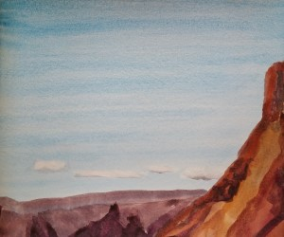
There are clouds in the desert. Every day for the first thirty days some small clouds appeared. They often developed slowly in the late morning and mostly remain above the river corridor or the mountains and then dissipated around sunset. (Figure 1.) This pattern was replaced with a sequence of incoming storms on two days in May, when light wispy cirrus clouds developed into altocumulus clouds, called ‘mackerel skies’ for their scale-like pattern and were followed by increasingly thick and dark cumulus clouds, which brought a little rain. Observations continued throughout July when the altocumulus castellanus, known as thunderheads, first appeared to announce the beginning of the ‘monsoon’ season, which is considered by locals to be mid-July through late August. Some days were hazy due to dust raised by high winds, several days received significant smoke haze from wildfires in Nevada, but throughout most of the journaling period exceptionally clear air and few contrails were experienced due to the Covid-19 lockdown.
Figure 1. Iza Steiner (1959 -), River Clouds, 2020, watercolor. Photo: Artist.

Discussion

Cloud Colors
Clouds are theoretically white. As a mass of water drops, I think clouds should be transparent, like a clear mountain lake. Water is highly reflective across the entire spectrum so that light striking the edge of the cloud is reflecting the white light of the sun. According to Bishop, clouds appear greyish and silken when the water drops turn to ice crystals at higher elevations, such as the tops of anvil heads. The dark bases of thunderheads and other cumulus clouds are their own shadows and thin edges may be transparent.
I think of blue sky as clear or even empty, yet the air molecules scatter blue and violet wavelengths more than other wavelengths. For the watercolorist, this means clouds must be portrayed by preserving the white of the paper, while the sky is filled around it with blue pigment. Shadows can then be added to the cloud holes in the sky wash.
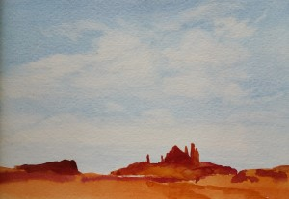
Rendering several weeks of lightly clouded skies resulted in a series of canvases, which appear to have two dimensional shapes, lightly smudged, subtracted from a blue sky. (Figure 2.) According to James Guilford Swinnerton (1875-1974), ‘The clouds should float, instead of looking like rocks. The sky should be air, not blue paint.’ Various techniques of lifting out the blue sky, creating backruns, wax or masking resist, wet-in-wet were employed to create the hard and soft edges of clouds and specifically trying to retain the brilliant white edges, where cloud meets sky. The use of masking fluid retained the full brightness of the paper along a cloud-shaped edge, but this technique made it difficult to effectively model shading within the cloud. (Figure 3.) In interviews by Vincent Miller of twenty-two artists on their sky painting techniques, only six said that they used masking fluid. The twenty-two artists also listed the colors they use for skies. In total, eighty-five different pigments were named, while only three colors were used by ten or more artists: burnt sienna, ultramarine blue and cobalt blue. Every color of the spectrum was represented, yet most colors were only used by one or two artists.
Figure 2. Iza Steiner (1959 -), Cirrus Holes, 2020, watercolor. Photo: Artist.

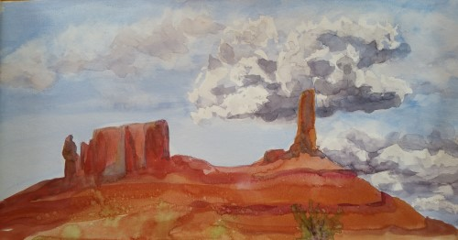
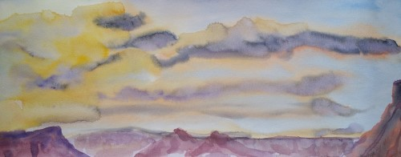
My preference for painting South-western, purple-tinted blue skies was to start with ultramarine blue, diluted and mixed with the paler cobalt or cerulean blues as the wash approached the hazy edge of horizon. The only time I witnessed green or yellow skies were along the horizon through the haze of dust or smoke catching sunset light, while still retaining enough transparency to mix with blue sky. Even though sunsets and sunrises lasted a few minutes when sunlight filtered through the atmosphere horizontally, a range of yellows through reds were transmitted or reflected off the clouds. (Figure 4.)
Figure 3. Iza Steiner (1959 -), Crisp-edged Cumulus, 2020, watercolor. The use of masking fluid left a bright-edged, but over-worked appearance to the clouds in the center and right; the left cloud is wet-in-wet and lifted out. Photo: Artist.

Figure 4. Iza Steiner (1959 -), Sunset Clouds, 2020, watercolor. Photo: Artist. Hard-edged backruns are seen in the lower left and some top clouds. The setting sun was on the left.

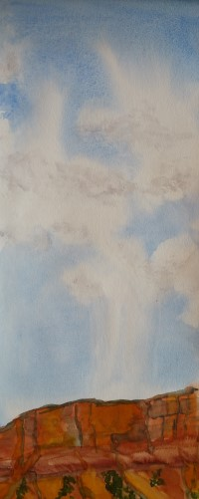
In summary, because clouds are masses of water and highly reflective, a full range of colors have been witnessed and effectively painted into cloudy skies. Clouds have no local color, due to the properties of water and could be conceived as floating mirrors, which reflect or transmit the light of the sun or moon and the colors of the land and atmosphere.

Cloud Forms
The shapes of clouds present a second challenge. The observed clouds often had crisp edges, which Bishop explained is the shape of water drops where moving clouds encounter air resistance. Flocks of smaller clouds seemed to occupy a flat plain, while the cumulus clouds built into towers, eclipsed and dwarfed the clouds beyond it. Cirrus, composed of ice crystals, appear as high streamers, according to the National weather Service. (Figure 5.)
Figure 5. Iza Steiner (1959 -), Feather Clouds, 2020, watercolor. Photo: Artist.
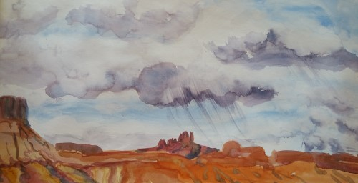
Clouds change. In the ten or fifteen minutes I spent painting one sky, the cloud I started rendering completely disappeared. Clouds are affected by wind and evaporation, but in Bishop’s description all clouds are storms, including cumulonimbus clouds, which have internal updrafts and downdrafts up to 30m/sec. Bishop explained the development of desert thunderheads, which reach the stratosphere, where ice crystals form at super-cooled temperatures of -15 Celsius, fall, aggregate water drops, vaporize and recycle upward until critical mass is accumulated and huge drops pour from the center of the cloud in cloudbursts, producing localized flooding. Bishop detailed the generation of electrical charges through friction between moving ice crystals and water, resulting in horizontal lightning, before ground strikes. The wind preceding desert storms, the falling rain and the lightning made it impossible to do watercolor in plein air, but did inspire erotic prose in the journal. For all the bluster and drama, the first monsoon rain left only six drops per 100 cm² curling into the dry dust.
Figure 6. Iza Steiner (1959 -), Sister Superior Virga, 2020, watercolor. Photo: Artist.

Cloud studies based on altocumulus castellanus depict the billowing towers through modeling of various grays. Rounded turrets are on top and crisp white edges face the sun. As the cloud develops, the icy anvil head trails downwind with grey silken strands and potentially light curtains of falling rain or virga can be seen emanating from the flat dark bases. (Figure 6.) Yet careful modeling with various shades of grey leaves my cumulus clouds looking two dimensional, until an insight from Jeanne Dobie leads me to add a touch of warm color to contrast and add depth to the cool cloud colors I am perceiving. An acrylic was amended using this principle, allowing the clouds to pop into three dimensions. (Figure 7.)
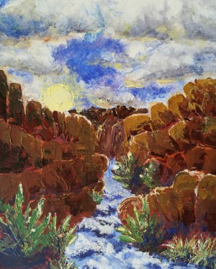
All of Miller’s international artists used wet-in-wet techniques, which involve putting wet paint on wet paper and letting the colors interact loosely. It produces soft effects and lends itself to misty or overcast conditions when the clouds are not distinct. The dry air of Utah had many small distinct clouds of altocumulus, which may be more crisply portrayed with wet-in-dry techniques onto dry paper. Quite a few artists agreed with Xavier Swolf’s assessment that, ‘Painting with watercolors is a flowing, uncontrollable manipulation of paint and water,’ and let the medium create their clouds. Other artists like Jeane Duffey say that skyscapes can be labored, they should however not look like it. It makes sense that one uses water to portray clouds, but my experience echoed Swolf’s opinion, when I lamented in the journal, ‘herding cats, herding clouds, herding thoughts, and herding watercolours.’ Using pastels and acrylics eliminated the uncertainties of watercolour. (Figure 8.)
Figure 7. Iza Steiner (1959 -), Canyon Sunrise, unfinished, 2020, acyrlic. Photo: Artist.

In summary, cloud forms are snapshots of the transformative processes of weather. The stormy essence of clouds is difficult to capture in plein air. While watercolour maintains an elemental affinity to clouds, many accomplished artists apply paint loosely and let the clouds paint themselves.
Figure 8. Iza Steiner (1959 -), Adobe Mesa Cloud Study, 2020, pastel. Photo: Artist.

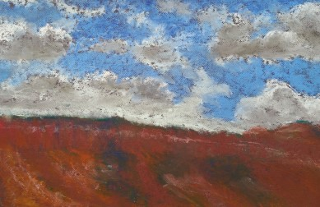

The Relationship to Land
I watch for clouds to bring rain from the Pacific Ocean, but the ocean’s clouds are raked of moisture by the 4000 m peaks in California long before they reach Eastern Utah. In Campbell’s words this is a ‘rain shadow desert.’ The relationship of land and cloud is one of scarcity.
Audubon’s contemporary definition of desert is a region where annual evaporation from water bodies, animals, and transpiration from plants exceeds the annual rainfall. ‘Evaporation in the American deserts ranges from seventy to 160 inches per year,’ according to Audubon. The fine cirrus and small fleeced clouds that pass overhead are not the remnants of moisture that have survived the rain-shadow ranges, it is our life water, the moisture from our skin, the humidity in our breath, urine on hot stone and the last blood of a roadkill lizard collected by the blue sky and carried to greener meadows in the high Rockies. The fine band of clouds to the north of Castle Valley, which I saw nearly every morning were extracted from the river. The clouds I watch for eagerly are not bringing water to the desert but stealing it away. (Figure 1.)
The small clouds always seem to be somewhere else, along the horizon. I realized that my skyscape is much larger than the viewshed of the valley. To the east and west, cliffs at twelve degrees altitude cut off long views. The mountains twenty km to the south block cloud views beyond their peaks. To the north, the view extends twenty km past the Colorado River. I estimate that I can see 400 km² of sky and only 125 km² of land in this narrow valley. When I lived by the Needles District of Canyonlands with unrestricted views, I estimate the skyscape extended over 40,000 km². The smallest acreage in one’s skyscape is directly overhead, while the edges viewed through the atmosphere cover many kilometers and if one sees far enough there are usually some clouds, somewhere. The skyscape is shared by many communities, not only by virtue of the unobstructed view above, but also because it is the most mobile element of our environment. Wind, clouds, rain, air, and sky are always moving from one place to another. I begin to think of the global heritage of sky as an open market of air and water, where clouds are the currency.
When it comes to painting, Thomas Cole (1801-1848) described skies as, ‘the soul of all scenery, in it are the fountains of light, and shade, and color. Whatever expression the sky takes, the features of the landscape are in unison…’ In Utah, there is a strong contrast between the red rock cliffs and the blue sky. According to Sven Birger Sandzen (1871-1954):

In the atmosphere in which the intensive light vibration and ring of color produce the great power of light, which is often the situation in the dry air of the Southwest… One must then use pure colors which refract each other… since the usual blending on the palette... is not intensive enough and does not “vibrate”.

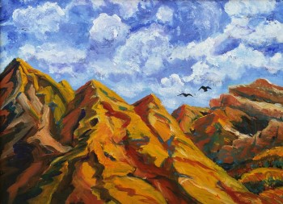
The blues of the sky creep into the shadows, but the slow blending of a distant horizon is missing in canyonlands. (Figure 9.) Using the concept that both clouds and land reflect light, I created buttes as light as sky. (Figure 10.) A true union of sky and land in my paintings was unrealized.
Douglas John Braithwaite (1964 -) said he loved plein air, ‘the feelings of heat, cold, bugs, wind and the visual experience… all emotions that I hope to translate into my paintings…’ Plein air painting in the land of wind-sculpted stone and desert storms is the essence of being in Ingold’s ‘open world’ with eyes wide open. Maynard Dixon said of his years in the desert, ‘Here remains the solid mountains and the fluid sky (full of planes) and the sun and stars, and my kin, the wandering desert dust.’ I often say that painting is a good excuse to stare at rocks… and now clouds.
Figure 9. Iza Steiner (1959 -), Two Ravens, unfinished, 2019, acrylic. Blue sky is found reflected in shadows, but the land and sky are still in sharp contrast. The clouds also lack warm colors to reflect the earth or show depth.
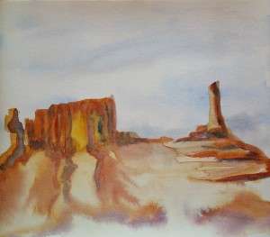
In summary, clouds may represent a hardscrabble give and take in the desert, but they connect us to the larger world. Plein air painting in the desert challenges the artist to unify the contrasting earth and sky but offers a rich immersion in the transformative processes of the ‘open world’.
Figure 10. Iza Steiner (1959 -), Castellanus Tower, 2020, watercolor.

Conclusion
Maynard Dixon’s summary of his work at the end of his life is an appropriate summation of this journal:
I must find in the visible world the forms, the colors, the relationships that for me are most true of it, and find a way to state them clearly so that the painting may pass on something of my vision.
The forms, colours and relationships of clouds have revealed that they are in a process of becoming, not only by growing, raining or dissipating, but in their relationship to the land and sky. Clouds have morphed in my perception from exotic features passing over the landscape to become floating mirrors, storms and rivers in the sky and thieves of precious desert water.
Painting in plein air has deepened my participation in the ‘open world’ and challenged me to find new ways to translate the movements of the sky’s water to fluid medium of watercolours. While some understanding of the relationship between light and sky, landscape and skyscape have been gleaned from this study, the translation of that understanding is a lifelong pursuit, as testified by Dixon.

Bibliography

Ainsworth, Ed, Painters of the Desert: Thirteen Painters who Found Beauty in the Southwest – and a Gallery of their Works, (Palm Desert: Desert Printers, Inc., 1960) p. 37, cited in Poulton.
Bishop, Jim, Mountain & Desert Thunderstorms: Their Formation & Field-Forecasting Guidelines
2nd Edition, (University of Oklahoma Press, 2016 [2007]) https://www.fs.fed.us/psw/cirmount/gloria/pdf/2016%20Bishop%20MtnDesertT-storms.pdf [accessed August 12, 2020]

Campbell, John Martin, Few and Far Between: Moments in the North American Desert, (Santa Fe: Museum of New Mexico Press, 1997)
Carylon, Richard, A Guide to the Gods (New York: Quill, 1981)
Colapietro, Vincent, ‘The Weather World of Human Experience’ The Journal of Speculative Philosophy, Vol. 29, No. 1 (2015), pp. 25-40.
Cole, Thomas, ‘Essay on American Scenery’, 1835, pp.10-11. cited in The Natural Paradise: Painting in America 1800-1950, The Museum of Modern Art, New York, ed. by Kynaston McShine, (New York: The Museum of Modern Art, 1976)
Edensor, Tim, ‘Seeing with Landscape, Seeing with Light.’ From Light to Dark: Daylight, Illumination, and Gloom, (Minneapolis; London: University of Minnesota Press, 2017)
Hagerty, Donald J., The Life of Maynard Dixon, (Salt Lake City: Gibbs Smith, 2010)
Harris, Alexandra, Weatherland: Writers and Artists Under English Skies, (New York: Thames and Hudson, 2015)
Hasse, Cathrine, ‘Postphenomenology: Learning Cultural Perception in Science’, Human Studies, Vol. 31, No. 1, Postphenomenology Research (March, 2008), pp. 43-61.
Heraclitus, fg. 20 translated by William Harris, http://wayback.archive-it.org/6670/20161201173100/http:/community.middlebury.edu/~harris/[accessed May 25, 2020]
Tim Ingold, ‘Earth, Sky, Wind, and Weather’, The Journal of the Royal Anthropological Institute, Vol. 13, Wind, Life, Health: Anthropological and Historical Perspectives (2007), pp. S19-S38.
Lokke, ‘Donald H., ‘Cloud Observations Applied to Ecological Studies’, The American Biology Teacher, Vol. 23, No. 4 (April, 1961), pp. 208-209.
Miller, Vincent, The Watercolor Skies & Clouds Techniques of 23 International Artists, (Verdi, NV: International Artist Publishing, Inc., 2005)
Obrist, Hans Ulrich, ‘Science and Art: A Conversation with Ilya Prigogine’ Review (Fernand Braudel Center), 2005, Vol. 28, No. 2, Discussions of Knowledge (2005), pp. 115-128.
Poulton, Donna G. and Vern G. Swanson, Painters of Utah’s Canyons and Deserts, (Salt Lake City: Gibbs Smith, 2009)
NASA website, https://www.nasa.gov/audience/forstudents/5-8/features/nasa-knows/what-are-clouds-58.html [accessed August 11, 2020]
NOAA website, Scijinks: Why is the Sky Blue?, https://scijinks.gov/blue-sky/ [accessed August 15, 2020]
National Weather Service website, ‘Moab Annual Precipitation’ https://w2.weather.gov/climate/getclimate.php?wfo=gjt [accessed Aug.,11, 2020]
National Weather Service, ‘NWS Cloud Chart’ https://www.weather.gov/jetstream/cloudchart
National Weather Service, ‘Ten Basic Clouds’ https://www.weather.gov/jetstream/basicten [accessed August 14, 2020]
Sandzen, Sven Birger, quoted by Emory Lindquist, Birger Sandzen: An Illustrated Biography, (Lawrence: University of Kansas, 1993), p. 70, cited in Poulton.
Whitehead, Alfred North, Process and Reality: An Essay in Cosmology, corrected edition, ed. David Ray Griffin and Donald W. Sherburne (New York: The Free Press, [1929] 1978). p.338, cited in Kraus, Elizabeth M., Chapter: Process Philosophy and its Problems in The Metaphysics of Experience: A Companion to Whitehead's Process and Reality (New York: Fordham University Press, 1997)
Wikipedia, ‘Mount Whitney’ , https://en.wikipedia.org/wiki/Mount_Whitney [accessed August 15, 2020]

Donald H. Lokke, ‘Cloud Observations Applied to Ecological Studies’, The American Biology Teacher, Vol. 23, No. 4 (April, 1961), p. 208
Richard Carylon, A Guide to the Gods (New York: Quill, 1981)
Alexandra Harris, Weatherland: Writers and Artists Under English Skies (New York: Thames and Hudson, 2015)
Vincent Colapietro, ‘The Weather World of Human Experience’ The Journal of Speculative Philosophy, Vol. 29, No. 1 (2015), pp. 25-40.
Tim Edensor, ‘Seeing with Landscape, Seeing with Light.’ From Light to Dark: Daylight, Illumination, and Gloom (Minneapolis; London: University of Minnesota Press, 2017), p. 4.
Tim Ingold, ‘Earth, Sky, Wind, and Weather’, The Journal of the Royal Anthropological Institute, Vol. 13, Wind, Life, Health: Anthropological and Historical Perspectives (2007), p. S30
Ingold, ‘Earth’ p. S28
Alfred North Whitehead, Process and Reality: An Essay in Cosmology, corrected edition, ed. David Ray Griffin and Donald W. Sherburne (New York: The Free Press, [1929] 1978). p.338, cited in Kraus, Elizabeth M., Chapter: Process Philosophy and its Problems in The Metaphysics of Experience: A Companion to Whitehead's Process and Reality (New York: Fordham University Press, 1997), p. 1
Hans Ulrich Obrist, ‘Science and Art: A Conversation with Ilya Prigogine’ Review (Fernand Braudel Center) , 2005, Vol. 28, No. 2, Discussions of Knowledge (2005), pp. 115-128, p. 120
Heraclitus, fg. 20 translated by William Harris, http://wayback.archive-it.org/6670/20161201173100/http:/community.middlebury.edu/~harris/[accessed May 25, 2020]
Cathrine Hasse, ‘Postphenomenology: Learning Cultural Perception in Science’, Human Studies, Vol. 31, No. 1, Postphenomenology Research (March, 2008), p. 42
Don Ihde, ‘Postphenomenological Research’, Human Studies, Vol. 31, No. 1, Postphenomenology Research (March., 2008), p. 6
Harris, Weatherland
John Martin Campbell, Few and Far Between: Moments in the North American Desert, (Santa Fe: Museum of New Mexico Press, 1997), p. 2.
National Weather Service website, ‘Moab Annual Precipitation’, https://w2.weather.gov/climate/getclimate.php?wfo=gjt [accessed Aug.,11, 2020]
NASA website https://www.nasa.gov/audience/forstudents/5-8/features/nasa-knows/what-are-clouds-58.html [accessed August 11, 2020]
National Weather Service, ‘NWS Cloud Chart’, https://www.weather.gov/jetstream/cloudchart [accessed August 15, 2020]
Jim Bishop, Mountain & Desert Thunderstorms: Their Formation & Field-Forecasting Guidelines 2nd Edition, (University of Oklahoma Press, 2016 [2007]), p. 4 https://www.fs.fed.us/psw/cirmount/gloria/pdf/2016%20Bishop%20MtnDesertT-storms.pdf [accessed August 12, 2020]
Bishop, p. 8
NOAA website, ‘Scijinks: Why is the Sky Blue?’, https://scijinks.gov/blue-sky/ [accessed August 15, 2020]
Ed Ainsworth, Painters of the Desert: Thirteen Painters who Found Beauty in the Southwest – and a Gallery of their Works, (Palm Desert: Desert Printers, Inc., 1960) p. 37, cited in Donna L Poulton and Vern G. Swanson, Painters of Utah’s Canyons and Deserts, (Salt Lake City: Gibbs Smith, 2009), p. 112
Vincent Miller, The Watercolor Skies & Clouds Techniques of 23 International Artists, (Verdi, NV: International Artist Publishing, Inc., 2005)
National Weather Service, ‘Ten Basic Clouds’ https://www.weather.gov/jetstream/basicten [accessed August 14, 2020]
Bishop, pp. 6-13.
Bishop, pp. 8-13.
Bishop, pp. 13-14.
Jeanne Dobie, Making Colors Sing: Practical Lessons in Color and Design, (New York: Watson-Guptill Publications, 1986) pp. 30-35.
Miller
Miller, p.114
Miller, p. 46
Mount Whitney, Wikipedia, https://en.wikipedia.org/wiki/Mount_Whitney [accessed August 15, 2020]
Campbell, p. 5
Audubon, p. 29
Audubon, p. 29
Thomas Cole, ‘Essay on American Scenery’, 1835, pp.10-11. cited in The Natural Paradise: Painting in America 1800-1950, The Museum of Modern Art, New York, ed. by Kynaston McShine, (New York: The Museum of Modern Art, 1976) p. 86
Sven Birger Sandzen, quoted by Emory Lindquist, Birger Sandzen: An Illustrated Biography, (Lawrence: University of Kansas, 1993), p. 70, cited in Poulton, p. 107
Douglas John Braithwaite, private correspondence with Donna Poulton, February, 2008, cited in Poulton, p. 208
Maynard Dixon to Joseph Loeb, Tucson, Arizona, October 23, 1943, copy in Maynard Dixon Papers, Collection of DonaldJ. Hagerty, cited in Donald J. Hagerty, The Life of Maynard Dixon, (Salt Lake City: Gibbs Smith, 2010) p. 230
Donald J. Hagerty, The Life of Maynard Dixon, (Salt Lake City: Gibbs Smith, 2010), p. 234

