Optimising Group Meeting Scheduling for College Project Teams
A Problem Analysis and Solution Development Report
Module: ACCA4019 – Analysing & Solving Problems
Component 2: Written Assessment
Student Name: Kaled Mensur
Student ID:2514975
Module: ACCA4019 – Analysing & Solving Problems

Abstract
From my observations in group projects during my computing studies, one of the biggest hurdles isn't a lack of skills among students, but the constant struggle to find times when everyone can meet. This report takes a close look at the scheduling challenges faced by college students balancing part-time jobs, varying lecture schedules, and personal life, all while trying to meet tight weekly deadlines for group work. By applying the MoSCoW prioritisation method, I break down the requirements into must-haves and nice-to-haves [4], reframing the issue as a constraint satisfaction problem where individual availabilities are variables constrained by the project deadline [2]. The proposed solution uses a flowchart to first find a slot that works for essential attendees, then optimizes for broader involvement, and includes controlled relaxation of constraints if needed. Finally, I reflect on the computational thinking techniques like abstraction and decomposition that guided this [1], while noting the limitations of a practical, manual approach versus a full software solution.

1. Introduction
Although coordinating meetings might appear trivial at first glance, it often has a profound effect on the success of group projects. When meetings can't be arranged, teams miss out on crucial opportunities to assign tasks, check in on progress, and sort out issues ahead of deadlines. In this report, I'm examining a typical situation for computing students who are juggling part-time work, clashing lecture schedules, and other commitments, making consistent group meetings difficult. This leads to imbalanced workloads and heightened risk of missing deadlines. My aims here are threefold: to deconstruct the scheduling issue into its core components and constraints, to propose a clear, flowchart-based solution that can be applied generally, and to critically reflect on the problem-solving methods I used along with the practical limits of the design [1][7].

2. Problem Deconstruction
Deconstruction, in the sense used by computational thinking, is the practice of breaking a complex task into smaller, more manageable components before attempting to solve it as a whole. Wing describes computational thinking as “using abstraction and decomposition when attacking a large complex task or designing a large complex system” [1]. Applying this lens to the meeting-scheduling scenario separates the situation into four component elements: the actors (group members with individual constraints), the resource being allocated (blocks of shared time), the boundary condition (the weekly project deadline), and the desired outcome (a confirmed, attended meeting that produces usable progress).

2.1 Key variables
- Member availability: the set of time windows in which each individual is free, derived from lecture timetables, part-time work shift patterns, and personal commitments.
- Attendee priority: whether a member's presence is essential to the meeting (e.g. the task owner for that week) or merely beneficial.
- Meeting duration: the minimum block of continuous time required for the session to be useful.
- Deadline: the fixed point by which the meeting, and the work it produces, must be completed.
- Location or medium: whether the session is in person, online, or hybrid, which can itself narrow the usable time windows.
When viewed this way, finding a meeting time becomes a classic scheduling problem. The academic literature on meeting scheduling treats it as a constraint satisfaction problem (CSP): a set of variables (each person's calendar), each with a domain of possible values (free or busy in a given slot), that must be assigned consistently so that a set of constraints (all essential attendees free, session before the deadline, minimum duration met) is satisfied simultaneously [2]. Research on business meeting scheduling shows that even professionally organised events treat this as a combinatorial optimisation problem solved through constraint programming or integer programming once the number of participants and time slots grows [3]. A student group of four to six members produces a far smaller search space, which makes a manual or lightly automated process practical rather than requiring specialist solver software.

2.2 Requirements and constraints using MoSCoW
The MoSCoW technique, created by Dai Clegg and later adopted into the Dynamic Systems Development Method (DSDM), is a prioritisation tool that sorts requirements into four categories: Must have, Should have, Could have, and Won't have this time [4]. It is particularly suited to a timeboxed, resource-constrained context such as a weekly student deadline, because it forces a distinction between what a solution absolutely requires and what would merely improve it. The DSDM guidance recommends that Must Have items should not exceed roughly 60% of total effort, leaving room for Should and Could items to flex if time is short [5]; the same logic applies here, where the essential outcome (a valid meeting slot) must never be sacrificed for a secondary preference (such as notifying every member automatically).
Category | Requirement | Justification
Must have | The system must identify at least one time slot, before each weekly deadline, at which every core (must-attend) group member is free. | Without this, the deliverable cannot be completed on time regardless of any other feature.
Must have | The system must draw on each member's declared weekly availability (classes, part-time work shifts, fixed commitments). | Accurate input data is the foundation the whole process depends on.
Should have | The system should prefer slots where the largest possible number of non-core members are also free. | Improves participation and workload balance without being essential to producing a valid slot.
Should have | The system should flag a slot at least 48 hours before the deadline wherever the schedule allows. | Gives members preparation time; desirable but not always achievable in a compressed week.
Could have | The system could rank alternative slots and present a shortlist rather than a single fixed time. | Adds flexibility and user choice but is not required for the core scheduling function.
Could have | The system could send automated reminder notifications ahead of the confirmed slot. | A convenience feature; its absence does not prevent a meeting being scheduled.
Won't have (this time) | Automatic integration with every member's personal calendar application. | Out of scope for the current timebox; would require API access this project does not have.
Table 1. MoSCoW breakdown of the scheduling solution's requirements.

3. Proposed Solution and Explanation
The proposed solution is represented as a flowchart (Figure 1) that treats scheduling as a two-stage search: first for a slot that satisfies the hard constraint (all Must-attend members free before the deadline), and second, if that search fails, for a controlled relaxation of the constraints rather than an unplanned cancellation of the meeting [2].
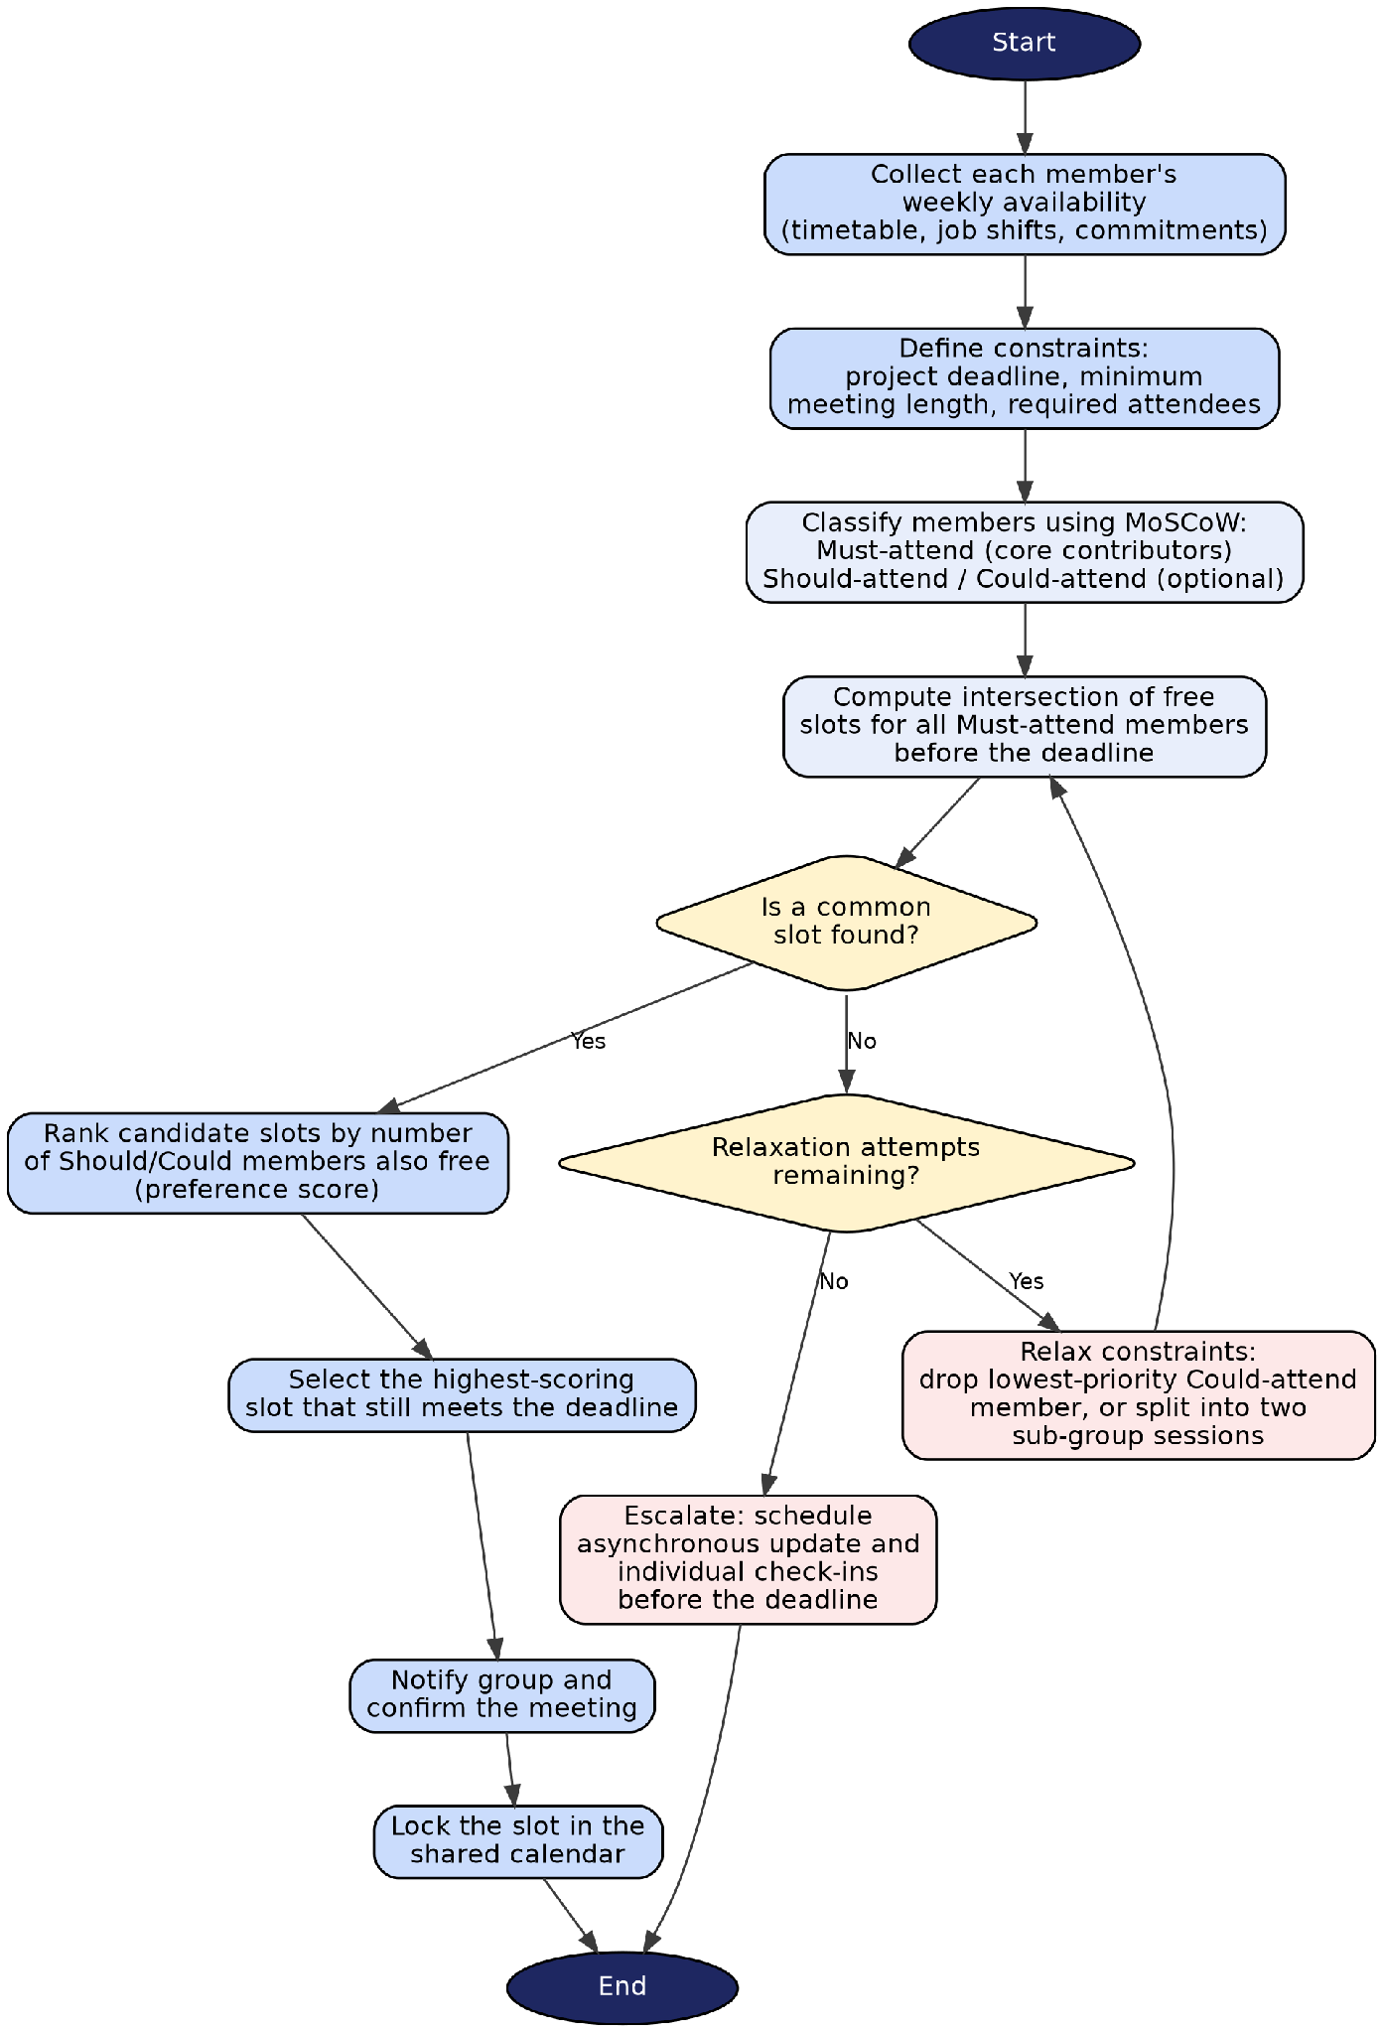
Figure 1. Flowchart of the proposed group meeting scheduling process.

3.1 Walkthrough of the process
The process begins by collecting each member's weekly availability, expressed as free or busy blocks derived from lecture timetables, work shifts and personal commitments. Alongside this, the group defines the constraints that bound the search: the project deadline, the minimum acceptable meeting length, and which members are required for the session to be worthwhile. Members are then classified using MoSCoW into Must-attend (for example, the person responsible for the week's deliverable, or anyone whose sign-off is required) and Should/Could-attend (members whose presence is valuable but not essential).
The system then computes the intersection of free time across all Must-attend members that falls before the deadline. If this intersection is non-empty, the candidate slots are ranked by a simple preference score: the number of Should/Could-attend members who are also free in that window. The highest-scoring slot that still respects the deadline is selected, the group is notified, and the slot is locked into a shared calendar.
If no common slot exists among Must-attend members, the process does not stop there. Instead, it checks whether a relaxation attempt remains available. Two relaxation strategies are proposed: dropping the lowest-priority Could-attend requirement from the Must-attend set where genuinely possible (for example, if a member's contribution for that specific week is non-critical), or splitting the group into two smaller sub-sessions that each cover part of the agenda. After relaxation, the intersection search is repeated. If none of these options work does the process escalate to an asynchronous fallback: a written progress update circulated to the group together with short individual check-ins, so that the deadline is still met even without a synchronous meeting.

3.2 Key decision points and assumptions
Two decision points drive the logic: whether a common Must-attend slot exists, and, if not, whether a relaxation attempt remains. These decisions were chosen because they mirror how a well-run group actually behaves under pressure: it does not treat a missed meeting slot as a dead end, but tries a bounded number of reasonable adjustments before falling back on an alternative form of collaboration. A related and well-studied technique here is the min-conflict heuristic used in agent-based meeting-scheduling research, in which small, incremental adjustments are attempted before a schedule is declared infeasible, rather than exhaustively searching every possible combination [6].
The solution assumes that members submit reasonably accurate and up-to-date availability information, that the group has already agreed who is genuinely essential for a given week, and that a minimum viable meeting length has been agreed in advance. It also assumes a small group size (four to six members), which keeps the search space small enough to be solved manually or with a simple shared spreadsheet or scheduling poll, without requiring dedicated solver software.

3.3 How the solution meets its objectives
- Suitable meeting times for all members: the Must-attend intersection guarantees that anyone essential to a given session is available, while the preference ranking maximises attendance beyond that minimum.
- Minimised timetable conflicts: classifying members by priority prevents a single low-priority conflict from blocking the whole group, since the search only insists on agreement among those who are essential that week.
- Meetings before deadlines: the deadline is encoded as a hard boundary in the intersection search itself, so any slot returned by the process is, by construction, early enough to be useful; the escalation path guarantees the deadline is still met even in the worst case.

4. Reflection and Justification
This task was approached using two complementary techniques: decomposition and MoSCoW prioritisation. Decomposition, one of the four pillars of computational thinking identified by Wing, alongside pattern recognition, abstraction and algorithm design, was used to break the vague complaint of “we can never find a time to meet” into concrete variables (availability, priority, duration, deadline) that could each be reasoned about separately [1][7]. This mirrors the approach recommended for ill-structured, real-world problems, where the situation itself is not yet a clearly defined “problem” until it has been examined and reframed; Checkland's Soft Systems Methodology makes a similar point, arguing that the “whats” of a messy situation must be debated before the “hows” of a solution are designed .
MoSCoW was chosen over a simpler high/medium/low priority scale because it forces an explicit, defensible line between requirements that cannot be dropped and those that can. This was appropriate for a timeboxed university project, since it directly reflects the pressure the students in the scenario are under: a matching pressure exists in DSDM projects, which use MoSCoW specifically because delivery dates are fixed and requirements must flex around them rather than the reverse [5].
Treating the scenario as a constraint satisfaction problem gave the solution a clear logical structure rather than a purely intuitive one. It also exposed a genuine limitation: this report proposes a manual or lightly tool-assisted process, not an automated solver. Some academic approaches to meeting scheduling increasingly use metaheuristics such as particle swarm optimisation or neural-network-based conflict minimisation to handle large numbers of participants and constraints [6]; for a group of four to six students, this level of computational machinery is unnecessary and would add complexity without a proportionate benefit. The trade-off is that the proposed flowchart depends on members honestly and promptly reporting their availability, and it does not automatically re-optimise if circumstances change mid-week.
A further limitation is that the relaxation stage relies on subjective judgement about which member's attendance is genuinely non-critical in a given week; this is a soft, human decision rather than a variable the flowchart can evaluate for itself. In line with the Soft Systems Methodology's caution against treating human-centred situations as purely technical problems to be solved outright, this report treats the flowchart as a decision-support aid for the group rather than a fully autonomous scheduler. Future refinement could weight this decision using objective criteria, such as which member's assigned subtask has the nearest sub-deadline, rather than leaving it entirely to discussion.

5. Conclusion
The difficulty college project groups face in finding shared meeting times is a genuine scheduling problem that can be addressed more effectively through structured analysis than informal negotiation. decomposing the scenario into its constituent variables, prioritising requirements with MoSCoW, and modelling the search for a suitable slot as a constraint satisfaction process with a defined escalation path, the proposed flowchart offers groups a repeatable way to protect their weekly deadlines even when perfect attendance is not possible. The approach is deliberately lightweight and manual, reflecting the realistic scale of a student group, while remaining grounded in the same principles that underpin far larger, automated scheduling systems used in industry and research.

References
[1] J. M. Wing, “Computational Thinking,” Communications of the ACM, vol. 49, no. 3, pp. 33–35, Mar. 2006. Available: https://www.cs.cmu.edu/~15110-s13/Wing06-ct.pdf
[2] E. Tsang, Foundations of Constraint Satisfaction. London: Academic Press, 1993. Available: https://cse.unl.edu/~choueiry/Documents/TsangTextbook/Tsang-Fcs1993-Toc.pdf
[3] M. Bofill, J. Coll, M. Garcia, J. Giráldez-Cru, G. Pesant, J. Suy, and M. Villaret, “Constraint Solving Approaches to the Business-to-Business Meeting Scheduling Problem,” Journal of Artificial Intelligence Research, vol. 74, 2022. Available: https://doi.org/10.1613/jair.1.12670
[4] D. Clegg and R. Barker, Case Method Fast-Track: A RAD Approach. Wokingham: Addison-Wesley, 1994. Available: https://www.amazon.com/Case-Method-Fast-Track-Approach-Engineering/dp/020162432X
[5] Agile Business Consortium, “MoSCoW Prioritisation,” DSDM Project Framework Handbook, 2014. Available: https://www.agilebusiness.org/dsdm-project-framework/moscow-prioritisation.html
[6] A. Bouhouch, L. Chakir, and A. El Qadi, “Scheduling meeting solved by neural network and min-conflict heuristic,” in 2016 4th IEEE Int. Colloquium on Information Science and Technology (CiSt), pp. 773–778, 2016. Available: https://ieeexplore.ieee.org/document/7804991/
[7] BBC Bitesize, “Introduction to computational thinking,” British Broadcasting Corporation. Available: https://www.bbc.co.uk/bitesize/guides/zp92mp3/revision/1

