ESSAY

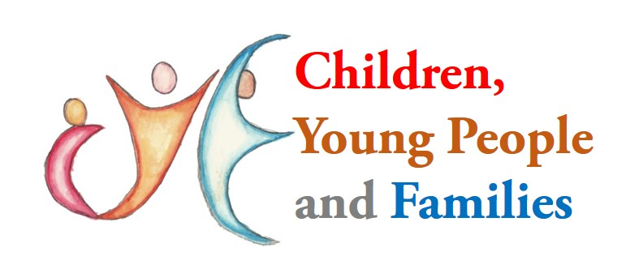

STUDENT NAME: NOREEN AKHTAR
STUDENT NUMBER: 2016543
MODULE: BMHP5004
ASSIGNMENT: CHILDREN, YOUNG PEOPLE AND FAMILIES
LECTURER: DR MUHAMMED HOSSAIN

CONTENTS

Introduction 3
What is safeguarding for children? 4
What is Covid19? 5/6
Closure of schools 7
Vulnerable children and families 8/11
Acts 11/12
Conclusion 13
References 14/16

INTRODUCTION

In this essay I will be assessing the impact of Covid19 and its affects around safeguarding with children and families. During Covid19 a lot of things had to change. Everyone had to adapt to the changes that were being made from the government. Everything had to change something that never has happened before. With these changes the children and families from were feeling the pressure. Emotional well-being and mental health was becoming a concern for families and children about the Covid-19 virus and its possible risks, such as death in the family. Substantial disturbances to children's life include social isolation, school closures, isolation from social support networks, and reduced possibilities for exercise and outdoor play.

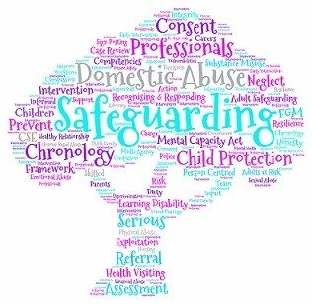
What is Safeguarding for children?
The action of promoting the welfare of children and protecting them from harm is known as safeguarding. Preventing children from abuse and maltreatment is what safeguarding involves. Making sure that children's health and development are not jeopardized, also making sure that children are cared for in a safe and effective manner as they grow up (NSPCC Learning. 2022).
DEFINITION OF:
ABUSE: When someone harms or causes suffering to another individual, this is referred to as abuse. It might happen at home, at a nursing home, in a hospital, or in a public area. People who abuse others frequently take advantage of a particular relationship. They might be a family member, a family friend, a neighbor, or a hired babysitter with whom we have placed our confidence. Abuse is sometimes unintentional and occurs when someone lacks the skills or support needed to care for someone. That doesn't change the fact that it had an influence, but it does provide insight into how it occurred. Neglect, as well as physical, emotional, and sexual abuse, are four categories of abuse. Use of physical punishment is considered child abuse in several nations. Abuse might be difficult to see, but being distant, quiet, and too obedient could also be indicators of some kind of abuse (Brazier, 2018)
MALTREATMENT: Child maltreatment is defined as "all forms of physical and/or emotional ill-treatment, sexual abuse, neglect or negligent treatment, or commercial or other exploitation, resulting in actual or potential harm to the child's health, survival, or development," according to the National Society for the Prevention of Cruelty to Children (NSPCC) (Cks.nice.org.uk. 2019).
HEALTH AND DEVELOPMENT: According to the Universal Declaration of Human Rights, excellent health helps people to attain their full potential, children to learn more effectively, employees to be more creative, and parents to provide excellent care for their children. Growth, new information, or an event is all examples of development. The transformation of a caterpillar into a butterfly is an example of development (Pallipedia.org. 2022).

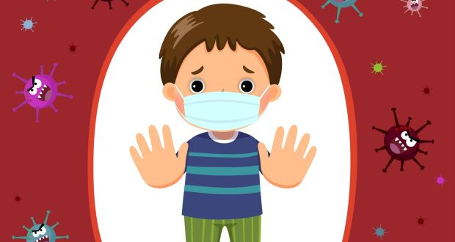
What is Covid19?
Coronaviruses are viral types. There are numerous distinct sorts, and some of them are pathogenic. SARS-CoV-2, a coronavirus discovered in 2019, has produced a pandemic of respiratory sickness known as COVID-19. The coronavirus is known to spread by droplets and virus particles released into the air when an infected person breathes, talks, laughs, sings, coughs, or sneezes. Larger droplets may fall to the ground in a matter of seconds, but microscopic infectious particles can persist in the air and concentrate in enclosed spaces, particularly if a large number of people are assembled and ventilation is inadequate. This is why mask use, hand cleanliness, and physical separation are critical in the prevention of COVID-19 (Mental health and COVID-19, 2022)

In April and May 2020, our grantees notified us about how the Covid-19 epidemic was negatively impacting children and young people who were already facing issues in their lives. The scenario was exacerbating and complicating existing problems for some. It was also posing additional obstacles and threats for children and adolescents to contend with (Bbcchildreninneed.co.uk. 2020)

The World Health Organization (WHO) was notified on December 31, 2019, that a cluster of pneumonia patients with an unknown origin had been discovered in China. Following that, a new coronavirus was discovered in patient samples. The main signs that will be connected to Covid19 are a high temperature persistent cough, a lack or change to smell or taste (GOV.UK. a2020, b2021).

This following information was taken from The British Foreign Policy Group (BFPG):
The first two people that were Chinese nationals from the same family fell ill at a hotel in Yorkshire on January were tested positive for Coronavirus. The first British death of the coronavirus dies on board the Diamond Princess in February. To allow the NHS time to deal with the epidemic, Boris Johnson recommended everyone to work from home so they could stay safe and less people will get infected with the virus. In March, while the UK government declared that schools in England must close until further notice. Prime Minister Boris Johnson also spoke to the public, telling them that they should only go outside to purchase food, exercise once each day, or go to work if they could not really work from home. Refusal to implement the new regulations would result in penalties from the police. In April, the UK achieved major daily number of deaths, with 938 people dying in a single day. In May, UK schools would return in stages, starting with year one and year six on June 1st, and then year ten and year twelve on June 15th. In little bubbles, they would reintroduce the youngsters to school. To aid in the fight against the pandemic, tiers were established (Timeline, 2022).

Roadmap out of lockdown
This roadmap was introduced to the people which had to be followed to come out of lockdown.
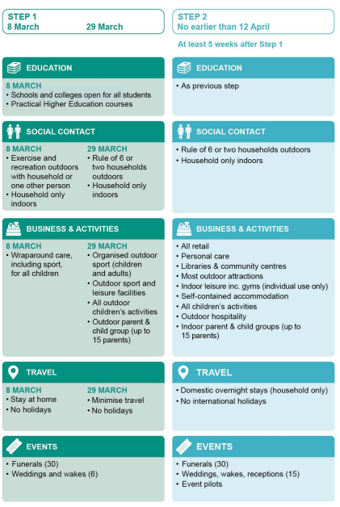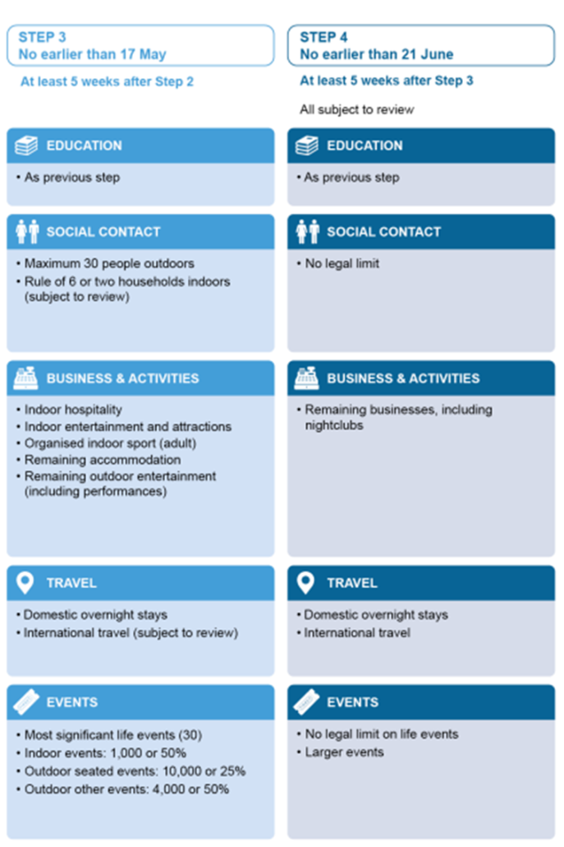
(COVID-19 RESPONSE − SPRING 2021)
Closure of schools
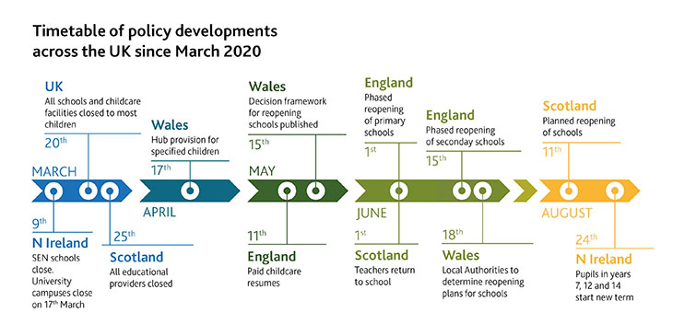(Cambridgeassessment.org.uk. 2020)

With covid19 spreading so quickly. people all over the country were falling ill, the staff and children attendance of each school was dropping down to a really low which has never accrued in the past. So, the government had to take action. School had to close which has never happened before. Since its eruption two years ago of the COVID-19 virus has devastated education systems worldwide, wreaking the most havoc on the most vulnerable students. It has worsened an already-existing education problem and deepened inequities. School closures have ranged from none in a few nations to more than a full school year in others. At least one-third of students were unable to pursue remote learning due to a lack of internet and gadgets. During the first peak, almost 1.5 billion children were absent from school, and economic uncertainty has impacted the most disadvantaged, with various possible negative consequences (Rajmil et al., 2021).
After the first lockdown the government also suggested that the usage of facial masks for secondary schools and higher education students should be expanded for a short time to all indoor situations, including classrooms, unless 2m social distance was maintained. Face coverings were suggested at early childhood and primary schools for staff and adult visitors in times where social distance between adults is impossible, such as when moving through hallways and common spaces. All pupils were expected to return back to school.

Vulnerable children and families
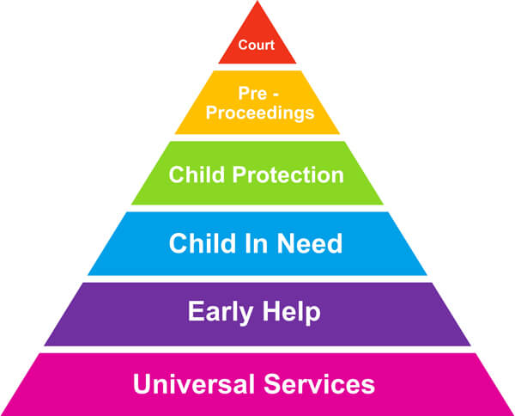
(User, 2007)
Families that were barely getting by before the outbreak of the corona virus and would not ordinarily come to the notice of social services were suddenly in desperate need of major assistance." More children were arriving later in the process, when difficulties had become complicated and entrenched, and then became objects of child protection plans or procedures." According to the research, local governments received an estimated 2.5 million first contacts in 2019/20, a 5% rise over the previous two years. It also discovers that, when compared to the other six stages of the research, which were conducted over the preceding 12 years, the primary sources of referrals switched during the first six months of the epidemic. Due to school closures, there were fewer recommendations from schools, and an increase in those from the public and self-referrals," the study notes, adding that the emergency services continue to become the most common source of referrals, followed by general practice and A&E departments (Simpson, 2021).

- Poverty- Poverty is defined as any individual who is denied of basic needs, for example the person who could not really buy any food, have a roof over their head, clothing, education, and health care facilities, in due to financial difficulties. As a result, they fall below the poverty line. Poverty is defined as a lack of funds to cover basic requirements, on the other hand, is much more than simply not having enough money. During COVID19 they had limited or basic income coming in which they had to live on. When they were isolating in their homes 24 hours it is hard to live on a basic wage or benefit. For parents providing for their children it is really hard thinking how they to put another meal on the table or where it is going to come from. Or even If they have enough money for the bills. During COVID the families have been stressing over how they would manage.

- Domestic violence- Domestic violence is defined as violence done by someone in the victim's immediate family like partners and close family members. When there is a close link between the offender and the victim, the term "domestic violence" is applied. Domestic violence has an influence on one's ideas, feelings, and behaviours, as well as one's mental stability. Survivors of domestic abuse frequently have increased anxiety, post-traumatic stress disorder, and depression symptoms. During COVID as everyone had to isolate at home not having much space to move around being around family all around the clock takes took a lot of strain on the families. The way of coping taking out their frustration was easy to take it out on their family member. Due to this during this time families have broken up.

- Foster/ Care homes- Fostering is the act of giving your home to a child or young person in need of love, care, and support. It is not always simple. The youngster you're caring for may frequently view things quite differently than you do and may reject your efforts to reach out to them. A foster family is no different than any other. It offers a shoulder to cry on when things are tough and someone to laugh and rejoice with when things are going well. And it provides the love, forgiveness, and support that we all require in order to grow, learn, and become better people. During COVID were going through a hard time having limited social life, problems at home and creating issues. The child was being moved to care homes or being fostered to help with family life and work with social workers to bring back the child back into a happier environment.

These are some of the fostering types:

- SHORT-TERM- A temporary placement while the child/young person(s). The placements are frequently made with little advance notice and might last anywhere from a few weeks to a few months.
- LONG-TERM- A pre-planned placement in which a child or young person joins the household of a foster caregiver and provides a stable living environment until they are at the age to be independent.
- ONE-ON-ONE CARE- The provision of care for a single kid is referred to as solo care. This youngster requires one-on-one care and is frequently best served by a two-parent home.
- SHORT INTERRUPTIONS- Giving mom and dad or temporary carers a break from day-to-day care and duties by providing a regular respite for a handicapped kid.
(Progress. 2022)

- Mental health- Our emotional, psychological, and social well-being all contribute to our mental health. It has an impact on how we believe, react, and behave. It also influences how we deal with stress, interact with people, and make decisions. Mental health is essential at all stages of life, from infancy and adolescence through maturity. Nevertheless, you do not have to be yourself all of the time to be lonely. Many people feel lonely even when they are spending time with friends or relatives. Loneliness may afflict people of any age and especially people that are vulnerable to social isolation. A lot of families had someone or another go through mental health issues during COVID. Lives changed during this pandemic. From having freedom going out meeting family, friends, schools then out of nowhere being told to isolate with nothing much to do which was not for few days it went on for months. Not having a normal and living and seeing the same people and the walls day in day out took a lot of strain on some people. Which has left them needind treatment for their mental state.

- Bereavement- Bereavement is the phase of sadness and grieving that follows the death of a loved one. Grieving is a natural element of the process of coping with a loss. Grief can emerge as a mental, bodily, social, or emotional reaction. Anger, guilt, worry, sadness, and despair are all examples of mental responses. A person's mental health might suffer greatly as a result of bereavement. Persons who already have a mental health problem may have their condition deteriorate following the loss of a loved one, and otherwise mentally healthy people may develop a mental health problem as a result. Many individuals are bereaved as a result of the COVID-19 epidemic. Grief is a natural reaction to loss that occurs during or after a tragedy or other stressful event. Grief may occur as a result of the loss of a loved one, as well as severe changes in daily routines and ways of life that normally provide us with comfort and a sense of security. Because of the COVID-19 epidemic, you may be unable to be with a close loved one when they die, or to grieve in person with friends and relatives (GRIEF AND LOSS, 2021). During grief, these feelings can have an influence on many of our mental and physiological systems, resulting in difficulties sleeping, weariness, lack of appetite, stomach aches, attention issues, restlessness or hyperactivity, and difficulty making decisions. Grief is an emotion to loss, but it is also the term we use to describe the practice of coping with the death of a loved one. Grief is a natural process that involves feeling soothed, accepting a loss, and figuring out how to adjust.

ACTS
Acts are usually written legal documents with probative and executor significance. Law comes before Act since there would be no Act if no law existed. Acts are written to inform people about particular laws and regulations, whereas the Law is written to prevent unfair acts, preserve public order, and, most importantly, protect persons or people. Human Rights 1998 and Equality Act 2010 and many more Acts are placed for the children, young people and families. They are put in place to safeguard and wellbeing of all individuals.

- Children Act 1989 and 2004
A central tenet of the 1989 Act is that children are best cared for inside their families, with their parents actively involved in their lives, until compulsory involvement in family life is required. The Children Act of 2004 is an evolution of the 1989 Act. It reaffirmed that all persons and organisations that work with children have a responsibility to assist protect and promote the welfare of children (Children Act, 2004).
- Children and Family Act

The Children and Families Act of 2014 continues the alliance government's commitment to improving services for vulnerable children and building strong families. It strengthens broader changes aimed at ensuring that all children and young people, whatever of circumstance, may achieve. Edward Timpson, Children and Families Minister, said: “The Children and Families Act is all about reforming services for vulnerable children - reflecting this government’s deep determination to give every child, whatever their start in life, an equal chance to make the best of themselves” (Children and Families Act 2014).

- Child and Young People Act 2008- The 2008 Act aims to promote placement stability as well as the educational experience and achievement of young people in local authority care or about to exit care. Also there should be activities associated with parenting (Children and Young Persons Act, 2008)

- Keeping Children Safe in School 2021- It is everyone's obligation to protect and promote the wellbeing of children. Everyone who interacts with children and their families plays a role. To properly carry out this role, all practitioners must ensure that their approach is child-centred. This implies that they must always examine what is in the best interests of the child. This is totally up to the school or college, and will be determined based on their judgement of which guidelines will be most helpful for their personnel in safeguarding and promoting the welfare of children (Keeping children safe in education , 2021)
,

CONCLUSION

The COVID19 caused a massive uproar and a standstill to the country. It shook the whole world. All business, schools and enterprises had to stop services due to the spreading of the virus. The whole country went into lockdown withholding peoples’ freedom rights for their own security and health. This left families scared and worried how they would survive without work, no money and feeling vulnerable. The children had nowhere to go other than stay indoor with limited social contact. The population of poverty was growing. People where doing panic shopping they were buying food which they did not need. Families living in poverty were barely managing to cope with the pandemic. Celebrity like Marc Rashford stepped in to help raise money and awareness for children who use to receive free dinners, but now the burden was on the families to provide for the children. All domestic legal restrictions to end it took nearly two years, ended on 24/02/2022. All the country is trying to get back to the new norm. Unfortunately the long term effect still show especially in the NHS sectors which now have very long waiting lists for new referrals, follow-ups and procedures.

REFERENCES

Bbcchildreninneed.co.uk. (2020). Understanding the impact of Covid-19 on children and young people Early Pandemic Period April. [online] Available at: <https://www.bbcchildreninneed.co.uk/wp-content/uploads/2020/11/CN1081-Impact-Report.pdf> [Accessed 4 April 2022].

Brazier, Y., (2018). Child abuse: Types, signs, and reporting possible abuse. [online] Medicalnewstoday.com. Available at: <https://www.medicalnewstoday.com/articles/241532> [Accessed 25 March 2022].

Children and Families Act (2014) gains royal assent. [online] Available at: <https://assets.publishing.service.gov.uk/government/uploads/system/uploads/attachment_data/file/350685/Early_Years_Guide_to_SEND_Code_of_Practice_-_02Sept14.pdf> [Accessed 3 April 2022].

Children and Young Persons Act (2008). [online] Available at: <https://www.legislation.gov.uk/ukpga/2008/23/pdfs/ukpga_20080023_en.pdf> [Accessed 4 April 2022].

COVID-19 RESPONSE − SPRING (2021). [online] Available at: <https://assets.publishing.service.gov.uk/government/uploads/system/uploads/attachment_data/file/963491/COVID-19_Response_-_Spring_2021.pdf> [Accessed 2 April 2022].

Cambridgeassessment.org.uk. (2020). Covid-19 Curriculum Watch: Education Policy in the first 3 months of the pandemic. [online] Available at: <https://www.cambridgeassessment.org.uk/insights/uk-education-policy-during-covid-19-pandemic-topic-one/> [Accessed 2 April 2022].

Children Act. (2004). [online] Available at: <https://www.legislation.gov.uk/ukpga/2004/31/pdfs/ukpga_20040031_en.pdf> [Accessed 3 April 2022].

Cks.nice.org.uk.(2019). Definition | Background information | Child maltreatment - recognition and management | CKS | NICE. [online] Available at: <https://cks.nice.org.uk/topics/child-maltreatment-recognition-management/background-information/definition/> [Accessed 25 March 2022].

GOV.UK.( a2020, b2021). COVID-19: background information. [online] Available at: <https://www.gov.uk/government/publications/wuhan-novel-coronavirus-background-information#:~:text=On%2031%20December%202019%2C,identified%20from%20patient%20samples.> [Accessed 25 March 2022].

GREIF AND LOSS,( 2021). [online] Available at: <https://www.cdc.gov/mentalhealth/stress-coping/grief-loss/index.html> [Accessed 3 April 2022].

Mental health and COVID-19. (2022) [online] Available at: <https://www.euro.who.int/en/health-topics/health-emergencies/coronavirus-covid-19/publications-and-technical-guidance/mental-health-and-covid-19#:~:text=As%20the%20coronavirus%20pandemic%20rapidly,also%20expected%20to%20rise.> [Accessed 4 April 2022].

NSPCC Learning. (2022). Safeguarding children and child protection | NSPCC Learning. [online] Available at: <https://learning.nspcc.org.uk/safeguarding-child-protection> [Accessed 23 March 2022].

Pallipedia.org. (2022). What is Health development - Meaning and definition - Pallipedia. [online] Available at: <https://pallipedia.org/health-development/> [Accessed 25 March 2022].

Progress. (2022). Thinking About Fostering & Want To Know More? | Progress Care. [online] Available at: <https://progresscare.co.uk/about-fostering/> [Accessed 2 April 2022].

Rajmil, L., Hjern, A., Boran, P., Gunnlaugsson, G., Kraus de Camargo, O. and Raman, S., (2021). Impact of lockdown and school closure on children’s health and well-being during the first wave of COVID-19: a narrative review. BMJ Paediatrics Open, 5(1), p.e001043.

Simpson, F., (2021). MORE CHILDREN 'MADE KNOWN TO SOCIAL SERVICES IN FIRST SIX MONTHS OF PANDEMIC'. CYPNOW, [online] Available at: <https://www.cypnow.co.uk/news/article/more-children-made-known-to-social-services-in-first-six-months-of-pandemic> [Accessed 2 April 2022].

Timeline, 0., (2022). COVID-19 Timeline - British Foreign Policy Group. [online] British Foreign Policy Group. Available at: <https://bfpg.co.uk/2020/04/covid-19-timeline/> [Accessed 25 March 2022].

User, S., (2007). CHILDREN'S SERVICES - Young Parents Advice. [online] Frg.org.uk. Available at: <https://www.frg.org.uk/ypa/need-help-or-advice/childrens-services> [Accessed 2 April 2022].

