Analysis of Electromagnetic Wave Propagation
ACDC5009 - Natalie Coplin - April 2025
Table of Contents
Abstract 4
1 Introduction 5
1.1 Waveguides 5
1.1.1 TE and TM modes 5
1.2 Antenna 6
1.3 Dipole and half wave dipole antenna 7
2 Methodology 8
2.1 Task 1a and 1b 8
2.2 Task 2 10
3 Results 11
3.1 Task 1a – Vacuum 11
3.2 Task 1b – Teflon 20
3.3 Task 2 - Halfwave Dipole Antenna 29
4 Discussion 31
5 Conclusion 32

Table of Figures
Figure 1 Rectangular waveguide [6] 5
Figure 2 Example of antenna in line with a source, transmission line and free space [11] 7
Figure 3 Rectangular waveguide model with Perfect Electric Conductor (PEC) walls filled with vacuum. 9
Figure 4 Rectangular waveguide model with PEC walls filled with vacuum - port one 9
Figure 5 Rectangular waveguide model with PEC walls filled with vacuum - port two 10
Figure 6 Wave port one - mode one 11
Figure 7 Wave port one - mode two 11
Figure 8 Wave port one - mode three 12
Figure 9 Rectangular plot showing the cutoff frequencies for modes one, two and three 12
Figure 10 E field magnitude mode one 13
Figure 11 E field vector mode one 13
Figure 12 E field magnitude mode two 14
Figure 13 E field vector mode two 14
Figure 14 E field magnitude mode three 15
Figure 15 E field vector mode three 15
Figure 16 H field magnitude mode one 16
Figure 17 H field vector mode one 16
Figure 18 H field magnitude mode two 17
Figure 19 H field vector mode two 17
Figure 20 H field magnitude mode three 18
Figure 21 H field vector mode three 18
Figure 22 Wave port one - mode one 20
Figure 23 Wave port one - mode two 20
Figure 24 Wave port one - mode three 21
Figure 25 Rectangular waveguide plot showing the cutoff frequencies for modes one, two and three 21
Figure 26 E field magnitude mode one 22
Figure 27 E field vector mode one 22
Figure 28 E field vector mode one 23
Figure 29 E field magnitude mode two 23
Figure 30 E field vector mode two 24
Figure 31 E field magnitude mode three 24
Figure 32 E field vector mode three 25
Figure 33 H field magnitude mode one 25
Figure 34 H field vector mode one 26
Figure 35 H field magnitude mode two 26
Figure 36 H field vector mode two 27
Figure 37 H field magnitude mode three 27
Figure 38 H field vector mode three 28
Figure 39 S-plot - halfwave dipole antenna showing the operating frequency 1.2875 GHz 29
Figure 40 Gain plot of halfwave dipole antenna 30

List of Tables
Table 1 Dimensions of the wave guide for task 1a and 1b 8
Table 2 Measured and calculated cutoff frequencies (vacuum). 19
Table 3 m and n numbers for mode one, two, three for the vacuum. 19
Table 4 m and n numbers for mode one, two and three for Teflon. 28
Table 5 Measured and calculated cutoff frequencies (Teflon). 28
Table 6 Simulated cutoff frequency comparison for both waveguides 28
Table 7 Operating frequency of the simulated and calculated antennas 29

List of Equations
Equation 1 Cut off frequency 19
Equation 2 Resonant frequency 29

Abstract
Using Ansys HFSS, rectangular waveguide simulations were performed on two different models, one filled with a vacuum and the other filled with Teflon. All other parameters remained the same. The simulated values were then compared with results obtained from theoretical calculations.
A third simulation was then performed on a half wave dipole antenna, observing the radiation pattern and noting the resonant frequency which was then compared to the theoretical value for the same system.

Introduction

Waveguides
In consideration of radio frequency (RF), waveguides are often metallic rectangular cross-sections of tubing, designed to carry RF waves. The ‘tubing’ guides the wave and controls its propagation, depending on the material properties of the waveguide. A simple representation of a waveguide filled with air can be seen in Figure 1, with relevant dimensions labelled. Electromagnetic waves are reflected off the waveguide walls, remaining within the guide. The wavelength of the wave should approximate the cross-sectional dimensions of the waveguide for the guide to be functional. Waveguides are commonly used to carry signals in the radio wave region of the electromagnetic spectrum [1]. Waves will only propagate in a single direction in the waveguide. Without the guide, the waves would dissipate in all directions from the source. The shape and material used for waveguides are dictated by its purpose. They are commonly used for applications requiring high power, or for military related operations [2] [3] [4].
Waveguides can contain a dielectric material such as Teflon. Dielectrics are poor at conducting electricity but capable of supporting electromagnetic waves. When used in a waveguide, the dielectric material facilitates efficient transmission of the signal, through the principle of total internal reflection. Using different dielectrics will create different impedance values. This characteristic can be used to minimise reflections and signal loss. Dielectrics are of particular importance where environmental factors could affect wave propagation as they are more resistant to external factors. In comparison, a perfect electric conductor (PEC) will act as a reflector, without absorbing any of the electromagnetic waves. [5]
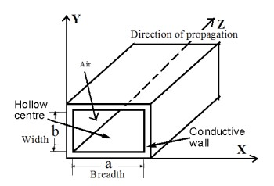
Figure 1 Rectangular waveguide [6]

TE and TM modes
There are two main “modes” to consider with respect to a waveguide. These are transverse electric (TE) and transverse magnetic (TM) mode. The mode is dependent upon which field is perpendicular to the direction of travel of the wave. A third mode does exist, transverse electric and magnetic (TEM) but this requires both fields to be perpendicular to the direction of wave travel and therefore cannot exist in a waveguide as only one conductor is present [6] [7]. Each mode has indices which indicate the number of half wavelengths present in the x and y directions of the waveguide. This notation is used to characterise the mode of the wave propagation. The mode is given by TE_{mn} or TM_{mn}. TE₁₀ is always the dominant mode in a rectangular waveguide. It has the lowest cutoff frequency of all modes that can be supported by the waveguide, meaning below this frequency a wave will not propagate.
A coupling method such as an antenna is used to introduce or remove a signal into a waveguidev [8]. For efficiency, the impedance of the guide and the antenna must be matched. This allows the maximum amount of power to be transferred.

Antenna
Since the first electromagnetic waves were transmitted and received in the late 1800s, antenna design and use has continually evolved, shaping life as we know it today in the digital age [9]. This includes mobile networks, defence applications such as RADAR, and in scientific fields such as medical and space applications. At its core, this advancement is based on Maxwell’s equations and theory of electromagnetism.
The IEEE standard definition for an antenna is “That part of a transmitting or receiving system that is designed to radiate or to receive electromagnetic waves” [10]. This means the antenna is the interface between a guided wave and free space where electromagnetic energy is transferred from one to the other. That guide make take different forms, one of which could be a waveguide. Antenna can receive or transmit electromagnetic waves – from a guide or from free space. In some instances, they can perform both functions [11]. Figure 2 shows where the antenna fits in a transmission structure, showing the wave behaviour as it travels through the guide and antenna into free space.

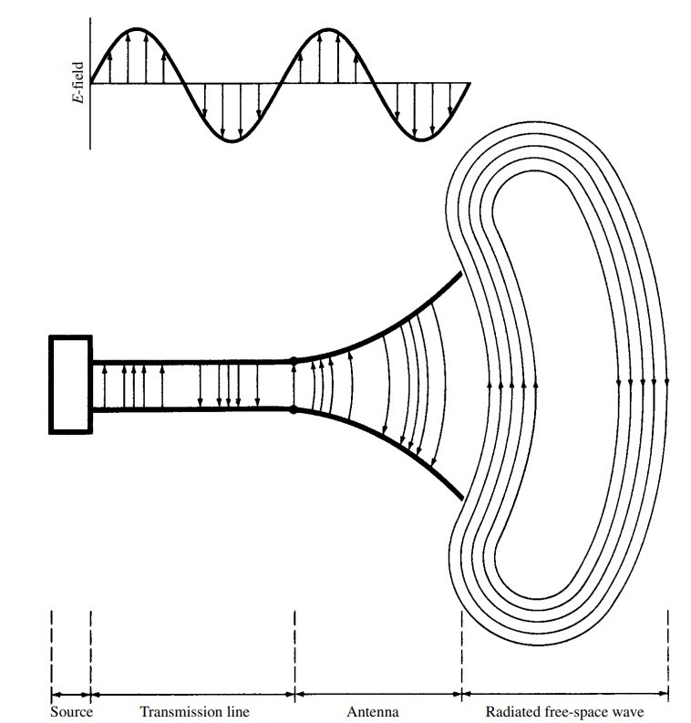
Figure 2 Example of antenna in line with a source, transmission line and free space [12]
A wide variety of antenna types exist, including reflector antenna, wire antenna and aperture antenna [13]. A specific type of wire antenna, the half wave dipole, has been focused on for task 2 in this report. A brief overview of half wave dipoles is covered below.

Dipole and half wave dipole antenna
The dipole antenna is intrinsically simple, consisting of two conductive wires of equal length, with a central gap between each radiating section, where a signal is provided. If this gap size is varied, the operational frequency of the antenna can also be varied [14]. Antenna performance is affected by factors such as its length, conductivity and its environment [15].
Dipole antennas are omnidirectional, meaning the signal is transmitted and/or received equally in all directions, perpendicular to an axis [16]. This approach means that good coverage can be achieved but signal strength decreases further from the antenna [17]. Dipole antennas are most efficient when their length is approximately half the wavelength of the operating frequency – creating the half wave dipole. At this length that the antenna will resonate, exhibiting efficient impedance matching and minimising loses through reflections or standing waves. Current in the antenna will be lowest at the ends, higher at the centre - voltage has the opposite distribution.

Methodology

Task 1a and 1b
A rectangular waveguide model with perfect electric conductor (PEC) walls was designed using Ansys HFSS. For task 1a the waveguide was filled with vacuum and for task 1b it was filled with Teflon.
Dimension X and Y were produced from the student number as follows:
$x= first two numbers of the student ID$
$y=$ $\frac{3rd and 4th number of the student ID}{2}$
z was provided in the brief
Table 1 Dimensions of the wave guide for task 1a and 1b
Dimension | Length (mm)
x | 21
y | 7.5
z | 50

Waveguide ports were assigned as port one and port two. The number of modes was set to three to facilitate the simulation and analysis of waveguide modes.
The frequency sweep was set to 2GHz - 30GHz, enabling analysis of the waveguide behaviour across a range of frequencies. From this setup it was possible to identify the dominant mode and the modes propagating through the waveguide. Magnitude and vectors of electric and magnetic fields for the modes were recorded and screenshots taken, shown in the Results. The cutoff frequency of the first three modes using mathematical formula for rectangular waveguide were calculated, enabling comparison with the simulated data. Additionally for task 1b the relative permeability of Teflon is 1 and relative permittivity is 2.1.
Figure 3 to Figure 5 show the design of the waveguide, which was used in task 1a and b.

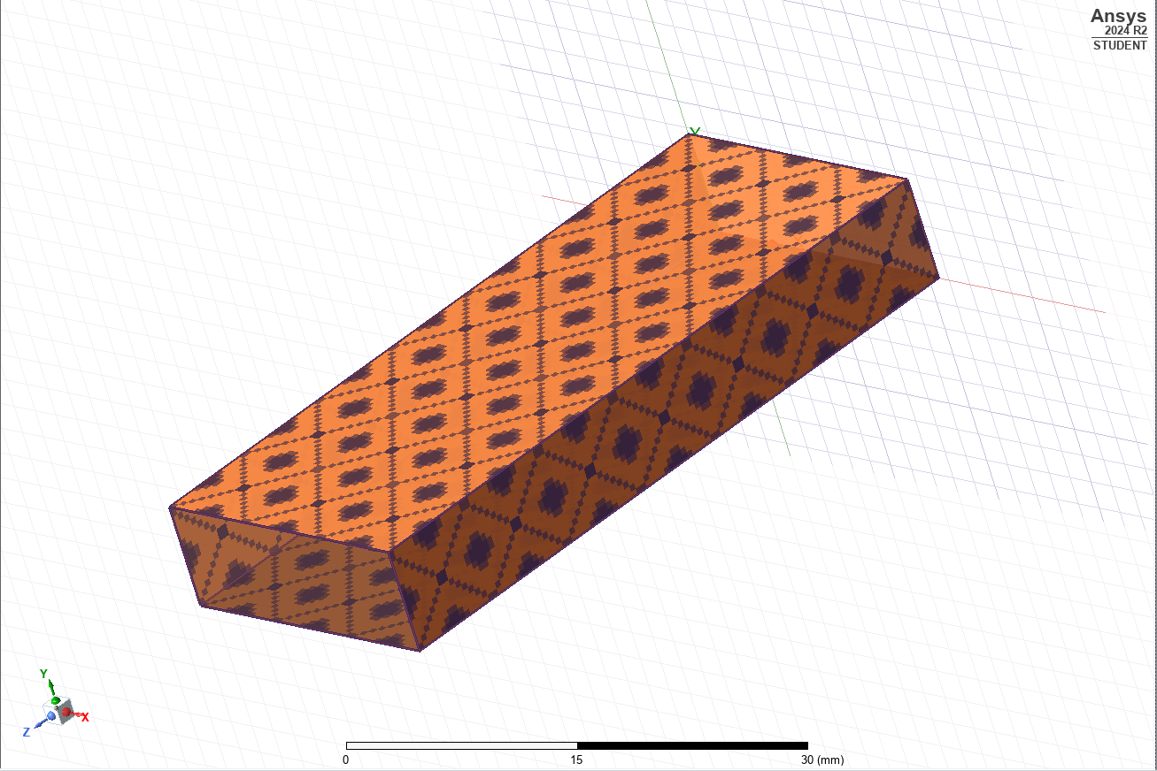
Figure 3 Rectangular waveguide model with Perfect Electric Conductor (PEC) walls filled with vacuum.

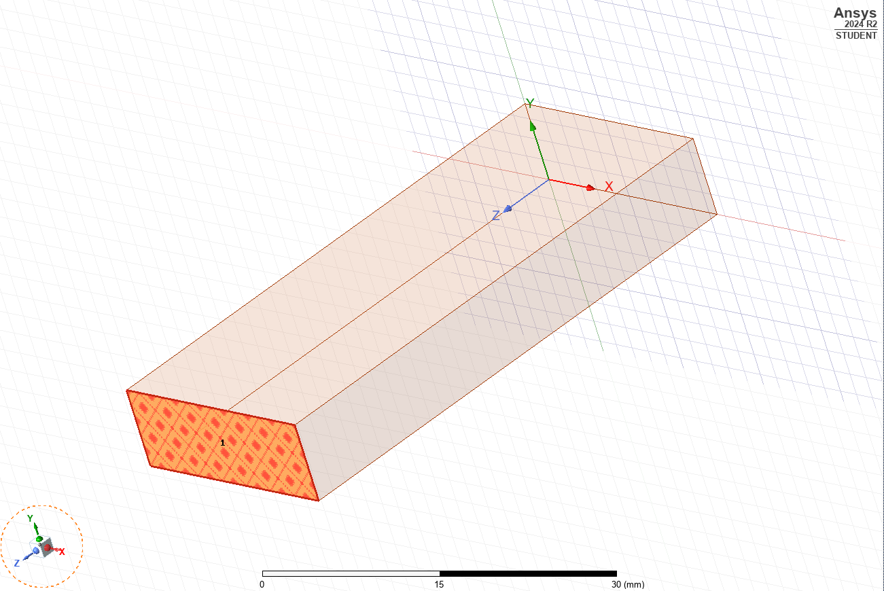
Figure 4 Rectangular waveguide model with PEC walls filled with vacuum - port one

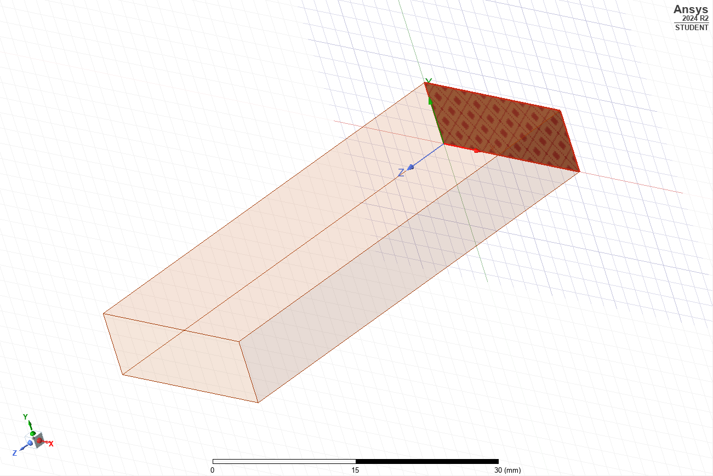
Figure 5 Rectangular waveguide model with PEC walls filled with vacuum - port two

Task 2
A halfwave dipole antenna with a radius of 1mm was designed using Ansys HFSS, to radiate electromagnetic waves with a wavelength of 211mm. The antenna was designed with PEC, and excitation was applied through the lumped port with an impedance of 50Ω. The model contained a rectangular radiating surface at the centre. The antenna parameters were designed using the first three digits of the student ID.
Student ID = 2113351
$a=21mm$
$b=\frac{13}{2} =7.5mm$
$λ=211mm$

Results

Task 1a – Vacuum
Figure 6 to Figure 8 show modes one, two and three for wave port one.

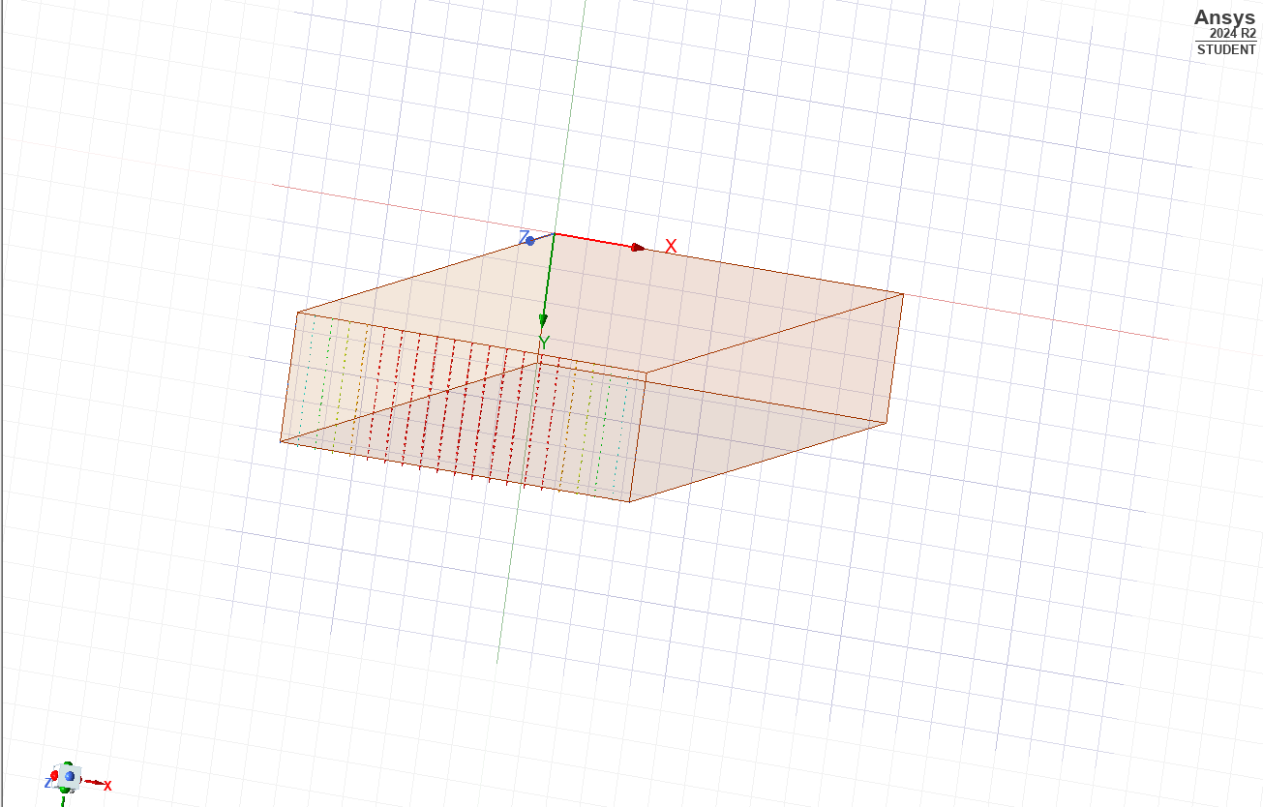
Figure 6 Wave port one - mode one

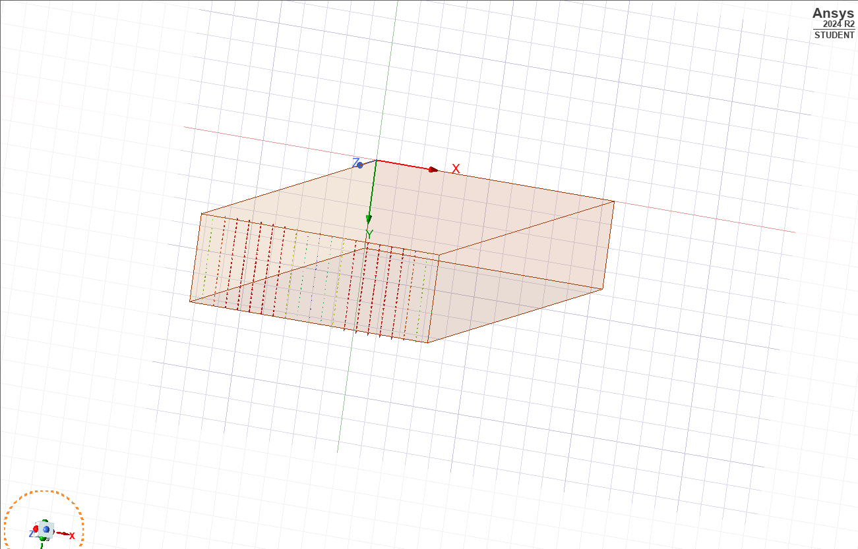
Figure 7 Wave port one - mode two

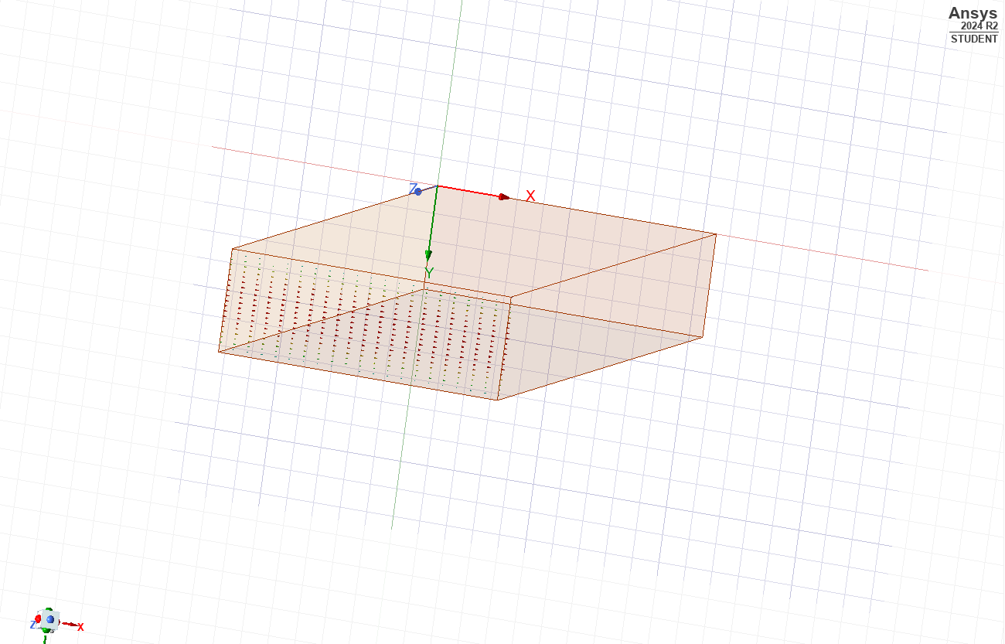
Figure 8 Wave port one - mode three

Figure 9 below displays the cut off frequencies calculated by Ansys HFSS for each of the modes.
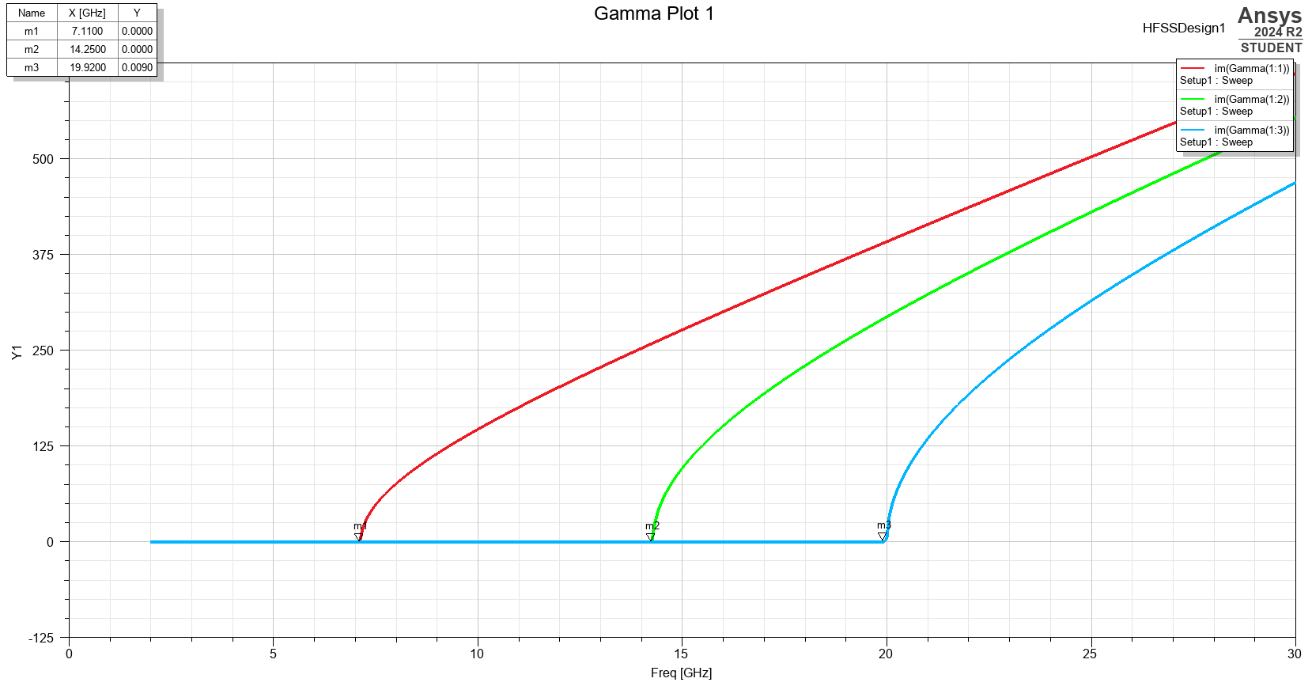
Figure 9 Rectangular plot showing the cutoff frequencies for modes one, two and three

In Figure 10 to Figure 21, the magnitude and vectors are shown for both the E and H fields in modes one, two and three.
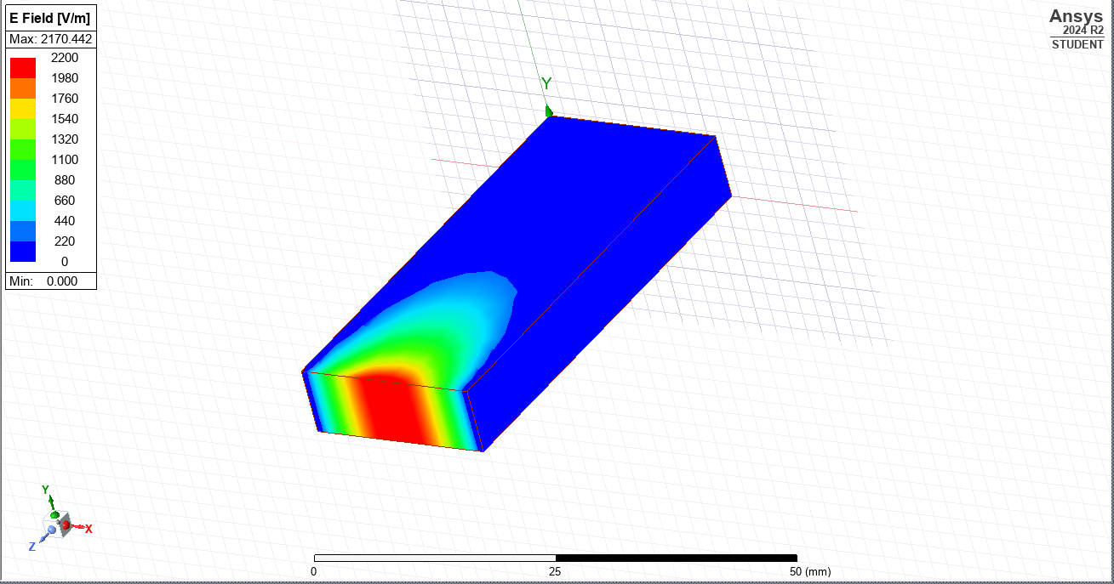
Figure 10 E field magnitude mode one

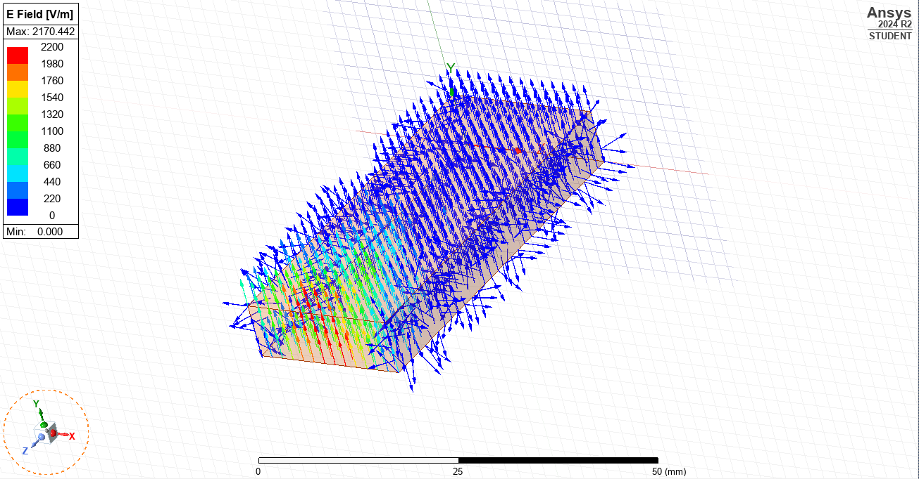
Figure 11 E field vector mode one

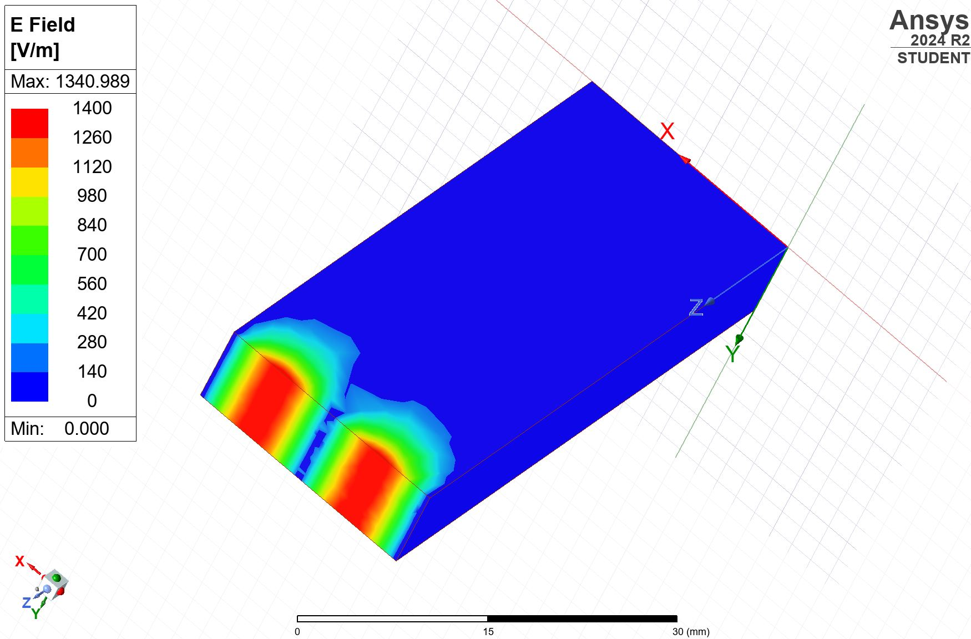
Figure 12 E field magnitude mode two

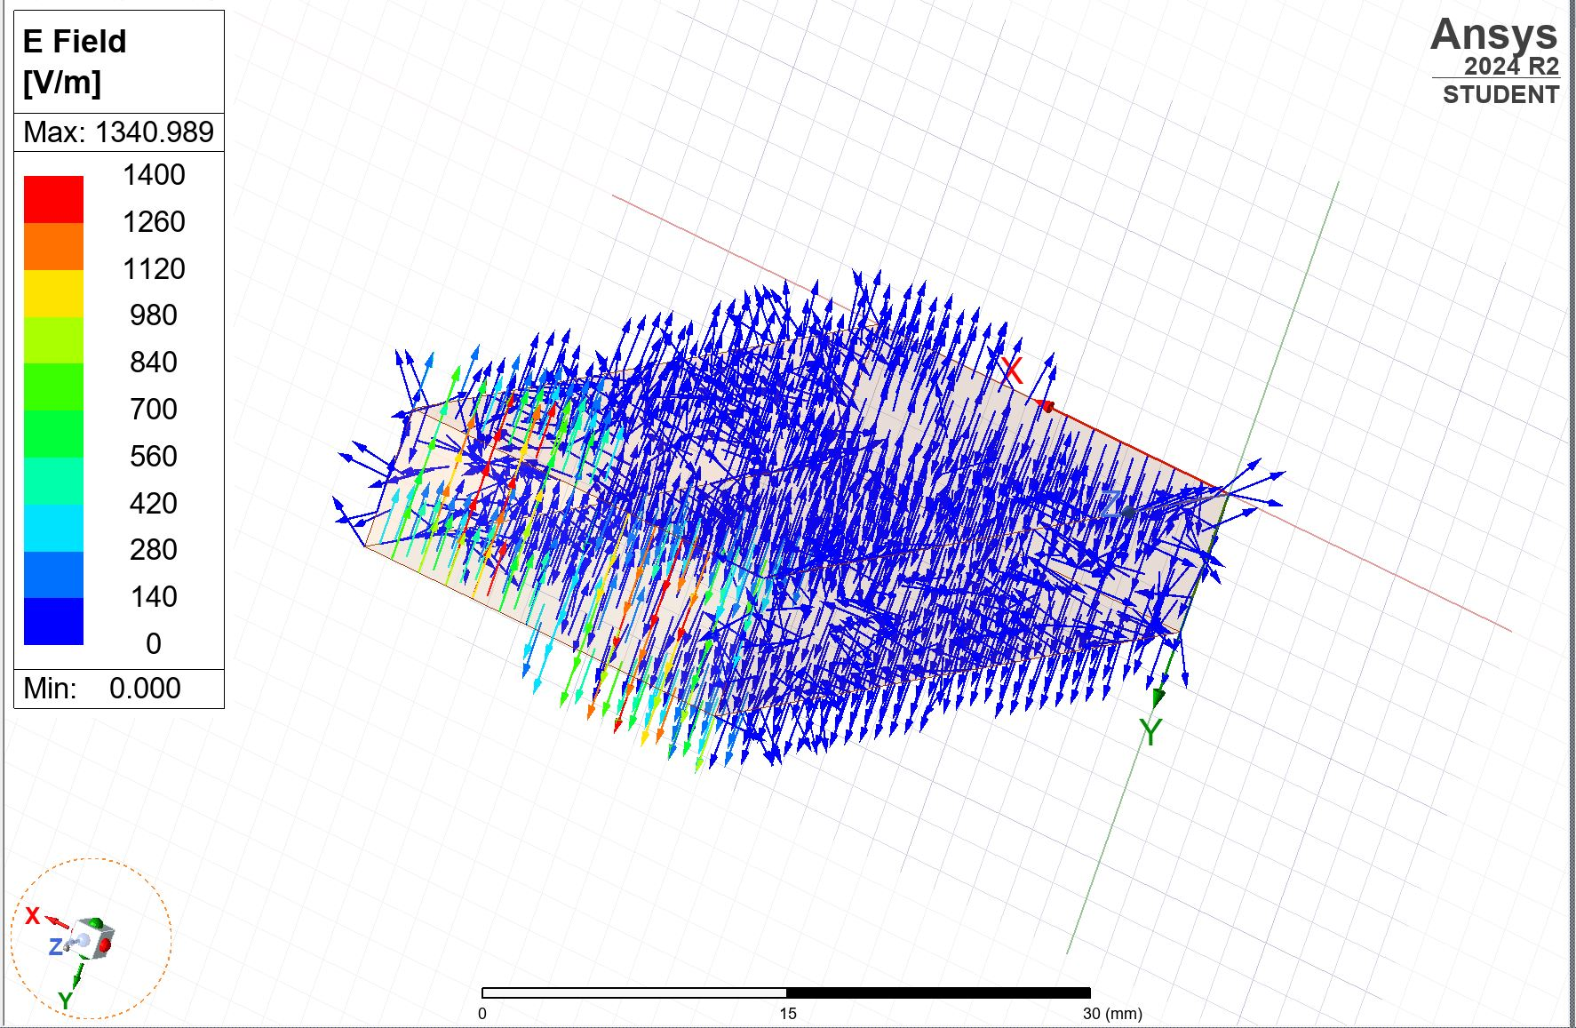
Figure 13 E field vector mode two

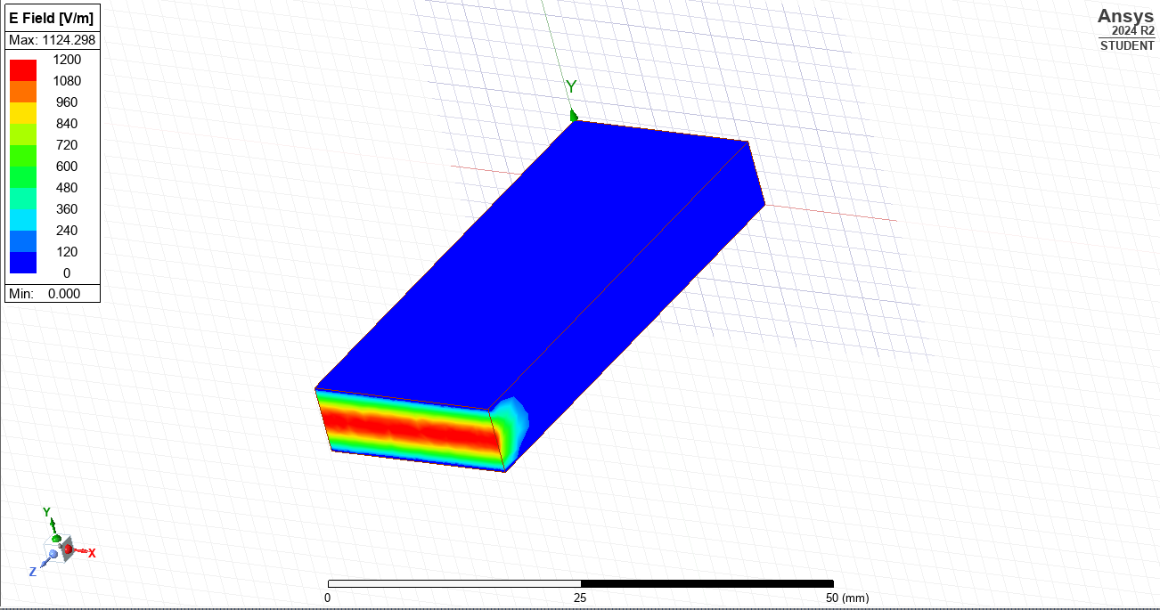
Figure 14 E field magnitude mode three

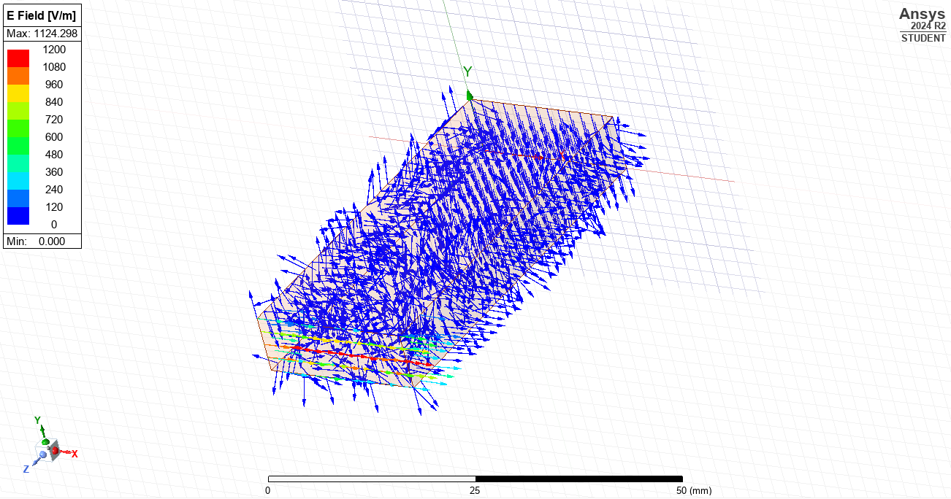
Figure 15 E field vector mode three
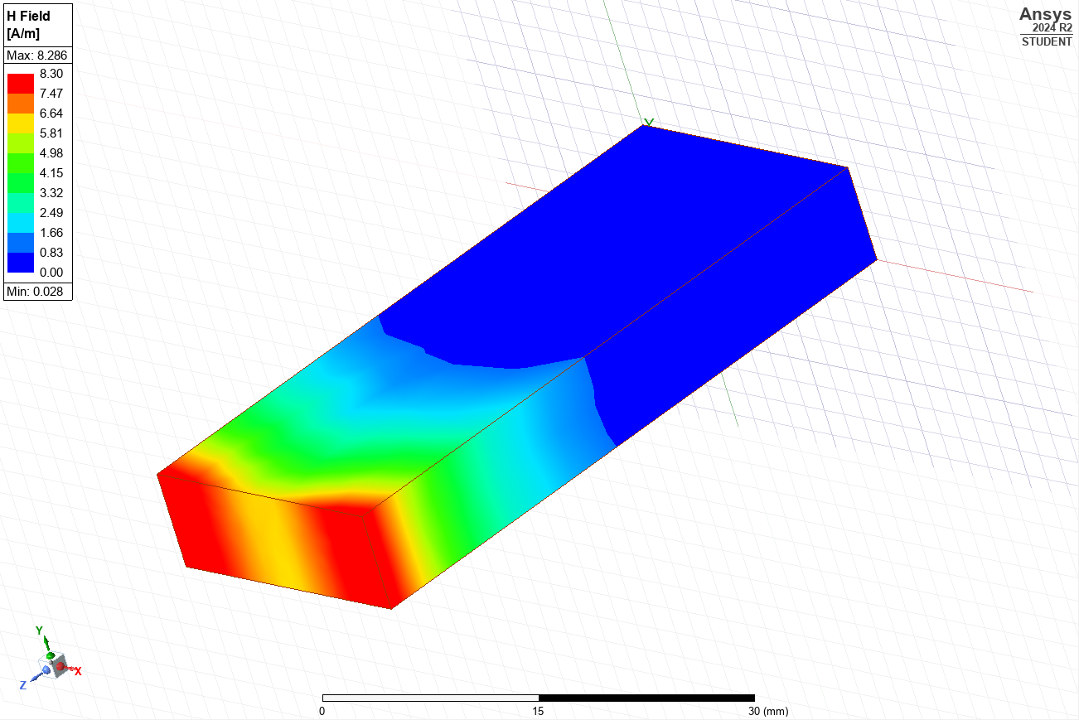
Figure 16 H field magnitude mode one

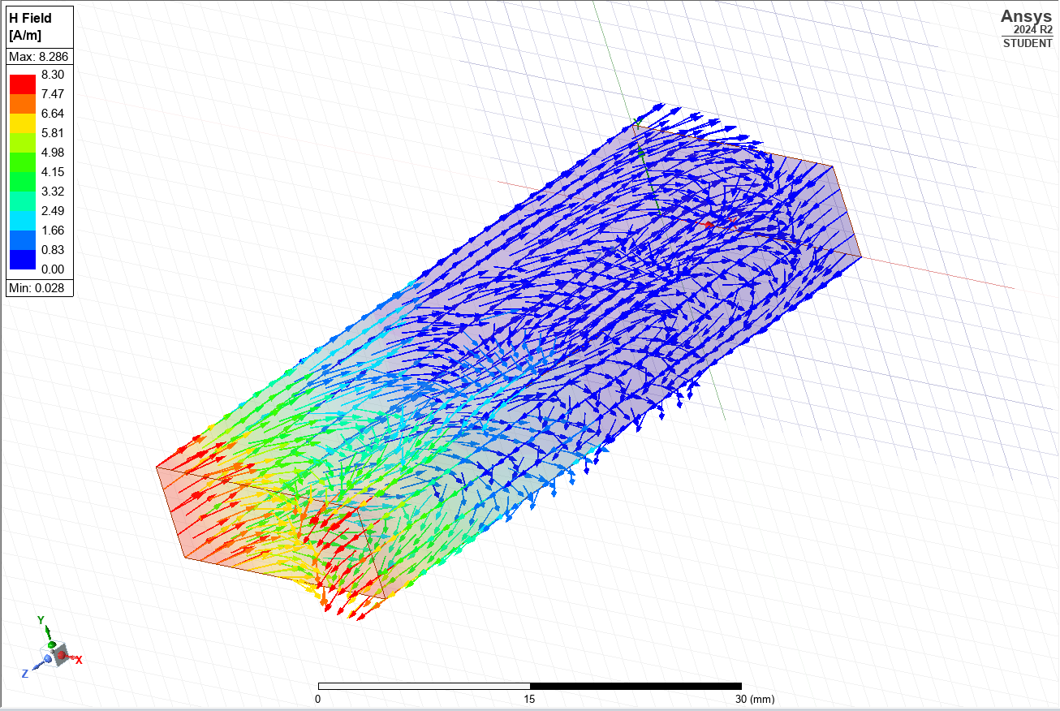
Figure 17 H field vector mode one

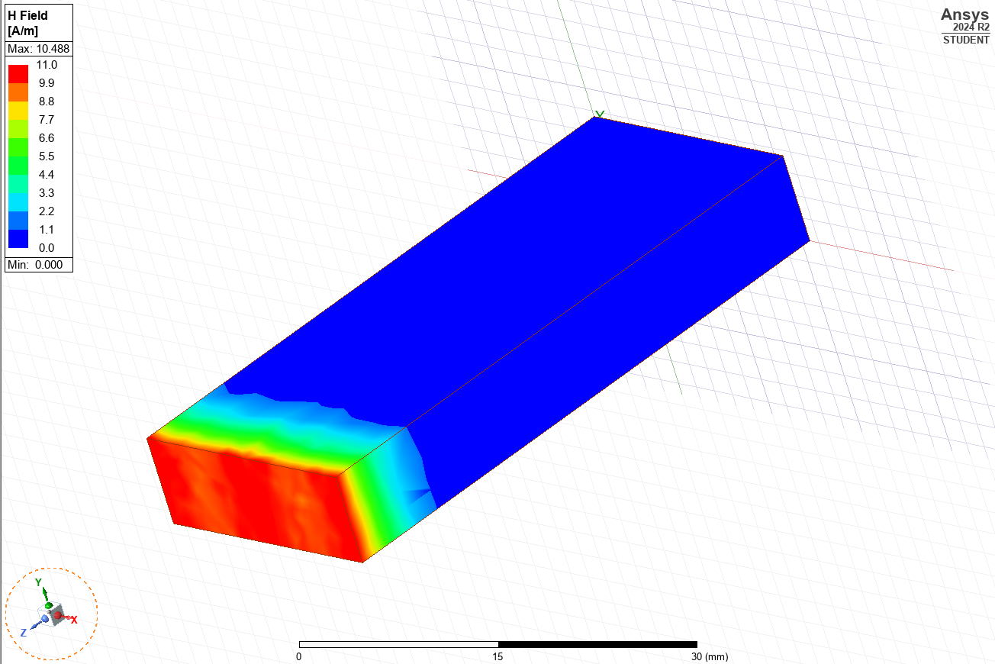
Figure 18 H field magnitude mode two

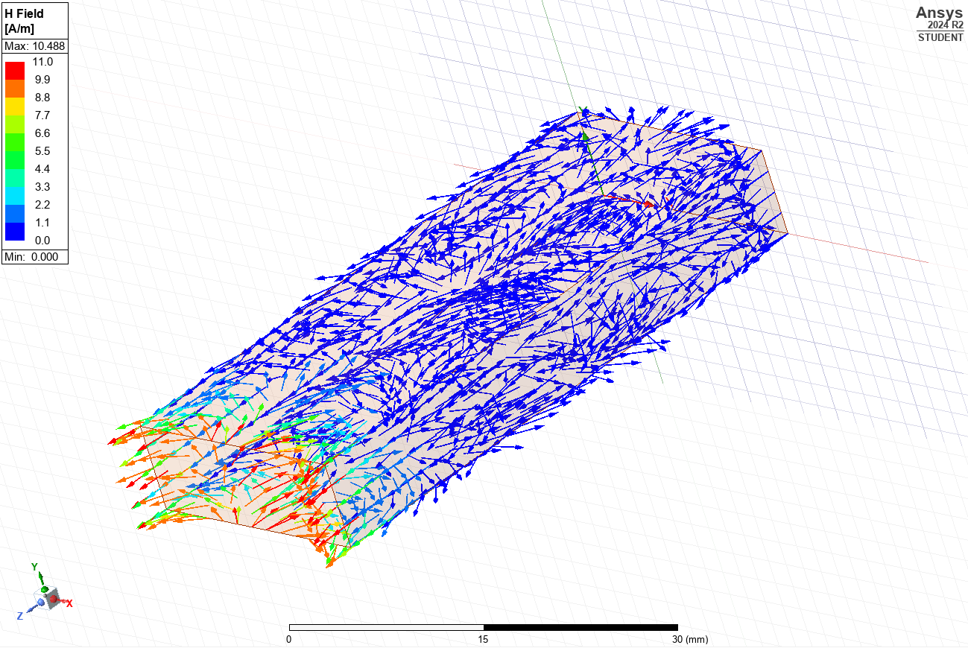
Figure 19 H field vector mode two

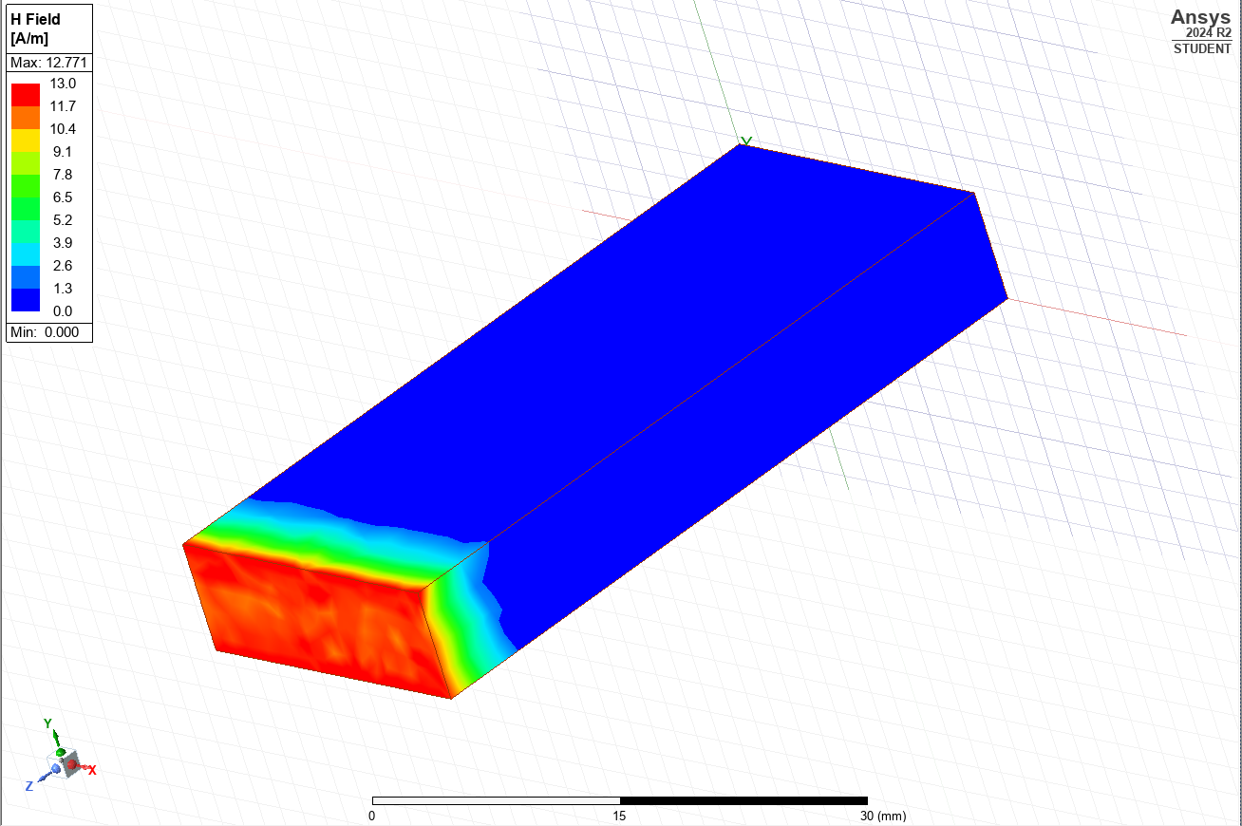
Figure 20 H field magnitude mode three

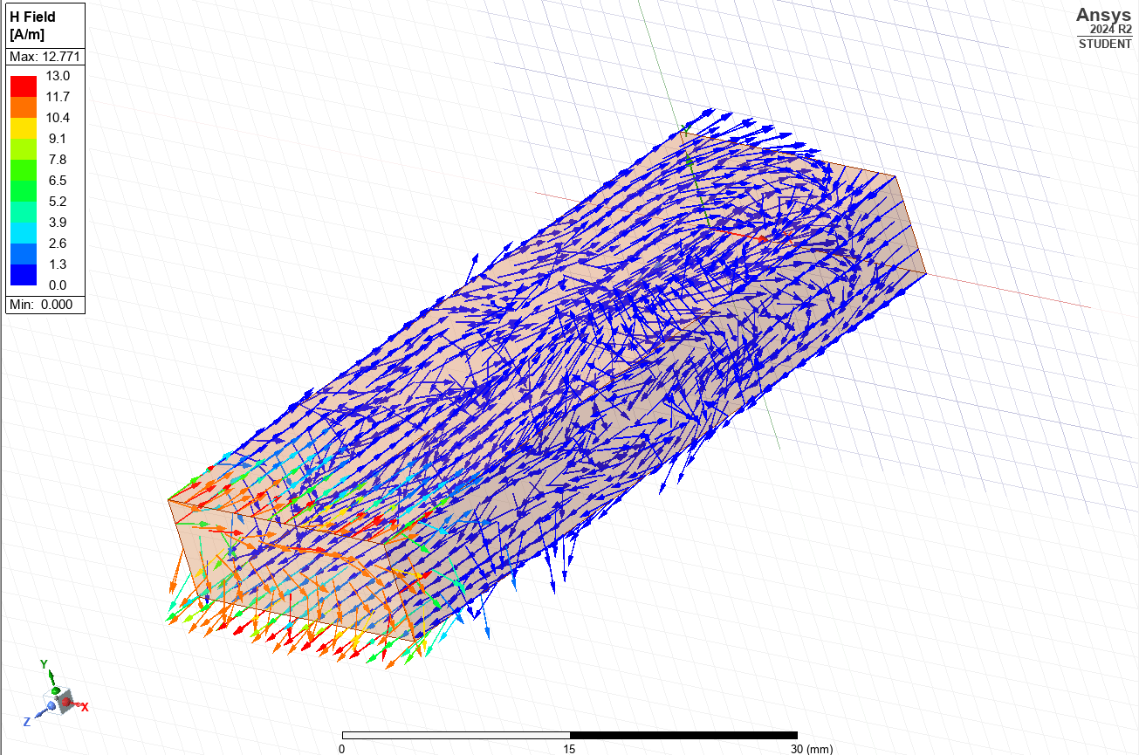
Figure 21 H field vector mode three
Equation 1 below was used to calculate the cut off frequency for the simulations and the theoretical models in both task 1a and b.
$$\begin{aligned}fc=\frac{c}{2}\sqrt{{\left(\frac{m}{a}\right)}^{2}+{\left(\frac{n}{b}\right)}^{2}}\#\end{aligned}$$
Equation 1 Cut off frequency
Where:
fc = cutoff frequency GHz
c = speed of light in a vacuum = 3x10⁸ m/s
m = mode number in the x direction
n = mode number in the y direction
a = width of the waveguide (m)
b = height of the waveguide (m)

For mode one simulated data, the cut off frequency was calculated as follows:
$$fc=\frac{3x{10}^{8}}{2}\sqrt{{\left(\frac{1}{21}\right)}^{2}+{\left(\frac{0}{7.5}\right)}^{2}}$$
$$fc=7142857143 Hz$$
This calculation was repeated for modes two and three. The cut off frequency results are shown in Table 2 with a comparison of the values obtained in the simulation.
Table 3 shows the indices numbers obtained for each from the simulation for with a vacuum.
Table 2 Measured and calculated cutoff frequencies (vacuum).
Vacuum
Simulated cutoff frequency GHz | Calculated cutoff frequency GHz
7.11 | 7.14
14.25 | 14.29
19.92 | 20

Table 3 m and n numbers for mode one, two, three for the vacuum.
Vacuum | m | n
Mode 1 | 1 | 0
Mode 2 | 2 | 0
Mode 3 | 0 | 1

Task 1b – Teflon
Figure 22 Wave port one - mode Figure 24 show modes one, two and three for wave port one in the Teflon filled waveguide.
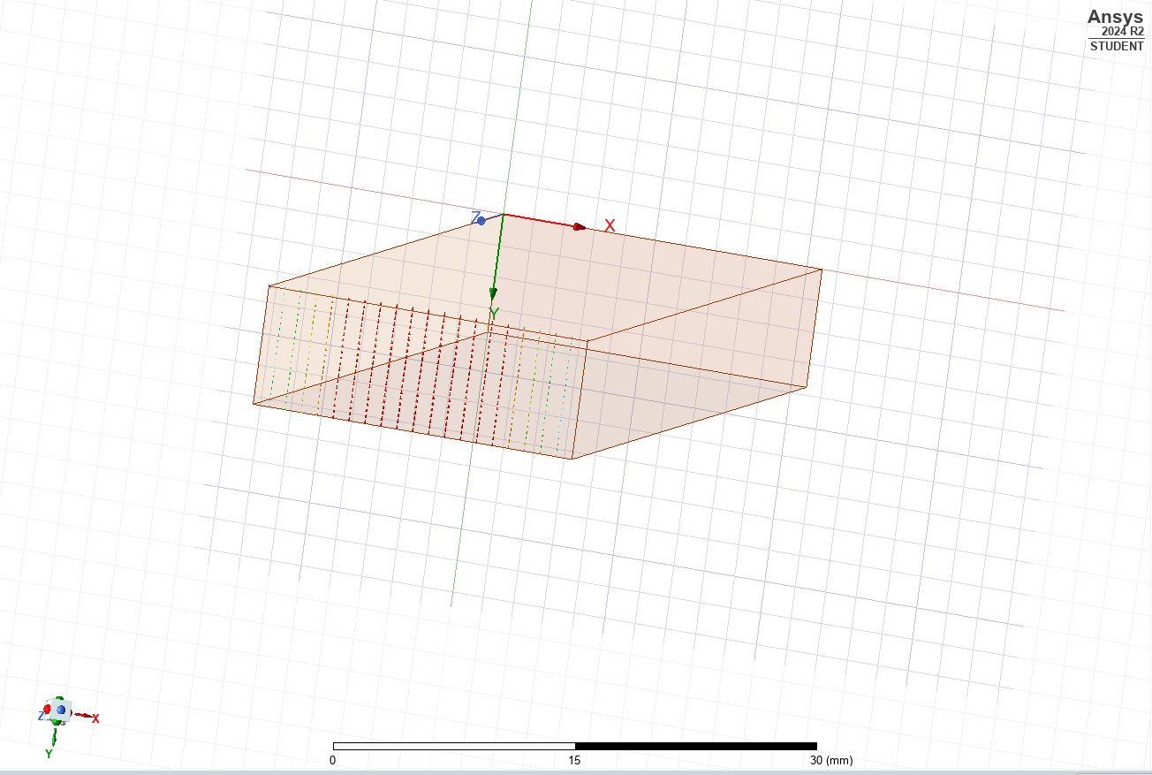
Figure 22 Wave port one - mode one

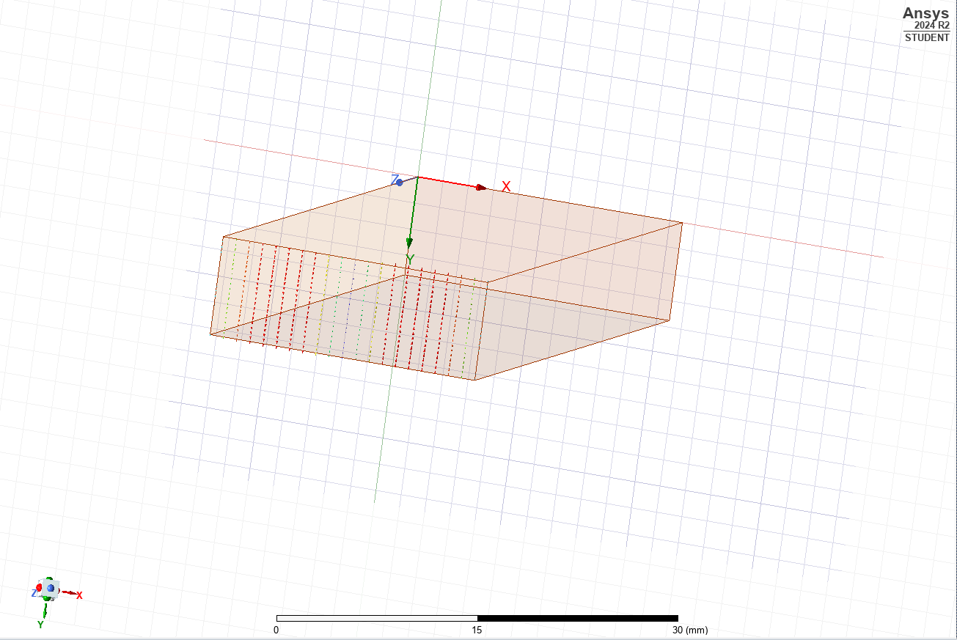
Figure 23 Wave port one - mode two
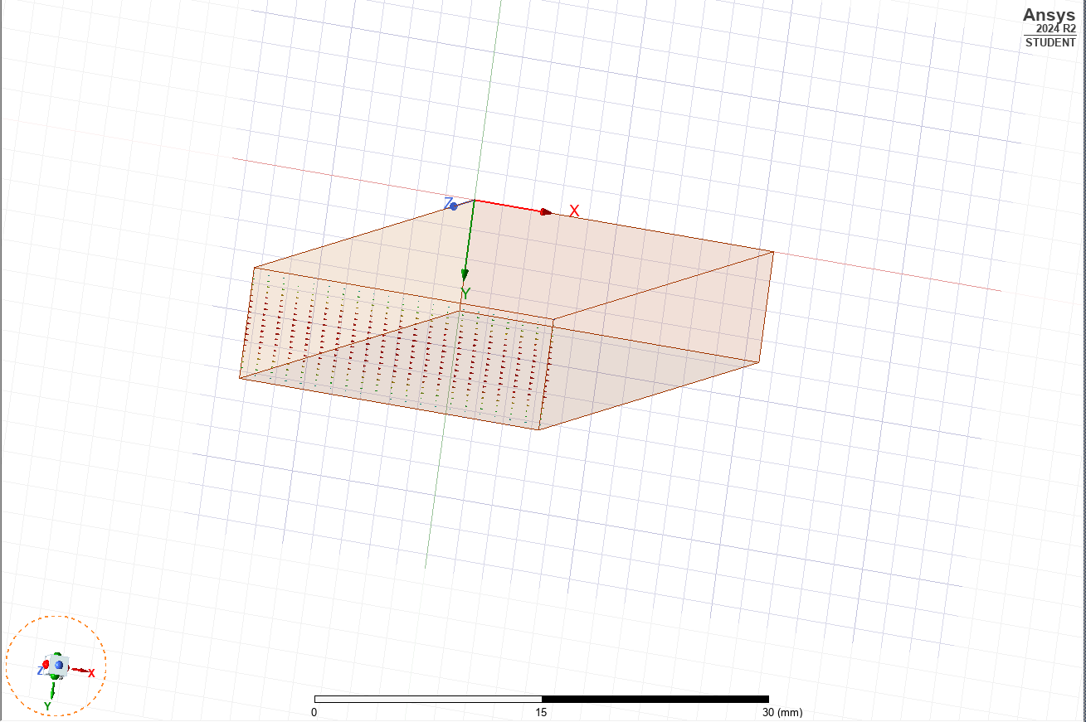
Figure 24 Wave port one - mode three
Figure 25 below displays the simulated cut off frequency for mode one, two and three. This is indicated by the marked points on the x axis.
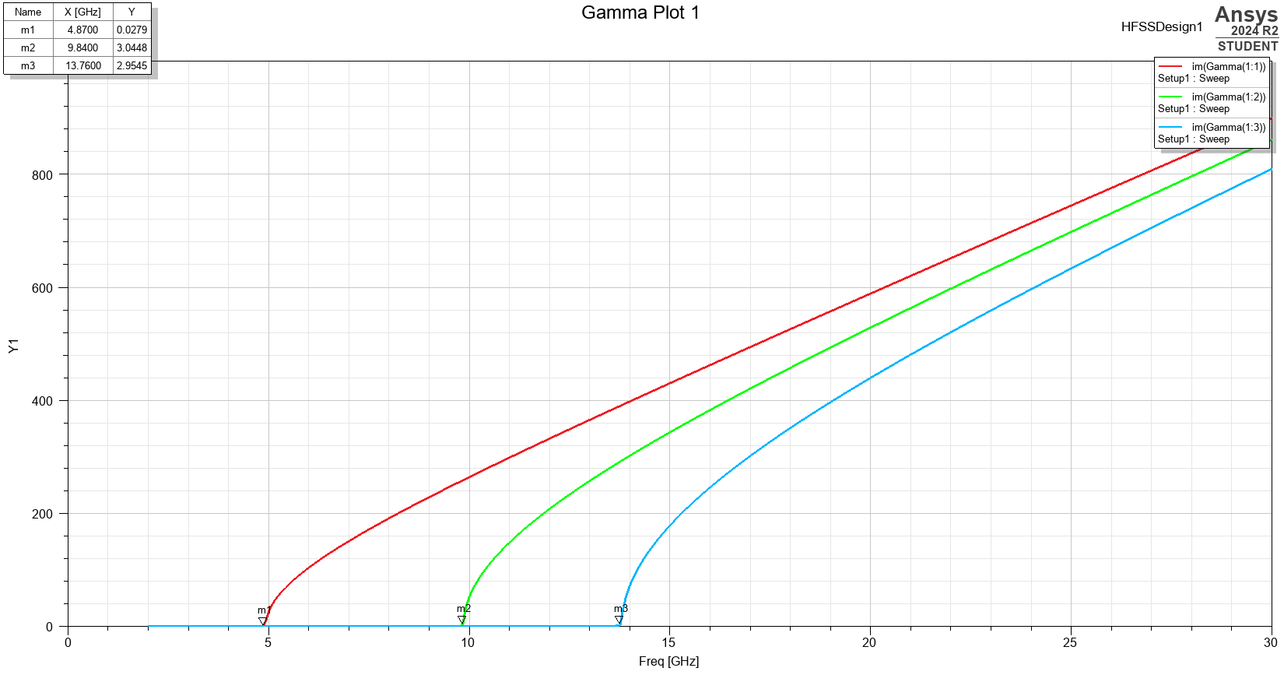
Figure 25 Rectangular waveguide plot showing the cutoff frequencies for modes one, two and three
Figure 26 to Figure 38 show a visual representation of the magnitude and vectors for the electric and magnetic fields for each mode.
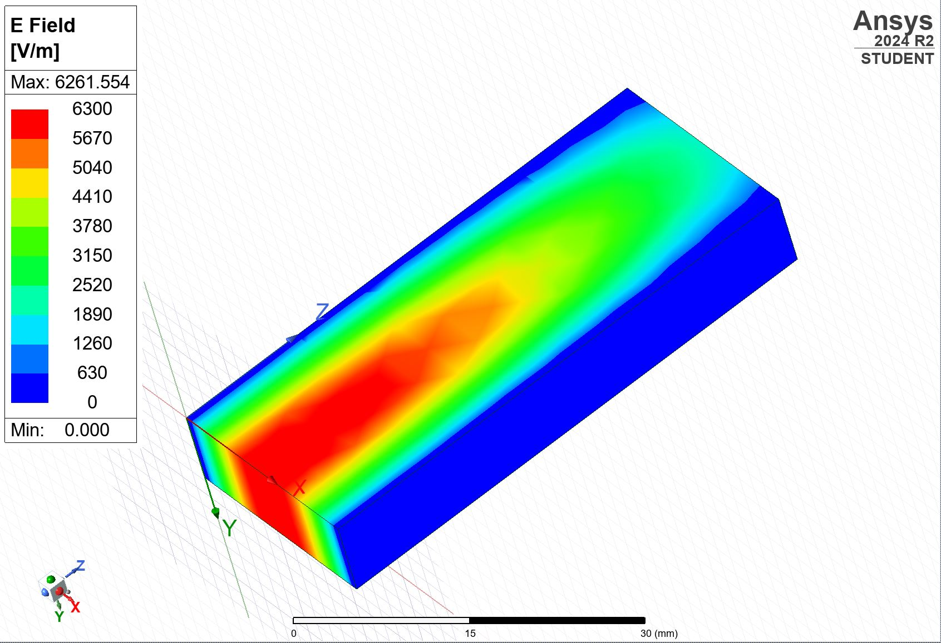
Figure 26 E field magnitude mode one

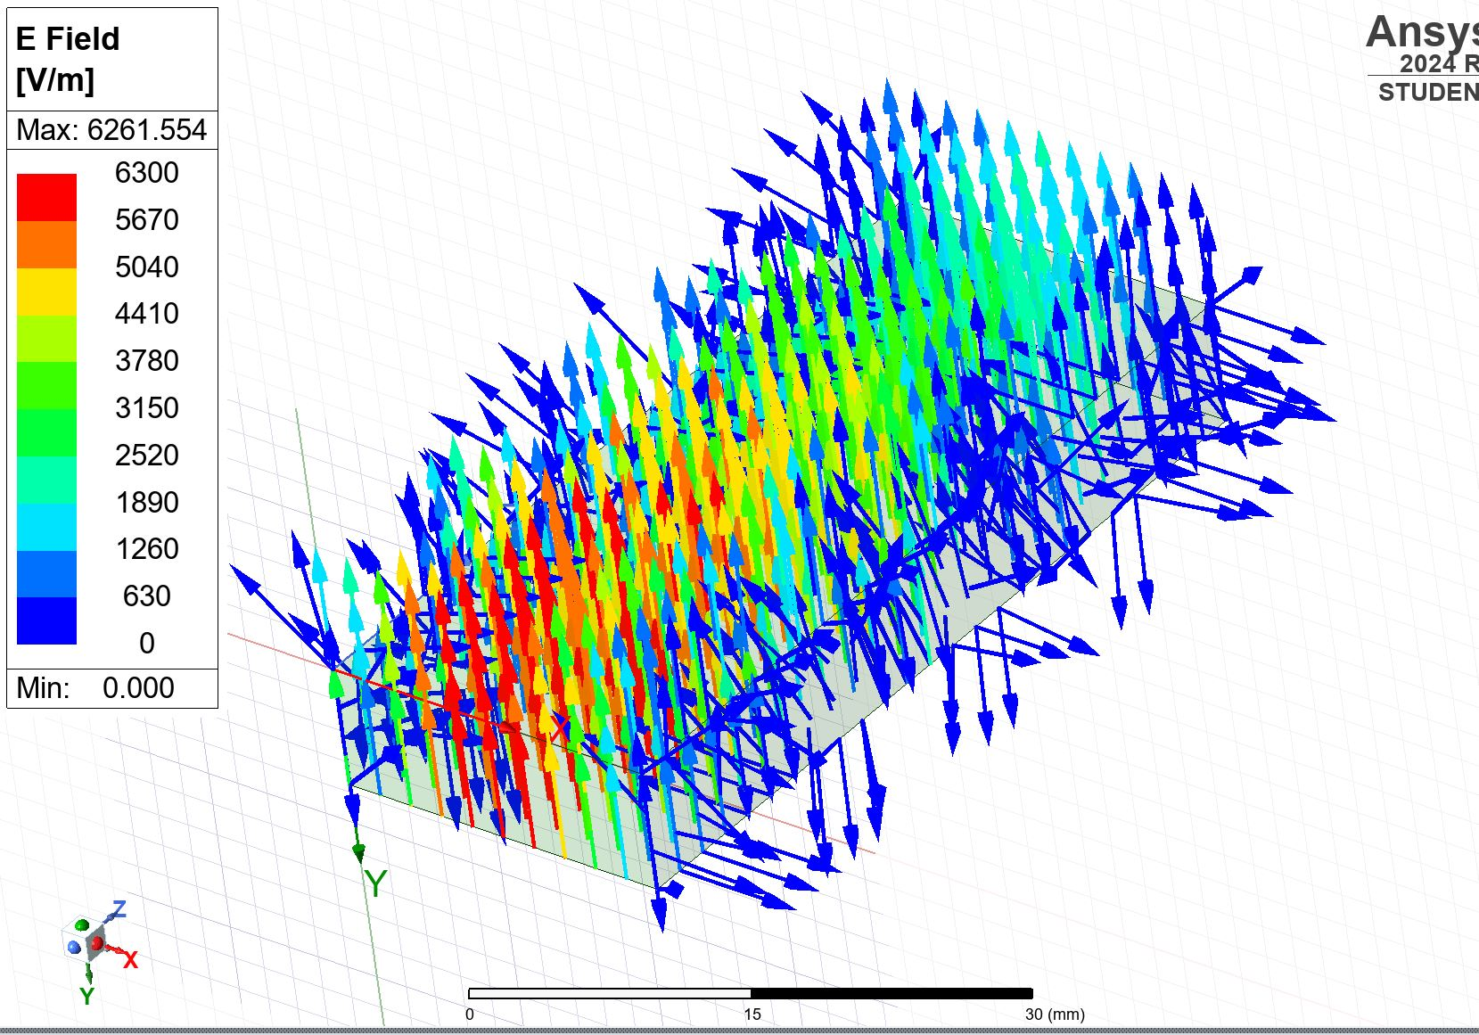
Figure 27 E field vector mode one
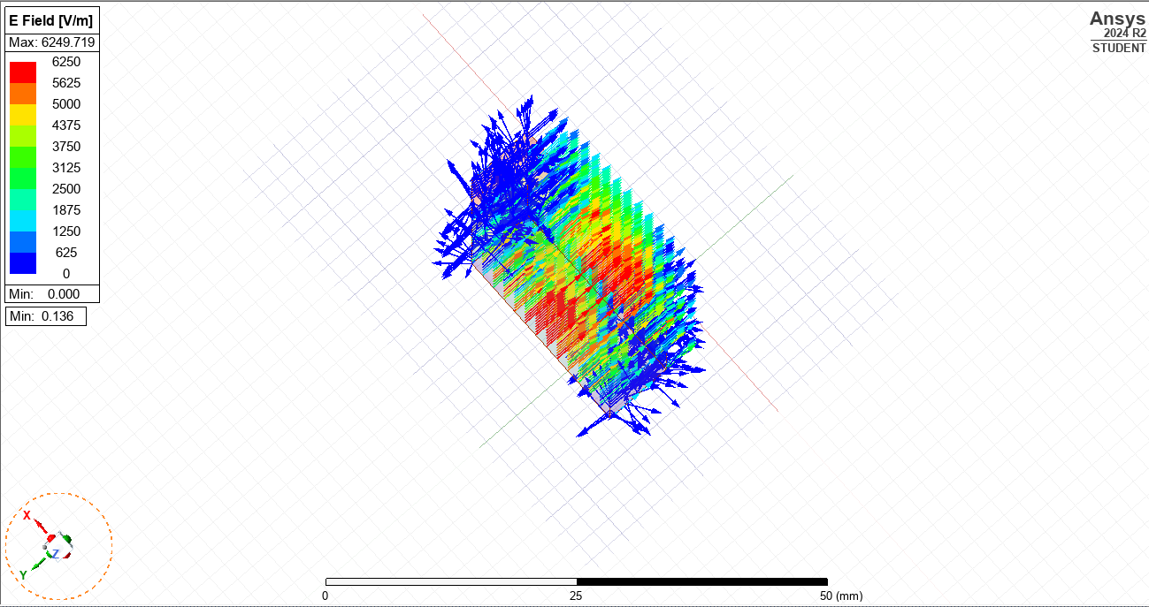
Figure 28 E field vector mode one

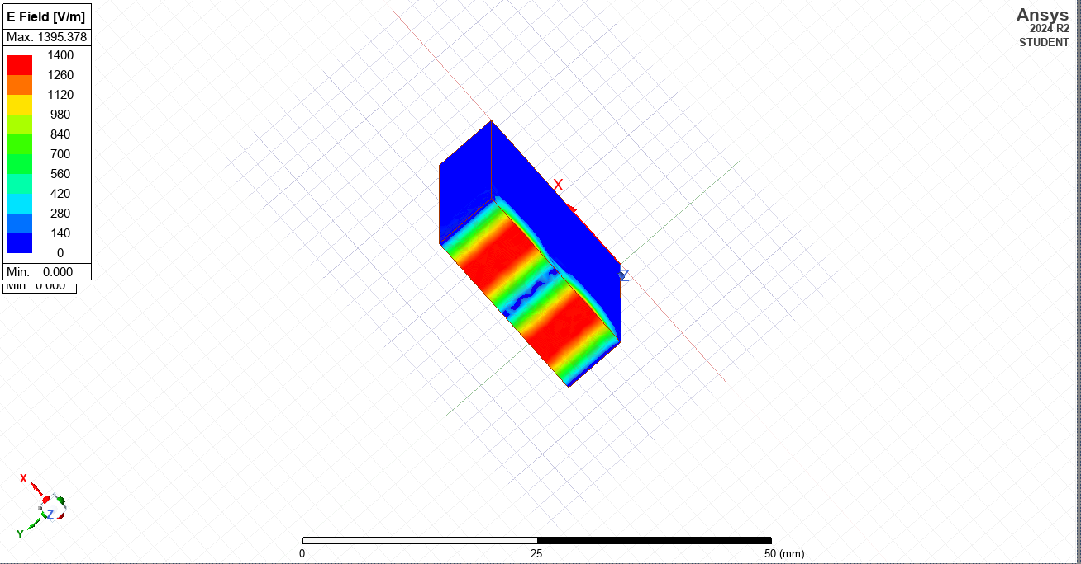
Figure 29 E field magnitude mode two

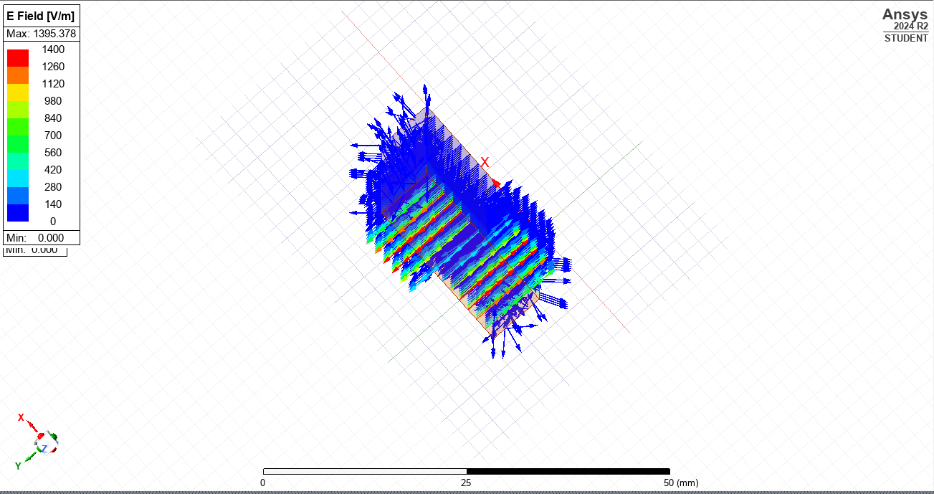
Figure 30 E field vector mode two

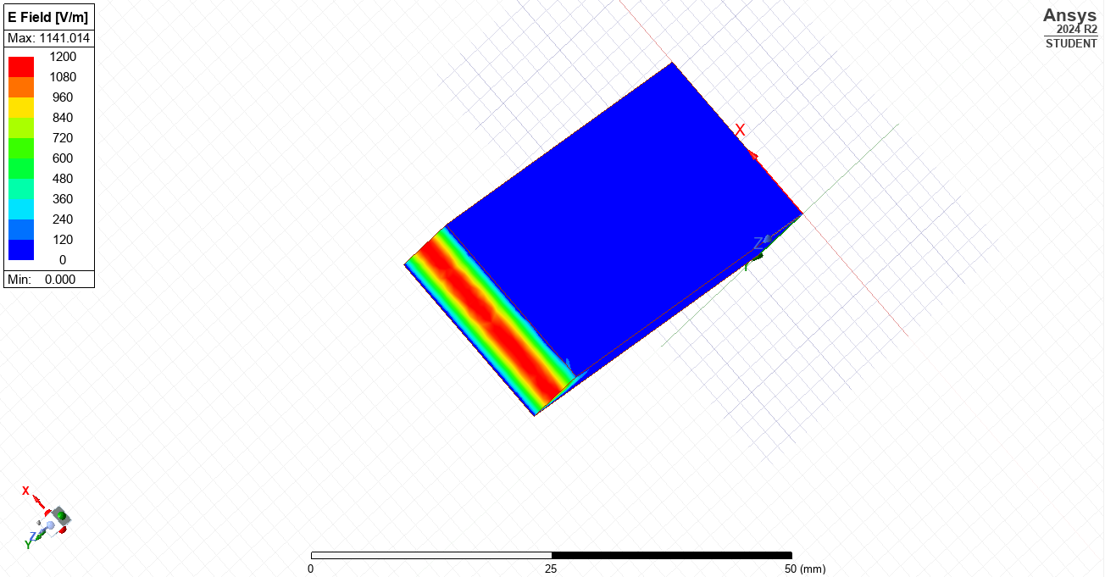
Figure 31 E field magnitude mode three

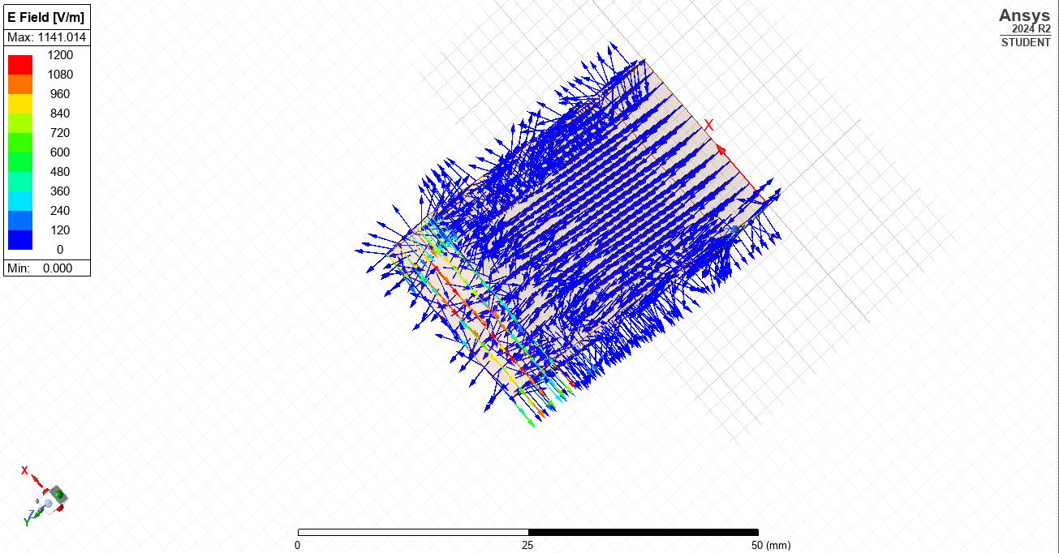
Figure 32 E field vector mode three
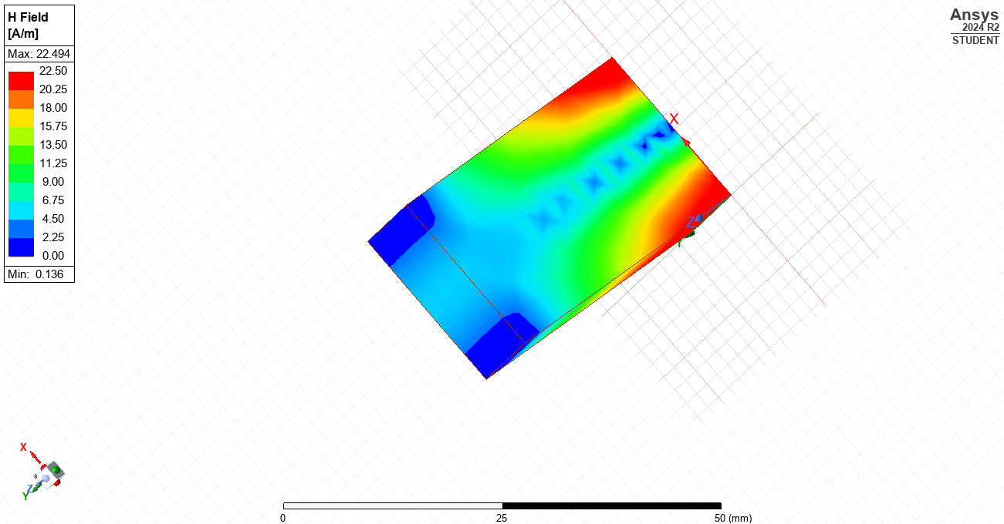
Figure 33 H field magnitude mode one
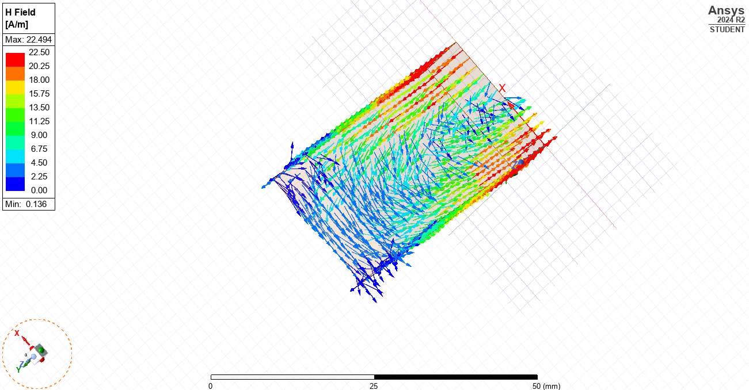
Figure 34 H field vector mode one
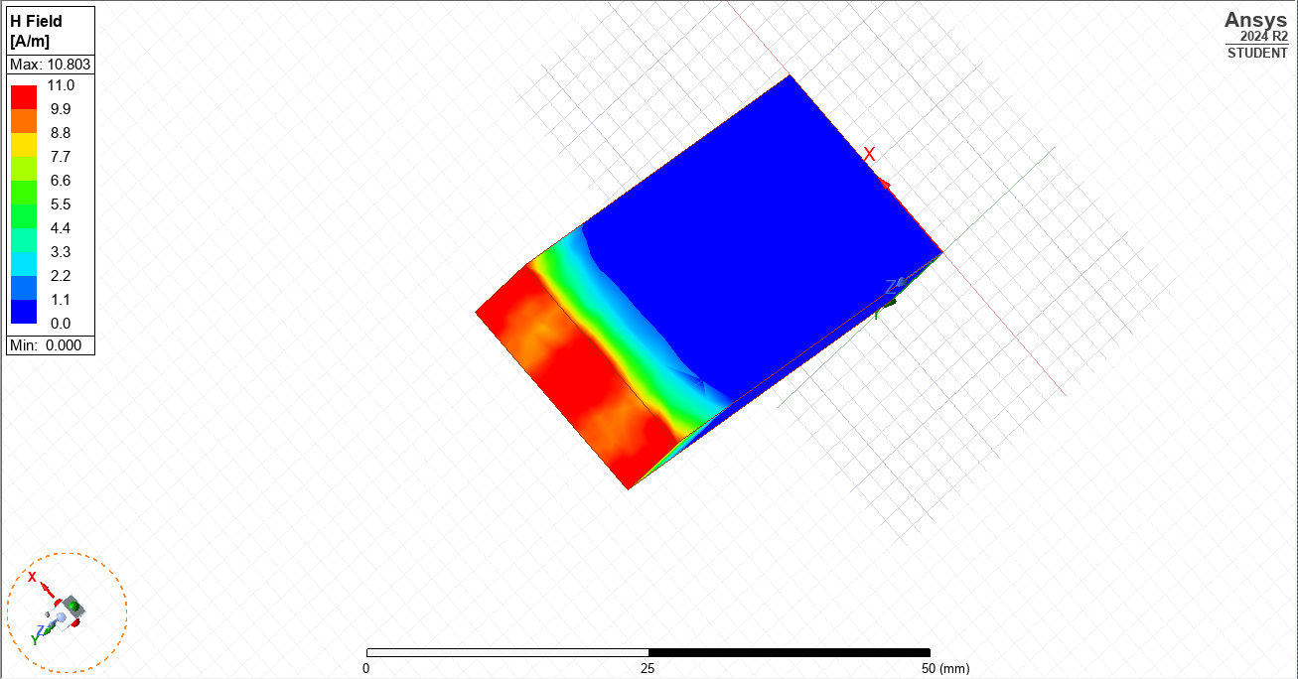
Figure 35 H field magnitude mode two
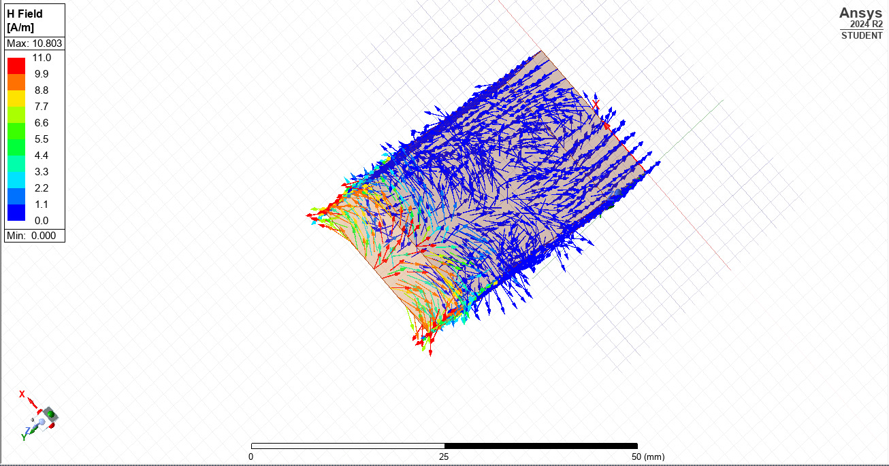
Figure 36 H field vector mode two

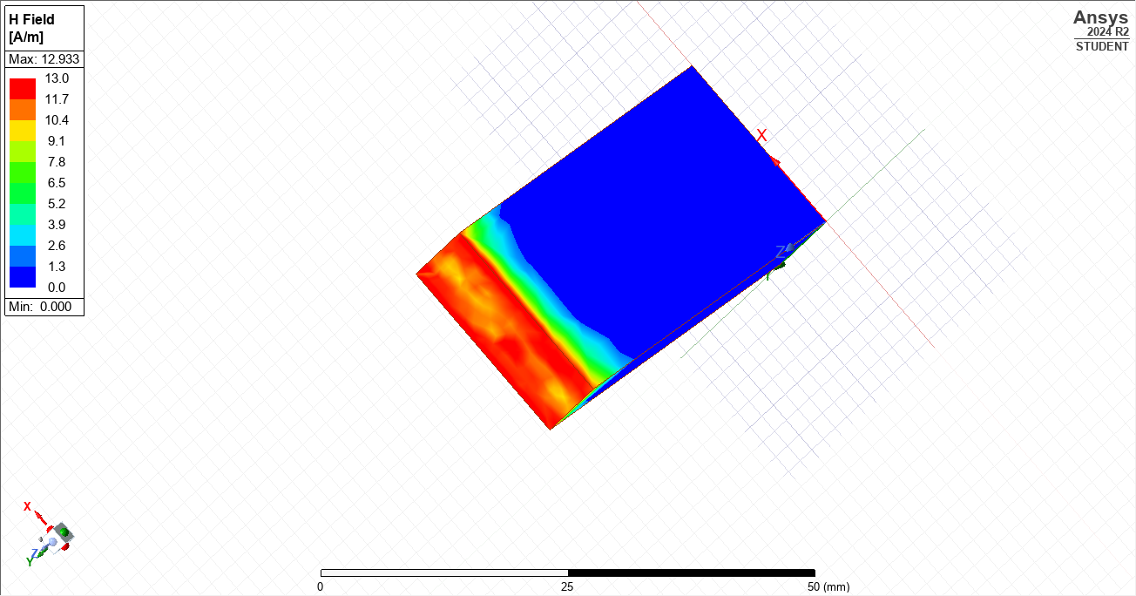
Figure 37 H field magnitude mode three

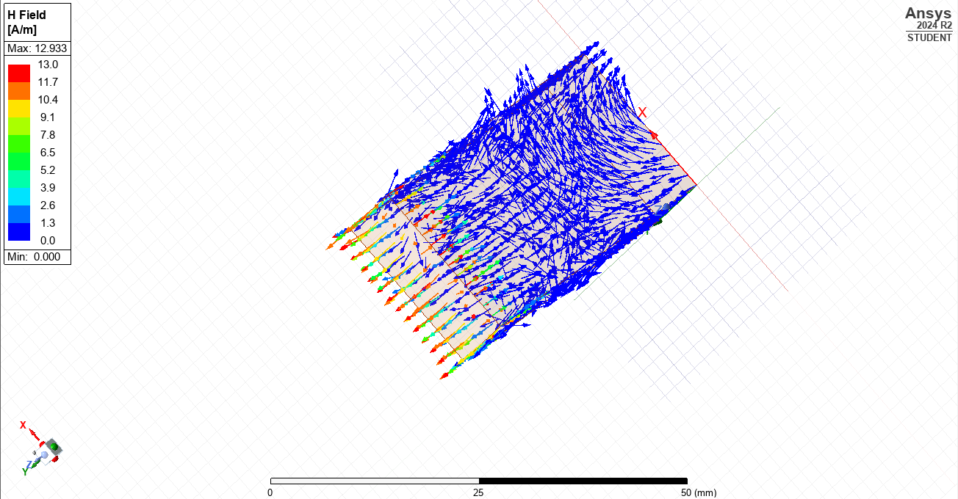
Figure 38 H field vector mode three
Table 4 displays the m and n indices for each of the modes in the Teflon simulation.
Table 4 m and n numbers for mode one, two and three for Teflon.
Teflon | m | n
Mode 1 | 1 | 0
Mode 2 | 2 | 0
Mode 3 | 0 | 1

Table 5 Measured and calculated cutoff frequencies (Teflon).
Teflon
Simulated cutoff frequency (GHz) | Calculated cutoff frequency (GHz)
4.87 | 4.93
9.84 | 9.85
13.76 | 13.79

The formula shown in Equation 1 was used to calculate the simulated and theoretical cutoff frequencies for the Teflon waveguide. The results are shown in Table 5. Table 6 shows the differences between the cutoff frequency in the vacuum versus Teflon waveguide.
Table 6 Simulated cutoff frequency comparison for both waveguides
Vacuum - Measured cutoff frequency (GHz) | Teflon - Measured cutoff frequency (GHz)
7.11 | 4.87
14.25 | 9.84
19.29 | 13.76

Task 2 - Halfwave Dipole Antenna
Figure 39 is the S-plot obtained from the half dipole antenna simulation. The marked point on the graph shows the operating frequency of the antenna, m1 = 1.2875GHz.
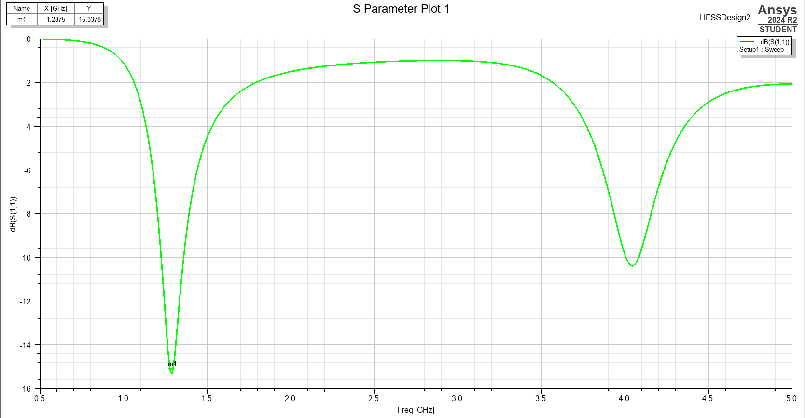
Figure 39 S-plot - halfwave dipole antenna showing the operating frequency 1.2875 GHz
The data in Table 7 provides a comparison of the operating frequency obtained from the simulation of the antenna to that calculated using the following equation:
$$\begin{aligned}f=\frac{c}{λ} \#\end{aligned}$$
Equation 2 Resonant frequency
Where:
$f$ = resonant frequency (Hz)
c = speed of light (m/s)
λ = wavelength (m)
Table 7 Operating frequency of the simulated and calculated antennas
Operating Frequency (GHz)
Simulated | Calculated
1.2875 | 1.42

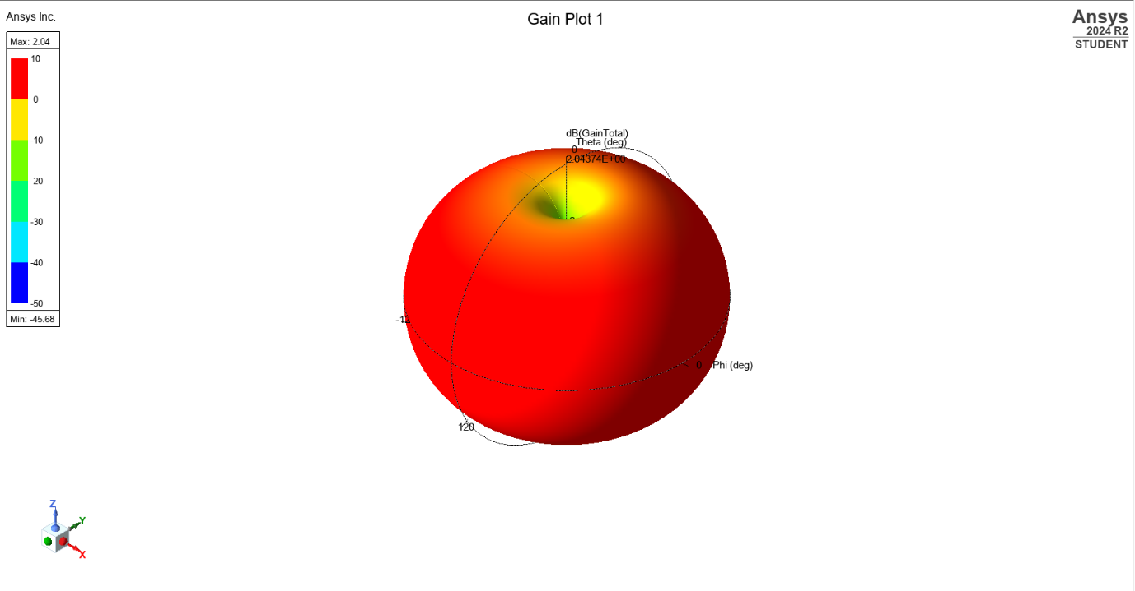
Figure 40 Gain plot of halfwave dipole antenna

Discussion
The cutoff frequencies in the waveguide filled with Teflon is lower for each mode in comparison to the cutoff frequency for the waveguide filled with a vacuum. The relative permittivity of Teflon is higher than for a vacuum – 2.1 and 1 respectively. The higher the permittivity, the lower the cut off frequency is going to be, as the waves are slowed as they pass through the Teflon filled waveguide. This relationship can easily be seen from Equation 1. A waveguide filled with a dielectric material will cause a reduction in the wave speed of the signal while in the waveguide, the wavelength increases and the cut off frequency lowers. [18] [19].
The difference between simulated results in Ansys HFSS and that obtained from the calculations could be considered insignificant. It may be down to software discrepancies, or the software attempting to consider more real-life conditions than a mathematical formula is capable of doing. For example, the software may consider material surface roughness, whereas this was not a consideration in the equation used in the calculation. However, John S Seybold, in his book “Introduction to RF Propagation”, notes that it is likely impossible to create perfect simulations due to the huge variations in real-world circumstances. Free-space propagation provides a ‘simple’ environment where this may be more of a possibility [20]. Simulations provide results based on the data entered by the software designer and the user, this may be an approximation of perfect conditions but it easy to understand that errors may be made, thus generating a small variation in results. In reality it is not possible for a waveguide to be perfectly conducting [21].
Additionally, model simulation could generate variation in results depending on the software used, as this is reliant on the programming of the software and the method of analysis. Caution should therefore be applied when analysing any simulation results. Where possible, comparison of simulation data from different models will allow greater confidence in results [20]. Additionally, once simulations and mathematical models have been completed, results could be validated by manufacturing the waveguide and antenna, recording the results and comparing with those produced above. It is worth noting at this stage, that results from a physical system will vary from those obtained in simulations. Simulations are just an approximation of the antenna. Manufacturer data is unlikely to perfectly match that in the software and permittivity may not be completely uniform throughout the waveguide in real-life.
The S-plot shown in Figure 39 provides a visual representation of the radiation produced by the antenna. This method can be used to ensure optimum operation when designing antennas. The plot in Figure 40 shows a good omnidirectional radiation pattern meaning the signal radiates in all directions. The operating frequency in the simulated model differs by 0.1325 GHz. This is significant when considering transmissions on these frequencies. When looking at the UK Frequency Allocation Table [22] it is clear this could problematic if the simulation data was relied upon to manufacture an antenna as data could be transmitted on the wrong frequency.

Conclusion
This study compared simulated and analytically calculated waveguides, examining the differences between Teflon and vacuum filled waveguides. The results show that while a good approximation can be obtained from analytical methods, a simulation can provide more detailed insights.
The key findings from this report are:
- In vacuum filled waveguides, waves can propagate faster.
- Teflon filled waveguides reduce the wave speed slightly.
A mathematical approach can be useful for initial work, but simulations should be utilised for more detailed research and validation of mathematical methods.
However, both sets of results should be viewed with caution, as real-life tests will likely produce a third different set of results.
Simulations of antenna design are beneficial for visualising the radiation pattern of the signal. They may be of particular benefit when designing an antenna which must transmit in a particular direction or over a longer distance. Producing simulations prior to manufacture could be cost saving and may also prevent the unintended use an otherwise allocated frequency.

References
[1] | Z. Ahmad, M. K. Abdullah, M. Z. Ali and M. A. M. Zawawi, “Chapter 5 - Polymers in optoelectronic devices,” in Polymers in Electronics, Elsevier, 2023, pp. 273-388.
[2] | C. J. Weisman, The Essential Guide to RF and Wireless, Upper Saddle City: Bernard M Goodwin, 2002.
[3] | E. M. Earle Williams, “Recent progress on the global electrical circuit,” Atmospheric Research, Vols. 135-136, pp. 208-227, 2014.
[4] | R. L. Dowden and et al, “World-wide lightning location using VLF propagation in the Earth–ionosphere waveguide,” IEEE Antennas and Propagation Magazine, vol. 50, no. 5, pp. 40-60, 2008.
[5] | P. Kumar, J. P. Singh and V. Kumar, “15 - Electrical and dielectric behavior in oxide semiconductors,” in Defect-Induced Magnetism in Oxide Semiconductors, Woodhead Publishing, 2023, pp. 339-365.
[6] | V. a. P. Sandeep, “Mode Patterns in Rectangular Waveguide,” International Journal of Trend in Research and Development, pp. 796-797, 2017.
[7] | Y. Herhil, S. Piltyay, A. Bulashenko and O. Bulashenko, “Characteristic Impedances of Rectangular and Circular Waveguides for Fundamental Modes,” in IEEE 3rd Ukraine Conference on Electrical and Computer Engineering (UKRCON), Lviv, 2021.
[8] | C. Furse, D. A. Christensen and C. H. Durney, Electric and Magnetic Fields: Basic Concepts, Boca Raton: Taylor and Francis Group, 2009.
[9] | C. Süsskind, “Heinrich Hertz and the discovery of electromagnetic-wave propagation,” Endeavour, vol. 12, no. 2, pp. 84-85, 1988.
[10] | IEEE Antennas and Propagation Society, “IEEE Standard for Definitions of Terms for Antennas,” IEEE, New York, 2013.
[11] | K. Raghunandan, Introduction to Wireless Communications and Networks: A Practical Perspective, Springer International Publishing, 2022.
[12] | C. A. Balanis, Antenna Theory Analysis and Design, New Jersey: John Wiley & Sons, Inc, 2005.
[13] | A. Q. Khan, M. Riaz and A. Bilal, “Various Types of Antenna with Respect to their Applications: A Review,” International Journal of Multidisciplinary Sciences and Engineering, vol. 7, no. 3, 2016.
[14] | S. Hashemi, “Dipole Antenna Based on Forward-Coupling Multilayer Ring Resonators (MRR),” in 2019 IEEE 19th Mediterranean Microwave Symposium (MMS), Hammamet, Tunisia., 2019.
[15] | C. L. R. Sosa, S. R. Timpoc and E. R. Arboleda, “Performance Analysis of Dipole Antenna Applications: A Literature Review,” International Journal of Research Publication and Reviews, vol. 5, no. 7, pp. 1281-1290, 2024.
[16] | V. Inzillo, F. D. Rango, L. Zampogna and A. A. Quintana, “Smart Antenna Systems Model Simulation Design for 5G Wireless Network Systems,” in Array Pattern Optimization, IntechOpen, 2019.
[17] | C. A. Balanis and P. I. Ioannides, “Antenna Array and Diversity Techniques,” in Introduction to Smart Antennas, Morgan and Claypool, 2007, p. 22.
[18] | C. Yeh and F. I. Shimabukuro, The Essence of Dielectric Waveguides, Springer, 2008.
[19] | M. Ibanescu and et al, “Analysis of mode structure in hollow dielectric waveguide fibers,” Physical Review E, vol. 64, 2003.
[20] | J. S. Seybold, Introduction to RF Propagation, New Jersey: John Wiley & Sons, Inc., 2005.
[21] | J. Baker-Jarvis, “Transmission/Reflection and Short-Circuit Line Permittivity Measurements,” U.S Government Printing Office, Washington, 1990.
[22] | OFCOM, “UK Frequency Allocation Table (UKFAT),” OFCOM, 8 Jan 2020. [Online]. Available: http://static.ofcom.org.uk/static/spectrum/fat.html. [Accessed 26 April 2025].

