
Programme Name: Master of Business Administration

Module Name: Human Capital Management

Module Code: LCMB7023

Title: Assessment component 1: Individual report

Lecturer’s Name: Nerys Dosseh

Student Name: Patel Riyakumari

Student ID:2544711

Word Count: 2721

Submission Date: 17 July 2026

Table of Contents
Introduction 2
TASK A: Socialisation, Identity & Business Activism 2
Traditional Onboarding versus Strategic Organisational Socialisation 2
Structured Socialisation Framework for Helios 3
Building Identity, Ethics and Business Activism 6
TASK B: Job Design 7
Innovative Job Design Strategy 7
Explanation of the Design to Stimulate Motivation and Support Innovation 9
TASK C: Reflective report 10
AI as Decision Support 10
Personal Capability Development Plan 10
Conclusion 12
References 13

Introduction
Helios Urban Mobility, a European smart-mobility startup operates across London, Berlin and Singapore, with 450 employees across regions. The firm caters to city governments by providing AI-enabled electric transport solutions and designing smart infrastructure to support its electric vehicles. The organisation recorded rapid growth and expansion in the first five years. However, it is facing severe organisational challenges, including weak ramp-up time, with average time for new hires to become productive being 8 months, decimating employee engagement at 54% and high attrition rate amongst high-potential graduates. The purpose of this report is to design a structured socialisation framework and propose an innovative job design strategy for Helios, followed by a reflective report.

TASK A: Socialisation, Identity & Business Activism
Current Challenges at Helios
The challenges that Helios is experiencing are related to poor engagement, longer ramp-up time for new hires and inability to retain high-potential graduates, indicating a strategic human capital failure as these outcomes reveal weaknesses in talent development, engagement and retention.

Traditional On-boarding versus Strategic Organisational Socialisation
On-boarding is a critical organisational process to ensure human resource retention, under which, new hires are incorporated within the organisational culture and ambience (Rani et al., 2024). There exist traditional and strategic organisational socialisation processes with distinct features, discussed and evaluated below. According to Van Maanen and Schein’s theory (1977), organisational socialisation depends on six opposing socialisation strategies (Ricciardelli, 2022). Traditional on-boarding, evident within Helios’ current approach, primarily focuses on formal, sequential and fixed socialisation tactics (Peltokorpi et al., 2020). This ensures procedural compliance but restricts employee autonomy and distinct professional identity development. Conversely, Helios would benefit from strategic organisational socialisation, wherein investiture tactics is employed, and individual strengths and potentials are recognised. Nevertheless, Peltokorpi et al. (2020) argue that socialisation outcomes vary for individual newcomer characteristics because of differences in expectations and needs from organisations. Accommodating individual needs can be costly for Helios alongside maintaining global socialisation consistency. Thereby Helios must implement Work Locus of Control (WLOC), an assessment process to understand the individual work orientation (Peltokorpi et al., 2020). This will enable Helios to allocate resources and tailor the onboarding process for newcomers who require it the most to reduce turnover.
In organisational setup, a psychological contract theory pertains to a set of personal expectations founded on unspoken exchange promises (Topa et al., 2022). At Helios, the psychological contract appears to be negative, resulting in less obligations and high attrition among high-potential graduates. Al-Abrrow et al. (2019) suggest open communication channels and improved HRM practices to bridge the gap between staff and employers. This will allow Helios to address and accommodate employees’ inputs and feedback to improve the communication between employees and employers to mitigate turnover intention.
Identity construction theory states that an individual/organisation defines itself in a certain way and how employees tailor their professional selves within that identity (Ashforth and Schinoff, 2016). However, the theory is critiqued because it assumes that employees have equal say in their professional identity development (Summerville et al., 2026). Whereas in reality, organisations enforce specific culture and identities on employees that limit development of individual identity. However, Helios can use this to their benefit and maintain global socialisation consistency/culture by combining social network and intersectionality theories (Summerville et al., 2026). Combination of these two will allow Helios to embrace diverse identities by spotting conflicts and building harmony through improved HRM practices.
Therefore, strategic socialisation will increase resource requirements, but Helios can overcome this by improving their HRM practices, integrating positive psychological contracts and investing in identity construction to address and mitigate the current challenges.

Structured Socialisation Framework for Helios
Organisations that take proactive measures in on-boarding stages are found to make 2.5 times as much revenue and 1.9 times as more net profit than the ones who fail to take effective measures, highlighting the importance of the phase (Frögéli et al., 2023). The following measures may help Helios to improve their process.
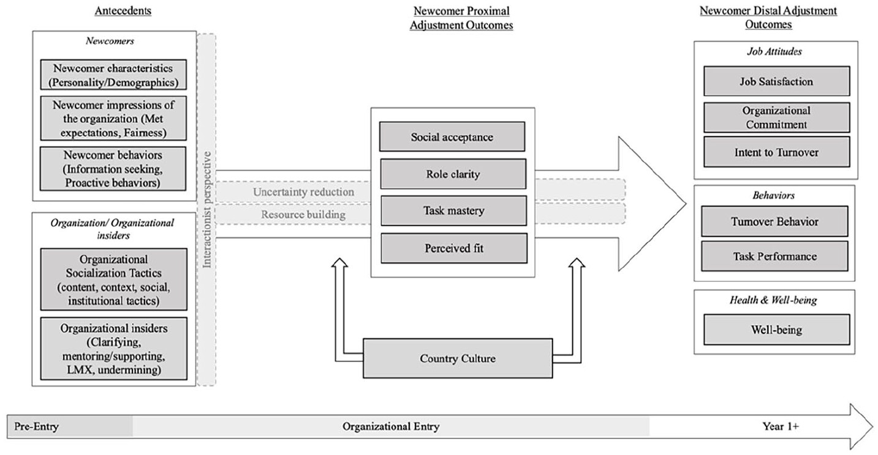
Figure 1: Newcomer organisational socialisation model
(Source: Bauer et al., 2025)
Pre-Onboarding
In the pre-on-boarding phase, Helios must deploy formal, sequential and serial socialisation tactics by providing a structured pre-onboarding roadmap (Ricciardelli, 2022). This will reduce uncertainty before entry and check initial-stage attrition. However, career maturity plays a crucial role in directing individual socialisation behaviour post-entry (Takeuchi et al., 2020). New hires must be clearly communicated on the job role, responsibilities, induction training period, career development opportunities, role expectations, organisational values, job security and flexible working conditions. These factors influence UK job seekers’ organisational preferences and expectations before entry (OECD, 2024). New hires’ job search behaviour can be analysed to understand pre-onboarding “anticipatory socialisation” (Takeuchi et al., 2020). This stage will be overseen by the HR Manager and Hiring Manager using HRIS, LMS and onboarding platforms (Handayani et al., 2025). Nevertheless, excessive pre-entry information may overwhelm newcomers, thus information must be delivered gradually.
First 90 Days
In the first 90 days, Helios must implement serial socialisation through mentoring, guidance and regular manager interaction to improve social acceptance and new hire adjustment (Frögéli et al., 2023). College-to-work new hires must be given special attention to reduce their stress and uncertainty. To build task mastery and strengthen role clarity, Helios must conduct 30, 60 and 90 day developmental reviews using Behaviourally Anchored Rating Scales (BARS) and constructive feedback mechanisms (Bauer et al., 2025). This will support employee recognition and esteem needs as proposed by Maslow’s Hierarchy of Needs Theory (Ugoani, 2023). Additionally, mentoring effectiveness depends on mentor quality and newcomer engagement. Therefore, Helios must foster relational psychological contract to reduce withdrawal intentions and employee wellbeing (Cai et al., 2021). Line managers and mentors will oversee this stage through LMS, performance management software and collaborative platforms. However, Helios must balance information/knowledge sharing with the new hires’ capacities.
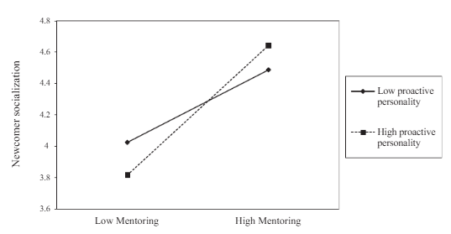
Figure 2: Impact of mentoring in newcomer socialisation
(Source: Cai et al., 2021)

Year One
A survey conducted in 2021 found that 63% of the participants left their jobs due to lack of progression opportunities (Baskin, 2026). Helios must implement career pathways and succession planning to provide tangible progression opportunities and strengthen long-term retention (van der Baan et al., 2025). It must also nurture leadership development and cross-functional mobility through continuous learning. To evaluate organisational identification, engagement and retention outcomes, Helios must conduct a 12-month appraisal, assessment centre-based development review and socialisation review (Mosquera and Soares, 2025). This stage will be led by L&D managers using LMS and talent management systems. However, career advancement expectations may not meet available opportunities, creating dissatisfaction, thus transparent promotion criteria should be clearly communicated. These measures may reduce ramp-up time, attrition and disengagement.
Implementation Plan
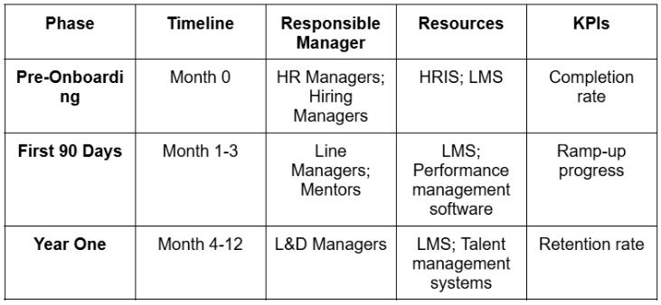

KPIs
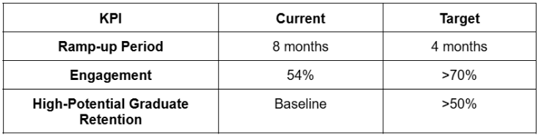

Building Identity, Ethics and Business Activism
Organisational Identification
To build organisational identity, Helios must align employee goals with organisational objectives. Following Ulrich’s (2017) six competencies model, Helios must develop line managers as “credible activists" to build trust, communicate purpose and strengthen employee commitment. It must apply "capability builder” competency by spearheading cross-functional collaboration to reinforce Helios’ collective identity (Ulrich, 2017). However, excessive organisational identification may hinder employees to challenge unethical practices, undermining innovation and accountability, thereby allowing development of professional, distinct identity construction is essential.
Ethical Professionalism
To harbour ethical professionalism, Helios must embed visible ethical decision-making and fairness principles within onboarding, performance management and leadership practices (Armstrong, 2021). To strengthen trust and psychological contract fulfilment, it must establish transparent communication and accountability procedures (Armstrong, 2021). Employee voices must be encouraged to report unethical practices to reinforce integrity, justice and responsible professional conduct (Armstrong, 2021).
Business Activism
Following Ulrich’s Business Partner Model, Helios must position HR as a strategic “HR Business Partner”, instrumental in aligning people practices with organisational sustainability and stakeholder priorities rather than administrative objectives (Wach et al., 2021). It must adopt a stakeholder capitalism perspective to create values for employees, communities, customers and society alongside organisational performance (WEF, 2021). Although scholars argue that catering to each stakeholder's requirements will ultimately weaken strategic objectives and create conflicting priorities (DIas et al., 2026). Also, employees may resist business activism if corporate positions conflict with their personal beliefs and leadership actions and social goals. To address this, Helios must foster transparent business activism and leadership practices to build collective organisational capabilities to integrate business activism in newcomers through organisational activities.

TASK B: Job Design
Current Job Design Problems
The job design prevalent at Helios is ineffective and flawed, resulting in failure to retain key human assets, poor engagement and a prolonged ramp-up period for new hires. This suggests misalignment between employee and organisational requirements. Therefore, the following innovative job design strategy, employing the Job Characteristics Model, the Job Crafting Theory and the Skills-Based architecture, are recommended aimed at mitigating these challenges and ensuring Helios’ sustained international growth.

Innovative Job Design Strategy
Job Characteristics Model
Helios must redesign its job roles using the Job Characteristics Model (Hackman and Oldham, 1976) to accelerate productivity, improve engagement and reduce high-potential graduate attrition. The model outlines five components to induce motivation, namely: “skill variety,” “task identity,” “task significance,” “autonomy” and “feedback” (Zhao et al., 2024). Under “skill variety,” Helios must expand roles beyond narrow technical tasks by involving employees in AI development and smart infrastructure projects to mitigate monotony and develop diverse competencies required in a rapidly expanding organisation. To apply “task identity,” it must assign employees ownership of entire projects to enable them to observe outcomes, strengthen accountability, engagement and commitment through greater personal responsibility (Cotič et al., 2025). “Task significance” can be achieved by communicating the overarching impact of AI-enabled transport solutions in realising urban sustainability to prompt stronger perception of societal impact, meaningfulness, satisfaction, motivation and organisational commitment (Siruri and Cheche, 2021).
Job autonomy and feedback has high motivating potential scores, with either of them compromised can lead to reduced motivation (Chen et al., 2023). Helios must impart “autonomy” to project teams over innovation decisions, project execution and problem-solving methods, particularly important to support creativity in technology-driven environments. However, the model is critiqued because it assumes employees respond similarly to enriched job motivators (Knight and Parker, 2021). This can be addressed by fostering regular, tailored interactions, embracing individual cultural and skills expectations and implementing continuous/real-time “feedback” loops through managers, clients and project outcomes to address/reduce turnover intention and ramp-up time.
Job Crafting Theory
Job Crafting Theory, propounded by Wrzesniewski and Dutton (2001), states that employees proactively reshape tasks, relationships and work perceptions to better align their jobs with their strengths and values through three dimensions: “task crafting,” “relational crafting” and “cognitive crafting” (Geldenhuys et al., 2020). Helios should create opportunities for employees to engage in job crafting by allowing autonomy, cross-functional collaboration and role flexibility. “Task crafting” would allow employees to customise their project responsibilities based on strengths and interests; for instance, AI engineers could participate in sustainability initiatives or innovation projects beyond their core duties. This will address Helios’ low engagement level and high attrition among graduates by increasing ownership and meaningfulness of work (Nie et al., 2023).
“Relational crafting” can be achieved by encouraging cross-functional collaboration across engineering, infrastructure and city-government teams. This will enhance engagement, expand networking and knowledge-sharing across London, Berlin and Singapore operations (Letona-Ibañez et al., 2021). This will also promote faster organisational integration and reduce ramp-up periods.
To induce “cognitive crafting,” Helios must encourage employees to look at their roles as contributing to the greater good of the society through sustainable urban mobility rather than isolated technical tasks, improving performance, and strengthening organisational commitment and identification with Helios’ broader objectives (Geldenhuys et al., 2020). During rapid expansion job crafting transforms passive job roles into active role designers, prompting adaptability, engagement and retention. Conversely, excessive job crafting may trigger role inconsistency, therefore, managerial oversight must ensure alignment of crafting with organisational objectives.
Skills-Based Architecture
Skills-based architecture focuses on organising employee roles according to verified skills rather than fixed job titles (Deloitte, 2026). Helios must deploy skills-based architecture by replacing rigid job roles, wherein employees will be put in roles where their capabilities can flourish rather than sticking to job descriptions. This can be achieved through creating a central skills inventory covering AI development, data analytics, smart infrastructure, data analytics, project management and stakeholder engagement. Helios must introduce micro-credentialing programmes to continuously test emerging technical and managerial competencies (Amiri et al., 2026). Whereas job rotation and cross-training initiatives will broaden employee skill portfolios and organisational flexibility (Daher and Ziade, 2023). It must match employees to projects based on skills availability and developmental requirements and not on departmental needs, supporting objective talent deployment aligned with the Equality Act 2010 and Employment Rights Act 1996 (Deloitte, 2026; GOV UK, 2026; GOV UK, 2026). This approach suits Helios because rapid expansion requires faster talent deployment (Rothwell, 2026). However, it can introduce bias/inaccuracies, thereby evaluation criteria must be transparent.
Job characteristics model will provide motivational foundation, job crafting will allow job flexibility, whereas skills-based architecture will provide skill-based talent deployment. Collectively these three approaches will be more effective for Helios rather than implementing them independently.

Explanation of the Design to Stimulate Motivation and Support Innovation
The new innovative job design following the Job Characteristics Model would stimulate intrinsic motivation through increased variety of skills, enhanced identity and significance of tasks, autonomy and feedback mechanisms, such as 360-degree feedback by creating meaningfulness and responsibility (Zhao et al., 2024). For Helios, greater autonomy and real-time feedback supported by Management by Objectives (MBO), will augment learning, reduce ramp-up time and encourage innovative problem-solving, key to AI-based technology solutions. Allowing employees to craft tasks, relationships and cognition would translate into increased ownership, accountability and engagement, resulting in generation of novel ideas and enhanced adaptability to shifting organisational demands (Nie et al., 2023; Letona-Ibañez et al., 2021). This is crucial for Helios to support innovation during rapid expansion drives. Skills-based architecture would enable employees to be deployed and develop diverse capabilities across projects, which will increase growth opportunities and career mobility, checking early-stage attrition and retention of highly-skilled graduates for Helios (Deloitte, 2026). Innovation initiatives may increase workload, thus, initiatives must be accompanied by resources and wellbeing support.

TASK C: Reflective report

AI as Decision Support
During this assignment, I used AI to search for specific literature to support my argument. For example, while discussing identity construction or psychological contract theories, I could come up with the limitations myself. However, to further expand my perspective, I used AI by giving it specific keywords to search for academic debates. I found that scholars are critiquing the theories almost similarly and with some differing views. This strengthened my understanding of the theories and decision-making process for Helios’ job redesign. Therefore, AI as a decision-support tool is very helpful but if relied entirely on it, it may create bias and error (Meidema et al., 2025). Overall, AI should remain a human-supervised decision-support tool.

Personal Capability Development Plan
To critically evaluate my future employability requirements and identify key areas for professional growth, I will apply Rolfe’s reflective model (Orsini et al., 2026).
What? - This module highlighted capability gaps in data literacy, AI augmentation in HR, strategic influencing skills, change management and global mobility awareness, which are gaining traction in technology-driven and global organisations.
So what? - This assignment revealed capability gaps relevant to future job roles. These capability gaps will hinder my ability to contribute effectively in my future job role, thereby developing these competencies is essential for me to improve my future employability and strategic contribution.
Now what? - To develop data literacy, I will complete Power BI, Excel analytics and HR analytics training within the next 12 months (Saxena et al., 2021). For AI augmentation in HR, I will develop knowledge of AI-assisted recruitment, workforce planning and people analytics by taking professional courses within the next 6 months (Nawaz et al., 2024). Strategic influencing can be improved by learning stakeholder management, negotiation and communication skills through leadership activities and group project participation. I will study change management frameworks and how established organisations are employing them within the next 12 months to hone change management capabilities. To develop global mobility awareness capability, I will build knowledge on expatriate management, cultural assimilation and international HRM through independent study and professional development.
Following this strategy, I will bridge the capabilities gaps and be prepared for future employability.
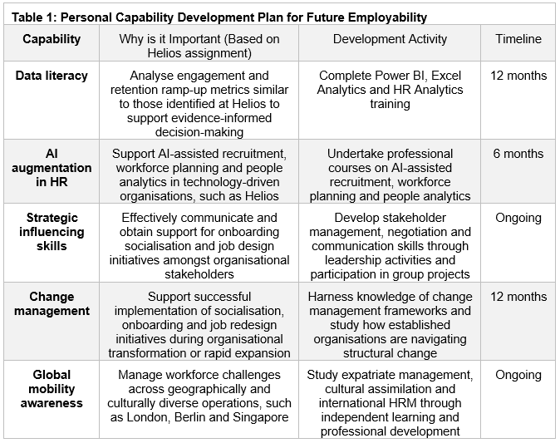
(Source: Self-Created)

Conclusion
To conclude, strategic socialisation and innovative job design may strengthen engagement, retention and organisational growth at Helios, provided the implementation is phased and data-informed.

References
Al-Abrrow, H., Alnoor, A., Ismail, E., Eneizan, B. and Makhamreh, H.Z., (2019). Psychological contract and organizational misbehavior: Exploring the moderating and mediating effects of organizational health and psychological contract breach in Iraqi oil tanks company. Cogent Business & Management, 6(1), p.1683123. Available at: https://doi.org/10.1080/23311975.2019.1683123
Amiri, S.M.H., Noor, S.A., Labib, L.M., Anjum, F. and Mithila, M., (2026). Micro-Credentials, Macro Impact: The Credentialing Revolution Goes Mainstream. Available at: https://www.preprints.org/frontend/manuscript/0efb9e3ee7ecb8fa484efd3f880e3d16/download_pub
Armstrong, M. (2021). Armstrong’s Handbook of Human Resource Management Practice (15th Ed.). Kogan Page.
Ashforth, B.E. and Schinoff, B.S. (2016) 'Identity under construction: How individuals come to define themselves in organizations,' Annual Review of Organizational Psychology and Organizational Behavior, 3(1), pp. 111–137. Available at: https://doi.org/10.1146/annurev-orgpsych-041015-062322.
Baskin, K. (2026) To keep employees, focus on career advancement. Available at: https://mitsloan.mit.edu/ideas-made-to-matter/to-keep-employees-focus-career-advancement. (Accessed: 2 July 2026)
Bauer, T.N., Erdogan, B., Ellis, A.M., Truxillo, D.M., Brady, G.M. and McCarthy, J.M., (2025). The evolving future of work: Implications for newcomer adaptability and connectivity during organizational socialization. Human resource management, 64(6), pp.1651-1668. Available at: https://doi.org/10.1002/hrm.70008
Bauer, T.N., Erdogan, B., Ellis, A.M., Truxillo, D.M., Brady, G.M. and Bodner, T., (2025). New horizons for newcomer organizational socialization: A review, meta-analysis, and future research directions. Journal of Management, 51(1), pp.344-382. Available at: https://doi.org/10.1177/01492063241277168

Cai, D., Liu, S., Liu, J., Yao, L. and Jia, X., (2021). Mentoring and newcomer well-being: a socialization resources perspective. Journal of Managerial Psychology, 36(3), pp.285-298. Available at: https://doi.org/10.1108/JMP-08-2019-0485
Chen, C., Zhang, K.S., Chen, C.M. and Pao, L.S., (2023). The impact between motivational potential characteristics of job and job satisfaction: a moderation model of personality traits in a high-tech industry. International Journal of Asian Business and Information Management (IJABIM), 14(1), pp.1-19. Available at: https://doi.org/10.4018/IJABIM.325650
Cotič, L.P., Man, M.M.K., Soga, L.R., Konstantopoulou, A. and Lodorfos, G., (2025). Job characteristics for work engagement: autonomy, feedback, skill variety, task identity, and task significance. Global Business and Organizational Excellence, 44(5), pp.75-85. Available at: https://doi.org/10.1002/joe.22295
Daher, M.M. and Ziade, F. (2023) 'Technology, workforce, and the future of sustainable work,' in Contributions to environmental sciences & innovative business technology, pp. 119–136. Available at: https://doi.org/10.1007/978-981-99-8572-2_6.
Deloitte (2026) The skills-based organization: A new operating model for work and the workforce. Available at: https://www.deloitte.com/us/en/insights/topics/talent/organizational-skill-based-hiring.html. (Accessed: 2 July 2026)
Dias, C., F. Pereira, L. and Dias, Á., (2026). Stakeholder capitalism: a new perspective on corporate sustainability. Corporate Governance: The International Journal of Business in Society, pp.1-34.https://doi.org/10.1108/CG-11-2025-0925
Frögéli, E., Jenner, B. and Gustavsson, P. (2023) 'Effectiveness of formal onboarding for facilitating organizational socialization: A systematic review,' PLoS ONE, 18(2), p. E0281823. Available at: https://doi.org/10.1371/journal.pone.0281823
Geldenhuys, M., Bakker, A.B. and Demerouti, E. (2020) 'How task, relational and cognitive crafting relate to job performance: a weekly diary study on the role of meaningfulness,' European Journal of Work and Organizational Psychology, 30(1), pp. 83–94. Available at: https://doi.org/10.1080/1359432x.2020.1825378.
GOV UK (2026) Employment Rights Act 1996. Available at: https://www.legislation.gov.uk/ukpga/1996/18/contents. (Accessed: 2 July 2026)
GOV UK (2026) Equality Act 2010: guidance. Available at: https://www.gov.uk/guidance/equality-act-2010-guidance. (Accessed: 2 July 2026)
Handayani, N.S., Cahaya, R. and Shaddiq, S., (2025). Integrating Human Resource Information Systems (HRIS) Into Industry 4.0 and Society 5.0: Toward A Smarter and More Strategic Human Capital Management. AT-TAKLIM: Jurnal Pendidikan Multidisiplin, 2(7), pp.349-366. Available at: https://journal.hasbaedukasi.co.id/index.php/at-taklim/article/download/700/647
Knight, C. and Parker, S.K., (2021). How work redesign interventions affect performance: An evidence-based model from a systematic review. Human relations, 74(1), pp.69-104. Available at: https://doi.org/10.1177/0018726719865604
Letona-Ibañez, O., Martinez-Rodriguez, S., Ortiz-Marques, N., Carrasco, M. and Amillano, A., (2021). Job crafting and work engagement: The mediating role of work meaning. International Journal of Environmental Research and Public Health, 18(10), p.5383. Available at: https://doi.org/10.3390/ijerph18105383
Miedema, E., Waschull, S. and Emmanouilidis, C. (2025) 'Towards trustworthy artificial intelligence for decision-making: A lifecycle perspective on knowledge- and data-driven artificial intelligence systems,' Computers in Industry, 174, p. 104409. Available at: https://doi.org/10.1016/j.compind.2025.104409.
Mosquera, P. and Soares, M.E. (2025) 'Onboarding: a key to employee retention and workplace well-being,' Review of Managerial Science, 19(12), pp. 3687–3711. Available at: https://doi.org/10.1007/s11846-025-00864-3.
Nawaz, N., Arunachalam, H., Pathi, B.K. and Gajenderan, V., (2024). The adoption of artificial intelligence in human resources management practices. International journal of information management data insights, 4(1), p.100208. Available at: https://doi.org/10.1016/j.jjimei.2023.100208
Nie, T., Tian, M., Cai, M. and Yan, Q., (2023). Job autonomy and work meaning: Drivers of employee job-crafting behaviors in the VUCA times. Behavioral Sciences, 13(6), p.493. Available at: https://doi.org/10.3390/bs13060493
OECD (2024), Promoting Better Career Mobility for Longer Working Lives in the United Kingdom, Ageing and Employment Policies, OECD Publishing, Paris, Available at: https://doi.org/10.1787/2b41ab8e-en.
Orsini, C., Soto‐Faúndez, N. and Taha, M.H. (2026) 'Structured Approaches to Reflection: models and applications for clinical educators’ professional development,' European Journal of Dental Education [Preprint]. Available at: https://doi.org/10.1111/eje.70092.
Peltokorpi, V., Feng, J., Pustovit, S., Allen, D.G. and Rubenstein, A.L., (2022). The interactive effects of socialization tactics and work locus of control on newcomer work adjustment, job embeddedness, and voluntary turnover. Human Relations, 75(1), pp.177-202.
Rani, B., Praveen, R.V.S., Alex, S., Mohiuddin, M.Q., HARALAYYA, B. and Chinthamu, N., (2024). Benefits of on boarding as an approach to sustaining human resources in organizations. Bhadrappa and S., Deeja and Chinthamu, Narender, Benefits of on Boarding as an Approach to Sustaining Human Resources in Organizations (November 10, 2024). Accountancy Business and the Public Interest Theme, 2. Available at: https://abpi.uk/wp-content/uploads/2024/11/03AU2406.pdf
Ricciardelli, R. (2022). Socialization Across the Three Stages of the Correctional Services of Canada's Correctional Officer Training Program: An Ethnographic Study. Qualitative Criminology (QC), 11(1), 3. Available at: https://dc.swosu.edu/cgi/viewcontent.cgi?article=1146&context=qc
Rothwell, W. (2026) 'Talent deployment and workforce readiness in the AI era,' International Journal of AI in Pedagogy Innovation and Learning Futures, 2(1). Available at: https://doi.org/10.46787/ijaipil.v2i1.7492.
Saxena, M., Bagga, T. and Gupta, S. (2021) 'Fearless path for human resource personnel’s through analytics: a study of recent tools and techniques of human resource analytics and its implication,' International Journal of Information Technology, 13(4), pp. 1649–1657. Available at: https://doi.org/10.1007/s41870-021-00677-z.
Siruri, M.M. and Cheche, S., (2021). Revisiting the Hackman and Oldham job characteristics model and Herzberg’s two factor theory: Propositions on how to make job enrichment effective in today’s organizations. European Journal of Business and Management Research, 6(2), pp.162-167. Available at: https://doi.org/10.24018/ejbmr.2021.6.2.767
Summerville, K.M., Tonidandel, S., Ruggs, E.N. and Traylor, H.D., (2026). Multiple identity construction at work: An intrapersonal identity network approach to intersectionality. Personnel Psychology, 79(1), pp.41-64. Available at: https://doi.org/10.1111/peps.70017
Takeuchi, T., Takeuchi, N. and Jung, Y. (2020) 'Toward a process model of newcomer socialization: Integrating pre‐ and post‐entry factors for newcomer adjustment,' Human Resource Development Quarterly, 32(3), pp. 391–418. Available at: https://doi.org/10.1002/hrdq.21420.
Topa, G., Aranda-Carmena, M. and De-Maria, B. (2022) 'Psychological Contract Breach and Outcomes: A Systematic Review of Reviews,' International Journal of Environmental Research and Public Health, 19(23), p. 15527. Available at: https://doi.org/10.3390/ijerph192315527.
Ugoani, J. (2023) 'Employee Motivation: Maslow’s Needs Theory and Human Behavior in Organizations,' SSRN Electronic Journal [Preprint]. Available at: https://doi.org/10.2139/ssrn.4533426.
Ulrich, D. (2017). Victory Through Organization: Why the War for Talent is Failing Your Company and What You Can Do About It. McGraw-Hill Education.
Ulrich, D., Kryscynski, D., Ulrich, M., &amp; Brockbank, W. (2017). HR from the Outside In: Six Competencies for the Future of Human Resources. McGraw-Hill.
van der Baan, N.A., Meinke, G., Virolainen, M.H., Beausaert, S. and Gast, I., (2025). Retention of newcomers and factors influencing turnover intentions and behaviour: a review of the literature. Education+ Training, 67(1), pp.107-136. Available at: https://doi.org/10.1108/ET-06-2023-0240
Wach, B.A., Wehner, M.C. and Kabst, R. (2021) 'Performance implications of the HR business partner model and the mediating role of internal efficiency: a comparison between Germany and the United Kingdom,' The International Journal of Human Resource Management, 33(20), pp. 4113–4150. Available at: https://doi.org/10.1080/09585192.2021.1943490.
WEF (2025) What is stakeholder capitalism? It’s History and Relevance. Available at: https://www.weforum.org/stories/2021/01/klaus-schwab-on-what-is-stakeholder-capitalism-history-relevance/. (Accessed: 2 July 2026)
Zhao, S., Ping, J., Zhu, H., Ji, W., Wang, Y. and Wang, Y., (2024). Job characteristics model-based study of the intrinsic motivations for primary care practitioners. Chinese General Practice Journal, 1(1), pp.3-10. Available at: https://doi.org/10.1016/j.cgpj.2024.03.004

