BUSINESS PLAN



Student Name : Vijay Rani
Student Number : 2432357
Module Code and Title : LCLM4006- Enterprise & Entrepreneurship
Task Title : Task I - Business Plan
Lecturer Name : Fouziya Farheen

EXECUTIVE SUMMARY

This business plan outlines the launch of a sole‑trader handmade soap business specialising in natural, eco‑friendly, and artisan soaps produced using high‑quality plant‑based ingredients. The business aims to meet the growing consumer demand for sustainable, chemical‑free personal‑care products while offering unique scents, attractive packaging, and a strong brand identity.
Operating as a sole trader allows for low startup costs, full creative control, and the flexibility to scale production gradually. The business will initially be run from home, selling through online platforms such as Etsy, Facebook, Instagram, as well as at local craft markets and community events. This multi‑channel approach supports steady customer growth and repeat sales.
The core mission is to provide customers with gentle, skin‑friendly soaps that are handmade in small batches, packaged sustainably, and priced competitively. The brand will differentiate itself through natural ingredients, visually appealing designs, and personalised customer service. As demand increases, the business will expand its product range to include gift sets, seasonal collections, and complementary bath products.

TABLE OF CONTENTS
1.0 Cover Page ………………………………………………...…...…………….. 1
2.0 Executive Summary …………………………………………………............. 2
3.0 Table of Contents ......................……………………………………………... 3
4.0 Overview of the business idea……………………………………………..... 4-9
4.1 Legal Format........................................................................................... 5
4.2 Justification ........................................................................................... 6
4.3 Management Structure.......................................................................... 7-9
5.0 Marketing Research................................................................................... 10-13
5.1 Pestel Analysis…………........................................................................ 10-11
5.2 SWOT Analysis ..................................................................................... 12
5.3 Competition ........................................................................................... 13
6.0 Market Strategies........................................................................................ 14-15
6.1 Market Segmentation ............................................................................. 14
7.0 Financials .................................................................................................... 16-17
7.1 Funds requirements & source of funds .................................................. 16
7.2 Cash Flow Chart ................................................................................... 17
8.0 References ………………………………………………………………............ 18-19

OVERVIEW OF THE BUSINESS IDEA
Business Name: Pure Bloom Handmade Soaps
Location: West Midlands Birmingham, UK
Business Concept: A small‑batch, eco‑friendly soap brand offering natural, skin‑safe soaps made with plant‑based oils, essential oils, and sustainable packaging.
- Mission: To create eco-friendly, skin-safe soaps using natural ingredients.
- Vision: Become a trusted local and online brand for artisanal soaps.
- Products: Handmade bar soaps, liquid soaps and gift sets
- Target Market: Health-conscious consumers, eco-friendly shoppers, gift buyers.
Business Goals:

Short-Term (0–12 months)
- Launch online store
- Develop 6 core soap varieties
- Attend 6–10 local markets
- Achieve first £ 800/month in sales
Long-Term (1–5 years)
- Expand product line
- Secure retail partnerships
- Increase production capacity

Future Vision: Expand into bath products (scrubs, balms, bath bombs), sell through local shops, and build a strong online presence.
USP: 100% natural ingredients, custom scents, and plastic‑free packaging.

sustainable packaging
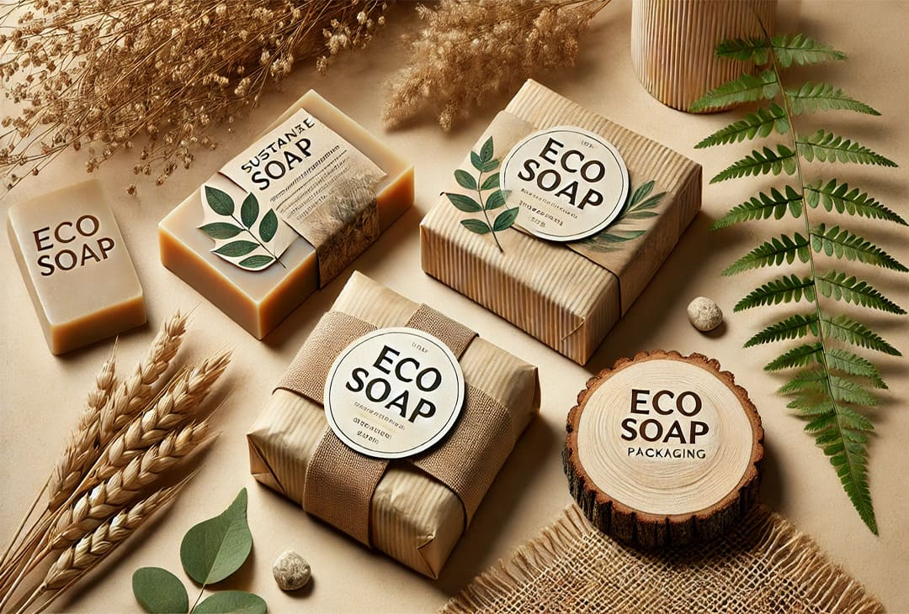 (Asher, 2024)
“Global demand for soap continues to rise. Industry forecasts project the global soap market will reach $66.5 billion by 2032, driven by heightened hygiene awareness and growing consumer preference for natural, sustainably packaged products (Shopify, 2025)”.
Legal Format
There are three main legal forms of businesses in the private sector; sole proprietorships/traders, ordinary partnerships, and companies. According to UK Govt. Website (2024) regulation for the Sole Trader is minimal: there is no requirement for a formal constitution for the business, and no need to register or file accounts and returns with Companies House. Pure Bloom Handmade Soaps will operate as a sole trader business initially, producing cold‑process soaps from home. Products will be sold online, at local markets, and through small retailers. The business will operate within a monopolistic competitive market structure, a structure where firms offer similar but differentiated products.

Hand crafted soap
(Bing.com, 2020)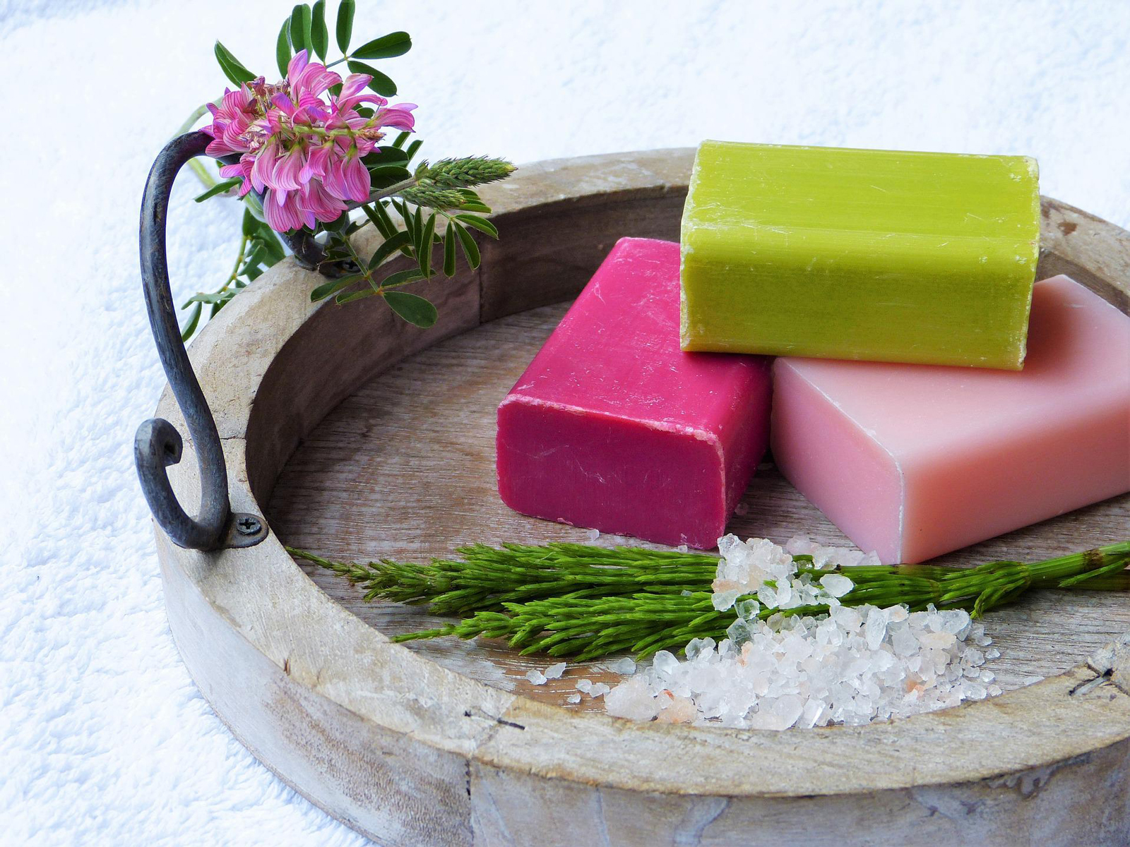

Justification
For a small handmade soap start‑up, a sole trader structure is often the best choice because it is simple, low‑cost, flexible, and gives the owner full control and it can start from home with small batches, test the market at local fairs and/or online, and scale production as demand increases. It also allows the entrepreneur to focus on building the brand, perfecting products, and growing the business without unnecessary administrative burdens.
Management Structure
OWNER/FOUNDER
SALES & MARKETING COORDINATOR
PRODUCTION MANAGER
FINANCE/ADMN SUPPORT
PACKING ASSISTANT

1. OWNER/FOUNDER
Qualification: Diploma in Soap Making business with deep knowledge in soap formulation, safety standards, and business operations.
Experience: Hands-on experience of 4-5 years with a retail shop selling handmade soaps, candles and beauty products.
Responsibilities:
- Overall business strategy and decision‑making
- Product development and recipe creation
- Financial management and budgeting

------------------------------------------------------------------------------------------------------------------
2. PRODUCTION MANAGER
Qualification: Diploma in soap making business
- Advanced short course postgraduate certificate focusing on natural ingredients, product development and marketing
- Business management course
Experience: Hands-on experience of 2-3 years with cold process, melt-and-pour, and hot process methods. Understanding of essential oils, additives, and curing.
Responsibilities:
- Soap making & batch production
- Quality control & testing
- Maintain hygiene and safety standards
------------------------------------------------------------------------------------------------------------------
3. SALES & MARKETING COORDINATOR
Qualification: Diploma in Marketing and Business Administration with thorough knowledge of social media marketing
Experience: 1-2 years of experience in sales & marketing in a beauty and wellness product with full knowledge of natural products and their benefits

Responsibilities:
- Managing social media & online presence
- Customer engagement & responding to enquiries
- Planning promotions, events and market stalls
------------------------------------------------------------------------------------------------------------------
4. FINANCE & ADMIN. SUPPORT
Qualification: GCSE + Diploma in book-keeping & record-keeping
Experience: 2-3 years of experience in finance and administration in a retail operation with good organisational skills and the ability to multitask
Responsibilities:
- Book-keeping & recording-keeping
- Tracking expenses & revenue
- Preparing financial reports
- Supporting tax related tasks

------------------------------------------------------------------------------------------------------------------
5. PACKING ASSISTANT
Qualification: GCSE with training in manual handling
Experience: 4-5 years of experience in a busy warehouse with hands-on experience of stock & inventory handling and basic understanding of cosmetic lebelling (allergens, ingredients and batch codes)
Responsibilities:
- Cutting, curing & packaging soaps
- Labelling
- Preparing & dispatching orders
- Maintaining stock of finished products

MARKET RESEARCH
Businesses do not operate in isolation; instead, they function within a constantly changing environment that directly affects their operations and their ability to achieve objectives. As Remy Lemmens (2020) explains, the business environment consists of a combination of internal and external factors that shape how a business performs.
Similarly, Barrow, Barrow and Brown (2021) emphasise that gathering market research data is essential for selecting an effective marketing strategy. Such information supports decisions related to pricing, service and quality levels, and determining where and how extensively to advertise. It is often used in collaboration with other analytical business tools such as the SWOT analysis to give a clear understanding of a situation and related internal and external factors.
PESTEL ANALYSIS
PESTEL analysis is a framework used in strategic management to identify and assess the external factors that can influence an organisation’s performance and strategy (Johnson et al., 2017). It is a tool to understand the opportunities and threats that lie
within it.
POLITICAL
- Regulations for cosmetics and personal‑care products related to safety standards, trade tariffs and how products are made, labelled and sold
- Policies regarding government support for small businesses through grants, start‑up loans, and tax incentives.
- Import/export rules affecting raw materials such as oils, fragrances, and packaging

ECONOMICAL
- Fluctuating prices of raw materials such as oil, fragrances, lye and colours etc.
- High inflation rate affects the rise in production cost such as packaging, utilities, and distribution costs
- Change in consumer behaviours, spending trends and basic preferences

SOCIAL
- Growing preference for natural, chemical‑free, eco‑friendly skincare products.
- Increased awareness of sustainability and ethical sourcing.
- Popularity of handmade and artisan goods, especially for gifting.

TECHNOLOGIAL
- Online retail growth
- Technology for sustainable packaging innovations.
- Online payment systems and inventory management tools.
ENVIRONMENTAL
- Demand for biodegradable, cruelty‑free, and vegan products.
- Regulations on safe disposal of lye and production waste.
- Eco-friendly packaging

LEGAL
- Compliance with cosmetic product safety regulations
- Mandatory labelling requirements (ingredients, allergens, batch numbers).
- Health & safety rules for manufacturing environments.

SWOT ANALYSIS

Internal Factors: Strengths & Weaknesses
STRENGTHS  - High-quality, natural ingredients for health-conscious customers  - Low start-up costs and flexibility to produce from home  - Direct-to-consumer sales through social media & local markets | WEAKNESSES  - Higher cost per unit due to small-batch manufacturing  - Limited production capacity  - Lower brand recognition in early stages
OPPORTUNITIES  - Growing demand for natural, chemical-free products  - Expansion into complementary products (bath bombs, scrubs, balms)  - E-commerce growth through Etsy, Shopify, Instagram, Facebook | THREATS  - Intense competition from both handmade sellers & big brands  - Rising costs of raw materials  - Economic downturns reducing spending on premium artisan products
External Factors: Opportunities & Threats

COMPETITION

According to Barringer & Ireland (2019) competitor analysis is a structured evaluation of competitors to understand their strengths, weaknesses, and strategic positions. It is essential for shaping marketing strategy, pricing, product development, and positioning.

Handmade soap startups face competition from both small artisan producers and large commercial brands. Local competitors often include independent soap makers who sell through craft markets, Etsy, and social media, offering natural or customised products similar to those of a new start‑up. At the same time, established commercial brands dominate supermarket shelves with lower prices and strong brand recognition, making it challenging for new entrants to stand out.

Competitor weaknesses: generic branding, limited customisation
Opportunity: strong branding, personalised scents, gift sets

MARKETING STRATEGIES
Entrepreneurs can gain a much clearer understanding of their customers and overall market by applying effective market segmentation. Kotler and Armstrong (2020) describe segmentation as the process of dividing a market into distinct groups of consumers who share similar needs or characteristics. This approach enables businesses to tailor their products or services more precisely to customer expectations, while also helping them allocate financial and human resources more efficiently.
There are four main types of Market Segmentation:
- Geographic segmentation: Groups of customers based on their location, such as country, region, county, city, community, or educational institution.
- Demographic segmentation: Categorises customers according to measurable traits such as age, gender, marital status, education level, income, and religion.
- Psychographic segmentation: Focuses on customers’ attitudes, opinions, values, and lifestyles.
- Behavioural segmentation: Groups of customers based on their purchasing habits, usage patterns, and lifestyle behaviours.

Effective marketing strategies for a small business may include referral and loyalty programmes, as well as content marketing and social media engagement. These methods help attract new customers while retaining existing ones. According to Haag, 2022, “It is important for the business owner to differentiate the business from other competing businesses by promoting the benefits of the product or service.” Haag 2022 also emphasised that “being socially responsible brings many benefits to a company. It will attract employees and gain visibility for the company”.

Whereas Richard Branson highlights the importance of maintaining a strong customer focus, noting that entrepreneurs should put themself in their customers’ shoes, as businesses often overlook client needs when they become too focused on profit (Preston, 2015). Similarly, Mariotti and Glackin (2015, p.155) stress the value of customer feedback, explaining that entrepreneurs should use this information to develop products or services that genuinely meet customer needs.

FINANCIALS

According to Hagg (2022), creating a comprehensive fiscal plan is essential for anticipating the future financial needs of a business, including projected sales, staffing, materials, equipment, and service requirements. This planning also involves detailing key financial considerations such as origination costs and the allocation of funding across areas like marketing, salaries, facilities, capital equipment, research and development, and ongoing operational expenses. Barringer and Ireland (2018) similarly highlight that many entrepreneurs underestimate the challenges of operating without adequate investment capital, emphasising that understanding the role of external funding is vital to the survival and long‑term success of a new venture.

In line with these principles, the financial plan for this business outlines the projected costs and funding requirements necessary to launch and sustain operations, including raw materials for soap production, packaging, branding, marketing activities, equipment, and initial operating expenses. Careful allocation of start‑up capital, combined with sales forecasting, cost monitoring, and structured budgeting will support effective cash‑flow management and enable the business to build a stable foundation for future growth. Pure Bloom will initially be financed through personal investment, with further growth supported by continued bootstrapping as the business expands.

CASH FLOW
 |  | MONTH
Cash in |  | 1
Start-up capital (personal savings) |  | £1,500
Sales (total sales of product) |  | £800
Total cash in-flows (A) |  | £2,300
 |  | MONTH
Cash out-expenses |  | 1
Rent (running from home) |  | £0
FIXED COSTS (upto 20% in total)
Utilities (gas, electricity, water, telephone, internet) | £150 | £0
Cost of equipment (scales, thermometer, moulds, blender, etc) | £50
 |  | £40
RAW MATERIAL
Ingredients: Oils, chemical, botanicals, fragrances, colours, etc |  | £30
Marketing and advertising expenses |  | £150
Packaging |  | £175
Branding |  | £100
Postage |  | £100
Legal requirements |  | £200
Wages your own |  | £800
Staff wages (no staff for the first few months) |  | £0
Any other (misc.) |  | £100
Total cash out-flows (B) |  | £1,695
Your net cash flow (A-B) |  | £605

REFERENCES

Barringer, B.R. and R Duane Ireland (2018). Entrepreneurship successfully launching new ventures. 5th ed. Harlow London New York, Ny Boston [U.A.] Pearson.

Barringer, B.R. and R Duane Ireland (2019). Entrepreneurship successfully launching new ventures. 6th ed. Harlow London New York, Ny Boston [U.A.] Pearson.

Barrow, C., Barrow, P. and Brown, R. (2021). The business plan workbook: A step-by-step guide to creating and developing a successful business.10th Edition London, United Kingdom New York, Ny Kogan Page.

Business, S. (2025). How to Make Your Handcrafted Soap Business Stand Out at Farmers’ Markets and Craft Fairs. [online] Soapmaking Business. Available at: https://soapmakingbusiness.com/articles/how-to-make-your-handcrafted-soap-business-stand-out-at-farmers-markets-and-craft-fairs [Accessed 31 Jan. 2026].
‌Haag, A.B. (2022). Writing a Successful Business Plan. Workplace Health & Safety, 61(1), pp.19–29. doi:https://doi.org/10.1177/216507991306100104
Kotler, P. and Armstrong, G. (2020). Principles of marketing. 18th ed. New York, Ny: Pearson Education.

Mariotti, S, & Glackin, C 2015, Entrepreneurship: Starting and Operating a Small Business, Global Edition, Pearson Education, Limited, Harlow. Available from: ProQuest Ebook Central. [4 February 2026].

Preston, J. (2015). Richard Branson: How to attract customers | Virgin. [online] Virgin.com. Available at: https://www.virgin.com/about-virgin/latest/richard-branson-how-attract-customers.

Remy Lemmens (2020). The Business Environment. YouTube. Available at: https://www.youtube.com/watch?v=Q1yw7Tchsc8.

‌
‌

Shopify (2025). How to Make Soap to Sell: A Step-by-Step Guide (2026) - Shopify. [online] Shopify. Available at: https://www.shopify.com/blog/how-to-make-soap-turning-a-necessity-into-a-diy-business [Accessed 24 Jan. 2026].

www.gov.uk. (2024). Business regulation - GOV.UK. [online] Available at:
https://www.gov.uk/business-and-industry/business-regulation.

