RESEARCH PROPOSAL
Location-Based Information for Sustainable Development of Forests – Case of Fiji

Mohammed Shorab (2105064)
MSc Environmental Conservation and Management
University of Wales Trinity St David – 2022

Contents
1.0 Introduction 3
1.1 Hypotheses 5
1.2 Relevance of the study 6
2.0 Literature Review 6
2.1 Sustainable Forest Management (SFM) 6
2.2 Importance of Decision Making for Sustainable Development 7
2.3 Spatial Information for Decision Making 8
2.4 Research Gap 9
3.0 Aims and Objectives 10
3.1 Aims: 11
3.2 Objectives: 11
4.0 Methodology 12
4.1 Semi Structured In-Depth Interviews 12
4.1.1 Limitations: 13
4.2 Survey 14
4.2.1 Limitations: 14
4.3 Study of Historical Materials 14
4.3.1 Limitations: 15
5.0 Results and Discussion 16
6.0 Timeline 17
References 18

1.0 Introduction
Decision making is an essential aspect of sustainable development. Our future and the future of our generations are dependent on the choices we make every day, which turn into decisions. These decisions range from a forester in the field who plans a reforestation or logging activity right up to the top tier decision-makers of the world who make policies and regulations for the world's forest.
A vital aid to these decision-makers is location-based information such as maps, locational statistics (example; extent of forests, changes in the extent of forest, deforestation rates, afforestation rates), future projections/predictions, and past information. These so many different types of information and maps are derived from analysis using software and locational data from primary and secondary sources.
Although the need to protect and conserve natural resources for future generations had long been widely accepted, the concept of sustainability began to increase in importance at the end of the 1980s (Martin and Diez, 2012). Sample and Sajdo (1996) have cited Heske (1938) to state that the origins of the term 'Sustainable Forest Management' can be found in 18th century Europe. Sustainable Forest Management (SFM) has been given numerous definitions over the years, all of which summarises to using forest resources in a manner that sustains it for future generations. SFM is one of several vital components in the global pursuit of ecologically, economically, and socially sustainable development goals, also known as the Sustainable Development Goals (SDGs). SFM is a key indicator of the 15th sustainable development goal in the 2020 Agenda for Sustainable Development adopted by the United Nations member states in 2015 (United Nations, n.d.).
Studies have shown that making decisions to sustainably manage forests usually relies on spatial information (Ishtiaque, A. et al., 2020; Varma, Ferguson et al., 2000). Spatial information is defined as information directly related to a location or any geographic area. Analysis and visualisation of spatial information can help measure, monitor, report, and verify the status of forest resources. This process is commonly known as Monitoring, Reporting and Verification (MRV). Essential information such as the location of forests, extent of forests, changes in forest extent/area, effects on the immediate environment surrounding the forest, and many others are basic locational information that influences forestry decision-making.
Fiji, a small island nation in the South Pacific, has used spatial information for forest-related decision-making for over three decades (Forstreuter, 2022). Delineation of forest area extent and changes in the extent (deforestation/reforestation), different types of forest (protection, upland, lowland, cloud, primary, secondary) have been used for decision making and international reporting. In addition, field-level spatial information on maps has been used to plan harvesting operations, harvest area monitoring, and reforestation planning and monitoring. In Fiji, the Ministry of Forestry is responsible for the Sustainable Management of Forests (Ministry of Fisheries & Forests, 2007). A unit within the Ministry known as the Forest Resource Assessment and Conservation Division (formerly known as Management Services Division) is responsible for collecting, manipulating, analysing, verifying, reporting, and providing forest spatial information.
Geographical information systems, a system used to store, manipulate, analyse, and present spatial data, was first set up at this Unit in 1991. This system was set up with assistance from the then GTZ (Forstreuter, 2022), now known as GIZ (Deutsche Gesellschaft für Internationale Zusammenarbeit) and was the first of its kind in the Pacific Islands country region. It was set up to assist in making effective and efficient decisions for the sustainable management of forest resources using spatial information. This system was operated with the Germans' assistance until the late 1990s, after which the Fijians took over (Lewai, 2022). From an analysis of publications in the PGRCS Newsletters, spatial information played a crucial role in decision-making for sustainable forest management in Fiji in the 1990s. However, in the 2000s, when the Germans had left, the division struggled in the task. For example, mapping for the National Forest Inventory 2005 took nine years to complete, and the maps were finally published in 2014. In late 2018 the Ministry recruited a qualified GIS officer who established web mapping systems and advanced information systems to provide spatial information. In 2019 the Ministry transitioned to a more digital approach for disseminating spatial information and started using dynamic web maps for the provision/visualisation of real-time spatial information for decision-making in place of static maps.
  - 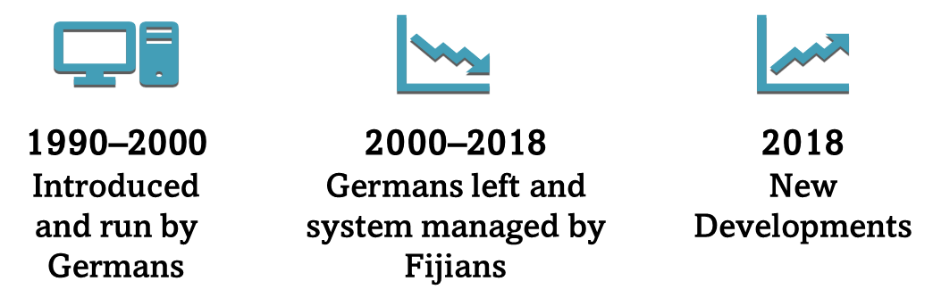Graphic 1: Three different periods that the Ministry of Forestry's spatial information management unit underwent since 1991.
Keeping time constraints in mind, this study will only focus on the Ministry of Forestry in Fiji. Although there are other players who play a role in the Forestry industry of Fiji but as earlier stated, the Ministry is responsible and leads for the conservation, management, and sustainable development of Forests.

1.1 Hypotheses
In the late 1900s, when the Germans left, a clear succession plan was not in place. Therefore, the knowledge, skills, and abilities for operating this system to provide quality data for decision making did not exist with the Fijians. This seems to be a significant setback for the system at the time. Later, in the 2000s, the Ministry employed a qualified GIS officer in 2002. The others working in the Unit were all floating with the knowledge and skills gained from experience while in the Unit and from workshops and short course training overseas through international development partners. This may have been a reason for the fall in the system from where it was in the 1990s and a halt in adapting to modern technologies to keep up to par with the rapid developments of the 21st century. These developments only happened after the employment of qualified personnel in 2018. Throughout these three different periods, there also does not seem to be a proper transition of personnel whenever there were changes in the team. While there are systems in place already, many things can be done better. Establishing a proper unit with qualified Foresters and Spatial Scientists forming the team is necessary for a promising future. Together with the team, there should be systems of data control, data/process' documentation, retainer programmes and proper transition systems (should there be a change in the team members).

1.2 Relevance of the study
The outcomes of this study will influence policy and planning for proper administration and operation of spatial information management units. It will also provide a basis for investment into spatial information systems by giving an insight into the importance of spatial information for the overall decision-making process and the sustainable management of forests. Finally, it will also provide recommendations for best practices and the proper establishment and running of a spatial management unit to provide real-time data using the latest technology available.

2.0 Literature Review

2.1 Sustainable Forest Management (SFM)
As early as the 17th century, the harmful impact of the previous use of forest resources and the necessity for future generations to continue using these resources had gained the scientific community's attention (Glacken, 1976, as cited in Martin and Diez, 2012). Increased environmental consciousness and increasing scientific understanding of environmental degradation have affected society's values and global policy, which have impacted forest management aims in the 20th century (Wang and Wilson, 2007). However, many scientists believe that the paradigm is shifting due to climate change. Upon analysing numerous definitions of the SFM concepts in the early historical periods of the 1980s and 1990s, Martin and Diez (2012) conclude that they all are just refining the definition of sustainable development given by the Brundtland Commission (1987) "development that meets the needs of the present without compromising the ability of future generations to meet their own needs" to apply it to forests.
Goal 15.2 of the United Nations Sustainable Development Goals (UN SDGs) 2015 is to "promote the implementation of sustainable management of all types of forests, halt deforestation, restore degraded forests and substantially increase afforestation and reforestation globally" (United Nations, 2022). There are numerous definitions for SFM, all of which are dependent on the context in which the term is used. The United Nations Food and Agriculture Organization (FAO) defines sustainable forest management as a "dynamic and evolving concept, which aims to maintain and enhance the economic, social and environmental values of all types of forests, for the benefit of present and future generations" (Food and Agriculture Organization of the United Nations, 2020). This study, together with the SDG 15.2 and the FAO definition of SFM, aims to include the protection, conservation, and sustainable logging of forests in the concept of SFM as these activities encompass the sustainability of our forests for the future generation. Hence this study will define SFM as follows: 'Any activity involving or leading to the protection, conservation, sustainable management, establishment and sustainable logging of forests'.

2.2 Importance of Decision Making for Sustainable Development
Decision making is an essential part of our daily lives. Decisions shape our future and those of our future generations. At any point in time, any decision we make may have an impact on someone or something somehow or the other today, tomorrow, and in the near and far future. The nature of this impact (positive or negative) depends on the decision-maker. Only the right decisions made will contribute to sustainable development. Informed decision making is the right way to make decisions (Espey, 2018).
Many authors have attributed multi-criteria decision making (MCDM) to leading the pathway to sustainable development (Sani et al., 2016; Wu et al., 2020; Blicharska et al., 2020; Jeong, 2018). Sousa et al. (2021) reviewed 143 published scientific articles ranging from the years 2016 to 2020 which employ MCDM methods to support decision making for achieving the UNSDGs. Their findings revealed that in 2019-2020 MCDM methodology in research has seen a rise of 112%. Of the 143 case studies, nine were specifically for SDG 15. Furthermore, 56% of the case studies that employed MCDM for SDG 15 decision-making employed a location-based approach. This study tells us that sustainable development requires informed decision-making. It is now widely acknowledged that environmental concerns must be considered at all levels of decision-making, keeping in mind the impact our decisions have on the environment.

2.3 Spatial Information for Decision Making
Spatial information, a term first coined by Hopkins & Armstrong in 1985 (Keenan and Jankowski, 2019), has proven to be a valuable tool for decision making over the years, with many authors also referring to it as Spatial Decision Support Systems (Shekhar and Xiong, 2008; Vincent et al., 2019; Keenan and Jankowski, 2019). With recent advancements in the acquisition, processing, analysis, and presentation of spatial data, it is widely being used by decision-makers as a basis for sustainable decision-making (i.e., decisions which lead to sustainable development) (Feeney, M., Rajabifard, A. & Williamson, I. P., 2001; Liu, S., Bai, J. and Chen, J., 2019). Location, a critical factor in decision-making, is also a key determinant of sustainable decision making (Liu, S., Bai, J. and Chen, J., 2019).
There has been an increase in acknowledging the importance of locational information in decision making. Spatial decision issues require the use of locational data and information. As a result of the complexity of locational choice issues and the need to consider numerous factors, spatial decisions are usually a part of multi-criteria judgments (Massam 1980).
Janssen and Uran's (2003) experiment on the preferred method of spatial information for decision-making found that most people prefer locational information presented in maps, followed by graphs, tables, and text format. Furthermore, the study recommended that the user of this spatial information be able to interact with it in real-time (zoom in and zoom out) to see different levels of information on the maps. As this research was conducted in 2003, web maps were not a popular thing at the time; however, today, real-time dynamic maps have become very popular, displaying tons of information with endless functionality to manipulate, analyse and visualise spatial information in real-time (Horbiński et al., 2021; Pârvu et al., 2021).

2.4 Research Gap
Many studies have focused on policy-level decision making approaches for sustainable forest management. Most literature has also focused on using GIS for a multi criteria-based approach to decision making (Geneletti, 2019; Andrew and Katy, 2008). This study will focus on the locational information component of that decision-making process; Firstly, how has locational information assisted in decision making and directed decisions in the past, and secondly, it will provide a guide for the future with recommended best practices. There is a fine line between these two fields of study because location-based information is usually, in today's world, derived from GIS analysis and databases; hence when it comes to the people who produce this information, they are using a GIS system to produce location-based information for decision making. On the broader approach, however, how this location-based information has assisted decision-making over the years in Fiji is one of the significant study objectives. Going further into depth, studying the Unit's management, structure, and running, which produces this information is a minor objective of the study.
A significant research gap is seen in decision-making studies for sustainable forest management at the base level (fieldwork level). For example, how do they make decisions when someone decides to alter the structure of a forest (reforestation or cutting down of trees). How does location-based information guide their decision-making process? This study is going to focus on how have Foresters, right from the field up to the decision-makers for forestry in Fiji, over time, used locational information to make decisions for the sustainability of forests (Due to the three different periods of information provision, have these decisions making been affected due to the difference in quality and timeliness of information provision), and provide a guide for making the best use of locational information for future decision making.

3.0 Aims and Objectives
For this study, I aim to explore how spatial information has assisted in decision-making for sustainable forest management in Fiji over the years. Since Fiji has had three periods of spatial information systems in the forestry domain, it is essential to explore the influence of spatial information on decision-making over these three different periods, how this information contributed to the conservation of forests, protection of forests, sustainable harvesting of forests, measurement, reporting, and verification of forests, and in decision making for sustainable forest management at the national level. Furthermore, the existing spatial information management systems and their influence on decision making will be studied. Finally, I also aim to study the limitations in spatial information availability and its reasons.
Specifics aims and objectives are as follows:

3.1 Aims:
- Study the three different periods that the spatial information management unit at the Ministry of Forestry underwent.
- Find out how locational information has aided the Foresters of Fiji in decision making at ground level/fieldwork.
- Explore how locational information has guided decision-making for developing and implementing policy and regulations in the Fijian forestry sector.
- Study the current systems of location information provision for forestry decision making and how it meets good practice.

3.2 Objectives:
- Establish the role played by locational information in decision making for sustainable forestry.
- Establish the effectiveness of location-based information in making a difference for the sustainability of forests in Fiji.
- Establish the limitations of location-based information for decision making in the forestry domain in Fiji.
- Note the reasons behind the three different periods of the spatial information management unit at the Ministry of Forestry and the lessons learnt from the three different periods.
- Based on the findings, devise a plan/model for a sustainable future of the spatial information management unit that abides by international good practices for providing good quality location-based information to make sustainable forestry decisions.

4.0 Methodology
A growing number of researchers have recently used qualitative research methods to study the human dimensional aspect of environment and conservation (Macura et al., 2019). Since decision making is human behaviour, using qualitative methods for this study will help understand how and why things happened over time. Decision making is human behaviour; hence, to understand how location-based information has aided in decision making for the sustainability of Fijis forests, qualitative research methods seem the most viable.
This research focuses on a small group of people who have been involved with the Ministry of Forestry under location-based information. Since quantitative research methods usually require a large sample (Yilmaz, 2013), and this study has a very small one, employing qualitative methods seems most suitable.

4.1 Semi-Structured In-Depth Interviews
Semi-structured in-depth interviews as seen employed by (Young et al., 2018) to be undertaken with key people who have spent a long-time span (at least a decade or more) in the Ministry of Forestry during the three time periods. This one-to-one setting interview is to gain insight into the historical differences in providing and using location-based information. In addition, it will help create a narrative of what happened over time through oral history means. These people will be divided into four different groups:
- Spent most time at the senior (policy building and implementing) decision-making level.
- Spent most time at spatial information provision division.
- Spent most time doing fieldwork.
- Spent time at different levels (1-3 stated above) in the Ministry.
The division of these people into these four groups is because all these groups of people have used locational information over time somehow or the other to influence their decisions. In addition, since these people will have spent time at different periods at different levels, their experiences will give a vast array of views of how things happened.
The reason for in-depth interviews with these people is that if questions are standardised through a structured formal interview or questionnaire, their answers will be specific to the question, and they will not relay extra information. On the other hand, an interview in the form of conversations with pre-determined topics for discussion will give these people an arena to spill out all the information they have from their personal experiences and share their knowledge.
4.1.1 Limitations: It may be tough to establish contact with some of these people as they may have left the Ministry by now, either retired or moved on to another role. Therefore, I will target the people who are still at the Ministry first, and due to my connection with them from my time at the Ministry, I might be able to secure their time. Once contact is established with these people, it may be a task to schedule an interview appointment with them due to the difference in UK and Fiji time zones. I will have to use my out-of-office hours to get these interviews done. Therefore, there is a possibility that the number of people I manage to finally interview may be minimal. I am trying to tackle this by reaching out to the key people involved first and getting information from them on other key people I should reach out to to gather all the key information, even from a few people. Due to the limitation identified, the data gathered from this methodology may be biased as it will be from the experiences of a handful of people and not from a whole set of different experiences. However, this also gives an advantage that it will be easier to put together a historical overview due to the compact, concise, and precise information.

4.2 Survey
In an empirical study, Dias (2007) used surveys to study the impact spatial information had on users to contribute to sustainability. This methodology helped understand the impact different information dimensions (e.g., having the information or not) and different information mediums had on the behaviour of tourists towards natural areas.
A web-based survey will be designed to study the specific experience of foresters at different levels with location-based information. This survey will straight answer questions such as how location-based information has aided and made a difference in a forester's decision making, at what instances have they needed location-based information for making a decision, the limitations they have faced with this information, the different specific uses they have made of location-based information for their decision making and such. This survey will be sent to the foresters of all levels, and their take on it will be collated and analysed in an excel spreadsheet to draw conclusions.
4.2.1 Limitations: The data gathered from this survey may be biased in numerous ways. A few to mention based on the people undertaking these surveys are; the amount of time spent in the Ministry, the Division in which time was spent in the Ministry, their role in the Ministry. These different factors will have different perceptions on the survey. To minimise this bias, weighting will be given to these factors, and statistical analysis will determine the results.

4.3 Study of Historical Materials
Historical material will be studied to establish the use of location-based information in policy and decision making. The following are some written materials that will be studied:
- National level reports which include input from the Forestry sector, such as the National Biodiversity Strategy Action Plans (NBSAP), State of Environment Reports, State of Forest Resources reports,
- Policy and legislature
- Annual Reports of the Ministry
- National Forest Inventory Reports
- Divisional annual reports of the different divisions at the Ministry
- Newsletters of the Pacific Geographical Information Systems and Remote Sensing Council
- Any other relevant material.
These historical materials will help establish a historical overview of the work done in the past and its relevance.
An attempt will be made to study archive location-based information to determine its timeliness and other qualities. This will inform me of the type of data available and the level of its accuracy.
    - Limitations: It may be challenging to access these data due to their format and storage locations, such as floppy disks and CDs. Due to the new developments in technology, it would also be unfair to compare some of the historical data quality, accuracy, and timeliness to today's standards. Attempts will be made to access and go through the maximum data possible by using different means. The data quality, accuracy and timeliness will be measured against the standards and technology available at the time and not to current standards and technology.
  - 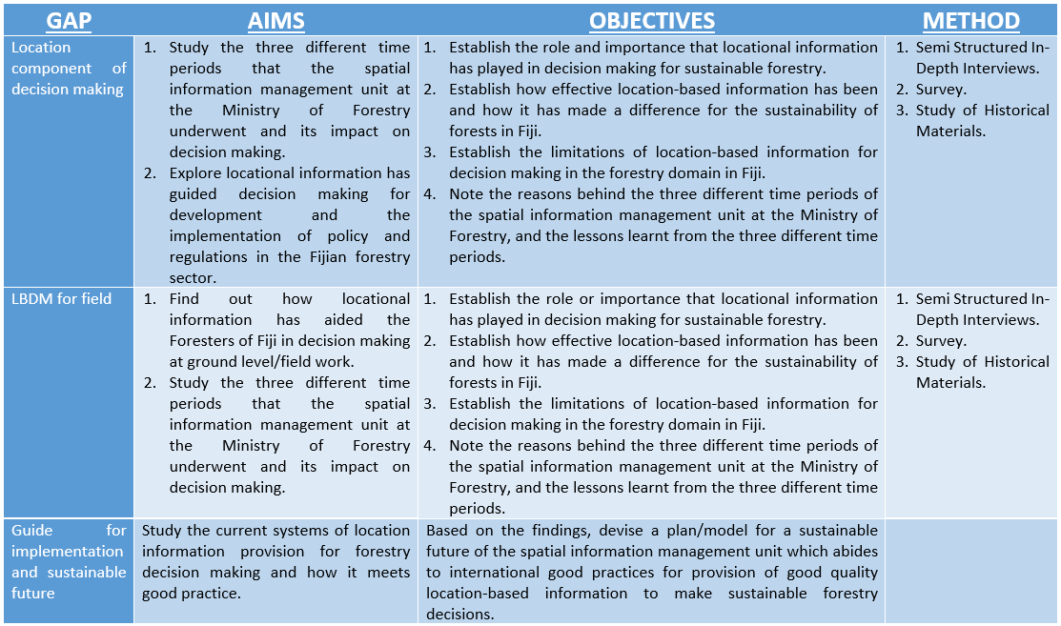 Table 1: The connection between the data gap, aims, objectives, and methodology used to fill the gaps.

5.0 Results and Discussion
There is significant evidence of location-based information being used in Forestry since the early 1990s. This information has been used to make field decisions and monitor reports and verify forest resources. They have also been used to build and drive policy level decision making and implementation of policies for the sustainability of Fijis forests. However, the timeliness, accuracy and quality of these information remain in question and how these factors impacted decision making is something I will be able to explore through my study.
Development and use of harvesting plan maps, forest extent information, forest and nature reserves information have also been popular. These are some things that have not gone through many changes over time as they were always needed for decision making. Over time it has had its ups and downs with different provision systems and usages. My study will explore in-depth its evolution through the different periods.
Other dependent locational information needed for decision making, such as protected areas, areas of national significance and many others, have also been present with other organisations in the country. However, the level of access of the Ministry and its timeliness of updates is in question and will be found out through my research.
A few problems have already been identified with preliminary interviews with two key people and my background knowledge. It can be mentioned that over time while location-based information has continually been used to make decisions for sustainable forestry in Fiji, there has not been management attention paid particularly to the location-based information provision systems and its development until recently. This can be seen from the rise and drop of information provision systems. Transitional arrangements and knowledge and skills retainer systems (if any were in place) have not worked.
Having a base with factual information on the issues and factors mentioned above, a clear guideline can be developed for the best provision and use of location-based information for decision making.

6.0 Timeline
The following is a tentative timeline for the completion of the dissertation. Full-time work on the dissertation starts in May of 2022, and a first draft is to be submitted in the last week of August. The final work is to be tentatively submitted by mid of September 2022.

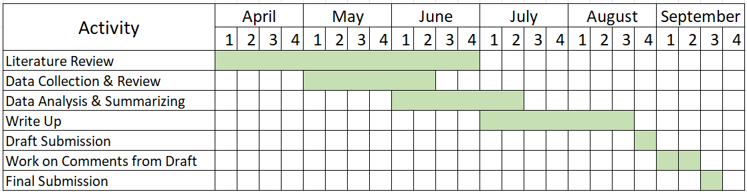

References
15.2.1 Progress Towards Sustainable Forest Management. Available: https://sdg.tracking-progress.org/indicator/15-2-1-progress-towards-sustainable-forest-management/ [Feb 3, 2022].
Ahmadi Sani, N., Babaie Kafaky, S., Pukkala, T. And Mataji, A. (2016) Integrated use of GIS, remote sensing, and multi-criteria decision analysis to assess ecological land suitability in multi-functional forestry. Journal of Forestry Research, 27(5), pp. 1127-1135.
Blicharska, M., Angelstam, P., Giessen, L., Hilszczański, J., Hermanowicz, E., Holeksa, J., Jacobsen, J.B., Jaroszewicz, B., Konczal, A., Konieczny, A., Mikusiński, G., Mirek, Z., Mohren, F., Muys, B., Niedziałkowski, K., Sotirov, M., Stereńczak, K., Szwagrzyk, J., Winder, G.M., Witkowski, Z., Zaplata, R. And Winkel, G. (2020) Between biodiversity conservation and sustainable forest management – A multidisciplinary assessment of the emblematic Białowieża Forest case. Biological Conservation, 248, pp. 108614.
Crossland M. (2008) Decision‐Making Effectiveness with GIS. In: Shekhar S., Xiong H. (eds) Encyclopedia of GIS. Springer, Boston, MA.
DFAT. (2021) Tropical Cyclone Yasa [Homepage of Australian Govt - Department of Foreign Affairs and Trade], [Online]. Available: https://www.dfat.gov.au/crisis-hub/tropical-cyclone-yasa [Feb 4, 2022].
Espey, J. Using evidence & data to drive action on the SDGs. SDSN http://unsdsn.org/news/2018/06/28/using-evidence-data-to-drive-action-on-the-sdgs/ (2018)
Feeney, M., Rajabifard, A. & Williamson, I. P. (2001). Spatial data infrastructure frameworks to support decision-making for sustainable development. Proceedings of the 5th Global Spatial Data Infrastructures, pp.1-15. Geography Institute of Colombia. https://doi.org/10.1007/978-0-387-35973-1_271
Food And Agriculture Organization of The United Nations, Sustainable Forest management. Available: https://www.fao.org/forestry/sfm/en/ [Feb 11, 2022].
Forstreuter, W. (2022) Interview with Mohammed Shorab, 24 January.
Geneletti, D. (2019). Multicriteria Analysis for Environmental Decision-Making. Anthem Press.
Horbiński T, Cybulski P, Medyńska-Gulij B. (2021) Web Map Effectiveness in the Responsive Context of the Graphical User Interface. ISPRS International Journal of Geo-Information. https://doi.org/10.3390/ijgi10030134
Ishtiaque A, Masrur A, Rabby YW, Jerin T, Dewan A. (2020) Remote Sensing-Based Research for Monitoring Progress towards SDG 15 in Bangladesh: A Review. Remote Sensing. 12(4):691. https://doi.org/10.3390/rs12040691
Janssen, R. And Uran, O. (2003) Presentation of information for spatial decision support A survey on the use of maps by participants in quantitative water management in the IJsselmeer region, The Netherlands. Physics and Chemistry of the Earth, Parts A/B/C, 28(14), pp. 611-620.
Jeong, J.S. (2018) Design of spatial PGIS-MCDA-based land assessment planning for identifying sustainable land-use adaptation priorities for climate change impacts. Agricultural Systems, 167, pp. 61-71.
Keenan, P.B. And Jankowski, P. (2019) Spatial Decision Support Systems: Three decades on. Decision Support Systems, 116, pp. 64-76.
Lewai, A. (2022) Interview with Mohammed Shorab, 31 January.
Liu, S., Bai, J. and Chen, J. (2019) Measuring SDG 15 at the County Scale: Localisation and Practice of SDGs Indicators Based on Geospatial Information, ISPRS international journal of geo-information, 8(11), p. 515–. doi:10.3390/ijgi8110515.
Macura, B., Suškevičs, M., Garside, R., Hannes, K., Rees, R. And Rodela, R. (2019) Systematic reviews of qualitative evidence for environmental policy and management: an overview of different methodological options. Environmental evidence, 8(1), pp. 24.
Martín-García, J., Diez J. (2012) Sustainable Forest Management: An Introduction and Overview, in J. M. Garcia, J. J. Diez (eds.), Sustainable Forest Management - Current Research, IntechOpen, London. 10.5772/45839.
National Conference on GIS Research UK, Andrew A. Lovett, and Katy Appleton. (2008) GIS for environmental decision-making. Boca Raton: CRC Press.
Pârvu, I.M., Cuibac Picu, I.C., Dragomir, P.D. And Pantan, R. (2021) Promoting Open Data services to decision-makers: Providing interactive data through Web Maps and Web Applications for Oradea city and Bihor County. IOP Conference Series: Earth and Environmental Science, 664(1), pp. 012073.
Questions and answers about GIZ. Available: https://www.giz.de/en/press/9785.html [ Accessed: Feb 3, 2022].
Sample, V. A. and Sedjo, R. A. (1996) Sustainability in forest management: An evolving concept, International Advances in Economic Research, 2(2), p. 165. doi: 10.1007/BF02295056.
Simao Da Graca Dias, E. (2007) The added value of contextual information in natural areas: Measuring impacts of mobile environmental information, PhD, Vrije Universiteit Amsterdam, Amsterdam. Available: https://research.vu.nl/en/publications/the-added-value-of-contextual-information-in-natural-areas-measur [Accessed: 19/02/2022]
Sousa, M., Almeida, M.F. And Calili, R. (2021) Multiple Criteria Decision Making for the Achievement of the UN Sustainable Development Goals: A Systematic Literature Review and a Research Agenda.
Teherani, A., Martimianakis, T., Stenfors-Hayes, T., Wadhwa, A., & Varpio, L. (2015). Choosing a Qualitative Research Approach. Journal of graduate medical education, 7(4), 669–670. https://doi.org/10.4300/JGME-D-15-00414.1
Varma, V.K., Ferguson, I. And Wild, I. (2000) Decision support system for the sustainable forest management. Forest Ecology and Management, 128(1), pp. 49-55.
World Health Organization (2015) Human health and climate change in Pacific Island countries.
Wu, B., Meng, X., Ye, Q., Sharma, R.P., Duan, G., Lei, Y. And Fu, L. (2020) Method of Estimating Degraded Forest Area: Cases from Dominant Tree Species from Guangdong and Tibet in China.
Yilmaz, K. (2013) Comparison of Quantitative and Qualitative Research Traditions: epistemological, theoretical, and methodological differences. European Journal of Education, 48(2), pp. 311-325.
Young, J.C., Marzano, M., Quine, C.P. And Ambrose-Oji, B. (2018) Working with decision-makers for resilient forests: A case study from the UK. Forest Ecology and Management, 417, pp. 291-300.
Ministry of Fisheries & Forests (2007) Fiji Forest Policy Statement. Suva: Government of the Republic of Fiji Islands.
United Nations, n.d. Sustainable Development - The 17 Goals. [Online] Available at: https://sdgs.un.org/goals [Accessed: March 3rd 2022].

