

Knowledge Management of Large Law Firms in China: From the Perspective of Organizational Culture

Student Number: 1806559
Module Title: Qualitative Research (LCDB7003)
Module Lecturer: Dr. Suman Saha

Part 1
Knowledge Management of Large Law Firms in China: From the Perspective of Organizational Culture

Abstract:
Organizational culture and knowledge management are concepts in the field of organizational research and management. There are many studies on the impact of organizational culture on knowledge management. However, there are few studies on the application of organizational culture to knowledge management in law firms, and most of them are from the perspectives of values and leadership. This study does not attempt to define the specific organizational culture of large-scale law firms, but evaluates the three interpersonal value orientations of lawyers affected by these large-scale law firms through qualitative research, which hinders or promotes the knowledge management of law firms.
From the perspective of organizational culture, the values pursued by each law firm are different. Even if the law firms with the same values on the surface, the value orientations felt by lawyers in the organization is not the same. Through interviews with lawyers from these large law firms，attitudes and actions of lawyers towards knowledge management can be understood from individualism orientation, hierarchy orientation and attachment orientation perspectives.

Introduction
Most companies attach importance to knowledge management. The goal is to obtain competitive advantage, improve marketing efficiency, improve customer focus or product innovation. Knowledge management usually refers to management practices with the main (or only) goal of creating, storing, disseminating and utilizing organizational knowledge (Davenport and Prusak 2000). Knowledge management practices can have a very diverse nature: they may include information technology, organizational structure and new human resources policies (Pandey and Chaudhary 2013). As an intangible asset, knowledge becomes a competitive strategic resource because of its uniqueness, path dependence, causal ambiguity, difficulty in imitation or substitution(Eriksson et al. 2000), thus becoming a logical goal of management's attention.
In recent years, China's legal industry has gradually attached importance to knowledge management, but the degree of attention is still insufficient, or little catching on of the concept of knowledge management and the value of the development of law firms. The essence of competition in law firms has become knowledge-based competition. Competitive advantage are from the effective development and scientific management of knowledge resources. "Knowledge management is one of the core competitiveness of law firms," said Lawyer Ye Xuan, senior partner of King & Wood Mallesons Law Firm. The experience of these lawyers is summarized, stored and reproduced. This is the difference between large law firms and the newly established law firms.
The biggest characteristic of the lawyer industry is the high mobility of talents. Culture is the key to how to maintain a strong driving force to achieve sustainable development under the impact of the economic environment transformation and the great tide of science and technology. The culture here refers to the formation of a shared organizational culture atmosphere, which then drives the construction of knowledge management, so as to enhance the competitiveness of law firms as a whole.
80% of knowledge management is related to human and organizational culture, and 20% is related to knowledge management technology (de Long and Fahey 2000). Therefore, organization existing culture is critical to the success of knowledge management. It provides a framework to help understand the psychosocial processes that control communication between employees and organizations, and may guide the design of interventions to successfully manage organizational knowledge.
So, the research question of this article:
How does organizational culture affect knowledge management in China's Large law firms?
Ahmady et al. (2016) considered that the influence of culture on knowledge has the following aspects: Firstly, there are many connotations of knowledge, but culture determines which knowledge is worth managing. Secondly, organizational culture also determines the willingness to exchange personal knowledge and organizational knowledge. Thirdly, culture determines the way knowledge is used and new knowledge is formed.
Although more and more people are conscious of the importance of culture to knowledge management, they lack the mechanism to know how organizational culture affects all aspects of organizational knowledge management by influencing employees' behavior. To address this gap, we can conduct qualitative research on large law firms, where managers and some lawyers try to answer the following sub-questions:
1. How do differences in cultural values, assumptions and preferences affect the way lawyers acquire and share professional knowledge?
2. How does different organizational cultures affect the way lawyers search for information, express knowledge and share it?
3. What are the cultural barriers affecting lawyers' knowledge management?

2. Literature review

2.1 Concept of Large Law Firms
Large law firms refer to law firms with more than 50 lawyers, also known as "omni-directional service" firms. In addition to lawyers, they also include managers, paralegals and general administrators. Large law firms can span many cities, States and even countries (Reuters 2014; The OHIO State University 2019).
The reasons for the study of China's large law firms are as follows:
1) As the leading lawyers in the legal industry, large law firms serve the global market and are the long-term research objects of researchers.
2) The large law firms should more concern about the construction of organizational culture and knowledge management, so that it is easier to obtain their information in this respect. Many small and medium-sized law firms have not formed their own organizational culture because of the small number of people.
3) From the experience of foreign countries, the business of large law firms has also increased in the economic depression (Wald 2012), and their ability to withstand risks is stronger, the reasons behind this are worth studying.

2.2 Knowledge Management of Large Law Firms

2.2.1 Knowledge Management Concept
Drucker (1999) pointed out that the most valuable assets of institutions in the 21st century, whether commercial or non-commercial, would be their knowledge workers and their productivity. Conner and Prahalad (1996) thinks Knowledge is regarded as the basis of organizational competitive advantage.
Knowledge is the thoughts, realities, concepts, data and technologies that are preserved in human memory. It is based on information obtained from experience, belief and individual value, and then forms in human thought. It can be combined with decision-making and action and will become mature and productive(Allameh et al. 2011). Davenport and Prusak (2000) regarded knowledge as unite of experience, values, information and expert opinions within which new experiences and information can be assessed and integrated. Knowledge separated into three classes：human knowledge, social knowledge and structured knowledge, and these knowledges are critical when make decision (de Long and Fahey 2000).
Gonzalez et al. (2017) considered knowledge management is a clear and systematic process. The process contained knowledge creation, collection, dissemination and application (Obeidat 2016), and to transform individual knowledge into collective knowledge effectively. Sharing knowledge and innovation are two important aspects of knowledge application. Davenport and Prusak (2000)believed knowledge management is the transformation of hidden knowledge into organizational assets that can be accessed and used by all personnel in an organization. Gandhi (2004) considered knowledge management as an effort to transform workers' knowledge (human assets) into public organization assets (basic intellectual property rights). Schein (2010) defined knowledge management is a process that organizations are allowed to create, validate, disseminate and use new knowledge. Whether at the technical or strategic level, the use of knowledge management activities will have an effective influence on the culture and productivity. Obeidat (2016) believed that knowledge management is the transfer of important information and professional knowledge of the organization, such as decision making, problem solving, learning and strategic planning.

2.2.2 Knowledge Management Process
Knowledge management is a dynamic and a systematic process. After gaining, organizing, accumulating, creating, storing, sharing, distribute and realize vague knowledge inside and outside of it, other employees can use it, make more efficient decisions and adapt to the market in work, and achieve goals more effectively (Kebede 2010; Raudeliūnienė et al. 2018). Some suggested two knowledge process models for knowledge management (Newman and Conrad 2000). Knowledge management system includes manual system and automation and related systems. It provides a framework for balancing the technologies and methods that provide value and integrating them into a whole. It helps analysts and designers better deal with the interests of stakeholders in the knowledge flow. By doing so, individuals, systems and organizations can better display intelligent activities in different contexts (Figure 1).
Base on the research, Raudeliūnienė et al. (2018) constructed a new organizational knowledge management model. He believed that researchers lack a clear understanding of the process, order, structure and feedback of knowledge management, which are vital for evaluating the process model of knowledge management, containing the beginning and end of the process. For large law firms, the process of knowledge management is similar to other enterprises.

Figure 1: General model of knowledge management processes

Resource: (Newman and Conrad 2000; Ahmady et al. 2016)

2.3 Organizational Culture
Cultural concepts are abstract. Culture creates people's internal mode of thinking and frame of reference. Culture is strong or weak, good or bad, good culture and strong culture are more effective for organizations (Schein 2010). Culture is like a person's character to an organization. We can derive results from behavior, but what drives him need to explore. Schein has increased awareness of culture, reflected on the role of the workplace as a behavioral intermediary, and demonstrated the positive role of cultural construction.
Organizational culture is important for understanding all the richness and diversity of organizational life. The central position of cultural concepts stems from the far-reaching importance of the common meaning of any coordinated action. Organizational culture is a group phenomenon effected by contextual elements. Schein (2010) defines culture as a shared basic hypothesis model acquired by a group in solving its external adaptability and internal integration problems. It has proved effective in solving such problems, so for new members, this hypothetical model is a correct way of perception, thinking and feeling when it comes to such problems. Organizational culture develops through the organization's attempt to solve the issues of internal integration and external adaptation. It is these contextual factors that make the organizational culture of different organizations unique. Researchers believed that a unit or a strong norm for organizational coherence is a unified cultural unit in an organization, which can connect and coordinate different parts of the organization (Meyerson and Martin 1987).
Every organizations have cultures, but some seem to have stronger cultures. People of different professions, such as lawyers and accountants, in addition to learning professional skills, will also acquire certain values and norms in their education and practice (Schein 2010).
The positive impact of organizational culture is that a strong and universal culture is conducted to all organizations, for it promotes organizational motivation, commitment, identity, solidarity and consistency, and can further promote the integration and coordination within the organization (Önday 2016).
Organizational culture also has some negative effects. The potential dysfunction of a strong culture, for example, NASA's organizational culture, resulting in serious errors in launching Challenger and Columbia (Balthazard and Cooke 2004). Strong culture and its associated internal control may lead individuals to make unrestrained demands on themselves and become obstacles to adaptation and change (Perrow 2015). Culture may also lead to the transfer of organizational goals or the formation of sub-goals, emphasizing norms of conduct and ways of doing things, so that the original goals of the organization are forgotten (Merton 1968).

2.4 The Impact of Organizational Culture on Knowledge Management
Schein (2010)believes that as intangible assets, knowledge assets are the fundamental source of value. Culture can maximize the value of employees' knowledge assets, Organizational culture is vital to input in organizational effective knowledge management and learning, because culture determines whether to support or impede knowledge creation and sharing. Culture promotes intellectual engagement and reasoning, including personal and organizational learning, create and apply new knowledge and the willingness of share knowledge. Previous research shows that organizational effectiveness also emphasizes culture can motivate and maximize its intellectual assets. Knowledge-intensive organizations such as the legal industry are particularly important (Önday 2016). Therefore, the most effective knowledge management strategies should focus on strengthening and developing organizational culture and establishing a knowledge-centered learning culture (Detienne and Jackson 2001). In addition, learning culture is also a strategic resource and evidence of organizational competitiveness.
The strategy of increasing tacit knowledge transfer ultimately based on the culture and values of the organization. In the long run, the more people who share knowledge, the more likely it is that organizations will recognize that they value and reward knowledgeable people. This is where knowledge management and change management intersect. As Snowden (2002) once said, knowledge cannot be coerced out of someone, it must be volunteered. Organizations seem to have a hard time learning that.
Some scholars analyzed through quantitative research. Pan and Scarbrough (1999) studied the performance of successful knowledge management methods from the perspective of social technology. Their research found that the role of organizational management and the people who use technology can better realize knowledge management than technology itself, and the organizational culture that defines new roles plays a key role in knowledge creation. Most scholars believe that culture has a dual role. Some researchers tested The Culture-KM relationship model through quantitative analysis (McCann and Buckner 2004; Allameh et al. 2011; Önday 2016). The results show that if the organizational culture and organizational structure, system, technology and skills/quality are consistent with the goal and direction, then the success of knowledge management is likely to follow to measure the efficiency, effectiveness and potential of the success of knowledge management. If organizational collaborators are not willing to share or exchange knowledge that is at variance with the mainstream culture they refer to, then regardless of whether they are professionals or what their common goals are, it is hard for knowledge management. Culture creates expectations of behavior, some of which lead to unconstructive interactions that ultimately impede knowledge management.
Some scholars explore the relationship through qualitative analysis (Goh et al. 2006). Through qualitative interviews, cultural factors such as collaboration, mutual trust, leadership and incentives/incentives were extracted to influence knowledge management in Malaysian companies. Ardichvili et al. (2006) argued that the degree of collectivism, competitiveness, the importance of face-saving, intra-group orientation, emphasis on power and hierarchy, and communication patterns could explain the differences in knowledge-seeking and sharing patterns.

2.5 Kluckhohn and Strodtbeck's Values Orientation Theory
A brief review of the relevant literature shows that a specific organizational culture is a necessary condition for the effective implementation of the knowledge management process. Effective culture is one that emphasizes the exchange, trust, interaction and creativity of knowledge that can be successfully managed.
However, there are different cultural classifications in organizational culture, which have different influences on knowledge management. Based on Kluckhohn and Strodtbeck's theory of value orientation, the author analyzes the influence of different organizational cultures on organizational knowledge management. Value orientation theory argues from a psychological perspective that values are the aspects of motivation caused by personal or cultural standards (Kluckhohn and Strodtbeck 1976). For all cultures must find the method to solve the problem, puts forward five problems: human orientation, the relationship between human and nature, orientation, time orientation, action orientation, interpersonal relationship orientation. Due to the complexity of the human organism as social, economic, and political, interactive performance influenced by many factors. An organization is a socio-economic system made up of people who come together for some common goals and their personal intentions (Li et al. 2013).
Kluckhohn and Strodtbeck (1976) proposed that human beings also have three orientations in dealing with human relations: individualism orientation, hierarchy orientation and attachment orientation. The orientation of individualism is characterized by individual autonomy, and individuals are regarded as unique individuals. In this orientation, individual goals and objectives are superior to group. If the organizational culture of law firms advocates the individual ability of lawyers, lawyers are more likely to conduct personal knowledge management, and they are unwillingness to share knowledge with others due to the replicability and uniqueness of knowledge. Hierarchical orientation focuses on groups, whose goals are superior to those of individuals. Groups are divided into different levels, and the status of each group remains stable over time. The hierarchical approach is often found in corporate law firms, and the influence of such culture and knowledge management is often mandatory. Attachment orientation also focuses on the group, but it is not a group with time continuity, but a group member who has the closest relationship with the individual in time and space. In fact, this orientation only considers people's group membership rather than specific people. In the implementation of the affiliated orientation of law firms, high requirements are put forward for the leadership and management ability of law firm partners, and the influence of culture on knowledge management is in an uncertain state. If the management ability is strong, the organization's strong culture can promote the knowledge management, on the contrary, the weak culture will hinder the knowledge management.

2.6 Gap and Framework
Previous studies only analyzed the impact of organizational culture on knowledge management, but the literature did not explain how organizational culture affects knowledge management in different law firms by influencing the orientation of interpersonal relationships. Through qualitative research on large-scale law firms, semi-structured interviews with law firms' managers and some lawyers are conducted to explore the deeper reasons why different organizational cultures have such different impacts on knowledge management.
Based on the theoretical framework of value orientation theory, this paper puts forward the factors that organizational culture may affect organizational knowledge management, and puts forward a design model for realizing this integration（Figure 2）.
Figure 2: The model of impact of organizational culture on knowledge management
Individualistic Culture
Knowledge Acquisition

Knowledge Share
Organizational Culture
Hierarchical culture
Knowledge Maintain

Knowledge Use
Affiliated Culture

Knowledge Creation

Resource: Author

2.7 Summary
Large law firms have become harder to create and maintain corporate-wide cultural norms because of their size and cross-regional distribution. And it may erode the influence of organizational culture. Henderson and Galanter (2008) argues that large law firms have different market trends. At present, China's big law firms are also experiencing a confused transition period. On the one hand, large law firms attach great importance to knowledge management strategy, but also actively implement it. On the other hand, law firms are not aware of the influence of organizational culture. For most lawyers, when law firms become more corporate, the thinner corporate culture cannot contain the centripetal force of internal competition, which is strengthened by the constant liquidity threat, seriously affecting the effectiveness of law knowledge management. Therefore, through the case study of several law firms, we can explore the reasons and mechanisms of how organizational culture affects the knowledge management of large law firms in China. In the next chapter, the philosophy, methodology, sampling strategies, data collection and analysis techniques of this study are discussed.

Research Method
In the previous chapter, we introduced organizational culture, knowledge management and the relationship between them. In this study, due to the exploratory nature, qualitative and multi-case research methods will be adopted.

3.1 Philosophy and Approach
Interpretivism developed because positivism lacked in meeting the needs of social scientists(Collis and Hussey 2013). Interpretivism holds that social reality is shaped by human choice and has subjectivity. This research paradigm is also called descriptive or phenomenological approach(Dan Remenyi et al. 1998).
This study will adopt an interpretive paradigm, because it conforms to two aspects of this study. Firstly, organizational culture is a dynamic process, including direct interaction between law firms and lawyers, interaction between lawyers, and interaction between lawyers and law firms and external environment. In this process, both law firms and lawyers should adapt to the changes of external and internal environment. This process of change is constructed by interaction between individuals and organizations. This includes seeking and understanding the subject in a social context. In this change, lawyers will adopt different value orientations. Secondly, knowledge management is also a process of organizational-employee interaction. Lawyers' value orientation influences this process. There is no clear theory in this field. In order to understand the mechanism behind the impact, researchers need to interact with the subjects. So interpretivism is applicable.

Ontology is the study of existence, focusing on the essence of reality and the recognition of the world (Crotty 1998). This paper adopts the interpretive paradigm, ontology as following：
the lawyers' perception of organizational culture and the impact of such value orientation on knowledge management, which is composed of interaction in the organizational and social environment. This paper discusses how these three different value orientations promote or hinder knowledge management in organizations. Because of the different organizational culture perceived by each lawyer, they have different attitudes and methods to the knowledge management of the organization based on this understanding. This motivation contains different reasons and purposes. That is to say, it was constructed by them.

Epistemology deals with the nature and form of knowledge (Cohen et al. 2011).
The epistemology of this research as follow：
This study insists on studying the influence of organizational culture of law firms on organizational members from the perspective of intentional behavior, so organizational members have different value orientations. This study advocates an objective interpretation of the meaning of lawyer's behavior from the perspectives of beliefs, wishes and intentions of human behavior. Through semi-structured interviews, lawyers' data on culture and knowledge management are collected and coded, which is also the core of the hermeneutic approach (Bryman and Bell 2015). In this study, we can find the cultural factors that affect the law firms’ knowledge management. To understand the role of interpersonal value orientation in knowledge management from the perspective of new theory of organizational culture. From the perspective of epistemology, we draw participants' world views from this research topic, and draw lawyers' views by analyzing and establishing the connection between the two concepts of organizational culture and knowledge management.

Bryman and Bell (2015) divided research into two types: induction and deduction. Inductive methods include developing theoretical frameworks based on raw data collected for research. However, deductive methods involve the use of theory to collect and analyze data. The research methods of this paper are summarized. From the literature review, we find that the perception of organizational culture is depended on the impact of corporate ethics culture and corporate variables on lawyer's value and behavior. This kind of research regards law firm culture as a homogeneous and independent variable, often relying on the relevant individual firms. Limited data cannot clearly explain how to influence knowledge management. We need to summarize a new mechanism of organizational culture integration based on previous theories and new data collected to enrich the previous theoretical framework. Such research will help enrich organizational theory.

3.2 Methodological Design
Qualitative research is effective when researchers aim to collect data related to attitudes, motivations and opinions (Yin 2009). Quantitative research is appropriate when the objective is to test theory through statistical analysis. The author of this paper decides to adopt qualitative research methods for the following reasons:
1) Qualitative research must interact with subjects, ask questions, find out their attitudes and motivations, and clarify their significance. The purpose of this study is to explore the individual behavior affected by culture, what impact it will have on knowledge management, and construct a new meaning.
2) The empirical study of cultural dynamics is essentially difficult (Chambliss 2010). Qualitative research is not only a methodological issue, but also a need for theoretical development. This article will understand and explain the social reality of lawyers' view of knowledge management, which is also an ever-changing attribute of value orientation.

Experiments, surveys, case studies, action studies, grounded theory, ethnography, archival studies, cross-sectional studies, longitudinal studies and participatory inquiries are general research strategies used in business management (Easterby-Smith et al. 2015). Saunders et al. (2009) pointed out that the research strategy must match the objectives of the research question, the scope of existing knowledge in the field to be studied, the available time and resources, and the philosophical base of the researcher. Whatever strategy you choose, the most vital consideration will be to choose the optimal strategy for study (Saunders et al. 2009; Yin 2009). In Yin's opinion, case studies are the preferred research strategy when it is difficult to distinguish phenomena from contexts.
The reasons for adopting case study in this study are as follows:
Yin (2009) argues that case study design should consider the following points: (a) the concentrate of the study is to answer questions about how and why; (b) you can't control the behavior of the people involved in the study; (c) The degree of focus on contemporary issues.
This study try to answer 1）How do differences in cultural values, assumptions and preferences affect the way lawyers acquire and share professional knowledge? 2）How does different organizational cultures affect the way lawyers search for information, express knowledge and share it? 3）What are the cultural barriers to knowledge management for lawyers? From the research questions, we can see that they mainly consist of the way and reason of the research questions, and they tend to be case studies.
The second condition that Yin (2003b) found was the extent to which researchers controlled actual behavioral events. In this study, the researchers did not control the situation in which lawyers were affected by organizational culture or their behavior in influencing knowledge management. Researchers are always on the outside record of the case and observe it. In addition, it is impossible to investigate the influence of attorneys' value orientation factors (independent variables) on dependent variables (knowledge management).
Further, the question of investigation is contemporary, and how and to what extent lawyers are affected by organizational culture, which has an impact on knowledge management and meets the third condition of case study selection.

The reasons for adopting the multi-case study method in this study are as follows:
The design of case studies has been criticized for its lack of robustness as a research tool, so it is essential to craftsmanship the design of case studies. According to the different problems, researchers can use either single case design or multi-case design. A single case applies to situations where scientific investigation was previously impossible and represents an extreme or unique case of well-expressed theory. The disadvantage of single case design is that it cannot provide general conclusions. When the purpose of research is to describe, construct or test theory, multi-case design is desirable. Yin (2009) describes how to use multiple case studies, (a) to predict similar results (text replication) or (b) to predict comparative results for predictable reasons (theoretical replication).
This study chooses law firms according to the following criteria:
Firstly, the selection of large law firms in Jiangxi Province which in central China. In this study, the number of lawyers in one law firm exceed 50. In the selection of law firms that meet the requirements, we have selected two national large law firm branch: Beijing Dentons (Nanchang) Law Firm, Beijing Yingke (Nanchang) Law Firm; two local law firms in big city of Jiangxi: Jiangxi QZ&WD Law Firm, Jiangxi Yuzhang Law Firm; two local law firms in small city of Jiangxi: Jiangxi Shengyi Law Firm and Jiangxi Nanfang Law Firm (Table 1). Secondly, after the firm was identified, the researchers will contact the law firm's managers or partners by telephone and explain the study to them. In order to alleviate any concerns of participants in the study, the researchers will review the research methods to ensure anonymity of the results. Participants will also be informed that they can get the final copy of the paper, consult the bibliography and use the survey results which help assess their own company's behavior and organizational dynamics, organizational culture and knowledge management.
Table 1: Law Firms in This Research
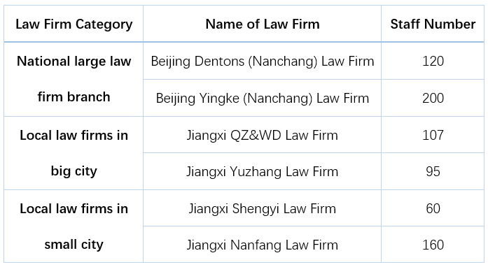
Resource: Author

3.3 Data Collection
Data collection for qualitative research including observation, text or visual analysis (e.g. from books or videos) and interviews (individuals or groups) (Bornstein et al. 2013).
For most case studies, the main data source is participant interviews. In addition to interview data, determine what challenges to collect. In this study, lawyers tend to adopt a method worthy of in-depth analysis for the goal of knowledge management. Therefore, semi-structured interviews are the preferred data source.
The semi-structured interviews in this study are divided into two stages: pilot interviews and formal interviews (Table 2). The subjects of the pilot interview are a senior partner of a law firm and a general lawyer. The pilot interview will guide the questionnaire design used in the survey phase. The investigation will modify the inappropriate problems. Later, formal interviews will be conducted with senior partners, lawyers and administrators of six law firms through purpose sampling. This interview try to explain the survey results in more detail. In each interview, the principle of voluntariness and confidentiality will be followed, and the interview time will be limited to half an hour to one hour. In order to ensure that the content of the interview is controlled, an interview guide will be prepared.
Using case study strategy, multiple data sources can be used for data collection and analysis, so researchers could solve research objectives and research problems well. Stake (1995) discussed two other potential sources of data for case studies: observation and document review.
Table 2: Formal Interview Design
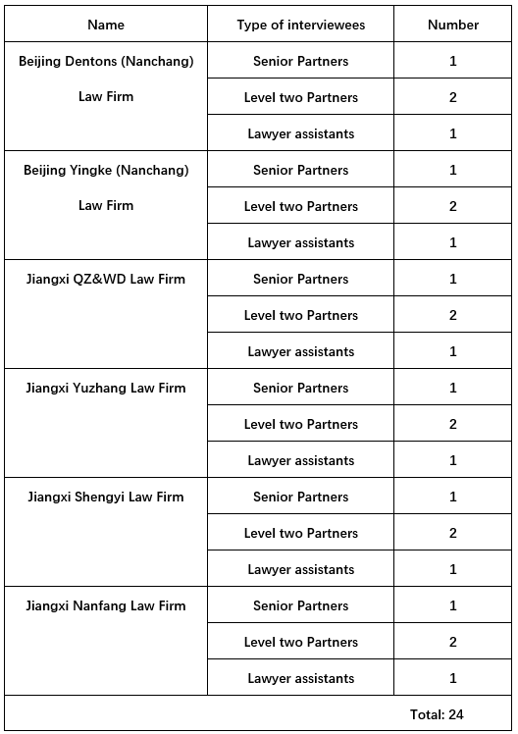

Individuals in a case can be observed in a natural environment. In this study, researchers will go to each law firm to observe their actions, including managers and lawyers. With their consent, researchers can observe their actions in meetings or other activities held in their offices, law firms (for example, the lawyers' meeting of Yuzhang Law firm gathers to discuss and share their experiences every Wednesday afternoon). Observations are different from those recorded during interviews. As Stake (1995) pointed out, interviews are conducted by researchers, while observation involves taking notes and recording unsupervised, natural events.
Another source of data is document review. Every law firm has its minutes and regulations. With the consent of its managers, researchers will consult these data. In addition, law firms will set up chat groups, and researchers can apply for membership and record what they will say in group.
In case studies, data from these multiple sources are aggregated rather than processed separately in the analysis process. Each data source is a piece of the puzzle, which can help researchers understand the whole phenomenon. Because different data links are woven together to facilitate a deeper understanding of the case, the aggregation made research results more strength.

3.4 Data Analysis
Data collection and analysis are synchronous activities in qualitative research. The data acquisition and analysis process are recursive and dynamic. But analysis is not over when all the data are collected. Data analysis is a complex process that involves moving back and forth between concrete data and abstract concepts (Merriam and Tisdell 2016). As the research progresses and all the data are collected, the analysis turned more in-depth. According to Merriam and Tisdell (2016)"qualitative data analysis is mainly inductive and comparative". The goal of data analysis is that the process of understanding meaning from data, and to answer research questions.
The following two points should be paid attention to in data analysis:
Beginning analysis during data collection: If not timely analysis of data, data quality will be parsimonious and illuminating(Merriam and Tisdell 2016). Data collection and analysis is indeed a continuous process that can be extended indefinitely. Data is saturated when continuous data collection does not yield new information or insight into the phenomenon you are studying.
Managing data: As researchers collect data it is important to code it according to whatever scheme is relevant to study, and according to the theoretical framework that informs the study. Researchers also need to keep track of their thoughts, musing, speculations, and hunches as you prepare your data for analysis.

In the absence of standards, we adopted Merriam and Tisdell (2016) methods to introduce analysis process.
Category construction: From the beginning of interviews and records, take notes beside the data and expand as much as possible. This process of marking off bits of data that might be relevant to answering research questions is also called coding. Because researchers are just beginning the analysis, it is often called open coding. Assigning codes to pieces of data is how researchers begin to construct categories. Try to group those comments and notes that seem to go together. This process also called axial coding (Merriam and Tisdell 2016).
Sorting categories and data: Dozens of tentative categories are generated at the start of the analysis, and when assigning code, topic, or category names to the data, these categories should be compiled in a separate memo, and then code, topic, or category names are assigned to the data, and compiled in a separate memo, keeping those notes. researchers will rename the categories. After that, they will need to sort through all the conspiracy evidence. Create file folders and add category name. During this process, research will use computer programs, such as Nvivo, to store, sort, and retrieve qualitative data.
Naming the Categories: Classification design is an intuitive and systematic process. Every research has a certain theoretical framework. That is to say, every research is based on some literature, which can help us to put forward a goal statement and research questions. Because the category, subject or research results can provide answers to the questions, so it is necessary for us to study the classification design. The names of these categories are in line with the direction of research. Categories should be sensitizing and conceptually congruent(Merriam and Tisdell 2016).
Notice the number of categories: the number of categories should be manageable. The fewer categories, the higher the level of abstraction, and the easier it is for researchers to communicate findings to others. Five or six themes will be suitable(Creswell 2012).
Becoming more theoretical: analysis at this level involves making inferences, developing models, or generating theory. The process is called “glue observables and unobservables”(Miles et al. 2014). As categories and their attributes are simplified and refined and then linked together, analysis moves toward models or theories that explain the meaning of data.
Computers can help data analysis: computers have a great ability to organize large amounts of data, facilitate analysis, and facilitate communication among research team members. Bogdan and Biklen (2007) argued that the computer program was only an organization or classification tool, rather than an analysis for researchers. But Gibbs (2013) deem that CAQDAS (computer assisted qualitative data analysis software) can help researchers. Researchers can allocate code to data fragments for retrieval, saving a lot of time and energy. By drawing visual models, researchers can visualize the relationship between code and topic, and can be used for mixed method research.

3.5 Case study Validity and Reliability
Yin (2009) proposed some measures to improve the robustness of qualitative research, these approaches can be used in the following ways:
- Construct validity
- Use multiple sources of evidence during data collection phase, make the researcher free from bias(Flick 1992).
- In the process of data collection, the chain of evidence is established, and everything observed is recorded during the interview (Hirschman 1986).
- Find specific concepts to define the scope and object of the study, review the draft at the stage of report writing, and improve unclear issues and aspects(Yin 2009).
- Internal validity
- Display illustrations and charts，within-case analysis, the cross-case and cross-nation pattern matching, to assist in interpreting data during the analysis phase (Miles and Huberman 1994).
- Cross-check the results to ensure the internal consistency of the results (Yin 2009). Merriam and (Tisdell 2016) describes various types of triangulation to help with internal effectiveness.
- External validity
- Using (words or theory) replication logic in multiple cases at the research and design stage (Eisenhardt 1989)，
- Defining the scope and boundary of the research and design stage is helpful to achieve a reasonable analysis overview in the research and design stage(Merriam and Tisdell 2016).
- Contrast evidence and existing theories when analyze data, summarize the scope and contribution of the study(Yin 2009).
- Reliability
- Give full consideration to the theories and ideas at each stage of the study.
- To ensure the consistency of research issues and research design characteristics in the research and design stage.
- Record and observe as correctly as possible. It can be applied to recording equipment and other tools. Improve the draft case study design through pilot studies testing and apply to peer review(Lecompte and Goetz 1982; Yin 2009).

In order to solve the structural validity of this study, data were collected from multiple sources, including interviews with lawyers, direct observation of law firms, and access to relevant records and documents. Since this study is exploratory, Yin (2009) believed that intrinsic validity cannot be used in descriptive and exploratory case studies. External validity refers to the establishment of a category that summarizes the results of research under this category(Yin 2009). In order to solve the problem of external validity, text replication and theoretical replication logic are adopted. In case studies of law firms, different characteristics of law firms are taken into account in order to produce similar findings, so that different results can be compared.
The more important question for qualitative research is “whether the results are consistent with the data collected” (Merriam and Tisdell 2016). The reliability of this study will be relied on the following methods: First, draw up a research plan. Secondly, the process of research and data collection and analysis are recorded in detail, and the results of research are objectively recorded. Thirdly, keep interviews, observation notes, documents and archives.

3.6 Ethic
Difficulties inherent in qualitative research can be alleviated by recognizing and using established ethical principles, especially autonomy, beneficence and justice (Milinki 2000). Ethic should be carried out from the beginning of research.
Autonomy: In qualitative research, this principle is followed by informed consent, which means a reasonable balance between over-notification and under-notification(Kvale 1996).
Beneficence: The second ethical principle closely related to research is good and harm prevention. For example, in my research, when inquiring about interpersonal relationships, we should be careful not to hurt the feelings of the interviewees.
Justice: The principle of justice refers to equal sharing and fairness. An important and unique feature of this principle is the avoid exploit and maltreat of participants. For example, when we analyze data and think that a concept comes from a participant, we should request permission to use the concept. Another way is to listen to minorities and vulnerable groups.

Limitation
This study was conducted in China. If it is based on the background of other countries, Hofstede's national cultural model should be taken into account. The interviewees may provide different results when conducting interviews. In addition, the sample size of this interview is relatively small, and the interviews are conducted for the personnel of large law firms. It is not clear whether there is any reference significance for small and medium-sized law firms.

Conclusion
Through reviewing the academic literature, we find that few academic papers apply the research of organizational culture to law firms. This study attempts to answer how organizational culture affects the knowledge management activities of law firms. If knowledge management strategy is not supported by organizational culture, it may fail in the implementation stage. Facts have proved that culture is an extremely powerful factor in the process of strategy implementation and change management. In fact, the difficulty of cultural change is that the best strategy can only succeed if it is accompanied by profound and drastic cultural change or supported and coordinated with the strategy. Organizational culture is not stagnant and changes with time. A good organizational culture enables members of an organization to share common values. The development of sub-culture will conflict with other cultures within the company or within the company itself. An effective way to create a positive organizational culture is to reduce uncertainty, increase organizational collaboration, and build organizational trust. In today's legal environment, it is not easy to develop a culture that promotes the development of law firms and a working environment that makes everyone professionally and economically satisfied. Before implementing change, they should realize whether their culture is positive or negative.

Part 2

Choose Qualitative or Quantitative?

- Comparison of Qualitative and Quantitative

1.1 Similarity
- Qualitative and quantitative research belong to sociological methods, which generally analyze and explain problems by comparison. (Bickman and Rog 2009).
- Researchers use similar elements in their work. They all rely on theoretical frameworks and are very concerned about preciseness.
- Both methods collect and study data in natural Settings. Each method is influenced by the researcher. Because researchers make choices about information. Therefore, no matter what method is chosen, researchers have a great influence in determining the results of the study.
- Both quantitative and qualitative research can be used to test theories and generate hypotheses and theories. Quantitative research is more used to test hypotheses and theories than qualitative theory.
- Statements can be used as qualitative quantitative data. Data collected from open questions can also be used as the basis for quantitative research. Both methods are measurements of a limited number of specific variables. This means that a unique approach is limited only by the specific variables it measures.

1.2 Difference

1.2.1 Different Philosophy
The philosophy and paradigm of qualitative research and quantitative research are different, which can be distinguished from ontology, epistemology, research methods and research purposes.

Ontology
Qualitative research design assumes that knowledge is not independent of intellectuals, but social constructed, and that reality is neither static nor fixed. Because the reality of different cultural groups based on their own world outlook or value system is diverse, there are many explanations or perspectives for any event or situation (Shiping 2015).
Quantitative research adopts positivism. The ontological position of positivism is realism. The logic of differences between groups with different characteristics explains an action (Shiping, 2015). Realism refers to the view that objects exist independently of the known. Therefore, discoverable reality exists independently of researchers (Scotland 2012).

Epistemology
The epistemology of qualitative research is a subjectivism denpended on the phenomena of the real world. The world does not exist independently of our understanding of it. Knowledge is generated by exploring and understanding the social world of the subject, paying attention to their meaning and interpretation. Researchers also constructed meanings and explanations based on participants' understanding. The research process is considered to be inductive reasoning to a large extent(Ritchie et al. 2003; Ormston et al. 2013).
The epistemology of quantitative research is one of the epistemologies of objectivism. Positivists believe that absolute knowledge of objective reality can be found. The researcher and the subject are independent entities. Meaning exists only in the object, and the researcher aims to obtain this meaning. Scientific paradigm is the basis, because scientific propositions are depended on data and facts(House 1991), and the research process is largely deductive.

1.2.2 Different Research Steps
In qualitative analysis, reading literature is based on the experience of predecessors to establish a keen sense of touch and multiple perspectives, not to guide their own research design, nor to verify the correctness of the theory in the literature, through literature researchers to identify research issues, provide a new framework for research issues, collection and analysis of data (see Table 1).

Table 1: Qualitative Research Steps
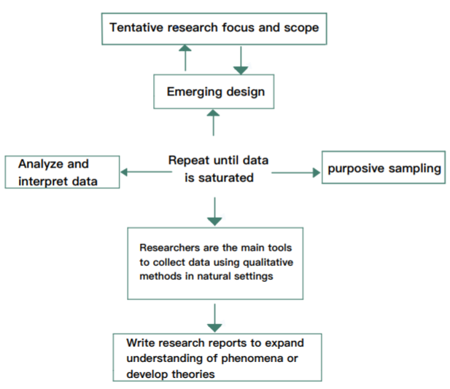
Resource: Author,Marshall and Rossman (2016), Niu (2018)

In quantitative analysis, the research framework is guided by reading the literature, conceptualization and operability of the research topics, then research questions are formed and hypotheses are put forward. In order to verify hypotheses, relevant data are collected and analyzed (see Table 2).

Table 2: Quantitative Research Steps
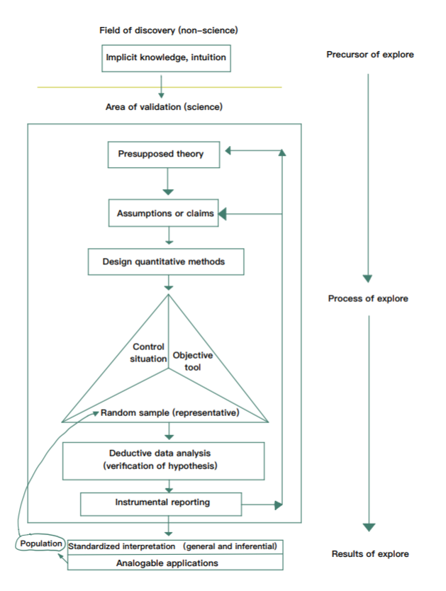
Resource: Author, Guba and Lincoln (1989), Niu (2018)

1.2.3 Different Sampling Strategies
For both qualitative and quantitative surveys, sampling strategies seem fundamentally different. Quantitative research uses probability sampling, also known as representative sampling, to select participants. Nonprobability sampling was used in qualitative research, of which purposive sampling was the most frequently used(Mihas 2019). Other methods like convenience sampling, quota sampling, snowball sampling.

1.2.4 Different Analysis Methodology
The most commonly used methods of qualitative data analysis are content analysis, narrative analysis, discourse analysis and grounded theory. Content analysis is an empirical approach that follows the rules of content analysis and a step-by-step model(Mayring 2000) . Narrative analysis regards stories as the representation of events, uses this method to analyze the form and content of narrative data, and extracts the key elements (Mihas 2019). Discourse analysis is used to examine meaning in research interviews, texts or therapeutic meetings. It examines the orderly way individuals interpret and understand themselves and the social world (Burck 2005). Grounded theory is an analytical method that uses systematic procedures to develop and induce a phenomenon rooted in real data (Burck, 2005).
The two most commonly used methods of quantitative data analysis are descriptive statistics and inferential statistics. Descriptive statistics can help researchers understand the phenomena of interest and use this knowledge to rank possible causal mechanisms, generate hypotheses and intervention strategies, interpret the results of causal studies, diagnose problems that need to be solved for practitioners and decision makers, and identify new problems that need to be studied (Loeb et al. 2017). Inferential statistics includes various statistical significance tests that researchers can use to infer from sample data. According to the expected purpose of the tests, these tests can be divided into three basic categories: evaluating differences, examining relationships and making predictions. The decision of which program to use is, to a certain extent, determined by the research questions or research designs (Allua and Thompson 2009).
- Which is Easier to Use?
None of the qualitative and quantitative studies is easier to use. This is because any kind of method has its advantages and disadvantages (Appendix 1), but there is no omnipotent method.
Quantitative methods are mostly based on realistic considerations and take quantitative discovery as a data supplement to enhance the reliability of qualitative results. In my opinion, it is related to the general preference for data among academics and readers. After all, quantitative methods are still the mainstream and the stronger side in academia.
I will also consider cost constraints. In quantitative research, data acquisition and sample selection require a large amount of human, financial and material input, and the number of participants involved in the survey process is also more, so it is more difficult to coordinate and ensure quality. Relatively speaking, data collection can be accomplished by relying on oneself or a small team in qualitative analysis. But this does not mean that it is difficult to quantify and easy to characterize. Case tracking and participatory observation in qualitative research are also very time-consuming and painstaking, and it is difficult to do well without certain determination and perseverance.
Therefore, I believe that only when we know many skills and understand their respective strengths and weaknesses, can we flexibly use different methods to solve practical research problems and solve them better.
- Which Do I Prefer to Use in Doctoral Research?
In my paper, I will use qualitative and quantitative analysis methods.
Firstly, my thesis is to explore the value orientation of the people behind the organizational culture, which requires qualitative interviews to obtain data and find meaning. After the qualitative research, I can measure the influence of organizational culture (independent variables) on all dimensions of knowledge management (dependent variables) through quantitative research and questionnaire collection. Qualitative and quantitative research also conforms to triangulation. triangulation can make the paper more reliable and valid. Triangulation includes data triangulation, investigator triangulation, method triangulation and theoretical triangulation(Atieno 2009). There are two types of triangulation, one is within-method triangulation, the other is between-method triangulation, which using the method of combining the two to measure the same variable can make up for the possible shortcomings of a single method (Atieno, 2009).
Secondly, quantitative methods have the advantage of identifying factors and combinations of factors, so as to help us determine which of the different "causal paths" is more likely to be correct. In contrast, the empirical hypothesis of qualitative research must have three parts: factors (including time and space), factors interaction and mechanism. The unique advantage of qualitative method is that it can solve the problem of mechanism, although it can also help us to identify factors and combinations of factors. Therefore, more and more good research is the combination of qualitative, quantitative and other methods (Atieno, 2009).

Reference
Ahmady, G.A. et al. 2016. ScienceDirect Effect of organizational culture on knowledge management based on Denison model. Procedia - Social and Behavioral Sciences 230, pp. 387–395.
Allameh, M. et al. 2011. The relationship between organizational culture and knowledge management. Procedia Computer Science 3, pp. 1224–1236.
Allua, S. and Thompson, C.B. 2009. Inferential Statistics. Air Medical Journal 28(4), pp. 168–171.
Ardichvili, A. et al. 2006. Cultural influences on knowledge sharing through online communities of practice. Journal of Knowledge Management 10(1), pp. 94–107.
Atieno, O.P. 2009. An Analysis of the Strengths and Limitation of Qualitative and Quantitave Research Paradigms. Problems of Education in the 21st Century 13, pp. 13–18.
Balthazard, P.A. and Cooke, R.A. 2004. Organizational culture and knowledge management success: Assessing the behavior-performance continuum. In: Proceedings of the Hawaii International Conference on System Sciences.
Bickman, L. and Rog, D.J. 2009. The SAGE handbook of applied social research methods. 2nd ed. Thousand Oaks: SAGE.
Bogdan, Robert. and Biklen, S.Knopp. 2007. Qualitative research for education : an introduction to theories and methods. Pearson A & B.
Bornstein, M.H. et al. 2013. Sampling in Developmental Science: Situations, Shortcomings, Solutions, and Standards. Developmental review : DR 33(4), pp. 357–370.
Bryman, Alan. and Bell, E. 2015. Business research methods. 4th ed. Oxford University Press.
Burck, C. 2005. Comparing qualitative research methodologies for systemic research: the use of grounded theory, discourse analysis and narrative analysis. Journal of Family Therapy 27(3), pp. 237–262.
Cohen, L. et al. 2011. Research methods in education. New York: Routledge.
Collis, Jill. and Hussey, Roger. 2013. Business research : a practical guide for undergraduate &amp; postgraduate students. UK: Macmillan Education.
Conner, K.R. and Prahalad, C.K. 1996. A Resource-Based Theory of the Firm: Knowledge Versus Opportunism. Organization Science 7(5), pp. 477–501.
Creswell, J.W. 2012. Research Design: Qualitative and Quantitative Approaches. 4th ed. California: Sage Publications.
Crotty, Michael. 1998. The foundations of social research : meaning and perspective in the research process. Sage Publications.
Dan Remenyi et al. 1998. Doing Research in Business and Management:An Introduction to Process and Method. SAGE.
Davenport, B.T.H. and Prusak, L. 2000. Working knowledge: how organizations manage what they know. Boston: Harvard Business School Press.
Denzin, N.K. 1989. The research act : a theoretical introduction to sociological methods. 3rd ed. Prentice Hall.
Detienne, K.B. and Jackson, L.A. 2001. Knowledge Management: Understanding Theory And Developing Strategy. Competitiveness Review An International Business Journal incorporating Journal of Global Competitiveness 11(1).
Drucker, P.F. 1999. Knowledge-Worker Productivity: The Biggest Challenge. California Management Review 41(2), pp. 79–94.
Easterby-Smith, M. et al. 2015. Management and business research. SAGE.
Eisenhardt, K.M. 1989. Building Theories from Case Study Research. The Academy of Management Review 14(4), pp. 532–550.
Eriksson, K. et al. 2000. Path dependence and knowledge development in the internationalization process. Management International Review 40(4), pp. 307–328.
Flick, U. 1992. Triangulation Revisited: Strategy of Validation or Alternative? Journal for the Theory of Social Behaviour 22(2), pp. 175–197.
Flick, U. 2011. Introducing research methodology : a beginner’s guide to doing a research project. Sage Publications.
Gandhi, S. 2004. Knowledge Management and Reference Services. The Journal of Academic Librarianship 30(5), pp. 368–381.
Gibbs, G.R. 2013. Using software in qualitative analysis. In: SAGE Handbook of Qualitative Data Analysis. London: SAGE, pp. 277–295.
Goh, G. et al. 2006. The Effects of Culture On Knowledge Management Practice: A Qualitative Case Study of Msc Status Companies. Kajian Malaysia XXIV(2), pp. 97–128.
Gonzalez, R.V.D. et al. 2017. O Processo de Gestão do Conhecimento: uma pesquisa teórico-conceitual. Gestão & Produção 24(2), pp. 248–265.
Guba, E.G. and Lincoln, Y.S. 1989. Fourth generation evaluation. Sage Publications.
Haraway, D. 1988. Situated Knowledges: The Science Question in Feminism and the Privilege of Partial Perspective. Feminist Studies 14(3), pp. 575–599.
Henderson, W. and Galanter, M. 2008. The Elastic Tournament: A Second Transformation of the Big Law Firm. Stanford Law Review 60(6), pp. 1867–1930.
Hirschman, E.C. 1986. Humanistic Inquiry in Marketing Research: Philosophy, Method, and Criteria. Journal of Marketing Research 23(3), pp. 237–249.
House, E.R. 1991. Realism in Research. Educational Researcher 20(6), pp. 2–9.
Kebede, G. 2010. Knowledge management: An information science perspective. International Journal of Information Management 30(5), pp. 416–424.
Kluckhohn, F.Rockwood. and Strodtbeck, F.L. 1976. Variations in Value Orientations. Greenwood Press.
Kvale, S. 1996. Interviews : an introduction to qualitative research interviewing. Sage Publications.
Lecompte, M.D. and Goetz, J.P. 1982. Problems of Reliability and Validity in Ethnographic Research. Review of Educational Research 52(1), pp. 31–60.
Li, B. et al. 2013. Knowledge Management and Organizational Culture: An Exploratory Study. Creative and Knowledge Society 3(1), pp. 65–77.
de Long, D.W. and Fahey, L. 2000. Diagnosing cultural barriers to knowledge management. Academy of Management Perspectives 14(4), pp. 113–127.
Loeb, S. et al. 2017. Descriptive analysis in education: A guide for researchers.
Malterud, K. 2001. Qualitative Research: Standards, Challenges, and Guidelines. Lancet 358, pp. 483–488.
Marshall, C. and Rossman, G.B. 2016. Designing qualitative research. 6th ed. SAGE Publications.
Maxwell, J.A. 2012. Qualitative research design : an interactive approach. SAGE Publications.
Mayring, P. 2000. Quantitative Content Analysis. Forum: Qualitative Social Research 1(2), p. Art (20).
Mihas, P. 2019. Qualitative Data Analysis. In: Oxford Research Encyclopedia of Education. Oxford University Press.
McCann, J.E. and Buckner, M. 2004. Strategically integrating knowledge management initiatives. Journal of Knowledge Management 8(1), pp. 47–63.
Merriam, S.B. and Tisdell, E.J. 2016. Qualitative research : a guide to design and implementation. San Francisco: John Wiley & Sons.
Merton, R.K. 1968. Social theory and social structure. New York: The Free Press.
Meyerson, D. and Martin, J. 1987. Cultural Change: An Intergration of Three DifferentI Views. Journal of Management Studies 24(6), pp. 623–647.
Miles, M.B. et al. 2014. Qualitative data analysis : a methods sourcebook. SAGE.
Miles, M.B. and Huberman, A.M. 1994. Qualitative data analysis : an expanded sourcebook. 2nd ed. CA: SAGE.
Milinki, A. 2000. Cases in Qualitative Research. Journal of Nursing Scholarship 33(1), pp. 93–96.
Newman, B.D. and Conrad, K.W. 2000. A Framework for Characterizing Knowledge Management Methods, Practices, and Technologies.
Niu, W. 2018. Qualitative Research Method and Paper Writing. 2nd ed. Tai Wan: Double-leaf Gallery.
Obeidat, B.Y. 2016. Exploring the Relationship between Corporate Social Responsibility, Employee Engagement, and Organizational Performance: The Case of Jordanian Mobile Telecommunication Companies. International Journal of Communications, Network and System Sciences 9(9), pp. 361–386.
Önday, Ö. 2016. Organization Culture Theory - From Organizational Culture of Schein to Appreciative Inquiry of Cooperrider and Whitney. Elixir International Journal (October)
Ormston, R. et al. 2013. Qualitative research practice : a guide for social science students and researchers., pp. 1–25.
Pandey, S. and Chaudhary, V. 2013. Knowledege Management in Indian Law Firms. . Review of Knowledge Management 3(12), pp. 4–10.
Pan, S.L. and Scarbrough, H. 1999. Knowledge Management in Practice: An Exploratory Case Study. Technology Analysis & Strategic Management 11(3), pp. 359–374.
Perrow, C. 2015. Complex Organizations: A Critical Essay. ECHO POINT Books & MEDIA.
Raudeliūnienė, J. et al. 2018. Knowledge Management Process Model. Entrepreneurship and Sustainability Issues 5(3), pp. 542–554.
Reuters, T. 2014. Types of Law Firms. Available at: http://hirealawyer.findlaw.com/choosing-the-right-lawyer/types-of-law-firms.html [Accessed: 25 August 2019].
Ritchie, J. et al. 2003. Qualitative research practice : a guide for social science students and researchers. SAGE.
Saunders, M.N.K. et al. 2009. Research methods for business students. 5th ed. Prentice Hall.
Schein, E.H. 2010. Organizational culture and leadership. San Francisco: Jossey-Bass.
Scotland, J. 2012. Exploring the Philosophical Underpinnings of Research: Relating Ontology and Epistemology to the Methodology and Methods of the Scientific, Interpretive, and Critical Research Paradigms. English Language Teaching 5(9), pp. 9–16.
Shiping, T. 2015. Beyond the qualitative and quantitative debate. Journal of Public Administration 4.
Snowden, D. 2002. Complex Acts of Knowing: Paradox and Descriptive Self-awareness. Journal of Knowledge Management 6(2), pp. 100–111.
Stake, R.E. 1995. The art of case study research. London: Thousand Oaks.
The OHIO State University 2019. Small And Medium Size Law Firms. Available at: https://moritzlaw.osu.edu/careers/students/start-your-job-search/legal-career-options/law-firms/small-and-medium-size-law-firms/ [Accessed: 25 August 2019].
Wald, E. 2012. Smart Growth: The Large Law Firm in the Twenty-First Century. Fordham Law Review 80(6), pp. 2867–2915.
Yin, R.K. 2009. Case study research : design and methods. SAGE.

Appendix 1

Advantages and Disadvantages of Qualitative and Quantitative

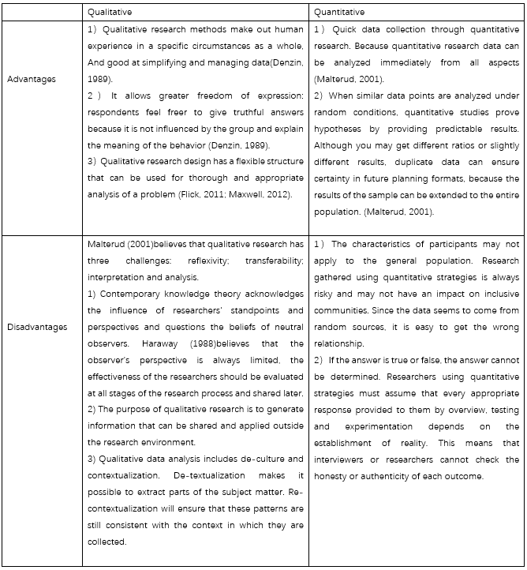
Resource：Author

