
aSSIGNMENT 2 Menu EnGINEERING (practical task)
Module Code BMIH4002

STUDENT NAME: ADAMACHE ANAIDA
STUDENT ID:2026381
LECTURER NAME: Muhammad Cassamo

Table of Contents
Part 1: Restaurant Concept 2
Restaurant concept 2
Target audience 2
Reasoning behind menu choices 2
References 4

Part 1: Restaurant Concept

Restaurant concept
A restaurant namely Wind Stay is going to open under the Hotel Trinity Hotel chain in London, UK which will provide different types of fruits, a range of meats including chicken, pork, cakes, soup, crisps and beverages. The restaurant is an upscale restaurant which is offering a full table service and a very good quality of our cuisine and an perfect ambiance at our facilities.The menu is a static menu and is offering the clients every day a good experience culinary and fresh and tasty dishes. It will include different types of menus for starters, main courses and dinners as per customer demand. Starter will have baked products like cheese muffins, sandwiches, bacon rolls and pork sausage. It is identified that foreign foods like Spaghetti, Chinese foods, Jerk Chicken, and peri-peri are mostly preferred by the UK people (Greatbritishmag.co.uk, 2023). The restaurant will also offer Italian food like Spaghetti and Chinese foods because these foods have also demand in the UK market. The competitors of WindStay restaurant are small restaurants like The Barbary, Evelyn's Table, Casamia, Bocca di Lupo, Salon, Sparrow, Llewelyn’s and Ceviche (Standard.co.uk, 2023).

Target audience
The target audience for Trinity Hotel in the UK will be frequent restaurant visitors and people who dine out frequently in restaurants. The Trinity City Hotel in the heart of Clapham Old Town offers both domestic as well as continental cuisine for its visitors (Trinitycityhotel.com, 2023). Considering this aspect, world cuisine enthusiasts can also be segmented as the target audience of Trinity Hotel. Apart from regular customers, food content creators can also be targeted as Trinity Hotel has options for both regular as well as Courtyard Restaurant Diner that attracts new-age food content creators. Apart from that, beverage enthusiasts can also be targeted for the Brunswick Bar Diner section in Trinity Hotel.

Reasoning behind menu choices
The restaurant will design a menu as per the demand of the UK people who are restaurant visitors, cuisine enthusiasts and people associated with food delivery services. It has been noticed that the most popular foods in the UK are fish, roast chips, chicken, soups, beef stew, steak, potato fries, eggs, pudding, sea bass and apple crumble (Pantazi, 2023). Henceforth, these menus will be included in the menus of WindStay restaurants. The menus have been designed based on the estimated budget and the products which can promote profit (Penne and Goedemé, 2021). The menu has been planned by considering the choices of both vegan and non-vegan people and therefore different types of menus have been designed for people with different tastes. Italian food like pizza and spaghetti will be provided to the customers as this food has a high popularity in the UK. Dessert will include baked cake and muffins as muffin is one of the popular foods in the UK which are demanded by food delivery people. Flyers will be used for advertising the restaurant.
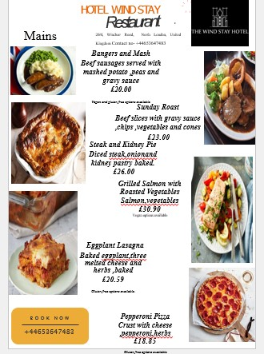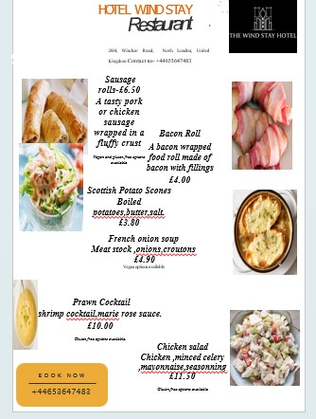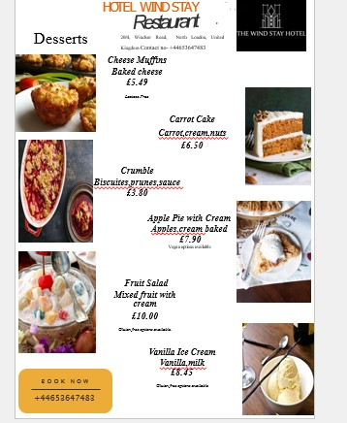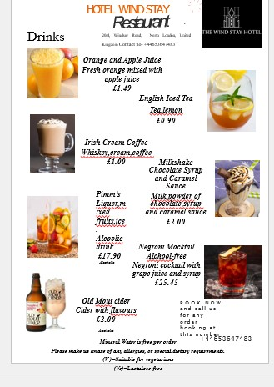

References
Greatbritishmag.co.uk. (2023). “7 foreign foods that Brits love”. Available at: https://greatbritishmag.co.uk/uk-culture/7-foreign-foods-that-brits-love/ [Accessed on: 26th May 2023]
Pantazi, C. (2023). “9 foods that British people are obsessed with, according to Google”. https://www.independent.co.uk/life-style/food-and-drink/9-foods-that-british-people-are-obsessed-with-according-to-google-a7079656.html [Accessed on: 26th May, 2023]
Penne, T. and Goedemé, T., (2021). Can low-income households afford a healthy diet? Insufficient income as a driver of food insecurity in Europe. Food Policy, 99, p.101978.
Standard.co.uk. (2023). “21 of our favourite small restaurants, from The Palomar to Otto’s”. Available at: https://www.standard.co.uk/reveller/restaurants/best-small-restaurants-london-a4538416.html [Accessed on: 26th May 2023]
Trinitycityhotel.com, (2023). “Our Dining Menus”. Available at: https://www.trinitycityhotel.com/en/menus/ [Accessed on: 26th May 2023]

