John Hamilton

Explosively Formed Penetrator (EFP) Shaped Charge Simulation Assignment

Abstract
This report will discuss the modelling and critical analysis of an Explosively Formed Penetrator (EFP). The report will review the construction on an EFP and the stress and strain features using the simulation software Abaqus. A literature review has been completed on EFP shaped charges and the differences between unique design material properties. Two 2D design will be analysed and discussed as well as a 3D design of the EFP which are selected from the 2D exercises completed. All designs in the report are shaped to have a hemispherical shape which contrasts from a conical shape of a shaped charge. This will make the results differ to those from a regular shaped charge. This design allowed the frontal point of the explosive detonation to increase in size which also reduced the detonation velocity of the EFP. A comparison was made between the uses of TNT and PETN to further analyse the difference between the High explosive charges. The 2D designs both created unexpected results which are viewed as unrealistic for an EFP design. Both EFP designs create an aerodynamic jet as well as a slug from the designs. The TNT creation achieved a velocity of detonation of 5855 ms⁻¹ whereas the PETN EFP velocity of detonation was recorded as 8951 ms⁻¹ so the PETN 2-dimensional simulation was created in a 3-dimensional format.
The 3-dimensional PETN EFP simulation was successful and produced the anticipated results for the shape and the liner. The 3-dimensional design produced a projectile jet. Abaqus also allowed for results to be analysed and the points where stress occur on each of the components cause significant (strain) on the material. The results for the final design produced a projectile jet which was recorded at a velocity of 5025ms⁻¹; However, the simulation did abort prior to completion of the simulation.

Table of Contents
Abstract 1
List of Tables 4
1 Introduction 5
2 Shaped Charges 5
2.1 What is a Shaped Charge? 5
2.2 Types of Shaped Charges 7
2.3 Explosively Formed Penetrators (EFPs) 7
2.4 Flexible Linear Shaped Charges (FLSC) 7
2.5 Tandem Warheads 8
3 Method 9
3.1 2-Dimensional EFP Part Creation 9
3.2 Assembly 11
3.3 Material Properties Selection 11
3.4 Meshing of the 2-Dimensional Model 13
4 Initial Simulation of 2-Dimensional EFP using TNT as HE Filler 13
5 2-Dimensional Design Change 16
5.1 Redesign of Liner 16
5.2 Redesign of Casing and EFP Assembly 17
6 Simulation Results of 2-Dimensional EFP 20
6.1 Results using TNT as HE Filler 20
6.2 Results using PETN as HE Filler 21
7 Analysis of 2-Dimensional EFP designs 23
7.1 TNT Simulation Analysis 23
7.2 PETN Simulation Analysis 28
8 PETN 3-Dimensional model 30
8.1 Meshing of the 3-dimensional model 30
8.2 Results of 3D model 31
8.3 Analysis of 3D model 33
8.3.1 EFP Liner 34
8.3.2 Casing Analysis 36
9 Conclusion 39
9.1 2-Dimensional Designs 39
9.1.1 TNT Design Conclusion 39
9.1.2 PETN Design Conclusion 39
9.2 3-Dimensional Design 39
9.3 Future Recommendations 39
References 40

Figure 1- Shaped Charge Detonation Process [10] 8
Figure 2-: EFP and Linear Shaped charge detonation comparison [12] 9
Figure 3-FLSC Detonation Process [13] 9
Figure 4-Tandem Shaped Charge Diagram [14] [15] 10
Figure 5-Original design for the Liner 11
Figure 6- Casing of EFP 11
Figure 7- Original HE Design 12
Figure 8- Assembled EFP Design 13
Figure 9- Initial EFP Meshing 15
Figure 10- EFP Simulation 16
Figure 11 - EFP Simulation Progression 17
Figure 12-EFP defect 17
Figure 13-Copper Liner Re-design 18
Figure 14-Redesigned Liner Meshing 19
Figure 15- Redesign of EFP Casing 19
Figure 16- Redesigned Casing Meshing 20
Figure 17- Assembly stage of EFP Design 21
Figure 18-Diagram 38: TNT Filler Result 22
Figure 19- TNT Filler in EFP Jet Velocity 23
Figure 20- Result of 2-dimensional PETN simulation 24
Figure 21- Velocity of Detonation of PETN Jet in EFP 24
Figure 22-Element Distortion in TNT Model 25
Figure 23-TNT EFP Distortion 26
Figure 24- Stress in TNT Simulation 27
Figure 25- Extruded View of TNT EFP Simulation 27
Figure 26- Initial Pressure put on the liner………………………………………………………………………………………………………………………….29 Figure 27-Progressive Pressure put on the liner 29
Figure 28-Emergence of Jet…………………………………………………………………………………………………………………………….29 Figure 29-Jet length increasing 29
Figure 30-Expansion of Casing 30
Figure 31-PETN stress Wave detonation process 31
Figure 32- Initial Deformation of the Casing 31
Figure 33- 3-Dimensional Meshing 32
Figure 34- Liner Re-Meshing 33
Figure 35- PETN 3D Results 34
Figure 36- PETN 3-Dimensional Design Jet Velocity Graph 35
Figure 37- PETN 3D Initial Detonation 36
Figure 38-Pressure Impacting the Liner 37
Figure 39- Progression of EFP Simulation 38
Figure 40- Pressure on Casing 3D PETN Model 39
Figure 41-Pressure Increase throughout the Simulation 40
Figure 42- Maximum Principle Stress of PETN Design 40

List of Tables

Table 1-Definitions 5
Table 2-Material Properties 11
Table 3-Copper Material Properties 11
Table 4-TNT Material Properties 12
Table 5-Stainless Steel Casing Material Properties 12
Table 6-PETN Material Properties 12

Introduction
This report will analyse the impact of changing the explosive in an Explosively Formed Penetrator (EFP) shaped charge using the simulation software Abaqus. Trinitrotoluene (TNT) and Pentaerythritol tetranitrate (PETN)explosives were selected based on their performance characteristics. The simulations were initially conducted in 2-dimensional (2D) form with one design taken forward into 3-Dimensional (3D) form. The analysis was initially conducted in 2-dimensional (2D) with and 3-dimensional (3D). This report will also explore the creation of the models including how they were meshed. The analysis was focused on the jet formation of the EFP. Types of stress are listed below in Table 1 for future reference during analysis stage:
Table 1-Definitions
Word | Definition
Stress | A force which acts on the unt area of a material [1].
Strain | Deformation of a material under stress [2].
Direct Stress | The stress which is produced by loading directly. Typically changes the volume of the material. Includes: tension, compression, and shear stress [3].
Direct Strain | A result of opposing forces which change the length of a material [4].
Axial Stress | Stress that changes the length of a body [5].
Tensile Strength | Maximum stress which a material can undertake prior to detachment/breaking, when it is pulled or stretched [6].
Deformation | The action of distorting.
Maximum Principal Stress | The material will fail when the maximum normal is exceeded by a materials Ultimate Tensile Strength (UTS) [7].

2 Shaped Charges

2.1 What is a Shaped Charge?

Shaped charges are explosive devices which use an explosive load to collapse a liner, this therefore creates a high velocity jet that has the potential to penetrate or perforate deep into metals, concrete structures or other materials [8]. Shaped charges can be used in many industries including military and the petroleum and natural gas industry.

The Shaped charge is constructed by combining 3 components: Casing, Liner, and a High Explosive (HE). The liner is typically made of copper or tungsten in most shaped charges, and this is due to maximising the penetrability into the target material from the jet [9]. The liner should be a material property which is ductile and malleable. The case of a shaped charge is typically made from a steel casing or another solid metallic property that can support a detonation wave to complete its projected flight path. The shaped charge High Explosive (HE) can be made from different materials, but the composition must be able to sustain detonation from a fuze or a detonator and produce a shockwave great enough to convert the liner into a spiked head. Typical material properties for HE charges are TNT, PETN or HMX. The detonation process is shown below in figure 1.

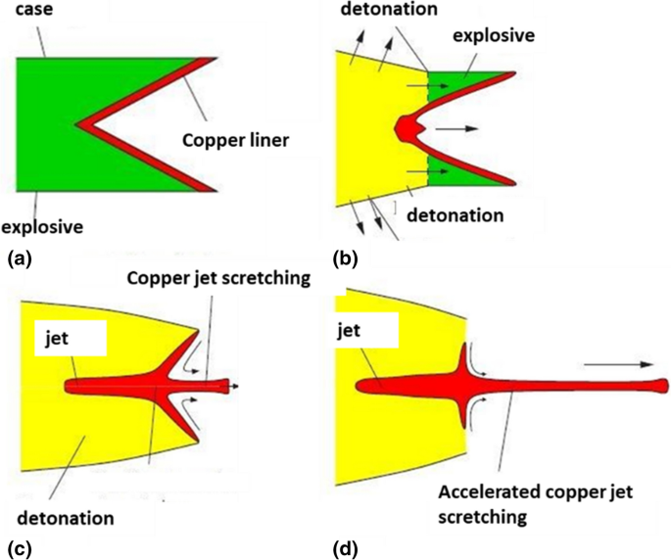
Figure 1- Shaped Charge Detonation Process [10]

Types of Shaped Charges
There are multiple types of shaped charges which are used in the military sector and the natural gas industry with all unique purposes. Different types of shaped charges include: EFPs, flexible linear shaped charges and tandem warheads.

Explosively Formed Penetrators (EFPs)
Explosively Formed Penetrators (EFPs) are used in a range of munition systems to destroy armour, masonry, and other targets [11] . The EFP relies on the aerodynamic ability of the design and are launched from considerably great distances from the target. EFPs are uniquely shaped charges as the liner in an EFP is hemispherical to the conical shape of a linear shaped charge. This therefore allows the liner to make a greater a greater contact on the suitable target. They are capable of penetrating armour with a longer standoff time. However, this should have a lesser velocity of detonation compared to the linear shaped charge and this is analysed later in this report. The detonation process of an EFP is demonstrated below in figure 2 in comparison to a conical shaped charge design.

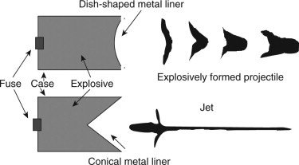

Figure 2-: EFP and Linear Shaped charge detonation comparison [12]

Flexible Linear Shaped Charges (FLSC)
The force from a flexible linear shaped charge radiates in all directions, the geometry of the edged side concentrates into pushing forces into a direction which therefore creates an effective cutting jet. These shaped charges can be used to penetrate or impact a variety of targets. Other applications of the flexible linear shaped charge include rocket thrust and flight termination. This shaped charge is applied in the emergency egress of aircraft. The linear shaped charge has the potential to use HE such as: RDX, HMX, CH6, PBXNS and HNS. This shaped charge can also produce a velocity of detonation of 6000-8000 ms⁻¹ (dependant on the HE and liner material properties used [13]. An example of a linear shaped charge is shown below in figure 3 during the detonation process.

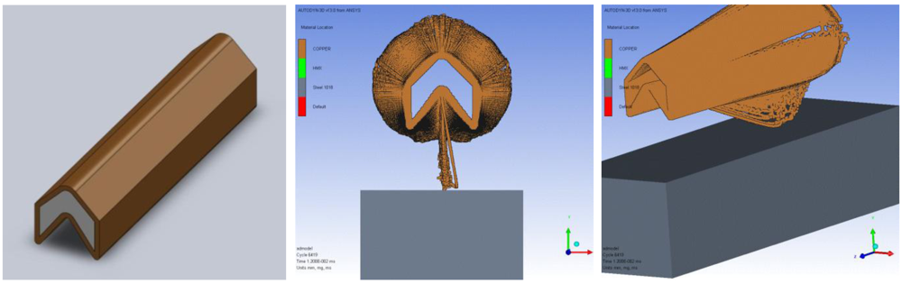
Figure 3-FLSC Detonation Process [13]

Tandem Warheads

Tandem warheads are anti-tank missiles which use two shaped charges to penetrate through the target material. In the tandem warhead system configuration, two shaped charges namely a main shaped charge and a precursor shaped charge are fitted in the same missile and are detonated one after the other with pre-determined time delay. Both these shaped charges are fitted at a specified distance keeping in view the warhead system constraints. It is integral to protect the secondary shaped charge (Main Shaped Charge) from the blast effects of the primary shaped charge (Precursor shaped charge) during the specified time delay between the detonations of two shaped charges [14]. Shown below is a tandem shaped charge diagram in figure 4.

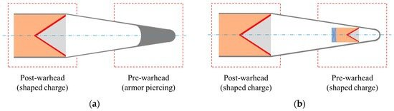
Figure 4-Tandem Shaped Charge Diagram [14] [15]

Method

2-Dimensional EFP Part Creation
To create the EFP model on Abaqus, the 3 components were generated individually before being assembled. Three separate parts had to be sketched and then assembled as part of the construction phase of the EFP. Firstly, a liner was created using the sketch tool and saved to allow the user to reuse the sketch when creating other components. The liner was made from copper as this is a ductile material which would be capable of projecting the HE energy into a target. Figure 5 presents the original liner design which was created during the sketching stage.

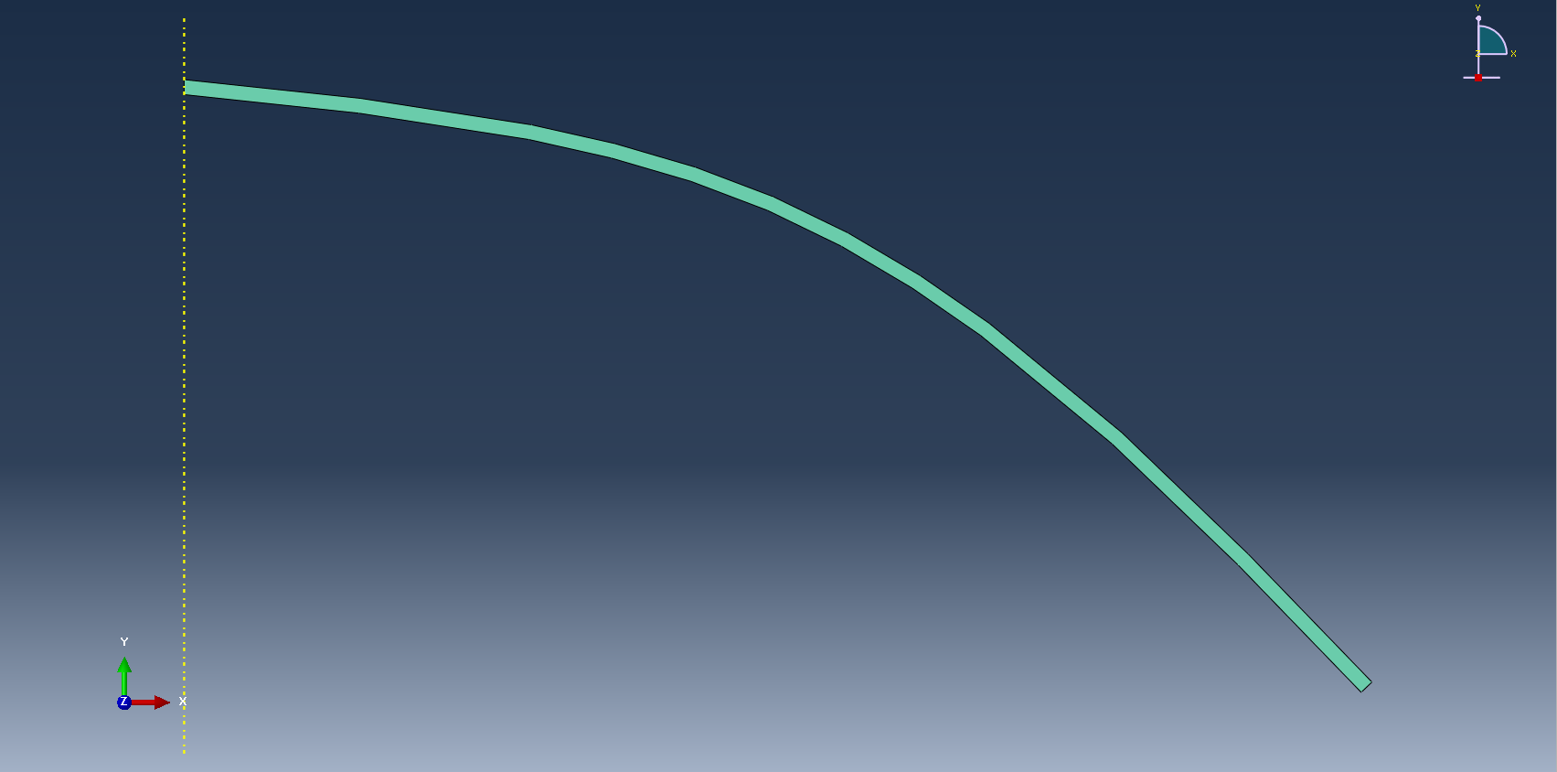
Figure 5-Original design for the Liner
Using this liner, the casing of the EFP could be sketched and created as a part. This therefore would allow for the HE energy created from the HE detonation to be contained within the casing. This would minimalize energy losses and direct energy into the centre point of the liner. Figure 6 presents the original sketch design of the steel casing.

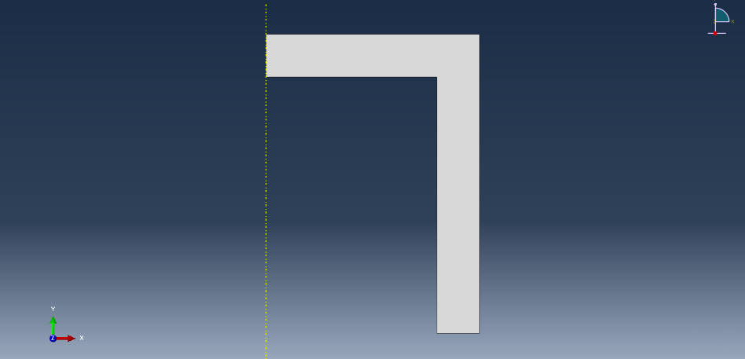
Figure 6- Casing of EFP
Using the casing and the liner the HE could be created by sketching round the previously sketched components to create the HE material shape. This is the alternating material during the 2D testing process. The original test would be undertaken using a HE filler of TNT and a second test would be undertaken using PETN as the explosive material. Figure 7 shows the original sketch of the HE designs.

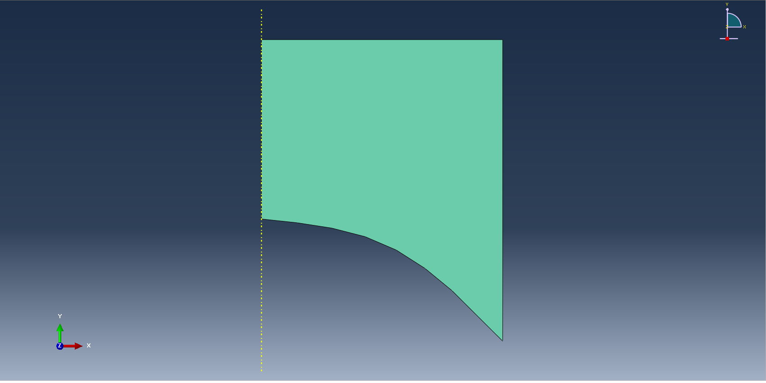

Figure 7- Original HE Design

3.2 Assembly
The components were then assembled using the ‘create assembly’ function on the simulation software Abaqus. The three components previously created was selected and this therefore showed a completed EFP shaped charge design. The coordinates of the detonation point were selected. The tools and then query section was selected which allowed the node selection above the HE charge point of detonation to be selected in an X, Y and Z coordinated format. Figure 8 demonstrates the assembled EFP for the original design.
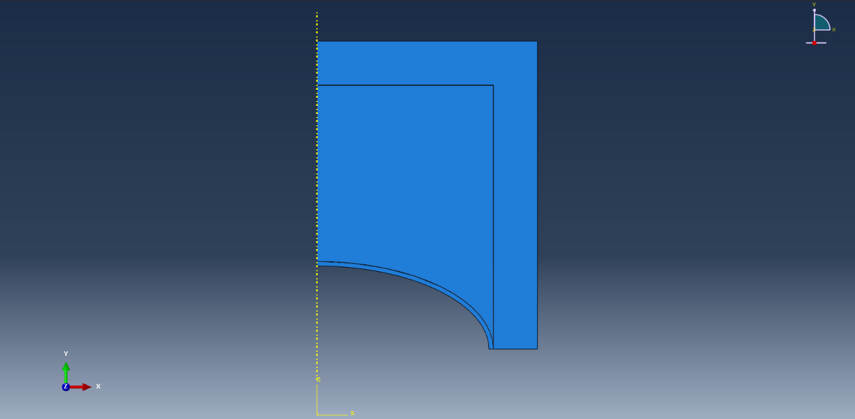
Figure 8- Assembled EFP Design

3.3 Material Properties Selection
The next step in the EFP configuration process was assigning the material properties researched in the literacy search. Each section was assigned to the correct material property. Each sections material property values are listed below in tables 1.
Table 2-Material Properties
Casing | Liner | Explosive Composition
Density | Density | Density
Elastic properties (isotropic type) | Shear Elastic properties (Johnson Cook) | Equation of state (sub option to detonation point)
Johnson Cook plastic (Johnson Cook hardening) | Johnson Cook plastic properties
Hardening JC properties | Equation of state (Change type to Us-Up/ mie Gruneisen values)

Table 3-Copper Material Properties
Density | 8690g/cm³ [16]
Shear Elastic Properties (Johnson-Cook) | 39 Gpa
Johnson Cook Plastic Properties | A:90 Mpa  B:292 Mpa  n:0.31  m:1.09  Melting Temperature:1083K [17]  Transition Temperature: 298K [16]
Equation of state (mie gruneisen values) | c0:3490  s:1.49 [17]  Gamma0: 2.02

Table 4-TNT Material Properties
Density | 1630 g/cm³ [18]
Equation of state (detonation point) | Detonation Wave Speed: 6390 ms⁻¹  A: 373.8 Gpa  B: 3.75 Gpa  Omega: 0.35  R1: 4.15  R2:0.95  Detonation Energy Density: 4183 GJkg⁻¹  Pre-detonation Bulk modulus: 4.3437Gpa  Detonation point: 0, 0.17, 0

Table 5-Stainless Steel Casing Material Properties
Density | 7700 g/cm³ [19]
Elastic Properties (isotropic type) | Young’s Modulus: 21 Gpa  Poissons ratio: 0.3
Johnson-Cook plastic (Johnson-Cook hardening) | A: 310 Gpa [20]  B: 1 Gpa  n: 0.65  m: 1  Melting Temperature: 1733K  Transition Temperature: 293K
Hardening JC Properties | C: 0.07 [20]  Epsilon dot: 0.01

Table 6-PETN Material Properties
Density | Mass Density: 1160 g/cm⁻³ [21]
Equation of state (detonation point) | Detonation Wave Speed: 5600 ms⁻¹  A:5370 Gpa  B:201Gpa  Omega:0.28  R1:6  R2:1.8  Detonation Energy Density: 7.2GJkg⁻¹  Pre-detonation Bulk Modulus: 85.2 Gpa  Detonation point: 0, 0.17, 0.

3.4 Meshing of the 2-Dimensional Model
The meshing of each component of the shaped charge was crucial to the success of the EFP simulation stage. The steel casing was given a global mesh to start as this provided the shockwave given from the HE detonation to focus the energy on the liner which provides accurate results. This therefore meant that a larger and thicker mesh was created for the steel casing.

For the HE composition meshing it was integral to create a larger meshing method between the interaction from the steel casing and the top of the HE filler. Local meshing method was created between the HE filler and the liner. This allowed the concentration of the mesh to contact the liner and produce the desired outcome. In other simulations the larger mesh in this region meant that the HE filler for the 2D design would penetrate all angles of the EFP.

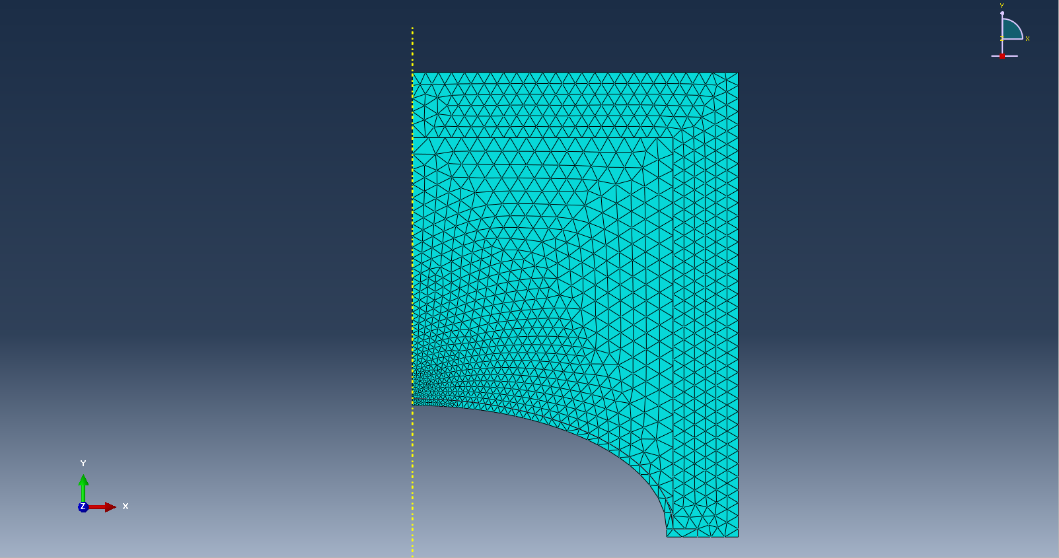
In terms of the copper liner, the meshing towards the centre of the liner was very fine with multiple layers and this gradually was reduced at side of the EFP design using a local meshing method. This therefore allows the liner shape to disform into the anticipated shape designed. This is presented below in figure 9.
Figure 9- Initial EFP Meshing

4 Initial Simulation of 2-Dimensional EFP using TNT as HE Filler
For the simulation to occur a job was created for the testing stage, the simulation was set to complete 100 steps however only 29 were managed. The first simulation aborted at an exceptional rate of 2.002 Gpa when it should have reached a time stamp of 2.003 Gpa should have been achieved. Some results from the simulation could be evaluated and a change in design could be considered. Figure 10 shows pressure distribution across the casing and the range of pressure is between 21-45Gpa, this is seen from the green, yellow, orange and red colouring.
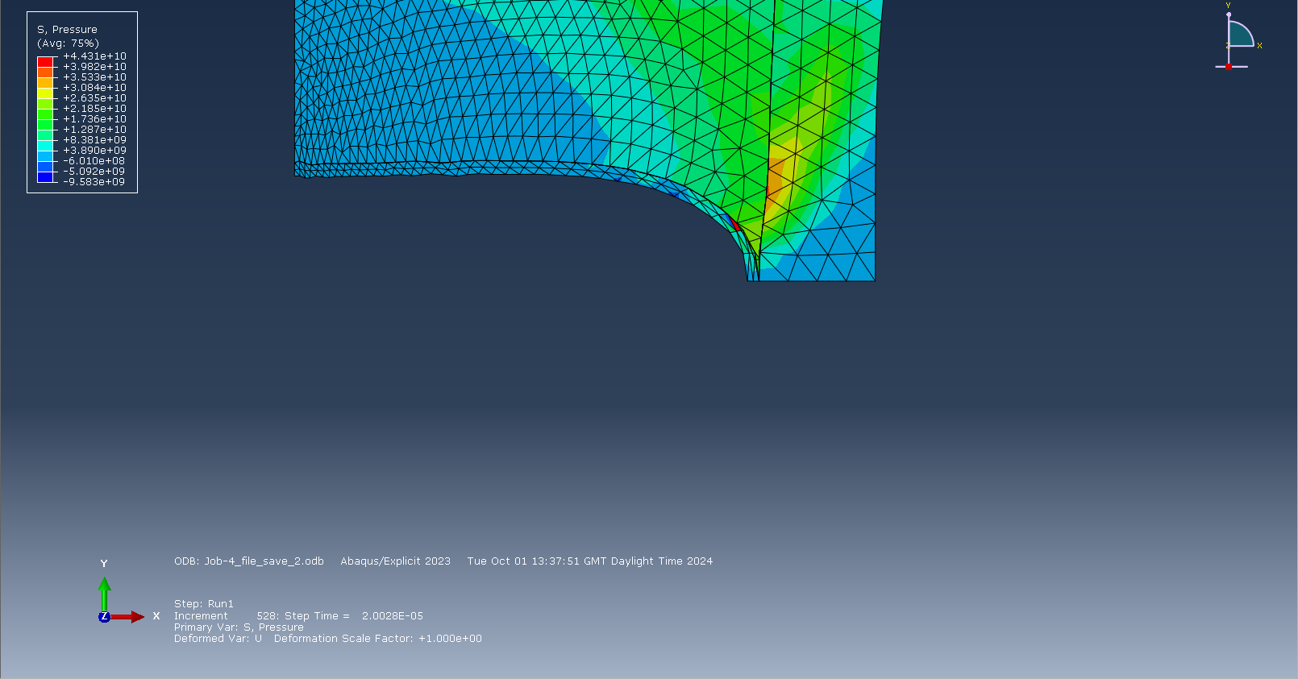

Figure 10- EFP Simulation

The pressure wave is targeted towards the axis of symmetry as set in the boundary setup section however, due to the design of this EFP it meant that the side of the liner detached from the casing which allowed energy to escape and therefore the simulation was aborted due to significant element distortion. Figure 11 confirms that energy losses occurred during the detonation process. This is shown by the reduction in pressure from 21-40 Gpa in figure 9 to 0.8-11 Gpa region, this is seen from the yellow, red, and orange colouring. This therefore effects the projectile velocity.
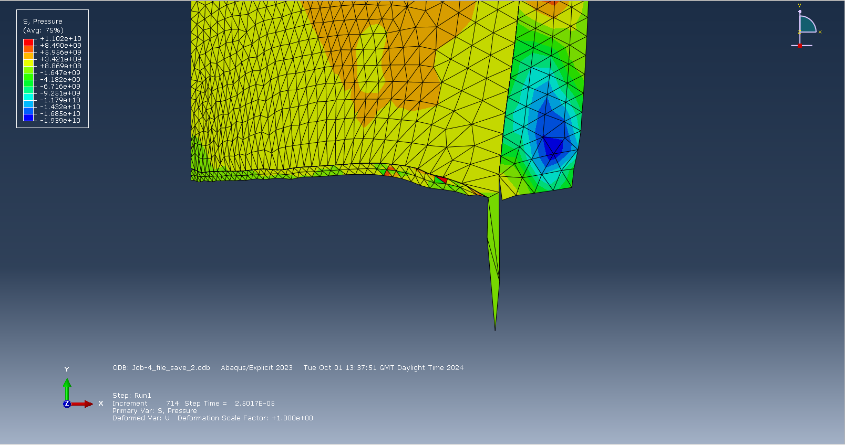
Figure 11 - EFP Simulation Progression
It can be interpreted that the pressure wave from the detonation of the TNT filler allowed for significant energy losses through the opening of the gap between the casing and the liner which therefore made for an unsatisfactory conclusion for the visualization. The copper liner and the steel casing both exceed their maximum tensile stress limitations of 210 [22]MPa and 625 [23]Mpa respectively, and this therefore causes the HE to penetrate through the side of the EFP instead of the central point. Below demonstrates this was completed in Figure 12.

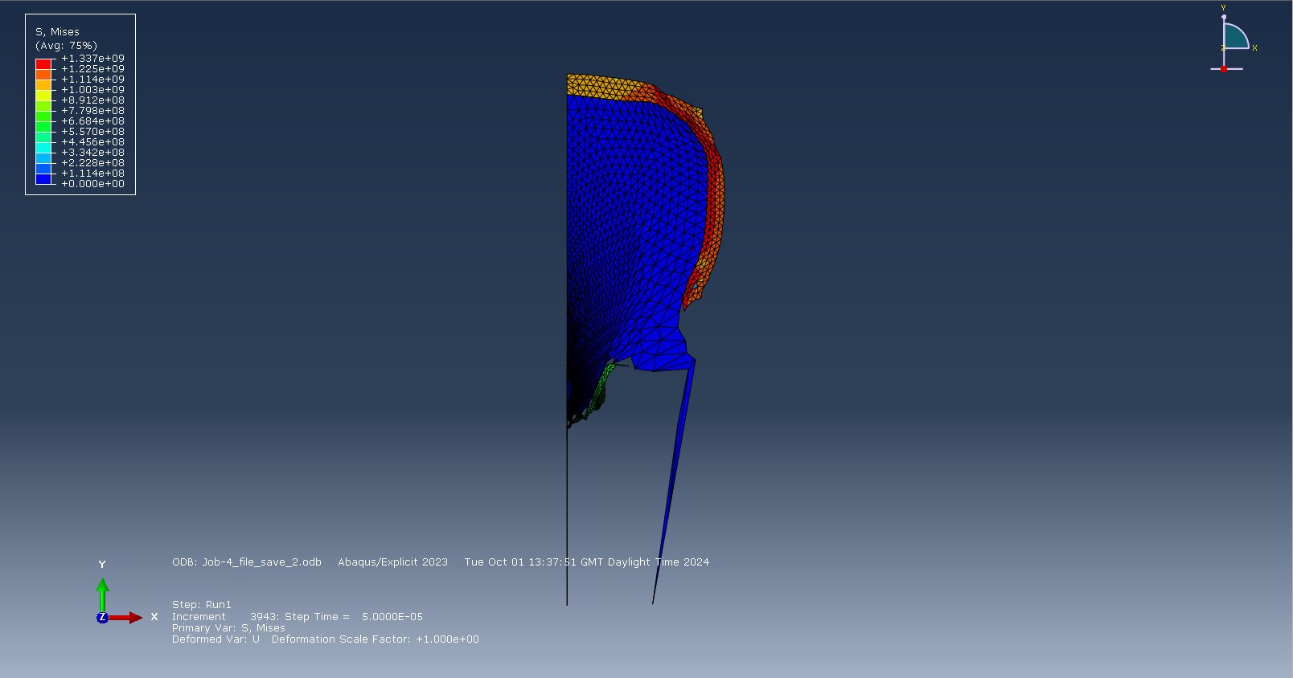
Figure 12-EFP defect

5 2-Dimensional Design Change

5.1 Redesign of Liner
Since the separation of the liner is believed to be the main cause of the abortion of the simulation, the liner and the casing were both redesigned. The Liner was given an extension which attached into the metal casing design. This caused the energy created by the detonation wave to progress through the centre of the EFP and deform the liner shape. The same meshing was applied to the previous design was exerted on the new design. Figure 13 presents the improved liner design.
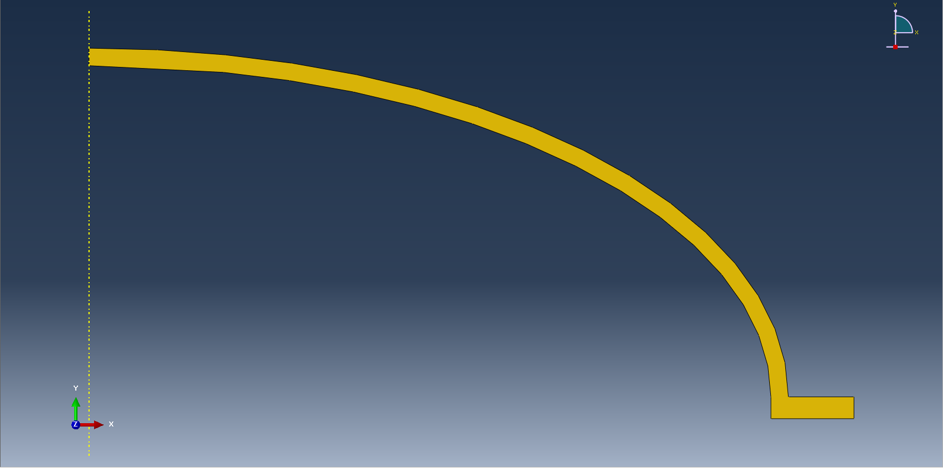
Figure 13-Copper Liner Re-design

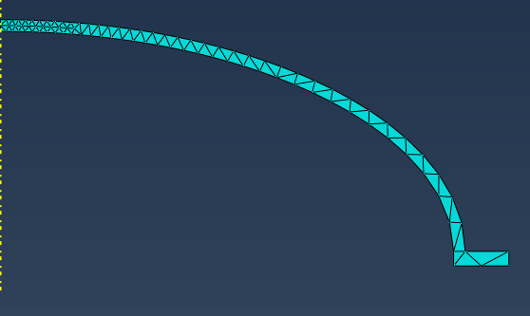
Figure 14-Redesigned Liner Meshing

Redesign of Casing and EFP Assembly
The EFP casing was also redesigned, this allowed the stress created from the detonation in the He filler to travel through the case but delay during the transfer of energy between the casing and the liner. This therefore keeps the energy contained within the EFDP which is then projected into the centre point of the liner and can produce the EFP liner projectile. Figure 15 demonstrates the redesigned.
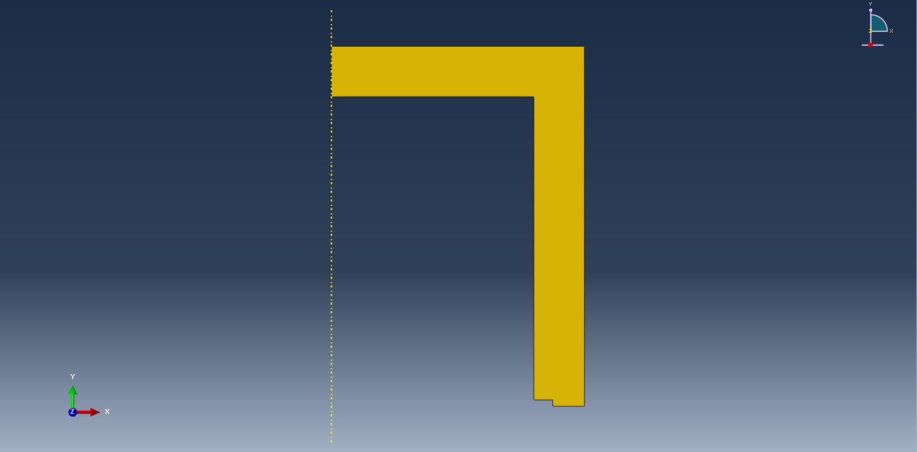
Figure 15- Redesign of EFP Casing
The EFP casing was given a coarser mesh, this was decided to reduce the chance of the simulation crashing due to pressure overclosure and this would not allow the transfer of tensile stress across the design. This may provide unexpected results. In figure 16 the casing meshing is presented.

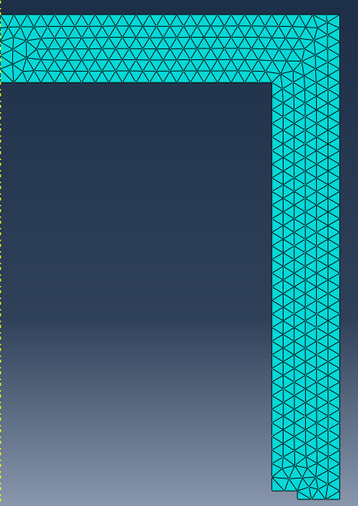

Figure 16- Redesigned Casing Meshing
Despite having to reconstruct the design, the work to redesign the key components in the assembly phase are seen below. This enabled the opportunity to create accurate results of how the EFP projectile should perform and the pressure, stress and strain which is applied during the detonation phase of the simulation. The assembly phase can be viewed in figure 17.

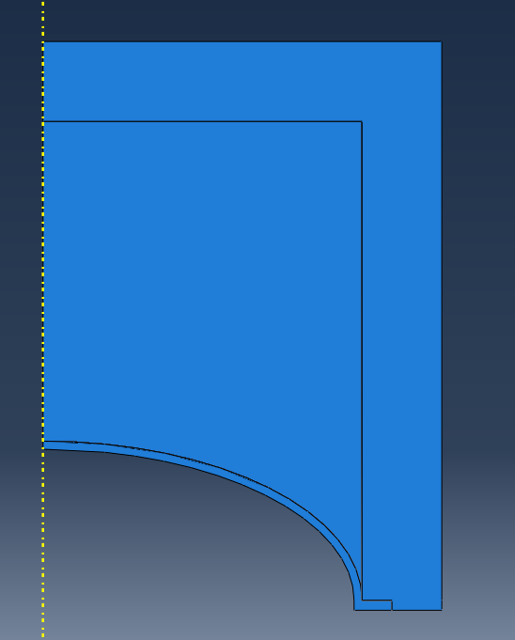

Figure 17- Assembly stage of EFP Design

6 Simulation Results of 2-Dimensional EFP

6.1 Results using TNT as HE Filler

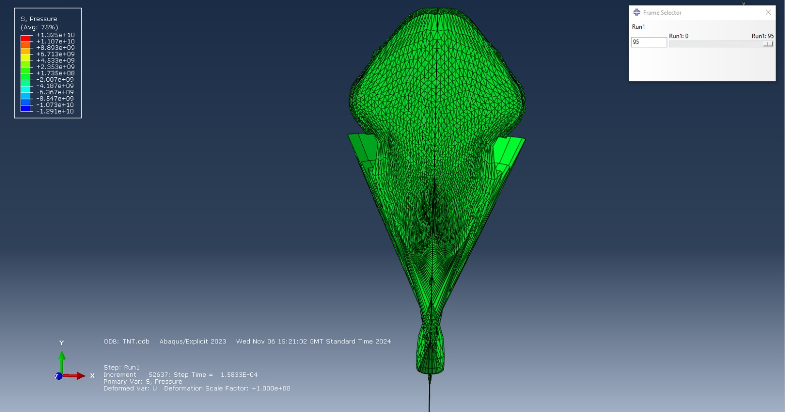
Upon second attempt, the simulation of the EFP jet reached a velocity of 5855ms⁻¹. This created an aerodynamic jet as well as a deformation caused by the stress of the shockwave pressure. All components from the 2D simulation were distorted during detonation of the TNT filler and stress and strain shown on the liner, casing, and the TNT filler. The result can be viewed below in figure 17.

Figure 18-Diagram 38: TNT Filler Result

The velocity of the jet at the result of the detonation was 5855 ms⁻¹, refer to figure 19. The graph shown in figure 19 is the velocity of the jet during the initial stages of detonation of the EFP. It can be seen from the graph that there were peaks and troughs during this stage of the liner detonation.
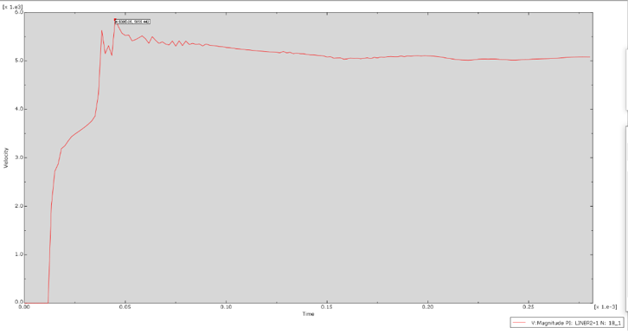
Figure 19- TNT Filler in EFP Jet Velocity

Results using PETN as HE Filler

The secondary 2D simulation which included PETN as the HE composition of the EFP was also completed successfully. This produced a jet at a similar size to the one produced in the TNT model, however this was produced at a greater velocity. This will be demonstrated further in the analysis section of the report. The simulation also performed a greater number of steps in this simulation which enables greater evaluation to be undertaken. This will be included in the analysis section between both 2D models. Refer to figure 20 for the result of the 2D PETN simulation.
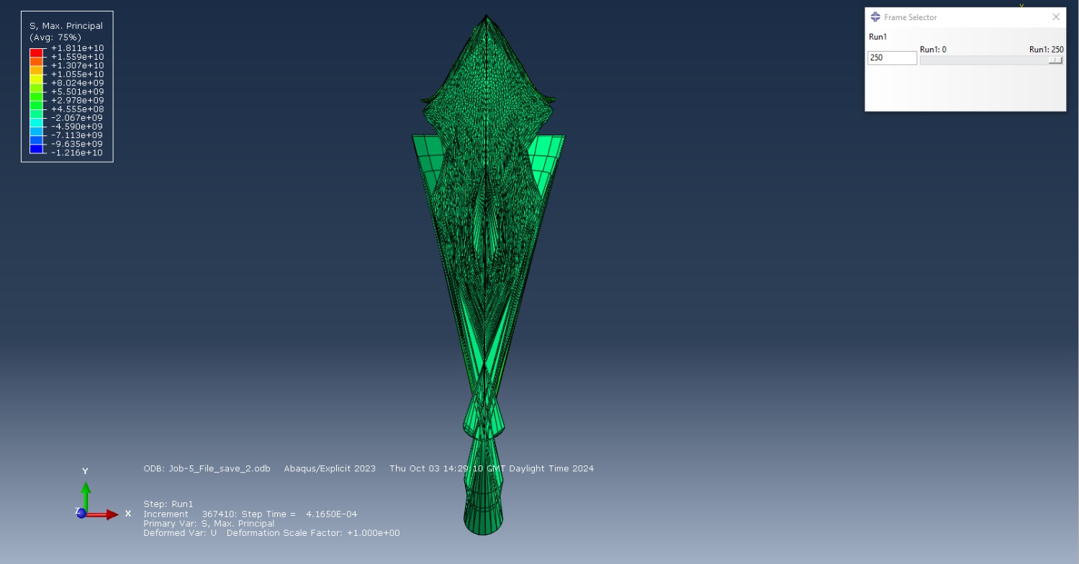
Figure 20- Result of 2-dimensional PETN simulation
This EFP jet successfully managed to produce a velocity of 8951 ms⁻¹ as seen from the Velocity of detonation graph shown in figure 20. This is exceptionally greater to what was anticipated in the planning stage of the EFP creation and hence the reasoning that this model type was used to create the 3-dimsenional design and simulation.

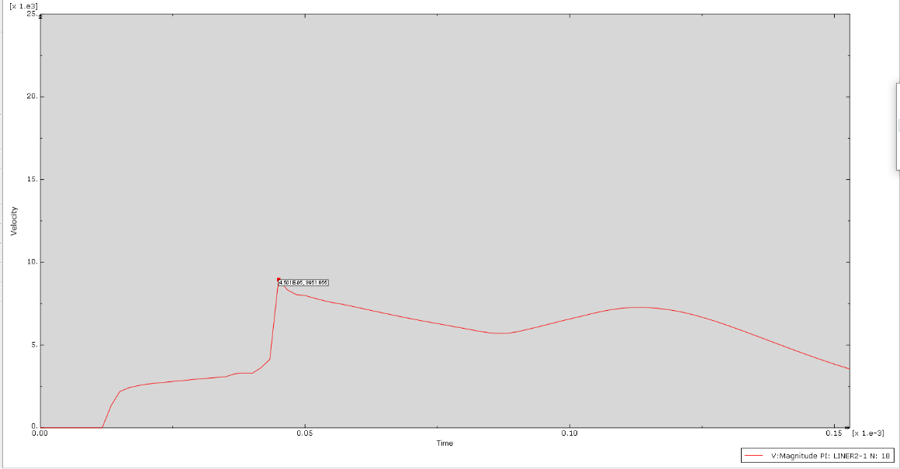

Figure 21- Velocity of Detonation of PETN Jet in EFP

Analysis of 2-Dimensional EFP designs

TNT Simulation Analysis

During the ignition stage, the TNT filler expands gasses at a rapid rate and therefore provides distortion to the casing and the liner at a rapid rate. This allows the pressure created to be focused to one section of the liner in the y-axis. Figure 21 demonstrates the distortion of elements throughout the simulation and visualization stage. This is due to the overclosure pressure of elements between the coarser meshing of the TNT filler and the finer meshing of the copper liner. This is particularly apparent from the element distortion towards the bottom of the TNT filler which almost creates a cylindrical/ conical shape.
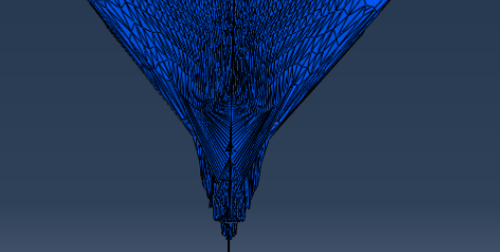

Figure 22-Element Distortion in TNT Model
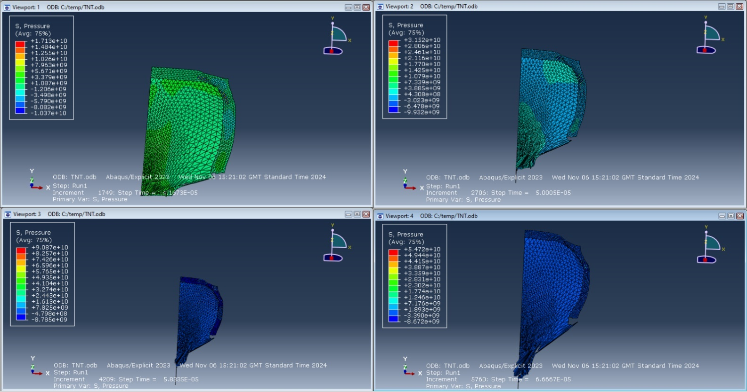
In figure 23 the initial detonation wave produced a shockwave which travels in the X-axis direction and expands through the EFP casing. Upon impact of the shockwave contact, the meshing compresses which causes stress and after the passing of the shockwave an expansion is caused. This is due to the limitations of the maximum tensile stress being exceeded and after the compression of the elements and nodes, distortion and an expansion is caused. This is evident in figure 22 as the steel casing is expanded significantly causing distortion but also allowing significant energies to be contained and focused into the central point of the liner.
Figure 23-TNT EFP Distortion
Figure 24 presents the maximum tensile stress which is being applied to the EFP design during the initial detonation stage. In viewport 1 the higher levels of stress are being produced across the casing and the liner which is exceeding the UTS of both material properties. This is the stage where strain occurs on the liner and casing. In viewport 2 it presents the EFP design with the UTS of 210 Mpa being exceeded and deformation occurring and inverting the shape of the liner. The value of the stress being applied to the liner in this case is 3.17Gpa approximately and is highlighted by red colouring. The extent of distortion can be seen in viewport 3 and it is apparent that stress has been applied to all 3 components of the EFP and caused distortion. Viewport 4 demonstrates both have stresses applied at the side of the casing. The stress values range from 1.936 Gpa to 9.053 Gpa and is shown by green, yellow, orange and red colouring of the elements. This pressure is caused by the detonation and as part of the design should allow for detachment of the projectile and allow flight towards a target.
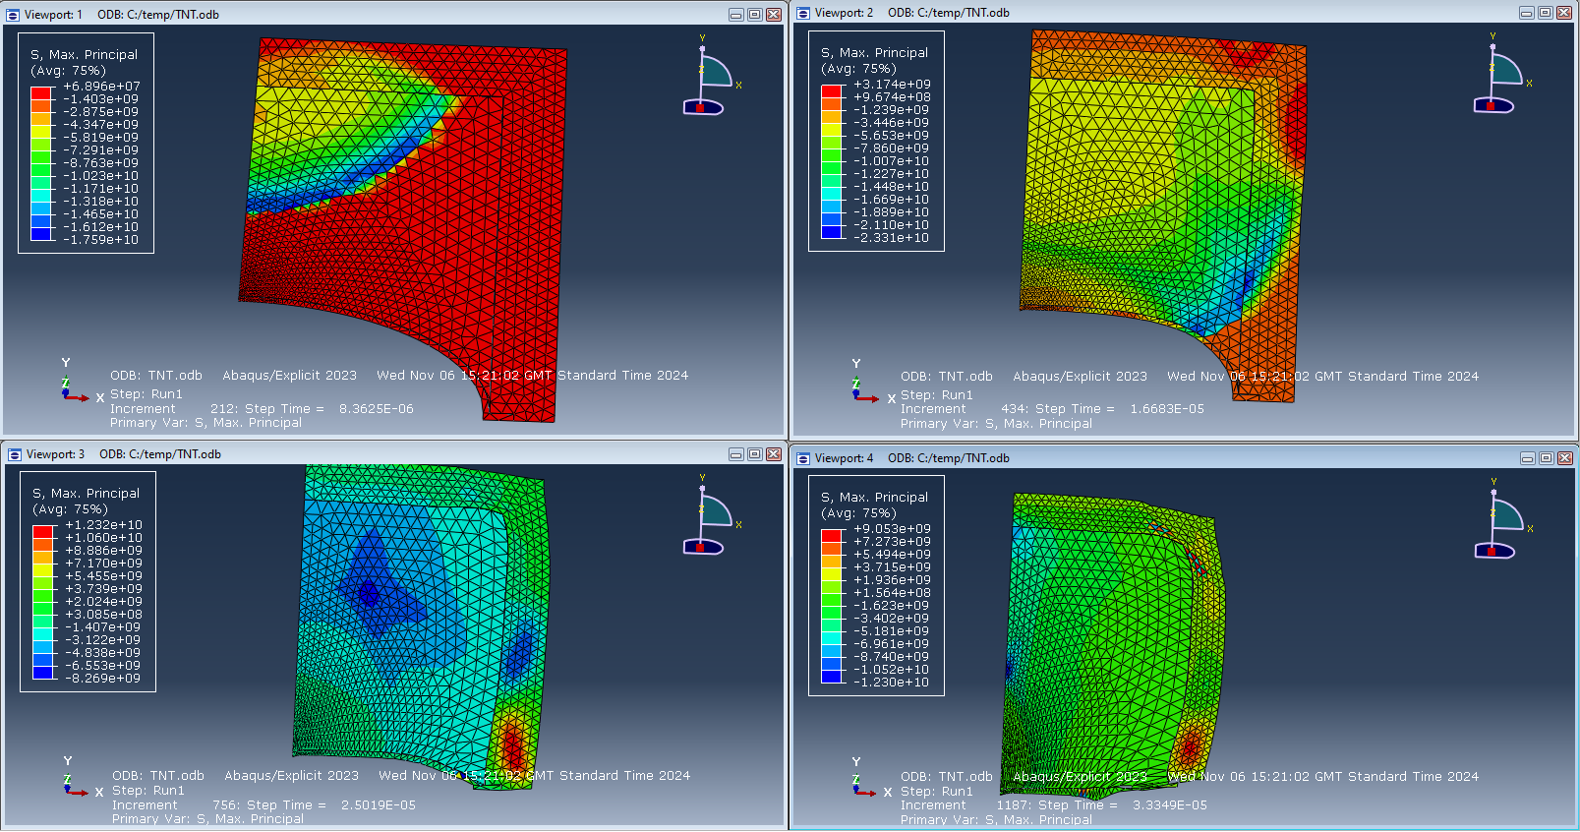
Figure 24- Stress in TNT Simulation
Figure 25 refers to this same principle however, this is taken from an extruded view which covers this 2-dimensional model from a 180-degree perspective. This shows the pressure wave from the EFP at the same point as viewport 4 in figure 24. This shows that there is a greater increase in shockwave pressure through the centre of the EFP, this is demonstrated from the red colouring in the centre of the EFP. The central detonation points which were set in the material properties stage also shows greater pressure than in other areas of the EFP. In theory, the EFP should have a lesser jet velocity in comparison to a regular conical shaped charge as the HE charges used in the EFP will contact the liner later and therefore this grants the opportunity for the velocity of detonation to be reduced inside the EFP.
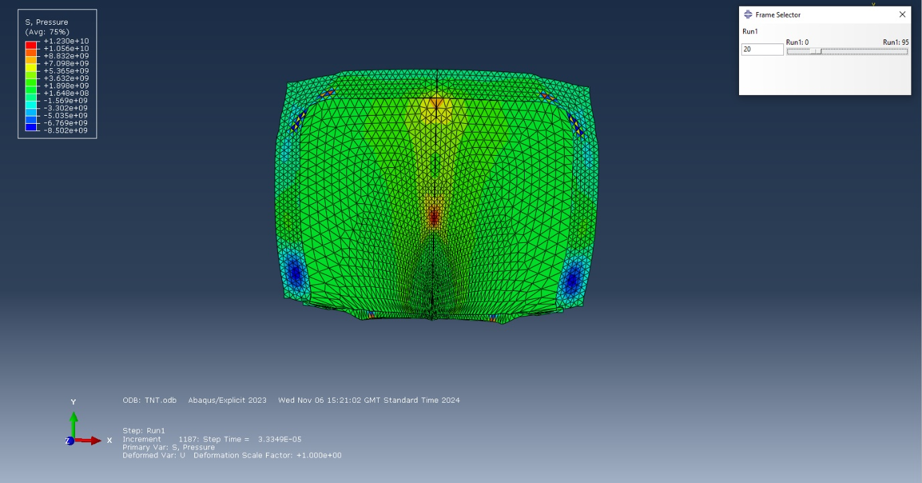
Figure 25- Extruded View of TNT EFP Simulation

The simulation was then broken down into each individual section during the simulation process. This allowed for analysis to be completed on each component of the EFP during the simulation stage and understand the effects of the compression and expansion which the detonation wave causes by maximum principal stress theory.

The liner in the EFP endured extreme stress until the maximum tensile stress was reach and strain on the material occurred. Once the maximum tensile stress had been surpassed, distortion in the liner occurred which allowed superplastic properties to shape into the projectile jet. This was then closely followed by a denser block of copper material from the HE charges and the copper liner. This is not the intended result for this model.

Upon detonation, it can be identified that the pressure from the detonation wave reaches between 14.61 Gpa and 32.5 Gpa near the point of detonation as the wave expands and exerts compression forces across the liner, this is presented in figure 26. The red to turquoise colouring shows the pressure at this point. As the detonation wave progresses, the impact which the pressure detonation wave inflicts on the liner at this point can be seen. The pressure in the liner has increased due to the energy transferred into the central point of the liner therefore exerting greater stresses on the liner and causing strain into a projectile point (Jet creation) this is presented in figure 27. Through further progression during the simulation stage, it is seen that at figure 28 during the simulation the jet forming from the liner is created and projected forward. This is the point at which the maximum tensile stress for this component is exceeded beyond the copper materials elasticity parameters and therefore permanent deformation occurs in the liner (plasticity occurs), refer to figure 27. Upon the halfway point of the simulation completion state, it is seen that the jet is forming with great pressure being applied to the centre of the liner model. There is stress being applied from the outer region of the liner causing disfigurement due to the TNT expanding. It is also demonstrated in figure 29 that there is significant stress being applied in the central region and this is demonstrated by the red/yellow colouring about the jet forming from the liner. This colouring indicates that between 1.603Gpa and 1.113Gpa are the maximum stress values at this point in the simulation at the central point, refer to figure 29.

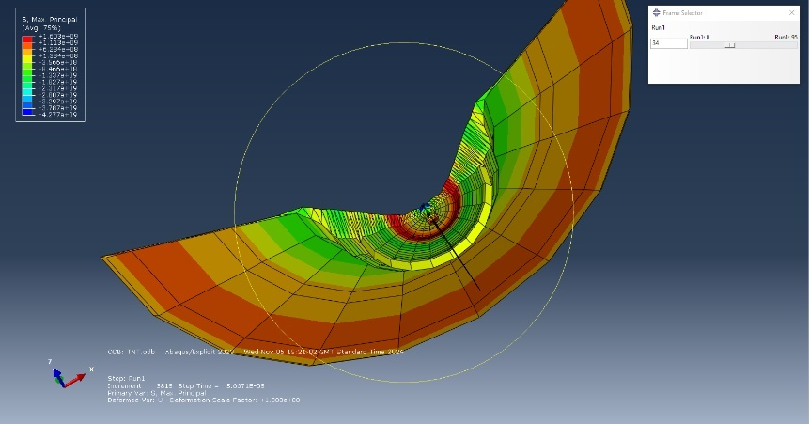
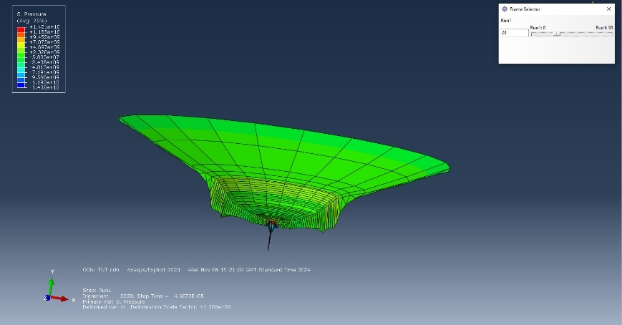
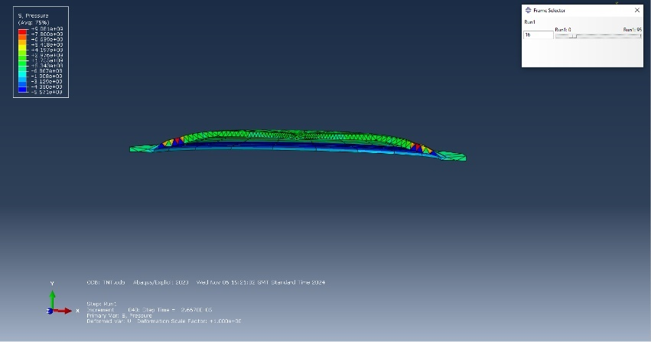
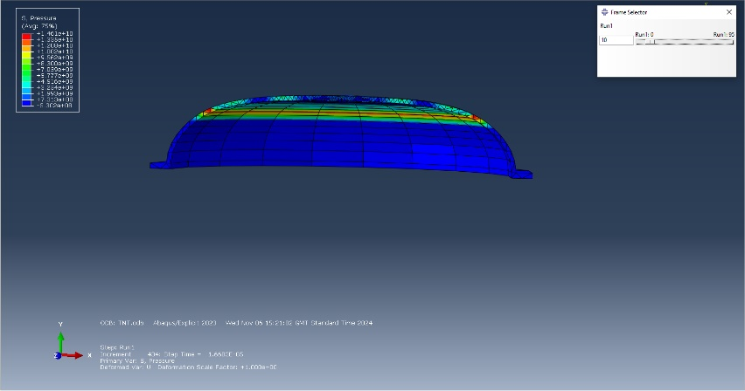
Figure 26- Initial Pressure put on the liner Figure 27-Progressive Pressure put on the liner
Figure 28-Emergence of Jet Figure 29-Jet length increasing
The casing compresses almost instantaneously in conjunction with the rapid acceleration of the detonation wave. The expansion of gases across the casing compresses the nodes and therefore transfers the energy created from the detonation into the liner. The casing them starts to show principles of significant strain towards the latter stages of the simulation and this causes permanent disfiguration in the casing, this however allows for the remaining pressure to be focus into the symmetrical point of the liner. In this casing during step 22, there is stress being applied across each section of the liner by the colouring of red, yellow, and orange. This has caused some expansion in each of the top corners of the model in comparison to the casing prior to the beginning of this simulation. Refer to figure 30 for the simulation result.

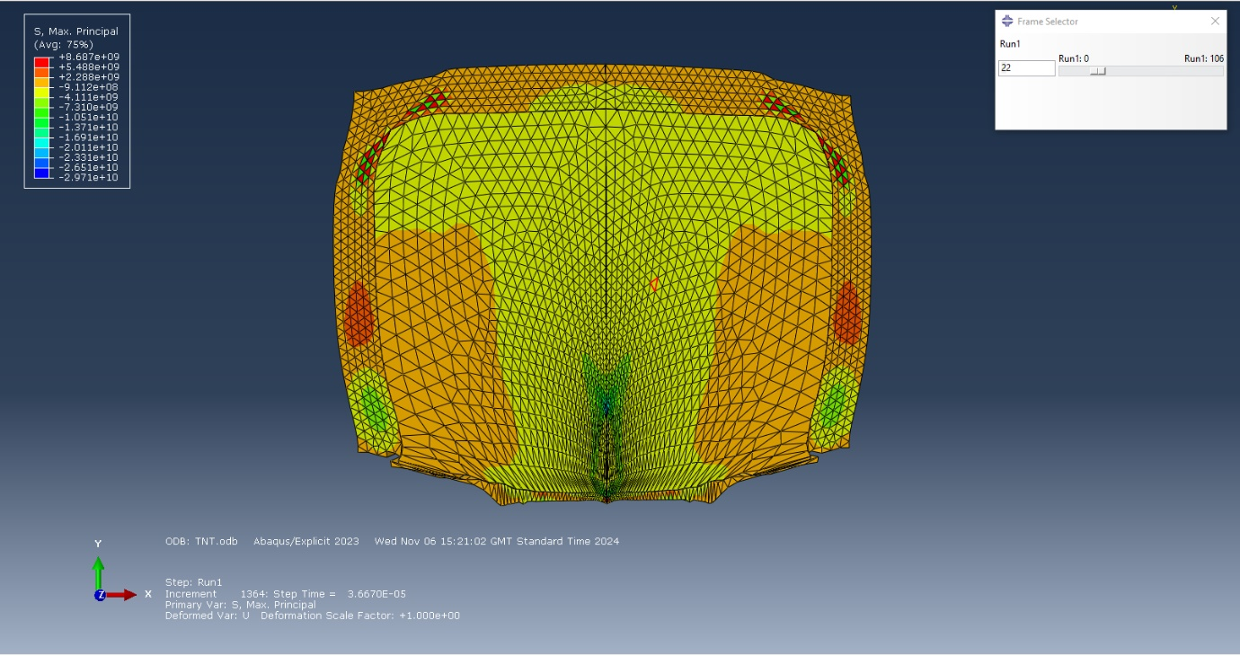
Figure 30-Expansion of Casing

PETN Simulation Analysis
In comparison to the TNT HE filler, the PETN filler detonated at a greater velocity and therefore allowed for a more prominent jet to form. The velocity in this simulation reached 8951 ms⁻¹ which is a 3096 ms⁻¹ increase in velocity detonation in comparison to the TNT. This therefore makes the PETN filler a more suitable secondary explosive property for the 3D simulation.
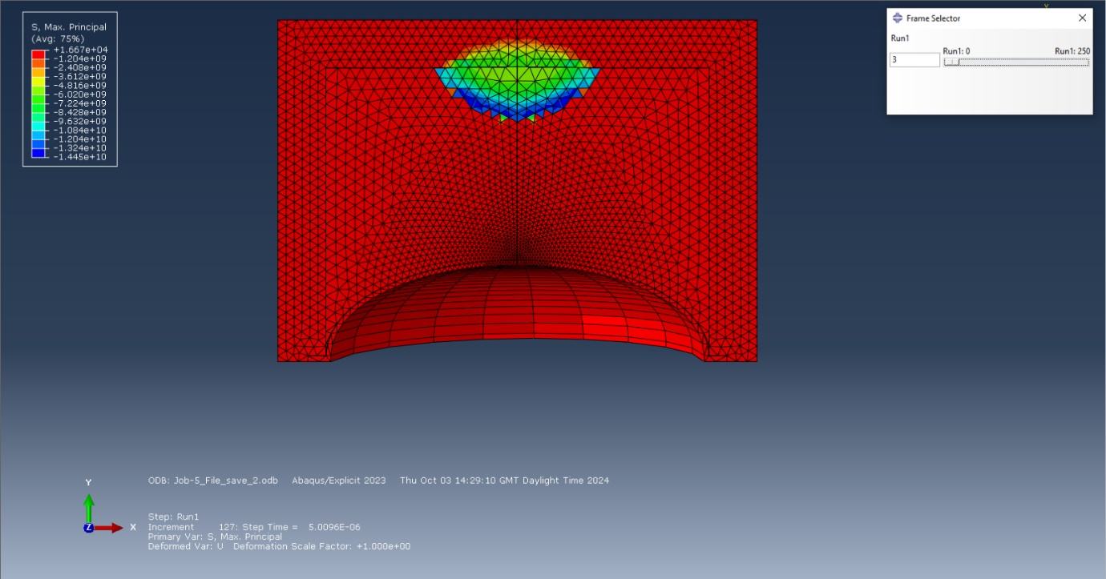
During initial detonation of the PETN the shock wave travels similar in comparison to the TNT shockwave during this simulation stage. The shock wave during this detonation in the simulation travels in the same curvature, which is expected however, the energy is significantly higher which therefore allows for a greater jet velocity. It can be seen in figure 31 that the detonation wave provides instant stress to the model within the opening stages of the detonation process. This will begin to disperse to all components of the EFP shaped charge which similarly to the TNT model will provide disfigurement and strain to the casing, liner and the HE.
Figure 31-PETN stress Wave detonation process

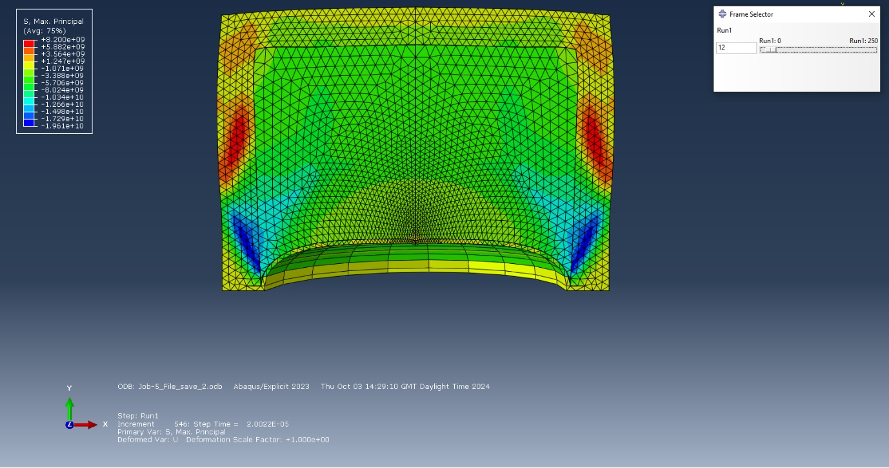
The detonation wave moves through the PETN filler and the components to the liner. This provides a stress on each component like the TNT simulation however, at a greater velocity. It can be viewed in figure 32 that during the initial stages of the detonation process the liner is under significant stress at the central point and has also begun the deformation process in which the liner has started to direct the explosive energy into an inverted position which would be directed at a target as a projectile.
Figure 32- Initial Deformation of the Casing
Overall, it is conclusive from the simulation evidence of each 2D model that an EFP with PETN is the most effective and would inflict the greatest amount of penetration through a target. The TNT solution provides a somewhat effective jet which could impact a target and most likely would penetrate a material such as mild steel which is less robust. PETN provides an exceptional jet velocity and therefore would be more susceptible to penetration through more robust targets or inflict more stress on a material causing perforation in a target. The PETN final simulation shows the tip also converting into a greater mass of the liner which makes a projectile with a larger surface area which enables greater stresses to be applied on a region. This therefore makes the PETN explosive filler EFP design the obvious choice to recreate and simulate in a 3D setting.

PETN 3-Dimensional model

Meshing of the 3-dimensional model
The meshing of the 3D model is crucial to a successful simulation occurring. Models allows for 250,000 nodes to be created during the meshing process however, any greater than this value will cause the program to abort. Similarly to the 2D designs the casing was given a coarser mesh since the energy created from the EFP filler can be projected forward and connect with the liner. This also helped to manage the number of nodes which were in the design and avoid abortion of the simulation. Initially the simulation started to produce results however, 35 elements distorted and therefore caused results which were inaccurate and therefore the meshing had to be completed once more. The mesh of the copper liner caused element distortion with the PETN meshing. The meshing design is shown in figure 33.

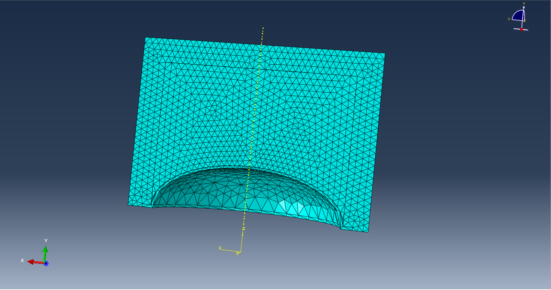
Figure 33- 3-Dimensional Meshing
Each component was then re-meshed with the Liner being finer throughout the centre of the EFP. The finer the meshing in specific areas can significantly increase the accuracy of the simulation results and hence should increase the number of intervals before abortion or the simulation completes. This can be viewed in figure 34.

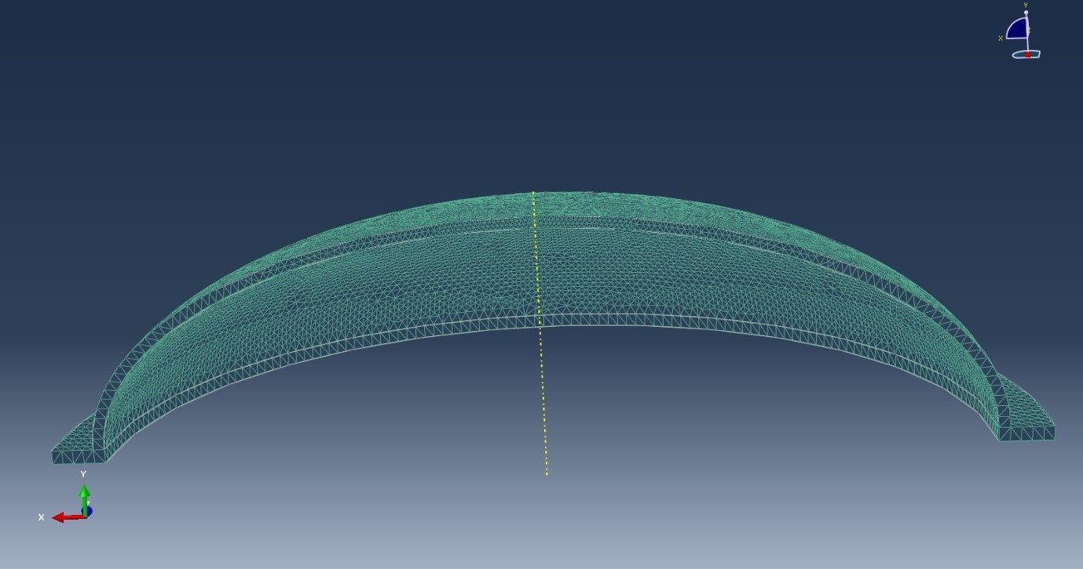
Figure 34- Liner Re-Meshing

Results of 3D model
The simulation results produced a better representation of an EFP design and instead of a jet forming like previously shown in figure 19 the EFP only produces a projectile which can penetrate a target with a greater surface area. This type of shaped charge will provide greater penetration power on armoured vehicles. Figure 35 presents the progression of the simulation for the EFP design.
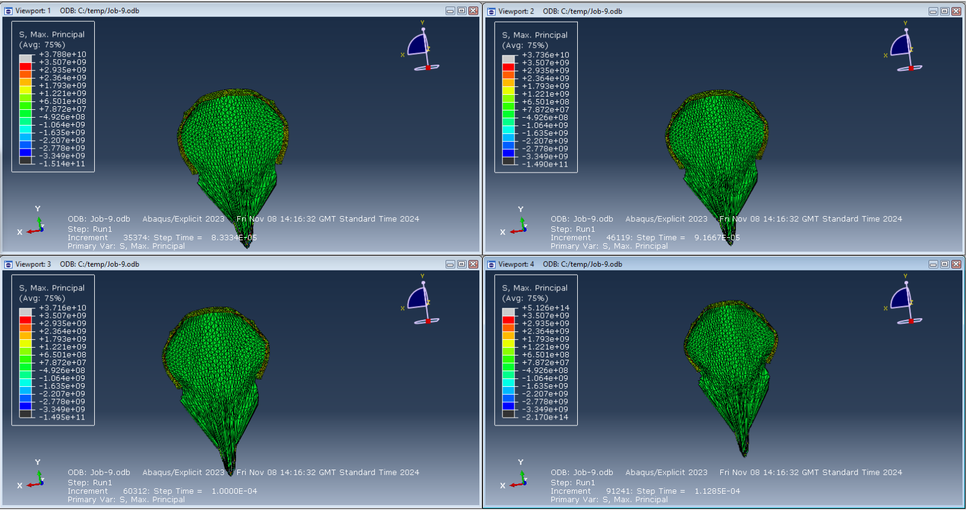
Figure 35- PETN 3D Results
In figure 36, it shows the jet velocity of the liner during detonation. This 3D design managed to achieve a jet velocity of 5025 ms⁻¹ which is significantly less than the original 2D design jet velocity of 8951 ms⁻¹. This is a decrease in jet velocity and is expected for a 3D design as factors such as meshing and the number of elements which are in the EFP.
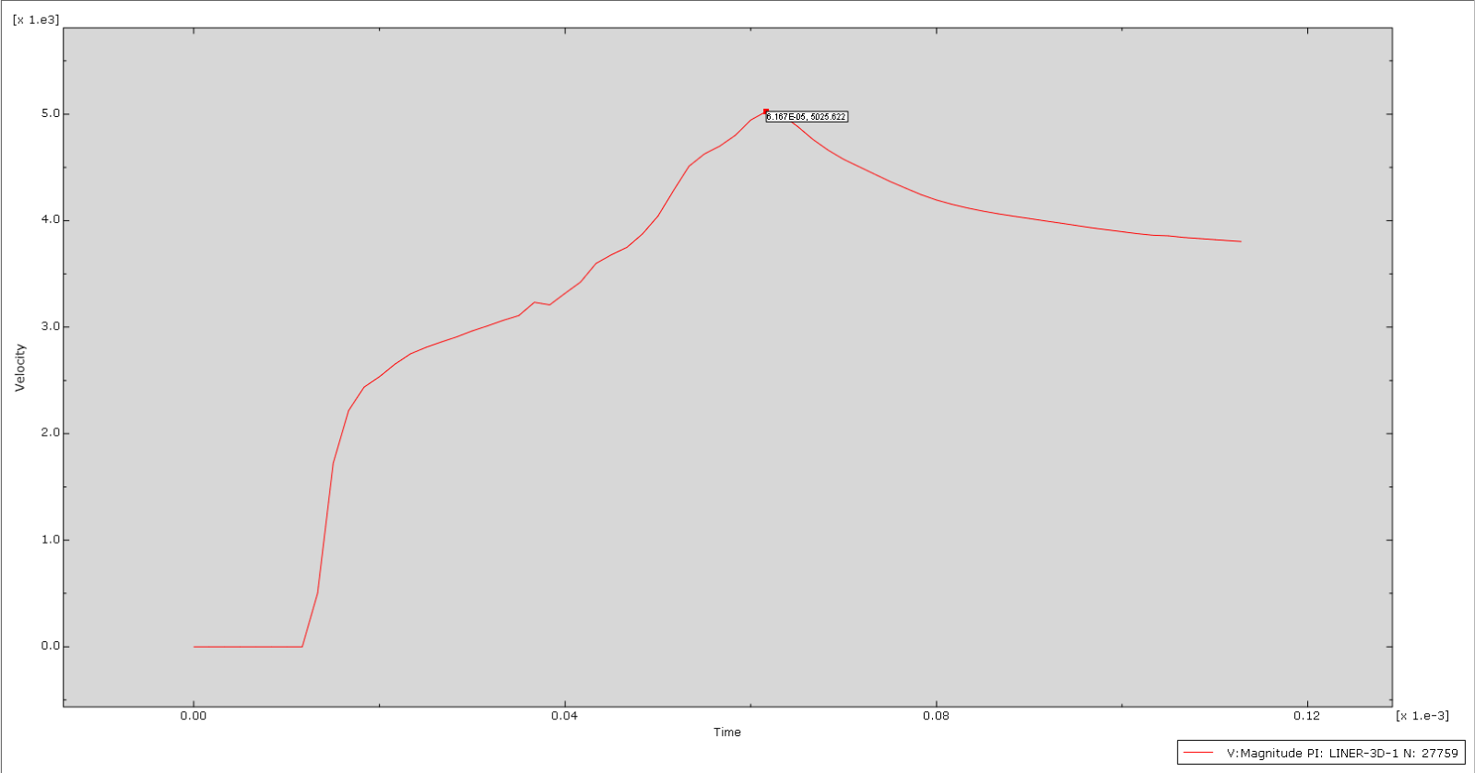
Figure 36- PETN 3-Dimensional Design Jet Velocity Graph

Analysis of 3D model

The 3D PETN EFP results produced more realistic and accurate results compared to the previous results produced in the 2-dimensional initial design for both TNT and PETN simulations. The design of an EFP is to produce a jet with a larger cross-section only which impacts the target however, in the 2-dimensional designs it can be viewed that a jet from the liner was produced. Figure 37 presents instant detonation stress has impacted all 3 components of the EFP. The pressure spreads across the liner and the casing which deformation have started from the strain applied by the shockwave of the HE PETN composition. As viewed in viewport 3 this is the point at which the casing has started to distort outwards, and this helps to direct explosive energy towards the liner and creating a more effective slug should this hit the target. In terms of the liner components, the liner has started to distort due to the pressure applied and this has created a large jet inversion, and this would be directed towards a target. Viewpoint 4 further highlights both strained elements and the maximum tensile stress strength of the copper and steel materials has been breached and caused significant strain. The liner has increased in length showing direct strain also. Axial stress is also apparent and is due to the nodes have compressing and shaping the liner into a different shape as to what originally designed and therefore successfully effecting EFP performance.

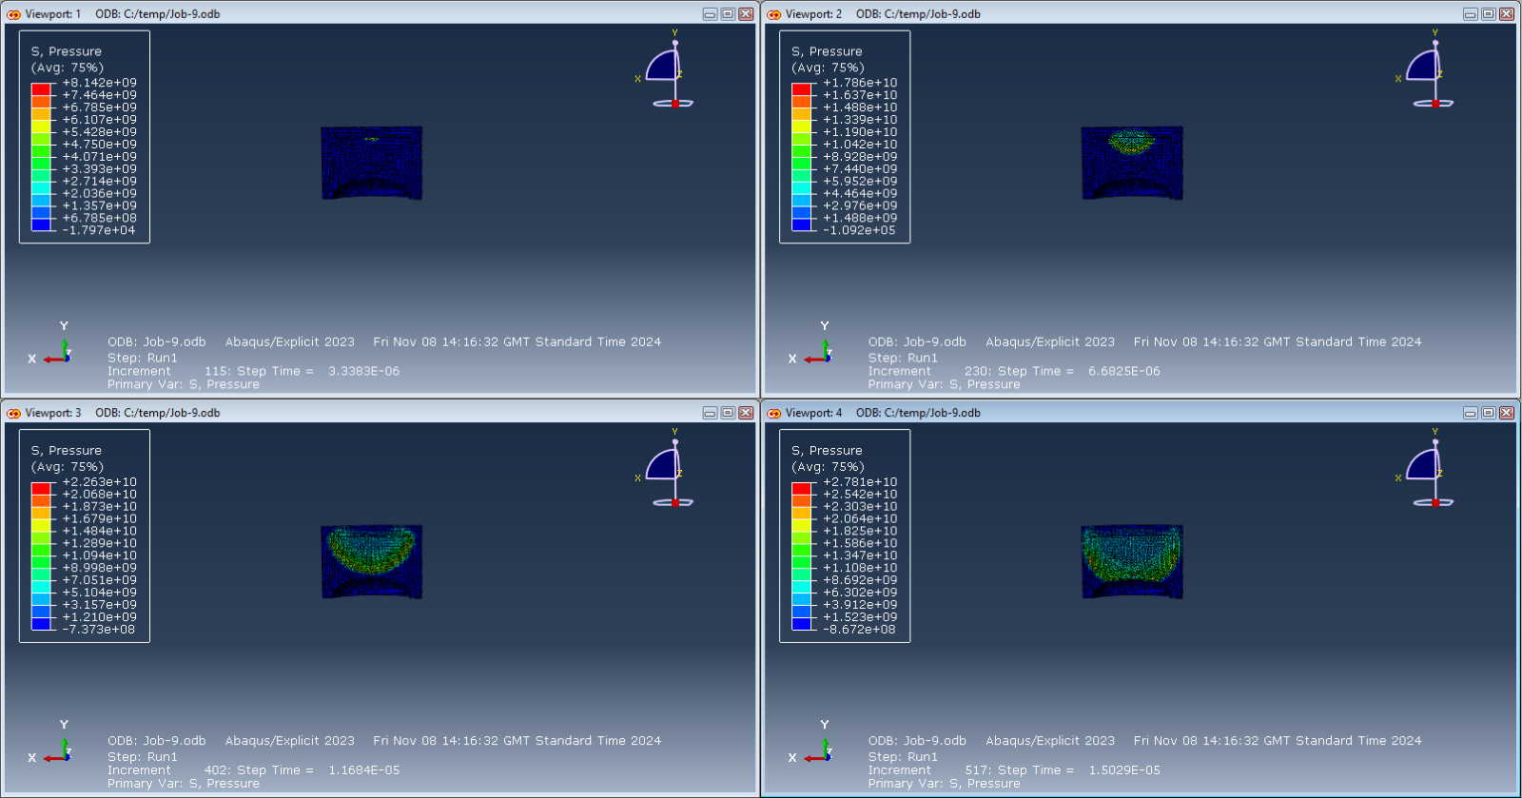
Figure 37- PETN 3D Initial Detonation

EFP Liner

During the initial stages of detonation of the EFP the pressure on the liner starts to increase and disperse in all directions inside the casing. This therefore applies stress to the middle of the liner which then spreads to the edges and the connection point between the liner and the casing. These viewports show the compression of the nodes and therefore condensing the liner which then exceeds the maximum tensile stress of the material which causes deformation. At the time of these viewports the pressure is increasing rapidly and therefore reach the destination where the tensile stress of the copper will be surpassed, and the deformation process will begin. The nodes and elements within the simulation currently have started to compress and therefore direct strain is in the process of occurring. Figure 38 presents the pressure applied on the liner during the detonation stage.

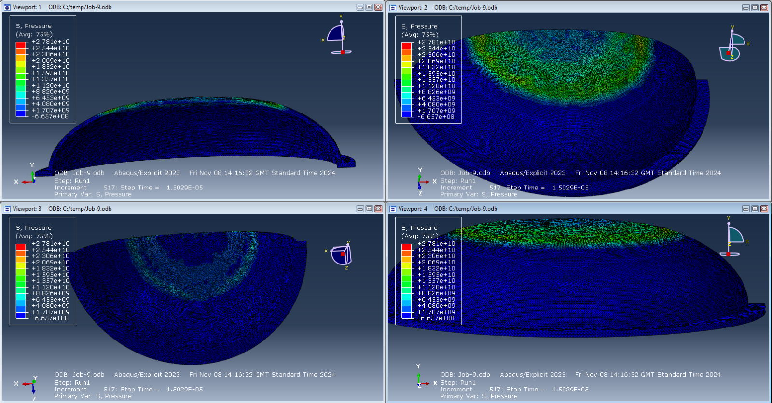
Figure 38-Pressure Impacting the Liner

This is further demonstrated in the full EFP section which shows the progression of the model after deformation of all elements. This demonstrates the instant maximum principal stress which is put on the model and particularly the case and liner. As the shockwave filters through the model the increase in colour from blue and red is evident and therefore showing that each component is progressing towards maximum principal stress and permanent deformation. In viewpoint 4, it shows some elements which are reaching the 21.97 Gpa region and for the case of the copper liner this has already been breached and the projectile jet formation process has begun.

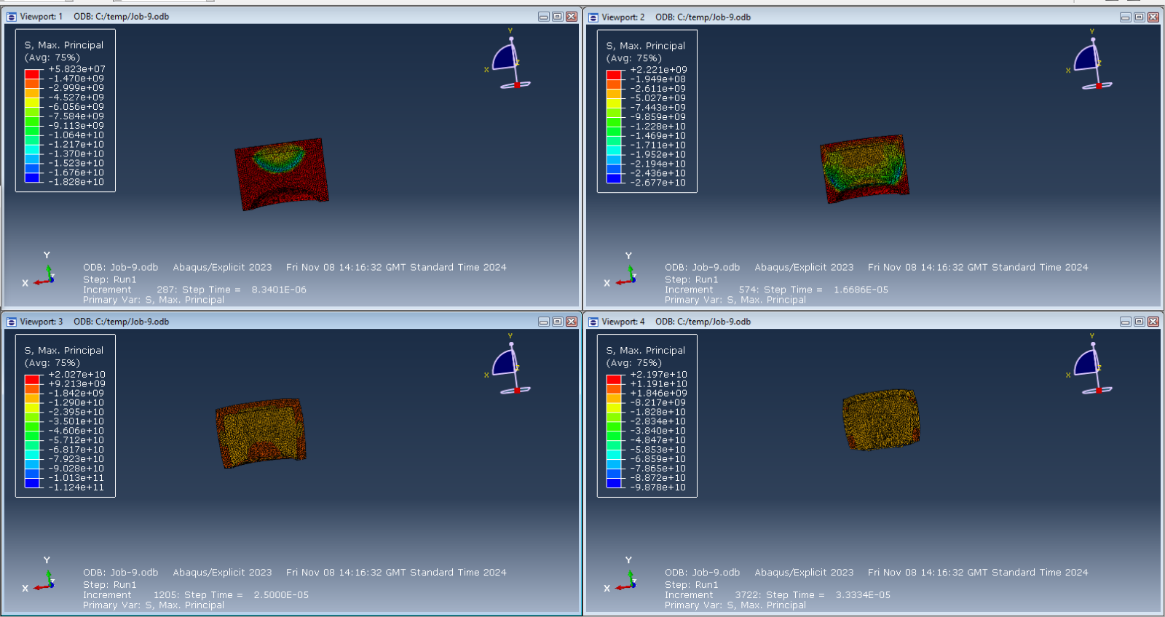
Figure 39- Progression of EFP Simulation

8.3.2 Casing Analysis
Another component which is crucial to the success of the 3-dimensional simulation results is the steel casing. The steel casing ensured that the explosive energy directed forward in the fashion expected. The steel casing exceeded is being exposed to pressure which will lead to the maximum tensile strength of the material being surpassed. The pressure from the explosive detonation dispersed throughout the casing and then transferred into the liner connection point. The meshing for this section is coarser as results in the liner are more important than the results from the casing. This is due to the impact point being the liner of an EFP. Figure 39 shows the instant detonation shockwave spreading across the casing and this would also have an effect to the liner as the simulation progresses. The Casing has not commenced direct strain where permanent deformation of the material is apparent at this point in the simulation.

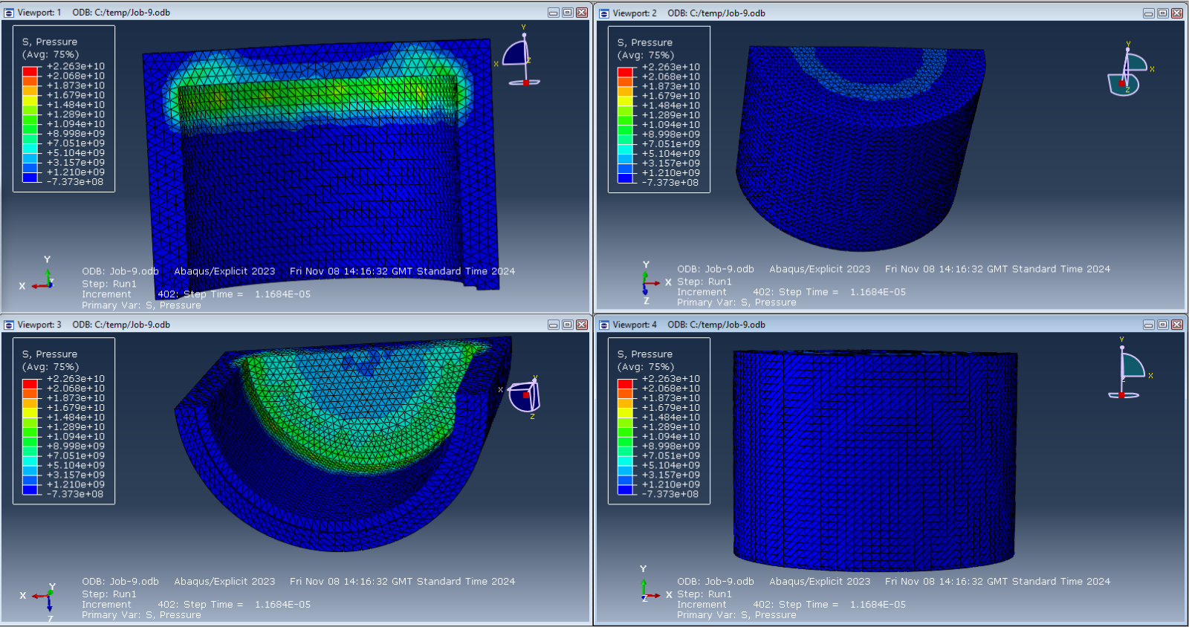
Figure 40- Pressure on Casing 3D PETN Model
Shown in figure 41 and 42 is the progression of the pressure applied by the shockwave through the casing and the stress being applied to the EFP components. The pressure has dispersed almost entirely through the casing and the stress is being applied from the inside. It can be seen particularly in viewport 1 in figure 41 that the direct strain has taken place, and the steel material has been permanently deformed. The red colouring indicates the shockwave pressure funnelling down into the outer edge of the casing. Figure 42 shows the stress which is present throughout almost the entirety of the casing.

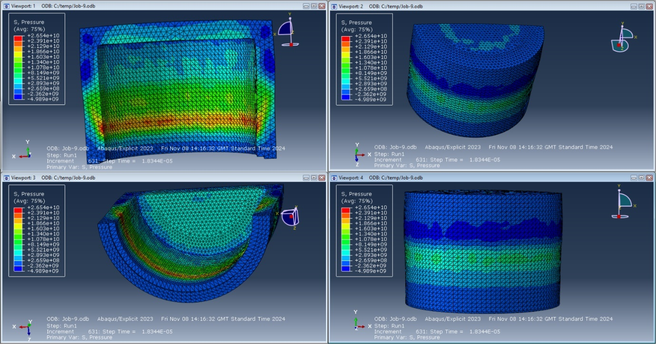
Figure 41-Pressure Increase throughout the Simulation

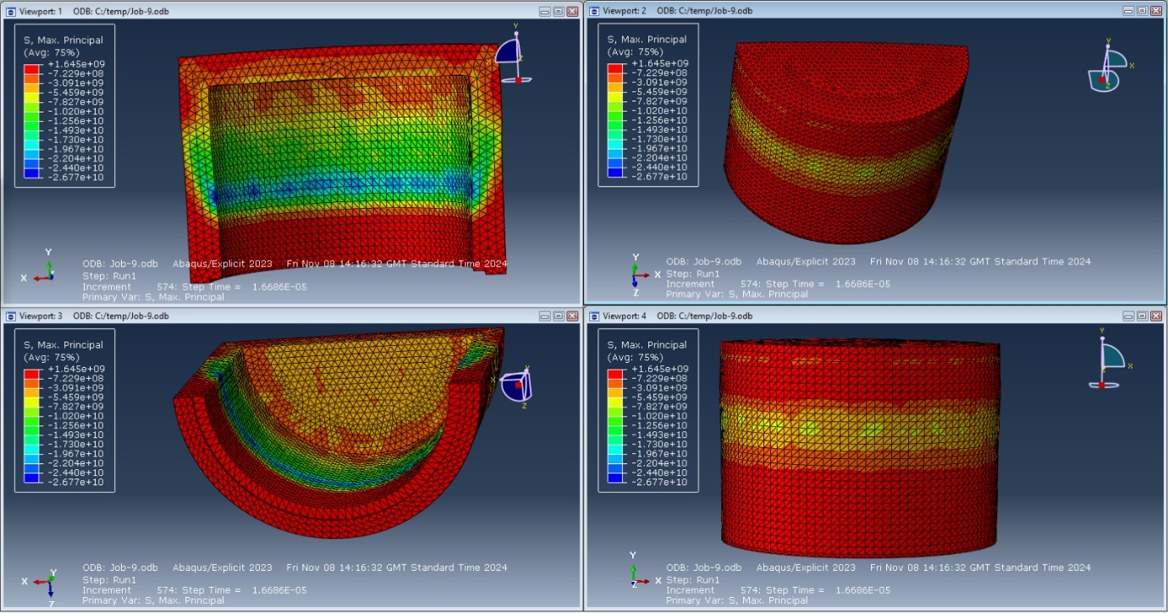
Figure 42- Maximum Principle Stress of PETN Design

Conclusion

9.1 2-Dimensional Designs
In conclusion, the simulations produced for all 3 designs were relatively successful despite abortion from all. These three designs provided an analysis to adapt and improve performance of the EFP into a way which is seen as the most accurate and realistic. The shaped charges for the 2-dimensional designs were unanticipated but this did show the effect which the PETN and TNT high explosive compositions can produce in a compressed environment.

TNT Design Conclusion
Overall, the TNT design performed well by producing a velocity of detonation of 5025 ms⁻¹ and as unanticipated produced an aerodynamic jet from the copper liner. The results produced were unusual from an EFP however, and the meshing for the model was adequate and sensible for 2-dimensional assembly. The results resembled more from a conical shaped liner. The unrealistic results produced could be due to many significant reasons resulting from human error. The reason for a jet forming inadvertently could be due to element distortion resulting from the HE charges.

9.1.2 PETN Design Conclusion
The PETN test results produced a significant 8951 ms⁻¹ velocity of detonation which is also unrealistic in terms of the typical velocity at which an EFP should detonate. The meshing type used was potentially also inaccurate for this scale of model which may have hindered the accuracy of the simulation. Element distortion can be seen as potentially the reason for inaccuracies in terms of the block of material as well as the aerodynamic jet which is formed during the simulation.

9.2 3-Dimensional Design
The 3-dimensional results produced realistic and accurate results from the simulations which is believed to be down the correct meshing techniques applied to the middle. This ensured that accurate results could be created from the simulations as well as limiting element distortion from effecting the results. This model produced the best results relative to realistic testing completed on EFP shaped charges. All components of the shaped charge showed signs of strain, and the jet produced is accurate in terms of the purpose of an EFP. The potential only improvements which could be made from the design is that there is no detachment seen from the high explosive and the liner as this should occur during an EFP detonation.

Future Recommendations
As for future reference 3 stages of the modelling/design process would be made to provide more accurate results for all models. The first alterations which would be adapted would be the shaping of the liner and HE. The liner could be inclined less which would potentially give the opportunity for the detachment of the EFP jet. Another alteration which could be made would be the meshing for all 3 models. The meshing could be altered to a finer meshing on the whole of the liner and adaptive meshing across the HE PETN explosive. Therefore, by adding his feature the simulations could complete or produce more steps in the detonation process which could be further analysed to view the pressure or stress which is enforced on the model.

References

[1] | BYJU's, “Stress Definition and TYpes,” BYJU's, [Online]. Available: https://byjus.com/physics/stress/#:~:text=Stress%20%E2%80%93%20Definition%20and%20Types,be%20measured%20using%20stress%20units.. [Accessed 04 11 2024].
[2] | Boston University, “Mechanics of Materials:Strain,” Boston University, [Online]. Available: https://www.bu.edu/moss/mechanics-of-materials-strain/. [Accessed 18 11 2024].
[3] | Unacademy, Unacademy, [Online]. Available: https://unacademy.com/content/jee/study-material/physics/types-of-stress/#:~:text=Simple%20or%20direct%20stress%20can,tension%2C%20compression%20and%20shear%20stress.. [Accessed 04 11 2024].
[4] | D. A. V. D. W. a. G. Sybrand van der Zwaag. [Online]. Available: https://www.sciencedirect.com/science/article/abs/pii/B9780080993591000163.
[5] | Dictionary.com, “Axial Stress,” Dictionary.com. [Online]. Available: https://www.dictionary.com/browse/axial-stress. [Accessed 04 11 2024].
[6] | S. P. K. D. V. S. Z. N. P. M. a. K. K. K. Tanvi Pal, “Handbook of Fly Ash,” 2022. [Online]. Available: https://www.sciencedirect.com/topics/earth-and-planetary-sciences/tensile-strength#:~:text=Tensile%20strength%20can%20be%20defined,to%20be%20stretched%20or%20pulled.. [Accessed 04 11 2024].
[7] | Testbook, “What us maximum principle stress,” [Online]. Available: https://testbook.com/civil-engineering/principal-stress#:~:text=The%20Maximum%20Principal%20Stress%20Theory%20states%20that%20a%20material%20will,ultimate%20tensile%20or%20compressive%20strength.. [Accessed 02 11 2024].
[8] | Z.-X. Zhang, “Shaped Charge,” International Journal of Refractory Metals and Hard Materials, vol. 75, pp. 30-42, 2016.
[9] | Z. H.-R. Wang Tie-Fu, “Copper-Tungsten Shaped Charge Liner and its Jet,” August 1996. [Online]. Available: https://onlinelibrary.wiley.com/doi/abs/10.1002/prep.19960210406#:~:text=The%20use%20of%20copper%2Dtungsten,and%20the%20break%2Dup%20time.. [Accessed 13 October 2024].
[10] | V. G. &. A. D. Tarık Baykara, “Structural Evolution and Microstructural Features of the Hydrodynamically Penetrating Copper Jet of a Shaped Charge,” Springer Link, 5 February 2021. [Online]. Available: https://link.springer.com/article/10.1007/s11665-021-05514-9. [Accessed 14 October 2024].
[11] | J.-q. L. W.-b. G. H.-m. X. a. S.-z. W. Ming Lu, “Formation of explosively formed penetrator with fins and its flight characteristics,” Defence Technology , vol. 10, no. 2, pp. 83-250, June 2024.
[12] | Quora, “What are the pros and cons of an EFP ATGM warhead compared to a tandem-HEAT? Which one is likely to be more popular in the future?,” Quora, [Online]. Available: https://www.quora.com/What-are-the-pros-and-cons-of-an-EFP-ATGM-warhead-compared-to-a-tandem-HEAT-Which-one-is-likely-to-be-more-popular-in-the-future. [Accessed 21 October 2024].
[13] | PASCI EMC, “FLSC,” PASCI EMC, [Online]. Available: https://psemc.com/products/flexible-linear-shaped-charge-flsc/#:~:text=What%20is%20a%20linear%20shaped,linear%20cutting%20action%20upon%20detonation.. [Accessed 18 October 2024].
[14] | DRDO, “120mm Tandem Warhead System for Anti-Tank Application,” DRDO, [Online]. Available: https://www.drdo.gov.in/drdo/sites/default/files/inline-files/120mm_Anti-Tank_Application.pdf. [Accessed 21 October 2024].
[15] | W. T. a. X. R. LiangLiang Ding, “Simulation Study on Jet Formability and Damage Characteristics of a Low-Density Material Liner,” 4 January 2018. [Online]. Available: https://www.mdpi.com/1996-1944/11/1/72. [Accessed 4 11 2024].
[16] | J. S. a. R. Chakrabarty, “Surface and Coatings Technology,” Surface and Coatings Technology, vol. 397, 2020.
[17] | X. W. X. S. H. L. Z. G. W. L. a. C. C. Shuo Yin, “Acta Materialia,” Acta Materialia, vol. 61, no. 14, pp. 5105-5118, 2013.
[18] | X. W. Z. H. L. M. L. W. C. K. C. P. Y. X. H. J. H. C. H. a. D. Y. G. Xing Long Li, “Energetic Materals Frontiers,” Energetic Materals Frontiers, vol. 3, no. 2, pp. 61-67, 2022.
[19] | Efunda Engineering Fundamentals, “AISI Type 404,” Efunda Engineering Fundamentals, [Online]. Available: https://www.efunda.com/materials/alloys/stainless_steels/show_stainless.cfm?ID=AISI_Type_404&show_prop=all&Page_Title=AISI%20Type%20404. [Accessed 17 11 2024].
[20] | M. S. I. W. W. N. Y. Prawoto, “Computational Material Science,” Computational Material Science , vol. 54, pp. 48-55, 2-012.
[21] | Z. Y. Y. a. X. W. Chen, “International Journal of Impact Engineering,” International Journal of Impact Engineering, vol. 183, 2024.
[22] | Matweb, “Copper, Cu; Annealed,” Matweb, [Online]. Available: https://www.matweb.com/search/datasheet_print.aspx?matguid=9aebe83845c04c1db5126fada6f76f7e. [Accessed 10 December 2024].
[23] | AZo Network, “What is 304 Stainless Steel?,” MASTEEL, 14 September 2022. [Online]. Available: https://masteel.co.uk/news/what-304-stainless-steel/#:~:text=The%20tensile%20strength%20of%20304,625%20MPa%20as%20a%20maximum.&text=The%20yield%20strength%20of%20304,it%20will%20become%20permanently%20deformed.. [Accessed 15 December 2024].
[24] | M. J. a. Lim, “Numerical Observation of the Jet Flight Patterns of Linear Shaped Charges,” MDPI, [Online]. Available: https://www.mdpi.com/2076-3417/2/3/629. [Accessed 18 October 2024].
[25] | Quora, “Are EFP anti tank mines any different from tandem charge warheads used in HEAT shells and missiles?,” Quora, [Online]. Available: https://www.quora.com/Are-EFP-anti-tank-mines-any-different-from-tandem-charge-warheads-used-in-HEAT-shells-and-missiles. [Accessed 18 October 2024].
[26] | M. B. M. K. G. S. W. G. M. K. a. M. E. K. Murat Aktürk, “Numerical and experimental investigations of built orientation dependent Johnson–Cook model for selective laser melting manufactured AlSi10Mg,” JMR & T, December 2021. [Online]. Available: https://www.sciencedirect.com/science/article/pii/S2238785421013417. [Accessed 1st October 2024].

