Advanced Character Animation
M6X02056

Kaan Hanrahan
1904580

Word Count: 2715

When creating my various animations, I decided that finding and importing videos from sources like YouTube onto the Maya scene to use as references was a very efficient method for me.

Using this process, I used a piece of software that was brand new to me, so learning new skills was valuable to me.

So, the process of importing a reference video into the scene firstly started with actually finding a video that I would want to reference.

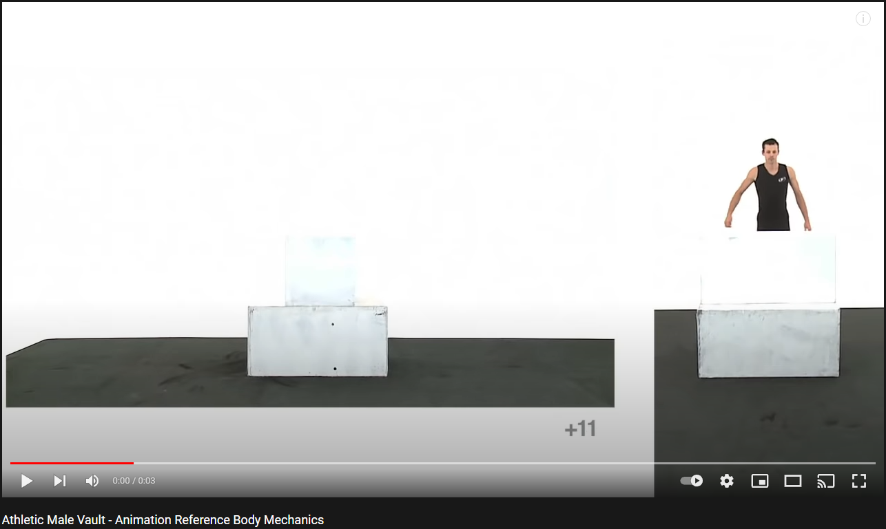

After downloading the video in the MP4 format, I used Adobe After Effects to convert the file into something I can import into the Maya scene.

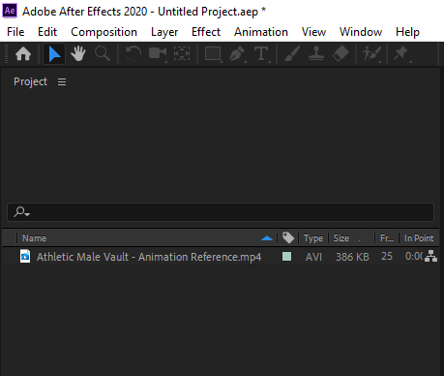
After renaming the file to something more manageable, I created a new After Effects scene - where I imported the reference video.

The goal here is to convert the file (which is currently an MP4) into a JPEG sequence, which then allows me to convert every single frame from the video into a separate picture - which works really well with Maya and laying out each frame of the reference with each animation frame in the project.

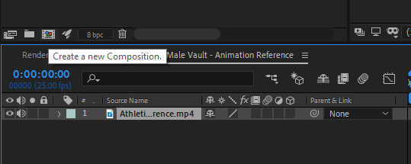
I then dragged the imported MP4 file onto the “Create a new Composition” button which performs said action.

This process allows me to edit the new composition in the render queue.

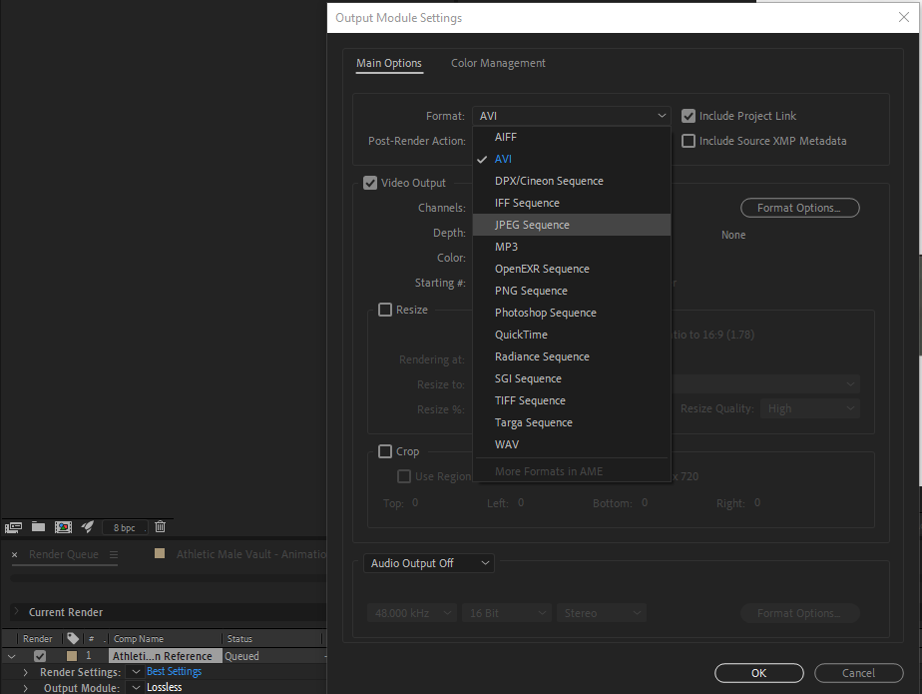
After adding the new composition to the render queue, I can select the “Lossless” settings (on the bottom left of the figure above) and change a few settings, more specifically, converting the format from the default to a “JPEG Sequence”.

It’s also really important for me to take note of what the default resolution of the file is. In the figure, it is covered by the drop down menu, but the resolution is 1280x720p.

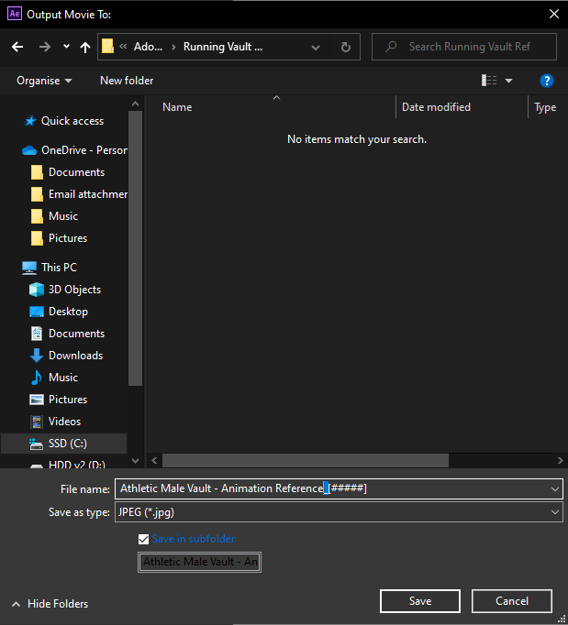

Before I render the queue within After Effects, I have to make sure that I set the output to a suitable location, and most importantly, that I replace the underscore in the default file name to a full stop.

This is necessary because Maya does not recognise underscores as a proper character - which would cause problems further down the line of this process.
After rendering the queue, the selected location will have each and every frame of the original video saved as an individual JPEG.
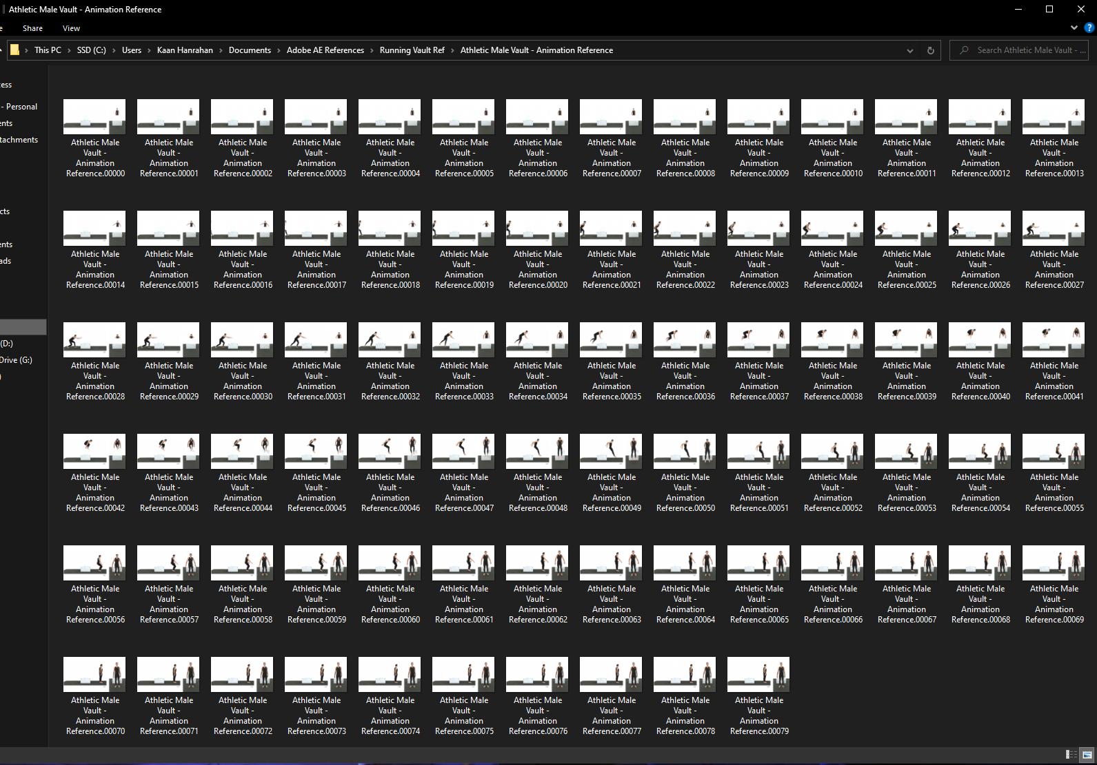
Now, with these files - we go into the Maya project. The goal here is to apply these JPEGs to a lambert material that will be applied to a plane.

After creating a plane, we have zero uses for any subdivisions, so I reduce all of those values to 1, from 10.
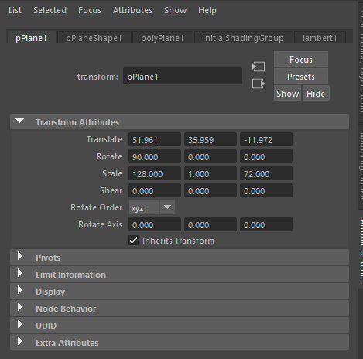
Adjusting the attributes is important here as it would interfere with the playback of the video.

This is where keeping a note of the file resolution comes in handy as we will adjust the scale to fit within the 1280 x 720p size. However, I found out that the default size is way too big for the scene, so dividing both the values of the resolution by 10 will keep the ratio and scale in check, while simultaneously accomplishing my goal of reducing the in-project size of the video.

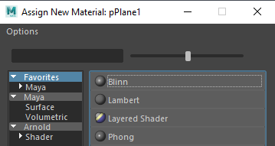
While the plane is selected, I can hold the right mouse button to open up a menu, then opening the “Assign New Material” tab will open the menu on the left.

Selecting the “Lambert” option will open a different menu where I can start to apply the JPEGs onto the plane.

In the new lambert settings that opened up on the right, pressing the checker box on the right hand side of the “Color” attribute will open up the menu on the left.

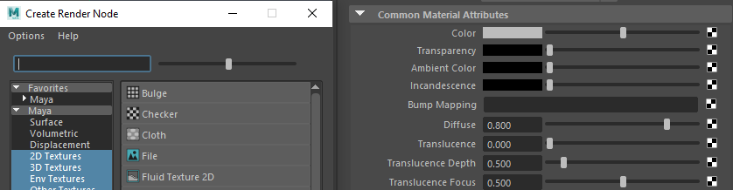
On this menu, selecting the “File” option will open another set of options.

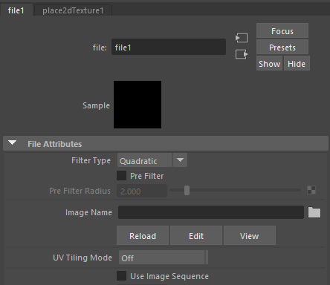
With these options available, pressing the file icon will open up a selection menu where I can select an image.

However, If I select the first frame of a sequence - via the “Use Image Sequence” check box, it sets up every individual JPEG in relation to the frames on the animation.

After the options are set in, pressing “6” on the keyboard will set Maya to show the texture.

Before starting the animation, it’s smart to set the frame limit on the animation to match the amount of frames (or the JPEGs) that the reference contains. In this case, it’s 79 frames.

After these steps are complete, the reference video should be showing properly in the viewer. Moving the plane around a bit to ensure that the grid is lined up with the way the character in the reference is stood is a good choice which should help during the animation.

I will now show a few screenshots of different frames, to show that the JPEGs have correctly aligned themselves with the Maya timeline.
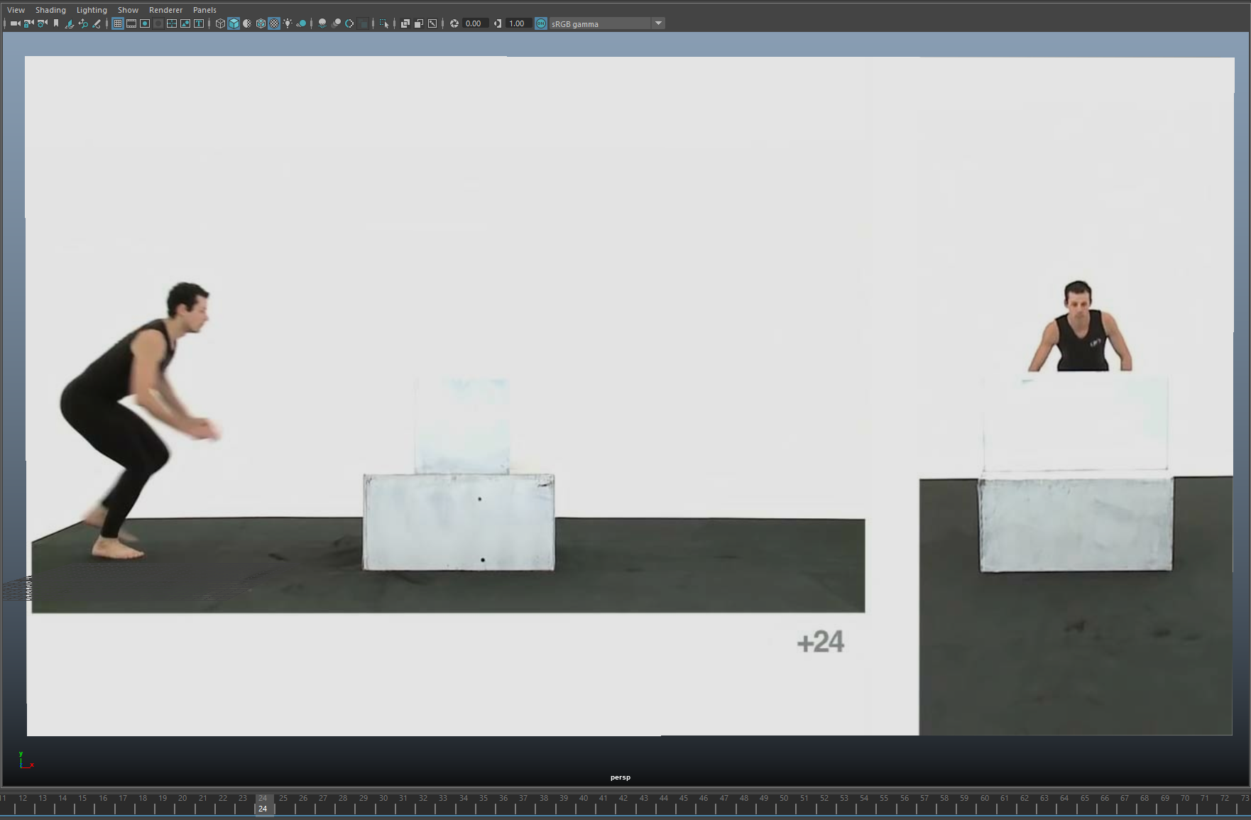

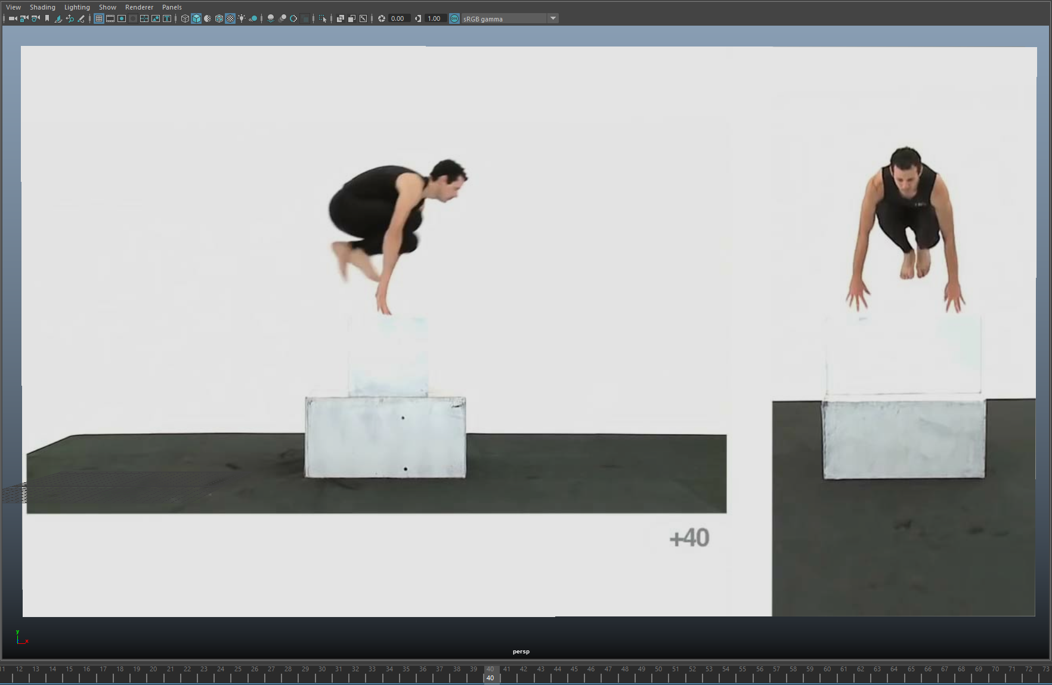
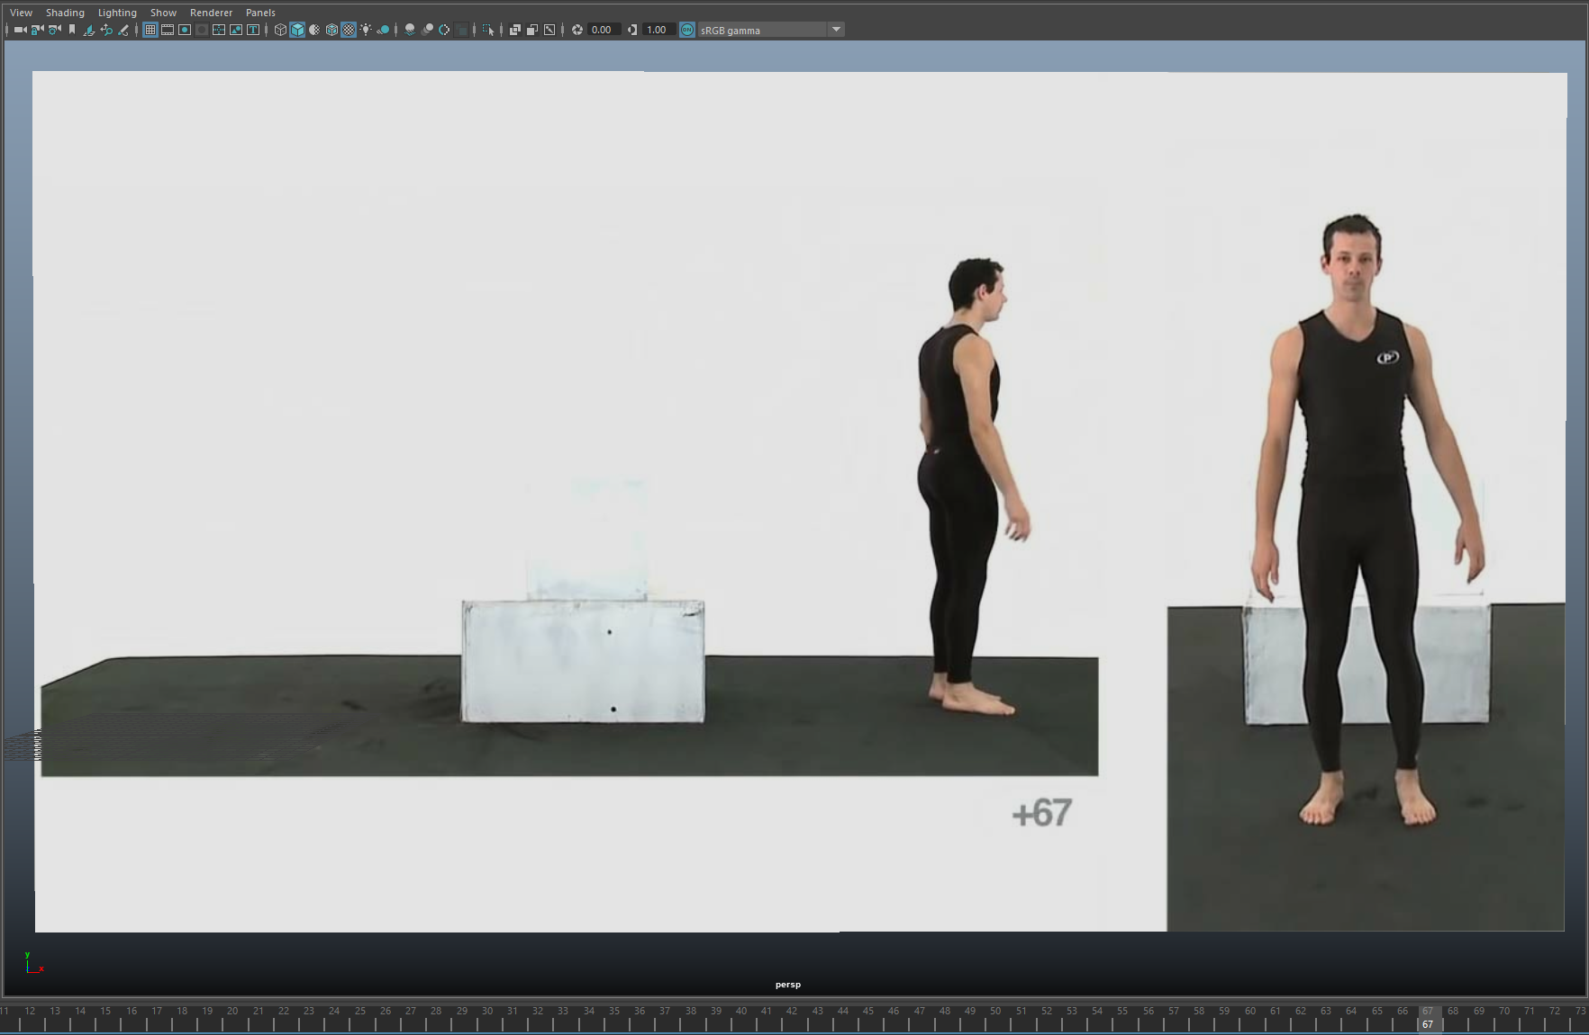

In all of my animations, I used a free, external rig named “Ultimate Bony” created by Ugur Ulvi Yetiskin, I downloaded it on the website: https://www.highend3d.com/maya/downloads/character-rigs/c/ultimate-bony-for-maya

I decided to use this rig due to the good reviews from other happy users, the fact that it is relatively ‘human’ shaped and also because I felt like it contained the right amount of complexity and easiness to use for a beginner like myself.

Later on, I discovered that the rig’s hand joints had an option to be converted from Full Kinematics to Inverse Kinematics, which overall made my experience with animating a lot more comfortable for me.

When actually getting around to creating the animations, it was important to me to actually understand what it meant to create a good animation and what I should be aiming towards if I wanted to make a realistic, and believable animation.

So, initially, I started to research various articles and blog posts online about what creates good animation. Nuno Pinheiro, who is a Senior Graphic Designer and Illustrator mentions on their blog post on the website kdab.com that:

“Animation is communication and that communication should be structured so that users can understand its central idea. No matter how simple or short the point you’re making, think of an animation as a mini movie with tension and release, a story arc and a conclusion. This will help ensure that each animation is engaging and serves a point. A button that “jumps” down and suddenly stops says nothing, while the same button sliding down and bouncing before settling can convey weight and importance.” [1]

This quote gives me a lot of information on what I should be looking for in my animations, especially the part where they mention that no matter how simple or short the animation is, you need to think of it as a mini movie with a start, middle and ending.

He also goes on to state that:

“Animation is feedback to users and helps explain the nature of objects in your program. It needs to be understandable, natural, and, most important perhaps, believable. Believability is achieved by being faithful to the concept you’re explaining. A bouncing ball should look like it obeys physics. If it doesn’t, it will look awkward and distract users from your point. You don’t want to make users work to figure out what an animation is, what it’s doing, or why it’s not quite right.” [1]

It is important to me that the basic rules like weight and gravity are followed to the best of my ability as it will help ground my animation in our reality, hence making it more believable.

Another really good source of information was the great 12 Principles of Animation by legendary Disney animators Ollie Johnson and Frank Thomas in 1981.

I have selected and extracted a few of these principles on the list that I felt like applies more to my animations:

- “Anticipation: this helps to prepare the viewer for what's about to happen. When applied, it has the effect of making the object's action more realistic. Consider how it might look if you were to jump in the air without bending your knees, or perhaps to throw a ball without first pulling your arm back, it would appear very unnatural.

- Arc: when working in animation, it's best to stick with the laws of physics. Most objects follow an arc or a path when they're moving, and your animations should reflect that arc. For example, when you toss a ball into the air, it follows a natural arc as the effects of the Earth's gravity act upon it. This is also one of the conclusions that I drew from the previous Blog source.

- Timing: for this principle of animation we need to look to the laws of physics again, and apply what we see in the natural world to our animations. In this case, the focus is on timing. If you move an object more quickly or slowly than it would naturally move in the real world, the effect won't be believable. Using the correct timing allows you to control the mood and the reaction of your characters and objects.” [2]

Focusing on a section of the last post there, it says “If you move an object more quickly or slowly than it would naturally move in the real world, the effect won’t be believable”. Now, if we consider the “object” in this scenario to be the character in which I am animating, it now shows the importance of having the character grounded in reality to be believable. I think this is where the importance of references come into play.

The blog post on pluralsight.com has an excellent post about the importance of studying video references for animation, and what information to extract from them.

Their blogpost mentions a strategy with video references that perfectly replicates what method I used for my animations:

“It's also an excellent tool to use for a basic timing structure for your animation. By converting the playback to frames in your video player application, you can see exactly how many frames it takes for say, your hand to grab the cup, or to complete a single step in a walk.” [3]

They go on to state what information would be the most useful to extract from these video references.

“Really pick apart what you are seeing in the reference and why it's happening. When the person moves toward the "down" position, how are their hips rotating? Additionally, where is their weight centered during this moment in time? What is the arc pattern of the feet during the walk? And as the hips are rotating upward as the leg raises, what type of effect is that having on the torso and upper body?” [3]

It is important that I ensure that I understand this and apply it to the references that I used with my animations.

I am going to be going through three of my references and the animations that I created from them. I am going to attempt to compare the differences using hindsight and extra research. I am going to show what I feel like I did well with the animation, and what I feel like I could improve upon. As a beginner in 3D animation, I can use this reflection to improve my skills for any future task or endeavor.

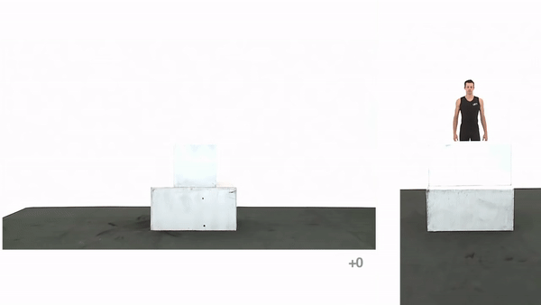

This is the first animation reference I used, which is the same as the example I used
earlier as the method of me importing references. Credit to endlessreference on YouTube. [4]

I think that this is a good reference as it gives me two perspectives of the person vaulting the obstacle, which was really good as it allowed me to get another angle on how I was to animate the characters legs as they pass under the arms at the peak of the jump.

Continued on the next page.

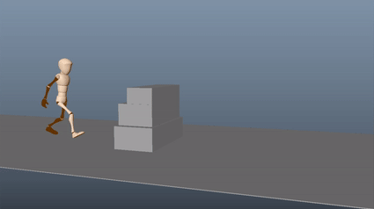
The video above is my animation, for my first time using a video reference, I’m not disappointed with how it turned out. I think that the run up and jumping part of the sequence is actually quite good for me with it falling apart slightly towards the landing.

A few mistakes that I can clearly see is that the hands of my character do not stay planted on the boxes when the character is jumping - it’s not quite easy to see but if you compare the vaulting section to the reference material, you can notice it more. I know that I can rectify that issue by ensuring that the hands are keyed in the same location throughout the whole vault procedure.

Another issue that I can notice is the landing, the character doesn’t carry the weight on the land like someone would in real life, the legs, I feel, don’t spring properly on landing, which makes the whole landing sequence a little unrealistic.

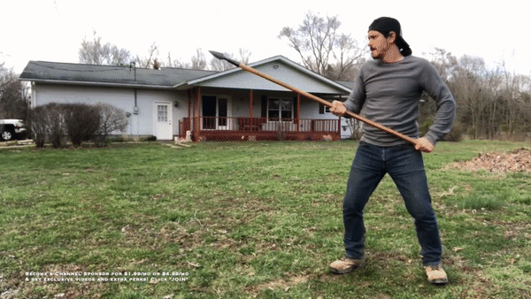
Credit to Kali Center on YouTube. [5]

This was another reference I used, which was for a spear melee attack.
There were many different choices but this video was chosen over the rest to my reference because of the very clear and concise movements that the man portrays.

Another reason as to why I used this as a reference is due to how he plants his feet during the whole process and they do not move from the initial position. I found this to be easier for me to animate at my skill level.

Continued on the next page.

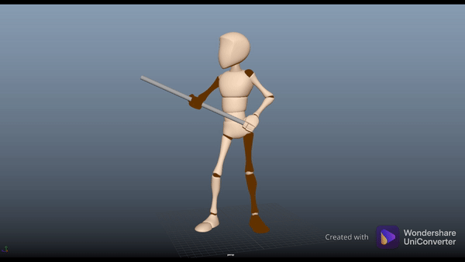
In this animation, I’m pretty proud of the character’s posing and posture. I think I managed to keep a fairly good job with the positioning in relation to the reference video.
However, after the fact, I noticed that I didn’t make the character lean on it’s right knee enough. I think this has led the animation to look a little more stiff from the waist down than I had hoped.

This was my first attempt at animating with a prop, in this case - it was a two-handed spear (which was shortened for assumed ease). I initially took a long time trying to figure out how to use the parent and constraint tools to ‘attach’ the rig’s hands to the prop, which would theoretically allow me to control the character by moving the prop. This was also the main reason for switching the rig’s hand controls from FK to IK, which just made my overall animation experience a lot better, and will be something I’d definitely consider using for the future.

The last problem that mainly sticks out to me is the fact that outside of the very first jab, all subsequent jabs are a lot slower and doesn’t replicate the speed of the reference/
To fix this, I’d just shorten the amount of time the character gets into ‘fully-extended’ pose.
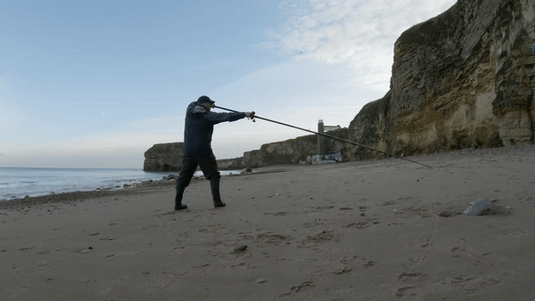
Credit to Fishing in the UK on YouTube. [6]

This reference video was really interesting to me as the video’s editor included the biomechanics of how to cast a fishing rod - which was actually pretty useful as this animation was the first time that my character had to rotate its body from one direction to the other.

I felt like I was really lucky to find this video, as the man was also standing at a nice angle in which I refer to nicely, however this became a little issue as his body rotated, and him wearing the jacket adding more difficulty as I couldn’t easily see his torso movement properly.

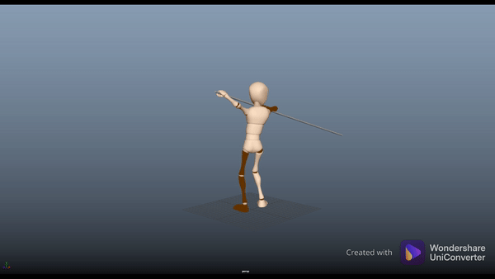

In this animation, I feel like the torso, arms and head are all animated well for my first time attempting something a little more complex. It was a little more challenging than I had initially expected due to me only seeing one side of the person in the reference.

I decided to use a full-sized prop to get a better idea of the ‘weight’ of the object, in this case - a fishing rod. I think this genuinely helped me get a better understanding of the positioning and momentum of the hands and shoulder.

The main issue with this animation is the legs, the initial posing, and the right leg rotation when the torso changes is not bad, however as soon as the fishing rod has switched sides, it is hard to shift the body’s direction to the other side without causing the feet to slide unnaturally.

I am to be sure that I refer back to this document when I am next creating character animations to ensure that I remember what I could improve upon and change.

Bibliography

[1] N. Pinheiro, "What makes for good animation?", KDAB, 2017. [Online]. Available: https://www.kdab.com/makes-good-animation/. [Accessed: 08- Dec- 2021].

[2] T. Coron, "Understand Disney's 12 principles of animation", Creative Bloq, 2021. [Online]. Available: https://www.creativebloq.com/advice/understand-the-12-principles-of-animation. [Accessed: 08- Dec- 2021].

[3] "Animation Body Mechanics: The Importance of Video Reference", Pluralsight.com, 2021. [Online]. Available: https://www.pluralsight.com/blog/film-games/animation-body-mechanics-importance-video-reference. [Accessed: 08- Dec- 2021].

[4] endlessreference, Athletic Male Vault - Animation Reference Body Mechanics. 2015.

[5] Kali Center, Spear Fighting Basic Techniques - Kali Escrima Arnis. 2020.

[6] Fishing in the UK, Beach Casting for Beginners - The Off the Ground Cast. 2021.

