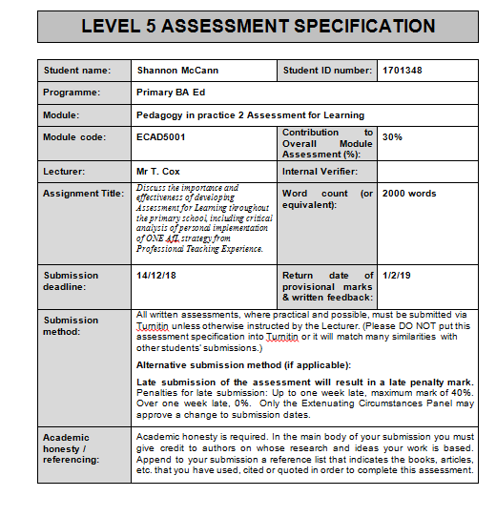
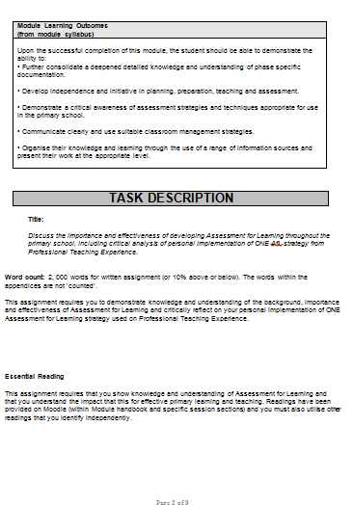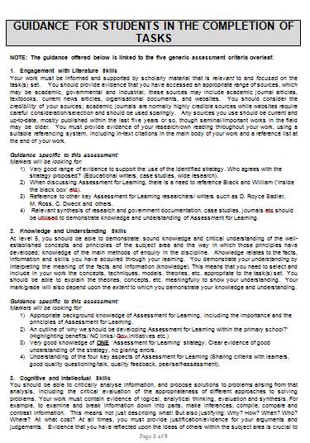

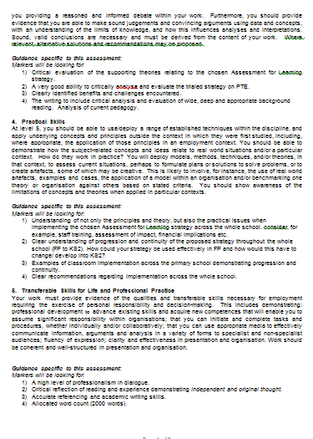

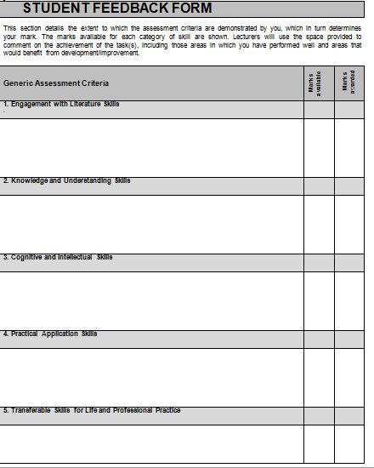

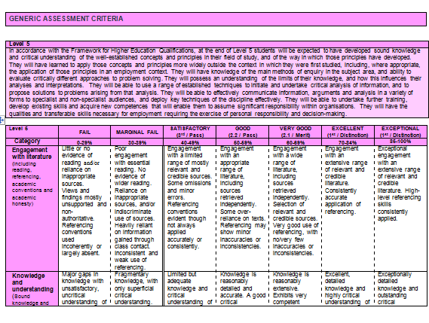

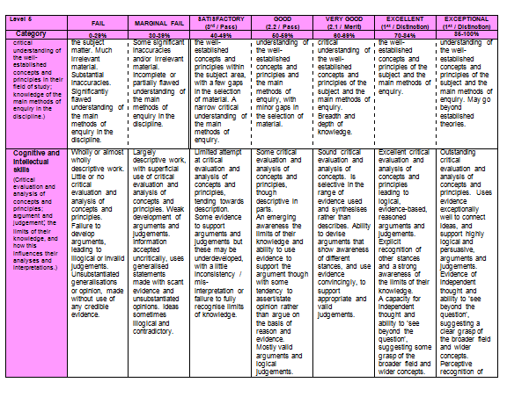

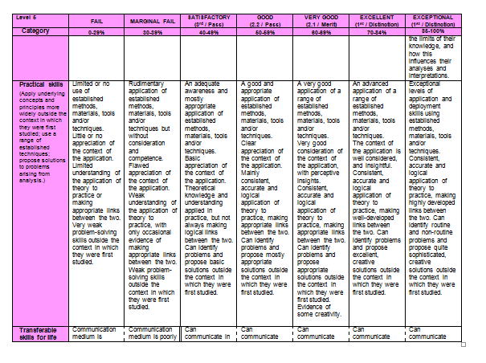

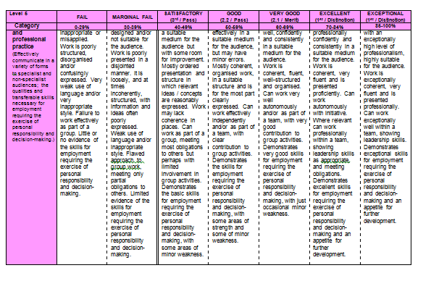
‘Discuss the importance and effectiveness of developing Assessment for Learning throughout the primary school, including critical analysis of personal implementation of one AFL strategy from Professional Teaching Practice’.
This portfolio demonstrates the sufficient use of Assessment for Learning (AFL) at a primary school level where reflecting on pupil progress, in various formats, has become an essential attribute to the national education that is associated with lifting and accomplishing the learning requirements across both phases (Black and Wiliam, 1998). According to Black and Wiliam (1998) and Barnes (2015), assessing the way in which a child learns can be considered challenging if there is no direct purpose for the lesson. Additionally, from a constructivist view, Barnes (2015) and Dunn (2017) indicate that successful assessment will enhance the individual’s learning, encouraging the learner to value their individual progress and understanding. Grigg (2010) complements the prior perspectives when synthesising that Assessment for Learning (AFL) correlates to formative assessment, which is a daily judgement, in order to evaluate the next steps for improved learning. Assessment for Learning includes four elements with regards to sharing criteria with learners, the quality of questions and language, peer and self-assessment and the use and quality of feedback. Furthermore, Grigg (2010) incorporates that this specific format of AFL should be inclusive to peer and self-assessment as magnifying feedback in a perspective that is teacher-led only, prevents the action of reflection. Therefore, the chosen strategy that will be highlighted through this assignment will be within the element of sharing criteria with the learners through exemplar work.
According to Dunn (2017), developing effective AFL originates to the planning stage of learning including both learning objectives and the Success Criteria whilst complementing the interactivity through engaging resources. This pedagogy is important as through a humanistic perspective, Cohen et al (2010) emphasises that in order to have feedback from the learners, the lessons need to be inclusive and enhance self-esteem. The previous assessment strategies across the nation consisted of targeting the capacity of accuracy through the learner’s work, instead of evaluating progress that now complements monitored Learning Objectives to create a positive perspective to education from both teachers and learners (Barnes, 2015). Supporting this, the Estyn Annual report (2018) highlights the well-being of an individual such that the majority of learners will have confidence in engaging with different environments and new areas of learning in order to “demonstrate positive attitudes to learning, sustain concentration well and take pride in their work” (Estyn, 2018, p.27). Additionally, Estyn (2018) connotes that a school that is equipped with the appropriate AFL strategies produces learners that can determine their own learning and are able to recognise the process to reaching their personal targets. Within Professional Teaching Experience, the strategy used was allowing the learners to create their own class Success Criteria implying that the learners had to reflect on their prior knowledge to conclude the elements that they had to assess themselves and others on which according to Barnes (2015), transfers the knowledge and aids them to visualise the gaps in their learning. This area relates to Bloom’s Taxonomy with regards to the learners using the method to activate prior knowledge and transfer information to identify the features of the presentation (informative poster) that they had to create (Welsh Assembly Government, 2010). Furthermore, allowing the learners to create a criteria that they need to meet, emphasises the movement in to the new curriculum where Donaldson’s (2015) Successful Futures conclude that learners should be “ambitious, capable learners” (Donaldson, 2015, p31) emphasising that they are visualising challenges for themselves.
Donaldson (2015) synthesises that successful Assessment for Learning is correlated to good practice of teaching and learning intertwined and includes the use of consistent and purposeful feedback. This may be considered significant in terms of Grigg’s (2010) implication that to have valuable teaching, the current mindset needs to reform into a criterion that crucially involves the standards of each learner. Even through the strategy of exemplar work using Success Criteria, Barnes (2015) alongside Dunn (2017) propose that learners still need effective questioning and discussions of the Success Criteria to be able to peer assess. According to Grigg (2010), developing this strategy allows the opportunity to enhance all learners’ thinking skills despite perhaps being an individual with low attainment or a disability to which he refers to a learner’s intellect as adjustable to the environment and community around them. In order to develop sufficient assessment for learning, Grigg (2010) highlights De Bono’s (2000) ‘Six Thinking Hats’ emphasising the various levels of thinking to enhance creativity. Through teaching practice, there was an obvious use of these levels through using an exemplar to construct a Success Criteria as De bono (2000) synthesises that each hat represents the different attitudes a learner can have and how they would evaluate the exemplar work, mostly consisting of the black hat to criticise the exemplar in order to create their own poster. Additionally, this implies that exemplar work develops effective ‘AFL’ as Hattie and Timperley (2007) insinuate that identifying flaws in a model will allow learners to self-asses their work to produce a better understanding and critical awareness.
Exemplar work, with regards to Assessment for Learning strategies, is an element of Visible thinking as the learners will need to reactivate their prior knowledge to participate in the activities throughout all areas of learning (Colcott et al, 2009). Additionally, the writer indicates that there needs to be a differentiation from assessment within the foundation phase and Key Stage 2 as Colcott et al (2009) synthesises that younger children need to visualise daily reminders of their basic Success Criteria. Therefore, enhancing symbols that complement exemplar work through all areas of learning would be essential to reflect upon as learners need the constant reminder as Moore (2011) acknowledges Watson’s behaviourist approach which highlights that learners need the constant reminder of their learning in order to remain within their long-term memory. This assessment can be done within groups or in pairs where, from a personal experience, the children engage and feedback efficiently when visualising aids or listening to the comments from their peers. It is essential that within assessments and activities such as these that the cognitive development uses the correct terminology when Black et al (2007) and Grigg (2010) refer to the work of Vygotsky(1978, cited in Grigg, 2010, p115) with regards to language being a significant attribute to a learner’s development. However, with regards to Vygotsky’s Zone of Proximal Development, using the exemplar work to emphasise criterion in a whole-class approach may not be as successful as the tasks set need to be intrinsic to all learners’ needs. Simultaneously, Piaget’s theory complements the work of Vygotsky where it is evident that the teacher has the responsibility to create tasks that are inclusive to the children’s needs allowing them to be responsible for their own learning through play and general areas of learning (1976, cited in Grigg, 2010, p115). Despite this, differentiating mixed ability groupings where low attainment and achievers are constructing relationships with their peers will be an effective form of AFL with regards to behaviour management throughout the classroom (Dunn, 2017).
Furthermore, Black et al (2007) argues that perhaps using exemplar work has a negative impact on the feedback and development as many teachers disregard a child’s learning when targeting the overall appearance of work where he emphasises that “A focus on standards and accountability that ignores the process of teaching and learning in classrooms will not provide the direction that teachers need in their quest to improve”(Black and Wiliam, 1998). Furthermore, Hattie and Timperley (2007) and Grigg (2010) harmonise with this as when the focus is primarily on the quality of learning , rather than quantity, it creates opportunities for a reflective environment. This being said, learners will begin to recognise the standards for appearance within their work such that they will direct their thinking based on their teachers’ body language and expectations rather than using their intellect (Holt, 2009). Therefore, assessment for learning will not be effective if a child perceives of their education as adhering to the expectations of their practitioners.
Assessment for Learning has to construct a foundation for learners to monitor their own learning; therefore, it is essential that practitioners adjust their monitoring strategies to complement the learners’ development (Grigg, 2010; Sadler, 2010). In order to have effective monitoring and assessment for learning, Dunn (2017) comments that learners need time to be able to respond and improve their learning as they need to be critically aware of their current standard and the movement to their next. Primary schools that use effective formative assessment are allowing their pupils to have a voice to inquire about their own learning but also improve the standard outlook teachers have on their responsibility within their classroom whilst assessing how the learners learn. (Black et al, 2007; ARG, 2002). For example, during professional teaching practice, it was important when discussing the exemplar work, the additional element of questioning used aided the children to examine their knowledge and understanding from the exemplar work which they then collaborated with their peers in order to have a “richer student involvement” (Black et al, 2007, p39). In addition to this, having insight on the criteria for assessment is significant in areas such as the expressive arts, as the feedback questioning and subtle model interference helps promote a positive professional growth and aids an innovative summative assessment at the end of a topic (Bloomfield and Childs, 2012).
It is beneficial that primary schools consider the need of having a whole-school assessment approach that delivers effective AFL in order for practitioners across both phases are aware of the on-going themes and resources used to be able to implement them into their individual teaching styles (Wragg, 2001 ). Supporting this, Black et al (2007) synthesises that discussion and gathering a variety of assessment for learning findings would be beneficial for teachers as they are able to deliver efficient strategies. Discussing the criteria is essential for effective AFL development as schools should use Assessment for Learning to empower engagement with the criteria itself and the learning objectives it follows as both learners and teachers need the achievement understanding (ARG, 2002). Therefore, for the key stage 2 learners, discussing the criteria fulfilments allows them to self and peer assess to then provide their own examples of the criteria and prepares them for summative assessment where they are tested on the basis of criteria levels (Wragg, 2001). Hence, the importance of assessment is to direct learners towards their potential.
Moreover, for Assessment for Learning to be successful, it needs to consider the confidence and motivation of the learner with regards to emotions, as well as a positive perception, focusing on body language (ARG, 2002; Grigg, 2010). Therefore, it is essential to influence the capabilities of all learners, including the lower achievers, by adjusting the language used through formative assessment in order to provide constructive feedback to the learners that focus on the work itself (ARG, 2002; Black et al, 2007). Hence, the necessity for education systems to approach the learners’ needs sensitively in order to grasp the success and failures. Demonstrating this approach through Professional Teaching Experience had to include the element of questioning as there were individuals who portrayed the lack of confidence, therefore, undertaking the adaptation of language allowed a better engagement.
To conclude, Assessment for Learning is a vital element in primary schools as practitioners need to be aware of their learners’ abilities within their class to be able to adapt their teaching to influence the engagement and self-confidence in order to produce effective formative assessment (Black and Wiliam, 1998). According to Clarke (2008) and Barnes (2015), formative assessment is used effectively when assessment allows learners to be responsible for their own learning and improvements, which as a result, raises the standards of attainment. Moreover, using the strategy of exemplar work provides insight of the criteria in order for the learners to be able to assess their work against the differentiation of criteria levels (Dunn, 2017). Consequently, this encourages the confidence and inclusivity of all learners, including the low attainment and achievers, to respond and reflect on their own learning (Grigg, 2010; Dunn, 2017). Additionally, Assessment for Learning relies on the outstanding teaching and learning practice, requiring a whole-school approach that discusses the differing strategies throughout the primary school, in order to provide learners with the understanding to gain purposeful feedback (Donaldson, 2015).

Bibliography
- ARG (2002) Assessment for Learning: 10 principles. Assessment Reform Group 2002. Available at:
https://www.aaia.org.uk/content/uploads/2010/06/Assessment-for-Learning-10-principles.pdf [Accessed: 12th December 2018]
- Barnes, J. (2015) Cross-Curricular Learning 3-14. 3rd edn. London: SAGE.
- Black, P. Wiliam, D. (1998) Inside the Black Box: Raising Standards Through Classroom Assessment. Phi Delta Kappa, October, 1998
- Black, P et al (2007) Assessment for Learning. Maidenhead: McGraw-Hill Education 2007.
- Bloomfield, A. Childs, J. (2012) Teaching Integrated Arts in the Primary School. 2nd edn. London and New York: Routledge.
- Clarke, S. (2008) Active Learning through Formative Assessment. London: Hodder Murray.
- Cohen, L et al. (2010) A Guide To Teaching Practice. Revised 5th edn. London and New York: Routledge.
- Colcott,D. et al. (2009) Thinking about thinking: innovative pedagogy designed to foster thinking skills in junior primary classrooms. Vol. 13, no. 1, February 2009, 17-27. Australia: Routledge. DOI: 10.1080/13664530902858477
- De Bono, E. (2000) Six Thinking Hats. UK: Penguin.
- Donaldson, G. (2015) Successful Futures. Cardiff: Crown. Available at:
https://gov.wales/docs/dcells/publications/150225-successful-futures-en.pdf [Accessed: 11th December 2018].
- Dunn, D. (2017) How to be an Outstanding Primary Teacher. 2nd edn. London, England: Bloomsbury.
- Estyn (2018) The Annual Report of Her Majesty’s Chief Inspector of Education and Training in Wales 2017-2018. Available at:
https://www.estyn.gov.wales/sites/default/files/documents/ESTYN_Annual%20Report_Accessible_English__2018.pdf [Accessed: 11th December 2018].
- Grigg, R. (2010) Becoming an Outstanding Primary School Teacher. Harlow: Pearson.
- Hattie, J. Timperley, H. (2007) The Power of Feedback. Review of Educational Research. March 2007; Vol 7, No 1, pp 81-112. ProQuest Central.
DOI: 10.3102/003465430298487
- Holt, J. (2009) How Children Learn. New York: Da Capo Press 2009.
- Moore, J (2011) Behaviourism. The psychological Record; Heidelberg. Vol. 61, Iss. 3, Summer 2011.
DOI: 10.1007/BF03395771
- Sadler, D.R. (2010) Beyond Feedback: Developing Student Capability in Complex appraisal. Assessment & Evaluation, Vol. 35(5) p.535-550.
DOI: 10.1080/02602930903541015
- Welsh Assembly Government (2010) How to develop thinking and assessment for learning in the classroom. Cardiff: Crown. Available at:
http://learning.gov.wales/docs/learningwales/publications/130429how-to-develop-thinking-en.pdf [Accessed: 11th December 2018]
- Wragg, E.C (2001) Assessment and Learning in the Primary School. London and New York: Routledge.

