
Critical evaluation of non-traditional machining equipment for the manufacturing industry Advanced Processes and Materials
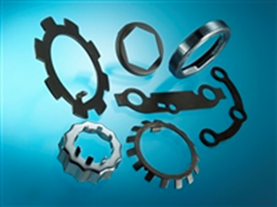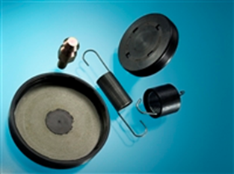
March 16, 2018
EriSh ISMAIL (p143357)
Lecture- Rachel Alexander

TABLE OF CONTENTS
TABLE OF CONTENTS i
LIST of FIGURES ii
LIST of TABLES ii
ABSTRACT iii
1.0 INTRODUCTION 1
2.0 SCIENTIFIC PRINCIPLES of the TECHNOLOGIES 2
2.1 Abrasive Water Jet Cutting 2
2.2 Ultrasonic Machining 3
3.0 ADVANTAGES, DISDVANTAGES & APPLICATIONS 5
3.1 Advantages 5
3.1.1 Abrasive Water Jet Cutting 5
3.1.2 Ultrasonic Machining 5
3.2 Disadvantages 5
3.2.1 Abrasive Water Jet Cutting 5
3.2.2 Ultrasonic Machining 6
3.3 Applications 6
3.3.1 Abrasive water Jet Cutting 6
3.3.2 Ultrasonic Machining 6
4.0 COMPARISON 7
5.0 POSSIBLE EFFECT of the NEW TECHNOLOGY on the COMPANY 9
6.0 CONCLUSION 9
REFERENCES 10

LIST of FIGURES
Figure 1: Products Produced by the Company under Consideration 1
Figure 2: Abrasive Water Jet Cutting Machine [5] 2
Figure 3: Abrasive Water Jet Nozzle [6] 3
Figure 4: Parts of an Ultrasonic Machining Machine [10] 3
Figure 5: Working Principle of Ultrasonic Machining [11] 4

LIST of TABLES
Table 1: Comparison of Abrasive Jet Cutting and Ultrasonic Machining [5, 9, 14, 15, 17]. 7
Table 2: Comparison of Abrasive Jet Cutting and Ultrasonic Machining on the basis of Process Applicability [17] 7

ABSTRACT
The aim of this assignment is recommending two non-traditional machining technologies for a company manufacturing components such as compression & torsion springs, fastenings and fixings. The company are currently using manufacturing techniques such as formed, laser and pressed cutting techniques. The specific objectives are: explaining the working principles of the two technologies, giving advantages and limitations of each technology, comparing and contrasting the two technologies and giving the possible effects of the recommended technology on the company in relation to their industry sector.
Two techniques have been recommended that is, ultrasonic machining and abrasive jet cutting. It has been that both techniques have many advantages when compared to the traditional machining techniques such as ability to manufacture complex parts, ability to machine flexible / fragile components, high surface finish quality, economical in terms of time and returns, requires less man power, high accuracy & repeatability, no hazardous product and there is minimal distortion of the component’s properties
It has been seen that the ultrasonic machining is better than abrasive water jet cutting since it has more advantages both economically and technically. The technique will be more productive than abrasive water jet cutting since less capital and time will be spent. Also the surface finish will be high. The possible effects of this technology on the company are higher profits, improved health & safety workplace, higher productivity & efficiency.

1.0 INTRODUCTION
Non-traditional machining methods have overtaken the traditional machining methods because of their several advantages such as ability to manufacture complex parts, ability to machine flexible / fragile components, high surface finish quality, economical in terms of time and returns, requires less man power, high accuracy & repeatability, no hazardous product and there is minimal distortion of the component’s properties. Though the initial capital of purchasing these non-traditional equipment is high, they have long term benefits [1].
Non-traditional machining techniques include water jet cutting (pure water and abrasive water jet), ultrasonic machining, electrical discharge machining and electrochemical machining [2].
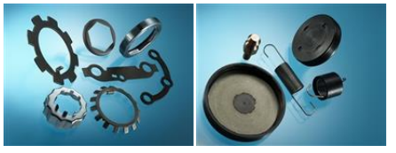
Figure 1: Products Produced by the Company under Consideration
The aim of this assignment is recommending two non-traditional machining technologies for a company manufacturing components such as compression & torsion springs, fastenings and fixings as shown in Figure 1. These two techniques will be then compared and contrasted to find the most suitable one. The company are currently using manufacturing techniques such as formed, laser and pressed cutting techniques. Two techniques will be recommended that is, ultrasonic machining and abrasive jet cutting.
The specific objectives are:
- Explaining the working principles of the two technologies.
- Giving advantages and limitations of each technology.
- Comparing and contrasting the two technologies.
- Giving the possible effects of the recommended technology on the company in relation to their industry sector.

2.0 SCIENTIFIC PRINCIPLES of the TECHNOLOGIES

2.1 Abrasive Water Jet Cutting
Water jet cutting processes can be classified into 2 groups namely: pure water cutting and abrasive water jet cutting. For the pure water cutting on a jet of clean water at ultra-high pressure is utilized while in abrasive water jet cutting an abrasive material (garnet) is fed into the ultra-high pressure stream so as to cut hard materials containing metal or glass such as ceramics, stainless steel, stone and composites [3].
So as to understand the principle of abrasive cutting, it is better to understand the principle of pure water cutting. Pure water cutting is utilized mainly on profiling “soft” materials for example rubber, plastics & foam. First, filtered water is introduced into an intensifier pump. Inside the pump, the filtered water is pressured to a pressure of 60,000psi. The ultra-high pressure water is then forced through a tiny orifice jewel having a diameter of 0.00015m. The orifice jewel is made of sapphire. The orifice focuses the water beam into a fine & accurate stream which travels at high speeds of about 900m/sec. This high travelling beam is capable of cutting the soft materials [4].
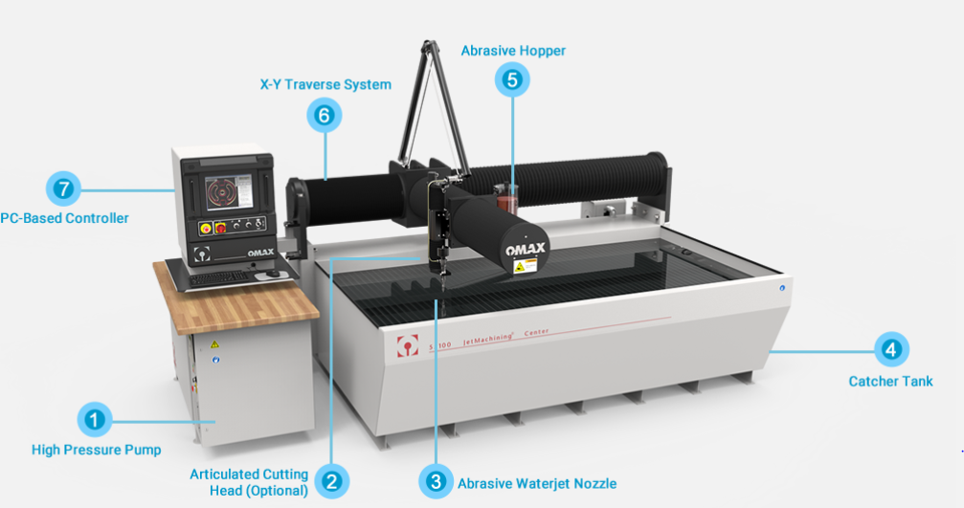
Figure 2: Abrasive Water Jet Cutting Machine [5]
Abrasive water jet cutting employs the same operating principle as the pure water cutting, but the ultra-high pressure enters a carbide nozzle after passing through the orifice. In this carbide nozzle there is mixing chamber where there is creation of a partial vacuum as the water passes through. An abrasive material mainly garnet, is fed into the carbide nozzle under the gravity and the created partial vacuum drags the garnet into the water stream for the creation of highly abrasive cutting jet. The cutting head is normally controlled by a Computer Numerical Control (CNC) thus making the cutting process more accurate and have high repeatability [5].
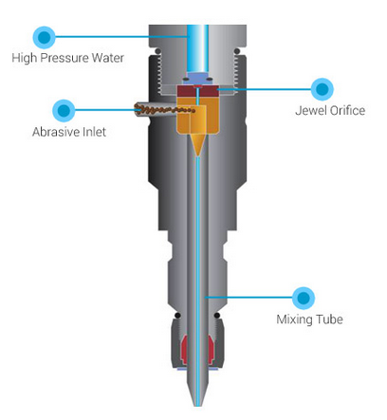
Figure 3: Abrasive Water Jet Nozzle [6]

2.2 Ultrasonic Machining
This a machining process which involves material removal from a part’s surface by utilizing a high frequency (but low amplitude of between 0.05mm-0.125mm) vibrational tool in the presence of an abrasive slurry. The tool moves orthogonally or vertically to the part’s surface [7]. The abrasive slurry is made of a mixture of water and fine abrasive particles [8]. Ultrasonic machining is normally applied in machining brittle and high hardness materials. These materials include glass, diamonds, ceramics, alumina, CVD silicon carbide and sapphire. The cutting tool is made of a softer material such as nickel & soft steels as compared as the work piece’s material [9].
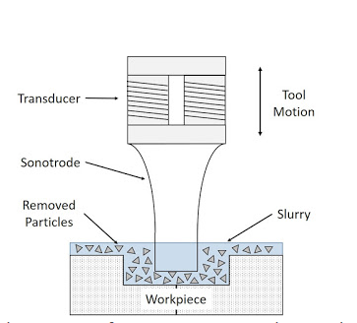
Figure 4: Parts of an Ultrasonic Machining Machine [10]
The ultrasonic machining machine has three main parts namely low carbon steel sonotrode, control unit and transducer. Transducer has piezoelectric ceramic cylinder. The cylinder is used in the conversion of electrical energy to mechanical vibration. The transducer vibrates the sonotrode at high frequency and low amplitude. One end of the sonotrode is connected to the transducer while the other end has the tool. The high frequency and low amplitude vibration of the sonotrode assist in material removal. The control unit has an electronic oscillator which produces alternating current at high frequency (18 kHz-40 kHz) [10].
Working Principle:
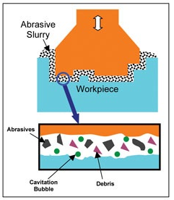
Figure 5: Working Principle of Ultrasonic Machining [11]
A high frequency alternating current is used in mechanical vibration generation. This vibration is utilized in machining the part’s surface in presence of an abrasive slurry. The abrasive slurry flows across the work piece and the tool thus there is no contact between the tool and the work piece. As the work piece is pressed by the tool, the abrasive slurry chips the materials off [11].

3.0 ADVANTAGES, DISADVANTAGES & APPLICATIONS

3.1 Advantages

3.1.1 Abrasive Water Jet Cutting
The advantages include:
- The method has high precision since it can parts with tolerances close as ± 0.005" since the cutting is controlled by a Computer Aided Design (CAD) software [12].
- The method does not produce heat affected zones on the work piece thus there is no distortion or warping of the produced work pieces [12].
- The method has a high repeatability of down to 0.025mm [13].
- Complex shapes can be cut since the technique utilizes 3-D cutting heads and specialized software. It has the ability to cut in any direction [13].
- The scrap amount is minimized since the water jet has a narrow kerf thus permitting uncut parts to be nested closely [5].
- There is minimum airborne fumes or contaminants produced by the water jet thus minimizing exposing the operator to poisonous substances. Also the water used is clean and the abrasive non-toxic [5}.

3.1.2 Ultrasonic Machining
The advantages include:
- Produces high precision parts which are made of brittle and hard materials that have high difficulty in machining [14].
- The technique can machine fragile parts made of materials such as glass which cannot be manufactured by other methods [14].
- There are no heat generation zones on the work piece since there is no contact between the tool and the work piece. Thus the properties of the work piece are least affected [15].
- High tolerance components can be machined since the worked materials is not distorted [15].
- Produces fine finished parts since there is no burrs formed [15].
- Because of the tool’s vibratory motion, several hole shapes can be cut [16].

3.2 Disadvantages

3.2.1 Abrasive Water Jet Cutting
The disadvantages include:
- The initial costs for purchasing the machine and additional abrasive materials such granite (for improving cutter’s efficiency), are high [12].
- The cutting time of the water jet is more compared to a traditional cutter when cutting the same materials [12].
- There is high tendency of the orifice to breakdown thus affecting the cutting process and in turn resulting to wastage of time and lower productivity [6].
- The technique has low accuracies when cutting thick materials [5].
.

3.2.2 Ultrasonic Machining
The disadvantages include:
- The rate of material removal can be slow since the technique is driven by erosion mechanisms [15].
- The tool life is short since the sonotrode tip wears faster because of the constant abrasive particles impact [15].
- The process is limited to materials having a hardness value of about 45 HRC [16].
- It difficult to drill deep holes since the slurry used do not reach the hole’s bottom effectively [16].
- The technique requires high skilled operator [16].

3.3 Applications

3.3.1 Abrasive water Jet Cutting
The following are the applications [3, 4, 5, 12, and 13]:
- Cutting hardened materials
- Conversion of plate stock to bars
- Custom shims in exotic materials and stainless steel.
- Cutting complex shapes in delicate materials made of glass.
- Cutting blanks for final machining.
- Short run lots of parts made of sheet metal.
- Net size cutting of 0.5” and thicker stainless steels.
- Cutting shapes of 0.25” and thicker Aluminum.
- Screen cutting
- Tube cutting
- Polishing
- Drilling
- 3D shaping
- Piercing.

3.3.2 Ultrasonic Machining
The following are the applications [7, 8, 9, 14, 15, and 16]:
- Machining hard & brittle materials such as ceramics, glass & hardened steels, which are mainly utilized for electrical & optical applications.
- Machining structural components due to high surface finish and precision.
- Drilling
- Profiling
- Grinding
- Coining
- Dies piercing
- Welding operations
- Machining irregular shaped holes

4.0 COMPARISON
The two selected techniques will be compared and contrasted as in the two tables below:
Table 1: Comparison of Abrasive Jet Cutting and Ultrasonic Machining [5, 9, 14, 15, 17].
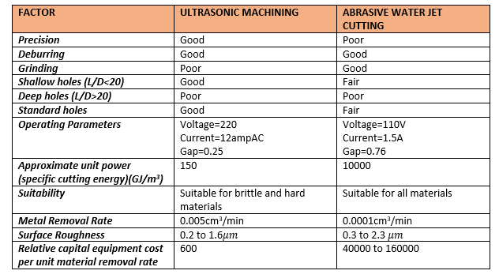
Table 2: Comparison of Abrasive Jet Cutting and Ultrasonic Machining on the basis of Process Applicability [17]
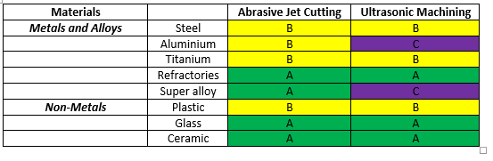
Key:
A | GOOD
B | FAIR
C | POOR
D | INAPPLICABLE

From the above comparison several aspects can be deduced.
First we will start at looking at the advantages of ultrasonic machining over abrasive water jet cutting, which are:
- Has a better precision thus higher accuracy
- Better in terms of drilling shallow holes.
- Less specific cutting energy thus less power needed and it is cheaper.
- Higher metal removal rate thus less time spent on machining a work piece.
- Lower values of surface roughness thus better surface finish.
- Less relative capital equipment cost per unit material removal rate
The advantages of abrasive water jet cutting over ultrasonic machining are:
- Better grinding properties
- Less operating voltage and current
- Suitable for all materials.
The similarities between these two methods include:
- Good deburring properties thus good surface quality
- Poor in terms of drilling long holes.
- Suitability in machining non-metals
From the above analysis, it has been seen that the ultrasonic machining is better than abrasive water jet cutting since it has more advantages both economically and technically. The technique will be more productive than abrasive water jet cutting since less capital and time will be spent. Also the surface finish will be high.
From Table 1, first we will start at looking at the advantages of ultrasonic machining over abrasive water jet cutting, which are:
Has a better precision thus higher accuracy. USM can achieve higher tolerances of between 7 to 20 microns compared to 75 to 125 microns achieved in AWJC. This is because in USM there is no distortion of the work piece since there is no contact of the work piece and the tool. AWJC has low accuracies when cutting thick materials
Less specific cutting energy thus less power needed and it is cheaper. USM has a specific energy of 150GJ/m3 while AWJC has a specific cutting energy of 10000GJ/m3. This can be attributed to low friction values because there are no heat generation zones on the work piece since there is no contact between the tool and the work piece.
Higher metal removal rate thus less time spent on machining a work piece. The metal removal rate in USM is 0.005cm3/min while that of AWJM is 0.0001cm3/min. This can be attributed to the higher machining frequency of USM of about 18 kHz-40 kHz. Also the abrasive slurry allows the debris to flow easily from the cutting area thus making the cutting process more efficient.
Lower values of surface roughness thus better surface finish. USM can achieve surface roughness of about Sa≥250nm. This is because USM utilizes lower vibration amplitudes of 15 to 50 micrometers and requires finer abrasive particles thus producing finer surfaces. Abrasive particles utilized in USM are usually 50-150 micrometers in size
Less relative capital equipment cost per unit material removal rate. USM have a capital equipment cost per unit material removal rate of 600 compared to that of AWJC of 40000 to 160000. The initial costs for purchasing the AWJC machine and additional abrasive materials such granite (for improving cutter’s efficiency), are high
Better in terms of drilling shallow holes. Shallow holes are found in fastenings such as 4 hole security machine screws and 4 hole security nuts. This is because the abrasive slurry can be controlled more easily not to reach deeper depths than the water jet.

Figure 6: 4 Hole Security Machine Tools Figure 7: 4 Hole Security Nut
The advantages of abrasive water jet cutting over ultrasonic machining is:
Suitable for all materials. From table 2 it is seen that AWJC is suitable for all categories of materials while USM is not suitable for Aluminium & super alloys. Some of the components such as fixings and fastenings are made of Aluminium & super alloys thus USM will not be suitable for this.
The similarities between these two methods include:
Good deburring properties thus good surface quality. The abrasive slurry allows the debris to flow easily from the cutting area thus making the cutting process more efficient.
Suitability in machining non-metals. This is as seen in Table 2. Most of the fastenings and fixings are made of non-metals such as Thermoplastics Polyurethane (TPU), Polyarylamide (PARA) and FR-4/G10 (a composite material made up of woven fiberglass cloth and an epoxy resin).
From the above analysis, it has been seen that the ultrasonic machining is better than abrasive water jet cutting since it has more advantages both economically and technically. The technique will be more productive than abrasive water jet cutting since less capital and time will be spent. Also the surface finish will be high.

5.0 POSSIBLE EFFECT of the NEW TECHNOLOGY on the COMPANY
From the analysis it has been that the best technology to adopt is the ultrasonic machining. The possible effects of this technology are:
- The company will get more profits since the relative capital equipment cost per unit material removal rate is less and the process is faster.
- The health and safety of the workplace will be greatly improved since the process will be automated & enclosed thus motivating the employees as compared to the traditional- machining methods. Also the materials being used are not toxic when in contact with human beings.
- The company will have a good reputation to the public since no hazardous waste will be released as waste.
- Higher productivity will be achieved since the metal removal rate is high thus less time consuming process. This will help in increasing the number of products produced at a time.
- Efficient production process will be achieved since the output will be will be high in relation to the input because there is minimized rework on the work pieces. This because the parts produced have no heat affected zones and burrs thus there is minimal distortion. This will also help in the reduction of rework costs.
- There will be great diversification since variety shapes can be manufactured according to customer’s requirements thus giving the company ability to meet all the customer needs.

6.0 CONCLUSION
It has been that the non-traditional machining techniques have many advantages when compared to the traditional machining techniques such as ability to manufacture complex parts, ability to machine flexible / fragile components, high surface finish quality, economical in terms of time and returns, requires less man power, high accuracy & repeatability, no hazardous product and there is minimal distortion of the component’s properties.
Abrasive water jet cutting and ultrasonic machining are the two techniques which have been recommended for the manufacturing industry. The advantages of ultrasonic machining over abrasive water jet cutting include better precision, better in terms of drilling shallow holes, less specific cutting energy, higher metal removal rate, lower values of surface roughness thus better surface finish and less relative capital equipment cost per unit material removal rate. The advantages of abrasive water jet cutting over ultrasonic machining include better grinding properties, less operating voltage and current and it is suitable for all materials. The similarities between these two methods include good deburring properties, poor in terms of drilling long holes and suitability in machining non-metals
It has been seen that the ultrasonic machining is better than abrasive water jet cutting since it has more advantages both economically and technically. The technique will be more productive than abrasive water jet cutting since less capital and time will be spent. Also the surface finish will be high. The possible effects of this technology on the company are higher profits, improved health & safety workplace, higher productivity & efficiency.

REFERENCES
[1]. Nee, A.Y. ed., 2015. Handbook of manufacturing engineering and technology. Springer Reference.
[2]. Roy, M.K., Ray, A. and Pradhan, B.B., 2017. NON-TRADITIONAL MACHINING PROCESS SELECTION-AN INTEGRATED APPROACH. International Journal for Quality Research, 11(1).
[3]. Krajcarz, D., 2014. Comparison metal water jet cutting with laser and plasma cutting. Procedia Engineering, 69, pp.838-843.
[4]. Kalpakjian, S. and Schmid, S.R., 2014. Manufacturing engineering and technology (p. 913). Upper Saddle River, NJ, USA: Pearson.
[5]. Begic-Hajdarevic, D., Cekic, A., Mehmedovic, M. and Djelmic, A., 2015. Experimental study on surface roughness in abrasive water jet cutting. Procedia Engineering, 100, pp.394-399.
[6]. Kinik, D., Gánovská, B., Hloch, S., Monka, P., Monková, K. and Hutyrová, Z., 2015. ON-LINE MONITORING OF TECHNOLOGICAL PROCESS OF MATERIAL ABRASIVE WATER JET CUTTING. Tehnicki vjesnik/Technical Gazette, 22(2).
[7]. Ning, F.D., Cong, W.L., Pei, Z.J. and Treadwell, C., 2016. Rotary ultrasonic machining of CFRP: a comparison with grinding. Ultrasonics, 66, pp.125-132.
[8]. Kataria, R., Kumar, J. and Pabla, B.S., 2015. Experimental investigation into the hole quality in ultrasonic machining of WC-Co composite. Materials and Manufacturing Processes, 30(7), pp.921-933.
[9]. Agarwal, S., 2015. On the mechanism and mechanics of material removal in ultrasonic machining. International Journal of Machine Tools and Manufacture, 96, pp.1-14.
[10]. Liu, J.W., Baek, D.K. and Ko, T.J., 2014. Chipping minimization in drilling ceramic materials with rotary ultrasonic machining. The International Journal of Advanced Manufacturing Technology, 72(9-12), pp.1527-1535.
[11]. Ding, K., Fu, Y., Su, H., Chen, Y., Yu, X. and Ding, G., 2014. Experimental studies on drilling tool load and machining quality of C/SiC composites in rotary ultrasonic machining. Journal of Materials Processing Technology, 214(12), pp.2900-2907.
[12]. Armağan, M. and Arici, A.A., 2017. Cutting performance of glass-vinyl ester composite by abrasive water jet. Materials and Manufacturing Processes, 32(15), pp.1715-1722.
[13]. Goutham, U., Hasu, B.S., Chakraverti, G. and Kanthababu, M., 2016. Experimental investigation of pocket milling on Inconel 825 using abrasive water jet machining. Int J Curr Eng Technol, 6(1), pp.295-302.
[14]. Jain, A.K. and Pandey, P.M., 2017. Experimental investigations of ceramic machining using µ-grinding and µ-rotary ultrasonic machining processes: A comparative study. Materials and Manufacturing Processes, 32(6), pp.598-607.
[15]. Feucht, F., Ketelaer, J., Wolff, A., Mori, M. and Fujishima, M., 2014. Latest machining technologies of hard-to-cut materials by ultrasonic machine tool. Procedia CIRP, 14, pp.148-152.
[16]. Wang, J., Feng, P., Zhang, J., Cai, W. and Shen, H., 2017. Investigations on the critical feed rate guaranteeing the effectiveness of rotary ultrasonic machining. Ultrasonics, 74, pp.81-88.
[17]. Azmir, M.A. and Ahsan, A.K., 2009. A study of abrasive water jet machining process on glass/epoxy composite laminate. Journal of Materials Processing Technology, 209(20), pp.6168-6173.

