
Applied Computing
Wales Institute of Science and Art (WISA)

Networks and Cybersecurity Essentials (ACCA4024)

Lab 4: Design and Configure Home Network (Basic configurations in networking devices).

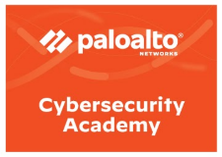
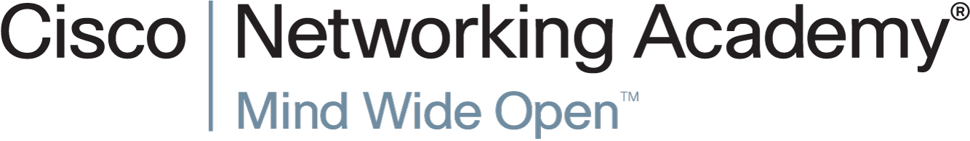
Task 1: Understand Networking devices and configure them to deploy a successful network.

Task 2: Create and Analyze Packet Captures (Refer to Lab 3 and 4 from Palo Alto Network Security Fundamentals Course. Complete the activity using NDG Platform)

Task 3: Checkpoint: Complete the below task
Based on your acquired skills from all the lab works, complete the following.
- Build a Simple Network (include wired and wireless devices) and dedicate an IP Addressing scheme to the network.
- Configure the IP Address
- Use necessary commands to check if the connection is successful and document the results (use appropriate screen capture).
- Draw both Physical and Logical Topology and document the successful network.

LAB Objectives
Understand the types, purpose and functionality of various networking devices and configure them.
Requirements
- Use appropriate Cisco Devices to configure or Use simulated environment in packet tracer
Task 1: Understand Networking Devices.
Introduction:
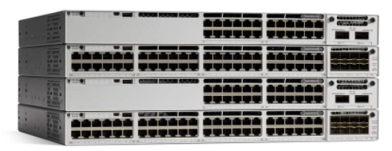
LAN switches provide connectivity for a local area network. Routers interconnect local networks and are needed in a WAN environment.
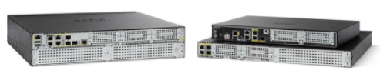

Cisco 4300 Series Routers
Cisco Catalyst 9300 Series Switches

When selecting a switch, keep in mind the type of ports, speed required, expandability, and manageability of the device.
- Lower-cost switches support only copper twisted-pair ports whereas higher priced switches may have fiber-optic connections to link the switch to other switches that may be located over long distances.
- A 10/100 Ethernet port can only function at either 10 or 100 Mbps. Switches may also include gigabit Ethernet ports that can also operate at 10/100 Mbps.
- Fixed configurations have a specific type and number of ports or interfaces and Modular devices have expansion slots that provide the flexibility to add new modules as required.
- A managed switch can be configured and controlled.
- Switches that support Power over Ethernet (PoE) allows some devices to be powered by attaching a cable from the device to a switch port.
- Uplink ports are used to connect to other switches.
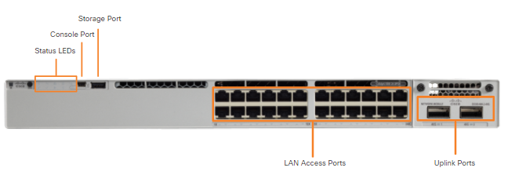
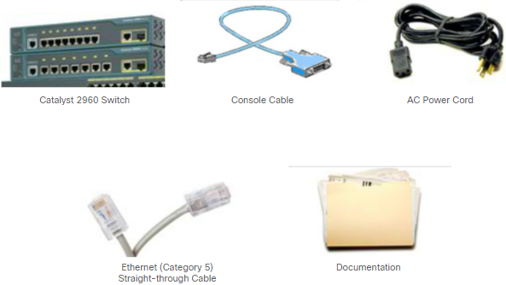
Understanding a Switch:
Checklist: (What you need to connect and configure a switch)
- console cable,
- power cord,
- Ethernet cable, and
- switch documentation
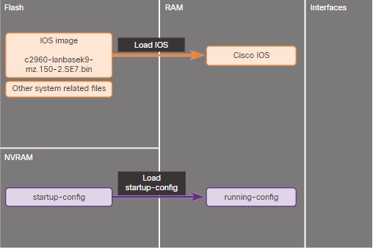
There are two methods to connect a PC to a network device to monitor or configure 1. Out-of-band management and 2. In-band management
Two files load into RAM when a switch boots
- IOS image file that is initially stored in flash, but loaded into RAM
- Startup configuration file that is initially stored in NVRAM (then loaded into RAM) and contains configuration commands
Understanding a Router:
Routers have components similar to computers, tablets, and smart devices:
- Operating system (OS) that is Cisco Internetwork Operating System (IOS)
- Central processing unit (CPU)
- Random-access memory (RAM)
- Nonvolatile random-access memory (NVRAM)
Each router model has a different type and number of ports. An example is a Cisco 4321 Integrated Services Router (ISR) that has the following connections:
- Multiple console ports used for initial configuration and command-line interface (CLI) work that includes an RJ-45 and mini-B USB connectors.
- Two RJ-45 LAN Gigabit Ethernet interfaces
- Expansion slots that can hold network interface modules (NIMs)
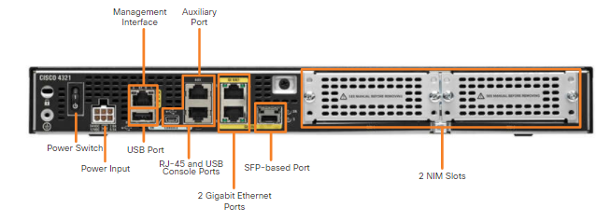
Connecting and Configuring a Switch/ Router
Out-of-band management
- Requires a console cable connection, not a network connection, and a terminal emulation client
- Commonly done to initially configure a device
- Might be done if network connectivity is not possible
In-band management
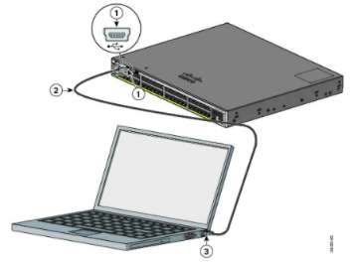
- Uses a network connection and an IP address to connect to the network device. (Virtual Terminals – we discussed during our previous lecture session)
- Telnet, HTTP, or SSH used
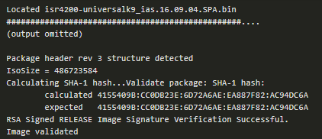
Step 1: Connect the console cable to the switch/ Router and start a terminal emulation session. Connect the AC power cord for a switch/ power on the router.
Step 2: Power up the switch and note that some models do not have an on/off switch. Power-on self-test (POST) begins. Observe startup messages.
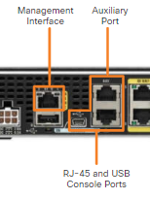
On both Switch and Router:
To access the CLI on a router three methods can be used
- Console port (serial or USB connection) for out-of-band management
- SSH using the network and an IP address on the router
- AUX port that can connect to a modem and a dial-up telephone line
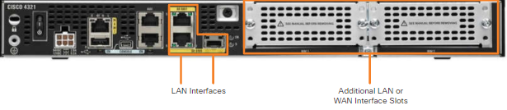
- LAN and WAN interfaces are available as a type of network interface.

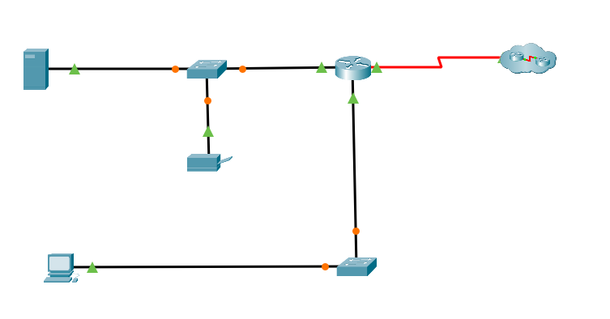
Topology 1
To configure a router or a switch in a real time, refer to our lecture video’s. Below are the instructions to configure using packet tracer. (If working with Real Time Devices, use PC’s for Printer and Server. A router with Serial Connection for ISP)
- The Cisco IOS command line interface (CLI) is a text-based program that enables entering and executing Cisco IOS commands to configure, monitor, and maintain Cisco devices.
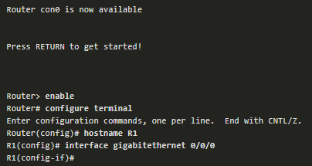
- The Cisco CLI can be used with either in-band or out-of-band management tasks.
- CLI commands are used to alter the configuration of the device and to display the current status of processes on the router.
- The CLI can be used to enter Cisco IOS commands.
Command Mode | Description | Default Device Prompt
User Exec Mode | Mode allows access to only a limited number of basic monitoring commands. It is often referred to as “view-only" mode. | Switch>  Router>
Privileged EXEC Mode | Mode allows access to all commands and features. The user can use any monitoring commands and execute configuration and management commands. | Switch#  Router#

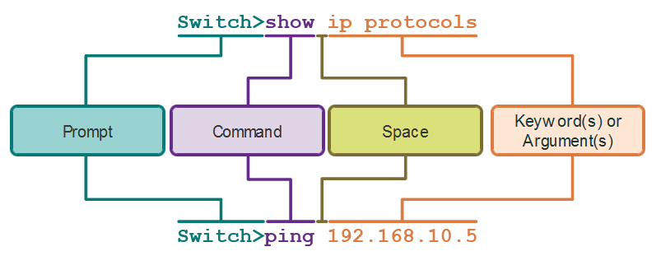
Command | Used to
show running-config | Verify the current configuration and settings.
show interfaces | Verify the interface status and see if there are any error messages.
show ip interface | Verify the Layer 3 information of an interface.
show arp | Verify the list of known hosts on the local Ethernet LANs.
show ip route | Verify the Layer 3 routing information.
show protocols | Verify which protocols are operational.
show version | Verify the memory, interfaces, and licenses of the device.

Key Stroke | Description
Ctrl+E | Moves the cursor to the end of command line.
Up Arrow or Ctrl+P | Recalls the previous command in the history buffer, beginning with the most recent command.
Down Arrow or Ctrl+N | Goes to the next line in the history buffer.
Ctrl+R or Ctrl+I or Ctrl+L | Redisplays the system prompt and command line after a console message is received.
Enter | Displays the next line.
Space | Displays the next screen.
Any other key* | Ends the display string, returning to previous prompt.  *Except "y", which answers "yes" to the --More-- prompt, and acts like the Space.
Ctrl-C | When in any configuration mode, ends the configuration mode and returns to privileged EXEC mode. When in setup mode, aborts back to the command prompt.
Ctrl-Z | When in any configuration mode, ends the configuration mode and returns to privileged EXEC mode.
Ctrl-Shift-6 | All-purpose break sequence used to abort DNS lookups, traceroutes, pings, and to interrupt an IOS process.
Backspace | Erases the character to the left of the cursor.
Ctrl+D | Erases the character at the cursor.
Ctrl+K | Erases all characters from the cursor to the end of the command line.
Esc D | Erases all characters from the cursor to the end of the word.
Ctrl+U or Ctrl+X | Erases all characters from the cursor back to the beginning of the command line.
Ctrl+W | Erases the word to the left of the cursor.
Ctrl+A | Moves the cursor to the beginning of the line.
Left Arrow or Ctrl+B | Moves the cursor one character to the left.

Router Basic Configuration
Step 1. Configure the device name.
Router(config)# hostname hostname
Router(config)# hostname R1
Step 2. Privileged EXEC mode.
Router(config)# enable password password
R1(config)# enable password class
Step 3. Secure privileged EXEC mode.
Router(config)# enable secret password
R1(config)# enable secret class
Step 4. Secure user EXEC mode.
Router(config)# line console 0
Router(config-line)# password password
R1(config-line)# password cisco
Router(config-line)# login
Step 5. Secure remote Telnet / SSH access.
Router(config-line)# line vty 0 4
Router(config-line)# password password
R1(config-line)# password cisco
Router(config-line)# login
Router(config-line)# transport input {ssh | telnet | none | all}
R1(config-line)# transport input ssh telnet
Step 6. Secure all passwords in the config file.
Router(config)# service password-encryption
Step 7. Provide legal notification.
Router(config)# banner motd delimiter message delimiter
Step 8. Save the configuration.
Router# copy running-config startup-config
Before beginning to configure your network, understand another aspect of network.
If your local network has only one router, it will be the gateway router, and all hosts and switches on your network must be configured with this information. The default gateway is only used when the host wants to send a packet to a device on another network. The default gateway address is generally the router interface address attached to the local network of the host. The IP address of the host device and the router interface address must be in the same network.
In our Topology 1, R1’s Gi0/0/0 will be the default gateway for that LAN Network.
Let’s assume that the following design is made for the above topology. (Consider this as a sample for your Task 2 and also your Coursework Task)

Physical Topology
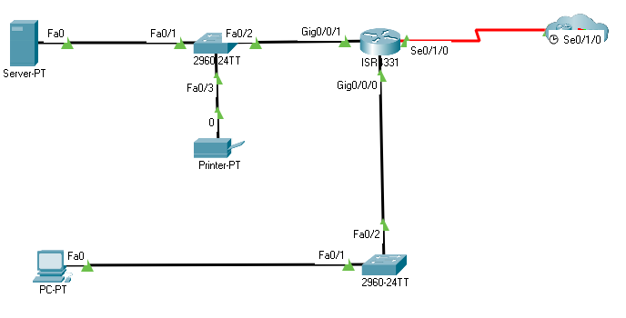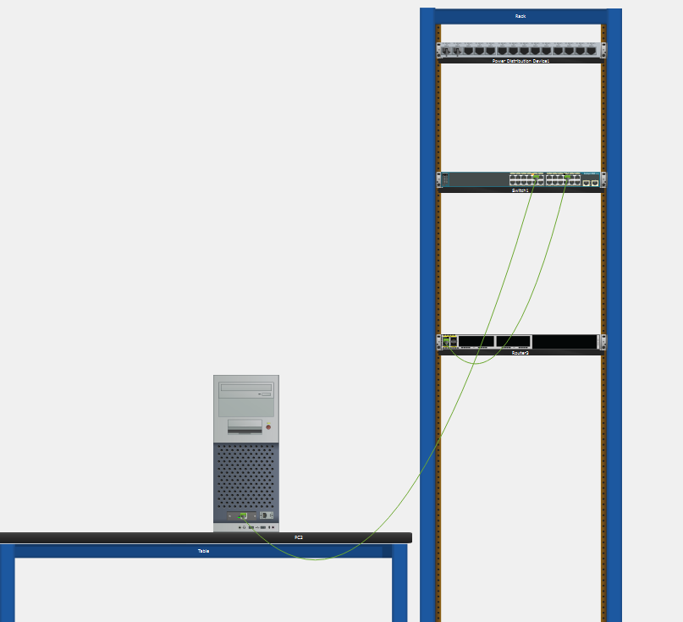
Logical Topology
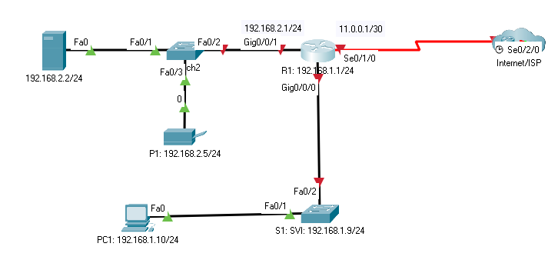
Logical Topology
PC1: NIC: 192.168.1.10 – 255.255.255.0 – 192.168.1.1
Ser1: NIC: 192.168.2.2 – 255.255.255.0 – 192.168.2.1
P1: 192.168.2.5 – 255.255.255.0 – 192.168.1.1
R1 : Gi0/0/0 192.168.1.1 – 255.255.255.0
Gi0/0/1 192.168.2.1 – 255.255.255.0
Se0/1/0 11.0.0.1 – 255.255.255.252
S1: SVI Interface: 192.168.1.9 – 255.255.255.0
Default Gateway: 192.168.1.1

Configurations
PC1 Desktop IP Configuration
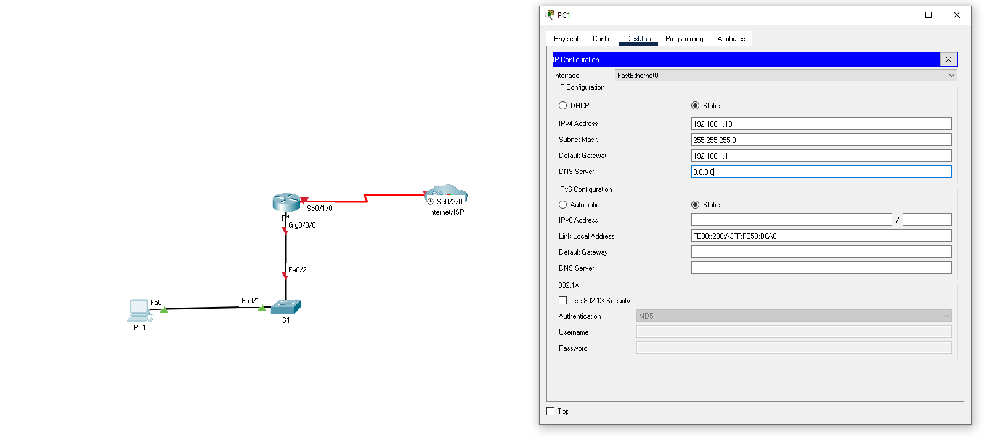
S1 CLI
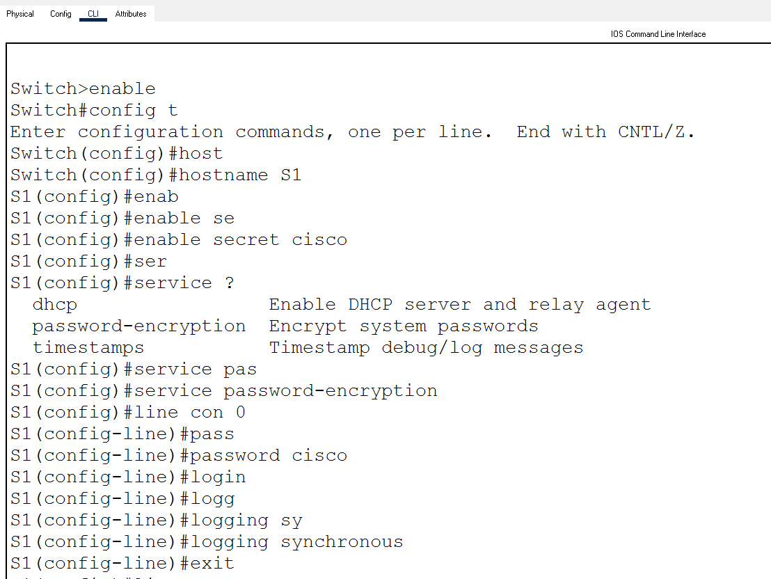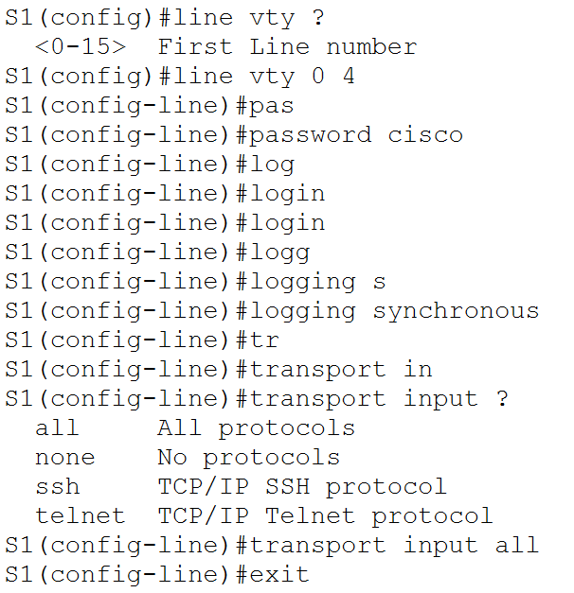
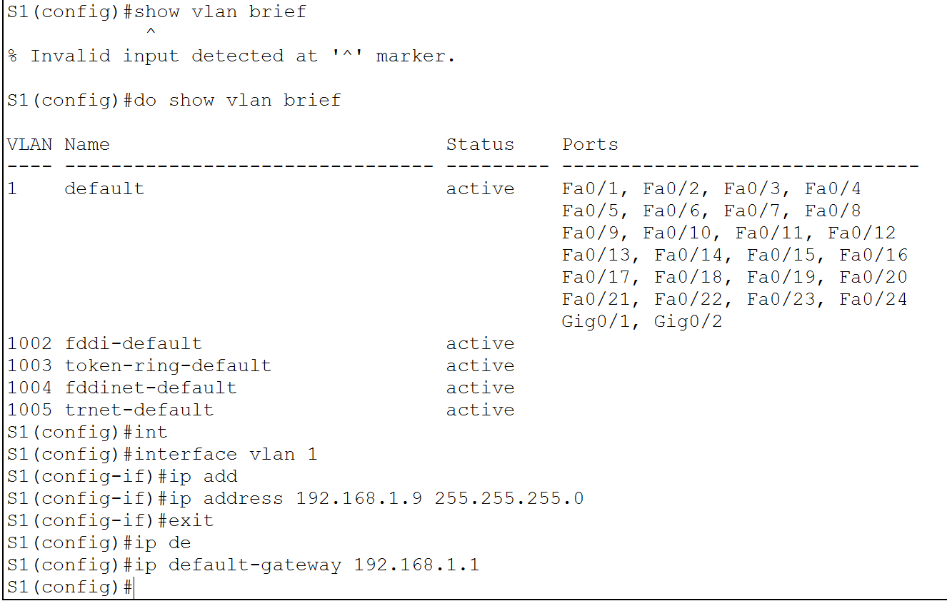
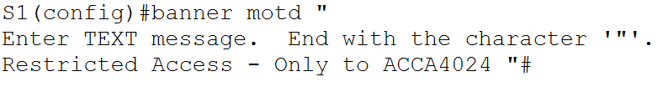
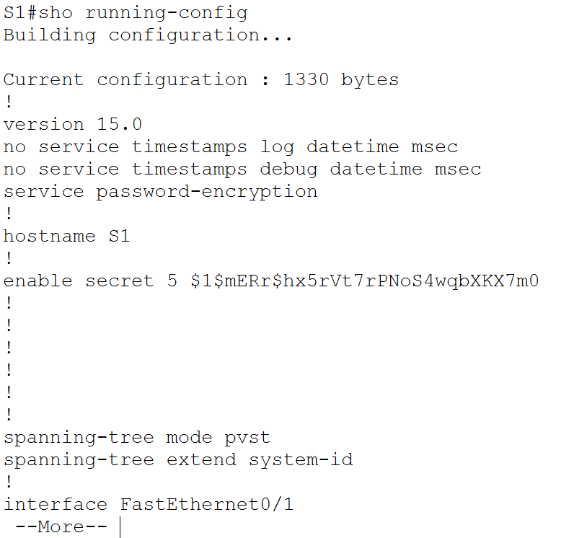

R1 CLI
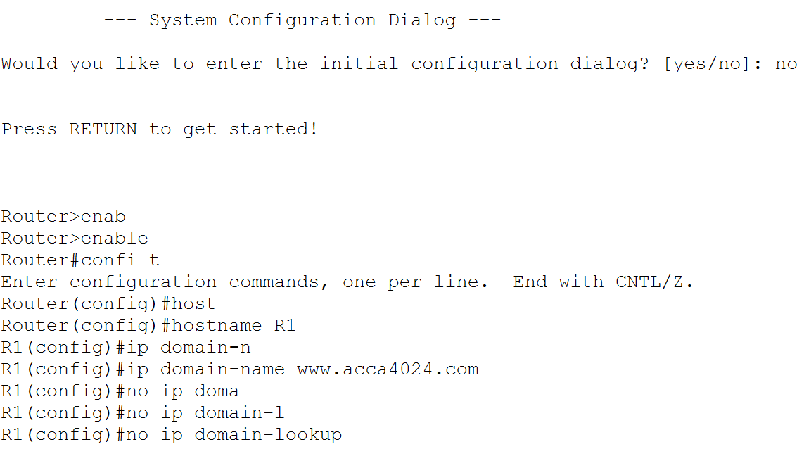
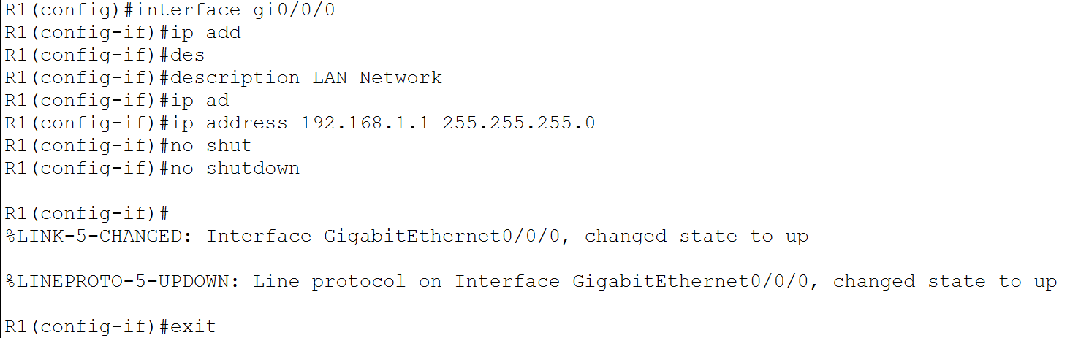
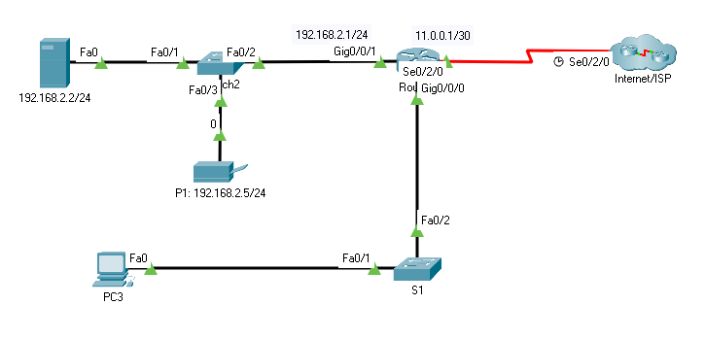

Switch Commands (Reference)
Switch>enable
Switch#configure terminal
Enter configuration commands, one per line. End with CNTL/Z.

Switch(config)#hostname S1
S1(config)#enable secret cisco

S1(config)#line console 0
S1(config-line)#password ciscocon
S1(config-line)#login
S1(config-line)#logging synchronous
S1(config-line)#exit

S1(config)#line vty 0 4
S1(config-line)#password ciscovty
S1(config-line)#login
S1(config-line)#logging synchronous
S1(config-line)#transport input all
S1(config-line)#exit

S1(config)#service password-encryption

S1(config)#int vlan 1
S1(config-if)#ip address 192.168.1.9 255.255.255.0
S1(config-if)#no shut
S1(config-if)#exit

S1(config)#ip default-gateway 192.168.1.1

S1(config)#banner motd "
Enter TEXT message. End with the character '"'.
Restricted Access only for ACCA4024 "
S1(config)#exit

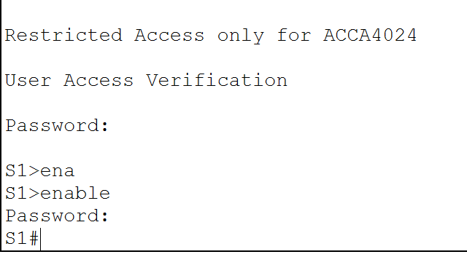
Router Commands (Reference)
Router(config)#hostname R1
R1(config)#enable secret cisco

R1(config)#no ip domain-lookup

R1(config)#ip domain-name www.acca4024.com

R1(config)#username admin secret cisco
R1(config)#exit

R1#
R1(config)#line con 0
R1(config-line)#password cisco
R1(config-line)#login
R1(config-line)#logging synchronous
R1(config-line)#exit

R1(config)#line vty 0 1
R1(config-line)#password ciscovty
R1(config-line)#logging synchronous
R1(config-line)#transport input all
R1(config-line)#exit

R1(config)#crypto key ?
generate Generate new keys
zeroize Remove keys

R1(config)#crypto key generate rsa
The name for the keys will be: R1.www.acca4024.com
Choose the size of the key modulus in the range of 360 to 2048 for your
General Purpose Keys. Choosing a key modulus greater than 512 may take
a few minutes.

How many bits in the modulus [512]: 1024
% Generating 1024 bit RSA keys, keys will be non-exportable...[OK]

R1(config)#ip ssh version 2
R1(config)#
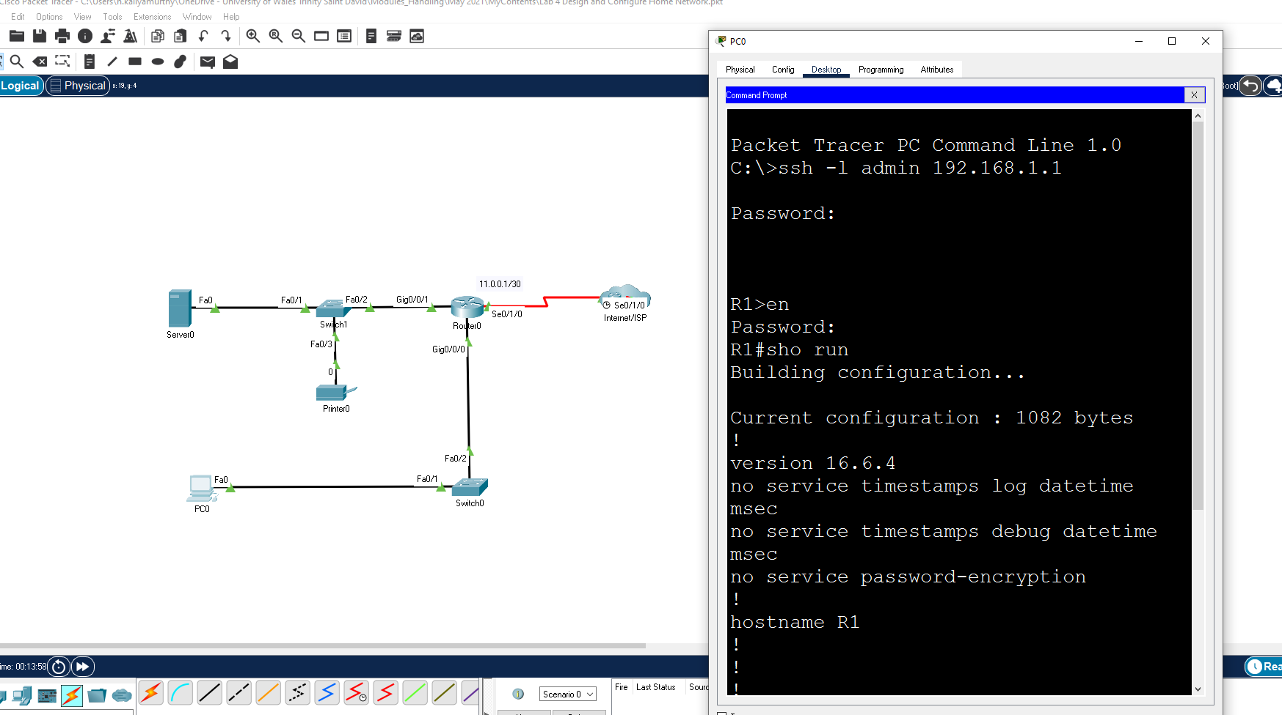
Learnings from tutorials done so far:
- Build a Simple Network
- Understand and configure IP Address
- Use Ping/ Trace route Utility to check the connection status
- Use ipconfig /all command to determine the MAC address of a Windows computer on an Ethernet network.
- Analyze a MAC address to determine the manufacturer.
- Analyze the Wired and Wireless Network connection.
- Analyze Address Resolution Protocol (ARP).
- Connect to a Wireless Router and configure the basic settings in a wireless router
- Use nslookup command to understand the url to ip conversion
- Build a Small Network, do basic configurations and establish a successful network connectivity.
- Use simulated/real time environment in packet tracer.
- Create Packet Captures
- Analyse Packet Captures

