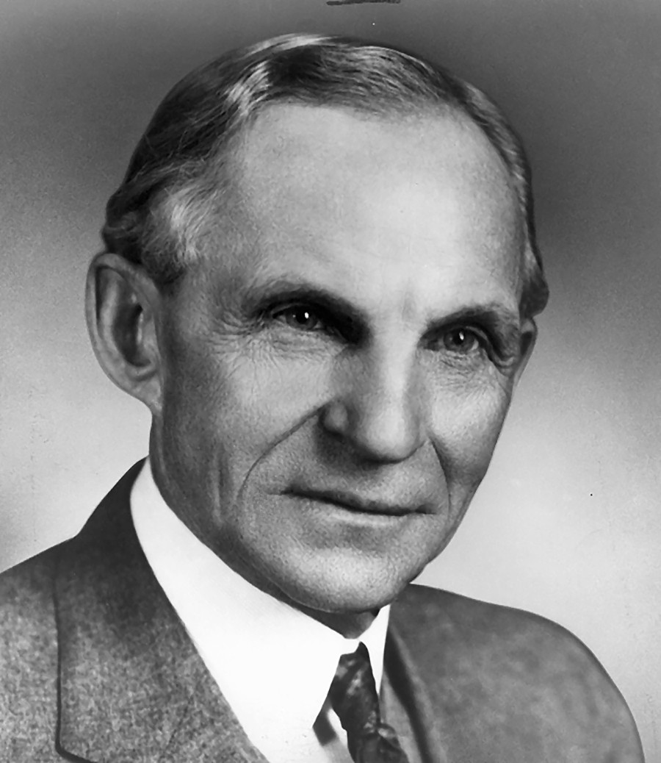  Henry ford Leadership style | Learning from past, Applying in present, Improve for future.  Daniel Grasu (1805703)  BMSW6101

Contents
1. Introduction 2
2. Henry Ford Leadership Style – Learning from past 3
3. Author Leadership Style – Applying in present 7
4. References 9

Introduction

During the time, leadership styles had suffered a major transformation do the business and law changes. The aim of this essay is to analyse the leadership styles transformation by studying a historical businessman leadership style and the applicability of it in our days.
Leadership style and leadership skills are the most important pillows for the business health and business future for that it is very important to learn from history, apply in present and try to improve them for future. The historical business man chosen by author is Henry Ford, founder of Ford Motor Company. The great inventor and engineer Henry Ford had managed to lead his business through two big wars, World War I and World War II adapting in every situation and facing all the changes.

Henry Ford Leadership Style – Learning from past

Henry Ford history
Born on 30 July 1863 in Springwells Township, Michigan, from an Irish father and a Belgian mother, Henry Ford did not have a beautiful childhood. His parents have died when he was very young, and he was adopted by their neighbours. At 15 years old, Henry Ford was known by friends and neighbours as the watch repairman. (Evans, Buckland and Lefer, 2004)
At 24 years, Henry Ford had built the first four-cycle engine with one cylinder and in 1890, he started to work on a two-cylinder engine. In 1892, Henry Ford had completed his first gasoline engine, powered by a two-cylinder having a power of four horses (four horsepower motor). After many jobs and many positions in many companies, in 1899 had founded the Detroit Automobile Company but it was not a success do the low quality and high price of the automobiles produced and it was dissolved in January 1901. (Bak, 2012) In October 1901, Henry Ford Ford designed, built, and successfully raced a 26-horsepower automobile and after this event he managed to gather all his stockholders from Detroit Automobile Company and build the Henry Ford Company on November 1901. In 1908, Henry Ford had developed the Model T, his first successful car who have become the most known and accessible car in America. (Brooke, 2008)
Regarding the labour philosophy, Henry Ford had demonstrated that he was a true visioner and he known how to grow up his business. By raising the minimum daily payment from $2.34 to $5, Henry had managed to hire the best mechanics, eliminating in this way the training costs, and raising the productivity. (Brinkley, 2009) By introducing the assembly line in his business, Ford had managed to drop the car production cost and in 1914, sales had passed 250,000 units. In 1926, Ford had announced that will be 5 days working week instead of 6 days working week with a shift of 8 hours in every day. Ford was convinced that the productivity will grow up because the employees will put more effort into their work in exchange of free time. (Crowther, 1926) During the World War I, Henry Ford was known as a pacifist and he was involved in many peace events in Europe. Henry Ford have so the WWI as a result of financial greedy. During the WWI, Ford had accused the German Jewish bankers of instigating the war and he became Senator of Michigan in 1918. (Stephen Harlan, 2008) During the World War II, Henry Ford had get involved by producing war material for Nazi Germany. During this time, he opened a factory in Germany named Ford-Werke GmbH where he used as labour’s POWs ( Prisoner of war). In this way Henry Ford had become a leader example for Adolf Hitler how so it as an inspiration. Adolf Hitler mentioned that he was keeping a life-size portrait of Henry Ford next to his desk. (Dobbs, 1998)
In time, Ford had discovered that many journal articles regarding Jews had been forged in his name leading to an international hatred against Jewish people. In 1942 the distribution of The International Jew has been halted, and Ford have tried to clarify the situation. In a letter to Sigmund Livingston. Ford state that the hatred of the Jewish people and hatred against any other racial or religious groups need to stop. (Lewis, 1987)

Leadership Style
Every person has his leadership style base on his human character. Every leader has his own way to provide employees direction, implementing business plans and motivating his people. The intellectual capacity its one of the most important key in leadership style development. (Kotter, 2001)
During the time, many researchers have identified from 6 to 9 leadership styles which are in connection with the personal character.

The most common leaderships styles are :
- Democratic Leadership – Every team member matter. Even if only one person will take the last decision, all the team members opinions matter. The final decision is taken based on the input of each team member. (Kane and Patapan, 2012)

- Autocratic Leadership – A dictatorial way where all the team members need to fallow the lead even the decisions are not the best. Theirs opinions does not matter, and they need to execute the orders without questions. (Iqbal, 2011)

- Laissez-Faire Leadership – The team have the freedom to do whatever they want as long the company main objective is achieved. The team lead is getting involved only when a team member need or request his help in object or target achievement. (Schyns and Hansbrough, 2010)

The most common personality styles are :
- The Dominance Personality – Leaders how have a dominant personality tend to have high self-confidence and their primary concerns are results and not relationships. In general, this kind of leaders are focus on achieving the business goals and tangible results by leading their team with authority and submission. (Maclay and Knipe, 1973)

- The Influence Personality – Focussed on relationships first and get tasks done second, leaders with an influence personality love to be in the centre of attention and sometimes they can be impulsive, having an innate fear of being rejected by others. (Cartwright and Cooper, 2008)

- The Steadiness Personality – Leaders with Steadiness Personality are focused on relationship and stability. They avoid any argue or conflicts and sometimes the business objective can be missed. In general, they are hard workers doing the other jobs just to ensure team harmony and balance. (Voges, Braund and Rohm, 1995)

- The Conscientiousness Personality – Focussed on quality, leaders with this personality are focused on business objective first and after that on relationships. In general, they have a grate analytical style and very perfectionists in what they do. (Briggs, Hogan and Johnson, 1997)

Henry Ford Leadership Style

According to the author, base on his research, Henry Ford was a great engineer, great inventor, hard worker, a true visioner, opportunist, businessman but not a great leader. Henry Ford leadership style cand be divided in 3 parts. First Leadership style which was before WWII, second leadership style which was during the WWII, and the third leadership style which was after the WWII. Starting as an engineer for Edison Illuminating Company of Detroit in 1891, Henry Ford had been involved in many activities and inventions and in 1893 he was promoted as Chief Engineer. In August 1899 he founded the Detroit Automobile Company, but the company was dissolved in January 1901 due to the lower quality and higher price of the automobiles produced. In November 1901, Henry Ford formed the Henry Ford Company, but he quit in 1902 because Henry M. Leland (founder of Cadillac Automobile Company) was named consultant. In October 1902, Henry Ford with Alexander Y. Malcomson have founded Ford & Malcomson, Ltd. but in 1903 after a few issues with Dodge brothers the company have become Ford Motor Company. (Shurtleff and Aoyagi, 2011) Henry Ford it is known as a pioneer of "welfare capitalism". This hiring technique it is meant to improve the business workforce by keeping only the best employees. It is a long-term vision and will allow the business to reach the objectives. This technique is regarding hiring 300 people per year to fill 100 slots and it is used in our days to. (Esping Andersen, 1990) As an example, it is Amazon who it is hiring over 2000 people during the Q4 to be able to fulfil customers demands and when the demands drop, they will start release them, converting only the top 50 or 100 people from temporary contract to permanent contract depending on how many they need. From here the author have concluded that Henry Ford wad a dominance personality and it was an autocratic leadership. Business objectives are above employee’s mental health. Studies reveals that business have registered a profit grow by applying this employment technique, but the countries are losing money do the people mental health because the employees have become more stressed due to the unsecure future.
Another business strategy used by Henry Ford was regarding the employee wages. In 1914 he doble the wages from $2.34 to $5 per day. In this way he managed to force his competitors to raise the wages or to lose their best workers. This wage rase was offered to employees how was working for company more than six months and respecting the company live standards rules. Live standards rules were regarding the employees personal live. An employee can lose this right if he was a heavy drinker, gambling or he did not fulfil his parental responsibilities. (Ford Motor Company Publication: "Helpful Hints and Advice to Ford Employes," 1915 - The Henry Ford, 2021) In this way Henry Ford had managed to cut business cost regarding employees training and he managed to hire the top skilled engineers and workers. This business strategy it is used in our days by almost all companies. Almost all companies have a payment raise or others benefits for employees after 6 months , 1 year, 2 years or 3 years of contract and sometimes the companies are getting involved in employee’s personal life to. As an example, a police officer can lose his job if he has law problems and find guilty.
In 1926 Ford had implemented the 5 days working schedule with 8-hours daily shift , 40 hours per week. By implementing this working schedule Ford had managed to keep his factory open 24/7. Reducing the working time Ford had managed to keep his employees more focused on work and eliminate the tiredness and raising the productivity. This working schedule it is used in present by almost all the factories which have an assembly or working line. In UK, the maximum weekly working time it is 48 hours.
Henry Ford was against the labour unions, because he thought they were a negative influencer, and they do more harm than good to a company and his employees. (Henry, 2018) Even in present there are companies, organisations, giants who do not want to recognise the labour union. As an example, in this case, it is Amazon. Many unions are fighting with the big giant Amazon, to be recognised and to be heard but it seems that the Amazon do not care about them.
Based on his research, the author had discovered that before WWII, Henry Ford had managed to lead his business with:
- Empathy – by understanding the common struggles and needs, Ford had managed to gain his worker dedication by boosting their wages and reducing work shift times.
- Diversity and Inclusion - Ford employed over 900 people with disabilities and had over 62 nationalities represented in his workforce. Ford had ensured that all his healthcare benefits were available to all his employees.
- Leadership with Humility - hard worker , commitment, compassion for others had made Ford to lose his objectives sometimes and had allowed the competitors to excel. As an example, are buyers’ critics regarding lack of design options among his car models.
From his research, the author had discovered that Henry ford was an Autocratic Leader with a Dominance Personality because he did not manage to work with other peoples and implement his ideas and his working stiles. He preferred to start it from beginning following his way instead of convincing other people to follow him. In less then 3 years until he managed to form Ford Motor Company, he managed to lose the ownership of one company do the bad decision taken and to quit from another one because another person was named the company consultant. Due to the autocratic leadership and dominance personality, Henry Ford was almost near to lose the Ford Motor Company too, but he was lucky because James J. Couzens and others business mans have financed and supported him. (Dickmeyer, 2004)
In time, Henry Ford have changed his dominance personality and his autocratic leadership style in to influence personality and democratic leadership style and started to focus on relationships between stakeholders and his company. He started to care about his employees and their health. In time he managed to become an influent person in USA do his recognise as a great engineer, inventor, and business man. Before WWII Henry Ford was known as a pacifist being involved in many global peace activities. He started to extend his business activities in UK, Sweden, Netherlands. During the WWI he become Senator of Michigan. All this fame had managed to transform him in a greedy and racist person during the WWII. Ford's mentality collapse during the World War II had changed him from a pacifist in to a racist. He started to use war prisoners in his factories from all the world especial in Germany. (The legend of Henry Ford : Sward, Keith, 1904- author : Free Download, Borrow, and Streaming : Internet Archive, 2021) He become again an autocratic leader with a dominance personality because he did not manage to keep the world peace as he wanted. He started to blame all the Jewish and his mental health started to aggravate. Many journals article how instigate to war was forged in to Henry Ford name because he was a very influent person, and many people trust his judgment. All the stress regarding forged articles, war, racism, critics has made Henry Ford to lose his minds and near the WWII end he lost his company to. In 1945 after a long fight in justice with his wife Clara and Edsel's widow Eleanor, Ford was forced to cede company control to his grandson Henry Ford II. (Watts, 2006)
Henry Ford health had suffered a big sock when he has saw the footage with Jewish people in Nazi concentration camps because he realised that he has contributed on those atrocities by instigating and blaming Jewish people and he died in 1947 at age 83 after a cerebral haemorrhage. (Henry Ford Is Dead at 83 in Dearborn, 2021)

Author Leadership Style – Applying in present

As Henry Ford, the author had become a team lead at a very young age. At 23 years, Daniel Grasu had become a transport manager for AVICOLA FOCSANI in Romania. Avicola Focsani was a chicken farm with activities in all domains as agriculture, chicken feed factory, chicken farms, abattoir, stores. His role was to coordinate all the driver’s activities as:
- ensure that the agriculture department have all the necessary resources as tractors, lorries, wagons for plow the field, harvest and transporting the grains to chicken feed factory,
- ensure that the chicken feed factory have all the necessary resources as lorries, wagons for bringing the chicken feed to chicken farms.
- ensure that the chicken farms are operating without any problems and the farm cycles are respecting.
- preparing the lorries and wagons for transporting chicken from farms to abattoir.
- ensure the transport from abattoir to stores.
In a short description he was coordinating around 106 drivers of all ages and all characters.
Being very young and having the director support and others influence people support he had developed an autocratic leadership style even if his personality was steadiness, sometimes heading to conscientiousness. For him it was very hard to be autocratic and dictatorial because he was raised in a family with hard workers parents, and he did not have the right experience required for this kind of job but in time he managed to lead his team and after 4 years he started to have a democratic leadership style. He started to trust his team and he started to listen their opinions and advices. This leadership stile chance will come after a team lead starts to know his team. Always will be a swap between democratic and autocratic leadership style. The personality type will help a leader to change his leadership style easier or can become a barrier. The most important is to identify, choose and apply the right leadership style based on the situation, because it is a very thin line between leading the team in the right way and losing the team faith and trust. Having the support of a few very influencer people from that town, the author had managed to gain the right skills for his role in a short period of time. It was situation when he failed to lead his team and he took the bad decisions, but he always received the support and help to cross over the situation and in this way, he managed to learn from mistakes. At the beginning for a teenager, it was very exciting to give orders and to see how people are following your rules. It was an achievement for him, because his family and friend have started to respect him do his work and reputation. But the reality was that all this respect and all this situation accrued because he was supported by some very influenced people from that city. Deep in his heart he was not happy because he knows that everything was happening due to the other people support and not because of his straight and skills. He was cheating the system and after 6 years he decides to take everything from beginning to prove himself that he will manage to become someone without other people help. He wanted to be respected and appreciated for how it is and for his skills. He wanted to find himself and develop his own personality not to copy other people personality. He moved in other city and start working for British American Tobacco. In short time he managed to become an area manager sale but not after long time he face a new situation. His skills and his hard effort wasn’t been appreciated because in Romania if you are nor supported by someone, you will not be able to evolve. After this incident he decide to change the country. In 2016, he moved in United Kingdom and he started to work for Amazon in Swansea and enrol at University of Wales Trinity Saint David. It was very difficult because he didn’t know or study the English language, and everything was new for him.

After 3 years of hard working for Amazon, language learning, university studying, he managed to become team lead on STOW department. Having a background in team lead, facing all the situations, it was very easy for him to coordinate a team of 45 people. Applying autocratic, democratic, and Laissez-Faire leadership style, he managed to gain his team, manager, ops manager and senior ops manager respect. The most used leadership stile was Laissez-Faire because in Amazon everyone knows what they need to do, and a team lead role is to monitor and support the team. Every employer has his own specific task as, stowing, picking, packing and the team lead job is to help and support the team members. Not after long time he quit, and he start his own business in transport. In 2020 after only 4 years, he managed to set up and run his own haulage company GRS ROADTRANS LTD. with no one hep. During the 2020 he managed to work in partnership with Wales Water, LIDL, ALDI, FedEx, and many others.
Having a steadiness and conscientiousness personality, the author had managed to gain his partners respect and even when the United Kingdom was in full lockdown do the COVID-19 pandemic, he managed to have a job and to work full time. Sometimes it was very hard for him to work 12 hours daily, 6 days on the week to be able to keep his partners happy and to carry on with the University studying but nothing it is impossible if you will manage to setup your priorities and objectives.
Sometimes you are the team, you are the team leader, you are the manager, you are the organisation. Sometimes you need to lead your actions to reach the desired outcome. You need to be autocratic with you and democratic with others.
Example of Autocratic Leadership style with you – tomorrow I will wake up at 6:00 am because I need to finish my assessment and I need to send my draft to my teacher to receive a feedback to know what I need to improve on it to receive a higher mark.
Example of Democratic Leadership style with others – I will appreciate if you have time to read my assessment and provide me a feedback regarding what I can improve on it for a better mark.
As a team lead, before choosing your leadership style, it is very important to know your team, to know your personality, to know your desire outcome. It is very important to know how to swich between democratic, autocratic, and laissez-faire leadership style because every situation it’s unique and every person has his own personality.

References

- Evans, H., Buckland, G. and Lefer, D., 2004. They made America. New York: Back Bay Books.
- Bak, R., 2012. Henry and Edsel: The Creation of the Ford Empire. Detroit: John Wiley & Sons.
- Brooke, L., 2008. Ford Model T : The Car That Put the World on Wheels. Minneapolis: Motorbooks.
- Brinkley, D., 2009. Wheels for the World : Henry Ford, His Company, and a Century of Progress. Collingdale: Diane Publishing Company.
- Crowther, S., 1926. HENRY FORD: Why I Favor Five Days' Work With Six Days' Pay. World's Work, pp.613-616.
- Stephen Harlan, N., 2008. Encyclopedia of American Jewish History. Abc-clio, 1, p.182.
- Dobbs, M., 1998. Ford and GM Scrutinized for Alleged Nazi Collaboration. Washington Post Staff Writer, p.A01.
- Lewis, D., 1987. The public image of Henry Ford. Detroit: Wayne State University Press.
- Kotter, J., 2001. What leaders really do. Boston: Harvard Business School Pub. Corp.
- Kane, J. and Patapan, H., 2012. The democratic leader. Oxford : Oxford University Press.
- Iqbal, T., 2011. The impact of leadership styles on organizational effectiveness. Munich: Grin Verlag.
- Schyns, B. and Hansbrough, T., 2010. When leadership goes wrong. Charlotte, N.C.: Information Age Pub.
- Maclay, G. and Knipe, H., 1973. The dominant man. London: Collins.
- Cartwright, S. and Cooper, C., 2008. Personnel Psychology. Oxford: Oxford University Press.
- Voges, K., Braund, R. and Rohm, R., 1995. Understanding How Others Misunderstand You. Chicago: Moody Publishers.
- Briggs, S., Hogan, R. and Johnson, J., 1997. Handbook of personality psychology. San Diego: Academic Press.
- Shurtleff, W. and Aoyagi, A., 2011. Henry Ford and his researchers. Lafayette, CA: Soyinfo Center.
- Esping Andersen, G., 1990. The Three Worlds of Welfare Capitalism. Cambrige: Polity Press.
- Thehenryford.org. 2021. Ford Motor Company Publication: "Helpful Hints and Advice to Ford Employes," 1915 - The Henry Ford. [online] Available at: https://www.thehenryford.org/collections-and-research/digital-collections/artifact/367411/#slide=gs-215691 [Accessed 29 March 2021].
- Henry, F., 2018. My Life and Work. New Delhi: General Press.
- Dickmeyer, E., 2004. Putting the world together. Michigan: LivingForce Publ.
- Internet Archive. 2021. The legend of Henry Ford : Sward, Keith, 1904- author : Free Download, Borrow, and Streaming : Internet Archive. [online] Available at: https://archive.org/details/unset0000unse_d3s5/page/n7/mode/2up [Accessed 29 March 2021].
- Watts, S., 2006. The people's tycoon. New York: Vintage Books.
- Archive.nytimes.com. 2021. Henry Ford Is Dead at 83 in Dearborn. [online] Available at: https://archive.nytimes.com/www.nytimes.com/learning/general/onthisday/bday/0730.html [Accessed 31 March 2021].

