
Skills for the Workplace
Module Assignment Submission
Student Name: | Lucy Paton
Student Number: | 2119943
Module No: | BMSK4002
Module Title: | Effective Team Working and Communication Part 2

Statement of Confirmation of Authenticity
By the act of making this submission, the student declares that this is the work of the student named above. The work has not, in whole or in part, been knowingly presented elsewhere for assessment, or where assessment has been built on a previous assessment, this has been identified. Where materials have been used from other sources it has been properly acknowledged. If this statement is untrue, the student acknowledges that an assessment offence has been committed.
Attention is drawn to the plagiarism and unfair practice policies of both the University and of ILM.
Permission for ILM to use this script
ILM uses learners’ submissions – on an anonymous basis – for assessment standardisation. By submitting, both the centre and the learner agree that ILM may use this script on condition that identifying information is removed. However, if you are unwilling to allow ILM use this script, please refuse by ticking the box: □

Table of Contents
Introduction 3
What is Communication and why is it Important in the Workplace 3
Shannon and Weaver communication Theory 4
communication Theory of Mehrabian: Verbal, Nonverbal, and Body Language 5
Berlo's SMCR model of communication 6
My Own Communication Skills 7
Feedback 7
Appendix 1 8
References 10

Introduction
In this assignment I will explore what communication is and why it is important in the Workplace . I am going to look at Shannon and Weavers linear model of communication, Mehrabian's theory and also Berlo's SMCR transactional model of communication. I will assess my own communication skills and include my feedback given from my classmates, including my personal development plan and my references.

What is Communication and why is it Important in the Workplace

Communication is an understanding between 2 or more people that can be verbal, non verbal or written . To communicate you have to have a sender, a message and a recipient , whilst the message is being delivered there can be a number of things that can affect how it is delivered and how it is received. The things that can interfere with getting the correct message across can include language barriers, personal barriers, psychological barriers and perceptual barriers.
We communicate in various ways which include speaking to give the message and listening to receive it, visual which could be body language or sign language and then we have written or electronic which we would read. There are a lot of things that can affect how someone perceives the message you are trying to convey, these include thoughts, motives, attitudes, feelings, emotions and values. Non verbal communication is where these things can change someone's perception of how the sender is delivering the message. When in a Workplace it is very important that all communication is delivered the correct way as if not, then problems can arise whether it be work colleagues communicating with each other or management trying to address their workforce. This could lead to misunderstandings which could then lead to an unhappy or unproductive work force.The best way to ensure that messages are being sent and received correctly is to make sure you use the simplest terms and be clear. When being faced with certain situations where you may have to be sympathetic, you may have to deliver difficult news to someone or you may be in a situation where you need to be in control and need someone to listen this is when you need to choose what tone you use what words you use and also whether your body language is coinciding with the message you are trying to deliver, for instance if your a boss and taking a meeting with your workforce then your not going to sit there slouched over looking around the room, Your going to be standing speaking with a clear voice using the correct tone to engage the audience whilst maintaining good eye contact with the group.

Shannon and Weaver communication Theory

There are different models which examine the process of communication the one i'm going to discuss here is the Shannon and Weaver model

“The fundamental problem of communication is that of reproducing a message sent from one point, either exactly or approximately, to another point” (Shannon, 1948, p. 379).


(Shannon and Weaver, 1949)

C. Shannon and W. Weaver devised the most well-known and influential formal model of communication in 1949. It's a five-part transmission model that includes an information source that generates a message that would be the sender, a transmitter that converts the message into signals that would be the encoder , a channel that adapts the signals for transmission this is where the noise can affect how it is transmitted , a receiver that decodes (reconstructs) the message from the signal, and a destination where the message is delivered which is the receiver. The sixth ingredient, noise, is a dysfunctional factor: any interference with the message travelling down the channel (such as static on the phone or radio) that could cause the signal received to differ from the signal sent.

communication Theory of Mehrabian: Verbal, Nonverbal, and Body Language
Since the 1960s, Professor Albert Mehrabian has been at the head of communication research. He gained his PhD from Clark University and began a long career as a professor and researcher at the University of California, Los Angeles in 1994.

As Professor Emeritus of Psychology at UCLA, he now spends his time researching, writing, and consulting. Mehrabian's work was essential in creating an early understanding of body language and nonverbal communication (mid-late 1900s).

Apart from his many and many other fascinating studies, Mehrabian's research was the foundation for the often mentioned and often greatly oversimplified statistics about the efficacy of spoken communications. Mehrabian's findings are represented here in a more specific (and necessarily detailed) manner than is usually cited or applied.

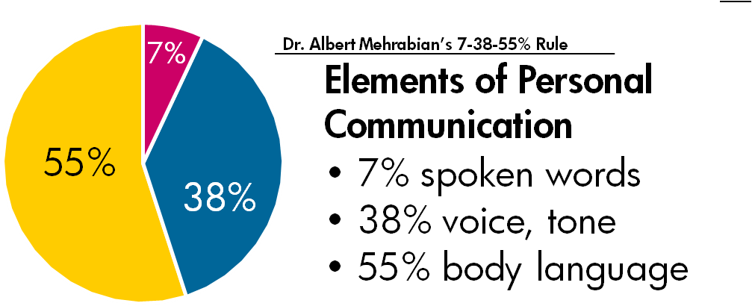

According to Dr. Albert Mehrabian's findings body language is the biggest part of how someone perceives the message you are communicating with them, only 7% is the words that are spoken, this confirms that messages that aren't conveyed face to face are far more likely to be taken the wrong way seeing as you can not see someone's body language if the message is written or over the phone.

Berlo's SMCR model of communication
In 1960, David Berlo expanded on Shannon and Weavers linear communication model and created the SMCR Model of Communication.
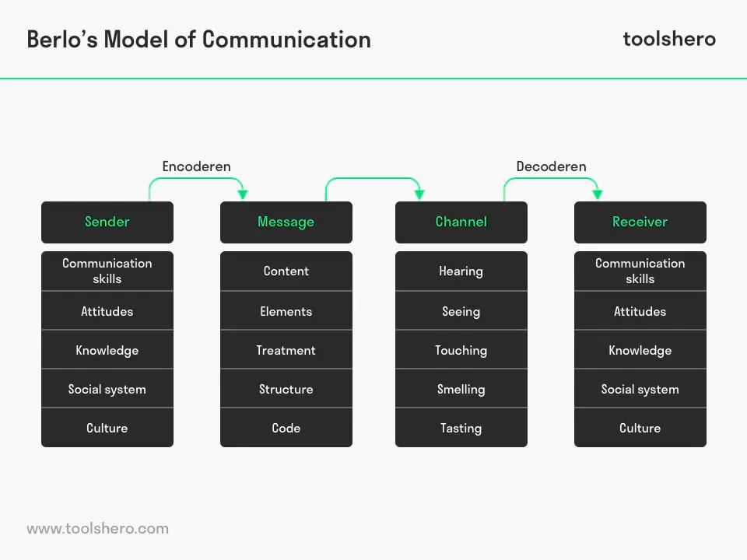
Berlo's SMCR communication model includes four components that describe the communication process. The different components in the model are affected by different factors. This is where even though the basic structure of the model is the same as the Shannon and Weaver model, Berlo starts to take into account a lot more things that could affect how the message is conveyed. There are two types of models of communication, one being linear and the other transactional. Linear is very basic this would be the Shannon and Weaver , whereas, transactional which is Berlo's builds and elaborates on it. In the linear model, the sender communicates to the receiver.
Factors that may affect the sender are also applied to recipients. For example, consider how messages are interpreted. The Berlo SMCR communication model identifies the factors in the picture above that affect the outcome.

My Own Communication Skills

I am self employed and see many different people within my line of work. I feel I have good communication skills and convey them well. When first meeting new clients I use formal words and behaviour, as I get to know them more on a personal level my communication with them will become more informal.I feel i am a good listener and absorb the information given to me before answering or trying to find a solution. My confidence in speaking in front of a room or group of people is definitely something I want to work on as I feel the way I don't keep eye contact or portray my body language doesn't offer the best communication that I can give.

Feedback
During part 1 of this module we had to give a presentation on effective team working. I presented my audience with a feedback sheet which I had made prior to delivering my presentation. On the feedback sheet it gave my audience options to score me on my communication skills. My findings when looking at the feedback was as i thought, that my eye contact wasn't held with the audience very well and my body language was giving mixed signals. I was expecting these findings as i don't feel confident when having to stand up and present in front of people which is something i am going to include in my PDP and aim to improve on by the next time i have to give a presentation.My aim is to feel a lot more confident speaking in front of groups of people that i don't know.My audience did score me high for my formal way of delivering my presentation also the language used was straight and clear to understand which i was happy with and will continue to portray in future.

Appendix 1

What do I want to learn? | What do I have to do? | What support and resources will I need? | How will I measure success? | Target Date for Review
become more confident speaking in front of a group | mock presentations, online confidence building | i can ask my tutor for feedback, online courses | do a mock presentation ask for feedback | 01/05/22
Be more prepared for my assignment deadlines | set aside a certain amount of time per day/week to be more efficient | arrange childcare in advance , use a diary | keep track of how much work im getting done | 1/05/22

Feedback Evaluation Sheet for Presentation
please score accordingly
1-Outstanding
2-Very Satisfactory
3-Satisfactory
4-Unsatisfactory
5-Poor

- Has the presenter used easy to understand language

1 | 2 | 3 | 4 | 5

- Has the presenter used appropriate body language ?

1 | 2 | 3 | 4 | 5

- Has the presenter used an appropriate tone ?

1 | 2 | 3 | 4 | 5

- Has the presenter kept adequate eye contact throughout the presentation ?

1 | 2 | 3 | 4 | 5

- How did the presenter do overall ?

1 | 2 | 3 | 4 | 5

Please provide any additional feedback that you think could help the presenter in future in the space provided below

References

- businesstopia, "Models of Communication," in Businesstopia, February 4, 2018, https://www.businesstopia.net/communication.
- Shannon, C. E., & Weaver, W. (1949). The mathematical theory of communication. Urbana: University of Illinois Press.
- https://www.businessballs.com/communication-skills/mehrabians-communication-theory-verbal-non-verbal-body-language/
- Mehrabian, Albert (1981). Silent Messages: Implicit Communication of Emotions and Attitudes (2nd ed.). Belmont, CA: Wadsworth.
- Berlo, D. K. (1960). The process of communication: An introduction to theory and practice. New York: Holt, Rinehart and Winston.
- https://www.toolshero.com/communication-skills/berlos-smcr-model-of-communication/

