
Synthesize a Solution to a Potential Real-Life Scenario
Networks and Cyber Security Essentials

Computing (Games Development)

William Foot (2405192)
Contents
Abstract 1
Introduction 2
Identifying and Mitigating Threats 2
Mobile Devices 2
Phishing 3
Physical Threats 3
Insider Threats 4
Security Policies 5
Monitoring and Response 6
Training and Awareness 6
Conclusion 7
Appendix 8
A. Presentation 8
References 15

Abstract
Due to the recent series of security incidents, this report has been created to identify the cybersecurity threats that FSL faces and propose strategies to mitigate and prevent further damage. After researching the current threats using various papers and other materials, we have identified key threats and mitigation strategies. Using guidance from the best practices for network and cybersecurity, we have created a list of policies to implement. We then outline plans to monitor the network and devices and to follow up on any security incidents. Using the policies and other best practices, we have created a training program to implement for staff to improve their awareness of cybersecurity and measures they can take to improve security.

Introduction
At FSL, we work with lots of sensitive financial data, and all employees must be aware of the potential cybersecurity risks we face. As the business grows, we will begin to possess increasing amounts of sensitive data. Due to the recent incidents, if we don’t implement a security policy now, the impact of a data breach could be massive, and the business could lose a large amount of value and business. Bringing awareness of these issues to employees is paramount, and we must work to ensure that these issues are solved so that FSL can continue to expand while keeping the data of its customers secure.

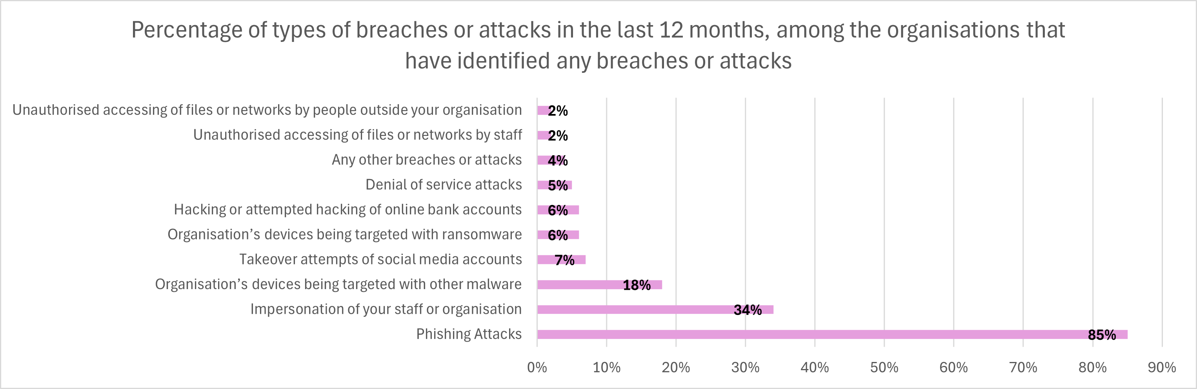
Identifying and Mitigating Threats
Figure 1. Percentage of types of breaches or attacks in the last 12 months, among the organisations that have identified any breaches or attacks[3]

Mobile Devices
The increase in mobile device use and staff working from home poses a huge security risk.
“Mobile devices are currently at the top of the list of most significant security risks” [1, p.2]
Mobile devices are everywhere; they are easy to carry and provide the user with access to the internet almost everywhere. This allows employees to access their work email or even company data whenever they want. The use of public hotspots, which are not secure, can open the company to data theft [2]. For example, a man-in-the-middle attack where a hacker creates a fake hotspot that mimics a genuine hotspot to steal any data that is passed through it. Mobile phones are also small and can sometimes be lost or stolen.
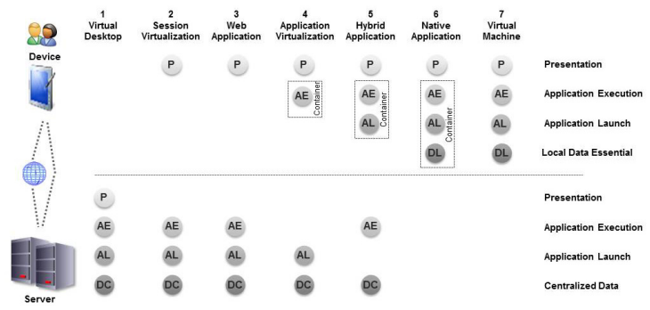
To mitigate this, employees should only use their mobile phones for calling or checking email. Any access to company data should be done through a company-issued laptop or workstation over a secure connection, e.g. the office or at home. A virtual desktop could also be used on a mobile device to isolate any sensitive data and enhance security [1, p.3].
Figure 2. Approaches to Integrate Mobile Devices[1]

Phishing
Phishing is the most common cyber threat we face. In the last 12 months of organisations that have suffered a cyber-attack 85% received some form of phishing attack [3]. A phishing attack is where the attacker uses social engineering techniques to obtain personal information. These are typically emails with links to a website that mimics genuine websites like Microsoft. They prompt you to enter your login information and then send your username and password to the attackers, giving them access to your account and any information associated with it [4][5]. As we are a company with access to customers’ financial information, this can have severe consequences for both the company and the customers.
To mitigate this threat, we should use any multi-factor authentication (MFA) present on any accounts associated with the business. We should also provide training for those employed at FSL. Further details will be outlined in the Training and Awareness section.

Physical Threats
The physical security of our data is also a factor we must consider when identifying threats. Unlocked doors can allow anyone to walk into the building and steal devices containing sensitive data or allow unauthorised persons access to the company server.
The two tenets of a durable physical security system are: delay and deny [6, p.5]. First, we deny access to the building by implementing access cards; this can also be refined by only allowing certain employees access to certain floors or rooms. Doors to rooms containing workstations, servers, or areas containing sensitive data should always remain locked and only accessible to those who are authorised to be there. Windows are also a weak point and should be reinforced with bars or burglary-resistant glass, especially any windows into server rooms [6, p.6]. Doors into sensitive areas should also be equipped with automatic door-closing devices. The final layer of defence is to ensure all workstations and devices, including USBs, have passwords and encryption set up so all data is safe in the event of a theft or loss of a device. Any filing cabinets should also be fitted with locks, and cameras should be installed.

Insider Threats
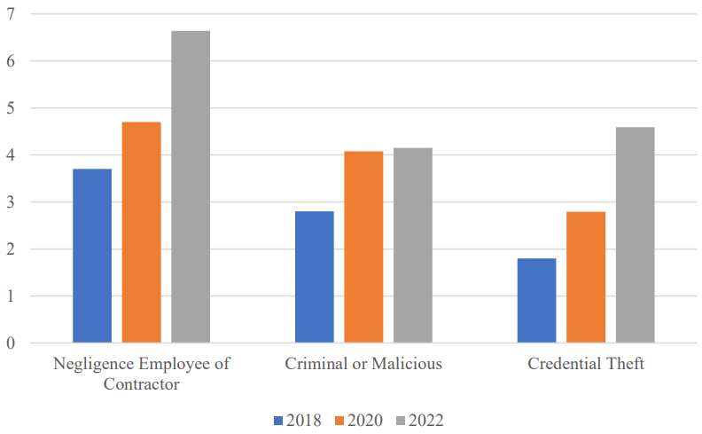
There are typically three groups of users that pose a risk to data protection: Disgruntled/Malicious, Careless/Negligent, and Infiltrator [7, p.75]. These users may decide to make unauthorised changes to data, whether by accident or on purpose. Those with higher access can do a severe amount of damage, not just to the customers but also to the company's image. They could leak data to competitors, sell the information online, or just destroy data.
Figure 3. Impact of insider incidents in 2018 - 2022 in millions of USD [7, p.75]
To protect against the rising threat of insider incidents, we must include general rules for data handling, access and encryption within our code of conduct. We should also consider the use of Non-Disclosure Agreements (NDA) for those who come into contact or have access to sensitive information or data. We should also implement levels of document confidentiality to control access to sensitive information [7, p.79-80].

Security Policies
Using various sources and best practices, I have compiled a list of proposed policies to implement for enhanced data protection [8][9][10][11].
- Employees should only use workstations provided by the company to work in the office or at home.
- All company devices should use the latest updated version of the selected antivirus and firewall software. Any issues or breaches should be reported immediately.
- All device operating systems should remain up to date.
- The use of public Wi-Fi hotspots is prohibited when using company devices; only password-protected private networks should be used. This applies to home Wi-Fi networks.
- Suitable passwords and MFA should be set up on company devices and any associated accounts. Passwords should never be reused.
- Passwords should not be left available for anyone to find and use.
- Employees should create secure passwords and only use a verified password management tool to record passwords.
- Devices should be locked when not in use, and the automatic locking features of Windows should also be applied to lock after a period of inactivity.
- Access to files and information should be limited, subject to the role of the user.
- Any loss or theft of a company device should be reported immediately.
- Personal devices should only be used for phone calls or checking emails and should not be used to access any company systems.
- Exterior doors should be locked after work hours.
- Doors into areas containing sensitive data, e.g., server rooms, rooms with laptops or files, should be locked and only accessible to those authorised. Windows into these rooms should also be fitted with bars or burglary-resistant glass.
- Any filing cabinets or briefcases used to store or transfer sensitive information should be fitted with locks.
- Avoid sending sensitive information over email or storing sensitive information on USBs unless necessary. If necessary, USBs or files sent over email should be password protected, and in the event of a loss or theft, they should be reported immediately.
- All staff should receive training for GDPR compliance.
- All staff should receive training on how to recognise phishing emails.

Monitoring and Response
In addition to identifying threats and creating policies, we must also create a plan for detecting threats on the network and responding to any security incidents. A quick response time will help reduce the impact and mitigate any further data loss [12].
All devices should be fitted with a firewall and antivirus software to monitor network traffic and quarantine any threats that make it into the system. These will also provide us with an early warning if threats are detected, allowing us to respond [13].
We also have to rely heavily on employees being honest in the event of a breach and reporting the event, allowing us to respond.
A network inventory application should be used to monitor and store information about the connected devices. This way we can view connected devices and remove them if they are not authorised to be connected to the network. The network could also be segmented into more manageable segments instead of one big network. This will also limit the access of unauthorised users [14]. We should also monitor network traffic, system logs, and other data sources to detect threats as they happen [12].
Utilising Identity and Access Management (IAM) will allow us to gain further control over access to applications and data. We can also monitor user login behaviour, flag suspicious activity, and add additional authentication steps for those with access to sensitive information [14].
Internal audits should also be performed periodically, either by an internal team or a third party, to assess that the methods for identifying threats and policies still function as threats evolve and new threats emerge. This will allow us to develop new policies or change old ones to help us keep our data secure [12].

Training and Awareness
With the increase in cyber threats to our company, all staff should receive further training to help protect the company from these new threats.
First, a presentation will need to be given on the new policies that will be implemented and what kind of cybersecurity threats the company faces.
Staff should receive training to recognise potential phishing emails. Gamification has been shown to enhance user engagement, for example, by offering scores or rewards for correctly identifying phishing emails [15, p.20]. A method of doing this would be to give a presentation of the common ways to spot phishing emails, like poor spelling and grammar, incorrect sender addresses, disguised links, and malicious file attachments. A phishing email should then be periodically sent by a manager to the employees; those who click on the email should attend the presentation again [16].
All staff should also receive training on how to comply with the General Data Protection Regulation (GDPR), which will allow them to better understand how to handle the data they work with. There are plenty of online courses available, such as the Data Protection and GDPR Awareness online course from HSQE, allowing us to sign up multiple users at once [17].
A presentation should also be given on proper password practices to help employees create secure passwords and reduce vulnerability. For example, not reusing passwords, never leaving a note of the password available for anyone to read, correctly using a password management tool, using special characters and numbers, having a minimum length of at least 8 characters, etc [18].

Conclusion
With the ever-increasing threat of data breaches and other cyber threats cyber cybersecurity must remain a high priority for FSL. The Official Statistics Cyber Security Breaches Survey from the Department for Science, Innovation & Technology [3] is a great source for insight into the common types of attacks that are being used against businesses. By remaining up to date with current trends, we can pre-emptively identify any threats that we are not prepared for and update our policies and staff training accordingly.
Maintaining a cybersecurity-competent workforce is also essential to the protection of sensitive data. According to the Cyber Security Breaches Survey from the Department for Science, additional staff training was the most common preventive measure taken after a breach or attack [3]. K. Jansson and R. von Solms mention in their research that simulating phishing attacks, along with training, reduces the risk of becoming a victim of phishing attacks [5]. With phishing becoming the most common type of cyber-attack, it is very important that all staff can recognise these types of emails. The employees must also understand the best practices for creating passwords, as weak passwords account for 81% of data breaches [18]. By implementing our password policies, we can control the strength of the passwords used in our organisation.
Even after recognising threats and creating policies to mitigate them, we must continuously monitor our network and staff so that in the event of a breach, we can act swiftly and reduce the impact. Collaboration and information sharing with other organisations will enhance our collective ability to identify and respond to ever-evolving cyber threats [12].
The overall strength of our security lies with our weakest link. By identifying common threats, creating comprehensive policies, and providing our staff with the proper training, we can improve the overall security of our organisation and our customers.

Appendix

Presentation

Slide 1


Slide 2
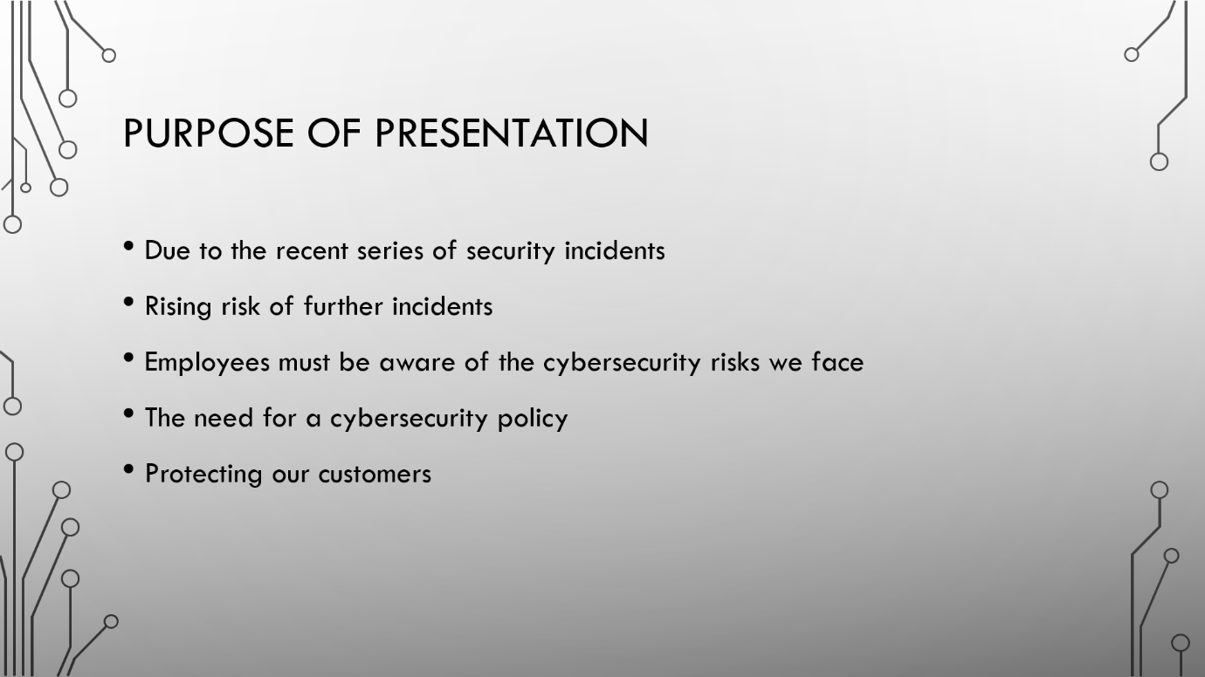

Slide 3
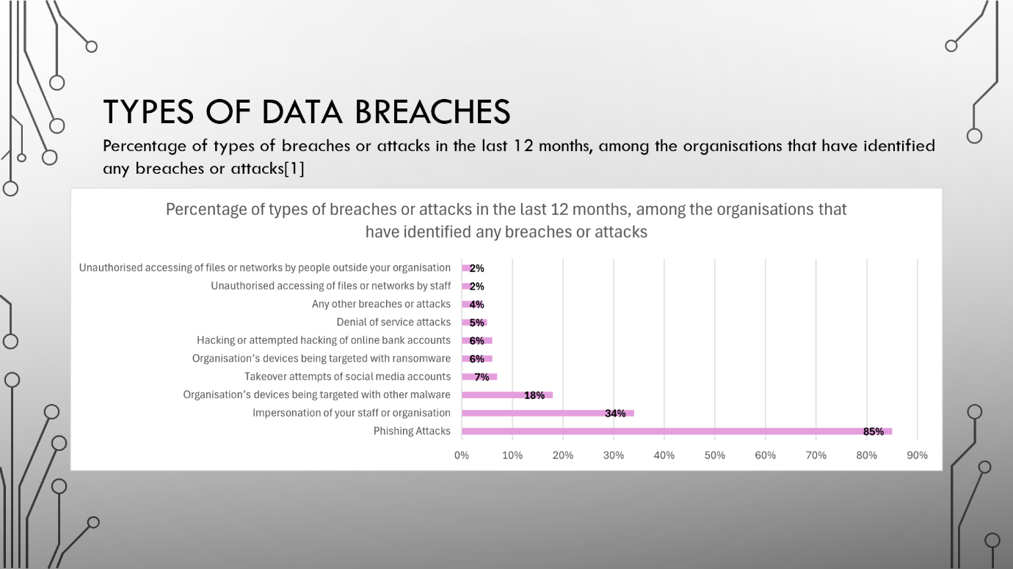

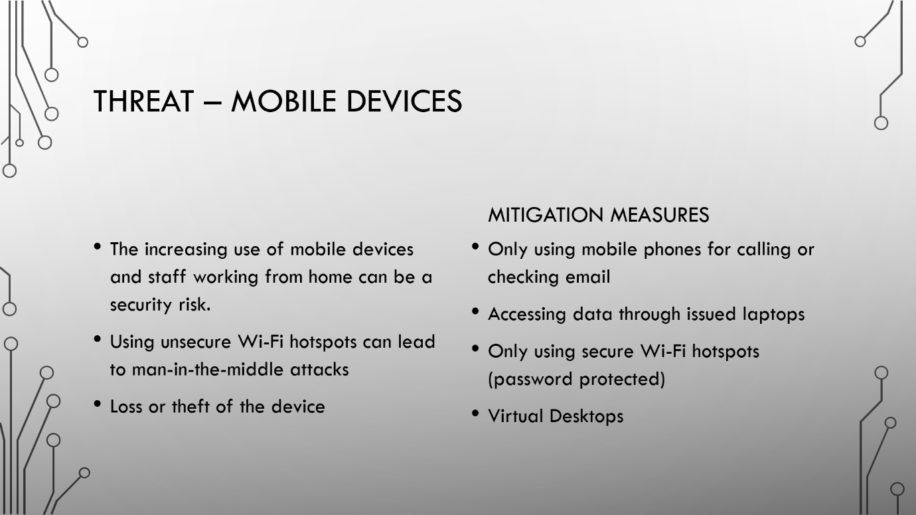
Slide 4

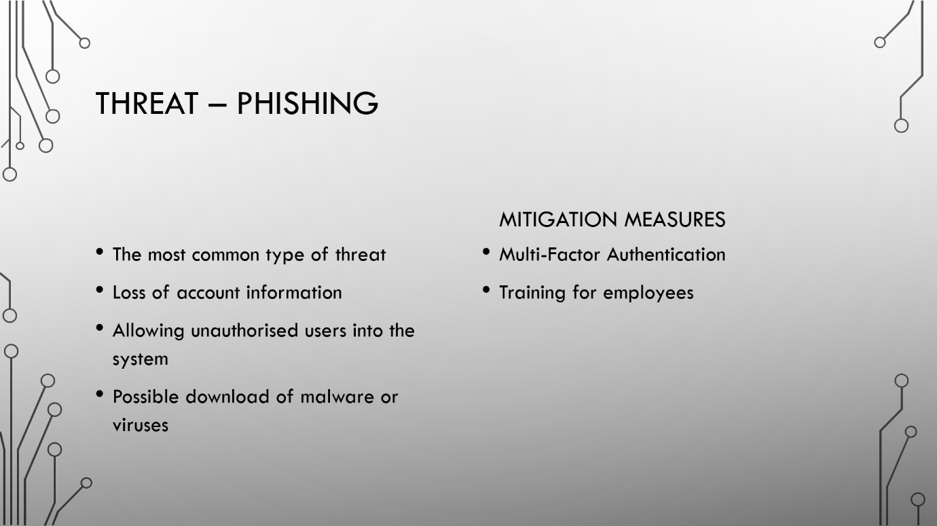
Slide 5

Slide 6
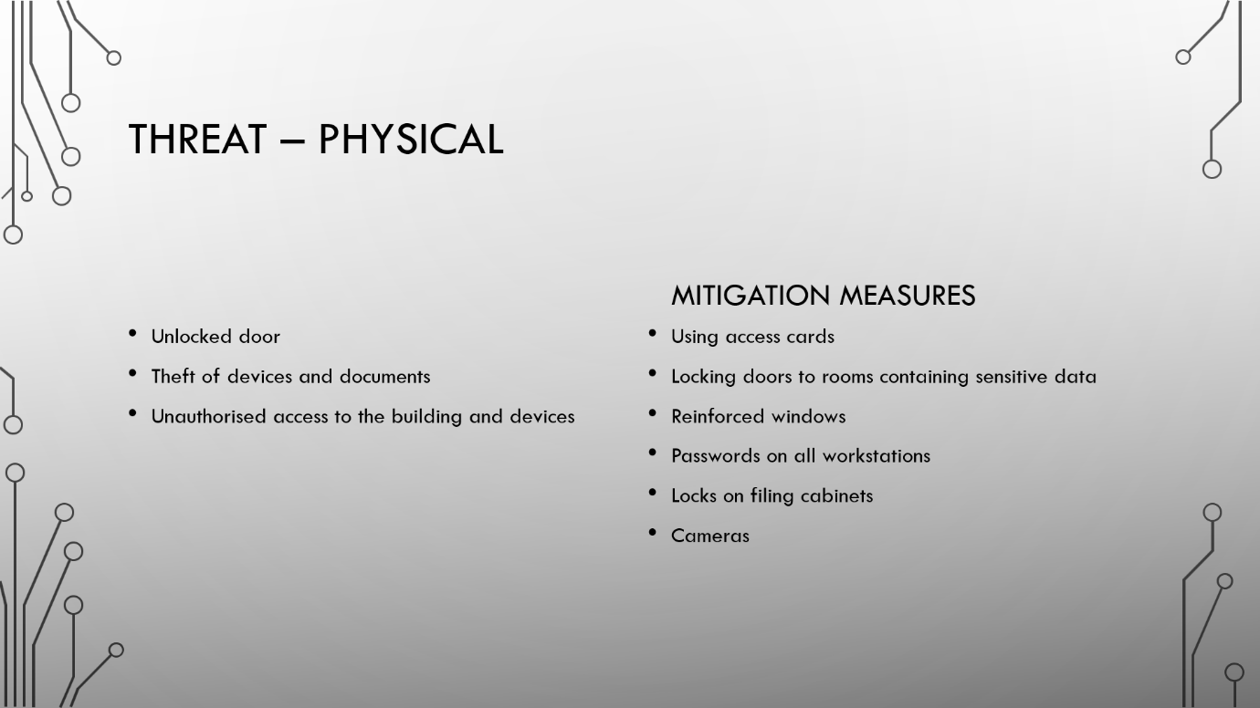

Slide 7
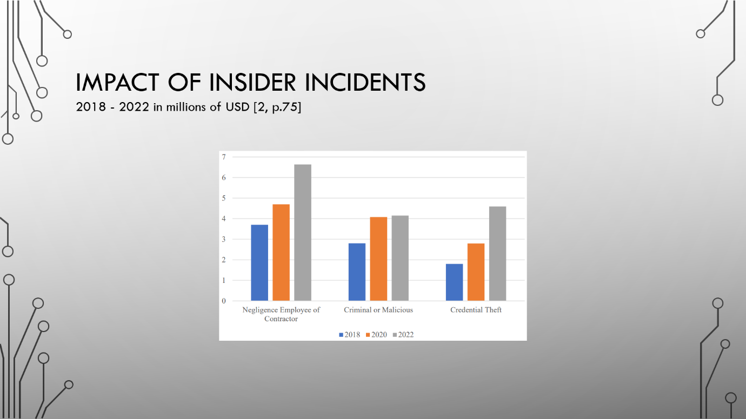

Slide 8
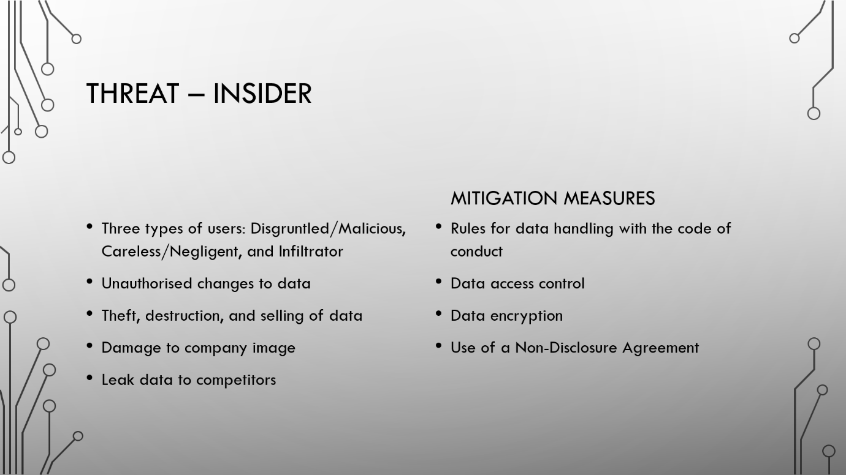

Slide 9
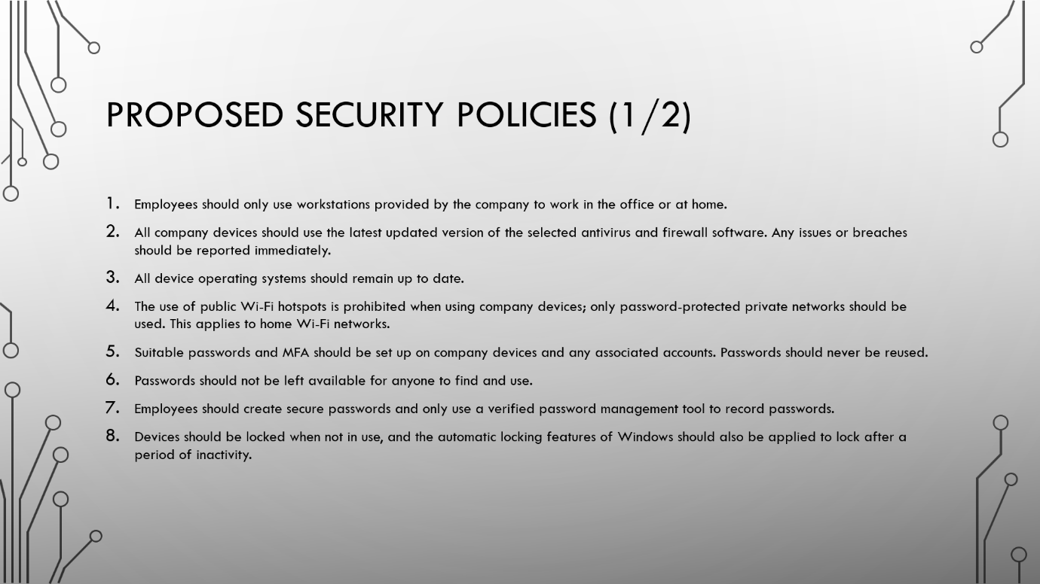

Slide 10
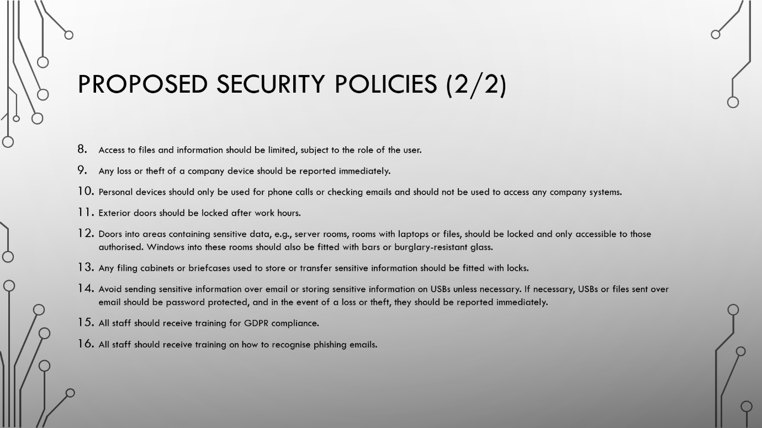

Slide 11
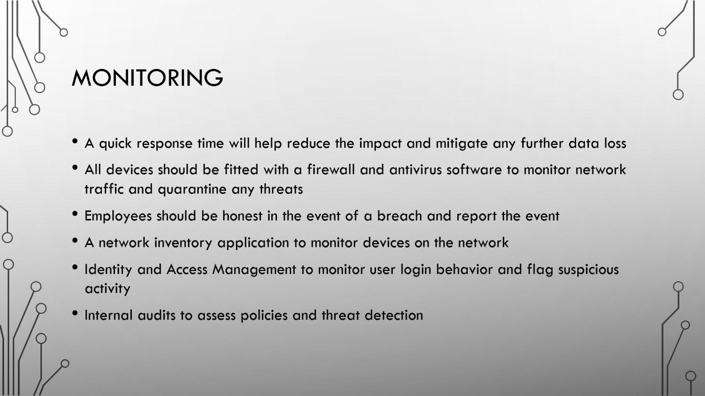

Slide 12
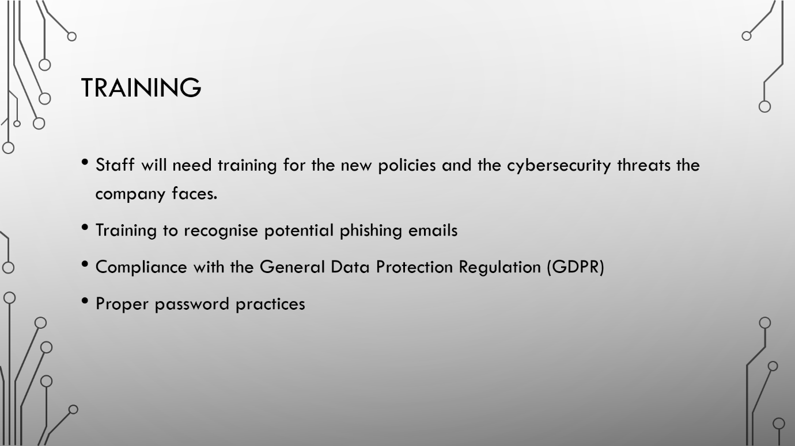

Slide 13
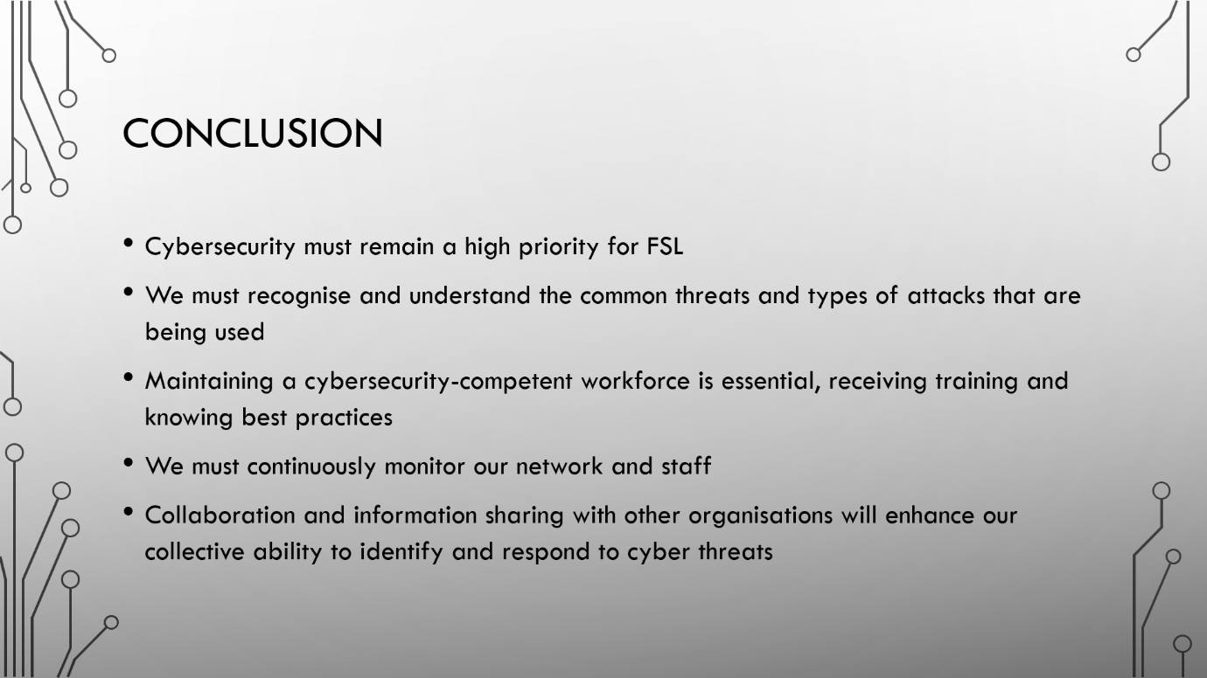

Slide 14
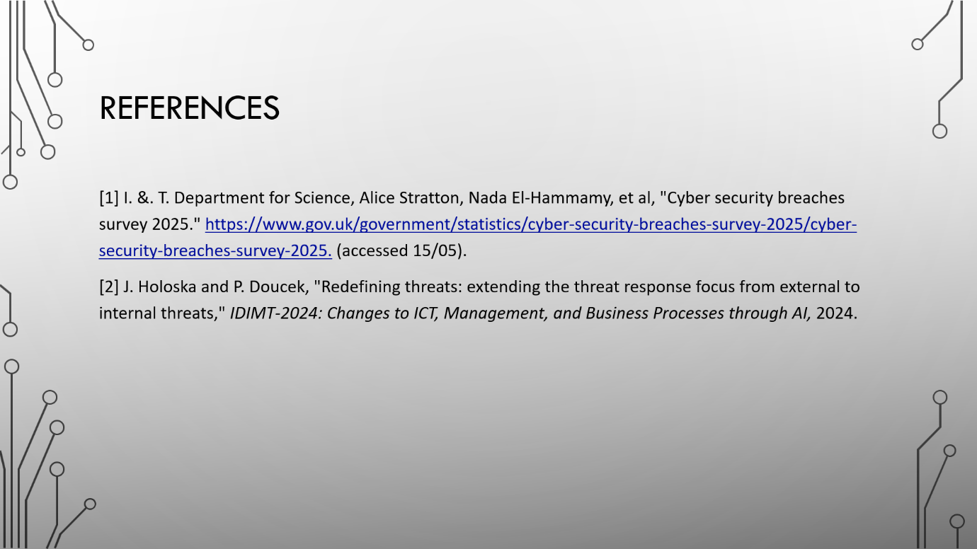

References
[1] Carsten Kleiner, Georg Disterer and University of Applied Sciences and Arts, Ricklinger Stadtweg, "Ensuring mobile device security and compliance at the workplace," Accessed: 16/05/25. [Online]. https://pdf.sciencedirectassets.com/280203/1-s2.0-S1877050915X00251/1-s2.0-S1877050915026253/main.pdf?X-Amz-Security-Token=IQoJb3JpZ2luX2VjEJD%2F%2F%2F%2F%2F%2F%2F%2F%2F%2FwEaCXVzLWVhc3QtMSJHMEUCIQCrLHnCHOYvcVueXlYxRaifrAV1IhkZtfAHglrg1VMdhwIgA%2BRMYaik6Pbd4Gd9RlArfX8o55we7FpGshlaysdIZlgqswUISRAFGgwwNTkwMDM1NDY4NjUiDCTCgoitM74%2BgxNRuyqQBbnuUt2z7vHGhqvSAeAxJLkmbYabN%2Fdraoumpqz9cistvWdLUtLPLU8ZJFn%2F3sfGm%2FG1ej1Z5EnlkCgpfm7CgVQeEAyKC6e3FrGw%2BrKJgVvxdnIKY7QPBVjvC8ZwtGHmZwJRFf8tpnaZlvQ6Tp3TjU2AfLfq38zQMRFAKigrtwqdkG%2FWzOT95Cf4YoVPHQHYdkMeYG3B4VU5x55mcxoRU2NXETI1lPpxhonb2HNg3y4oNozs5%2BvdnqisRM6st%2FaZvq115bCdg2t7NnCsjfuWr8fT5szP9LTd7PdEL5AGL6M3v8KjZqzX5rTDFy8tMH%2BxITWlulo3O9daTllgGO7YLm74t9oWxukdK%2F1EhStK8h5eG0BTTbt%2F1PxR49XCBTwpgMW7pIFk42Lpv733yqt1giztLi3Vmc6zpSZUTOUSlfaJ6fYJcrv%2F%2F3ywmJSWwuGaQwquqmaHCiSv3BacUg8zE7Nbk4NsA2JF3jEMNd8sVehWJ4o0Aua1mv00tsdNKi423O68iINW192BY0UhrYu0pW27KFDdbviuAAZdVeCEK1lOWKUzg9lSwG3g0FrjZDDOWV92uHrvAoYyCPJrd1JCsHOUEYHVjf8YtmiwV%2F2Ojd7jQu9aKjTpoVE6N1TG097CYM96AOIywiieeHbpbrUmqSgRrVf4tdPLvCLKVMiKR52DuIwbqt2ndbEHhF656gO0NKF5dRL2jL7%2FVWeZcGZl0JPOXg5ZgwBGdpHp4DZII3Hz7xKy57giHVviEkKPqwApiUGVCOfO0%2FWot%2BTrWdXaHGkoHIgqfqk%2BAMudYJAeAYRhBsGpwUiPCapiIc38JTBQnlGoHeIJKixoTcn4VwprtedVFjTAms6j7%2Fb%2BadcMyZJ5MNW5ncEGOrEB3qVXE213m7m3%2FBzxIA9prLB74nLJi%2Fo2F78wgIo53cdZ0sozhqPJtaVkh0FroVQMEu73Aed2jvPrPyEZVBDqIp3NS7Qa5smGTbfW%2FzJoeYZAo57fYqi7v41hbQDtOxzDCpu8EcGUbJFgG2vyh11FBIg3Km%2Blel7zB5EnAfIqM9Yg2pm8lMO5qTsZU0T7De1c6gNadOhplNMyiZQqxgBwxoFu8Gw5YMBHkknGbWSWAGdr&X-Amz-Algorithm=AWS4-HMAC-SHA256&X-Amz-Date=20250516T161512Z&X-Amz-SignedHeaders=host&X-Amz-Expires=300&X-Amz-Credential=ASIAQ3PHCVTYUZVLLK56%2F20250516%2Fus-east-1%2Fs3%2Faws4_request&X-Amz-Signature=71fef17214e0bd2ff2e7d8d6c910d2ca78f240baba572d7dd3c516a1d21b06b3&hash=ed17dabe6a283bdf6506ae405c4bda78a9ae7a8171a93a175fe5898811336898&host=68042c943591013ac2b2430a89b270f6af2c76d8dfd086a07176afe7c76c2c61&pii=S1877050915026253&tid=spdf-75435e63-c351-45e1-86e8-63e4db5897b9&sid=86a6baf86f15d7464c7bdd426167754c156egxrqb&type=client&tsoh=d3d3LnNjaWVuY2VkaXJlY3QuY29t&rh=d3d3LnNjaWVuY2VkaXJlY3QuY29t&ua=1d045b5152045000515a03&rr=940c2c25caf076c5&cc=gb
[2] B. Halpert, "Mobile device security," Proceedings of the 1st annual conference on Information security curriculum development, 2004.
[3] I. &. T. Department for Science, Alice Stratton, Nada El-Hammamy, et al, "Cyber security breaches survey 2025." https://www.gov.uk/government/statistics/cyber-security-breaches-survey-2025/cyber-security-breaches-survey-2025. (accessed 15/05).
[4] Ahmed, et al., "Phishing environments, techniques, and countermeasures: A survey," 2017. Accessed: 15/05/2025. [Online]. https://www.sciencedirect.com/science/article/pii/S0167404817300810?casa_token=X1K3mtEKYyUAAAAA:N27MZskncmeZfrfmGrE8Ccjv1uM1EqvgQ9PBkj8Uoguoj1ZTXqrnvV0k4GZI8jisbnoGx-4NmUBt3Q
[5] K. Jansson and R. and von Solms, "Phishing for phishing awareness," Behaviour & Information Technology, vol. 32, no. 6, pp.584–593, June 1 2013. doi: 10.1080/0144929X.2011.632650. Accessed: May 15, 2025, [Online]. Available: https://doi.org/10.1080/0144929X.2011.632650
[6] S. (Zech) Lee and The University of Texas at Arlington, United States of America&nbsp, "A Basic Principle of Physical Security and Its Link to Cybersecurity," International Journal of Cyber Criminology; Thirunelveli, vol. 14, no. 1, pp.203–219, Jan 2020. Available: https://www.proquest.com/docview/2404395113/fulltextPDF/95FB1C80FF5A4AAAPQ/1?accountid=130472&sourcetype=Scholarly%20Journals
[7] J. Holoska and P. Doucek, "Redefining threats: extending the threat response focus from external to internal threats," IDIMT-2024: Changes to ICT, Management, and Business Processes through AI, 2024.
[8] H. Kleinberg, B. Reinicke and J. Cummings, "Cyber security best practices: What to do," Journal of Information Systems Applied Research, vol. 8, no. 2, pp.52–59, 2015.
[9] H. Azmat and Z. Huma, "Comprehensive Guide to Cybersecurity: Best Practices for Safeguarding Information in the Digital Age," Aitoz Multidisciplinary Review, vol. 2, no. 1, pp.9–15, 2023.
[10] S. Nasir, "Exploring the effectiveness of cybersecurity training programs: factors, best practices, and future directions," Proceedings of the Cyber Secure Nigeria Conference, 2023.
[11] "General Data Protection Regulation (GDPR) Compliance Guidelines." https://gdpr.eu/ (accessed May 18).
[12] E. Blessing and K. Hubert, "Security Auditing and Monitoring: Incident response and management," 2024.
[13] A. Malin and G. Van Heule, "Continuous monitoring and cyber security for high performance computing," Proceedings of the first workshop on Changing landscapes in HPC security, 2013.
[14] "What is Network Security?" https://www.splunk.com/en_us/blog/learn/network-security.html (accessed May 19).
[15] A. Shahzadi, et al., "Unveiling personalized and gamification-based cybersecurity risks within financial institutions," PeerJ.Computer science, vol. 11, pp.e2598, 2025. doi: 10.7717/peerj-cs.2598.
[16] J. Kävrestad, et al., "Evaluation of Contextual and Game-Based Training for Phishing Detection," Future Internet, vol. 14, no. 4, pp.104, /4 2022. doi: 10.3390/fi14040104. Accessed: May 16, 2025, [Online]. Available: https://www.mdpi.com/1999-5903/14/4/104
[17] "Data Protection and GDPR Awareness Online Course - From £6.50+VAT", HSQE, https://hsqe.co.uk/courses/data-protection-and-gdpr-awareness/ (accessed May 19, 2025).
[18] H. Hussain, "Password Security: Best Practices and Management Strategies," Available at SSRN 4136333, 2022.

