THE IMPACT OF SOCIAL MEDIA MARKETING (SMM) ON BRAND TRUST AND BRAND LOYALTY IN THE UK FASHION INDUSTRY

Name: NASIF CHIRANDAYATH SAIDUMUHAMMED
Student ID: 2309872

Abstract
Purpose: The use of social media platforms has been greatly increasing, and around 82% of UK fashion consumers have been using social media to make purchases of fashion items. The popularity of social media platforms has been increasing, which raises the importance of identifying the impacts of SMM on developing brand trust and loyalty in the UK fashion industry.
Literature Review: The existing literature mentions that the use of SMM has been effective for fashion retailers in developing brand experiences. The developed communication, interaction, and sharing of information increase opportunities for the retailers to develop confidence. The developed endeavours have been effective in building brand prescriptions, and SMM has enhanced opportunities to create brand experiences. The "social penetration theory" shows that relationships gradually develop the intensity of communication, and the core relationships help brands manage uncertainties.
Method: The researcher has used mono-method quantitative and a survey have been conducted to collect the primary data. The purposive sampling technique hs been used to select the customers of UK fashion industry to collect data. Further, quantitative data analysis has been used with SPSS software which has helped in statistical analysis.
Result and discussion: The findings shows that most of consumers in the survey has mentioned that SMM of UK fashion industry is informative which engages the customers. The developed interaction ad experiences plays significant role in developing the relationships ad confidence. The developed confidence influence purchasing decision nd this also helps the brand in developing loyalty.
Conclusion: The conclusion highlights the significance of SMM in influencing brand loyalty and trust among international consumer segments within the UK fashion industry. It shows a reciprocal relationship wherein effective SMM drives loyalty and trust to the brand whereas high-level loyalty and trust drive consumers to be responsive towards the social media efforts of brands. The paper finds that ongoing authentic and dynamic social media activities are essential for developing and maintaining these core elements of the brand-consumer relationship. However, caution is warranted when interpreting the results as sample size and demographic range may limit generalizability.
Keywords: Social media marketing, UK fashion industry, customers, loyalty, trust, communication, experiences, emotional attachment, content

Acknowledgement
I completed the dissertation with immense pleasure on the topic. It has been beneficial for me to finish this dissertation because it has given me access to a wealth of knowledge about this subject. I gratefully recognise the support and assistance of all those whose efforts helped me finish this dissertation. I sincerely appreciate everything my reputable supervisor has done for me. Along with that, I want to thank my fellow students, family, and friends for helping me with this dissertation.
Thanking you all,

List of Abbreviation
SMM: Social media marketing
SEO: Search engine optimisation
SEM: Search engine marketing
WOM: Word-of-mouth
Table of Contents
Chapter 1: Introduction 13
1.1. Introduction 13
1.2. Background of the Study 13
1.3. Problem Statement 14
1.4 Rationale 15
1.5. Research aims and objectives 18
1.5.1. Research Aim 18
1.5.2. Research Objectives 18
1.6. Research Questions 19
1.7. Significance of the research 19
1.8. Structure of Dissertation 19
1.9. Summary 20
Chapter 2: Literature Review 22
2.1 Introduction 22
2.2. Overview of the research topic 22
2.2.1. Concept of SMM 22
2.2.2. Definition of brand loyalty and trust 23
2.3. Relationship between Brand Loyalty and SMM in the UK Fashion Industry 24
2.3.1. Relationship between brand loyalty and SMM in UK fashion industry 24
2.3.2. Relationship between brand trust and SMM in UK fashion industry 26
2.4. Different SMM used by UK fashion brands 28
2.5 Role of SMM Activities in UK Fashion Industry 30
2.5.1. Role of SMM in developing customer relationships 30
2.5.2. SMM helps in communicating and expanding 31
2.5.3. Role of SMM to improve brand loyalty 32
2.5.4. Role of SMM to reach target audience and higher engagement 32
2.6. Impacts of SMM on Brand trust and loyalty in the UK fashion industry 33
2.7. Strategies for SMM to develop brand loyalty and Trust in the UK fashion industry 35
2.8. Theoretical underpinnings 37
2.9. Literature gap 38
2.10. Conceptual Framework 38
2.11. Summary 39
Chapter 3: Research Methodology 41
3.1. Introduction 41
3.2. Research Onion 41
3.3. Research Philosophy 42
3.4. Research Approach 42
3.5. Research Method 43
3.6. Research Strategy 44
3.7. Questionnaire Development 44
3.8. Inclusion and Exclusion Criteria 45
3.9. Sample size 45
3.10. Sampling Technique 46
3.11. Data collection method 46
3.12. Data analysis technique 46
3.13. Reliability and Trustworthiness 47
3.14. Ethical considerations 47
3.15. Summary 47
Chapter 4: Results 49
4.1. Introduction 49
4.2. Findings 49
4.3. Correlation, regression, descriptive statistics 62
4.3.1. Reliability test 62
4.3.2. Descriptive Statistics 63
4.3.3. Correlations Statistics 64
4.3.4. Regression analysis 66
4.4. Summary 68
Chapter 5: Discussion 70
5.1. Introduction 70
5.2. Implications of findings 70
5.3. Summary 77
Chapter 6: Conclusion and Recommendations 79
6.1. Conclusion 79
6.2. Linking with Objectives 80
6.3. Recommendations 82
6.4. Limitations of this study 84
6.5. Future research scope 84
Reference list 86
Appendixes 101
Appendix 1: Survey questionnaire 101

Table of Figures
Figure 1.1: Use of social media platforms by UK lifestyle and fashion buyers 14
Figure 1.2: Digital media marketing expenses by UK fashion industry 16
Figure 1.3: Market value of the UK e-commerce fashion industry 17
Figure1.4: Revenue of UK fashion industry 18
Figure 1.5: Structure of the study 20
Figure 2.2: Relationship of customer loyalty and SMM tactics 25
Figure 2.3: Relationships between brand trust and SMM 27
Figure 2.4: Relationships of SMM with brand experiences and trust 28
Figure 2.5: Role of SMM on brand equity 31
Figure 2.6: Impact of SMM on purchasing intentions 34
Figure 2.8: Conceptual framework 39
Figure 3.1: Saunders’ Research Onion 41
Figure 4.1: Purchased from UK fashion brands 49
Figure 4.2: Gender of participants 50
Figure 4.3: Age groups of participants 51
Figure 4.4: Level of education 51
Figure 4.5: Monthly spending on the fashion industry 52
Figure 4.6: SMM is engaging and informative 53
Figure 4.7: SMM enhance trust 54
Figure 4.8: SMM interaction develops loyalty 55
Figure 4.9: Influence of Visual Content on purchasing decisions 56
Figure 4.10: Influence of SMM on Connectedness 57
Figure 4.11: Influence of SMM on loyalty 58
Figure 4.12: Impact of SMM on developing brand value 59
Figure 4.13: Impact of SMM on developing brand trust 59
Figure 4.14: SMM enhances confidence 61
Figure 4.15: SMM enhances confidence 62
Figure 4.16: SMM positive interaction helps in developing brand recommendations 62

Table of Tables
Table 3.1: Inclusion and exclusion 45
Table 4.1: Findings for objective 1 53
Table 4.2: Findings for objective 2 56
Table 4.3: Findings for objective 3 60
Table 4.4: Reliability Statistics 63
Table 4.5: Descriptive statistics 63
Table 4.6: Correlations 64
Table 4.7: Correlations 65
Table 4.8: Correlations 66
Table 4.9: Model Summary 67
Table 4.10: ANOVA 67
Table 4.11: Coefficients 68

Chapter 1: Introduction

1.1. Introduction
This section of the research dissertation introduces the research project. This study analyses effects of the SMM tactics on brand loyalty and trust in the UK fashion industry. The overall background of the study about the marketing activities through social media would be presented in this introduction section. It discusses the background information, problem statement, rationale, research questions, aims, objectives, and significance.

1.2. Background of the Study
The fashion industry is one of the largest in the country, and fashion retailers have successfully expanded their business to international markets. The UK fashion industry generates around 1.3 million jobs and significantly contributes to the GDP with £62 billion (Ukft, 2023). During the pandemic, around 46% of UK consumers mentioned accessing content about fashion products through Instagram. The pandemic has been a significant reason, for which around 82% of UK customers have noted that their use of social media platforms has increased to purchase fashion products (Fashionnetwork, 2020). Figure 1.1 shows that 32.2% of UK fashion consumers prefer Instagram to engage with fashion brands. Conversely, 21.58% of customers engage through Facebook, 14.49% through YouTube, 12.77% through TikTok, and around 7.32% through Twitter (Statista, 2023). UK fashion consumers also use Snapchat, Pinterest and others indicates that consumer purchasing from SMM have been increasing.
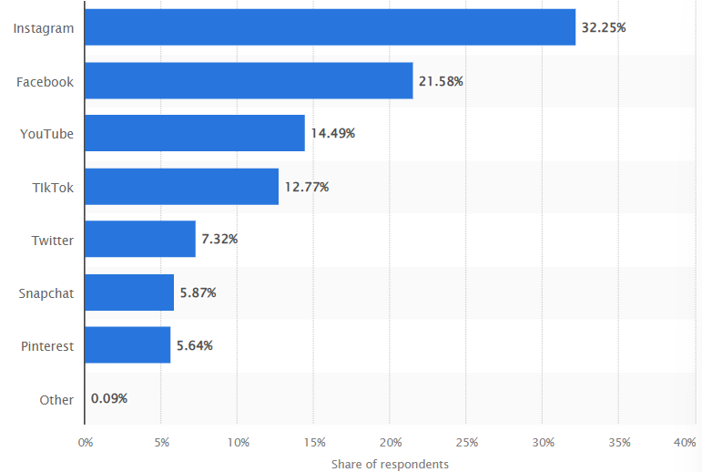

Figure 1.1: Use of social media platforms by UK lifestyle and fashion buyers
(Source: Statista, 2023)
The implementation of SMM platforms significantly influences individual impulses and attitudes. Positive experiences through SMM help brands develop substantial customer relationships (Djafarova and Bowes, 2021). SMM strategies are beneficial for UK fashion companies in brand building. Famous fashion brands have been using social media platforms to reach more customers. Fashion brands have been using customer-generated content, such as “haul videos,” to market their products and engage customers to determine brand loyalty (Mahmood, 2022). Social media activities help customers understand the brand. According to Fetais et al. (2023), social media platforms help improve word-of-mouth (WOM), which helps in building brand loyalty. Customers consider social media platforms as trustworthy sources of information, which helps improve customer trust. Zara uses Facebook to market customer loyalty and satisfaction at a highly competitive level. The structured interactions with social media platforms have been helping Zara to foster loyal relationships (Popović et al. 2021).

1.3. Problem Statement
SMM are effective tool to communicate and interact with customers which helps brands in developing loyalty and trust in consumers. According to Zhang, Zhang, and Zhou (2021), with the development of cognitive attitude, customers' behaviour has dramatically changed towards sustainability. The lack of time and vibing with social media platforms is quite challenging. Selecting appropriate social media platforms to brand fashionable products has been difficult for leading fashion brands. The lack of connection and ineffectiveness of SMM affects the brand loyalty and brand trust (Stokel-Walker, 2023). The developed marketing companies have been significant in helping fashion retailers develop relationships with fashion consumers. However, marketing strategies have increased the challenges for brands in competing with global customers to determine higher brand trust and loyal consumers. According to Nuseir and Elrefae, (2022), competition in global business environment has been increased and identification of most efficient SMM platforms have become challenging to enhance brand awareness and trust. Managing efficiency of SMM has been quite crucial for UK fashion industry to ensure customer loyalty and trust as, Zara have been facing backlash against the brand (Dmitracova, 2023). The lack of prove of greenwashing initiatives have enhanced complexities for UK fashion brands to ensure trust and loyalty (Theguardian, 2022). The SMM have significant impact on consumers brand perception. Thus, developing customer loyalty and brand through interactivities of SMM has been crucial to ensure competitiveness by UK fashion brands.

1.4 Rationale
SMM has been entirely dominant in the UK fashion industry. Digital display marketing expenses have continuously increased in the UK fashion industry. Figure 1.1 highlights that the digital advertising expenses of the UK fashion industry were 232.28 million in 2019, 211.9 million in 2020, and the spending reached 259.56 million in 2021 (Statista, 2023a). The digital markets of fashion brands aim to fit the marketing activities with the purpose and richness of the brand. According to Cao et al. (2021), the trustworthiness of digital marketing media content helps to engage customers with the brand. Digital marketing has increased opportunities for fashion brands to engage online communities. Sharing common interests helps customers engage with the brand, which helps develop brand loyalty and trust. The UK fashion brands have significantly increased their investment in online branding. Customer loyalty significantly impacts the customers’ intention to be loyal. Fashion brands have also been facing complexities in understanding customer engagement, and negative responses on social media platforms raise concerns (Ozuem et al. 2021).
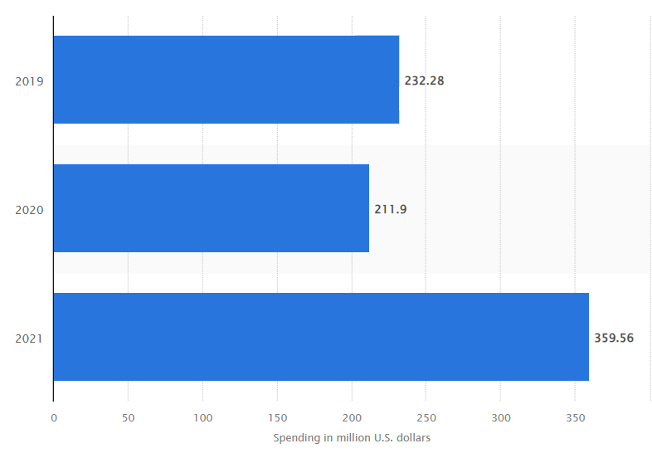

Figure 1.2: Digital media marketing expenses by UK fashion industry
(Source: Statista, 2023a)
The customer experience on an e-commerce platform significantly impacts the development of customer loyalty. SMM helps fashion brands influence brand perception and satisfaction with audio, video, appealing imagery, text-based information, and others. The positive brand perception helps in developing satisfaction which improves customer loyalty and trust in fashion industry (Urdea and Constantin, 2021). A significant role is played by the SMM tactics in delivering compelling experiences to customers, and this has been prioritised by e-commerce businesses to ensure considerable brand loyalty and trust. Figure 1.3 shows that the e-commerce market of the UK fashion industry has been expected to reach from 36 billion in 2024 to 86 billion by 2030. The growth of the fashion industry has increased the importance of critically analysing and evaluating the impact of SMM marketing on developing brand loyalty and trust of customers.
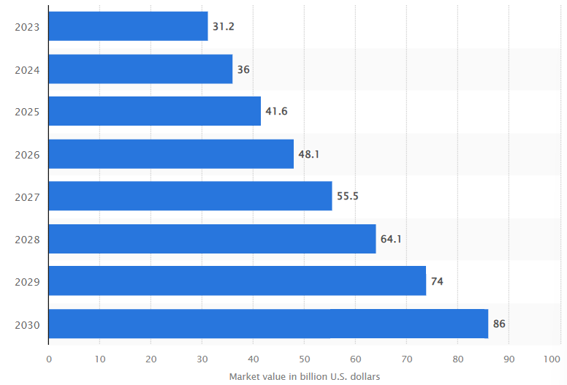

Figure 1.3: Market value of the UK e-commerce fashion industry
(Source: Statista, 2024)
SMM platforms are significant in building brand loyalty and trust. Incorporating brand loyalty and trust has been necessary for the UK fashion industry because this helps the brands ensure long-term relationships with the customers. The revenue of the UK fashion industry is expected to increase by 45.56% from 2024 to 2029 (Statista, 2024a). Figure 1.4 shows that the UK fashion industry's revenue reached 39.95 billion in the 2024 financial year. The sector's revenue has been estimated to be 58.1 billion by the 2028 financial year. This has increased the importance of analysing the impact of marketing through social media on brand loyalty and trust to ensure significant development in revenue. Brand loyalty and trust influence the competitive advantages necessary for substantial growth. The analysis of SMM has been significant for managing customer loyalty and trust of customers. The efficient analysis would be effective to develop performances to engage consumers.
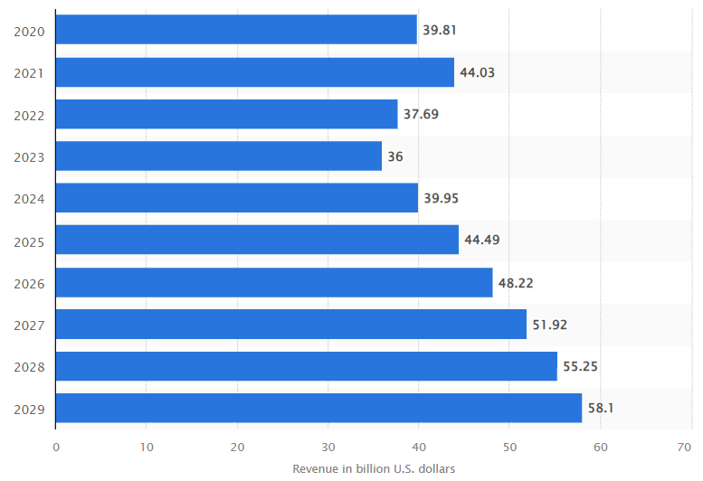

Figure1.4: Revenue of UK fashion industry
(Source: Statista, 2024a)

1.5. Research aims and objectives

1.5.1. Research Aim
This study aims to critically evaluate the impact of social media platforms on customer brand loyalty and trust in the UK fashion industry.

1.5.2. Research Objectives
- To analyse the role of SMM in developing brand loyalty and trust in the UK fashion industry
- To develop a critical comprehension of the role of SMM, brand loyalty and trust referring to UK fashion industry
- To analyse the relationships between brand loyalty and brand trust triggered by SMM

1.6. Research Questions
- What is the importance of SMM for developing brand loyalty and trust in the UK fashion industry?
- How does SMM impact brand loyalty and trust in the UK fashion industry?
- What is the relationship between SMM, brand loyalty and trust referring to UK fashion industry?

1.7. Significance of the research
Completing this research would be significant to developing an overall comprehension of marketing activities though social media platforms used by the UK fashion industry. This study develops a comprehensive understanding of the relationships between brand loyalty, SMM and trust would be helpful for UK fashion brands in making significant improvements in their marketing activities. The knowledge of the significance of marketing campaigns through social media would be suitable for the researchers to develop the relationships and approaches at a higher level to ensure higher performance measures and significant brand loyalty and trust. Further, this study would be necessary to create a comprehensive understanding of the role of marketing through social media in the e-commerce fashion industry. Further, analysis of the relationships would also be effective for UK fashion brands in developing brand loyalty and trust, which are significant in improving competitive advantages.

1.8. Structure of Dissertation
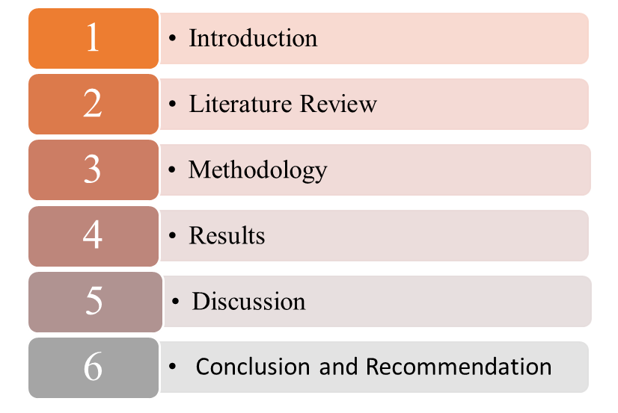

Figure 1.5: Structure of the study
(Source: Adopted from Module Handbook)
This study has been divided into six chapters, and all chapters have been systematically ordered. This study has six chapters which have been shown in Figure 1.5. The structure would be effective in developing understanding about the research topic.

1.9. Summary
UK fashion consumers have significantly used social media platforms. Instagram, Facebook, YouTube, TikTok, and Twitter are UK fashion consumers' most popular social media platforms on which to purchase products. SMM activities significantly shape customers' brand perception, influencing their loyalty and trust. Customers' e-commerce experiences significantly affect brand loyalty. The UK fashion industry is expected to grow by 45.56% from 2024 to 2029 (Statista, 2024a). On the other hand, digital marketing expenses will reach 259.56 million in 2021 in the UK fashion industry. The analysis of the relationship between brand loyalty, SMM and trust would be significant for UK fashion brands to develop SMM activities to develop competitive advantages effectively. The analysis of the effectiveness of the social media operations have been significant to improve brand loyalty and brand trust.

Chapter 2: Literature Review

2.1 Introduction
The literature review section of the study provides an opportunity to critically analyse literary works on marketing with social media platforms. The impact the marketing on brand loyalty and trust would be critically analysed. It helps enhance knowledge of the effects of SMM on brand loyalty and trust. The significant insight on the topic is practical to determine a unique approach. This section will develop conceptual understanding of marketing through social media and its impact on brand loyalty and trust in the UK fashion industry, relationships, different SMM, importance of marketing with social media platforms, barriers and strategies, theoretical interpretation and others.

2.2. Overview of the research topic

2.2.1. Concept of SMM
Brands with their accounts use marketing through social media to connect with customers. The scattered and isolated aspects of the brands help develop the overall comprehension of the selected customers' brand identity. Li et al. (2021) state that SMM allows brands to conceptualise marketing operations. Conceptual improvements in SMM significantly improve the dynamics and knowledge of the business and brands. The marketing through social media comes with different marketing approach than the conventional marketing operations. Technology has been prioritised in SMM to reach to the larger volume consumers. However, Ebrahim (2020) argued that online social networking sites are used to make effective brand communication with customers. The interactivity and connectivity of the users with the brand have been significant characteristics. The audience significantly triggers the communication dialogues about the information of brands, products and services.
The appealing information helps brands and customers to be involved in communication about features, values and benefits. Further, research by Tarsakoo and Charoensukmongkol (2020) shows that SMM is directly linked to financial performance because it develops customer relationships. Informative contents are used in this marketing strategy through Facebook, Instagram, Twitter and YouTube is used to make content communication (Li, Larimo and Leonidou, 2021). Zara, a UK fashion brand has been using SMM platforms for its growth in the industry (Singh, 2020). The collaboration and communication through the social media platforms have been encouraged to engage with brand. However, Vinerean and Opreana (2021) argued that marketing strategies through social media entertain and inform customers about products and services. Social media platforms enhance opportunities for the brand to exchange information, create and share information about the product. The share of information through SMM has been developing efficiency of marketing operations to develop customer experiences.

2.2.2. Definition of brand loyalty and trust
Customer loyalty indicates that customers continuously purchase products and services from a particular brands rather than competitors. According to Bernarto et al. (2020), brand awareness plays a significant role in building a substantial customer relationship. However, the research has identified no significant impact of brand image on customer loyalty. The customers' likeness to change their preferred brands to similar products and services. Similarly, Górska-Warsewicz and Kulykovets, (2020), attachment of consumers is a significant measure to identify loyalty of consumers. Further, the study explored that brand loyalty is typically the attachment of the customers, which influences their purchasing decisions. According to Barath, (2022) net promoter score, refer consumers likeliness to promote brand to others are used to measure loyalty of consumers. Further, Maduabuchi, Patrick and Wilson, (2020) indicates purchase ratio and number of engagements are major measures used to measure customer loyalty.
The customers' satisfaction and loyalty helps to influence purchasing decisions. According to Diputra and Yasa (2021), brand loyalty is measured by customer satisfaction, and brand trust significantly influences brand satisfaction. The customers' reliability, safety, and honesty for the brand play a substantial role in shaping brand trust. The commitment of consumers comes with consumer trust which is influenced by SMM. The engagement with contents and frequency of visiting the brands are used to measure trust of consumers on the brand. The upselling ratio is a major tool to measure consumer trust because purchasing more than one item from the brand highlights trust of consumers (Itani, Badrinarayanan, and Rangarajan, 2023). However, according to research by Barijan, Ariningsih, and Rahmawati (2021), stronger brand attachment is a significant factor in shaping customer trust. The connection with the brand is the key to developing brand trust. The ability of the brand to meet the stated functions of the brand has been necessary because the capability of the brand increases the reliability and trust of customers.

2.3. Relationship between Brand Loyalty and SMM in the UK Fashion Industry

2.3.1. Relationship between brand loyalty and SMM in UK fashion industry
Brand loyalty has been identified as a significant aspect of the fashion industry to ensure the significance of the nomological network with the customers. As per the opinion of Fetais et al. (2023), social media platforms develop significant connections between fashion brands and their customers, which is responsible for creating brand loyalty. Positive WOM influences the actual purchasing intentions of the customers. The price sensitivity of fashion brands is significantly reduced through efficient SMM activities. However, research by Budiman, (2021) stated that e-WOM, marketing activities through social media, plays a significant role in developing brand image and experiential marketing, which enhances brand loyalty of the customers. Further, the online community significantly helps customers with quality information, appreciation, interaction, and systems, positively related to customer loyalty to fashion brands. The positive attitudes are encouraged with SMM with helps of valuable information about product features.
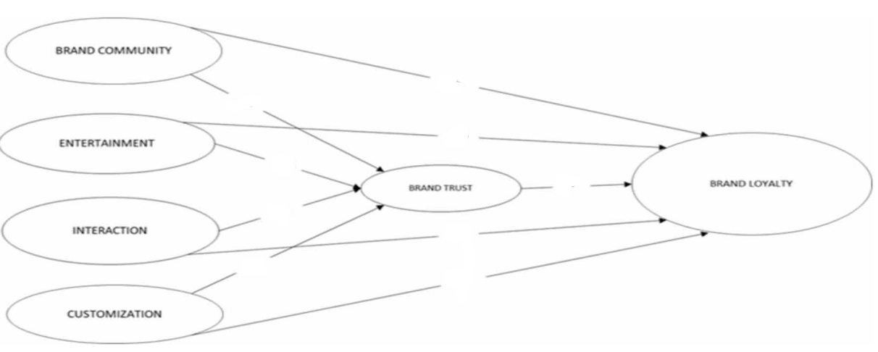
Figure 2.1: Relationships between SMM, brand trust and loyalty
(Source: Sohail, Hasan and Sohail, 2020)
The symbols of fashion brands are used to market product facilities and efficiencies to improve brand trust and brand loyalty. According to Ozuem et al. (2021), brand symbols and functions are marketed in SMM which is essential for the brands inbuilding loyal consumers. Personalised contents, control by consumers, style, improvements according feedback, posts, inquiries and others shapes brand perception (Dwivedi et al. 2021). Figure 2.1 shows that SMM activities such as brand community, entertainment, customisation and interaction significant related with the customer’s brand trust and brand loyalty. The interactive activities of SMM influences customer trust and loyalty. However, Majeed et al. (2021) argue that communication through marketing through social media has a positive relationship with brand loyalty. Audience targeted contents are used to make effective communication through social media platforms. Further, research by Jawaid and Rajadurai (2021) illustrated that Facebook is directly linked with customer brand loyalty, which analysis of fans of Zara has proved. SMM activities directly influence emotional attachment, which influences brand loyalty.
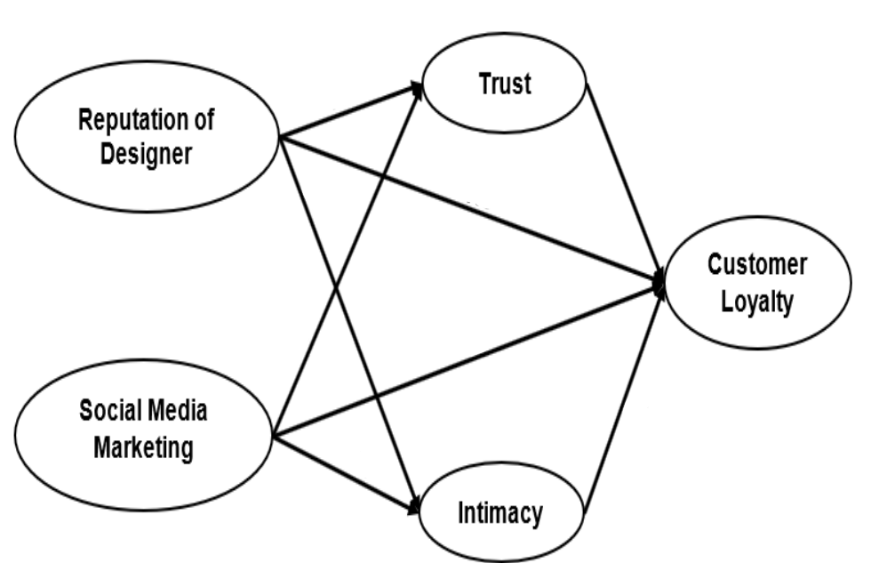

Figure 2.2: Relationship of customer loyalty and SMM tactics
(Source: Khoa, 2020)
The designers in fashion industry significantly affects customers trust and satisfaction. Figure 2.2 shows marketing activities using designers' reputations, enhancing the intimacy interconnected with brand loyalty (Khoa, 2020). The marketing activities through social media have a significant relationship with brand loyalty. The devotedness of customers towards a brand helps determine them to be loyal customers. Social media influencers helps consumers to relate with brand and relatability improves trust (Pinto and Paramita, 2021). Further, the luxury fashion brand Louis Vuitton creates brand loyalty by implementing SMM activities (Xiao, 2023). However, research by Muniesa and Giménez (2020) outlined that SMM activities have enhanced opportunities for fashion brands to promote brand loyalty. SMM of Primark helps the brands to promote positive brand experience to improve trust (Ologunebi, 2023). Digital marketing operations contribute to developing consumer value that links with brand loyalty.
The qualitative analysis of the SMM researchers have helped to understand the relationships of SMM activities on developing brand trust (Ozuem et al. 2021, Dwivedi et al. 2021, Majeed et al. 2021, Jawaid and Rajadurai, 2021, Ologunebi, 2023). These SMM researchers have mentioned significant role of SMM tactics on the brand trust of consumers. However, the qualitative evidences of SMM does not clearly interpret the process of developing brand trust. The developed following hypothesis has helped in effectively analysing impact of SMM on brand trust by quantitative data. The specific analyse of UK fashion industry has helped to meet the research objectives in this study by developing the following hypothesis.
H2: SMM of UK fashion brands have significant impact on the brand trust

2.3.2. Relationship between brand trust and SMM in UK fashion industry
SMM operations have enhanced opportunities for fashion industry in interacting and engaging with the target customers. According to Wantini and Yudiana (2021), these operations have enhanced possibilities for fashion industry to engage and interact with customers, which is connected with brand trust. The good responses from brands through SM platforms enhances trust which is using by UK fashion brands, such as Adidas (Widodo, 2023). Figure 2.3 shows that experiential and SMM operations are linked to brand trust. But, Ebrahim, (2020), argued that incorrect information, content and lack of communication through SMM affects experiences of customers. Figure 2.4 indicates that experiential marketing helps in developing customers experience which affects trust and repurchase intensions. Khoirunnisa and Astini (2021) argue that brand trust is a mediation which is directly affected by SMM and, as a result, repurchasing customers' interests. SMM activities influence customers' trust on fashion brand, and positive perception developed through the marketing activities develops repurchasing behaviour. However, research by Chavadi et al. (2023) shows that customers' online experiences are linked with brand trust, and SMM operations influence brand experiences. The consumer interaction of consumers with brands through SMM helps in building positive brand attitudes of customers.
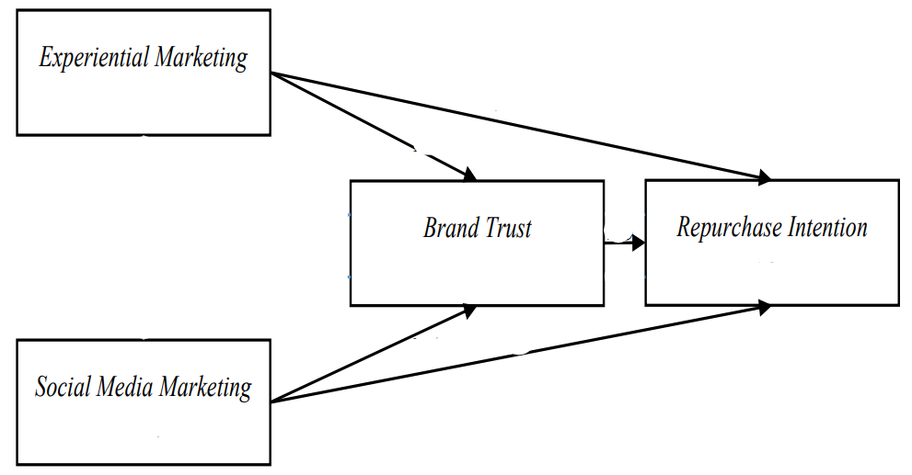

Figure 2.3: Relationships between brand trust and SMM
(Source: Khoirunnisa and Astini, 2021)
Community interactions through SM platforms about features and benefits of products enhance opportunities for fashion brands to develop brand trust. Research by Hidayati (2023) solidifies the argument, stating that SMM operations enhance the capabilities to interact, engage and communicate with customers, which are mediums to improve brand trust. Thus, brand community, content marketing, WOM and others SM activities influences intentions and activities mediate brand trust and brand equity. However, research by Ashrafa and Ansaric (2022) argues that brand trust mediates in enhancing brand loyalty. Brand trust has been identified as a significant tool by fashion brands, and SMM directly collaborates with and communicates with consumers. Further, research by Persada, Jati and Nadlifatin (2022) solidifies the argument that SMM is directly linked with brand trust, essential to developing brand loyalty and experiences. Figure 2.4 indicates that SMM has significant impact on customers experiences which enhance brand equity.
The researchers of SMM in the literature has drawn significant relationships between the SMM and customer loyalty (Wantini and Yudiana (2021, Khoirunnisa and Astini, 2021, Chavadi et al. 2023, Hidayati, 2023, Persada, Jati and Nadlifatin, 2022). The qualitative interpretation of the relationship is not effective in developing comprehensions about the impact of SMM by UK fashion industry on customer loyalty. The quantitative interpretation of impacts of SMM on consumer loyalty has been effective in determining complete understating. Thus, the analyse and proving the following hypothesis has helped to understand the impacts of SMM on brand loyalty.
H1: The SMM of UK fashion brands have a significant impact on the brand loyalty
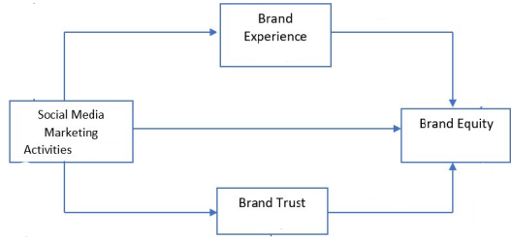

Figure 2.4: Relationships of SMM with brand experiences and trust
(Source: Hidayati, 2023)

2.4. Different SMM used by UK fashion brands
Marketing through social media has been identified as an effective tool for UK fashion industry. As per Arustamyan, Taj and Nasir's (2020) opinion, Marks and Spencer endorse SMM activities to offer its products to customers, enhancing customer engagement with the brand. Twitter, Instagram, Facebook, and Snapchat have been major social media platforms which are helpful tools because they strengthen brand loyalty. The social media platforms used by this brand have effectively developed capabilities to meet the needs and requirements of the customers (Ng and Yee, 2020). This brand has used Facebook, Instagram, Twitter and others to develop public relationships with UK customers. According to Herjanto et al. (2020), social media platforms have been significant for the fashion industry because they enhance opportunities for brand recognition and affiliation. The contents, polls, community groups, comments, feedback are helps UK fashion brands to enhance brand awareness.
Louis Vuitton has also incorporated SMM operations, and domestic social media platforms such as Sina Weibo have also been used to promote the brand to customers. According to Yuqi (2022), adopting social networking suites enhances the opportunity for luxury fashion brands in the UK to improve their popularity. Research by Li (2023) shows that social networking sites such as Facebook have been significant for Louis Vuitton in having wider exposure to a larger volume of customers. SM platforms provides opportunities to directly communicate to understand requirements and needs of consumers. The social media platforms helps to enhance online service-providing platform, which has capabilities to provide personalised services to customers. Further, research by Dobre et al. (2021) highlights that the use of Facebook, Instagram, Twitter and others has empowered the luxury fashion of the UK to make interpersonal communication. Using "social penetration theory" enables brands to identify individual differences (Huber and Martinaitytė, 2022). The communication with deeper insights of consumers, desire, feelings, experiences through SMM helps in building consumer loyalty and trust.
Customising SMM activities and customer interaction through social media platforms enhances customers' brand experiences. According to Tőkés (2022), visual communication has gained importance in the fashion industry of UK. Zara has been using Instagram to make visual communication through contents, blogs, videos, photos and others. Further, research by Singh (2020) highlighted that Zara posted the same visual elements on Twitter, Facebook, YouTube, Snapchat and others multiple social media platforms, which enhanced brand communication significantly. However, Caliandro and Anselmi (2021) argue that Zara uses social media platforms to analyse consumer journeys in each touchpoint. The analysis of the consumer journey enhances opportunities for the brands to improve customer loyalty and trust. According to Ramesh, (2022), Primark using SMM to enhance brand awareness, traffic and sales.
Facebook, Instagram, YouTube, Twitter, LinkedIn, Snapchat, TikTok, and others have been identified as significant social media platforms to enhance awareness of brands. According to Ologunebi and Taiwo (2023), ASOS has used paid social media ads to connect with consumers. Search engine marketing (SEM) and optimisation (SEO) have been significant digital marketing strategies that improve ASOS's customer interactions. Further, research by Casaló, Flavián and Ibáñez-Sánchez (2021) argued that ASOS has prioritised the importance of creative stories for social networking sites to enhance the band experiences of customers. The brand account on Instagram has been used to engage with consumers through marketing contents, posts, polls and others, these results in brand loyalty and trust. Research by Oliveira and Fernandes (2022) solidifies the argument, stating that Burberry has incorporated SMM through Instagram to improve customer relationships.
Next Plc, a significant fashion brand in the UK, has integrated social networking sites to incorporate omnichannel marketing strategies to develop relationships with customers. According to Merritt and Zhao (2020), social media has been significant for Next Plc because online sales have surpassed sales of traditional bricks. Incorporating social networking sites used to post videos, stories, picture and contents have been important for developing communication and excellence to a greater level. This enhance performance efficiency, and determining the positive brand experiences of customers. However, according to research by Foroudi et al. (2021), social networking sites have been significant for Next Plc because they enhance the extent of communication. The responses from the brand to feedback and review helps consumers to make develop emotional relationship with brand. The expenditures of marketing activities through social media have been enhanced in fashion industry of UK.

2.5 Role of SMM Activities in UK Fashion Industry

2.5.1. Role of SMM in developing customer relationships
UK fashion brands have been developed marketing activities with social media platforms to enhance sales, engagement and interaction. According to Sharma et al. (2020), social media activities significantly develop substantial customer relationships. The engagement of community groups helps in developing value of products to consumers and informative communication through SM sites. Figure 2.5 shows SMM activities which enhances brand awareness, perceived risks, association, perceived quality, equity and brand loyalty development. Social media platforms have effectively created customer relationships, which helps manage success to a greater level. However, research by Wibowo et al. (2020) highlighted that SMM has a significant role in offering effective to provide valuable insights about the product and services. The brands directly connects with brands though SM platforms and solving problems helps to build trust. Furthermore, the research by Jayasuriya (2022) demonstrated the important role of SMM in developing the brand perception of customers, which influences their purchasing intentions to a significantly higher level.
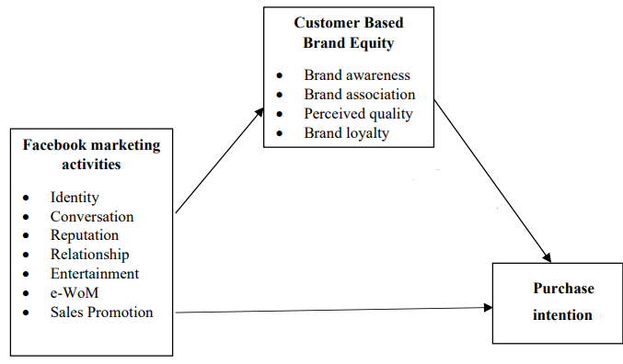

Figure 2.5: Role of SMM on brand equity
(Source: Jayasuriya, 2022)

2.5.2. SMM helps in communicating and expanding
The marketing activities through social media play an effective role in developing customer engagement. Research by Rienda, Ruiz-Fernandez and Carey (2021) highlighted that SMM operations had been the most crucial marketing strategy for the significant characteristics of the fashion industry. The research has also emphasised that SMM strategy has benefited fashion industries to internationalise the brands. According to research by Alatawy (2022), social media networks, technologies, tools, and transmissions have been quite efficient for brands to develop organisational performances to a greater level, which helps brands expand. Adidas has been using SM platforms to improve its presence in social networking sites to reach to larger volume consumers (Widodo, 2023). Further, social media's communication functions have been the most significant and outstanding marketing method, which helps improve brand loyalty. But, Chen and Cheng, (2020), argued that fake news on SMM platforms negatively affects consumers perception about brand. However, research by Puspaningrum (2020) argued that integrating communication through social media has no significant impact on brand loyalty of customer. However, according to research by Herjanto et al. (2020), celebrity endorsement and marketing through social media platforms have been popularised in the fashion industry. This has been effective for the UK fashion industry in branding and engaging a larger audience.

2.5.3. Role of SMM to improve brand loyalty
The marketing through social media has been developed as an effective marketing strategy to identify loyal consumers. According to Dewi, Herlina, and Boetar (2022), marketing activities through social media influence brand awareness, brand equity and positive brand perception forms loyalty. The positive reviews of other customers significantly impact the perception about brand and trust development. However, the role of SMM in influencing negative consumer feedback has yet to be considered. According to research by Yaacob, Gan and Yusuf (2021), negative consumer reviews have been a dominating factor that affects brand perception, loyalty and trust. However, considerable customer analysis and review have been identified as efficient approaches to avoid the consequences of negative reviews. The direct line benefits to make significant personalised interactions, which improves brand perception and loyalty. Further, research by Molina-Prados et al. (2022) argued that social media activities empower fashion brands to develop higher-quality customer relationships. The developed relationships are responsible for improving brand loyalty in the fashion industry.

2.5.4. Role of SMM to reach target audience and higher engagement
The social media platforms have been used by UK fashion brands to connect with their target audience. According to Wibowo et al. (2020), marketing activities through social media use creative content that meets customers' preferences. Nike use contents in SMM to reach the untapped market and influence purchasing decisions of target consumers (Champaneri and Jain, 2021). Marketing activities have a substantial role in developing good relationships with target customers. However, research by Zhao et al. (2022) claims that social networking tools, Facebook, YouTube, Twitter and others help brands gain in-depth insights into the needs and requirements of customers. The in-depth insights into the customer preferences have been effective for fashion brands in developing marketing activities to meet their needs and requirements. The enjoyable and unique experiences of consumers are focused by SMM to engage consumers to a greater extent. Further, research by Ibrahim (2022) agreed that social media activities determine how consumers develop their brand perception. Customers' engagement in different social media platforms significantly enhances opportunities to engage with target consumers.

2.6. Impacts of SMM on Brand trust and loyalty in the UK fashion industry
SMM activities have a differently affected on the fashion industry. According to Rathnayake and Lakshika (2022), SMM activities affect brands' trustworthiness, influencing purchasing intentions and brand trust. Research has also claimed that SMM significantly increases the attractiveness of unattractive fashion products. However, research by Handa (2020) disagreed by stating that social media has influenced complaints about unimpressive products. This raises questions about the credibility of fashion designers in offering attractive and efficient fashion products. Further, research by Yeo et al. (2022) solidifies the argument setting that perceived risk factors comprehended by customers through SMM affect purchasing decisions. Communication with efficient information has been a positive factor in developing cognitive trust in consumers. The E-commerce sector has significant capabilities to ensure risk-free purchasing, and developed experiences ensure brand trust.
Implementing SMM has developed relationships between the brand and the target consumers with two-way interaction. According to Kong, Witmaier and Ko (2021), social media communication significantly affects catering to customer preferences. Considerable considerations of customers' preferences have been identified as efficient in managing higher-quality customer relationships. The anticipation of the “social penetration theory” has highlighted that SMM activities have significantly improved brand loyalty and trust in fashion brands by sharing vulnerabilities (Macharia and Namusonge, 2021). Figure 2.6 shows that SMM has significant impact on consumer trust and purchasing decisions of customers. The anticipation of “social penetration theory” empowers brands to significantly improve their relationships with customers, which provides long-term value to the brand. The feeling, experiences and others are used to interact with brand though SM platforms which increases emotional attachment with the brand. Research by Natiqa, Kusumawati and Aprilianty (2022) solidifies that social media platforms help improve brand equity. The improved brand equity significantly impacts the customers’ purchasing behaviour of fashion products.
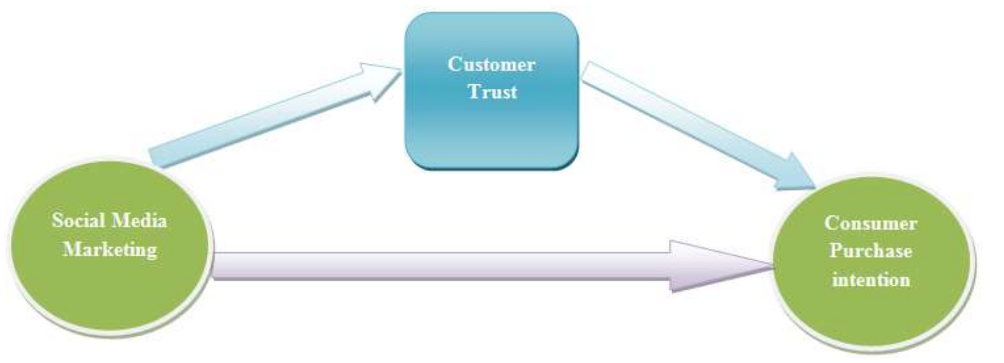

Figure 2.6: Impact of SMM on purchasing intentions
(Source: Manzoor et al. 2020)
The opportunities for fashion brands have been developed through social media platforms to offer in-depth insights about the brand. The expert information circulated through social media platforms efficiently impacts purchasing decision-making. According to Kim, Kang and Lee (2020), YouTube is the most significant social media platform because it helps markets build substantial customer relationships. This social media platform has efficiently developed more interactive relationships with the brand. Online contests and polling are interactive social media activities which improves relationships and evoke interest, which enhances sales (Apsari and Aruan, 2024). However, according to research by Irshad, Ahmad, and Malik (2020), customers' trust is significantly affected due to a lack of face-to-face communication in SMM, which influences higher performance efficiency. The lower trust of consumers in SMM activities enhances fashion brands' communication challenges. However, research by Ihzaturrahma and Kusumawati (2021) has mentioned that SMM is significant in reinforcing awareness of fashion brands. This reinforcement increases brand loyalty and brand trust to a considerable level.
The UK fashion brands have used content appraisal, increasing marketing operations' efficiency to enhance customers’ awareness about brands. As per the opinion of Britt et al. (2020), the prioritisation of practical content used in SMM which has been significant for the fashion industry. This is mainly because social media influences perceptions about the brand by showcasing attractive features and benefits. After all, this allows brands to have a substantial comprehension of consumers. Further, the degree of the valuable content significantly impacts the development of positive trust in consumers. Research by Manzoor et al. (2020) states that social media platforms have improved experiences and knowledge, because consumers' content creation has significantly increased. Further, research by Zhao et al. (2022) solidifies that social media helps brands gain in-depth insights about the target audience. This helps brands in developing personalised communication, interaction and engagement which enhances reliability on brand. The in-depth insights about the customers have benefited the customers, and the fashion industry has been offering more sustainable products as demands for sustainable fashion products have increased. Thus, social media platforms significantly contribute to developing customer relationships and engagement.

2.7. Strategies for SMM to develop brand loyalty and Trust in the UK fashion industry
The UK fashion industry has employed SMM strategies to develop efficiency of branding. According to Muniesa and Giménez (2020), brand experiences are used for marketing through social media platforms. This positive interaction of customers through social media platforms enhances brand loyalty and trust in the fashion industry. Further research by Jung, Kim and Kim (2020) shows that the brand image of fashion brands plays a vital role in influencing consumers' purchasing intentions. The brand image and functions are significantly communicated to the customers, which helps shape customers' purchasing behaviour. Further, research by Nobar, Kalejahi and Rostamzadeh (2020) argued that social media are used as significant interactive platforms, through contests, polls, comments, review and others. The brands pursue positive interactions. Social media polls are effective for UK fashion brands to enhance ownerships in consumers to generate insightful ideas and contents for marketing (Brüns and Meißner, 2024).
The information output produced by SMM is easily accessible by the customers. Easy access to social media platforms has significantly influenced brand perception. According to Khoa and Huynh (2023), cutting-edge methods to overcome online presence of brands have been used in marketing activities through social media, and this helps fashion brands reach larger customers. Interactive contents, personalisation, collaboration with influencers and other cutting-edge technologies are used to influence consumers trust and loyalty. Personalised positive brand experiences are provided through SMM, increasing opportunities for brands to enhance customer satisfaction. Research by Heskiano, Syah and Hilmy (2020) solidifies the argument, stating that fashion brands utilise efficient content that meets individual customers' requirements. Appealing content through multiple social media platforms has been significant for the brand. Further, research by Dülek and Aydın (2020) stated that user-generated content improves WOM, substantially influencing brand loyalty. Trust in the brand operations and products is used to mediate marketing operations and strengthen brand loyalty. Zara has used user-generated contents which helped this fashion brand in humanising the brand in greater extent (Popović et al. 2021).
SEO and SEM are significant strategies used in marketing tactics of social media by the fashion industry because these tools have been identified as effective in enhancing brand awareness. According to Drummond, O'Toole, and McGrath (2020), personalised messages through different social media platforms have been most effective tactics to promote brand loyalty and trust. This tactics is used by Nike which helps brands in determining seamless customer experiences (Champaneri and Jain, 2021). This significantly impacts the development of personalised customer experiences, which prompts them to be loyal customers. The fashion industry, therefore, has enhanced social media's commercial functions, which has been identified as a significant tool that enhances opportunities to achieve success (Gornostaeva, 2023). But, research by Sharma et al. (2020) argued that SMM operations strengthen brand value and brand awareness to engage customers. Efficient SMM operations have a significant impact on the motivation of consumers, which results in an influx of consumer purchasing intentions.

2.8. Theoretical underpinnings
“Social Penetration Theory”
This theory illustrates that along with the development of relationships, communication becomes shallower to more intimate communication. Regarding SMM activities (Huber and Martinaitytė, 2022), the “Social Penetration Theory” is necessary because it highlights the impacts of marketing activities of social media on interpersonal communication with consumers. The consumers make communication about their feeling, experiences, relationships and others. Further, research by Macharia and Namusonge (2021) has highlighted that this theory progresses through step by step, which are significant for developing customer relationships. This theory would be effective to understand the significant process of developing loyal and satisfied customers in UK fashion industry, because UK fashion companies used SMM to interact and engage with customers through valuable information (Gornostaeva, 2023). The outer superficial level determines lack of interaction and share of limited information. The self-discloser of customers about their likes, dislikes and personal and intimate information sharing and communication helps in developing trust, loyalty and strengthened relationships (Pearce, 2020). This theory gradually develops trustworthy relationships and each stages of the onion would be significant to elaborate the gradual impact of SMM by UK fashion industry in building trust and loyal customers. These stages would be effective for UK fashion industry to make significant SMM to develop customer satisfaction and loyalty.
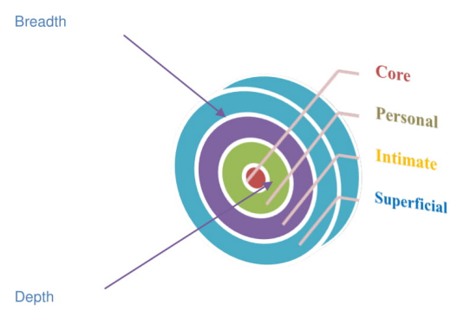
Figure 2.7: Social Penetration Theory
(Source: Pearce, 2020)

2.9. Literature gap
Critical analysis of the literature has been practical in understanding the significant gap in the literature on social marketing to influence brand loyalty and trust. The research in this literature by Ebrahim (2020), lower sample size and inefficient demographic representation are raises concern to generalise impact of SMM on developing brand trust, Further, the study by Park, Im, and Kim (2020) conduct study only considering impact of influencer and brand trust with significant emotional attachments. Further, Puspaningrum (2020) illustrated that social media communication has no significant relationship with brand trust and loyalty. Research by Sohail, Hasan and Sohail, (2020), has limited discussion about how the interaction of SMM develops brand trust and loyalty. Thus, the existing study has demographic issues, lower sample size, lack of clearer picture of how SMM develops brands trust and loyalty and existing study contrasts that SMM has not impact on brand trust and loyalty. This study bridges the literature gap by collecting data from particular demographics, ade data, process of how SMM develops brand trust and loyalty and analyses efficiency of SMM on developing brand trust and loyalty by UK fashion industry.

2.10. Conceptual Framework
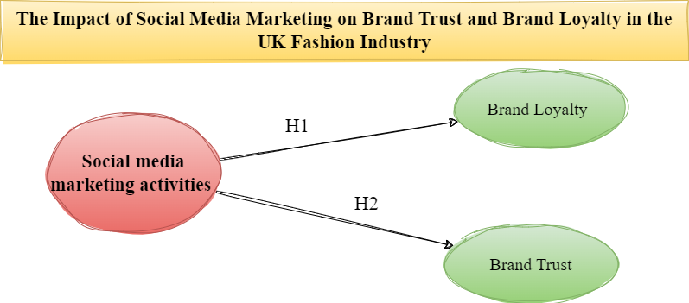

Figure 2.8: Conceptual framework
(Source: Developed by researcher)
Figure 2.7 of conceptual framework highlighted the relationships among independent and independent variables. The brand trust and brand loyalty are dependent variable which are influenced by independent variables. The framework highlights the significant relationships between brand trust and brand loyalty. In the literature, the hypothesis developments have been interpreted which are analysed in this study. Thus, hypothesis are H1 has been designed as “SMM of UK fashion brands have a significant impact on the brand loyalty” and H2 is “SMM of UK fashion brands have no significant impact on the brand trust”. The hypothesises shows the major areas of this study which has been investigated by the researcher.

2.11. Summary
Brand trust is the commitment of consumers to continue purchasing without considering competitors. The efficiency of the brand operations and products significantly increases loyalty to the brand. UK fashion brands like Louis Vuitton, Zara, Next Plc, ASOS, Marks and Spencer, and other famous brands have integrated SMM strategies. This has increased the significance of SMM strategies to directly engage, communicate, interact, engage and develop brand perceptions. SMM has been playing a significant role in creating a positive brand perception, and considerable band experiences have enhanced the brand's opportunities to build marketing operations. Social media platforms, personalised offerings, messages, and other things have allowed UK fashion brands to improve their brand experiences and positive perceptions. The "social penetration theory" has been influential in understanding the process of how social media develops high-quality relationships with consumers. The use of creative and engaging content and marketing through Facebook, Instagram, Twitter, YouTube and others have been effective in developing brand perceptions.

Chapter 3: Research Methodology

3.1. Introduction
The selection of appropriate research methods, mechanisms, and tools is essential in conducting research. Applying research methods and procedures is significant for researchers to enhance the reliability and efficiency of research outcomes. This section of this study evaluates and justifies selected research methods to ensure the reliability and efficiency of the research outcomes.

3.2. Research Onion
“Saunders’ Research onion” works as a research design model that is helpful for researchers in developing empirical approaches to conduct research. Figure 3.1 shows each layer of this onion, which helps produce significant research methodology for conducting the research. According to Abdelhakim (2021), this research onion is an essential tool for the researchers because it guides research in each choice to ensure significant research approaches.
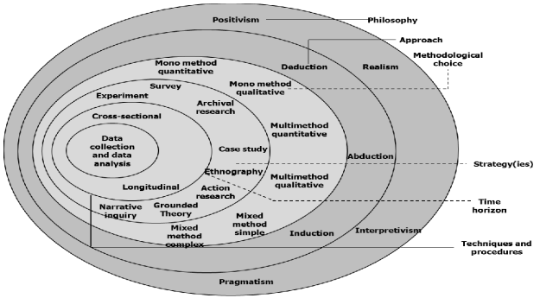

Figure 3.1: Saunders’ Research Onion
(Source: Abdelhakim, 2021)

3.3. Research Philosophy
The first layer of the onion shows four research philosophies used in conducting the research. “Positivism” helps to make objective observations and observations of significant areas to improve experiences, but assumptions affect the reliability of the research outcomes (Park, Konge, and Artino, 2020). Interpretivism helps in understanding experiences, but the outcomes of this philosophy are unreliable (Alharahsheh and Pius, 2020). Further, realism helps understand the essence but does not consider imagination and emotions. On the other hand, pragmatism effectively comprehends actions within a situation, and data discrepancies raise complications when analysing and evaluating data.
Justification
The analysis helped the researcher follow “Positivism” because this approach helped the researcher make objective data observations. The critical objective observation of collected data has been helpful for researchers who want to make significant improvements in their assumptions. The data has been aligned with empirical measurements, which developed the efficiency of the research methods. This philosophy has helped determine more reliable research outcomes, which would not have been possible with Interpretivism for higher dependability on participants (Alharahsheh and Pius, 2020). The objective observation has benefited the researcher in identifying the role of SMM, brand trust, brand loyalty, impacts and relationships with the UK fashion industry. The controlled experimentation has practically aligned the observation to answer research questions.

3.4. Research Approach
The second layer of the onion shows three research approaches used in conducting the research. The “Deductive approach” follows a logical flow in interpreting and reaching a conclusion. However, incorrect use of statistical research methods results in erroneous conclusions (Casula, Rangarajan, and Shields, 2021). The “inductive research approach” develops a new theory with a correct contextual explanation, but immediate application results in chaos. The “abductive approach” combines deductive and inductive reasoning, which is helpful for surprising observations but is also a limitation to conducting the studies.
Justification
The analysis of the research approaches has been helpful for the researcher in selecting the “Inductive research approach.” This reasoning has been practical for the researcher in identifying patterns from collected data and has benefited the researcher in determining generic research outcomes from specific observations (Vears and Gillam, 2022). The identification of particular observations of the data has been helpful for the researcher in developing an understanding of the significance of SMM for creating brand loyalty and trust in the UK fashion industry. The development of specific undertakings of the role and importance has helped the researcher develop generalised research outcomes about the role, impacts, and relationships of SMM with brand loyalty and trust.

3.5. Research Method
The third layer of this onion shows three significant methods, which have been further divided into two segments. Mono-methods are more accessible, and researchers can conduct studies from single sources, but they need more reliability and validity. Mixed methods are more complex and require sample size, requiring more research skills and resources (Eichsteller, 2022). Further, qualitative research is not statistically represented as a quantitative method. The qualitative method enabled the collection of new beliefs and approaches, which is less practical than the quantitative method (Kandel, 2020).
Justification
Evaluating the methods has helped the researchers approach with “mono-method quantitative”. This scientific and relatable method has been significant for researchers in collecting reliable and specific data. This study's objectives and research questions have been used to collect specific quantitative data, and statistical analysis has helped to identify the role and impacts of relationships of SMM with brand loyalty and trust in UK fashion industry. The use of the Internet and Google Forms has been effective in conducting the survey, which helped in collecting most appropriate quantitative data as a result of this selected research method (Kaur and Bansal, 2022). Analysing the existing literature and identifying the research questions has helped apply this research method.

3.6. Research Strategy
The fourth layer of the research onion shows different research strategies. Experimental strategies are used to understand effects and causes, and manipulating variables results in unethical practices (Gopalan, Rosinger, and Ahn, 2020). Archival strategy collection uses different resources to validate in-depth comprehensions, but identification of sources is crucial. The case study strategy collects data from different sources, but one's feelings significantly influence research outcomes (Schoch, 2020). Action research is used in ongoing procedures, and research outcomes are crucial to replicate. Grounded theory uses interviews to direct real-world research, but data analysis is complicated (Cullen and Brennan, 2021).
Justification
The researcher used the “Archival research strategy,” which helped the researcher to gain an in-depth comprehension of the role, impact, and relationships of SMM with brand trust and loyalty in the UK fashion industry (Jo and Gebru, 2020). The researcher has selected consumers of UK fashion industry because consumers are suitable sources to identify the impacts of SMM on their brand loyalty and trust in UK fashion industry. The selection of natural archives has been useful for the research in this study to guide the data collection. This has helped to make an in-depth study about the role, impacts and relationships of SMM with brand trust and loyalty in UK fashion industry.

3.7. Questionnaire Development
The researcher used a closed-ended survey questionnaire to ensure structured responses, which helped reduce difficulties (Taherdoost, 2022). The questionnaire was developed using a focused group, and pilot testing was conducted to develop questionnaire (Aithal and Aithal, 2020). The open-ended questions have been encouraged to have insights which have been used in formulating clear and concise questionnaire to conduct the survey. The literature review has helped decide the focus of this study and identify research questions that have been used in developing the research. Each research question and objective was used to create the research questions. In order to ensure a significant source of data collection, the researcher used one qualifying question and four demographic questions [Refer to Appendix 1].

3.8. Inclusion and Exclusion Criteria
Criteria | Inclusion | Exclusion
Purchased from UK fashion brands | Consumers purchased from UK fashion brands | Consumes did not purchase from UK fashion brands
Geographic location | UK | UK
Age | More than 18 | Less than 18
Knowledge about SMM | Consumers know and are experienced in SMM | Consumers have no knowledge and experience about SMM

Table 3.1: Inclusion and exclusion
(Source: Developed by researcher)
Table 3.1 shows the criteria which has been used by the researcher to select the participants for conducting the survey. The inclusion criteria shows that survey participants would consumer of fashion brands only from UK. The age of consumers needed to be more than 18 and the consumer needed to have experience about SMM. The exclusion criteria are completely opposite to inclusion criteria.

3.9. Sample size
Using a significant sampling method and the sample size is crucial for the researchers conducting the research. The sample size enables the researchers to determine the true representative of the selected groups (Rahman, 2023). In order to be sure about true representatives, in this study, the research has collected responses from 81 consumers of UK fashion industry. Initially, responses were collected from 90 participants and applying excluding and including criteria, this study collected selected responses from 81 participants. A sample size has been used in this study to determine powerful statistical representation. On the other hand, using a sample size has helped avoid possible errors. The lower errors enhance the reliability and validity of the research outcomes, which leads to significant research conclusions about the role, impacts and relationships of SMM with brand loyalty and trust in UK fashion industry.

3.10. Sampling Technique
The researcher in this study used the “purposive sampling technique”, which has helped select the most relevant participants. The purpose, research questions, and objectives were used to develop criteria for selecting survey participants (Andrade, 2021). This has helped the researcher to ensure rich and reliable research outcomes, which have been crucial for the researcher in collecting the research to a significantly higher level. The focused findings have empowered the researcher to identify the role, impacts and relationships of SMM with brand trust and loyalty in UK fashion industry.

3.11. Data collection method
The researcher has used “Primary data collection method” because access to authentic data helps researchers enhance the research outcomes' reliability and validity. The source has been selected to collect rich and efficient primary data to explore the role and effects of SMM on consumers’ brand loyalty and trust (Schuurman, 2020). Primary data collection has been used in this study to conduct this study with recent data and information about SMM in UK fashion industry. The survey was conducted to collect primary quantitative data, and this tool helped collect primary data from a sample size. The internet in the survey has been effective for direct communication with consumers and gathering raw data regarding the impacts, tole and relationships of SMM with brand loyalty and trust in UK fashion industry (Shatrı, 2020). This tool has helped collect valid and specific information with pre-developed close-ended questionnaires. This has helped the researcher collect vast data to answer the research questions.

3.12. Data analysis technique
The researcher has used the “quantitative data analysis technique”, and selecting this technique has benefited quantitively measuring the impacts, role and relationships of SMM with brand trust and loyalty in UK fashion industry. Using quantitative analysis through SPSS software has effectively enhanced statistical data analysis with greater emphasis on the research outcomes and approaches (Hassan, Poon and Alisa, 2023). Descriptive, Correlation and Regression statistics have been used to identify the impacts and relationships and test the research hypothesis. The statistical measurement of the quantitative data has helped to investigate the impacts, role and relationships of SMM with consumers’ brand loyalty and brand trust to a significantly higher level.

3.13. Reliability and Trustworthiness
The researcher in this study considered objective data collection and interpretation to ensure the effectiveness of the research outcomes. The personal biases and subjective interpretations of collected data have benefited the research in concluding the research according to the collected data. Further, the research has collected data from a sample size, which is true representatives of the selected consumer groups ((Rahman, 2023). This has also effectively investigated SMM's overall impacts, role and relationships in the fashion industry. The research methods and mechanisms have been significantly followed to reach efficient research outcomes.

3.14. Ethical considerations
The researcher followed the institute's guidelines, and the ethics form was helpful in determining ethical considerations for conducting the research. The consent form was used to instruct participants on the purpose, use of data, and value condition of their responses. The “Data Protection Act 2018” has been applied and followed by the researcher in this study to ensure the safety of consumers, and the researcher has not used identifiable information to ensure privacy and security (Almeida, Shmarko and Lomas, 2022). Further, this study has followed significant measures in applying primary research methods and tools. This study has not been used commercially, and no other institutes have published it.

3.15. Summary
The following Sauders’ framework in selecting the research mechanisms and tools has significantly helped the research develop the empirical research method. The selection of Positivism has directed the researcher at a significant level from the first layer in conducting this study. Further, inductive reasoning has been helpful for the researcher to reach from specific observation to generalise research outcomes. Mono-method quantitative has the benefit of allowing the researcher to concentrate on answering research questions. The archival strategy helped to understand SMM's role, impacts, and relationships with brand loyalty and trust. A closed-ended survey questionnaire was used to collect quantitative data, and SPP software was used to interpret and analyse statistical data. The data was collected from 81 consumers using a purposive sampling method to enhance the reliability and validity of the research outcomes.

Chapter 4: Results

4.1. Introduction
The result section interprets the findings, and the implications are analysed in the next chapter. The findings of this study are presented to ensure that the context of this study is according to the research objectives and questions. In this section, the research logically presents the findings without biased interpretation. The survey questions and the responses collected from the survey have been presented in this study, and the research hypotheses have been measured.

4.2. Findings
Question 1. Have you purchased fashion items from any UK fashion brand in the past 12 months?
In the survey, around 95.1% of respondents mentioned purchasing fashion products in the UK fashion industry in the last 12 months. However, 3.7% of participants mentioned buying products within the previous 12 months.
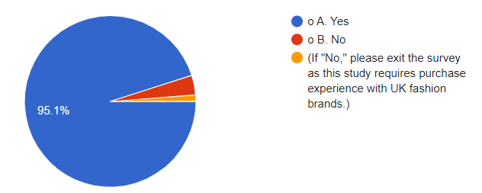

Figure 4.1: Purchased from UK fashion brands
(Source: Developed by researcher)
Question 2. What is your gender?
Figure 4.2 shows that 53.1% of respondents in the survey were male, and this group had a higher percentage of male respondents than female respondents (38.3%). Further, 8.6% of respondents stated they prefer not to disclose their gender identity.
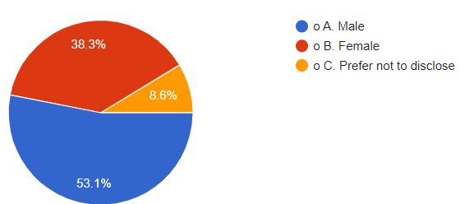

Figure 4.2: Gender of participants
(Source: Developed by researcher)
Question 3. What is your age range?
In this survey, 21% of respondents belong to the 18- 24 age group, 61.7% of participants belong to the 25- 34 age group, 9.9% of participants belong to the 35- 44 age group, 3.7% of participants belong to the 45- 54 age group, and 3.7% of participants belong to the 55-above age group.
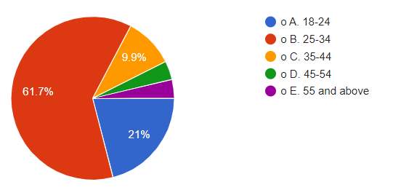

Figure 4.3: Age groups of participants
(Source: Developed by researcher)
Question 4. What is your highest level of education?
Figure 4.4 shows that 11.1% of participants have high school diplomas, 4.9% have associate degrees, 32.1% have bachelor's degrees, 40.7% have master's degrees, 7.4% have doctoral degrees, and 3.7% have not disclosed their educational degrees.
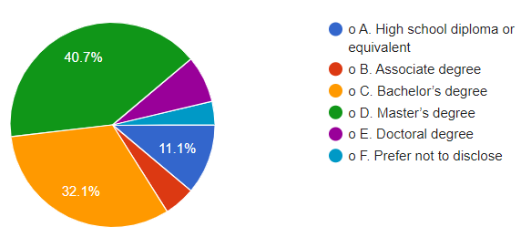

Figure 4.4: Level of education
(Source: Developed by researcher)
Question 5. What is your approximate monthly spending on fashion items?
In the survey, 25.9% of participants mentioned their monthly expenses in the fashion industry are £0-£50, 34.6% of participants stated £51-£100, 25.9% of participants mentioned £101-£200, 9.9% of participants mentioned £201-£500 and 3.7% of participants have mentioned £501 and above expenses.
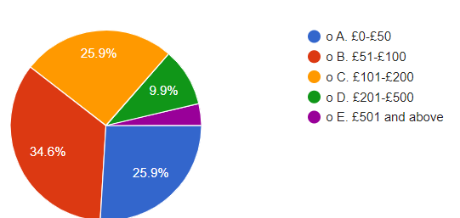

Figure 4.5: Monthly spending on the fashion industry
(Source: Developed by researcher)
Objective 1: To analyse the role of SMM in developing brand loyalty and trust in the UK fashion industry
Research questions | Intent to measure | Referred to the objective
Question 6 | Measures efficiency of SMM | Define role of SMM information
Question 7 | Measures effectiveness of SMM | Identify role of SMM in defining loyalty and trust
Question 8 | Measure role of SMM in interaction | Shows role of SMM in determining trust and loyalty
Question 9 | Measures usefulness of contents used in SMM | Highlights role of contents in defining loyalty and trust

Table 4.1: Findings for objective 1
(Source: Developed by researcher)
Table 4.1 indicates that question 6, 7, 8 and 9 helps in interpreting role of SMM information and contents in developing brand loyalty and brand trust of consumers in UK fashion industry.
Question 6. Social media content by UK fashion brands is informative and engaging.
Figure 4.6 shows that 37% of participants agree, and 13.6% strongly agree, that SMM is informative and engaging. However, 9.9% strongly disagreed, and 7.4% disagreed about the efficiency of SMM by UK fashion brands in being informative and engaging. Further, 32.1% of participants in this survey have remained neutral and have not answered this survey question.
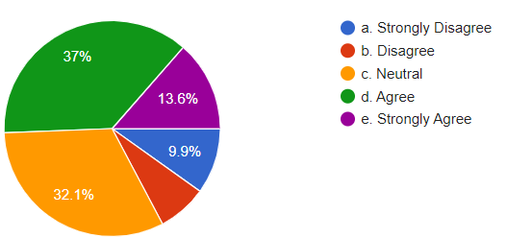

Figure 4.6: SMM is engaging and informative
(Source: Developed by researcher)
Question 7. Social media marketing by UK fashion brands enhances my trust in these brands.
The SMM is significant for UK fashion retailers because it improves consumers’ brand trust. 39.5% of participants agreed, and 8.6% strongly agreed with this statement. However, 7.4% of participants in this survey strongly disagreed, and 11.1% disagreed with this statement. On the other hand, 33.3% of participants did not answer this survey question and remained neutral.
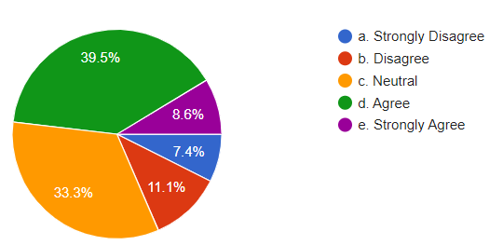

Figure 4.7: SMM enhance trust
(Source: Developed by researcher)
Question 8. Interactions with UK fashion brands on social media increase my loyalty to these brands.
Figure 4.8 indicates that 32.1% of survey respondents agreed, and 9.9% of respondents strongly agreed that interaction of consumers with UK fashion brands through SMM improves their loyalty. However, 44.4% of respondents in the survey have yet to answer this survey question. However, 3.7% of respondents in the survey disagreed, and 9.9% strongly disagreed about the effectiveness of SMM interaction in developing brand loyalty for UK fashion brands.
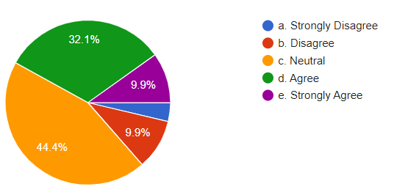

Figure 4.8: SMM interaction develops loyalty
(Source: Developed by researcher)
Question 9. The visual content UK fashion brands share on social media influences my purchasing decisions.
Appealing to visual consent marketing through SMM by UK fashion brands has a significant impact on developing brand perception and purchasing decisions. Figure 4.9 shows that 33.3% of survey respondents agree, and 16% strongly agree with the statement. However, 6.52% of survey respondents disagreed, and 4.9% strongly disagreed with this statement. However, 39.5% of survey respondents have yet to answer this question and remain neutral.
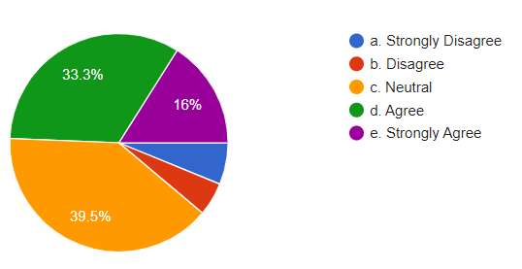

Figure 4.9: Influence of Visual Content on purchasing decisions
(Source: Developed by researcher)
Objective 2
Objective 2: To develop a critical comprehension of the role of SMM, brand loyalty, and trust with reference to the UK fashion industry
Research questions | Intent to measure | Referred to the objective
Question 10 | Measure efficiency of SMM in managing relationships | Develops knowledge about role of SMM in developing relationships
Question 11 | Analyse role of engagement on brand loyalty | Highlights effectiveness of SMM in building loyalty and engagement
Question 12 | Measure role of SMM in determining brand value | Evaluates significance of SMM to showcase brand value of UK fashion brands
Question 13 | Measure role of SMM in building trust | Showcase role of SMM in building trust

Table 4.2: Findings for objective 2
(Source: Developed by researcher)
Table 4.2 indicates that question 10, 11, 12 and 13 measures the role of SMM in developing the brand loyalty and brand trust in consumers for UK fashion brands.
Question 10. Social media interactions with fashion brands make me feel more connected to the brand.
In the survey, 40.7% of respondents agreed, and 16% strongly agreed that SMM has significantly influenced their connectedness with UK fashion brands. However, 8.6% of respondents disagreed, and 6.2% strongly disagreed about the effectiveness of SMM in developing connectedness with UK fashion brands. On the other hand, 28.4% of consumers remained neutral when answering this survey question.
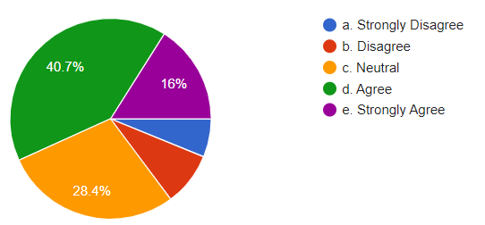

Figure 4.10: Influence of SMM on Connectedness
(Source: Developed by researcher)
Question 11. I am more likely to remain loyal to a UK fashion brand that actively engages with customers on social media.
Figure 4.11 shows that 37% of survey participants have agreed, and 14.8% have strongly agreed that they remain loyal to UK fashion brands actively engaged with SMM. However, 3.7% of survey respondents strongly disagreed, and 8.6% disagreed about SMM's role in determining loyalty towards UK fashion brands. Further, 5.8% of participants have remained neutral and have yet to answer this survey question.
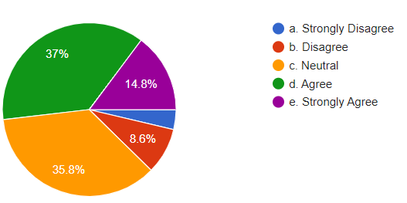

Figure 4.11: Influence of SMM on loyalty
(Source: Developed by researcher)
Question 12. Social media marketing helps me understand the values and commitments of UK fashion brands.
In the survey, 42% of respondents agreed, and 12.3% strongly agreed that SMM helps understand UK fashion brands' brand values and commitments. However, 4.9% strongly disagreed, and 7.4% disagreed about the efficiency of SMM in understanding brand values and organisational commitments through SMM communication. However, 33.3% of survey respondents remained neutral and did not answer this question.
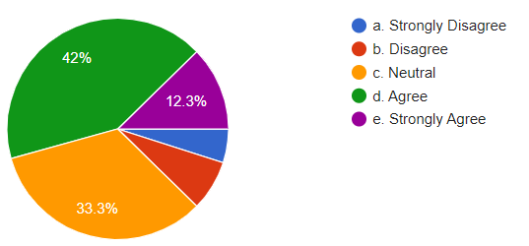

Figure 4.12: Impact of SMM on developing brand value
(Source: Developed by researcher)
Question 13. I trust fashion brands with a solid social media presence more than those without.
Figure 4.13 shows that 32.1% of survey respondents agreed, and 18.5% strongly agreed, that using SMM helps UK fashion brands build brand trust. However, 35.8% of survey respondents have remained neutral in answering this survey question. However, 7.4% of survey respondents disagreed, and 6.2% strongly disagreed about the role of SMM in building brand trust.
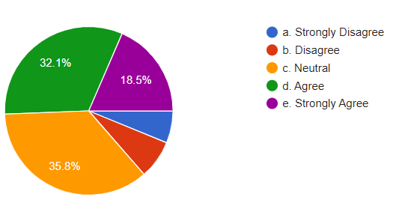

Figure 4.13: Impact of SMM on developing brand trust
(Source: Developed by researcher)
Objective 3
Objective 3: To analyse the relationships between brand loyalty and brand trust triggered by SMM
Research questions | Intent to measure | Referred to the objective
Question 14 | Measure efficiency of SMM in building confidence | Shows relationship between SMM in developing trust and purchasing intensions
Question 15 | Measures strong SMM position on consumer trust | Highlights effectiveness of SMM in building trust
Question 16 | Measures efficiency of SMM to recommend brand to others | Shows relation of SMM to trigger brand loyalty and brand trust

Table 4.3: Findings for objective 3
(Source: Developed by researcher)
Table 4.3 indicates that question 14, 15 and 16 shows significance of SMM I building trust and loyalty of consumers which influence intentions of consumers to recommend to others.
Question 14. Social media marketing by UK fashion brands makes me more confident in my purchasing decisions.
In the survey, 38.3% of participants agreed, and 16% strongly agreed that SMM significantly impacts developing consumers’ confidence in purchasing decisions. However, 9.9% of participants disagreed, and 4.9% strongly disagreed with the role of SMM in building confidence while making purchasing decisions.
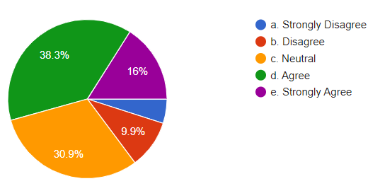

Figure 4.14: SMM enhances confidence
(Source: Developed by researcher)
Question 15. My trust in a UK fashion brand grows stronger with positive experiences on social media.
Consumers' positive experiences in SMM help UK fashion brands enhance brand trust. Figure 4.15 shows that 42% of participants agreed, and 16% strongly agreed with the statement. On the other hand, 29.6% of respondents did not answer this survey question and remained neutral. However, 8.6% of participants disagreed, and 3.7% of participants strongly disagreed with the statement.
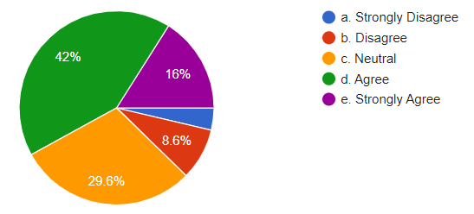

Figure 4.15: SMM enhances confidence
(Source: Developed by researcher)
Question 16. I would like to recommend a UK fashion brand to others if I have positively interacted with them on social media.
Figure 1.16 shows that 40.7% of survey respondents agreed and 13.6% strongly agreed that SMM positive interaction influences the likeliness to recommend UK fashion brands to others. However, 3.7% strongly disagreed, and 8.6% disagreed with this statement. On the other hand, 33.3% of respondents remained neutral and did not answer this research question.
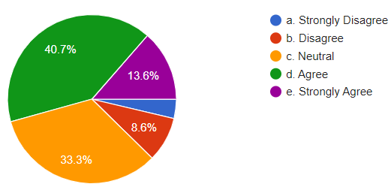

Figure 4.16: SMM positive interaction helps in developing brand recommendations
(Source: Developed by researcher)

4.3. Correlation, regression, descriptive statistics

4.3.1. Reliability test
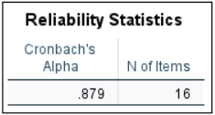

Table 4.4: Reliability Statistics
(Source: Developed by researcher)
table 4.4 shows the value of Cronbach’s Alpha value is 0.879 which is close to 1. This indicates 16 questions of the survey used is valid and reliable.

4.3.2. Descriptive Statistics
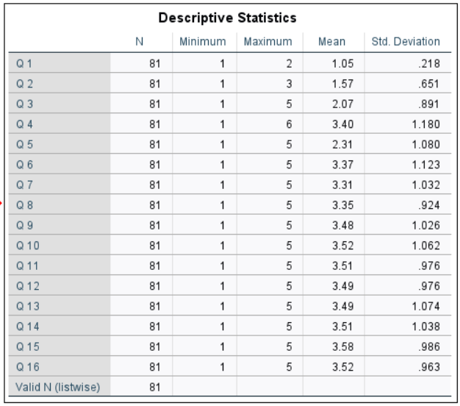

Table 4.5: Descriptive statistics
(Source: Developed by the researcher)
The value of N is 81, which indicates no missing data. The average response of the variables is 1, which is higher than the maximum values. The Std values are high, which suggests that the collected data are widely spread from the mean value.

4.3.3. Correlations Statistics
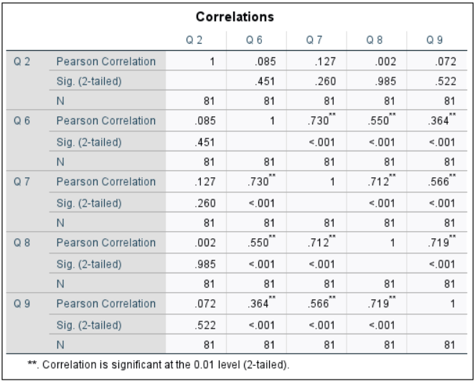

Table 4.6: Correlations
(Source: Developed by researcher)
Table 4.6 shows Pearson correlation values of 1 and 2-tailed values of 0.45, 0.98, and 0.52, which are close to 0.05. This indicates positive relationships between the variables. The question 6, 7, 8 and 9 role of SMM in developing brand trust and loyalty.
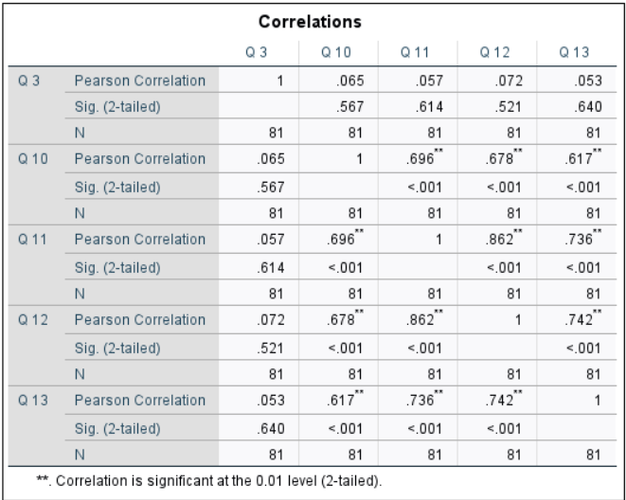

Table 4.7: Correlations
(Source: Developed by researcher)
The Pearson correlation values are one, and the 2-tailed sig values are 0.56, 0.61, 0.52, and 0.64, which are close to 0.05. This indicates that the variables in these statistics have positive relationships. The question 10, 11, 12 and 13 measures role of SMM for UK fashion brands in building brand trust and loyalty.
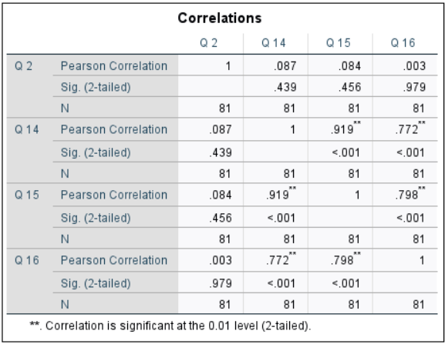

Table 4.8: Correlations
(Source: Developed by the researcher)
Table 4.8 shows the Pearson correlation values of the variable 1. The 2-tailed sig values are 043, 0.45, and 0.97, close to 0.05, indicating the positive relationship between the variables. The positive relationships of the variables indicate that the SMM used by UK fashion brands have a significant positive impact on developing brand loyalty and trust of consumers. Question 14, 15 and 16 measures the influence of SMM on brand loyalty and brand trust.

4.3.4. Regression analysis
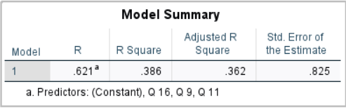

Table 4.9: Model Summary
(Source: Developed by researcher)
Table 4.9 shows that R is 0.62, which is higher than 0.4. This indicates that the variables SMM, brand loyalty, and brand trust in the UK fashion industry have significant relationships with each other.
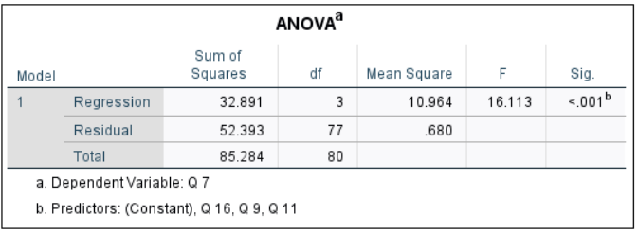

Table 4.10: ANOVA
(Source: Developed by researcher)
This regression model has been identified as effective because Table 4.10 shows that the value of F is 16, greater than 1. The more excellent value of F indicates the model's significance.
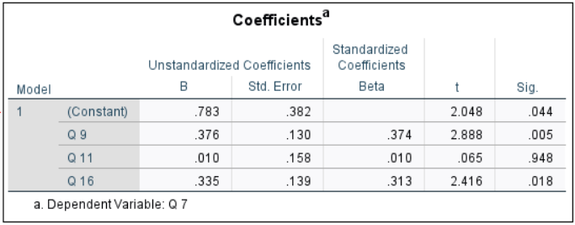

Table 4.11: Coefficients
(Source: Developed by researcher)
The sig value of the dependent variable 11 is 0.94, which indicates higher than 0.05. This suggests that the independent variable significantly impacts the dependent variable. As the sig value is higher than 0.05 in with 95% confidence interval, this helps the researcher in rejecting the null hypotheses. The null hypotheses are “H01: The SMM of UK fashion brands have no significant impact on brand loyalty” has been rejected and “H02: SMM of UK fashion brands have no significant impact on brand trust” alternative hypothesis has been accepted. Further, this helped the researcher accept the alternative hypotheses “H1: The SMM of UK fashion brands has a significant impact on brand loyalty” and “H2: SMM of UK fashion brands has a significant impact on brand trust”.

4.4. Summary
The results of this study indicate that SMM of UK fashion industry is engaging and informative. The positive interaction of consumers with UK fashion brands has effectively developed brand trust and loyalty. The visually appealing SMM has a significant impact on consumers' purchasing decisions. The use of SMM has enhanced the abilities of UK fashion brands to develop connectedness with consumers. On the other side, active engagement of UK fashion brands in SMM has potential impacts to ensure the loyalty of consumers. The active engagement of UK fashion brands positively affects leveraging brand loyalty and trust. Further, SMM enhances consumer confidence and trust, influencing their purchasing decisions. The positive brand experience through SMM builds trust, and significant positive experiences help brands recommend UK fashion brands to others. Conversely, quantitative measures through statistics have helped reject the null hypothesis and accept the alternative hypothesis.

Chapter 5: Discussion

5.1. Introduction
This study has analysed and interpreted the results' implications. The interpretation was practical for the researcher in determining the significance of this study. Findings of this study is compared and contrast against the findings of literature review.

5.2. Implications of findings
Research question 1: What is the importance of SMM for developing brand loyalty and trust in the UK fashion industry?
The SMM has significantly developed relationships, loyalty, and trust in the UK fashion industry. In question 6, 37% of consumers mentioned that the content of SMM has been adequate for UK fashion brands in developing engagement with more informative SMM content. In section 2.5.1 of the literature review (LR), Wibowo et al. (2020) agreed that SMM helps fashion brands by providing in-depth visibility of the products and services. This helps determine the positive effects of determining relationships with consumers. Further, the findings of Lim and Rasul (2022) showed that social media content helps develop desired customer engagement. The content related to brands helps communicate effectively, which engages customers. In the survey, 13.6% of customers strongly agreed that SMM content is informative and engages customers with fashion brands in UK. Similarly, Arustamyan, Taj and Nasir (2020), in section 2.4 of LR, stated that Marks and Spencer’s focuses more on customer engagements.
The quality of content plays a crucial role in developing customer engagement through SMM. In the survey, 7.4% of consumers in question 5 disagreed about the role of SMM content in engaging customers with UK fashion brands. Similarly, research by Shahbaznezhad, Dolan, and Rashidirad (2021) outlined that lower-quality SMM content negatively impacts customer engagement. However, Jayasuriya (2022), in section 2.5.1 of LR, argued that SMM plays a significant role in the fashion industry in building significant brand perceptions. However, 9.9% of consumers in the survey stated that SMM content could be more informative and engaging. Research by Champaneri and Jain (2021) contrasted that Nike uses SMM to reach untapped markets with efficient SMM content, and significant application of SMM enhances opportunities for fashion brands to reach targeted consumers. Further, Wibowo et al. (2020) agreed that SMM uses creative marketing content which attracts or engages customers. Further, research by Zhao et al. (2022) states that Twitter, Facebook, YouTube and others are primary networking tools used to engage customers. However, research by Shen (2021) argued that the WOM of influencers on social media plays a significant role in developing customer engagement in the fashion industry.
SMM is vital for UK fashion retailers to communicate effectively and directly interact with customers. In the findings, 39.5% of customers agreed that SMM has a significant role in developing trust in UK fashion companies. Dewi, Herlina, and Boetar (2022), in 2.5.3 of LR, elaborated that positive reviews influence brand perception and trust. However, 11.1% of consumers in the findings did not agree about the role of SMM in building confidence in UK fashion brands. Similarly, research by Yaacob, Gan and Yusuf (2021) stated that negative reviews of customers on SMM are essential in reducing customers’ trust in brands. However, Wibowo et al. (2020), in section 2.5.1 of LR, argued that SMM resolves customers’ issues, enhancing customer trust. Further, 7.4% of customers in the findings strongly disagreed about the importance of SMM in building customer trust in UK fashion brands. Research by Rienda, Ruiz-Fernandez, and Carey (2021) highlighted the significance of SMM, which is challenging in achieving the best strategic outcomes.
The role of SMM is significant in developing brand presence and customer interaction. In the findings, 32.1% of consumers have agreed that SMM interaction with UK fashion brands plays a substantial role in creating customer loyalty. Dewi, Herlina, and Boetar (2022), in section 2.5.3 of LR, agreed by stating that SMM activities interact and build awareness of customers. Forming positive brand perception has a significant role in building brand loyalty. Further, 9.9% of consumers in the findings strongly agreed with this statement. Molina-Prados et al. (2022), in section 2.5.3 of LR, agreed by showing that SMM conducted by fashion brands have played a significant role in managing positive brand perception, which is crucial for organisations in managing performances to a considerable level. But, 9.9% of consumers strongly disagreed about the role of SMM in building brand loyalty. Yaacob, Gan and Yusuf (2021), in section 2.5.3 of LR, stated that negative perceptions of customers from negative feedback affect customer satisfaction.
The contents and communication used in SMM have played a significant role in building customer satisfaction. The developed customer satisfaction with SMM enhanced the ability of UK fashion companies to influence customers’ purchasing decisions. In the findings, 33.3% of customers agreed that visually appealing SMMs have positive relationships with customers’ purchasing decision-making. Jayasuriya (2022), in section 2.5.1 of LR, agreed that SMM plays a significant role in building positive perceptions of the brands, and this positive brand perception plays a considerable role in customers' purchasing decisions. However, Alatawy (2022), in section 2.5.2 of LR, argued that SMM has a significant role in developing overall organisational performances to a greater extent. On the other side, in the findings, 16% of customers agreed about the role of SMM in creating positive brand attitudes, and this positive brand attitude has a significant role in building trust. Tőkés (2022), in LR, stated that in SMM, Zara uses images, videos and other visually appealing content to influence customers' purchasing decisions. The positive experiences are provided by significant SMM, which is crucial for UK fashion brands in developing trust and loyalty.
Research question 2: How does SMM impact brand loyalty and trust in the UK fashion industry?
SMM used by UK fashion companies have a significant role in building customer loyalty and trust. SMM have a substantial impact on creating positive emotional attachment with the customers. In the findings, 40.7% of customers agreed that SM has significant implications in developing a positive emotional connection with the customers. Research by Natiqa, Kusumawati and Aprilianty (2022), in section 2.6 of LR, agreed that positive interactions between consumers with brands through SMM have effectively built emotional connections and developed brand equity. The higher brands quietly have a significant positive impact on creating positive brand attitudes, which influences the purchasing decision-making of customers. Further, Rathnayake and Lakshika (2022), in section 2.6 of LR, stated that SMM has a significant impact on developing the trust of consumers in the brand, and the developed brand trust influences the purchasing of the customers. The development of emotional connections helps UK fashion brands build long-term brand relationships. In the findings of question 10, 16% of customers strongly agreed that positive interaction with brands significantly impacts building long-term emotional connections UK fashion brands.
The development of SMM participation by UK fashion brands has a significant positive impact on building customer relationships. In the findings of question 11, 37% of customers mentioned that active engagement with UK fashion brands through SMM positively affects long-term loyalty. The positive brand attitudes throughout SMM play a significant role in building solid personalities and customer efficiency and building a significantly higher level of trust. Further, an investigation by Kong, Witmaier and Ko (2021), in section 2.6 of LR, argued that SMM is essential in catering to customers' preferences, and a higher understanding of customers helps brands develop loyalty. SMM empowers UK fashion brands to manage the preferences and needs of customers, which has a significant impact on enhancing brand loyalty. On the other hand, 14.8% of customers in the findings strongly agreed that utilising SMM has empowered UK fashion brands to develop efforts to engage customers, which enhances the potential chances of creating brand loyalty.
The engagement effort in SMM gradually develops, as mentioned in “social penetration theory”. The value of interactions with customers gradually develops, and at the core level, the interactions have a significant positive impact on building long-term relationships with the customers. In question 11, most participants agreed that the impact of SMM and the significant SMM conducted by UK fashion brands enabled them to retain customers for a more extended period. Macharia and Namusonge (2021), in section 2.6 of LR, agreed that at the core level of SPT, they developed customer relationships and retained the customer even during brand vulnerabilities. On the other hand, Kong, Witmaier and Ko (2021), in section 2.6 of LR, agreed that using SMM enhances communication effectiveness. The consideration of the customers’ preferences in SMM communication builds trust in brands, and brand trust significantly impacts the development and determination of long-term brand loyalty. This indicates that UK fashion brands improved communication through integrating SMM, and effective SMM communication enhances the possibility of making adequate considerations at a significantly higher level. However, in finding question 11, 8.6% of customers disagreed with the impact of SMM in developing engagement with brands to build long-term loyalty. However, Manzoor et al. (2020), in section 2.6 of LR, stated that efficient SMM develops customers’ trust, which significantly impacts their purchasing intentions.
The SMM has helped develop interactive communication models for the fashion industry. This interaction enhances the communication's visibility and efficiency, producing significantly higher customer satisfaction. In question 12, 42% of customers agreed that SMM properly develops communication efficiency. The developed communication has been practical to understand commitments and brand messages. Kim, Kang, and Lee (2020), in section 2.6 of LR, agreed that SMM significantly impacts the development of brands' capabilities to meet community values and goals. Customers' higher understanding and positive attitudes are adequate for organisations to build customer trust and loyalty to a significant level. Further, Apsari and Aruan (2024), in section 2.6 of LR, agreed that effective SMM communication helps brands evoke customers' interests. The developed interests of customers have a significant impact on developing trust in the brands. However, research by Puspaningrum (2020) argued that the quality of products also has a considerable effect on developing relationships with customers to ensure brand trust and loyalty.
The effectiveness of SMM communication significantly impacts building positive brand perceptions among customers. The developed positive perception through efficient communication enhances the likelihood of determining long-term brand loyalty, which has been agreed by 12.3% of customers in question 12. Burt, Irshad, Ahmad, and Malik (2020), in section 2.6 of LR, disagreed that in SMM communication, customers lack face-to-face interaction, which significantly impacts the development of customer trust. Similarly, in the findings of question 12, 7.4% of customers disagreed about the effectiveness of SMM communication in developing underlying customer perceptions of UK fashion brands. In section 2.6 of LR, Kusumawati (2021) disagreed with the findings that SMM communication has a significant positive impact because it enhances brand awareness. The lower scale of disagreement shows that SMM has been a substantial tool for customers to understand UK fashion brands, influencing brand loyalty and trust. Britt et al. (2020), in section 2.6 of R, mentioned that using practical content helps brands develop practical brand perception and understanding.
The creation of content by customers significantly impacts the efficiency of the content used in communication. In question 13 of the survey, 32.1% of customers' greed and 18.5% of customers strongly agreed that presence and brand presence through social networking sites have a positive impact and likelihood of customers being loyal customers of UK fashion brands. Zhao et al. (2022), in section 2.6 of LR, agreed that social networking sites with significant marketing content help target customers to have in-depth insights about the brand. The developed quality of content and SMM endeavours initiated by UK fashion brands positively impact building customer loyalty and trust. Further, Manzoor et al. (2020), in section 2.6 of LR, agreed that SMM is a valuable tool for customers because it enhances their knowledge and experience. The positive interaction and quality experience in SMM of UK fashion brands affect brand perception and likelihood to be loyal towards particular fashion brands.
Research question 3: What is the relationship between SMM, brand loyalty and trust referring to UK fashion industry?
The endeavours developed by the UK fashion industry have significantly improved to enhance brand loyalty and trust. In survey question 14, 38.3% of customers agreed, and 16% of customers strongly agreed that SMM plays a significant role in developing trust for UK fashion brands, and subsequently, this brand trust leads to loyalty. The higher trust in the brand results in the purchase from the fashion brands, which also directs customers towards brand loyalty. However, Wantini and Yudiana (2021), in section 2.3.2 of LR, argued that the interaction of customers with brands through SMM plays a significant role in developing trust. Adidas has been responding significantly to the queries on SM sites to determine significant positive customer experiences. The developed customer experiences have been related to resolving customers’ trust and loyalty. The positive experiences in SMM build confidence in customers, which helps develop their purchasing attitudes and allows the brands to create positive attitudes, significantly related to developing trust and loyalty.
The SMM needs to constantly develop positive customer experiences and confidence. In survey question 14, 9.9% of customers disagreed about SMM's relationships in building confidence in UK fashion brands, which generates trust and subsequently develops brand loyalty. Ebrahim (2020), in section 2.3.2 of LR, agreed with the statement that lac of effective communication through SMM and the use of unreliable information in SMM reduces customers' confidence in brands. Brand trust is a crucial factor for UK fashion brands because confidence generates trust, which leads to the loyalty of the customers. As mentioned by Khoirunnisa and Astini (2021), SMM is effective in building trust in the customers, and the developed trust enhances repurchasing customers' intentions. The continuous repurchasing intentions build long-term loyalty in customers towards the fashion brands. Further, Fetais et al. (2023) argued that positive customer experiences enhance positive WOM, and this positive WOM is a significant tool to improve the loyalty of the customers.
Brand experiences play a significant role in developing customers' trust and loyalty. The SMM has a substantial impact on developing consumers' trust. In question 15, 42% of customers agreed, and 16% strongly agreed that positive SMM experiences build trust and loyalty significantly. A consistently positive experience through SMM is necessary for developing customer experiences. Primark, a UK fashion brand, has been paying significant attention to creating positive customer experiences, which has been effective for the organisations in developing loyalty and trust in the brand (Ologunebi, 2023). Further, research by Chavadi et al. (2023) stated that customers' positive experiences are developed through online experiences. The developed online experiences are practical for organisations in developing brand trust. However, research by Persada, Jati and Nadlifatin (2022), in section 2.3.2 of LR, argued that online presence and SMM significantly impact customer relationships and attitudes. Positive attitudes determine brand trust and significant brand trust improves customers' loyalty to UK fashion brands.
The developed organisational trust and loyalty of the customers have a significant impact on building truss on the brand to a significantly higher level. The developed endeavours in SMM help make potential customers recommend the brand to others. In question 16, 40.7% of customers agreed, and 13.6% strongly agreed that positive interaction of customers with the brand has a positive impact on developing the customer experiences to a significantly higher level. The positive experiences developed through SMM have a significant effect on building customer trust. The developed brand trust increases opportunities for the brands to build customer relationships. Budiman (2021), in section 2.3.1 of LR, stated that the developed endeavours of SMM help create a positive brand image, and a significant positive brand image plays a crucial role in UK fashion brands' developing trust and loyalty.
The developed customer experiences through the SMM have a significant positive impact on developing organisational performances and attitudes to a significantly higher level. As per the opinion of Khoirunnisa and Astini (2021), brand trust plays a moderating role for fashion companies in building loyalty or repurchase intentions of customers. The developed repurchase intentions have a significant positive impact on growing the brand performances because repurchasing intentions determine long-term relationships with the customers. Further, research by Persada, Jati and Nadlifatin (2022) outlined that SMM plays a crucial role in developing customer brand experiences. Developed brand experiences play a vital role in building trust and loyal customers for business organisations.
The findings have highlighted that the customers' positive experiences are significantly influenced by the customers' positive experiences through SMM. The developed customer experiences have a significant role in building trust in UK fashion brands. The SMM has empowered fashion brands to create effective communication and interaction. This positive interaction communication play helps the UK fashion industry develop trust in the UK fashion industry. The developed communication enhances confidence in the customers, and developed customers’ confidence has a significant positive impact on developing relationships with the customers. Brand trust plays a moderating role in the fashion industry in creating loyalty. On the other hand, higher brand loyalty and trust help fashion brands build long-term relationships with customers.

5.3. Summary
The UK fashion brands have been developing the efficiency of SMM to connect with customers effectively. The developed interaction with the customers plays a significant role in building customer confidence to make purchasing decisions. Trust in the brand helps customers develop their repurchasing intentions. The interaction of customers through SMM has been effective for UK fashion brands in building significant customer relationships. The developed relationships with the customers have enhanced the efficiency of UK fashion brands in determining the power to influence customers' purchasing decisions. The developed relationships with SMM have improved its efficiency as a significant marketing tool for UK fashion brands to build the trust and loyalty of customers.

Chapter 6: Conclusion and Recommendations

6.1. Conclusion
This brings to light the impact of SMM on brand trust and brand loyalty in the UK fashion industry, uncovering some fundamental principles persuading contemporary consumer behaviour through extensive research into SMM. The conclusion combines the implications of these findings into three points related to SMM and brand loyalty, SMM is a direct influence on trust. The indirect relationship between meaningful social media strategies leading towards achieving fashion-related UK brand authenticity. These results highlight that social media marketing is essential to developing brand loyalty and trust in UK fashion. Consumers spend more time on Instagram, Twitter, and other social media platforms, so their interactions with brands have become increasingly frequent. This includes not only positive engagement but also complaints and feedback. Therefore, SMM is crucial for building two core elements of the brand-consumer relationship: loyalty and trust. How brands stay active, engage meaningfully and be authentic on social media is a substantial contributing factor to their reputation as credible. Fashion brands use social media as a communication tool to convey their brand values and share behind-the-scenes content. This direct engagement helps develop a sense of community and connection with consumers. This interaction not only increases brand awareness but also augments consumer loyalty and trust.
Brands who can offer thoughtful, relevant and personalised content on social media day in and out are more likely to cultivate a loyal customer base over time. This is what makes SMM important, its ability to create a working and interactive space in which brands can also build deeper connections with the audience providing high class brand loyalty and trust. SMM directly influences brand loyalty and trust. This study suggests that SMM strategies ultimately result in high brand loyalty and trust among UK fashion consumers. Brands that use social media channels to answer customer questions and address negative sentiments demonstrate their commitment to consumer care. This active management of issues and feedback helps to boost trust levels among consumers. Additionally, positive engagement and personalised replies on social media create a good brand image, leading to customer loyalty. This impact is further enhanced by user-generated content, influencer partnerships and targeting ads to reach the right audience, creating a relatable brand experience. Social media enables two-way interaction in real time, allowing brands to quickly sense and adapt to consumer needs. This dynamic engagement helps build trust by following consumer preferences closely. Fashion brands that effectively utilise these digital platforms experience increased engagement and consistent consumer commitment. Thus, there is a clear relationship between SMM and brand loyalty and trust development.
The social media marketing relates to both brand loyalty and brand trust is complex in the UK fashion industry. This research illustrates that SMM is the most critical pipe for brand loyalty and trust building. Not only does a great social media strategy increase brand visibility, but it also establishes the foundation for trust and loyalty. With SMM, brands can maintain continuous interaction with their audience, ensuring they remain relevant while spending time on the platform, allowing for an emotionally closer brand. This process of interacting with a brand is coupled with how consumers perceive its credibility, reliability, and meaning with loyalty. The relationship between SMM and brand loyalty and trust is reciprocal. Effective SMM can enhance brand loyalty and trust, while solid brand loyalty and trust can improve consumer responsiveness to the company’s social media activities. This reciprocal relationship highlights the need for a strategic approach to social media marketing. Building brand loyalty and trust depends on consistency, authenticity, and engagement. Leveraging these features across key platforms forms the foundational strategies for your business’s social media efforts.

6.2. Linking with Objectives
Objective 1: To analyse the role of SMM in developing brand loyalty and trust in the UK fashion industry
The role of SMM in developing brand loyalty and trust in the UK fashion industry is primarily recognised by determining how organisations facilitate communication and customer engagement. The facilitation of communication and customer engagement is an essential factor in achieving a proactive business competitive advantage and sustainability, which is largely identified for the company concerned as Marks and Spencer. The SMM role in developing brand loyalty and trust in the UK fashion industry is also visible in measuring positive customer relationships and a detailed observation of products and services facilitated by organisations on regular intervals. The linking of this research with the objective of brand loyalty also includes content provided through SMM, which is why a high level of brand loyalty exists if special priority is offered to produce reliable and favourable content. Social media channels are also critical to facilitate direct communication and help build customer trust and confidence in fashion trends and brands. The role of SMM also includes consumer rights protection, due to which malignant information, products, or services are often discharged to ensure integrity and enable the preservation of brand loyalty.
Objective 2: To develop a critical comprehension of the role of SMM, brand loyalty and trust referring to UK fashion industry
The second objective of developing a critical comprehension of SMM's role in brand loyalty and trust, referring to the UK fashion industry, is primarily observed based on how organisations complement emotional connections with customers. The trend of emotional connection is essential for resolving generic and complex customer queries, which is why better fashion products can be offered on a short- or long-term basis. Additional aspects include its potential impact, where the customer retention ratio is a significant demerit if continuous modification and innovation are not processed in the fashion industry. As a result of this, a high level of competition is observed in the fashion industry, due to which customer monopoly can impact the non-financial and financial gains of an organisation. The role of SMM in a critical, comprehensive manner is also considered to be filled with challenges where content efficiency and originality are often subject to umpteen questions. Usually, organisations follow a more accessible blueprint or a pathway where false information is communicated through advertisements, which causes adverse impacts on brand perception from a customer’s perspective. Additionally, impacts include a lack of quality in customer relationship development or management, due to which brand awareness and knowledge often lack pro-bono attributes.
Objective 3: To analyse the relationships between brand loyalty and brand trust triggered by SMM
The relationship between land loyalty and brand trust triggered primarily by SMM is a complex area of study identified in this research where customer interaction and communication and higher availability of products are directly related to the brand valuation of a company. Positive experiences and business-customer relationships are part of the SMM referendum in which a higher emphasis and stress are likely to generate higher brand loyalty in favour of long-term customers. In this research, positive online and offline shopping experiences for customers are also identified to be the main trigger points in which a favourable and direct brand loyalty and brain trust relationship can be fostered by an organisation. Favourable customer experience and constant adaptation of organisations to make subtle product and service variations are also correlated with developing high brand loyalty and trust, which remains durable for a prolonged period.

6.3. Recommendations
Recommendation 1: UK fashion brands needed to effectively design SMM for significant interaction
The interaction with the brands through SMM has been playing a significant role in increasing opportunities for UK fashion companies to build trust to a higher level. As per opinion of Muniesa and Giménez (2020), the interaction of customers through SMM helps in defining positive experiences. The positive experiences would be practical for UK fashion bands in building confidence in their customers to make purchases of fashion items. Further, the positive experiences in online platforms would also help develop the value of the brands to the customers. However, Fetais et al. (2023) mentioned that the nature of interaction needed to be understood by the fashion brands while making interaction. The developed SMM activities would be practical in determining significant customer experiences, which would be effective for the customers in developing trust in the organisations to a considerably higher level. The each SMM activities needed to add value in SMM which would be practical application of SMM which would be effective in building trust nd loyalty.
Recommendation 2: The UK fashion bands needed to foster interactive communication
Interactive communication is two-dimensional communication that helps fashion brands actively engage customers with SMM activities. The encouragement of the interactive communication would be practical for the organisations in developing the efficiency of the UK fashion brands to respond to queries, and these queries are adequate for the organisations in building trust and efficiency in communication. According to Naeem (2020), brand-related concepts are helpful in effective communication. Using brand-related content in SMM would effectively build effective interactive communication, which would help UK fashion brands develop significant relationships with customers. Further, research by Nobar, Kalejahi and Rostamzadeh (2020), shows that using polls, responding reviews and contests are major tools of interactive communication through SMM. Applying these tools by UK fashion companies would effectively facilitate interactive communication. This would effectively develop brand trust, which would lead to brand loyalty.
Recommendation 3: Personalised SMM to develop personal relationships with customers
Using personalised content effectively communicates and interacts with consumers with the most relevant marketing activities. As per the opinion of Mandala et al. (2024), interactive communication has enhanced customer satisfaction. Personalised marketing activities meet the needs and requirements of the customers, which helps develop significant relationships with them. These developed customer relationships would be substantial for UK fashion companies in building customer trust and loyalty. As per the view of Khoa and Huynh (2023), cutting-edge methods are helpful for organisations in developing personalised collaboration with customers. The developed personalised interaction would benefit UK fashion retailers to retain customers by providing exclusive experiences. The preferences and needs of the customers needed to identified in developing the personalised marketing. the personalised discounts, suggestion and services would also be effective in determining significant positive experiences which would be effective in building significant brand trust.
Recommendation 4: UK fashion companies need to incorporate user-generated content
Using user-generated content is reliable and relatable to customers, which helps brands build positive relationships with customers. The user-generated content helps UK fashion brands build potent views of the brands, which has been effective in developing customer engagement. As per the opinion by Dülek and Aydın (2020), user-generated content has a significant impact on developing potential opportunities for retailers to build trust and loyalty, improving positive WOM. the recommendation of the brand to others would be helpful for UK fashion companies in developing in attracting customers to boost sales. Further, Sadiq et al. (2023) argued that the incorporation of user-generated content is helpful for SMM because it enhances brand awareness and the potential opportunities for the brands to have a positive influence on the customers. The developed endeavours in using the user-generated content would be effective for UK fashion companies in creating engagement, and positive experiences would be adequate to build trust and loyalty.

6.4. Limitations of this study
The limitations of this study were the self-reported data which might introduce bias and may alter its finding. Furthermore, the paper emphasised large social media systems, which could not uniquely describe this brand loyalty and trust in developing markets or uninfluential subsidiaries. The findings may be corroborated only to some extent for broader populations or other industries. The sample size and demographic scope used in the study might limit the generalisability of the results. This limitation should be considered when applying the findings to different contexts. Also, social media does change; therefore, it may be based on trends and consumer behaviour that can, in evidence, outdated the study conclusions. These considerations should be taken into account when interpreting study conclusions and implications.

6.5. Future research scope
Further research must expand the investigation into emerging social media platforms and their characteristics on brand loyalty and trust. In order to broaden the generalizability of the findings, the study should be expanded to include diverse demographics and industries. This research can add great value by analysing the long term impact of SSM strategies on consumer attitudes and behaviour towards brands. Moreover, a mixed research strategy would be effective with interviews or focus groups that could help gain deeper insights into consumer attitudes and experiences. On another side, focusing on the particular SM platforms and UK fashion brands would be effective in gaining a more in-depth understanding of the impact of SMM on building brand loyalty and trust.

Reference list
Abdelhakim, A.S., (2021). Adopted Research Designs by Tourism and Hospitality Postgraduates in The Light‎ of Research Onion. International Journal of Tourism and Hospitality Management, 4(2), pp.98-124.
Aithal, A. and Aithal, P.S., (2020). Development and validation of survey questionnaire & experimental data–a systematical review-based statistical approach. International Journal of Management, Technology, and Social Sciences (IJMTS), 5(2), pp.233-251.
Alatawy, K.S., (2022). The role social media marketing plays in customers’ purchase decisions in the context of the fashion industry in Saudi Arabia. International journal of business and management, 17(1), p.117.
Alharahsheh, H.H. and Pius, A., (2020). A review of key paradigms: Positivism VS interpretivism. Global Academic Journal of Humanities and Social Sciences, 2(3), pp.39-43.
Almeida, D., Shmarko, K. and Lomas, E., (2022). The ethics of facial recognition technologies, surveillance, and accountability in an age of artificial intelligence: a comparative analysis of US, EU, and UK regulatory frameworks. AI and Ethics, 2(3), pp.377-387.
Andrade, C., (2021). The inconvenient truth about convenience and purposive samples. Indian journal of psychological medicine, 43(1), pp.86-88.
Apsari, R. and Aruan, D.T.H., (2024). Examining Factors Influencing Consumers’ Participation in Social Media Contests. International Review of Management and Marketing, 14(4), pp.152-160.
Arustamyan, A., Al Taj, S. and Nasir, A., (2020). Role of strategic marketing in creating organisational value. Journal of Education And Humanities Research (JEHR), University of Balochistan, Quetta, 10(2), pp.42-66.
Ashrafa, M.U. and Ansaric, A.A., (2022). Impact of Brand Awareness and Social Media Content Marketing on Brand loyalty: The Mediating Role of Brand Trust. Journal of Organization and Business, 3(1), pp.01-07.
Barath, M., (2022). Net Promoter Score as Measuring Instrument of Customer Brand Loyalty. In Developments in Information & Knowledge Management for Business Applications: Volume 5 (pp. 363-377). Cham: Springer International Publishing.
Barijan, D., Ariningsih, E.P. and Rahmawati, F., (2021). The influence of brand trust, brand familiarity, and brand experience on brand attachments. Journal of Digital Marketing and Halal Industry, 3(1), pp.73-84.
Bernarto, I., Berlianto, M.P., Meilani, Y.F.C.P., Masman, R.R. and Suryawan, I.N., (2020). The influence of brand awareness, brand image, and brand trust on brand loyalty. Jurnal Manajemen, 24(3), pp.412-426.
Britt, R.K., Hayes, J.L., Britt, B.C. and Park, H., (2020). Too big to sell? A computational analysis of network and content characteristics among mega and micro beauty and fashion social media influencers. Journal of Interactive Advertising, 20(2), pp.111-118.
Brüns, J.D. and Meißner, M., (2024). Do you create your content yourself? Using generative artificial intelligence for social media content creation diminishes perceived brand authenticity. Journal of Retailing and Consumer Services, 79, p.103790.
Budiman, S., (2021). The effect of social media on brand image and brand loyalty in generation Y. The Journal of Asian Finance, Economics and Business, 8(3), pp.1339-1347.
Caliandro, A. and Anselmi, G., (2021). Affordances-based brand relations: An inquire on memetic brands on Instagram. Social Media+ Society, 7(2), p.20563051211021367.
Cao, D., Meadows, M., Wong, D. and Xia, S., (2021). Understanding consumers’ social media engagement behaviour: An examination of the moderation effect of social media context. Journal of Business Research, 122, pp.835-846.
Casaló, L.V., Flavián, C. and Ibáñez-Sánchez, S., (2021). Be creative, my friend! Engaging users on Instagram by promoting positive emotions. Journal of Business Research, 130, pp.416-425.
Casula, M., Rangarajan, N. and Shields, P., (2021). The potential of working hypotheses for deductive exploratory research. Quality & Quantity, 55(5), pp.1703-1725.
Champaneri, A. and Jain, P., (2021). A content marketing as the leading technique in digital marketing: A case of Nike. International Journal of Research and Analytical Reviews, 8(4).
Champaneri, A. and Jain, P., (2021). A content marketing as the leading technique in digital marketing: A case of Nike. International Journal of Research and Analytical Reviews, 8(4).
Chavadi, C.A., Sirothiya, M., Menon, S.R. and MR, V., (2023). Modelling the effects of social media–based brand communities on brand trust, brand equity and consumer response. Vikalpa, 48(2), pp.114-141.
Chen, Z.F. and Cheng, Y., (2020). Consumer response to fake news about brands on social media: the effects of self-efficacy, media trust, and persuasion knowledge on brand trust. Journal of Product & Brand Management, 29(2), pp.188-198.
Cullen, M.M. and Brennan, N.M., (2021). Grounded theory: Description, divergences and application. Accounting, Finance & Governance Review, 27.
Dewi, D., Herlina, M. and Boetar, A.E.M.B., (2022). The effect of social media marketing on purchase intention in fashion industry. International Journal of Data and Network Science, 6(2), pp.355-362.
Diputra, I.G.A.W. and Yasa, N.N., (2021). The influence of product quality, brand image, brand trust on customer satisfaction and loyalty. American International Journal of Business Management (AIJBM), 4(1), pp.25-34.
Djafarova, E. and Bowes, T., (2021). ‘Instagram made Me buy it’: Generation Z impulse purchases in fashion industry. Journal of retailing and consumer services, 59, p.102345.
Dmitracova, C. (2023), Zara pulls controversial ad campaign that critics said evoked Gaza war. Available at: https://www.cnn.com/2023/12/12/business/zara-ad-gaza-controversy/index.html [Accessed on: 29.06.2024]
Dobre, C., Milovan, A.M., Duțu, C., Preda, G. and Agapie, A., (2021). The common values of social media marketing and luxury brands. The millennials and generation z perspective. Journal of Theoretical and Applied Electronic Commerce Research, 16(7), pp.2532-2553.
Drummond, C., O'Toole, T. and McGrath, H., (2020). Digital engagement strategies and tactics in social media marketing. European Journal of Marketing, 54(6), pp.1247-1280.
Dülek, B. and Aydın, İ., (2020). Effect of social media marketing on e-wom, brand loyalty, and purchase intent. Bingöl Üniversitesi Sosyal Bilimler Enstitüsü Dergisi, (20), pp.271-288.
Dwivedi, Y.K., Ismagilova, E., Hughes, D.L., Carlson, J., Filieri, R., Jacobson, J., Jain, V., Karjaluoto, H., Kefi, H., Krishen, A.S. and Kumar, V., (2021). Setting the future of digital and social media marketing research: Perspectives and research propositions. International journal of information management, 59, p.102168.
Ebrahim, R.S., (2020). The role of trust in understanding the impact of social media marketing on brand equity and brand loyalty. Journal of Relationship Marketing, 19(4), pp.287-308.
Eichsteller, M., (2022). There is more than one way–a study of mixed analytical methods in biographical narrative research. In Biographical Research (pp. 103-118). Routledge.
Fashionnetwork, (2020), Instagram was UK's top social media platform in lockdown, key for shopping. Available at: https://ww.fashionnetwork.com/news/Instagram-was-uk-s-top-social-media-platform-in-lockdown-key-for-shopping,1237797.html [Accessed on: 29.06.2024]
Fetais, A.H., Algharabat, R.S., Aljafari, A. and Rana, N.P., (2023). Do social media marketing activities improve brand loyalty? An empirical study on luxury fashion brands. Information Systems Frontiers, 25(2), pp.795-817.
Fetais, A.H., Algharabat, R.S., Aljafari, A. and Rana, N.P., (2023). Do social media marketing activities improve brand loyalty? An empirical study on luxury fashion brands. Information Systems Frontiers, 25(2), pp.795-817.
Foroudi, P., Foroudi, M.M., Hafeez, K. and Izadi, J., (2021). Managing marketing competencies: A framework for understanding antecedents of marketing capability and its relation to the company's core competencies. In Building Corporate Identity, Image and Reputation in the Digital Era (pp. 75-112). Routledge.
Gangu Naidu Mandala, M.G.B., Reddy, R.K.V., Kumar, K.S., Rizvi, M. and Srivastava, S., (2024). Building Lasting Relationships with Customer-Centric Digital Marketing. Journal of Informatics Education and Research, 4(1).
Gopalan, M., Rosinger, K. and Ahn, J.B., (2020). Use of quasi-experimental research designs in education research: Growth, promise, and challenges. Review of Research in Education, 44(1), pp.218-243.
Gornostaeva, G., (2023). The development of digital commerce in the fashion industry: The typology of emerging designers in London. Technological Forecasting and Social Change, 186, p.122122.
Górska-Warsewicz, H. and Kulykovets, O., (2020). Hotel brand loyalty—A systematic literature review. Sustainability, 12(12), p.4810.
Handa, J.O.S.H.N.A., (2020). Impact of social media and digitalization on the growth of fashion designers. International Journal of Textile and Fashion Technology, 10(1), pp.1-12.
Hassan, S., Poon, W.C. and Alisa, I., (2023). Australian housing market: a descriptive study on key issues around housing affordability relevance to international university students in Melbourne, Australia. In E3S Web of Conferences (Vol. 389, p. 09029). EDP Sciences.
Herjanto, H., Adiwijaya, M., Wijaya, E. and Semuel, H., (2020). The effect of celebrity endorsement on instagram fashion purchase intention: The evidence from Indonesia (Doctoral dissertation, Petra Christian University).
Heskiano, H., Syah, T.Y.R. and Hilmy, M.R., (2020). Social media marketing relations, brand awareness to brand loyalty through the brand image. Journal of Multidisciplinary Academic, 4(4), pp.208-214.
Hidayati, N., (2023). Exploring Gen Z Social Media Marketing Engagement on Brand Experience, Brand Equity, and Brand Trust: The Context of Muslim Fashion. Jurnal Manajemen Teori dan Terapan, 16(3).
Huber, L. and Martinaitytė, M., (2022). Relationships in the digital age: Self-disclosure and communication in social networking sites. European integration studies., (16), pp.24-40.
Ibrahim, B., (2022). Social media marketing activities and brand loyalty: A meta-analysis examination. Journal of Promotion Management, 28(1), pp.60-90.
Ihzaturrahma, N. and Kusumawati, N., (2021). Influence of Integrated Marketing Communication To Brand Awareness and Brand Image Toward Purchase Intention of Local Fashion Product. International Journal of Entrepreneurship and Management Practices, 4(15), pp.23-41.
Irshad, M., Ahmad, M.S. and Malik, O.F., (2020). Understanding consumers’ trust in social media marketing environment. International Journal of Retail & Distribution Management, 48(11), pp.1195-1212.
Itani, O.S., Badrinarayanan, V. and Rangarajan, D., (2023). The impact of business-to-business salespeople’s social media use on value co-creation and cross/up-selling: the role of social capital. European Journal of Marketing, 57(3), pp.683-717.
Jawaid, M. and Rajadurai, K.G., (2021). The effect of social media marketing on customer loyalty amongst university students: evidence from the fashion industry in kuala lumpur. Journal of Content, Community & Communication, 13(1), pp.66-81.
Jayasuriya, N., (2022). The impact of Facebook marketing on customer-based brand equity and purchase intention on fashionwear retail industry in Sri Lanka. Asian Journal of Marketing Management, 1(02).
Jo, E.S. and Gebru, T., (2020), January. Lessons from archives: Strategies for collecting sociocultural data in machine learning. In Proceedings of the 2020 conference on fairness, accountability, and transparency (pp. 306-316).
Jung, J., Kim, S.J. and Kim, K.H., (2020). Sustainable marketing activities of traditional fashion market and brand loyalty. Journal of Business Research, 120, pp.294-301.
Kandel, B., (2020). Qualitative versus quantitative research. Journal of product Innovation management, 32(5), p.658.
Kaur, M. and Bansal, B., (2022). Digital platforms and technology are helpful in literacy development in ECE. A mono quantitative study in New Zealand. ICL Journal, p.113.
Khoa, B. and Huynh, T., (2023). The influence of social media marketing activities on customer loyalty: A study of e-commerce industry. International Journal of Data and Network Science, 7(1), pp.175-184.
Khoa, B.T., (2020). The antecedents of relationship marketing and customer loyalty: A case of the designed fashion product. Journal of Asian Finance, Economics and Business, 7(2), pp.195-204.
Khoirunnisa, A. and Astini, R., (2021). The effects of experiential marketing and social media marketing on repurchase intention with brand trust as variable mediation for wearing Klamby hijab fashion products. European Journal of Business and Management Research, 6(6), pp.35-41.
Kim, J., Kang, S. and Lee, K.H., (2020). How social capital impacts the purchase intention of sustainable fashion products. Journal of Business Research, 117, pp.596-603.
Kong, H.M., Witmaier, A. and Ko, E., (2021). Sustainability and social media communication: How consumers respond to marketing efforts of luxury and non-luxury fashion brands. Journal of Business Research, 131, pp.640-651.
Li, F., Larimo, J. and Leonidou, L.C., (2021). Social media marketing strategy: definition, conceptualization, taxonomy, validation, and future agenda. Journal of the Academy of Marketing Science, 49, pp.51-70.
Li, Y., (2023), September. Comparison of Marketing Methods and Strategies of Luxury Brands-Take Balenciaga and Louis Vuitton as Examples. In 3rd International Conference on Economic Development and Business Culture (ICEDBC 2023) (pp. 245-251). Atlantis Press.
Lim, W.M. and Rasul, T., (2022). Customer engagement and social media: Revisiting the past to inform the future. Journal of Business Research, 148, pp.325-342.
Macharia, D.M. and Namusonge, M., (2021). The role of social media on the performance of small and medium enterprises: A review of literature. International Academic Journal of Innovation, Leadership and Entrepreneurship, 2(2), pp.258-278.
Maduabuchi, I.R., Patrick, O.K. and Wilson, E.O., (2020). Relationship marketing practices in community pharmacies in Nigeria. Malaysian Journal of Pharmaceutical Sciences, 18(2), pp.33-45.
Mahmood, Z. (2022), Ultra-fast fashion is taking over – and using every trick in the book to get us addicted. Available at: https://www.theguardian.com/commentisfree/2022/apr/18/ultra-fast-fashion-retail-sites-shein [Accessed on: 29.06.2024]
Majeed, M., Owusu-Ansah, M. and Ashmond, A.A., (2021). The influence of social media on purchase intention: The mediating role of brand equity. Cogent Business & Management, 8(1), p.1944008.
Manzoor, U., Baig, S.A., Hashim, M. and Sami, A., (2020). Impact of social media marketing on consumer’s purchase intentions: the mediating role of customer trust. International Journal of Entrepreneurial Research, 3(2), pp.41-48.
Merritt, K. and Zhao, S., (2020). An investigation of what factors determine the way in which customer satisfaction is increased through omni-channel marketing in retail. Administrative Sciences, 10(4), p.85.
Molina-Prados, A., Munoz-Leiva, F. and Prados-Peña, M.B., (2022). The role of customer brand engagement in the use of Instagram as a “shop window” for fashion-industry social commerce. Journal of Fashion Marketing and Management: An International Journal, 26(3), pp.495-515.
Muniesa, R.L. and Giménez, C.G., (2020). The importance of the loyalty of fashion brands through digital marketing. Journal of Spatial and Organizational Dynamics, 8(3), pp.230-243.
Naeem, M., (2020). Uncovering the role of social motivational factors as a tool for enhancing brand-related content. Qualitative Market Research: An International Journal, 23(2), pp.287-307.
Natiqa, D., Kusumawati, N. and Aprilianty, F., (2022), March. The Effect of Instagram on Customer Relationship, Customer Equity, and Purchase Intention Towards Luxury Fashion Brands. In Proceedings of the 4th International Conference on Economics, Business and Economic Education Science, ICE-BEES 2021, 27-28 July 2021, Semarang, Indonesia.
Ng, K.H. and Yee, R.W., (2020). Technological affordance discovery in enterprise social media success. Industrial Management & Data Systems, 120(10), pp.1797-1812.
Nobar, H.B.K., Kalejahi, H.K. and Rostamzadeh, R., (2020). Impact of social media marketing activities on brand equity and brand commitment in the leather industry. International Journal of Business Excellence, 20(2), pp.191-204.
Nuseir, M. and Elrefae, G., (2022). The effects of facilitating conditions, customer experience and brand loyalty on customer-based brand equity through social media marketing. International Journal of Data and Network Science, 6(3), pp.875-884.
Oliveira, M. and Fernandes, T., (2022). Luxury brands and social media: drivers and outcomes of consumer engagement on Instagram. Journal of Strategic Marketing, 30(4), pp.389-407.
Ologunebi, J. and Taiwo, E.O., (2023). The Importance of SEO and SEM in improving brand visibility in E-commerce industry; A study of Decathlon, Amazon and ASOS. A study of Decathlon, Amazon and ASOS.(November 20, 2023).
Ologunebi, J., (2023). An analysis of customer retention strategies in e-commerce fashion business in the UK: A case study of Primark. Available at SSRN 4628521.
Ozuem, W., Willis, M., Howell, K., Helal, G., Ranfagni, S. and Lancaster, G., (2021). Effects of online brand communities on millennials' brand loyalty in the fashion industry. Psychology & Marketing, 38(5), pp.774-793.
Park, M., Im, H. and Kim, H.Y., (2020). “You are too friendly!” The negative effects of social media marketing on value perceptions of luxury fashion brands. Journal of Business Research, 117, pp.529-542.
Park, Y.S., Konge, L. and Artino Jr, A.R., (2020). The positivism paradigm of research. Academic medicine, 95(5), pp.690-694.
Pearce, A., (2020), October. Socially-oriented technologies attractability influence on individuals academically and neurologically. In Proceedings of the 12th International Conference on Education Technology and Computers (pp. 165-171).
Persada, S.F., Jati, E.K. and Nadlifatin, R., 2022. The Effect of Social Media Marketing to Brand Trust and Brand Loyalty. SISFO, 10(02).
Pinto, P.A. and Paramita, E.L., (2021). Social media influencer and brand loyalty on generation Z: the mediating effect of purchase intention. Diponegoro International Journal of Business, 4(2), pp.105-115.
Popović, Š.N., Jeremić, A., Slijepčević, M. and Ilić, M., (2021). Marketing focused on the online brand community: The example of Zara. Marketing, 52(1), pp.32-42.
Puspaningrum, A., (2020). Social media marketing and brand loyalty: The role of brand trust. The Journal of Asian Finance, Economics and Business, 7(12), pp.951-958.
Rahman, M.M., (2023). Sample size determination for survey research and non-probability sampling techniques: A review and set of recommendations. Journal of Entrepreneurship, Business and Economics, 11(1), pp.42-62.
Ramesh, D.N., (2022). Importance of brand strategy in stakeholder communication and satisfaction (A study on fashion retail company's stakeholder management) (Doctoral dissertation, Dublin, National College of Ireland).
Rathnayake, R.A.S.D. and Lakshika, V.G.P., (2022). Impact Of Social Media Influencers’ Credibility on The Purchase Intention: Reference to The Beauty Industry. Asian Journal of Marketing Management, 2(01).
Rienda, L., Ruiz-Fernandez, L. and Carey, L., (2021). Analysing trademark and social media in the fashion industry: tools that impact performance and internationalization for SMEs. Journal of Fashion Marketing and Management: An International Journal, 25(1), pp.117-132.
Sadiq, B., Zhongfu, T., Bashir, T., Naseem, A. and Jamil, K., (2023). An empirical assessment of consumer-brand engagement and brand knowledge through social media marketing activities: a study on online garments buyers. Industria Textila, 74(4), pp.446-452.
Schoch, K., (2020). Case study research. Research design and methods: An applied guide for the scholar-practitioner, 31(1), pp.245-258.
Schuurman, B., (2020). Research on terrorism, 2007–2016: A review of data, methods, and authorship. Terrorism and Political Violence, 32(5), pp.1011-1026.
Shahbaznezhad, H., Dolan, R. and Rashidirad, M., (2021). The role of social media content format and platform in users’ engagement behavior. Journal of Interactive Marketing, 53(1), pp.47-65.
Sharma, S., Singh, S., Kujur, F. and Das, G., (2020). Social media activities and its influence on customer-brand relationship: an empirical study of apparel retailers’ activity in India. Journal of Theoretical and Applied Electronic Commerce Research, 16(4), pp.602-617.
Sharma, S., Singh, S., Kujur, F. and Das, G., (2020). Social media activities and its influence on customer-brand relationship: an empirical study of apparel retailers’ activity in India. Journal of Theoretical and Applied Electronic Commerce Research, 16(4), pp.602-617.
Shatrı, Z.G., (2020). Advantages and disadvantages of using ınformation technology in learning process of students. Journal of Turkish Science Education, 17(3), pp.420-428.
Shen, Z., (2021). A persuasive eWOM model for increasing consumer engagement on social media: evidence from Irish fashion micro-influencers. Journal of Research in Interactive Marketing, 15(2), pp.181-199.
Singh, M.S., (2020). A STUDY ON SUPPLY CHAIN AND SOCIAL MEDIA PLATFORMS WITH SPECIAL REFERENCE TO THE CLOTHING BRAND ZARA. Towards Excellence, 12(5).
Singh, M.S., (2020). A STUDY ON SUPPLY CHAIN AND SOCIAL MEDIA PLATFORMS WITH SPECIAL REFERENCE TO THE CLOTHING BRAND ZARA. Towards Excellence, 12(5).
Sohail, M.S., Hasan, M. and Sohail, A.F., (2020). The impact of social media marketing on brand trust and brand loyalty: An Arab perspective. International Journal of Online Marketing (IJOM), 10(1), pp.15-31.
Statista, (2023), Most popular social media platforms among fashion and lifestyle buyers in the United Kingdom as of spring 2022. Available at: https://www.statista.com/statistics/1321178/social-media-platform-use-fashion-lifestyle-buyers-uk/#:~:text=During%20a%202022%20survey%20carried,was%20the%20most%20popular%20platform. [Accessed on: 29.06.2024]
Statista, (2023a), Apparel advertising spending on digital static display in the United Kingdom (UK) from 2019 to 2021. Available at: https://www.statista.com/statistics/1355685/apparel-ad-spend-internet-uk/ [Accessed on: 29.06.2024]
Statista, (2024), Fashion e-commerce market value in the United Kingdom (UK) from 2023 to 2030. Available at: https://www.statista.com/statistics/1425353/market-value-fashion-ecommerce-uk/ [Accessed on: 29.06.2024]
Statista, (2024a), Revenue of the fashion market in the United Kingdom from 2020 to 2029. Available at: https://www.statista.com/forecasts/480843/e-commerce-revenue-fashion-forecast-in-the-united-kingdom [Accessed on: 29.06.2024]
Stokel-Walker, C. (2023), Why your favourite brand may be taking a social media break. Available at: https://www.bbc.com/worklife/article/20230712-consumer-brands-leave-social-media-meta-threads [Accessed on: 29.06.2024]
Taherdoost, H., (2022). Designing a questionnaire for a research paper: A comprehensive guide to design and develop an effective questionnaire. Asian Journal of Managerial Science, 11(1), pp.8-16.
Tarsakoo, P. and Charoensukmongkol, P., (2020). Dimensions of social media marketing capabilities and their contribution to business performance of firms in Thailand. Journal of Asia Business Studies, 14(4), pp.441-461.
Theguardian, (2022), Greenwashing UK fashion firms to be named and shamed by watchdog. Available at: https://www.theguardian.com/fashion/2022/mar/11/greenwashing-uk-fashion-firms-to-be-named-and-shamed-by-watchdog [Accessed on: 10.08.2024]
Tőkés, G.E., (2022). The Digital Brand Identity of Fast-Fashion Brand Zara. A Case Study. Acta Universitatis Sapientiae, Social Analysis, (12), pp.131-154.
Ukft, (2023), The UK fashion and textile industry contributes £62bn to the UK economy. Available at: https://ukft.org/industry-footprint-report/#:~:text=14%2F11%2F2023&text=The%20UK%20fashion%20and%20textile%20industry%20directly%20supported%20a%20%C2%A3,landmark%20report%20commissioned%20by%20UKFT. [Accessed on: 29.06.2024]
Urdea, A.M. and Constantin, C.P., (2021). Exploring the impact of customer experience on customer loyalty in e-commerce. In Proceedings of the International Conference on Business Excellence (Vol. 15, No. 1, pp. 672-682).
Vears, D.F. and Gillam, L., (2022). Inductive content analysis: A guide for beginning qualitative researchers. Focus on Health Professional Education: A Multi-Professional Journal, 23(1), pp.111-127.
Vinerean, S. and Opreana, A., (2021). Measuring customer engagement in social media marketing: A higher-order model. Journal of Theoretical and Applied Electronic Commerce Research, 16(7), pp.2633-2654.
Wantini, E. and Yudiana, F.E., (2021). Social media marketing and brand personality to brand loyalty with brand trust and brand equity as a mediator. Indonesian Journal of Islamic Economics Research, 3(1), pp.1-14.
Wibowo, A., Chen, S.C., Wiangin, U., Ma, Y. and Ruangkanjanases, A., (2020). Customer behavior as an outcome of social media marketing: The role of social media marketing activity and customer experience. Sustainability, 13(1), p.189.
Widodo, T., (2023). The Influence of Social Media Marketing on Consumer Brand Engagement (Adidas Study on Tiktok Application in Bandung City). Quantitative Economics and Management Studies, 4(6), pp.1169-1182.
Xiao, J., (2023), September. The Role of Social Media in the Purchase of Luxury Goods–Taking Louis Vuitton as an Example. In 3rd International Conference on Economic Development and Business Culture (ICEDBC 2023) (pp. 213-220). Atlantis Press.
Yeo, S.F., Tan, C.L., Kumar, A., Tan, K.H. and Wong, J.K., (2022). Investigating the impact of AI-powered technologies on Instagrammers’ purchase decisions in digitalization era–A study of the fashion and apparel industry. Technological Forecasting and Social Change, 177, p.121551.
Yuqi, L., (2022). Brief Study on Marketing Strategies of French Luxury Brands in China-Taking Louis Vuitton as an Example. Academic Journal of Business & Management, 4(16), pp.58-65.
Zhang, B., Zhang, Y. and Zhou, P., (2021). Consumer attitude towards sustainability of fast fashion products in the UK. Sustainability, 13(4), p.1646.
Zhao, L., Lee, S.H., Li, M. and Sun, P., (2022). The use of social media to promote sustainable fashion and benefit communications: A data-mining approach. Sustainability, 14(3), p.1178.

Appendixes

Appendix 1: Survey questionnaire
Introductory Paragraph
Thank you for participating in this survey. This research is designed to understand the impact of social media marketing (SMM) on brand trust and loyalty within the UK fashion industry. Your responses will provide valuable insights into how social media influences your perceptions and behaviors regarding fashion brands. This survey is intended for individuals who have purchased from UK fashion brands. It should take approximately 5-10 minutes to complete, and your responses will be kept confidential.
Qualifying Question
- Have you purchased fashion items from any UK fashion brand in the past 12 months?
  - A. Yes
  - B. No
(If "No," please exit the survey as this study requires purchase experience with UK fashion brands.)
Demographic Questions
- What is your gender?
  - A. Male
  - B. Female
  - C. Prefer not to disclose
- What is your age range?
  - A. 18-24
  - B. 25-34
  - C. 35-44
  - D. 45-54
  - E. 55 and above
- What is your highest level of education?
  - A. High school diploma or equivalent
  - B. Associate degree
  - C. Bachelor’s degree
  - D. Master’s degree
  - E. Doctoral degree
  - F. Prefer not to disclose
- What is your approximate monthly spending on fashion items?
  - A. £0-£50
  - B. £51-£100
  - C. £101-£200
  - D. £201-£500
  - E. £501 and above
Likert Scale Statements
Please indicate how strongly you agree or disagree with the following statements, where 1 = Strongly Disagree and 5 = Strongly Agree.
Objective 1: To analyze the role of SMM in developing brand loyalty and trust in the UK fashion industry
- Social media content by UK fashion brands is informative and engaging.
  - Strongly Disagree
  - Disagree
  - Neutral
  - Agree
  - Strongly Agree
- Social media marketing by UK fashion brands enhances my trust in these brands.
  - Strongly Disagree
  - Disagree
  - Neutral
  - Agree
  - Strongly Agree
- Interactions with UK fashion brands on social media increase my loyalty to these brands.
  - Strongly Disagree
  - Disagree
  - Neutral
  - Agree
  - Strongly Agree
- The visual content shared by UK fashion brands on social media influences my purchasing decisions.
  - Strongly
  - +. Disagree
  - Disagree
  - Neutral
  - Agree
  - Strongly Agree
Objective 2: To develop a critical comprehension of the role of SMM, brand loyalty, and trust with reference to the UK fashion industry
- Social media interactions with fashion brands make me feel more connected to the brand.
  - Strongly Disagree
  - Disagree
  - Neutral
  - Agree
  - Strongly Agree
- I am more likely to remain loyal to a UK fashion brand that actively engages with customers on social media.
  - Strongly Disagree
  - Disagree
  - Neutral
  - Agree
  - Strongly Agree
- Social media marketing helps me understand the values and commitments of UK fashion brands.
  - Strongly Disagree
  - Disagree
  - Neutral
  - Agree
  - Strongly Agree
- I trust fashion brands that have a strong social media presence more than those that do not.
  - Strongly Disagree
  - Disagree
  - Neutral
  - Agree
  - Strongly Agree
Objective 3: To analyse the relationships between brand loyalty and brand trust triggered by SMM
- Social media marketing by UK fashion brands makes me feel more confident in my purchasing decisions.
  - Strongly Disagree
  - Disagree
  - Neutral
  - Agree
  - Strongly Agree
- My trust in a UK fashion brand grows stronger with positive experiences on social media.
  - Strongly Disagree
  - Disagree
  - Neutral
  - Agree
  - Strongly Agree
- I am more likely to recommend a UK fashion brand to others if I have had positive interactions with them on social media.
  - Strongly Disagree
  - Disagree
  - Neutral
  - Agree
  - Strongly Agree

