FT-IR AND RAMAN ANALYSIS OF AN UNKNOWN MATERIAL
LAB REPORT 1
Mr Finn Mallon
2024

Contents
The Aim of the Experiment 2
Hypothesis 2
Variables 3
Controlled Variables 3
Independent Variables 3
Dependent Variables 4
What is FTIR Spectroscopy? 5
Substances & Equipment 5
Procedure 5
FTIR Spectroscopy Procedure 6
Raman Spectroscopy Procedure 6
Observations/Data 6
Sample A 7
Sample B 9
Sample C 11
Results and Discussion 14
Limitations of FTIR Spectroscopy: 15
Limitations of Raman Spectroscopy: 15
Conclusions 15
References 16

The Aim of the Experiment

The experiment that was conducted was to identify three unknown white powder substances using Fourier Transfer Infra-Red Spectroscopy and Raman Spectroscopy. The two techniques that were utilised are both used widely in the OME industry in order to analyse the organic components of explosive devices.
According to the brief the white powder substances “originate from large packs of tablets” which contained a relatively low amount of explosive.

Hypothesis

FTIR Spectroscopy should show the samples spectrum which is typically in the range of 4000-400cm-1 range. Then, by using sufficient scans for a good signal-to-noise ratio it will be clear to examine the fingerprint region (1500-500cm-1) for any unique patterns. These patterns that can be observed are very specific to each molecule being tested and will show complex molecular vibrations, bending modes of various bonds and skeletal vibrations of the molecular backbone.
The testing will also enable the functional groups to be identified from characteristic absorption bands which are simply the specific regions of the infrared spectrum where certain chemical bonds absorb the infrared radiation. Once the functional groups have been identified the spectrum can be compared to reference databases such as published literature, online databases and commercial libraries.
Confirmation strategies are also commonly used to confirm the results obtained are correct. In this case Raman Spectroscopy was used as a confirmation strategy. Raman Spectroscopy is a great method of confirming obtained results are correct as it has various benefits over other methods such as FTIR Spectroscopy. Some of these advantages are:
- Minimal sample preparation, usually no preparation at all.
- Can analyse through containers which is a great advantage for hazardous materials such as explosives
- Identifies some vibrations that are not visible in FTIR Spectroscopy
It is always beneficial to have a confirmation test to confirm the results obtain from the first test are accurate. This evidence is clear as a C=O stretch appears strong in FTIR Spectroscopy but shows a weaker stretch in Raman Spectroscopy. On the other hand, a C=C stretch appears strong in Raman Spectroscopy but weaker in FTIR Spectroscopy.
Raman Spectroscopy should show various spectral features such as Raman shifts which are peaks at specific wavenumbers from the laser frequency. As well as this peak positions will be revealed with characteristic fingerprints that are unique to each molecular structure.

Variables

For both tests that were carried out, FTIR Spectroscopy and Raman Spectroscopy, there were various different variables that were involved which were either independent, dependent or controlled.

Controlled Variables

For FTIR Spectroscopy there are lots of controlled variables that can be put in place, these are:
- The measurement mode – Absorption mode (Typically the primary measuring mode in FTIR Spectroscopy)
- The number of scans – Ten scans (Typically between 16-64 but in certain cases ten is enough depending on various different factors)
- Scan duration – Ten seconds (Adequate signal averaging for routine analysis and is a sufficient time for identifying major components within a sample)
There are many more controlled variables that can also be considered before conducting the test. These may be, the temperature of the sample chamber as well as the humidity inside the chamber. Potentially sometimes the background acquisition parameters as well as making sure the instrument is calibrated.
For Raman Spectroscopy there are also lots of controlled variables that can be put in place, these are:
- Set at an appropriate wavelength for tests – Fixed Excitation wavelength (532nm or 785nm)
- The laser power output – Needs to be maintained at a specific level (e.g. 50mW)
- The laser exposure time – A critical control measure which can affect sample integrity if not set correctly. Typical range (Short Exposure: 1-10 seconds).
There are many more controlled variables just like FTIR Spectroscopy that can also be considered before conducting the test. Some of these measures are, the optical setup such as the magnification, the detector settings, environmental conditions just like the FTIR Spectroscopy (temperature and humidity) as well as checking if the instrument is calibrated.

Independent Variables

There can be many Independent variables within FTIR Spectroscopy that can be deliberately changed by the user, these variables may be: [1]
- Sample composition
- Sample concentration
- Sample physical state
- Sample Technique
There are many more Independent variables that can be listed however, these are typically the main ones.
Independent variables in Raman Spectroscopy that can also be deliberately changed by the user are:
- Laser Parameters – Laser Wavelength, Laser Power, Spot Size. [2]
- Sample Characteristics – Composition, Concentration, Phase, Orientation.
- Environmental Conditions – Ambient atmosphere, Humidity, External Fields.
Just like FTIR Spectroscopy there are also many more Independent Variables that can be modified by the user. By varying these variables, the user can extract valuable information about the molecular structure which makes Raman Spectroscopy a very versatile technique to use.

Dependent Variables

Dependant variables in FTIR Spectroscopy are variables which are outcomes that respond to the effect of the Independent variable being changed. These are:
- Absorption band positions (wavenumbers) [3]
- Peak intensities (absorbance units)
- Peak area (quantitative analysis)
- Band shapes (sharp or broad)
- Functional Group Identification
There are many more dependant variables that will change depending on which independent variables are changed by the user. These are the main ones that will alter when independent variable are amended.
There are also many dependant variables with Raman Spectroscopy that will change depending on the changes that are made to the independent variables, some of these are:
- Peak positions (Raman shifts) [4]
- Peak Intensities The heights of the spectral bands)
- Peak Ratios (relative intensities)
- Band Splitting (The appearance of closely spaced peaks)
These are the main dependent variables that are subject to change due to the amending of the Independent variables changed by the user.

Ultimately, changing and amending variables within both FTIR Spectroscopy and Raman Spectroscopy can have a significant effect on the results obtained from the two tests.
Understanding the relationships between all of the parameters with FTIR and Raman Spectroscopy can help to obtain the best results that are clear and concise.

What is FTIR Spectroscopy?

One of the most popular spectroscopic methods in analytical labs for both qualitative and quantitative analysis is infrared (IR) spectroscopy. It provides chemical identification by measuring how infrared radiation interacts with a sample. The near-IR 14000-4000 cm-1, mid-IR 4000-400 cm-1, and far-IR 400-10 cm-1 are the three primary regions that IR studies. [5]

Substances & Equipment

There were three substances involved in the scenario that needed to be identified, all substances came in the form of small tablets and were all the colour white. Also provided was an FTIR Spectroscopy machine as well as a Raman Spectroscopy machine.

Procedure

FTIR Spectroscopy Procedure

The first test was FTIR Spectroscopy. For this there were three unknown substances provided as well as the FTIR Spectroscopy machine. Before the tests could be conducted the three substances that all came in the form of a small pill needed to be crushed into a fine white powder using a mortar and pestle provided. These fine white powders were then transferred into three separate weighing boats for safe storage.
Once the substances had been prepped the FTIR Spectroscopy machine needed to be prepared and set to the correct settings. Firstly, the machine needed to be set to absorption mode in order to perform the correct tests, this is typically the default mode for FTIR Spectroscopy. Once set in absorption mode the number of scans needed to be set at ten scans, the number of scans is typically between 16-64 however for what was being tested and the different variables involved ten scans was adequate. Then a ten second duration for each scan was set meaning the total scan time of each substance would be 100 seconds or 1 minute 40 seconds.
Now all of the correct parameters had been set the machine needed to be cleaned down using IPA and blue roll in order to eliminate and cross contamination of previous substances tested to enable the results to be as accurate as possible.
A background scan then needed to be conducted in order to eliminate any background contamination from the sample. Sample A was then added to the machine in the UATR unit and clamped down. A name was then set on the computer in this case ‘Sample A’ and then first test was ran. The computer screen then showed the results that were being obtained from the scan, there were many visible peaks from the scan, some a lot taller than others as well as narrow peaks or wider peaks. Once the ten second scan had come to an end the process was repeated for each sample, ‘Sample B’ and ‘Sample C’ followed suit. There were three scans for each sample.
From the graphs shown the functional groups could be identified by looking at the peaks height and width in the general and fingerprint zones. Once the key functional groups and peaks have been identified online research needs to be investigated in order to find out what type of substance it is by comparing to online data.

Raman Spectroscopy Procedure

The procedure for Raman spectroscopy is fairly simple. Firstly, make sure the machine is calibrated so the results are accurate. Make sure the excitation wavelength is appropriate for organic materials this is either 532nm or 785nm. Perform three scans for each sample just like FTIR and make sure the laser power and exposure time are adjusted to avoid the samples from degrading.

Observations/Data

After conducting three scans of FTIR Spectroscopy for each sample the following results were obtained. These results will be shown in Graph and Table format and explained in further detail about what they show and how to establish what the data collected means.

Sample A

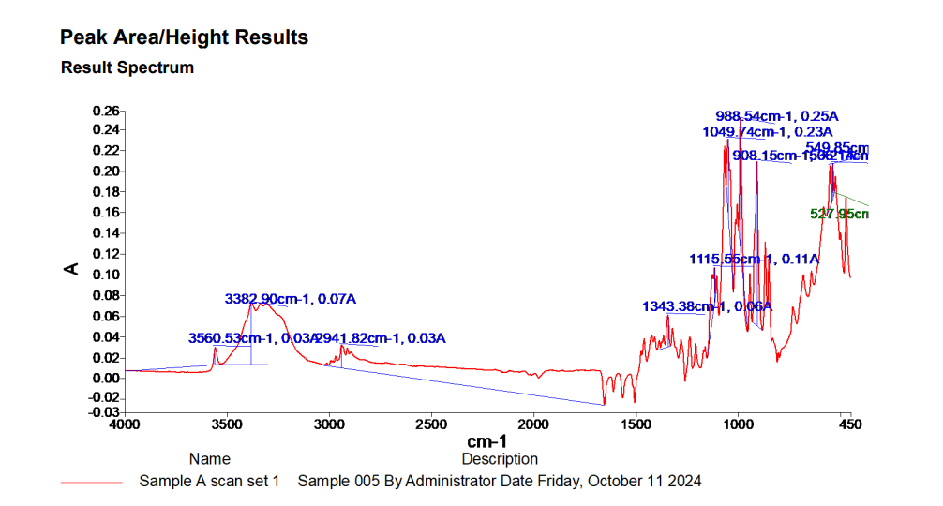
Sample A was the first sample which was tested by the FTIR Spectroscopy machine. The following results were obtained from the three scans that were conducted on it:

(Figure 1- Sample A FTIR Results Graph)

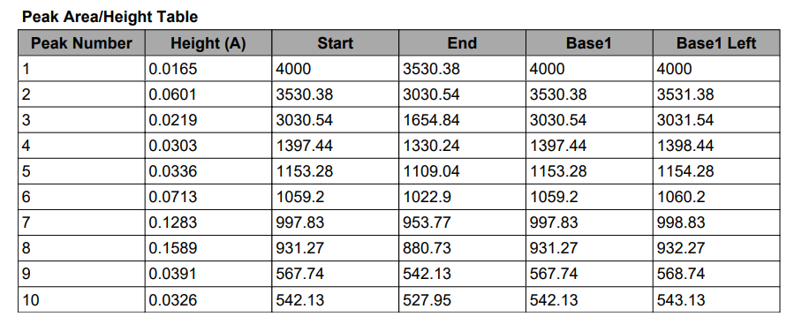

(Figure 2 – Sample A FTIR Results Table)
Before breaking down the data shown, lets first break down what the axis mean on the graph to give a better understanding of what is being shown. The X-axis (horizontal) is showing the wavelength in cm-1. In this cases it ranges from 4000cm-1 -450cm-1 which is common for FTIR. The higher wavenumbers on the left side refer to the higher energy vibrations. The Y-axis (vertical) shows the absorbance (A) on a logarithmic scale where the peaks point upwards just like this graph.
The key spikes that stand out from the ten, ten second scans are:
- 3560.53cm-1, 0.03A – Falls between a O-H stretch, free hydroxyl alcohols/phenols functional group (3640-3610) and a O-H stretch, H bonded alcohols/ phenols functional group (3500-3200).

- 3382.90cm-1, 0.07A – Falls under the functional group of N-H stretch (3400-3250). This is a Hydrogen bonded N-H stretching with a lower wavenumber in this functional group, typically a broader spike which in this case is.

- 2941.82cm-1, 0.03A – Falls inside the O-H stretch Carboxylic acids functional group.

- 1343.38cm-1, 0.06A
These results all fall under the fingerprint region (1500-650). This unique part in the sample is completely different to any other sample being tested just like a human fingerprint.

- 1115.55cm-1, 0.11A
- 1049.74cm-1, 0.23A
- 988.54cm-1, 0.25A
- 908.15cm-1, 0.21A

- 549.25cm-1, 0.20A
Both of these results fall under the C-Br stretch, alkyl halides functional group.
- 527.95cm-1, 0.17A

After conducting some research within spectra databases online on what ‘Sample A’ might be. After the first test of the sample was conducted it came back saying it was Saccharose (0.90) then after the second test it came back saying it was Sucrose (0.85) and finally after the third test it came back saying it was Saccharose (0.85). Ultimately ‘Sample A’ came back as some type of sugar.

Sample B

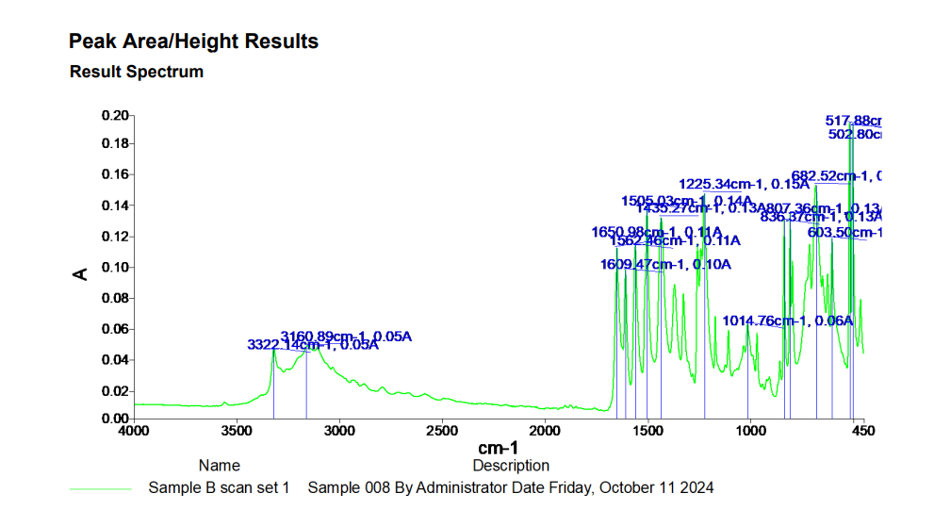
Sample B was the second sample which was tested by the FTIR Spectroscopy machine. The following results were obtained from the three scans that were conducted on it:

(Figure 3 – Sample B FTIR results graph)

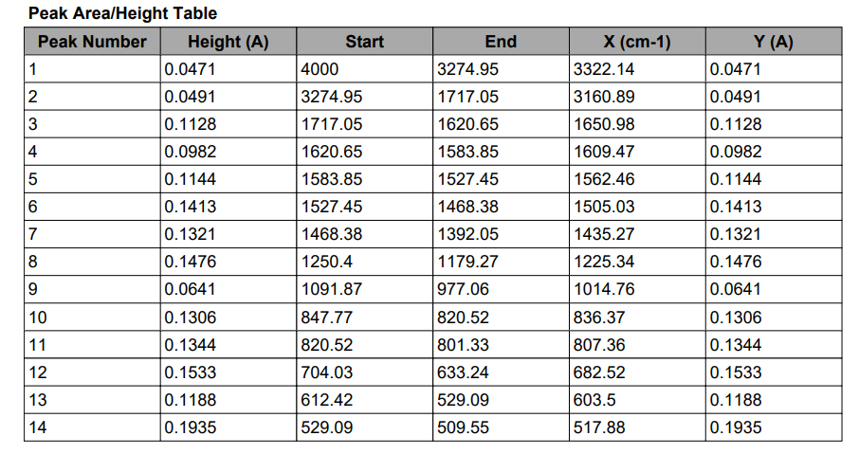

(Figure 4 – Sample B FTIR results table)

The key spikes that stand out from the ten, ten second scans are:
- 3322.14cm-1, 0.05A – Falls under the N-H Stretch Primary, Secondary amines, amides functional group.

- 3160.89cm-1, 0.05A – Falls under O-H Stretch Carboxylic Acids functional group.

- 1650.98cm-1, 0.11A – Falls under the N-H Bend Primary amines functional group.

- 1609.47cm-1, 0.10A - Falls under the N-H Bend Primary amines functional group.

- 1562.46cm-1, 0.11A – Falls under the C=C functional group

- 1505.03cm-1, 0.14A - Falls under the C=C functional group

- 1435.27cm-1, 0.13A
These results all fall under the fingerprint region (1500-650). This unique part in the sample is completely different to any other sample being tested just like a human fingerprint.

- 1225.34cm-1, 0.15A
- 1014.76cm-1, 0.06A
- 836.67cm-1, 0.13A

After conducting some research within spectra databases online on what ‘Sample B’ might be. After the first test of the sample was conducted it came back saying it was Paracetamol (0.96) then after the second test it came back saying it was Paracetamol Tablet (0.95) and finally after the third test it came back saying it was Paracetamol (0.94). Ultimately ‘Sample B’ came back as a crushed up Paracetamol.

Sample C

Sample B was the second sample which was tested by the FTIR Spectroscopy machine. The following results were obtained from the three scans that were conducted on it
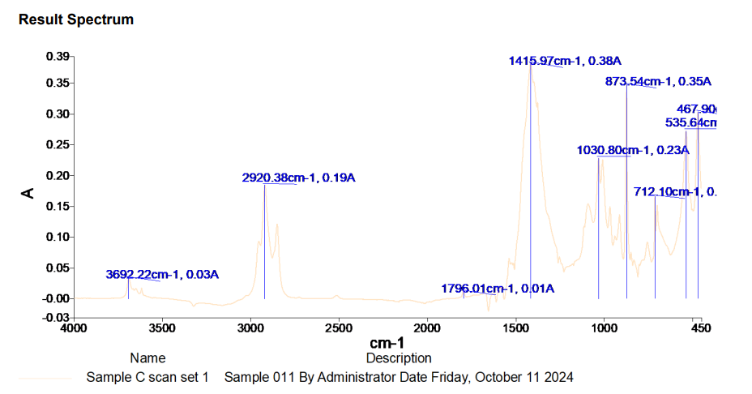
(Figure 5 – Sample C FTIR results graph)

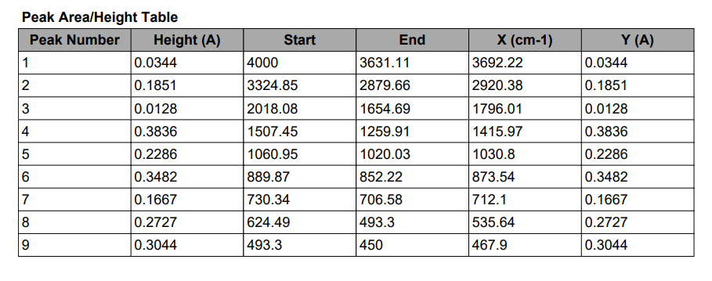

(Figure 6 – Sample C FTIR results table)

The key spikes that stand out from the ten, ten second scans are:
- 3692.22cm-1, 0.03A – Closest to the O-H functional group

- 2920.38cm-1, 0.19A – Falls under the C-H Stretch Alkanes functional group

- 1796.01cm-1, 0.01A – Falls under the =C-H functional group

- 1415.097cm-1, 0.38A
- 1030.80cm-1, 0.23A
These results all fall under the fingerprint region (1500-650). This unique part in the sample is completely different to any other sample being tested just like a human fingerprint.

- 873.54cm-1, 0.35A
- 712.10cm-1, 0.17A
- 535.64cm-1, 0.27A
- 467.90cm-1, 0.30A

After conducting some research within spectra databases online on what ‘Sample C’ might be. After the first test of the sample was conducted it came back saying it was Polyethylene Chlorosulfinated (0.78) then after the second test it came back saying it was BP17-1 IRS Adhesive (0.74) and finally after the third test it came back saying it was BP32-1 IRS Adhesive (0.72). Ultimately ‘Sample B’ came back as some kind of flexible epoxy adhesive.

Once the FTIR Spectroscopy had been conducted, Raman Spectroscopy was conducted as a confirmation strategy in order to confirm the results from the FTIR Analysis were correct.
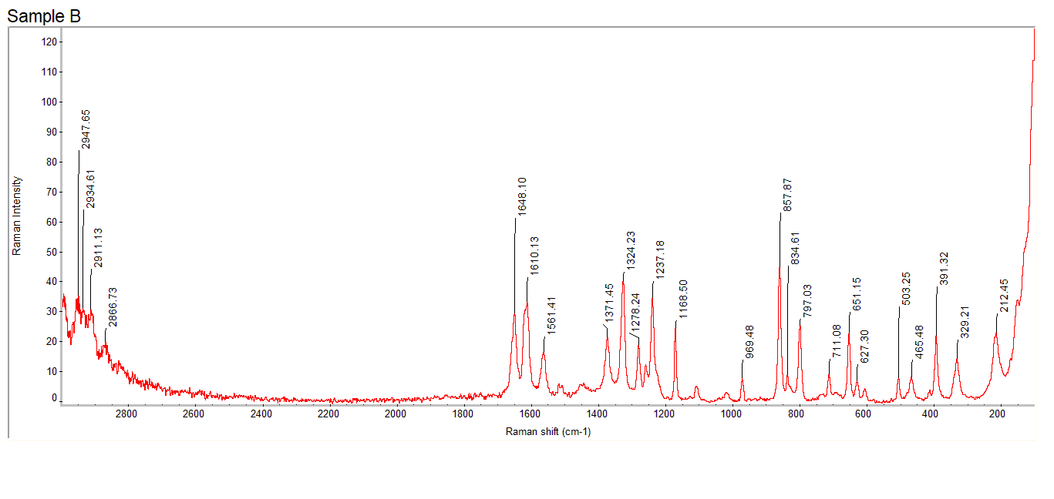
The graph below shows the Raman Spectroscopy results for Sample B.
(Figure 7 – Sample B Raman Spectroscopy Results)
Before breaking down the data shown, lets first break down what the axis mean on the graph to give a better understanding of what is being shown. The X-axis (horizontal) is showing the Raman Shifts that are measured in wavenumbers (cm-1). In this case it ranges from 3000cm-1 -200cm-1 which is common for Raman Spectroscopy. The higher wavenumbers on the left side are related to the chemical bond lengths of the molecules. The Y-axis (vertical) shows the Raman Intensity on a logarithmic scale where the peaks point upwards just like this graph. [6]

The Raman bands shown on (Figure 7) can vary in shift (position, width or height). The changes that occur can reveal stresses in the tested sample as well as the differences in crystallinity. The results from the Raman test conducted on Sample B shows various different shift in various different shapes and sizes. To use these results as a confirmation technique in order to confirm the FTIR analysis was accurate the functional groups need to be considered again just like FTIR Spectroscopy. As Sample B was identified as some sort of Paracetamol tablet from the scans that were conducted for FTIR analysis, research can be conducted using online libraries and databases in order to find the Raman Spectroscopy results graph for Paracetamol. Below shows a results graph for the analysis of a Paracetamol tablet under different storage conditions that was found on an online article.
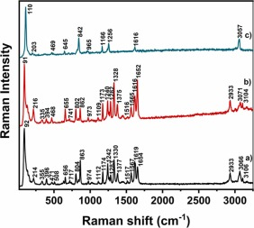

(Figure 8 – Online reference Image for Raman Spectroscopy conducted on a paracetamol tablet stored in different conditions) [7]
Although the Raman Shift scale runs in the opposite direction to the graph shown for Sample B the results obtained from the two tests are very similar. At the start of Sample B’s testing the results show spikes at the start of the analysis which are all similar in height and width. These results were also obtained from the tests carried out by the team at the University of Aveiro shown in (Figure 8). They show spikes with similar height and width. These spikes then die out in both Figures until they spike again with a few narrow tall spikes at around 1700cm-1. From this point up until the end of the test the Raman shift stays at a consistent rate until a very tall spike right at the end of the testing where the intensity increases drastically.

Results and Discussion

As shown from all of the results obtained. The three unknown samples were identified as all different. This can be visualised from the three graphs that were made showing the different functional groups. After conducting some online research for the functional groups it is easy to identify the accuracy of the results using databases. Also, after conducting Raman Spectroscopy as the confirmation technique on Sample B it is confirmed that the FTIR Results for Sample B were accurate. This is confirmed from the research conducted that compares the results from the Raman Test conducted on Sample B to the Raman tests that were conducted by chemist at the University of Aveiro on Paracetamol tablets stored in different temperatures.

Limitations of FTIR Spectroscopy:

- Limited Surface Sensitivity (Max thickness of 100nm)
- Unknown sample quantitation (to measure the quantity) requires standards to compare to
- Glass and water absorb infrared light which may interfere with the analysis.
- Cannot analyse metals that are capable of reflecting light. [8]

Limitations of Raman Spectroscopy:

- Cannot be used for metals or any type of metal alloy
- The Raman effect is very weak, which mean there is low sensitivity, ultimately making it complex to measure low concentrations of a substance.
- The analysis can be swamped by fluorescence from certain materials. [9]

Both Methods have limitations however, they are both great methods of spectroscopy if used in the correct manner and to obtain the results that are being tested for.

Conclusions

Both Spectroscopy tests that have been used in order to identify three unknown substances have worked well. From the FTIR Analysis the scans that were conducted on each sample came back accurate when compared to each other as well as online databases. The Raman Spectroscopy that was tested on Sample B helped to provide further sufficient evidence that supported the results from the FTIR testing. The online databases help drastically in proving that the results obtained were accurate.

References

[1] | D. A. o. Science, “Sample Preparation for FTIR Analysis: Sample Types and Prepare Methods,” 31 May 2024. [Online]. Available: https://www.drawellanalytical.com/sample-preparation-for-ftir-analysis-sample-types-and-prepare-methods/#:~:text=For%20solutions%2C%20the%20concentration%20should,ensure%20consistent%20and%20representative%20spectra.. [Accessed 19 February 2025].
[2] | BRUKER, “Guide to Infrared Spectroscopy,” [Online]. Available: https://www.bruker.com/en/products-and-solutions/infrared-and-raman/ft-ir-routine-spectrometer/what-is-ft-ir-spectroscopy.html. [Accessed 19 February 2025].
[3] | X. Liu, “LibreTexts Chemistry,” [Online]. Available: https://chem.libretexts.org/Bookshelves/Organic_Chemistry/Organic_Chemistry_I_(Liu)/06%3A_Structural_Identification_of_Organic_Compounds-_IR_and_NMR_Spectroscopy/6.03%3A_IR_Spectrum_and_Characteristic_Absorption_Bands. [Accessed 19 February 2025].
[4] | S. X. Xinwei Wang, “Raman Peak,” International Journal of Heat and Mass Transfer, pp. 10-12, 2020.
[5] | “Edinburgh Instruments,” 25 April 2023. [Online]. Available: https://www.edinst.com/resource/what-is-ftir-spectroscopy/. [Accessed 19 February 2025].
[6] | M. Unal, “ResearchGate,” 10 October 2014. [Online]. Available: https://www.researchgate.net/post/In_raman_spectra_We_observed_the_shifting_of_peaks_towards_lower_higher_wavenumbers_why#:~:text=In%20Raman%20spectra%2C%20shifting%20of,may%20cause%20to%20shift%20wavenumber.. [Accessed 19 February 2025].
[7] | H. I. N. T. T. Otílio Mulandeza, Raman imaging studies on the stability of Paracetamol tablets under different storage conditions, Aveiro: Department of Chemistry, 2022.
[8] | eurofins, “Fourier Transform Infrared Spectroscopy (FTIR),” [Online]. Available: https://www.eag.com/techniques/spectroscopy/fourier-transform-infrared-spectroscopy-ftir/. [Accessed 19 February 2025].
[9] | U. o. Cambridge, “Advantages and Disadvantages of Raman Spectroscopy,” [Online]. Available: https://www.doitpoms.ac.uk/tlplib/raman/advantages_disadvantages.php. [Accessed 19 February 2025].

