MARCUS TAYLOR (2011241)
University of Wales Trinity Saint David
MSc Policing (Operational and Strategic Leadership) – BMPO 7001
Operational Leadership in Modern Policing

Contents
1. Abstract 2
2. Introduction 2
3. Gibbs Reflective Cycle - Description 4
I. Lack of Command Structures. 5
II. Staffing Levels within the Organisation 6
III. Training and delivery 6
IV. A lack of multi-agency networking 6
V. Mobilisation Plan. 7
4. Gibbs Reflective Cycle - Feelings 8
5. Gibbs Reflective Cycle - Evaluation 9
6. Gibbs Reflective Cycle - Analysis 10
7. Gibbs Reflective Cycle – Conclusion 10
8. Gibbs Reflective Cycle – Action Plan 11
9. Conclusion 11

Abstract

Chemical, Biological, Radiation and Nuclear (CBRN) threats of terrorism are realistic and ever changing. The UK and its counter terrorism strategies must reflect this to ensure people can be safe and live with confidence around CBRN (Home Office, 2011).
This report will reflect on the CBRN capabilities and changes that I was involved with and managed in my role as the lead for CBRN accreditation and advisor for Dyfed Powys within Specialist Operations. It will examine and reflect on the planning and preparation of incidents including outcomes and is submitted as part of the MSc in Policing (Operational and Strategic Leadership).
Throughout I will explore my own leadership style and show clear links to academic and educational theory. I will reflect on how this has aided in my development by the use of self-reflection and experiential learning. I will reflect on my own actions and decision making throughout, sharing the complexities I encountered from managing this specialism, highlighting team-working, professional and personal relationships with colleagues and external partners and explore areas of improvement. I will explain challenges that I overcame and what learning outcomes were had. Exploring my own leadership style and linking how experiential learning has aided me and helped develop functions around future proofing as a result of evaluations, debriefing and experiences. This continues to assist me in my role to offer better service moving forward.

Introduction

When discussing leadership and ultimately what makes a good leader there are a number of academic arguments and thoughts around it. According to many scholars the question of whether leaders are born or made is a continuous area for debate. The Great Man Theory is one such argument that leaders, great men are sent from gods as gifts to uplift the populations they live among (Carlyle, 1841, Cited in Spector, 2016, pp.250,251). Seen as more of a statement of faith than that of legitimate research and theory and with a distinct lack of diversity in the statement itself, Day et al (2014) argues a more realistic approach claiming that leaders are developed over a period of time and effort to pick up those interpersonal and management skills. In essence leadership deals with people as a core function.
Within the current structures of policing in the UK, leadership has been a key area following the Winsor report (2011) and resulted in the college of policing (COP) improving working practices and management. One programme developed and brought in during 2014 was the Direct Entry Superintendent programme. An initial 5 year pilot set up to attract managers from outside sectors that had relevant leadership skills to enhance the policing service provided by joining at senior manager level (College Of Policing, 2020). Currently on pause till later this year due to a consultative process to evaluate how this concept has gone and we await these findings (College of Policing , 2021).
Leadership and command within my own area of business of Specialist Operations Is essential and is especially prevalent in terms of CBRN and Public Order events with both having their own leadership of gold/strategic, silver/tactical and bronze/operational hierarchical command structures for better management of incidents (College Of Policing, 2021). In the past both specialisms have relied on a strong leadership style of, do as I say and not as I do. Although this can work it is not seen as ideal today in academia. Harms, et al (2017) describes this type of leadership as autocratic and that the people who follow as authoritarian in nature. It is essential in this example to have autocratic leaders who are confident and know what they are doing for it to work as if not the buck falls with them. Having worked in specilaist tactics for a number of years I have seen lots of poor autocratic leaders with little knowledge or confidence and this causes incidents to be managed poorly and ultimately to fail as the public order officer under their command (authoritarian followers) do not question their orders. Freud (2011) suggests that a reason for a authoritarian follower mindset is due to a need for acceptance and urge to follow a father type figure, someone of strength. Im not quite sure this fits within a CBRN or Public order world but it is definitely the case that subordinates will follow leadership or rank without question within the police.
Having worked at the National CBRN centre for over 6 years I returned to Dyfed Powys in 2017 and was appointed as lead for specialist tactics, one of which CBRN. I quickly realised and found that working practices around how we as a service managed this area of business was poor and needed modernising. During this transition I set out to change, improve practices, structures and took ownership to better our performance strategically and tactically. To assist me in reflecting on this transition I will use Gibbs reflective cycle to show how reflection has assisted my development, working style and learning practices. Using this cycle (Gibbs, 1988, p. 49) to structure my report using the strands within it and will form the basis for my report including reflections, thoughts and discussions on how CBRN business and operations ran throughout. It will assist me to explore and analyse my own experiences, highlighting issues and complexities found and link practices to academic theory to better understand and reflect on my work. Outcomes and lessons learned will assist in my performance, enabling me to transform working and operating procedures and future proof as an organisation to be more efficient and effective in dealing with these complex situations.
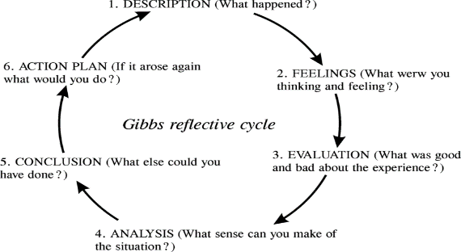(Gibbs, 1988, Cited by Sicora, 2010, p.161)

Gibbs Reflective Cycle - Description

Following my return to Dyfed Powys from secondment I took up the role as the supervisor in Specialist Operations. Primarily my role was to lead on delivery of specialist tactics in line with national accreditation, guidance and policies. To engage and train staff within the organisation and advise strategically and tactically on live incidents of Public Order and CBRN. During this report I will be concentrating on CBRN only and the strategic way Dyfed Powys is dealing with this complex demand on it as this is one area of change the service has gone through. On returning to force it quickly became apparent that the way we strategically and tactically ran CBRN was out of line with national standards and procedures. Newly in the role I took ownership of what I saw as a problem and started to change the working practices and philosophies around it. Claessens, et al (2010) explores issues around time management and prioritising tasks, their attributes and how they are completed. She states that setting the right goals and prioritising the importance of a specific task and making it attractive for people to buy into and engage with it as essential. For me in this case, the task of getting our CBRN structures in order to mitigate safety, fall in line nationally strategically. I had bought into this task as I felt its importance so it was now a matter of the me getting the team and the organisation on board.
I have always been someone who will volunteer first and ask questions later. I would jump in to situations and projects and later examine outcomes and results, usually without the full facts. I have completed Honey and Mumford’s learning styles questionnaire (1992) and this has consistently shown me as an activist in my learning style and this is something on reflection that I am conscious of and try to be more pragmatic and reflective in my professional capacity and this report has given me an opportunity to further enhance my development here. I have always considered myself a natural leader and not a manager as I saw these as different roles. Managers being very outcome led and leaders being more personal and inspirational concentrating on relationships, however Kent (2005) argues that in fact they are in practical situations both essential and necessary to be effective, both essential if someone is to succeed as a leader. He goes on to discuss that they can only really be seperated theoretically as you can then define easier with one more organisational and one more personal in its output.
My general leadership style is that of charisma, confidence and an individual who engages with people, trying to motivate them to improve and achieve goals. My style links closely to Transformational leadership in theory, as defined by Bass (1995) who stated that this form of leadership relied on the trust of followers, loyalty and respect towards a charismatic leader. Both follower and leader striving for the same goals and bettering themselves as a result. This form of leadership also links in closely with Maslow’s Hierachial needs (Maslow, 1943, cited in Mullins, 2013, pp.252-254) where individuals are developed and motivated to reach higher goals, wanting more depending on what they have and where they have come from. Moving up through stages as they complete them, bettering themselves in essence. These needs are arranged in an order of importance as the figure shows below, but this isnt always true as in fact peoples needs are very different. Maslow suggests as the needs are met and the higher they go the less they need and hence why the depiction is of a triangle with self actualisation being small as they need little more having reached the final goal.
(Mullins, 2013)

During these reflections I can see how my own actions on return to force worked through this hierarchy of needs as I returned back to a safe and secure job with good working conditions and a good structured supervisory group in place (Physiological, Safety and social) to me working through to esteem and self-actualisation as I strived to be creative and achieve advancement in CBRN for the organisation.
The Blake and Mouton Managerial Grid was interesting for me as it placed 5 leadership styles within certain boxes around axis, either concerned for production or people at its core. Naming the styles of leadership of each box within its coordinates as impoverished managers who exerts minimum effort to get things done. The country club manager who is thoughtful, friendly and attends the needs of the people. The autocratic authority figure who is efficient and is not concerned with interaction. The middle of the road manager who sits in the middle, on the fence type of character if you like, and finally participative or team manager who gets the work accomplished, people are fully committed and work well towards common goals together (Blake & Mouton, 1982). This was important for me to realise where I was as I probably sat in the Country Club manger as I am a people person but it showed me that although some traits there are good I needed to become more participative and look at achieving goals and tasks as a priority also.
I set out the main concerns, issues within my role and strategically looking at CBRN I wanted to utilise a more thorough leadership style to manage our capability. My initial investigation showed areas for concern around;
- Lack of command structures within this area of business and not enough accredited commanders.
- Lower levels of staffing at all levels within the organisation from general responders to specialist practitioners around search and scene investigation.
- Training and delivery was being affected by lack of certified trainers.
- A lack of multi-agency networking around partner agencies in line with Joint working principles.
- Better mobilisation plans.
Following these findings, my goal now was to ensure better and more productive working practices within the department moving forward as to ensure our overall performance was improved, and I explored the issues in more depth.

Lack of Command Structures.

It was imperative that I spoke with senior officers within the organisation to discuss the issues around our command as we only had 2 accredited commanders within the force, some of whom had never done anything with it and frankly forgotten how to manage CBRN over time. Adair (2004) states that to achieve a common task or goal the harmony within the team and the individual needs must all be in sinc and met to achieve any task, this is illustrated as below
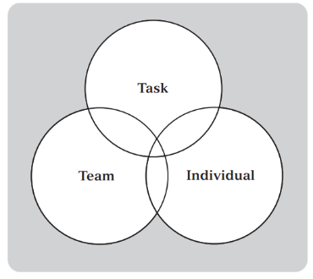 (Adair, 2004)

My task of improving command structures would mean discussing issues we faced with several commanders (Individuals) and my own management team (Team) to gain support in order to improve our cadre. I arranged meetings, explained very carefully to each commander the requirements of the role. I was motivated in my pitch and highlighted my vision and ultimate goal to improve the organisation and how they fitted into that. I utilised the hierarchy of needs theory to consider each member’s motivational priority throughout these by ensuring each stage was covered and achieved in order to convince them to get involved to reach their pinnacle (Maslow, 1943).

Staffing Levels within the Organisation
Staffing levels at the operational levels were poor and we were underrepresented as an organisation. I wanted to sit down with my own team to set out a plan moving forward to mitigate these issues. The team had fallen into a specific way of working and the 4 staff within it were a little unfocused, not driven and this may have had an impact on how we weren’t at the levels I wanted us to be resulting in our poor performance around CBRN. I set out to motivate my team to achieve our outcomes. Herzberg, et al (1959) suggests that to motivate staff there are two factors that need to be achieved, hygiene factors (dissatisfiers) and motivating factors. Similar to Maslows theory the basis of the work is that for motivation to take place things need to be in place and corret for the individual to be productive and excel. This is illustrated below
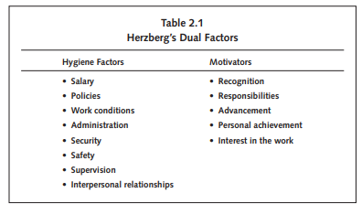(Herzberg, 1959, Cited in Wong, 2007, p.22)
On reflection and linking with the above it was clear that the current work conditions and supervision within the department had not been there prior to my arrival and this was causing job dissatisfaction and that the responsibility on them and oppourtunity to advance and achieve was also missing so there was limited areas to evolve, and levels of motivation were poor. I set out to change this, I held regular meetings with all staff to improve their moral, ensured that the working conditions and spaces were improved and then set out clear parameters and goals to improve our numbers and allocated each memebr of staff specific areas to manage, empowering them and giving some personal responsibility. This would assist in achieving our goals and recognition would follow.

Training and delivery

A lack of multi-agency networking
There was a clear link between CBRN delivery and multi-agency working and I had experienced this first hand having worked with partner agencies nationally, so I saw this as an opportunity to bring the two together to improve working practices in line with Joint Emergency Services Interoperability Principles (JESIP, 2016).
Getting the required levels of training done and staff through would require additional resources. I set out to develop my plan. Schilit (1987) describes when setting out a business plan key considerations are to keep it simple, organised, specific and highlight the benefits to the organisation and how this assists in future planning and finally to ensure the request is reasonable and not too ambitious. I asked for one further member of staff at this stage to achieve our goals. Abiding by these simple principles and steps I was successful in achieving a new member of the team and this enabled us to start delivering as a group to operational staff in line with national requirements.
As explained by Murphy et al (2020) Multi-agency working is key in achieving public service delivery and achieving organisational goals. In order for me to provide better results and outcomes for Dyfed Powys Police CBRN, I wanted to get my partner agency colleagues on board early. I arranged external meetings where I along with my team met with them and we engaged in dialogue around how we could work better, bringing a more realistic approach to training and a more professional operational deployments capability moving forward. This collaboration would benefit all parties. Tuckman (1965) explains his stages of team development mainly known as FORMING, STORMING, NORMING and PERFORMING as key to working within groups. During these meetings there was active discussion as each organisation had its own thoughts and ideas. As the chair it was my responsibility to bring all the necessary parties to the table, and facilitate a positive outcome as a result (Forming). I wanted everyone to gain confidence from these meetings and I ensured all had an equal part in discussions, so all personalities could engage and they discussed all ideas (Storming). I wanted us all as a team to agree on an outcome and I believe this helped motivate all involved and we left the meeting with clear direction for the future with all having better strategic awareness of each other’s practices as a result (Norming). I have continued to engage and share thoughts and visions with partner agencies throughout my time in Specialist Operations and we continue to work well together (performing).
By reflecting and evaluating current practices as a service and taking positive action to manage and mitigate issues within our leadership capabilities, under performance, improved learning and development, better morale and wellbeing of teams and staff and the inclusion of innovation around joint working principles we are now achieving better organisational leadership principles (College of Policing, 2017). On reflection throughout this work I can relate some of my leadership decisions to other theory models. Hill’s model of leadership shows that the leader has decisive decisions to make early as to whether to monitor or intervene in teams and in my case throughout this reflection I have chosen to step in and task staff with actions to be more goal orientated, giving a structure in order to achieve better standards, results and team effectiveness. I have looked at improving internal relationships, morale and external networking by meetings and sometimes simply listening to problems. I’ve also shared relevant information to better perform as a team and becoming more effective (Northouse, 2016). Hills model of team leadership illustrated below;
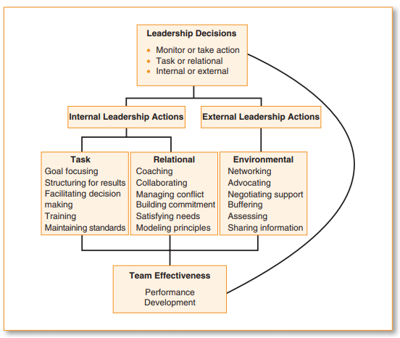(Northouse, 2016)

Mobilisation Plan.
Evaluating mobilisation and the risks around accountability and safety I wanted to ensure that our working practices were sound. Due to the significant risks around CBRN the Home Office released its strategy to combat and tackle this type of incident by Pursuing, Preventing, Protecting and Preparing for CBRN incidents, namely the CONTEST strategy (Home Office , 2009) with its basic aim of reducing the risk to the UK. Although at a more local level I was looking to improve our ‘PREPARE’ strategies by getting more operational officers trained to deal with incidents and also have the structures in place to respond and mobilise more efficiently. Decision making within the police service is key to any incident or investigation and the use of the National Decision Model (College of Policing, 2014) or Joint Decision Model in CBRN terms (JESIP, 2016) is imperative around risk and threat perception and use of information to utilise tactical options and contingencies. Although most officers are aware of its importance Hillsborough to name just one incident where the decision making was very poor and ineffective, directly contributed to a large loss of life during a football match (Turner, 2016). This is very relevant in CBRN and my decision making and leadership skills need to be sound as safety is paramount. I highlighted a lack of transport and no central storage locations for officer’s equipment should we need to deploy assets. Two major areas that needed attention. I needed to change practices so I managed up, meeting my superiors and also senior finance and estate managers. Slayter (2016) suggests there are ways in which to manage your relationship with supervisors and managers, these being to highlight the problem and have a solution to it beforehand, being calm and positive, look to remedy issues rather than blaming others. On reflection I proposed additional funding for a Specialist Operations vehicle and to utilise a central location for storage as a solution to mitigate concerns around mobilisation. I was positive throughout and set out the value to my managers and explained how this would negate unnecessary risks on them, as the example of Hillsborough clearly showed some years later. They agreed with my proposals.

Gibbs Reflective Cycle - Feelings

Throughout this entire process of change it has been quite time consuming and has taken a lot of effort from all involved. Before I took on this role and decided to look into CBRN I felt that the task was a daunting one. My team at the time were content in their own space and there were some negative attitudes around change and they thought current working practices were ok, something I saw differently. On reflection I have found myself to be quite frustrated at times where it appeared there was a lack of support from management or the team, or I just wasn’t getting the outcomes quick enough in my own work or others. I am conscious of how emotions can come to the surface and affect situations, stress and anger to name two and how these can contaminate a group and be quite contagious and have impacts on others attitudes. From my training background and especially within conflict management delivery I have used Betari Box model for a number of years now, an emotions based theory that has worked for me through my career and its helped to remind me to be very conscious that my attitude and behaviour does not negatively impact on others attitude and behaviours and as a result be counterproductive. On occasions where my emotions were getting the better of me I quickly realised and took myself away for a break to re-gather my thoughts as to not impact negatively on the team. Betari Box is illustrated below;
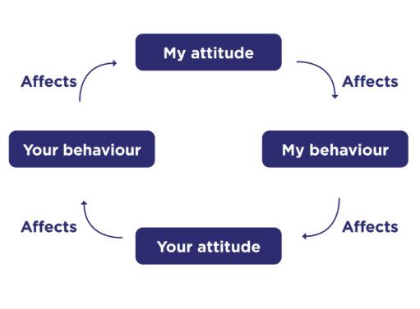 (College of Policing, 2020)

Although I am more of a transformational leader in my style I have during this reflection seen the value around having a more transactional style of leadership, a you do this for me and ill reward you with this attitude. There were occasions where I financially rewarded work, overtime and time off given as this was the only way to achieve certain goals due to time constraints or family issues of my team that took precedent. It is important to realise that although motivation and inspiration can get you so far, financial reward and gain on occasion must be factored in to keep the team happy and productive (Burns, 2010).
There were occasions where I felt that the atmosphere was bad as I could feel the pressure of the task maybe getting to one or two team members as they were a little anxious and it was my responsibility on these occasions to take steps to change this. I did so by remaining calm, warm and friendly. Within the service there are standards and I reiterated these to the group at times in a relaxed more informal way during breaks, coffee meetings and I found that although confident this approach worked best to ensure attitudes and work continued to move forward (Adair, 2004). On reflection and looking back now and although at the time I did have some anxious moments where I felt the pressure and also the pressure of the team I feel happy that we did in fact put in the necessary work to achieve the outcomes and goals we got as we are now much better equipped.

Gibbs Reflective Cycle – Evaluation

It is critical for me to reflect and evaluate performance now around CBRN as a result of changes and the hard work as this determines our effectiveness and efficiency. Organisational goals have been important to me and I have evaluated our performance in line with strategic goals around CBRN. I have lead on the increased numbers of commanders and operational staff throughout the organisation and this has given us the ability to be more professional. Given the changes around training and multi-agency working we now have better mobilisation in place to meet strategic goals as an organisation with all necessary accreditation in place. This was recently evident in a live CBRN deployment. We had correct command structures in place to manage effectively and safely. Operational staff mobilised in our new transport with all the relevant equipment being picked up centrally. Very pleasing to me was the multi-agency working throughout as both the FRS and Ambulance resources were on hand from the early meeting phases to deployment in line with JESIP and strategic objectives of all three organisations. A massive improvement to where we were and very pleasing for both me and the team to see these results in action as they all received the recognition they deserved from commanders on the day and subsequently since which helps as a motivator moving forward (Herzberg, et al., 1959).
I have been happy with my transformational leadership style through this transition of change but on reflection there has been times where a more robust authoritarian management style was needed, especially in early management meetings where I as the subject expert in the room if you like would have benefitted in making essential decisions as the sole leader. There was a distinct lack of knowledge from my managers and this slowed down some processes, making me frustrated as I could not utilise them in decision making and I felt like I just wanted to get on with it but my more democratic style was getting us nowhere as I was constantly explaining my rationale and subject matter to them. Maybe utilising the leadership behaviour continuum could have assisted me in being a little more robust, staying at the Tells (leader section) to make more decisions, rather than delegating, sharing ideas and being more to the right hand side, as below illustrates (Tannenbaum & Schmidt, 2009)
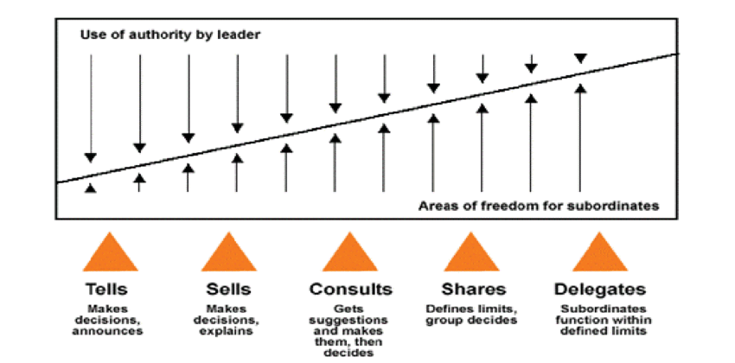 (Tannenbaum & Schmidt, 2009)

Gibbs Reflective Cycle – Analysis

I think when analysing this CBRN uplift one key bit of learning for myself on reflection is the number of good theory available to me from a leadership point of view that could assist me in my work, one of which being the Situational Theory of Leadership (Hersey & Blanchard, 1988). I have been involved in learning and delivery for a number of years and I have come to rely and use certain models only but this was one particular theory that would have assisted me in my task and help me manage members of my team better and more efficiently. It discusses different stages of knowledge and competence within the team and how committed they are to the task, enabling me as the leader to manage people differently to achieve best outcomes as all are not at the same level. My style of leadership could change dependant on this state of readiness of each team member. The goal to bring the best out of each member of the team to achieve best results around the task in hand and giving them the confidence to develop from coaching or mentoring by me. This would have assisted me as some staff had minimal exposure to CBRN and others had lots and I tended to treat all the same which is something on reflection to address as it directs me in the style of leadership needed for each individual. This has shown me to be more aware of team capabilities and competence levels. I will use this in future developments of me and my staff. The below illustrates the methodology;
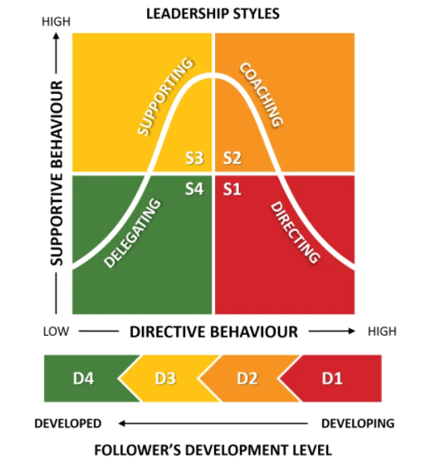 (Hersey & Blanchard, 1988)

Gibbs Reflective Cycle – Conclusion

To conclude my reflection, I have learned greatly from this situation, about myself as a manager and leader of a team and also the members within the team and how they work, feel and what type of personalities they have. It has brought us closer as a unit and we are working better, more productively due to better management, newer structures in place and the productivity of individuals has improved (Livi, et al., 2015). Police are used to change and some embrace it and some fear it and this was evident in the Windsor report (Winsor, 2011) but police officers are resilient. Hanson (2018) explores the possibility of resilience coming from a changing of the brain as it remodels constantly when learning from experiences and this strenthens it and your resolve. An interesting theory. In any organisational change or uplift there is going to be questions to answer as to why it is happening and I see myself as a leader within my role who must be capable of effective management of any change as my department constantly evolves as new ideas and technologies are incorporated and tested. I will need to adapt to cope with significant pressures to come in managing organisational need, the task and the team’s individual requirements. If anything this reflective report has shown me that I am doing a lot of things right within the organisation but I am keen to develop further and will continue to adapt according to circumstances and I will be a driver for change moving forward. Reflecting on my leadership style and management of the team during this time I am happy that it has been effective but I will look to engage in more theory around it, look to improve relationships and empower my staff where and when I can. Smith (2019) discusses the role of the change manager within the organisation moving forward and I can see that this is something that all staff will need to adapt to in order to be more efficient as the more authoritarian practices of the past seem to be fading out.

Gibbs Reflective Cycle – Action Plan

Throughout this process I have learned that forward planning and preparation is essential in the world of CBRN. Kennedy (2014) discusses various models of continued professional development (CPD) and I am incorporating some of these within my department and have already looked at using the Cascade Model discussed by sending my staff on specific training events to improve knowledge and application around CBRN. I am implementing the Training/Standards Model of CPD where all staff and managers will be assessed to national standards annually to ensure their skillset, levels do not drop and we continue to grow.
If the same organisational problems occur for me in the future within other specialisms I feel that my experiences here and leadership, team management and improvements made as an organisation as a whole will stand us in good stead and prepared.

Conclusion

During my introduction I spoke around my transition returning back to Dyfed Powys and how I started on my journey of changing CBRN. In utilising the Gibbs cycle (1988) I have been able to look at my leadership style, working practices and relate them to theory to improve standards within the organisation. It has enabled me to see what type of a person I am personally and professionally and enabled me to explore how I manager my staff and how I am viewed within my organisation.
I am grateful because on reflection during this project I have improved in my ability to focus on theory that can only benefit me moving forward although academic opinions are open for counter argument and debate. Leadership within the police service is ever changing and with direct entry and innovation at the forefront of our governing bodies the capacity to change is there. I will continue to adapt and develop members of my staff and seek development from my peers above as I strive to be better and offer value within my role.
I believe I have demonstrated in this reflection that I have a leadership style that has got results for the organisation, I am not saying that this is the only way to lead but I believe that in many management theories there is one constant and that is the ability to lead people and for them to follow you and I believe by being motivated, focused and inspiring you can achieve something valuable for any organisation.

References
Adair, J., 2004. Adair on Teambuilding and Motivation. London: Thorogood Publishing Ltd.
Bass, B. M., 1995. Theory Of Transformational Leadership Redux. Leadership Quarterly, 6(4), pp. 464-476.
Blake, R. R. & Mouton, j. S., 1982. A Comparitive Analysis of Situationalism and 9,9 Management by Principle. Organizational Dynamics, pp. 20-43.
Burns, J. M., 2010. Leadership. New York: Harper Collins Publishers Inc.
Claessens, B. J., Eerde, W. v., Rutte, C. G. & Roe, R. A., 2010. Things to Do Today...: A Daily Diary Study on Task Completion at Work. Applied Psychology: An International Review, 59(2), pp. 273-295.
College of Policing , 2021. Direct entry into the police. [Online]
Available at: https://www.college.police.uk/joining-police/direct-entry-police
[Accessed 23 June 2021].
College of Policing, 2014. National Decision Model. [Online]
Available at: https://www.app.college.police.uk/national-decision-model-index/#national-decision-model
[Accessed 24 June 2021].
College of Policing, 2017. Guiding Principles of Leadership, Coventry: College Of Policing.
College of Policing, 2020. Conflict mnagement Skills. [Online]
Available at: https://www.college.police.uk/guidance/conflict-management/conflict-management-skills
[Accessed 24 June 2021].
College Of Policing, 2020. Direct Entry Superintendent Programme, Coventry: College Of Policing Limited.
College of Policing, 2021. Chemical Biological Radiological and Nuclear Commander. [Online]
Available at: https://profdev.college.police.uk/?s=cbrn
[Accessed 22 June 2021].
College Of Policing, 2021. Operations Command Structures. [Online]
Available at: https://www.app.college.police.uk/app-content/operations/command-and-control/command-structures/?highlight=major%20incident
[Accessed 22 June 2021].
Day, D. et al., 2014. Advances in leader and leadership development: A review of25 years of research and theory. The Leadership Quarterly, Volume 25, pp. 63-82.
Freud, S. W., 2011. Civilization And Its Discontents. Oxford: Benediction Classics.
Gibbs, G., 1988. Learning by doing : a guide to teaching and learning methods. In: London: FEU, p. 49.
Hanson, R. & Hanson, F., 2018. Resilient. New York: Harmony Books.
Harms, P. D. et al., 2017. Autocratic Leaders and Authoritarian Followers Revisited: A Review and Agenda for the Future. The Leadership Quarterly, Volume 12, pp. 1-18.
Hersey, P. & Blanchard, k., 1988. Management of Organisational Behaviour: Utilizing Human resources. 7 ed. London: Pearson education.
Herzberg, F., Mausner, B. & Snyderman, B. B., 1959. The Motivation to Work. New York: John Wiley & sons.
Home Office , 2009. Pursue Prevent Protect Prepare The United Kingdoms Strategy for Countering International Terrorism, London: Home Office.
Home Office, 2011. CONTEST The United Kingdoms Strategy For Counter Terrorism, London: TSO.
Honey, P. & Mumford, A., 1992. The manual of learning styles. 3 ed. Maidenhead: Peter Honey Publications.
JESIP, 2016. Joint Doctrine : The Interoperability Framework , London: Home Office.
Kennedy, A., 2014. Models of Continuing Professional Development: A Framework for Analysis. Professional Development in Education, 40(3), pp. 336-351.
Kent, T. W., 2005. Leading and managing: it takes two to tango. Management Decision, 43(7\8), pp. 1010-1018.
Livi, S., Alessandri, G., Caprara, G. V. & Pierro, A., 2015. Positivity Within Teamwork: Cross-Level effects of Positivity on Performance. Personality and Individual Differences, Volume 85, pp. 230-235.
Maslow , A. H., 1954. Motivation and Personality. New York: Harper & Row .
Maslow, A., 1943. A theory of human motivation.. Psychological Review, 50(4), pp. 371-396.
Mullins, L. J., 2013. Management and Organisational Behaviour. 10 ed. Harlow: Pearson Education Limited.
Mullins, L. J., 2013. Work Motivation and Job Satisfaction. In: Management And Organisational Behaviour. London: Pearson Education Limited, pp. 252-254.
Murphy, P., Wankhade, P. & Lakoma, K., 2020. The strategic and operational landscape of emergency services in the UK. International Journal of Emergency Services, 9(1), pp. 69-85.
Northouse, P. G., 2016. Leadership Theory and Practice. 7 ed. London: sage.
Schilit, K. W., 1987. How to write a Winning Business Plan. Business Horizons, pp. 13-22.
Sicora, A., 2010. Self-evaluation of Social Work Practicethrough Reflection on ProfessionalMistakes. Practice Makes Perfect. Revista de Asistenta Sociala, Volume 9, pp. 153-164.
Slayter, M. E., 2016. 7 tips for managing up. Administrative Professional Today , Volume 8, pp. 1-2.
Smith, R., 2019. The ‘Police Change Manager’: Exploring a new leadership paradigm for policing. International Journal of Police Science and Management, pp. 1-12.
Spector, B. A., 2016. Carlyle, Freud, and the Greta man Theory more fully considered. Leadership, 12(2), pp. 250-260.
Tannenbaum , R. & Schmidt, W. H., 2009. How to Choose a Leadership Pattern. Boston: Harvard Business Review.
Tuckman, B. W., 1965. Developmental Sequence in Small Groups. Psychological Bulletin, 63(6), pp. 384-399.
Turner, R., 2016. Hillsborough disaster: Five key mistakes. [Online]
Available at: https://www.bbc.co.uk/news/uk-england-merseyside-35462767
[Accessed 24 June 2021].
Winsor, T., 2011. Independent Review of Police Officer and Staff Remuneration and Conditions, London: Home Office.
Wong, Z., 2007. Human factors in project managemenet. San franciso: Jossey-Bass.

