Entrepreneurship

Assessment 2

LCBB5001

Lecturer: Nishi Ramsurrun
Student: Sandrina Rangelova
Student ID: 1917133

Table of Contents
Introduction 3
Business Description / Market Opportunity 4
Industry Analysis 5
Operations 8
Management Team 9
Marketing: 10
Financials 11
Conclusion 13
Reference 14

Introduction

Entrepreneurship is the study of taking risks to create a new product or service to meet the market gap. It is directly or indirectly linked to facing uncertainty in multiple areas such as uncertainty in market structure, customer needs and behaviours, and changes in laws. This research has been done on entrepreneurship covering various areas. With multiple sections, the objectives of this report are going to be covered. The first section describes the business and its market opportunity where the mission statements, product description and general information of the selected company have been articulated. The second section has clarified the industry analysis of the selected firm based on Porter’s Five Forces Analysis. The third section has focused on the analysis of major operations including the supply chain process and roles of the management team. The next section has analysed the 4Ps of marketing of the selected company and the financials in the last section.

Business Description / Market Opportunity

About the Company: AI Systems Inc. is a leading company delivering AI-trading software to individual and institutional-level customers. As a AI trading software company AI Systems Inc. offers facilities to investors and help them maximise return on investments (Anansakunwat, 2021). The company is trying to sell its AI Trading software or platform supported by a range of features and benefits such as predictive analytics, database learning, data science, neuroscience and algorithms for real-time decision-making.

Mission Statement: The mission of AI Systems Inc. is ‘to maximise the return on investment of investors ad businesses in terms of providing them information about today’s economy. To accomplish the mission, AI-Trader offers data-driven observations and helps customers to enjoy the best stock trading experiences through the use of AI tools and machine learning.

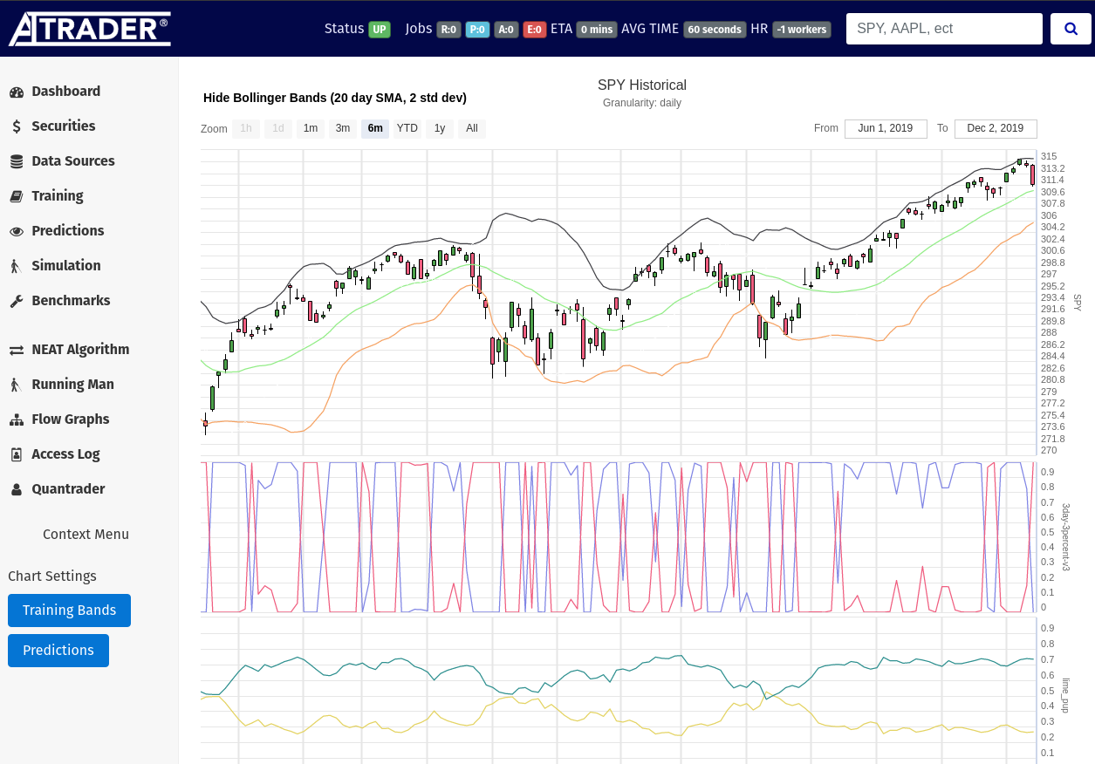
Figure 1: AI-Trader Software for Stock Trading
Source: (Anansakunwat, 2021)

Product Description: AI Systems Inc. wants to sell AI-Trader as one of the best stock trading software because of its unique features for example deep learning AI products, high-resolution simulations, proprietary techniques as well as fully autonomous facilities (Corgnet, 2016). In the current business world, more than $60 billion has been spent on developing AI trading software. With the passage of time and changes in stock trading attitudes, customers demand advanced stock trading options. To meet the market gap, AI Systems Inc has aimed to sell this product.

Segmentation, Target & Positioning (STP) Analysis: AI Systems Inc. has carried out an effective STP analysis to segment its customers as risk level, trading experiences and financial goals. It has targeted both institutions and individuals as potential customers having a strong aspiration to make a return from stock investment and capital market. AI Systems Inc has positioned itself based on performance and effectiveness (Woldemariam, 2022). Considering effectiveness, AI Trader is one of the best reliable stock trading platforms offering an 80% success rate, reducing the gap or difference between the expected and actual rate of return on investment (Bowman and McCormick, 2018).

Legal Status of Business: AI Systems Inc, according to the legal structure of the business, falls into a private partnership company. The logic behind this structure is the sharing of profits and losses among the partners along with collection of initial funds from them (Grelecki and Willey, 2017). Major benefits linked to this structure can be summarised as a quick collection of required funds from the partners, sharing of roles, risks and responsibilities among the partners, sharing skills, expertise and business knowledge in dynamic situations, and effective sharing and management of roles and responsibilities of a partner (Grelecki and Willey, 2017). The limitations discouraging entrepreneurs such as AI Systems Inc. to use this structure are the unlimited liability of the owner, huge mutual conflicts between owners or partners, and huge complexities and dilemmas in decision-making.

Industry Analysis

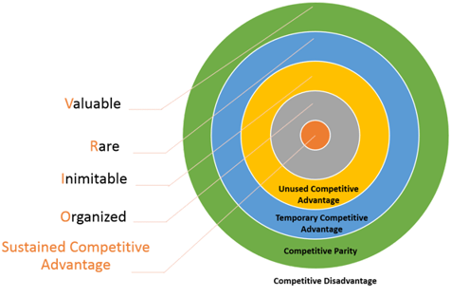
Figure 2: VIRO Analysis of AI-Trader
Source: (Goggin, 2019)

The threat of new entrants for Ai Systems Inc. for its AI-Trader Platform is moderate. Many new entrepreneurs are entering the current market with specialised knowledge in AI-Trading software. Considering the impact of new entrants, AI Systems Inc has focused on VIRO Analysis to ensure sustained competitive advantage. To create and deliver superior value, the company offer data-driven insights, predictive analytics, human and machine interaction, smart stock classification facility (Goggin, 2019). AI Systems Inc. take care of a range of features and facilities in its software solution such as brokerage plus, odds maker window, news and alert, simulated trading, hybrid pricing strategies, highly transparent trade details and trading platform building sustained competitive advantage and making it different from others. The company considering imitability has also intensified its inimitable resources such as AI-Trader Dashboard or Platform development, strong customer base, innovation and creativity skills, predictive analytics and machine learning tools (Goggin, 2019).

 | 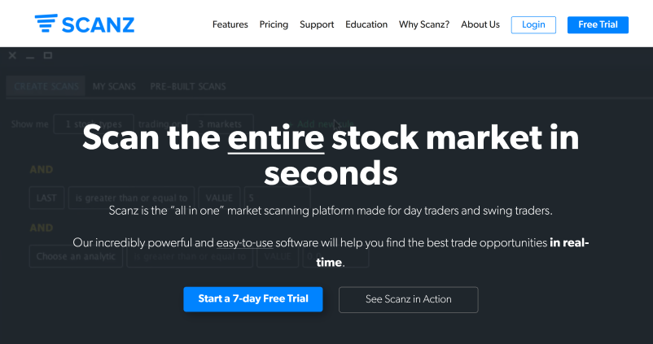 | 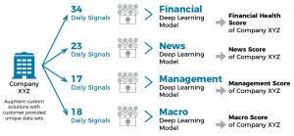
 | 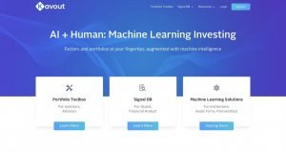 | 

Table 1: Competitors of AI-Trader (Anansakunwat, 2021)

The threat of substitutes for AI-Trader in the current market is so high because a range of alternatives is noticed in the markets such as Trade Ideas, Stock Hero, Scanz, Equbot as well as Imperative Execution. In comparison with AI-Trader, substitutes are in a much better position in terms of pricing options, quality of services, features etc. (Asad, 2021). For this, AI-Trader needs to be more competitive by AI Systems Inc. It will change its current pricing strategies and should choose hybrid pricing strategies and add diverse features such as intelligence cross, automated order management, continuous order matching, developing the intuitive interface, connect with brokers account, adding machine learning process, including human interactions, linking with market analysis and decision-making tools (Corgnet, 2016).
The bargaining Power of Buyers states that the current market has a gap in trading software and related services. The AI-Trading till 2021 was valued at 8.9 billion Usd. Scholars predicted rapid growth of demand linked to increasing demand by 18.4 billion USD within 2031. Customers have a higher demand for AI trader services associated with 7.8% in the current market after 2022 (Markets, 2021). This higher demand leads the bargaining power of customers to be so high because they can accept services from many competitors with a range of benefits, and features.

Power of Suppliers: AI Systems Inc. for its Ai-Trader faces moderate pressure from its suppliers including Japan, China, the US, Germany, and India. Japan is the best supplier providing the highest quality software digital tools and software resources. When accessing resources from suppliers, AI Systems experience various restrictions on export, and foreign exchange rates (Asad, 2021). The trade barriers imposed by Japan and other pliers include the raise of taxes and tariffs on goods and frequent changes in the exchange rate.

Power of Competitors: Based on the analysis, the threat from existing competitors in the current market is so high. AI Systems Inc needs to differentiate its products to compete with them including Tickeron, Trend Spider, and Trade Ideas (Jansen, 2020).

Competitor | Description | Differentiation
Tickeron | This is one the best trading software having a unique approach and features to attract customers and raise return on stock investment such as AI Real-Time Patterns, AI Pattern Serch Engine, AI Trend Prediction Engine, AI Portfolio Wizard, Scanner Search and pay-as-you-go pricing strategy (Jansen, 2020). | AI-Trader can differentiate its product in terms of removing complications in the use of software by all level of users, developing system to provide more accurate rate of return expected by the customers or investors (Anansakunwat, 2021). It also can offer built-in assest insights features, complete basketing system with free trails for users as well as add various beneficial tools for investors (Jansen, 2020).
TrendSpider | Core features offered by TrendSpider include a strategy tester, asset insights, stock scanner, chart tools, automatic trending detection, support and resistance detention, breakout detection and candlestick pattern recognition along with a three-tier pricing plan namely premier ($33 per month), elite ($65 per month), and master ($97 per month) (Horton, Cunningham and Charalambous, 2020). | AI-Trader can differentiate its service in terms of adding stock scanner, chart tools and different types of detection such as support and ressitance, breakout detection, candlestick pattern recognition, and automatic trendline dtection and adding more than one pricing startegies (Anansakunwat, 2021).
Trade Ideas | This is one of the best trading tools in the stock market having a range of basic and advanced opportunities such as brokerage plus, odds maker window, stimulated trading, chat windows and news & alert (Anansakunwat, 2021). The company uses a standard pricing plan. | A range of ways through which AI-Trader can differentiate its services include offering excellent free training and educational courses on the fortware, adding features such as automated trading to brokerage accounts, all-in-one technical stock research tool, highly transparent analysis platform (Horton, Cunningham and Charalambous, 2020).

Operations

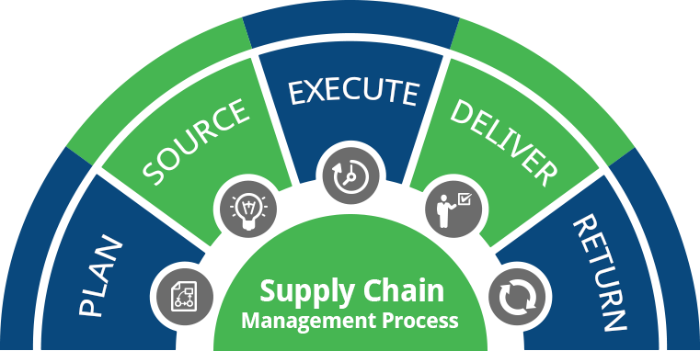
Figure 3: Supply Chain Process of AI-Trader
Source: (Carmignani, 2019)

AI Systems Inc smartly manages its operations with effective management of its supply chain process. As per the process, first, plans about the demands, needs and expectations of the customers as market forces, availability of customers, raw materials, manufacturing capacity as well as human limitations (Carmignani, 2019). Secondly, the company searches for potential trusted suppliers. For example, it sources raw materials, technological tools, machines, and equipment from Japanese suppliers. When sourcing the manufacturing requirements, AI Systems Inc needs to think about the current market price and cost against the price or revenue. Thirdly, the company produces trading software namely AI-Trader in terms of incorporating a range of robots, digital tools, and equipment (Carmignani, 2019). In this area, AI-Trader effectively assembles, tests, aspects, and packages the product as a major source of promotion and enhancement of brand reputation.

Ways of Generating Revenues and managing loss
AI-Trader would generate revenue for the business namely AI Systems Inc. using upgrading, upselling, and promotional mixes. As per upgrading, it can upgrade its pricing strategies such as incorporating a standard price plan and a premium plan. It accepts technologies from trusted suppliers such as Japan to add unique features supporting millions of trading scenarios. For all levels of customers, it can add more promotional offers such as free trials for the first month, adding advanced AI robots in multiple areas such as gap trading, swing trading, day trader etc. (Hensley, 2021). It can update its product in terms of linking new pricing strategies such as pay-as-you-go, and bundle pricing including low, medium, elite, or premium pricing options.

AI Systems Inc. can prevent loss of revenue using appropriate product management tools such as lean management, total quality management (TQM), and stock ad cost review. TQM would help AI-Trader prevent loss in terms of strengthening a competitive position via management of rare and value-based resources, enhancing productivity levels, removal of defects or errors in trading software and reduction of cost and resources (Gundogan, 2019). The TQM method plays a crucial role to reduce loss by building long-term commitment with trusted buyers and suppliers, ensuring continuous improvement, and fastening communication and professional networking.

Management Team

Name | Skills | What They Bring
Strategic Level CEO - Director – GM | Leadership, focus on the future, communication skills, focus to change, numeracy, problem-solving, leadership skills (Gundogan, 2019) | They tend to develop new missions and visions, ensure sustainable performance, build company culture, set tactical and operational goals
Tactical – Finance Manager, HR manager, Marketing, and advertising | Business intelligence, finance and accounting skills, marketing skills, project management, customer experience management and Hr and talent management | They help AI Systems Inc source funds at a lower cost from trusted sources, manage the project in terms of risk and return analysis, manage the financial growth
Operations – General Staff, operational team members | Delegation skills, flexibility and business finance skills, product development skills, decision-making skills, risk management as well as cost reduction capacity (Grelecki and Willey, 2017) | They help in finding potential markets and dealing with customers, increase the number of customers and target markets, add new features or services, promote decision-making culture and collaboration (Barnewall and Webster, 2021)

Marketing:

Product: AI Systems Inc. has designed its AI-Trader product adding a range of features, standard quality, and benefits. It supports stock trading operations with a range of software tools including data science, deep learning, genetic algorithms, neuroscience, and neural networks. The features that make AI-Trader unique from other companies are smart data classification, object detection service, computer vision, advanced machine learning, predictive modelling and forecasting, deep learning, and autonomous AI agents (Bowman and McCormick, 2018).
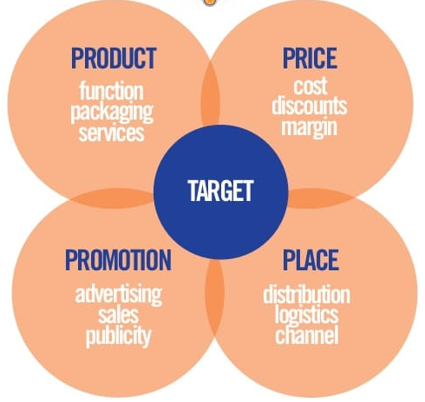

Figure 4: 4Ps of Marketing Mix of AI-Trader
Source: (Barnewall and Webster, 2021)

Price: AI Systems Inc. has aimed to sell its products at $84, the lowest possible price in the current market. Besides, the company has decided to use a pay-as-you-go pricing strategy along with bundle offers. the price that AI-Trader aims to charge is for one month and it also offers yearly and half-yearly or quarterly subscriptions because of delivering a range of unique services and features including automatic scanning and generating trading signals, giving one-click trading facility, supporting basket trading, allowing trading anytime from any market along with lifetime license and updates (Perreault and E Jerome Mccarthy, 2019).

Promotional Mix: A range of promotional strategies is avaliable for AI Systems Inc for its AI-Trader software such as strategic price discounts, off-shelf product branding, retailer sales content as well as on-site events. As per strategic price discounts, AI Systems Inc. can reduce the price such as 20% off of its AI-Trader and add coupon facilities for purchasing within specific deadlines such as a 40% discount for the buyers who will buy AI Trader within the 31st of January 2023 (Manning, 2021). AI Systems Inc. can also strengthen its promotion of AI Trader by adding a bonus pack with the slogan ‘buy one get one free’ such as buying one month’s service and getting one month’s service free.
Besides, AI Systems Inc. can promote its AI Trader using banners, signs, floor stickers, posters, displays, athletes and celebrities. As per on-site events, the company can use demonstrations and provide samples to specific customers for a certain period with a limited version of services (Manning, 2021). To communicate with customers, AI Systems Inc has decided to use digital media such as email, and social networking tools such as Facebook, LinkedIn, and WhatsApp. The company can also use video and audio-conferencing tools supporting a high level of collaboration (Barnewall and Webster, 2021). These media have been suggested for AI Systems because, by these means, the company can easily reduce expense, minimise resource consumption, and manage the quick sharing of data and information for effective decision-making.

Place (Distribution strategy): AI Systems Inc. can place its trading software by uploading the software and downloading links on its official website (Bowman and McCormick, 2018).

Financials

AI Systems Inc. for its AI-Trader development, sales and distribution can get funds for development from a range of potential sources including angel investors, NHS Trust, personal savings, crowdfunding, and love money.
Angel Investors are called private individuals having strong financial positions providing adequate funds for entrepreneurs or small startups in exchange for equity or ownership of the company. AI-Trader can collect funds from 24 Haymarket, Angel Academy, Angel Investment Network, FSE Angel Group and so forth (DeGennaro, 2018).
Crowd Funding is another potential source of funding for AI-Trader. The company can collect funds from Kickstarter, GoFundMe, Lending Club, Indiegogo along with other crowdfunding firms (Garaus, Izdebski and Lettl, 2020).
Love Money is a kind of funding raised by an entrepreneur from friends and family members. AI-Trader as a reputed stock trading software company can also be funded with love money. Besides, the company can access funds from the business savings generated from past business activities.

Projected Income Statement

Particulars | January | February | March | April | May | June
Cash Reciepts
Sales of AI-Trader Software | 150,000 | 160,500 | 171,735 | 183,756 | 196,619 | 210,383
Revenue | 150,000 | 160,500 | 171,735 | 183,756 | 196,619 | 210,383
Cash Disbursements
Variable Costs:
Communication Expense | 10,000 | 10,700 | 11,449 | 12,250 | 12,495 | 13,370
Salaries & Wages | 40,000 | 42,800 | 45,796 | 49,002 | 52,432 | 56,102
Engineering and other costs | 5,000 | 5,350 | 5,725 | 6,125 | 6,248 | 6,373
Marketing & Selling Cost | 10,000 | 10,700 | 11,449 | 12,250 | 13,108 | 14,026
Data Collection Cost | 15,000 | 15,300 | 15,606 | 15,918 | 16,236 | 16,561
Total Variable Expenses | 80,000 | 84,850 | 90,025 | 95,546 | 100,519 | 106,432
Fixed Costs
Hardware Installation Cost | 20,000 | 21,400 | 22,898 | 24,501 | 26,216 | 28,051
Utility Expense | 8,000 | 8,560 | 9,159 | 9,800 | 10,486 | 11,220
Rental Expense | 5,000 | 5,350 | 5,725 | 6,125 | 6,554 | 7,013
Cost of Capital | 2,000 | 2,140 | 2,290 | 2,450 | 2,622 | 2,805
Total Fixed Expenses | 35,000 | 37,450 | 40,072 | 42,877 | 45,878 | 49,089
Total Expenses (Variable + Fixed) | 115,000 | 122,300 | 130,096 | 138,422 | 146,397 | 155,521
Net Income | 35,000 | 38,200 | 41,639 | 45,334 | 50,222 | 54,862

Conclusion

Effective research has been linked to this report to source potential buyers of the product. Mostly secondary sources have been taken into consideration to target potential customers including institutions and individuals. The industry analysis also called competitive environment analysis shows a slightly positive performance towards AI-Trader. But most of the areas suggest AI-Trader be more competitive and differentiated from competitors. As per different operations management tools, the company expects the use of TQM to combine all areas of improvement such as company network, customer commitment, quality and price, functionality etc. The analysis of the marketing environment states Ai-Trade highly competitive in the current marketplace because of its unique features, benefits and uniqueness. The financial analysis articulates angel investors, family, and friends as the major source of funding for future improvement.

Reference

- Anansakunwat, P. (2021). 3 Best AI Stock Trading Software to Make High Returns in 2023. [online] Victory Tale. Available at: https://victorytale.com/best-ai-stock-trading-software/.
- Asad, M. (2021). Porter Five Forces vs Resource Based View - A Comparison. SSRN Electronic Journal, [online] 2(1). Available at: https://papers.ssrn.com/sol3/papers.cfm?abstract_id=1986725.
- Barnewall, G.G. and Webster, F.E. (2021). Marketing Communication: Modern Promotional Strategy. Journal of Marketing, 37(2), p.120. doi:10.2307/1250076.
- Bowman, B.F. and McCormick, F.E. (2018). Market Segmentation and Marketing Mixes. Journal of Marketing, 25(3), pp.25–29. doi:10.1177/002224296102500305.
- Carmignani, G. (2019). Supply chain and quality management. Business Process Management Journal, 15(3), pp.395–407. doi:10.1108/14637150910960639.
- Corgnet, B. (2016). What Makes a Good Trader? On the Role of Intuition and Reflection on Trader Performance. SSRN Electronic Journal. doi:10.2139/ssrn.2837755.
- DeGennaro, R.P. (2018). Angel Investors and their Investments. SSRN Electronic Journal. doi:10.2139/ssrn.1784489.
- Garaus, C., Izdebski, N. and Lettl, C. (2020). What Do Crowd Equity Investors Do? Exploring Postinvestment Activities in Equity Crowd Funding. IEEE Transactions on Engineering Management, pp.1–12. doi:10.1109/tem.2020.3041073.
- Goggin, M. (2019). Explaining The VRIO Framework. [online] ClearPoint Strategy. Available at: https://www.clearpointstrategy.com/vrio-framework/.
- Grelecki, R.C. and Willey, S.L. (2017). Applying Legal Concepts to Business in a Legal and Ethical Environment of Business Course: The Build-a-Business Project. Journal of Legal Studies Education, 34(1), pp.89–126. doi:10.1111/jlse.12058.
- Gundogan, M. (2019). Total quality management: A way towards total integration. Total Quality Management, 7(4), pp.379–384. doi:10.1080/09544129650034738.
- Hensley, R.L. (2021). A review of operations management studies using scale development techniques. Journal of Operations Management, 17(3), pp.343–358. doi:10.1016/s0272-6963(98)00051-5.
- Horton, A., Cunningham, A. and Charalambous, C. (2020). What Is the Impact of Ai and Social Media Analytics on Investor and Trader Behavior in the Stock Markets and Other Financial Contexts? SSRN Electronic Journal. doi:10.2139/ssrn.3709526.
- Jansen, S. (2020). Machine learning for algorithmic trading predictive models to extract signals from market and alternative data for systematic trading strategies with Python, second edition. Packt Publishing.
- Manning, P. (2021). Trade Promotions: The Ultimate Guide to Selling More in the Store. [online] www.repsly.com. Available at: https://www.repsly.com/blog/consumer-goods/trade-promotions-ultimate-guide-to-selling-more-in-store [Accessed 11 Jan. 2023].
- Perreault, W.D. and E Jerome Mccarthy (2019). Basic marketing : a global-managerial approach /
Basic marketing : a global-managerial approach. 机械工业出版社, Beijing: Ji Xie Gong Ye Chu Ban She.
- WebFX (2021). AI Pricing | How Much Does Artificial Intelligence Cost in 2020? [online] WebFX. Available at: https://www.webfx.com/martech/pricing/ai/.
- Woldemariam, S.H. (2022). Market Segmentation Strategy and Excellent Global Brand Positioning. SSRN Electronic Journal. doi:10.2139/ssrn.4248439

