Quality Tools and Root Cause Analysis

Introduction

For the task at hand, I have been given the responsibility to analyse process defect data for a Drill Base Unit design. Firstly, I broke the data down and filtered out the possible causes that may be affecting the defects. I went on to use an array of business improvement tools and techniques to uncover possible root causes to the problem, assess the risks and propose an action plan to improve the process.
The assumptions that I made were; Machine 1 was at fault for most of the defects. It is a sand-casting operation and the first machine used in the process, which is known for its inaccuracies and poor surface finishes. Knowing this, I assumed that this was a factor.
The other assumption that I made was; Worker B of Machine 1 was at fault for the most defects and compared with the other workers they were noticeably higher. This could be down to lack of training and because of this, I assumed that this was also a factor.

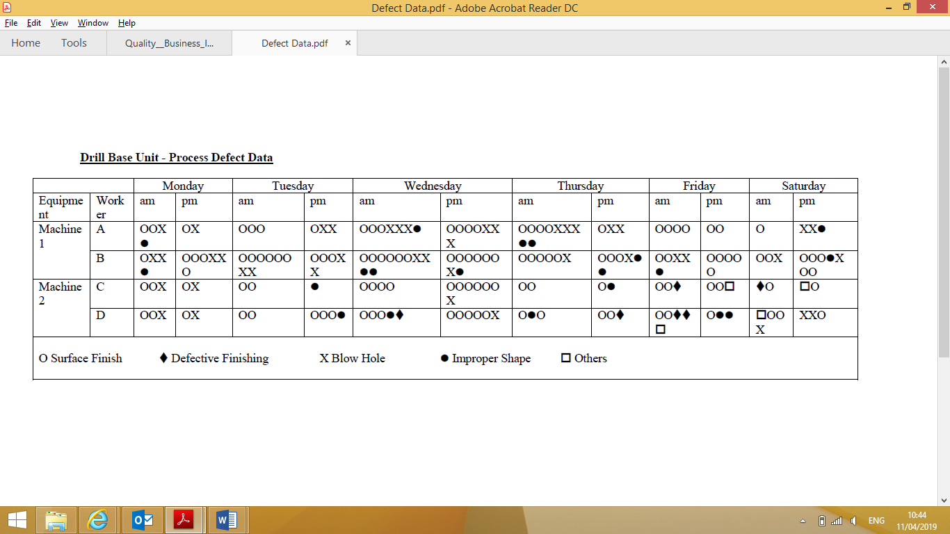
Total defects
Fig. 1 – Drill Base Unit – Process Defect Data
Given Fig. 1, I analysed the data given, filtered out the possible variables and gathered the following results:

Total number of defects: 197
Surface finish defects: 124
Defective finishing defects: 6
Blow Hole defects: 43
Improper Shape defects: 20
Other defects: 4

Total number of defects caused by Machine 1: 121
Total number of defects caused by Machine 2: 76

Total number of defects caused by Worker A: 48
Total number of defects caused by Worker B: 73
Total number of defects caused by Worker C: 33
Total number of defects caused by Worker D: 43

Surface finishing defects

Surface finish defects AM/PM: 65/59
Surface finish defects Mon/Tue/Wed/Thu/Fri/Sat: 14/20/37/20/10/13
Surface finish defects Mon AM/PM: 7/7
Surface finish defects Tue AM/PM: 13/7
Surface finish defects Wed AM/PM: 16/21
Surface finish defects Thu AM/PM: 13/7
Surface finish defects Fri AM/PM: 10/10
Surface finish defects Sat AM/PM: 6/7

Total number of Surface finish defects cause by Machine 1: 74
Total number of Surface finish defects cause by Machine 2: 50
Worker A and B: Machine 1
Worker C and D: Machine 2

Total number of Worker A Surface finish defects: 26
Worker A Surface finish defects AM/PM: 17/9
Worker A Surface finish defects Mon AM/PM: 2/1
Worker A Surface finish defects Tue AM/PM: 3/1
Worker A Surface finish defects Wed AM/PM: 3/4
Worker A Surface finish defects Thu AM/PM: 4/1
Worker A Surface finish defects Fri AM/PM: 4/2
Worker A Surface finish defects Sat AM/PM:1/0

Total number of Worker B Surface finish defects: 48
Worker B Surface finish defects AM/PM: 22/26
Worker B Surface finish defects Mon AM/PM: 1/4
Worker B Surface finish defects Tue AM/PM: 6/3
Worker B Surface finish defects Wed AM/PM: 6/6
Worker B Surface finish defects Thu AM/PM: 5/3
Worker B Surface finish defects Fri AM/PM: 2/5
Worker B Surface finish defects Sat AM/PM: 2/5

Total number of Worker C Surface finish defects: 24
Worker C Surface finish defects AM/PM: 13/11
Worker C Surface finish defects Mon AM/PM: 2/1
Worker C Surface finish defects Tue AM/PM: 2/0
Worker C Surface finish defects Wed AM/PM: 4/6
Worker C Surface finish defects Thu AM/PM: 2/1
Worker C Surface finish defects Fri AM/PM: 2/2
Worker C Surface finish defects Sat AM/PM:1/1

Total number of Worker D Surface finish defects: 26
Worker D Surface finish defects AM/PM: 13/13
Worker D Surface finish defects Mon AM/PM: 2/1
Worker D Surface finish defects Tue AM/PM: 2/3
Worker D Surface finish defects Wed AM/PM: 3/5
Worker D Surface finish defects Thu AM/PM: 2/2
Worker D Surface finish defects Fri AM/PM: 2/1
Worker D Surface finish defects Sat AM/PM: 2/1

Defective finishing defects

Defective finishing defects AM/PM: 5/1
Defective finishing defects Mon/Tue/Wed/Thu/Fri/Sat: 0/0/1/1/3/1
Defective finishing defects Mon AM/PM: 0/0
Defective finishing defects Tue AM/PM: 0/0
Defective finishing defects Wed AM/PM: 1/0
Defective finishing defects Thu AM/PM: 0/1
Defective finishing defects Fri AM/PM: 3/0
Defective finishing defects Sat AM/PM: 1/0

Total number of Defective finishing defects cause by Machine 1: 0
Total number of Defective finishing defects cause by Machine 2: 6
Worker A and B: Machine 1
Worker C and D: Machine 2

Total number of Worker A Defective finishing defects: 0
Total number of Worker B Defective finishing defects: 0

Total number of Worker C Defective finishing defects: 2
Worker C Defective finishing defects AM/PM: 2/0
Worker C Defective finishing defects Mon AM/PM: 0/0
Worker C Defective finishing defects Tue AM/PM: 0/0
Worker C Defective finishing defects Wed AM/PM: 0/0
Worker C Defective finishing defects Thu AM/PM: 0/0
Worker C Defective finishing defects Fri AM/PM: 1/0
Worker C Defective finishing defects Sat AM/PM: 1/0

Total number of Worker D Defective finishing defects: 4
Worker D Defective finishing defects AM/PM: 3/1
Worker D Defective finishing defects Mon AM/PM: 0/0
Worker D Defective finishing defects Tue AM/PM: 0/0
Worker D Defective finishing defects Wed AM/PM: 1/0
Worker D Defective finishing defects Thu AM/PM: 0/1
Worker D Defective finishing defects Fri AM/PM: 2/0
Worker D Defective finishing defects Sat AM/PM: 1/0

Blow hole defects

Blow hole defects AM/PM: 20/23
Blow hole defects Mon/Tue/Wed/Thu/Fri/Sat: 10/6/11/7/2/5
Blow hole defects Mon AM/PM: 7/7
Blow hole defects Tue AM/PM: 13/7
Blow hole defects Wed AM/PM: 16/21
Blow hole defects Thu AM/PM: 13/7
Blow hole defects Fri AM/PM: 10/10
Blow hole defects Sat AM/PM: 6/7

Total number of Blow hole defects cause by Machine 1: 34
Total number of Blow hole defects cause by Machine 2: 9
Worker A and B: Machine 1
Worker C and D: Machine 2

Total number of Worker A Blow hole defects: 17

Worker A Blow hole defects AM/PM: 7/9
Worker A Blow hole defects Mon AM/PM: 1/1
Worker A Blow hole defects Tue AM/PM: 0/2
Worker A Blow hole defects Wed AM/PM: 3/2
Worker A Blow hole defects Thu AM/PM: 3/2
Worker A Blow hole defects Fri AM/PM: 0/0
Worker A Blow hole defects Sat AM/PM:0/2

Total number of Worker B Blow hole defects: 17
Worker B Blow hole defects AM/PM: 10/7
Worker B Blow hole defects Mon AM/PM: 2/2
Worker B Blow hole defects Tue AM/PM: 2/2
Worker B Blow hole defects Wed AM/PM: 2/1
Worker B Blow hole defects Thu AM/PM: 1/1
Worker B Blow hole defects Fri AM/PM: 2/0
Worker B Blow hole defects Sat AM/PM: 1/1

Total number of Worker C Blow hole defects: 3
Worker C Blow hole defects AM/PM: 1/2
Worker C Blow hole defects Mon AM/PM: 2/1
Worker C Blow hole defects Tue AM/PM: 0/0
Worker C Blow hole defects Wed AM/PM: 0/1
Worker C Blow hole defects Thu AM/PM: 0/0
Worker C Blow hole defects Fri AM/PM: 0/0
Worker C Blow hole defects Sat AM/PM:0/0

Total number of Worker D Blow hole defects: 6
Worker D Blow hole defects AM/PM: 2/4
Worker D Blow hole defects Mon AM/PM: 1/1
Worker D Blow hole defects Tue AM/PM: 0/0
Worker D Blow hole defects Wed AM/PM: 0/1
Worker D Blow hole defects Thu AM/PM: 0/0
Worker D Blow hole defects Fri AM/PM: 0/0
Worker D Blow hole defects Sat AM/PM: 1/2

Improper shape

Improper shape defects AM/PM: 10/10
Improper shape defects Mon/Tue/Wed/Thu/Fri/Sat: 2/2/5/6/3/2
Improper shape defects Mon AM/PM: 2/0
Improper shape defects Tue AM/PM: 0/2
Improper shape defects Wed AM/PM: 4/1
Improper shape defects Thu AM/PM: 3/3
Improper shape defects Fri AM/PM: 2/1
Improper shape defects Sat AM/PM: 0/2

Total number of Improper shape defects cause by Machine 1: 13
Total number of Improper shape defects cause by Machine 2: 7
Worker A and B: Machine 1
Worker C and D: Machine 2

Total number of Worker A Improper shape defects: 5
Worker A Improper shape defects AM/PM: 4/1
Worker A Improper shape defects Mon AM/PM: 1/0
Worker A Improper shape defects Tue AM/PM: 0/0
Worker A Improper shape defects Wed AM/PM: 1/0
Worker A Improper shape defects Thu AM/PM: 2/0
Worker A Improper shape defects Fri AM/PM: 0/0
Worker A Improper shape defects Sat AM/PM:0/1

Total number of Worker B Improper shape defects: 8
Worker B Improper shape defects AM/PM: 4/4
Worker B Improper shape defects Mon AM/PM: 1/0
Worker B Improper shape defects Tue AM/PM: 0/0
Worker B Improper shape defects Wed AM/PM: 2/1
Worker B Improper shape defects Thu AM/PM: 0/2
Worker B Improper shape defects Fri AM/PM: 1/0
Worker B Improper shape defects Sat AM/PM: 0/1

Total number of Worker C Improper shape defects: 2
Worker C Improper shape defects AM/PM: 0/2
Worker C Improper shape defects Mon AM/PM: 0/0
Worker C Improper shape defects Tue AM/PM: 0/1
Worker C Improper shape defects Wed AM/PM: 0/0
Worker C Improper shape defects Thu AM/PM: 0/1
Worker C Improper shape defects Fri AM/PM: 0/0
Worker C Improper shape defects Sat AM/PM:0/0

Total number of Worker D Improper shape defects: 5
Worker D Improper shape defects AM/PM: 2/3
Worker D Improper shape defects Mon AM/PM: 0/0
Worker D Improper shape defects Tue AM/PM: 0/1
Worker D Improper shape defects Wed AM/PM: 1/0
Worker D Improper shape defects Thu AM/PM: 1/0
Worker D Improper shape defects Fri AM/PM: 0/2
Worker D Improper shape defects Sat AM/PM: 0/0

Other Defects

Other defects AM/PM: 5/1
Other defects Mon/Tue/Wed/Thu/Fri/Sat: 0/0/1/1/3/1
Other defects Mon AM/PM: 0/0
Other defects Tue AM/PM: 0/0
Other defects Wed AM/PM: 1/0
Other defects Thu AM/PM: 0/1
Other defects Fri AM/PM: 3/0
Other defects Sat AM/PM: 1/0

Total number of Other defects cause by Machine 1: 0
Total number of Other defects cause by Machine 2: 6
Worker A and B: Machine 1
Worker C and D: Machine 2

Total number of Worker C Other defects: 2
Worker C Other defects AM/PM: 0/2
Worker C Other defects Mon AM/PM: 0/0
Worker C Other defects Tue AM/PM: 0/1
Worker C Other defects Wed AM/PM: 0/0
Worker C Other defects Thu AM/PM: 0/1
Worker C Other defects Fri AM/PM: 0/0
Worker C Other defects Sat AM/PM:0/0

Total number of Worker D Other defects: 5
Worker D Other defects AM/PM: 2/3
Worker D Other defects Mon AM/PM: 0/0
Worker D Other defects Tue AM/PM: 0/1
Worker D Other defects Wed AM/PM: 1/0
Worker D Other defects Thu AM/PM: 1/0
Worker D Other defects Fri AM/PM: 0/2
Worker D Other defects Sat AM/PM: 0/0

Root Cause Analysis

Pareto Analysis

Fig. 2 – Pareto chart of Process Defect Data
Also known as the 80-20 rule, the Pareto chart above displays the type of defect along with many there are for each individual one. The Pareto principle states that, for many events, roughly 80% of the effects come from 20% of the causes. In this case, we will see that roughly 80% of the total number of defects, which is Surface Finishing come from 20% of the types of defect.

Bar and Pie Charts

Fig. 3 – Relationship between Machines and Defects
Fig. 3 above displays the difference between Machines A & B (1 & 2) and the number of defects cause by either one. It clearly shows that Machine 1 has caused many more defects than number 2. This could mean that there is a problem with Machine 1. Workers A & B work with Machine 1 and Workers C & D work with Machine 2.

Fig. 4 – Relationship between Workers and Defects
Fig. 4 above displays the correlation between Workers A,B,C and D and number of defects cause by each one. It clearly shows that Worker B compared to the others, has caused a considerable amount more defects than the others. This could be down to a training issue.

The 5 Whys

Why are there such a high number of defects?

 | Why | Answer
Why No.1 | Frequent defects occurring on the drill base unit | Number of factors including Machines and Workers
Why No.2 | Machine 1 causing more defects that Machine 2 | Machine 1 is a sand-casting process which creates more Surface finish defects than Machine 2 (Milling)
Why No.3 | Worker B(2) has contributed to a lot more defects than the other (Worker B operates Machine 1) | Worker B(2) could not have been trained proper or given insufficient training, leading to him creating more defects
Why No.4 | Worker B(2) has had insufficient training | Worker B(2) hasn’t been trained by a competent person
Why No.5 | Worker B(2) hasn’t been trained by a competent person | Worker B(2) needs the proper training in order to the decrease the amount of defects he’s making

Fig. 5 displays a 5 Whys table
From asking the question ‘Why?’ 5 times, as seen in Fig. 5. I discovered the root causes to the problem.

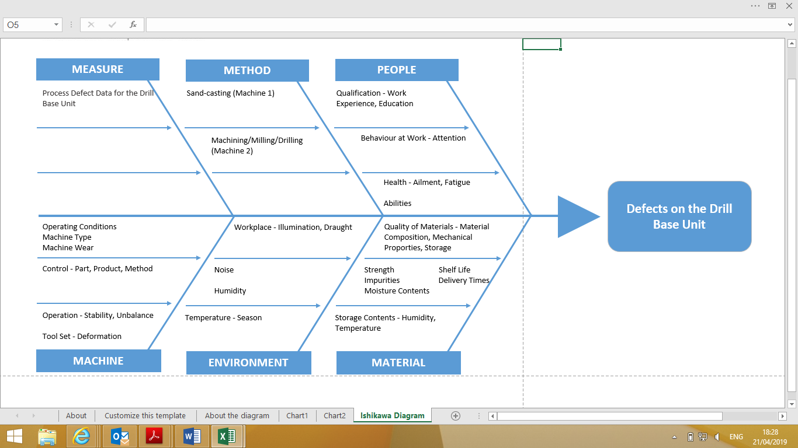
Ishikawa – Cause & Effect Analysis
Fig. 6 – Ishikawa Diagram – Cause & Effect
The Ishikawa diagram (Or Fishbone) as shown in Fig.6, breaks down the causes into 6 different categories, known as the 6M’s. I‘ve highlighted factors within each cause that I believe had a direct effect on the defects on the drill base unit.

Failure Mode and Effect Analysis (FMEA)

I decided to undertake a FMEA on sand-casting only, as it was the operation that caused most of the defects. Sand-casting is a process known for its inaccuracies

Potential Failure | Potential Failure Mode | Potential Effect(s) of Failure | Potential Cause(s) of Failure | Severity | Occurrence | Detection | RPN
Sand drop | Sand mould drops and cause similar shaped sand holes | Change in required shape and affect surface finish | Fast metal pouring | 7 | 9 | 8 | 504
Core shift | Displacement of core from its seat | Undesirable variation in wall thickness and final shape | Fast metal pouring | 8 | 9 | 8 | 576
Scab | A portion of face of a mould lifts or breaks and the recess thus made it filled by metal | Sand is washed away and cavity is filled with metal. Improper shape | High moisture content | 8 | 9 | 8 | 576
Knock out | Breakage of casting corners when stuck on vibrator mesh plate | Surface finish defect | Damaged mesh plate | 5 | 9 | 7 | 315
Mould break | Breakage of pattern print in the sand mould | Improper shape | Jerking of machine | 6 | 8 | 7 | 336
Crack | Very thin parting lines on casting surface | Affect the mechanical properties of casting | Due to shrinkage of casting | 8 | 8 | 8 | 512
Blow hole | Smooth round holes of casting surface | Improper shape | High moisture content | 3 | 7 | 7 | 147
Broken casting | Fractured sections of casting | Casting is separated into pieces | Operator fault | 2 | 7 | 7 | 98
Box leak | Molten metal leaks in between mould box | Failed to obtain a casting | Mould box damage | 3 | 7 | 7 | 147
Cold joint | Two metallic  streams are not fused together | Improper shape | Slow metal pouring | 7 | 7 | 8 | 392
Over shot | Excess removal of metal from the surface | Change in required dimension | Operator fault | 2 | 6 | 6 | 72

Action Plan
 | Defect | Cause | Improvement Action
1 | Scabbing | High moisture content | New silica sand is  added to reduce  moisture content in the  reused mould sand
2 | Core shift | High metal pouring rate | Maintain a sufficient pouring time
3 | Sand drop | High metal pouring rate | Maintain a sufficient pouring time
4 | Crack | Shrinkage | Provide sufficient molten metal into the mould
5 | Cold joint | Low pouring rate | Maintain a sufficient pouring time
6 | Mould break | Jerking of machine | Revised the preventive maintenance schedule
7 | Box leak | Damage to box clamp | Revised the preventive  maintenance schedule  and perform regular  condition monitoring  for mould box
8 | Blow hole | Gas entrapment in metal | Decrease moisture  content in sand and  increase air ventilation
9 | Knock out | Damage mesh sheet | Revised the preventive maintenance schedule and replacement schedule, and perform regular condition monitoring
10 | Broken casting | Operators fault | Give necessary instructions and training. Provide safety measures to operators
11 | Over shot | Operators fault | Give necessary instructions and training. Provide safety measures to operators

Conclusion

The identification of the root cause of the casting defect is important to initiate remedial measures to minimize/eliminate defects. This report adopts a systematic procedure to find the root cause of the defects that occurred in a Drill Base Unit. Pareto chart, Ishikawa diagram and FMEA were among the improvement tools used. It was found that the root causes were the sand-casting process (Machine 1) and lack of training (Worker B). The necessary remedial measures were taken, and castings were reproduced. The defects in the castings have been minimized/eliminated.

References

BLACK, J. TEMPLE. (2008). DeGarmo's materials and processes in manufacturing. Hoboken, NJ: Wiley,
GROOVER, M. P. (1996). Fundamentals of modern manufacturing: materials, processes, and systems. Upper Saddle River, N.J., Prentice Hall.

