Performance Management

STUDENT NAME: JUDITH KIDENYA
MODULE :PERFOMANCE MANAGEMENT
MODULE CODE :7013
STUDENT ID: 2242265
DATE: 16/11/2023

Table of Contents

List of figures 4
1. Introduction 5
2. Contingency approach model 5
2.1. Startup Stage 5
2.2. Growth Stage 6
2.3. Maturity Stage 7
2.4. Post Maturity Stage 7
2.5. Challenges in Implementing Contingency Approach 8
3. Organisation for each stage 9
3.1. Startup Stage: Airbnb 9
3.1.1. Introduction to Airbnb's Early Days 9
3.1.2. Performance Management during Inception 10
3.1.3. Critical Analysis of Initial Strategies and Adjustments 11
3.2. Growth Stage: Uber 11
3.2.1. Uber's Rapid Expansion Overview 11
3.2.2. Performance Management during Scaling 12
3.2.3. Critical Evaluation of Growth Strategies and their Implications 13
3.3. Maturity Stage: Apple 13
3.3.1. Apple's Market Dominance and Product Evolution 13
3.3.2. Performance Management in Maintaining Innovation 14
3.3.3. Critical Reflection on Apple's Sustained Success and Challenges 14
3.4. Post Maturity Stage: Nokia 15
3.4.1. Nokia's Reign and Subsequent Challenges 15
3.4.2. Performance Management during Reinvention Attempts 16
3.4.3. Critical Dissection of Nokia's Adaptive Strategies and Market Repositioning 16
4. Reflection on the post-maturity stage 17
4.1. Performance Management for Renewal 17
4.2. Steady State Performance Management 18
4.3. Managing Decline with Performance Metrics 19
4.4. Balancing Stakeholder Expectations in Post-Maturity 20
5. Improvement in practice 21
6. Conclusion and recommendation 22
References 24

List of figures

Figure 1: Stages of contingency approach model (McMullin, 2020) 8
Figure 2: Startup cost of Airbnb (Clemente, 2023) 10
Figure 3: Growth Stage of uber (Wells, Attoh, & Cullen, 2021) 12
Figure 4: Performance management (Al-Delawi, 2020) 19

Introduction

In today's ever-changing business environment, identifying and adapting to changes in a company's life cycle is crucial. Each stage of its life cycle, from inception to late maturity, has its own set of problems and possibilities, each of which calls for a different approach to ensure maximum development and longevity (Banerjee & Hofmann, 2022). Understanding the interplay between performance management, stakeholder expectations, and strategy alignment requires delving into these levels.
This report is presented in an orderly manner. It starts by explaining the differences between the many stages of a business's life cycle and delving into the causes and factors behind each stage's emergence. The following sections will go more into the function of performance management, stressing its importance at each location. Using examples from successful companies like Airbnb, Uber, Apple, and Nokia, the report highlights promising strategies and dangers to avoid. The last section offers concrete suggestions for firms hoping to endure and thrive by achieving a delicate balance between the demands of various stakeholders, particularly in the post-maturity stage.

Contingency approach model

Startup Stage
Enthusiasm, rapid ideation, and searching for a proven business strategy characterize the startup stage. When a company is trying to find its product-market fit and carve itself a niche, it faces a time of uncertainty. The top priorities are attracting early adopters, keeping costs down, and maintaining the model's longevity (Chen, 2022).
The use of the "contingency approach" at this point calls for quick thinking and adaptability. The most successful companies adapt to changing conditions rather than relying on a single, universal approach (Corominas et al., 2020). As a result of client feedback, businesses may need to make changes to their products, their marketing approaches, or even their whole company models. With a focus on what-if scenarios, entrepreneurs may be prepared for a wide range of potential obstacles. A Plan B or C may be implemented quickly if the primary approach to the market does not provide the desired results. Change is one constant in a startup's environment; therefore, they need a strategy to deal with the unexpected (Zhang, Luo, Zhang, & Zhao, 2019). Simply put, a contingency model provides a flexible but organised plan of action to help you get through the uncertainty of the initial period.
Managing performance is essential in the early stages of a business. It stresses the need for being flexible, listening to and acting on criticism quickly, and anticipating change. Team members are realigned with shifting business plans regularly to guarantee firm development and product-market fit in the fast-paced, unpredictable early business environment (Chen, 2022).

Growth Stage
In the growth stage of a company's life cycle, it increases its market share, generates more money, and expands its activities. In this phase, a company's client base grows, its product offerings broaden, and it expands into new markets. With the company's growing presence in the market comes a rise in rivalry, calling for action to defend and expand market share.
At this point, the approach to unforeseen events must change to account for the intricacies of scale. The emphasis moves from guaranteeing rapid expansion to ensuring that development can be maintained over the long term. Some examples of external variables that necessitate a change in strategy include a rise in competition, the possibility of market saturation, or new regulations. Procedures for quickly increasing (or decreasing) production in response to fluctuations in demand, managing bigger teams, and coping with logistical obstacles should be in place (Crane & Hartwell, 2019).
Performance management must change throughout the expansion phase to meet the difficulties of expansion. Team members adjust to new levels of production, management, and logistics. The key to overcoming difficult obstacles and making the most of new openings is to focus on development maintenance, market volatility planning, and implementing more specific contingency strategies.(ref)

Maturity Stage
The maturity stage is characterized by sustained profitability for the company. Businesses in this stage have weathered the storms of the startup and growth phases and now have a stable client base and honed operating procedures. Growth rates have peaked, and more attention is paid to preserving market share, perfecting processes, and increasing profitability.
The approach to contingencies is more sophisticated for well-established businesses. Planning for the unexpected now focuses on stability, guaranteeing operational efficiency, and protecting against rivals due to increased size and more predictable market behaviors. Market fluctuations, technological upheaval, and changes in customer habits are all factors that must be anticipated. It's essential to prepare for the possibility of a market slowdown or the introduction of a disruptive invention (Franco, 2019).
Performance management at the mature stage focuses on avoiding instability, improving operational efficiency, and anticipating disturbances. Team members work to improve procedures, respond to market and technology changes, and coordinate during times of crisis. Succession planning provides a smooth handoff of power, setting up the team for continued performance despite changes in the industry.ref

Post Maturity Stage
During this stage, it is crucial to thoroughly comprehend the company's present trajectory to adapt the contingency approach appropriately. Those anticipating a fall may consider merging with a more stable company, selling off non-essential assets, or focusing on their strengths to increase their value. Companies that want to survive must prioritize effectiveness, cost control, and market protection (Kaliannan, Darmalinggam, Dorasamy, & Abraham, 2023). To reinvent themselves, businesses may need to encourage creativity, explore new markets or product lines, and even undergo a structural shift. Both immediate problems, like cash flow management, and more far-off ones, such as future industry disruptions or macroeconomic upheavals, should be included in the model. In conclusion, the post-maturity stage calls for a dynamic, multidimensional, and closely linked approach to the selected route of the enterprise contingency strategy to deal with the inevitable uncertainties that arise (Zhang, Zhong, Farooque, Kang, & Venkatesh, 2020).
The focus of performance management in the post-maturity phase is on understanding and adapting to the company's strategic direction. Members of the team prioritize effectiveness, flexibility, and creativity. Whether the firm is streamlining for survival, defending its market position, or blazing a new trail, everyone's responsibilities and goals are in sync with the organization’s chosen direction (Kaliannan, Darmalinggam, Dorasamy, & Abraham, 2023).

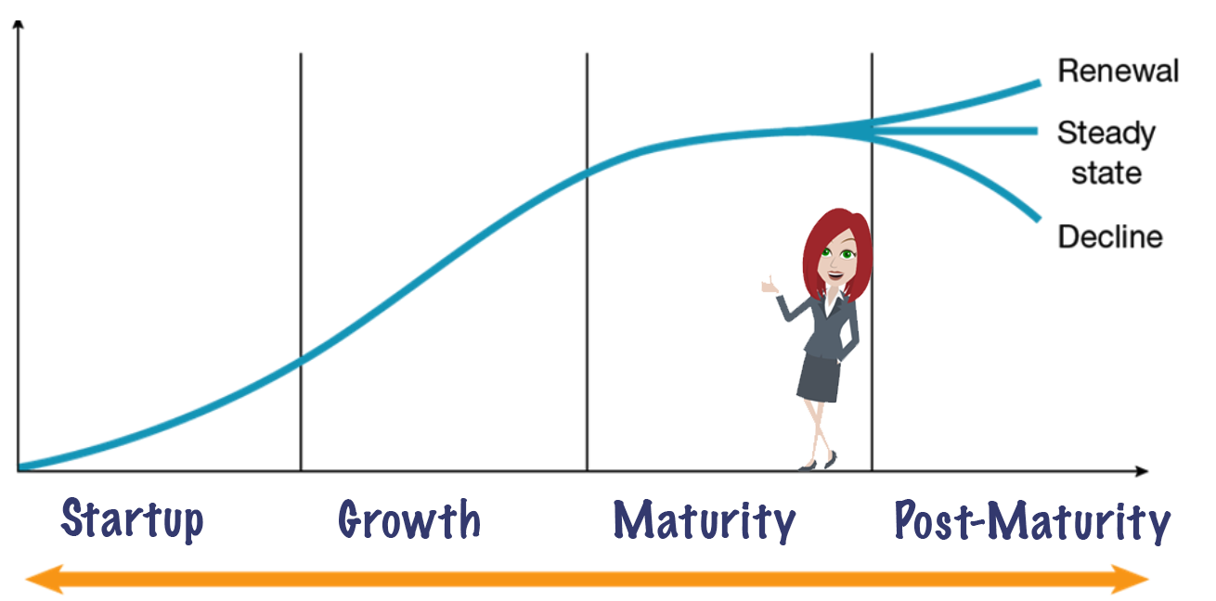
Figure 1: Stages of contingency approach model (McMullin, 2020)

Challenges in Implementing Contingency Approach
The contingency approach works well in theory but putting it into practice might be challenging. Rapid market shifts or worldwide crises are unforeseeable external variables that may derail even the best-laid plans (Khan, Razzaq, Yu, & Miller, 2021). The ever-changing nature of markets and competition might make it difficult to compile the latest data for solid contingency planning.
The dynamics inside organization’s provide yet another obstacle. Companies resistant to change, especially those older or more significant, often need more skill for successful contingency planning. The possibility of analysis paralysis also exists, with decision-makers being paralyzed by the sheer number of possible outcomes.
Organizational cultures that encourage change and innovation are vital to overcoming these obstacles. Team members may be better prepared to act under their plans if they participate in regular training and simulations. Using technology and predictive analytics helps organisations foresee potential problems and develop solutions (Lee & Trimi, 2021).

Organization for each stage

Startup Stage: Airbnb

Introduction to Airbnb's Early Days
In 2008, Airbnb's founders, Brian Chesky, Joe Gebbia, and Nathan Blecharczyk, turned a spare room in their San Francisco apartment into a makeshift guesthouse. This wasn't simply a way to save money on rent; it was the seed of a concept that would eventually shake up the hotel business worldwide (Clemente, 2023). They saw a need in the market and filled it by creating a system that allowed for unusual forms of housing while also giving property owners a chance to earn extra money.

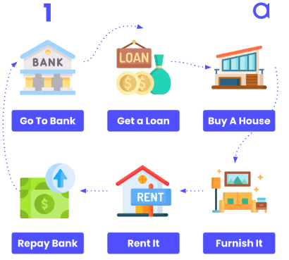
Figure 2: Startup cost of Airbnb (Clemente, 2023)

Performance Management during Inception
Performance management was essential to Airbnb's growth in its early years. Airbnb's original idea necessitated carefully aligning its operations with its goals. The platform had a slow start and needed help attracting users. The most significant challenge was overcoming the importance of trust in hospitality. Travellers were wary of staying with strangers, and hosts were attentive to opening their doors to strangers.
Airbnb used several methods to track and improve performance. The platform prioritised ease of use above anything else. To get valuable ideas from hosts and guests, user-friendly interface designs and feedback systems were built. This input was crucial in shaping the future of their products and services. Second, Airbnb understood how vital it was to foster a sense of community. The group made house calls to get to know the hosts and held gatherings to discuss their concerns. An increased understanding of community and trust resulted from this hands-on approach. Airbnb provided complimentary professional photographic services to hosts to further guarantee standardization and quality. More people visited listings with high-quality photos since they improved the platform's attractiveness.

Critical Analysis of Initial Strategies and Adjustments
Airbnb's early strategies, which showed commendable flexibility, cleverly laid the groundwork for its global success. Each tactic, however, comes with its own set of difficulties and insights.
Although the trust-building tactics were innovative, they were not failsafe. Airbnb has instituted host guarantees and more robust verification methods in response to reports of property damage and security concerns. While their clever choice to include excellent photographs in ads increased their attractiveness, it also prompted concerns about the postings' validity among some visitors who saw discrepancies between the images and their experience. The benefits and drawbacks of their data-driven strategy were equal. Airbnb was able to be more agile and responsive because of this. Still, the company also faced legal and ethical issues when it used questionable tactics like reverse engineering to gain an advantage over rivals.
Airbnb's shift towards emphasizing activities in addition to lodging was admirable. Airbnb's 'Experiences' component was developed in response to the growing demand for unique activities hosted by locals and the fact that contemporary tourists value genuine cultural immersion. Airbnb's early days serve as a case study on the value of flexibility, vision, and a focus on the customer (Clemente, 2023). Despite facing many obstacles, they eventually became an industry leader worldwide because of their dedication to providing excellent service and keeping up with the changing demands of their customer base.

Growth Stage: Uber

Uber's Rapid Expansion Overview
In 2009, Travis Kalanick and Garrett Camp launched Uber, which at the time was a luxury automobile service in San Francisco. In 2012, Uber launched UberX, which allowed riders to be driven by people who didn't have commercial driver's licenses. This change profoundly democratized the ride-hailing industry. By the end of 2015, "Ubering" had become a worldwide phenomenon, having expanded to over 300 cities in 58 countries (Daum et al., 2021).. The ingenuity lay in the app's straightforward function: pairing up drivers and passengers. This and Uber's low prices helped propel the company to the top of its industry.

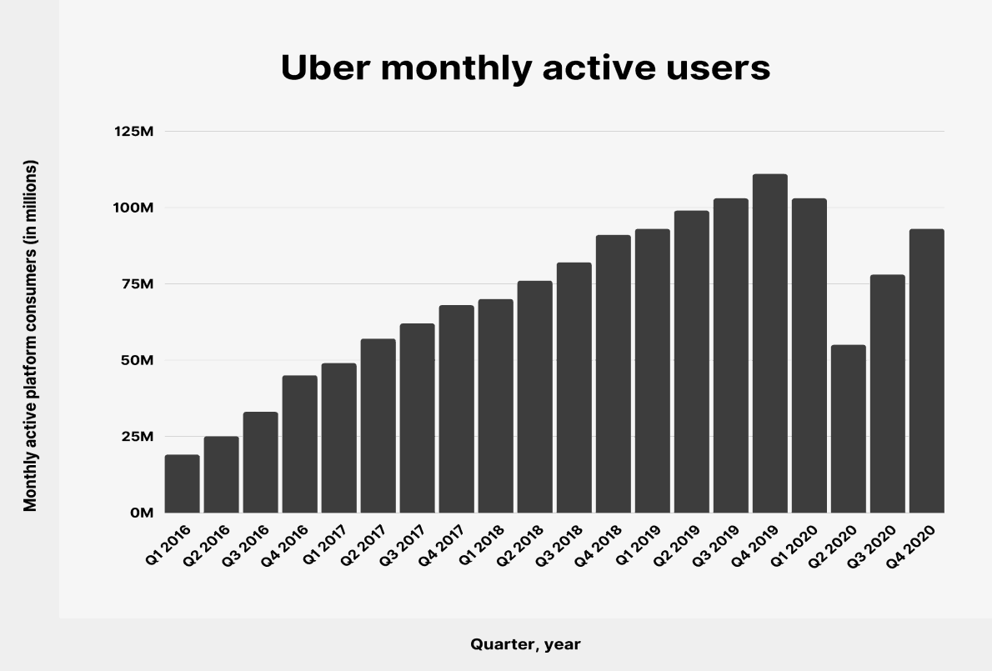
Figure 3: Growth Stage of uber (Wells, Attoh, & Cullen, 2021)

Performance Management during Scaling
Scaling is frequently a delicate balancing act between rapid expansion and stable operations. This required Uber to deal with unfamiliar regulatory landscapes, local customs, and formidable rivals. Background checks, vehicle inspections, app-integrated navigation and feedback features, and other measures were necessary to provide consistent service for customers across the globe.
Uber has built performance measurements into every facet of its business. The brand's signature dynamic pricing algorithms adjusted real-time prices in response to demand changes. Both riders and drivers would feel responsible for their actions thanks to a dual-rating system. There was a wealth of information gleaned from service indicators, including completion rate, average driver rating, and trip frequency, which aided in making strategic choices. Uber's technological strength solidified as the company's foundation during this time (Stanton, Salmon, Walker, & Stanton, 2019). Using big data analytics allowed for more efficient route planning, shorter wait times for riders, and better preparation for demand spikes. The 'God View' feature gave drivers a bird's-eye view of all moving Uber cars, boosting productivity and safety.

Critical Evaluation of Growth Strategies and their Implications
Uber's rapid ascent to the top of the ride-hailing industry was characterised by audacious decisions that drew both praise and criticism. They used a straightforward strategy to market supremacy by offering massive incentives and rapidly seizing the lion's share. This strategy raised questions about long-term viability while generating substantial market capitalization. Uber's trademark surge in pricing reflected prevailing market conditions. During busy times, prices increased to make sure there would be enough drivers. Consumers complained about this dynamic pricing because they saw price changes as exploitative, particularly in times of crisis.
The 'disrupt first, dialogue afterwards' mentality was typical in Uber's aggressive expansion into new areas. As a result, there were many run-ins with law enforcement in the area. Sometimes, rather than operate within the established parameters, Uber has chosen to directly defy them, leading to bans, demonstrations, and a series of lawsuits. The process of cultural adaptation could have been more straightforward. Uber has shown adaptability in local markets by including features like cash payments, but the company has been criticized for needing to understand local customs in places like India fully (Wells, Attoh, & Cullen, 2021).

Maturity Stage: Apple

Apple's Market Dominance and Product Evolution
Apple started as a little computer company in a California garage and has grown into a multinational conglomerate. The Apple I computer was the first of a series of products that has since expanded to include desktop computers, smartphones, tablets, wearables, and online services. The iPhone is the most revolutionary technology product in recent history because of Steve Jobs' vision of a digital hub approach, in which products like the iPod will serve as the epicentre of digital existence. In 2018, Apple was the first corporation to surpass a market valuation of $1 trillion (Liébana-Cabanillas et al., 2020). The ecosystem's seamless integration of hardware, software, and services is a significant factor in the company's rapid expansion. These factors all work together to build consumer satisfaction and encourage repeat purchases.

Performance Management in Maintaining Innovation
Apple's goal now is to preserve its dominant position in the market through continuous innovation, which it has done in the past. Its approach to performance management is driven by a desire to innovate and raise standards constantly. Apple's dedication to its developer community is displayed at the company's semiannual Worldwide Developers Conference (WWDC), where in-house and external programmers learn about its newest operating system developments (Podolny & Hansen, 2020).
Apple's design-first strategy allows for much freedom of expression among the product teams. Software developers and hardware designers are encouraged to work together on projects to provide a unified result. The result is a suite in which hardware and software are mutually supportive. The business has also perfected supply chain management, ensuring consistent quality and on-time deliveries. To keep production practical and moral, audits are performed often, supplier standards are maintained high, and efforts are made to reduce environmental impact. User comments, software bugs, and hardware failures are all included in performance measures, not sales data. This system of continuous feedback ensures the continued improvement and viability of goods.

Critical Reflection on Apple's Sustained Success and Challenges
Apple's achievements are a model of how accuracy can complement inventiveness. Although their goods are more expensive than the competition, they provide customers with exceptional quality and support. The natural environment contributes to this advantage. Because of how well Apple's products and services work together, leaving the Apple ecosystem after purchasing an Apple product may take time and effort.
There have been challenges to this supremacy, too. Others claim Apple has lost its innovative edge after Steve Jobs' departure. Although the iPhone is a significant technological advancement, it has not been revolutionary. Despite its commercial success, Apple's iPad series has formidable competition from more flexible 2-in-1 tablets (Sharon, 2021).
The company's extreme dependence on iPhone sales has also been a problem. Although Apple's other income generators—including Apple Music, Apple TV+, and the App Store—are sizable, the iPhone is still the company's most lucrative product. Changes in sales trajectory have a significant effect on the company's bottom line. While Apple's closed environment has helped foster devotion, it has also been criticised. Lawsuits and antitrust investigations have been filed because of its App Store regulations, notably those involving its 30% commission. Saturation of the market is another issue of note. With strong iPhone penetration rates in developed areas like the United States and Europe, companies must look to developing markets or new products to fuel future expansion (Liébana-Cabanillas et al., 2020). Because of this, Apple is looking at developing technologies for augmented reality, wearables, and potentially autonomous vehicles.

Post Maturity Stage: Nokia

Nokia's Reign and Subsequent Challenges
Nokia, a former industry leader known as the "King of Mobile Phones," has left an indelible mark on the telecommunications industry. Starting as a paper mill in Finland in 1865, Nokia eventually became a telecom giant that dominated the worldwide mobile phone industry in the 1990s and early 2000s (Irawaty, 2020). Nokia's widespread popularity may be attributed to the company's user-friendly interfaces, sturdy builds, and groundbreaking models like the 3310, among others (Lindén, 2021).
However, the winds of the technological world change quickly. Smartphones, pioneered by Apple's iPhone in 2007 and followed by Android-based devices, presented a challenge for which Nokia needed to prepare. Nokia's Symbian OS did not match Apple's iOS or Google's Android. Before Nokia could grasp the seriousness of the problem, its market share had already begun to decline. Its 2011 merger with Microsoft, when it adopted Windows OS for its Lumia series, was risky, but it ultimately failed because rivals had already surpassed the company's former greatness (Panigrahi, 2020).

Performance Management during Reinvention Attempts
The transition into adulthood may be difficult for anybody, but it can be particularly intimidating for someone who has previously experienced domination. Nokia used a multi-pronged strategy. Initially, they tried to capitalise on people's familiarity and respect for the name. Indeed, advertising for Nokia emphasised the company's dependability and longevity. Brand loyalty, user participation, and the pace of new model acceptance were the primary indicators of success during this time frame.
At the same time, Nokia began to reflect on its character. As a result of its Symbian operating system's limitations, it has switched to the Windows platform. This effort was to provide something distinct from the dominant iOS and Android platforms. This would have called for significant internal changes, including new procedures, training, and objectives. Adoption rates, software reliability, user feedback, and integration smoothness would have replaced simple sales data as KPIs.
The corporation also restructured internally. This company's transition from hardware was signalled in 2014 when it sold its Devices & Services subsidiary to Microsoft. Integration, staff retention, and the efficient release of Nokia and Microsoft's combined products would have necessitated substantial revisions to performance management during this stage (Stradowski & Madeyski, 2023).

Critical Dissection of Nokia's Adaptive Strategies and Market Repositioning
Nokia's first approach, leveraging the company's history while still making innovative strides, had some value. Brand recognition was relatively high, so a return was possible by introducing a new operating system. But Windows Mobile OS was also faltering; thus, this partnership was an example of two organizations in peril trying to help each other. The subsequent sale to Microsoft signaled a second shift in strategy due to the realization that competing with industry giants like Apple and Samsung required cutting-edge products and a robust ecosystem, which Microsoft could provide (Lindén, 2021). However, the expected synergy never materialized, and Microsoft ultimately wrote down the transaction.
Nokia's rebranding efforts after this challenging period are remarkable. The company realized it would not be a market leader in smartphones and instead focused on creating network infrastructure for other companies via Nokia Networks. Taking advantage of Nokia's long history in the telecommunications industry, this rebranding is well thought out and clever (Ojansivu, 2022).

Reflection on the post-maturity stage

Performance Management for Renewal
As companies enter the challenging post-maturity phase, the search for revitalisation takes centre stage. The first order of business is to locate problem spaces that might benefit from new approaches. This requires in-depth familiarity with market trends, consumer tastes, and further technical developments. A company may revitalise its product line by analysing these factors and identifying possibilities that fit its core skills.
The next crucial stage is alignment. Once the renewal vision has been defined, it must permeate the whole organisation. The team's vision must be shared, and each member must know what they must do to make it a reality. Leadership initiatives, training courses, and seminars may all help with this alignment process (Goh & Okumus, 2020). By having everyone on the same page, we can ensure that our efforts to revitalise the area are productive and efficient.
Finally, management is a function of measurement. The success of these rejuvenation methods may be evaluated using key performance indicators (KPIs). With well-defined KPIs, firms can monitor their performance in real-time. Key performance indicators include the percentage of customers satisfied with a product after it has been updated or the percentage increase in revenue (Ma, 2020). By regularly measuring progress against these key performance indicators, management can make adjustments as needed, recognise achievements, and bring the company back to financial health.

Steady State Performance Management
In the corporate world, stability results from striking a delicate balance between exploring new opportunities and protecting established practices. Maintaining equilibrium is similar to walking a tightrope; swaying too much in one direction might cause you to fall. While it's true that constant innovation is necessary to keep up with a changing market, a company's core activities are what bring in the money and keep things steady (Majewski et al., 2020). Therefore, businesses need to find a happy medium, not letting the pursuit of new enterprises detract from the quality of their core offerings.
Efficiency and economy in operation are essential to preserving this balance. Businesses may strengthen their foundation by implementing process improvements, integrating new technology, and maximising their available resources. This does not require layoffs or reductions in personnel but rather the optimisation of processes to achieve maximum output with little input.
Setting up persistent feedback loops is a hallmark of steady-state performance management. Due to the dynamic nature of the modern corporate world, there are more viable strategies than complacency. Real-time data and analytics support routine monitoring of creative initiatives and core operations, yielding priceless insights (Sönnichsen & Clement, 2020). In turn, this facilitates rapid revisions to strategy, keeping the organisation agile, adaptable, and, most crucially, stable so that it may seize opportunities while protecting its core strengths.

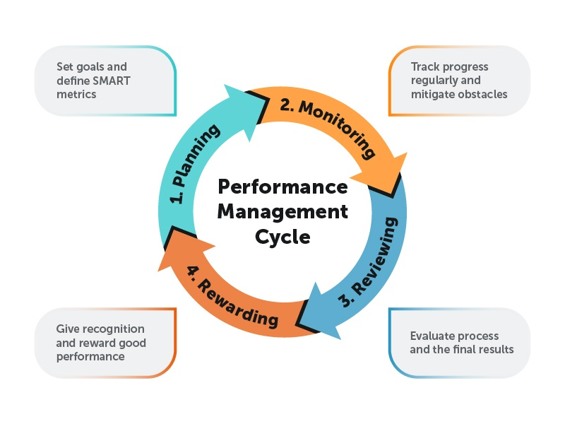
Figure 4: Performance management (Al-Delawi, 2020)

Managing Decline with Performance Metrics
Recognising early warning signals of a downturn might be the difference between a measured response and a panicked one in the complex dance of business. Early warnings may be gleaned by carefully monitoring performance data. These might show up as a steady decrease in revenue, a smaller proportion of the market, or a higher percentage of churning customers. These KPIs act as the proverbial canary in the coal mine, letting companies know there are problems under the surface.
As soon as these warnings are recognised, preventative measures must be taken. The key here is optimising your use of resources. It entails taking stock of all human and otherwise resources and deciding how best to put them to use. This may necessitate shifting assets to more lucrative departments, funding employee education and development, or implementing innovative technological solutions. However, there are situations when more than the most thorough attempts at optimisation can turn the tide. Companies may have to consider options like strategic downsizing or selling off divisions. To do so, leaders must sometimes make tough choices, like selling off non-essential assets, closing down unprofitable divisions, or laying off employees(so what use redundancy strategy) (Hasaan, Biscaia, & Ross, 2019). These choices are complicated and fraught with difficulties, yet they are frequently essential to the continued existence and revitalisation of the organisation. In summary, a corporation may navigate the difficult decline period with the right mix of metrics-based monitoring and the guts to act.

Balancing Stakeholder Expectations in Post-Maturity don’t need
Post-maturity is a difficult time for businesses since it requires balancing the needs of many stakeholders. This is when investors start to worry that their returns may decrease or become negative. Transparency regarding the company's strategic direction, emphasising adaptation and resilience, is necessary to address these issues. Investor confidence may be bolstered by keeping them updated often, demonstrating thoughtfulness in the face of potential challenges, and emphasising the company's triumphs (Rossi, 2020). Keeping the staff inspired is just as tricky. Negative rumours can lower morale by sowing the seeds of doubt. Leadership must take the initiative to reinforce the organisation's goal, creating a culture that values flexibility and ongoing education (Helmold & Samara, 2019). These concerns may be alleviated by implementing employee engagement activities, being open with workers about the state of the business, and, most crucially, outlining distinct routes for professional advancement.
Customers who pick up on the change may reevaluate their commitment. Therefore, firms must double down on providing reliable value. Enhancing after-sale service, launching customer loyalty programmes, or developing novel features for current product lines are all viable options (Whysall, Owtram, & Brittain, 2019). The post-maturity stage of a company's life cycle requires a careful balancing act to ensure that even if the company is winding down, its dedication to its constituents has remained strong.

Improvement in practice

This in-depth analysis of the phases of company development and the importance of performance management at each one has given me invaluable knowledge that will undoubtedly improve my work in the future. My perspective and method for strategic planning and decision-making have been completely reworked by the realisation that companies are not fixed entities but rather entities that change through several stages. It used to be safe to assume that established businesses might benefit from the same techniques that helped startups. However, as this module has made evident, a unique set of strategies is required at each stage of a company's life cycle, from infancy to decline. Therefore, a regular evaluation of the company's present stage in its life cycle should be one of the first measures in improving practice (Hong, Wang, Luo, & Zhang, 2020). This evaluation would guarantee that the tactics used are optimally suited to the given circumstances.
The module's focus on performance management as an HR tool and a strategic imperative has further emphasised the latter's importance. A company may have a culture of constant improvement, adaptability, and resilience if performance measures are well aligned with business goals. Applying what I've learned in the workplace, I want to promote a more unified strategy for evaluating employee performance. To achieve this goal, it is necessary to go beyond conventional measurements and create a set of Key Performance Indicators (KPIs) that align with the company's present and future goals (Hill, Schilling, & Jones, 2020).
The subject also taught me the significance of stakeholder management, particularly in the post-maturity stage. A corporation's capacity to adapt to its stakeholders' changing needs might be the difference between growth and stagnation in today's competitive business environment. In my future endeavours, I want to place a premium on open lines of communication with all of my most important stakeholders, including investors, staff, and consumers. This preventative measure may lessen the impact of problems and increase the likelihood of successful problem-solving.
Finally, the contingency approach's emphasis on flexibility must be considered. The uncertainty of today's corporate environment makes constant adaptation a must. Adaptability is the ability to deal with change and welcome it. Organisations can remain ahead of the curve by continually monitoring the external environment for possible disruptions and trends and by cultivating an internal culture that sees change as an opportunity rather than a danger. Overall, this session gave me a better grasp of companies, their growth, and the necessary tactics at each stage. As I use what I've learned in the workplace, I'll be better able to meet the difficulties of today's corporate environment and foster an environment of development, innovation, and sustainability.

Conclusion and recommendation

Organisations operate in dynamic terrain after diving into the details of the company life cycle and performance management. They need a specialised strategy for each development phase, from infancy to old age. Rather than being a rigid system, performance management should be adaptable enough to fit in with wherever a company happens to be in its life cycle at any one time (Antelava et al., 2019). This convergence is crucial in directing businesses towards long-term success.
Particularly in the turbulent seas of post-maturity, stakeholder management highlights the intricate network through which firms operate. How an organisation handles its connections with its stakeholders—from shareholders and workers to clients and customers—can significantly impact whether or not it will thrive in the future. Therefore, it is advised that firms keep their life cycle positioning at the forefront of their minds and use this knowledge to guide their strategic choices. As a result, you may be sure that everything you do will have the maximum impact. In addition, putting stakeholder input first must not be an afterthought. Maintaining staff morale and developing tactics to keep customers returning, especially in challenging circumstances, should be prioritised. The entire structure of performance measurements and management systems should be flexible. Because of this flexibility, firms are better able to overcome challenges (Claus, 2019).
In conclusion, performance management techniques have a solid connection to a company's life cycle stage. Businesses must adapt their strategy to new threats to keep up with the ever-changing business landscape and survive.

References

- Al-Delawi, A.S. and Ramo, W.M., 2020. The impact of accounting information system on performance management. Polish Journal of Management Studies, 21(2), pp.36-48.
- Antelava, A., Damilos, S., Hafeez, S., Manos, G., Al-Salem, S.M., Sharma, B.K., Kohli, K. and Constantinou, A., 2019. Plastic solid waste (PSW) in the context of life cycle assessment (LCA) and sustainable management. Environmental Management, 64, pp.230-244.
- Banerjee, R. and Hofmann, B., 2022. Corporate zombies: Anatomy and life cycle. Economic Policy, 37(112), pp.757-803.
- Chen, A.J., Hoberg, G. and Maksimovic, V., 2022. Life cycles of firm disclosures. In Life Cycles of Firm Disclosures: Chen, AJ| uHoberg, Gerard| uMaksimovic, Vojislav. [Sl]: SSRN.
- Claus, L., 2019. HR disruption—Time already to reinvent talent management. BRQ Business Research Quarterly, 22(3), pp.207-215.
- Clemente, P.T.A., 2023. OPERATIONS STRATEGY OF AIR BED AND BREAKFAST (AIRBNB): BASIS FOR AN ENHANCED BUSINESS MODEL. Globus-An International Journal of Management & IT, 14(2).
- Corominas, L., Byrne, D.M., Guest, J.S., Hospido, A., Roux, P., Shaw, A. and Short, M.D., 2020. The application of life cycle assessment (LCA) to wastewater treatment: A best practice guide and critical review. Water Research, 184, p.116058.
- Crane, B. and Hartwell, C.J., 2019. Global talent management: A life cycle view of the interaction between human and social capital. Journal of World Business, 54(2), pp.82-92.
- Franco, M.A., 2019. A system dynamics approach to product design and business model strategies for the circular economy. Journal of Cleaner Production, 241, p.118327.
- Goh, E. and Okumus, F., 2020. Avoiding the hospitality workforce bubble: Strategies to attract and retain generation Z talent in the hospitality workforce. Tourism Management Perspectives, 33, p.100603.
- Hasaan, A., Biscaia, R. and Ross, S., 2019. Understanding athlete brand life cycle. Sport in Society.
- Helmold, M. and Samara, W., 2019. Progress in performance management. Springer International Publishing.
- Hill, C.W., Schilling, M.A. and Jones, G.R., 2020. Strategic management: an integrated approach: theory and cases. Cengage Learning.
- Hong, T., Wang, Z., Luo, X. and Zhang, W., 2020. State-of-the-art on research and applications of machine learning in the building life cycle. Energy and Buildings, 212, p.109831.
- Irawaty, I., Andreswari, R. and Pramesti, D., 2020, November. Development of Youtube Sentiment Analysis Application using K-Nearest Neighbors (Nokia Case Study). In 2020 3rd International Conference on Information and Communications Technology (ICOIACT) (pp. 39-44). IEEE.
- Kaliannan, M., Darmalinggam, D., Dorasamy, M. and Abraham, M., 2023. Inclusive talent development as a key talent management approach: A systematic literature review. Human Resource Management Review, 33(1), p.100926.
- Khan, S.A.R., Razzaq, A., Yu, Z. and Miller, S., 2021. Industry 4.0 and circular economy practices: A new era business strategies for environmental sustainability. Business Strategy and the Environment, 30(8), pp.4001-4014.
- Lee, S.M. and Trimi, S., 2021. Convergence innovation in the digital age and in the COVID-19 pandemic crisis. Journal of Business Research, 123, pp.14-22.
- Liébana-Cabanillas, F., García-Maroto, I., Muñoz-Leiva, F. and Ramos-de-Luna, I., 2020. Mobile payment adoption in the age of digital transformation: The case of Apple Pay. Sustainability, 12(13), p.5443.
- Lindén, C.G., 2021. Kingdom of Nokia: How a nation served the needs of one company (p. 274). Helsinki University Press.
- Ma, S., 2020. The life cycle of corporate venture capital. The Review of Financial Studies, 33(1), pp.358-394.
- Majewski, E., Komerska, A., Kwiatkowski, J., Malak-Rawlikowska, A., Wąs, A., Sulewski, P., Gołaś, M., Pogodzińska, K., Lecoeur, J.L., Tocco, B. and Török, Á., 2020. Are short food supply chains more environmentally sustainable than long chains? A life cycle assessment (LCA) of the eco-efficiency of food chains in selected EU countries. Energies, 13(18), p.4853.
- McMullin, C. and Raggo, P., 2020. Leadership and governance in times of crisis: A balancing act for nonprofit boards. Nonprofit and Voluntary Sector Quarterly, 49(6), pp.1182-1190.
- Ojansivu, I., Laari-Salmela, S. and Hermes, J., 2022. The social impact of the Nokia-Elcoteq business relationship: Examining the consequences of legitimating relationship norms. Journal of Business Research, 149, pp.193-206.
- Panigrahi, C.M.A., 2020. Failure of Nokia–Lessons from Losers. Published in the book'Emerging Issues in Business Management'Published By: National Press Associates, New Delhi, ISBN, (978-81), pp.944303-9.
- Podolny, J.M. and Hansen, M.T., 2020. How Apple is organized for innovation. Harvard Business Review, 98(6), pp.86-95.
- Rossi, E., Bertassini, A.C., dos Santos Ferreira, C., do Amaral, W.A.N. and Ometto, A.R., 2020. Circular economy indicators for organizations considering sustainability and business models: Plastic, textile and electro-electronic cases. Journal of Cleaner Production, 247, p.119137.
- Sharon, T., 2021. Blind-sided by privacy? Digital contact tracing, the Apple/Google API and big tech’s newfound role as global health policy makers. Ethics and information technology, 23(Suppl 1), pp.45-57.
- Sönnichsen, S.D. and Clement, J., 2020. Review of green and sustainable public procurement: Towards circular public procurement. Journal of cleaner production, 245, p.118901.
- Stanton, N.A., Salmon, P.M., Walker, G.H. and Stanton, M., 2019. Models and methods for collision analysis: A comparison study based on the Uber collision with a pedestrian. Safety Science, 120, pp.117-128.
- Stradowski, S. and Madeyski, L., 2023. Exploring the challenges in software testing of the 5G system at Nokia: A survey. Information and Software Technology, 153, p.107067.
- Wells, K.J., Attoh, K. and Cullen, D., 2021. “Just-in-Place” labor: Driver organizing in the Uber workplace. Environment and Planning A: Economy and Space, 53(2), pp.315-331.
- Whysall, Z., Owtram, M. and Brittain, S., 2019. The new talent management challenges of Industry 4.0. Journal of management development, 38(2), pp.118-129.
- Zhang, A., Zhong, R.Y., Farooque, M., Kang, K. and Venkatesh, V.G., 2020. Blockchain-based life cycle assessment: An implementation framework and system architecture. Resources, Conservation and Recycling, 152, p.104512.
- Zhang, Y., Luo, Y., Zhang, X. and Zhao, J., 2019. How green human resource management can promote green employee behavior in China: A technology acceptance model perspective. Sustainability, 11(19), p.5408.

