

Postgraduate/Distance Learning
Assignment coversheet & feedback form

THIS SHEET MUST BE THE FIRST PAGE OF THE ASSIGNMENT YOU ARE SUBMITTING (DO NOT SEND AS A SEPARATE FILE)

For completion by the student:
Student Name: Korinna Williams

Student University Email: 1710547@student.uwtsd.ac.uk
Module code: HPCA7002  Module title: Researching Contemporary Cosmologies | Student ID number: 1710547 |  |  | Educational support needs:  Yes
Assignment title: Research Paper

Assignment due date: 20/05/19 (deferred from 13/05/19)
This assignment is for the 1st 2nd 3rd 4th 5th 6th module of the degree
I confirm that this is my original work and that I have adhered to the University policy on plagiarism.
Signed …………Korinna williams…………………………………………………
Email submission:if you are submitting this form via email, please tick this box □
(as a substitute for your signature) to confirm that you agree to the above declaration.
Assignment Mark
1st Marker’s Provisional mark
2nd Marker’s/Moderator’s provisional mark
External Examiner’s mark (if relevant)
Final Mark

NB. All marks are provisional until confirmed by the Final Examination Board.

For completion by Marker 1 :
Comments:

Marker’s signature: |  |  | Date:
For completion by Marker 2/Moderator:

Comments:

Marker’s Signature: |  | Date:
External Examiner’s comments (if relevant)

External Examiner’s Signature: |  | Date:

Modern People and Ancient Religion: Exploring Zoroastrian Cosmologies and Attitudes

Introduction
Freya Mathews wrote, ‘Cosmologies are not of course pulled out of the air to suit the convenience of the communities to which they are attached. They are conditioned by many and various historical, environmental, technological, psychological and social factors. A flourishing community is likely to evolve a bright, self-affirming cosmology, and a languishing community is likely to see the world in darker shades... A good cosmology, in other words, is good for its adherents’. In Chapter 2 of his Astrology and Cosmology in the World’s Religions, Nicholas Campion references such concepts as cosmogony, cosmophilia, cosmophobia and cosmovision, and develops the idea that all of us have a personal cosmology, or cosmovision, a set of beliefs about the way the cosmos is and works, and how we fit into it. Zoroastrian cosmology is split into 3 parts: creation, mixture and separation. Much of the cosmology centres around light and dark, thus duality. Its followers live by the maxim ‘good thoughts, good words, good deeds.’

The research intends to examine whether Mathews’ view - that a person’s cosmology can reflect their attitude to life - applies to Zoroastrianism and whether the religious cosmology of the community has helped the community flourish by creating self-affirming individuals. Plus, following Campion’s idea that we all have a view about the cosmos, this research aims to see how developed the personal cosmologies of modern Zoroastrians are. By the end, I aim to gain an understanding of whether there is an alignment between the cosmologies, both personal and religious, of Zoroastrians and their outlook. The findings will be applied to the Zoroastrian dilemma of declining numbers in the religion and thus, see whether the participants’ cosmologies and attitudes impact their approach to the future of their religion. The research is divided into the following sections: literature review, methodology and analysis of research.

Literature Review

Perfect Light and the Destructive Force
Zoroastrian cosmology has themes of duality rippling throughout it. The Avesta provides many details of Zoroastrian cosmology but it is the Bundahišn, which translates to ‘Primal creation’ in English, that provides the most succinct account of Zoroastrian cosmology. According to Zoroastrian cosmology, Ahura Mazda (Ohrmazd), the original creator, fashioned the material world in purely white spiritual light. It was perfect, immortal and light. Ohrmazd created prototypes of man, bull and plant and placed them on earth. Angra Mainyu (Ahriman), the destructive force, is the opposite of creation. Ahriman created demons in darkness and latched on to the pure light world of Ohrmazd. To protect his creations, Ohrmazd agreed to battle Ahriman on earth for 9,000-12,000 years. Ohrmazd managed to protect his prototypes by placing them in the heavenly spheres of the sky. The skies were soon overpowered by Ahriman who was at first, victorious, but Ohrmazd’s creations began to fight back; the essence of plants were scattered across the earth and the seed of the bull and man purified in the sun and moon where cattle and men sprang out of to fight the destructive, evil force. And so, Ahriman was trapped in the sky, in darkness and defeated. However, Ahriman’s force still lives today on earth: deceit, death, evil thought and arrogance are all remnants of the battle. Thus, the material creation, created perfect by Ahura Mazda now is imperfect and mortal as a result of evil’s assault.

Self -affirmation and Community
Self-affirmation is the recognition of one’s own self value. Self-affirmation theory is a theory in psychology made popular by Steele who considered how individuals adapt to situations that could threaten their self-conception and in order to protect their self-integrity. Interlinked with this is how well a person perceives themselves to be able to control moral outcomes and manage if their concept of self is threatened. These ideas link to identity. Aspects of self-affirmation include positive feelings, less cognitive dissonance, dealing with a threat to self-image, such as criticism, and the sense of control over one’s life. Steele supposed those who believed themselves to have self-integrity viewed themselves as moral people who abide by cultural norms. On a similar theme to Steele, Matthews argues that a flourishing community will have a cosmology that is self-affirming. This research will explore how self-affirming Zoroastrians are and whether Matthews’ premise is correct plus, see whether this aligns with Steele, whose theory implies that Zoroastrians should abide by Zoroastrian cultural norms if they’re self-affirming. Belonging to the Zoroastrian religion can, therefore, be seen as being part of the religious community. Being religious is more than just reporting to be of a particular faith but also how much one is committed to the values, beliefs and practices of their religion in their daily life.Sherman and Cohen propose that belonging to groups may affect the self-affirmation of an individual. They argue that those who belong to a collective group are more likely to have cognitive dissonance but those who are from a more individualist culture are less likely to have cognitive dissonance, and more self-affirmation. There is a tension here between Matthews and Sherman and Cohen because Matthews suggests that a culture flourishes and is self-affirming with a positive cosmology, whereas Sherman and Cohen suggest self-affirmation is actually reduced within collective cultures. Furthermore, a study by Simon, Greenberg and Brehm found that cultures that promote individuality had more self-affirmed participants and saw reduced cognitive dissonance. Matthews believes that flourishing communities with bright cosmologies are more likely to produce self-affirming people, whereas, it seems regardless of the cosmology, self-affirmation comes from individuality rather than culture. These theories of self-affirmation and community will be tested in my questionnaires and interviews of Zoroastrians as I aim to see whether those with stronger personal cosmologies, or those with stronger religious affiliation are more self-affirming.

Additionally, the Parsee Zoroastrian community is declining. There are more people attempting to convert to the religion but there is inconsistency within the community as to whether converts can join. Some Parsees reject converts altogether. Zoroastrianism, however, encourages free will and many Zoroastrians are concerned about their religion ‘dying’. Arguably, the rejection of converts but the belief in free will and desire to revive the religion can be seen as an example of cognitive dissonance and thus a lack of self-affirmation. Moreover, there is a passage in the Avesta in Yasna 31.3 which states ‘yā jvantō vīspəˊng vāurayā “by which I might convert all the living” The beliefs surrounding conversion and the approaches to combatting the ‘decline’ of the religion is also something that will be explored through the research.

Individuality and Personal Cosmologies
A considerable amount of literature has been published about cosmology. There is a distinction between scientific cosmology and anthropological cosmology however, the two can blur, especially within the personal cosmologies of individuals. Often, the scientific understanding of the word cosmology is privileged over other views of cosmology. Munitz wrote ‘scientific cosmology is commonly defined as the branch of physics or theoretical astronomy that is engaged in the study of the properties of the universe, where the universe is thought of as being the most inclusive or complete physical whole’ and compares this to ‘primitive’ cosmologies that ‘made an appeal to all sorts of dramatic and anthropocentric analogies.’ The use of the word primitive insinuates inferiority. This definition is important to my findings as I will be allowing participants to freely write on their cosmological beliefs and will compare scientific versus anthropological answers. North, however, points out that cosmology is a word that continues to evolve and has ‘changed with time and… varied from one culture to another.’ While Abrams and Primack argue ‘every traditional culture known to anthropology has had a cosmology – a story of how the world began and continues, how humans came to exist, and what the gods expect of us. Cosmology made sense of the ordinary world by defining a larger context and grounding people’s sense of reality, their identity, and their code of behaviour in that grand scheme.’ Cosmology, therefore, is more than just large views about the universe, it is about how people act and identify themselves within the universe as argued by Campion. Based on this literature on cosmology, I am going to look for themes surrounding science, behaviour and culture within the answers of my participants to see if my sample group of Zoroastrians support this literature or reveal new understandings of cosmology.

Methodology:
The methodological approach for this research paper consists of a literature review, interviews and questionnaires. Via questionnaire, I asked 32 people (aged 18 - 68) who identify as Zoroastrians about their relationship with Zoroastrianism, their cosmology and their attitudes. There were 17 male respondents and 15 female respondents from the UK, India, Canada, Poland, USA and France. The questionnaire was easily distributed electronically in the format of a Google Form. Participants were found from Zoroastrian community Facebook groups. I also interviewed three people for approximately 30 minutes in a semi unstructured interview. I conducted 1 interview via phone and 2 via Skype. All 3 were recorded and transcribed. Of those interviewed, 2 were female and 1 was male. They were aged 26, 32 and 59. The interviewees were located in the UK, India and the USA.

The questionnaire was split into three sections: Zoroastrian beliefs, personal cosmology and attitudes. It mainly consisted of quotes which participants could answer ‘strongly agree’ ‘agree’ ‘neutral’ ‘disagree’ and ‘strongly disagree’ to. This is known as likert-type scales and are useful when measuring unobservable individual characteristics such as attitudes, feelings and opinions. As this research is detailing belief and personality, it was also valuable to allow participants the opportunity to write free form to some open-ended answers. Bell states that open questionnaires are useful when it is ‘necessary to give respondents the opportunity to give their own views on the topic being researched.’ Therefore, in addition to the 24 statement questions, there were also 4 free form questions which required longer answers.

I used semi-structured informal interviews because Hennick, Hutter and Bailey (HHB) state that in-dept interviews gain ‘detailed insight into the research issues from the perspective of the study participants themselves’ and are appropriate when ‘seeking information on individual, personal experiences.’ Also, Bell recommends a combination of both interviews and questionnaires to get both an overview of a topic and in-depth opinions too. Therefore, this approach was relevant to this research project on belief. I did not have fixed questions when going into the interviews however, I did have a list of areas I wanted to cover to guide the conversation. I also had some back up questions in case the interview started drying up before the end.

Given the short time frame and limited scope my methods were effective. However, had there been more time it would also have been useful to do some observations of Zoroastrians. HHB write that observations would enable the researcher to ‘systematically observe and record people’s behaviour, actions and interactions.’ This would have been useful if I would have been able to attend, for example, the Zoroastrian Congress which debates some of the areas covered in my research. HHB explain that this would be valuable to ‘provide context to a study through a social setting’ and ‘a contextual understanding to the findings’.

Outsider Far
My status in respect of this research is ‘outsider far’. I am an outsider because I do not belong to the Zoroastrian religion. According to Kikumura in social research being an outsider is beneficial because ‘access to authentic knowledge is more obtainable because of the objectivity and scientific detachment with which one can approach one’s investigation.’ The ‘far’ comes from the approach to research methods this is demonstrated by my chosen research methods of online questionnaires and semi-structured phone and Skype interviews. Zoroastrians happily engaged with the questionnaire requests posted on Facebook, many people commenting on the ‘fascinating’ nature of the research. This could also be to do with the relatively unknown popularity of the religion, and a willingness that many of its followers have to spread its popularity. Clark suggests that at a collective level, people engage in research to increase representation and to inform change. After receiving 32 questionnaire responses I closed the questionnaire as Facebook proved to be too popular of a platform to share it on. Had I been an insider I would have selected a smaller, more targeted group of participants. Fifteen people also offered to engage further in an 30-minute interview. Overall, participants were keen to engage despite my outsider far status.

Reflexive Considerations
I have actively tried to be reflexive throughout the duration of the research as HHB explain that this process ensures the researcher is explicit about the influence on the research. In designing and executing this research I have taken into account that I am a British 24-year-old female of Caribbean and Irish heritage who was raised in a Christian environment but as an adult does not identify with any organised religion. My interest in Zoroastrianism developed 12 months ago following from interests in astrology, Mesopotamian history and theosophy. I do have friends who are British-Iranian and British-Indian, although, I have never met an individual of Zoroastrian faith, therefore, all knowledge I had about the religion was from literature and videos. As such, I went into this research with biases, both conscious and unconscious, about Zoroastrianism.

Bryman warned that reading theory before or in the early stages of research can prejudice the researcher before meeting the subjects. Initially, I had read that Zoroastrian’s do not accept mixed babies from Zoroastrian women into the religion, but they do accept the mixed babies of Zoroastrian. My modern Western stance made me think that this was misogynistic, and I acknowledged my bias on this topic. To mitigate some bias, I had to consciously keep reminding myself throughout the research project that I must think beyond of my own generational and cultural position. I also made it a point not to ask anything about gender as I was mindful of Bell who argues that I may have unwittingly used ‘inappropriate language which might indicate strength of feeling.’

Additionally, I was aware that Zoroastrian’s do not accept converts into the religion and only Parsees are allowed to be Zoroastrian. As such, I catered my questionnaire to Parsees and designed it based on the literature I had read regarding their declining numbers. I found though, that after sharing my questionnaire on Zoroastrian Facebook pages that I had non-Parsee converts filling in the questionnaire as they self-identified as Zoroastrian. My outsider-far position in relation to this research stopped me from foreseeing this as a problem plus it is impossible to predict all outcomes as Selltiz et al. states ‘interviewers are human beings and not machines.’ Moreover, I found myself condemning these people for self-identifying as Zoroastrians because I struggled with the idea of white westerners hijacking the minority religion of people of colour. In order to resolve my outlook though, care was taken to take a less personally invested approach to the research and thus, I still included their responses in my data pool.

Findings and Analysis

I was interested to find the Zoroastrian view on cosmology however; I note from Worthington that self-defining in a particular religion does not necessarily indicate being religious. That’s why I asked questions to understand the extend of a person’s religious affiliation to Zoroastrianism. (Figure 1, 2, 3)

Figure 1

Figure 2

Figure 3

The question that is of particular significance here is ‘I have formed my own beliefs, some of these beliefs are different from Zoroastrian teachings’. 13 people agreed with this statement, 14 disagreed whereas 5 chose to remain neutral. This question was to explore Simon, Greenberg and Brehm’s argument that individualist cultures have more self-affirming individuals versus Matthews who believes the self-affirmation comes from being part of a flourishing community. I decided to investigate further Campion’s idea that we all have a view about the cosmos and how we fit into it. To begin I asked a very general question about the origins of the universe to get a broad idea of people’s viewpoint and whether they think about cosmology at all. (Figure 4)

Figure 4 indicates that that the majority of people do think about the origins of the universe. This supports Campion’s idea that we all have a view about the cosmos, however, the value attached to the belief isn’t important to all Zoroastrians. To some, the origin of the universe is irrelevant to their cosmology and their cosmology is only about their actions. This supports Abrams and Primack, who argue that cosmology to people is about their code of behaviour, as stated in the literature review.

I feel everyone was out here with a purpose whether that's to help another human being or help the wider world. (#1)
No religion or scientist at present can explain the entirety of the cosmos - I believe we have a duty to live the best life we can, but to ourselves and each other, rather than to some intangible being. (#8)
Logic lends itself to science. Faith lends itself to religion. I would like to believe that we are all here on earth to be the best person we can be. (#11)

No belief as such just happy to be a part of this (#19)

Just be a good person and everything will work for you (#27)

Figure 4

At the beginning of my questionnaire, I explained ‘a cosmology is an account or theory of the origins of the universe. Personal cosmologies are personal beliefs which encompass the cosmos’. As indicated in the literature review, Munitz privileges scientific cosmologies. This too was true of my participants who also prioritised the idea of a scientific understanding above any other understanding of the universe. Words used like ‘although’ and ‘but’ show that they recognise these other theories exist however, the value is in the scientific understandings.

I believe in scientific origin stories, although I am fascinated by the thought we still don't fully understand it. I categorically do not believe in a Creator or that one set of religious laws is the 'right' one. The cosmos operates randomly but with wondrous precision, which occasionally does make you wonder how it all came to be... (#7)
Big Bang + evolution is fine. Creation story is not historical but has spiritual truths and importance. (#17)
I believe in science over religion. I don't think God created the world, but I do feel that there is something out there bigger than myself. (#10)
Origins beyond the Big Bang are unclear (yet). It works according the laws of physics (different on various levels)… Ancient religious texts…can sometimes…serve as metaphors for life (#9)
In order to see whether people just think about the creation of the universe in general or more detailed aspects, I also asked further questions to see how much thought people had put into their cosmology. (Figure 5). This figure shows that very few people answered ‘not given the topic much thought’ which means that the Zoroastrians in question do in fact regularly think about the universe, which supports Campion’s argument.

Figure 5

The statement ‘Ahura Mazda created the universe’ was to see how strongly affiliated my participants were with the Zoroastrian cosmology discussed in the literature review, or whether their own personal cosmologies take precedence. It is apparent that many do still hold a firm religious cosmology.

Yes buhindashin and the religious texts explain the origins of the universe (#2)
Cosmos is created by two powers good and Ahriman (#13)
Its all' Gods creations... (#18)
Ahura Mazda's Wisdom is revealed to us through the light. The light is the source of all matter and truth that we humans comprehend. I believe our knowledge is limited to what we observe. (#30)

However, the answers to this question are inconsistent with the answers in Figure 1. 17 people agree that Ohrmazd created the universe, with 7 neutral and 2 not given much thought. However, 14 people say that their beliefs are not different from Zoroastrianism, with 5 neutral. Its peculiar that not all of the 14 people who say their beliefs are different from Zoroastrianism make up the 17 that agree Ohrmazd created the universe.

I also explained in my introductory questionnaire paragraph that cosmology is more than just the universe it is about behaviour and attitude too. I therefore, felt it important to ask specific questions to uncover more about a person’s personal cosmology and attitude. For example, Figure 6 displays the answers to the statement ‘if something is going wrong in life, I have the power to change it’ this statement displays self-affirmation and also reveals aspects of someone’s personal cosmology.
Figure 6

88% of the people surveyed do believe that if something is going wrong in life, they have the power to change it. This relates to my literature on self-affirmation and attack on the ‘self’. Something ‘going wrong’ could be, in this case, the decline of the religion. This question does show up a glaring cognitive dissonance amongst some, which could be an example of the point that Sherman and Cohen were making that those who belong to a collective group are more likely to have cognitive dissonance, as was highlighted in the literature review. Zoroastrians do have the power to combat the decline, but many take a defeatist attitude to the situation. Figure 6 only encapsulates one of the questions about self-affirmation, full answers on this topic can be found in the appendix.

At first it came as a surprise to me that there was such an extreme contrast in responses about combattng the decline of Zoroastrianism and also on the acceptance of converts into the religion, but then I remembered that the central theme is of this religion duality so perhaps it should have been obvious. So, can anything be done?

Yes. Stringent education of a new generation of priests as full-time priests at a new, professional seminary. Empowering the orthodoxy. Organising the community (church, scouts, groups, rituals, etc.). Dramatically raising the value and social prestige of creating a family (i.e. positive image of the roles of "father" and "mother", children as valuable gifts rather than burden on your way to a PhD etc.). (#9)
This view does not consider the possibility of converts and it isn’t unique
Yes, we can't increase it in a fortnight, but gradually we can. Zoroastrians should marry Zoroastrians and each family should at least produce 2 kids depending on the individual capacity. (#27)
Versus

Yes! Allow 'intermarriage'. Allow children from mixed parents to be Zoroastrian if they choose. Do not be restrictive. (#6)
And

There is an incongruity inherent in opposing conversion within Zoroastrian because of Zoroaster saying that anyone can become a Zoroastrian. This needs to be addressed as it is in opposition to the belief system and asha. I think the aversion to conversion or mixed marriage is cultural and related to Parsees inadvertently assimilating the casts system when they settled in India. The Parsees need to do more to welcome children of mixed marriage, especially when the Parsee parent is female. I think they also need to accept conversion because I believe the belief system is precious and what the world really needs right now. (#12)

And shining through with more duality

While maintaining the purity of the lineage?? Zoroaster always emphasised on purity (#29)

This debate seems to supersede age, gender and country as Lola (not her real name) insightfully told me as our interview was wrapping up

I met a young priest out of California, a liberal city... And I’d say his views on a lot of things are very liberal, but in this one sense he’s super conservative [about accepting converts] and he’s only 23. And I was kinda shocked to hear somebody so young have these really strict views about the religion… there’s always going to be people like that, in my mind it was always gonna be…the elderly, but clearly that’s not the case.

The answers, which can be seen in full in the appendix, beg the question of whether there is any correlation between cosmology and attitude. I believe the debate about the decline of the religion within the Zoroastrian community challenges Matthews because quite literally there is no consensus amongst the participants. In fact there appears to be no coherent theme amongst my group of participants. This data also does not support the idea that individualists are more likely to be self-affirming because, even those in my group who did not strongly associate with Zoroastrianism did not show any more propensity to be more self-affirming.

Conclusion
This research is still in its infant stages, but it has already started to identify some unexpected findings. The baseline question that this paper attempted to answer was whether the religious cosmology and personal cosmologies of Zoroastrians effected their attitudes in life, and consequently, whether said attitude would have any impact on the future of the religion. A summary of the findings is as follows; religious identity is subjective and the extend of that religious identity does not impact the likelihood of a person adopting the cosmology of the religion. Cosmology, as with identity, is individual and does not appear to have any influence on the attitude of a person and how self-affirming they are. Finally, as this paper was comparing attitude to the religion’s decline, my Zoroastrian participants had such a wide-ranging view on this area that no such assumptions could be drawn as to whether cosmology and attitude has an impact on this.

Initially, I wanted to end this research with a quote from one of my participants, but I decided it would be a reflection of my own bias if I decided which voice should be the concluding remarks of the research. I do hope that this research has permitted as many unique voices as possible to be expressed throughout. For now, though I conclude that the cosmology a person identifies with does not impact their attitude and while this is not reflective of the entire Zoroastrian faith, it does indicate that Campion is correct that we all do have a view of the cosmos. The lack of trends implies that individuals do begin to form their own personal cosmologies, but the individuality does not equate to increased self-affirmation. The attitudes of participants in my survey differ so vastly therefore, any prediction on my part as to whether the personal cosmologies of individual Zoroastrians can impact the future of the religion, would be unsubstantiated.

Bibliography

Abrams, N, and Primack, J, “Cosmology & 21st Century Culture”, Science. 293. (2001)

Bell, J, Doing Your Research Project: A Guide for First-time researchers in Education, Health and Social Science. (Maidenhead: McGraw-Hill Open University Press, 2010)

Boyce, M, Zoroastrians: Their Religious Beliefs and Practices (Oxon: Routledge, 2001)

Bryman, A, Quantity and Quality in Social Research (London: Unwin Hyman Ltd, 1988)

Campion, N, Astrology and Cosmology in the World’s Religions, (New York and London: New York University Press, 2012)

Clark, T ‘On ‘Being Researched’: Why Do People Engage with Qualitative Research?’ Qualitative Research. 10 (2010)

Clark, P, Zoroastrianism: An Introduction to an Ancient Faith. (Sussex: Sussex Academic Press, 1998)

Cohen, G & Sherman, D ‘The Psychology of Change: Self-affirmation and Social Psychological Intervention’, Annual Review of Psychology. 65 (2014)

Hennick, M, Hutter, I and Bailey, A, Qualitative Research Methods (London: Sage Publications, 2011)

Hintze, A, ‘Monotheism the Zoroastrian Way’ Journal of the Royal Asiatic Society. 24 (2014),

Insler, S, ‘The Gathas of Zarathustra’, in Acta Iranica (Belgium: Bibliotheque Pahlavi, 1975)

Kikumura, A ‘Family life histories. A collaborative venture’, The oral history reader, ed. Perks, R & Thomson, A (London: Routledge, 1998)

Kreyenbroek, P, “Cosmogony and Cosmology. In Zoroastrianism/ Mazdaism”. In: E. Yarshater (ed.), Encyclopaedia Iranica, vol.VI, (London/New York: Routledge & Kegan Paul, 1993)

MacKenzie, D, “Bundahišn”. In: E. Yarshater (ed.), Encyclopaedia Iranica, vol.IV,( London/New York: Routledge & Kegan Paul, 1990)

Mathews, F, The ecological self (London: Routledge, 1991).

McIntyre, D, ‘Zoroastrianism: A Universal Religion’ Zoroastrian Unity Worldwide (unknown) https://www.w-z-o.org/articles/zoroastrianism-a-universal-religion/ [accessed 8th May 2019]

Mcqueen, A & Klein, W ‘Experimental manipulations of self-affirmation: A systematic review’ Self and Identity 5 (2006). P.290

Munitz, M, ‘The logic of Cosmology,’ The British Journal for the Philosophy of Science. 13, (1962)

Nair, M, ‘As their population declines, Parsi-Zoroastrians struggle to manage religious properties’ Hindustan Times (2019) https://www.hindustantimes.com/mumbai-news/as-their-population-declines-parsi-zoroastrians-struggle-to-manage-religious-properties/story-9ldRw9KNefTO5c7CSn65OL.html [accessed 7th May 2019]

North, J, Cosmos, an Illustrated History of Astronomy and Cosmology (Chicago, London: The University of Chicago Press, 2008),

Rose, J, Zoroastrianism: A Guide for the Perplexed (London: Continuum, 2011)

Saati, P, CONVERSION vii. To the Zoroastrian faith in the modern period In: E. Yarshater (ed.), Encyclopaedia Iranica, vol. VI,( London/New York: Routledge & Kegan Paul, 1990)

Selltiz, C Jahoda, M, Deutsch, M, and Cook, S, Research Methods in Social Relations (New York: Holt, Rinehart and Winston, 1962)

Sherine, A, ‘Zoroastrianism needs to adapt its archaic laws or die’ The Guardian (2013) https://www.theguardian.com/commentisfree/belief/2013/dec/08/zorastrianism-adapt-archaic-laws-die-parsi [accessed 7th May 2019]

Sherman, D & Cohen, G, ‘The psychology of Self-defence: Self-affirmation Theory,’ in Advances in Experimental Social Psychology, ed. by M. P. Zanna (New York, NY: Guildford Press, 2006)

Simon, L, Greenberh, J, and Brehm, J, ‘Trivialization: The Forgotten Mode of Dissonance Reduction’ Journal of Personality and Social Psychology. 68 (1995)

Steele, C, ‘The Psychology of Self-affirmation: Sustaining the Integrity of The Self’, Advances in Experimental Social Psychology. 21 (1988)

Worthington, E. L., Jr., Wade, N. G., Hight, T. L., Ripley, J. S., McCullough, M. E., Berry, J. W., Schmitt, M. M., Berry, J. T., Bursley, K. H., & O’Conner, L. (2003). The religious commitment inventory-10: Development, refinement, and validation of a brief scale for research and counseling. Journal of Counseling Psychology, 50

Appendix

Identity question word cloud:
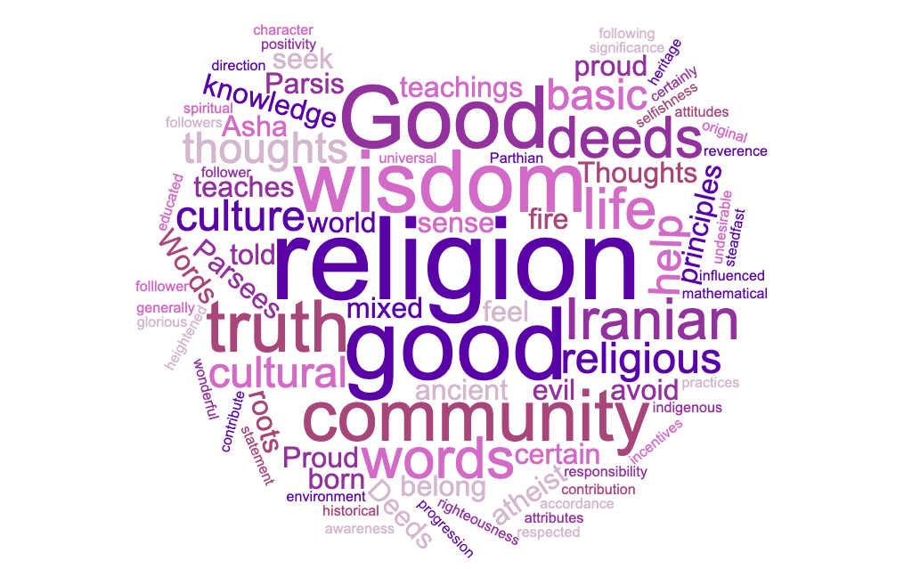
Feeling about decline word cloud:
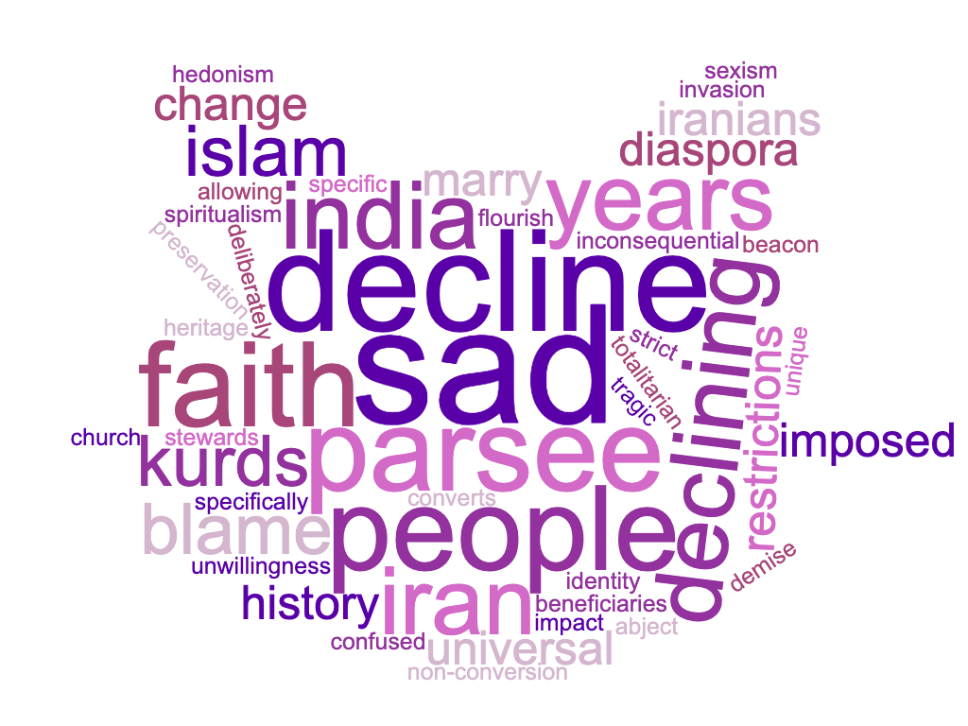

Personal cosmology word cloud: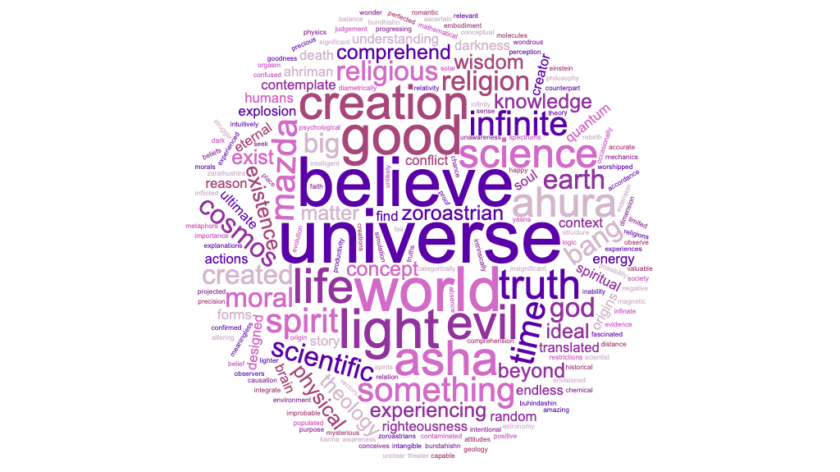
How to combat decline word cloud:
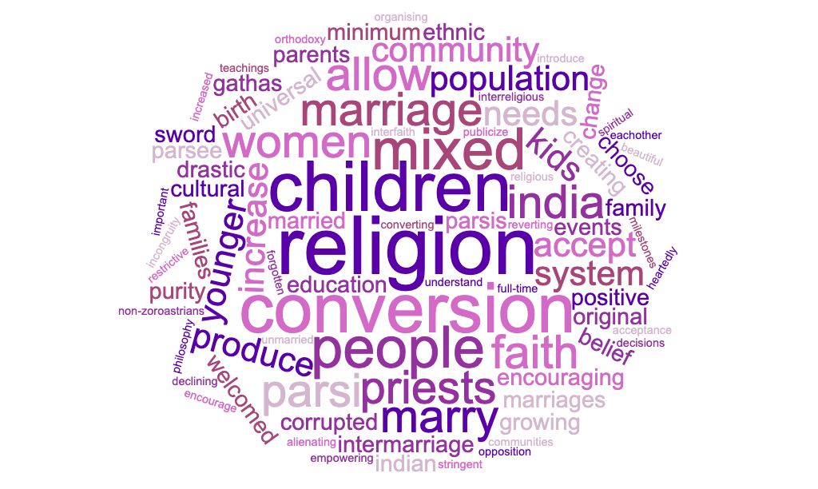
 | I have read the Avesta |  | I regularly read the Avesta
Yes, all of it | 6 | Very regularly (more than once a week) | 4
No, but I have read Zoroastrian literature from other sources | 7 | Somewhat regularly (once a month) | 8
Yes, sparingly | 10 | Occasionally (twice a year or more) | 4
Yes, the majority | 8 | Rarely (once a year or less) | 11
No, I have not read it at all | 1 | I have not read the Avesta | 5

 | I am a religious person | I would describe myself as a devout Zoroastrian | My religious beliefs are a large part of my personal identity | My family are more religious than I am | I only identify as a Zoroastrian because this is the faith that I was born in to | I would like to marry someone who is also Zoroastrian | I firmly believe that all Zoroastrian teachings are true | I have formed my own religious beliefs as I have got older, some of these beliefs are different from Zoroastrian teachings
Strongly Agree | 8 | 6 | 6 | 6 | 5 | 8 | 6 | 5
Agree | 13 | 17 | 18 | 9 | 3 | 11 | 11 | 8
Disagree | 0 | 3 | 3 | 9 | 16 | 2 | 6 | 13
Strongly disagree | 2 | 1 | 1 | 4 | 5 | 1 | 1 | 1
Neutral | 9 | 5 | 4 | 4 | 3 | 10 | 8 | 5

 | I often find myself thinking about the origins of the universe | I believe science can successfully tell us how the universe was created | I think the universe is ordered and planned, rather than random and chaotic | My life has meaning within the universe | The universe is infinite and incomprehensible | Ahura Mazda created the universe
Not given the topic much thought | 0 | 1 | 2 | 2 | 1 | 2
Strongly Agree | 8 | 10 | 5 | 9 | 10 | 9
Agree | 14 | 11 | 13 | 12 | 12 | 8
Disagree | 5 | 2 | 6 | 4 | 5 | 5
Strongly disagree | 1 | 1 | 1 | 1 | 0 | 1
Neutral | 4 | 7 | 5 | 4 | 4 | 7

 | If something is going wrong in my life, I have the power to change it | I am a positive person | Good and bad 'luck' exists | There is such thing as necessary evil | My actions can make a significant difference to the universe | I can do anything I set my mind to | I am still a good person even though I have faults | Criticism is useful to receive even if it is hurtful
Not given the topic much thought | 0 | 0 | 0 | 0 | 0 | 0 | 0 | 0
Strongly Agree | 13 | 8 | 3 | 1 | 8 | 7 | 8 | 8
Agree | 15 | 18 | 19 | 14 | 13 | 20 | 20 | 20
Disagree | 1 | 3 | 3 | 9 | 3 | 3 | 0 | 1
Strongly disagree | 0 | 0 | 1 | 1 | 1 | 0 | 0 | 0
Neutral | 3 | 3 | 6 | 7 | 7 | 2 | 4 | 3

What does it mean to you to identify as Zoroastrian? | How do you feel about the decline of Zoroastrianism?
A sense of community | Upset because I love my religion and lots of my friends are from it. The religion is unique and should live on
It helps form my identity. I think the religion is wonderful and that I‚Äôm lucky that I was born in the faith and so made aware of it. It‚Äôs a simple but powerful religion | It‚Äôs unfortunate but no matter what it has still had a huge impact on the world. Not sure what will happen with the numbers in the future but I will certainly practice and teach my children too
Good thoughts, good words, good deeds | Angry - it can be attributed directly to a philosophy of misogyny and unwillingness to change
I'm mixed. Mother is Christian. Father was Zoroastrian. I never got on with Christianity. I've come to it later in life, as we're becoming more accepted by the Parsees. I identify with being Zoroastrian despite attitudes towards mixed marriage with Parsees because it is a rational belief system that I find modern. Because of its focus on questioning everything as being a religious duty, it's emphasis on personal responsibility and it's reverence for the environment. | I don't think it's declining. Maybe traditional Zoroastrianism is, but it's flourishing in Iran, with the Kurds and in Iran. Additionally there are now converts in USA, Canada, UK, Netherlands and Europe. I think even the Parsees are becoming less xenophobic regarding children of mixed marriage, especially outside of India and Pakistan.
A folllower of knowledge and wisdom and a defender of Aryanem Vaej | The decline 1400 ago? Extremely sad. There is no decline today but a renaissance
Zoroastrianism is a universal way of life and stands on the basic principles of Good Thoughts, Words and Deeds. For me to identify as a Zoroastrian is to remain steadfast to these core beliefs | It is very sad that an ancient order of wise people may come to an end soon in the future. We are not to blame for the Arab invasion but we are surely to blame for its decline in India. Others must be accepted into the fold just as once Zarathushtra brought forth the light and accepted people into the fold
Zorastrian/ Parsis followers of Good Thoughts, Good Deeds, Good Words... Followers of Zarathustra and his preachings.....praying holy fire... | Feel nervous...
Proud, as it is the oldest monotheistic religion which has influenced Judaism, christianity and Islam. It was the first to give morale direction through Asha (righteousness ) to humanity. | Being India specific, the root cause of decline is late marriages or no marriage at all, also producing less children due to economic contrains , thirdly we do not allow conversion, a Parsee Zoroastrian has to be by birth from both Parsee Zoroastrian parents, fourthly restrictions on interfaith marriages and their progeny. I have deliberately used the terminology Parsee Zoroastrian which is an ethnic identity of people who migrated from Iran 1388 years ago to save their religion and who are beneficiaries to various trusts and properties specifically reserved for Parsee Zoroastrians. So world over Zoroastrians are increasing as any one can be a Zoroastrian, but Parsee Zoroastrians are decreasing.
To seek wisdom and progression of the living universe in accordance with Asha | Sad. This is a universal spiritual philosophy that is very relevant and applicable in modern times. Over thousands of years some later interpretations (post Gathas not written by Zarathushtra) have confused the core message or imposed interpretations (e.g. Taking allegoric metaphors literally).
Good words, good deeds and good thoughts | The main reason that the community encourages us to marry within is because of the tremendous decline in the population.
A heightened awareness of the good in the world and the need to contribute to spread goodness | Feel sad of the decline in numbers. Not in the religion per se. However the purity of thought remains surviving the odds
I am born a Zoroastrian so am blessed but I love the logic of the religion and strongly feel it is one the best religions for all times | Very sad but also feel that we are not good stewards of the religion
I agree with the teachings of Zoroaster | Sad
To follow the path of ash and and trust in Ahura Mazda as the only lord who by our actions words and deeds will help defeat Ahriman | Sad . We need to reclaim Iran as our own and the loss to Islam is the biggest tragedy we have suffered.

What are your personal beliefs about the cosmos? This could include: its origins, how it works and how you fit into it?

I believe science, Big Bang and gases, although people I believe were created by god
Ahura Mazda is not a god in the sense of how modern society describes god. It‚Äôs more light and the counteract is the absence of light. I believe we‚Äôre here to help do good and make the world were ina better place
No religion or scientist at present can explain the entirety of the cosmos - i believe we have a duty to live the best life we can, but to ourselves and each other, rather than to some intangible being.
I think at the moment that there was a big bang. How and why that happened we have yet to ascertain. It could be that it's a simulation, as the inability of the theory of relativity and quantum mechanics to integrate; but as yet we don't have proof of this. The double slit experiment tells me that as observers we are able to affect the universe at a quantum level, so we must be highly relevant in the universe. I still struggle to comprehend where the universe actually is, given that it's assumed to be infinate. So is there anything outside the universe? My brain says it's got to be inside somewhere, but that may be because the human brain is unable to contemplate the concept of infinity. I believe that we are not insignificant, but precious and valuable to the universe. It seems to be designed to nurture life in the right environment. I find it intuitively significant that with the mathematical constants, chemical properties of water, the shape of our solar system, Earth's magnetic field and the size and distance of the moon from the Earth, that these are so improbable that it has to be intentional and designed for life to exist. Any small alteration would make life unlikely. From my understanding of the above I believe that the Zoroastrian concept that every thought, word and act impacts on the universe in a positive or negative way, thereby altering the balance of light and shadow is accurate and that a scientific view of the universe does not clash in any way with being Zoroastrian. Maybe intelligent life is the universe's way to contemplate itself?
Ahura mazda is infinite knlowzdge and wisdom thru science and knowledge we will find what asha(cosmos) is
Zoroastrians believe that Ahura Mazda created the universe and populated the earth with his creation while Ahriman inflicted it with evil. Though there may be variations in the stories concerning Creation most major religions in the world believe in the good, wise and just Creator of the world and his evil counterpart. I believe in this story but we may never know what really came about. The universe they say works in mysterious ways and its true. Though I believe what ever happens is always for the greater good, sometimes it can took too long to realize. Man - presumably the greatest creation of Ahura Mazda is in the forefront of the eternal conflict between good and evil and we are given the free will to choose and all our actions play a role towards the Final Judgement that awaits us all
Its all' Gods creations...
It is infinite beyond the comprehension of mind, it is beyond thoughts, something which is only to be bowed and worshipped the source of endless energy, endless light. I would not know if my statement is correct, but something to be experienced only after death, where the soul does not have any physical restrictions of time, space and Causation. There are 2 time spectrums as per Zoroastrian beliefs, Zarvane akarne (Infinite time) and Zarvane Darego khadat (Finite time)
There is an ideal mental creation that is known as Asha - the physical world is evolving and progressing towards this ideal state. Because of true free will there is a chance that Asha may not be actualized in the physical world and we must strive to seek Wisdom, understand Asha and bring it about.
Dr. K.D. Irani summarizes this very well "Zarathushtra conceives of the world we live in as a theater of conflict between two diametrically opposed moral spirits (mainyus), they stand for mental attitudes in the psychological domain, and also opposing moral vectors in all of creation. They are the Spirit of Goodness (Spenta Mainyu), and the Spirit of Evil (Angre Mainyu, not so named in the Gathas, but in the later literature). Their characters are defined in relation to the pivotal concept of Zarathushtra's theology, Asha, usually translated as Truth. Truth, in this context means the Ultimate Truth, that is, the Ideal form of existence of the world as envisioned by Ahura Mazda. The form the world would have had but for the Spirit of Evil, and hence the form the world ought to have. Acting in accordance with Truth is the right thing to do, hence Asha is also translated as Righteousness. Indeed, since Zarathushtra's theology is always projected with a moral dimension, Asha always carries the joint meaning of Truth and Righteousness.
Thus we comprehend the world as an intrinsically good, divine creation, contaminated by evil, but capable of being perfected by the actions of humans by reason of their capacity of moral choice. Human action can promote good and reject evil leading to its ultimate banishment from the world, though it may continue to exist as a conceptual possibility."
Just be a good person and everything will work for you
Confused with the info available today
My degree is in geology and I read the Bundhishn much later but it's amazing how much of our theology is confirmed by science
We are here to husband the earth n by extension the universe
To bring order n productivity n progress
Yes buhindashin and the religious texts explain the origins of the universe

Freya Mathews, The ecological self (London: Routledge, 1991). p. 109
Nicholas Campion, Astrology and Cosmology in the World’s Religions, (New York and London: New York University Press, 2012)
Philip Kreyenbroek, “Cosmogony and Cosmology. In Zoroastrianism/ Mazdaism”. In: E. Yarshater (ed.), Encyclopaedia Iranica, vol.VI, (London/New York: Routledge & Kegan Paul, 1993) pp. 303–307.
Peter Clark, Zoroastrianism: An Introduction to an Ancient Faith. (Sussex: Sussex Academic Press, 1998)
Jenny Rose, Zoroastrianism: A Guide for the Perplexed (London: Continuum, 2011) p. 41
David MacKenzie, “Bundahišn”. In: E. Yarshater (ed.), Encyclopaedia Iranica, vol.IV,( London/New York: Routledge & Kegan Paul, 1990) pp. 547–551.
Kreyenbroek, (1993) pp. 303–307.
Almut Hintze, ‘Monotheism the Zoroastrian Way’ Journal of the Royal Asiatic Society. 24 (2014), pp.225-249
Kreyenbroek, (1993) pp. 303–307.
Kreyenbroek, (1993) pp. 303–307.
Mary Boyce, Zoroastrians: Their Religious Beliefs and Practices (Oxon: Routledge, 2001) p.25
Kreyenbroek, (1993) pp. 303–307.
Claude Steele, ‘The Psychology of Self-affirmation: Sustaining the Integrity of The Self’, Advances in Experimental Social Psychology. 21 (1988), pp 261-302
Geoffrey Cohen & David Sherman, ‘The Psychology of Change: Self-affirmation and Social Psychological Intervention’, Annual Review of Psychology. 65 (2014) pp.333-371.
Amy Mcqueen & William Klein, ‘Experimental manipulations of self-affirmation: A systematic review’ Self and Identity 5 (2006). P.290
Steele (1988) p.280
Freya Mathews, The Ecological Self (London: Routledge, 1991). p. 109
E Worthington et a.,l ‘The Religious Commitment Inventory-10: Development, Refinement, And Validation Of A Brief Scale For Research And Counselling’ Journal of Counselling Psychology. 50 (2003), pp.85-87
David Sherman & Geoffrey Cohen, ‘The psychology of Self-defence: Self-affirmation Theory,’ in Advances in Experimental Social Psychology, ed. by M. P. Zanna (New York, NY: Guildford Press, 2006) pp. 183-242
Linda Simon, Jeff Greenberh and Jack Brehm, ‘Trivialization: The Forgotten Mode of Dissonance Reduction’ Journal of Personality and Social Psychology. 68 (1995) p.260
Manoj Nair, ‘As their population declines, Parsi-Zoroastrians struggle to manage religious properties’ Hindustan Times (2019) https://www.hindustantimes.com/mumbai-news/as-their-population-declines-parsi-zoroastrians-struggle-to-manage-religious-properties/story-9ldRw9KNefTO5c7CSn65OL.html [accessed 7th May 2019]
Pargol Saati, CONVERSION vii. To the Zoroastrian faith in the modern period In: E. Yarshater (ed.), Encyclopaedia Iranica, vol. VI,( London/New York: Routledge & Kegan Paul, 1990) pp. 242-243
Dina McIntyre, ‘Zoroastrianism: A Universal Religion’ Zoroastrian Unity Worldwide (unknown) https://www.w-z-o.org/articles/zoroastrianism-a-universal-religion/ [accessed 8th May 2019]
Ariane Sherine, ‘Zoroastrianism needs to adapt its archaic laws or die’ The Guardian (2013) https://www.theguardian.com/commentisfree/belief/2013/dec/08/zorastrianism-adapt-archaic-laws-die-parsi [accessed 7th May 2019]
Stanley Insler, ‘The Gathas of Zarathustra’, in Acta Iranica (Belgium: Bibliotheque Pahlavi, 1975) p.182
Milton Munitz, ‘The logic of Cosmology,’ The British Journal for the Philosophy of Science. 13, (1962), pp35-38.
John North, Cosmos, an Illustrated History of Astronomy and Cosmology (Chicago, London: The University of Chicago Press, 2008), p.xxiv
Nancy Ellen Abrams and Joel R Primack, “Cosmology & 21st Century Culture”, Science. 293. (2001), pp 1769-1770
Nicholas Campion, Astrology and Cosmology in the World’s Religions, (New York and London: New York University Press, 2012) chapter 2
Judith Bell, Doing Your Research Project: A Guide for First-time researchers in Education, Health and Social Science. (Maidenhead: McGraw-Hill Open University Press, 2010) p. 146
Bell (2010) p. 141
Monique Hennick, Inge Hutter and Ajay Bailey, Qualitative Research Methods (London: Sage Publications, 2011) p. 109
Bell (2010) pp.212-14
Hennick, Hutter and Bailey (2011) p. 170
Hennick, Hutter and Bailey (2011) p. 171
Akemi Kikumura, ‘Family life histories. A collaborative venture’, The oral history reader, ed. Perks, R & Thomson, A (London: Routledge, 1998) pp.140 -141
Tom Clark ‘On ‘Being Researched’: Why Do People Engage with Qualitative Research?’ Qualitative Research. 10 (2010), pp. 399–419
Hennick, Hutter and Bailey (2011) p. 19
Alan Bryman, Quantity and Quality in Social Research (London: Unwin Hyman Ltd, 1988) pp. 86-87
Bell (2010) p. 169
Claire Selltiz, Marie Jahoda, Morton Deutsch and Stuart Cook, Research Methods in Social Relations (New York: Holt, Rinehart and Winston, 1962) p. 583

