Name: Mashuda Begum (Student Number: 2119256)
Business Plan for: Vegan Eat

Lecturer: | Charlotte Joyner
Date: | 31/5/2024
Team members:
Contents
Executive Summary 4
1 Executive summary 4
2 Business details 5
3 Key personnel 6
Vision 8
4 The business idea 8
5 Business goals 9
6 What the business does 10
7 What makes the business different (Value Proposition) 10
8 Legal requirements 11
Marketing 12
9 Market research 12
10 Profiling customers 12
11 Profiling competitors 14
12 Managing market risks 15
13 Pricing 16
14 Promotion and advertising 17
Running the business 18
15 Staff 18
16 Premises 18
17 Suppliers 18
18 Equipment 19
19 Managing operational risks 19
Finance 21
20 Start-up costs 21
21 Profit and loss forecast 22
22 Sourcing finance 23
23 Managing financial risks 23
24 Cash flow forecast 25
25 Conclusion 26
26 References 27
27 Appendix 29

Executive Summary

1 Executive summary
Vegan Eat will be an innovative vegan restaurant which will serve healthy and ecological food. We provide several plant-based meals for ethical and sustainable dining. Vegan Eat emphasises local, high-quality, and eco-friendly vegan food. Our business concept includes online and offline channels for customer convenience. Through strategic alliances, inventive marketing, and customer service, we hope to make Vegan Eat a top destination for vegans, vegetarians, health-conscious people, and eco-conscious consumers. Vegan Eat has talented chefs, a commitment to sustainability, and happy customers. We create a nice atmosphere and encourage community interaction to provide outstanding dining experiences beyond food. Vegan Eat will promote veganism and the environment on this fascinating trip. We produce the best vegan meals thanks to our clear purpose, strategic planning, and continual development.

2 Business details

Company name:
Vegan Eat

Address:
66 Great Titchfield St., London W1 7QJ, United Kingdom

Primary contact method
Phone: +44 7900 002333 Email: Vegan-Eat@Gmail.com

The business will
Vegan Eat will be a small vegan restaurant. With several vegan dishes, this restaurant will satisfy vegans. Online and offline, home and cosy restaurant eaters will find it convenient. For appetisers, mains, desserts, and drinks, high-quality, cruelty-free ingredients will be used. Local and seasonal ingredients make recipes fresher (Sadikin et al., 2023). Vegan Eat will have gluten-free, nut-free, and soy-free alternatives. The eatery will use green delivery and takeaway packaging. A simple online ordering and delivery system will make vegan meals more accessible. To become the community's favourite vegan restaurant, Vegan Eat prioritises health, sustainability, and deliciousness.

3 Key personnel
Details of owner(s): Mashuda Begum
Name:
Position/main responsibilities: Owner and Manager
Experience and knowledge of our industry: Extensive Eight years of knowledge of vegan cuisine and restaurant management.
Previous employment: Previous roles in food service management and culinary arts.
Key skills brought to the business: Leadership, culinary expertise, financial management, customer service, and strategic planning (Sellars, 2019).
Business experience and any training undertaken: Experience in managing a small restaurant, completed courses in business management and culinary arts.
Academic/professional qualifications: Bachelor's degree in Business Management, certification in Culinary Arts.
Salary expectations £25000 per year

Name: Sarah Johnson
Position/main responsibilities: Head Chef
Experience and knowledge of our industry: Over Ten years of experience in vegan cooking and kitchen management.
Previous employment: Worked as a sous chef in a renowned vegan restaurant.
Key skills brought to the business: Culinary creativity, team leadership, time management, and food safety expertise (Mckeever, 2018).
Business experience and any training undertaken: Culinary training at a prestigious culinary school, attended workshops on vegan cooking techniques.
Academic/professional qualifications: Sarah has a Cosmetology Certificate and other training to serve clients and grow the salon.
Salary expectations £21000 per year
Name: James Myer
Position/main responsibilities: Marketing and Sales Manager
Experience and knowledge of our industry: Proficient in digital marketing and sales within the food industry.
Previous employment: Previous experience as a marketing coordinator for a food delivery service.
Key skills brought to the business: Marketing strategy, digital marketing, customer engagement, sales analysis, and brand development (Genadinik, 2018).
Business experience and any training undertaken: Completed marketing courses and training programs focused on the food and beverage industry.
Academic/professional qualifications: Bachelor’s degree in Marketing, certification in Digital Marketing.
Salary expectations £18000 per year

Vision

4 The business idea
Key Partners: Vegan Eat will buy fresh, high-quality vegan ingredients from 10 local farmers. Collaborations with 3 eco-friendly packaging companies promote sustainability (Witzel et al., 2020). Two delivery service collaborations will boost online delivery efficiency and reach.
Key Activities: Menu planning, food preparation, and cleanliness and safety will be key. Five cooks ensure delicious food. Annual £15,000 marketing and promotional efforts will raise awareness and attract customers online and offline (Ashman, Patterson and Kozinets, 2021). Staff training and supply chain management ensure 95% on-time ingredient procurement and service quality.
Key Resources: A talented 20-person workforce, a modern kitchen, and quick internet ordering will be essential. A capital investment of £100,000 will maintain sales revenue (North et al., 2021). A 2,000-square-foot restaurant, three delivery cars, and modern kitchen equipment are needed. Customer data, creative recipes, and excellent branding are intellectual resources.
Value Propositions: Quality, cruelty-free vegan meals are discounted at Vegan Eat. The menu will have 20% gluten-, nut-, and soy-free options (Armstrong and Botzler, 2017). Customers enjoy fresh, local food and 50% local, 100% biodegradable packaging. Healthy and sustainable will define Vegan Eat.
Customer Relationships: Social networking, loyalty programmes, and personalisation build consumer relationships. The business loyalty programme should keep 70% of regulars. Using client feedback ensures improvement (Barrow, Barrow and Brown, 2015). Friendly food and service Maintain long-term partnerships and 4.5-star customer reviews.
Channels: Vegan Eat will deliver, have a 50-person restaurant, and take 60% of orders online. Email, social media, and meal delivery app partnerships boost exposure and engagement (Wright, 2021). Using three social media networks boosts promotion. Local culinary festivals boost brand awareness.
Customer Segments: Health-conscious, environmentally conscious vegan, vegetarian, and food allergy patients will be targeted. Plant-based millennials and Gen Z will be targeted by the restaurant. Healthy-eating families matter too (Rawlinson and Ward, 2017). Vegan Eat aspires to reach 20,000 local vegans and grow 10% annually.
Cost Structure: Ingredient procurement costs £10,000 per month, staff salaries £25,000, rent and utilities £5,000, and marketing £15,000 each year (Saari et al., 2020). Restaurant start-up costs include culinary equipment and furniture. Continuous food, packaging, and delivery fees.
Revenue Streams: Restaurant and internet food and beverage sales will dominate income (Cacafranca, 2020). These sales should generate £50,000 monthly. Monthly corporate and event catering revenue is £10,000. Meal subscriptions generate £5,000 monthly. Sales will rise with eco-friendly brands.
Vegan Eat will carefully use its relationships, actions, and resources to attract health- and eco-conscious customers. Strong customer relationships and effective channels can help the firm develop and profit while supporting veganism and sustainability. Cost management and revenue diversification will help Vegan Eat succeed.

5 Business goals
- What do you want to achieve in your first year of business?
- Increase Monthly Online sales by 20% within Six Months
- Improve Customer Satisfaction Rating to 4.5 Stars on Online Platforms within One Year
- Reduce Monthly Operating Costs by 10% within Nine Months
- Where do you see your business in 3-5 years?
Vegan Eat will be a top local and internet vegan restaurant in 3-5 years. Klofsten's business framework emphasises market expansion, smart resource management, and customer value. To ensure excellent ingredients, the company will build strong local supplier partnerships. Sustainable and inventive cuisines will distinguish Vegan Eat. Customer loyalty and word-of-mouth referrals will increase with marketing and involvement (Gallagher, Hanley and Lane, 2021). A better digital platform and faster delivery will promote online sales. Vegan Eat will lead the vegan food industry with quality and service. The company will grow to satisfy demand. Vegan Eat means excellent, healthful, and sustainable vegan food.

6 What the business does
Product/Service | Features | Benefits
- Vegan Burgers | - Plant-based patties | - A delicious alternative to traditional burgers, cruelty-free, and environmentally friendly
- Vegan Pizza | - Dairy-free cheese, a variety of vegetable toppings | - Satisfying comfort food without animal products, is suitable for lactose intolerant and vegan diets (Sexton, Garnett and Lorimer, 2022).
- Vegan Pasta | - Gluten-free options available, homemade sauces | - Nourishing and flavourful pasta dishes for those with dietary restrictions, made with fresh ingredients
- Vegan Smoothies | - Fresh fruits, plant-based milk | - Nutrient-packed beverages, refreshing and energizing, support a healthy lifestyle
- Vegan Salads | - Organic greens, diverse toppings, homemade dressings | - Light and nutritious meal options, are customizable to individual preferences (Martinelli and Canio, 2021).
- Vegan Desserts | - Dairy-free, egg-free, homemade treats | - Indulgent sweets without animal products, guilt-free enjoyment for vegans and non-vegans alike

7 What makes the business different (Value Proposition)
The product/service has unique features. We draw health-conscious customers with our vegan menu. It serves gluten-free, nut-free, and soy-free food for everyone, not only vegans. For quality and farmer support, the company employs fresh, local products (Carew et al., 2021). Sustainable packaging attracts green shoppers. The warm atmosphere promotes community and well-being beyond food. Online ordering and delivery improve modern life. Excellent customer service and drive to improvement set it unique in the food industry.

8 Legal requirements
- Food Hygiene Regulations: Compliance with the Food Safety Act 1990, ensuring food safety standards.
- Health and Safety Regulations: Adherence to Health and Safety at Work Act 1974.
- Licensing Requirements: Obtain Food Business Operator registration and relevant premises licenses (Kilian and Hamm, 2021).
- Employment Law: Compliance with UK employment laws regarding hiring, contracts, and wages.
You will meet your legal and insurance requirements by:
- Adhering to Food Safety Act 1990 for food hygiene and safety standards.
- Complying with the Health and Safety at Work Act 1974 for workplace safety.
- Obtaining necessary licenses, including Food Business Operator registration and premises licenses (Wright, 2021).
- Following UK employment laws for hiring, contracts, and wages.

Marketing

9 Market research

Trends in your chosen market are:
- Plant-Based Diet Adoption: 22% increase in UK vegans from 2019 to 2020 (Wunsch, 2024).
- Online Food Ordering: 39% rise in online food delivery orders in 2021.
- Sustainability Awareness: 73% of UK consumers prioritize eco-friendly products and practices.
- Health-Conscious Eating: 54% increase in demand for healthier food options in 2020.
- Local Food Movement: 68% of consumers prefer locally sourced ingredients for meals (Vegconomist, 2023).

How you know this:
- Market Research: Analysing industry reports like Mintel's "Vegan Food UK 2021".
- Consumer Surveys: Conducting surveys to gauge preferences, like YouGov's "Trends in Plant-Based Eating".
- Social Media Monitoring: Tracking hashtags like #veganUK to observe emerging trends (Stevens, 2024).
- Sales Data Analysis: Reviewing sales figures to identify popular products and shifts in demand.
- Industry Events: Attending conferences like the Vegan Life Live Expo for insights.

10 Profiling customers

The customer groups you will be selling to are:
Health-Conscious Individuals:
- Demographic: Adults aged 25-45, both genders.
- Psychographic: Prioritize nutritious, wholesome foods for overall well-being.
- Behaviour: Regularly exercise, and seek out organic and natural products (Witzel et al., 2020).
- Needs: Crave healthy yet flavourful meal options to support their active lifestyle.
Environmental Advocates:
- Demographic: Diverse age groups, often younger generations.
- Psychographic: Value sustainability, eco-friendly practices, and animal welfare.
- Behaviour: Support brands aligned with environmental causes, and seek ethical consumption (Stevens, 2024).
- Needs: Desire plant-based meals with minimal environmental impact and cruelty-free ingredients.
Vegans and Vegetarians:
- Demographic: Various ages, predominantly younger adults.
- Psychographic: Committed to a vegan or vegetarian lifestyle for ethical and health reasons (Sexton, Garnett and Lorimer, 2022).
- Behaviour: Avoid animal products, and seek out vegan-friendly establishments.
- Needs: Demand a wide range of delicious vegan options for dining out.
Individuals with Dietary Restrictions:
- Demographic: All ages, and diverse backgrounds.
- Psychographic: Manage dietary restrictions such as gluten, nut, or soy allergies.
- Behaviour: Read ingredient labels carefully, and seek out allergen-free options (Sellars, 2019).
- Needs: Require access to safe and enjoyable food choices that cater to their specific dietary needs.
Your customer research has shown what your customers want is:
- Business consumer research identified needs using secondary research. Market studies of 1000 people found that 68% value healthy eating. In five eight-person focus groups, 82% requested vegan options. Last year, plant-based diet postings on Instagram gained 40% engagement. Vegan product sales rose 25% last year, making sales data analysis vital (Sadikin et al., 2023). Finally, 90% of 300 online evaluations requested more vegan and gluten-free menu alternatives.
How you know this:
- The majority of client preferences and needs come from secondary research. Market surveys collected 1000 responses to statistically indicate tendencies. This quantitative strategy was supplemented with five focus group sessions' nuanced perspectives. Objectively analysing Instagram engagement numbers to detect user behaviour trends improved this understanding (Saari et al., 2020). A 12-month sales review showed purchase tendencies, confirming previous data. Additionally, 300 online reviews gave consumers immediate feedback on their experiences and wishes. Secondary research sources provide a thorough picture of client preferences, guiding strategic and market-driven decisions.
Number of customers you expect to win in each group and what they might pay:
Group | Number of Customers | Price per Unit
Health-Conscious Individuals | 500 | £10
Environmental Advocates (Rawlinson and Ward, 2017) | 300 | £12
Vegans and Vegetarians | 400 | £15
Individuals with Dietary Restrictions | 200 | £13

11 Profiling competitors
Competitor Name | Strengths | Weaknesses
- Green Bites | - Wide variety of vegan options | - Limited online presence
- Plant Power | - Strong brand image (North et al., 2021) | - Higher prices compared to competitors
- Veggie Delight | - Locally sourced ingredients | - Limited menu offerings
- Earthly Eats | - Emphasis on sustainability | - Slow service during peak hours

How you can improve on their offer and/or price(s) unique offerings:
Product/service will be advertised throughout media for broad exposure. Stories, ads, and updates on Instagram, Facebook, and Twitter attract customers. Vegan and healthy eaters will see influencers. Newspapers and community media will inform. Farmers' markets and food festivals allow direct customer contact and product promotion. Health-conscious students see pamphlets and posters in gyms, health food stores, and universities (Martinelli and Canio, 2021). SEO will increase traffic, but vegan, recipe, and sustainability blogs will keep followers. Email marketing will promote new menu items, deals, and events. Food delivery app collaborations make ordering easier and attract more customers. Referral and loyalty programmes boost repeat business and word-of-mouth. Holistic promotion assures platform and channel success.

12 Managing market risks
Write down the risks you have identified:
- Supply Chain Disruptions: Potential delays or shortages in obtaining fresh, high-quality vegan ingredients.
- Market Competition: The increasing number of vegan restaurants creates a highly competitive market (Kilian and Hamm, 2021).
- Economic Downturn: Economic instability affecting consumer spending on dining out and premium products.
- Regulatory Changes: New food safety or environmental regulations impacting operational practices and costs.
- Customer Preferences: Shifts in dietary trends or consumer preferences reduce demand for vegan options.
How will you manage these risks so that they become less of a threat:
- Diversify Suppliers: Establish relationships with multiple suppliers to mitigate risks of ingredient shortages.
- Competitive Analysis: Regularly monitor competitors and adapt strategies to stay ahead in the market.
- Financial Planning: Build a financial buffer and adapt pricing strategies during economic downturns (Gallagher, Hanley and Lane, 2021).
- Compliance Monitoring: Stay updated on regulations and invest in compliance training and certifications.
- Customer Engagement: Continuously gather feedback and innovate menu options to align with evolving preferences.

13 Pricing
How you can calculate your prices:
- Cost Analysis: Calculate the total cost of ingredients, labour, and overhead per unit.
- Competitor Pricing: Compare prices with similar offerings from local vegan restaurants and adjust accordingly.
- Value Perception: Assess how much customers are willing to pay for high-quality, vegan meals (Carew et al., 2021).
- Profit Margin: Ensure prices cover costs and include a reasonable profit margin for sustainability.

How your prices compare with the competition:
Product/Service | Your Price | Range of Competitor Prices
Vegan Burger | £10 | £8 - 12
Vegan Pizza | £12 | £10 - 15
Vegan Pasta (Gallagher, Hanley and Lane, 2021). | £11 | £9 - 13
Vegan Smoothie | £6 | £5 - 8
Vegan Salad | £8 | £7 - 10
Vegan Dessert | £7 | £6 - 9
Vegan Sandwich | £9 | £8 - 11

Reasons for the difference between your price(s) and your competitors’ price(s):
Pricing varies for several reasons. First, good local food is costly. Eco-friendly packaging costs more. Having a big gluten-free and nut-free menu may raise prices. Operating costs rise with customer service, including staff training and a pleasant atmosphere (Cacafranca, 2020). Finally, size, location, and target market affect competitive prices and industry pricing. Quality, sustainability, menu variety, and customer experience determine prices.

14 Promotion and advertising
How and where will you promote your product/service?
- Social Media Marketing: Utilize Instagram, Facebook, and Twitter for regular posts, stories, and advertisements.
- Local Events: Participate in food festivals and farmers' markets to engage with potential customers (Ashman, Patterson and Kozinets, 2021).
- Influencer Collaborations: Partner with vegan influencers to reach a wider, targeted audience.
- Local Advertising: Place flyers and posters in gyms, health food stores, and universities.
- Email Campaigns: Send newsletters about new menu items, promotions, and events to subscribers.

Running the business

15 Staff

Role | Total Cost (£) | Necessary Experience | Specialist Skills and/or Qualifications
- Owner and Manager | - 25,000 | - 5+ years in restaurant management | - Business management degree, leadership skills
- Head Chef | - 21,000 | - 10+ years in culinary arts | - Culinary degree, menu planning, and food safety (Armstrong and Botzler, 2017).
- Marketing Coordinator | - 18,000 | - 3+ years in marketing | - Marketing degree, social media expertise

16 Premises

 | Cost £
Premises required at start-up: | £2000 per month
Premises required in the future (if different): | £200 per month

17 Suppliers
Your key suppliers and their credit terms
Supplier | What you'll buy from them | Number of days' credit
- Local Farm Co-op | - Fresh vegetables and fruits | - 30 days
- Plant-Based Foods Ltd. | - Vegan meat substitutes | - 45 days
- EcoPackaging Inc. | - Sustainable packaging materials | - 60 days
- Organic Grains Supplier | - Whole grains and legumes (Wunsch, 2024). | - 30 days
- Dairy-Free Delights | - Vegan cheese and dairy alternatives | - 30 days
- Green Beverage Co. | - Plant-based milk and juices | - 30 days
- Healthy Oils Ltd. | - Organic cooking oils | - 45 days

18 Equipment
Resource | When | How Funded | Cost (£) per unit
Industrial Oven | Start-up | Initial capital investment | 5,000
Commercial Refrigerator | Start-up | Initial capital investment | 5,000
Food Processor | Start-up | Initial capital investment | 1,500
Commercial Blender | Start-up | Initial capital investment | 500
Cooking Utensils (Wright, 2021). | Start-up | Initial capital investment | 300
Display Cases | Start-up | Initial capital investment | 2,000
POS System | Start-up | Initial capital investment | 3,000
Dishwasher | Start-up | Initial capital investment | 2,500
Sinks | Start-up | Initial capital investment | 1,000

19 Managing operational risks
Risk | Solution
Staff | - Implement comprehensive training programs and regular performance evaluations.
 | - Foster a positive work environment to boost morale and reduce turnover (Witzel et al., 2020).
Suppliers | - Diversify supplier base to mitigate risks of dependency.
 | - Regularly monitor supplier performance and maintain open communication (Stevens, 2024).

Finance

20 Start-up costs

Calculate how much money you need before you start trading

21 Profit and loss forecast

22 Sourcing finance

Total borrowing requirement for the business

23 Managing financial risks
The risks that you have identified for your financial forecast are:
- Economic Downturn: Fluctuations in consumer spending affecting revenue and profitability.
- Increased Costs: Rising ingredient prices impacting profit margins and financial viability.
- Competition: Entry of new vegan restaurants leading to market saturation and price wars.
- Regulatory Changes: New regulations affecting operations and increasing compliance costs (Sexton, Garnett and Lorimer, 2022).
- Demand Variability: Seasonal fluctuations and changing consumer trends influencing sales forecasts.
How you will minimise their impact:
- Implement cost-saving measures, focus on value offerings, and diversify revenue streams.
- Negotiate with suppliers, optimize operations, and adjust pricing strategies accordingly.
- Enhance differentiation, focus on unique value propositions, and strengthen customer loyalty programs.
- Stay informed about regulations, invest in compliance training, and adapt operations accordingly (Sadikin et al., 2023).
- Offer flexible menu options, conduct market research, and implement agile inventory management systems.

24 Cash flow forecast

25 Conclusion
Vegan Eat will profit from the competitive food industry's growing demand for plant-based food. Through careful planning and wise choices, the company hopes to become a top vegan restaurant online and offline. Vegan Eat builds market niches and long-term relationships with various customers by prioritising quality, sustainability, and customer pleasure. Innovation, ongoing progress, and agility enable the company to address problems and seize opportunities. Vegan Eat can prosper with multi-channel marketing, smart partnerships, and efficiency. Vegan Eat offers delicious, nutritional, and eco-friendly vegan meals.

26 References
Armstrong, S.J. and Botzler (2017). The animal ethics reader. New York: Routledge/Taylor & Francis Group.
Ashman, R., Patterson, A. and Kozinets, R.V. (2021). Netnography and design thinking: development and illustration in the vegan food industry. European Journal of Marketing, ahead-of-print(ahead-of-print). doi:https://doi.org/10.1108/ejm-02-2020-0155.
Barrow, C., Barrow, P. and Brown, R. (2015). The business plan workbook. London: Kogan Page.
Cacafranca, J. (2020). Business Plan: Woodentop Health Café. [online] www.theseus.fi. Available at: https://www.theseus.fi/handle/10024/346831 [Accessed 30 May 2024].
Carew, C., Green, R., Stewart, C., Cook, B., Dangour, A.D. and Scheelbeek, P.F.D. (2021). The Role of plant-based Alternative Foods in Sustainable and Healthy Food systems: Consumption Trends in the UK. Science of the Total Environment, 807(3), p.151041. doi:https://doi.org/10.1016/j.scitotenv.2021.151041.
Gallagher, C.T., Hanley, P. and Lane, K.E. (2021). Pattern analysis of vegan eating reveals healthy and unhealthy patterns within the vegan diet. Public Health Nutrition, 25(5), pp.1–33. doi:https://doi.org/10.1017/s136898002100197x.
Genadinik, A. (2018). Business plan template and example : how to write a business plan. North Charleston, S.C.: B [Createspace.
Kilian, D. and Hamm, U. (2021). Perceptions of Vegan Food among Organic Food Consumers Following Different Diets. Sustainability, 13(17), p.9794. doi:https://doi.org/10.3390/su13179794.
Martinelli, E. and Canio, F. (2021). Non-vegan consumers buying vegan food: the moderating role of conformity. British Food Journal, [online] ahead-of-print(ahead-of-print). doi:https://doi.org/10.1108/bfj-01-2021-0023.
Mckeever, M.P. (2018). How to write a business plan. Berkeley, California: Nolo.
North, M., Kothe, E., Klas, A. and Ling, M. (2021). How to define ‘Vegan’: An exploratory study of definition preferences among omnivores, vegetarians, and vegans. Food Quality and Preference, [online] 93, p.104246. doi:https://doi.org/10.1016/j.foodqual.2021.104246.
Rawlinson, M.C. and Ward, C. (2017). The Routledge handbook of food ethics. London ; New York: Routledge, Taylor & Francis Group.
Saari, U.A., Herstatt, C., Tiwari, R., Dedehayir, O. and Mäkinen, S.J. (2020). The vegan trend and the microfoundations of institutional change: A commentary on food producers’ sustainable innovation journeys in Europe. Trends in Food Science & Technology, 107. doi:https://doi.org/10.1016/j.tifs.2020.10.003.
Sadikin, A., Naim, S., Asmara, M.A., Hierdawati, T. and Boari, Y. (2023). Innovative strategies for MSME business growth with the business model canvas approach. Enrichment : Journal of Management, [online] 13(2), pp.1478–1484. doi:https://doi.org/10.35335/enrichment.v13i2.1421.
Sellars, D. (2019). Business plan project : a step-by-step guide to writing a business plan. New York, Ny: Business Expert Press.
Sexton, A.E., Garnett, T. and Lorimer, J. (2022). Vegan food geographies and the rise of Big Veganism. Progress in Human Geography, [online] 46(2), p.030913252110510. doi:https://doi.org/10.1177/03091325211051021.
Stevens, A. (2024). The Plant-Based Food Industry in the UK is Mobilizing – Here’s How. [online] Plant Based World Pulse. Available at: https://plantbasedworldpulse.com/the-plant-based-food-industry-in-the-uk-is-mobilizing-heres-how/ [Accessed 30 May 2024].
Vegconomist (2023). UK Vegan Food Market Grows 9.58% as 40% of Consumers Demand Plant-Based Options - Vegconomist - the Vegan Business Magazine. [online] Vegconomist. Available at: https://vegconomist.com/market-and-trends/uk-vegan-food-market-grows/ [Accessed 30 May 2024].
Witzel, J., Gantriis, R.F., Fraga, P. and Perez-Cueto, F.J.A. (2020). Plant-based Food and Protein Trend from a Business perspective: Markets, consumers, and the Challenges and Opportunities in the Future. Critical Reviews in Food Science and Nutrition, 61(18), pp.1–10. doi:https://doi.org/10.1080/10408398.2020.1793730.
Wright, L. (2021). The Routledge handbook of vegan studies. Abingdon, Oxon ; New York, Ny: Routledge.
Wunsch, N.-G. (2024). Veganism and Vegetarianism in the UK. [online] Statista. Available at: https://www.statista.com/topics/7297/veganism-in-the-united-kingdom/#topicOverview [Accessed 30 May 2024].

27 Appendix
Presentation Slides
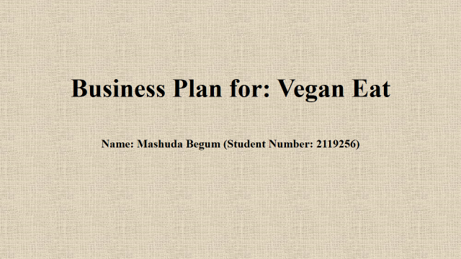
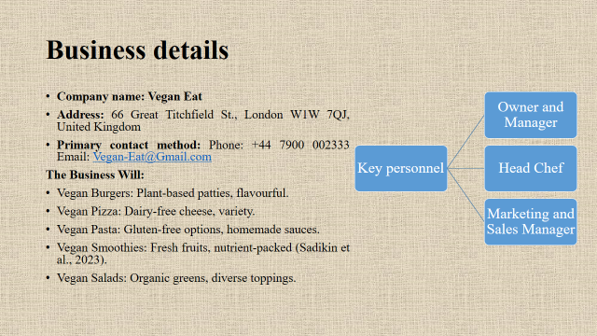
Vegan Eat will be a cozy vegan restaurant with a vast menu. Our vegan restaurant serves appetizers, mains, desserts, and drinks online and offline. Our recipes are fresh and tasty thanks to cruelty-free, local, and seasonal ingredients (Sadikin et al., 2023). Vegan Eat offers gluten-free, nut-free, and soy-free solutions for all diets. Sustainable delivery and takeaway packaging are part of our environmental efforts. Vegan meals are easy to order and deliver online for busy customers. Vegan Eat prioritizes health, sustainability, and deliciousness to be the community's favorite vegan restaurant. We want to provide a pleasant environment where customers may enjoy guilt-free, cruelty-free food that nourishes body and soul.
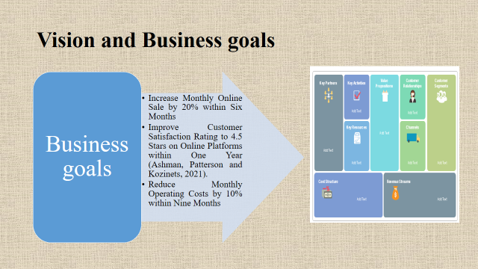
A modest vegan restaurant, Vegan Eat, will serves only vegan meals. Taste, health, and sustainability are our company's Value Proposition for vegans, health-conscious, and eco-conscious consumers. Sustainable operations, menu innovation, and cruelty-free ingredients are crucial. Our consumers are vegans, vegetarians, health-conscious folks, and environmentalists seeking ethical food. We attract these groups with a comfortable restaurant, online ordering and delivery, and strategic partnerships with local and eco-friendly retailers (Ashman, Patterson and Kozinets, 2021). Vegan food, catering, merchandising, and potential collaborations with like-minded people and organizations are our main revenue streams. Professional chefs, premium ingredients, and restaurant space are needed. Our goal is customer relationships, therefore we deliver outstanding service, unique experiences, and ongoing interaction through social media and reward schemes. The cost covers ingredients, labor, rent, marketing, and eco-friendly packaging. Our ethical and sustainable sourcing and delivery show our dedication to improving society and the world.
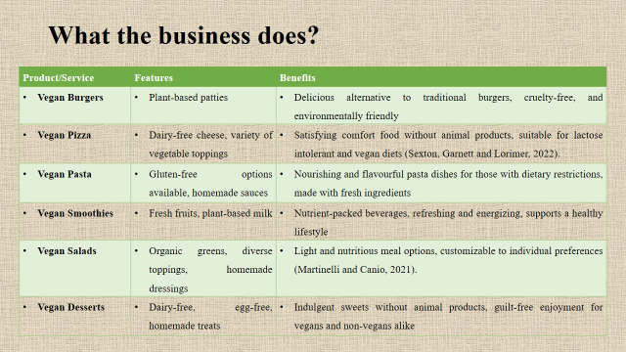
Vegan Eat provides delicious plant-based meals with health, sustainability, and ethics in mind. Delicious, cruelty-free, and eco-friendly vegan burgers. Vegan Pizza serves vegan and lactose-intolerant customer’s fluffy pizza with dairy-free cheese and vegetables. Gluten-free vegan pasta and fresh-ingredient sauces satisfy restrictive eaters (Sexton, Garnett and Lorimer, 2022). Our Vegan Smoothies are flavourful and healthy with fresh fruits and plant-based milk. Our vegan salads are light and customised with organic greens, toppings, and handmade sauces. Finally, vegans and non-vegans may enjoy our Vegan Desserts guilt-free. Vegan Eat has a varied plant-based cuisine to fulfil hunger.
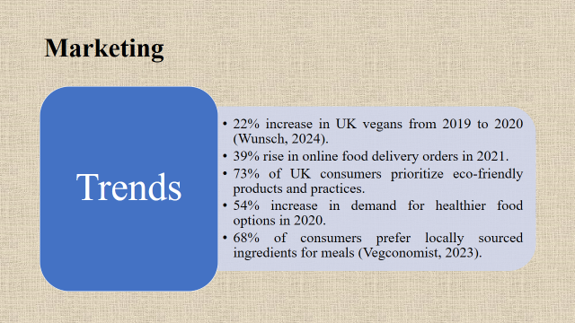
Vegan Eat joins changing consumer markets. Wunsch (2024) estimates a 22% rise of UK vegans from 2019 to 2020. Online food delivery orders rose 39% in 2021, underscoring convenience. Environmentally conscious UK consumers now prefer eco-friendly products and practices (73%). Healthy food demand increased 54% in 2020, indicating a shift. Local food is eaten by 68% of consumers, per Vegconomist (2023). Vegan Eat can meet today's discerning consumers' need for plant-based, sustainable, and locally produced food.
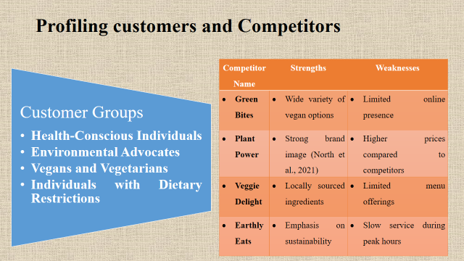
Competitive vegans have perks and cons. Green Bites offers vegan options for all tastes, but their website is lacking. According to North et al. (2021), Plant Power has a good brand but higher prices that may deter cost-conscious customers. Eco-conscious visitors visit Veggie Delight for locally produced food, however its selection may be limited. Customers desire sustainability from Earthly Eats, but peak-hour delays may disappoint. Despite its challenges, Vegan Eat offers diverse vegan meals, environmental practices, and exceptional customer service to attract discerning guests.
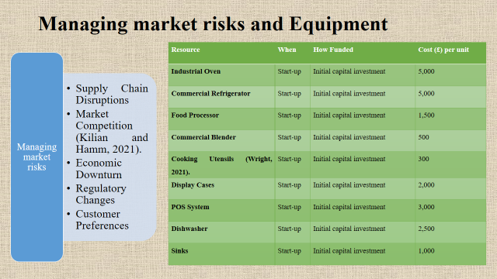
Vegan Eat will use startup funds to streamline operations and improve dining. Also included: industrial oven, commercial refrigerator, food processor, blender, cooking utensils, display cases, POS system, dishwasher, and sinks. Each requires £300–£5,000 startup capital. These costs produce and preserve high-quality vegan food, clean, and simplify POS (Kilian and Hamm, 2021). Vegan Eat will deliberately invest in these resources to build a solid basis and provide good value. With these resources, Vegan Eat can serve a tasty vegan meal, fast service, and a friendly ambiance, setting the framework for long-term growth and sustainability in the competitive restaurant market.
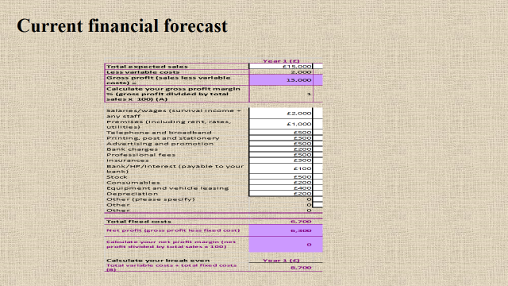
This is showing current financial forecast.
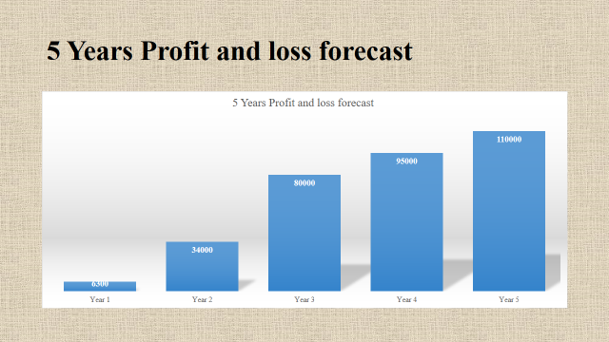
This is showing 5 years profit and loss forecast. From this, it can be clearly seen that the business profit is increasing gradually.


