

Understanding Organisational Structure and Culture
LCBB4009
Component 1: Practical: Individual presentation
Title: Presentation on Sainsbury’s methods of designing organisational structure

Student Name: FLORINA LOIZIDIS
Student ID: 2013750

Slide 1: Cover Slide

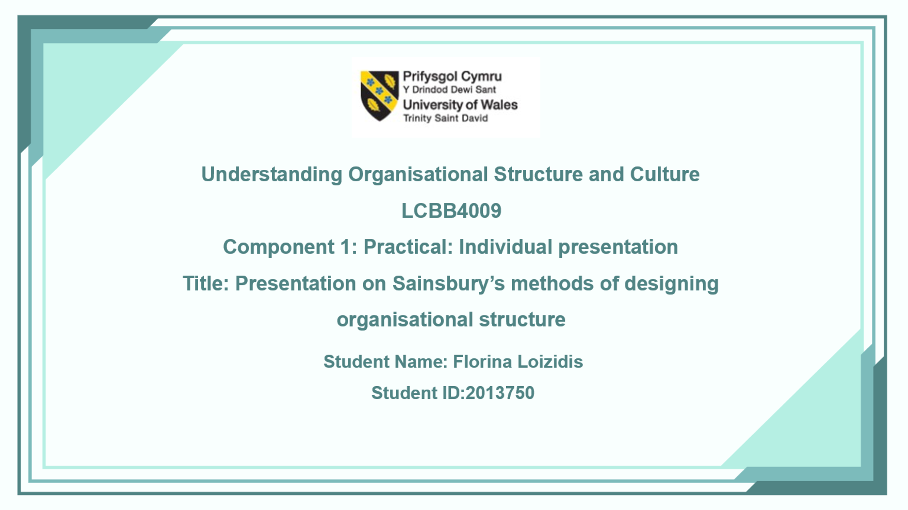
Slide 2: Introduction
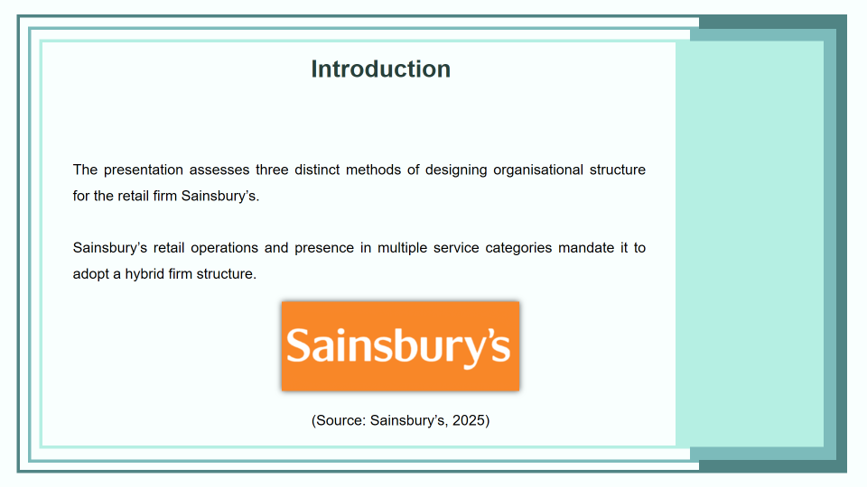
Speaker Notes
I have detailed the distinct methods of firm structure for this presentation by considering the properties of firm structure. Within this presentation, I propose the adoption of initiatives that are aimed to enhance the management of Sainsbury’s by identifying viable structures for the firm to operate on.

Slide 3: Concept of Organisational structure, chart, and its importance
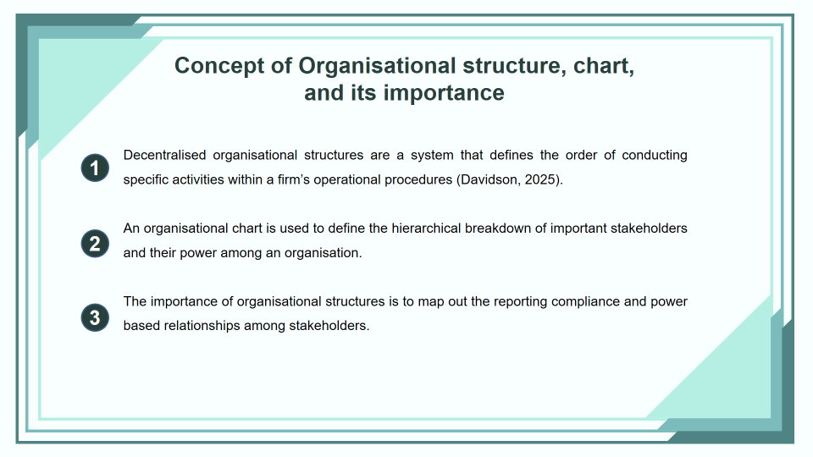
Speaker Notes
I have assessed that the concept of organisational structure is to identify the reporting lines that define the span of control within an organisation. I believe that it is important since it enables stakeholders to identify their reporting liabilities and their main stakeholders.

Slide 4: Explain each of the ways of designing structure of an organisation
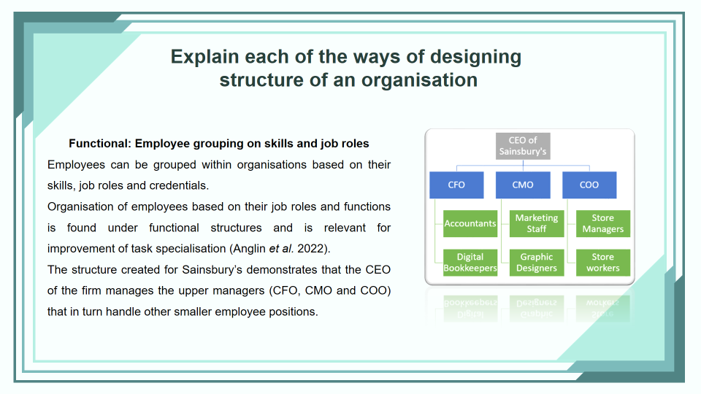
Speaker Notes
I have demonstrated that the grouping of employees as per their skills and job roles constitutes the functional approach to structure and is useful for maintaining clear communication lines within Sainsbury’s.
Slide 5: Explain each of the ways of designing structure of an organisation
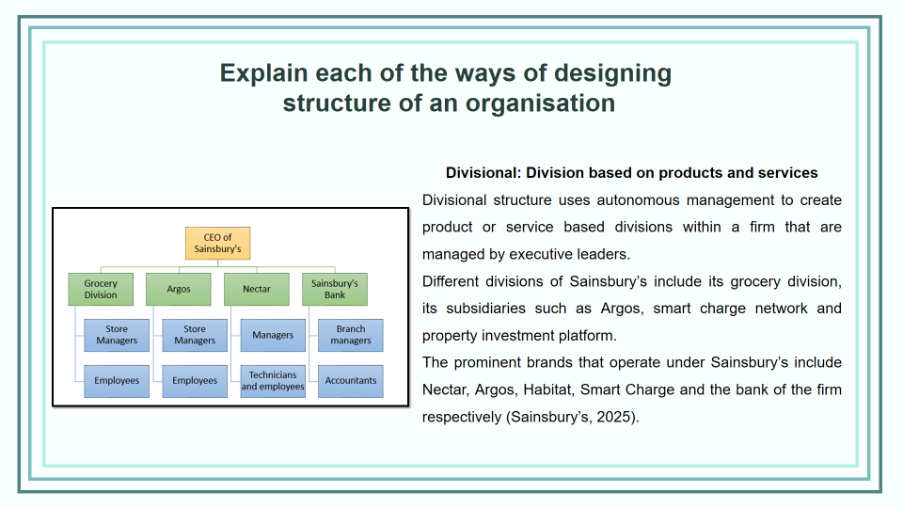
Speaker Notes
I have demonstrated the decision of firm structure based on different departments of Sainsbury’s and considered its various subsidiaries to formulate the figure. Thus, I believe that this division method can be effective if the different managers are able to manage their individual departments effectively.

Slide 6: Divisional: Division based on products and services
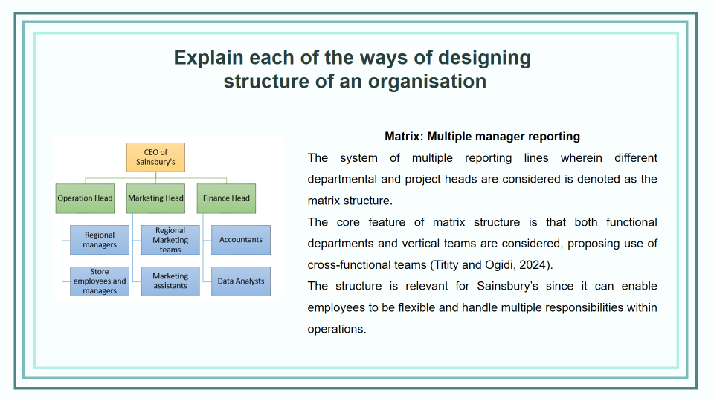
Speaker Notes
I have demonstrated above the essence of dual reporting lines wherein vertical and horizontal divisions of stakeholders are considered in a firm structure. I believe that this structure would be relevant for Sainsbury’s as it enables the firm to maintain cross-functional teams to enhance lead times.

Slide 7: Relevant theories and frameworks
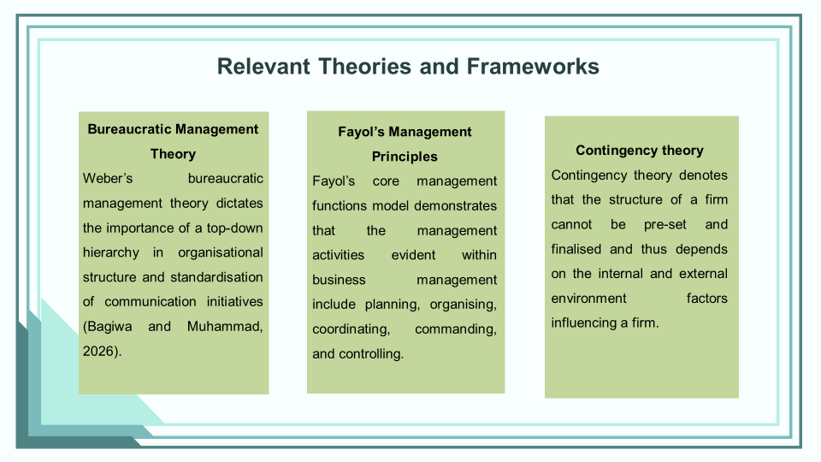
Speaker Notes
I have used the concepts that I learned from the bureaucratic management theory, Fayol’s principles and contingency theory to guide my learning initiatives during this presentation.

Slide 8: Conclusion
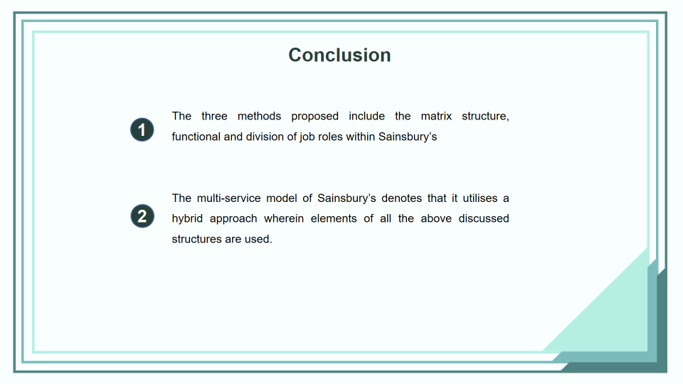
Speaker Notes
Within this presentation, I have elaborated on the hybrid structure of Sainsbury’s and the three distinct methods that can be used to frame organisational structure.

Slide 9: Reference List
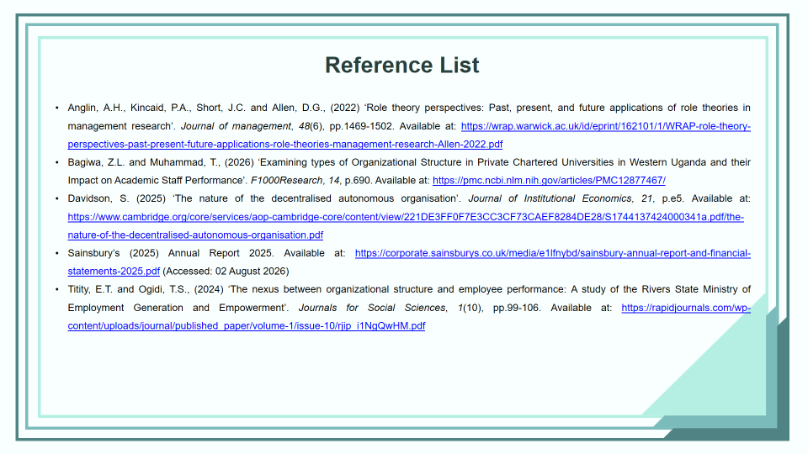

Slide 10: Thank You


Reference List
Anglin, A.H., Kincaid, P.A., Short, J.C. and Allen, D.G., (2022) ‘Role theory perspectives: Past, present, and future applications of role theories in management research’. Journal of management, 48(6), pp.1469-1502. Available at: https://wrap.warwick.ac.uk/id/eprint/162101/1/WRAP-role-theory-perspectives-past-present-future-applications-role-theories-management-research-Allen-2022.pdf
Bagiwa, Z.L. and Muhammad, T., (2026) ‘Examining types of Organizational Structure in Private Chartered Universities in Western Uganda and their Impact on Academic Staff Performance’. F1000Research, 14, p.690. Available at: https://pmc.ncbi.nlm.nih.gov/articles/PMC12877467/
Davidson, S. (2025) ‘The nature of the decentralised autonomous organisation’. Journal of Institutional Economics, 21, p.e5. Available at: https://www.cambridge.org/core/services/aop-cambridge-core/content/view/221DE3FF0F7E3CC3CF73CAEF8284DE28/S1744137424000341a.pdf/the-nature-of-the-decentralised-autonomous-organisation.pdf
Sainsbury’s (2025) Annual Report 2025. Available at: https://corporate.sainsburys.co.uk/media/e1lfnybd/sainsbury-annual-report-and-financial-statements-2025.pdf (Accessed: 02 August 2026)
Titity, E.T. and Ogidi, T.S., (2024) ‘The nexus between organizational structure and employee performance: A study of the Rivers State Ministry of Employment Generation and Empowerment’. Journals for Social Sciences, 1(10), pp.99-106. Available at: https://rapidjournals.com/wp-content/uploads/journal/published_paper/volume-1/issue-10/rjip_i1NgQwHM.pdf

GAI Declaration
I have not made use of any form of generative AI for this assignment. I have only used relevant and valid information I sourced from books and journals.

