

LEVEL 4

MODULE CODE: BMSA4001
Developing and Supporting Early Childhood Physical Development
aSSESSMENT TYPE: Reflective journal
Assessment/Component: 1

COMPONENT WEIGHTING: 50 %

WORD COUNT: 2000 WORDS (approx. 1000 per cycle)

MODULE TUTOR: Nalda Wainwright

SUBMISSION DETAILS:

You need to complete two reflective journal cycles. Each cycle should demonstrate specific learning about the practical implementation of the SKIP-Cymru programme in your setting.

Your reflections should link your experiences with relevant literature and key theories relating to early childhood physical development. Each cycle should clearly demonstrate progressive developments in your knowledge, understanding and skills in relation to the implementation of SKIP-Cymru.

Submit via Turnitin

School of Sport, Health & Outdoor Education

Assessment Feedback Sheet

Student No./Name: Steffan Wyn Phillips

Personal Evaluation – to support your academic progress please complete the section below BEFORE submitting your work.
What do you consider to be the best aspects of this work? |  |  | I think my use of referencing was good to help support my points and to strengthen my observations.
Which aspects do you consider could have been improved in this piece of work? |  |  | Perhaps the structure of my work.
What have you found most satisfying whilst undertaking this submission? |  |  | That I’ve had the opportunity to improve my knowledge through my reading and reflections.
ASSESSMENT CRITERIA | Learning  Outcomes |  | GRADE
ASSESSMENT CRITERIA |  |  | Poor  < 20% | Weak  20-29% | Unsatisfactory  30-39% |  | Satisfactory  40 – 49% | Good  50 – 59% | Very Good  60 – 69% | Excellent  70 – 84% |  | Exceptional  85– 100% | %
Overview of setting and evaluation of practical activities | 3 |  |  |  |  |  |  |  |  |  |  |  | 30%
Reflection and analysis of practical delivery. Linking reflections to child development, motor development theory and implications for future practice | 2,3 |  |  |  |  |  |  |  |  |  |  |  | 40%
Analysis of pupils’ physical skills and implications for their development, Physical activity and self-perceptions | 1, 2 |  |  |  |  |  |  |  |  |  |  |  | 30%
It is expected that students will present work that is proof read, correctly referenced and adheres to the Assessment Checklist. Therefore a range of 0 – 10 marks will be deducted for non-completion of any of the points on the checklist below.
TUTOR COMMENTS:

Submission date:  via Turnitin |  | Return date:  (at least within 4 weeks) |  |  |  | Tutor: Nalda Wainwright |  |  |  |  | Mark:

Reflective journal

This reflective journey is based on my delivery and experience of SKIP Cymru sessions within Ammanford Nursery school where I am a Foundation Phase Teacher. The delivery of sessions was focused within my class where I had 31 pupils aged 3-4 years old. As a school we are in a deprived area, where we have noticed that many of pupils have specific barriers which hinder their ability to participate in activities outside of school. Many of these pupils also find it difficult to sit and concentrate within adult led activities during the day, which has become a big challenge for some of the class teachers
My aim while running SKIP Cymru sessions was to deliver sessions every other day during the week, in order to give my pupils plenty of opportunity to participate and engage in a broad range of physical activities. This was something that I identified that was very important for my pupils to do as Gallahue, Ozmun and Goodway (2012) stated, that the more opportunities that young pupils have to access physical activity the more opportunity they will get to develop their Fundamental Motor Skills (FMS), which is supported by Burton & Miller (1998) who state that good FMS are the building blocks needed for young people and adults to do more advanced movement skills and also to focus their skills on specific sport skills as they grow. In reflection on reading these findings it was very apparent to me that I must make sure that all my pupils had constant opportunity to build a good movement vocabulary and also be given constant opportunity to practice and improve their skills which is supported by SKIP Cymru (2016).
One of the main desired outcomes from these sessions was to help provide plenty of positive and fun experiences for my pupils in physical activity, to ensure that it was something that they would love to do for the rest of their lives. It was very encouraging to see how the attitudes of pupils had changed throughout the course of running the sessions where pupils would be really excited to go out and have their turn to do sessions, with one pupil stating “yes I love doing that”. This strengthened and allowed me to see in person that “within every child there is a great inner drive to develop sensory integration” (Ayres, 2005 :15) which also links with Hodgson (2001 : 172) of the importance of pupils having opportunity to move, as it states “everything that we discover about life, we discover through movements”. The importance of providing these opportunities is even greater after reading the statistics by the NHS (2021) which stated that 26.9% of children in Wales are overweight or obese, which is much higher compared in England with 22.6% and 22.4% in Scotland. It is vital that we as educators ensure that we provide our pupils with good quality and positive physical education, as it will encourage physical activity for life. This is also suggested by Stodden et al (2008) in regards to the relationship between proficiency in our motor competence and physical activity levels, where if they can apply good FSM in their physical activities they will be less likely to drop out compared to someone with lower FSM ability. This strengthens my belief of the importance of SKIP Cymru session within school, as it allowed me to correctly identify the stages that pupils were at, to set the correct level of activity for each pupil in order to give them higher chance of success, thus hopefully leading them to a positive spiral of Engagement. (See Figure 1)

Figure 1 - Developmental mechanisms influencing physical activity trajectories of children
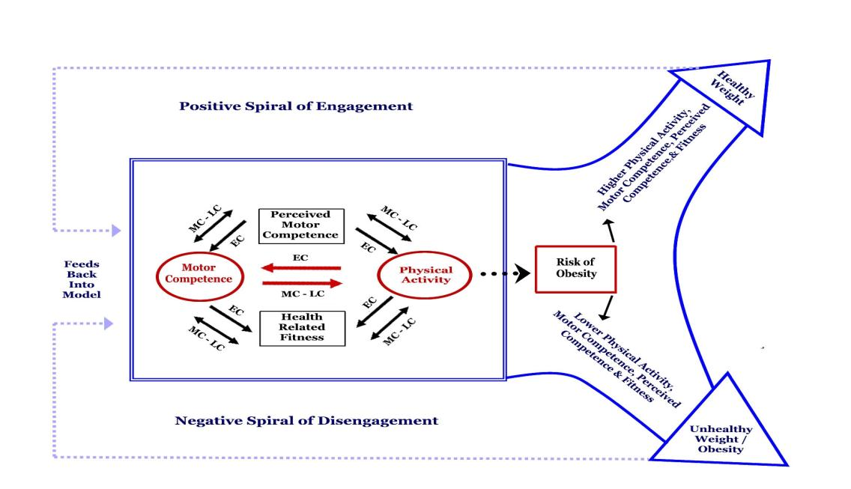
(Stodden et al, 2008: 294).
We aimed at developing our pupils fundamental movement skills in terms of their locomotor skills, which Gallahue et al (2012) states are a group of fundamental motor skills that allow individuals to move from one point in the space to another, and also their manipulation skills that allow them to have controlled contact with objects in their environment (Gallahue et al, 2012), we also wanted our pupils to become ready to learn within the classroom where it was stated by SKIP Cymru (2016) that when a child is allowed to move and improve their skills, their brain will develop more connections that aid their ability to learn to process information quicker and more efficient which will aid them greatly within the classroom. Through focusing on these FMS, I am giving my pupils the steppingstones needed in their motor development and their lifelong participation in physical activity (Stodden et al 2008). This is also supported by Clark & Metcalfe (2002); Seefeldlt (1980) as they state that these skills are vital for the foundation of any future movement and their physical activity. As Gallahue et al (2012) suggests that these FMS should be developed in pupils early and middles years which gives myself a greater responsibility to give my pupils the correct activities with my pupils being aged 3-4 years old. This is supported by Stodden et al (2008: 298) who “believe the acquisition of motor skill competence in FMS in early childhood (2–5 years of age) serves to promote physical fitness, because time spent initially developing these skills promotes increased physical activity and neuromotor development".

The initial sessions, my main focus was to teach the pupils about their spatial awareness in order for them to understand and develop how they can move within their own personal space, this consisted of having the pupils within the garden and to encourage and show them how to find and move within their space safely. This was a new concept to many of the pupils, I showed them by modelling and guiding pupils to space within the garden. Once this was understood by pupils, I could then introduce them to the concept of moving safely within the general space. Within the garden the focus was on how they travelled in the space with the focus on the direction, levels, pathways and their locomotor skills which are to Run, Hop, Skip, jump and gallop. Before attending the course, I had no idea regarding the concept that this was something that pupils needed to be taught, as I thought it would have been something that pupils would learn within their spontaneous play. I also was unaware of the stages that were present in the locomotor movements, and how important these are for their future participation in physical activity, this is highlighted by Gallahue et al (2012: 247) as they state that “Developing basic competence in locomotive skills is essential for the engagement in meaningful physical activity for health and to move effectively in various games, and dances.” I was also very surprised while assessing pupils movements in the gardens, on how the pupils I assumed that were good movers and were aware of their spatial awareness as they were visually more active outside, were in fact worse than pupils who were slower and steadier movers in the outdoors. I was also naïve to the fact that Skip Cymru (2016) also stated that until pupils are proficient movers that they should not take part in sport games at all. Through developing my knowledge of these developmental sequences, I have thus developed my own personal ability to “design developmental appropriate movement experiences for the children” (Gallahue et al, 2012: 247).

During these sessions it allowed me to focus on the locomotor stages of the pupils to group pupils appropriately. As my class has 31 pupils, I grouped the pupils into 2 groups of 10 and 1 group of 11. My observation highlighted that most of my pupils were stage 2 runners, with some pupils showing signs of being stage 3 runners. This element was really interesting to see as when pupils run out on the playground, I just assumed that they were all good runners, but through focusing on the criteria for each stage I soon realised that this wasn’t the case. In order for pupils to have success in the locomotor skills I had to reflect on how I was delivering my sessions, in regards to the instructions that I gave and making sure that my garden was big enough for them to move around in. In light of attending the SKIP Cymru sessions, it made me reflect on the way that I had been delivering session in the past, where I wasn’t giving appropriate verbal cues to pupils that would allow them to think and improve their movements further, this really did help the pupils understand what needed doing, it also led to pupils giving coaching cues to each other in regards to what they needed to do.
An element that pupils found difficult at the start was their use of pathways where I observed that when moving around the garden, they were all running around in a circle format. In order to correct this, I introduced games such as Tails and partner mirroring as warmups to help develop their skills moving in pathways, which really pulled their focus to move with their partners around the garden safely in the general space. During the session I also slowly fed more information regarding different movements for pupils to do, as I did not want to overload the information given. During my research I also became aware of the Newells constraint model which was researched by Haywood and Getchell (2005) which focused on specific constraints that effect a child’s ability to access and become confidant in the activity that you are doing. To ensure that all my pupils felt that they could take part in these activities, I ensured that I focused on the individual constraints of the pupils, I did this by changing the way that I asked and directed pupils to move. An example of this was where I’d ask pupils to perform and move like a bear around the garden on all fours, I saw that some pupils really found this difficult and could not do this. In order to ensure that pupils persevered , I changed the manner that I would direct and ask the questions for example, “show me different ways that you can travel low around the garden”, by doing this I ensured that pupils could then move in ways that they felt comfortable in which made it accessible for them to take part, resulting in increased positive experiences through being successful.
As the weeks progressed an area that I identified that needed focus was their object control regarding their throwing and catching ability. During my initial observations regarding their catching ability I noticed that most pupils were at stage one and two, where they were struggling to track the ball and hugging the ball. To develop their ability, I introduced the ‘me to you’ game where to start I got pupils to sit opposite each other and just focus on rolling the ball back and forth in order to develop their ability to track the ball and use their fingers to do so. As the pupils were spread around the garden it allowed pupils not to focus on what others were doing as SKIP Cymru (2016) stated that you could change the level of the activity specifically to each pair. This was done when pupils developed their tracking ability so I would then move the pairs that were ready to their feet in order to pass the ball back and forth. By the end of the sessions most of the pupils were stage 3 and showing good signs of being a stage 4 catchers. Despite many pupils finding it difficult they did not get discouraged, this is supported by Stodden et al (2008) who sates that young children have perceived higher motor competence, but in reality their actual motor competence is low, this highlights why the pupils persevered. To aid their development I did specific warmups that would focus on the skills needed which were their fine motor skills to make them use their fingers such as Busy bee, treasure hunt, and tail/ribbon games, to aid them using their hands to catch.
During the power throwing sessions, I observed that many of the pupils were at stage 2 and stage 3 throwers at the beginning of these sessions. This was an activity that pupils really enjoyed doing where they loved working in pairs going round the garden and having turns at throwing beanbags at targets on the wall and to throw towards markers at the floor. Pupils really gained confidence when they were successful in hitting the target and were even enjoying if they were not. As most of the pupils were doing Ipsilateral Step, I tied ribbons to their throwing and their opposite foot, where I then modeled that they needed to step and throw with opposite foot and hand. I was surprised on how quickly they developed this and was even pleased to see that pupils began to correct their partners, by reinforcing to step and throw where the ribbons were. Blythe (2005:101) highlights the importance of using both sides of the body in sync as “Both sides of the brain are involved in a the period of entrainment, and that the partner that succeeds supremacy to the other side continues to provide a supporting, if secondary role”.

Participating in these SKIP Cymru sessions has really opened my eye in regards to the importance of getting the FMS in place as this young age to provide necessary skills needed for these children to live healthy and active lives, as Stodden et al (2008) states without these skills they will have limited opportunities to take part in any physical activity without being proficient in running, jumping, catching and throwing.

Reference list

Ayres, J. A. (2005) Sensory Integration and the child. Understanding Hidden Sensory Challeges. Los Angeles, CA: Western Psychological Services.

Burton, A.W, & Miller, D.E. (1998). Movement Skills assessment. Champaign, IL: Human Kinetics.

Clark, J.E., & Metcalfe, J.S. (2002). The mountain of motor development: A metaphor. In J.E. Clark & J.H. Humphrey (Eds.), Motor development: Research and reviews (Vol. 2, pp. 163–190). Reston, VA: National Association of Sport and Physical Education.

Gallahue, D.L., Ozmun, J.C. and Goodway, J. (2012) Understanding Motor Development: Infants, Children, Adolescents, Adults. McGraw-Hill, New York
Goddard Blythe, S., (2005) The Well Balanced Child (2nd edition) Glouscester, Hawthorn Press.

Goodway J. 2016 SKIP Cymru Ohio State University.

Haywood, K.M., & Getchell, N. (2005). Lifespan motor development (4th ed.). Champaign, IL: Human Kinetics.

Hodgson, J., 2001. Mastering movement. London: Methuen.

NHS wales. 2021. Child Measurement Programme - Public Health Wales. [online] Available at: <https://phw.nhs.wales/services-and-teams/child-measurement-programme/> [Accessed 5 July 2021].

Seefeldt, V. (1980). Developmental motor patterns: Implications for elementary school physical education. In C. Nadeau, W. Holliwell, K. Newell, & G. Roberts (Eds.), Psychology of motor behaviour and sport (pp. 314–323). Champaign, IL: Human Kinetics.

Stodden.D.F., Goodway, D., Langendorfer, S.J., Roberton, M.A., Rudisill, M.E., Garcia, C & Garcia, L.E (2008) ‘A Developmental Perspective on the Role of Motor Skill Competence’ (2008) National Association for Kinesiology and Physical Education in Higher Education 60 (2), pp. 290-306.

Assignment Checklist

- Please complete the Personal Evaluation section of the Assessment Feedback sheet, add your name and details, and paste the whole of this assignment document into the front of your assignment

- Submission is a single word file, clearly labelled with your name and module code
- Font style - Times New Roman, size -12 for text and 14 for headings
- Ink colour – black only
- Line spacing – 1.5 line spacing and 2cm- 2.5cm page margins
- Quotations more than three lines to be indented 1 line spacing
- One line space between paragraphs, paragraphs must be left aligned
- Pagination (your assignment should have page numbers)
- All tables and figures are internally referenced and have a title
- Word count checked and written at end of text (before references and any appendix)
- Assignment is within 10% of the word limit (excluding references and any appendices)
- All references in the text are included in the reference list
- Correct referencing following the Harvard style, as described in the Palgrave study skills book ‘Cite them Right’.
- Correct spelling using UK English
- Correct use of punctuation
- Grammar and syntax correct- double check anything that has a green line under it
- I have read my assignment out loud to myself and it makes sense and is easy to read
- Somebody else has read my work and it makes sense to him or her!
- I have checked and I have not plagiarised
Failure to follow these guidelines will cost you marks!

