To create an insight into the opinions of unarmed techniques taught during Officer Safety Training amongst serving Police Officers in the United Kingdom, I have created a survey based around their feelings around this subject. This survey has then been proliferated on various platforms to which to be accessed by South Wales Police officers. The survey was advertised to be completed by serving Police Constables and Police Sergeants on various platforms only accessible to South Wales Police Officers and Staff. Although 59 participants started this survey only 52 participants answered all questions. This is not known if this is due to technical of if the 7 participants grew fatigued through 13 questions. This survey was anonymous to allow the participants to answer without the fear of being scrutinised by their answers therefore having no biased in the answers given.



I felt it was important to ask the length of service of the participating Police Officers and Sergeants to give an idea of how long the individuals completing the survey had been serving officers to show the scope of the answers being given. The results showed that the majority of officers were either 10+ year veterans or had only been in the role for 3 years and under.

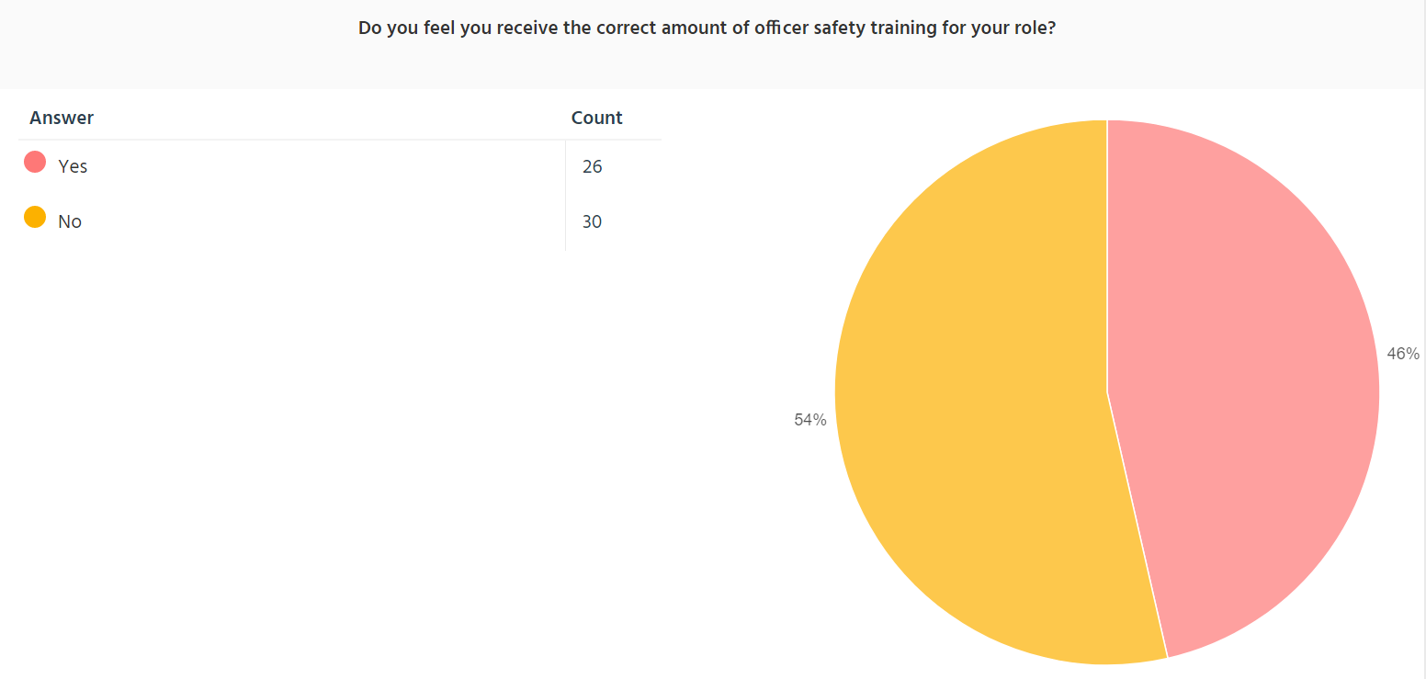

I have decided to ask these serving officers if they felt they had the correct amount of Officer Safety Training as I know there are many different demands on the officer’s time without including training for of other aspects of the role. Therefore, I wanted to know what the general opinion was of the amount of input to be put into this subject. The results of this were fairly split with 54% stating it was not the correct time whereby 46% stated it was.

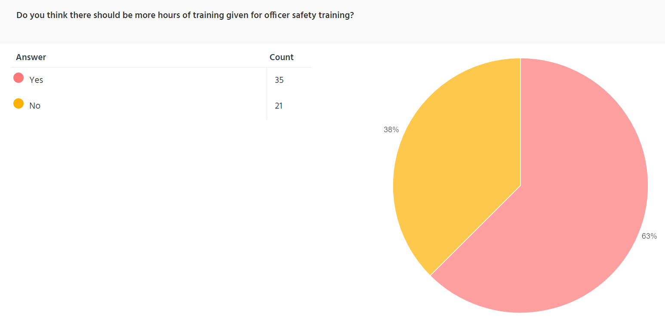
Whether more hours of training should be given to Officer Safety Training was then asked to see if serving officers needed more time on this subject to perfect techniques. The results showed that the majority of Police Constables and Sergeants think that there should be more time given to officer safety training with 63% thinking there should be more hours of training given to this.
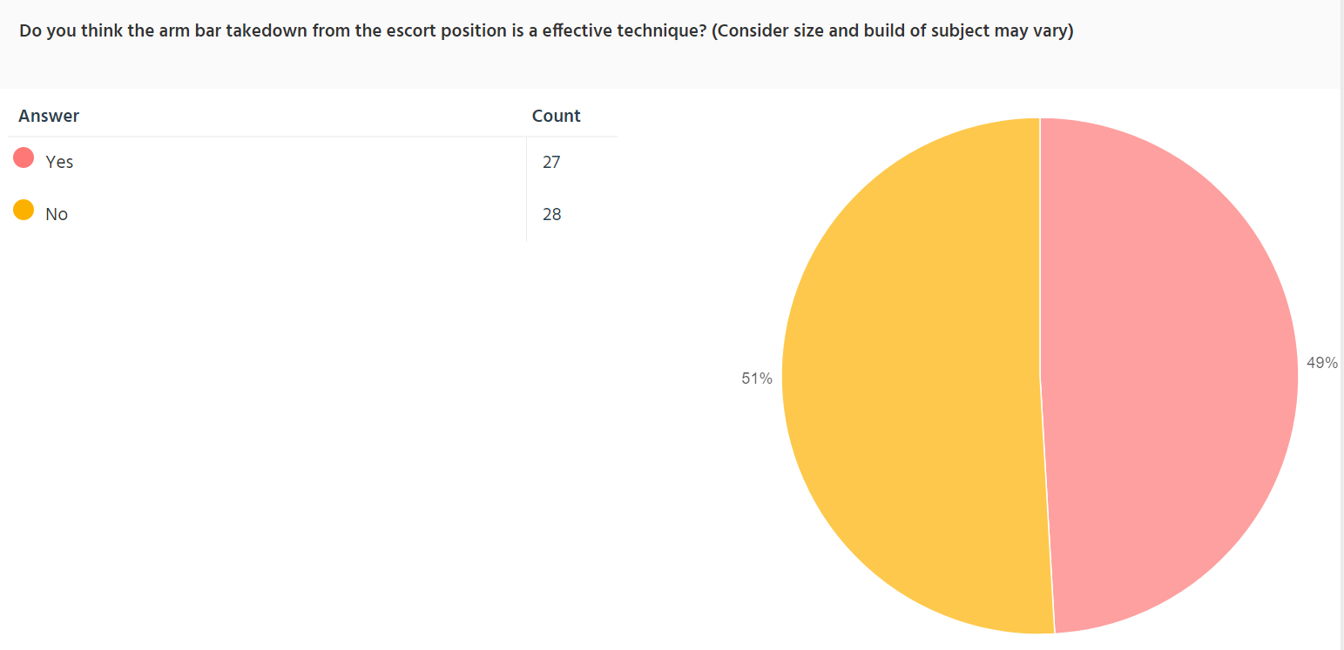
I have then started to ask the serving Police officers about the specific techniques taught in Officer Safety training. Police Constables and Sergeants were mostly split as to whether the armbar takedown technique from the escort position was an effective with 51% showing to have answered no and 49% answered yes.

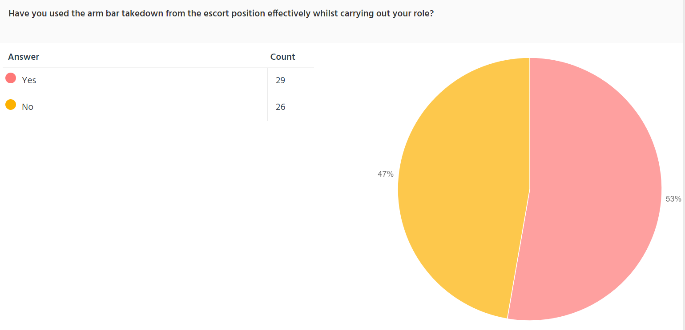
I have then asked that if the serving officers have effectively used this technique whilst carrying out their role. The results showed that the majority had used this technique by a small margin as 53% said they had used the technique effectively whereas 47% have said they have not.

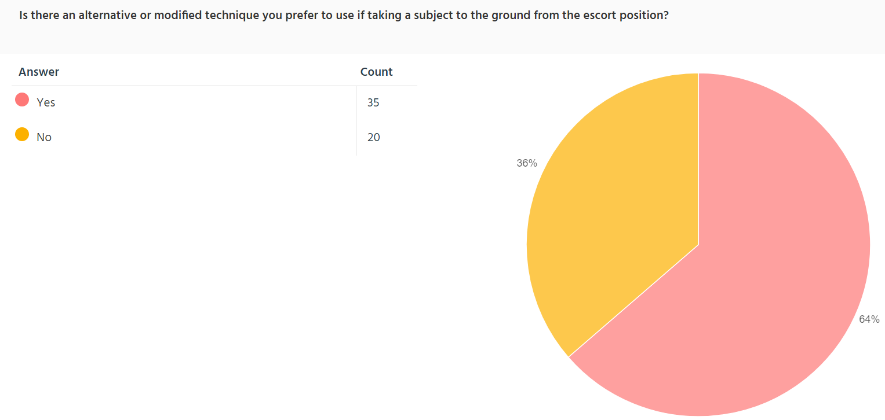
I have then gone on to ask if the serving Police Constables and Sergeants prefer an alternative technique to take a subject to the ground from the escort position. I have this question to enquire whether serving Officers are using planed alternative techniques over the ones taught in training. The majority of the officers said they did have an alternative technique that they use with 64% saying they did along with 36% said they did not.

I have them implemented the same methid of questioning with the remaining techniques discussed in this survey and the results are as follows.

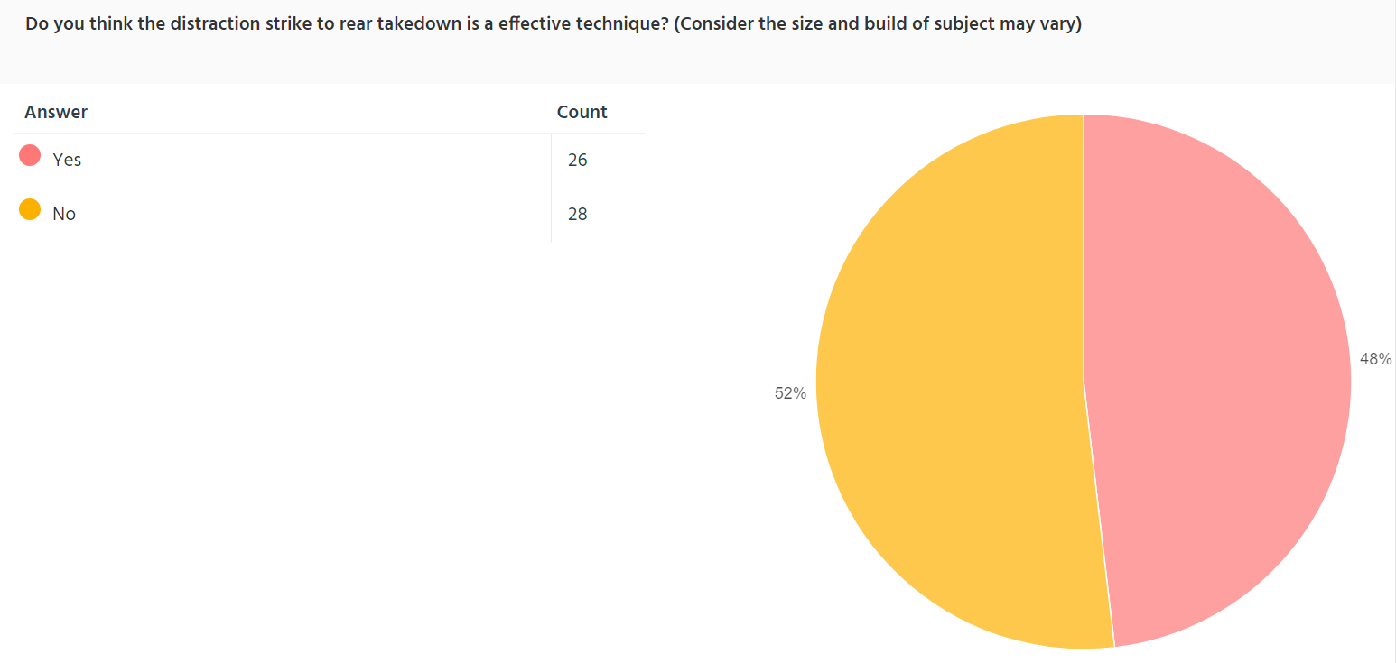
52% have stated that they do not think the distraction strike to rear takedown is an effective technique whereas 48% said that its was.

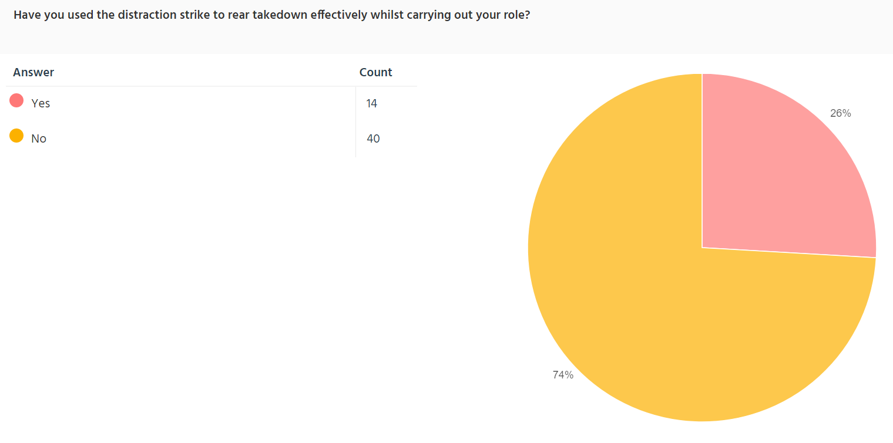

74% have said they have not used this technique during their role and 26% said they have not.

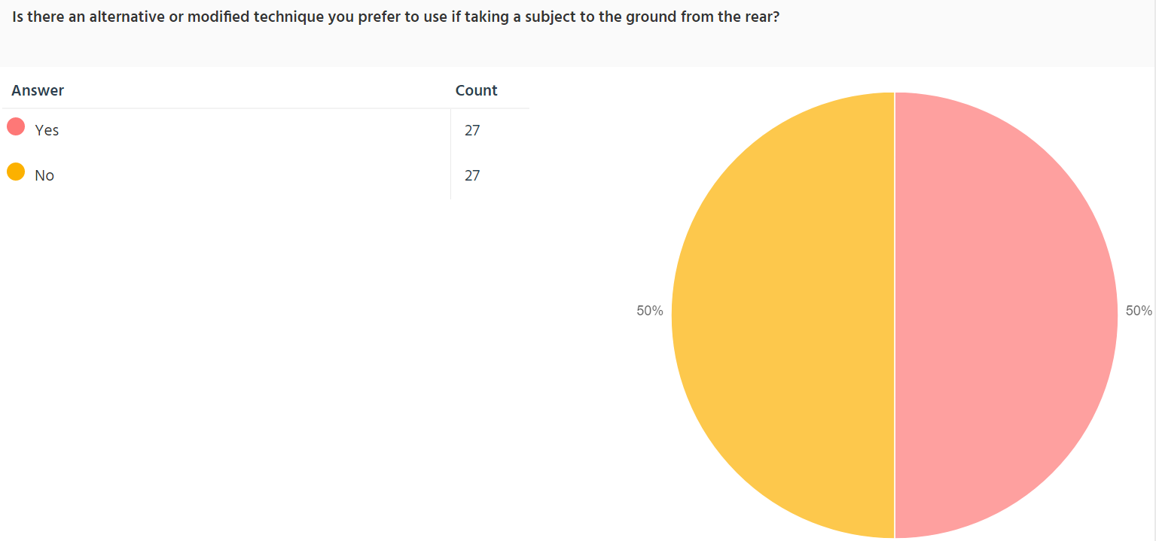

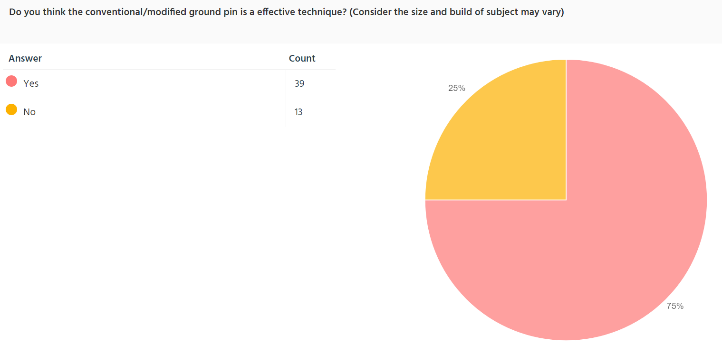

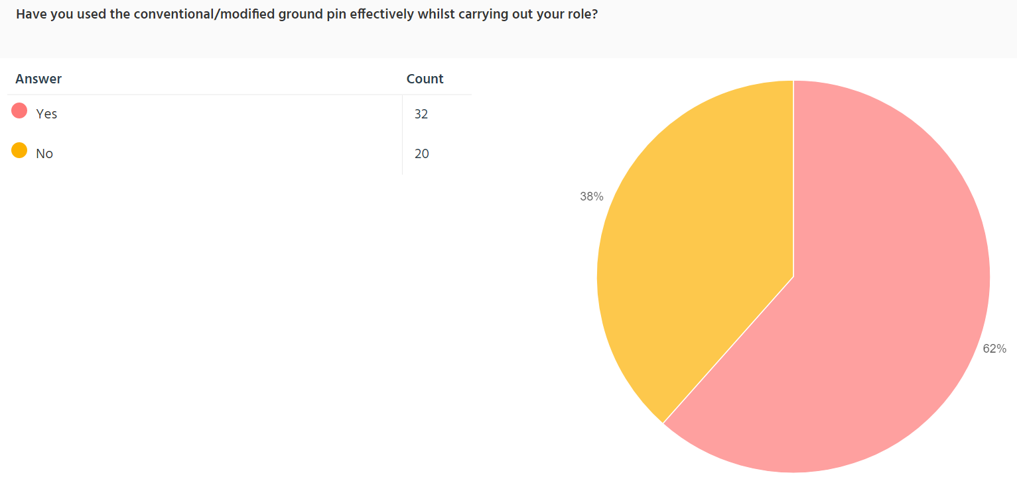

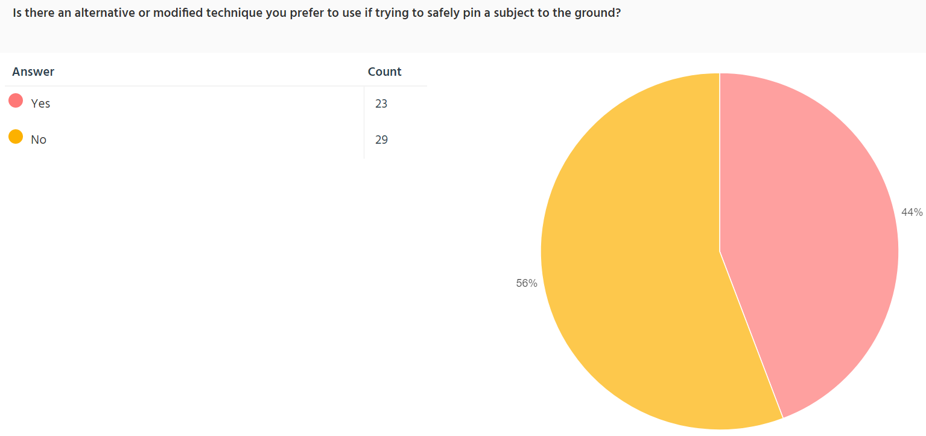

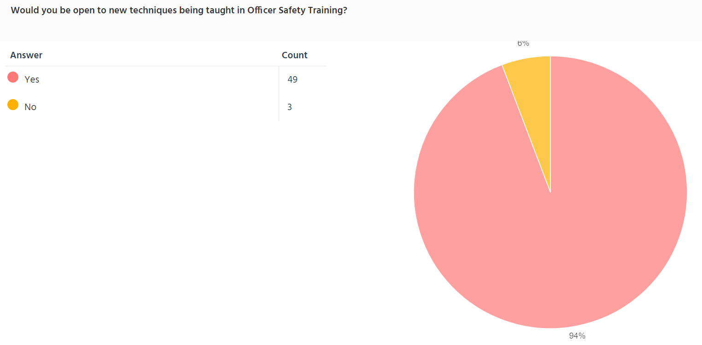

In conclusion of these results it shows that the majority of Serving South Wales Police Officers express that there should be more time dedicated to Officer Safety Training. Also the opinions on whether certain techniques taught are effective are either split or negative accept for the conventional/modified ground pin. The majority of officers seem to have expressed that they use alternative techniques than the ones taught in officer safety training therefore this maybe due to them finding something more effective to control a subject safely. Lastly an overwhelming majority of serving officers are open to learning new techniques. Therefore there should be a opening for new techniques to be taught which maybe more effective and not leading to officers using alternative techniques not taught in training.

