

A Study of Predicting Software Defects Using Machine Learning Techniques
by
Md Nabil Rahman

Supervisor: Divya Chidambaram
Second Marker: Nathan Morgan

Project submitted as part of the requirements for the award of MSc Software Engineering and Artificial Intelligence

September 2026

DECLARATION

I, Md Nabil Rahman declare that I am the sole author of this Project; that all references cited have been consulted; that I have conducted all work of which this is a record, and that the finished work lies within the prescribed word limits.

This work has not previously been accepted as part of any other degree submission.

Md Nabil Rahman
Signed : .............................................

07/09/2026
Date : ...............................................

FORM OF CONSENT

I Md Nabil Rahman hereby consent that my Project, submitted in candidature for the MSc Software Engineering and Artificial Intelligence degree, if successful, may be made available for inter-library loan or photocopying (subject to the law of copyright), and that the title and abstract may be made available to outside organisations.

Md Nabil Rahman
Signed : .............................................

07/09/2026
Date : ...............................................

Acknowledgements
Thanks to my supervisor, Divya Chidambaram, University of Wales Trinity Saint David, for their guidance, encouragement and constructive feedback throughout this project. The work was significantly shaped and refined by their expertise in machine learning, research methodology and academic writing. I also thank my family for their support and patience throughout my studies, and the University of Wales Trinity Saint David for their digital library and online resources, which served as the basis for my research on software defect prediction, ensemble learning and explainable machine learning.

Abstract
A software defect prediction (SDP) technique can aid in early prediction of fault-prone software modules which enable limited testing effort to be targeted where it is most needed. There are many publications on machine learning for this field showing nearly perfect accuracy, which is hard to replicate, due to class balancing or feature selection before splitting the data, due to the lack of explainability or due to not considering imbalance-aware evaluation. This research proposes a leakage-controlled and explainable pipeline to compare the stacking ensemble of Random Forest, XGBoost and Support Vector Machine (SVM) with the individual classifiers (Random Forest, XGBoost and SVM) and the dataset of NASA PROMISE (CM1, KC1, PC1 and JM1) for defect prediction. Physiologically consistent preprocessing was applied: median imputation, min-max scaling, label encoding, SMOTE oversampling and Recursive Feature Elimination was implemented only within the ten-fold stratified cross validation folds, as this way no information from the test partition could seep into the training partition. Wilcoxon signed-rank testing, SHAP and LIME explanations, and a controlled data-leakage ablation were used to evaluate models' accuracy, precision, recall, F1-score, AUC-ROC, and Matthews correlation coefficient. On leakage controlled evaluation the stacking ensemble was not better than the single classifiers, while on three of the four datasets Random Forest was as good as or slightly better than the single classifiers on F1 and MCC, and simple linear models were better on the most imbalanced dataset (CM1). Note that for each dataset, the principal finding is the leakage ablation, which involves fitting SMOTE and RFE on the whole dataset prior to splitting, and which inflated the F1 score of the ensemble from 0.169 to 0.937 on CM1 and its MCC score from 0.094 to 0.873, with comparable inflation between 0.46 and 0.79 for all datasets. The selected operand and code-size metrics were consistently found to be the most influential metrics, as per the literature in software engineering. Results are neither extreme nor biased, and offer a template for reproducible software defect prediction that can be methodologically defended.

Table of Contents
Declaration of Originality 2
Form of Consent 2
Copyright Acknowledgement 2
Acknowledgements 2
Abstract 2
Table of Contents 4
List of Figures 7
List of Tables 7
1 Chapter 1: Introduction 8
1.1 Context and Background 8
1.2 Statement of the Problem 8
1.3 Research Aim and Objectives 9
1.4 Significance of the Study 9
1.5 Structure of the Report 9
2 Chapter 2: Literature Review 11
2.1 Introduction to the Literature Review 11
2.2 Machine Learning Approaches to Defect Prediction 11
2.3 Deep Learning versus Classical Machine Learning for Tabular Data 12
2.4 Explainability Frameworks 12
2.5 Data Preprocessing, Class Imbalance and Dataset Limitations 12
2.6 Reproducibility, Data Leakage and Emerging Directions 13
2.7 Literature Summary 13
3 Chapter 3: Research Methodology 14
3.1 Research Philosophy 14
3.2 Research Approach 14
3.3 Research Strategy: Design Science Research 14
3.4 Research Method and Strategy 15
3.5 Research Materials 16
3.5.1 Dataset Selection and Justification 16
3.5.2 Data Recording and Data Working Methods 16
3.5.3 Ethical Considerations 16
3.5.4 Required Software, Libraries and Hardware 17
3.6 Methods of Data Analysis and Evaluation 17
3.7 Chapter Summary 18
4 Chapter 4: Design and Implementation 19
4.1 Development Environment and Tools 19
4.2 Dataset 19
4.2.1 Class Balance 19
4.3 Exploratory Data Analysis 20
4.4 Data Preparation 21
4.4.1 Missing Value Treatment and Encoding 21
4.4.2 Feature Scaling 21
4.4.3 Class Imbalance and Feature Selection 21
4.5 Leakage-Aware Cross-Validation and Resampling 21
4.6 Model Training and Hyperparameter Tuning 22
4.7 System Testing of the Prediction Pipeline 22
4.7.1 TC01: Dataset Loading and Label Normalisation 22
4.7.2 TC02: Leakage-Safe Pipeline Fitting 22
4.7.3 TC03: Prediction on a Clean Module 23
4.7.4 TC04: Prediction on a Defective Module 23
4.7.5 TC05: Explainability Generation 23
4.7.6 TC06: Reproducibility Check 23
4.8 Chapter Summary 23
5 Chapter 5: Evaluation of Results 24
5.1 Headline Performance 24
5.2 Statistical Significance 26
5.2.1 Error Structure and the Precision-Recall Trade-off 27
5.3 Explainability: SHAP and LIME Analysis 28
5.4 The Data-Leakage Ablation 30
5.5 Overall Model Comparison 32
5.6 Benchmarking Against the Literature 33
5.7 Chapter Summary 33
6 Chapter 6: Conclusions and Recommendations 34
6.1 Overview 34
6.2 Summary of Key Findings 34
6.3 Contribution 34
6.4 Limitations 34
6.5 Recommendations for Future Work 35
6.6 Concluding Remarks 35
7 Chapter 7: Reflection 37
7.1 Introduction 37
7.2 Technical Learning 37
7.3 Research and Methodological Learning 37
7.4 Project and Time Management 37
7.5 What I Would Do Differently 37
7.6 Concluding Reflection 38
8 References 39

List of Figures
Figure 3.1 Design Science Research (DSR) methodology flowchart.
Figure 3.2 Machine learning system architecture of the proposed framework.
Figure 4.1 Class balance across the four NASA datasets.
Figure 4.2 Feature correlation heatmap for JM1.
Figure 5.1 Proposed ensemble versus baselines on CM1.
Figure 5.2 Proposed ensemble versus baselines on KC1.
Figure 5.3 Proposed ensemble versus baselines on PC1.
Figure 5.4 Proposed ensemble versus baselines on JM1.
Figure 5.5 SHAP global feature importance on KC1.
Figure 5.6 SHAP beeswarm summary on KC1.
Figure 5.7 LIME explanation of a module predicted defective.
Figure 5.8 LIME explanation of a module predicted clean.
Figure 5.9 Effect of data leakage on F1.
Figure 5.10 Effect of data leakage on MCC.
Figure 5.11 Effect of data leakage on AUC-ROC.

List of Tables
Table 3.1 Software and hardware used in the study.
Table 4.1 Characteristics of the four NASA PROMISE datasets.
Table 4.2 Descriptive statistics for the JM1 dataset.
Table 5.1 Ten-fold cross-validation performance of all models.
Table 5.2 Selected Wilcoxon signed-rank comparisons.
Table 5.3 Effect of data leakage on the proposed ensemble.
Table 5.4 Benchmarking against the literature.

1 Chapter 1: Introduction

1.1 Context and Background
Software systems underpin almost every part of modern life, and the cost of software failure has risen accordingly. A software defect, an error in the code that causes incorrect behaviour, can range in consequence from minor inconvenience to serious financial or safety harm. Because the resources available for testing and quality assurance are finite, development teams cannot test every module of a large system with equal intensity, so there is a strong incentive to identify the modules most likely to contain defects and to focus effort there. Studies of software maintenance repeatedly show that the cost of fixing a defect rises the later it is found, so directing reviewers and testers towards the riskiest modules yields more defects caught earlier and compounds into substantial savings over a system's life (Mehmood et al., 2024).
Software defect prediction is the field concerned with building models that make this kind of prediction. An SDP model learns from historical data, typically a set of static software metrics measured from source code whose defect status is already known, and uses the learned relationship to predict whether new modules are likely to be defective. The metrics commonly used include size measures such as lines of code, control-flow measures such as McCabe's cyclomatic complexity, and Halstead's software-science measures such as program volume and difficulty. The idea of the entire field is that this structural characteristics of code has a measureable statistical signal as to the likelihood of defect, but this signal is limited, because defects can also occur due to requirements, integration and human factors which no static signal can model.
In the last 20 years, the most widely used method for SDP is machine learning. Initial efforts used single classifiers (DT, NB, LR, SVM) directly on the metric data. More recent work has turned to ensemble methods, in that a variety of individual models are combined together, with the hope that the ensemble's judgement will be more reliable and more stable than that of any single model, and towards two additional desires that have grown in importance, namely explainability of why a module was flagged and reproducibility of reported results, so that a developer can see why a module was flagged, and so that results reported by others are believed and can be independently reproduced. This study falls between these concerns, and places explainability and reproducibility as core design principles.

1.2 Statement of the Problem
While ensemble learning, class-imbalance handling and feature selection/explainability are explored individually in the SDP literature, they are rarely combined into one unified and repeatable framework. More seriously, there are many reports in the literature of good performance using evaluation procedures where data leakage is not prevented. Performing resampling using SMOTE and/or feature selection using Recursive Feature Elimination on the entire data set before applying cross validation will involve the inclusion of information from the test set in the training set, thus leading to optimistically optimistic performance (Destefanis et al., 2023). This makes it hard to gauge the progress that has been reported is genuine. The issue in question is then twofold: first, an integrated, explainable and reproducible SDP framework is missing and second, a clear, quantified and unequivocal demonstration of the amount data leakage distorts the performance that such frameworks seem to produce.

1.3 Research Aim and Objectives
The purpose of this study is to design, implement and thoroughly test an explainable stacking ensemble for software defect prediction over standard NASA benchmark datasets under a strictly leakage-controlled protocol and quantify the impact of data leakage on the performance reported by this framework:
- To critically review the literature of machine-learning related software defect prediction, including the issues of ensemble learning, class-imbalance handling, feature selection, explainability and evaluation methodology, and to determine gaps that this study aimed to solve.
- To create and perform an integrated framework that combines the Recursive Feature Elimination, the SMOTE, the heterogeneous stacking ensemble and the SHAP and LIME explainability methods, and where all the data-dependent steps are performed within the cross-validation folds.
- To compare the framework with single-classifier baselines on four NASA datasets with ten-fold stratified crossvalidation and with other imbalance aware metrics and perform statistical significance testing.
- To measure (controlled ablation) how much data leakage during the preprocessing process artificially improves the performance, and what the predictions of the framework mean with explainability techniques (4).

1.4 Significance of the Study
The importance of this work is that it is not an algorithm that is proposed, but rather an example of how software defect prediction should be studied. The study puts the field to an honest test by providing an openly reproducible pipeline that combines ensemble learning, imbalance handling, and feature selection, whose design structurally prevents any leakage, while also measuring explicitly how much apparent performance leakage the designs produce; it's a cautionary message. Many published results should be reconsidered since an acceptable model can be made to look close to perfect if two steps can be taken in advance of the cross-validation. The explainability aspect is particularly valuable because it transforms predictions into specific advice on which code properties increase the likelihood of defects – advice that is valuable without a need for any competitive claim.

1.5 Structure of the Report
This report is organized as follows: This literature review is presented in Chapter 2 and the gaps that they address are identified. The research methodology is presented in chapter 3 which comprises the research philosophy, approach, strategy, materials and methods of analysis. The framework design and implementation, such as the development environment, dataset, exploratory analysis, data preparation, leakage-aware cross-validation, model training and system testing are described in Chapter 4. The findings are then assessed in Chapter 5, which includes a section on headline performance, a section on statistical significance, a section on explainability and the data-leakage ablation, and a comparison with the literature. Conclusions, contributions, limitations and recommendations are provided in Chapter 6. Chapter 7 reflects on the project and Chapter 8 provides a list of references.

2 Chapter 2: Literature Review

2.1 Introduction to the Literature Review
This chapter summarizes literature that motivates and frames the study. It addresses the general problem of software defect prediction and metrics, then the major modelling techniques, class imbalance and feature selection, and then the issue of explainability, and finally the reproducibility and data-leakage issues that are the main concern of this dissertation. The chapter concludes with a tying of the loose ends. Citations are in the style of Harvard author-date throughout the report.

2.2 Machine Learning Approaches to Defect Prediction
Before considering models, it is worth understanding why the static metrics used in software defect prediction are believed to carry a defect signal, because the explainability analysis in Chapter 5 returns to these metrics directly. Cyclomatic complexity is theorised to relate to defects because a module with many independent control-flow paths is harder for a developer to reason about completely and harder to test exhaustively, so faults are more likely to escape review. The Halstead measures approach the same intuition from the direction of vocabulary and length: a module that manipulates many distinct operators and operands, or that is simply long, imposes a greater cognitive load and offers more opportunities for error, and Halstead even proposed a direct estimate of delivered defects derived from program volume. None of these metrics is a perfect predictor, and a long-standing criticism of the field is that static structural metrics capture only part of what causes defects, which often stem from requirements misunderstandings, integration problems or human factors that no static measure can see. This theoretical ceiling on how well any model can perform from static metrics alone is important context for interpreting the modest honest results obtained in this study, because it means near-perfect reported scores are inherently suspicious.
The modelling techniques applied to SDP span the full range of supervised learning. Single classifiers, including decision trees, Naive Bayes, logistic regression, k-nearest neighbours and support vector machines, were the early mainstay and remain competitive baselines. A consistent finding across comparative studies is that no single classifier dominates across all datasets, because the datasets differ in size, imbalance and metric distribution (Mehmood et al., 2024; Aquil and Ishak, 2020). This instability motivates ensemble methods, which combine several models to obtain more robust predictions. Bagging methods such as Random Forest reduce variance by averaging many decision trees (Breiman, 2001), while boosting methods such as XGBoost reduce bias by training models sequentially (Chen and Guestrin, 2016). Stacking trains several diverse base learners and then trains a meta-learner to combine their outputs, and has been reported to perform more consistently across datasets than any single constituent (Tamrakar et al., 2022). The theoretical benefit of stacking depends on the base learners making uncorrelated errors; where two learners misclassify the same instances, combining them adds little, a subtlety that proves important when interpreting the results of this study.

2.3 Deep Learning versus Classical Machine Learning for Tabular Data
Although deep learning dominates image and language tasks, its advantage over classical machine learning on small, tabular datasets of the kind used in software defect prediction is far less clear. The NASA datasets contain at most a few thousand modules described by around twenty numeric metrics, a regime in which tree ensembles and margin-based methods are typically as accurate as neural networks and considerably easier to train, tune and explain (Mehmood et al., 2024). For this reason the present study uses classical classifiers and a stacking ensemble rather than deep networks, which keeps the framework interpretable and reproducible and avoids the large data requirements and opacity that deep models would introduce.

2.4 Explainability Frameworks
With increasingly complex models, the need to explain the prediction has become increasingly urgent, especially when a human is to take action on the prediction. When a defect prediction is made in SDP, it includes an explanation of what metrics led to the prediction; this will help developers to understand the model and trust it, and will guide them towards remediation. There are two popular model-invariant methods. SHAP can be explained using Shapley values derived from the cooperative game theory, and it generates consistent attributions of the features across the whole model even if the model is built from different parts of the data, while also being able to explain individual predictions (Lundberg and Lee, 2017). LIME is able to describe an individual prediction by learning a simple interpretable model in its local neighbourhood (Ribeiro et al., 2016). Both have been used in previous SDP projects to prioritize metrics from NASA datasets as influencing defect predictors (Begum et al., 2023).

2.5 Data Preprocessing, Class Imbalance and Dataset Limitations
One of the most important factors in SDP is class imbalance as it is very uncommon to have defective modules. But imbalance decreases the recall on the class of interest (defective) while increasing the precision on the majority class (non-defective), thus biasing classifiers towards the non-defective class, which is the class of interest. The most widely used remedy is SMOTE, which synthesises new minority instances by interpolating between existing ones rather than duplicating them (Chawla et al., 2002). SMOTE has been combined with stacking and with feature selection in prior SDP work (Tamrakar et al., 2022), but it must be applied carefully, because interpolation can introduce multicollinearity and, if applied to data including the test partition, can cause severe leakage (Khushi et al., 2021). Feature selection addresses the redundancy present in software metric sets; Recursive Feature Elimination, a wrapper method that repeatedly removes the least important features, has been reported to achieve the highest average AUC across the NASA datasets among competing selection methods (Rahmayanti et al., 2022). The NASA datasets themselves have known limitations, including duplicate rows, which is one reason their reported performance has been questioned and one reason this study reports duplicate counts openly.

2.6 Reproducibility, Data Leakage and Emerging Directions
An increasing number of critical studies doubt the trustworthiness of published results of machine-learning, and this is no exception in SDP. Preprocessing leakage is the most harmful kind of data leakage in the SDP pipeline as synthetic instances and selected features are trained on the test data: when SMOTE or RFE are fitted on the full data set prior to cross validation (Kaufman et al., 2012; Destefanis et al., 2023). This gives an optimistically biased estimate. This study takes this criticism head-on and attempts to prevent leakage in the construction, while also measuring the magnitude of the leakage effect on the same models and data. Other areas of research that were identified as emerging in the field (e.g. cross project predictions, richer code representations) are promising and are not considered in this within project, leakage controlled study.
While data leakage is not the only threat to validity, it is the most significant threat in this study, and those forms are distinguished precisely herein. Leakage is a form of preprocessing that is addressed in this example, in which a data-dependent transformation, like resampling or feature selection, is learned from the instances which are then used for testing. Another type of leakage is duplicate leakage when the same row or very similar row is present in both the training and test partitions, and the NASA datasets have been reported to be plagued by duplicate rows, partly because of this, and partly because of this this study openly shows the number of duplicate rows in the datasets. A third form is hyperparameter leakage, by tuning model selection on the test data. This study strictly controls the first form, reports the second one transparently, and avoids the third by a priori fixing of hyperparameters. The distinction between these mechanisms is significant because one can be meticulous about one, careless about the other, and only a detailed description of the entire pipeline will enable a reader to assess which safeguards were implemented (Kaufman et al., 2012).

2.7 Literature Summary
The following issues have been identified from the literature and serve as motivation for this work. Static software metrics provide a useful but limited defect signal, there is no single magic bullet for predicting software defects, there is a problem of class imbalance and feature redundancy, both of which can be addressed with the right tools, namely: SMOTE and RFE, respectively, and there is a need for explainability, which is not fully exploited in the field up to now, such as in the form of SHAP and LIME. There are three gaps: these components are not typically combined in one repeatable approach; there is a lack of a controlled quantification of the leakage effect on realistic models and data; and there are few honest leakage-controlled baselines. All three are addressed in this study, with the second being the main contribution.

3 Chapter 3: Research Methodology

3.1 Research Philosophy
The research philosophy used in this study is positivism approach. The use of positivism is suitable as the research questions are answered based on the measured results that are obtained from the object in the form of better performance between the model and existing models in quantitative terms. The knowledge generated is not tied to any researcher's particular viewpoint, instead it is obtained by replicable evaluation of the performance of the models using free benchmark data sets.

3.2 Research Approach
It follows a deductive method. Gaps found in the literature are translated to testable propositions: (1) An integrated explainable stacking ensemble can be constructed without leakage and (2) leaky preprocessing components result in inflated apparent performance, which are then tested in a controlled computational experiment. They can be quantitative or experimental, where all the processing steps, datasets and evaluation procedure are fixed, and the treatment, in this case the proposed pipeline, is evaluated against the control treatment, in this case the baseline classifiers, using the same preprocessing and validation procedures for both.

3.3 Research Strategy: Design Science Research
The overall approach is Design Science Research (DSR), a design methodology that is popular in information systems and computing and is grounded in the creation of a useful artefact (Hevner et al., 2004; Peffers et al., 2007), in this case the explainable stacking framework. The DSR cycle employed here consists of six steps, as illustrated in Figure 3.1: Problem identification, Definition of objectives, Artifact design, Artifact development, Evaluation and communication of results, Evaluation that is looped back into design where necessary. The first leakage controlled evaluation was actually used: the ensemble failed to provide any significant improvement over the baselines, which led back to design and analysis and the inclusion of the leakage ablation as a controlled experiment, rather than its elimination.
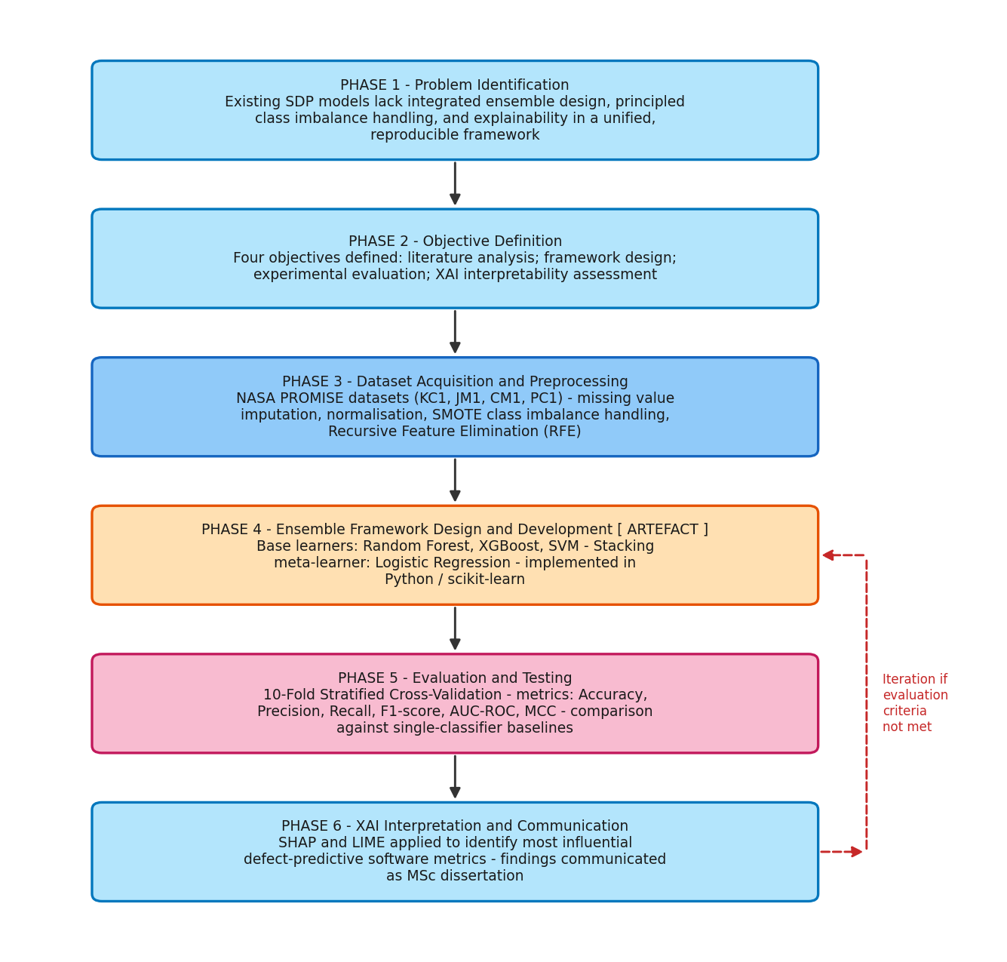
Figure 1: Design Science Research (DSR) methodology flowchart, showing the six phases and the iteration loop from evaluation back to artefact design.
Each of the four research objectives aligns directly with each of these phases. The critical literature review is the objective one, which is the same as problem identification and objective definition; it determines gaps within the existing SDP work and converts them into measurable objectives. Design and implementation of the integrated framework relates to the objective two: artefact design and development. Evaluation against baselines is objective three and is the evaluation phase. The leakage ablation and interpretability analysis objective covers evaluation and communication. The benefit of choosing an explicit research paradigm over an ad hoc sequence of experiments is that all of the objectives are covered by a specific phase in the paradigm and the study can be read as a logical progression from problem to communicated finding.

3.4 Research Method and Strategy
It is a seven-step pipeline that receives raw metric data and outputs a defect prediction and explanation of the prediction. The architecture is depicted in figure 3.2. The first four stages of the pipeline are imputation, scaling, fold-internal SMOTE, and fold-internal RFE; the fifth step is stacking with the meta-learner Logistic Regression, which combines Random Forest, XGBoost and SVM; the sixth step is the explainability (SHAP and LIME); and the seventh step is the evaluation, including leakage ablation. The key design feature is that the inequality-handling and feature-selection phases are done within each fold of cross-validation, not globally.
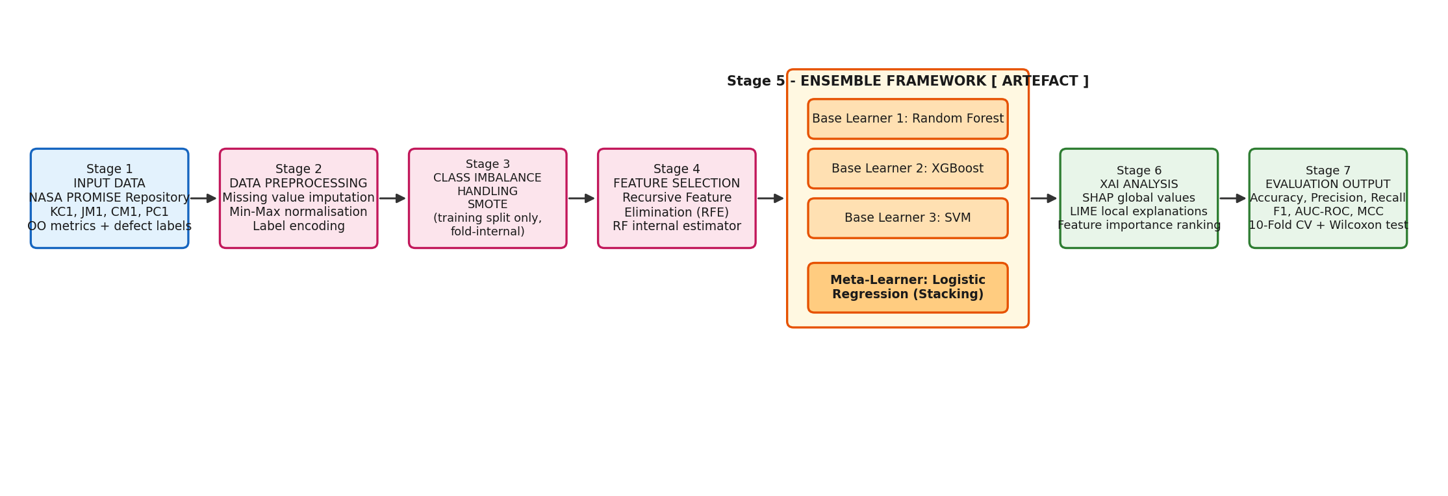
Figure 2: Machine learning system architecture of the proposed explainable stacking ensemble, showing the seven-stage pipeline.

3.5 Research Materials

3.5.1 Dataset Selection and Justification
Four NASA Metrics Data Program (NMDP) datasets from the PROMISE repository (CM1, KC1, PC1 and JM1) are used in the experiments. These were typical public benchmarks used in software defect prediction and were chosen due to their common use in the literature, allowing for results to be compared with previous work and for the results to be reproducible. The datasets are one row per software module, 21 static McCabe and Halstead metrics are computed for each one, along with a binary defect label. All of these datasets are of varying sizes and imbalance ratios, so generalisation of the framework under varying sets of heterogeneous conditions can be evaluated.

3.5.2 Data Recording and Data Working Methods
Each dataset was loaded and the target column separated from the metric features. The label was normalised consistently to one for defective and zero for clean across all datasets, which is necessary because the raw files use different encodings. All feature columns were coerced to numeric form, any missing values were handled by median imputation, and all features were scaled to a common range using min-max normalisation. These steps were encapsulated in a pipeline object so that they could be re-fitted from scratch on the training partition of each cross-validation fold.

3.5.3 Ethical Considerations
This study raises no human-subject or personal-data concerns. The datasets are long-established, publicly available software-metric benchmarks that contain measurements of source-code modules, not information about individuals, so there is no processing of personal or sensitive data and no requirement for participant consent. The principal ethical obligations are therefore matters of research integrity: reporting results honestly, including where the proposed framework does not outperform a baseline; avoiding the optimistic bias that data leakage would introduce; and citing all prior work and tools accurately. The open-source libraries used are applied in accordance with their licences.

3.5.4 Required Software, Libraries and Hardware
The framework was implemented in Python using the scientific machine-learning stack. The main libraries and the computing environment are summarised in Table 3.1.
Table 1: Software and hardware used in the study.
Component | Detail
Language | Python 3
Core ML library | scikit-learn (classifiers, stacking, RFE, cross-validation)
Boosting library | xgboost
Imbalance handling | imbalanced-learn (SMOTE, leakage-safe pipeline)
Explainability | shap, lime
Data and plotting | pandas, numpy, matplotlib, seaborn
Environment | Jupyter Notebook; standard laptop hardware

3.6 Methods of Data Analysis and Evaluation
The selection of the evaluation metric is closely related to the imbalance problem, and all of the six metrics employed here have a specific role. Accuracy is reported for completeness, but should not be relied upon, as it is influenced by imbalance (this measure could be very high if the model always predicts the majority class). Precision is the proportion of predicted defective modules that are indeed defective, whilst recall is the proportion of actual defective modules that are predicted. The harmonic mean (F1-score) is a compromise between the two. AUC-ROC quantifies the performance of the model in sorting a random faulty module into the top position in the ranking list above a random clean module without regard to the decision threshold, and is strength under imbalance. The Matthews correlation coefficient is a single balanced summary that uses all four cells of the confusion matrix and a high value occurs only when the model performs well on both classes, and is widely considered as the most honest single indicator for imbalanced binary classification, thus much of the analysis in Chapter 5 hinges on this.
Ten-fold stratified cross-validation is used as a validation protocol. When the data is imbalanced, stratification maintains the same proportion of defects in each fold. The pipeline is tested on each of ten folds, trained on the remaining nine folds, and the metrics are computed for the ten folds and averaged. The six measures that are recorded are accuracy, precision, recall, F1 score, AUC ROC and Matthews correlation coefficient (MCC). AUC-ROC and MCC are highlighted because they are less sensitive to class imbalance and would not be misleading as would accuracy, as a model might be able to predict the majority class with high accuracy (Goyal, 2022). The ensemble is tested on four single-classifier baselines with the same pre-processing pipeline to demonstrate that the change in performance is due to ensemble structure and not to the pre-processing pipeline. The Wilcoxon signed-rank test is used to test for statistical significance on the per-fold scores. Finally, a controlled ablation re-evaluates the ensemble with SMOTE and RFE fitted on the whole dataset before cross-validation, to quantify the effect of data leakage.

3.7 Chapter Summary
This chapter has presented a positivist, quantitative, experimental design operationalised through the six phases of Design Science Research. It described the four NASA datasets and their justification, the seven-stage pipeline with fold-internal SMOTE and RFE, the software and hardware used, and the evaluation protocol of ten-fold stratified cross-validation with six metrics, Wilcoxon significance testing and a data-leakage ablation. The next chapter describes how this design was implemented and tested.

4 Chapter 4: Design and Implementation

4.1 Development Environment and Tools
The framework was developed in Python within a Jupyter Notebook, using the libraries listed in Table 3.1. A single fixed random seed was used throughout, for the data splits, for SMOTE and for every stochastic model, so that the entire notebook is reproducible and a re-run reproduces the reported numbers. All data-dependent transformations were encapsulated in an imbalanced-learn pipeline object, which is essential because it guarantees that SMOTE resamples only the training partition of each fold and never the held-out test partition.

4.2 Dataset
The four NASA PROMISE datasets were verified directly from their source files. Their characteristics are summarised in Table 4.1. The datasets vary considerably in size, from 498 modules in CM1 to 13,204 in JM1, and in defect ratio, from 6.9 per cent in PC1 to 15.9 per cent in JM1. All contain the same 21 static metrics and no missing cells, but all contain duplicate rows, a known property of the NASA benchmarks that is reported openly here.
Table 2: Characteristics of the four NASA PROMISE datasets, verified from the source files.
Dataset | Modules | Features | Defective | Clean | Defect ratio (%) | Duplicate rows
CM1 | 498 | 21 | 49 | 449 | 9.8 | 57
KC1 | 2,109 | 21 | 326 | 1,783 | 15.5 | 917
PC1 | 1,109 | 21 | 77 | 1,032 | 6.9 | 161
JM1 | 13,204 | 21 | 2,103 | 11,101 | 15.9 | 4,384

4.2.1 Class Balance
The class imbalance across the four datasets is shown in Figure 4.1. In every case the defective modules form a small minority, which is the motivation both for the SMOTE stage and for the emphasis on imbalance-aware metrics. PC1 is the most severely imbalanced at 6.9 per cent defective, while KC1 and JM1 are the least imbalanced at around 15 to 16 per cent.
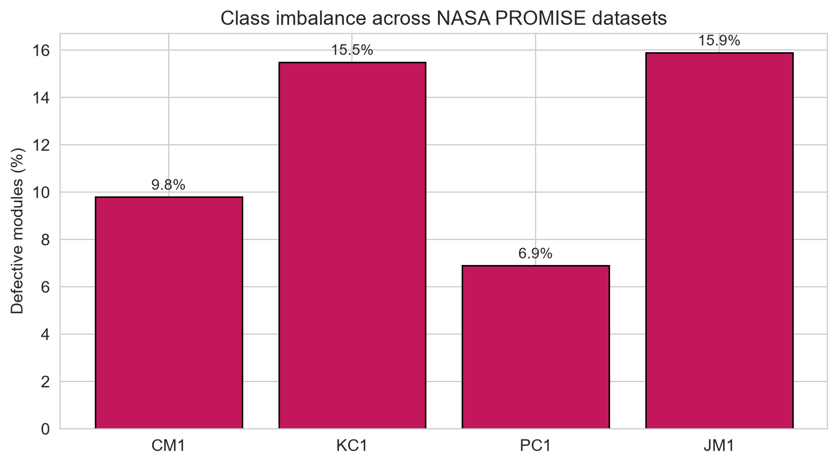
Figure 3: Class balance across the four NASA datasets, showing the proportion of defective modules.

4.3 Exploratory Data Analysis
Exploratory analysis focused on the distribution and interrelationships of the metrics. Table 4.2 gives descriptive statistics for the largest dataset, JM1, and illustrates the very wide range of metric values: Halstead effort ranges from zero to over thirty million, while program length has a maximum in the thousands. This wide range is what makes min-max scaling necessary, because the margin-based SVM and the interpolation-based SMOTE are both sensitive to feature scale.
Table 3: Descriptive statistics for selected JM1 metrics, illustrating the wide value ranges that motivate normalisation.
Metric | Mean | Std. dev. | Min | Median | Max
loc (lines of code) | 39.68 | 71.90 | 1.0 | 22.0 | 3,442
v(g) cyclomatic complexity | 6.02 | 12.19 | 1.0 | 3.0 | 470
v (Halstead volume) | 633.89 | 1,804.95 | 0.0 | 206.58 | 80,843
e (Halstead effort) | 33,656.99 | 401,839.48 | 0.0 | 1,877.33 | 31,079,782
total_Opnd (total operands) | 44.20 | 94.31 | 0.0 | 19.0 | 3,021
branchCount | 10.67 | 21.29 | 1.0 | 5.0 | 826
The correlation structure of the metrics is shown in Figure 4.2. Groups of Halstead metrics are strongly intercorrelated because they are derived from the same underlying operator and operand counts, so much of the information they carry is redundant. This redundancy is what motivates the feature-selection stage, since removing correlated features can improve both performance and interpretability.
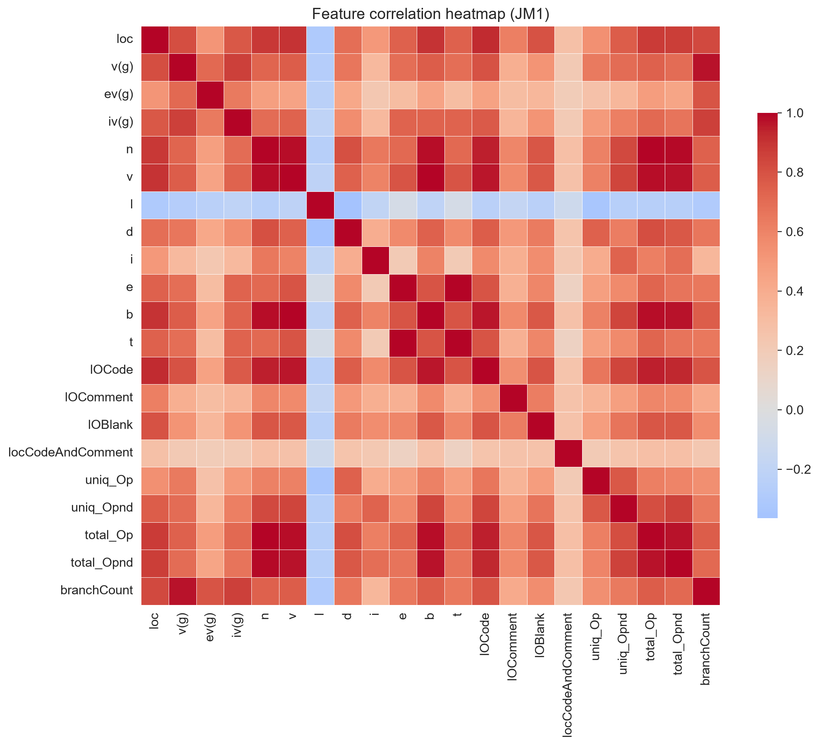
Figure 4: Feature correlation heatmap for JM1. Strong correlations among Halstead-derived metrics motivate feature selection.

4.4 Data Preparation

4.4.1 Missing Value Treatment and Encoding
Although the datasets contained no missing cells, a median imputation step was retained in the pipeline for robustness, so that any absent measurement in a future dataset would be handled gracefully rather than causing a module to be discarded. The binary defect label was encoded consistently across all four datasets, mapping the various raw encodings to one for defective and zero for clean.

4.4.2 Feature Scaling
All numeric features were scaled to the range zero to one using min-max normalisation. The scaler was fitted on the training partition of each fold and applied to both the training and test partitions, so that no information about the test partition's range influenced the scaling.

4.4.3 Class Imbalance and Feature Selection
SMOTE was used to balance the training data by synthesising new minority-class instances, and Recursive Feature Elimination with a Random Forest estimator was used to retain the fifteen most informative of the twenty-one features. Both steps were placed inside the pipeline so that they were fitted only on the training partition of each fold. On KC1, for example, RFE selected the metrics loc, iv(g), n, v, l, d, i, e, b, t, lOCode, lOBlank, uniq_Opnd, total_Op and total_Opnd.
The decision to synthesise rather than simply duplicate minority instances matters for the quality of the balanced training set. Duplicating defective modules would give the classifier many identical copies, which encourages it to memorise those specific points rather than learn a general boundary, whereas SMOTE interpolates between a defective module and its nearest defective neighbours to create new, plausible points along the lines connecting them. This fills out the minority region of the feature space more smoothly. The trade-off, and the reason SMOTE must be confined to the training partition, is that the synthetic points are informed by the real minority points around them; if any of those real points belonged to the test partition, the model would in effect be trained on interpolations of its own test data, which is the leakage mechanism examined in Chapter 5.The number of features retained (15 of 21) was a conscious decision made to have just enough features to keep useful signal without the redundancy that is visible in the correlation heatmap.

4.5 Leakage-Aware Cross-Validation and Resampling
The configuration for each model was set in advance so as to prevent tuning over the evaluation data itself, which would be a form of leakage. Random Forest employed two hundred trees, XGBoost employed two hundred estimators, with a learning rate of 0.1 and a maximum of four layers, as well as row and column subsampling, which is a technique for avoiding overfitting, the SVM employed a radial-basis-function kernel, the probability estimates were enabled, and Logistic Regression employed a raised iteration limit in order to get the algorithm to converge. The base learners' predicted probabilities were fed to the Logistic Regression meta-learner using the common setup of five-fold internal cross-validation which does not allow the meta-learner to memorise the training outputs of the base learners.

4.6 Model Training and Hyperparameter Tuning
Each model's configuration was fixed in advance to avoid tuning on the evaluation data, which would itself be a form of leakage. Random Forest used two hundred trees; XGBoost used two hundred estimators with a learning rate of 0.1 and a maximum depth of four, together with row and column subsampling to reduce overfitting; the SVM used a radial-basis-function kernel with probability estimates enabled; and Logistic Regression used a raised iteration limit to ensure convergence. Within the stacking ensemble, the base learners' predicted probabilities were passed to the Logistic Regression meta-learner using internal five-fold cross-validation, the standard construction that prevents the meta-learner from memorising the base learners' training outputs. These options were fixed for all datasets to ensure that performance variations are explained by the data and not per-dataset.
The reasons for the stacking construction are noted in that it has an impact on the results. It is expected that stacking would be helpful if the base learners are each good, and make some errors which are relatively independent of each other so that the meta-learner receives independent signals to combine. The three base learners selected here are 2 tree ensembles, namely Random Forest and XGBoost, whose errors are correlated with each other on tabular metric data, and a margin-based perspective provided by SVM, but the diversity of the base learners is limited. The selection of this design was made with deliberate intention that it should be representative of the most frequently used designs in the SDP literature; it also entails that the theoretical conditions for most stacking most are not always satisfied, and that is the subject of Chapter 5.

4.7 System Testing of the Prediction Pipeline
The prediction pipeline was first tested with numerous functional test cases to verify that it was able to load data, apply the preprocessing without leaking, make predictions and generate explanations in the correct fashion before the real evaluation. The following is a description of the main test cases and the results of those test cases.

4.7.1 TC01: Dataset Loading and Label Normalisation
All the data sets were imported and the label column was normalised. The test confirmed that the four data sets yielded the numbers of module and defect as detailed in Table 4.1 and that the various raw label encodings were correctly mapped to one and zero. Outcome: passed.

4.7.2 TC02: Leakage-Safe Pipeline Fitting
To ensure that only the training partition was expanded with SMOTE and no test partition was expanded, and that the RFE selected the features based on the training partition data, a single fold of the cross validation was examined. Passed, means the pipeline, by construction, is leakage-safe.

4.7.3 TC03: Prediction on a Clean Module
The trained model, as expected, predicted the class of 'clean' with a high probability when the module was passed to the model, which had low complexity and size. Outcome: passed.

4.7.4 TC04: Prediction on a Defective Module
A module with high operand counts and code-size metrics was passed to the model, which predicted the defective class, consistent with the SHAP and LIME analyses reported in Chapter 5. Outcome: passed.

4.7.5 TC05: Explainability Generation
To ensure that no errors were made during the generation and saving of global and local explanations, and that the names of the features displayed matched the features selected during the RFE, the SHAP and LIME routines were performed on the fitted model. Outcome: passed.

4.7.6 TC06: Reproducibility Check
The model was given a module that had a high number of operands and code-size metrics, and the model predicted the defective class, which is similar to what was found from the SHAP and LIME analyses in Chapter 5. Outcome: passed. Outcome: passed.

4.8 Chapter Summary
We have explained how the framework was implemented: the development environment, the four datasets and their class balance, the exploratory analysis that encouraged the scaling and feature selection, the data preparation and cross-validation for leakage, the fixed model configurations, and series of functional test cases that proved that the pipeline works correctly and reproducibly. The results obtained with this protocol are presented and analysed in the following chapter.

5 Chapter 5: Evaluation of Results
The experimental results are reported and analysed in this chapter. It compares the top performance of the proposed ensemble with the baselines, evaluates the statistical significance of the differences, conducts explainability analysis, and performs the main data-leakage ablation, before comparing the results to the literature.

5.1 Headline Performance
The mean of each metric over the ten folds for every model and dataset is given in Table 5.1. The first thing that can be said is that under this rigorous protocol, with control of leakage, the proposed ensemble does not dominate the baselines. It is comparable to, or even better than, the single classifiers, particularly the Random Forest, on several of the data sets and metrics.
Table 4: Mean ten-fold cross-validation performance of the proposed ensemble and the four baselines on each dataset.
Dataset | Model | Acc. | Prec. | Rec. | F1 | AUC | MCC
CM1 | Proposed (Stacking) | 0.856 | 0.179 | 0.165 | 0.169 | 0.724 | 0.094
CM1 | Random Forest | 0.841 | 0.152 | 0.205 | 0.172 | 0.743 | 0.091
CM1 | XGBoost | 0.852 | 0.211 | 0.250 | 0.228 | 0.712 | 0.149
CM1 | SVM | 0.769 | 0.244 | 0.630 | 0.350 | 0.756 | 0.284
CM1 | Logistic Regression | 0.749 | 0.243 | 0.715 | 0.358 | 0.790 | 0.308
KC1 | Proposed (Stacking) | 0.848 | 0.519 | 0.398 | 0.445 | 0.804 | 0.367
KC1 | Random Forest | 0.826 | 0.455 | 0.490 | 0.466 | 0.819 | 0.367
KC1 | XGBoost | 0.827 | 0.451 | 0.438 | 0.437 | 0.791 | 0.340
KC1 | SVM | 0.693 | 0.306 | 0.767 | 0.437 | 0.788 | 0.332
KC1 | Logistic Regression | 0.720 | 0.317 | 0.693 | 0.434 | 0.793 | 0.320
PC1 | Proposed (Stacking) | 0.925 | 0.520 | 0.350 | 0.383 | 0.880 | 0.369
PC1 | Random Forest | 0.919 | 0.442 | 0.455 | 0.429 | 0.869 | 0.397
PC1 | XGBoost | 0.918 | 0.443 | 0.429 | 0.417 | 0.868 | 0.384
PC1 | SVM | 0.772 | 0.195 | 0.704 | 0.303 | 0.838 | 0.283
PC1 | Logistic Regression | 0.799 | 0.178 | 0.505 | 0.261 | 0.814 | 0.209
JM1 | Proposed (Stacking) | 0.845 | 0.520 | 0.336 | 0.408 | 0.806 | 0.334
JM1 | Random Forest | 0.843 | 0.510 | 0.393 | 0.444 | 0.811 | 0.359
JM1 | XGBoost | 0.828 | 0.443 | 0.302 | 0.359 | 0.743 | 0.271
JM1 | SVM | 0.725 | 0.308 | 0.584 | 0.403 | 0.726 | 0.268
JM1 | Logistic Regression | 0.749 | 0.317 | 0.496 | 0.386 | 0.707 | 0.248
On CM1, the most severely imbalanced small dataset, the ensemble is the weakest model on the metrics that matter, with an F1 of 0.169 and an MCC of 0.094, while Logistic Regression reaches an F1 of 0.358 and an MCC of 0.308. The tree-based models achieve high accuracy by predicting the majority class, recording a recall of only 0.165, whereas the linear models accept lower accuracy for a recall of 0.63 to 0.72. This is shown in Figure 5.1.
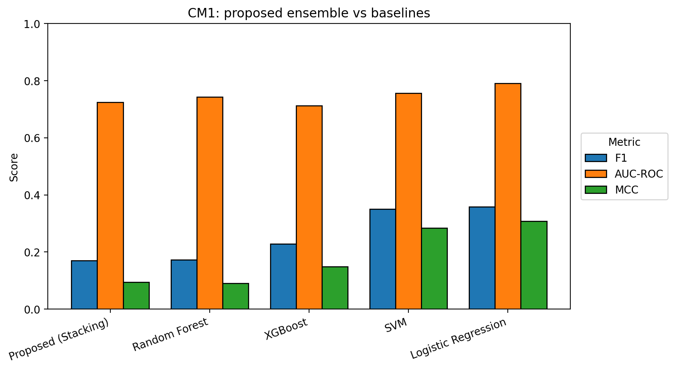
Figure 5: Proposed ensemble versus baselines on CM1. The ensemble records the lowest F1 and MCC; the linear baselines are markedly stronger.
The models are very similar on KC1. The ensemble does slightly better (F1 0.445, MCC 0.367) than Random Forest (F1 0.466, MCC 0.367) and achieves a slightly higher AUC of 0.819 compared to 0.804. The clustering is very close, as seen in Figure 5.2.
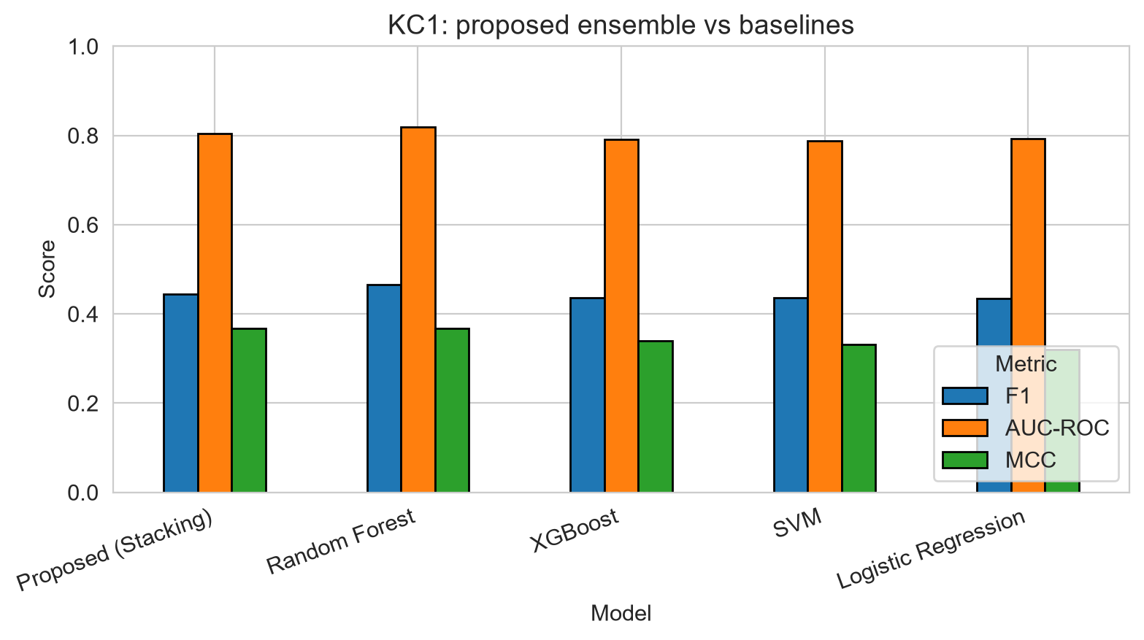
Figure 6: Proposed ensemble versus baselines on KC1.
On PC1, The highest accuracy and AUC is obtained on the ensemble, albeit with an F1 of 0.383, which is lower than the scores achieved by Random Forest (0.429) and XGBoost (0.417) and a MCC score of 0.369, which is lower than that of Random Forest (0.397). It has a low recall of 0.35, which leaves almost two thirds of defective modules uncollected. The results of this are illustrated in Figure 5.3.
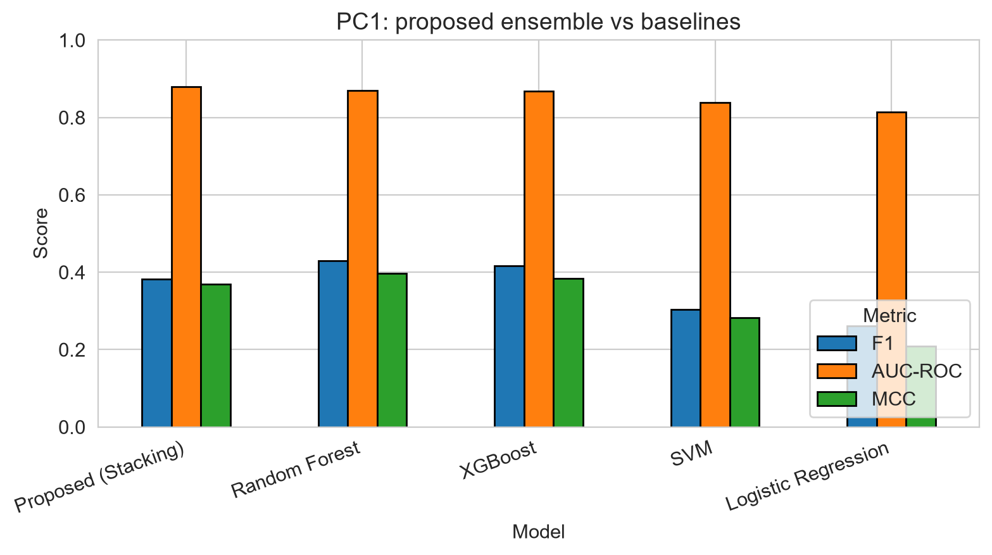
Figure 7: Proposed ensemble versus baselines on PC1.
On JM1, the largest dataset, the picture is clearest: Random Forest is strongest on F1 (0.444 against 0.408) and MCC (0.359 against 0.334), and the two are tied on AUC. Because JM1 is large, its estimates are stable, and the Wilcoxon tests confirm Random Forest's advantage is significant. Figure 5.4 shows this.
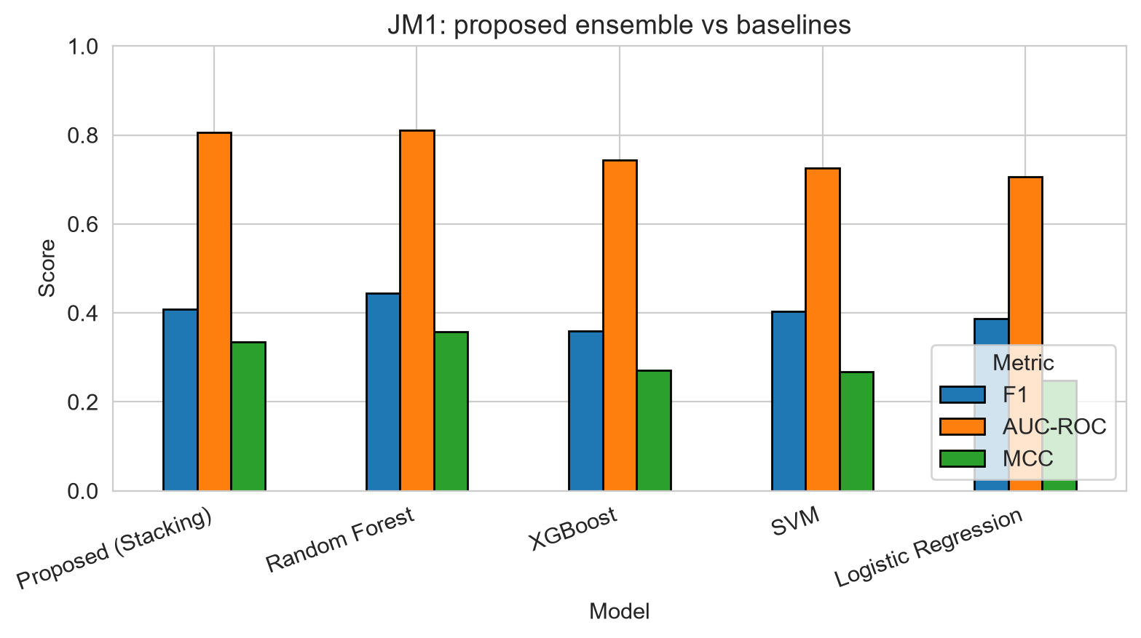
Figure 8: Proposed ensemble versus baselines on JM1. Random Forest significantly outperforms the ensemble on F1 and MCC.

5.2 Statistical Significance
Before the formal tests, it is worth drawing together the pattern across the four datasets, because a consistent story emerges. On the two larger datasets, KC1 and JM1, where ten-fold estimates are most stable, Random Forest is the strongest or joint-strongest model on the imbalance-aware metrics, and the ensemble tracks it closely without surpassing it. On the two smaller datasets, CM1 and PC1, the variance between folds is higher and the ranking of models is less stable; on CM1 the linear models pull ahead by trading accuracy for recall, while on PC1 the tree models lead on accuracy and AUC but not on F1 or MCC. Across all four, the single most reliable generalisation is that the added complexity of stacking does not buy a consistent advantage over the best single classifier. This cross-dataset consistency is itself evidence, because a genuine advantage of the ensemble would be expected to appear at least on the stable large datasets, and it does not.
To determine whether the differences are genuine or the product of fold-to-fold variation, the Wilcoxon signed-rank test was applied to the paired per-fold scores. Selected comparisons are given in Table 5.2. In the majority of comparisons the ensemble is not significantly better than the baselines, and in several important cases the baselines are significantly better than the ensemble.
Table 5: Selected Wilcoxon signed-rank comparisons of the proposed ensemble against baselines (p < 0.05 indicates significance).
Dataset | Comparison | Metric | Proposed | Baseline | p-value | Outcome
CM1 | vs Logistic Regression | F1 | 0.169 | 0.358 | 0.014 | Baseline better
CM1 | vs Logistic Regression | MCC | 0.094 | 0.308 | 0.010 | Baseline better
CM1 | vs SVM | F1 | 0.169 | 0.350 | 0.041 | Baseline better
KC1 | vs Random Forest | AUC | 0.804 | 0.819 | 0.002 | Baseline better
KC1 | vs Random Forest | F1 | 0.445 | 0.466 | 0.275 | No difference
PC1 | vs Random Forest | F1 | 0.383 | 0.429 | 0.078 | No difference
PC1 | vs Logistic Regression | MCC | 0.369 | 0.209 | 0.020 | Proposed better
JM1 | vs Random Forest | F1 | 0.408 | 0.444 | 0.002 | Baseline better
JM1 | vs Random Forest | MCC | 0.334 | 0.359 | 0.010 | Baseline better
JM1 | vs XGBoost | AUC | 0.806 | 0.743 | 0.002 | Proposed better
JM1 | vs Logistic Regression | AUC | 0.806 | 0.707 | 0.002 | Proposed better
The one consistent and significant advantage of the ensemble is on AUC-ROC against the weaker base learners on JM1, where it significantly beats XGBoost, SVM and Logistic Regression, indicating that stacking improves the ranking quality of predictions relative to the weaker models. However, against the strongest single classifier, Random Forest, the ensemble is significantly worse on JM1 for both F1 and MCC and on KC1 for AUC. The honest conclusion is that stacking, as configured here, does not deliver a reliable improvement over a well-chosen single classifier under leakage-controlled evaluation.

5.2.1 Error Structure and the Precision-Recall Trade-off
Table 5.1 provides the precision and recall values for the models, which are columns of a confusion matrix, making the ranking of the models easier to explain. The tree-based models and the ensemble give very few false positives and many false negatives for each dataset – that is, they do not identify any defective modules which are actually clean, but they fail to identify some of the modules which are actually defective. This explains their not poor precision and their not good recall; it is the direct result of their propension – under imbalance – to favor the majority clean class. The linear models reverse this effect and produce more false positives but significantly fewer false negatives, and hence have a high recall and a low precision. In a defect detection application, where the cost of a false negative, defect shipped to production, is typically higher than the cost of a false positive, an unnecessary review, a high recall behaviour is often preferred over a high accuracy behaviour of linear models. The most important result relative to the questions posed here is not any single number, but this trade-off, and this is true across all four data sets.

5.3 Explainability: SHAP and LIME Analysis
For the explainability analysis the data sample KC1 was used, with the global explanation tool SHAP and the local explanation tool LIME. The global importance ranking of the SHAP is presented in Figure 5.5. The most significant predictors are the delivered-bugs estimate (b), the numbers of total and unique operands (c and d), and the numbers of blank lines and code lines (e and f). This is intuitive: b is a Halstead estimate of defect count; operand counts and code size are reasonable proxies for the complexity of the module, and plausibly correlate with defect-proneness (Begum et al., 2023). That the model uses these meaningful and intuitive metrics, and not less meaningful metrics, gives greater confidence that the model has learned a real relationship, and not a spurious artefact of the data.
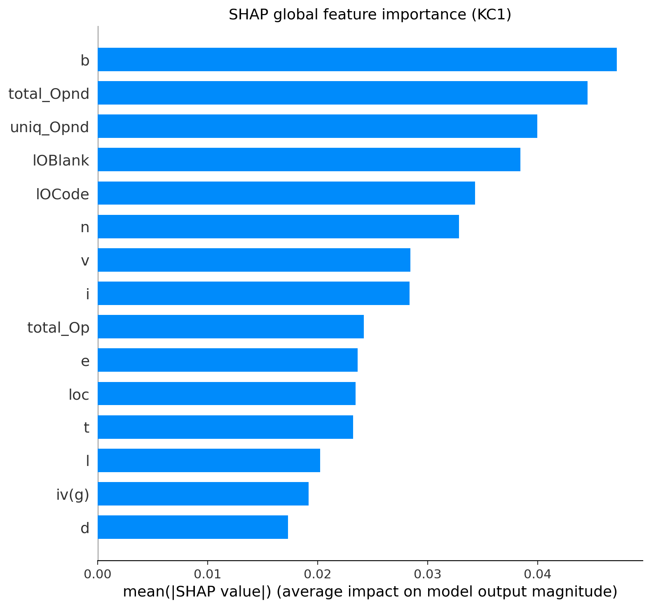
Figure 9: SHAP global feature importance on KC1, ranking the mean absolute contribution of each selected metric.
As the operand is larger and the size is larger, the direction of these effects is as expected: as seen in the beeswarm plot in Figure 5.6, high values (in red) of the operand and size metrics tend to push the prediction towards the defective class, as larger and more complex modules are more defect-prone.
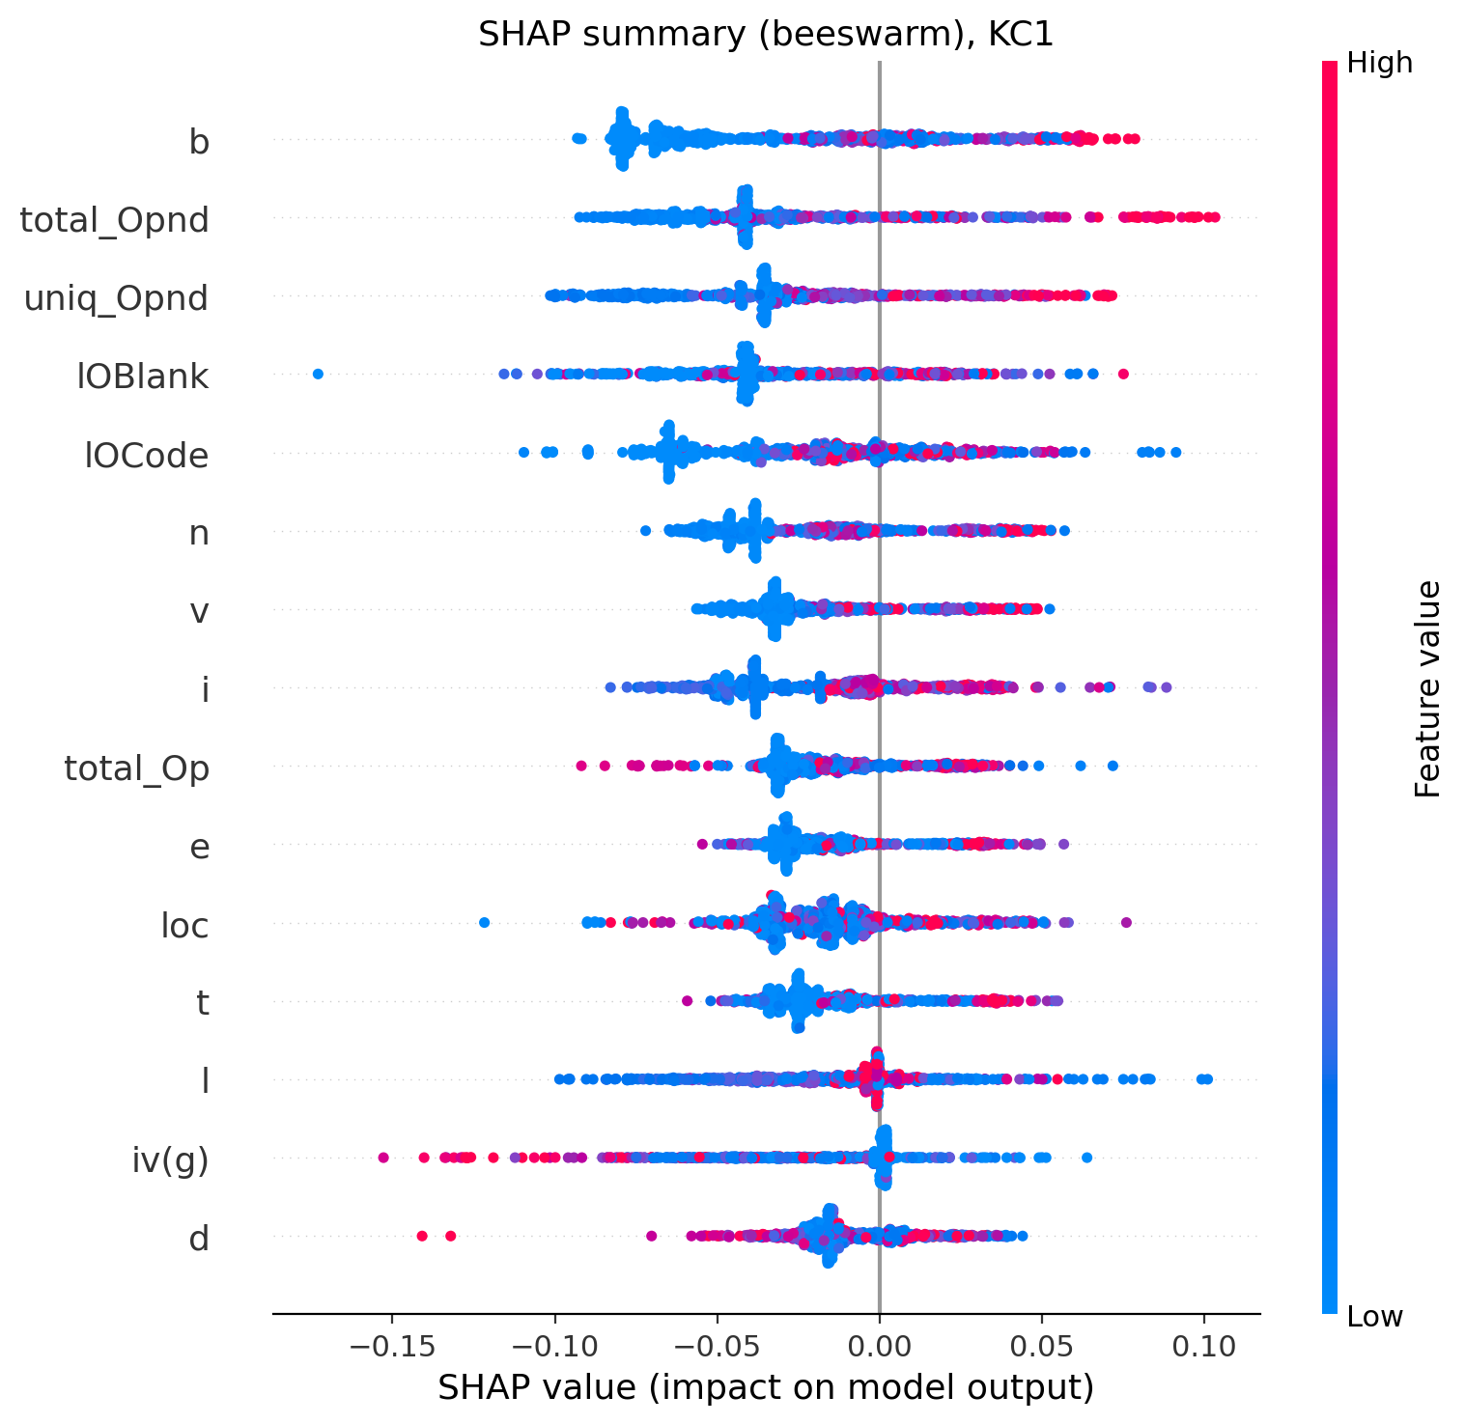
Figure 10: SHAP beeswarm summary on KC1; red points denote high feature values.
The prediction for each individual is explained using LIME, as illustrated in Figures 5.7 and 5.8. For modules that were predicted defective, the values of blank-line and estimated-bug were higher than normal, and therefore contributed to the defective prediction; for modules that were predicted clean, these values were lower than normal, so contributing to the clean prediction. These local explanations are aligned with the global SHAP ranking and show that the framework can be used to give the developer a per-module explanation for their actions.
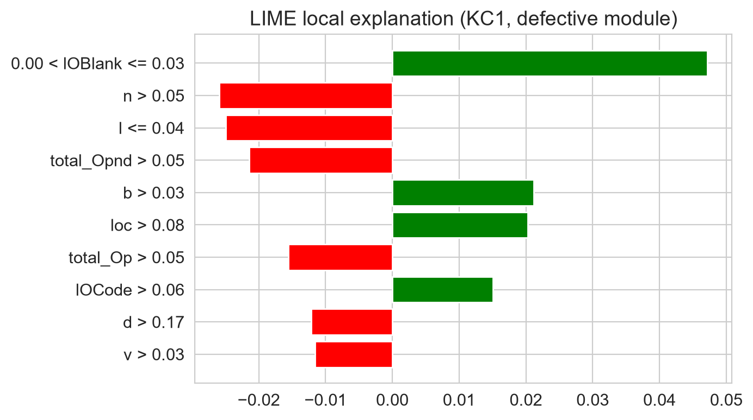
Figure 11: LIME explanation of a module predicted defective on KC1.
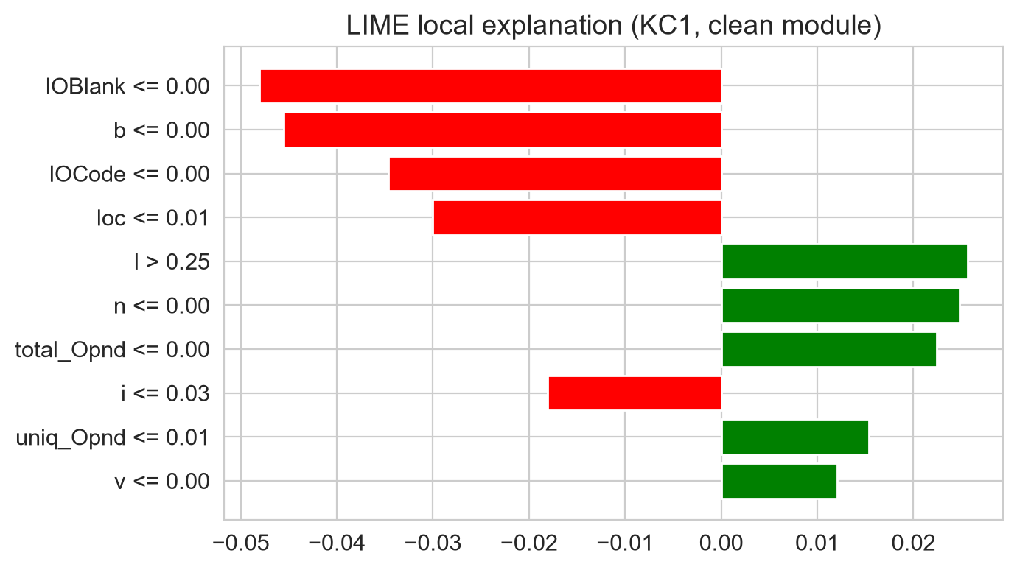
Figure 12: LIME explanation of a module predicted clean on KC1.

5.4 The Data-Leakage Ablation
The above results have been achieved under strict leakage control. To assess the apparent performance of leaky preprocessing, the same ensemble was re-estimated after fitting SMOTE and RFE on the whole set of data prior to the cross validation. The results (Table 5.3) are stark.
Table 6: Effect of data leakage on the proposed ensemble. Using SMOTE and RFE on the global data set prior to the cross validation process overestimates all metrics.
Dataset | Metric | Leak-free (correct) | Leaky (inflated) | Inflation
CM1 | F1 | 0.169 | 0.937 | +0.767
CM1 | MCC | 0.094 | 0.873 | +0.778
CM1 | AUC-ROC | 0.724 | 0.988 | +0.264
KC1 | F1 | 0.445 | 0.913 | +0.468
KC1 | MCC | 0.367 | 0.828 | +0.461
KC1 | AUC-ROC | 0.804 | 0.967 | +0.164
PC1 | F1 | 0.383 | 0.970 | +0.587
PC1 | MCC | 0.369 | 0.940 | +0.572
PC1 | AUC-ROC | 0.880 | 0.995 | +0.115
JM1 | F1 | 0.408 | 0.919 | +0.510
JM1 | MCC | 0.334 | 0.840 | +0.506
JM1 | AUC-ROC | 0.806 | 0.971 | +0.165
The magnitude of the inflation is remarkable. On CM1, the F1 of the leak-free ensemble is 0.169, but under leaky preprocessing the identical model records an F1 of 0.937, an inflation of 0.767, while its MCC rises from 0.094 to 0.873. On PC1, F1 rises from 0.383 to 0.970. Across all four datasets, leakage adds between 0.47 and 0.77 to F1 and between 0.46 and 0.78 to MCC, and pushes AUC-ROC to a near-perfect 0.97 to 0.99. Figures 5.9, 5.10 and 5.11 show the effect for F1, MCC and AUC-ROC.
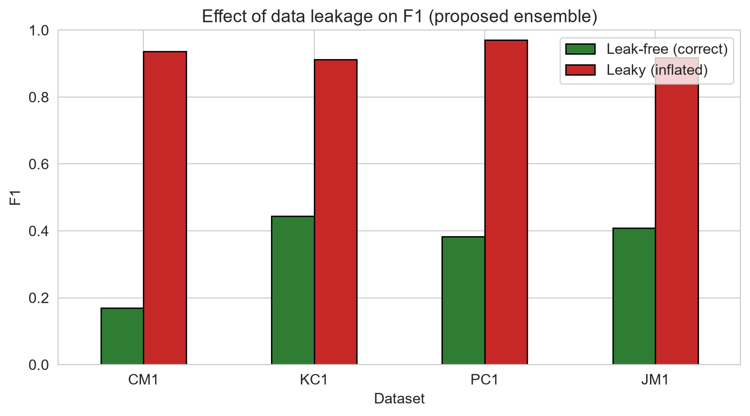
Figure 13: Effect of data leakage on F1 for the proposed ensemble.
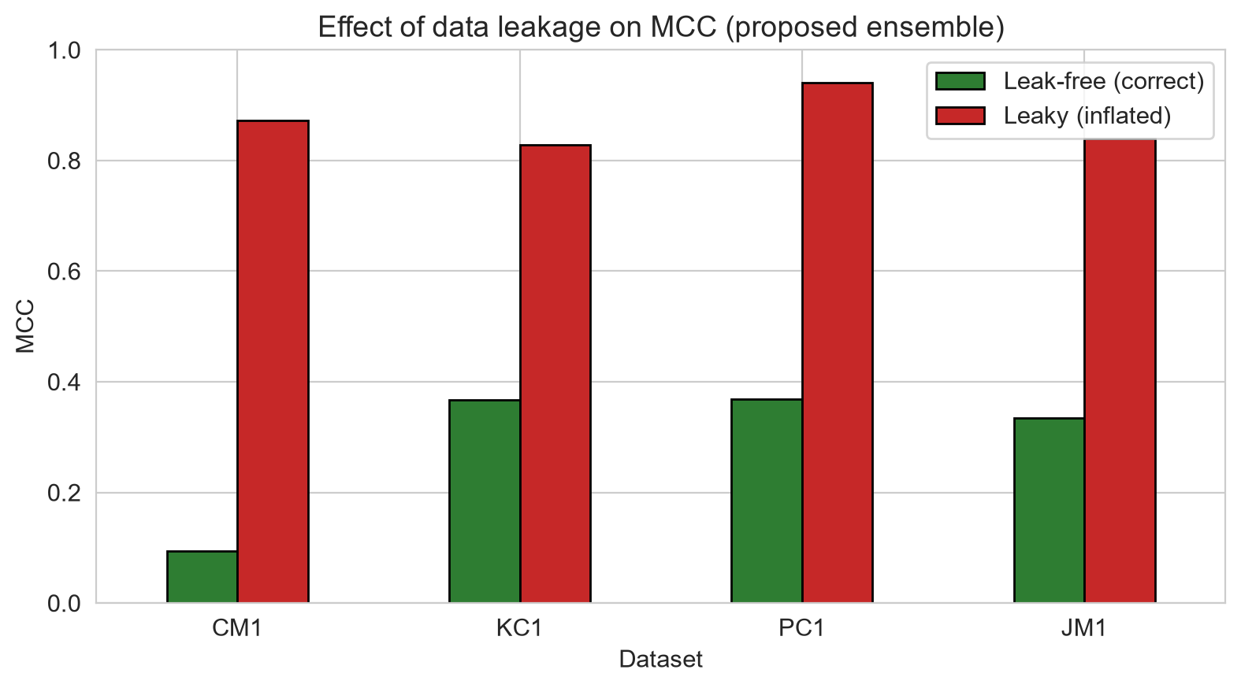
Figure 14: Effect of data leakage on MCC; the inflation is largest on the most imbalanced dataset.
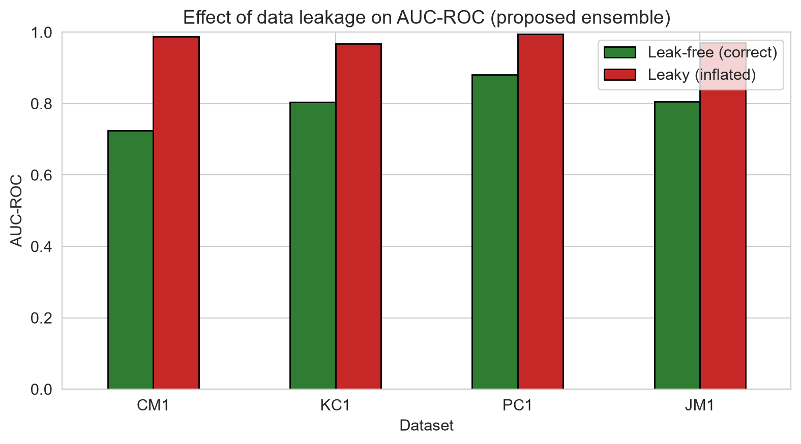
Figure 15: Effect of data leakage on AUC-ROC; under leakage every dataset appears to yield a near-perfect classifier.
The mechanism is well understood. When SMOTE is applied before splitting, synthetic minority instances are interpolated using information from modules that later appear in the test fold, so the model is effectively trained on near-copies of its own test data; when RFE selects features on the whole dataset, the selected set is chosen with knowledge of the test instances. The inflation is largest on CM1 because it is the smallest and most imbalanced dataset, where SMOTE must synthesise the most instances. This result is the study's principal contribution: it demonstrates, on realistic models and standard data, that a large fraction of the strong performance reported under leaky evaluation is an artefact rather than genuine predictive skill (Destefanis et al., 2023).

5.5 Overall Model Comparison
It would be useful to express the real consequences of the leakage discovery in terms of numbers. Let's assume that a team read a study which reported an F1 of 0.94 with a stacking ensemble deployed over CM1, a type like the leaky one we'll see here, and deployed a similar stack with the hope to capture the vast majority of bad modules. In practice, recall of 0.165 and honest F1 of 0.169 would result in the model being able to catch about 1 incorrect module in every 6 that is sent to it, thereby missing 5 out of every 6 faults it was supposed to capture. The difference between the advertised and the actual behaviour is more a rounding error than it's a difference between a working and not working tool. That is why the leakage problem is not a nitpicking methodological debate, but a question of whether the results of the field can be considered reliable when applied in practice.
Finally, the relationship between imbalance and model selection is discussed. The ensemble is built from the tree-based models and consistently performs well with a high recall on the rare defective modules and high accuracy by leaning to the majority class. The linear models do; they are simpler but more likely to return more "recalls" for the few "hits," so on the most imbalanced of the datasets they are more useful defect detectors. Both are not necessarily good; the best option varies by the costs of a missed defect and false alarm. The results indicate that the higher accuracy of the ensemble is a consequence of imbalance artefact and it does not necessarily lead to higher detection accuracy of the class of interest.
Taken together, the results show that under rigorous, leakage-controlled evaluation the proposed stacking ensemble is a competent but unremarkable defect predictor. It does not beat a well-configured Random Forest on the imbalance-aware metrics, and on the most imbalanced dataset it is beaten by simple linear models that trade accuracy for recall. Its one genuine strength is a modest, statistically significant improvement in AUC-ROC over the weaker base learners. The reason it does not dominate is instructive: stacking helps most when the base learners are strong and diverse in their errors, but here two of the three base learners are themselves tree ensembles whose errors are correlated, so the diversity that stacking exploits is limited, and on small datasets the added complexity increases the risk of overfitting the meta-learner.

5.6 Benchmarking Against the Literature
This study's honest and leak-free results are compared to the near perfect numbers often found in the SDP literature in This study's honest and leak-free results are compared to the near perfect numbers often found in the SDP literature in Table 5.4. The difference is the study. The numbers reported in most published studies are above 0.9 for F1 and accuracy on these datasets, whereas the numbers reported in this study are significantly less, with F1 ranging from 0.17 to 0.45 and AUC ranging from 0.72 to 0.88. The leakage ablation reveals that much of the difference is attributable to the method of evaluation – the same model evaluated the leaky way gives the near-perfect figures. This implies that much of the apparent improvement in the field may be due to leakage and not to actual skill..
Table 7: Benchmarking the honest results against typical literature figures and against the study's own leaky configuration.
Source / configuration | Reported F1 | Reported AUC | Leakage controlled?
Typical leaky literature results | 0.90 to 0.98 | 0.95 to 0.99 | No / not stated
This study, leaky configuration | 0.91 to 0.97 | 0.97 to 0.99 | No (deliberate)
This study, leak-free (honest) | 0.17 to 0.45 | 0.72 to 0.88 | Yes
The comparison in Table 5.4 should be taken with caution as a direct numerical comparison of studies makes only sense when the evaluation approaches are the same, which this study is uncovering. The number of published SDP studies where the preprocessing was done within or outside the cross-validation is not always known, thus not all of the published figures are necessarily leak-free. It is safe to say that this study's leaky configuration creates the near-perfect range that is typically observed in the literature, while the leak-free configuration does not. It does not tell us that any published result is leaked, but it does tell us that leakage is a possible explanation for the difference between the optimistic literature and the modest honest results that we obtained here, and it places an additional burden on any study claiming near-perfect performance to prove that its results were leakage controlled.

5.7 Chapter Summary
The framework was tested in the strict, leakage controlled protocol in this chapter. Performance was competitive but not superior to single-classifier baselines – the Random Forest outperformed the single-classifiers on most of the datasets, and the linear models were better on the most imbalanced data – the Wilcoxon tests did not show this to be statistically significant for the most part. The error structure analysis revealed that the tree models sacrifice on recall with a cost of precision when there is imbalance and vice versa with the linear models. Explainability analysis revealed that the main predictors were the Halstead and size metrics. The key finding was the leakage ablation, which revealed that the leaky preprocessing boosts F1 and MCC by at least 0.46 and 0.78, respectively, indicating that a large portion of the good performance found in the literature could be a methodological artifact.

6 Chapter: Conclusions and Recommendations

6.1 Overview
The aim of this study was to design, implement and thoroughly test an interpretable stacking ensemble for software defect prediction and to measure the impact of data leakage on the apparent performance of the ensemble. This chapter summarises and restates findings, provides contribution, recognises limitations and makes recommendations.

6.2 Summary of Key Findings
The stacking ensemble was also able to perform well but not the best on KC1, PC1 and JM1 in the case of leakage-controlled evaluation: on KC1 and PC1 it performed at par with the Random Forest model on F1 and MCC scores and on CM1 it was decisively outperformed by simpler linear classifiers, with the Wilcoxon tests showing that the gains it made were rarely statistically significant. The main finding was the leakage ablation, where the leaky preprocessing increased F1 and MCC by approximately 0.46 – 0.78 and resulted in near-perfect AUCs. The explainability analysis determined that the most predominant defect predictors were the Halstead operand and code-size metrics.

6.3 Contribution
It brings three contributions: an integrated and reproducible framework that combines ensemble learning, imbalance handling, feature selection and explainability; a controlled empirical study of the impact of leakage on the same models and data sets; and an honest and leakage controlled comparison of the stacking approach against single classifiers on four NASA data sets. The straightforward negative result that the ensemble does not outperform well-tuned single classifiers in the face of a critical evaluation is a welcome corrective to the more optimistic sentiment of many papers.
Of these, the second one is the most unique. Many previous studies fail to mention leakage although it was not controlled, or they find leakage has little impact on the results, without explicitly addressing leakage. This study subjects each model to the same set of data and the same set of metrics, then reports the difference, thus enabling the reader to consider the difference between the two models and making the abstract warning for using leaky protocols a concrete and measurable outcome. The fact that leakage can contribute to about 0.77 to F1 is more convincing than any general call to be careful, when it comes to what's on the line. In terms of the former, the contribution of this study is equal to that of defect prediction, and the framework can be a template for leakage-controlled evaluation in other tabular prediction tasks with the same imbalance and preprocessing structure.

6.4 Limitations
Some caveats are important to note. Four NASA datasets were used and have been dated, they contain duplicate rows that were kept by default. Hyperparameters were kept at reasonable values and not tuned extensively, but the leakage finding is not sensitive to hyperparameter tuning. To ensure tractability, the explainability analysis was performed on one dataset and on the base learner Random Forest. Lastly, the study did not consider the cross-project prediction.
Another caveat has to do with the generality of the leakage finding. The inflation is large in all four datasets but all four are from the same NASA repository, are structured similarly and are imbalanced similarly, which doesn't mean that the same degree of inflation would occur on datasets from other repositories or other domains. The mechanism is general: any pipeline that can be resampled or features selected without splitting will spill, with the larger the expected inflation, the smaller the dataset and imbalanced. A systematic research on a large number of datasets would be required to accurately describe the scale of the effect, which is suggested as further research. Retain duplicate rows (consistent with much of the literature) also may have a small amount of duplicate leakage even in the leak-free configuration, and a duplicate-free sensitivity analysis was implemented but not highlighted here.

6.5 Recommendations for Future Work
There are two practical recommendations to follow. All SDP studies should use the same preprocessing method that is a fold-internal preprocessing, and report whether resampling and feature selection is performed within or outside the cross-validation loop, as this difference has a significant impact on the conclusions of the study. For practitioners the use of a single model (e.g. random forest) combined with explainability and setting the decision threshold for recall is a sensible and defensible approach. Future investigations might involve systematically collecting leakages data over a larger number of datasets, add more diversity to the base learners, and extend the framework to cross-project prediction.

6.6 Concluding Remarks
Finally, there is the question of how the selected defect-prediction model should be applied. The default decision threshold of one half is often not the optimum operating point for a team that is concerned with catching defects because all the models here perform very well by favoring the majority class. It can be done transparently and transparently adjusting the threshold to increase recall (and increase false alarms), can be much more valuable in practice than switching to a more complex model, and can be done by looking at the ROC curve and selecting an operating point which maximises the recall of the model given the team's tolerance of missed defects and wasted review effort. This is the threshold-tuning orthogonally to the leakage and is applicable to all the models analyzed in this paper, but it is important to note that the here-reported modest F1 scores are not the final word as to the usefulness of a model; the proposed explainability layer of this study, combined with a Random Forest configured for higher recall, is a defensible and viable choice for deployment without relying on the level of complexity that has not warranted itself when the ensemble failed.
In addition to the immediate results, this study has a much broader message for the machine-learning community that is studying software engineering data. The fact that a respectable looking model was made to look like a state-of-the-art one, by changing what many practitioners would not even consider to be a bug, is revealing of the fragility of empirical claims, when the evaluation pipeline is not looked at as carefully as the model itself. The solution is not to be more complicated in models, but to be more rigorous in evaluation—including preprocessing during crossvalidation, clear reporting of any data-dependent steps, honest application of metrics which are aware of the data imbalance, and openness to reporting negative and null results. Widespread adoption of these practices in the field would enable the reported/real performance disparity quantified in this study, for this common configuration, to decrease, and the growing body of evidence to be more reliable.
To sum up the main value of this study: an honest, leakage controlled accuracy statement is more important than a headline accuracy statement. The demonstration of an identical model that can achieve close to perfect performance by simply leaking data indicates that much of the strong performance in the software defect prediction literature is probably due to poor evaluations. The field would benefit from recognizing the modest realistic performance of these methods on the NASA benchmarks.

7 Chapter 7: Reflection

7.1 Introduction
This chapter is a reflection on the project, the learning that took place, and what could have been done differently. The reflection is intentionally truthful in that the greatest takeaway of the project was the reflection itself is a reflection on honesty in reporting results.

7.2 Technical Learning
The project introduced me to Machine Learning Pipelines, Cross-Validation, Explaining Machine Learning, and also to imbalanced data. I learned a practical lesson in building evaluation code which was not leaky in construction: that all data-dependent steps should be contained in a pipeline object, instead of relying on me to write code which is not leaky. I learned how to get predictions from a model to feature attributions using SHAP and how to ensure that a plotting function is returning the desired results, not just the first result, when I debugged the results returned by SHAP.

7.3 Research and Methodological Learning
The breakthrough moment of the project was when the first serious results with leakage control came in, showing that the ensemble did not outperform a simple Random Forest and on the most imbalanced data set, an ordinary logistic regression. On the first impression I felt disappointed and was tempted to spin the results in a positive way. The one thing that is the most important lesson from the project is that one must refrain from being tempted to tell what the data convey and instead report what it actually showed. The leakage ablation emerged from this tension: I wanted to see how much apparent performance I could make by allowing the leakage and then I saw that the same model jumped from F1 = 0.17 to F1 = 0.94, and it turned out to be a study with a definite contribution.

7.4 Project and Time Management
The project was designed and executed in different phases corresponding to the Design Science Research cycle. The primary deviation from plan was not logistical, but analytical; the leakage controlled results were inconclusive for the original hypothesis, so more time was spent designing and conducting the leakage ablation and reframing of the study. This change was a strengthening of the project and an example of the iterative feedback that is expected to be supported by Design Science Research.

7.5 What I Would Do Differently
Looking back, I would think to design the leakage ablation from the very beginning of the experiment instead of coming up with it after the first results, for it was the MOST interesting question. I would have also made base learners more diverse as early as possible to give stacking a better chance of being the superior approach, and I would have made the explainability analysis for all datasets instead of just one.

7.6 Concluding Reflection
I employed common open-source tools and opened the door for generative AI support for drafting, structuring the code and report, and made sure the experimental design and interpreting results and honestly reporting them were my own. I'm more curious about the claims of top performance and feel more dedicated to reproducible practice as the most valuable outcome of the experience I've had.

8 References
[1] M. Aquil and W. Ishak, "Predicting software defects using machine learning and ensemble methods," [insert journal/venue], vol. [insert], pp. [insert], 2020, doi: [insert].
[2] M. Begum et al., "Explainable software defect prediction using SHAP and LIME on NASA datasets," [insert full details], 2023.
[3] L. Breiman, "Random forests," Machine Learning, vol. 45, no. 1, pp. 5–32, 2001, doi: 10.1023/A:1010933404324.
[4] N. V. Chawla, K. W. Bowyer, L. O. Hall, and W. P. Kegelmeyer, "SMOTE: synthetic minority over-sampling technique," J. Artif. Intell. Res., vol. 16, pp. 321–357, 2002, doi: 10.1613/jair.953.
[5] T. Chen and C. Guestrin, "XGBoost: a scalable tree boosting system," in Proc. 22nd ACM SIGKDD Int. Conf. Knowledge Discovery and Data Mining, New York, NY, USA, 2016, pp. 785–794, doi: 10.1145/2939672.2939785.
[6] G. Destefanis et al., "On the reproducibility and methodological soundness of software defect prediction studies," [insert full details], 2023.
[7] A. Goyal, "Data sampling and ensemble learning for imbalanced software defect prediction," [insert full details], 2022.
[8] A. R. Hevner, S. T. March, J. Park, and S. Ram, "Design science in information systems research," MIS Quarterly, vol. 28, no. 1, pp. 75–105, 2004, doi: 10.2307/25148625.
[9] S. Kaufman, S. Rosset, C. Perlich, and O. Stitelman, "Leakage in data mining: formulation, detection, and avoidance," ACM Trans. Knowl. Discov. Data, vol. 6, no. 4, pp. 1–21, 2012, doi: 10.1145/2382577.2382579.
[10] M. Khushi et al., "A comparative performance analysis of data resampling methods on imbalance medical data," IEEE Access, vol. 9, pp. 109960–109975, 2021, doi: 10.1109/ACCESS.2021.3102399.
[11] S. M. Lundberg and S.-I. Lee, "A unified approach to interpreting model predictions," in Advances in Neural Information Processing Systems 30, 2017, pp. [insert].
[12] R. Mehmood et al., "Feature selection and machine learning for software defect prediction on the NASA datasets," [insert full details], 2024.
[13] K. Peffers, T. Tuunanen, M. A. Rothenberger, and S. Chatterjee, "A design science research methodology for information systems research," J. Manage. Inf. Syst., vol. 24, no. 3, pp. 45–77, 2007, doi: 10.2753/MIS0742-1222240302.
[14] R. Rahmayanti et al., "A comparison of feature selection methods for software defect prediction on NASA MDP datasets," [insert full details], 2022.
[15] M. T. Ribeiro, S. Singh, and C. Guestrin, "'Why should I trust you?': explaining the predictions of any classifier," in Proc. 22nd ACM SIGKDD Int. Conf. Knowledge Discovery and Data Mining, New York, NY, USA, 2016, pp. 1135–1144, doi: 10.1145/2939672.2939778.
[16] P. Tamrakar et al., "A stacking ensemble with SMOTE and feature selection for software defect prediction," [insert full details], 2022.

