Name: Tim Kirk
Student Number: 1710839
Module: HPAR4004

The Landscape Archaeology of
Bryn Eglwys Quarry, Meirionethshire.
(52º38’N, 003º55’53’’W) (NGR SH700060)

The North-western quadrant of Wales in the modern county of Gwynedd is administered by the Snowdonia National Park Authority and for the past one hundred and eighty years has been dominated by two industries – Hill Farming and Slate Quarrying. The geology that has enabled this is dominated by the “Harlech Dome”. At the southern end of this feature, bordered by the Dyfi Basin is the Cadair Idris mountain range and the Tal-y-Llyn Valley in the old County of Meirioneth (Watson, 1962:16).

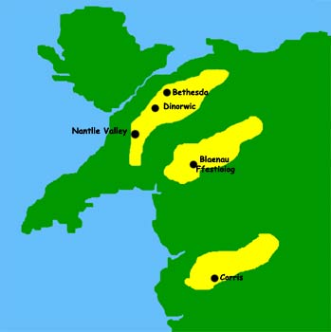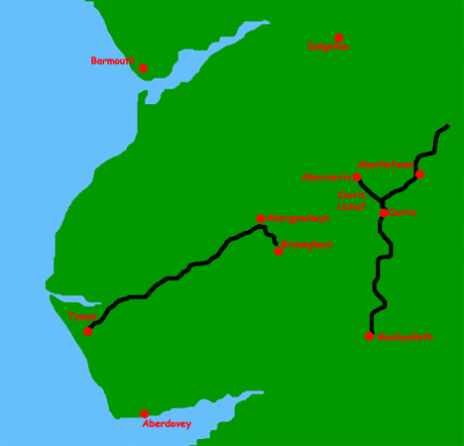
Slate bands within the Harlech Dome The Southern Slate Band showing Bryneglwys (Source: grantonline.com) (Source: grantonline.com)

The Glacial Morphology which gave access to the slate in this area is beyond the scope of this examination, but is described by Watson (1962). The Southernmost of the slate bands within the Harlech Dome encompasses Bryneglwys (above the village of Abergynolwyn) and, further East, the quarries at Corris and Aberllefenni (Holmes,1999).

These quarries are important not for their great output or profitability, but for their technical innovation including their use of water-powered inclines to raise the slate from the quarry to the workshops and, further down the valley, the use of narrow-gauge steam railways to move the finished product to the coast and the newly-constructed mainline at Towyn (now Tywyn) (Llechi Cymru, 2016).

As such, Bryneglwys, the inclines and the Talyllyn Railway were included in the 2012 bid by Gwynedd County Council for the Slate Landscape of Northwest Wales to be inscribed as a UNESCO World Heritage Site under Criteria (ii), (iv) and (v) (Gwyn, 2018:8).

Prior to, and separately from this application, Forest Enterprise Wales who have (post-1945) planted and harvested timber across Snowdonia conducted a “comprehensive archaeological survey” of the site, in partnership with The Woodland Trust and the Tallyllyn Railway Company, as part of their Welsh Heritage Assets Project (Farmer and Eastwood, 2001:1). This led to the creation of a full Geographical Information System (GIS) developed in collaboration with the GeoData Institute of the University of Southampton. The GIS includes many of the buildings and structures associated with the quarry and it’s transport systems.

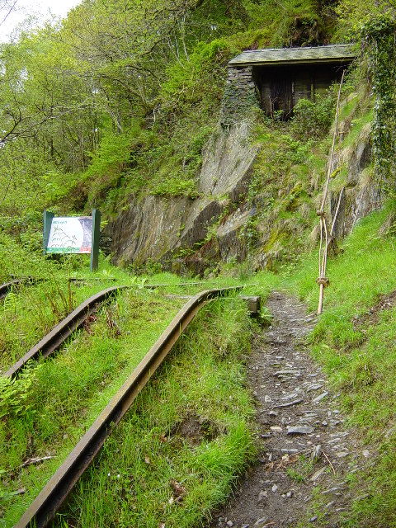 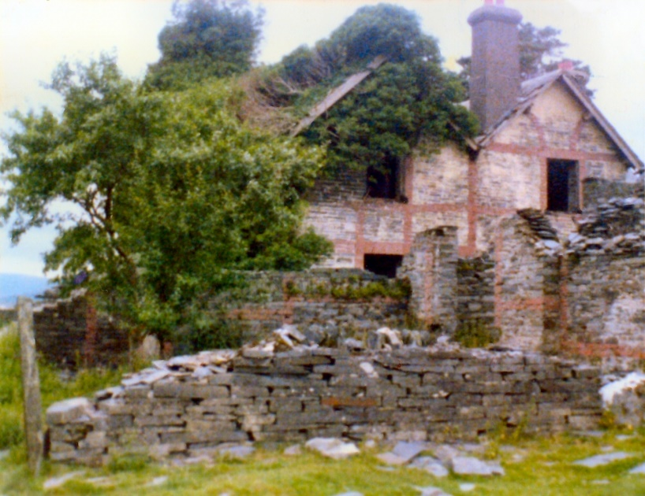
Alltyllwyd incline and winding house Managers House ca. 1979
(Source: Janine Forbes CC BY-SA2.0) (Source: jgd.org.uk)

Unfortunately, much of this historic site - the above-ground parts of which have open access - were reduced to rubble by the Forestry Commission (predecessor to Forest Enterprise Wales) on the grounds of Health and Safety in the 1980’s (Robinson, 2010).
Other organisations which have catalogued this area include Historic Wales, Gwynedd Archaeological Trust and CADW. Through Historic Wales, The Royal Commission on the Ancient and Historic Monuments of Wales (RCAHMW) have set up a navigable map-based website which details all the sites surveyed by the other organisations and gives details of National Monument Records, Historic Environment Records (HER), and Scheduled Ancient Monument Records. For Bryneglwys, these are summarised as follows:

National Monument Record for Wales

Type NPRN Description

Slate Quarry 40589 Bryneglwys Slate Quarry
Dwelling 28212 Manager’s House
Cemetery 43826 Bryneglwys Burial Ground
Inclined Plane 275918 Water Powered Chain Incline

Welsh Archaeological Trusts’ - Historic Environment Records

There are many of these, covering such sites as quarry buildings, tram-yards, bridges, inclines, spoil tips, airshafts, aquaducts, reservoirs and sluice-gates. Most of these have been at least partially destroyed but the Record give a detailed account of each individual site and allows an overall picture of the wider site to be compiled.

CADW - Scheduled Ancient Monument

Type I.D. Description

Water Power System ME186 Water Power System

(Source: Historic Wales, 2019).

The detailed record for ME186 states this as “the only surviving chain incline in Wales” and “of national importance for it’s potential to enhance our knowledge of water management systems”. However, the lofty descriptions of these artefacts often do not match up to what is seen on the ground; on this writer’s last visit in Summer 2017, most were just piles of slate, some through natural causes – as in the case of the quarry chambers themselves (see Robinson, 2010:4) – but some through deliberate destruction (Robinson, 2010:3).

The great benefit of the Historic Wales site is that it is scaleable, allowing the user to zoom in and out. In this mode it allows the user to place this site, which has been used in only a short, modern period, within the wider context of all discovered human activity within the wider locale. In doing so, we see that humans have acted upon the site and the surrounding area since the Neolithic period – with remains of barrows and cists on mountain peaks, Bronze-age hoards of copper and bronze placed in local natural features, major Roman roads and even modern wartime air crashes.

Since the 1920’s, aerial photography has become an important tool in identifying archaeological sites. Coflein, which is “…the online mapping system and to create distribution maps based on searches” (Coflein, 2019) is linked directly to the above organisations’ websites or can be reached independently and allows interrogation and interpretation of a site, often enabling features to be identified, possibly due to low light angle or wet/dry ground conditions, which could not be identified at ground-level. Below is the associated aerial photograph of Bryneglwys:

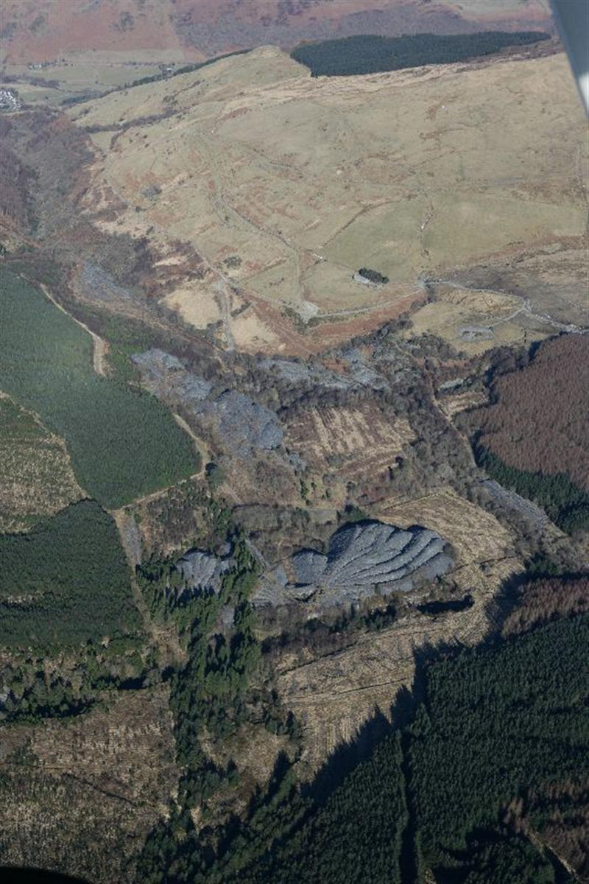 (Source: Coflein, 2019)

In this particular photograph (taken in 2010) it is not possible to see a great amount of detail due to the scale. However, it is clearly possible to identify the spoil heaps and (top left) the general track of the tramways and inclines as they make their way down the valley.

Given the importance of this site, as outlined in the above, and its possible designation as part of a World Heritage Site, it is to be hoped that further investigation will be carried out in the near future in order that the important industrial heritage that it holds might be secured for future generations.

Bibliography

Coflein (2019). Available at: https://coflein.gov.uk (last accessed 24.03.2019).

Farmer, R. and Earwood, C. (2001). ‘Heritage Management in Multi-purpose Forestry’ in Forestry and British Timber, Dec. 2001. Available at: https://www.search.proquest.com/docview/223795578 (last accessed: 24.03.2019)

Grant, D. (no date) Bryneglwys Slate Quarry. Available at: https://www.grantonline.com (last accessed 23.03.2019)

Gwyn, D. (2018). ‘The Talyllyn Railway - World Heritage Site?’ in Talyllyn News, 259:8. Sept. 2018. Tywyn: Talyllyn Railway Preservation Society.

Historic Wales (2019). Available at: https://historicwales.gov.uk (last accessed 24.03.2019).

Holmes, A. (1999). Slates from Abergynolwyn. Caernarfon: Gwynedd Archives Service.

Llechi Cymru (2016). Bryneglwys, Abergynolwyn and the Talyllyn Railway: The Nomination. Available at: https://www.llechicymru/en/Slate-Areas/DeMeirionydd (last accessed 24.03.2019).

Robinson, I. (2010). The Road to Bryn Eglwys. Available at: https://www.robinsonmaps.blogspot.com/2010/road-to-bryneglwys (last accessed 24.03.19).

Watson, E. (1962). ‘The Glacial Morphology of the Tal-y-llyn Valley, Merionethshire’ in Transactions and Papers (Institute of British Geographers), 30:1962, pp.15-31. Available at: https://www.jstor.org/stable/621299. (last accessed 22.03.2019).

