STUDENT NAME: Chantelle Simmonds
STUDENT NUMBER: 1914402
PROGRAM: BSc Health and Social Care
MODULE: Introduction to Physiology
MODULE CODE: BMHP 5003_BIRM
LECTURER: Giridhar Katti
ASSIGNMENT TITLE: Health Assessment Report
CONTENTS
Introduction
Case study
Assessment Report
Recommendation
Conclusion
References
Lifestyle Questionnaire
Appendix
Introduction
This evaluation report is based on a case study of a female who shows several symptoms. Based on the patient's completed lifestyle questionnaire. With her consent, the patient allowed further examination into her medical history and consented to more tests. Multiple illnesses of the respiratory and cardiac systems were diagnosed, and how they work normally and abnormally was discussed. Recommendations have been made to improve the management of the disease's symptoms and diseases through lifestyle changes and medicines.
Case Study
Female aged 60 years old, smokes on average 20 cigarettes a day, drinks between 3-6 units daily, slightly underweight so has supplement meal replacement, suffers from high blood pressure and angina attacks. Because of the frequent angina attacks patient only exercise is once a week when she goes to pay bills, does her shopping, and collects prescription. Family history of high Cholesterol.
Assessment Report
Based on her assessment and prior medical history, the patient has also had a pacemaker implanted because she was born with a septal defect (hole in the of heart). These findings show that Miss Branning has Chronic Obstructive Pulmonary Disease (COPD) has atrial fibrillation, due to slower and sometimes faster intermittent heart rate which led to her undergoing surgery and receiving a pacemaker. COPD is quite common among patients who have atrial fibrillation. (Simons et al., 2021) She also may be suffering from coronary heart disease. The causes of these symptoms are prolonged smoking and drinking which are influencing the patients' symptoms, of high blood pressure, angina attacks and weight loss.
Chronic Obstructive Pulmonary Disease (COPD)
Our respiratory systems are a network of organs that oversee absorbing oxygen and discarding carbon dioxide. The lungs are the fundamental organs in charge of gas exchange when we breathe. The lungs collaborate with the circulatory system to deliver oxygen-rich blood to our cells. Our blood then transports waste and carbon dioxide back to the lungs, where they are expelled when we exhale.
Our respiratory system is made up of several different parts.
Small airways (bronchi) Large airways (bronchioles)
Lungs
Diaphragm
The Throat (trachea)
The voice box (larynx)
The windpipe (pharynx)
Mouth
Nose
The trachea transports air from the sinuses to the bronchi tubes, which transfer it to the lungs. (Kim Ann Zimmermann, 2018)
When relaxed, adults should take 12-16 breaths per minute and 40-60 breaths per minute when exercising. While exercising, healthy lungs will have a high quantity of breathing reserve, even if you feel out of breath. When you have a lower lung function, you will not have a great amount of breathing reserve, which will leave you feeling short of breath and quite uncomfortable. (Sheff, 2016)
COPD is a condition of multiple lung conditions that cause breathing conditions. Including emphysema which is damage to the air sacs (alveoli) of the lungs and Chronic bronchitis inflammation of the airways (bronchial tubes) Longterm. The progressive disease happens when the airflow in and out of the lungs decreases, making it hard to breathe. This condition affects older adults who tend to smoke, causing breathing problems over time this can get worse causing limitations in normal daily activities. (NICHS, 2021)
COPD: Chronic Bronchitis (tuwa, 2014)
COPD symptoms include shortness of breath that worsens with activity, waking up in the middle of the night feeling breathless, continuous coughing with phlegm that doesn't go away, and wheezing. Other symptoms include weight loss, weariness, and swollen ankles or feet, as well as chest pain and blood coughing.
The primary cause of COPD is smoking.
Lung function pulmonary tests are used to decide whether a patient has COPD. The most frequent one is a spirometry, which measures how much air your lungs hold and how quickly you can push air out. Pulse oximetry, six-minute walk tests, and measurements of lung volumes and diffusing capacity are among other lung function tests.
A chest x-ray can reveal whether the patient has emphysema, the most common form of COPD, as well as rule out any other lung diseases or heart failure.
A CT scan of the lungs can help detect emphysema and find whether the patient needs surgery, as well as whether the patient has lung cancer.
Analysis of arterial blood gases. These blood tests will reveal how well your lungs are delivering oxygen into your blood and eliminating carbon dioxide.
Labatory tests are given but these aren't to see if the patient has COPD but to rule out other conditions and the cause of the symptom's patient is showing. (Mayo Clinic, 2017)
Many bronchodilator (inhaler) medicines and anti-inflammatory drugs are available to help alleviate COPD by relaxing the airway muscles. Although this condition is not treatable, some patients with severe COPD will require extra oxygen to help them breathe. A lung transplant is a last choice for those with severe symptoms that do not improve with treatments. The greatest treatment for COPD is a change in lifestyle, such as quitting smoking. (MedlinePlus, 2018)
(Washko and Parraga, 2018)
Atrial Fibrillation
The heart is a muscle with three layers of tissue, the pericardium being the thin outer layer of tissue that protects and surrounds the heart.
Myocardium is the thick muscular middle layer that contracts and relaxes to circulate blood around the heart.
The endocardium is the thin inner layer that makes up the four chambers and valves.
Upper chambers on the left and right sides of the heart are known as the atrium, while lower chambers on the left and right sides are known as the ventricle.
The right side of the heart has two valves called the tricuspid and pulmonary valves, while the left side has two valves called the mitral and aortic valves. The direction of your blood flow is controlled by these valves.
The electrical system signals of the heart tell it when to contract and rest; these signals are delivered from the sinus nodes.
This is the natural pacemaker of the heart. The signals should be given at a consistent rate and should react to your emotions, whether you are busy or at rest. The rate at which the heart beats is referred to as the heart rate.
When your heart is working normally, it will beat approximately 100,000 times per day, sending approximately 8 pints of blood around the body through blood vessels of the circulatory system, carrying oxygen and nutrients to muscles and organs all over the body while expelling unwanted carbon dioxide and waste. (British Heart Foundation, 2019)
Atrial Fibrillation is a disorder that occurs when the two upper chambers (atria) of the heart stop working in tandem with the bottom chambers (ventricles). The heart chambers must beat at the same rate to be rhythmic. (Nhs.Uk, 2017) Atrial fibrillation happens when the four chambers stop working together due to an electrical signalling defect, resulting in the atria and ventricles beating uncoordinatedly with the atria contracting fast and irregularly. Because the right atrial sinoatrial (node) controls the electric impulses, atrial fibrillation is also known as sick sinus syndrome.
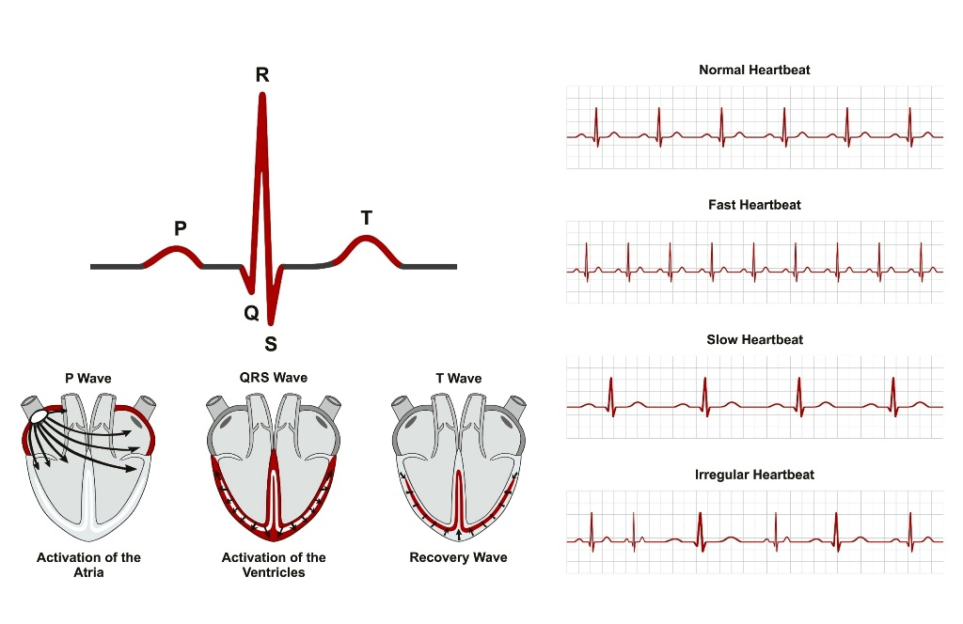Regular and Irregular Heart Rhythms (www.diseasefix.com, 2019)
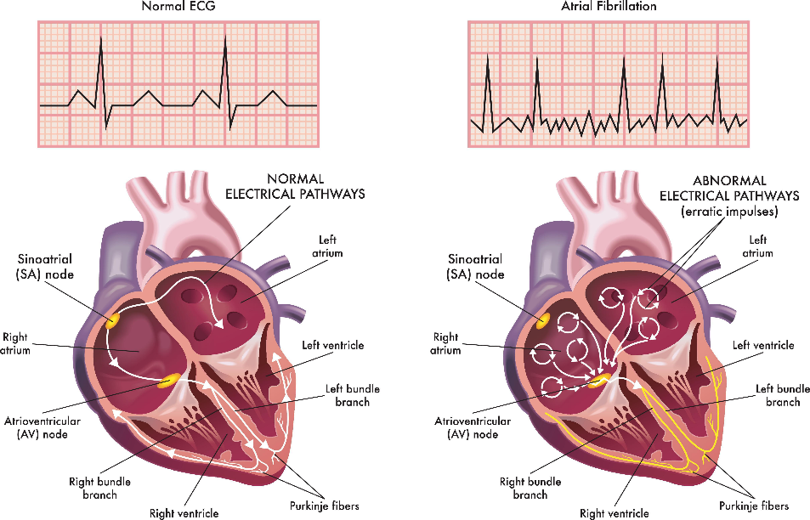
Normal Heart and Heart with Atrial Fibrillation (Sivasankaran, 2021)
The reasons of atrial fibrillation are not always understood. Conditions that can cause damage to the heart and lead to the condition include
- Congenital heart problems (heart defects presented at birth)
- High blood pressure
- Binge drinking
- Heart valve disease
- Hyperactive thyroid
- Certain medications and many others.
The symptoms people show with atrial fibrillations is
- Shortness of breath
- Weakness
- Heart palpitations (heart racing or beating irregularly)
- Chest pain
- Tiredness
- Reduced ability for physical activity
- Light headedness and dizziness
- Confusion
Atrial Fibrillation can endure for years or be a lifelong illness, however it is curable with medicine or medica procedures.
Anti-arrhythmic medicines are administered orally or intravenously to patients to restore the sinus node's normal activities. Controlling the heart rate and restoring the cardiac rhythm.
The type of atrial fibrillation, other medications the patient is taking, adverse effects, and how the atrial fibrillation responds to the drug selected. At times, patients may require more than one type of anti-arrhythmic medication, to restore heart rhythm, flecainide and beta blockers such as sotalol are recommended.
To keep the heart rate below 90 beats per minute whilst resting, the patient is given beta blockers like bisoprolol or atenolol, or calcium channel blocker like verapamil or diltiazem, Digoxin will be supplied if the heart rate needs more help in being managed.
If the first treatments do not work or if the side effects are too severe, alternative medications may be suggested.
As with all medication that is prescribed people can occur side effects taking anti-arrhythmic medications are low blood pressure, tiredness, cold hands and feet, impotence, heart rhythm disorders, sickness, ankle swelling, constipation and heart failure.
Because of how the heart beats in patients who suffer atrial fibrillation there is an increased risk of blood clots forming in the heart chambers if these were to enter the bloodstream there is a chance of a stroke. To prevent these prescribed warfarin or anticoagulants are given.
Medical procedures are considered if the medication is unsuccessful, such as
- Electrical Cardioversion
- Catheter ablation
- Atrioventricular (AV) node ablation
- Left atrial appendage closure
- Maze procedure
(NHS Choices, 2019)
Coronary Heart Disease (CHD)
Coronary heart disease (CHD) is typically caused by the accumulation of fatty deposits (atheroma) around the heart's coronary artery walls.
The build-up of atheroma causes the arteries to constrict, limiting blood flow to the heart muscle. This is known as atherosclerosis.
You have an increased risk of atherosclerosis if you are a smoker, have high blood pressure, high cholesterol, diabetes, do minimal exercise, smoke and have elevated levels of lipoprotein. Other factors of developing atherosclerosis are being overweight or obese and a family history of CHD.
Angina and shortness of breath, among other symptoms, are associated with CHD.
To manage CHD, the patient must manage and adapt to a healthier lifestyle, quit smoking, and take medication, such as anticoagulants, that can help with the condition by preventing blood clots by reducing blood thickness. Beta blockers, which lower blood pressure and heart rate, statins, which lower cholesterol levels if the patient has excessive cholesterol, nitrates, which widen blood vessels and improve blood flow throughout the body, and many other medications are available to aid the management of the disease. (NHS, 2019)
Recommendation
I suggest and recommend that the patient stop smoking since it will help to alleviate the disease. Smoking will not help, and the lungs will get more damaged. Smoking cessation was mentioned. Nicotine substitutes were offered. Reduce your alcohol consumption, your hunger will increase, and you should continue to consume a good, diverse diet. Has also been sent to a nutritionist and has a diet plan in place to help support and learn how to eat healthily to lower blood pressure and increase weight growth. Prescriptions are written for inhalers, nebulizers, and tablets to help open the airways and allow the patient to breathe more easily. Regular moderately strenuous, safe exercise will help the lungs and breathing. Keep an eye out for any other symptoms that could lead to a different diagnosis. A follow-up appointment will be scheduled to assess if there is a difference in breathing or weight growth.
Conclusion
To summarise, the patient's COPD is most likely related to a cardiac issue, in this case study, atrial fibrillation. You must understand the heart to comprehend COPD. The problems of COPD are caused in part by high blood pressure and heart disease. Your heart and lungs are crucial organs that cannot be separated to provide you with a decent quality of life. It is critical to adopt good lifestyle habits, such as dietary habits and frequent exercise, that will strengthen rather than harm your heart and lungs.

References

British Heart Foundation (2019). How Your Heart Works. [online] Bhf.org.uk. Available at: https://www.bhf.org.uk/informationsupport/how-a-healthy-heart-works.
Canadian Lung Association (2000). Respiratory system | the lung association. [online] Lung.ca. Available at: https://www.lung.ca/lung-health/lung-info/respiratory-system.
ECGMedicalTraining.com, T.B.E.-C. of, Manager, F.C. in S.C. where he is the E.C.C.P., STEMI and department, C.S.C. of his fire (2015). The Basics of Paced Rhythms. [online] ECG Medical Training. Available at: https://www.ecgmedicaltraining.com/the-basics-of-paced-rhythms-part-1/.
Kim Ann Zimmermann (2018). Respiratory System: Facts, Function and Diseases. [online] Live Science. Available at: https://www.livescience.com/22616-respiratory-system.html.
Mayo Clinic (2017). COPD - Diagnosis and treatment - Mayo Clinic. [online] Mayoclinic.org. Available at: https://www.mayoclinic.org/diseases-conditions/copd/diagnosis-treatment/drc-20353685.
MedicScientist :Total Health Portal Quality Generic Medicines. (2021). Atrial fibrillation Causes and Treatment Indications of DC Cardioversion - || MedicScientist :: Total Health Portal || Quality Generic Medicines ||. [online] Available at: https://medicscientist.com/disease-diagnosis/atrial-fibrillation-treatment-dc-cardioversion [Accessed 16 Dec. 2021].
MedlinePlus (2018). Chronic Bronchitis. [online] Medlineplus.gov. Available at: https://medlineplus.gov/chronicbronchitis.html.
NHS (2019). Treatment - Coronary heart disease. [online] NHS. Available at: https://www.nhs.uk/conditions/coronary-heart-disease/treatment/.
NHS Choices (2019). Treatment - Atrial fibrillation. [online] Available at: https://www.nhs.uk/conditions/atrial-fibrillation/treatment/.
NICHS. (2021). Statistics. [online] Available at: https://nichs.org.uk/research-policy/statistics?cv=1 [Accessed 17 Dec. 2021].
nhs.uk. (2017). Atrial fibrillation. [online] Available at: https://www.nhs.uk/Conditions/Atrial-fibrillation.
rarasprax (2021). Severe Copd Spirometry Results. [online] Available at: https://kronisd.blogspot.com/2019/06/severe-copd-spirometry-results.html.
Sheff, B. (2016). Your lungs and exercise. Breathe, [online] 12(1), pp.97–100. Available at: https://www.ncbi.nlm.nih.gov/pmc/articles/PMC4818249/.
Simons, S.O., Elliott, A., Sastry, M., Hendriks, J.M., Arzt, M., Rienstra, M., Kalman, J.M., Heidbuchel, H., Nattel, S., Wesseling, G., Schotten, U., van Gelder, I.C., Franssen, F.M.E., Sanders, P., Crijns, H.J.G.M. and Linz, D. (2021). Chronic obstructive pulmonary disease and atrial fibrillation: an interdisciplinary perspective. European Heart Journal, [online] 42(5), pp.532–540. Available at: https://pubmed.ncbi.nlm.nih.gov/33206945/.
Sivasankaran, S. (2021). Atrial Fibrillation Specialist. [online] www.sunshinecardiology.com. Available at: https://www.sunshinecardiology.com/services/atrial-fibrillation [Accessed 16 Dec. 2021].
tuwa (2014). Chronic obstructive pulmonary disease (COPD). [online] SlideServe. Available at: https://www.slideserve.com/tuwa/chronic-obstructive-pulmonary-disease-copd [Accessed 16 Dec. 2021].
Washko, G.R. and Parraga, G. (2018). COPD biomarkers and phenotypes: opportunities for better outcomes with precision imaging. European Respiratory Journal, [online] 52(5). Available at: https://erj.ersjournals.com/content/52/5/1801570 [Accessed 17 Dec. 2021].
Winder, A.M. and Smith, A. (2020). COPD: Here’s Exactly How It Affects Your Lungs. [online] www.healthcentral.com. Available at: https://www.healthcentral.com/article/how-copd-affects-lungs.
www.diseasefix.com. (2019). Disease Graphics, Videos & Images on Arrhythmia. [online] Available at: https://www.diseasefix.com/graphics/arrhythmia/61/1/ [Accessed 16 Dec. 2021].

IRAS ID:
Centre Number: 0204121317
Study Number: 1914402
Participant Identification Number for this trial: SB031061AFCOPD
CONSENT FORM
Title of Project: CASE STUDY
Name of Researcher: CHANTELLE SIMMONDS
Please initial box
Name of Participant SOPHIE BRANNING Date 17/12/2021 Signature Sophie Branning
Name of Person CHANTELLE SIMMONDS Date 17/12/2021 Signature C.Simmonds
seeking consent
LIFESTYLE QUESTIONNAIRE
Introduction:
To help us focus our Health Promotion activities in the practice, we would be grateful if you could fill in this short questionnaire. If you have already completed one on an earlier visit, please return this questionnaire to the receptionist.
Name ……SOPHIE BRANNING…………………..................Date of Birth …10/04/1961.......
Do you smoke? Yes [ ] No [ ]
If Yes, do you –
smoke less than 1 cigarette/day [ ]
1 – 9 cigarettes/day [ ]
10-19 cigarettes/day [X]
20-39 cigarettes/day [ ]
more than 40 cigarettes/day [ ]
smoke a pipe [ ]
smoke cigars [ ]
If No, have you –
never ever smoked given up smoking in the last year [ ]
not smoked for more than 1 year [ ]
Do you have high blood pressure? Yes [X] No [ ]
Have you ever had a heart attack
or suffered from angina? Yes [X] No [ ]
Have you ever had a stroke, “shock”
or any weakness down one side? Yes [ ] No [X]
Have any of the following – mother, father, brother, sister
a heart attack below the age of 60 Yes [ ] No [X]
a heart attack above the age of 60 Yes [ ] No [X]
a stroke Yes [ ] No [X]
trouble with very high cholesterol Yes [X] No [ ]
(hyperlipidaemia)
………………………………………………………………………………………
Practice Use Only
Health Education Smoking …Recommended going smoking cessation clinic……….
BP .143/89.
Height 5ft 7in.
Weight …7stone 6lbs……….
EXERCISE
Healthy exercise usually consists of activities that lasts at least 20 minutes, elevates your pulse, and causes you to breathe heavily. For younger individuals, this could be running, cycling, or sports, while for older people, it could be brisk walking. Do you take this type of exercise –
daily [ ]
3 times weekly [ ]
once weekly [X]
once monthly [ ]
seldom [ ]
I cannot take exercise because of disability [ ]
DIET
Please tick the one category which is closest to your usual eating pattern.
I eat no meat, fish, or dairy produce [ ]
I eat no meat [ ]
I eat a mixture including daily fruit and vegetables [X]
I eat a mixture including regular chips and fries [ ]
I eat frozen meals (e.g., TV dinners) 3 or 4 times/week [ ]
I eat mainly snacks [ ]
I eat a special medical diet [ ]
Please specify …eats a varied diet including meat and fish also has prescribed Ensure meal replacements/supplements ….
ALCOHOL
Please check the box next to the statement that best describes your regular average alcohol consumption. 1 unit equals one glass of wine, ½ pint beer or a single measure of spirit.)
I never drink alcohol [ ]
I drink less than 1 unit per day [ ]
I drink between 1 and 2 units a day [ ]
I drink between 3 and 6 units a day [X]
I drink between 7 and 9 units a day [ ]
I drink more than 9 units a day on average [ ]
……………………………………………………………………………………….
Practice Use Only
Health Education Alcohol [X]
Alcohol Brief Intervention [ ]

APPENDIX

(ECGMedicalTraining.com et al., 2015)

Atrial Fibrillation ECG( MedicScientist: Total Health Portal, Quality Generic Medicines, 2021)

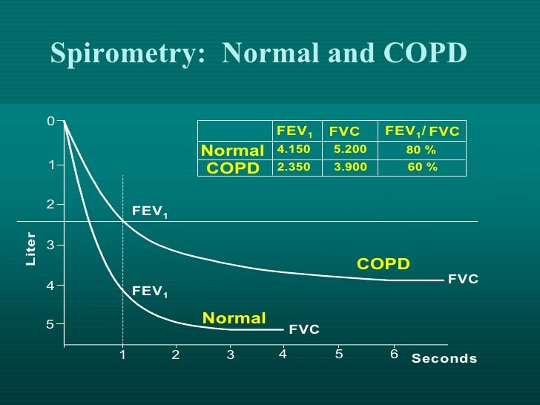(rarasprax, 2021)
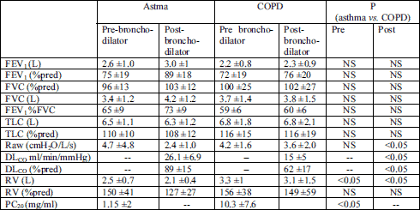(rarasprax, 2021)
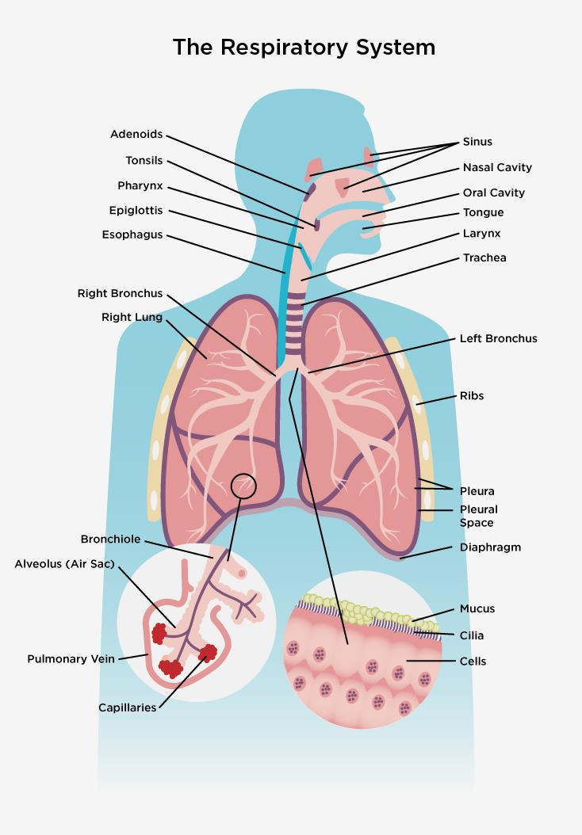
(Canadian Lung Association, 2000)
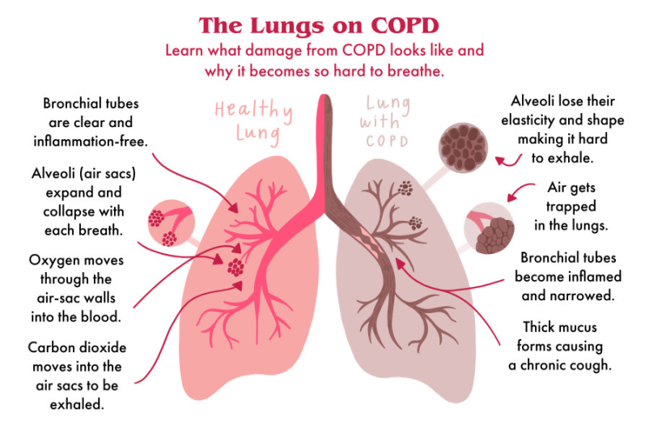
(Winder and Smith, 2020)

