Managing project in the organisation

BMSW 5104

Natasha Brookes
(1806574)

Dan Hart

Contents

Introduction
The effect of Covid 19 pandemic and weddings
Project portfolio
Project portfolio management life cycle
Five phases of project portfolio management life cycle:
How SWOT analysis is useful in Wedding Planning
Agile Methodologies positives in the workplace
Methodologies applied in the real world.
Waterfall methodology
Waterfall and agile

Agile Scrum Methodologies
Project scope, roles, and responsibilities scheduling
Scope, Time, and Cost
The recruitment processes
Identifying project stakeholders
Project End
Contract Closure
Releasing the project team
Conclusions
References

Introduction

This assignment will discuss different methods, tools, and techniques of how to manage a project as a wedding planner. On analysing several ways to achieve success through by looking at what works best on how to manage time, cost and what roles that each theory has to play a part in the success of the event in including Agile and waterfall, what strengths and weaknesses work best in order to get the task complete and how managing the project make the event or several events decide what are the best options through my own personal discussion with the evidence of the factual theories method, models that will be written within this report.

Wedding planners are known through different titles and jobs taking into consideration where they live or where they work. There are several different job titles that the wedding planner will be known as: wedding director, consultant, wedding director when a consultant or a wedding planner.

The effect of Covid 19 pandemic and weddings
This research information is based on the research of Stephanie Pywell and Prof Rebecca Probert who studied at the University of Exeter. Like most things during the Covid 19 pandemic, weddings were seriously affected within this period, back in early March 2019 people in the UK had to adapt their behaviour to comply with the restrictions the government had issued. The church of England(C+E) amplified the guidance issued under the marriage act 1949. Stating that weddings should be reduced to a minimum of just the bride and groom, two witnesses and the priest, becoming official March 19th2019 through the National Church of England report.
Social distancing is maintained except to the bride and groom, soon after all worship had been suspended. From Monday, 23 March 2019 total lockdown was immediately put in place across all formations of the United Kingdom.
To investigate the impact of overall restrictions, a survey was carried out in England and Wales questioning those that have been affected directly by Covid. The figures show 1,449 people that responded to the survey illustrated that the ease and speed which affected couples to be able to get married was affected not only on the national restrictions but also what route would be taken in order to get married. In some situations, some couples were unable to get married at all. Understanding of the legal and social terms of weddings play a major part in informing the recommendatioq1qwaz\ns on how the law should be changed in future not just to deal with similar crises but to ensure that the general law is fit for the future that all humans must face in the 21st century. (Pywell. Probert, 2021)

Project portfolio
Organisations that invest in projects need to properly plan and account for all outcomes of an investment. The organisation has the final decision as to which projects, they should fund. Sometimes it is fully funded, other times there’s part-fund.
This is known as a short-term decision: the budget cycle, or the long-term project can be covered through a series of multiple span budget circles. Sometimes this can be a very simple decision or can escalate to a long-winded extremely difficult one.
The life-cycle approach first analyses the proposal as an extension within the time period to the completion, postponement, or termination of the project.
Everybody knows the project is but not everybody understands the project must go through a portfolio management process. Sometimes there is more than one portfolio that will occur if advised through the organisation.
The first step is understanding what a clear portfolio is and knowing when maybe more than one portfolio is required.

Definition project: a project consists of finite dependent activities. The business decisions validate through successful completion of delivering excellent results.

Project portfolio management work well when the business focus aligns with the portfolio decision-making process, this is a great success in the real purpose of the project, but it doesn’t tell the whole story, through constructing a portfolio of projects is the content that is analysed to define if the quality for inclusion in the portfolio. Small projects may occur within the business unit, or a single department will focus on using its own resources only available to them and the others. This can lead to not fulfilling the full enterprise portfolio management process. Regardless this can be a part of the business units which is included in the process of the project. Conversely how complex, big, and expensive is the project before the portfolio before it is considered. (Wysocki, 2014)

Project portfolio management life cycle
Project portfolio management determines different types of projects within the corporation, such as prioritizing and evaluating proposed projects, monitoring the performance balancing investment objectives which must be adjusted periodically on occasions to achieve the desired best results.

Five phases life cycle
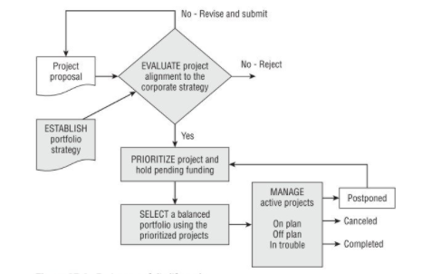 (Wysocki, 2014)

Five phases of project portfolio management life cycle:
This diagram illustrates the course and principles of the project action plan this can occur within its life cycle.
The five phases are established, evaluate, prioritise, select, and manage. Show the change in status within the project during this life cycle.
Proposed: a proposed project is requested through the portfolio when being submitted. In evaluating alignment is regarded the portfolio strategy.
Aligned: the alignment is determined through the purpose project once the decision is made it will be placed in the funding category sometimes may be more than one for future consideration.
Prioritised: if there are several projects aligned will be placed into a funding category and prioritised alongside others so they can work out where it is ranked at the final stages of selection for the portfolio.
Selected: priorities selected are placed in a queueing system before the project is given the go-ahead within the funding category and it awaits authorisation.
Active: if funding will authorise the selected the project will be open for work. The process is given the go-ahead with the assignment and the recruiting team members such as other activities that scheduling the work this will occur with the launch of the project
Postponed: if funding and authorisation have been removed temporarily the project is returned and the resources are postponed and returned to funding where the project originated. The resources may be allocated to a net project in the funding to which the original project is back in the queue.
Cancelled: the project is no longer in a high category of a priority that can occur if it has failed to show progress towards the finishing date. Those Funds will be returned for the next project which needs funding to what is available can be categorised to another project.
Completed: the project is completed through satisfaction and has met its objectives as proposed by delivering business value.
The proceeds through the five phases of the project management life cycle refined itself in one of these eight stages, every single stage is important and counts as much as the rest. (Wysocki, 2014)

How SWOT analysis is useful in Wedding Planning
Swot analysis is looking at the strengths and weaknesses plus the opportunities and threats that should not be ignored it’s an acronym that is used to analyse a business or analysts it connects the four categories to a specific subject or topic. While drawings or graphs can be useful in a scenario for a wedding planner. While this may be useful keep in mind that time is of the essence and needs to be optimised as there is always a fast-approaching deadline.
SWOT analysis has a great impact on achieving the results that are intended so by the time you fully analyse and understand what is good, what needs to be worked on where you happy with the project and your organising of the event, what is wasting your time, where you can save money, most of all what can compromise everyone’s happiness on the day most importantly making the day successful for both the bride and groom. (Swot, 2021)
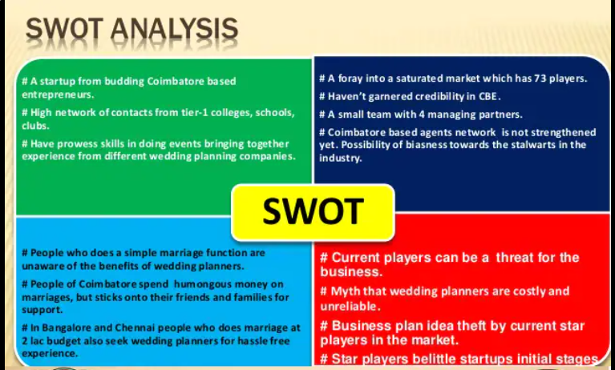
(Scribd, 2021)

Swot analysis is used by many types of different people to gain evil branding, clarity about the organisation or even just themselves, by going through sections bit by bit time you achieve swot analysis clarity.
Strengths and weaknesses: the first analysis is looking at and analysing the strengths. These are the things that you’ve already covered so there’s no need for you to worry about.

Strengths: This section consists of all the things that you have completed such as down payments and deposits. We must remember every single detail down to the tiniest things that make sure you have the correct silverware ready for all your guests.
Any task not fully completed we should note down and take the next steps in order to get the customer off your need-to-do list.
with your to-do list complete you can take a deeper look at things that are being handled, on their way and maybe some even finished.
Weaknesses: this consists of everything being wrong and not knowing a what-to-do list. These imperfections eat away at the wedding planners. This issue is a constant reminder driving up stress levels because people mainly focus on what has not been completed making the task ahead become more challenging. Through the weaknesses wedding planner focuses on this the most worrying about things like spilling wine in the bride’s wedding dress just before they walk down the aisle which would be devastating while about things like getting to pay for the guest’s food and there is only one hour to the service.
Creating a list will make a wonderful day to remember such as are there enough chairs, what if the DJ loses your playlist, always make sure you have a backup plan in place. Make a list to give yourself a sense of peace just in case any of these disaster scenarios may occur.

Opportunities and threats
When you are doing a swot analysis for wedding planning, sometimes there are coupons, deals and discounts such as bridesmaids receiving a percentage of the purchase of their dresses because of buying several items in bulk. Also, there could be a package deal when purchasing the DJ with the music. Having the opportunity during the wedding planning phase will reduce stress. By analysing the strength and weaknesses list look to see if you can find any opportunities hidden there
Threats: there’s one thing that should never be ignored. But they are exactly what you think they are, so this is the most worrying as they are things that threaten the bride and groom’s outcome of their wedding.
Creating a list of witnesses is very important within this section as weaknesses can become threats so very easily. Listing the rate of the threats 1 to 9 with nine being the highest level, this is put in place to figure out a plan to either mitigate or prevent the effects.
Once there has been completed through the section swot analysis will be achieved. Knowing another clear understanding of what is already finished, what needs to be done, where costs and expenses can be saved but most importantly the question is what could be Armageddon of your wedding day. IF Something is not done and nothing is achieved ASAP. (Pestle, 2021)

Agile Methodologies positives in the workplace
Scrum improves how we work in several ways:
- It produces higher product quality, due to constant testing and continuous improvement as small increments of the work are performed, in the instance of a wedding planner, the incremental rollout and developmental changes that take place during the process of planning the event are always presented to the Bride and Groom (who act as stakeholders would in a business making changes to a project or operation) and as a result...
- It results in higher customer satisfaction, doing this through a company’s communication to its customers (and stakeholders).
- The “Sprints” feature which acts as an intermission between developing and altering key features and as a result of (ideally) good communication there should be a constant adaptation to the client’s requirements as they build their feedback off of what they’ve already seen.
- It provides faster ROI because of it being constantly updated and therefore improving with each iteration, on the client end all they see is a service, software or concept of an event which is improving based on their personal preferences and is finally released or is concluded in development with a finished and concrete product.

Methodologies applied in the real world.
Agile software development is an approach to software development that focuses heavily on incremental delivery (a form of rollout which focuses on increasing product quality in every subsequent iteration), working and communicating effectively in a team and continuing to plan and learn.
Agile is not a specific and clear set of parameters that are followed, however there are some key steps to understanding and implementing its methodology.
- Planning: In the agile process, this is where projects are envisioned and prioritized however in the scope of a wedding planner this is where the original requirements are brought to be considered and a shortlist is made consisting of the requirements that the Bride and Groom have specified, Team members are chosen based on their key skills and abilities, funding is arranged and distributed, and anything immediately needed is sought after and organised. In event terms (which are perfect for this scenario) an overall budget (maximum), Team leaders and contingency plans are among those that are designated and chosen.
- Execution: Once a plan has been agreed on and drawn up the contracting of services and consideration of things that require booking in advance will ensue; decorating and designing the event, booking avenue, and sorting out food will apply for a Wedding Plan.
- Go Live: After the meticulous planning, booking, and scheduling it's time to deliver the working iteration into production. In other words, the big day has arrived! This is where the Wedding Planner has managed the event day itself, all that’s left to do is celebrate!
- Feedback: In the tech industry this is where stakeholder feedback would be factored and sought out after its release however for a wedding host and planner, this essentially means dedicating some time to properly review the quality of the services commissioned for the event, gather multiple (ideally) testimonials and revel in the event itself. (Demicoli, 2018)

Waterfall methodology
methodology is a systematic sequence of different activities that are there in order to achieve the objectives of the project is being developed, in detail it describes different activities needed to be addressed in order to solve the problem, each stages of of methodology has its own objectives, is important with the selection what methodology should take into account before developing a project this procedure needs to be taken into account for the systems development, making the correct choice is very important to ensure the quality of the resulting project was to the best satisfactory standards. This can come into operation throughout the predetermined time period. For wedding the agile waterfall methodology is chosen to develop the wedding planner (WP).
The waterfall model consists of five different stages, this is known as: The requirement analysis phase, design phase, information phase, verification phase and finally maintenance phase.
The requirement analysis phase: used for describing the process of system via using case diagram, class diagram, sequence diagram. All the data and information that is collected through this system will be analysed to develop what the user needs to meet the requirements. Sequence diagram the customer. (Half, 2014)

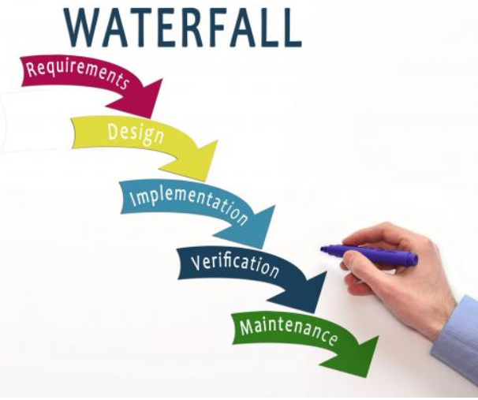
(Half, 2014)

Waterfall and agile
the waterfall method is like building a house. You must build a foundation from the ground upwards, is the foundation that counts the most, this diagram shows that the team worker one section at a time and completion they can move onto the next stage. The product or service can only be tested once deployed.
Once I phase completed is no going back unless you want to start back at the beginning from scratch.

Advantages of using waterfall
All team members know what to expect because of the size of the project, timeline and costs are determined from the get-go.
If there is one less developer in the project it shouldn’t make a big impact to instil achieve the outset goals, documentation is well detailed every step along the way.
The documentation is full of information which makes it much easier for improvement for the future.

Disadvantages of using waterfall

Once a section is completed by the developers it’s the point of no return there is no going back. In the unable to adjust changes and are less taxable throughout this can become more complex if the clients are involved. Prolonging deadlines plus overbudget set amount for the project.

The classic waterfall approach is good when it is clear, there are not too many stakeholders involved within the project is not overly complex but for any stakeholders that are involved in the project they should know what they are in for.

The advantages of agile:
You can adjust and explain the changes you have made to properly accommodate the business.
While doing the project you can add and delete features has it progresses along.
Bugs are detected and fixed as soon as possible.
The client can have input at the end of each sprint rather than having to what until the project is finished. (Scott, 2018)

The disadvantages of Agile:

This methodology requires full commitment from the team to collaborate and approach a skilled project manager this can assign and divine sprints carefully. Creating issues that manager or the team can doom a project.
Agile is best used when the developers and the clients that the project scope could change as they move along this occurs when rapid production is critical.
This method can be adopted by many other industries not only for software development. When a large organisation’s partitioned into chunks a project can become very complex.

Which method of development to choose:

Waterfall method is the way to go for reliably displaying a clear picture (in terms of business goings on can changes and alterations). scope, and all stakeholder influence.

If you don’t want to set anything in stone? Agile ensures by giving you an opportunity to switch it up at any time.

There is no option that fits all especially when it comes to your skill set, so look at your options, set a timeframe, prepare yourself for projects and always ask yourself plenty of question, such as with external stakeholders have impact? Do you have a team that provides all the skills that are necessary to complete the project? What is the timeframe? What is the context of the project? Is the project still vague or set in stone? (Scott, 2018)

Agile Scrum Methodologies

Scrum is used for the development of an agile framework where people can address any problems that are complex adaptive as well as delivering creative products to the highest standards
There are three different roles:
Development Team: People working together to deliver the products. (Developers)
Product owner: Manages the market and business requirements. Represents the clients’ interests and are accountable for the results. Motivation for the team makes decisions single handed.
Scrum Master: Arranges meetings, deals with all bottle neck challenges, helps to maintain staff to follow rules, practices, and theories. (Swan, 2006)

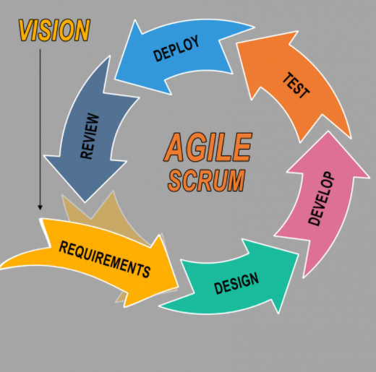
(Swan, 2006)

Project scope, roles, and responsibilities scheduling
The project scope is covered by five major aspects: initiation, planning, execution, monitoring and closing.
Intuition: is your budget, choosing the venue, how many guests and most importantly what date is the big day.
Planning: covers what is the theme of the wedding, where is the location most of all securing the wedding venue, this entails selection of the siding minister, clothing, décor, entertainment, and caterers,
Monitoring: this is when the team looks at the ongoing project activities by comparing the scope with project cost. Some identified factors are altered in order to meet the actions controlled by the team.
Execution: this entails organizing the catering, collection of the dress, implementation of the ceremony for the team.
Closing: arranging the honeymoon, arranging the flights to the set destination and payment of cheques.
The roles and responsibilities are that the bride and groom oversee the selection of the venue. The guest list, cake design, vows, ring choice, entertainment, wedding speech and honeymoon selection. Their composition ranges from guest seating, marriage license and wedding party.
Bridesmaids and groomsmen are in control of the travel plans, bachelor bachelorette party, accommodation for guests, arranging the photographer, their dresses, floral arrangements most of all gift registry.
The mother and father of the bride and groom help financing the big day, rehearsal dinner also make contributions to the creation of the guest list. (Kousholt, 2012)
Scope, Time, and Cost
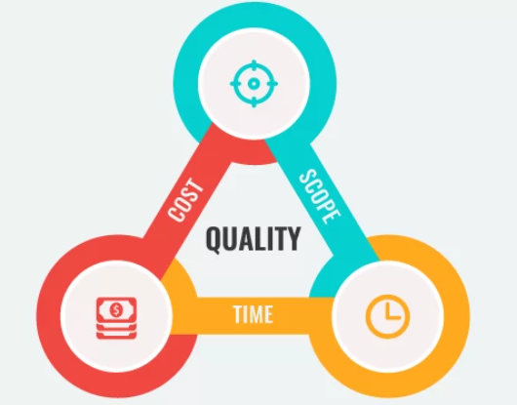
(Pabrai, 2020)
This concept was first introduced in the 1950’s it is used to communicate the convolutions of the project, so this is not new at all. It was first used to show the three constraints namely, time, scope also known as quality.
If you want to increase the quality of the project by adding more features the budget would automatically increase but this could push the deadline back for the launch of the product. If the project cannot be pushed back, the descope of the basic prototype may increase the expenditure. What I’m saying is all three are interconnected with one another this is way the project manager must keep a close observation then make some tough decisions on what might have to be compromised to make complete sense of his project.

The recruitment processes
Specifically for the sake of an independent Wedding Planner (A standalone entrepreneur), the recruitment process would be on the side of the client acting as an employer to the commissioned employee (The Wedding Planner.)

Methods of recruitment are vast in number and range from targeted marketing through what may be cookies and targeted online marketing through Search Engine Optimisation, Word of Mouth which despite being the simplest and most archaic form is definitely one of the most potent, in the case of a Wedding Planner (who’s work should ideally be well documented and displayed) this is extremely useful as the work they’ve previously done can be shown as examples in a portfolio, further increasing their potential to be “Recruited”

Through a capable portfolio as a means of displaying one’s work, advertisement and therefore recruitment can take many forms.

Similarly on the Wedding Planners end for the sake of being well equipped with reliable and high-quality contacts and services, those services would be verified and vetted through their ability to display their work/services; Venues, Caterers, Decorators, Transport and Florists all are subject to recruitment to be involved.
Identifying project stakeholders
A stakeholder is defined as a person with an interest or concern in something, especially a business.
In the case of our Wedding Planner, (and as aforementioned) the stakeholders in this scenario are the Bride and Groom.
Whilst all who attend surely have interest and concern for the event there are rarely none more concerned than the Bride and Groom who most likely would have reached out to the Wedding Planner.
Much like stakeholders have a keen interest in the business (closely eyeing changes made to administration, monitoring profits and expenditures, and measuring a business’s success on its competitors) a Bride and Groom hold a Wedding Planner (and by proxy) the Wedding planned to similar scrutiny.
Changes and alterations to plans overtly made, setbacks from unavailable choices and contingency plans for dealing with these setbacks (torrential rain for example ruining what should have been a sunny photo op on a field) should all be communicated to those who have the most interest in the business, however where the Wedding Planner differs in its operation is its heightened importance on the stakeholders, without them, there is no recruitment, no operation, and no job.

Project End
Every comes to an end this is the last stretch for completion with the project life cycle. The main objective is to make sure all steps for the life cycle has been complete to the highest standards making sure that every step has been finalised as promised by the wedding planner and the team knowing that the stakeholders have accepted that all criteria has been achieved with outstanding results, if all parties agree that the project has finished that’s when it can all come to an end.
Project completion is known to be the difficult stage of the project life cycle once its over its so easy to have closure then move straight on to the next project. Project completion consists of dissemination information to formalize and acknowledge the acceptance of the service, product, or project this is dealt with by closing the performing project. The project manager must check and review that all documents are up to date. Suh as scope changes were introduced into the project so changes had to be altered along the way like characteristics of the final product. The resources assignment must be updated. Many different team members will have come and gone by this stage of the project. Once all outcomes are checked, complete and documented, the stakeholder or customer will then be given the formal acceptance of knowing if the service or product meets the objectives of the project that was set to be accomplished so then all documentation will be finalised to share the project results with them.

Contract Closure
Just like the project closure also comes to an end so does contact closure. This is verified by completing and settling the terms of the contact let for project, this information supports the project completion process by determining the work that is described in the contract as been completed accurately and to high standard satisfaction. not all projects require the contract closure process it only applies to the deliverables or parts of the project that is stated in the contract.
Contact closure is dealing with the finalization of projects records final details. Checking all terms and conditions have been completed. This information is then provided to formally notify the seller or service provider through written form so check if the deliverables are accepted or are they satisfied otherwise being rejected. If the product or service is not up to standard, it’s the vendor will be responsible for the correction they are given a formal acceptance notice. This is done before the contact is closed. Things that are minor and still need attention before completion are then transferred to a punch list, this is a list written by the management team or the client stating what is still left to do before the whole project is finished.

Releasing the project team
This is not an official process; it should be noted that the Project management team can now return to being assigned to another project or return to their functional managers. When coming close to completion of the project its best to inform their manager so they have adequate plan for returning them back to the employees. Notifying their employers head of completion of the project gives them ample time to plan to reschedule them with another task or project. That is if the supplier has met the contractual obligations through making the repairs and fixing all the problems that are written on the punch list, the project has been signed off on the contract which is then submitted to the accounts department so payment can be finalised. The Supplier is the give final notice that everything has been paid off and completes the agreement contact making the whole contract complete and finally its all finished. (Palmer, 2019)

Conclusions
As aforementioned, I have attempted (through displaying the different methodologies and
explaining their places not only in the workplace but in the scope of a wedding planner too) to discuss tools and techniques of how to manage a project as a wedding planner.
With the planning that is involved, I believe I’ve properly explored the Strengths, Weaknesses, Opportunities and Threats that comes not only with businesses in general but also for the Wedding Planner business. Wedding planning project was a success improvement of the project into mission and planning phases have led to a better outcome the team to learn to adapt with the approach to project management techniques tools and plans will come together for conclusion that projects are complex but with teamwork, research on analysing what best steps to take for a project to get completed satisfying the stakeholders most importantly successful day for team members most of all bride and groom. I have learnt that there are different ways to approach managing a project, through this report, the conclusion has been revealed through this report research. So, throughout this report the changes that have occurred since the covid-19 shows that society has had a great impact and now that not only projects will have to change and be altered for the future. We will continue in this life of uncertainty not knowing will the future ever be the same or will life projects for ever be revolutionised for not just pandemic incidences but for a whole new 21st century that is here to stake changed. This way is the future.
Making that Big Day one to remember!

References

Bjarne Kousholt (2012), Theory and practice, 2nd ed Denmark.
Christopher Demicoli (2018), 12th May-last update, Process Management, People, General, Agile, Kanban. Available: https://blog.cdemi.io/planning-a-wedding-the-agile-way/ (Accessed: 22, September 2021).
Dr Stephanie Pywell and Professor Rebecca Probert (2021),, The effect of the COVID-19 pandemic on weddings. Available: https://business-school.open.ac.uk/news/effect-covid-19-pandemic-weddings (Accessed: 22 September 2021).
Erin Palmer (2019), project completion- Project Management, How to Build Relationships with Stakeholders ed., translated by Anonymous Wiley, CC BY-NC-SA.
James Scott (2018), August 20, Waterfall, Agile or Hybrid – What Development Method Should I Choose? Available: https://www.userbrain.com/blog/agile-waterfall-hybrid (Accessed: 22 September 2021).
Mr. Mohnish Pabrai (2020), May 26, Scope, Time, and Cost: How Important Are They for a Project Owner? https://www.hestabit.com/blog/quality-triangle-explained-for-project-owners/ (Accessed: 22 September 2021).
Robert Half (2014), February 11, Waterfall Methodology 101: the Pros and Cons. Available: https://www.roberthalf.com/ (Accessed: 22 September 2021).
Scott Swain (2016), Agile Scrum overview. Available: https://oceanmedia.net/agile-scrum-overview/ (Accessed: 22 September 2021).
Scribd (2021) Integrated Marketing Communications- Wedding Planning Industry. Available: https://www.slideshare.net/AdhithyaArunraja/integrated-marketing-communications-wedding-planning-industry ( Accessed: 22 September 2021).
Swot and business analysis Tools (2021), How SWOT Analysis is useful in wedding planning. Available: https://pestleanalysis.com/swot-analysis-before-new-product-launch-fatal/ (Accessed: 2021, 22 September).
Villanova University (2021), August 31, Project Team Roles and Responsibilities Explained. Available: https://www.villanovau.com/resources/project-management/project-team-roles-and-responsibilities/ (Accessed: 2021, 22 September).
Wysocki, R. (2013), effective project management, 7th ed., translated by Anonymous Wiley & Blackwe[[, Indianapolis.

