University of Wales Trinity Saint David
London campus

Module Name: Learning in the Software
Solutions for Business
Module Code: ACCA 4026

Student Name: Svitlana Matviiuk
Student ID: 2541758
Group: 1

Lecturer’s Name: Rajeev Nath

Software Solutions for Business

Contents
Introduction 2
Task 1. e-Commerce Website builders/software solutions 2
1.1 Wix 2
1.2 Shopify 2
Task 2. Mind-map of contemporary software applications 3
2.1 Describe mind mapping and explain the benefits of using mind mapping 3
2.2 Create a mind map of contemporary software applications 5
Task 3. Office Applications 5
3.1 Four office software solutions for business operations 6
Ms Word 6
Ms Excel 7
Ms PowerPoint 9
Ms Access 11
3.2 Test any two features 12
IF Function 13
VLOOKUP 13
Task 4. Communication and Collaboration applications 15
4.1 One contemporary Communication and one Online Collaboration 15
Microsoft Teams 15
Microsoft Outlook 15
4.2 Test one feature of a freely available Communication (1) and one feature of a Collaboration (1) application 15
Microsoft Teams 15
Microsoft Outlook 15
Conclusion 19
References 19

Introduction
Website builders for e-commerce websites are pieces of software that allow companies to establish and run their websites easily even if they do not possess high technical skills. These software packages include functions that allow building websites, managing products, processing payments, managing inventories, and building customer relationships. Choosing an appropriate e-commerce website builder is one of the key decisions of doing business. The three most popular e-commerce website builders are Wix, Shopify.

Task 1. e-Commerce Website builders/software solutions

1.1 Wix
 Wix is a website building platform that operates on the cloud and features drag-and-drop technology. It is mainly targeted at beginners and small firms wishing to set up an appealing online shop easily. Some of the features offered by Wix include a wide array of templates created by professionals, marketing tools, secure payments, and mobile optimization. The user can also use Wix to manage orders, monitor sales performance, and integrate social media sites. The greatest benefit of using Wix is that it is easy to use since no programming knowledge is necessary. However, there are some downsides to the platform concerning scalability and customization[1].

Figure 1. Wix Website Builder and E-commerce Features.

Figure 2. Wix Website Templates and Design Options.

1.2 Shopify
Shopify is among the top e-commerce platforms in the world. In contrast to Wix, which is more of a website building software platform, Shopify is designed for e-commerce use. The site has many business tools that allow users to handle a variety of functions within the business such as inventory management, multiple payment gateways, shipping services, customer analysis, abandoned cart recovery, and even international sales. Additionally, Shopify allows businesses to access thousands of third-party applications available in the App Store. Shopify is a very secure, reliable, and scalable platform capable of handling many products and sales. Despite being a subscription-based platform that also involves additional fees for some apps, it is a great choice for growing businesses[2].

Figure 3. Shopify E-commerce Platform.

Figure 4. Shopify Online Store and Business Management Features.

Task 2. Mind-map of contemporary software applications

2.1 Describe mind mapping and explain the benefits of using mind mapping

Figure 5. Mind Mapping as a Method of Organising Information.

A mind map is a graphical method of organizing, analysing, and presenting information. With mind maps, people and organizations can organize information around an idea in a central manner, making difficult information more comprehensible. While linear notetaking is the conventional way of organizing notes, mind mapping employs branches, keywords, colours, symbols, and images to illustrate relationships between various concepts. It fosters analytical as well as creative thinking[3].
The term mind mapping was coined by Tony Buzan in the 1970s. Currently, mind mapping tools include Mind, Mind Meister, and Miro; these allow real-time collaboration and better organization of business information.
Benefits of Mind Mapping
Improves Organisation
The mind map helps organize information in a structured way. The fact that it starts with a central concept and branches out into other concepts makes it easier for people to see how all concepts relate to each other.
Encourages Creativity
Mind maps encourage creativity since concepts are added in a free-flowing manner with no specific linear pattern being followed. This feature makes mind mapping an excellent tool for brainstorming.
Enhances Learning and Memory
Visual Learning techniques can help with retaining information. Mind maps use a combination of keywords, colours and imagery in a way that stimulates logical as well as creative thought, making the information more memorable than traditional note taking.
Supports Better Decision-Making
Aids Decision Making Process
All the pertinent data is displayed in one single diagram using mind maps. The managers along with their respective project teams can evaluate different options, establish relationships, determine possible risks and take better decisions.
Facilitates Communication & Teamwork
The latest mind mapping tools enable simultaneous collaboration among various people. Team members can exchange their ideas, amend their project plans and communicate more efficiently, especially when working in distant locations.
Improves Efficiency
The use of mind maps makes project planning easier as it helps break down large projects into smaller segments. The user can then prioritize activities and become more efficient.
Application in Business
A mind map can be used by businesses for software development projects, strategic planning, marketing campaigns, risk assessment, and meetings among other uses. When developing a software application, the project manager may create a mind map to capture the stakeholders, functional requirements, risks involved in the project, cost of implementation, phases of implementation, and expected business value.

2.2 Create a mind map of contemporary software applications
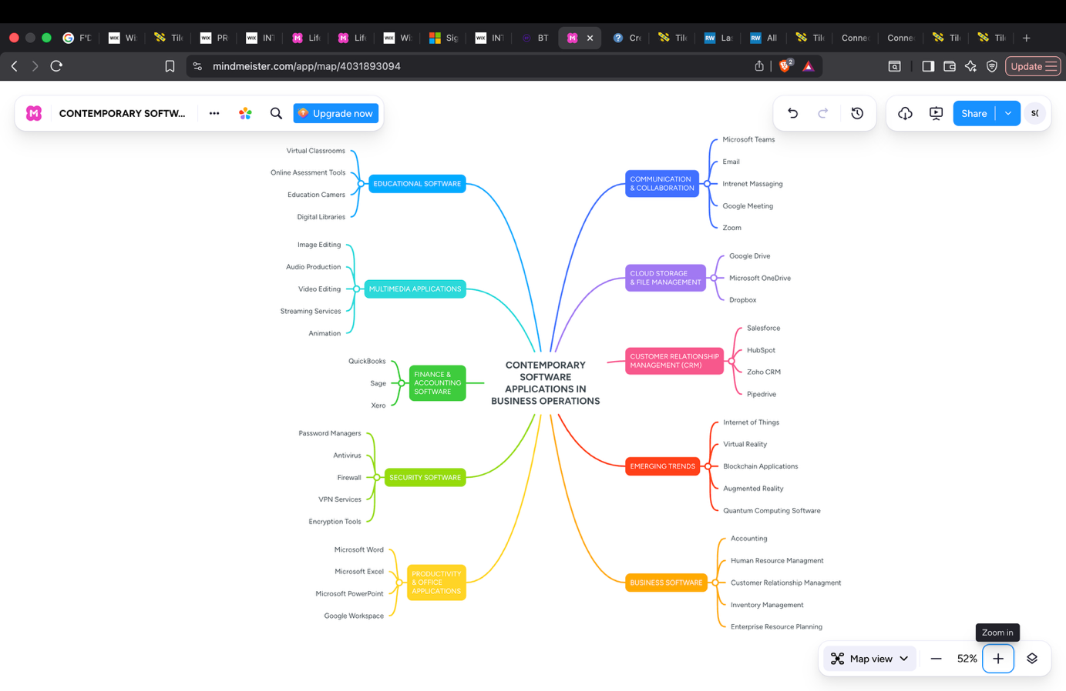
Figure 6. Mind Mapping of Contemporary Software Applications.

Task 3. Office Applications
Modern businesses require office software for document creation, analysis of business information, data management, and effective communication. Microsoft Office is a package of software applications which helps in carrying out day-to-day business activities. Some of the most used applications are Microsoft Word, Microsoft Excel, Microsoft Power Point, and Microsoft Access. All these applications have unique features which help in increasing efficiency and decision-making process. This report will highlight the features, advantages, and disadvantages of the above mentioned four applications, and the practical test of two features of Microsoft Office, namely Mail Merge in Microsoft Word, and VLOOKUP in Microsoft Excel[4].

3.1 Four office software solutions for business operations

Ms Word
Microsoft Word
Microsoft Word is a word processing software that allows organizations to develop and manipulate their professional documents. Microsoft Word is commonly used to write business reports, business contacts, minutes of meetings, letters, policies, and personnel documents. This software offers functions including templates, spelling and grammar check, tables, images, page layout, and comments for collaboration[5].
Microsoft states that Word enables users to generate documents by using blank files or templates and offers tools for formatting and reviewing documents.
Major Features
The most prominent feature of Microsoft Word includes document generation and formatting. Users can generate documents and make changes to fonts, headings, paragraphs, page layouts, margin and spacing. Users can also insert tables, pictures, charts, page numbers, headers and footers. This is quite helpful in generating professional business documents.
Another notable feature is templates. Templates help users to use them for generating documents like reports, letters, or business proposals. Templates already have styles and layouts pre-defined, and hence the user need not develop a document layout from scratch. Organizations can also create custom templates for maintaining a uniform style throughout. According to Microsoft, a document which is used frequently can be saved as a template and reused in the future.
Another aspect of the word processing software is the presence of editing tools. Through spelling and grammar checking, the user can get some hints regarding typical writing errors. The Track Changes tool helps review the changes to the document by coworkers, while comments may be used for giving some advice. This is especially important if a document or report needs to be approved by some manager.
The last aspect that should be mentioned is collaboration. Online stored documents may be accessed by other users who will be able to edit the same document. According to Microsoft, Word enables real-time co-authoring.
Benefits to business
Microsoft Word gives businesses several advantages. First, it allows staff to create professional documents in quite a short period of time. The usage of templates and formatting will minimize the time of preparation of standard business documents.
Secondly, Microsoft Word helps improve communication and cooperation in business. For instance, when several people are engaged in preparing a business report, they can edit one document, not create separate ones.
Thirdly, Microsoft Word can be used for information storage and presentation. Important written information can be stored in electronic documents and structured in the form of a report, policy or procedure.
Limitations
While Word is very efficient in handling text documents, it is not designed to substitute for specialized software like spreadsheets and databases. Handling numerical information in large amounts in Word may prove inefficient. For instance, a firm will use Excel and not Word in doing its financial calculations. The other limitation is that some of the features require a while to master.

Ms Excel
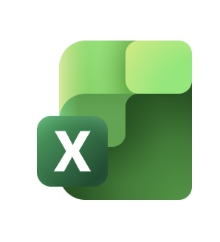Microsoft Excel

Microsoft Excel is an application meant for managing, analysing, and presenting numerical data. Excel can be used in various areas in the business world, such as budgeting, financial analysis, payroll calculation, inventory management, and forecasting. Excel offers the user many tools like functions, charts, and formulas, which enable the efficient analysis of business data.
Major Features
Information in Excel is organised using workbooks, worksheets, rows, columns and cells. Users can insert figures, text, dates and formulas in cells. Such structure enables Excel to be effective in the storage and analysis of numerous types of information in business organisations. The other key characteristic of Excel is formulas and functions. Formulas enable Excel to automatically carry out calculations. Functions can be used to calculate sums, averages, percentages and conditional values. Such feature saves a lot of time as opposed to manual calculation. Charts and graphs are also key characteristics of Excel. Users can transform data into several visual forms like column charts, line graphs and pie charts. This helps managers understand the trends and communicate business performance. Sorting and filtering are another key characteristic. If an organisation has a long list of sales transactions, employees can sort or filter data to identify certain customers, products, time periods or values. PivotTables and Pivot Charts are also included in Excel. PivotTable can summarise, analyse and investigate data whereas PivotChart presents results in graphical form. According to Microsoft, PivotTable and PivotChart can help users identify comparisons, patterns and trends[6].
Benefits to business

The advantage of Excel to business is the fact that it offers great flexibility. It can be used for basic functions like creation of expense list as well as for complex operations like financial analysis and forecasts. For instance, one may create a spreadsheet for sales each month with the amounts of sales of various products. Formulas will automatically compute totals and averages, and charts will demonstrate any changes in sales. Decision-making in business can also be assisted with Excel. Managers can analyse data, compare performance and evaluate trends and possible scenarios. Decisions will thus be made not on assumptions but based on the available data. Increased efficiency is another advantage. Once formulas and functions are entered correctly, computations can be automated.
Limitations
Excel is also not a good choice for big databases. A huge spreadsheet could be challenging to work with and especially if multiple users were putting data into it.
Another weakness of Excel is the risk of mistakes being made by humans. An employee could incorrectly put information into Excel or make an incorrect formula, which might lead to wrong data. This is why any crucial spreadsheet needs to be monitored and managed properly. In addition, Excel could be tricky to work with if there are some advanced functions, formulas, macros or data models. Therefore, employees need to be trained how to use them. While Excel does offer some database functionalities, it can still not replace such software as Microsoft Access, which is designed for relational database management systems.

Ms PowerPoint
Microsoft PowerPoint

Microsoft PowerPoint is presentation software used to create visual presentations for meetings, training sessions, sales pitches, and business reports. It allows users to combine text, images, charts, videos, animations, and transitions to communicate information effectively. Businesses use PowerPoint to present ideas clearly to employees, customers, and stakeholders. PowerPoint by Microsoft offers its users an opportunity to make presentations using templates or from scratch while using text, graphics, art and video clips[7].
Major Features
One of the main characteristics of PowerPoint is the ability to present information through slides. Slides help organize information. PowerPoint allows one to insert text, images, charts, tables, videos and audio into the slides. It is important since sometimes information that can be better conveyed using graphics is hard to convey using written information. Another key feature of PowerPoint is templates and themes. Users can create presentations where fonts, colours and layout would be consistent. Business organizations could use branded templates so that presentations would have their organizational style. One of the key characteristics of PowerPoint is animations and transitions. They allow to manage the process of displaying the information on the slides. PowerPoint also offers design assistance tools, such as PowerPoint Designer.
Benefits for Business
First, one should say that the most important thing about PowerPoint is the ability to visualize and communicate the information. For instance, a sales manager could show the results of the month by using charts. Besides, PowerPoint could help in business communication, as a manager could make an explanation of a certain strategy, and a salesperson could prepare a presentation to promote a product to customers. The ability to include such things as text, graphics, charts, images and video could help in communicating the information in an understandable way. Finally, PowerPoint is very helpful when preparing training sessions and meetings. First, training sessions could be held by using a well-prepared presentation, which would contain instructions and examples.
Limitations
One of the important problems is that ineffective presentations may hinder communication process. Slides with large amount of text, complicated animations and too many pictures may distract the audience.
Furthermore, PowerPoint largely relies on the presenter. An efficient presentation needs to include effective speech and communication skills; otherwise, PowerPoint cannot ensure understanding of information by the audience. Another problem is different features depending on which platform one uses. There may be some differences between features available for Windows, Mac, web and mobile versions of PowerPoint. Microsoft has created comparison platform to show which features differ from others.

Ms Access
 Microsoft Access

Microsoft Access is a database management system (DBMS) that enables businesses to store, organise, manage, and retrieve large amounts of data efficiently. It combines a relational database with an easy-to-use graphical interface, making it suitable for small and medium-sized organisations. Businesses use Microsoft Access to manage customer records, employee information, inventory, sales data, and other operational databases. It also allows users to create forms for data entry, queries for searching information, reports for analysis, and macros to automate routine tasks. Main Characteristics of Microsoft Access
Access is built on a relational database model. The information can be saved into tables, where relationships between tables can be formed. In case of a company, there could be tables for its customers, goods and orders, where relationships are made based on the information. One of the main advantages of Access is creating queries. Queries provide users with an opportunity to find information in a database. For instance, a company can create a query to find out its clients that bought certain product. Another feature of Access is forms[8].
Major Features
Microsoft Access is constructed upon the relational database structure. Data can be stored within tables, and relationships can be created between different tables. In case of company data, there might be tables for company customers, products and orders, and relationships will be based on data. One of the biggest strengths of Access is querying. Using queries allows users to access specific information from a database. For example, a company can create a query to identify its customers who purchased some product. The other feature of Access is forms.
Benefits for Business
The first advantage of using Access is its ability to handle structured business information efficiently. For instance, a small business might use Access for storing customer information, stock information, information about employees or sales information. Access will allow less redundancy in data entry since information will only have to be entered once and relationships established. Then queries will retrieve the necessary information when it is needed. Forms will also help with data entry since employees do not have to edit tables in the database. An employee will enter information via a form which was specifically made for such purpose. Reports offer yet another advantage since managers will be able to transform stored information into business information. For instance, a manager will be able to create a report on sales per customer, product or region.
Limitations
A drawback is that Access may not be the best option when dealing with big or sophisticated databases. The company having a lot of data or lots of concurrent users may have to use more advanced databases. The second drawback of Access is that this database requires more advanced understanding of technology than Word and Power Point applications do. Users must understand notions like table, relationship, query and form to work with this program efficiently. Another drawback of Access is that it is more related to desktop databases rather than contemporary cloud database platforms.

3.2 Test any two features
Introduction
Purpose of this Practical Exercise. This exercise aimed to examine and showcase how two different functionalities can be implemented in Microsoft Excel. For this particular purpose, IF Function and VLOOKUP have been selected because of their widespread usage in business as well as data handling for logical purposes and data extraction, respectively. Screenshot evidence of the two functions has been presented in this report.

IF Function
IF Function is a logical function and tests a condition which results in either True or False values. Syntax for IF Function is =IF (logical test). IF Function is commonly used for grading, for status checking and for automation of decisions[9].
A table of marks for a student has been created where Student Name and Score columns are included. IF function has been used to calculate the status automatically based on a passing grade of 60. The formula used is: =IF(C2>=60,"Passed","Failed").
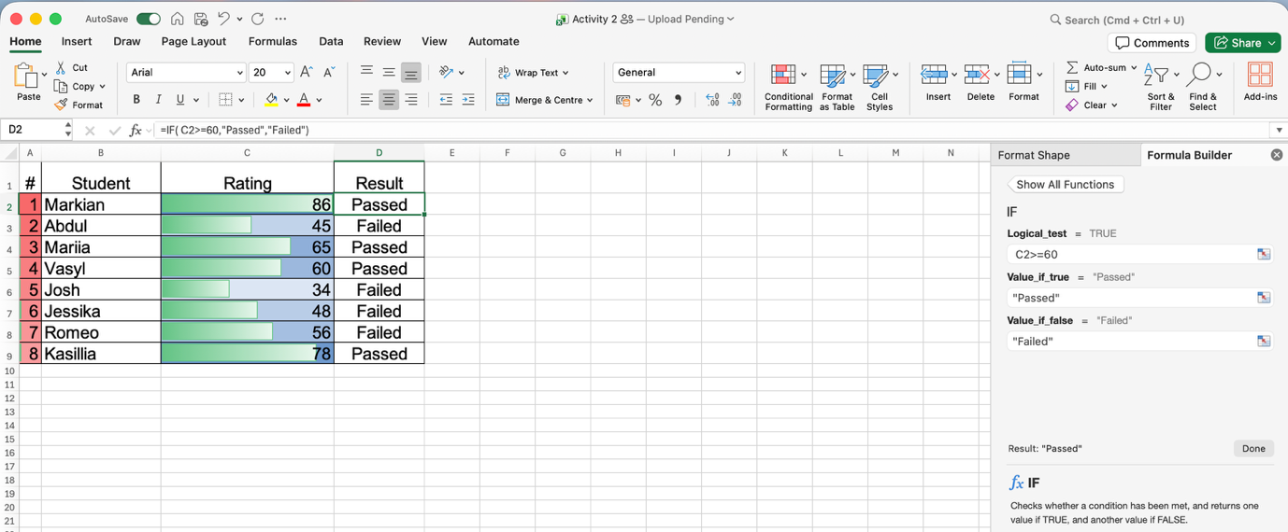
Figure 7. Use of IF function to find out the result of students. It is evident from the formula bar that the logic test of “C2>=60” is being used. The function gives result of “Pass” if the score is 60 or more. Otherwise, the result is “Failed”.

VLOOKUP
VLOOKUP (Vertical Lookup) is a function for looking up a particular value in the first column of a table array and retrieving a corresponding value from a second column in that same row. Its syntax is =VLOOKUP (lookup value, table array, [range lookup]). VLOOKUP is crucial for data consolidation from various tables.
Two tables were constructed for this test, namely: (1) Product Price List as the source data range (A3:C8), and (2) Search Table from which prices were to be extracted. The formula applied was: =VLOOKUP (A11, $A$3: $C$8, 3, FALSE). Here A11 represents the lookup value (Product ID), $A$3: $C$8 represents the absolute table array so that there would not be any range shift while filling down, 3 is the index number representing the column from which the price should be retrieved, and FALSE represents that the look up should be done with an exact match. The formula tested was in UK English, whereas the Ukrainian translation of it would be =VLOOKUP / =VPR (A11; $A$3: $C$8; 3; FALSE).

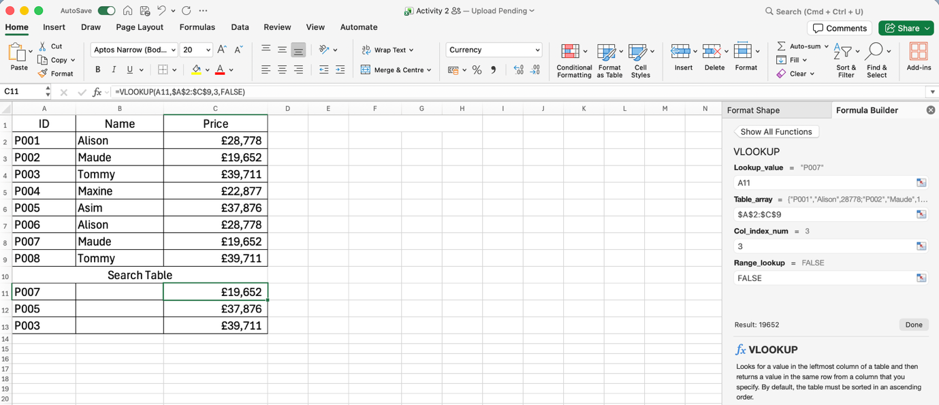
Figure 8. Implementation of VLOOKUP function to obtain product prices from the price list. In the formula bar, the whole function is shown with absolute referencing. The VLOOKUP function successfully located the Product ID code P003 in the original data table and correctly returned the value 12.99 from the third column. FALSE parameter made sure that only exact matches were found, with #N/A error message showing for non-existing codes.
The two functions performed successfully and worked as required. The IF function was successful in using conditional logic to automate the decision-making process on pass and fail results. Meanwhile, the VLOOKUP function proved very effective in extracting data from the table in an efficient way. The images attached below are examples of practical implementation of the above-discussed formulas and show their results[10].

Task 4. Communication and Collaboration applications

4.1 One contemporary Communication and one Online Collaboration
Modern organizations are becoming increasingly reliant on applications that offer digital communication and collaboration capabilities that would help employees in being more productive and having effective communication. These two Microsoft applications include Microsoft Outlook and Microsoft Teams. While they both belong to the Microsoft 365 suite, their functions are slightly different since Outlook is mostly about business communications while Teams is about communication and collaboration online.

Microsoft Teams
 Microsoft Teams is an online collaboration and communication platform designed to help employees work together digitally. It supports instant messaging, audio and video meetings, file sharing, group discussions and collaborative work. Teams is particularly useful for organisations with remote, hybrid or geographically distributed employees. One of the key advantages of Microsoft Teams is real-time collaboration. Employees can communicate through individual or group chats and participate in online meetings without being physically present in the same location. Teams can also be organised into channels based on departments, projects or specific business activities. This allows information to be grouped according to the purpose of the work. Microsoft Teams also supports collaborative document management. Users can share Microsoft Word, Excel and PowerPoint files and work on documents together. Multiple employees can contribute to a document, which can reduce the need to send different versions of the same file by email. This can improve productivity and make teamwork more efficient. For instance, users may open documents available on SharePoint or OneDrive, and utilize applications like Word, Excel, and PowerPoint within Microsoft Teams. As a result, a complete digital environment is created where people can work and communicate without switching between various applications.
Moreover, teams receive certain advantages concerning project management. Project team may create a dedicated team and channels, have meetings, exchange documents and communicate about tasks in one place. Thus, it might be beneficial because people can access all the conversations and documents[11].

Microsoft Outlook
 Microsoft Outlook is a communications and information management tool that is extensively used by organisations for their professional email correspondence. It helps employees exchange emails, plan the calendar, organise meetings, arrange contacts and tasks. Therefore, Outlook can be used not only for internal but also for external business communication.
The main strength of the tool is the possibility to create a unified communication platform. Employees will be able to exchange messages with colleagues, clients and business partners using professional email addresses. The calendar function of Outlook will help users organise their meetings, invite other people and track their availability. In this way, it will be easier to organise business activities and to avoid any communication delays.
Another key function of the tool is the possibility of integration with other applications of Microsoft 365. For instance, one can easily connect the meeting invite in Outlook to Microsoft Teams and use it to join the online meeting. In general, Microsoft Outlook is an efficient tool of modern communication since it facilitates formal business communication, scheduling, and information management. This tool is especially useful for communication where there should be some kind of documentation, for example, business inquiries, instructions, appointments, and communication with external parties[12].

4.2 Test one feature of a freely available Communication (1) and one feature of a Collaboration (1) application

Microsoft Teams
Microsoft Teams as a Contemporary Communication Application.

Microsoft Teams has evolved from a simple chat tool into a unified communications platform that brings messaging, voice, video, telephony and apps together.

Key features include:
Chat & Channels: Teams organises conversations by project or department, supports private or group chats, and allows file sharing in line with rich formatting, reactions. This reduces email overload and keeps communication contextual.
Meetings & Video Conferencing: It offers HD video, screen sharing, breakout rooms, collaborative notes and whiteboards to make meetings engaging. Intelligent recap helps everyone catch up quickly. In a business context, this supports daily stand-ups, client meetings and remote presentations.
File Sharing & Co-authoring: Real-time collaboration in Word, Excel and PowerPoint with SharePoint/OneDrive storage, permissions and version control is built in.
AI and Security: Modern Teams includes Microsoft Copilot for summarising meetings and drafting replies, and enterprise-grade controls such as end-to-end encryption, DLP, retention and compliance policies to protect data. Deep integration with Microsoft 365 apps like Outlook, Planner and Power BI makes it a central hub[13].

Figure 9. Microsoft Teams interface showing channels.
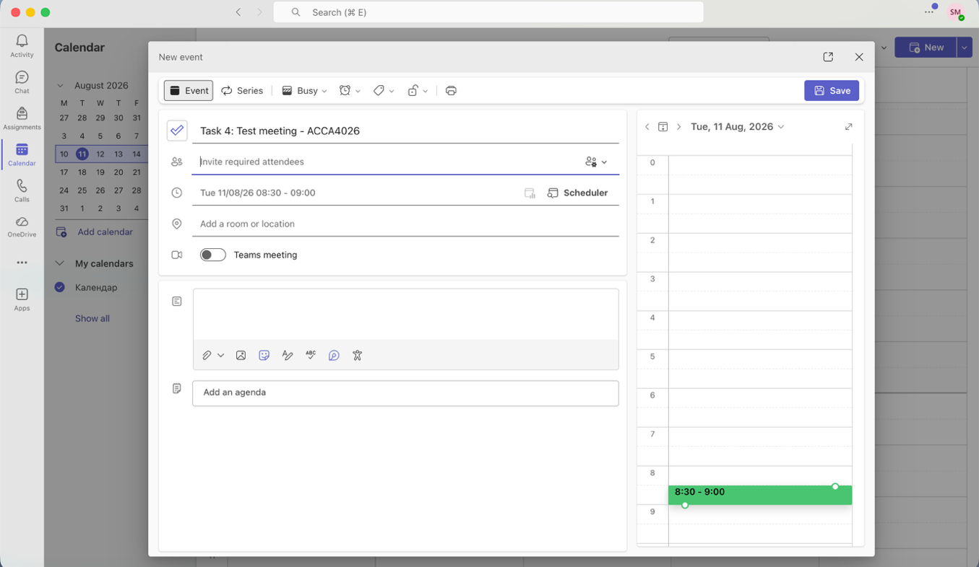
Figure 10. Microsoft Teams video meeting and file sharing - core communication features.

Microsoft Outlook
Microsoft Outlook as an Online Collaboration Application
While known as an email client, Outlook is a powerful collaboration tool, especially through its calendar and group features.
Key features include:
Shared Calendars and Scheduling: Each Microsoft 365 Group has a shared calendar where members can schedule, edit and see upcoming events. A calendar owner can share a calendar and let others view or modify events, including the primary or custom calendars. Sharing takes only a few steps: Select Calendar > Share Calendar > Choose calendar > Add recipient.
Permission Management: Users can set viewing or editing permissions, and when sharing inside an organization, the recipient can add it directly to their calendar view. Options include Can view, can edit, Delegate access.
Collaborative Organization: Outlook allows creation of multiple calendars to keep personal and work life separate while still being able to share important work events, sync with mobile for on-the-go scheduling and create calendar events directly from emails[14].
Business Value: Together, Teams handles synchronous communication (chat, calls, meetings) and Outlook handles asynchronous collaboration (scheduling, resource management, email-based task coordination). Their integration allows a user to schedule a Teams meeting directly from Outlook calendar, creating a seamless workflow.

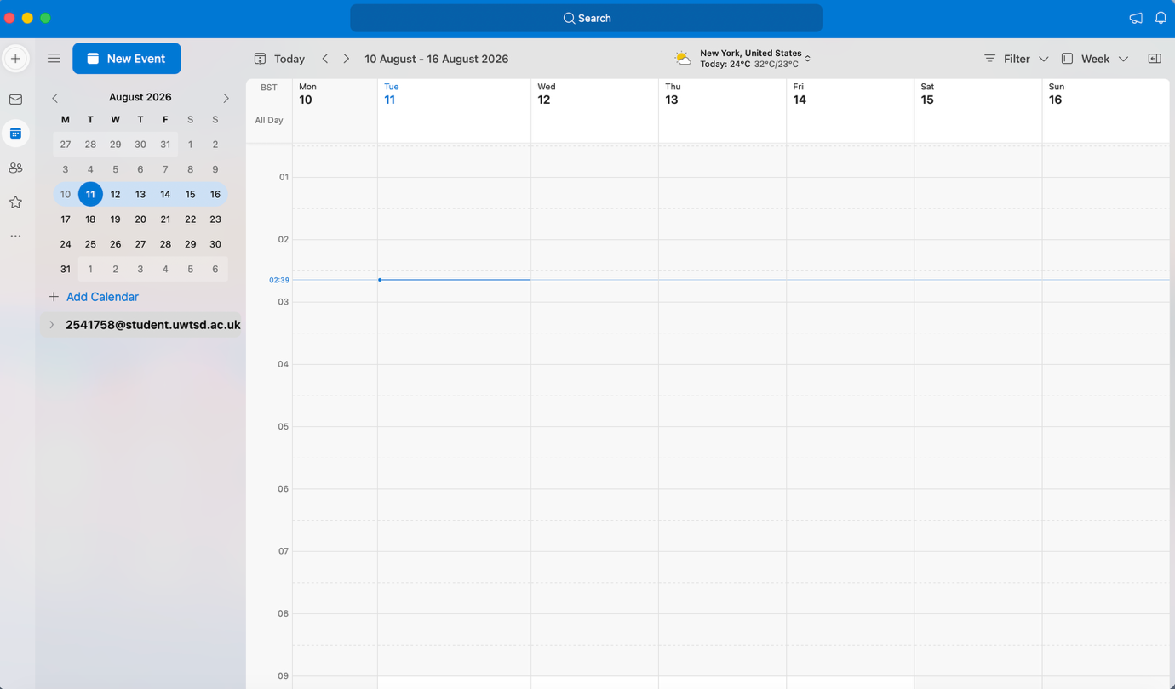

Figure 11. Outlook calendar.

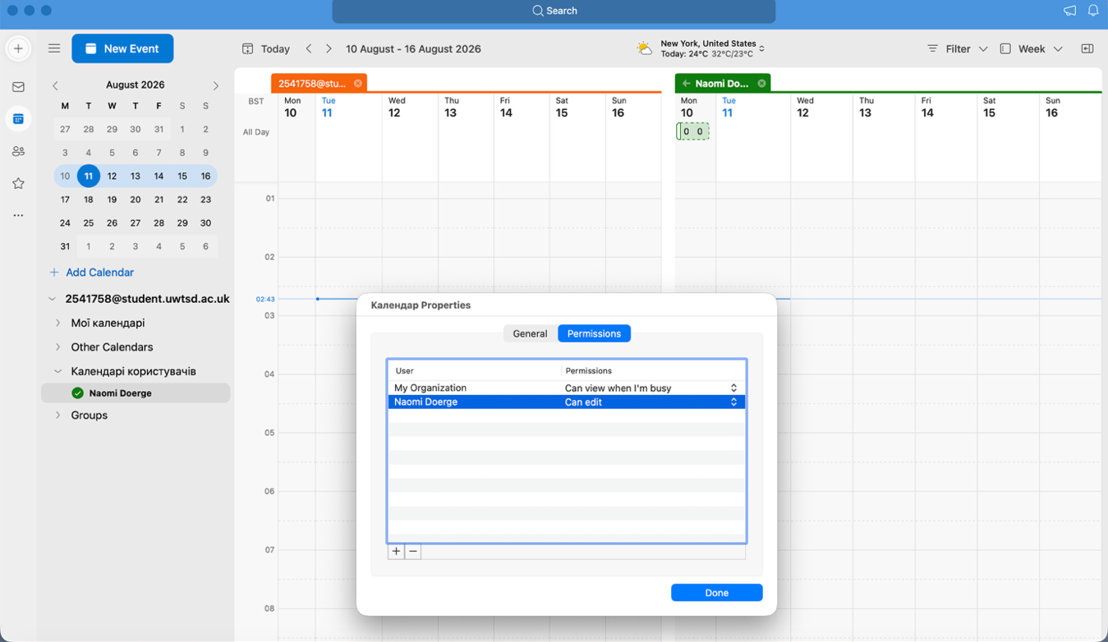
Figure 12. Outlook calendar sharing with permission levels - core collaboration feature.

Conclusion
In summary, this report has analysed how various contemporary software packages can aid in the performance of business and organisational activities. The four tasks were focused on e-Commerce site development, mind mapping, office software applications and communication/collaboration software. Task one highlighted the benefits associated with using software applications to conduct business over the internet and to communicate with customers. The use of software packages can significantly reduce time involved in creating an online store. Task two revealed that mind mapping is a very effective tool in information organization, idea generation and planning. It has illustrated how various software applications can be used in the business world daily in communication, financial management, data management and project management.
The third task was about Microsoft Word, PowerPoint, Excel and Access. Each of these applications can offer instruments for completing business tasks related to document creation, presentation preparation, data analysis and information management. The practical Excel exercises were also useful as they showed how particular functions can be used to accomplish various business assignments. The last task was devoted to the communication and collaboration applications. It allows employees to communicate with each other, exchange information and collaborate on different business projects much more easily, especially when employees work remotely or even in different countries. The practical testing also revealed how these functions can be applied in real business environment. In general, the tasks have shown that modern software applications play an important role in business operations. Utilizing proper applications allows companies to save their time, improve communication, organize information and analyse data. Thus, it is very important for both companies and employees to possess sufficient digital skills.

References
[1] J. Ponce, H. Litardo, A. Vicuña and O. Erazo, "Towards a Dashboard for E-Commerce Analytics in a Wix-Based Website", in XVIII Multidisciplinary International Congress on Science and Technology, pp. 56–71.
[2] L. MacDonald, The Shopify Story: How a Startup Rocketed to E-commerce Giant by Empowering Millions of Entrepreneurs, ECW Press, 2024.
[3] T. Buzan, Mind map mastery: The complete guide to learning and using the most powerful thinking tool in the universe, Jaico Publishing House, 2024.
[4] N. Carter, Office 365 User Guide: A comprehensive guide to increase collaboration and productivity with Microsoft Office 365, Packet Publishing Ltd, 2019.
[5] J. Roig, M. Ribera and D. Martín, "Analysis on the creation of accessible documents with Microsoft Word online in the field of education", in Proceedings of the XXI International Conference on Human Computer Interaction, pp. 1–4.
[6] J. M. Lindquist and C. A. Sulewski, "Microsoft Excel," vol. 21, 2024,
[7] R. J. Craig and J. H. Amernic, "PowerPoint presentation technology and the dynamics of teaching," vol. 31, no. 3, pp.147–160, 2006,
[8] G. Robinson, Real world microsoft access database protection and security, Apress, 2008.
[9] B. Held, B. Moriarty and T. Richardson,Microsoft excel functions and formulas with excel 2019/office 365, Walter de Gruyter GmbH & Co KG, 2019.
[10] B. Jelen, Power Excel with MrExcel: Master Pivot Tables, Subtotals, Charts, VLOOKUP, IF, Data Analysis in Excel 2010–2013, Holy Macro! Books, 2015.
[11] R. Buchal and E. Songsore, "Using Microsoft Teams to support collaborative knowledge building in the context of sustainability assessment," 2019,
[12] J. Boyce, Microsoft Outlook 2010 Inside Out, Microsoft Press, 2010.
[13] S. Veerapandian, H. Kaur, A. Madhvarayan and S. Rajamanickam, Reimagine remote working with microsoft teams: a practical guide to increasing your productivity and enhancing collaboration in the remote world, Packt Publishing Ltd, 2021.
[14] R. Mercurio and B. Merrill,Beginning Microsoft 365 Collaboration Apps, Springer, 2021.

