MANAGING PROJECTS IN THE ORGANIZATION

Table of Contents:
Introduction: 3
Project Management Tools and Techniques: 4
Project management life cycle: 13
Initiation Phase: 13
Target market: 14
Planning phase: 15
Project initiation document (PID): 15
Project Title: 15
Background: 15
Purpose: 15
Objectives: 16
Project scope: 16
Deliverables: 16
Business case: Project Benefits 17
Cost and Timescale: 17
Budget plan: 17
Operational Plan: 20
Risk Management Plan: 21
Roles and responsibilities: 22
Names of Project Sponsor: 23
Initial Project Plan (Gantt chart): 24
Human Resource Requirements: Project Team: 25
Project Control: Monitoring mechanisms: 25
Quality Control: 25
Communication channels and schedules: 27
Change management: 28
Execution Phase: 30
Closing phase: 31
Self-analysis: 33
Feedback: 37
Conclusion: 37
Self-development plan: 37
Reference List: 39

Introduction:
For most organizations nowadays Project Management has become the main process of business. It starts with an introduction to the project. This assignment is about the opening of a new kids' barber salon. With the help of Project Management managers can quickly understand the total summary plan of the project such as, when will be the tasks completed? Who is working on the project? And how the tasks relate to the whole project? This assignment will look forward to the various stages of the project as well as project responsibilities, budget, and risks of the project. In order to develop a project efficiently, some tools are required which are indicated as "Project management is the application of knowledge skills and tools."
The purpose of conducting this project is to create a positive and safe environment where in this pandemic situation children can feel free to groom themselves. The COVID-19 has stopped people partially from getting outside of their houses. In the meanwhile, children are in danger if they go for grooming themselves in common salons and parlours. Crowded places are vulnerable and dangerous for kids to visit. As a result, the plan for Stress Free Kidz Cuts is aimed to be made which creates a separate place for the children to groom themselves and protects them from getting any infection in the pandemic situation. The starting date of the project was on 16.04.2021 and the completion of the project was on 05.10.2021. Completion of the project was done mainly for the beneficiaries such as L’Oreal Team, Stress Free Kidz Cuts and the project manager, receptionist, junior cleaner, barbers, babysitter, clients, I.T employee, communications employee, nail technician, and accountant. In case, the project is not completed on time, then it can adversely affect the business of L’Oreal Team and Stress Free Kidz Cuts as more number of targeted customers cannot be grabbed. This in turn can affect the customer base, profitability, and brand image of the companies.

Project Management Tools and Techniques:
Gantt chart:
Gantt chart is a simple and effective tool of Project Management. It contains some horizontal bar charts that indicate the reliability between the works of the project and the pre-calculated time by which the tasks need to be accomplished (Sharon and Dori, 2017). Gantt chart helps to plan resource and time management and provides indications about the time duration of the whole project. Gantt chart is really easy to view. However, some research shows that this Project Management tool is losing its popularity and other research says that it makes project manager's attention away from the project. It also includes some graphs which are not matched with the proper plan.
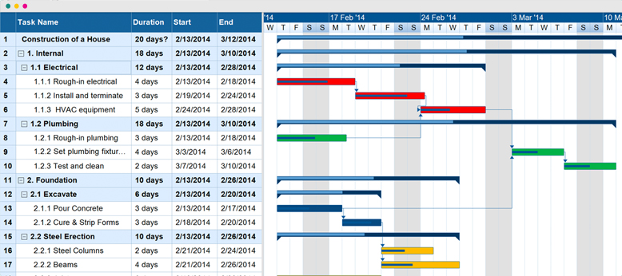
Template of Gantt chart
However, the Gantt chart helps the project manager to generate an idea about the tasks of the project. It helps in solving team confusion and also improves team communication. Gantt chart also helps in avoiding overload of resources and it evaluates the progress of the project. It helps to find out activities that are overlapped by the team members and find out task dependencies. This Project Management tool provides more clarity and improves the time management skills of the members.
PERT chart:
PERT chart is one of the most acceptable tools of Project Management. It is one of the best ways to summarise project activities through charts (Evdokimov et al. 2018). PERT chart offers a graphical presentation of project tasks that helps the project manager and project team to gain proper knowledge about the relationship between the different activities of the project. It is the best project management tool that offers operation level management and tactical level planning of the project. PERT chart can help manage a single project. It helps the project managers to analyze different project activities.
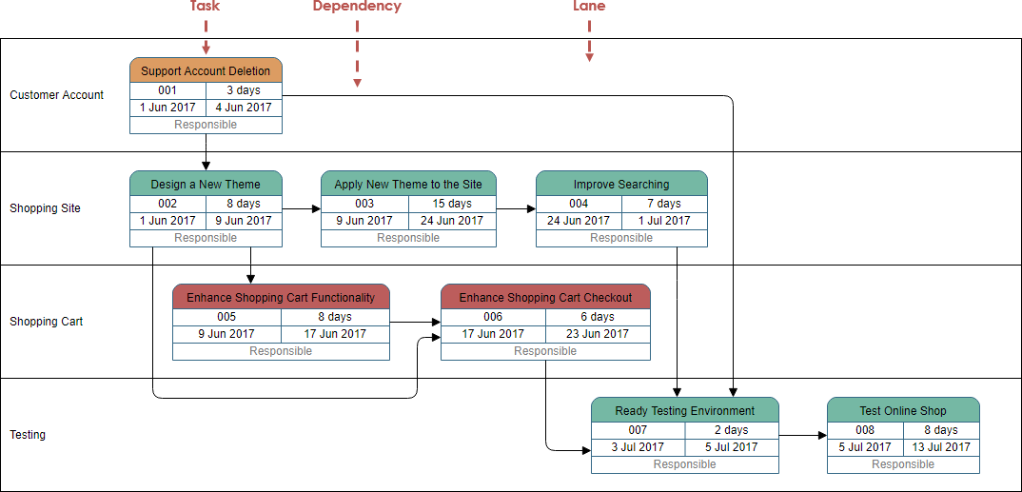
Template of PERT chart
However, there are some limitations to this Project Management tool. It simply cannot handle two different projects which share the same resources at a time effectively. When there is a slight change in sequential and precedence connections between different project activities this tool cannot analyze the tasks. This project management tool requires a large number of information to create an effective project plan which may raise the total budget of the project.
Budget plan:
A budget plan helps to keep track of financial expenses on the project. A budget plan is made for a certain period. It is important to keep the project budget comprehensive as possible. A budget plan helps in determining extra cost lying in each task of the project and also helps to reduce the cost and promote savings. The budget plan establishes proper guidelines and main objectives for the project (Yuliana, 2019). Budget plans allow the project manager and team to prioritize different levels of the project. The budget plan helps to keep focusing on the most important task of the project and it helps to find out which parts of the project are important and which are not. The budget plan covers the necessary cost which is required by the total project. Also, a budget plan makes it easier to evaluate the future costs regarding the project.
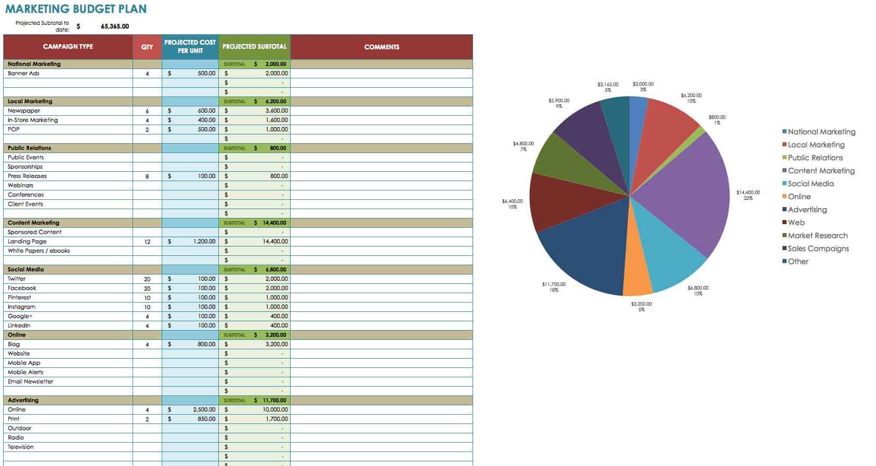
Template of Budget Plan
However, a budget plan is a highly time-consuming project management tool. Sometimes, it causes manipulating the system by increasing expenses and reducing the estimated revenue of the project. A budget plan sometimes blames the result of the project if the desired result is not achieved. The expense allocation method in budget planning might not be acceptable by some members. It causes chaos among team members. If the organization does not agree with some budget allocation for a certain project task, then the task has to eliminate from the total project tasks. It becomes a spend it or lose it situation for the members. Another problem with budget estimation is it only prefers financial outcomes.

CBA or Cost-Benefit Analysis:
This tool of project management allows the project management team to evaluate each decision regarding a project and helps to make it bias-free. It offers an evaluation based on evidence of the options which helps the project operations become more logical and data-driven. It helps the project managers and team to make decisions simply and reduce the complexity between project tasks (Koopmans and Mouter, 2019). Cost-Benefit Analysis helps to find out hidden costs from the project. It forces the team to point out each important cost and benefit within a project.
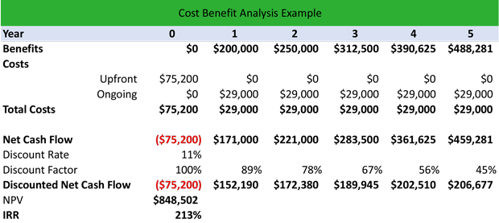
Example of CBA

However, this CBA tool of Project Management also has some flaws. It is complicated to predict all the variables through this tool. CBA tool cannot work with incomplete and inaccurate data. If proper and complete data is not given then the analyses also come full of errors. It is suitable for mid-length and short types of projects. It cannot handle a large amount of data in big and long-term projects.
Waterfall Technique
It is also described as a traditional or classic project management tool. The reason behind it is it takes help from the above-mentioned tools and takes it to a whole new level. Though, this technique is not suitable for all project types (Cantoni et al. 2019).
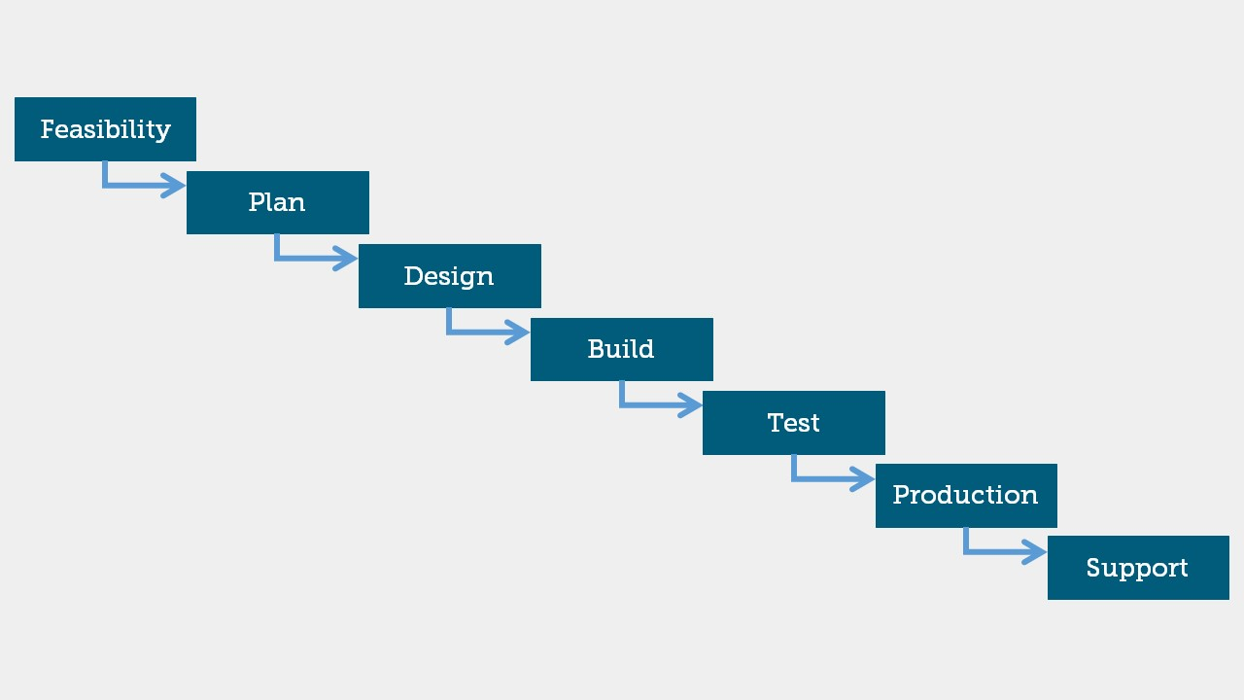
Model of Waterfall Technique
This technique does not use any working software until the finishing point. This tool contains high uncertainty and risks which can impact badly the outcome of the project. It does not help in object-oriented and complex model-based projects. This technique of project management is not good for long-term projects.
Agile Project Management:
This project management technique generally helps big and long-term projects. It provides a detailed analysis of the whole method and tasks of the project. This can help in creating effective planning that can modify itself according to the situation. This technique consists of various techniques like DSDM, FDD, Scrum and so more (Cooper and Sommer, 2018).
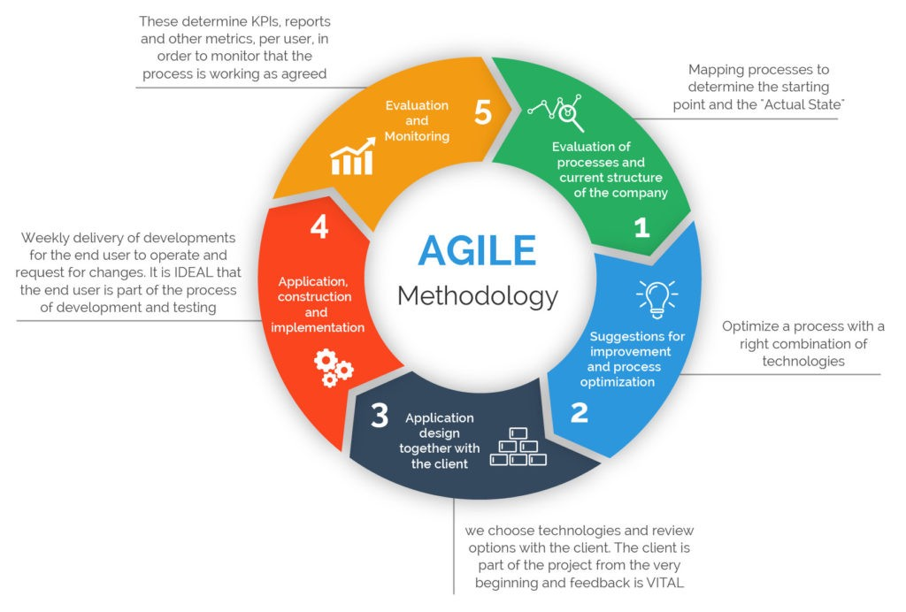
Method of Agile Project Management Technique
Though, this technique also has some limitations such as less and inaccurate predictability, more time-consuming process. This process also generates more demand for clients and developers. This Agile Project Management technique contains a lack of required information. With this technique, projects can easily fall from the target.
PRINCE-2
PRINCE-2 is the most famous and quite outstanding project management technique for its application. The reason behind it is this technique deals with projects in a different way rather than any other traditional method. It is widely recognized and used for basic projects related to IT but it also helps in other projects (Vaníčková, 2017). It is a more useful process to divide project tasks according to the budget and time limit of the whole project.
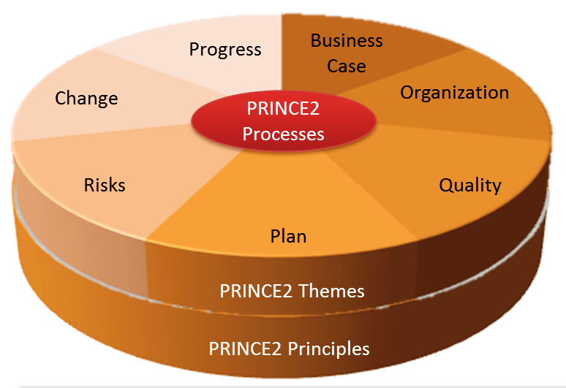
7 processes of Prince-2
PRINCE-2 helps to recognize the most important part of the project and also helps to accomplish the project with effectively and perfection. It is a highly flexible technique and can adapt to any kind of small or big changes in the project. This technique also deals with every uncertainty of the project. That is why this PRINCE-2 technique is unique and more efficient than other methods and techniques of project management. This technique is perfect to achieve all the project targets. This is the reason why I use this technique in this project.

Project management life cycle:
A project management life cycle can be described as the process of managing projects which can be wrecked up into clear phases to form a life cycle of the project. Project management life cycle is characteristically described by the processes of the project that series from the beginning of the project to the closure of the project. The main responsibilities of management are- command, organizing, planning, coordination, and control. These duties and responsibilities will be utilized during the whole process of the project plan (Dunmade, 2018).

Initiation Phase:
It is the beginning phase in the total life cycle of project management. This step involves starting up the project. In this phase project manager can begin the introduction of the project to the team members and also explaining the objectives, scope, and purpose of the project. The sponsor of the project is L’Oréal and the team. We all have experienced the annoying situation when we take children to the barbershop. They hate having hair cut and they became a crying mess in the name of the salon. There are many salons for men's and female's grooming but no barbershop is there for children. This fact became an opportunity for the team and they are planning to open a successful STRESS FREE KIDZ CUTZ' (sic) salon.
This salon will be only for kids. Also, the environment of the salon will be bright and colourful to attract the children. Besides, there will be plenty of trained employees who are good at babysitting too. That is how the parents do not need to get tensed about the hazard of taking their children to the barbershop. The salon will be filled with some bright and colourful furniture and equipment. For safety and measures, there will be kid's safe special scissors and other grooming kits. There will be a play space also where lots of toys and cartoon figures will be available. The interior of the salon will be decorated with cartoon figures more like pirates and Disney princesses.
The mirror in front of the seat will contain tablets which show different cartoon and kids shows to distract the children from getting scared in the time of haircut and prevent them from getting bored. 'Stress-Free Kidz Cutz' (sic) will be located at 19 Bridge Street, Cardiff, SA18 RFT due to it is the busiest part of the city with lots of crowds because it contains many attractions like museums, shopping malls, and other fast-food restaurants which is popular among kids such as McDonald's, and more.
The monthly rent for the premises will be £500 for a 500 ft squared property. A business loan of £10,000 has been taken from the bank for starting this business. Also, personal savings of £5,000will be used to run the business. Strategic marketing will help the business grow at low cost and strategic suppliers who will supply everything the business needs. There is no direct market competition for this plan so it is assumed that the business will go smooth and people will appreciate the idea.

Target market:
'Stress-Free Kidz Cutz' (sic) will be a limited company that will provide doorstep services due to the COVID-19 situation. The members will follow all the hygiene and safety measures. They will wear PPE kits, masks, and use sanitizer from time to time to prevent any kind of infections. Also, they will sanitize all the equipment before applying it to the children. The whole budget for this project is £15,000. The target market will contain kids age from 2 months to 13 years old girls and boys with their parents living on the outskirts and living in the area of the location. The closing of this project will be done when the first day of 'Stress-Free Kidz Cutz’ (sic) will start giving their services to the customers the children.

Planning phase:
A project initiation planning is created to show what the project aims to achieve, including a cost budget plan which derives the cost-effectiveness of the project.

Project initiation document (PID):

Project Title:
Re-opening of a salon named 'Stress-Free Kidz Cutz’(sic).

Background:
There is a lack of a children's salon. Even, in the normal salon, the employees are not patient or professional with kids. .'Stress free Kidz Kutz' (sic) will be the first of its kind and it soon will be a trendsetter. Also, it will be a limited company that will provide doorstep services due to the COVID-19 situation.
Purpose:
The purpose of the project is to create a child-friendly salon that will gain popularity; loyalty and commitment of people.

Objectives:
- To reach customer satisfaction
- To achieve a happy environment for children and employees
- To take feedback from people for future improvement
- To set a modern trend

Project scope:
This project will include all the members and the employees.

Deliverables:
- Weekly call and email updates between stakeholders and managers.
- High risk and con strains of project included
- Availability of funding
- Gaining bad reputation
- Damage of any equipment
- Late delivery of the product

Business case: Project Benefits
This project aims to provide the best quality of haircuts and experience for children. Make a reasonable profit.

Cost and Timescale:
Expected scale of time will be 7 months for the operation at an estimated budget of £15000.

Budget plan:
Project Investment | Cost of the Items
Premises | £1000
Setup Costs | £4500
Marketing Expenses | £800
Working Capital | £800
Preliminary Expenses | £1000
Total | £8100

Salaries
Job Designation | Number of Staffs | Monthly Salary | Total salary
IT professionals | 1 | £300 | £300
Receptionist | 1 | £550 | £550
Housekeeping staffs | 1 | £500 | £500
Baby sitter | 1 | £700 | £700
Barbers | 4 | £700 | £2800
Total |  |  | £5150

Utilities | Monthly Expenses
Water | £200
Internet | £100
Telephone | £100
Gas | £200
Electricity | £200
Total | £800

Total Cost
Expense Types | Cost
Utility Expenses | £800
Salaries | £5150
Project Investment | £8100
Total | £14050

Service Prices
Services | Prices
Up to the age of 10 years (Girls) dry hair cuts | £14
Up to the age of 10 years (Girls) styled, cut, and wash | £17
Up to the age of 10 years (Boys) dry hair cuts | £12
Up to the age of 10 years (Boys) styled, cut, and wash | £15
Kids below age of 2 years | £10
Age of girls between 10 and 17 years | £25
Age of boys between 10 and 17 years | £20
Fringes for kids | £7
Style up for kids | £20
Birthday party packages (Maximum 6 people) | £670

Operational Plan:
Opening Hour | 3:00 PM
Closing Hour | 10:00 PM
Open for | 7 Days (Monday-Sunday)  After school hours  Same for holidays
Lunch Break | 1 Hour
Online Services | 7 Days (Monday-Sunday)

Risk Management Plan:
Risk Identification | Risk probability | Risk Mitigation Strategies
Delivery of products not done on time (Operational Risk) | 20% | The ordering processing lead time needs to be efficiently handled which can improve the customer satisfaction every time
Loss of followers (Marketing Risk) | 25% | Confused advertisements need to be eliminated in order to show the right positioning of the services to the customers
Inadequate number of customers (Financial Risk) | 20% | Ensure to have extra bank accounts with proper savings
Management disruption leads to higher employee turnover and business loss | 15% | Conduct reward and recognition programme and provide appropriate feedback to staffs to motivate and retain them
Ineffective customer service lead to decrease customer base | 90% | Create a happy and positive environment
Injuries, accidents and ill healthiness | 20% | Training on Health and safety and ensure proper precautions and sanitization is done to safeguard from COVID-19

Roles and responsibilities:
The followings are the roles and responsibilities of the staffs at Stress-Free Kidz Cutz:
- The manager is in charge of ordering stock from the whole sellers who are undertaking every precaution amidst the COVID situation, and monitoring that proper sanitization is done to those stocks.
- Managers are also responsible for checking policies and licenses.
- Electricians are to ensure that everything is in working order. They are also obliged to follow safety protocols which include keeping a safe distance and wearing masks.
- Plumbers to install all of the required piping to ensure that everything is in working order. They have to show their temperature which is to be measured that morning before coming.
- Decorations are done by carpenters who strictly follow safety protocols.
- A babysitter with credentials and DBA verification to amuse all of the children in the play area. She must show her COVID test reports before joining and if hired must follow safety protocols.
- Development of home service facilities along with offers and birthday packages for kids as customers may not be willing to come to the shop due to COVID situation.
- Qualified and experienced receptionist and nail technician.
- The junior cleaner's job is to keep the barbers safe and tidy up after them. He is to make sure that their aprons are properly sanitized and dusted.
- A post-implementation analysis will be conducted by the project manager.

Names of Project Sponsor:
L’Oreal Team Project Manager (PM) Stress-Free Kidz Cuts.

Initial Project Plan (Gantt chart):
Key Milestones | Week 1  16.04.2021 | Week 2  02.05.2021 | Week 3  16.06.2021 | Week 4  10.09.2021 | Week 5  05.09.2021 | Week 6  04.10.2021 | Week 6  05.10.2021
Bank loan application for the new business
Rent an Office
Insurance or legal structure of the business and launching the online booking app
Plumbers/ electricians/construction/health and safety precautions
Marketing and advertisement campaigns and recruitment and selection of staffs
Qualification approval/ ordering and delivering uniforms for staffs
Opening day of the business

Human Resource Requirements: Project Team:
Job Designation | Number of Staffs
IT professionals | 1
Receptionist | 1
Housekeeping staffs | 1
Baby sitter | 1
Barbers | 4

Project Control: Monitoring mechanisms:
Managers and staff will be monitored on a conference call or through email once every week.

Quality Control:
There should be no considerations when it comes to performance and safety measures (quality). It is designed to ensure that each customer receives the highest level of service and safety assurance from our workers and barbers. Every employee’s job responsibility includes the task of providing efficiency and maintains proper safety protocols (Zuo et al. 2018).
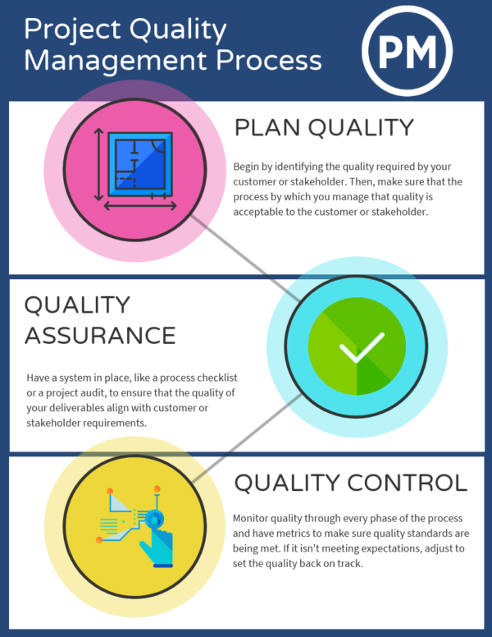
Quality Control Process
The management and staffs aim to remove all obstacles that stand in the way of providing high-quality facilities and ensure that the highest standards are met. The project's success can be shown in reviews based on consumer input. Six months after the barbershop reopens, a Post-implementation Review must be done.

Communication channels and schedules:
Before moving on to the implementation process, one must first develop a communication strategy. This depicts how project stakeholders can be kept up to date on the project's success (Lauren and Schreiber, 2018). The project manager, receptionist, junior cleaner, barbers, babysitter, clients, L'Oréal the retailer, I.T employee, communications employee, nail technician, and accountant are among the barbers' stakeholders.
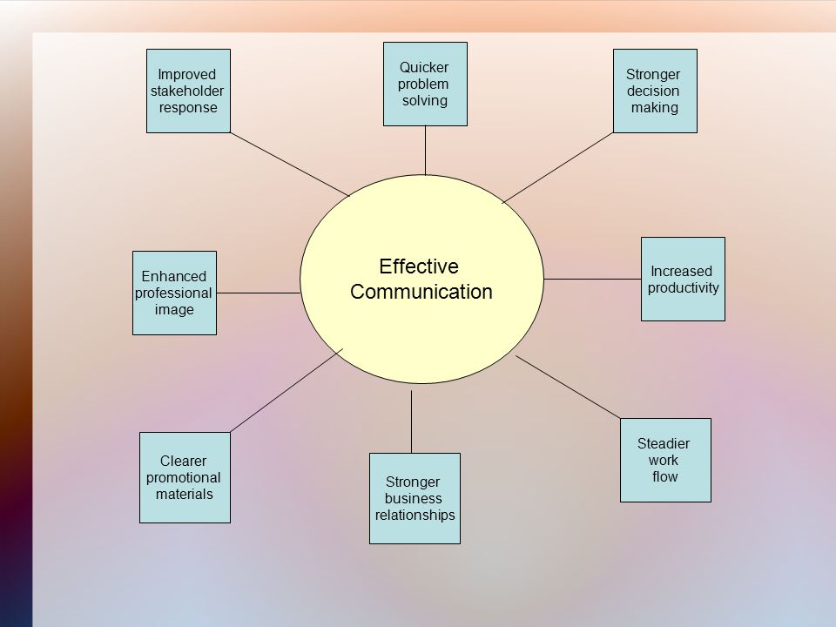
Effective Communication
This section of the plan outlines the procedures that must be followed to ensure that project information is collected, circulated, stored, retrieved, and disposed of in a timely and effective manner. Employees need coordination during times of transition.

Type of deliverables | Method of delivery | Responsible person | Delivery frequency
Strategy for stakeholder management | Sending documents via courier services and emails | Project manager | Every three week
Status reports | Calls and emails | Project manager | Every two week
Update documents as per the changing needs of thee business | Sending documents via courier services and emails | Support department | Every four month
Reports for meeting schedules | Calls and emails | Project manager | Every two week

Change management:
Before project management acceptance, all modification proposals shall be reported, forwarded to, and approved by the project manager and supervisors for implications and project needs.
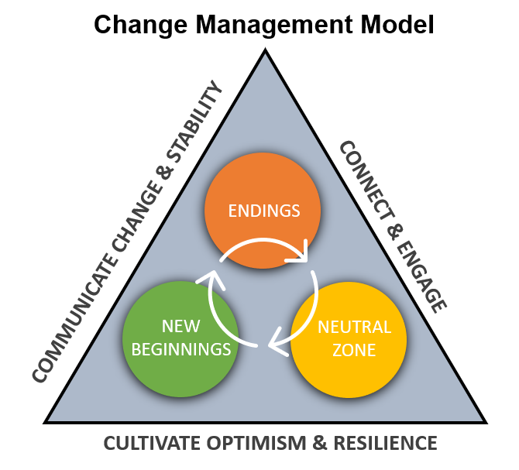
Change Management Process
If the transition is authorized, the project's timeline, context, and spending have to be revised, and the relevant stakeholders will be notified in compliance with the communication strategy. The approved transition and revised timeline would be communicated to the personnel responsible for initiating the change by the project manager and team.

Execution Phase:
The execution phase is where the study is conducted, along with capital procurement and stakeholder management. In this step, control and monitoring take place. Quality is tracked, as is project scope, and pricing allocations and time management are kept in check to stay under target (Jaafar and Yusof, 2019).
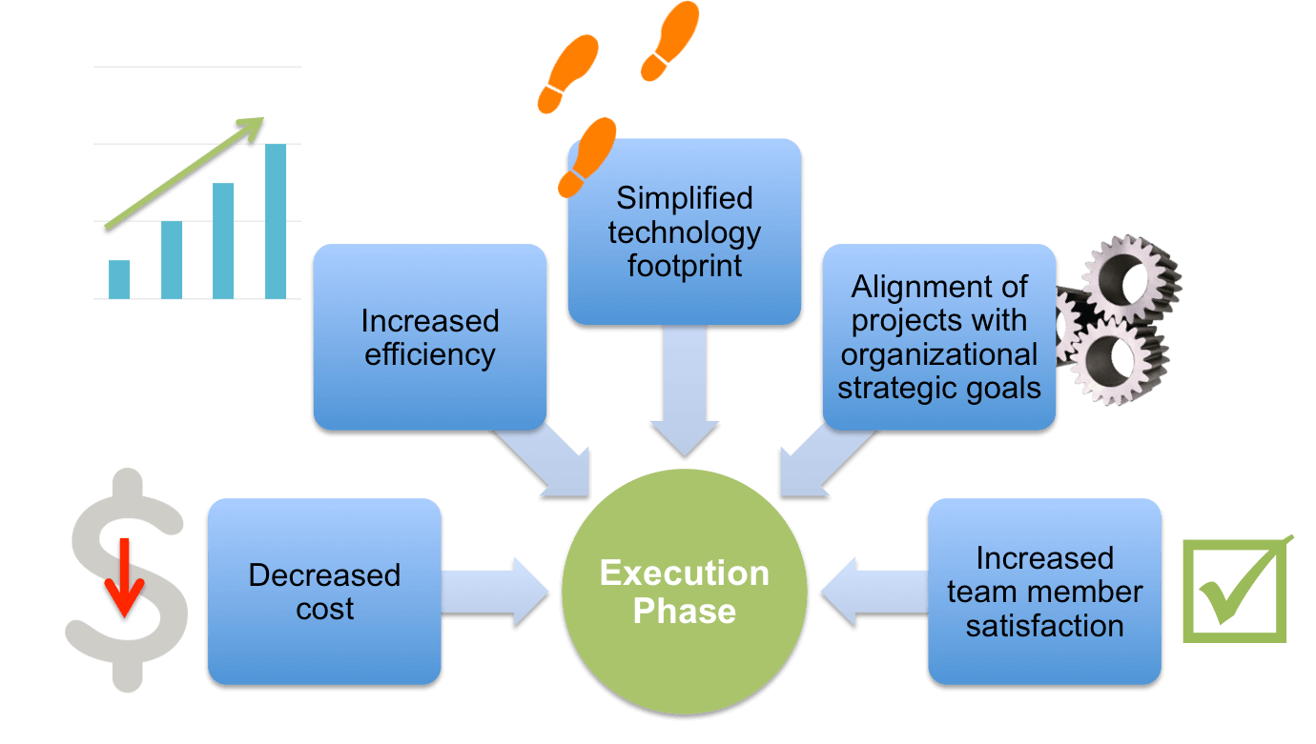
Execution Phase
By implementing the project schedule from the beginning, the project manager will be able to evaluate the progress to the project goals, and Grant Chart or Pert Chart is used to verifying that the projects are accomplished on budget and to the highest quality expectations. The use of a Pert chart is extremely individualized and dependent on management expertise (Petrenko and Ovcharuk, 2020). At each point, there will be weekly calls and conferences with the project manager and stakeholders. When the implementation process is completed, a phased assessment will be conducted to ensure that the project has fulfilled all of its intended goals before moving on to the closure phase.

Closing phase:
The closing phase involves the process in which the project is completed, the deliverable service is given to the clients, and the stakeholders are informed of the project's completion (Johnson, 2017). However, if the team is inefficient, and leads to deadline falloff, cost rise, product efficiency suffers, and in the worst-case scenario, the project fails. To get input, the project manager will do a post-implementation analysis to assess the project's efficacy and ensure that all of the goals have been fulfilled. The analysis will take place three months after the event's start date.
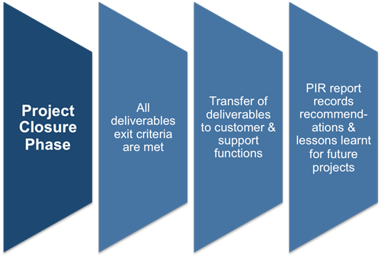
Closing Phase
Customers and staff will be sent a multi-choice survey to collect reviews, and if there are any concerns, customers will be allowed to voice them. Both reviews can be used to help the company make progress to become the most effective licensed barbers in the region, with customer loyalty as a top priority.

Self-analysis:
This project required me to take on the position of project manager, which was a new experience for me. This position led to the development of perspectives and ideas about how to reopen a barbershop and how it will help the demand gap in the future. I used the Small Project (SP) approach. It is a step-by-step guide to applying project management concepts to small projects clearly and straightforwardly. I consider my approach to be simple t gasp and apply, and that to even those with no project management knowledge will learn from it.
PRINCE2 approach, according to me appears to be the most appropriate. When working on a project, depending on the project, I have observed that the PRINCE2 approach is a highly useful technique for project management to use in designing and organizing a project. PRINCE2 is the most commonly used program in schedule nowadays. This is due to the fact that the PRINCE2 model is informative and explicitly outlines points of vulnerability and it still proposes a solution to any issues that arise (Bushuyev and Verenych, 2018).
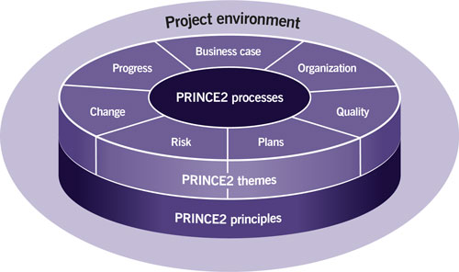
PRINCE2 Methodology
I have also realized while doing this project that Harold Kerzner’s planning process for the project management maturity model is an extremely useful model in term s of the planning project. Thus I used its guidance.
The use of Gantt chart and the Pert chart are one of my strengths in this mission. The Grantt Chart guaranteed that the project stayed on track, making it much easier for me to plan. To make it easier and offer a more concise schedule, the Grantt should be split into smaller groups. The Grantt chart with the vital direction was followed up by the Pert chart (Fathi et al. 2019). But here I experienced difficulty with MS-Excel since I was not a professional in using this software. The implementation of charts was a bit difficult for me initially.
The critical route is the sequence of operations that reflects the project's average time to completion. Any operation on the critical route that is delayed allows the project to be delayed. It is a genius strategy for determining how much time a project requires before it is finished. A defining characteristic of Pert is its capacity to deal with ambiguity in task completion time. While the project was a success, it revealed several flaws, one of which was the use of the budget plan, since I adopted the SP process. It was suggested that one should use a budget chart, but this caused a few issues. It also provides an explanation of how the money will be invested, as well as a segregation of the things on which it will be spent. Using a cost-benefit approach would have been more effective. Since it is a straightforward method to use, the cost-benefit analysis would have been more accurate. Whilst applying the cost-benefit tool, it is important to consider the costs of introducing the program, carrying it out, and supporting the improvements that come from it. Cost-benefit develops in-depth and precision over the course of the project (Khomyakov et al. 2020). This would have been a better option. The float was not included in this project; nonetheless, everything went according to schedule with no major setbacks. This is due to a smaller project, but due to the complexity and inconsistencies that exist within the programs, anticipated delays do arise, and this has a negative impact on the project.
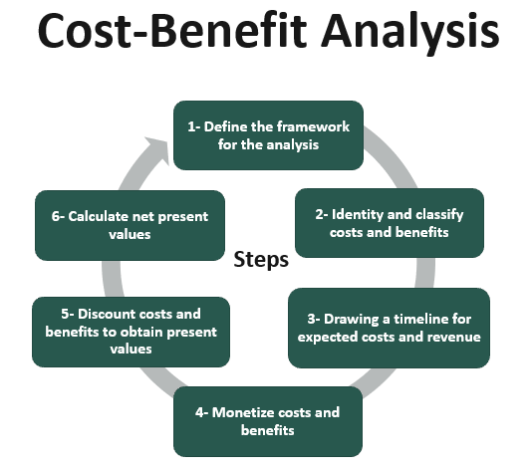
Cost Benefit Analysis
Contactors sometimes need to adjust equipment, activity durations, or start dates; which will only happen if the float was taken into account. While delays to operations that are not on essential pathways do not impact the project's completion date, unplanned float consumption limits the project's capacity to accommodate timetable adjustments and may result in additional costs. Conflicts can be eliminated if a formula is used to systematically calculate the cost of float consumption and allocate the float on a fair basis (Picciotto, 2020).

Feedback:
In project management, feedback is extremely crucial. I have developed a detailed questionnaire and which I shall send to the project team via email to get an unbiased opinion about my capabilities to manage projects. These are the questions I shall be asking:
- Did you think the idea implemented in this project was a success in general?
- Was the project manager easy to communicate with? Did you feel the project manager was there with you to support you the whole time?
- Did you get the impression that the project manager paid attention to you?
- Is there anything else you would like to suggest?

Conclusion:
This study addressed every aspect of the project's development. Throughout, the SP approach served as a reference. The project manager must be able to understand, plan for, implement and measure the transition process during the project life cycle. The objective was to provide a method to determine transition mechanisms through the four phases. The drawbacks have been identified and we may benefit from them, but the strengths have also been found. Larger and more complex projects will be completed in the future.

Self-development plan:
Development Goals | Knowledge skills | Strategies to develop | Deadline
Increase proficiency in MS Excel | Technical and Analytical skills | Take admission in online training courses to improve MS Excel proficiency | 3 months
Improve time management | Time management skills | Use Work Breakdown Structure (WBS) to split the tasks into subtasks and delegate the tasks to all the team members  Use prioritization matrix in order to identify the urgent and least expected tasks and accordingly do the tasks. | 2 weeks

Reference List:
Bjorvatn, T. and Wald, A., 2018. Project complexity and team-level absorptive capacity as drivers of project management performance. International Journal of Project Management, 36(6), pp.876-888.
Bushuyev, S. and Verenych, O., 2018. Organizational maturity and project: Program and portfolio success. In Developing Organizational Maturity for Effective Project Management (pp. 104-127). IGI Global.
Cantoni, F., Favari, E. and Pagnone, F., 2019. Large engineering projects. Favouring resilience in increasingly complex environments grafting an adaptive approach to waterfall technique. Electronic Journal of Management, 2.
Cooper, R.G. and Sommer, A.F., 2018. Agile–Stage-Gate for Manufacturers: Changing the Way New Products Are Developed Integrating Agile project management methods into a Stage-Gate system offers both opportunities and challenges. Research-Technology Management, 61(2), pp.17-26.
Dunmade, I., Udo, M., Akintayo, T., Oyedepo, S. and Okokpujie, I.P., 2018, September. Lifecycle impact assessment of an engineering project management process–a SLCA approach. In IOP conference series: materials science and engineering (Vol. 413, No. 1, p. 012061). IOP Publishing.
Evdokimov, I.V., Tsarev, R.Y., Yamskikh, T.N. and Pupkov, A.N., 2018, September. Using PERT and Gantt charts for planning software projects on the basis of distributed digital ecosystems. In Journal of Physics: Conference Series (Vol. 1074, No. 1, p. 012127). IOP Publishing.
Fathi, R.T., Ammari, M. and Allal, L.B., 2019, July. Critical Analysis of Project Management Methodologies and Its Tools. In International Conference on Advanced Intelligent Systems for Sustainable Development (pp. 162-168).
Jaafar, K. and Yusof, S., 2019. Evaluating Stakeholder's Level of Involvement in Project Execution Phase. The Journal of Modern Project Management, 7(1).
Johnson, J., 2017. Aligning Lean Six Sigma DMAIC with Project Management Methodology (Doctoral dissertation, The College of St. Scholastica).
Khomyakov, I., Mirgalimova, R. and Sillitti, A., 2020, March. An investigation of the project management approaches of agile and plan-based companies. In Proceedings of the 35th Annual ACM Symposium on Applied Computing (pp. 1662-1665).
Koopmans, C.C. and Mouter, N., 2020. Cost-benefit analysis. Standard Transport Appraisal Methods. Advances in Transport Policy and Planning, 6, pp.1-42.
Lauren, B. and Schreiber, J., 2018. An integrative literature review of project management in technical and professional communication. Technical Communication, 65(1), pp.85-106.
Petrenko, O. and Ovcharuk, I., 2020. SOME ASPECTS OF METHODOLOGIES IN PROJECTS MANAGEMENT. Norwegian Journal of Development of the International Science, (50-1), pp.49-54.
Picciotto, R., 2020. Towards a ‘New Project Management’movement? An international development perspective. International Journal of Project Management, 38(8), pp.474-485.
Sharon, A. and Dori, D., 2017. Model‐Based Project‐Product Lifecycle Management and Gantt Chart Models: A Comparative Study. Systems engineering, 20(5), pp.447-466.
Vaníčková, R., 2017. Application of PRINCE2 project management methodology. Studia Commercialia Bratislavensia, 10(38), p.227.
Yuliana, C., 2019. The Influence of Delays in the Implementation of Work on Budget Plan and Field Management on Building Project in Banjarmasin. In MATEC Web of
Zuo, J., Zhao, X., Nguyen, Q.B.M., Ma, T. and Gao, S., 2018. Soft skills of construction project management professionals and project success factors. Engineering, Construction and Architectural Management.

