Foreign Language & Cultural Awareness

Foreign languages and cultural awareness
Lecturer name: GIULIA CHIFARI
SYED AHSAN ALI
ID: 2126965
Table of Contents
Introduction: 3
Critical Differences in Cultural Aspects Regarding UK and Switzerland: 3
Religion: 3
Nation: 3
Gender: 3
Race: 3
Class: 3
Civilisation: 3
Examination of the GLOBE Project’s Culture and Leadership: 3
Power Distance: 3
Uncertainty Avoidance: 3
Individualism vs. Collectivism: 3
Masculinity vs. Femininity: 4
Future Orientation: 4
Performance Orientation: 4
Humane Orientation: 4
Most relevant Practice: 4
Charismatic/Value-Based Leadership: 4
Participative Leadership: 4
Switzerland: 4
Charismatic/Value-Based Leadership: 4
Participative Leadership: 4
Challenges of Intellectual Leadership 4
Communication: 5
Decision Making: 5
Potential areas of conflict: 5
Conclusion: 5
Recommendations: 5

Introduction:
The report will shed light on the cultural differences between the UK and Switzerland employees since this Hotel is set to begin employing employees from Switzerland to join the team in London starting in July 2024. Using culture and leadership findings from the GLOBE project, this brief analysis intends to demonstrate areas of difference in communication manners, choice of leaders and organisational practices as analysed by the research (Globe, 2020).

Critical Differences in Cultural Aspects Regarding UK and Switzerland:
Religion: The United Kingdom has a relatively diverse population that is less religious, whereas the Swiss population is mainly Christian and comprises Catholics, as per the research.
Nation: The UK is notably diverse, whereas Switzerland focuses more on regions.
Gender: Both envision equal rights for both genders. However, Switzerland and the UK have conservative views in some aspects but are slowly changing towards equality.
Race: The UK population is more ethnically blended; thus, there is a higher prevalence of racial diversity than in Switzerland.
Class: While the UK has a more substantial divide between the classes, the study found that Switzerland has a more idealistic approach to social justice and integration.
Civilisation: The two countries cherish democracy; however, Switzerland is a direct democracy with resolution, while the UK is a representative democracy (Breevaart & Bakker, 2018).
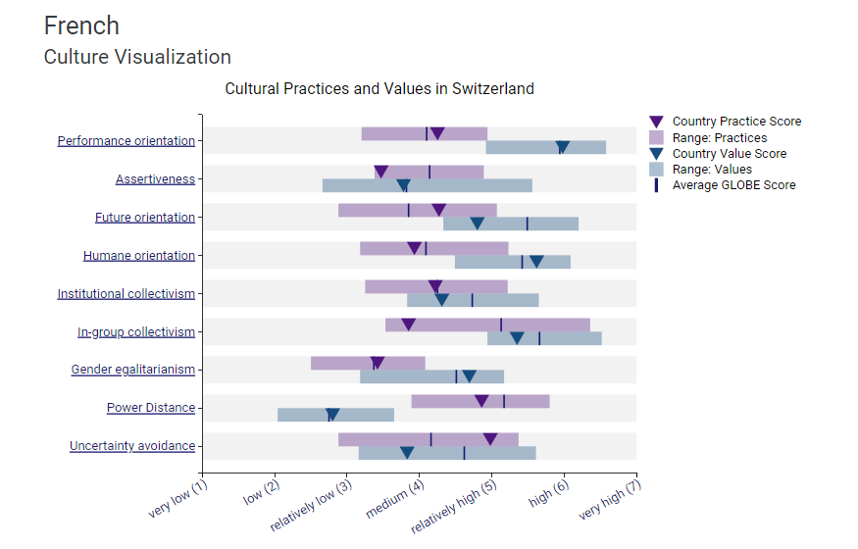

Examination of the GLOBE Project’s Culture and Leadership:
The analysis of GLOBE (Global Leadership and Organizational Behavior Effectiveness) will provide a framework for the systematic analysis of cultural differences and leadership approaches:

Power Distance:
According to the study, the UK's power distance is low, meaning that people in the UK are uncomfortable using power. They appreciate managers who are more communicative and responsive. Switzerland also has a low power distance, though the Swiss employees expect managers to be involved and engage workers in decision-making at the Hotel.

Uncertainty Avoidance:
The UK ranks quite average and tends to avoid uncertainty in organisational practices. This contributes to creativity, as there is a tolerance for ambiguity and a willingness to self-identify and take risks. Switzerland seems to have a high uncertainty avoidance, which means they aim for a structured and clearly defined setting where everyone has to follow the provided protocol (Beadles-II, et al., 2005).

Individualism vs. Collectivism:
The UK can be described as a strongly individualistic culture based on a high level of individual performance. The analysis shows that Switzerland aligns itself very much with the concept of individualism. They also focus heavily on community and social justice at the Hotel.

Masculinity vs. Femininity:
The UK’s score is moderate, representing both confident and slightly traditional masculinity, for which the UK stands for competitiveness and strives for material success. Switzerland’s masculinity is also mild. According to the analysis, gender roles are pretty conservative to a certain extent in the UK.

Future Orientation:
The UK is moderate to high regarding future orientation and values planning, investments, and long-term success. The study shows that Switzerland's high level of future orientation can be seen in the focus on preparing for the distant future to meet specific sustainability goals at the Hotel.

Performance Orientation:
In performance orientation, the UK ranks high, having a culture of achievement and initiative and acting accordingly to provide results. The analysis reveals that Swiss employees value excellence, hard work, and getting things right (Baird & Meshoulam, 1988).

Humane Orientation:
The UK has a moderate Human caring index and a moderate, humane orientation. Employees are moderately self-interested and care for others. Switzerland prioritises human caring in terms of mildness, kindly, altruism, and supporting communities.

Most relevant Practice:
Charismatic/Value-Based Leadership: Leadership in the UK is anticipated to be visionary, inspiring, and engaging success-oriented leaders. They are primarily viewed as the reference figures who set the pace and tone of innovation.
Participative Leadership: UK employees seek workforce involvement in decision-making processes to adopt a democratic leadership style, as stated by the research.

Switzerland:
Charismatic/Value-Based Leadership: As with the UK, the Swiss ideals for business leaders address innovation and goals concerning performance, disciplined codes of ethics, and integrity.
Participative Leadership: Swiss leaders delegate responsibilities and seek employees’ opinions. They are very apt to involve employees in the Hotel operations (Abramson & Moran, 2018).
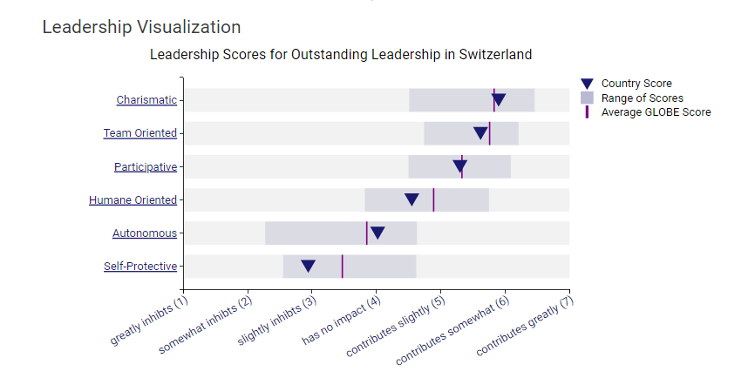

Challenges of Intellectual Leadership
Several cultural differences may cause issues with intercultural leadership for the managers organising the Hotel between the UK and Switzerland. Unlike the simplistic case of leadership experiments between cultures of the UK and Switzerland, these areas of intercultural leadership entail several problems, as indicated in the following section:
Communication: The UK employees at the Hotel may speak more directly and in a hurry, while Swiss people may be more reserved and formal, which may be misconstrued (Avelini, et al., 1995).
Decision Making: The research reveals that they also differ in their decision-making patterns. UK employees prefer more participation in the decision-making process, while Swiss employees would expect the consensus to be reached first, which could create tensions.
These factors make it appropriate for an understanding of different cultures, efficient communication, and leadership flexibility to address the client’s needs and endow them with a more democratic work environment.

Potential areas of conflict:
While using the example of UK and Swiss employees, it is possible to distinguish between preferences. While UK employees are receptive to any action and focus on individual decision-making, Swiss people, who tend to plan even minor events and value cooperation, will likely be afraid of taking risks. Differences in the speed and firmness of the decision-making process might cause conflict. On the one hand, employees from the UK may feel irritated with what they consider formalism (Alipour, 2019). In contrast, on the other, employees from Switzerland may perceive UK employees as hasty and somewhat reckless.

Conclusion:
The report aimed at exposing the cultural differences between UK and Swiss employees. Understanding these differences and their impact on the workforce is crucial. Staff must also respect the existence and significance of these differences since disagreements must be managed to promote mutual understanding and cooperation (Agarwal, 2014).

Recommendations:
The recommendations for dealing with the identified issues are as follows:
- Hotels should provide cross-cultural training programs to increase employees' understanding.
- The essential aspect of fostering workplace diversity is enhancing the free flow of communication of ideas and oversight.
- Initiatives for producing possibilities for teaming exercises would also enhance the organisation’s capacity to recognise company relations.

References
Abramson, N. & Moran, R., 2018. Managing Cultural .Differences: Global Leadership for the 21st Century.. Abingdon: Routledge.
Agarwal, U. A., 2014. Linking Justice, Trust and Innovative Work Behaviour to Work Engagement. Personnel Review, pp. 41-73.
Alipour, A., 2019. The conceptual difference really matters: Hofstede vs GLOBE’s uncertainty avoidance and the risk-taking behavior of firms. Cross Cultural & Strategic Management.
Avelini, H., Ivanka & Milena, P., 1995. Incorporation of Croatian hotel trade in the standard system of monitoring business results in the world hotel industry. Tourism and hospitality management 1, p. 239–51.
Baird, L. & Meshoulam, I., 1988. Managing two fits of strategic human resource management. Academy of Management Journal Review 13, pp. 116-28.
Beadles-II, N., Lowery, C. M. & Johns, K., 2005. The Impact of Human Resource Information Systems: An Exploratory Study in the Public Sector.. Journal of Communications of the IIM, pp. 39-46.
Breevaart, K. & Bakker, A. B., 2018. Daily Job Demands and Employee Work Engagement: The Role of Daily Transformational Leadership behavior. Journal of Occupational Health Psychology,. Educational Publishing Foundation, pp. 338-349.
Globe, P., 2020. GLOBE 2020 : Country Co-Investigator (CCI) Handbook. [Online]
Available at: https://globeproject.com/about%3Fpage_id=cci.html#globe2020_cci

