
2022
Jamie Waters (1551425)
UWTSD
1/1/2022
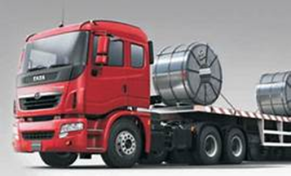
Improving Supply chain Performance
Table of Contents
Table of Figures 1
Introduction 3
Critical evaluation of the steel supply chain vulnerability 5
Supply risk 7
Process risks 8
Control Risk 8
Demand Risk 9
Environmental or Disruption 9
Steps to make the steel supply chain more resilient 11
Avoidance 12
Dropping specific products, geographical markets, suppliers, customers. 12
Control 12
Vertical integration 12
Increased Stockpiling and Buffer inventory 12
Maintaining extra capacity in production, storage, and handling/transport 12
Imposing contractual obligations on suppliers 13
Co-Operation 13
Joint efforts to improve supply chain visibility and understanding 13
Joint efforts to share risk related information 13
Joint efforts to prepare supply chain continuity plans 13
Flexibility 14
Postponement 14
Multiple sourcing 14
Localised sourcing 14
Recommendations 16
Reference list 22

Table of Figures
Figure 1 The Supply chain (Harrison et al. 2014) 2
Figure 2 Supply disruption factors between 2019 -2021 (Kingsley 2021). 3
Figure 3 Steel in society (World Steel Association, 2022) 4
Figure 4 Sources of risk within a supply chain (Christopher 2011) 5
Figure 5 The steel industry supply chain (World Steel Association, 2022) 6
Figure 6 Supply chain risk management model adapted from (Baz and Ruel 2021) 10
Figure 7 The impacts mitigation strategies (Chopra and Sodhi 2004) 14
Figure 8 Supplier evaluation and selection process (Lopes and Rodriguez-Lopez 2021) 15
Figure 9 Iron Ore Monthly Price in US Dollars per Dry Metric Ton (World in Maps, 2022) 17
Figure 10 Examples of supply chain integration in steel supply chains 18
Figure 11 EBITDA margin vs self-sufficiency (Global Steel 2014) 19
Figure 12 Supply chain integration approaches for steelmakers (Pinto 2019). 19
Figure 13 The steel supply chain (Sandhu et al. 2013) 20

Introduction

In an ever-changing world, the growth of global supply chains has forced businesses across the world to adapt. The internet explosion and the resulting emergence of E commerce, the growth of developing economies, overseas outsourcing and fluid customer demands with a focus on quality has forced all members of the supply chain to collaborate or risk failing (Crandall et al. 2015).
The supply chain (SC) can be thought of as the sequence of events with numerous participants that lead to the sale a product or the provision of a service, it involves the flow of raw materials from the supplier to the manufacturer, packaging, distribution to the end consumer and even the recycling of the used product. The SC comprises of all the planning and management activities required to source, procure, deliver (downstream and upstream) and manufacture all the materials and products within the SC, it requires collaboration with suppliers, customers, distributers and wholesalers to provide the best possible quality product at the lowest cost, on time (Crandall et al. 2015).
Christopher (2011) explains supply chain management (SCM), SCM aims to coordinate and facilitate these SC processes and interactions to help them be as efficient as possible. The definition of SCM according to (Christopher 2011) is:
‘The management of upstream and downstream relationships with suppliers and customers in order to deliver superior customer value at less cost to the supply chain as a whole.’
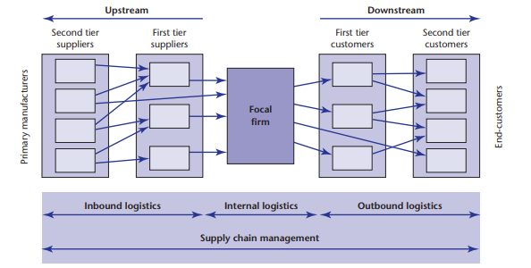
Figure 1 The Supply chain (Harrison et al. 2014)
The goal of SCM is to integrate the inbound, internal, and outbound logistics (shown above in figure 1) into one seamless system working together to meet the end customers’ needs. A well-managed efficient SC can provide the organisation with a competitive advantage (Harrison et al. 2014).
Historically relationships between downstream and upstream customers were adversarial, companies sought to gain profit or reduce costs at the expense of others in the SC. Transferring cost in this way did not improve their competitiveness but only pushed the cost to the end customer in increased prices. By working together an integrated SC can reduce costs and add value (Christopher 2011).
SC’s are complex and vulnerable to disruption, frequent events such as industrial accidents, fires, strikes, adverse weather events and political strife can be extremely costly. A global semiconductor shortage cost the automotive industry $210 billion revenue in 2021 (Duffy 2021), while the total cost of SC disruption in 2020 has been calculated to be as much as $4 trillion (Hart 2021).
Some factors that have impacted recent SC’s are shown below.
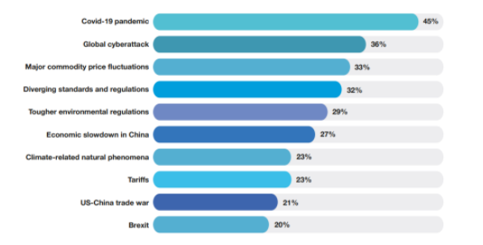
Figure 2 Supply disruption factors between 2019 -2021 (Kingsley 2021).
Hence the need to build robust SC’s. This report is going to look at risk in the SC, the steel industry SC in particular. The aims of this report are:
A: Critically evaluate the potential risks that exist in the steel industry SC that could threaten its supply.
B: Evaluate the steps that could be taken to make the steel industry SC more resilient.
C: Recommend what changes that could be made to the steel industry supplier appraisal process.

Critical evaluation of the steel supply chain vulnerability
Steel is an alloy of Iron, the fourth most abundant element on earth and Carbon. Steel is crucial for the development of industrialised economies and remains as important now as it has been since the industrial revolution. It is used to produce goods for key industries such as automotive, construction, energy, packaging, transport and manufacturing (Pinto et al. 2019) . Figure 3 show the uses of steel in today’s society.
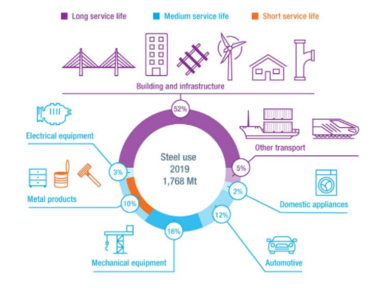
Figure 3 Steel in society (World Steel Association, 2022)
Steel can be produced in hundreds of different grades with varying strength and formability properties. Its high strength to weight ratio is what enables it to be used in so many applications and it is 100% recyclable without losing any of its properties. The challenges the industry has is overcoming its energy intensity and reducing its Carbon Dioxide footprint, to help tackle climate change and become sustainable (World Steel Association, 2022).
In recent years the steel industry has seen the cost of its raw materials (iron ore, metallurgical coke, coal and scrap steel) rise significantly, largely driven by the rapid development of the Chinese steel industry. With fierce global competition for these resources the steel upstream SC has become a sellers’ market. Steel production is dependent on production stability which relies on a timely supply of raw material. The procurement cost of these materials is substantial, approx. 60 – 70% of total production cost. The demand for steel unpredictable and its price can fluctuate and the supply of raw materials is variable, so it is vital that the management of risk in the steel SC is minimised and there are considerable financial benefits to be made if improvements can be implemented (Liu et al. 2017).
Supply chain risk management (SCRM) has been developed to manage and reduce risk in the SC and to mitigate the effects of any disruptions. (Tang 2006) describes two types of risk that could affect SC’s; Operational risks refer to the inherent uncertainties of supply and demand while Disruption risks refer to the disruptions caused by natural disasters including hurricanes, floods and earthquakes or man-made incidents such as socio-political events, terrorism attacks, economic crises, and events such as the recent global pandemic and war in Ukraine, these are essentially events that are beyond human control. The financial cost to disruption risks is generally far greater than the operational risks (Tang 2006).
(Christopher 2011) describes the main sources of SC risk in a business, illustrated in figure 4:
- Supply risk – The vulnerability of the SC to disruption to supply. Risk can be dependant on reliance on overseas suppliers, poor supply management and over dependence on key suppliers.
- Demand risk – Demand volatility, a spike in demand can cause an over reaction down the SC known as the bull whip effect.
- Process risk – Such as variation in processes, manufacturing capacity and process bottlenecks.
- Control risk – What is the effectiveness of the management of internal control systems such as order quantities, batch sizes and safety stocks?
- Environmental forces – These are the Disruption risks that were described in the previous paragraph.
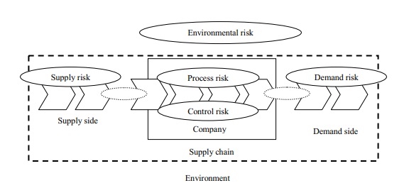
Figure 4 Sources of risk within a supply chain (Christopher 2011)

Supply risk
The steel industry requires large amounts of iron ores, coals, steel scrap and other raw materials and consumes large quantities of gas, electric and oils. Figure 5 below illustrates complexity of the steel industry SC (Liu et al. 2017).
- Raw materials, - Manufacturing processes, - Purpose of raw material
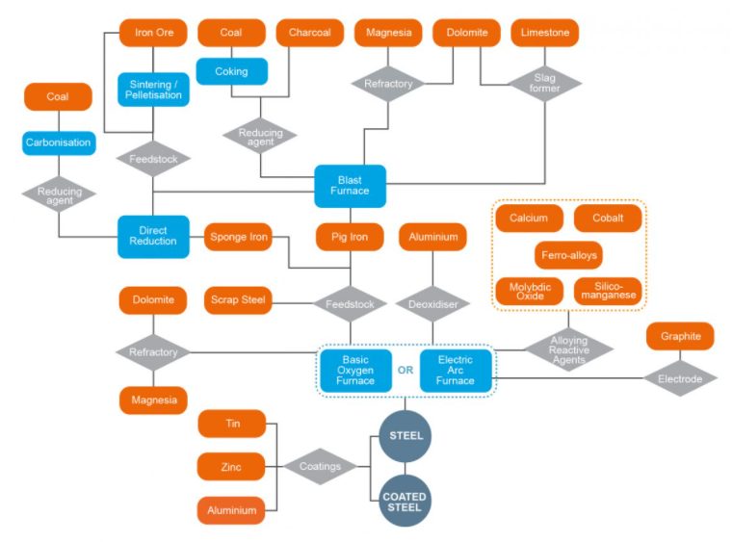
Figure 5 The steel industry supply chain (World Steel Association, 2022)
The supply risk for the steel industry can be summarised as follows:
- Contract – The risk of contract related issues disrupting supply. Global Iron ore supply is dominated by three major suppliers. This monopoly is driving up the price of iron ore as demand grows.
- Dependency – High dependency on suppliers and shipping corporations.
- Logistics – The risks associated with raw material transport, delays to cargo ships, insufficient supplier stocks, insufficient railway capacity, high cost of road transport.
- Price – The risk that costs challenge the competitiveness of the SC, instability in the price of raw materials, shipping cost fluctuations, increasing cost of energy.
- Quality – The risk of raw material quality not meeting expectations, steel making processes rely on high quality raw materials, impurities are detrimental to the quality of the final products.
- Import and export – Barriers to trade such as Brexit rule changes can lead to supply interruptions.
- Liquidity – The risk of supply interruption as a result of supplier companies running into financial difficulties.
Summarised from (Liu et al. 2017).

Process risks
These risks are mainly internal and can be controlled or prevented. They include:
- Insufficient maintenance – On equipment, assets and infrastructure.
- Production capability – Potential to miss out on opportunity for meeting order requirements.
- Instable manufacturing process – Leading to delay, missed opportunity and increased costs.
- Poor quality – Can result in the loss of customers.
- Production flexibility – The ability to switch between steel grades quickly and seamlessly.
- Technological changes – Not keeping up with technological advances such as new green steelmaking processes or failing to implement changes efficiently.
- Design changes - Can lead to delay and increased costs if not planned correctly.
- Lack of capacity – Failing to meet customer demand.
- Safety incidents – Can lead to lengthy delay and significant costs.
- Information infrastructure breakdown.
- Information delays.
- Lack of compatibility of IT platforms along the SC.
Any of these could lead to downstream supply delays and disrupt the SC (Tummala and Schoenherr 2011).

Control Risk
- Low technical reliability.
- Lead time for processing of payments.
- Credit periods for accounts payable and receivable.
- Quality control.
- Stock management.
- Working conditions.
- Supplier and customer policies.
- Poor customer service.
- Lean inventory.
(Christopher 2011)

Demand Risk
Steel come in many forms such as sheets, coil, bar, wire, tube, pipe and rail sections and supply many different industries (Otsuka et al. 2017). Risks to the upstream supply chain as explained by (Ho et al. 2015) are as follows:
- Inaccurate demand forecasts.
- Information distortion (bullwhip effect).
- Demand uncertainty.
- Inventory holding costs.
- Customer dependency – Can drive up prices and increase risk.
- Competitive markets – Chinese steel imports.
- Order fulfilment issues – Material quality, correct coil weight and size.
- Delivery issues – Ontime, on budget delivery.
- Logistics issues – Lorry/train driver strikes, damages, breakdowns and custom or border issues.
Environmental or Disruption
Acts of God or events out of human control, examples include:
- Natural disasters
- War and terrorism
- Political instability
- Economic recessions
- Large accidents
(Samvedi et al. 2013)
Other factors vital to the health of SC’s are information technology (Chopra and Sodhi 2004), financial systems (Heckmann et al. 2015) and transportation (Wu et al. 2006).
The price of steel has a significant impact on the price of iron ore, scrap steel, transportation by sea and on carbon emission allowances. China is the worlds largest iron ore importer and accounts for approx. 60% of global imports. In 2009 the spot price of iron ore rose to a record high of $180/t US. Steel prices have a high level of uncertainty and volatility and are vulnerable to shocks from the iron ore market. Iron ore supply is struggling to cope with downstream demand because of disruptions such as trade restrictions, the coronavirus outbreak, and regular SC issues (Ma 2021).
Scrap steel can be used as a partial substitute for iron ore in steelmaking and also as an alternative, 20% of steel in Japan is made using scrap steel and as much as 60% in the US. Scrap steel prices are currently higher than iron ore. The steel industry is coming under intense pressure to reduce carbon emissions and so steelmaking methods using electric arc furnaces may become more frequently used and therefore the demand for scrap will increase (Ma 2021).
The steel industry is guilty of emitting a substantial amount of CO₂. In an effort to reduce emissions Europe has implemented the emission trading scheme (ETS), which has set limits of allowable CO₂ emission. These allowances are tradable on the market. The ETS scheme has further driven up the cost of steelmaking.
Iron ore is transported around the globe using large cargo ships, countries such as Australia and Brazil account for a large percentage of iron ore exportation. The cost of transporting iron ore across these large distances by sea is correlated with economic conditions. High demand for iron ore has driven these costs upwards (Ma 2021).
Governments can exert considerable influence on steel markets through means such as trade regulation and international diplomacy. Examples include: Domestic steel production being supported by government subsidies, the lowering of interest rates for capital to allow investment in domestic steel industry activities and technologies, taxes implemented to discourage steel imports, government support for the investment in decentralised off-shore sourcing and production capacity and the taxation of shipping and transportation (Pinto 2019).

The following section will explore strategies that would make SC’s more resilient to disruption and risk

Steps to make the steel supply chain more resilient
Once the categories of risk are understood, the next step after risk identification would be risk assessment, to measure the probability of a disruption event and the likely consequence. Risk mitigation strategies then need to be decided upon to minimise any effects that the disruptions cause, before, through and after the event. Lastly a strategy for risk control needs to be implemented. Risk control aims to reduce the frequency and impact of SC disruptions (Baz and Ruel 2021).
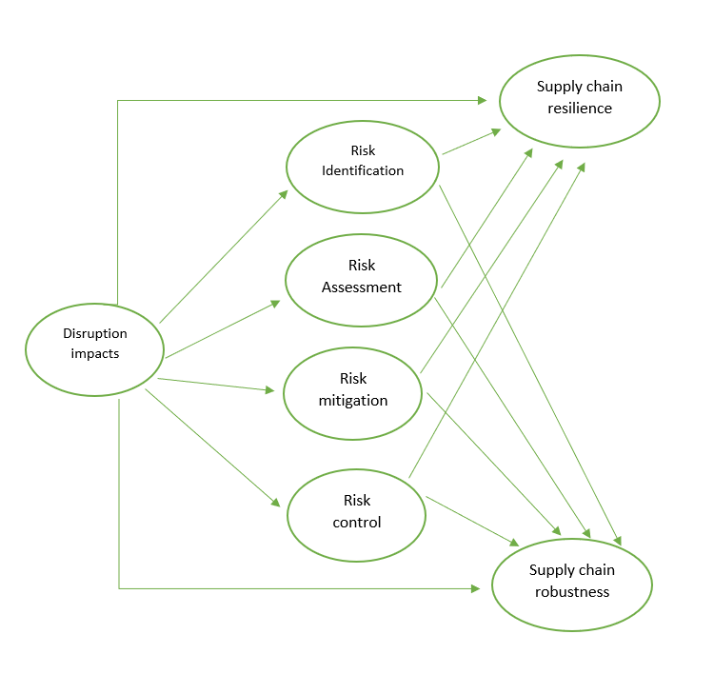
Figure 6 Supply chain risk management model adapted from (Baz and Ruel 2021)
SC resilience (SCRES) can be defined as the SC’s capability to react and recover from SC disruption. While SC robustness refers to the ability of a SC to maintain’ business as usual’ throughout SC disturbances (Baz and Ruel 2021).
Juttner et al. (2003) puts forth four strategies that companies could use to mitigate risk and make the SC more resilient – Avoidance, Control, Co-operation, and Flexibility.

Avoidance
Avoidance strategy is implemented when the risks associated with dealing with specific products, markets, or geographical area are deemed unacceptable.

Dropping specific products, geographical markets, suppliers, customers.
Identified risks that are deemed unacceptable can be averted, for example, using appropriate supplier/procurement selection by avoiding suppliers in politically unstable areas, unreliable suppliers, suppliers with poor technical support, financially unstable suppliers, suppliers with poor quality performance (Tukamuhabwa et al. 2017).

Control
Control strategy seeks to increase the predictability of contingency measures from the numerous risk sources.

Vertical integration
This entails the centralisation of suppliers by the main manufacturer through ownership by means of mergers or acquisition. Such a strategy requires heavy investment but can lead to self-sufficiency and raw material resource ownership (Pinto and Diemer 2020). A fully integrated SC can minimise inventory, improve lead times, fully utilise assets and helps a business become customer focused (Potter et al. 2004).

Increased Stockpiling and Buffer inventory
Chopra and Sodhi (2004) discuss the three key relationships associated with inventory pooling: 1. The cost of using inventory to cover a high-level demand risk is higher than the cost of covering a low level of risk. 2. For forecast risk, the necessary level of inventory needed to mitigate forecast risk decreases as it is pooled. 3. The benefit of pooling inventory increases with the level of risk. Therefore, this strategy is only recommended if the product has high inventory or forecast risk.

Maintaining extra capacity in production, storage, and handling/transport
Capacity flexibility in these areas enable both product mix and volume flexibility which are deemed to contribute to SC agility and in turn SC resilience. Volume flexibility is defined as the ability to vary production capacity without negatively affecting the cost or capability of the process, when impacted by a disruption. Mix flexibility refers to the ability to produce a varied range of products efficiently in response to variable demand (Braunscheidel and Suresh 2009).

Imposing contractual obligations on suppliers
Urciuoli et al. (2014) suggest negotiating contracts with suppliers so that some level of risk is shared. For example, a criteria could be included that it is necessary to have extra transport capacity available in case of disruption to a vessel. A supply contract could be split between long term contracts and partly by short term deals which would allow flexibility in supply. (Xiao and Yang 2009) advises including a risk subsidy to offset part of the manufacturers risk cost and that a coordinated contract can improve the members profits. Risk sharing is appropriate when dealing with risks that have low probability and high impact, the strategy can increase customer service levels and reduce risk associated costs (Lai et al. 2009).

Co-Operation
Cooperative responses use agreements across the whole SC to improve visibility and understanding in order to reduce uncertainty.

Joint efforts to improve supply chain visibility and understanding
Information sharing can allow a manufacturer to reduce both inventory and cost. Cost savings for the whole supply chain can be made when information such as customer demand, demand forecast, and inventory levels are shared. Although there are obstacles to such information sharing, SC partners are often reluctant to share information with manufacturers because of mistrust, they fear lower bargaining power, information leaks and such (Tang 2006).

Joint efforts to share risk related information
DuHadway et al. (2019) argue that as uncertainty increases, a firms information processing requirements increase in line and the firm should adopt the capability to meet these requirements, as their ability to process information efficiently increases the better equipped, they are to deal with uncertainty. Organisations make their strategic decisions based on the information available to them. The SC can act as a valuable information gathering system that could process this information and positively influence performance.

Joint efforts to prepare supply chain continuity plans
Azadegan et al. (2020) promote business continuity programs (BCP’s) to help organisations recover from disruptions, a BCP procedural strategy that helps businesses identify risks, set objectives and institutionalise practices that help mitigate risk and disruption. A BCP encompasses risk mitigation, risk management, continuity planning and emergency response. The BCP starts with a business impact analysis which identifies all the risk to the business and their likely impact. Next a step-by-step process aiding in recovering critical organisation functions, by delegating specific objectives and tasks a coordinated effort enhances disruption recovery. Institutionalising risk management practice is achieved with training exercises, mock drills and learning exercises. These are effective means of embedding the expectations and reactions required when the company is exposed to disruption.

Flexibility
Flexibility strategy attempts to increase the responsiveness of organisations.

Postponement
When considering a manufacturing process there may come a point in the process after which the product becomes differentiated, postponement strategies hold stock at the optimum stage in the manufacturing process so that the product can be manufactured according to demand. There are two systems used: – Make to order (MTO) and Make to stock (MTS). In the MTO system work in progress inventory (WIP) is held at the differentiation point and the product is made/customised on demand. Holding finished product inventory is more costly that holding WIP. The MTS system hold only finished products. This system assumes that the demand distributions are normal across time, an average base stock level and an average inventory level for each end product is calculated. When the number of end products reaches a certain threshold then the MTO becomes more cost effective (Tang 2006). Postponement reduces the dependence on demand forecasts and increases an organisations ability to respond to disruptions caused by variable demand (Juttner et al. 2003).

Multiple sourcing
The number of suppliers a manufacturer uses has an effect on its supply risk, working with one supplier (single sourcing) has benefits, such as lower inventories, lower production costs, better quality due to lean activities such as just in time and continuous improvement, stronger relationships and reduced administrative costs. Information sharing is easier as trust can be built. The issue with single sourcing, is the level of risk from disruption is significantly increased. Using two or more suppliers (multiple sourcing) reduces the risk from disruption and helps maintain competitiveness between suppliers. The choice between these strategies depends on the risk to disruption. For high impact, low frequency events with companies with a low to medium risk aversion then single sourcing is the most suitable strategy. If risk aversion is high, then the multiple sourcing strategy is advised. For low impact, high frequency disruptions, multiple sourcing strategy out preforms single sourcing regardless of the risk aversion (Namdar et al. 2018).

Localised sourcing
Advantages of globalisation include lower costs, new market opportunities, e-commerce and open lines of communication, however cultural differences, lack of standardisation, political instability and sizeable distances expose the SC to increased risk (Kırılmaz and Erol 2017). Local suppliers can offer short lead times and respond quickly. High levels of disruption risk is best mitigated by using a more reliable supplier despite the increase in cost, there must be a trade-off (Chopra et al. 2007).
Managing supply chain risk can often be difficult because the risks are often interconnected. Mitigations put in place to counter risk can aggravate another risk. There are often trade-offs in mitigation policies, see figure 7. Consider a lean supply chain for example, having low inventory using just in time decreases the impact of over forecasting demand while simultaneously increasing the impact of a supply chain disruption. Figure 7 shows the impact of various risk mitigation strategies.
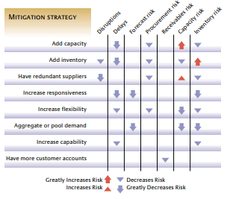
Figure 7 The impacts mitigation strategies (Chopra and Sodhi 2004)

Recommendations
Fierce competition in global markets has forced many companies to focus on their core competencies and outsource less profitable activities to suppliers. Supplier selection has become critical, enabling companies to source products of high quality, on time, in the correct quantity, at reduced cost and fulfilling customer requirements. The cost of purchased materials and components averages 40 – 60% and can be as high as 70% of total production costs thus choosing the right supplier directly impacts upon operational performance. Supplier selection influences inventory management, quality improvement, cost reduction, production planning and control and customer satisfaction. Supplier selection is vital to a successful organisation (Lopes and Rodriguez-Lopez 2021).
There are many different models discussed in literature that can be used to help in supplier selection, however many of them agree on the stages required in the process, these can be found in the diagram below in Figure 8.
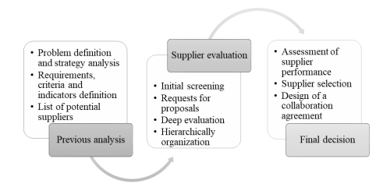
Figure 8 Supplier evaluation and selection process (Lopes and Rodriguez-Lopez 2021)
Previous analysis involves deciding on the criteria potential suppliers will require and compiling a list of prospective candidates. Next during supplier evaluation, the number of potential suppliers is reduced following an evaluation and screening process. During this stage the candidates are contacted and asked for further information, the analysis of which enables the appraising firm to list the suppliers hierarchically according to suitability. Finally, after a thorough assessment and following negotiations with the candidates, a supplier is selected (de Boer 2017).

One of the most important steps in the process is the supplier evaluation, the most often used criteria are:
- Quality – The capability to supply goods that conform to specification and government regulations, that satisfy customer requirements. Suitable quality management systems and continuous improvement programs, process control management, maintenance and calibration plans and staff training
- Delivery – Lead time, on time delivery, reliability
- Cost – Cost of product, transport, maintenance, labour
- Relationship – The ability to foster long term relationships, strong communication channels.
- Facilities and Capacity –Suitable infrastructure and resources and location.
- Service – Level of after service care.
- Flexibility – The ability to react to change in terms of product volume, product mix, or manufacturing processes.
- Culture – Shared values and goals.
- Geographical location – Distance between supplier and the company.
- Performance history – Reputation, supplier feedback, experience in the relevant industry.
- Financial status – Financial stability, payment terms and conditions and cash solvency.
- Innovation – Money spent on research and development activities can indicate a strong technical ability.
- Environmental – Drive for sustainability, strong environmental control and programs.
- Safety – Safety record, provides a safe and healthy work environment. Safety is an important factor as accidents can have a significant financial social and environmental impact.
(Chen 2011; de Boer 2017; Parkouhi and Ghadikolaei 2017; Lopes and Rodriguez-Lopez 2021)
The primary raw material used to make steel is iron ore and therefore volatility in supply and price of this material represents a significant risk to steel manufacturers. Despite being the fourth most abundant element on the planet iron ore reserves are not widespread, they are concentrated relatively sparsely, the counties with the biggest reserves are:
- Australia – 48 billion tonnes
- Brazil – 29 billion tonnes
- Russia – 25 billion tonnes
- China – 20 billion tonnes
- Ukraine – 6.5 billion tonnes
- Canada – 6 billion tonnes
- India – 5.5 billion tonnes
(NS Energy, no date)
Australia and Brazil account for approximately 70% of global production of iron ore with Australia providing 50% and Brazil making up the remaining 20%. Only iron ore of a specific grade is suitable for steel making, approx. 62% Fe concentration of the ore. Three companies dominate this market, the limited number of possible suppliers put the steel manufacturers at a disadvantage during negotiation for contracts (Comtois and Slack 2016). The large distances that need to be traversed is also a considerable risk. Steel and iron ore prices are closely linked and are volatile, creating issues in iron ore supply (see figure 9 for iron ore prices below).
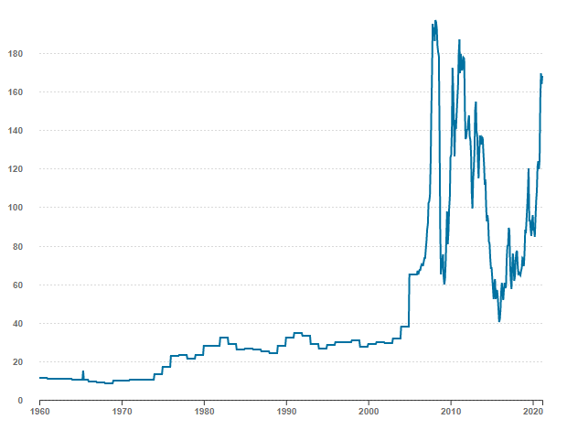
Figure 9 Iron Ore Monthly Price in US Dollars per Dry Metric Ton (World in Maps, 2022)
China imports 60% of the world’s total iron ore supply and so the fluctuation in prices can depend on the level of steel production in China (Ma 2021). Western European and northern American can also be disadvantaged by cost of wages, over regulation, tax burdens and energy costs when compared to steel manufacturers in developing companies.
Pinto and Diemer (2020) examine one strategy that is increasing used by steel manufacturers to protect themselves from such volatility and risk, supply chain integration (SCI), steel manufacturers are looking at becoming more raw material self-sufficient and increase resource ownership. SCI is the intention to collaborate with customers and suppliers with the aim of optimising the collective performance in the creation, distribution, and support of an end product. There are three options used in SCI:
- Horizontal integration – Information, strategies and decisions are shared but ownership and management of all the companies involved remain independent.
- Vertical integration – Ownership and management are shared by means of acquisitions and mergers etc.
- Hedging – Can occur vertically or horizontally, responds to market variation by increasing or lowering activity across different areas of the supply chain.
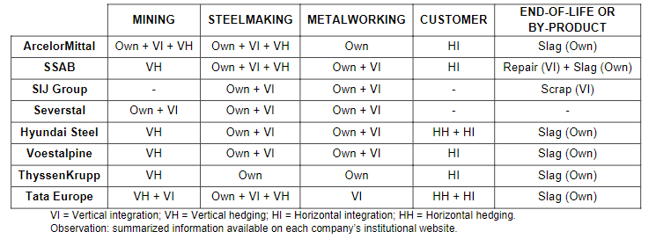
Figure 10 Examples of supply chain integration in steel supply chains
European steelmakers mostly look to vertically integrate suppliers, but many also try to use horizontal integration with the customer especially when it comes to supplying goods to the automotive industry. They use hedging mostly vertically on the supplier side, European steel manufacturers compensate for ore price and geopolitical volatility by controlling different operations abroad, figure 10 reveals the different integration approaches used by different steelmakers in their SC’s.
For example (This Week 2021) reports that Tata steel plans to boost iron ore production from 30 to 45 million tonnes over the next 5 years.
There are considerable risks to this strategy however, competing with mining companies can lead to overpaying for scarce resources, lack of operational experiences of mining business and large investment required. A report from (Global Steel 2014) found that raw material self-sufficiency had a negative correlation with the enterprise value of a steelmaker but has a positive impact on its EBITDA margins. Figure 11 shows the results of self-sufficiency for steelmakers from 2009 – 2013.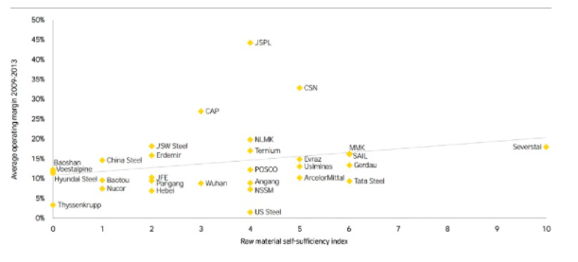
Figure 11 EBITDA margin vs self-sufficiency (Global Steel 2014)
Steelmakers are looking for methods to reduce their impact on the environment, the European steel industry has committed to the application of the Circular Economy (CE) model, based on the 3 R principle (reduce, reuse, recycle), aims at reducing pollution and waste generation by recycling all the many by-products and outputs created during steelmaking back into the economy. CE suggests that all industrial activity be designed so that renewable and clean energy sources are used, and the outputs collected in a way that allows for collection, recycling, refurbishing, reuse and redistribution throughout their lifespan. This can only be achieved with full cooperation with the SC stakeholders. The decisions on whether to centralise, decentralise or outsource the different steps involved can have a considerable impact on lead times, raw material self-sufficiency, resource ownership, environmental performance, and demand risk. Figure 12 illustrates the approaches recommended by (Pinto 2019).
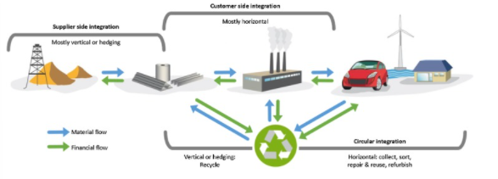
Figure 12 Supply chain integration approaches for steelmakers (Pinto 2019).
The bullwhip effect is a significant problem for steel SC’s, to try and mitigate this effect the MTO and MTS strategies can be used. The heavy end process depicted at the top of figure 13 produces a homogenous bulk product in a continuous production process, which ensures a smooth production process that suits the MTS strategy.
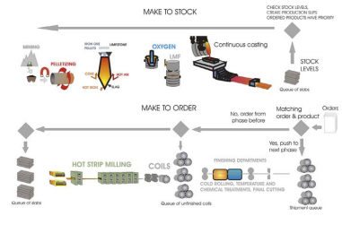
Figure 13 The steel supply chain (Sandhu et al. 2013)
The finishing end process of steel making involves a number of discrete processes that involve a number of setup and stock points that increase the likelihood of overstocking, the MTO strategy is best applied here (Sandhu et al. 2013).
Steel products can be assigned the MTO or MTS strategy, orders for the most popular products are shipped from stock, the production batch size is based on current demand and is forecast driven (MTS), Lower volume products are manufactured on a MTO basis and are sales driven , this ensures stock availability is not compromised and production cycle time is reduced (Potter et al. 2004).
While the developing nations challenge the western European steelmakers on the price of steel, they mainly produce from an unspecialised portfolio, therefore the European steelmakers invest capital and capacity into converting into specialised, differentiated, higher added value products that align with customer horizontal integration (Pinto 2019).
In the long-term reducing reliance on iron ore and improving its environmental impact, steel manufacturers could move towards electric arc steel steelmaking or other greener steelmaking technologies, but this requires significant investment in assets and research and development to make them viable alternatives. In the short-term increasing the use of alternative renewable fuels and energy sources such as biofuels, hydrogen, solar, wind and geothermal should be considered. For which effective SC collaboration will be required.

Reference list
Azadegan, A., Parast, M.M., Lucianetti, L., Nishant, R. and Blackhurst, J. 2020. Supply Chain Disruptions and Business Continuity: An Empirical Assessment. Decision Sciences 51(1), pp. 38–73. Available at: http://onlinelibrary.wiley.com/doi/10.1111/deci.12395 [Accessed: 2 April 2022].
Baz, J.E. and Ruel, S. 2021. Can supply chain risk management practices mitigate the disruption impacts on supply chains’ resilience and robustness? Evidence from an empirical survey in a COVID-19 outbreak era. International Journal of Production Economics 233, p. 107972. Available at: https://www.sciencedirect.com/science/article/pii/S0925527320303224 [Accessed: 3 March 2022].
Braunscheidel, M.J. and Suresh, N.C. 2009. The organizational antecedents of a firm’s supply chain agility for risk mitigation and response. Journal of Operations Management 27(2), pp. 119–140. Available at: http://onlinelibrary.wiley.com/doi/abs/10.1016/j.jom.2008.09.006 [Accessed: 30 March 2022].
Chen, Y.-J. 2011. Structured methodology for supplier selection and evaluation in a supply chain. Information Sciences 181(9), pp. 1651–1670. Available at: https://www.sciencedirect.com/science/article/pii/S0020025510003440 [Accessed: 10 April 2022].
Chopra, S., Reinhardt, G. and Mohan, U. 2007. The importance of decoupling recurrent and disruption risks in a supply chain. Naval Research Logistics (NRL) 54(5), pp. 544–555. Available at: http://onlinelibrary.wiley.com/doi/abs/10.1002/nav.20228 [Accessed: 5 April 2022].
Chopra, S. and Sodhi, M.S. 2004. Managing Risk to Avoid Supply-Chain Breakdown. MIT Sloan Management Review 46(1), pp. 53–61. Available at: https://www.proquest.com/docview/224964486/abstract/A6E592F3C96C4741PQ/1 [Accessed: 20 March 2022].
Christopher, M. 2011. Logistics & Supply Chain Management. Fourth. Harlow United Kingdom: Prentice Hall.
Comtois, C. and Slack, B. 2016. Steel markets. Available at: https://www.cirrelt.ca/documentstravail/cirrelt-2016-06.pdf [Accessed: 16 March 2022].
Crandall, R.E., Crandall, W.R. and Chen, C.C. 2015. Principles of Supply Chain Management. Second. Florida: CRC Press.
de Boer, L. 2017. Procedural rationality in supplier selection: Outlining three heuristics for choosing selection criteria. Management Decision 55(1), pp. 32–56. Available at: http://www.proquest.com/docview/1858619849/abstract/79DC9638FC5B4842PQ/1 [Accessed: 10 April 2022].
Duffy, K. 2021. Global chip shortages are expected to cost automakers $210 billion in 2021 — almost double previous estimates, a consulting firm says. Available at: https://www.businessinsider.com/global-chip-shortage-supply-chain-cost-auto-industry-210-billion-2021-9 [Accessed: 13 March 2022].
DuHadway, S., Carnovale, S. and Hazen, B. 2019. Understanding risk management for intentional supply chain disruptions: risk detection, risk mitigation, and risk recovery. Annals of Operations Research 283(1–2), pp. 179–198. Available at: https://www.proquest.com/docview/2320884596/abstract/3969EF25B1B04BD3PQ/1 [Accessed: 22 March 2022].
Global Steel 2014. Planning to proﬁt from opportunity: preparing for … preview / planning-to-pro-t-from-opportunity-preparing-for.pdf / PDF4PRO. Available at: https://pdf4pro.com/amp/fullscreen/planning-to-pro-t-from-opportunity-preparing-for-3cb05.html [Accessed: 17 April 2022].
Harrison, A., van Hoek, R. and Skipworth, H. 2014. Logistics Management and Strategy. Fifth. Harlow United Kingdom: Pearson Education Limited.
Hart, C. 2021. Total cost of supply chain disruption in 2020 ‘was $4tn’. Available at: https://www.cips.org/supply-management/news/2021/march/total-cost-of-supply-chain-disruption-in-2020-was-4tn/ [Accessed: 13 March 2022].
Heckmann, I., Comes, T. and Nickel, S. 2015. A critical review on supply chain risk – Definition, measure and modeling. Omega 52, pp. 119–132. Available at: https://www.sciencedirect.com/science/article/pii/S030504831400125X [Accessed: 3 March 2022].
Ho, W., Zheng, T., Yildiz, H. and Talluri, S. 2015. Supply chain risk management: a literature review. International Journal of Production Research 53(16), pp. 5031–5069. Available at: http://www.tandfonline.com/doi/full/10.1080/00207543.2015.1030467 [Accessed: 8 March 2022].
Iron ore. 2022. World in maps. Available at: https://worldinmaps.com/commodities/iron-ore/ [Accessed: 14 April 2022].
Juttner, U., Peck, H. and Martin, C. 2003. Supply chain risk management: outlining an agenda for future research: International Journal of Logistics Research and Applications: Vol 6, No 4. International Journal of Logistics Research and Applications 6(4), pp. 197–210. Available at: https://www-tandfonline-com.ezproxy.uwtsd.ac.uk/doi/abs/10.1080/13675560310001627016 [Accessed: 29 March 2022].
Kingsley, J. 2021. The Business Costs of Supply Chain Disruption. Available at: https://impact.economist.com/perspectives/sustainability/business-costs-supply-chain-disruption-1 [Accessed: 13 March 2022].
Kırılmaz, O. and Erol, S. 2017. A proactive approach to supply chain risk management: Shifting orders among suppliers to mitigate the supply side risks. Journal of Purchasing and Supply Management 23(1), pp. 54–65. Available at: https://www.sciencedirect.com/science/article/pii/S1478409216300061 [Accessed: 28 March 2022].
Lai, G., Debo, L.G. and Sycara, K. 2009. Sharing inventory risk in supply chain: The implication of financial constraint. Omega 37(4), pp. 811–825. Available at: https://www.sciencedirect.com/science/article/pii/S0305048308000911 [Accessed: 31 March 2022].
Liu, J., An, R., Xiao, R., Yang, Y., Wang, G. and Wang, Q. 2017. Implications from substance flow analysis, supply chain and supplier’ risk evaluation in iron and steel industry in Mainland China. Resources Policy 51, pp. 272–282. Available at: https://www.sciencedirect.com/science/article/pii/S0301420716301635 [Accessed: 27 January 2022].
Lopes, A.P. and Rodriguez-Lopez, N. 2021. A Decision Support Tool for Supplier Evaluation and Selection. Sustainability 13(22), p. 12387. Available at: https://www.proquest.com/docview/2602244901/abstract/7554B234107E45D6PQ/1 [Accessed: 10 April 2022].
Ma, Y. 2021. Do iron ore, scrap steel, carbon emission allowance, and seaborne transportation prices drive steel price fluctuations? Resources Policy 72, p. 102115. Available at: https://www.sciencedirect.com/science/article/pii/S030142072100129X [Accessed: 22 March 2022].
Namdar, J., Li, X., Sawhney, R. and Pradhan, N. 2018. Supply chain resilience for single and multiple sourcing in the presence of disruption risks. International Journal of Production Research 56(6), pp. 2339–2360. Available at: https://www.tandfonline.com/doi/full/10.1080/00207543.2017.1370149 [Accessed: 5 April 2022].
Otsuka, H., Mattera, G. and Silva, F. 2017. A first look at the steel industry in the context of global value chains. Paris: Organisation for Economic Co-operation and Development., p. 46.
Parkouhi, S.V. and Ghadikolaei, A.S. 2017. A resilience approach for supplier selection: Using Fuzzy Analytic Network Process and grey VIKOR techniques. Journal of Cleaner Production 161, pp. 431–451. Available at: https://www.sciencedirect.com/science/article/pii/S0959652617308740 [Accessed: 10 April 2022].
Pinto, J. 2019. Sustainable resource management in european steel supply chains. Doctorate, France: Universty of Clermont Auvergne.
Pinto, J.T.M. and Diemer, A. 2020. Supply chain integration strategies and circularity in the European steel industry. Resources, Conservation and Recycling 153, p. 104517. Available at: https://www.sciencedirect.com/science/article/pii/S0921344919304239 [Accessed: 27 January 2022].
Pinto, J.T.M., Sverdrup, H.U. and Diemer, A. 2019. Integrating life cycle analysis into system dynamics: the case of steel in Europe. Environmental Systems Research 8(1). Available at: https://www.proquest.com/docview/2223105623/abstract/E166C426F5BD43C9PQ/1 [Accessed: 27 January 2022].
Potter, A., Mason, R., Naim, M. and Lalwani, C. 2004. The evolution towards an integrated steel supply chain: A case study from the UK. International Journal of Production Economics 89(2), pp. 207–216. Available at: https://www.sciencedirect.com/science/article/pii/S0925527302004498 [Accessed: 27 January 2022].
Samvedi, A., Jain, V. and Chan, Felix T.S. 2013. Quantifying risks in a supply chain through integration of fuzzy AHP and fuzzy TOPSIS. International Journal of Production Research 51(8), pp. 2433–2442. Available at: https://ezproxy.uwtsd.ac.uk/login?url=https://search.ebscohost.com/login.aspx?direct=true&db=bth&AN=85879206&site=ehost-live [Accessed: 21 March 2022].
Sandhu, M.A., Helo, P. and Kristianto, Y. 2013. Steel supply chain management by simulation modelling. Benchmarking 20(1), pp. 45–61. Available at: https://www.proquest.com/docview/1288077580/abstract/D0403E2F8CCE4939PQ/1 [Accessed: 27 January 2022].
Seven countries with the largest iron ore reserves in the world in 2019. [no date]. Available at: https://www.nsenergybusiness.com/features/world-iron-ore-reserves-countries/ [Accessed: 14 April 2022].
Tang, C.S. 2006. Perspectives in supply chain risk management. International Journal of Production Economics 103(2), pp. 451–488. Available at: https://www.sciencedirect.com/science/article/pii/S0925527306000405 [Accessed: 3 March 2022].
This Week 2021. Tata Steel to boost iron ore production to 45 million tonnes per annum in 5 yrs. Available at: https://www.theweek.in/news/biz-tech/2021/11/28/tata-steel-to-boost-iron-ore-production-to-45-million-tonnes-per-annum-in-5-yrs.html [Accessed: 17 April 2022].
Tukamuhabwa, B., Stevenson, M. and Busby, J. 2017. Supply chain resilience in a developing country context: a case study on the interconnectedness of threats, strategies and outcomes. Supply Chain Management 22(6), pp. 486–505. Available at: http://www.proquest.com/docview/2532952540/abstract/592CD2C62AC44624PQ/1 [Accessed: 28 March 2022].
Tummala, R. and Schoenherr, T. 2011. Assessing and managing risks using the Supply Chain Risk Management Process (SCRMP). Supply Chain Management 16(6), pp. 474–483. Available at: http://www.proquest.com/docview/895358914/abstract/8B6D06B6A33C49C8PQ/1 [Accessed: 21 March 2022].
Urciuoli, L., Mohanty, S., Hintsa, J. and Boekesteijn, E.G. 2014. The resilience of energy supply chains: a multiple case study approach on oil and gas supply chains to Europe. Supply Chain Management 19(1), pp. 46–63. Available at: http://www.proquest.com/docview/1476457531/abstract/254BF59784894456PQ/1 [Accessed: 30 March 2022].
Wu, T., Blackhurst, J. and Chidambaram, V. 2006. A model for inbound supply risk analysis. Computers in Industry 57(4), pp. 350–365. Available at: https://www.sciencedirect.com/science/article/pii/S016636150500179X [Accessed: 22 March 2022].
Xiao, T. and Yang, D. 2009. Risk sharing and information revelation mechanism of a one-manufacturer and one-retailer supply chain facing an integrated competitor. European Journal of Operational Research 196(3), pp. 1076–1085. Available at: https://www.sciencedirect.com/science/article/pii/S0377221708004074 [Accessed: 30 March 2022].

