Moving away from the traditional classroom- The silent digital revolution in education
ECIE6002
Lisa-Marie Manning

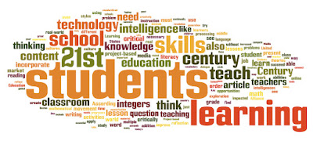
Welcome to the 21st Century!
So, what exactly is digital competence?
Digital competence is the ability to be able to use digital technology effectively and responsibly. According to Welsh
(Mrs Waughs Class, 2011).
Government (2018) " Digital competence is the set of skills, knowledge and attitudes that enable the confident, creative and critical use of technologies and systems" Digital competence allows individuals to develop a range of skills that create digital citizens who are capable of interacting, collaborating, producing digital content and are confident to analyse data as well as developing problem solving skills through computational thinking.
STOP! Digital competence is NOT Information and Communication Technology (ICT) and should not be confused with it. ICT is to remain in place and digital competency will work alongside whilst promoting digital skills across all subjects. Now we've cleared that up, let's move on..

What is the Digital Competence Framework (DCF)?
In an ever changing digital world, it is important children and young people are equipped with skills and knowledge to enable them to succeed in life. The Digital Competence Framework (DCF) is aimed at all learners aged 3-16 and sets out clear guidelines that when applied can support digital skills and competencies across all subject areas. GWE (2023) tells us a key component of the DCF is computational thinking and developing these skills can lead to learners achieving success in many areas such as science, engineering and technology (STEM). As well as this, the DCF also highlights the development of other essential skills such as communication, collaboration and digital literacy, all of which can guide learners to achieve in education, employment and social interactions.
Computational thinking = ability to think logically, break down complex problems into smaller parts, identify trends and use algorithms (basically problem solving)

How does it fit into the new curriculum in Wales?
The DCF is designed to fit into everyday classroom tasks and digital competence is one of three cross-curricular responsibilities alongside literacy and numeracy. According to Champion (2021) it was the first stage of the new Curriculum for Wales which is now based around six Areas of Learning and Experience (AOLES) which are;
- Expressive arts
- Health and well-being
"The need for change is also very clear if we are to develop a curriculum which supports and enables world-class teaching and learning in the twenty-first century" Donaldson, 2015 (p 21)
- Humanities
- Languages, literacy and communication
- Mathematics and numeracy
- Science and technology
The three cross-curricular responsibilities will be included in the AOLES.
According to Adobe Spark (no date) Adobe Spark enables anyone to create and share visual content on any device.
How does it work in lessons?
The DCF consists of four main strands;
- citizenship
- interacting and collaborating
- producing
- data and computational thinking

each further divided into elements, which can then be reinforced by suggested classroom tasks.

I recently supported a group of children, using a strand of the DCF framework, to learn and develop new skills specifically, interacting and collaborating. The task was to work collaboratively to create a news report on a topic they have been learning about, in this instance, the Rebecca Riots, using s programme such as Abode Spark.

(Adobe Spark, no date).

The group was of four mixed ability eight or nine year olds. I gave them verbal instructions along with guidance and modelling of what they had to do to be successful in this task. Vygotsky's Sociocultural Theory of Cognitive Development (1978) emphasized that cognitive development is influenced by social factors. According to McLeod (2023) Vygotsky believed cognitive development is a social process through which children gain cultural values, beliefs and strategies for problem solving by conversations with members of society, considered to be more knowledgeable.
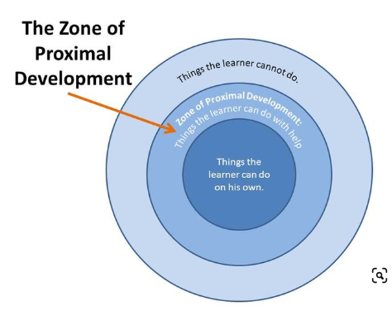
The distance between the actual development level as determined by independent problem solving and the level of potential development as determined through problem solving under adult guidance or in collaboration with more capable peers. (Vygotsky, 1978, pg 86)
How did it work?
For this collaborative task, I took on the role of the More Knowledgeable Other (MKO) by providing assistance to help develop their current skills and help them to learn new. We discussed each step, I answered any questions they had and they all successfully completed the task. Aubrey (2022) notes that the role of the teacher is vital for children to achieve tasks that were slightly out of their ability if working alone but with guidance they could attain them.
(Pinterest, 2014).
School A wants pupils to have the necessary knowledge, skills and attitudes to be able to confidently, creatively and critically use evolving technologies in an ever changing digital world.
School A (2017)
What happened next...
To ensure children are digitally competent, which is not just an important part of the curriculum but also a vital life skill now too, they should be given opportunities to use ICT with purpose whilst also enjoying it. School A aims to provide pupils with age appropriate technology through interactive educational apps, foster responsible online behaviour and cross-curricular activities.
To sum up
This blog has only discussed one strand from the DCF framework, there is much more to explore but before you run off to do that I would just like to conclude. Technology is growing and continuing to develop, whether we like it or not. It has become central to many people's lives, particularly children both in and out of school. "The internet and other digital information and communications technologies are powerful tools, which open up new opportunities for everyone" (School A, 2022). Therefore, whilst technology can be useful, it is important children are taught from a young age how to use it correctly and safely.

Reference List
Adobe Spark (No date) Adobe spark. Available at: Adobe Spark (Accessed 3rd December 2023).
Adobe Spark (No date) Adobe spark. [Image]. Available at: Adobe Spark (Accessed 3rd December 2023).
Aubrey, K. Riley, A (2022) Understanding and using educational theories. London, SAGE.
Champion, J (2021) Curriculum reform. Available at: Curriculum reform: The Digital Competence Framework (senedd.wales) (Accessed 20th November 2023).
Donaldson (2015) Successful futures. Available at: successful-futures.pdf (gov.wales) (Accessed 20th November 2023).
GWE (2023) Digital competence framework and learning in digital Wales. Available at: Digital Competence Framework and Learning in Digital Wales - GwE (gwegogledd.cymru) (Accessed 20th November 2023).
McLeod, S (2023) Lev Vygotsky's Sociocultural Theory of Cognitive Development. Available at: Lev Vygotsky's Sociocultural Theory Of Cognitive Development (simplypsychology.org) (Accessed 10th December 2023).
Mrs Waughs Class (2011)The paradox of 21st century education.[Image] Available at: Mrs. Waugh Barrios : The Paradox of 21st Century Education (mswaughsclass.blogspot.com) (Accessed 3rd December 2023).
Pinterest (2014) The Zone of Proximal Development. [Image]. Available at: The Zone of Proximal Development | Social emotional skills, Emotional skills, Social emotional learning (pinterest.co.uk) (Accessed 10th December 2023).
School A (2017) ICT policy. [Unpublished].
School A (2022) Acceptable use policy. [Unpublished].
Twirp Communications Inc (2023) Adobe Spark logo. [Image] Available at: Adobe_Spark_logo.svg (twirp.ca) (Accessed 3rd December 2023).
Vygotsky, L (1978) Mind in society. Cambridge, MA: Harvard university Press.
Welsh Government (2018) Digital competence framework your questions answered. Available at: digital-competence-framework-your-questions-answered.pdf (gov.wales) (Accessed 20th November 2023).

Effects of the digital world on children and young people
The term “digital world” refers to the totality of circumstances that characterize the living conditions in the digital age, which will be significantly shaped by a multitude of digital technologies
Lengfeld, J (2019)


The digital world has both negative and positive aspects on children and young people. Whilst, it can facilitate learning, social interaction and spark creativity, it can also cause issues such as inactive lifestyle, cyber bullying and mental health issues.
Let's look at this in more depth...
(Lim, R 2024)

According to Unicef (2017) digital technology has changed children and young people's lives and their life chances. If used appropriately and is accessible to all, digital technology can be a revolutionary development for children and young people particularly those who could potentially be 'left behind' whether that's because of poverty, race, ethnicity, gender, disability or geographical isolation. Digital technology allows children and young people like this to be connected to endless opportunities and providing them with the skills necessary to do well in a digital world. However, it is important to consider the divide that may still prevent these types of children from reaching their potential.
Achieving a healthy balance between technology and real-life connections may seem daunting in a world increasingly reliant on digital platforms. However, recognizing the potential consequences of excessive technology use is the first step toward cultivating healthier relationships
Virk, S (2023)

Positives
So first, let's take a look at what positive effects the digital world has on children and young people. The internet and all the devices to access it, such as smart phones, tablets, laptops and games consoles seem to be central to the lives of children and young people. Social media and messaging apps allow them to keep in touch with friends and also allowing the opportunity to meet new ones. The Lancet (2018) says access to a digital world has altered children and young people's education and learning as well as the way in which they make and maintain friendships, use their free time and connect with a wider community. Furthermore, digital technology can also allow children and young people gain access to;
- education
- training
- jobs
- news and information
All of these benefits of the internet can contribute to children and young people's development in this digital age and can promote their health, safety and rights.
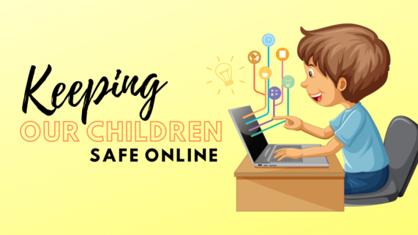
According to Lake (2017) the internet is a tool that will always be used as it is now an irreversible part of our lives and children and young people are helping to shape it. Unfortunately, a digital world can also harbour the worst of human nature and pose risks to children and young people which is why it is important they are protected so they can safely achieve opportunities and access the best benefits of a digital world.
(Anspired, 2024)
Before we start, we'll lighten the mood..
Q - Why do programmers prefer dark mode?
A - The light attracts bugs!

Negatives
Now, let's move to the darker side of the digital world.
Whilst, we have discovered how helpful the use of
technology can be for children and young people, we
will discuss the potential risks and harmful factors that
include;
- lower attention span
- increased risk and lack of privacy
- possibility of depression
- obesity
- struggles with school work
- cyber-bullying
- issues with social interaction
(WGU, 2019)

How do adults minimise the risks?
To protect children and young people from risks and harms online, adults (parents, carers, teachers, any other role models) should teach children about online safety, acceptable behaviour and educate them on digital literacy so they are able to develop critical thinking skills, model responsible behaviour and set boundaries such as screen time, appropriate websites. Parents/carers may also set up devices with parental controls to allow inappropriate content to be restricted as well as using monitoring apps to keep an eye on what they are doing online. "The role of schools is important in teaching critical digital literacy to students, as well as in guiding and informing parents regarding children’s internet use at home" (UKCCIS, 2017)
(Anspired, 2024)
Government, educators and parents all contribute to children's use and knowledge of the digital world.
The aim of Welsh Government (2023) is to protect children and young people from content on the internet that is illegal, harmful and false. A part of this is teaching children and young people digital resilience, which allows them to;
- spot risks online
- use reliable sources and use critical thinking to notice misinformation
- look for help when they need it
- learn from their experiences and bounce back if things go wrong
- thrive and benefit from opportunities the internet can offer

Theory into practise
According to WGU (2021) Theory of Connectivism (2005) suggests as technology plays a huge part of learning, children and young people should make connections to share their thoughts, theories and information in a useful way. Learning can happen through web browsers, social media, blogs or databases and can promote collaboration and discussions to each other online. In School A, children are shown how to find information and to ensure it is reliable are directed to Britannica Education before attempting to find their own information online which will be shared with their peers. "The information in Britannica School is aligned to the curriculum, updated daily and hosts thousands of educational articles as well as images, videos, eBooks and academic journals" (Welsh Government, no date) However, as Connectivism Theory is based on collaboration, pupil engagement is important to achieve best results.
Rundown
Children and young people living in this digital world with a vast array of technology and information from the internet can find themselves vulnerable to harm if they are not taught the dangers to watch out for. This blog touched upon these but was there not a word count, would have been in more depth. Nevertheless, in this ever growing digital age children and young people can really thrive and succeed. The Well-Being of Future Generations (Wales) Act 2015 says it is crucial children and young people can use technology in a responsible manner to develop a culture where mental and physical health is not negatively affected by the internet.

Reference List
Anspired (2024) Keeping children safe online. [Image]. Available at: Keeping Our Children Safe Online. – anspired (Accessed 4th January 2024).
Lake, A (2017) Children in a digital world. Available at: file (unicef.org) (Accessed 4th January 2024).
Lengsfeld, J (2019) Digital era framework. Available at: digital-era-framework-en.pdf (joernlengsfeld.com) (Accessed 4th January 2023).
Limm, R (2024) Lets dive in. [Image]. Available at: Lets Dive In by Rich Lim on Dribbble (Accessed 2nd January 2024).
The Lancet (2018) Growing up in a digital world. Available at: Growing up in a digital world: benefits and risks - The Lancet Child & Adolescent Health (Accessed 3rd January 2024).
UKCCIS (2017) Children's online activities, risks and safety. Available at: Literature_Review_Final_October_2017.pdf (publishing.service.gov.uk) (Accessed 4th January 2024).
Unicef (2017) Children in a digital world. Available at: file (unicef.org) (Accessed 2nd January 2024).
Virk, S (2023) Connecting in the digital age. Available at: Connecting in the Digital Age: Navigating Technology and social media – Visual Life (uw.edu) (Accessed 2nd January 2024).
Welsh Government (No date) Britannica Education. Available at: Britannica Education - Hwb (gov.wales) (Accessed 7th January 2024).
Welsh Government (2023) Enhancing digital resilience in education. Available at: Enhancing digital resilience in education: An action plan to protect children and young people online - Hwb (gov.wales) (Accessed 4th January 2024).
Welsh Government (2015) Well-being of future generations (Wales) act. Available at: Well-being of Future Generations (Wales) Act 2015: the essentials | GOV.WALES (Accessed 4th January 2024).
WGU (2019) Impact of technology on kids today and tomorrow. Available at: Impact of Technology on Kids Today and Tomorrow. (wgu.edu) (Accessed 4th January 2024).
WGU (2021) Connectivism learning theory. Available at: Connectivism Learning Theory (wgu.edu) (Accessed 4th January 2024).

What I do
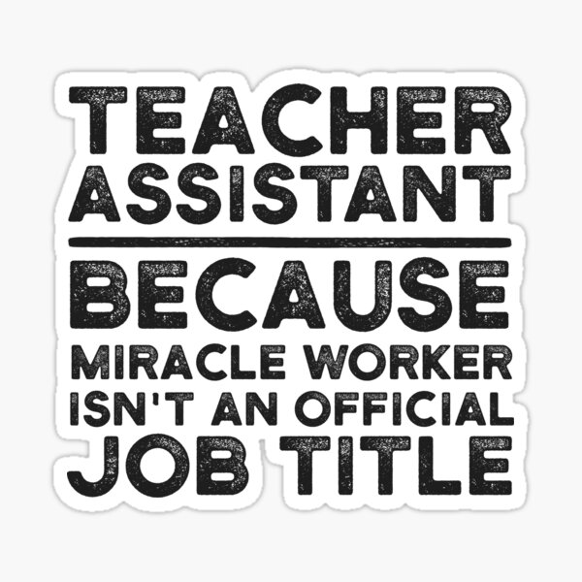
I am a teaching assistant and as I am sure you are aware, there is almost nothing off-limits when it comes to my duties and responsibilities. A teaching assistant to a teacher is like Robin to Batman! Generally, duties involve supporting the teacher and pupils in various tasks including classroom management, maintaining a positive learning environment, prepare resources, working with children one to one or in groups, provide plasters and so much more.. Since Covid-19 finally allowed the world to return to a somewhat normal stance, my role doesn't include a lot of distance blended learning anymore. I do, however, support the class with digital learning and face-to-face learning daily.
(Redbubble, 2017).

What's so good about digital learning?
The use of digital learning is definitely on the up. During Covid-19 the internet enabled family and friends to stay in contact and was able to facilitate a digital classroom where teachers and teaching assistants could still check in and teach pupils virtually. According to Walters (2022) learning has changed considerably in recent years and new technology is being used to improve it. Digital learning can boost children's engagement and interest in learning by allowing exciting opportunities and giving them more choice.
Some of the benefits of digital learning include;
- children can learn at their own pace
- learning can be personalised to the needs of the learner
- self-directed learning
- more learner friendly than traditional learning methods
- collaborative learning
- improve digital literacy
(Montes, 2022)

There's more..

Digital learning not only provides a connection between teacher and pupil but as said by Rennie (2020) it also allows for opportunity to be able to access useful resources such as online libraries, collaborative learning and pastoral care. As every child's learning is unique it is important to recognise this and allow learners choice in their learning that suits their needs. Digital learning also enables children from all backgrounds participate in their learning.

Proof is in the pudding
I have supported children with different educational needs in the use digital learning and have first hand experienced the positive effect it can have on those with additional learning needs. An example of this is child A who is a refugee and was unable to speak English. As my drawing skills leave a little to be desired, I could do a quick Google image search to show Child A what we would be learning about. We also made use of Google Translate which although not perfect, helped us to communicate with each other more. We also used online educational resources such as Nessy and Reading Eggs to develop Child A's English language skills. Spence (2022) says with the rise in online learning, there has also been improvements and developments in digital teaching tools, online learning platforms and games. The use of these digital tools and resources not only encourage participation but may also allow better communication between the teacher and pupil which effectively can improve learner independence and motivation. After a short time in School A, Child A was developing confidence and able to communicate with teachers and peers from the language skills she had learnt through digital learning, 1-to-1 support from teachers and peers and focussed interventions. According to Near-Life (2023), Kolb's Experiential Learning Theory (1984) encompasses four stages of learning: concrete experience, reflective observation, abstract conceptualisation and active experimentation. As the learner passes through the cycle, effective learning can be observed. By allowing Child A to engage with resources that are interactive and realistic helped them make progress.
“Learning is the process whereby knowledge is created through the transformation of experience” (Kolb, 1984, p. 38).
There are barriers too...
Whilst, digital learning can be extremely beneficial for a lot of children and young people, there can also be some hindrances of this type of learning for some.
For the UK to be a world-leading digital economy that works for everyone, it is crucial that everyone has the digital skills they need to fully participate in society. Although we live in an increasingly online world, a significant part of the population remains digitally excluded (Gov.UK, 2023)
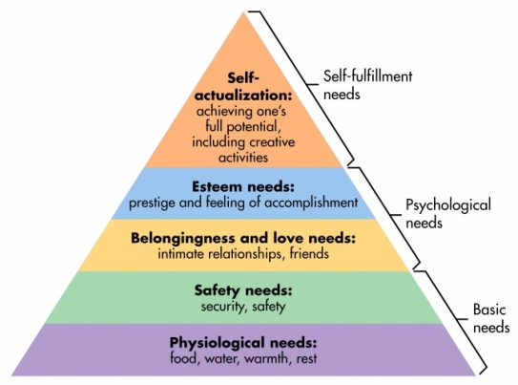
There are different factors that can cause people to be at a disadvantage in the digital world such as access to a device, lack of digital literacy skills, unreliable or no connection to the internet or little to no parental support. The United Nations Convention on the Rights of the Child (UNCRC) states every child has the right to education, culture, information and to be heard, yet, according to Unicef (2021) in the UK and an ever growing digital world, equal opportunities are not being given, potentially denying some children their rights. The children seeming to be most at risk of digital exclusion are those living in poverty, in deprived areas or those living rurally with connectivity difficulties. If the gap in digital exclusion is not addressed, it is likely those excluded will continue to be at a disadvantage through school and work life. Maslow's Hierarchy of Needs (1943) consists of five human needs starting with the basic physiological needs then psychological and finally personal growth. Children who are digitally excluded, particularly due to poverty, may face challenges fulfilling basic needs by having no access to a device or internet, which can also lead to self-esteem and belongingness needs not being met through social and educational exclusion and will be unlikely to reach self-actualization as they can miss opportunities of participation and skill development.
(Mcleod, 2023)

Let's round up
Digital learning can be a very helpful tool for teachers and pupils if all can access it effectively. Unfortunately, although the digital world is constantly evolving, not everyone has a fair chance to keep up if they face barriers accessing it. There is a lot more to explore but once again, the word count got me.

Reference List
Kolb, D. A. (1984). Experiential learning: Experience as the source of learning and development. Englewood Cliffs, NJ: Prentice-Hall.
Gov.UK (2023) Digital skills and inclusion. Available at: 2. Digital skills and inclusion - giving everyone access to the digital skills they need - GOV.UK (www.gov.uk) (Accessed 6th January 2024).
Mcleod, S (2023) Maslow's hierarchy of needs. [Image]. Available at: Maslow's Hierarchy of Needs (simplypsychology.org) (Accessed 6th January 2024).
Montes, E (2022) The advantages of digital education. Available at: The Advantages of Digital Education | D2L Europe (Accessed 5h January 2024).
Near-Life (2023) Experiential learning in a digital world. Available at: Experiential Learning in a Digital World | Near-Life™ (Accessed 6th January 2024).
RedBubble (2017) Teacher assistant because miracle worker isn't an official job title. [Image]. Available at: "Teacher Assistant Because Miracle Worker Isn't An Official Job Title" Sticker for Sale by UneDesigns | Redbubble (Accessed 5th January 2024).
Rennie, F (2020) Digital learning: The key concepts. New York: Routledge.
Spence, C (2022) The 7 best digital teaching tools for your ESL class. Available at: The 7 Best Digital Teaching Tools for your ESL Class - Cambridge English (Accessed 6th January 2024).
Unicef (2021) Closing the digital divide for good. Available at: Closing-the-Digital-Divide-for-Good_FINAL.pdf (unicef.org.uk) (Accessed 6th January 2024).
Walters, H (2022) Digital learning: The top 10 benefits. Available at: Digital Learning: The Top 10 Benefits - eLearning Industry (Accessed 5th January 2024).


(Weebly, 2022)

Welcome to a new(ish) way o f classroom learning
The most used digital tool I work with in my role is Google Classroom. All teachers and learners have access to this through Hwb website. It allows digital learning in the classroom and encourages collaboration between learners. It allows teachers to create their own learning content with the ability to personalise, manage the tasks and measure pupil progress. Google Classroom was created by Google to be used for educational purposes. Google (No date) says it has a lot of great features including;
- ability to customise class work for each learner
- accessible and inclusive learning
- prepare learners for the future by providing time management skills
- promote collaboration and connectivity between learners
- time saving marking, feedback and instruction tools for teachers
Teachers can share resources with learners, present presentations, set assignments, have learner's work submitted and if upgraded to the premium version, even more. It's worth noting though the free version works perfectly well. According to Edwards (2022) Google Classroom was designed as a way to reduce work on paper and in books and make digital learning possible. It was originally set for use with devices like Chromebooks in schools but works across a range of other devices now too which makes it more accessible for everyone. Teachers are able to create their virtual classroom which the learners then join and are able to interact on the classroom stream and leave comments (unless the teacher decides to disable this feature). There is the option to work across Google Docs, Slides, Sheets, Sites, Earth, Calendar and Gmail so the teacher can select the appropriate tool for the assignment they have set.
Anyone and everyone
Google Classroom is suitable for all learners with the appropriate instruction and support. It has many features that can enhance the learning especially for those with additional learning needs. Child A has a diagnosis of Autism Spectrum Disorder (ASD) and Global Developmental Delay (GDD) and requires adult support to complete tasks. Writing is particularly challenging for Child A and reading can sometimes be a little tricky.
Child A said no!
I introduced the idea of Google Classroom to Child A at the beginning of the new school year and as I anticipated, there were some reservations and a lot of questions due to the proposed idea of changing the way we will be learning and completing work. Child A also had an almost phobia of working digitally, which I think could be due to struggle with digital literacy. Before beginning any learning on Google Classroom, I worked with Child A to develop more of a growth mindset by praise, encouragement and modelling. I did this by telling Child A I was nervous about Google Classroom too but was excited to try a new way of learning, remaining positive about the difference it will make and explaining mistakes are helpful for our learning. Dweck's Mindset Theory (2019) refers to the beliefs and opinions individuals hold upon themselves and the theory is based upon two contrasting mindsets;
- Growth - willingness to work harder with patience and resilience to be more successful
- Fixed - feel like they are unable to learn anything new and there is no point trying as they will fail anyway
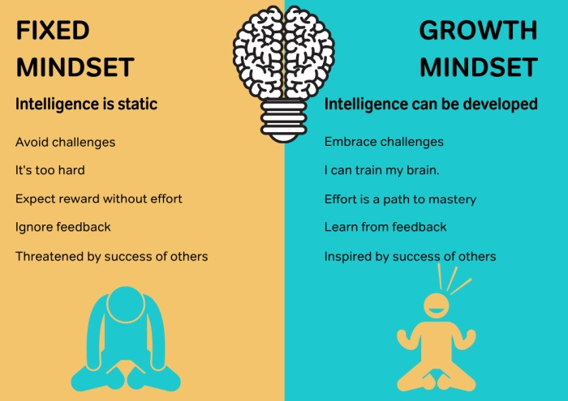
(Staake, 2023).

What Child A did next...
The day had come for Child A to begin the virtual learning adventure. I first showed Child A features that are available to support the learning which would allow more independent work and more peer work without an adult continually breaking down instructions for Child A. By using a Chromebook and Google Classroom, Child A was able to make use of accessibility tools that could really promote more independent learning such as screen reader and voice typing instead of using the keyboard which a lot of learners with additional learning needs may struggle with.
"Pre-COVID-19, half of the world’s children were already unable to read a simple text by the age of 10" (Unicef, 2021)
Almost three years on from Covid-19, schools are still seeing reading levels lower than average. However, accessibility tools such as screen reader can make a drastic impact on building independent learning as they are less reliant on a teacher or classmate to help with understanding. According to Mcleod (2023) Constructivism learning theory highlights the proactive role of learners in building their own understanding. It enables them to reflect on their experiences from mental representations and integrate new knowledge into their existing schemas. Knowledge is socially constructed suggesting learners acquire understanding through social interactions and shared learning. The use of Google Classroom allowed Child A to actively participate in their own learning and collaborative projects with others.
"Learning is a social activity – it is something we do together, in interaction with each other, rather than an abstract concept" (Dewey, 1938)
Is it all good?
I think we have discovered how useful platform like Google Classroom can be when integrated into a supported learning environment. Nevertheless, unless it is well planned and organised there could be some hiccups. Layne (No date) says These could include:
- lack of internet connectivity or devices to access
- technical glitches
- possibility of learners becoming distracted
- too much reliance on technology
- learning new skills for both teachers and pupils
To wrap up
The use of Google Classroom can be very beneficial to learning but how effective it can be depends on the resources the school has available such as enough devices, strong internet connection, training for staff and teaching children new skills. Whilst, Google Classroom has certainly taken some pressure off me in my role and I do enjoy supporting digital learning, I do still favour more traditional learning and find supporting a group is often easier without screens in faces.

Reference List
Dewey, J. (1938) Experience and Education. New York: Collier Books.
Edwards, L (2022) What is Google Classroom? Available at: What is Google Classroom? | Tech & Learning (techlearning.com) (Accessed 6th January 2024).
Google (No date) Classroom management tools & resources. Available at: Classroom Management Tools & Resources - Google for Education (Accessed 6th January 2024).
Layne, J (No date) 20 pros and cons of Google Classroom. Available at: 20 Pros and Cons of Google Classroom | Ablison (Accessed 7th January 2024).
Mcleod, S (2023) Constructivism learning theory & philosophy of education. Available at: Constructivism Learning Theory & Philosophy of Education (simplypsychology.org) (Accessed 7th January 2024).
Psychology Today (2024) Growth Mindset. Available at: Growth Mindset | Psychology Today (Accessed 7th January 2024).
Staake, J (2023) Growth mindset vs. fixed mindset. [Image]. Available at: Growth Mindset vs. Fixed Mindset: A Practical Guide for Teachers (weareteachers.com) (Accesed 7th January 2024).
Unicef (2021) Digital learning for every child. Available at: Digital Learning for Every Child.pdf (unicef.org) (Accessed 7th January 2024).
Weebly (2022) Google Classroom app. [Image]. Available at: Google classroom app - paghq (weebly.com) (Accessed 7th January 2024).

