

Master of Business Administration

Student Name: Md Kausar Hosen
Student ID: 2406152

Module Name: International Marketing: Principles and Practices

Module Code: LCMB7026

Lecturer’s Name: Tushara Balendran

Word Count: 5,000 words (± 10%)

Term 2

Table of Contents

1.Introduction 3
2.Company Background 3
2.1 Situational Analysis 4
A. PESTLE Analysis 5
2.2 Marketing Strategy 17
A. Segmentation, Targeting, and Positioning (STP) 17
B. 7Ps Marketing Mix 24
3. Recommendations 38
3.1 Recommendations – USA 38
3.2 Recommendations – Japan 38
4. Conclusion 39
References 41

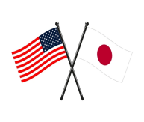
STARBUCKS
USA vs Japan

1.Introduction
This report presents a comparative analysis of Starbucks’ international marketing strategies in the United States and Japan. As the company’s country of origin, the U.S. serves as the foundation of Starbucks’ core branding, digital innovation, and product development practices, while Japan has become one of its most successful international markets, widely recognised for strong cultural adaptation, a premium brand image, and distinctive seasonal product customisation. The study applies key international marketing frameworks—including PESTLE analysis, Hofstede’s Cultural Dimensions, Segmentation–Targeting–Positioning (STP), and the 7Ps Marketing Mix—to explore strategic similarities and differences across both countries, with particular focus on product adaptation, pricing approaches, customer experience design, technology adoption, and overall branding effectiveness. In addition, the report evaluates the performance of Starbucks’ strategies using indicators such as store expansion, revenue trends, market share, and consumer engagement to provide a critical understanding of how Starbucks leverages international marketing to sustain competitiveness within the U.S. and Japanese markets.

2.Company Background
Starbucks Corporation is a multinational coffeehouse and roastery chain headquartered in Seattle, Washington, United States. Established in 1971 by Jerry Baldwin, Zev Siegl, and Gordon Bowker, Starbucks began as a single store selling high-quality coffee beans and equipment. However, under the leadership of Howard Schultz in the 1980s, the company transitioned into a coffeehouse model inspired by Italian espresso bars, emphasizing community, comfort, and premium coffee experiences (Schultz & Yang, 2011).
Today, Starbucks is the world’s largest specialty coffee retailer, offering a diverse range of products including coffee beverages, teas, pastries, and branded merchandise. As of 2024, the company reported annual revenues exceeding USD 36 billion, with the United States accounting for approximately 70% of its global revenue (Starbucks Annual Report, 2024).
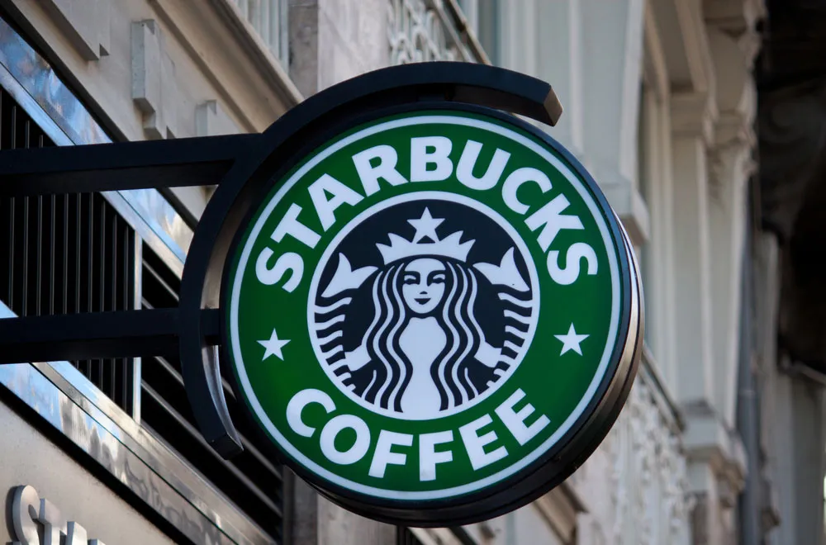
Source: (https://tinyurl.com/dh9w5r59)

2.1 Situational Analysis
Understanding the macro- and micro-environmental factors that influence Starbucks’ strategic decisions is essential for assessing its international marketing effectiveness in different markets. This section uses the PESTLE framework to analyse Starbucks’ external business environment in the United States (home market) and Japan (key international market). These factors reveal the driving forces for change, potential threats, and opportunities that influence Starbucks’ global marketing strategy.

A. PESTLE Analysis
The PESTLE framework examines Political, Economic, Social, Technological, Legal, and Environmental factors that influence a company’s external environment (Kotler & Keller, 2022). This comparative assessment evaluates how these factors affect Starbucks’ international operations in the USA and Japan, highlighting opportunities and challenges that shape the company’s marketing strategies.
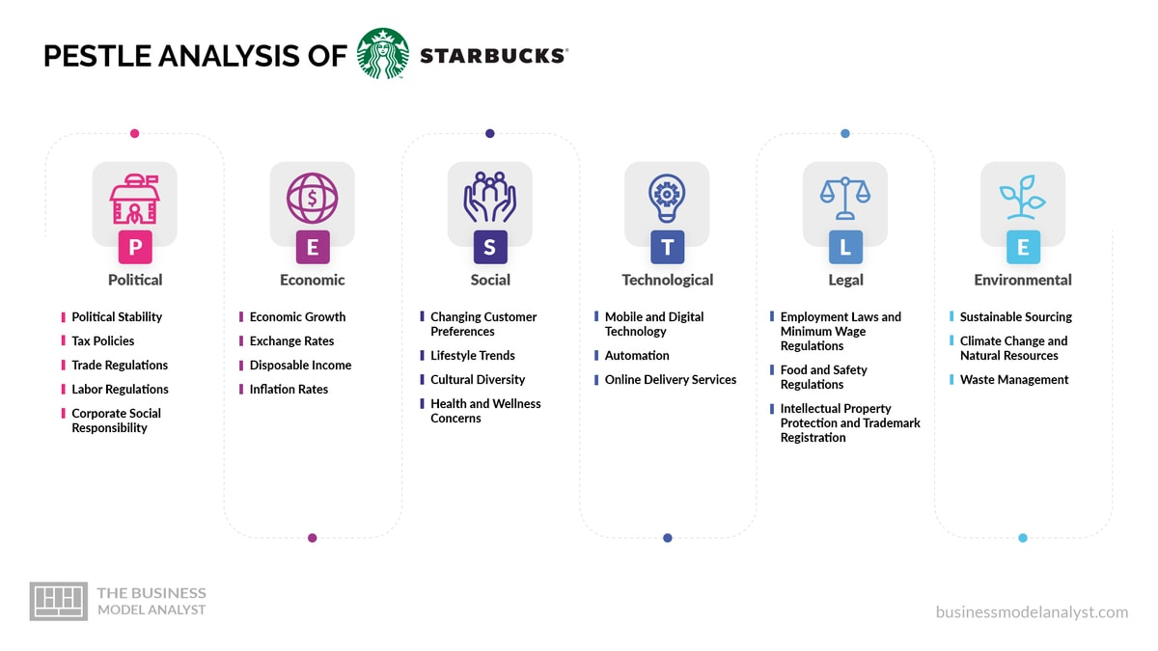
Source: From (https://tinyurl.com/5cy6bjxt)

Political Factors
USA(Favourable):
The United States offers a politically stable environment with a well-defined legal and regulatory system that supports business innovation and fair competition. Government initiatives promoting sustainability, small business support, and digital innovation align with Starbucks’ long-term strategy. However, the brand faces challenges from unionization efforts and labour activism, as employees push for higher wages and better benefits (CNBC, 2024). Despite this, the U.S. political climate remains supportive of business growth, allowing Starbucks to expand domestically through technology-driven customer experiences.
Japan ( Highly Favourable):
Japan enjoys a stable political environment and maintains strong trade relations with the United States, enabling efficient importation of coffee beans and raw materials. The government’s policies promoting work-life balance and urban lifestyle development indirectly benefit Starbucks by increasing demand for social and leisure spaces such as cafés. Moreover, Japan’s focus on foreign direct investment (FDI) and low corruption risk enhances Starbucks’ operational predictability and market stability (JETRO, 2024).
Comparison Insight:
Both countries provide political stability, but Japan offers a more predictable and less politically contentious business environment, while U.S. operations face occasional labour and regulatory challenges.

Economic Factors
1. GDP :
USA:
USA has the world’s largest GDP ($28.7 trillion in 2024), which reflects extremely high consumer spending power (World Bank, 2024). This provides Starbucks with a strong premium demand base and drives continuous product innovation.
Japan:
Japan’s GDP is approx. $4.9 trillion in 2024, making it the world’s 4th largest economy (World Bank, 2024). Japanese consumers also possess strong buying capacity, but spending behaviour is more value cautious than the U.S.

2. GNP :
USA:
The United States has a significantly high Gross National Product (GNP), reflecting strong national income from both domestic and international sources. This economic strength enables Starbucks to benefit from high brand loyalty and sustained demand for premium beverage consumption in its home market (World Bank, 2024).
Japan:
Japan maintains a high Gross National Product (GNP) driven by its strong export sectors, including technology, robotics, and automotive industries. This solid national income base supports Starbucks’ stable market performance in Japan, although overall growth remains moderate due to market maturity (World Bank, 2024).
3. Inflation:
USA :
The United States has experienced volatile inflation rates in recent years, fluctuating between 3.2% and 7% post-pandemic, which has increased Starbucks’ operational costs in labour, raw materials, and logistics. As a result, Starbucks adopts premium pricing and value-bundle strategies to maintain profitability while addressing changing consumer price sensitivity (Statista, 2024).
Japan :
Japan continues to maintain low inflation and occasional deflationary conditions, which help stabilise consumer prices but limit price adjustment opportunities for businesses. Consequently, Starbucks in Japan focuses less on frequent price-based promotions and more on long-term brand experience, product quality, and cultural engagement to retain customer loyalty (OECD, 2024).
4. Economic Stability:
USA :
The U.S. economy is technologically advanced and innovation-driven, ensuring long-term macroeconomic stability. However, periodic fluctuations in inflation and monetary policies pose short-term risks. Starbucks manages these challenges through its strong digital ecosystem, including mobile ordering, data analytics, and loyalty programs, which enhance operational efficiency (World Bank, 2024).

Japan:
Japan exhibits high macroeconomic stability, characterised by predictable consumer spending, low crime, and minimal economic fluctuation. This stable environment enables Starbucks to invest confidently in store ambience, premium retail designs, and seasonal limited-edition beverages that appeal to the country’s culturally sensitive consumers (OECD, 2024).

Economic Comparison
USA (Favourable):
The U.S. economy is highly developed with strong purchasing power and a large middle-class base, allowing Starbucks to position itself as an affordable luxury brand. The brand capitalises on convenience culture through mobile ordering, digital payments, and loyalty rewards. However, inflationary pressures have slightly reduced profit margins in 2024, leading Starbucks to increase automation and adopt value-based promotional strategies (Statista, 2024).

Japan ( Moderately Favourable):
Japan, the world’s third-largest economy, benefits from a strong yen and low inflation, enabling Starbucks to maintain stable pricing and consistent demand. While long-term growth is limited by economic stagnation and an ageing population, Starbucks continues to thrive as a modern, aspirational brand among young professionals and urban consumers, ensuring sustained profitability (OECD, 2024).
Comparison Insight
While the U.S. market offers scalability and income-driven growth due to its size and innovation, Japan’s mature and experience-oriented market ensures consistent brand loyalty and steady returns. Starbucks successfully adapts its strategies to balance innovation-led growth in the U.S. with cultural and experiential depth in Japan.

Social Factors

USA (Favourable):
The American market values individualism, convenience, and personalization, which align with Starbucks’ brand promise. Consumers appreciate the company’s commitment to diversity, inclusivity, and ethical sourcing. Health-conscious trends have also led Starbucks to introduce plant-based milk alternatives and lower-calorie options. Starbucks’ emphasis on a “third place” for community connection resonates strongly with American urban culture (Hofstede Insights, 2024).
Japan (Highly Favourable):
Japan’s collectivist and tradition-oriented society values harmony, respect, and aesthetics. Starbucks has integrated deeply into this culture by offering seasonal beverages (e.g., Sakura Latte), culturally themed stores, and tranquil environments for relaxation. In Japan, coffee drinking is viewed as an emotional and aesthetic experience, not merely a caffeine habit (Kawamura, 2023). Starbucks Japan’s localization strategy—respecting traditions while promoting modern lifestyles—has been pivotal to its brand success.

Comparison Insight
Both countries demonstrate strong social acceptance of Starbucks. However, the U.S. market drives innovation through personalization, while Japan emphasizes cultural immersion and emotional experience.

Cultural factors
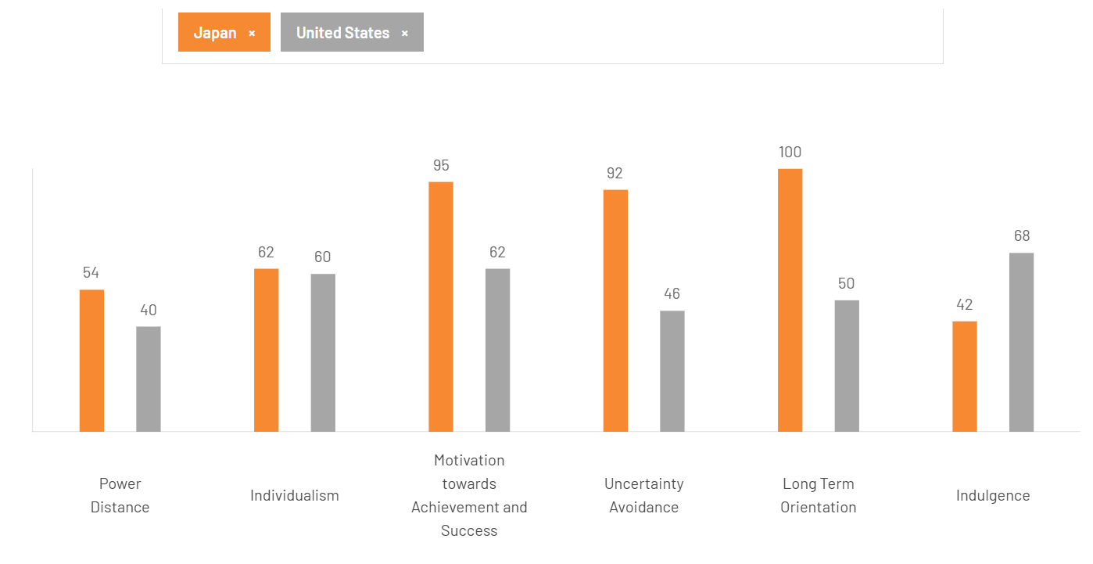
Source: https://tinyurl.com/3ku9wdpa

According to Hofstede’s national culture model, which includes six dimensions — Power Distance, Individualism, Masculinity, Uncertainty Avoidance, Long-Term Orientation, and Indulgence — Starbucks can adapt its international strategy to different cultural contexts (Hofstede Insights, 2024).
In terms of Power Distance (40 for the USA, 54 for Japan), Japan has a higher acceptance of hierarchical structures and authority. Therefore, in Japan, Starbucks emphasizes respectful, polite service and structured communication in stores, while in the USA, a culture of equality promotes casual interactions between customers and employees. American Starbucks stores encourage open dialogue and friendliness, reflecting the nation’s low power distance.
The Individualism score is notably higher in the USA (91) than in Japan (46). This suggests that American consumers value personal choice, customization, and independence. Starbucks caters to this by offering an extensive range of customizable drink options and promoting individual expression through its “personal cup” and name-on-cup experience. Conversely, in Japan’s more collectivist culture, Starbucks focuses on creating social harmony and shared experiences, offering relaxing environments where groups can connect and unwind peacefully.
Masculinity scores are high in both countries (USA: 62, Japan: 95), meaning success-oriented marketing works effectively in each. However, Japan’s extremely high masculinity score indicates an even greater emphasis on quality, perfection, and achievement. Starbucks Japan therefore highlights its premium craftsmanship, aesthetic presentation, and exclusive “Starbucks Reserve” experiences, while in the USA, the brand emphasizes achievement and self-reward, such as premium beverages marketed as lifestyle upgrades.
Uncertainty Avoidance measures comfort with ambiguity. The USA scores 46, showing openness to experimentation and new trends, while Japan scores 92, indicating a preference for stability and predictability. Accordingly, Starbucks frequently launches new and innovative drinks in the USA (e.g., plant-based cold brews), while in Japan, it maintains consistent quality standards and releases seasonal limited editions like the Sakura Latte to balance innovation with familiarity.
Regarding Long-Term Orientation, Japan’s score (88) far exceeds that of the USA (26). Japanese culture emphasizes perseverance, tradition, and sustainable relationships. Starbucks Japan integrates this through sustainability efforts, long-term supplier partnerships, and eco-friendly store designs. In contrast, the USA’s short-term orientation reflects a fast-paced, promotion-driven market, with Starbucks focusing on immediate gratification through new menu items and loyalty rewards.
Finally, Indulgence differs significantly between the two. The USA scores 68, showing a culture that embraces enjoyment, variety, and self-expression, while Japan’s score of 42 reflects restraint and balance. In the USA, Starbucks’ campaigns such as “Treat Yourself” and dessert-inspired Frappuccinos appeal to indulgence, whereas in Japan, the brand markets refined elegance and aesthetic satisfaction, offering subtle luxury experiences.
United States – Mostly Favourable Cultural Fit
Culture in the USA is highly favourable for Starbucks. The American culture strongly supports Individualism (91) and Indulgence (68), which aligns with Starbucks’ core brand positioning — personal choice, lifestyle consumption, and premium self-reward. Consumers enjoy frequent beverage customization, seasonal limited offers (e.g., Pumpkin Spice Latte), and trendy flavours. Low Uncertainty Avoidance (46) also helps Starbucks experiment with new products and marketing campaigns frequently without major risk. However, the short-term orientation of the US market makes brand loyalty more volatile and requires Starbucks to continuously innovate to maintain excitement and consumer retention — which increases marketing cost.
Japan – Favourable but with Certain Cultural Restrictions
Japan’s cultural environment is favourable for Starbucks but more demanding in terms of execution. High Long-Term Orientation (88) and high Masculinity (95) support Japan’s appreciation for premium quality, craftsmanship, detail, and aesthetic experience — values that match Starbucks’ global premium positioning. Starbucks can build deeper long-term emotional relationships and sustainable brand loyalty in Japan. However, extremely high Uncertainty Avoidance (92) means rapid radical innovation can create consumer resistance. Starbucks must introduce new concepts gradually, in alignment with cultural norms, traditions, and seasonal symbolism (e.g., Sakura Latte). Therefore, Japan is favourable for premium stable brand growth, but not favourable for overly disruptive product launches.

Advantages of the Hofstede Model
The Hofstede model provides a structured and systematic framework to compare cultural values between countries, which helps multinational organisations like Starbucks understand consumer behaviour differences more accurately (Hofstede Insights, 2024). It supports better decision-making in international marketing strategies because companies can align product design, communication style, and service experience with national cultural expectations. Additionally, the model is easy to interpret and widely used in academic research, making it a reliable starting point for international market comparisons. Furthermore, it allows businesses to identify which cultural dimensions can create opportunities or risks when entering new markets — such as individualism supporting product customization or uncertainty avoidance affecting the speed of innovation.
Disadvantages of the Hofstede Model
Hofstede’s cultural model has several limitations that affect its accuracy and applicability in modern international marketing. First, the data was originally collected from IBM employees in the 1970s, meaning the findings may not fully represent contemporary, globalised societies or evolving cultural behaviours (Hofstede Insights, 2024). The model also tends to generalise entire national populations, overlooking subcultures, regional differences, and individual personality variations that exist within each country. Additionally, culture is dynamic and constantly changing, yet Hofstede’s scores remain static and may not capture current generational shifts, such as the rise of digital culture, global youth identity, or multicultural integration. The framework also focuses mainly on national culture and does not account for micro-cultural influences such as lifestyle groups, online communities, or urban versus rural differences—factors that significantly shape consumer behaviour in markets like Starbucks. As a result, the model is useful for providing broad cultural comparisons but should be applied carefully and supplemented with modern, context-specific insights.

Technological Factors
USA (Highly Favourable):
As a global technology leader, the U.S. offers Starbucks advanced opportunities in AI-driven personalization, mobile payments, and digital loyalty programs. The Starbucks Rewards App has become a model of digital marketing success, with over 34 million active users contributing to higher retention and purchase frequency (Starbucks Annual Report, 2024). The integration of machine learning in supply chain management enhances efficiency and forecasting accuracy.
Japan (Favourable):
Japan’s highly tech-savvy population rapidly embraces digital innovations, making it an ideal environment for Starbucks’ technology-driven marketing and operations. However, cultural preferences in Japan favour aesthetic and experiential digital engagement over purely functional features. As a result, Starbucks Japan focuses on visually appealing and emotionally resonant digital campaigns, such as augmented reality (AR)-based seasonal promotions that align with local traditions and events. Additionally, the company integrates cashless payment systems like Suica and PayPay, catering to Japan’s widespread use of mobile and contactless payments while enhancing overall convenience and customer satisfaction (Statista, 2024).
Comparison Insight:
Both countries show high technological adaptability. The U.S. drives innovation, while Japan perfects user experience and digital artistry.

Legal Factors
USA (Moderately Favourable):
Starbucks must comply with complex labour, tax, and data privacy laws, as well as FDA food regulations. Increasing scrutiny from unionization movements has led to higher compliance costs and reputational risks (Reuters, 2024). Nevertheless, strong intellectual property protection safeguards Starbucks’ brand equity.
Japan (Favourable):
Japan’s legal system is highly transparent and consistent, supported by strong consumer protection and labour welfare regulations. Although food safety and hygiene laws are stringent, Starbucks’ strict compliance with these standards reinforces its reputation for premium quality and trustworthiness. Moreover, Japan’s strong emphasis on ethical business practices, corporate responsibility, and sustainability aligns closely with Starbucks’ global values of fairness, integrity, and environmental stewardship (OECD, 2024).
Comparison Insight:
Legal compliance in both countries enhances Starbucks’ reliability, but Japan’s legal environment is more predictable and less contentious.

Environmental Factors
USA (Favourable):
Environmental sustainability is central to Starbucks’ corporate strategy. The brand promotes recyclable packaging, waste reduction, and renewable energy use in U.S. stores. Starbucks aims to become a carbon-neutral company by 2030. However, U.S. consumers increasingly demand faster progress on environmental transparency (Starbucks CSR Report, 2024).
Japan (Highly Favourable):
Japanese consumers are highly eco-conscious and value minimalist, nature-aligned lifestyles. In response, Starbucks Japan integrates sustainability into its store design and daily operations through the use of wooden interiors, reusable tumblers, energy-efficient layouts, and zero-waste store concepts. Flagship eco-stores in Kyoto and Fukuoka have become global benchmarks for environmental design within Starbucks’ international portfolio, reflecting Japan’s cultural emphasis on harmony with nature and responsible consumption (Starbucks Japan, 2024).
Comparison Insight:
Both markets emphasize sustainability, but Japan approaches it through cultural aesthetics and minimalism, while the U.S. prioritizes measurable corporate responsibility.
Similarities and Differences in PESTLE Factors Between Starbucks in the USA and Japan
Similarities:
Both the USA and Japan offer politically stable business environments with reliable regulatory systems, which benefits Starbucks in maintaining long-term global expansion. Economically, both markets have high-income consumer groups, which supports the premium pricing strategy Starbucks applies in each country. Socially, both countries have strong café cultures where coffee consumption is not only a beverage habit but is associated with lifestyle identity and daily routine — which aligns with Starbucks’ “third place” positioning. Technologically, Starbucks in both countries benefits from digitally advanced consumer behaviour, enabling efficient use of mobile app ordering, rewards programs, and digital payment systems.
Differences:
However, the PESTLE influence varies strongly in scale and direction. Economically, the USA is Starbucks’ home market with the largest revenue share worldwide, while Japan remains a premium niche international market with slower economic growth but higher product refinement expectations. Socially, the USA culture supports individualism and personal expression, allowing Starbucks to introduce highly customizable drinks, whereas Japan culture values harmony and tradition, requiring Starbucks to adapt menu offerings to cultural seasonality such as Sakura-themed products. Technological adoption is also different: the USA drives major global digital innovations (e.g., Starbucks Rewards App) and Japan perfects user-experience aesthetic technologies (e.g., clean smart cafés, automated efficiency). Environmentally, the USA faces higher sustainability criticism due to large market scale and waste volume, while Japan focuses more on subtle aesthetic sustainability and packaging refinement expectation. Legally, US labour and food standards vary by state, whereas Japan applies stricter uniform national compliance standards — affecting store operation structure and training.

2.2 Marketing Strategy
Starbucks is one of the world’s most recognizable global coffee brands. Considering the USA and Japan’s unique cultural, economic, and social contexts, the brand has strategically modified its marketing practices in both countries. These adaptations have been essential in maintaining Starbucks’ competitive advantage and brand equity across diverse markets. This section explores a deeper explanation of Starbucks’ Segmentation, Targeting, and Positioning (STP) strategies within the two markets.

A. Segmentation, Targeting, and Positioning (STP)

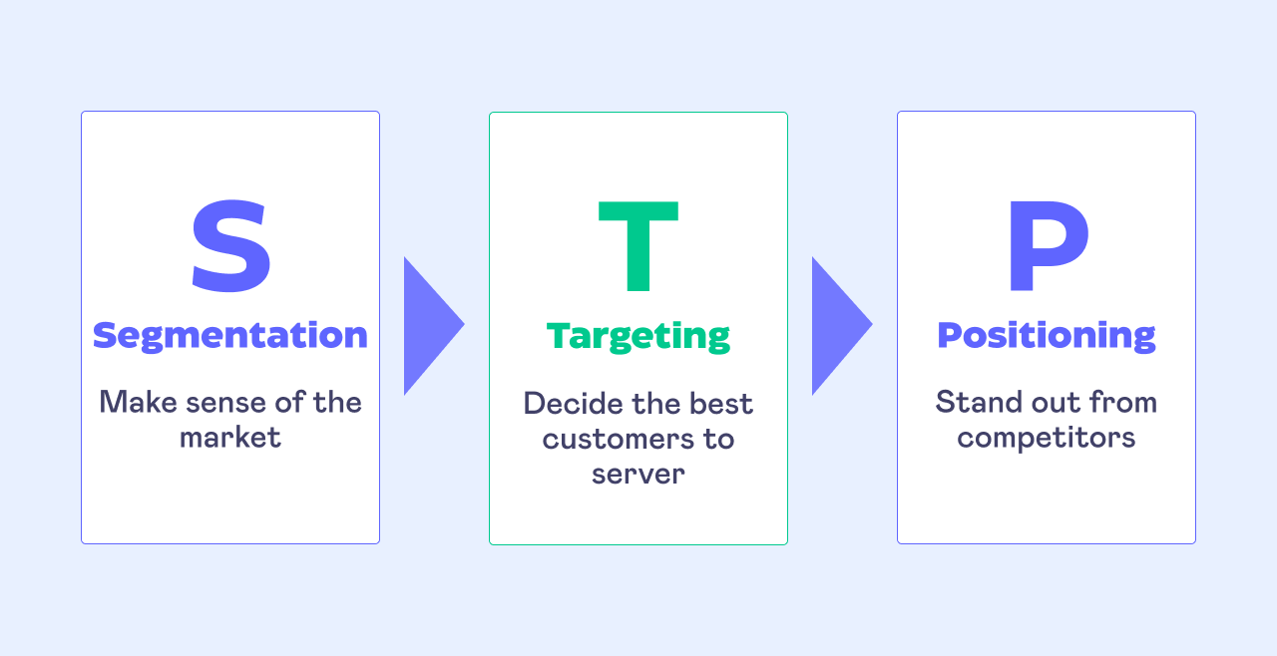 Source: https://tinyurl.com/2cs3njb9

Segmentation
Starbucks’ marketing strategy incorporates segmentation as a fundamental element to tailor its offerings to the preferences of distinct market groups. In both countries, Starbucks segments its market based on demographic, psychographic, and behavioral factors, allowing it to create personalized customer experiences.
USA :
Demographic Segmentation:
Starbucks targets young adults, students, working professionals, and middle-income to upper-middle-income consumers who regularly purchase premium beverages. These consumers are brand-conscious, convenience-driven, and value personal choice and product customization (Cateora et al., 2024).
Geographic Segmentation:
Starbucks focuses heavily on major metropolitan cities, high-traffic business districts, universities, airports, and suburban residential zones in the United States. The brand places stores strategically in locations where buying frequency is high and consumer access is convenient (Pereira, 2024).

Psychographic Segmentation (VALS-Based)
In the U.S. market, Starbucks primarily attracts VALS segments such as Innovators, Experiencers, and Achievers, who are typically socially aware, tech-savvy, and influenced by lifestyle-oriented branding. These consumers prioritise sustainability, convenience, fast service, and seamless digital integration in their daily routines. Starbucks aligns with these psychographic profiles by appealing to individuals who associate coffee consumption with personal identity, self-expression, and occasional self-indulgence. The brand’s digital ecosystem—including the Starbucks Rewards mobile app, personalised recommendations, and mobile ordering—further appeals to consumers who value efficiency, modern technology, and customisation (Schiffman & Wisenblit, 2020; Starbucks Annual Report, 2024).
Japan :
Demographic Segmentation:
Starbucks targets urban professionals, office workers, students, and middle-to-higher-income families that value premium international brands and a refined café environment (Nikkei Asia, 2024).
Geographic Segmentation:
In Japan, Starbucks strategically concentrates its store locations in dense urban business districts, major shopping areas, train station hubs, tourist destinations, and high-culture zones such as Kyoto’s historic districts. This approach allows the brand to benefit from Japan’s high population density and strong commuter culture. Starbucks also operates specialty formats such as Starbucks Reserve and regional concept stores that incorporate local cultural themes, traditional architectural elements, and seasonal design aesthetics. These culturally immersive store concepts enhance Starbucks’ premium positioning and strengthen emotional connections with Japanese consumers (Nikkei Asia, 2024; Starbucks Japan, 2024).
Psychographic Segmentation (Japan) :
In the Japanese market, consumers are psychographically segmented around values such as harmony, aesthetics, social balance, and cultural symbolism. Starbucks appeals strongly to these preferences by offering emotionally calming store environments, culturally resonant seasonal rituals such as the Sakura season, and experiences that emphasize artistic design and subtle luxury. The brand’s limited-edition seasonal beverages, region-exclusive menu items, and thoughtfully curated store aesthetics align with Japanese consumers’ desire for symbolic meaning, tradition, and refined experiences, making cultural customization a central component of Starbucks’ appeal in Japan (Smith, 2022).

Targeting
USA :
After segmenting customers by demographic and behavioural traits, Starbucks develops distinct targeting approaches that fit the socio-economic and cultural context of each market. In the United States, Starbucks applies a differentiated targeting strategy by focusing on multiple customer groups to ensure inclusivity and broad market coverage. Value-seeking customers are attracted to affordable coffee options and daily convenience through loyalty rewards and drive-thru services, while health-conscious and ethical consumers are drawn to Starbucks’ sustainability initiatives and plant-based menu choices. Premium customers are targeted through Starbucks Reserve Roasteries, which deliver luxury experiences and artisan coffee blends. This differentiated targeting strategy enables Starbucks to lead in both the mass market and premium niche by appealing to diverse customer motivations (Cateora et al., 2024).
Japan :
In Japan, Starbucks adopts a concentrated targeting strategy, focusing on a specific high-value consumer segment that associates the brand with elegance and cultural sophistication. The company primarily appeals to urban, educated consumers who seek a peaceful social environment with high aesthetic standards. Starbucks positions itself as a premium Western brand offering emotional fulfilment, cultural fusion, and serenity. Its marketing efforts are tailored through local celebrity endorsements, social media storytelling, and artistic store designs that reflect Japanese sensitivity to craftsmanship and balance (Shastri, 2025). By targeting this niche yet influential audience, Starbucks strengthens its aspirational brand image and enhances long-term customer loyalty.

Positioning
When brands position themselves, they establish a distinctive image that differentiates them from competitors. Starbucks has carefully crafted unique positioning in both the USA and Japan that reflects each market’s social values, consumer behaviors, and lifestyle aspirations.
USA :
Starbucks positions itself in its home market as a contemporary lifestyle brand built on innovation, convenience, and social responsibility. The company highlights personalisation by offering a wide range of customisable beverages through both its mobile app and in-store ordering. Starbucks further strengthens its value proposition through digital innovation—its mobile payment platform and loyalty programme create a seamless, efficient experience that aligns with the fast-paced lifestyles of American consumers. Additionally, its commitment to ethically sourced ingredients, recyclable packaging, and inclusive hiring practices reinforces its reputation as a socially responsible organisation (Pereira, 2024). Overall, Starbucks in the United States embodies the concept of affordable luxury, serving as a “third place” where customers can relax, connect, or work in an environment that reflects their individuality and lifestyle.
Japan :
In Japan, Starbucks positions itself as a premium, emotionally engaging brand that blends global sophistication with Japanese cultural values. A key cultural principle that Starbucks aligns with is “Wa” (和), which refers to harmony, balance, social unity, and peaceful coexistence—a foundational concept in Japanese society that emphasizes maintaining group harmony and avoiding conflict (Sugimoto, 2010).
Starbucks reflects Wa through calm store atmospheres, aesthetic and minimalist interior design, and polite, harmony-focused customer service. Seasonal and regionally exclusive beverages, such as the Sakura Latte, deepen cultural resonance by connecting to traditions that symbolize renewal and community. These strategies help Starbucks create tranquil, emotionally meaningful spaces within Japan’s dense urban environments, reinforcing its identity as a brand that respects and blends seamlessly with Japanese cultural expectations.

In both markets, Starbucks creates credibility as more than a coffee brand—it represents culture, community, and comfort. Convenience and quality are strong selling points in both countries, yet each market emphasizes different values. In the USA, Starbucks reflects modern innovation, personalization, and ethical leadership. In Japan, it embodies aesthetic harmony, exclusivity, and cultural respect.
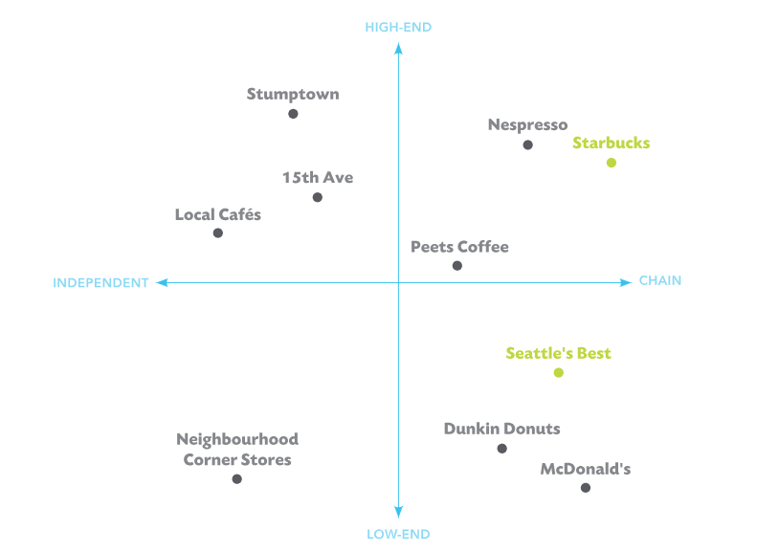
Source: https://tinyurl.com/4k2a7sap
Explanation of Starbucks USA Perceptual Positioning:
This perceptual map demonstrates that Starbucks strategically occupies the high-price and high-quality quadrant in the U.S. coffee market. Starbucks positions itself not as a basic beverage provider, but as a premium lifestyle coffee brand offering emotional value, social identity, and personalized consumption experience. Starbucks differentiates itself through specialty beverages, seasonal innovation (e.g. Pumpkin Spice Latte), ethical sourcing, store ambiance, and strong digital integration through the Starbucks Rewards App. These factors justify a higher price point, while maintaining consumer willingness to pay due to the strong brand equity and experiential value.
Competitors such as Dunkin’ and McCafé are positioned towards lower price and lower-to-mid quality, competing primarily on convenience, speed, and affordability rather than premium customer experience. Peet’s Coffee, although high quality like Starbucks, does not scale at the same brand lifestyle influence across the U.S., therefore it remains slightly lower in price and weaker in experiential influence.
Thus, this positioning reinforces Starbucks' competitive advantage in the United States: customers perceive the brand as a premium indulgence and emotionally expressive experience, rather than a commodity fast coffee purchase. Starbucks’ ability to maintain this perception is a central reason the company sustains market leadership in the U.S. specialty coffee segment.
Similarities in STP (USA & Japan)
Starbucks applies a similar global STP approach in both the USA and Japan by targeting urban, middle to higher income consumers who value premium coffee experiences, lifestyle branding and café culture. In both countries, Starbucks segments customers based on age, lifestyle, education, and behaviour, focusing on young adults, students and working professionals who frequently visit coffee shops for socialisation or work-related purposes. Starbucks also positions itself in both markets as a premium, high-quality coffee brand that creates a unique “third place” environment where consumers can relax, feel comfortable, and enjoy a socially meaningful experience beyond home and workplace. This similarity ensures that Starbucks maintains a consistent global brand identity while delivering superior product quality and emotional connection across international markets.

Differences in STP (USA vs Japan)
Although Starbucks uses the same global STP foundation, the execution of this strategy differs between the USA and Japan due to cultural consumption patterns and psychological expectations. In the USA, Starbucks focuses heavily on individualism, personal expression, innovation, and convenience, promoting high levels of beverage customisation, tech-driven ordering, seasonal trends, and lifestyle status branding. In contrast, Starbucks in Japan adapts its STP strategy to emphasise harmony, aesthetic balance, tradition, and subtle premium value, where store ambience, cultural symbolism, and seasonal limited editions such as Sakura drinks play a stronger role. Therefore, while the United States market reflects an expressive, fast-moving, trend-oriented positioning, the Japanese market reflects a refined, calm, high-quality cultural experience with emotional and artistic undertones.

B. 7Ps Marketing Mix
Starbucks’ 7Ps Marketing Mix serves as a strategic framework for delivering high-quality products, enhancing customer satisfaction, and ensuring long-term global growth. It includes Product, Price, Place, Promotion, People, Process, and Physical Evidence — each adapted to the cultural, social, and economic conditions of individual markets. The USA and Japan, though both highly developed, differ considerably in consumer behavior, cultural expectations, and value perception.
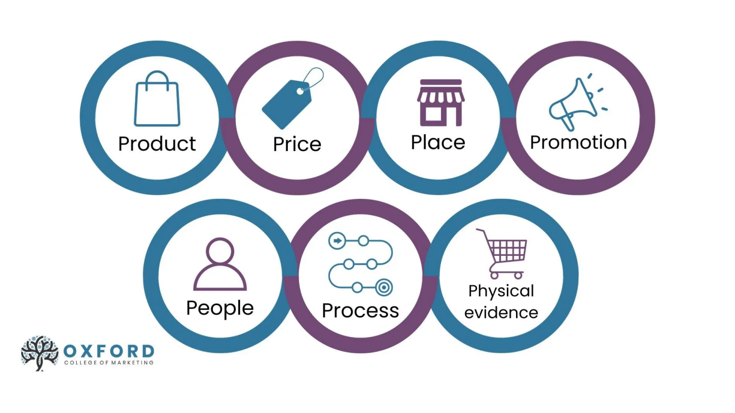 Source: https://tinyurl.com/2wte5zty

Product (depth and width)
USA – Width and Depth
Starbucks in the United States offers extensive product width, encompassing a wide variety of product categories such as hot and iced coffee, teas, Frappuccinos, refreshers, bakery items, sandwiches, whole-bean coffee, branded merchandise, and ready-to-drink bottled products. Within each product line, the company provides substantial product depth, offering numerous variations and customization options. For example, the espresso category alone includes multiple beverage types, with customizable choices for milk alternatives, syrups, flavours, toppings, temperature, and sweetness levels. Seasonal favourites like the Pumpkin Spice Latte or Sugar Cookie Almondmilk Latte further increase product depth and maintain consumer excitement. Starbucks’ U.S. product strategy continues to prioritise innovation, personalization, and health-oriented offerings, including widespread availability of plant-based milks and vegetarian food options, reflecting the evolving lifestyle and dietary preferences of American consumers (Pereira, 2024).
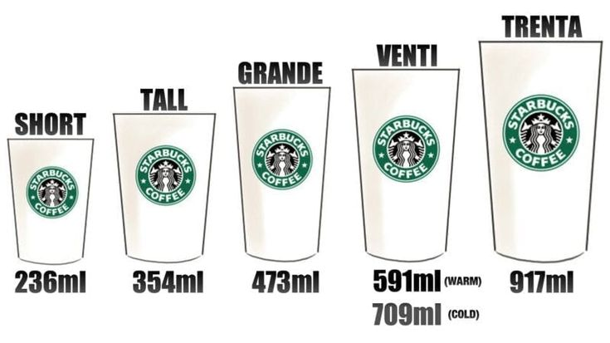
Source: https://shorturl.at/7jCOM

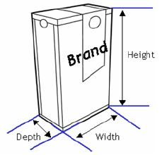
Source: https://shorturl.at/Ircgi

Japan – Width and Depth
In Japan, Starbucks maintains a moderate product width by offering its core global categories—such as espresso beverages, teas, Frappuccinos, food items, and branded merchandise—while placing significant emphasis on high product depth through localized and seasonal variations. Japan-exclusive items like the Sakura Latte, Matcha Cream Frappuccino, and Azuki Bean Mocha expand beverage lines with flavors that reflect Japanese cultural preferences and seasonal traditions (Nikkei Asia, 2024).
Starbucks further deepens its product lines through refined presentation, limited-edition packaging, and sensory elements that align with Japanese values of craftsmanship, harmony, and appreciation of seasonal aesthetics. This rich level of product customization strengthens emotional connections with consumers and enhances the brand’s cultural relevance in the Japanese market.

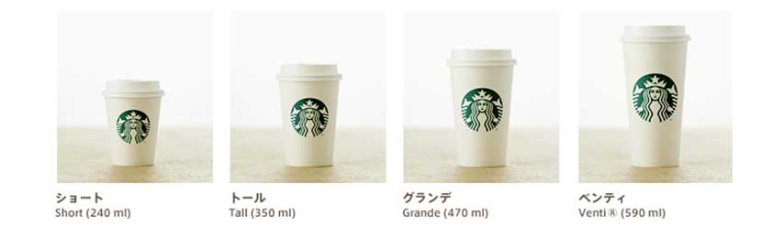
Source: https://shorturl.at/p3A5z
Branding Strategy – USA vs Japan (Short Version)
Starbucks adapts its branding strategy in both markets to reflect different cultural expectations and consumer behaviours.
USA:
Starbucks positions itself as an affordable premium lifestyle brand, focusing on convenience, individuality, and digital engagement. The brand highlights personal expression through drink customization and promotes everyday indulgence. Consistent visual identity and strong loyalty programs reinforce a modern, fast-paced American lifestyle (Pereira, 2024).
Japan:
In Japan, Starbucks follows a more culturally immersive and aesthetic branding approach. The brand integrates Japanese traditions, seasonality, and design—seen in Sakura-themed beverages and heritage-style stores—to create emotional and cultural resonance. Branding emphasises harmony, craftsmanship, and calm social experiences, appealing to Japan’s appreciation for refined, meaningful consumption (Nikkei Asia, 2024).
Starbucks’ product strategy varies between the United States and Japan due to differences in culture and consumer behavior. In the U.S., the company offers high product width and depth, providing a broad range of beverages, food items, merchandise, and extensive customization options that suit American preferences for variety and personalization (Pereira, 2024). In Japan, Starbucks maintains moderate width but very high depth, focusing on core categories enhanced by culturally inspired, seasonal items such as Sakura Latte and Matcha Frappuccino, reflecting Japanese values of craftsmanship, aesthetics, and emotional experience (Nikkei Asia, 2024). These tailored approaches allow Starbucks to meet the unique expectations of consumers in both markets (Cateora et al., 2024; Shastri, 2025).
Product Factors That May Change Due to International Marketing:
When a company enters international markets, several product factors may need to change to match local cultural preferences, regulations, consumer expectations and purchasing behaviours. Firstly, features and benefits may be modified to reflect local taste preferences, dietary patterns and functional expectations. For Starbucks, this includes adjusting sweetness levels, ingredient types, flavour intensity, and beverage temperature according to each country’s consumer preference. Secondly, branding may require cultural alignment, where global brand identity remains consistent but messaging, emotional value and symbolic meaning are adapted to local cultural expectations. Thirdly, product design and variety must be diversified to provide market-specific flavours and limited editions that reflect local culture and seasonality, such as Sakura-themed beverages in Japan and plant-based cold brew ranges in the United States. Packaging design and labelling may also need modification to meet regulatory requirements, language standards, sustainability expectations and cultural symbolism within each market. Finally, product size may differ, as some markets prefer larger portions (for example the USA), while others prefer smaller, minimalistic sizes that reflect moderation and aesthetic refinement (such as Japan). Therefore, these product factors significantly influence how Starbucks adapts its products across different countries to maintain global brand consistency while successfully meeting local consumer needs.

Price
In the USA, Starbucks’ pricing is influenced mainly by high labor costs, fluctuating inflation, and rising ingredient prices. Because the U.S. economy experiences frequent inflation changes, Starbucks often adjusts its prices to maintain profitability. Consumer willingness to pay for premium and customizable beverages also supports higher pricing.
In Japan, pricing is affected by low inflation, high operational standards, and cultural expectations for quality and aesthetics. Since Japan maintains stable prices and values consistency, Starbucks adjusts prices more slowly. Premium store designs and high-quality expectations also contribute to slightly higher but stable price levels.
USA:
Starbucks uses a value-based and tiered pricing strategy in the U.S., offering affordable options for daily coffee drinkers while maintaining premium pricing for specialty beverages and seasonal offerings (Cateora et al., 2024). The company balances accessibility and prestige by offering loyalty rewards through the Starbucks Rewards App, which incentivizes repeat purchases. However, with inflation and rising costs, Starbucks continuously reassesses prices to sustain profitability while maintaining consumer loyalty.
Japan:
In Japan, Starbucks adopts a premium pricing strategy to reflect its upscale brand positioning and exclusivity. Coffee shops are considered social experiences rather than quick stops; thus, customers are willing to pay more for quality, service, and ambiance. This pricing approach strengthens Starbucks’ image as a luxurious yet approachable Western brand. According to Nikkei Asia (2024), Japanese consumers perceive Starbucks beverages as indulgent treats — part of a lifestyle, not just a necessity.

Place
USA:
Starbucks has established an extensive distribution network across high-traffic areas such as airports, urban centers, suburban malls, and universities. Additionally, drive-thru services and mobile pickup options have become central to Starbucks’ U.S. model, particularly post-pandemic. Strategic partnerships with Uber Eats and DoorDash enhance accessibility and convenience for online customers (Pereira, 2024).
Japan:
In Japan, Starbucks carefully selects premium, aesthetic locations that emphasize the in-store experience. Many outlets feature Japanese architectural designs, natural lighting, and tranquil seating areas. Iconic stores — such as the Kyoto Ninenzaka Yasaka Chaya store built in a 100-year-old townhouse — showcase cultural integration. Starbucks Japan relies less on delivery apps and more on in-store ambiance, encouraging social interaction and relaxation (Shastri, 2025).

Direct Distribution Channels (USA & Japan)
Both the USA and Japan rely heavily on direct distribution channels, where the company operates its own stores or joint-venture outlets. In the USA, direct channels allow Starbucks to maintain full control over branding, pricing, customer service, and menu innovation. This includes company-owned stores, drive-thru outlets, mobile pickup points, and branded kiosks. In Japan, Starbucks also uses direct channels through its long-standing joint venture with Sazaby League, ensuring strict quality control, premium aesthetic store design, and culturally integrated service. Direct channels in both countries help maintain strong brand identity, consistency in product quality, and a high level of customer satisfaction.

Indirect Distribution Channels (USA & Japan)
Both countries also use indirect channels, but with different priorities. In the USA, Starbucks distributes products through supermarkets, online retailers, gas stations, and delivery partners such as Uber Eats and DoorDash. These channels expand market reach and support convenience-driven consumption. In Japan, indirect channels include convenience stores like 7-Eleven, FamilyMart, and Lawson, where Starbucks sells bottled beverages and packaged coffee. Additionally, Japan integrates technology-based vending machines and cashless retail options, aligning with local consumer habits. Indirect distribution in both countries boosts accessibility and increases sales outside traditional cafés.
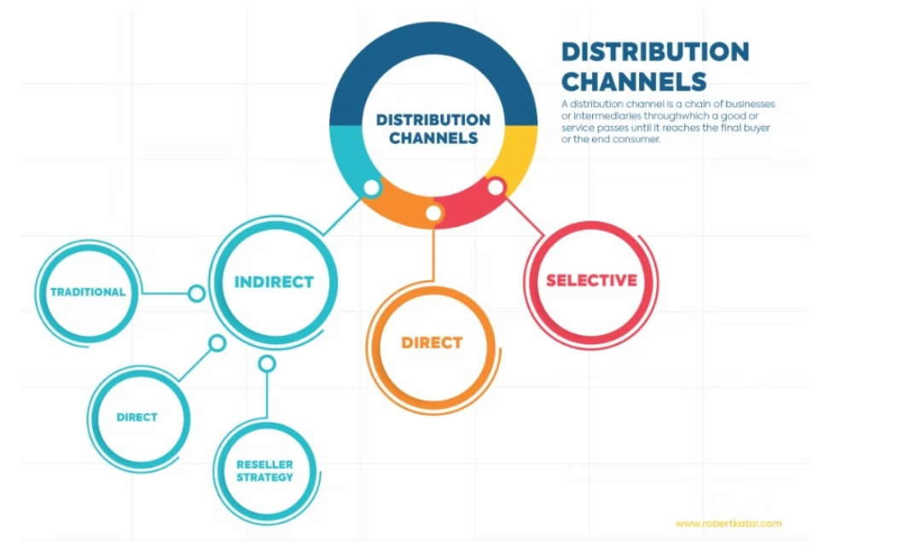
Source: https://tinyurl.com/ms8epk36

Market Entry Method – USA
Starbucks entered and expanded in the United States through direct company ownership, a strategy chosen because the brand originated in the U.S. and already possessed strong operational capacity, managerial expertise, and a deep understanding of consumer behaviour. Direct ownership allows Starbucks to maintain full control over store design, service quality, pricing, digital innovations, and employee training across all U.S. locations. This method provides major advantages such as complete control over decision-making, higher profit retention, and consistent brand experience nationwide. It enables Starbucks to scale innovations rapidly, including mobile ordering, drive-thru models, and AI-enhanced personalization. However, disadvantages include high financial investment, greater operational risk, and slower store expansion compared to franchising. Despite these challenges, direct ownership remains the most suitable method for the U.S. because it aligns with Starbucks’ strategy of maintaining premium brand control in its home and largest market (Starbucks Annual Report, 2024; Schultz & Yang, 2011; Cateora et al., 2024).
Advantages:
Direct ownership provides Starbucks with complete strategic and operational control, enabling strict quality management and strong protection of its brand identity. It also allows the company to retain 100% of profits, accelerate innovation, and ensure uniform customer experience nationwide. Starbucks can quickly adjust store layouts, menus, and digital features without negotiating with franchise partners.
Disadvantages:
However, this method requires high financial investment, especially for store construction, staffing, and ongoing operational costs. It also exposes Starbucks to greater business risk during economic downturns and slows down expansion speed compared to franchising or licensing. Managing a vast company-owned network also increases administrative complexity and labour-related challenges across multiple states.

Promotion
USA:
In the United States, Starbucks’ promotional strategy emphasizes seasonal product launches, in-store experiences, and loyalty-building initiatives that highlight the brand’s identity as an affordable luxury. Promotional materials focus on limited-time offerings such as holiday beverages and seasonal flavors, which strengthen consumer excitement and repeat purchases. Starbucks also uses in-store signage, product displays, and community-based initiatives such as charity drives or local events to reinforce its relationship with consumers. These promotional efforts are designed to enhance brand familiarity, encourage trial of new products, and maintain a strong emotional connection with customers across diverse regions (Pereira, 2024).
Japan:
In Japan, Starbucks adopts a promotion strategy grounded in cultural relevance, artistic presentation, and emotional storytelling. The company frequently aligns its campaigns with traditional Japanese seasons and cultural themes—such as sakura season, New Year traditions, and autumn festivals—to create a sense of harmony and cultural respect. Limited-edition beverages and merchandise are often presented through aesthetic packaging, elegant in-store displays, and collaborative designs with Japanese craftsmen or local artists. These culturally immersive promotions strengthen Starbucks’ positioning as a refined, premium, and culturally sensitive brand in Japan (Nikkei Asia, 2024).

People
USA:
Starbucks currently employs about 211,000 people in the U.S. (as of September 29, 2024). Starbucks refers to its workers as “partners,” and invests heavily in their development offering training, fair wages, health benefits, and college tuition assistance.

Japan:
In Japan, Starbucks has approximately 40,000 partners working across more than 1,600 stores. Employees receive specialized training in customer service, politeness, and cultural hospitality (omotenashi), supporting a service style that emphasizes elegance and emotional connection (Starbucks Coffee Japan, 2021).

Process
USA:
Starbucks in the United States operates with a highly digital and efficiency-focused process, supported by mobile payments, pre-ordering, drive-thrus, and AI-based personalization through the Starbucks Rewards platform (Gratton, 2024). These systems prioritize speed and convenience in line with the fast-paced American lifestyle. When customers are dissatisfied, Starbucks provides multiple complaint channels, including the official customer service hotline, the Starbucks website, in-app support, and direct in-store communication with managers. Common complaints in the U.S. include incorrect orders, long wait times, drink temperature or quality issues, and mobile order errors. Starbucks typically resolves these complaints by offering remakes, refunds, or digital “recovery stars” added to the customer’s account, reinforcing its commitment to service recovery and customer satisfaction.
Japan:
In Japan, Starbucks’ process emphasizes ritual, atmosphere, and service quality, reflecting cultural expectations of omotenashi—polite, attentive, and sincere hospitality. Although digital tools such as mobile payment and app ordering exist, many customers prefer in-person transactions and a slower, more thoughtful service experience (Shastri, 2025). Japanese customers generally complain less frequently than Americans, but when they do, issues are handled through polite, formal channels including in-store staff, store managers, or the official Japanese Starbucks customer service website. Typical complaints in Japan involve drink presentation, taste inconsistencies, seating availability, or disruptions to the calm atmosphere. Starbucks Japan addresses complaints with sincere apologies, immediate corrections, and a high level of politeness, ensuring the customer feels respected and valued. This approach maintains Starbucks’ image in Japan as a brand that values harmony, quality, and emotional satisfaction.

Physical Evidence
USA:
Starbucks’ physical evidence in the U.S. reflects its modern and sustainable brand ethos. Stores feature green-certified designs, recycled materials, and community-focused layouts. Minimalist interiors and recognizable branding — green logos, cup designs, and cozy seating — reinforce the Starbucks identity and contribute to a sense of belonging (Pereira, 2024).
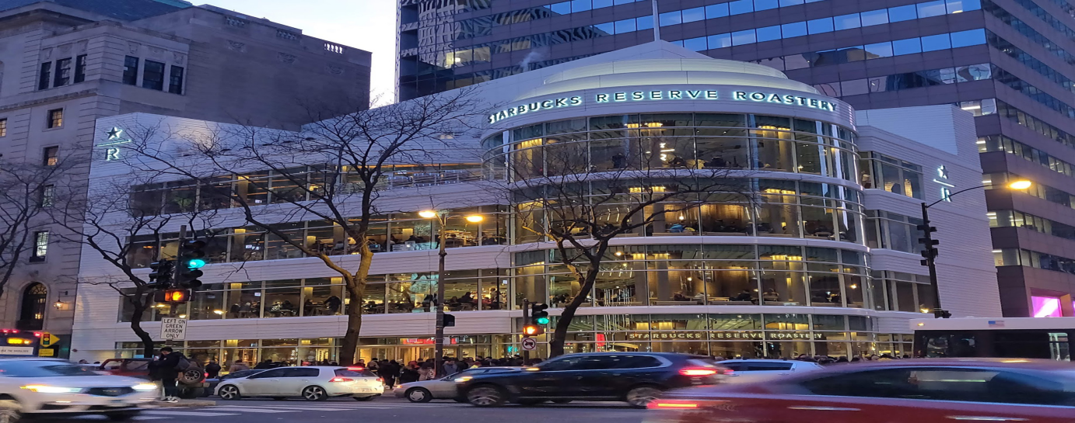
Source: https://tinyurl.com/yft2ef94
Japan:
In Japan, Starbucks’ physical spaces embody aesthetic excellence and cultural harmony. Many stores incorporate local art, wood textures, and natural light to evoke calmness. Seasonal decorations enhance the emotional connection. Starbucks Japan’s architecture blends modern minimalism with traditional Japanese motifs, creating immersive brand experiences that appeal to local sensibilities (Nikkei Asia, 2024).
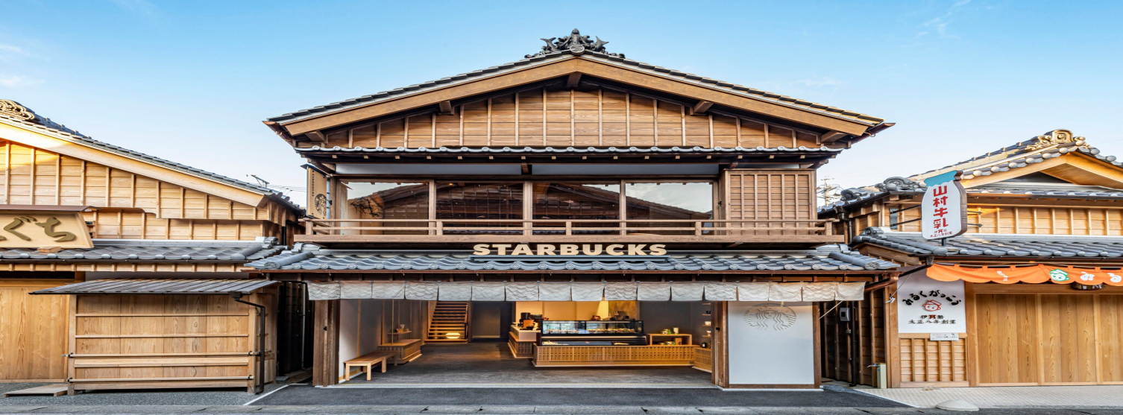
Source: https://shorturl.at/NX2HU

Both Starbucks in the USA and Japan illustrate how global consistency and local adaptation coexist within the brand’s marketing strategy. In the U.S., Starbucks represents efficiency, innovation, and ethical responsibility, while in Japan, it stands for elegance, emotional engagement, and cultural harmony. The brand’s success in both nations lies in its ability to adapt its 7Ps framework to resonate with local consumers without losing its global identity and brand essence.
Similarities
Both countries show strong loyalty to Starbucks’ brand identity, high engagement with seasonal beverages, and reliance on the Starbucks Rewards program to maintain customer relationships. Digital adoption is high in both markets, and customers consistently value quality, consistency, and the premium image Starbucks maintains globally.
Differences
The U.S. strategy focuses on speed, innovation, and convenience, while Japan prioritizes cultural aesthetics, emotional experience, and premium craftsmanship. Social media in the U.S. centres on viral trends, while Japan relies on visual beauty and tradition. Customer expectations also differ: Americans demand customisation and value, whereas Japanese consumers expect harmony, politeness, and refined presentation.

Ethical Practices – Japan
In Japan, Starbucks is widely recognized for its strong commitment to ethical business practices, which significantly strengthens its cultural acceptance and long-term customer trust. The company emphasizes inclusivity through initiatives such as the Starbucks Signing Store, which employs Deaf and hard-of-hearing partners and promotes barrier-free communication—an approach that aligns with Japan’s social values of respect, harmony, and community responsibility. Starbucks Japan also integrates sustainability into its store designs, using eco-friendly materials, energy-efficient systems, and community recycling initiatives to support Japan’s long-standing environmental priorities. Additionally, the brand maintains high standards of ethical sourcing, transparent operations, and respectful workplace practices, which resonate well with Japan’s expectations of corporate integrity and service excellence. Overall, Starbucks’ ethical strategy in Japan positively influences brand loyalty, enhances its premium image, and contributes to its strong social reputation.

Recommendations

3.1 Recommendations – USA
Starbucks in the United States should strengthen its market position by addressing key operational and ethical challenges. First, the company should prioritise rebuilding employee trust by engaging more constructively with union groups and improving labour relations, as this remains one of the most visible ethical issues affecting its reputation. To manage inflationary pressures and shifting consumer spending, Starbucks should introduce more value-based menu options—such as budget-friendly beverage bundles—while still innovating premium products to retain high-income customers. Expanding sustainability initiatives, including greater adoption of reusable cups, compostable packaging, and energy-efficient store designs, will help the company meet rising environmental expectations. Additionally, Starbucks should continue enhancing its digital ecosystem, using AI-driven personalisation to strengthen customer engagement and maintain a competitive edge in the highly saturated U.S. coffee market.

3.2 Recommendations – Japan
In Japan, Starbucks should focus on geographic expansion and deeper cultural integration to sustain long-term growth. The company would benefit from opening more stores in suburban and tier-two cities, where rising incomes and changing lifestyles provide new customer opportunities outside major urban centres. To meet the needs of Japan’s aging population and growing interest in health and wellness, Starbucks should expand its range of plant-based, low-calorie, and functional beverages. The brand should also continue strengthening its cultural connection through locally inspired collaborations, seasonal beverages, and artistic store designs that reflect Japanese traditions and aesthetics. Additionally, enhancing technological experiences—such as more cashless solutions, aesthetic app features, and AR-based campaigns—will help Starbucks match Japan’s digital expectations. These strategies will reinforce Starbucks’ reputation as a premium, culturally respectful, and emotionally engaging brand within the Japanese market.

Conclusion
This comparative analysis of Starbucks’ international marketing strategies in the USA and Japan demonstrates how the company effectively balances global standardisation with local market adaptation to sustain competitive advantage. Starbucks has proven that international success does not solely rely on replicating a single standardized business model across all markets, but rather on strategically modifying product offerings, pricing, customer experiences, technology adoption, and brand positioning in response to cultural preferences and market maturity differences.
In the USA, Starbucks’ strategic focus revolves around digital innovation, loyalty program expansion, and continuous product development aimed at satisfying fast-paced, convenience-driven, health-conscious consumers. Its marketing strategy is driven by personalisation, value offerings, and sustainability commitments that align with shifting societal expectations around ethical consumption and customization. The U.S. market remains the core growth engine and innovation test bed from which new concepts can be scaled globally.
In contrast, Starbucks’ Japanese strategy emphasizes cultural aesthetics, emotional value creation, premium brand positioning, and seasonal artistic product experiences. Japan demonstrates the importance of developing culturally immersive retail atmospheres and localized menu varieties in order to build emotional attachment rather than functional utility. Starbucks’ success in Japan proves that Western brands can thrive by respecting cultural nuance and enhancing experiential consumption value rather than imposing Western consumption norms.
Ultimately, Starbucks’ approach across both markets supports long-term global growth by leveraging international marketing frameworks such as STP, 7Ps, Ansoff Matrix, Hofstede Cultural Dimensions, and digital transformation integration. While both markets demonstrate high adoption of digital customer engagement, the U.S. takes the lead in driving technological innovation while Japan excels in cultural refinement and aesthetic brand experience. Starbucks should continue expanding plant-based options, tier-based pricing strategies, sustainability visibility, and localized digital experience development in order to further strengthen global loyalty, profitability, and brand differentiation.
Overall, Starbucks’ ability to align global brand equity with localized cultural responsiveness ensures lasting competitive advantage and positions Starbucks as an iconic global leader in premium coffee retail across diverse international markets.

References
Reference list
9167db07-5ac4-e911-81ff-005056ba12ca (2020). Starbucks first Signing Store in Japan celebrates human connection through sign language : Starbucks Stories Asia. [online] Starbucks Stories Asia. Available at: https://stories.starbucks.com/asia/stories/2020/starbucks-first-signing-store-in-japan/?utm_source=chatgpt.com [Accessed 22 Nov. 2025].
9167db07-5ac4-e911-81ff-005056ba12ca (2021). Celebrating the 25th year of Starbucks in Japan with the power of coffee and connection : Starbucks Stories Asia. [online] Starbucks Stories Asia. Available at: https://stories.starbucks.com/asia/stories/2021/celebrating-the-25th-year-of-starbucks-in-japan/?utm_source=chatgpt.com [Accessed 22 Nov. 2025].
Allen, A. (2020). The 7Ps of The Marketing Mix. [online] Oxford College of Marketing. Available at: https://blog.oxfordcollegeofmarketing.com/2020/10/08/understanding-the-7ps-of-the-marketing-mix/ [Accessed 22 Nov. 2025].
Bhasin, H. (2015). Starbucks Marketing Mix and 7Ps (Updated [year]) | Marketing91. [online] Marketing91. Available at: https://www.marketing91.com/marketing-mix-of-starbucks/?utm_source=chatgpt.com [Accessed 23 Nov. 2025].
Bhasin, H. (2024). Marketing mix of Starbucks - Starbucks marketing mix. [online] Marketing91. Available at: https://www.marketing91.com/marketing-mix-of-starbucks/ [Accessed 23 Nov. 2025].
Christodoulou, A. and Cullinane, K. (2019). Identifying the Main Opportunities and Challenges from the Implementation of a Port Energy Management System: a SWOT/PESTLE Analysis. Sustainability, [online] 11(21), p.6046. doi:https://doi.org/10.3390/su11216046.
Chuang, H.-J. (2019). Starbucks in the World. HOLISTICA – Journal of Business and Public Administration, [online] 10(3), pp.99–110. doi:https://doi.org/10.2478/hjbpa%E2%80%902019%E2%80%900031.
Cronjé, J.C. (2019). Using Hofstede’s cultural dimensions to interpret cross-cultural blended teaching and learning. Computers & Education, 56(3), pp.596–603. doi:https://doi.org/10.1016/j.compedu.2010.09.021.
DeSarbo, W.S., Blanchard, S.J. and Atalay, A.S. (2017). A new spatial classification methodology for simultaneous segmentation, targeting, and positioning (STP analysis) for marketing research. Review of Marketing Research, 5, pp.75–103. doi:https://doi.org/10.4324/9781351550901-4.
Dominik, V. (2018). Company analysis of Starbucks Corporation. [online] Available at: https://finance.hr/wp-content/uploads/2018/12/Starbucks-Company-Analysis.pdf [Accessed 25 Nov. 2025].
Haskova, K. (2015a). Starbucks Marketing Analysis. [online] ResearchGate. Available at: https://www.researchgate.net/publication/284112548_Starbucks_Marketing_Analysis [Accessed 25 Nov. 2025].
Haskova, K. (2015b). Starbucks Marketing Analysis. CRIS - Bulletin of the Centre for Research and Interdisciplinary Study, [online] 2015(1), pp.11–29. Available at: http://archive.sciendo.com/CRIS/cris.2015.2015.issue-1/cris-2015-0002/cris-2015-0002.pdf [Accessed 28 Nov. 2025].
http://facebook.com/sprudgemedia (2019). Agony And Ecstasy At The World’s Largest Starbucks | Sprudge Coffee. [online] Sprudge Coffee. Available at: https://sprudge.com/agony-and-ecstasy-at-the-worlds-largest-starbucks-153287.html [Accessed 29 Nov. 2025]
Islam, M.M. (2020). Segmenting, targeting and positioning in Islamic marketing. Journal of Islamic Marketing, [online] ahead-of-print(ahead-of-print). doi:https://doi.org/10.1108/jima-10-2018-0181.
Jangoulun Singsit (2024). Starbucks cuts US retail workforce by 8% despite new store openings. [online] Retail Insight Network. Available at: https://www.retail-insight-network.com/news/starbucks-retail-workforce-us/?cf-view [Accessed 28 Nov. 2025].
Kato, T. (2022). Brand Concept Drives Loyalty Toward Starbucks: Concept, Product, Place, and Staff in Japan. Central European Management Journal, 30(1), pp.70–90. doi:https://doi.org/10.7206/cemj.2658-0845.70.
Manrai, Lalita A and Manrai, Ajay K (2025). Las dimensiones culturales y la conducta turística según Hofstede: análisis y marco conceptual. Journal of Economics, Finance and Administrative Science, [online] 16(31), pp.23–48. Available at: http://www.scielo.org.pe/scielo.php?pid=S2077-18862011000200003&script=sci_arttext&tlng=es [Accessed 27 Nov. 2025].
Nishida, K. (2021). What is Starbucks Japan Regional Landmark Stores. [online] Japanese Coffee Co. Available at: https://japanesecoffeeco.com/blogs/japanese-coffee-blog/what-is-starbucks-japan-regional-landmark-stores?srsltid=AfmBOopDzuYBMS0hj7Li4XP68EYbw9U_2v5kBzmcmWZSZBM97T1gIV5W [Accessed 29 Nov. 2025].
Pereira, D. (2023). Starbucks PESTLE Analysis (2023). [online] The Business Model Analyst. Available at: https://businessmodelanalyst.com/starbucks-pestle-analysis/ [Accessed 28 Nov. 2025].
Rojo, J., Everett, B., Ramjan, L.M., Hunt, L. and Salamonson, Y. (2020). Hofstede’s Cultural Dimensions as the Explanatory Framework for Performance Issues during Clinical placement: a Mixed Methods Study. Nurse Education Today, 94(1), p.104581.
ScrapeHero (2018). Number of Starbucks locations in United States. [online] ScrapeHero. Available at: https://www.scrapehero.com/location-reports/Starbucks-USA/?utm_source=chatgpt.com [Accessed 29 Nov. 2025].
Shastri, A. (2024). Starbucks Marketing Strategy: Full Case Study | IIDE. [online] IIDE. Available at: https://iide.co/case-studies/starbucks-marketing-strategy/?utm_source=chatgpt.com [Accessed 29 Nov. 2025].
Symson (2024). The STP Marketing Model: A Comprehensive Guide to Mastering Market Dynamics. [online] www.symson.com. Available at: https://www.symson.com/blog/stp-marketing-model [Accessed 01 Dec. 2025].
Talib, F. (2019). Strategic Analysis Of Starbucks Coffee Company. [online] Available at: https://zaguan.unizar.es/record/101077/files/TAZ-TFG-2020-4193.pdf?version=1 [Accessed 01 Dec. 2025].
Team, P.F. (2023). Distribution Channels: Types, Role, and Impact. [online] Peak Frameworks. Available at: https://www.peakframeworks.com/post/distribution-channels [Accessed 29 Nov. 2025].
The Culture Factor (2025). Country comparison tool. [online] Theculturefactor.com. Available at: https://www.theculturefactor.com/country-comparison-tool?countries=united+states [Accessed 05 Dec. 2025].
Wahyudi, A.T. (2013). Segmentation, Targeting, dan Positioning Studio Tato di Surabaya dalam Perkembangan Gaya Hidup. Nirmana, 15(1). doi:https://doi.org/10.9744/nirmana.15.1.19-24.
Whitsy, D. (2016). The Alphabet Prophecy. Createspace Independent Publishing Platform.
Xu, Z. (2023). The Marketing Strategy Analysis of Starbucks. Advances in Economics Management and Political Sciences, [online] 58(1), pp.1–6. doi:https://doi.org/10.54254/2754-1169/58/20230979.
Appendix 1
Positioning

Source: https://tinyurl.com/4k2a7sap
Appendix 2
PESTLE Analysis
Source: From (https://tinyurl.com/5cy6bjxt

Appendix 3
Country Comparison
Source: https://tinyurl.com/3ku9wdpa

Appendix 4
Technology Adoption Comparison – USA vs Japan

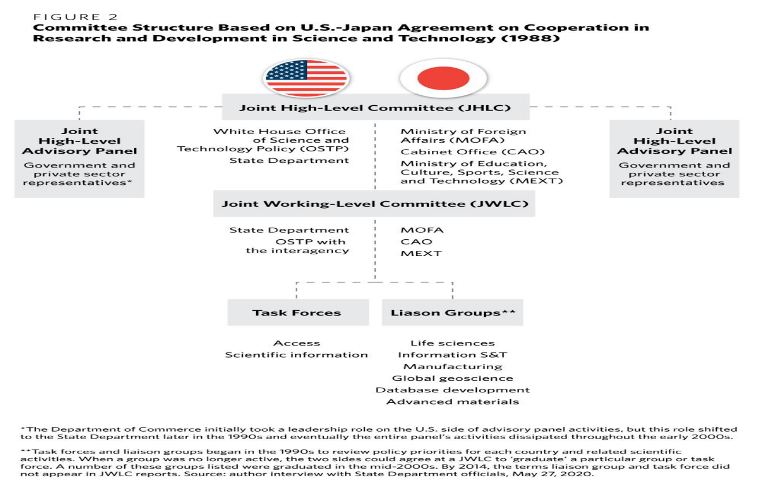
Source: https://shorturl.at/tTRxf

Appendix 5
Distribution Channels – Direct vs Indirect (USA & Japan)
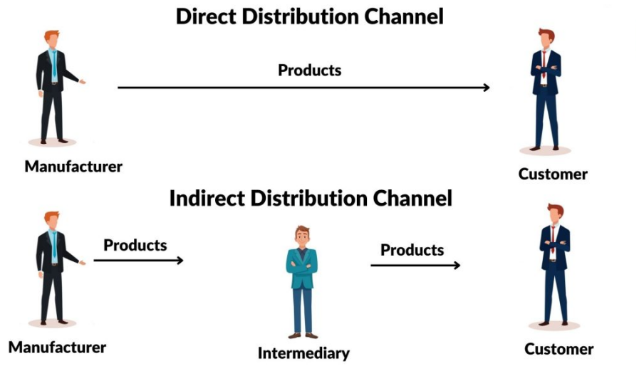
Source : https://shorturl.at/rh6wG
Appendix 6
Starbucks Market Entry Methods

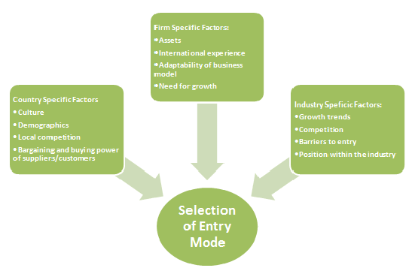
Source: https://shorturl.at/YKHL7
Appendix 7
Product Strategy – Width & Depth Comparison
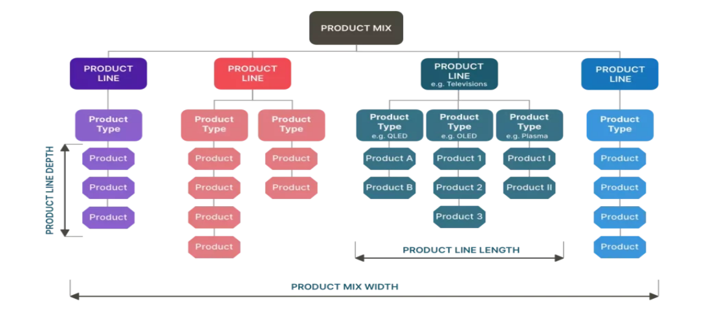

Source: https://shorturl.at/4uRuA
Appendix 8
Marketing Mix (7Ps) Comparison

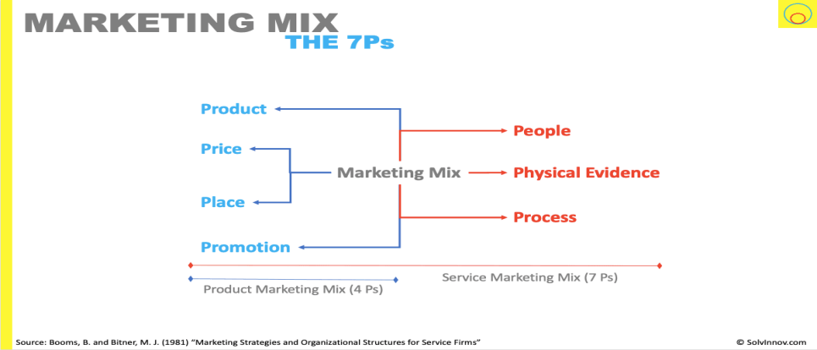

Source: https://tinyurl.com/3arbname

