Garin Criddle (2005224)
Word Count: 8030

1- Are UK and Government Strategies enough to reduce knife crime, should there be more emphasis on youth offenders regarding knife crime?

Table of Contents
1-Title: Are UK Police and Government strategies enough to reduce knife crime, and should there be more emphasis on youth offenders regarding knife crime? 0
Acknowledgements 1
Declarations 1
2- Abstract 1
3- Introduction 2
3.1- Background 2
4- Aims & Objectives 3
4.1- Aim 4
4.2- Objectives 4
5- Literature Review 4
5.1- Importance of UK Knife crime legislation 4
5.2- Operational Strategies 5
5.3- Public Health Approach 6
5.4- Age Crime Curve Theory 8
5.5- Theories and Opinions on Youth Involvement in Knife Crime 8
6- Methodology 10
6.1- Primary Research 10
6.2- Secondary Research 11
6.3- Qualitive and Quantitative Data 11
6.4- Research Onion 12
6.4.1- Philosophies 12
6.4.2- Research Approach 13
6.4.3- Research Strategies 13
6.4.4- Research Choices 13
6.4.5- Time Horizon 13
6.4.6- Techniques and Procedures 14
7- Findings and Analysis 14
8- Conclusion 20
8.1- Introduction 20
8.2- Main Findings 21
Bibliography 22
Appendices 25

Acknowledgements
I would like to thank my supervisor Luke Roach for helping during this research project. I would also like to thank my family and friends during my time at university for keeping me focused and determined to complete my course.

Declarations
This work has not previously been accepted in substance for any degree and is not being concurrently submitted in candidature for any degree.
STATEMENT 1
This dissertation is being submitted in partial fulfilment of the requirements for the degree of BA/BSc.
STATEMENT 2
This dissertation is the result of my own independent work/investigation, except where otherwise stated.
Other sources are acknowledged in the Reference Section.
STATEMENT 3
I hereby give consent for my dissertation, if accepted, to be available for photocopying and for interlibrary loan, and for the title and summary to be made available to outside organisations.
STATEMENT 4
I hereby give consent for my dissertation, if accepted, to be available on the university’s IT system to those who have consent to use the system.

Student’s Name: Garin Criddle

Signed: G Criddle

2- Abstract
This paper highlights findings which were developed by carrying out primary and secondary research, with the intention of understanding UK government policies and strategies in the struggle against knife crime and the prominence of youth have in knife crime. This will determine if the UK efforts are sufficient in acting against knife crime and if there are potential avenues, they could follow to reduce knife crime in the future. By comparing various police strategies and new legislation. It will allow a basic understanding of the prevalence of knife crime and why it is committed, will allow an evaluation on if youth are more vulnerable and susceptible to committing knife related offences. To obtain the knowledge to answer this research question, a variety of different resources will be gathered varying from government legislation and statistics, academic literature, and primary evidence of a public perception via questionnaire. The research conducted showed there are many different strategies being used across the UK and some of these strategies could be instrumental across the UK. The strategies vary from having national strategies against knife crime and focusing in reducing crime in the youth offending area. This would allow future generations to have correct morals and sway from a life of crime. Knife crime is very unpredictable, and every offense varies but by creating mindsets young, there will be a potential to change the future.

3- Introduction

3.1- Background
Stabbings have been the most common form of murder since the end of the second world war, accounting for 35% of the murders in the UK (Coleman, 2008). Despite the prevalence of knife crime over the decades since the war, the notion that knife crime is out of control has only been pushed into media spotlight recently (Squires, 2009). According to the Office for National Statistics (ONS, 2019), knife crime is crime is in 70-year peak for homicides in the year ending 2018. This has caused widespread national debate in whether that more needs to be done to combat knife crime or homicides in general or on the rise and knives in general are the most accessible weapon (Harding, 2020). The accessibility of knives has been a key factor in the increasing number of ‘knife crime’, the need for knives in certain aspects of life in unquestionable therefore it is difficult to differentiate between legitimacy and criminality (Hern, et al., 2005). The UK government has implemented various forms of legislation over the years to combat knife crime, but accessibility has always major factor and there has been no ideas combat ownership of potentially harmful knives. The government initially tried to reduce numbers of dangerous knives with Restriction of Offensive Weapons Act 1959, this act would outlaw the manufacture and sale of dangerous ‘flick knives’ and ‘gravity knives. This would also cover the manufacture and sale of dangerous knives vaguely, in the attempt to decrease the accessibility of harmful knives. In addition to the reduction in availability the government also brought in legislation to tackle possession of knives. The Criminal Justice Act 1988 distinguished that a person would be criminally liable to possession of a knife, if the knife’s cutting edge exceeded 3 inches. The legislation also outlines what would be deemed as ‘public place’ and gives the police clear rules in which to govern. This act also allows the police to have their onus on situations. This means they will be allowed to use their own judgement in certain situations regarding whether a person reasoning is genuine or whether a person is trying to pervert the cause of justice. Reducing people carrying knives is critical in UK legislation as less knives equally less knife related crimes committed (Squires, 2009), this is done through more interventions such as stop and search. Since 2008, the police will have power to stop and search anyone they have suspicion for without reasonable grounds under section 60 (Police and Criminal Evidence Act 1984) and increased number of section 1 stops. This was after the ‘Metropolitan Police declaring war on knife crime’ (Edwards, et al., 2008). By the threat of being caught in possession with a knife, it was thought that numbers of people carrying a knife would decrease thus having a knock-on effect. According to (Lemos & Crane, 2004), people who carry knives for their own protection can often lead to aggression. If you remove the knife from the equation, it removes the element of harm which also reduces criminality. The possession of knife creates more violent communities and leads to escalation (Silvestri, et al., 2009), the stress and tension from people feeling unsafe can cause more violence to ensue and thus more harmful knife crime. According to (Gladstone & Parker, 2003) majority of youths who carry knives for protection do so because they have no trust in the police and believe they must to put their safety in their own hands and cooperating with the police may cause more uncertainty on their safety. The media have shaped knife crime in recent years around street gangs in big cities (Harding, 2020), this has had a collateral effect on the public perception of knife crime. This has caused many people to overlook the threat of knife crime as they believe knife crime is prominent in gang related areas and as they don’t affiliate with that side of society (Squires, 2009). The media has potentially added more fear into the equation as more people may feel they will need protection in big city areas because of the prevalence of knife crime reported by the media (Lemos & Crane, 2004). The statistics show that between the year of 2016/17, gangs were represented for 5% of the knife crime committed in the London area (MOPAC, 2017). This shows how the media can twist news to seem more appealing. The knife crime epidemic needs to be addressed by a national front and the media should assess the full picture as spotlighting gangs in built up cities has had no benefits for the rate of knife offences over the past decade (MOPAC, 2017). The media have always showed that the knife crime problem starts from London gangs when statistics show that the metropolitan area has less knife crime offences per 100,000 than the west midlands area (ONS, 2023). This shows that the media show more on the capital despite not being the epicentre of the problem.

4- Aims & Objectives

4.1- Aim
To critically analyse UK Police and Government strategies in reducing knife crime and to evaluate whether there is a need for more awareness and protection for youth offenders in these strategies.

4.2- Objectives

- To assess Government legislation tackling Knife Crime.
- To assess the effectiveness of different strategies and how prevalent knife crime is in the UK.
- To review theories and opinions on what leads youth to becoming knife crime offending and if there’s a correlation.
- To explore if more can be done to help youth offenders.

5- Literature Review

5.1- Importance of UK Knife crime legislation
Knife crime legislation is very straight forward and requires little to no interpretation to understand what deems and offences or not. Any offence relating to a knife, blade or other pointed articles would then warrant the label of a knife crime (Crown-Prosecution-Service, 2022). The Prevention of Crime Act 1953 states that it is illegal to have an offensive weapon in a public place or threat a person with an offensive weapon in public. The Criminal Justice Act 1988 revised some of this legislation by adding that knives should never be used or seen in places of education and prohibiting the sale and manufacturing of offensive weapons. This act also made it illegal to own offensive weapons in private. Offensive Weapons Act 2019 outline that it is illegal to threaten another with an offensive weapon in a private place, illegal to deliver a bladed object to a residential place and illegal to deliver a bladed object to a person under the age of 18. The legislation on knife crime and offensive weapons have been consistently amended over the years which show how broad knife crime offenses can be and the government continues to try and make legislation which allows justice to prevail (UK-Government, 2019). Every amendment has given the police more powers in order to tackle knife crime and with the most recent Offensive Weapons Act 2019, it allows the police to place Knife Crime Prevention Orders (KCPOs) which are injunctions which can steer younger generations from knife crime through various positive requirements which will shape peoples future which will reduce the chances of offending (UK-Government, 2019). Legislation plays a major part in the conviction of knife crime offenders, but police strategies will get the evidence on the offender (Sidebottom, et al., 2021). The college of policing state that for many believe that knife crime offences are prominently made up of youth offenders even though many older people use and are injured with knives. The also reiterate that most offences are not conducted by strangers on one another in a public place like the media perceives but quite the opposite of the situation (Sidebottom, et al., 2021). The burden of knife crime falling on young males from metropolitan areas (Massey & Coupe, 2019), this is because knife crime offences are more of a reoccurring theme in build-up areas meaning that knives can be distinguished as the problem and not the offender. According to the college of policing different areas will have to treat their own problems respectively as areas which have a low level of knife crime offences cannot treat people in their area based on demographics which have no relevance to what their area is like (Sidebottom, et al., 2021). There have been many opinions and interventions on how to deal with knife crime and numbers consistently increase year by year therefore there is a need for a drastic change in strategy.

5.2- Operational Strategies
Operational strategies of knife crime can vary from different police forces (Sidebottom, et al., 2021), with variety of different methods to reduce numbers of knife crime and shape a better future. Operation Sceptre is an operational strategy used by all 43 police services and the British transport police in England and Wales (National-Police-Chiefs-Council, 2022). Operation sceptre is an intelligence led operation which allows police services across the UK to stop and search people and areas who they believe are more vulnerable to knife crime. This also allows police officers to do sweeps through schools and community groups to raise awareness about knife crime and how much of an impact it has across the community (Astrup, 2019). This national campaign which annually dedicates a week to combat knife crime and other violent crimes. The initiative has seen great success throughout UK Police services, in the most recent sceptre week the has been 2550 people arrested and 742 of those were related to knife crime (National-Police-Chiefs-Council, 2022). This is seen as a success in small manner as hopefully this initiative will shape people’s future thus meaning there will be less people to catch creating a safer community across the UK (Greater-Manchester-Police, 2022). The operational aspects of sceptre also enforce the prevention aspects in intends to present. By showing the public they’re dealing with knife crime and highlighting the importance to the younger generation that there is no need to carry knives for protection (National-Police-Chiefs-Council, 2022). Operation Sceptre emphasis on how much education on prevention plays a key role in a multi-agency approach against knife crime thus linking it with a public health approach (Christmas & Srivastava, 2019).

Stop and Search has been very influential on reducing numbers of knives being carried in public (Sidebottom, et al., 2021). Stop and Search is a police power to stop a person on grounds they reasonably suspect to be in possession of prohibited items under section 1 of the Police and Criminal Evidence Act 1984. In more recent years this has extended to anyone in specific areas for fixed periods of times under section 60 of Criminal Justice and Public Order Act 1994. Stop and search has been seen to have positive and negative effects on the public (Nickolls & Allen, 2022). Whilst stop and search can be a vital tool and save lives (MOPAC, 2017), it can also break trust in communities as people believe they’re seen as criminals if they are stopped and searched meaning the public loses trust in the police service (Sidebottom, et al., 2021). As well as catching a person with a prohibited item, the police use stops and search for a deterrence in knife crime offences as well. According to (Sidebottom, et al., 2021) the deterrence acts at two levels: the knowing that the police have the ability to stop and search may deter those thinking about carrying a knife in the first place. Those who have been stopped prior may never think of carrying a knife in the future as they’ve been stopped before and reminded of the risk of being caught with an offensive weapon.

5.3- Public Health Approach
In 2005, Scotland struggled with levels of violent crimes and was labelled as the most violent country in the world with a recorded 131 homicides (SVRU, 2022), this then forced drastic measures to be enforced in the attempt to lower violent crimes. This problem in violence was generally worse in Glasgow, so when the public health approach was implemented, they focused it on Glasgow. Due to the success of this approach, the public heath approach can often by regarded as the Glasgow Model (HMIP, 2023) Scotland scaled up violence reduction units from a regional project to a national strategy and implemented public health approaches against violent acts (Scottish-Governement, 2023). Scottish Violence Reduction Units (SVRUs) strategy against knife crime is the public health approach (SVRU, 2022). The ‘public health’ approach towards violence allows the police to collate all various data and demographics from areas and this will allow a better understanding of knife crime and how situations could be handled better and more efficiently (MOPAC, 2017). This strategy treats violent crimes as a disease and believes there are deeper meaning to specific crimes than the individuality of the acts (Christmas & Srivastava, 2019). The public health approach questions why violence happens and if there are commonalities between violent acts and can find the “cause of the cause” (P.4)(Christmas & Srivastava, 2019). The public health approach is broken down into four different areas. The analysis of data is crucial, this shows any correlations between violent acts and offenders. Data analysis outlines the causes of violence, this then allows further understanding of what makes these causes happen and hopefully provide more intelligence on the matter. Understanding data then allows solutions and prevention strategies which can be tested and evaluated and give more intelligence for what works best for who. This will then allow bigger scaled operations on dealing with effective programmes (SVRU, 2022). This approach is all targeted at the prevention aspect of knife crime, if violence is treated like a disease this will allow more space for prevention rather than treatment whilst violence consumes areas (Brohi, et al., 2019). A crucial aspect of the success of a public health approach will be the collaboration of multi-agencies which will allow a better understanding of the problem because of access to data whilst offering more resources and potential solutions (Christmas & Srivastava, 2019). A multi-agency approach allows input from not only from the police services and the justice system but from education, social care, community groups which then gives a broader approach to tackling knife crime before it is even committed through prevention (Brohi, et al., 2019). The information that a multi-agency approach will be able to gather with a united front against knife crime will prove to be essential. The Home Secretary of the UK Sajid Javid in 2019 states that having a “strong law enforcement plays an important role, and the police will continue to have our support on the front line, but we all need to look at what we can do in our communities, and in every part of the system, to safeguard young people.”(P.365) (Thornton, 2019). There could even be a change in the law to allow doctors to share information on their patients if the feel they feel their patient is in danger of being hurt said the home secretary (Thornton, 2019). The public health approach has significantly reduced violent crime in Scotland 35% from 2011 to 2019 thus causing a decrease in knife crime (Scottish-Governement, 2023), because of this success through this approach it had be decided in 2017 to be adopted by the Mayor’s Office for Policing and Crime in London for its knife crime strategy (MOPAC, 2017). The knife crime strategy has also expressed the effort which will be put into the multi-agency approach and have even created a multi-agency risk assessment conference (MARAC) which will allow all different agencies to convene quarterly to discuss matters of improvement and to maintain healthy relationships with one another. There will also be a youth conference as well which will help youth which have been affected by crime (MOPAC, 2017).

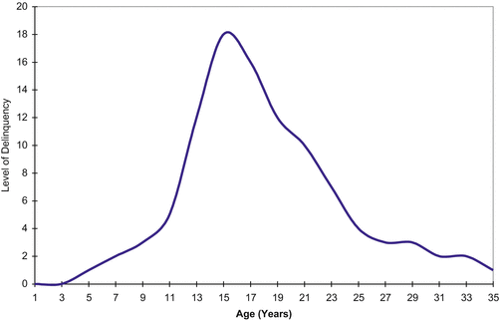
5.4- Age Crime Curve Theory
The age crime curve theory is a theory in which criminal behaviour increases in the adolescence before decreasing in adulthood (Shulman, et al., 2013). This theory relates to knife crime as the age of knife crime offenders would be very similar to the age crime curve (DeLisi, 2015). According to (Rocque, et al., 2015) criminality spikes for people when they hit the age of 14 and continues to rise until their mid 20s however there are no questions on what affects this theory such as crime type, social groups and other altercating factors which play big roles in offenders. (Rocque, et al., 2015) also discuss the type of crimes youths are more likely to offend compared to adults. Most adolescents spend time together and due to the free time and lack of responsibility, there’s more available avenues they can commit crime. Associating this to knife crime, there are high numbers of adolescents who are prone to knife crime because of the ways they can be dragged into various encounters (Gladstone & Parker, 2003), this is because a multitude of reasons such as lack of empathy, no thought of the repercussions and easily being pressured by social groups (MOPAC, 2017). This means that it will only be natural for those of a younger nature being caught up in offences such as knife crime because of the window of opportunity and the naivety of the offender (Lemos & Crane, 2004).
(DeLisi, 2015)

5.5- Theories and Opinions on Youth Involvement in Knife Crime
Youth and adolescent involvement in knife crime are the main target with both methodology (Public Health) and operational approaches (Operation Sceptre)(Christmas & Srivastava, 2019). The public health approach discusses methods which should be taken to handle situations before, while and after but doesn’t discuss the tools and resources needed by agencies to be able to put prevention strategies from the beginning (Brohi, et al., 2019). The operational strategies through programmes such as Operation Sceptre give a wave of awareness and knife crime reduction methods but fail to tackle individual struggles which is also need in young people (National-Police-Chiefs-Council, 2022). The London Knife Crime Strategy discusses how that majority of children will never be possessed to use a knife but focusing those who are at risk will allow safer environments for all (MOPAC, 2017). This also links to public health opinions of violent acts being a disease which could potentially infect those who would never be capable of such acts before persuasion or pressure (SVRU, 2022). Focusing on those vulnerable to crime is done through Youth Offending Teams (YOT) (UK-Government, 2023). Youth Offending Teams primarily focus on children who are high risk towards crime or have committed a crime and need help to change their life onto a positive path. This is done by a social worker unravelling underlaying problems which could push a child towards a negative path which could mean violence (HMIP, 2023). Some of the underlaying issues maybe result of adverse childhood experiences, this will mean that children are experiencing trauma in their lives and transferring their feelings towards different things in their lives such as social groups, education, and attitude (Christmas & Srivastava, 2019). This is when Youth Offending Teams, social workers and potentially teachers step in to potentially change a child's life (UK-Government, 2023). By changing a single child’s perspective, this could have a collateral on others as children often group with their friends and sometimes make decisions based on trust and influence their friends have on them (Lemos & Crane, 2004), this links in with the theory of the problem being a disease like a public health approach (Astrup, 2019). According to (HMIP, 2023) & (MOPAC, 2017) Youth Offending Teams and social work are the way forward but there are difficulties in funding and this is why they believe they could get better results. YOT provide well needed programmes to these children as well and with more funding, it allows them to concentrate on more people as individuals (HMIP, 2023). There are also charities which concentrate on tackling violence upon children such as the Youth Endowment Fund who ensure than children get the right support through various data analysis which means that there are efficient and effective ways of dealing with preventions (YouthEndowmentFund, 2023). Educational knife programmes in school are effective for four main reasons: Awareness of the risks and consequences; helping students to develop abilities to resist carrying a knife; challenging thoughts and opinions about carrying a knife and lastly building stronger bonds with the police (Sidebottom, et al., 2021). The last objective is essential as (Gladstone & Parker, 2003) states majority knife carriers are only doing so as protection and lack of faith in police and justice system to protect them, meaning the feel they must fend for their selves against other knife users.

6- Methodology

This chapter will focus on types of research which can be conducted to gather valuable information on this topic and other types of research which will not be used in this project and why. This will explain what both primary and secondary research are used for and what will be used in this study. It will also give a basic understanding of qualitive and quantitative research. To understand what research is needed and why, there will have to be an understanding on why this research is being conducted in the first place. This chapter will also outline this projects type of research which is public perception and explain how the results will be used and why this type of research was correct for the project.

6.1- Primary Research
Primary research is regarded as the first-person approach to gathering information, this can be conducted in three major ways: Observations, Interviews and Surveys (Driscoll, 2011). The observational approaches allow the researcher to evaluate and make a judgement on information that has been presented to them, this makes the research unique and allows comparison to show bigger overall views (Southampton-Uni, 2023). Interviews can be very useful while used in the right capacity as there is a need to let the person being questioned to expand on their thoughts which differentiates it from a normal survey. This allows us the interviewer to have greater perspectives on narrowly defined themes which gives us greater understanding of the concepts (Brounéus, 2011). To gain a very resourceful interview, the person being interviewed needs to very informed on the matter through personal observation or thoroughly studied the matter through secondary information. Lastly there are surveys and questionnaires which will be the main form of research conducted in this specific project. Questionnaires have the primary research aspect of gathering information which has never been gathered before (Southampton-Uni, 2023), this also allows room for more personal and primary research through observation (Driscoll, 2011). Conducting a questionnaire would be the most obtainable way of gathering first hand opinions on public perception of knife crime as it grasps honest and truthful information by those who make up society.

6.2- Secondary Research
Secondary research is data which is data collected by others (Stewart & Kamins, 1993). This is the research used in the literature review section of this project as it allows the research to collate various source of information and create a larger picture of the matter. Secondary research can be very useful it allows you to evaluate professional opinions and statistics, but questions can be raised about validity and reliability of the source (Weidman, et al., 2011). The advantage from using secondary information is to create a pool of information and by comparing many sources, basic understanding of the matter improves, and it also takes less time and resources than conducted your own first-hand resources (Stewart & Kamins, 1993).

6.3- Qualitive and Quantitative Data
Whilst researching information whether they be primary or secondary research, there are ways of distinctively outlining credibility of a source through these definitions of data (Allwood, 2012). Qualitive data research allows a personal view of peoples: thoughts, beliefs opinions and first-hand experiences. This then gives the researcher more insight into a topic by having more basic knowledge (Gibbs, 2018). Qualitive data would be the main outcome of semi-structured interviews, as the research looks for individuality and expansion on their thoughts and opinions (Brounéus, 2011). This would also connect with surveys and questionnaires as there may be some questions which may ask for experiences and thoughts and opinion thus a qualitive question. This also allows room for interpretation which allows more primary information to be received and more of a unique view to the research (Driscoll, 2011). Quantitative data can be known as numerical and quantity data which can implicate opinion, examples of this would be statistics and collating data which account for the same (Sukamolson, 2007). Quantitative data has always been information which can support qualitive opinions and can highlight thoughts and opinions (Allwood, 2012). In this project there will be a mixture of Quantitative and Qualitive data as statistics have been shown in the literature review and have supported expert opinions on the knife crime epidemic. Whilst conducting the questionnaire, the researcher asks personal opinions on what beliefs and attitude they have towards knife crime and yes or no questions which both add to the Quantitative and Qualitive approach.

6.4- Research Onion
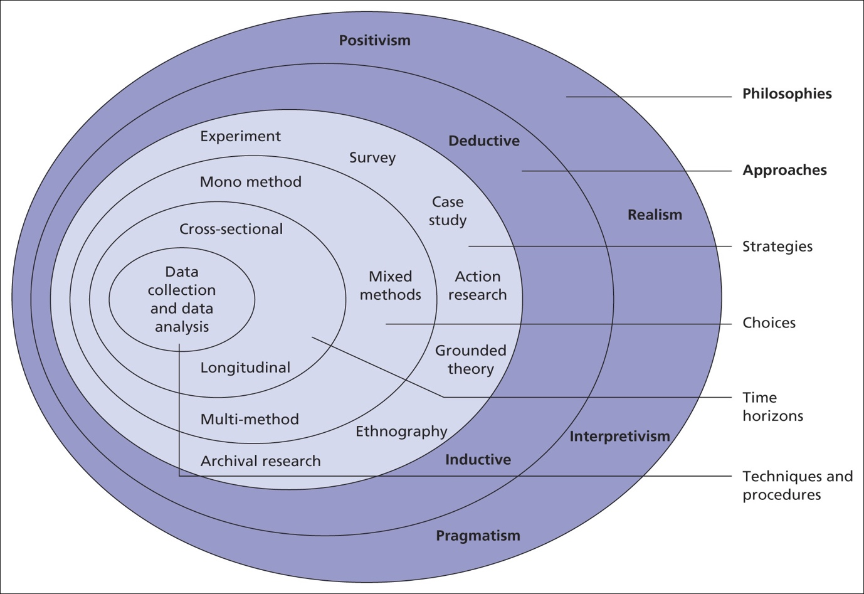
It is believed that to have to have a strong methodology when researching a specific topic, the researcher will need to address six layers of topics (Saunders, et al., 2009). These six layers have been known to create what has been labelled as a research onion guide which shapes how each good methodology must answer.
(Saunders, et al., 2009)

6.4.1- Philosophies
Different philosophies can vary dependant on the researchers view and understanding of the subject. The positivism philosophy believes that the solutions are beyond the study and what is being studied cannot be interfered but only observed, this will not be the philosophy of this study (Saunders, et al., 2009). The Interpretivism view would be that the study could be changed dependent on the researchers social and cultural factors meaning that results could vary depending on a person’s individuality (Saunders, et al., 2009). The last main philosophy would be Pragmatism which would mean no research is fixed and is open to be interpretated, this would mean that the researcher will draw an opinion at the end of the study which can be interpretated (Saunders, et al., 2009). In this project there will a be a focus on a pragmatic approach as all information outlining knife crime can be interpretated as both positive or negative and to get a full understanding of the problem, there needs to be an investigation into what works (Sahay, 2016).

6.4.2- Research Approach
There are two main research approaches according to (Saunders, et al., 2009), Inductive and Deductive. The inductive approach would be the creation of theories through research which could then be interpretated either way (Thomas, 2006), meaning that the researcher uncovers and fabricates the theory. A deductive approach would mean that the research would be beginning with a theory, this would mean that the research would spend time trying to disprove or prove the theory throughout its research (Sahay, 2016). For this project, there will be an deductive outlook into the research being conducted as many source point for the need to combat levels of knife crime across the UK such (MOPAC, 2017), (Sidebottom, et al., 2021) and (Brohi, et al., 2019). The theory is already present but looking into the success of the implications and further amendments if needed.

6.4.3- Research Strategies
According to (Saunders, et al., 2009) research onion, there are six potential strategies which can be used when conducting research: Experimental research, Action research, Case study research, Grounded theory, Ethnography and Archival research. This research project will be a combination of case study research because of the in-depth study of the public perception on knife crime and archival research by researching government documents and academic resources which will give more understanding of knife crime offences. Combining two methods will allow a complete understanding whether legislation and knife crime strategies are working or in need of amendments.

6.4.4- Research Choices
Research choices such as qualitive or quantitative data will be simple as this project will be running a mixed approach in gathering information. The questionnaire will gage understanding of personnel information via opinions whilst gather a public insight into how they feel about knife crime through statistics created through the questions. (Allwood, 2012)

6.4.5- Time Horizon
This project has been very hard to manage in terms of time frame. Countless hours of research have been needed to get a simple understanding of knife crime and legislation and strategies in place to combat it. Putting in the effort to tackle such a big project has not gone unseen. Looking at the structure set out to complete tasks inside this project has shown me that there is always more time for planning and preparation. The time horizon really affected the project whilst waiting for the results of the questionnaire as the project could not move forward without the public perception of knife crime.

6.4.6- Techniques and Procedures
In the research conducted, there were many factors which needed to be considered. As the main research being conducted will be getting a public perception on knife crime and then interpretating the information combined with academical research. Whilst conducting a public perception questionnaire there are many factors such as: ethicality of the questions, sample size and who would represent the public. The topic in general was overseen by a university supervisor to ensure no unethical questions were being asked, this meant that the green light was given, and every question was verified. The sample size was very difficult as the more answers and opinions would be better but getting a person to spend 10-15 minutes of their time is very difficult unless they had full understanding of what the project was trying to achieve. The questions were asked to anyone who would have liked to participate in this project but often answered by people who know me and have access to my social media. Lastly the aim of the questions was to gather social opinions and unique opinions on knife crime. By comparing answers, this will give more of a general overview.

7- Findings and Analysis
This chapter of this research project shows the findings from the questionnaire survey which has been conducted by the researcher. This outlines the public’s perception of knife crime and the role that youth have in this offence. This research will give a better understanding on if the public believe government methods are working to reduce this knife crime epidemic (Squires, 2009). This questionnaire was done on google forms and many of the questions have automated graphs which can present more representation to the statistics given. There were 52 responses to this questionnaire, and this will give a basis of public perception but understand to gauge a better understanding more response would be needed.

Question 1- “This questionnaire includes sensitive subjects in regard to knife crime. I understand all the terms and conditions and the data collected will only be used in this project and anonymous. I give permission for my answers to be used for research purposes”.

This first tick box question was to give the responder a disclaimer on the questionnaire and to remind them they have no obligation to complete this questionnaire if they are troubled by any questions or if they do not feel comfortable giving the answers. This would also remind them that all answers will remain confidential, and this survey will only be used for research and educational purposes. This question coincides with the university beliefs on ethics.

Question 2-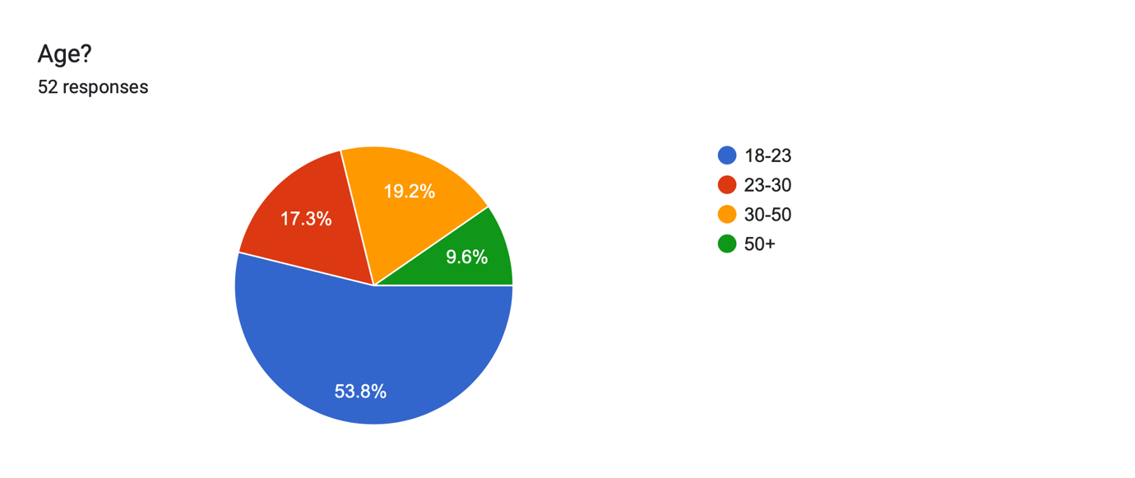

This graph shows that majority of the personnel which filled out this questionnaire were majority adolescents between the ages of 18-23 meaning that there may be a bias in majority of the people answering in favour of youth. The graph does show that all age groups participated in this survey which should give a more general view of the public. In an ideal research capacity, all ages would have been represented fairly but because of the researchers’ contacts, it was difficult getting opinions from older generations.

Question 3-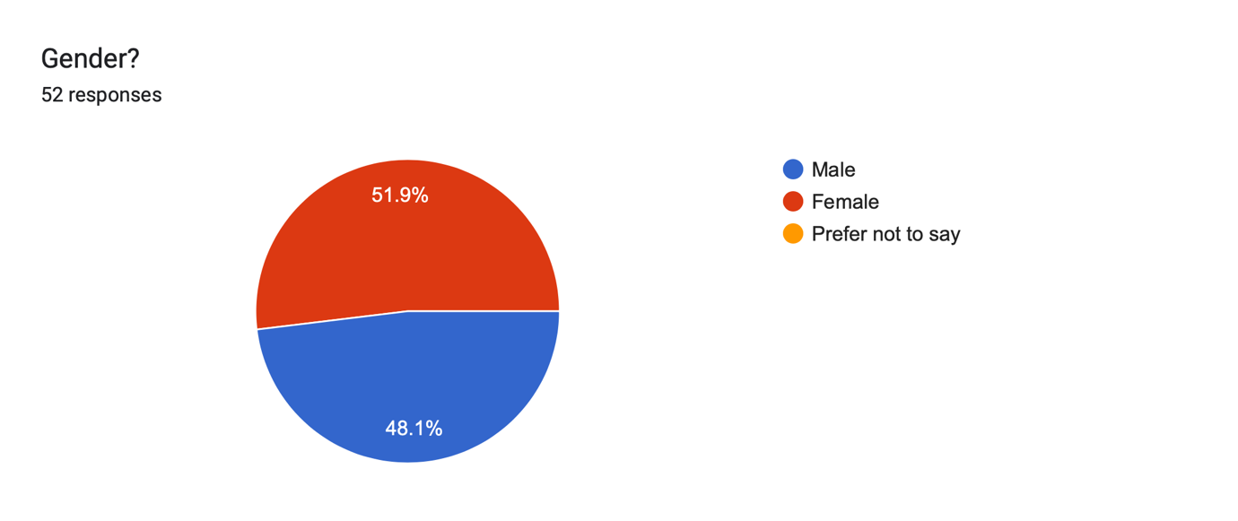
This graph shows a balance in gender, which proves that there will be fair representation of all of those involved in public. By subjecting more or a particular gender, this can cause gender mindsets and potentially narrow the information which can be gathered from conducting this survey.

Question 4- “Postcode? (Use first 3 letters, example SA1)”

This question was to understand the upcoming and where everyone generally lives without gathering confidential information. The statistics show that majority of the participants (47) in this questionnaire originate from SA region which indicates that their closest city would be Swansea. There are 4 participants from the Cardiff region of CF and lastly one participant who lives in Bristol are. This research would have been more insightful if there was a higher number of participants from various other regions but due to the reach of this research, it was difficult to get people who are unfamiliar to voice their opinion. If this research was conducted again, more attempt on creating a wider perspective will be made to create a broader understanding on the whole public belief on knife crime and not those who live in the Swansea region.

Question 5- Do you believe knife crime is a problem in the UK? If so why?

This question was to confirm that the British public beliefs that knife crime is a problem (Squires, 2009). It then allows them to voice their opinion into why they think there is a problem. In the 52 responses, 46 of the responses believed that knife crime was a problem in the UK. The other 6 responses emphasised that they didn’t believe that knife crime was a national problem but certain regions and built-up metropolitan areas (Massey & Coupe, 2019). There was a variety of reasons into why the public believed that knife crime is a problem from gangs, social media, protection and mostly accessibility to knives. All these subjects were highlighted by (Harding, 2020), showing that public have genuine knowledge and understanding into some of the factors which create majority of knife crime offenders.

Question 6- Are there many knife crime offences in your area?

This question was rather personal but gives information on the public beliefs regarding if knife crime is not a local offense they’re accustomed to, do they still believe it’s a problem. Majority of the participants in this questionnaire live local to each other therefore this will show similar results but different mindsets. The results show that 33 respondents don’t believe knife crime is a problem in their area. The 19 other results believed that it isn’t a major problem but certainly have seen a rise in recent years. This coincides with (Hern, et al., 2005) view that metropolitan areas could cause a knock-on effect on rural areas.

Question 7- Why do you think knife crime is so prevalent?

This question is an expansion of questions 5 but gives more of an insight into why they believe knife crime is so popular. Majority of the answers believe that the accessibility to knives is the real problem as knives have legitimate uses (Harding, 2020). Despite restrictions there will be no way knives could be removed from common usage. Methods such as knife amnesties used in operation sceptre (Greater-Manchester-Police, 2022), have prevention methods of people handing in dangerous knives without repercussions but this will not hinder the accessibility of knives.

Question 8- According to (Harding, 2020) knife crime is in a 70 year peak. Why do you think so many individuals carry knives?

This question gives the responder a reminder that knife crime is at an all-time high (Harding, 2020). Then asks why they believe there are so many individuals carrying knives. The most common answers were both ‘protection’ and ‘intimidation’, this is in line with (MOPAC, 2017) narratives into why so many individuals carry knives.

Question 9- (Lemos & Crane, 2004) state that most people who carry knives for protection can also become dangerous as "Protection can often change to aggression." Do you believe protection is an acceptable reason to carry a knife?

This question gives a quote from academic research which discusses knife carrying for the use of protection and how this can often change depending on perspective (Lemos & Crane, 2004). Majority of the public believe that this is not good enough as an excuse and there should be no excuse for breaking the law even if it was protection. A handful of responses gave reasoning into why they believe carrying knives for protection uses are okay in some scenarios.

“If you live in an area particularly affected by criminal activities e.g Mugging, assault, rape. The I understand the use of weapons with intent to defend oneself”

“I think in areas where knife crime is rampant it is more understandable however in quieter areas it is just absurd and reckless.”

“Yes and no, obviously if someone was walking home at night and decided to take a knife as they were scared, and ended up actually being attacked, the knife could save their life, but everyone will hear they carried a knife and stabbed someone.”

All the response above believe that using a knife for protection only applies dependent on the area one lives but contradicting to (Lemos & Crane, 2004), when one begins to carry a knife for protection, this can often lead to using the knife for other purposes.

Question 10- Do you believe government and police strategies in reducing knife crime are effective?

This question gathers the thoughts and opinions on government and policing strategies efforts against knife crime and majority of the answers believe that government strategies are ineffective solely on statistics (ONS, 2019). The responders also reference how if knife crime is in a 70-year peak as (Harding, 2020) states how can these strategies be working.

Question 11- Do you think that UK's youth is the problem in regard to knife crime?

This question collected the public opinion on whether youth were to blame about the problem with knife crime. According to (Gladstone & Parker, 2003), the media has shaped the knife crime ‘epidemic’ (Squires, 2009). This has meant that youth are perceived as the problem with knives in the UK. This question has had mixed responses.

“They aren’t the sole problem but they definitely don’t help. I feel like today’s generation of youth feel like they have a point to prove and in some cases that may mean carrying a knife to prove that they are someone to be frightened by or someone ‘not to mess with’”

“I think the youth now think carrying knifes are cool to intimidate and look grown up to their friends - especially if they have been recruited to drug run”

“Not really, they’ve had it from the older generation”

“I’d say the bigger issue is the older people who are grooming kids into a life if violence.”

These answers vary from youth responsibility to looking ‘cool’ to other youths causing violence, to them being exploited by older people who can manipulate younger people to do their jobs for them such as drug running. One response highlighted (Shulman, et al., 2013) of youths being more involved in crime in general meaning the problem isn’t knife crime but youth crime.

Question 12- Should Youth offenders get more support or receive harsher penalties for knife crime?

The response of the public to this question will give an insight in how the public would deal with youth offenders. This question again has divided opinions on how youth offenders should be treated. The problem the government have with issuing punishment would be the precedent side of proceedings, by supporting a social group they are neglecting other people who could also need the same help (HMIP, 2023). One participant gave the response of “depends on the situation and how the individuals attitude has been on the crime he has committed”. This response believes that if an individual has remorse for what they have done, they should get more support which is a very positive outlook on the situations but could this open the door to manipulation to reduce sentencing.

Question 13- Regarding the question above, can you elaborate on why you believe (Support or Harsher penalties) are needed?

This question asks the public to elaborate their thoughts and beliefs from the question above. These are a few of the different responses.

“Supporting people who carry knifes could lead to a greater understanding and stopping them from doing it in future and the harsher penalties could work but again I think the younger generation see prison as an accomplishment so community service or something supervised would work better.”

“Harsher penalties. If those who use knives/carry them do not have a good penalty then they will do it again. Punish them accordingly and it’ll help with not doing it again.”

“Bigger the punishment bigger the deterrent”

“Younger people need more opportunities to better themselves and get out of situations that lead to knife crime”

These responses give a very good insight into why both support and harsher penalties could potentially reduce knife crime. Harsher penalties could set more of an incentive on deterrence (Sidebottom, et al., 2021), this could then have collateral effects on associates of the offender and may warn others that they will receive the same treatment if they continue down this path. According to the (TheGuardian, 2019), prison has only had negative effects on youth who have experienced it from knife crime offences, this shows that the threat of prison may not be such a deterrent. The Youth Justice team would argue with some responses as by sending a person to prison this could send them down a different path in life like some of the responses believe (HMIP, 2023).

Question 14- Do you believe youth rehabilitation is effective? If so why?

Linking the last two questions, this question was to focus on if youth rehabilitation has been effective in the eyes of the public. This question also had a mixed response with no majority of responses as the responders generally believe it is down to the offender and not the act, which is contrary to (MOPAC, 2017) & (Astrup, 2019) beliefs in a public health approach to tackling knife crime. Yet the public health approach targets vulnerable individuals who before the stray down a bad path in prevention matters before committing an offence. Prison strategies of rehabilitation have been seen as a failure with youth (TheGuardian, 2019), this shows that more pre-emptive measures need to be put in place.

8- Conclusion

8.1- Introduction

This chapter will do a complete evaluation of all the research gathered on this topic and gave an opinion on if the government strategies and legislation are for the best whilst operating to reduce knife crime in the UK and whether there should be more emphasis on youth offenders. By combing both primary research of the public perception and secondary research through academic research.

8.2- Main Findings

This project has established that knife crime has become a real big problem in the UK over recent years, with it even being renounced as a ‘epidemic’ (Squires, 2009). Looking at legislation and strategies in place to counter knife crime, it was easy to see that severe measures were needed when knife crime statistics hit an all-time high of 45,000 cases in 2019 (ONS, 2023). The London Knife Crime Strategy was the first area which decided to initiate serious action on knife crime by announcing their know strategy to tackling knife crime and even ‘declaring war’ (Edwards, et al., 2008) on the matter. This strategy was bold and discussed all new initiatives on tackling knife crime by adopting a public health approach to tackle the war on knife crime (MOPAC, 2017). The public health approach strategy is used by the violence reduction units up in Glasgow had seen massive results in violence reduction (SVRU, 2022). (MOPAC, 2017) believed that by treating knife crime with this approach it will reduce violence and thus have a knock-on effect on knife crime as well. The public health approach was very supportive of multi-agency working which meant that more information could be shared between a variety of different agencies and service to understand what makes a violent offender, by understanding this it gives more understanding on prevention strategies which can be implemented to reduce violent offenders (Brohi, et al., 2019). This thesis has shown that a multi-agency approach to combatting can be beneficial to the reduction of violent offenders (Scottish-Governement, 2023), but statistics continue to raise in the UK (ONS, 2023). Lack of funding has been highlighted in both (MOPAC, 2017) & (HMIP, 2023) which has caused a breakdown in communication which is essential in multi-agency approach. The primary research conducted via questionnaire gives us the opinion of the public on knife crime, the results show mixed results and opinions on knife crime but also give more representation on personal opinions. Combining both academic research and the public perception it is clear to see that knife crime is so prevalent due to accessibility (Harding, 2020) and it is difficult to enforce people to not own knives because of their genuine uses. This project has also highlighted the influence media has over public perception as high numbers of the participants who engaged in the survey come from rural areas and they believe that knife crime is a big problem in gang culture yet (MOPAC, 2017) outlines that gang related knife crime only makes up for 5% of the knife offences in London. The questionnaire also shows public understanding on strategies and legislation in place, they believe as statistics (ONS, 2023) continue to rise there’s clearly a need for more change in strategies in tackling knife crime. This shows that prevention strategies are unknown to the public meaning how can they be affective if they are not aware of the laws, operational strategies such as sceptre are constructed on awareness (National-Police-Chiefs-Council, 2022). The public don’t feel that youth have complete responsibility for the knife crime statistics in the UK. The Age Crime Curve theory highlights that youth are more vulnerable in general to committing crime through their adolescent years meaning that youth offenders need more support in general to stop them venturing down a bad path in the first place (Astrup, 2019). The results show that the efforts being made to tackle youth offending are poor as statistics continue to rise but promising strategies of multi-agency work will take time for them to find optimal working strategies to combat youth offending (HMIP, 2023). Majority of the public that support would be better cause of action for youth offenders than harsher penalties as current penalties are not enough.

Bibliography
Allwood, C. M., 2012. The distinction between qualitative and quantitative research methods is problematic. Quality and Quantity, Volume 46, pp. 1417-1429.
Astrup, J., 2019. "KNIFE CRIME: WHERE'S THE PUBLIC HEALTH APPROACH?. Community Practitioner, 92(6), pp. 14-17.
Brohi, K. et al., 2019. A Public Health Approach to Knife Violence Reduction: Immunize, Protect & Rescue, s.l.: London Major Trauma System.
Brounéus, K., 2011. In-depth Interviewing: The process, skill and ethics of interviews in peace research. Understanding Peace Research, pp. 130-145.
Christmas, H. & Srivastava, J., 2019. Public health approaches in policing A discussion paper, s.l.: Public Health England.
Coleman, K., 2008. Home Office Statistical Bulletin 03/08, London: Home Office.
Crown-Prosecution-Service, 2022. Offensive Weapons, Knife Crime Practical Guidance. [Online]
Available at: https://www.cps.gov.uk/legal-guidance/offensive-weapons-knife-crime-practical-guidance
[Accessed 2 February 2023].
DeLisi, M., 2015. Age–Crime Curve and Criminal Career Patterns. The development of criminal and antisocial behavior: Theory, research and practical applications, pp. 51-63.
Driscoll, D. L., 2011. Introduction to Primary Research: Observations, Surveys, and Interviews. Writing spaces: Readings on writing, pp. 153-174.
Edwards, R., Farmer, B. & Allen, N., 2008. The-Telegraph. [Online]
Available at: https://www.telegraph.co.uk/news/majornews/1953088/Met-declares-war-on-knife-crime-gangs.html
[Accessed 20 March 2023].
Gibbs, G., 2018. Analyzing qualitative data.. Volume 6 ed. s.l.:Sage .
Gladstone, G. & Parker, G., 2003. What’s the use of worrying? Its function and its dysfunction. Australian and New Zealand Journal of Psychiatry, Volume 37, pp. 347-354.
Greater-Manchester-Police, 2022. Greater Manchester Police. [Online]
Available at: https://www.gmp.police.uk/news/greater-manchester/news/news/2022/november/greater-manchester-police-launches-operation-sceptre-intensification-week-of-action2/
[Accessed 12 March 2023].
Harding, S., 2020. Getting to the Point? Reframing Narratives on Knife Crime. Youth Justice, 20(1-2), pp. 31-49.
Hern, E., Glazebrook, W. & Beckett, M., 2005. Reducing knife crime. BMJ, 330(7502), pp. 1221-1222.
HMIP, 2023. Promising approaches to knife crime: an exploratory study, s.l.: HM Inspectorate of Probation.
Lemos, G. & Crane, P., 2004. The Use of Knives and Other Weapons by Young People.. Fear and Fashion.
Massey & Coupe, S. L. a., 2019. Forecasting knife crime homicide risk from prior knife assaults in 4835 local areas of London, 2016–2018.. Cambridge Journal of Evidence-Based Policing, Volume 3, pp. 1-20.
MOPAC, 2017. London Knife Crime Strategy, s.l.: Greater London Authority.
National-Police-Chiefs-Council, 2022. NPCC. [Online]
Available at: https://news.npcc.police.uk/releases/nationwide-week-of-action-sees-police-crackdown-on-knife-crime
[Accessed 18 February 2023].
Nickolls, L. & Allen, G., 2022. Police powers: stop and search, s.l.: House of Commons Library.
ONS, 2019. Homicide in England and Wales: Year Ending March 2018. , London: ONS.
ONS, 2023. Office for National Statistics. [Online]
Available at: https://www.ons.gov.uk/peoplepopulationandcommunity/crimeandjustice/datasets/policeforceareadatatables
[Accessed 17 March 2023].
Rocque, M., Posick, C. & Hoyle, J., 2015. Age and Crime. The encyclopedia of crime and punishment, pp. 1-8.
Sahay, A., 2016. "Peeling Saunder's research onion.". Research Gate, Art , pp. 1-5.
Saunders, M., Lewis, P. & Thornhill, A., 2009. Research methods for business students. 5th ed. s.l.:Pearson Education.
Scottish-Governement, 2023. Scottish Governemnt. [Online]
Available at: https://www.gov.scot/policies/crime-prevention-and-reduction/violence-knife-crime/
[Accessed 11 February 2023].
Shulman, E., Steinburg, L. & Piquero, A., 2013. The age-crime curve in adolescence and early adulthood is not due to age differences in economic status. J Youth Adolesc., 42(6), pp. 848-860.
Sidebottom, A. et al., 2021. Knife crime A problem solving guide, s.l.: College of Policing.
Silvestri, M, O., P, S. & R, G., 2009. Young People, Knives and Guns: A Comprehen- sive Review. Analysis and Critique of Gun and Knife Crime Strategies.
Southampton-Uni, 2023. The University of Southampton. [Online]
Available at: https://library.soton.ac.uk/sash/primary-research#:~:text=Primary%20research%20–%20what%20is%20it,go%20out%20and%20collect%20yourself.
[Accessed 1 April 2023].
Squires, P., 2009. The knife crime ‘epidemic’and British politics. British Politics, Volume 4, pp. 127-157.
Stewart, D. W. & Kamins, M. A., 1993. Secondary Research: Information Sources and Methods. s.l.:SAGE.
Sukamolson, S., 2007. "Fundamentals of quantitative research.". Language Institute Chulalongkorn University , pp. -20.
SVRU, 2022. Scottish Violence Reduction Unit. [Online]
Available at: http://www.svru.co.uk/public-health-approach/
[Accessed 10 February 2023].
TheGuardian, 2019. Guardian. [Online]
Available at: https://www.theguardian.com/uk-news/2019/apr/27/prison-increases-youth-knife-crime-reoffending-says-police-report
[Accessed 1 April 2023].
Thomas, D., 2006. A general inductive approach for analyzing qualitive evaluation data. American journal of evaluation, 26(2), pp. 237-246.
Thornton, J., 2019. Doctors could be obliged to report youths at risk of knife crime, says home secretary. BMJ : British Medical Journal, p. 365.
UK-Government, 2019. Gov.UK. [Online]
Available at: https://www.gov.uk/government/news/home-secretary-announces-new-police-powers-to-deal-with-knife-crime
[Accessed 2 February 2023].
UK-Government, 2023. Gov.uk Youth Offending Teams. [Online]
Available at: https://www.gov.uk/youth-offending-team
[Accessed 10 March 2023].
Weidman, K., Little, T., Preacher, K. & Salawami, G., 2011. On creating and using short forms of scales in secondary research. In. Secondary data analysis: An introduction for psychologists, pp. 39-61.
YouthEndowmentFund, 2023. YouthEndowmentFund. [Online]
Available at: https://youthendowmentfund.org.uk/about-us/our-strategy/

Appendices





