

UNIVERSITY OF WALES
TRINITY SAINT DAVID

DIGITAL DEGREE APPRENTICESHIP
APPLIED DATA SCIENCE

LEARNING IN THE DIGITAL ERA
ACCA4025

NICHOLAS ALDOUS
2237649

CONTENTS

TASK 1 3
TASK 2 5
TASK 3 7
TASK 4 9

TASK 1
SELF EVALUATION

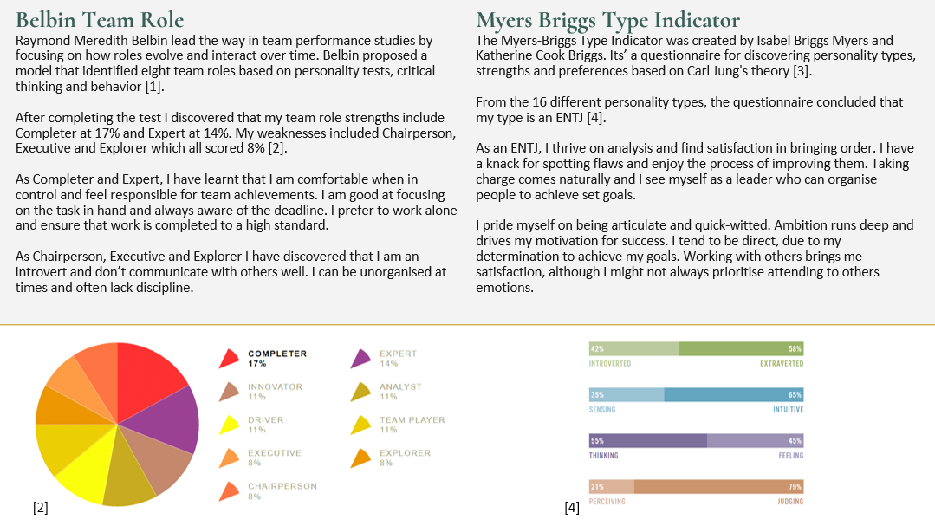
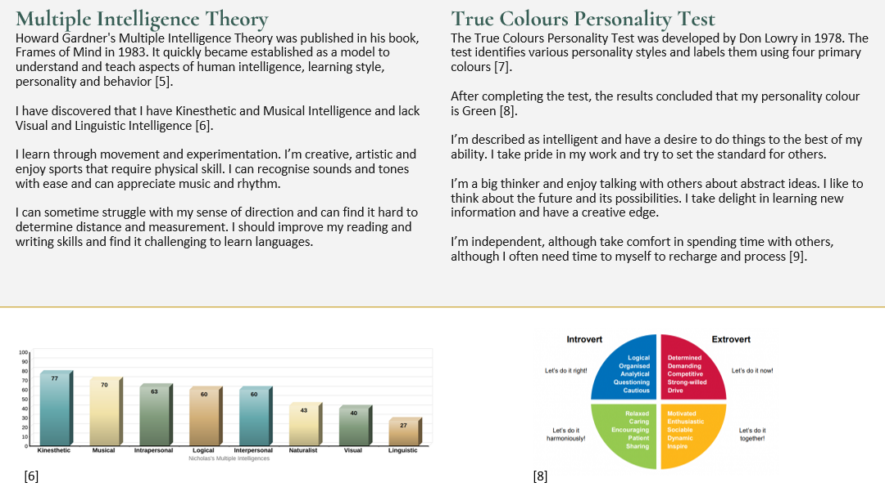

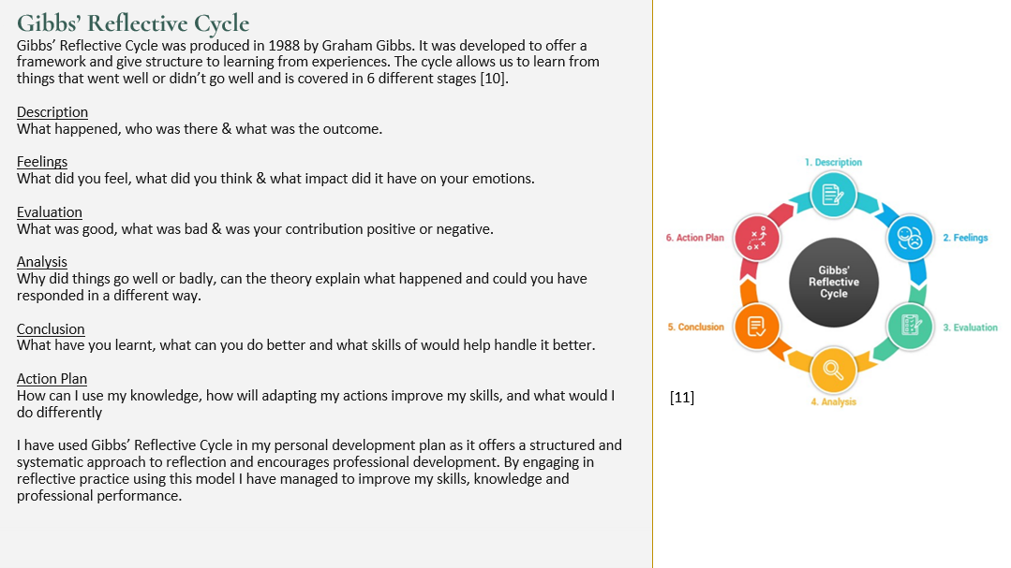

TASK 2
PERSONAL DEVELOPMENT PLAN

Please find below a link to the Personal Development Plan
https://docs.google.com/document/d/1qHfnZ-jBp426ExiEcaYv4Bt6oZ4cnw00/edit?usp=drive_link&ouid=100484526482929115189&rtpof=true&sd=true
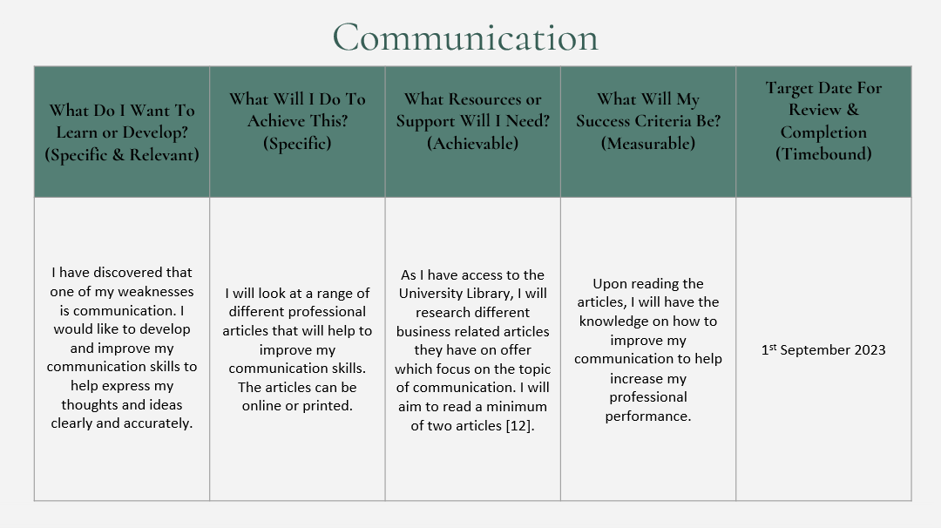
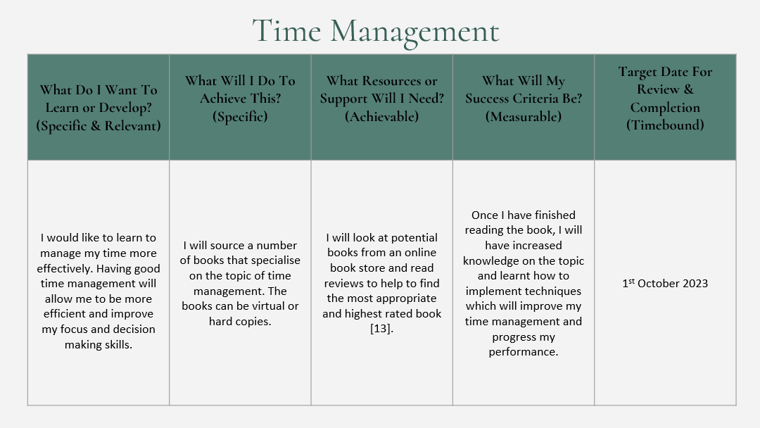
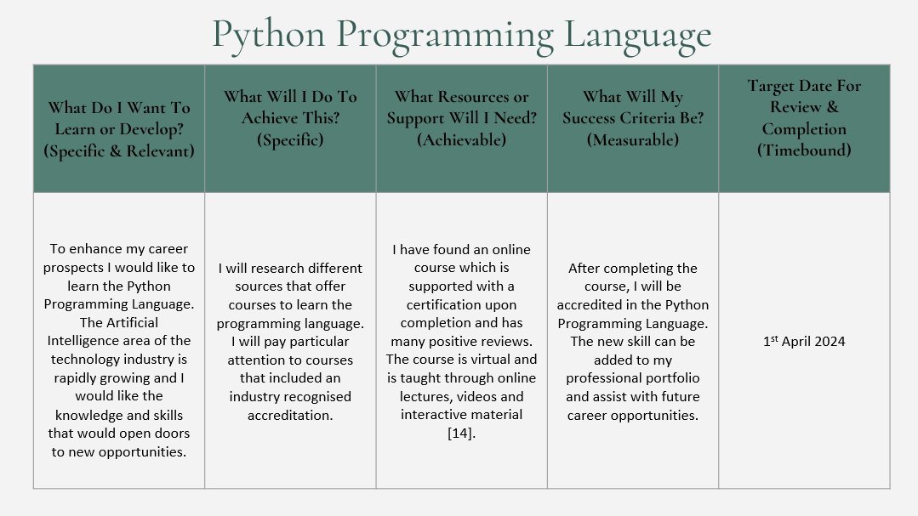

TASK 3
TOPIC SUMMARY

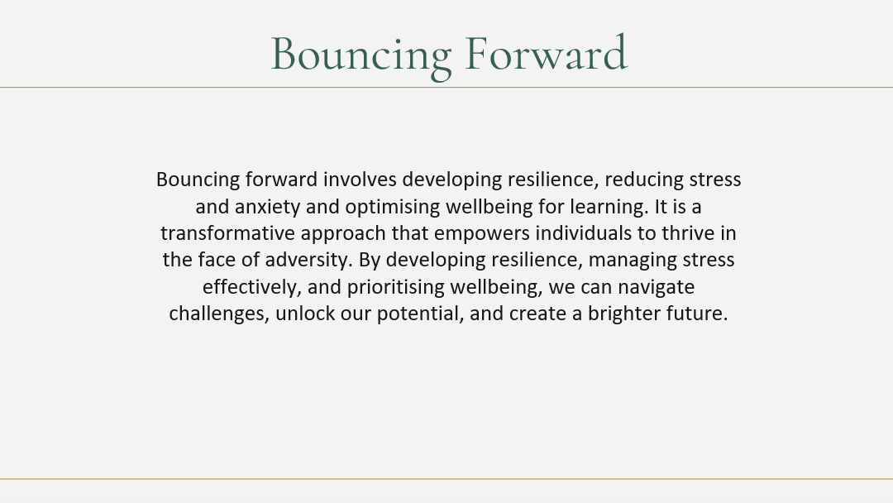
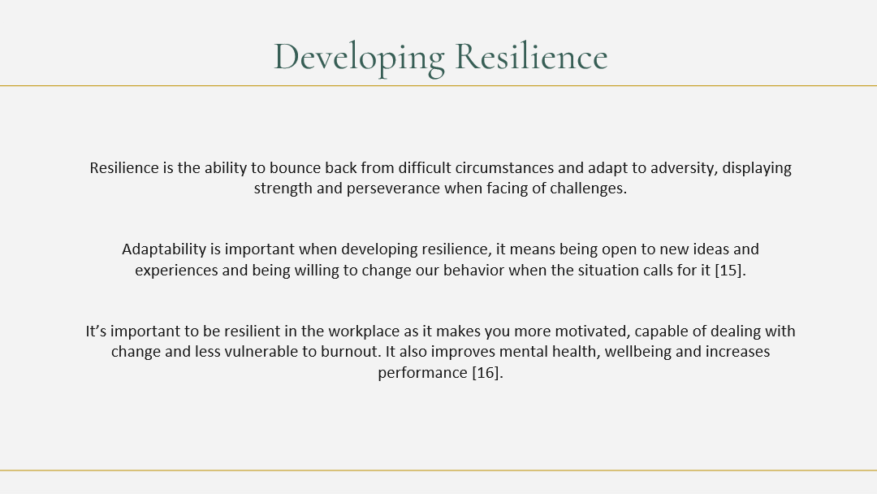
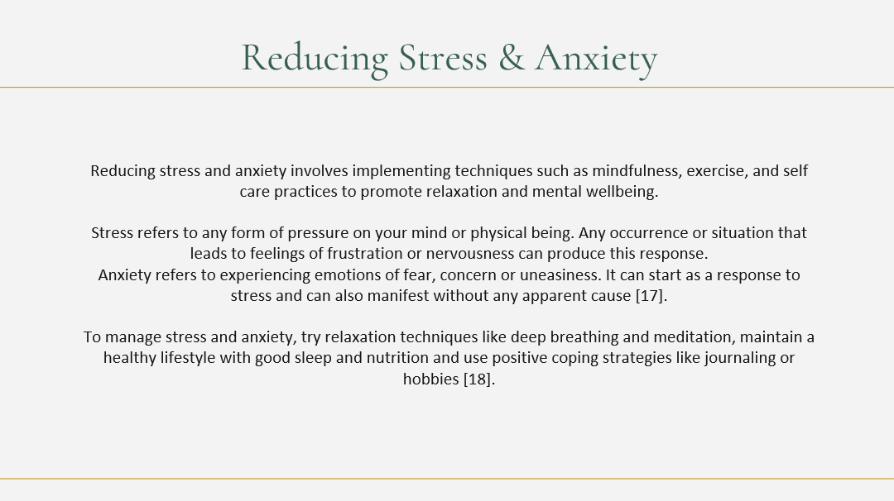
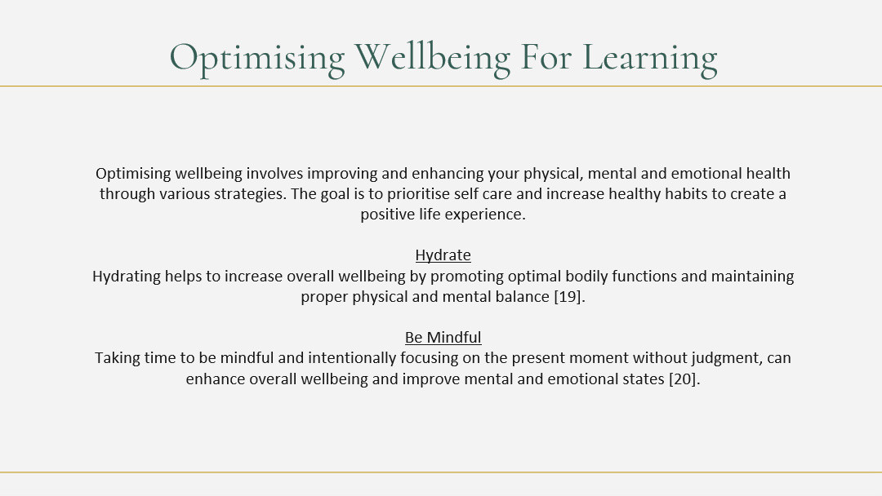

TASK 4
VIDEO

Please find below a link to the video
https://youtu.be/ISGRQMI2Anc

Please find below a link to the full presentation
https://docs.google.com/presentation/d/10ojBmoeDe-sEf0prJX5kjLGHrllNlOxt/edit?usp=drive_link&ouid=100484526482929115189&rtpof=true&sd=true

