1812519
Mercedes Harding
Supplementary notes
Creating a business plan

The Pretty Mad Cheshire
(Beauty Salon)
I will be bringing my makeup skills to the business and Katie and I will be jointly doing afternoon tea.
The makeup look I will be going for is a mix of full glam, natural glam, bridal as well as natural basically whatever the client wants to achieve. The reason behind doing make up for my business is because it has been a passion of mine for many years and my dream is to open up my very own salon one day and run my own business, making this business plan has been very helpful with knowing what to do in the future for when I open my very own beauty salon. I am not a qualified a makeup artist now, but within time and training I will be. I will be using a wide range of makeup brands to suit and match all skin colours and types; we will also be looking into a unique brand of makeup specially designed for transgender women. the requirements.
How much I am going to charge for my makeup service will solely depend on the look my client is hoping to achieve, the more the glam the more make up used me more expenses.
My basic prices will be anything from £25-£40. Price will vary if client wants eyelashes. But our goal is that people will not need to go elsewhere and can come and get everything done in one place, Katie will be offering lash extensions so customer can have lashes done before make up appointment but recommended that the client keeps around three hours for this, as eye lash extensions can take anywhere between 2-3 hours. But we do recommend having lashes day before make-up appointment if times is an issue on the day. We will also be looking expand on our service in the future by hiring a nail and spray tan technician, this will mean our clients can get the full works on their special day.

Afternoon tea.
Afternoon tea will be available to clients as an optional ad on, but it is only available with a large volume of clients. Booking will have to be a minimum on six and a maximum of ten this is because we know we are earning enough to be able to profit from the afternoon tea. The reason behind having a maximum of ten is because the table we will have will only hold up to ten guest and with the afternoon tea side of our business not being the main focus we need to make sure we have enough space in our salon for all our equipment and work stations. As well as plenty of storage for our stock. Katie and I will be making the afternoon tea but will not be holding any fresh food at the salon that will always be kept at our home. But our aim is to be as fresh as possible by purchasing and preparing the food the same day or night before so it perfectly fresh on the day, with doing our own food will need to have basic health and safety insurance as well as food inspectors out to issue our hygiene rating. The price of afternoon tea will by £10 per person. There will be a wide selection of teas, sandwiches, and cakes. We can meet dietary requirements, but we will need to be informed at least 48 hours before clients visit. This is to make sure we have what we need to cater for the requirements.
Booking system
We will have an online booking system for clients that will like to book, as well as over the phone this is so we can keep track with our appointments and make sure it’s a smooth and safe process. The booking system will also give you the option to put your skin type and allergies in so we can be aware before client’s appointment. Customers data will be stored under the data protection act data will be kept safe and will not be shared with any third parties, data protection is also for employees, suppliers and anyone else relating to the business (Gold, 2018). A £10 deposit will be taking when booking appointments threw the online booking system as well as over the phone this is to secure the appointment. the ten-pound deposit will be taking off the amount of the appointment on the day of the client’s appointment. Customer who cannot make their appointment or no longer require it, they will have to abide by our cancelation policy which 50% of the price of the appointment if cancelled with in 24hrs or if cancelled on the day of the appointment the full amount will be required and this will be taken by the card used to make the booking threw the online booking system as well as over the phone, terms and conditions of this will be available on the website so clients are able to read threw them before booking their appointment.
Marketing
my business partner Katie and myself will have our own social media pages, which will include Instagram and Facebook.
We will also be offering referral discounts, this is a brilliant idea because if I go someone to have my make-up done and I love it, I can’t wait to share it with my friends, so it would be such an amazing idea to offer referral discounts as it encourages clients to spread the word and grow your business even more. How we will give these discounts will be threw the post to our clients on little post cards to say thank you and here is a little discount off your next visit. This method would be a great way to get new clients through the door. Address are gathered threw our booking system.
We will also be providing loyalty cards to clients, this is a great way to give back to your honest loyal clients and another way to say thank you, we will be given our fabulous clients a little loyalty card meaning every time they have a service with us, they get a stamp and for every six visit they get a free service of their choice. It is very important to give back and keep your loyal customers loyal.
By given customers Birthday promotion discounts can be a nice gesture to your clients and also a good way to get your clients to come in for their birthday (Lister, 2019).
The advantages of social media marketing
90% of people that use social media for marketing said that it was great way to expose their business. It is also a great way for you to grow your business. Social media is one of the best ways for keeping costs down for marketing. By getting other businesses, family and friends to share your page will increase the amount of people that see it and the more followers you get the more you will get noticed. Keeping your page regularly updated by posting frequently and getting more and more people liking and sharing you work will defiantly boost clientele. More people knowing about your business on social media the better. By spending a few hours, a week on your social media page and getting as many people as you can sharing it will most defiantly be worth it. If you chose to not use social media, it will decrease the potential amount of customer you have, and you will be very limited to your regular customers or just your locals. Without social media it will be very difficult to reach out to customers further afield. With so many different people, out there become so many different needs and different ways of thinking. By placing your business on different types of social media, could make it reach thousands of people across the globe.
It is very clear that social media has its advantages, that’s why my business partner Katie and I will most definitely be using this platform for our salon. (Media, 2019)
Business cards
With starting our own business budgets are going to be tight and using business cards will be an affordable and affective way of marketing. Despite being a small way of marketing, you can be surprised at what you can put on them, you can put your name, contact, details and even a coupon. The even small enough your clients can put in their purse, so our clients have got access to our details when needs be as well as if they want to refer us to a family member or friend maybe even a college at work. The bottom line is to business cards they been around for a long time and that’s because they work, you can even give a pack of business cards to other local business for them to hand out to their customers, example if you handed your business cards to a local corner shop, there is a good chance that lots of different types of people will see them because think how many different types of people visit a corner shop. When designing our business cards they will need to be clean and smart looking to word heavy and people can get bored very easily and may not be interested than they first was when they first picked it up, so remember to keep it nice and simple and straight to the point (Rabida, 2017).
Surveys/Questionairs
Katie and I went out and asked the public to do a survey, based on the information gathered 52.5% of people will be 15-25 with a further 25% falling in to the 30+ category. This means that our target market will be more drawn towards the ages 15-25.
How we can target that age group can be threw fun and more vibrant décor as well as younger generation music. We could also include, wider selection of refreshments to suit youngers needs, like soft drinks as well as the tea and coffee we already have in place.
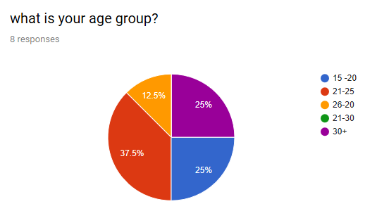
We gave the public the option to select the gender in our questionnaire, based on the statistics we found that 50% of our clients were males so as a business we will have to cater for males needs, which could be using make up products specifically designed for men. My partner and I have come across a brand that specifically supplies male make up products. Her brand has been featured on the front page of Forbes magazine, this is a massive achievement or the artist and it means her brand is a trust well known certified brand. (Knowles, 2018) this will be a fantastic opportunity to have a unique selling point for our business. We also always like to put the option in (prefer not to say).
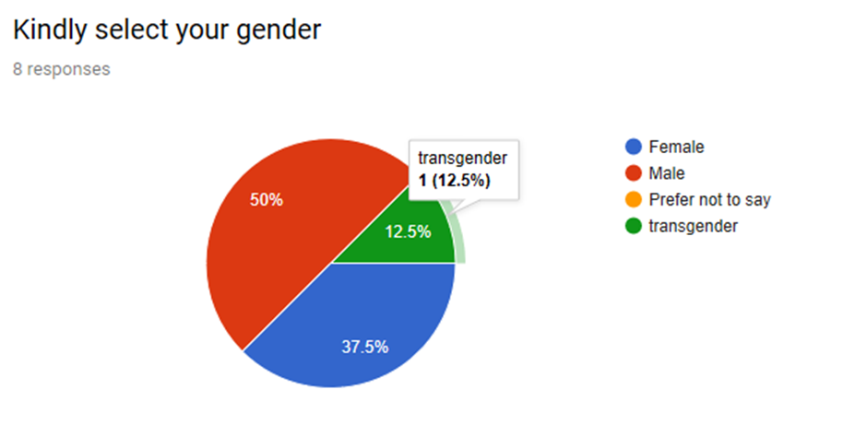

With our recent feedback 50% of people would like the option to have afternoon tea with the makeup and services, this is a great result for our business as my partner and I have put In a lot of time and effort to make the afternoon tea affective. Afternoon tea is only available with mass bookings but seeing as there is such a high interest, perhaps my partner and I could make it available with smaller bookings.
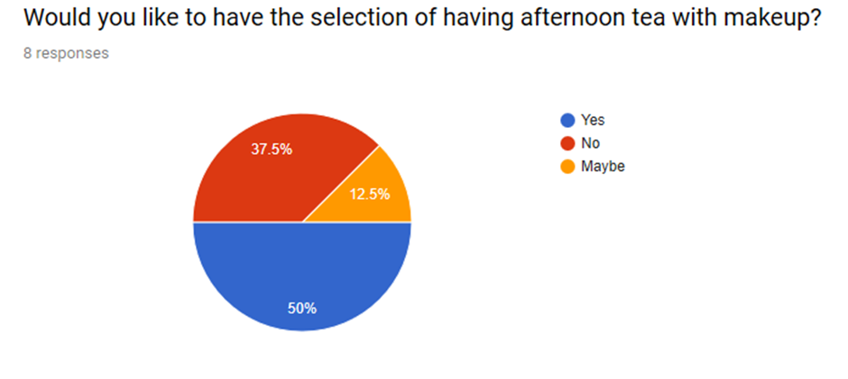

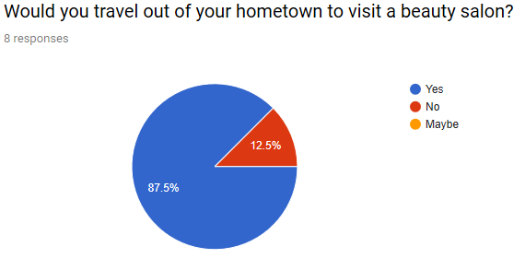

87.5% of people would travel out of the hometown to come visit our salon, this is such great news for us because it means our salon is so unique that people would travel to experience our twist on wonderland.
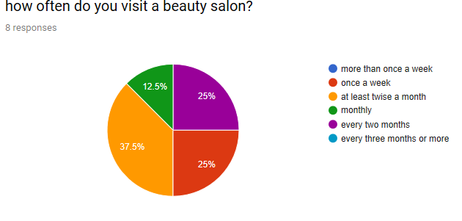
37.5% will visit our salon at least twice a month and 25% of clients will visit once a week, such great results to keep our loyal customer returning in a short space of time.
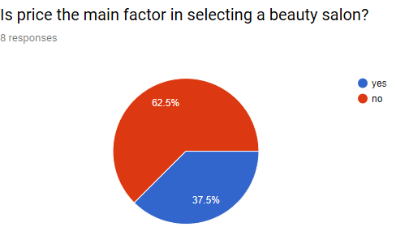
Its so good knowing 62.5% of our clients don’t think that price is the main factor, most of our clients know and understand its more to a salon than just a good price. Even know a good fair affordable price is one of the things that will keep our customers returning.
Doing this analysis has really helped us look at our business from a different prospective and will help widen our mindset.
Thank you for taking the time to read my business plan, below I have inserted my reference list.

Reference list
Gold, S., 2018. Salon Gold. [Online]
Available at: https://www.salongold.co.uk/salon-insurance/everything-you-need-to-know-about-gdpr-for-salons-compliance-checklist-for-2018
[Accessed 09 12 2019].
Knowles, K., 2018. Genderless Makeup Brand Jecca is L'oreal's Latest Startup Squeeze. [Online]
Available at: www.forbes.com
[Accessed 27 11 2019].
Lister, M., 2019. The World Sream Blog. [Online]
Available at: https://www.wordstream.com/blog/ws/2017/02/17/salon-marketing-ideas
[Accessed 09 12 2019].
Media, B. F., 2019. Blue Fountain Media. [Online]
Available at: https://www.bluefountainmedia.com/blog/advantages-of-social-media-marketing
[Accessed 09 12 2019].
Rabida, K., 2017. Print Place. [Online]
Available at: https://www.printplace.com/blog/5-benefits-of-business-cards/
[Accessed 09 12 2019].

