

BMHP6029-Psychopathological Classifications and Provisions

Component 2: Written Assignment (Report)
Student name: Delia Munteanu
Student number: 2314055

SCHIZOPHRENIA

Table of Contents
Introduction 4
2. Classification and Diagnosis: 5
2.1 ICD-11 Classification Overview 5
2.2 Diagnostic Criteria 5
3. Treatment and Rehabilitation: 6
3.1Pharmacological Interventions 6
3.2 Psychological and Psychosocial Interventions 7
3.3 Rehabilitation and Recovery Models 8
3.4 Effectiveness and Limitations 9
4. Current Debates and Emerging Issues: 9
4.1 The Neurodivergence Debate 9
4.2 Reclassification and Conceptual Debates 10
4.3 Socio-Political and Cultural Dimensions 10
4.4 Policy and Human Rights 10
Recommendations: 10
Conclusion 12
References 13

Introduction
This report gives a detailed description of the schizophrenia mental disorder, a severe disorder that falls under the ICD-11 classification of 6A20. It is typified by perceptual, cognitive and behavioural disruptions that affect functioning and socialisation. Schizophrenia has an estimated global prevalence of 24 million individuals. It is a top contributor to the worldwide burden of disease, with high ranks among the causes of disability-adjusted life-years among young adults. Its persistent character, high individual and social costs, and impact on quality of life highlight its public health concern. The aetiology of the disorder is explained in terms of biopsychosocial factors, which entail genetic susceptibilities, neurobiological changes, psychological susceptibility, and unfavourable social influences.

2. Classification and Diagnosis:

2.1 ICD-11 Classification Overview
According to the ICD-11, schizophrenia falls under Chapter 06: Mental, Behavioural, or Neurodevelopmental Disorders, where it is coded as 6A20. It characterises schizophrenia in terms of the enduring delusions, hallucinations, incoherent thinking, and negative symptoms. In contrast to ICD-10, ICD-11 eliminates the use of traditional subtypes (paranoid, catatonic, hebephrenic) and adopts a dimensional approach, prioritising the dimensions of symptoms: positive, negative, cognitive, and psychomotor (Barbieri et al., 2023). This is a bid to achieve a more representative range of presentations. To eliminate stigma and encourage a more inclusive view of mental health issues, ICD-11 also uses the term disorder rather than disease or illness.

2.2 Diagnostic Criteria
The difficulties and controversies that accompany the classification and diagnosis of schizophrenia indicate the ambiguous and disputable character of the disorder. Diagnostic overlap is one of the main issues because clinicians often have problems with distinguishing between schizophrenia and other disorders, including schizoaffective and bipolar disorder with psychotic symptoms, schizophrenic disorder and severe depression with psychosis. Such symptom overlap can lead to misdiagnosis, inappropriate treatment plans, and varying prevalence rates in clinical populations. Additionally, the signs that are central to the diagnosis are subject to diverse interpretation in different cultural backgrounds, especially hallucinations and delusions. What can be viewed as pathological in a given culture might be viewed as spiritual or normative in a different culture; thus, the importance of culturally sensitive diagnostic practices that do not overlook local beliefs and are not ethnocentric.
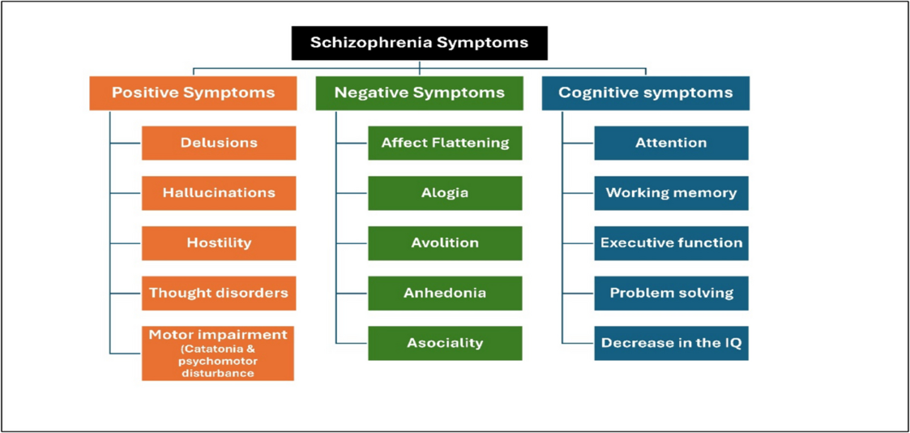
Figure 1: A comprehensive review of schizophrenia
(Source: Anwar et al. 2025)
Moreover, there are gender and age differences that pose additional diagnostic problems. Studies have shown that schizophrenia usually appears sooner and worse in males, and later and with a more promising prognosis in females. Equally, adolescent-onset and late-onset schizophrenia may vary in the manifestations of the disease, its progress, and treatment response, and it is also clear that clinicians should be flexible in their developmentally and gender-sensitive approaches to assessment. In addition to these clinical complexities, even the questions of construct validity are still debated in psychiatry and psychology (Deshields et al., 2021). This is becoming more of a thesis of researchers that schizophrenia is not a single disorder but a continuum of psychotic disorders, with multiple biological, cognitive, and social aspects. It has led to demands to implement a dimensional or spectrum-based diagnostic model, reflected in some of the changes made to ICD-11. Lastly, the stigma related to the word schizophrenia is still one of the greatest obstacles on the way to recovery and social integration. There is a general misunderstanding among the general population that the disorder is synonymous with danger or unpredictability, and this results in marginalisation, discrimination and self-stigmatisation among the people who are diagnosed. As a result, other mental health advocates and scientists suggest rebranding or redefining schizophrenia to reduce stigmas and enhance a more humane and recovery-focused conceptualisation of psychosis.

3. Treatment and Rehabilitation:

3.1Pharmacological Interventions
The pharmacological intervention continues to be the mainstay of schizophrenia treatment, and its main purpose is to control the occurrence of acute psychotic symptoms and prevent the relapse of the disease. Antipsychotic drugs fall into two broad categories: first-generation (typical) and second-generation (atypical). The antipsychotics of the first generation, including haloperidol and chlorpromazine, are primarily dopamine D2 receptor blockers, which can decrease positive symptoms such as hallucinations and delusions (Shukla et al., 2022). They are, however, limited mainly by a high risk of extrapyramidal side effects, such as tremors, rigidity, and tardive dyskinesia, which may severely affect quality of life and compliance. Second-generation antipsychotics, such as risperidone, olanzapine, and quetiapine, in contrast, are bispecific (targeting dopamine and serotonin receptors) with a more extensive neurochemical profile. They are linked to fewer motor side effects. They could have a negligible impact on reducing the negative and cognitive symptoms, including apathy and poor concentration, that are not readily responsive to most antipsychotics. Clozapine is the most useful atypical medication when treating schizophrenia that is not responding to other medications, and it has a better outcome in decreasing the persistent psychotic symptoms as well as in minimising the risk of suicide. However, its use is limited due to the risk of serious side effects, the most common being agranulocytosis, a life-threatening decrease in white blood cells, which requires frequent blood tests. Although pharmacotherapy is invaluable for symptom management, it is not devoid of significant constraints (Vita et al., 2021). The effects of antipsychotics on cognitive impairments and negative symptoms are typically limited, as these factors are important predictors of functional recovery in the long term. In addition, weight gain, metabolic syndrome, and risk of diabetes, especially with second-generation agents, are some of the side effects that lead to low levels of medication adherence. The consequences of non-adherence, be it intolerable side effects, lack of insight, or complicated treatment regimens, are often a symptom relapse, hospitalisation, and poor psychosocial functioning. Therefore, psychosocial and rehabilitative interventions should be used to supplement pharmacological therapy to achieve lasting recovery and enhance the overall quality of life of patients living with schizophrenia.

3.2 Psychological and Psychosocial Interventions
With pharmacological treatment of schizophrenia, psychological and psychosocial interventions are crucial as they tend to fill the gaps of treating the disorder, both psychologically and sociologically and in functional terms as well. These interventions aim to strengthen coping skills, reduce the risk of relapse, and improve overall quality of life. One of the most well-studied and most used methods is Cognitive Behavioural Therapy of Psychosis (CBTp), which assists individuals in identifying and re-evaluating unhelpful beliefs related to delusions and hallucinations. CBTp promotes the creation of functional coping patterns to manage distressing experiences, enhance insight, and support adaptive functioning. There is evidence that CBTp has the potential to lower symptom severity and improve emotional well-being with or without medication and long-term support. Family intervention is another necessary part of the psychosocial care. It is devoted to the education of family members on the nature of schizophrenia, supportive communication, and the high level of expressed emotion, which is highly correlated with relapse (Gowda and Isaac, 2022). Through such interventions, caregivers have also learned coping skills to manage the pressures of long-term care, thereby fostering a stable, recovery-oriented home environment. Social Skills Training (SST) also supports the recovery process by developing interpersonal skills, communication, problem-solving, and assertiveness. Such skills play a major role in restoring social networks and re-entering the community. Work-related programs, such as supported employment, help them find and keep meaningful work, thereby improving their autonomy, self-esteem, and social inclusion. Also, peer-based recovery opportunities, where people with lived experience mentor and support each other, have shown great potential to foster empowerment and reduce isolation. All these interventions emphasise a shift to a holistic, recovery-based paradigm of care, prioritising empowerment, inclusion, and person-centred support alongside clinical symptom management.

3.3 Rehabilitation and Recovery Models
The rehabilitation and recovery model of schizophrenia is a paradigm shift, focusing on symptom reduction to a more person-focused approach to recovery and inclusion in society, as well as the quality of life. In line with the postulates of ICD-11, recovery-oriented care motivates individuals to live meaningful lives with autonomy and dignity, despite persistent symptoms. In this respect, rehabilitation comprises a multifaceted spectrum of social, work, and community-based services intended to restore functioning and reintegration into society.
Supported employment is one of the most effective types of psychosocial rehabilitation and helps schizophrenic patients to locate and sustain competitive employment. It has been shown that stable employment not only increases financial independence but also makes individuals more confident in themselves and more socially included. Likewise, supported housing programs offer people safe, affordable, and independent living conditions, which are critical to stability and long-term recovery (Onitsuka et al., 2022). These housing services typically include case management and community services to ensure continuity of care. Also, there is the community participation program, which involves social, educational, and recreational activities that assist individuals in restructuring their social networks, learning new skills, and feeling a sense of belonging in their communities.
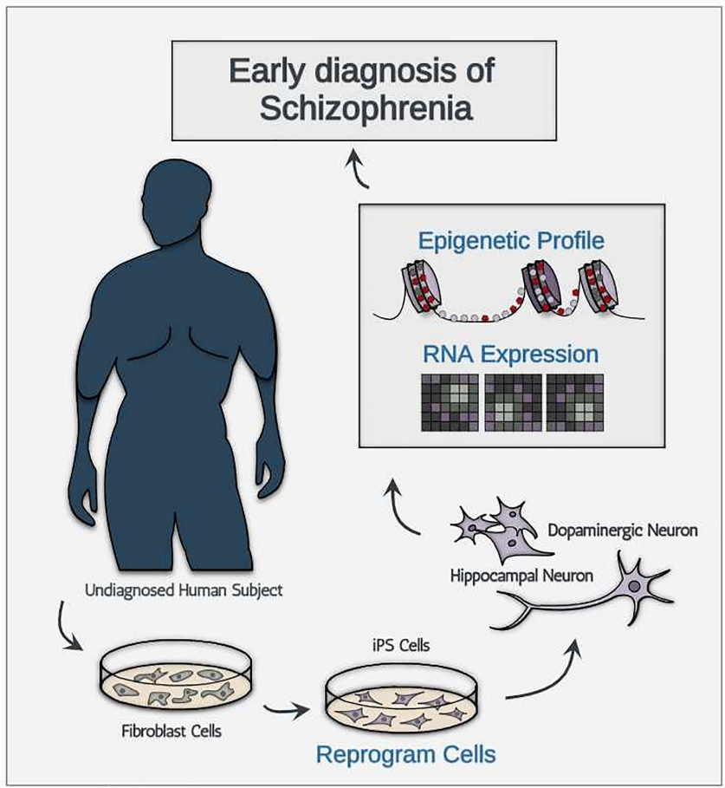
Figure 2: The Perspectives of Early Diagnosis of Schizophrenia Through the Detection
(Source: Lee et al., 2021)
Despite these advantages, recovery-oriented rehabilitation faces major obstacles that limit its full realisation. Services in most low- and middle-income nations are less developed and less coordinated, and access to trained mental health practitioners is low, and there is insufficient infrastructure. The stigma associated with a disease and the lack of its elimination at the societal and healthcare levels only contribute to the worsening of the exclusion and a diminished chance of individuals obtaining a job or an education. The recovery model redefines recovery as a strong, individual process of change, in which attitudes, values, and roles are transformed so that an individual can live a full life despite lingering symptoms. This is another perspective that emphasises self-determination, hope and empowerment over a more medicalised conception of schizophrenia.

3.4 Effectiveness and Limitations
The better the functional performance results, the lower the relapse rate, and the better the quality of life. First episode psychosis is one of them that can be addressed with early intervention programs that significantly improve the long-term prognosis (Ong, Fernandez and Lim, 2021).
Limitations include:
- Treatment Gaps: The number of people without quality care is high worldwide, particularly in low-resource settings.
- Medication Resistance: Other people do not react to various antipsychotic trials.
- Fragmented services: Lack of coordination among care components leads to the worst outcomes.
- Ethical Concerns: Coercive treatment and involuntary hospitalisation are problematic in terms of human rights and threaten autonomy and dignity. This is a complicated ethical question when balancing safety with an individual's rights.

Current Debates and Emerging Issues:

4.1 The Neurodivergence Debate
This discussion opposes the classical perspective on disorder and attempts to suggest that certain experiences, which are identified as symptoms of schizophrenia, are human cognitive and perception variations. The non-pathologising advocacy focuses on social inclusion, acceptance, and support, and pays attention to strengths and individual modes of world perception (Rocamora-Montenegro, Compañ-Gabucio, and De La Hera, 2021). Arguments against purely biomedical models are demanding more complex biopsychosocial approaches, with biological vulnerabilities and psychological mechanisms, social determinants, and trauma-informed care due to the high incidence of adverse childhood experiences.

4.2 Reclassification and Conceptual Debates
The reclassification of schizophrenia is under discussion, and some suggest a new term, such as psychosis spectrum disorder, to decrease the stigma and better represent the heterogeneity of the symptoms. This is in contrast to categorical diagnosis and dimensional models, which are supported by proponents who believe they are more effective at explaining the variability of presentations and inner mechanisms (Kaul et al., 2024). Reclassification has complex ethical implications; it may lead to ambiguity in diagnosis, complicate research and treatment guidelines, and disrupt epidemiologic data. Some patient advocacy groups are fearful of renaming because it may hinder understanding of the condition's severity.

4.3 Socio-Political and Cultural Dimensions
The onset, course, as well as recovery of schizophrenia is greatly affected by social determinants, such as poverty, urbanisation, migration and discrimination. The inequality in access to care based on racial and ethnic groups is of vital importance, and the minority groups have systemic challenges such as cultural insensitivity, language barriers, and implicit biases. Stigma is still fostered through media representation and false beliefs of the population that regard schizophrenia as a violent disorder and support the negative stereotypes.

4.4 Policy and Human Rights
Mental health policy in the global arena is shifting towards human rights and community-based care. The WHO QualityRights Initiative proposes shifting the paradigm toward institutionalisation and integrating community-based systems that prioritise human rights, encourage autonomy, and promote inclusion (Keshavan and Eack, 2023). Integrated and recovery-oriented policy frameworks seek to deliver accessible, person-centred, culturally appropriate, and comprehensive services with an emphasis on early intervention, continuity of care and people with lived experience.

Recommendations:
- Classification: Support dimensional and trauma-focused approaches to reflect the ideational diversity of symptoms and personal experiences.
- Diagnosis: To enhance the clinician’s accuracy and decrease disparities, enhance cultural competence and provide clinicians with global standardisation training.
- Treatment: This should promote integrated pharmacological and psychosocial paradigms and greater access to CBTp and peer support interventions.
- Rehabilitation: Invest in robust, recovery-oriented community-based systems of employment, housing, and social inclusion.
- Policy and Research: Increase funding for research on early intervention, longitudinal outcome research, and co-production of knowledge and services with people whose lives are lived.

Conclusion
Schizophrenia is a challenging and complex illness which has a major implication on an international level. Despite ICD-11 providing a more flexible structure, there has been a problem with adequate diagnosis, equal access to holistic care, and minimising stigmatisation. The formulation of progress is based on integrating biological, psychological, and social models with knowledge of lived experience. Future efforts must aim to develop a subtle, understanding, and recovery-oriented strategy to improve outcomes and human rights for all victims.

References
Barbieri, C., Neri, L., Stuard, S., Mari, F. and Martín-Guerrero, J.D., 2023. From electronic health records to clinical management systems: how the digital transformation can support healthcare services. Clinical Kidney Journal, 16(11), pp.1878-1884.
Deshields, T.L., Wells‐Di Gregorio, S., Flowers, S.R., Irwin, K.E., Nipp, R., Padgett, L. and Zebrack, B., 2021. Addressing distress management challenges: Recommendations from the consensus panel of the American Psychosocial Oncology Society and the Association of Oncology Social Work. CA: A Cancer Journal for Clinicians, 71(5), pp.407-436.
Shukla, A., Choudhari, S.G., Gaidhane, A.M., Syed, Z.Q. and Gaidhane, A., 2022. Role of art therapy in the promotion of mental health: a critical review. Cureus, 14(8).
Vita, A., Barlati, S., Ceraso, A., Nibbio, G., Ariu, C., Deste, G. and Wykes, T., 2021. Effectiveness, core elements, and moderators of response of cognitive remediation for schizophrenia: a systematic review and meta-analysis of randomized clinical trials. JAMA psychiatry, 78(8), pp.848-858.
Gowda, G.S. and Isaac, M.K., 2022. Models of care of schizophrenia in the community—an international perspective. Current psychiatry reports, 24(3), pp.195-202.
Onitsuka, T., Hirano, Y., Nakazawa, T., Ichihashi, K., Miura, K., Inada, K., Mitoma, R., Yasui‐Furukori, N. and Hashimoto, R., 2022. Toward recovery in schizophrenia: Current concepts, findings, and future research directions. Psychiatry and clinical neurosciences, 76(7), pp.282-291.
Ong, H.S., Fernandez, P.A. and Lim, H.K., 2021. Family engagement as part of managing patients with mental illness in primary care. Singapore medical journal, 62(5), p.213.
Rocamora-Montenegro, M., Compañ-Gabucio, L.M. and De La Hera, M.G., 2021. Occupational therapy interventions for adults with severe mental illness: a scoping review. BMJ open, 11(10), p.e047467.
Kaul, I., Sawchak, S., Walling, D.P., Tamminga, C.A., Breier, A., Zhu, H., Miller, A.C., Paul, S.M. and Brannan, S.K., 2024. Efficacy and safety of xanomeline-trospium chloride in schizophrenia: a randomized clinical trial. JAMA psychiatry, 81(8), pp.749-756.
Keshavan, M.S. and Eack, S.M., 2023. Cognitive enhancement interventions are effective for schizophrenia: why not provide them early?. World Psychiatry, 22(2), p.326.
Anwar, A., Mustafa, A.M., Abdou, K., A. Rabie, M., El-Shiekh, R.A. and El-Dessouki, A.M. (2025). A comprehensive review on schizophrenia: epidemiology, pathogenesis, diagnosis, conventional treatments, and proposed natural compounds used for management. Naunyn-Schmiedeberg’s Archives of Pharmacology. doi:https://doi.org/10.1007/s00210-025-04351-0.
Lee, D., Seo, J., Jeong, H. chan, Lee, H. and Lee, S.B. (2021). The Perspectives of Early Diagnosis of Schizophrenia Through the Detection of Epigenomics-Based Biomarkers in iPSC-Derived Neurons. Frontiers in Molecular Neuroscience, 14. doi:https://doi.org/10.3389/fnmol.2021.756613.
‌

‌

