Assignment one

In this essay, it will look at designing a six-week program for the summer holidays and how to get the young people involved with the project. It will also look at how the project will link to government policy and how the project will also link to the National Occupational Standard. The project planned is based on a genuine concern about how some young people only use the computers at a local club and are on them from start of the club day to the end of the club day. This concern is raised due to the amount of time they spend gaming on these and rejecting the offers to take part in other sessions which have been planned when asked for and that had been requested for a while. Looking at the suggested six-week holiday session plan, this will look at how the project will be decided on, what it will require and how it will be passed by management in order to begin the project. The method to be used to keep tabs on how the project is on track and the young people will still want to do, is by having a break near the end of the third and sixth week, ask a few questions to see if the young people are enjoying themselves and if they are happy to continue onwards. Finally, this essay will conclude on how this meets the National Occupational Standards criteria.
When looking at creating a six-week project for the summer holidays, one of the many things that need to be looked at is the need or demand for an activity or project that the young people want. By listening to the young people and looking into their interests, you can develop a program in which will hopefully meet the young people’s expectations. An example of this of this would be if there was concern about a group of young people and their health from the overuse of the computer suite in the club for example. A group of young boys always come into the club during the open times until closing time, and always go to the computer suite and play a game called roadblocks. While this game is fun and interesting to them, because they can talk to each other and help each other is good to them and fun, but it is not always healthy for them to be on computers for so long during the day and can have an effect on their bodies. The following reference is from the guardian website and says the following about gaming addiction:
Video games are enjoyed by millions of people around the world without any harmful effects whatsoever. Most players will never have to worry about it becoming a problem. But for a small number of people, what starts out as a fun hobby becomes a debilitating habit
(TheGuardian, 2018)
This gives us an idea of what video game addiction can be like. While the young people who attend the youth centre may just want to use the computer suite because they may not have access to a computer at home to be able to play these games with their friends, it can be a problem, as health risks can develop overtime which will affect their health later on in their life. When planning the said project for the six-weeks, it looked at consulting the young people who it will be aimed at, but also allow other young people who are interested to get involved in the project, this will allow them all to make a decision as a group, to decide on the project and if they wanted to do it over one or two sessions (see appendices one). By sitting down with the young people, a broad range of ideas can be discussed in which they will all look at the different skills that would be needed for a project of their choice, how long it could take and weather they would require any extra resources to develop the project before starting. Just by doing this, this allows the project to follow the National Occupational standards with the following points: YW05 Enable young people to use their learning to enhance their future development, YW06 Enable young people to work in groups, YW08 Support young people to identify and achieve aims and YW11 Plan, prepare and facilitate activities with young people (LSIS, p.g. 14, (Harris, 2001) (Tuckman, 2019) 2012). This allows the young people to start developing themselves, decide what is relevant to them and allows them to communicate and work together as a team to make these decisions on what will suit them all best. Such suggestions that will be made to the young people could be learning how to build websites, create their own basic programs, learn how to use photoshop or video editing software and even an opportunity to develop their own small games. All these options allow the young people an opportunity to learn and develop different skills and use them in the future, weather that be in school/college or even look at possible career opportunities. Once the young people have decided on what project they would like to start developing, this would then be down to the youth worker to prepare and plan for the upcoming sessions in order to provide the young people with the necessary tools to begin the project and their own learning. The youth worker would have to take into consideration what will the young people be learning, how many computers are required, does the club already have the software needed, can it be sourced for free or does the club need to buy the software and will the project require any finding to do all of this. This part of the process would then require discussion with other staff and the manager to begin facilitating the project for the young people. Although the project would be held within the club, a second member of staff would be required just to help assist with the setting up of the activity for the session. The only room which would be required for use would be the computer Suite, set up times where it would be closed of so the young people taking part could work on their project and take part. Another discussion would be weather food would be allowed in the room during break, or the young people can go to the café on their break and have food out of the room to get a change of scene. The final discussion with the manager would have to be about weather the project and the goal of it is achievable and weather the suggested project had the numbers to procced on the start date.
Planning is an important part of the project, as all work that will be started with the young people needs to be started off nice and simple, give them an idea about what they will be learning, starting off with a basic and simple tasks, and progress with small steps before taking any big steps

The following reference is form delivering good youth work and states the following about planning a program: The program should be designed to meet the needs of specific individuals and groups, by being challenging, responsive and flexible.
(Delivering good youth work, 2001)

By using just this example, the program that is being created needs to be of interest to any of the young people attending, weather that means to provide an opportunity to anyone who is requesting it, or opening it up for some time to allow those who are interested to come and ask about it, allowing them to decide if the activity being promoted is for them.
Once the sessions have been planned based on what the young people would like to work towards. The sessions will then be held over one or two days, depending on what the young people would like to do, depending on how much work such project would need. The next decision would then be how long each session runs on the day, weather it would be for example, two or three hours. Depending on session running time, this would allow young people to adjust their goal on how they would like to work on the project that would be started. The sessions will start when all the young people arrive and discuss how to start the work on the project, delegating the work out to each to each other. As a part of the project and an aim of it, the young people would also need to discuss when to take breaks from using the computers in order to rest their eyes and wrists in order to avoid any injuries from prolonged use. Allowing the young people to do all this, allows them to begin forming as a group to begin bonding over the suggested sessions. The theory which will back this up, will be Tuckman’s theory on forming, storming, norming and performing model (1965). This theory explains on how a group forms, how it becomes structured and how all the roles in the group become clear and how the group works towards the final goal of achieving what they have set out to do. The young people who are participating with the six-week program will go through the same process, where as some will know each other, they will also start to work with other young people, getting to know them and how they work and start to connect to be come a team. As a trainee youth worker, will help to facilitate this in order for the young people to progress with the project as they continue to form and bond as a team, but knowing there will be some struggles as the group forms, Tuckman’s theory suggests the following will start to happen at stage three, Norming, the following will happen:
Agreement and consensus largely forms among the team, who respond well to facilitation by a leader. Roles and responsibilities are clear and accepted. Big decisions are made by the group agreement. Smaller decisions may be delegated to individuals or small teams within the group.
(Business Balls, 2020)
This part of the stage of the stage suggests that each team member will have bonded, know what role what is and will start working towards the task as a complete group, know who is leading and what tasks are assigned to each person. At this stage, the young people could start to use what they learn to create the final piece of their project, or projects if they are split into smaller groups to allow multiple interests to be pursued while both could eventually meet together to collaborate on a much bigger project once the young people have learned and developed their new skills. While Tuckman does state on the fourth stage of Performing, that once the task is complete, the group disbands, the project if successful, could continue on to provide a much more bigger challenge to the young people to pursue and develop for themselves.
To know how well the project is running, and if it is meeting the needs of the young people, there are a few ways to monitor the project overall. One example is the number of young people participating, for example, if you had fourteen during the first week, but by the third or fourth week, only had eight left, you can see that interested had dropped due to either planned project not meeting enough of the needs of the young people or maybe what is planned may not be suitable to them due to difficulty in understanding. You could monitor the young peoples interest by having a thirty minuet to an hour session at the end, where you ask them a few questions to monitor how they think the project is going, what could be done differently or if they feel they have started to learn new skills in which they are benefiting from. The final week then can be used as another session after the project is completed, to see if the young people enjoyed it, are they happy with their completed project, would they consider doing it again, or possible continue on and take it to a whole new level? By asking all of this, we can determine how we meet not only the expectations of the young people, but also if they would like to develop a similar project like this in the future, if so, look at how to expand on this and determine if funding to get equipment to help further develop the project for the young people and goals they will like to next achieve.
Planning a project or setting out the goals can be simple enough and very straight forward, but when taking into consideration who trainee/professional youth workers are working with every day, following the National Occupational Standard is a must and meeting its requirements can be very challenging. Looking at the example in appendices 3, you can view many of the different YW functions, and that these are the functions in which you are required to meet when planning activities and projects that the young people want you to provide or work towards. Just a few of these functions would have been meet with the project in appendices one and two, the following criteria it will meet are: in function area A, B, C and D. in all of these area’s, the project will meet the criteria, such as in Function Area C, C2 YW18, which explore with young people their wellbeing. This would have been met when discussing the need to take breaks away from the computer, to avoid eye and wrist injuries when working on projects, to make sure they eat and drink to avoid being dehydrated and encouraging them to look after their health overall. The project also meets a lot of the criteria in function area B1, facilitate learning and development of young people through youth work and critical dialogue. This part of the NOS (National Occupational Standard), talks about helping young people look at learning new skills and their future development, working in groups, encouraging them to broaden their own horizons to become effective citizens, identify their own goals and aims, to plan and prepare and facilitate the activities with young people and so much more. It is important to follow the National Occupational standard as it sets out our goals and aims when working with young people, following this allows youth workers to ensure that they are always meeting the aims and needs of the government and the young people every day to ensure that youth work does not get repetitive and stale when working with the young people in the years to come. The national occupational standards are refreshed every six years to ensure youth work will always remain up to date with the current government policy and challenges that the young people face in everyday life.
In conclusion, the National occupational Standards is an important document in which provides youth work with it guidelines and objectives to ensure that any activity, trip and project has an achievable aim with the young people in mind. This allows us as youth workers to communicate effectively as staff and team members to create an environment in which allows the young people to feel safe and comfortable, to communicate effectively and ensure that all staff knows the goals that are being worked towards for current and future projects. This is what will always keep youth workers on task and set the achievable goals that allow youth workers to provide a non-informal education to the young people that allows them to learn and thrive in the youth environment to achieve their goals, develop as young people while still having fun, making friends and learning more about themselves as they progress in society. The National Occupational Standard adaptability in the years to come is the biggest benefit to youth work, as it will stop youth work from being stale or undefined, it will allow youth work to adapt to any future changes, weather big or small, it will always be the one document youth workers can rely on to ensure the aims of their work are being met for the benefit of the young people.

Appendices

Appendices one
Six Week Summer Project Plan
Youth workers in the club have noticed in recent weeks leading up to the 6 weeks holidays that young people are wanting to stay inside the building and use the computers for the full duration that the club is open for. Young people who use the computers in the club, normally stay in a group together playing a game from open time to closing time in the club, rarely taking time away from the computers to take a break from the screens.
Naomie
Six week Technology workshop project
Needs:
- To teach young people about other uses for computers, what they can do, and how they can apply the knowledge they already know to others ICT subjects.
- To help young people to understand how to have a healthier lifestyle regarding using computers, taking breaks to rest their eyes, the damage staying on a computer for too many hours can do and the health problems that can occur.
- The young people who come in every day to use the computers from 12pm to 6pm rarely engage in conversations with other young people who participate in other activities and are loud and disruptive when playing games on the computers.
- The young people who use the computers state that they enjoy using them, playing games with while chatting with each other. They find this more interesting to them and more enjoyable than most other activities within the youth club.

Aim:
- To help young people develop a healthier lifestyle when using computers and teach them about the negative health affects that can happen, when using a computer for too long.
- To help the young people engage in other sessions run by the club and to provide a
- To help young people learn and develop new skills on a computer which can help with their school education and skills which can be passed on to others to learn.

Objective:
- To get the young people involved in a project that involves their interests of using computers as a group, to develop a project that they would all like to work towards.
- To teach the young people new skills which can be then taught to others in the future, skills in which can be used in the future or in school/college if continuing education in ICT as an option to benefit themselves.
Methods:
- Talking to the young people as a group for an hour, to develop ideas on what type of projects they would like to work on, weather that would be making a game, learning how to program, or learning how to use new computer programs such as photo shop or video editing software.
- To look at current available resources which can be used to encourage the young people to take part within the project that will be decided with them as a group.

Implementation:
- Decide on a day in which the young people will take part in the agreed sessions on days which will suit them most. The young people will be given one to two hours a week where they will learn how to develop and enhance their skills.
- Keep a register of who attending each week, help the young people work out a schedule to get targets done each week and to communicate which tasks are required to start, being worked on or completed.

Evaluation:

- The current project will be evaluated by first looking at the interest in the idea of developing their own IT project. How many will be participating within the project.
- On week three/four, the young people will be asked to talk about how they feel the project is going and if they are enjoying the activity. This will be done by engaging in a group conversation twenty minuets before the sessions end.
- On week six, once the final session is over, the young people will engage in a group activity to provide feedback. The activity will involve the use of cards form numbers one to five. With one being the least enjoyed, and five being the most enjoyed. All results will be recorded, and discussion will lead to asking the young people if they would like to continue the project to develop it more and their skills or if they would like to take a break from such session if the interest is not there to continue.

Appendices two
Week 1 of 6 | Session plan | Sessions Completed
Date of sessions:  23/07/20  And  25/07/20 | - As group, to look at resources available to the young people to view for the projected that they have selected to do. Discuss what ICT skills the young people want to learn to achieve this.  - Check what programs they would require. Check that the computer suit has said programs installed or install programs if available.  Second week  - Software skills picked by young people to learn was 1)_________________  2)_________________  - Look at both software, how they work and let young people have a try.  - Young people to decide which one they would best like to try and develop further session plans around these skills.
 | Staff in session:

Week 3 of 6 | Session plan | Sessions Completed
Date of sessions:  29/07/20  And  01/08/20 | - Continue working on group projects.  - Look at three new software tools to use to develop work for the projects. Young people to learn how to do the following this week:  1)___________________  2)___________________  - At end of week, use thirty minuets to an hour to review current project to monitor projects current interest and look at youth attendance.
 | Staff in session:

Appendices three
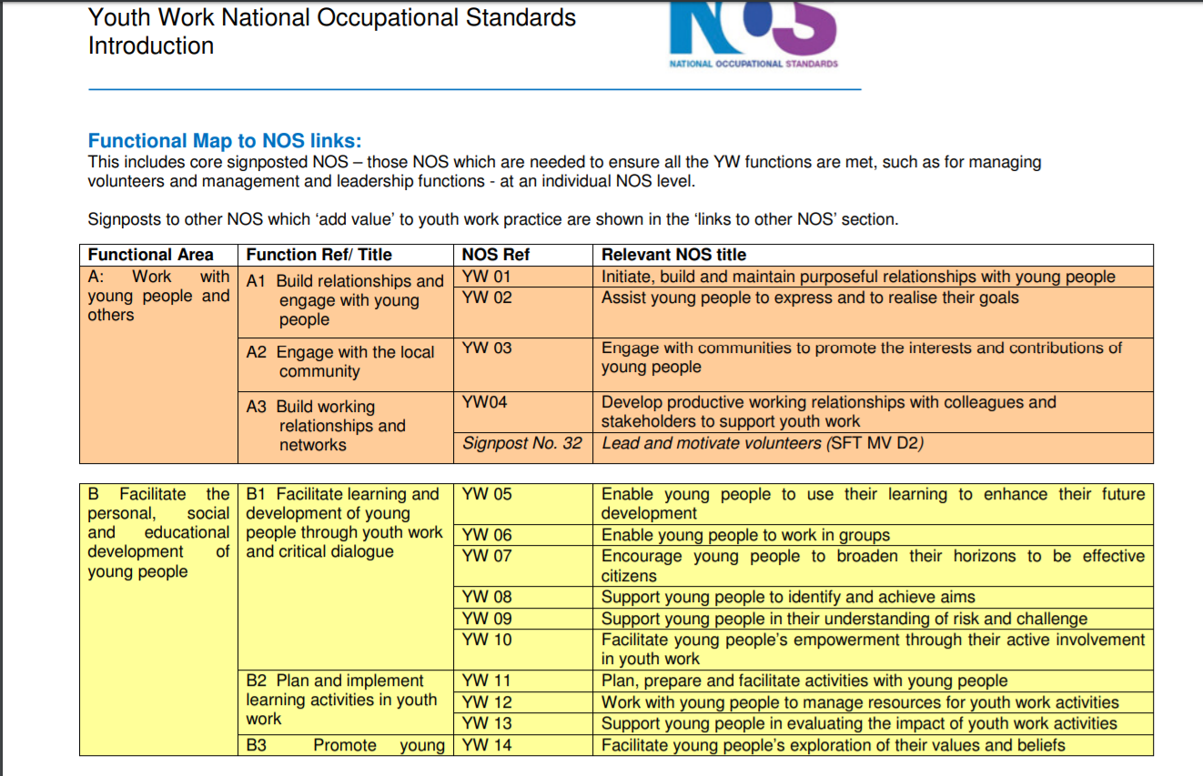
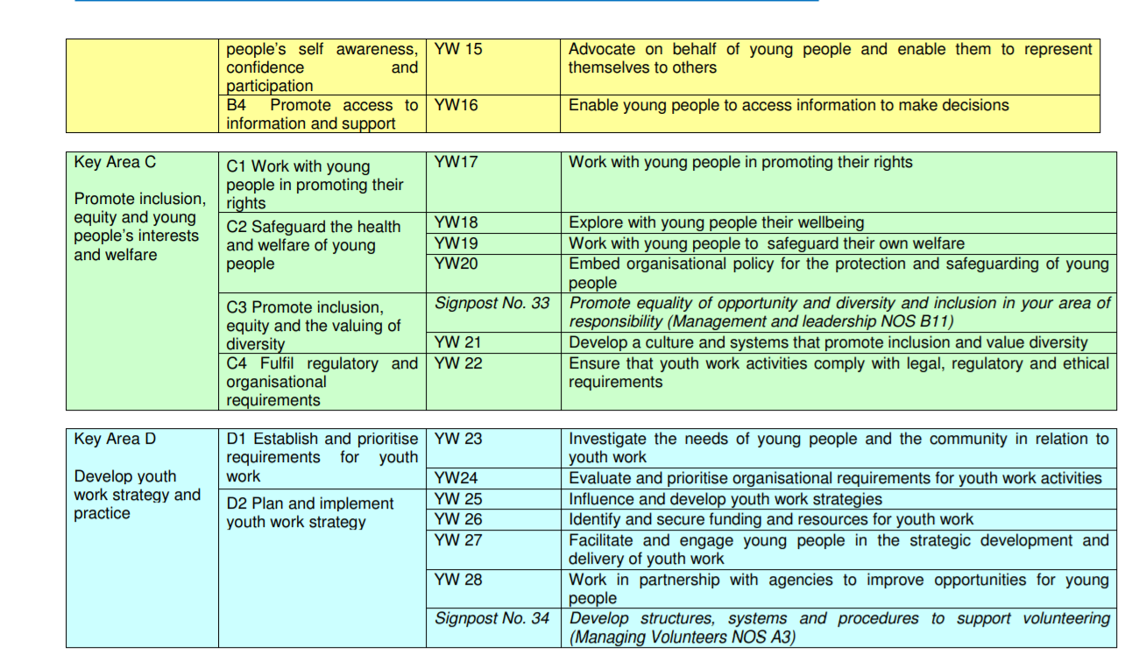
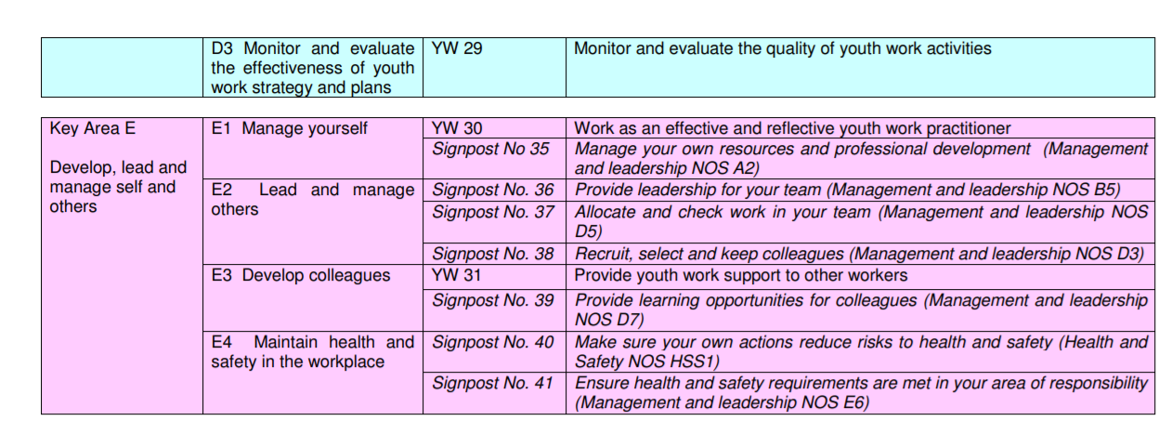

Bibliography
Batsleer, J. & Davies, B., 2011. What Is Youth Work?. Exeter: Learning Matters LTD.
Fitzsimons, A., Hope, M., Cooper, C. & Russell, K., 2011. Empowerment and Participation in Youth Work. Exeter: Learning Matters LTD.
Harris, G. I. a. J., 2001. Delivering Good Youth Work. Dorset: Russle House Publishing.
The Guardian, 2018. It consumed my life: inside a gaming addiction treatment centre. [Online]
Available at: https://www.theguardian.com/games/2018/jun/18/truth-gaming-addiction-world-health-organization-disorder-games
Tuckman, B., 2019. Tuckman: Forming, Storming, Norming and Performning. [Online]
Available at: https://www.businessballs.com/team-management/tuckman-forming-storming-norming-performing-model/#bruce-tuckmans-1965-team-development-model

References

References
Harris, G. I. a. J., 2001. Delivering Good Youth Work. Dorset: Russle House Publishing.
The Guardian, 2018. It consumed my life: inside a gaming addiction treatment centre. [Online]
Available at: https://www.theguardian.com/games/2018/jun/18/truth-gaming-addiction-world-health-organization-disorder-games
[Accessed 6th January 2020].
Tuckman, B., 2019. Tuckman: Forming, Storming, Norming and Performning. [Online]
Available at: https://www.businessballs.com/team-management/tuckman-forming-storming-norming-performing-model/#bruce-tuckmans-1965-team-development-model
[Accessed 8th January 2020].

