Report issued for the property at
Arben Manor
Country Road
Swansea
SA51 9FT

Report Reference
362361730_1_1

National Grid Reference
317880 178070

Customer Reference
R/337492/4145679_HCP

Report Date
1 October 2025
Landmark Contribution
By purchasing this report, the recipient may be eligible for Remediation Contribution of up to £100,000 if served with a Remediation Notice by the Local Authority. Such a notice may require the homeowner to pay for all, or contribute to, the remediation of the property. For more information see Landmark's Terms and Conditions.
Contact Details
If you require assistance please contact your Search Provider or phone Customer Services on 0844 844 9966 or email helpdesk@homecheck.co.uk



Homecheck Environmental

Contamination Risk PASSED
Professional Opinion
Argyll Environmental Consultants have passed this report in accordance with the definition of contaminated land within Part 2A of the Environmental Protection Act 1990. Please refer to the Professional Opinion page and Section 1 for further information.

Flood Risk: None Identified
Refer to Section 2 for further information
Conveyancer Guidance
While this report may have identified areas at risk of flooding within 250m of the search centre, we consider there to be no significant risk of flooding to the property. Please refer to Section 2 for further information.

Radon: None Identified
Refer to Section 3 for further information

Ground Stability: None Identified
Refer to Section 4 for further information

Other Influential Factors:
Refer to Section 5 for further information
Environmental Constraints: None Identified | See Section 5a
www.landmark.co.uk
Empowering People with Information
Homecheck Environmental
Professional Opinion
Contamination Risk
PASSED
In the professional opinion of Argyll Environmental Consultants, the level of contamination risk associated with the information disclosed in the Homecheck Professional report dated 1st October 2025 and reference 362361730_1_1, R/337492/4145679_HCP for

Arben Manor
Country Road
Swansea
SA51 9FT

- is unlikely that the property would be designated "contaminated land" within the meaning of Part 2A of the Environmental Protection Act 1990.

- is unlikely to have an adverse effect on the security of the property for normal lending purposes.

The professional opinion refers to Section 1 of this report and should always be read in conjunction with the full text of that report. No physical site inspection or survey has been carried out or is proposed.

Approved by

Argyll Environmental Ltd
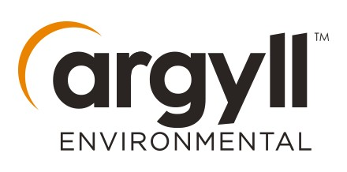

Contents and Summary of Findings
 Site Location
Section 1: Contamination Risk Findings
Contamination Risk | 0-25m | 25-250m | 250-500m | See Section
Designated Contaminated Land | No | No | No | 1a
Landfill and Waste | No | No | Yes | 1b
Potentially Contaminative Activities | No | Yes | Yes | 1c
Known Pollution Incidents | No | No | Yes | 1d
Other Potential Contaminative Land Uses | No | Yes | n/a | 1e
Section 2: Flood Findings
Flood | 0-25m | 25-250m | See Section
River Flooding | No | No | 2a
Coastal Flooding | No | No | 2b
Surface Water Flooding | No | Yes | 2c
Section 3: Radon Findings
Radon | Result |  | See Section
Radon Affected Property | No |  | 3
Section 4: Ground Stability Findings
Ground Stability | Result |  | See Section
Man-Made Factors | No |  | 4a
Natural Factors | No |  | 4b
Section 5: Other Influential Factors
Other Influential Factors | Result |  | See Section
Environmental Constraints | No |  | 5a

Site Location

Aerial Photograph
The photograph below shows the location of the site to which this report relates.

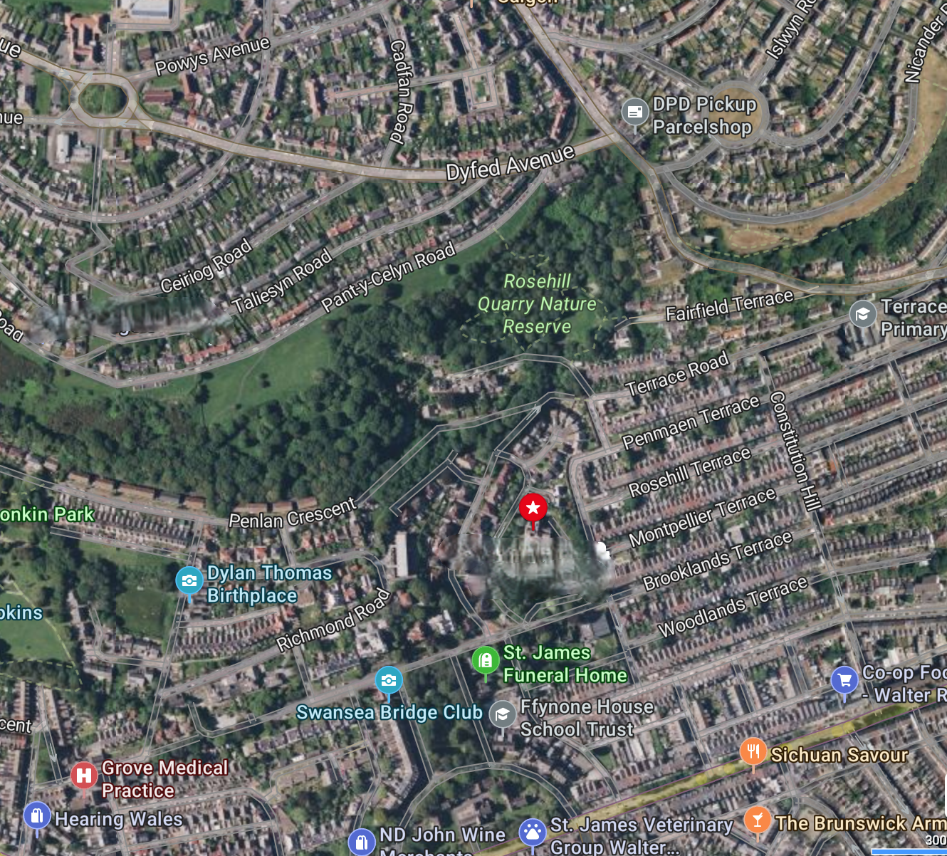

Location Map
The map below shows the location of the site to which this report relates.

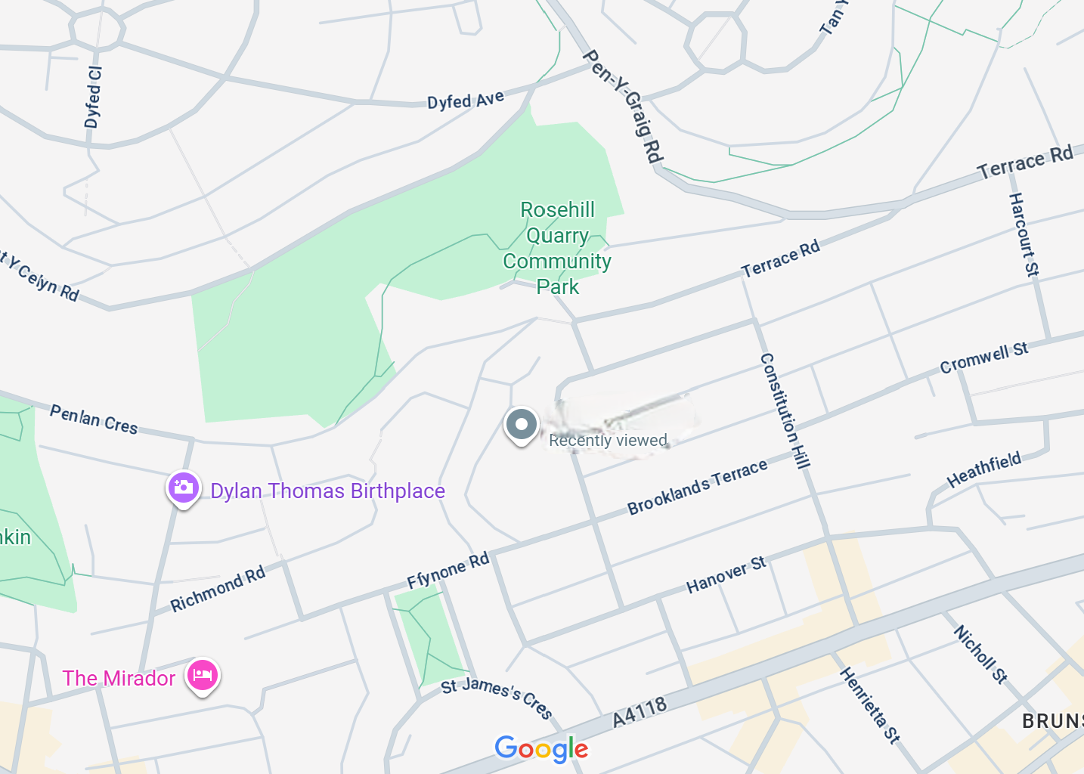

Section 1: Contamination Risk Findings
The whole of section 1 deals with potential sources of contamination and provides the information by which this report has either been passed or referred for assessment.

Section 1a and 1b: Information Map
The map detailed below shows the location of the Designated Contaminated Land and Landfill and Waste features highlighted within sections 1a and 1b of this report.

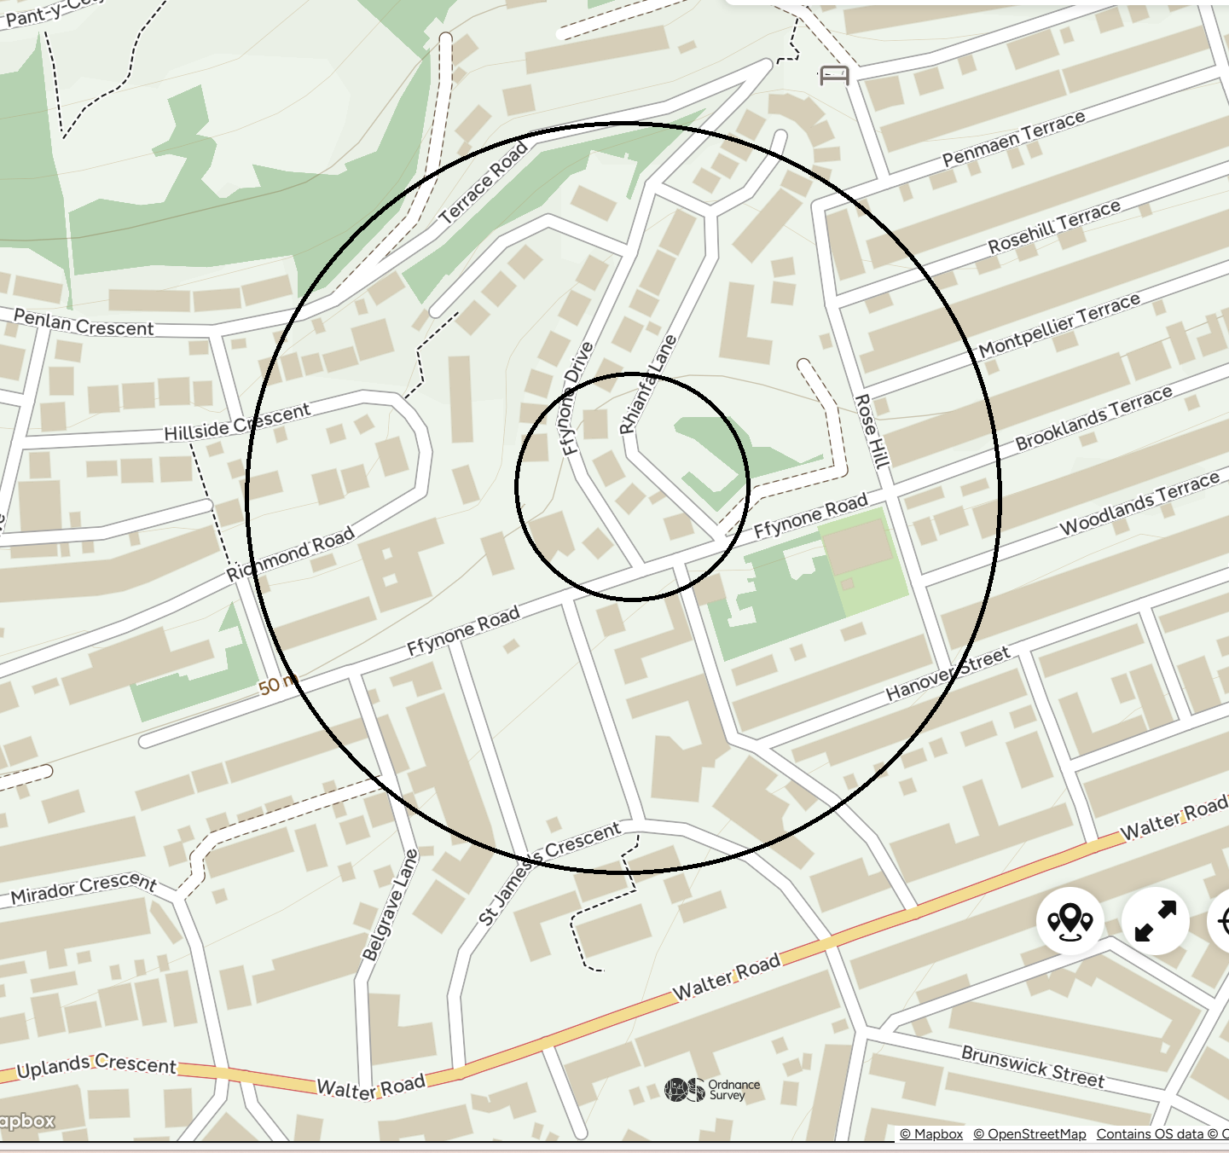

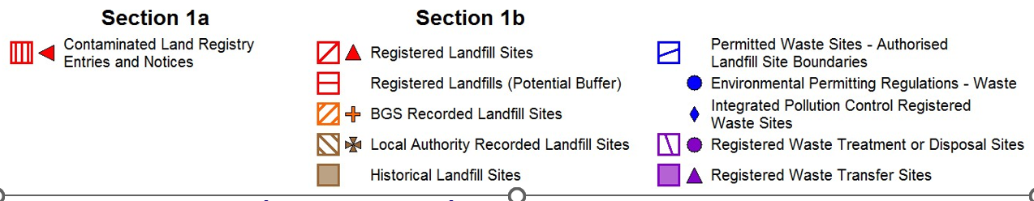

Section 1a: Designated Contaminated Land
The data within this section tells you whether your property or surrounding area has been identified by the Local Authority as "Contaminated Land" under the Environmental Protection Act 1990. Should there be an indication of contamination, it is not necessarily a cause for concern. Your report will be assessed by our professional environmental consultants who will advise you what, if any, considerations need to be made should you proceed with the property purchase.
Enquiry | Result
Has any contaminated land been identified within 500m of the property? | No
Map ID
Reference
Location
Details
Distance
Contact
Contaminated Land Register Entries and Notices
No factors identified for this property

Section 1b: Landfill and Waste
The information in this section is telling you about active and historic landfill and waste sites within 500 metres of the property. Having a landfill or waste site near your property does not necessarily mean that you or the property will be affected. However, it is something you need to be aware of, because landfill and waste can have a detrimental effect on the surrounding environment, house value and health. A closed landfill/waste site should be given equal consideration to an active site, because of landfill byproducts. For instance, landfill with lots of organic material can continue to produce odours and gas for many years.
Enquiry | Result
Have any landfill and waste sites been identified within 500m of the property? | Yes
Map ID
Reference
Location
Details
Distance
Contact
Registered Landfill Sites
No factors identified for this property
BGS Recorded Landfill Sites
No factors identified for this property
Local Authority Recorded Landfill Sites
No factors identified for this property
Local Authority Recorded Landfill Coverage
The following list details the Local Authorities that cover the search area who have made landfill data available:
Cardiff Council
- Has no landfill data to supply
4
For further information regarding the availability of Local Authority Recorded Landfill data you may wish to forward enquiries to one or more of the
contacts indicated above.
Historical Landfill Sites
1
Name:
Maindy
Reference:
EAHLD15198
Crown Way, Cardiff
Specified Waste Type:
Deposited Waste
included Inert, Industrial, Commercial, Household
and Special Waste
Date of Issue:
Not Supplied
First Input Date:
31st December 1940
Last Input Date:
31st December 1950
Boundary Quality:
As Supplied
Positional Accuracy:
Positioned by the supplier
285
m
1
Map ID
Reference
Location
Details
Distance
Contact
2
Name:
Glamorganshire Canal
Reference:
EAHLD15236
Cardiff, South Glamorganshire
Specified Waste Type:
Deposited Waste
included Inert, Industrial, Commercial and
Household Waste
Date of Issue:
Not Supplied
First Input Date:
30th December 1931
Last Input Date:
31st December 1950
Boundary Quality:
As Supplied
Positional Accuracy:
Positioned by the supplier
461
m
1
Permitted Waste Sites - Authorised Landfill Site Boundaries
No factors identified for this property
Environmental Permitting Regulations - Waste
3
Reference:
PAN-001434
Cardiff University Innovation
Campus
Maindy Rd
Cardiff
CF24 4HQ
Licensed Waste Type:
Mobile Plant for
remediation of land
Operator Name:
Sanctus Ltd
Status:
Effective
Date of issue:
2nd June 2017
Positional Accuracy:
Located by supplier to
within 10m
266
m
1
Integrated Pollution Control Registered Waste Sites
No factors identified for this property
Registered Waste Treatment or Disposal Sites
No factors identified for this property
Registered Waste Transfer Sites
No factors identified for this property

Next Steps
If you would like any further information in respect of the above findings we recommend that you get in touch with those listed in the 'Useful Contacts' section. Each contact reference shown in the above table relates to detailed contact information contained near the back of this report. Further information is also available in the 'Useful Information' section.

Section 1c and 1d: Information Map
The map detailed below shows the location of the Potentially Contaminative Activities and Known Pollution Incidents features highlighted within sections 1c and 1d of this report.

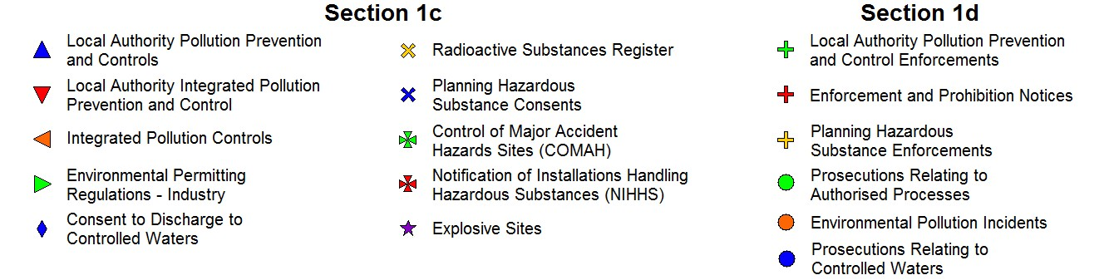

Section 1c: Potentially Contaminative Activities
This section describes current and historic licensed activities within 500 metres of the property, which have the potential to cause contamination or have an impact on the environment. The licensed activities could range from pollution to air, land or water; storage or disposal of radioactive substances; or storage of hazardous or explosive materials. Licences may no longer be active, but the nature of the past activity means it could still have an impact.
Enquiry | Result
Have any potentially contaminative activities been identified within 500m of the property? | Yes
Map ID
Reference
Location
Details
Distance
Contact
ention and Controls
Local Authority Pollution Prev
4
Name:
Somerfield Service
Station
Reference:
Ppc/81/1.4
Cathays Terrace
188
Cathays
CARDIFF
South Glamorgan
CF2 4HZ
Description:
PG1/14 Petrol filling station
Status:
Permitted
Date of Issue:
31st December 1998
Positional Accuracy:
Automatically positioned to
the address
206
m
2
5
Name:
Top Hat Dry Cleaning
Reference:
PPC/143/7
142
Crwys Road
Cathays
Cardiff
CF24 4NR
Description:
PG6/46 Dry cleaning
Status:
Permitted
Date of Issue:
Not Supplied
Positional Accuracy:
Manually positioned to the
address or location
262
m
2
Local Authority Integrated Poll
ution Prevention And Cont
rol
No factors identified for this property
Integrated Pollution Controls
No factors identified for this property
Environmental Permitting Regulations - Industry
No factors identified for this property
Consent to Discharge to Controlled Waters
No factors identified for this property
Radioactive Substances Register
No factors identified for this property
Planning Hazardous Substance Consents
No factors identified for this property
Control of Major Accident Hazards Sites (COMAH)
No factors identified for this property
Notification of Installations Handling Hazardous Substances (NIHHS)
No factors identified for this property
Explosive Sites
No factors identified for this property

Next Steps
If you would like any further information in respect of the above findings we recommend that you contact the relevant Local Authority or the Environment Agency/Natural Resources Wales, their contact details can be found in the 'Useful Contacts' section of this report. Further Information is also available in the 'Useful Information' section.

Section 1d: Known Pollution Incidents
The data within this section describes unpermitted activity in your area (e.g. polluting incidents, or exceedance of permitted allowance) where the activity led to a prosecution or enforcement of regulations. Whilst all of these records are historic, the nature of the incident may have long term effects.
Enquiry |  | Result
Have any known pollution incidents been identified within 500m of the property? |  | Yes
 |  |  | Contact
  Map ID Reference | Location | Details | Distance
Local Authority Pollution Prevention and Control Enforcements
No factors identified for this property
Enforcement and Prohibition Notices
No factors identified for this property
Planning Hazardous Substance Enforcements
No factors identified for this property
Prosecutions Relating to Authorised Processes
No factors identified for this property
Environmental Pollution Incidents
6 Reference: 957630 Not Supplied | Incident Type: Pollution Incident - Environmental 267m  Impact - Air: Significant Incident  Incident Date: 27th January 2012  Positional Accuracy: Located by supplier to within 10m  Pollutant Type: Atmospheric Pollutants and Effects: Smoke |  | 1
Prosecutions Relating to Controlled Waters
No factors identified for this property

Next Steps
If you would like any further information in respect of the above findings we recommend that you contact the relevant Local Authority or the Environment Agency/Natural Resources Wales, their contact details can be found in the "Useful Contacts" section of this report. Further information is also available in the "Useful Information" section.

Section 1e: Information Map
The map detailed below shows the location of the Other Potential Contaminative Land Uses features highlighted within section 1e of this report.

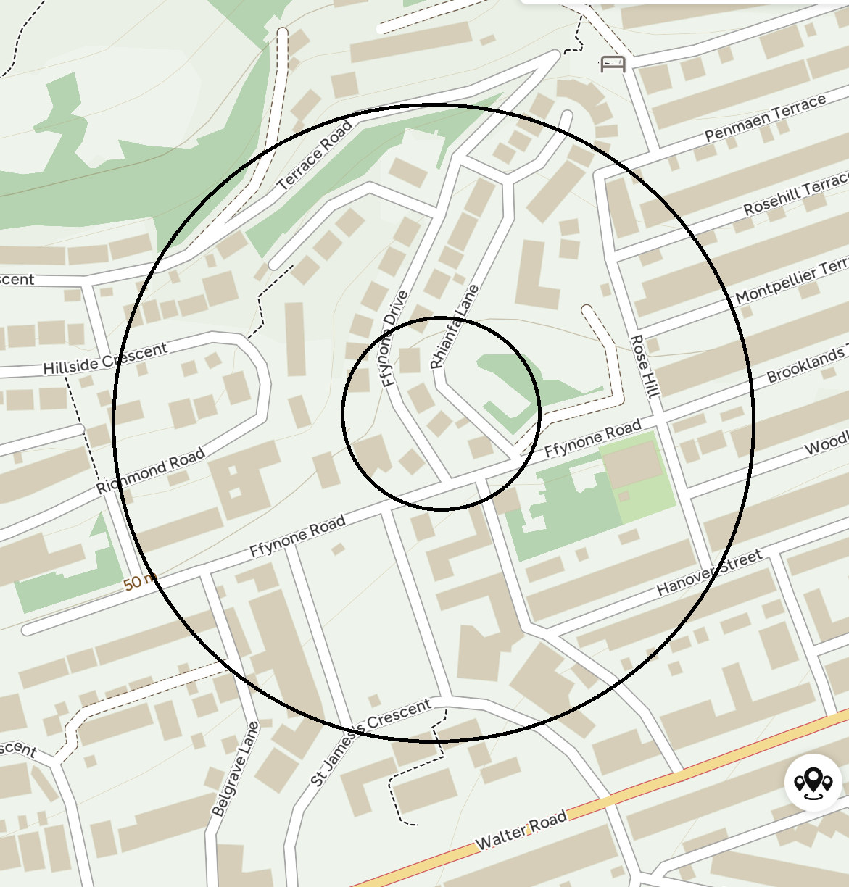
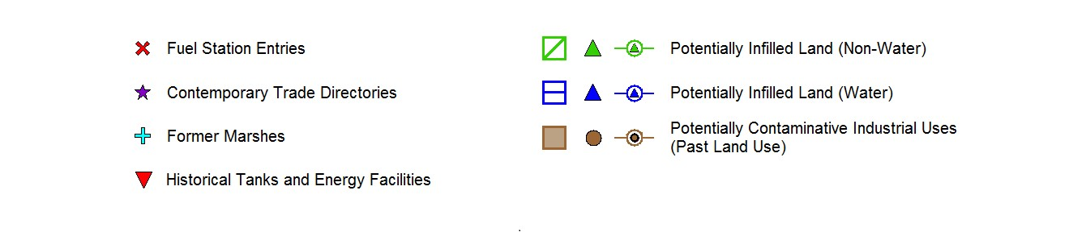

Section 1e: Other Potential Contaminative Land Uses
This section describes either current or historic activity, which could be considered to be contaminative. This section makes no statement about whether the activity requires a licence; however our environmental experts deem that the activities described in this section could lead to potential contamination. The information is taken from a variety of sources including trade directories, Landmark's extensive historical map collection and analysis of historic activity. Records are highlighted due to the potential for contamination to exist.
Enquiry |  |  | Result
Have any other potential sources of contamination been identified within 250m of the property? |  |  | Yes
Map ID Reference | Location |  |  | Contact
  Details | Distance
Fuel Station Entries
7 Name: Cathays Service  Station | 188  Cathays Terrace May Street  Cathays  Cardiff  Cardiff  CF24 4HZ | Premises Type: Not Applicable 206m  Status: Obsolete  Positional Accuracy: Automatically positioned to the address |  | -
Contemporary Trade Directory Entries
8 Name: 1st Choice Appliance  Repairs | 2  Cosmeston Street  Cardiff  CF24 4LP | Classification: Domestic Appliances - Servicing, 36m Repairs & Parts  Status: Inactive  Positional Accuracy: Automatically positioned to the address |  | -
9 Name: Advanced Typewriter  Services | Brithdir House  Brithdir Street  Cardiff  CF24 4LE | Classification: Office Equipment Servicing & 78m  Maintenance  Status: Inactive  Positional Accuracy: Automatically positioned to the address |  | -
10 Name: Sprint Print | Unit 1a Brithdir St  Cardiff  South Glamorgan  CF24 4LE | Classification: Printers 111m  Status: Inactive  Positional Accuracy: Manually positioned to the road within the address or location |  | -
11 Name: Mechanical  Engineering Ltd | 50  Cosmeston Street  Cardiff  CF24 4LR | Classification: Mechanical Engineers 142m  Status: Inactive  Positional Accuracy: Automatically positioned to the address |  | -
12 Name: Cathays Tyres | Rear Of 14-16  Cardiff  South Glamorgan  CF24 4JF | Classification: Tyre Dealers 153m  Status: Inactive  Positional Accuracy: Manually positioned to the address or location |  | -
13 Name: Amprite Autocentre | Rear Of 1-3  Darran Street  Cardiff  CF24 4JF | Classification: Garage Services 155m  Status: Inactive  Positional Accuracy: Automatically positioned to the address |  | -
14 Name: Cathays Service  Station | Cathays Terrace  Cardiff  CF24 4HZ | Classification: Petrol Filling Stations 206m  Status: Inactive  Positional Accuracy: Automatically positioned to the address |  | -

Map ID Reference |  | Location | Details  Distance |  | Contact
14 | Name: Cathays Service Station | Cathays Terrace  Cardiff  CF24 4HZ | Classification: Petrol Filling Stations 206m  Status: Inactive  Positional Accuracy: Automatically positioned to the address |  | -
15 | Name: Www.Cardiffcars.Com | Regal House  Gelligaer Lane  Cardiff  CF14 3JS | Classification: Car Dealers - Used 214m  Status: Inactive  Positional Accuracy: Automatically positioned to the address |  | -
15 | Name: Cardiff Cars | Regal House  Gelligaer Lane  Cardiff  South Glamorgan  CF14 3JS | Classification: Car Dealers - Used 215m  Status: Active  Positional Accuracy: Automatically positioned to the address |  | -
15 | Name: Total Preservation | Regal House  Gelligaer Lane  Cardiff  CF14 3JS | Classification: Damp & Dry Rot Control 215m  Status: Inactive  Positional Accuracy: Automatically positioned to the address |  | -
16 | Name: Ashbys | Gelligaer Street  Cardiff  CF24 4LA | Classification: Garage Services 225m  Status: Inactive  Positional Accuracy: Automatically positioned to the address |  | -
17 | Name: S J Autos | 2  Whitchurch Place  Cardiff  CF24 4HD | Classification: Garage Services 229m  Status: Active  Positional Accuracy: Automatically positioned to the address |  | -
18 | Name: Dr D Quarry | 151-153  Crwys Road  Cardiff  CF24 4XT | Classification: Office Furniture & Equipment 245m  Status: Inactive  Positional Accuracy: Automatically positioned to the address |  | -
18 | Name: Pearn'S | 149  Crwys Road  Cardiff  CF24 4NH | Classification: Photo & Digital Imaging Bureaus 247m  Status: Inactive  Positional Accuracy: Automatically positioned to the address |  | -
18 | Name: Touch Graphics | 147  Crwys Road  Cardiff  CF24 4NH | Classification: Copying & Duplicating Services 250m  Status: Inactive  Positional Accuracy: Automatically positioned to the address |  | -
Former Marshes
No factors identified for this property
Potentially Infilled Land (Non-Water)
No factors identified for this property
Potentially Infilled Land (Water)
19 Not Supplied |  | Not Supplied | Unknown Filled Ground (Pond, marsh, river, stream, dock etc)  Map Published Date: 1886 | 113m | -
20 Not Supplied |  | Not Supplied | Unknown Filled Ground (Pond, marsh, river, stream, dock etc)  Map Published Date: 1886 | 122m | -
21 Not Supplied Not Supplied |  |  | Unknown Filled Ground (Pond, marsh, river, stream, dock etc)  Map Published Date: 1901 | 125m | -
Map ID Reference |  | Location | Details | Distance | Contact
22 Not Supplied |  | Not Supplied | Unknown Filled Ground (Pond, marsh, river, stream, dock etc)  Map Published Date: 1886 | 200m | -
Potentially Contaminative Ind
ustrial Uses (Past Land Use)
23 Not Supplied |  | Not Supplied | Class: Railways  Map Published Date: 1886 - 1951 | 216m | -
24 Not Supplied |  | Not Supplied | Class: Factory or works - use not specified  Map Published Date: 1995 | 221m | -
25 Not Supplied |  | Not Supplied | Class: Transport manufacturing and repair  Map Published Date: 1965 | 223m | -
26 Not Supplied |  | Not Supplied | Class: Oil, petroleum & gas refining & storage  Map Published Date: 1922 | 232m | -
27 Not Supplied |  | Not Supplied | Class: Cemetery or Graveyard  Map Published Date: 1901 - 1995 | 242m | -
Historical Tanks And Energy Facilities
28 | Not Supplied | Not Supplied | Type: Electrical Sub Station Facilities  Positional Accuracy: Positioned to location of cartographic text  Date of Mapping: 1972 | 103m | -
29 | Not Supplied | Not Supplied | Type: Electrical Sub Station Facilities  Positional Accuracy: Positioned to location of cartographic text  Date of Mapping: 1972 | 137m | -
30 | Not Supplied | Not Supplied | Type: Potential Tanks  Positional Accuracy: Positioned to location of cartographic text  Date of Mapping: 1972 | 221m | -
31 | Not Supplied | Not Supplied | Type: Electrical Sub Station Facilities  Positional Accuracy: Positioned to location of cartographic text  Date of Mapping: 1953 - 1968 | 223m | -
31 | Not Supplied | Not Supplied | Type: Electrical Sub Station Facilities  Positional Accuracy: Positioned to location of cartographic text  Date of Mapping: 1954 | 224m | -
32 | Not Supplied | Not Supplied | Type: Electrical Sub Station Facilities  Positional Accuracy: Positioned to location of cartographic text  Date of Mapping: 1985 | 236m | -
33 | Not Supplied | Not Supplied | Type: Electrical Sub Station Facilities  Positional Accuracy: Positioned to location of cartographic text  Date of Mapping: 1985 | 240m | -
34 | Not Supplied | Not Supplied | Type: Electrical Sub Station Facilities  Positional Accuracy: Positioned to location of cartographic text  Date of Mapping: 1985 | 244m | -

Next Steps
If you would like any further information in respect of the above findings we recommend that you contact our Customer Services Team, whose details can be found in the 'Useful Contacts' section of this report. Further Information is also available in the 'Useful Information' section.

Section 2: Flood Findings

Section 2a and 2b: River and Coastal Flood Map
The whole of this section deals with potential sources of flooding that may impact the property.
The map detailed below shows the location of potential river and coastal flood risk. The potential risk has been modelled on the basis of an event occurring on average every 75, 200 or 1000 years.



Section 2c: Surface Water Flood Map
The map detailed below shows the location of potential surface water flood risk. The potential risk has been modelled on the basis of an event occurring on average every 75, 200 or 1000 years.



Section 2a: River Flooding
River flooding mainly happens when the river catchment (that is the area of land that feeds water into the river and the streams that flow into the main river) receives greater than usual amounts of water (for example through rainfall or melting of snow). The amount of runoff depends on the soil type, catchment steepness, drainage characteristics, agriculture and urbanisation as well as the saturation of the catchment. The extra water causes the level of the water in the river to rise above its banks or retaining structures.
Enquiry | Result | Contact
Is there a potential risk of river flooding within 250m of the property? | No | -

Section 2b: Coastal Flooding
Coastal flooding is the inundation of land areas along the coast caused by sea water rising above normal tidal conditions. Coastal flooding can arise from a combination of high tides, wind induced tidal surge, storm surge created by low pressure and wave action.
Enquiry | Result | Contact
Is there a potential risk of coastal flooding within 250m of the property? | No | -

Section 2c: Surface Water Flooding
Surface water flooding results from rainfall running over ground before entering a watercourse or sewer. It is usually associated with high intensity rainfall events (typically greater than 30mm per hour) but can also occur with lower intensity rainfall or melting snow where the ground is already saturated, frozen, developed (for example in an urban setting) or otherwise has low permeability.
Enquiry | Result | Contact
Is there a potential risk of surface water flooding within 250m of the property? | Yes | -

Next Steps
In order to gain more detailed information on the type and likelihood of your property being impacted by a flood event, and the potential impact on insurance, we recommend that you purchase our Landmark Flood Report.
If you would like more information please contact your Search Provider or our Customer Services Team on 0844 844 9966 or email helpdesk@homecheck.co.uk.

Flood data provided by JBA Risk Management Limited. © Copyright JBA Risk Management Limited 2008-2024

Section 3: Radon Findings
The information within this section tells you whether the property is located in a radon affected area. Radon is a radioactive gas which occurs naturally in rocks and soils. You cannot see, hear, feel or taste it. Exposure to particularly high levels of radon may increase the risk of developing lung cancer, and is therefore something you need to be aware of or should consider.
Enquiry | Result | Contact
Is the property in a radon affected area? | The property is in a lower probability radon area, as less than 1% of homes are above the action level | 3
What level of radon protection measures for new dwellings or extensions to existing ones is required for the property? | No radon protective measures are necessary in the construction of new dwellings or extensions | 3

Next Steps
The level of radon concentration can only be established by having the building tested. Action should be taken if the indoor radon level is measured and found to be above 200 becquerel's per cubic meter. If you would like any further information we recommend you contact Public Health England whose details can be found in the 'Useful Contacts' section of this report.

Further Action
Airtech Environmental Systems can advise on radon testing kits, which cost £39.36 including VAT and can run from 7 days to 3 months. They also have a team of surveyors on hand to provide recommendations and advice for any properties above the target level of 100 becquerel's per cubic meter or action level of 200 becquerel's per cubic meter. Airtech Environmental Systems can provide a report, recommendations and a quotation for any recommended works. For more detailed information please call their free-phone number 0800 378017.

Section 4: Ground Stability Findings
This section provides summary information on factors that could affect the ground stability of the property. It considers both manmade factors (e.g. mining activity) and natural hazards (e.g. geological stability).

Section 4a: Man-Made Factors
Enquiry | Result | Contact
Is the property within 25m of a Coal Mining Affected Area? | No | -

Section 4b: Natural Factors
Enquiry Result Contact
What is the potential for natural ground instability in the area within 50m of the Very Low property?
Comment: The British Geological Survey has assessed the area of search as having very low potential for natural ground instability. This does not necessarily mean there is cause for concern in terms of the property's stability. Active subsidence will be dependent on local conditions, such as the proximity of trees or areas where trees have been removed, which require an inspection of the site to identify the nature of the ground on which the property is built. A house buyers survey is advised to look for signs of property damage that may indicate poor natural ground conditions.

Section 5: Other Influential Factors  Section 5a: Environmental Constraints
The following section provides information on a variety of factors which may have an influence on the property or surrounding area.
Enquiry | Result
Is the property within 250m of an area likely to be impacted by Environmental Constraints? | No
Map ID
Reference
Location
Details
Distance
Contact
Areas of Outstanding Natural Beauty
No factors identified for this property
Local Nature Reserves
No factors identified for this property
National Nature Reserves
No factors identified for this property
National Parks
No factors identified for this property
Ramsar Sites
No factors identified for this property
Sites of Special Scientific Interest
No factors identified for this property
Special Areas of Conservation
No factors identified for this property
Special Protection Areas
No factors identified for this property

Useful Contacts
Ty Cambria Tel: 0300 065 3000  29 Newport Road  Cardiff  CF24 0TP  Contact 2 - Cardiff Council - Pollution Control Division | enquiries@naturalresourceswales.gov.uk
Regulatory Services Tel: 029 20872000  ^{City Hall} Fax: 01222 873212  Cardiff  Mid Glamorgan  CF10 3ND | www.cardiff.gov.uk
Contact 1 - Natural Resources Wales

Contact 3 - Public Health England - Radon Survey, Centre for Radiation, Chemical and Environmental Hazards
Chilton  Didcot  Oxfordshire  OX11 0RQ  Contact 4 - Cardiff Council | Tel: 01235 822622 Fax: 01235 833891 | radon@phe.gov.uk www.ukradon.org
County Hall  Atlantic Wharf  Cardiff  Mid Glamorgan  CF1 5UW  Landmark Information Group Limited | Tel: 029 2087 2000 Fax: 029 2087 3212 | www.cardiff.gov.uk
Legal and Financial Tel: 0844 844 9966 helpdesk@homecheck.co.uk
^{Imperium} Fax: 0844 844 9980 www.landmarkinfo.co.uk
Reading
Berkshire
RG2 0TD
The Landmark website contains links to many of our data suppliers which may prove useful.

Please note that the Environment Agency/Natural Resources Wales/SEPA have a charging policy in place for enquiries.
Landmark works in association with:
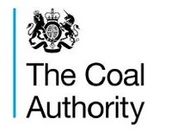
Report Version: HCP v1.0.4.5

Useful Information
The following explanatory notes may be of assistance to users of the Homecheck Professional report. Practitioners are reminded that full guidance notes are contained in the Practitioners Guide.

Professional Opinion
A Professional Opinion in relation to Part 2A of the Environmental Protection Act 1990 is provided by Argyll Environmental Consultants. In many cases the report will be PASSED without referral. However, in some cases, entries that may be of concern are revealed by the search, in which case the report is REFERRED free of charge for more detailed consideration, although this will not include a physical site inspection. After such referral the report may be PASSED or suggestions made of some FURTHER ACTION that could be taken, in the form of questions to ask of the appropriate authorities. When responses to these questions are received it is the responsibility of the client and their professional advisors to decide if they are happy to proceed.

Flood Risk
A limited flood risk screening exercise is included in this report designed to satisfy basic flood risk screening due diligence including consideration of river, coastal and surface water flooding. Where a potential flood risk is "Identified" you may wish to consider commissioning a more detailed flood risk screening report. When there is "None Identified" this does not indicate that there is not risk of flooding at the property, but that the risk of flooding from the sources screened (river, coastal and surface water) within the vicinity of the property is such that the risk may not be considered significant.

Location Map
The Ordnance Survey location map may show features which are not necessarily otherwise included in this report. You are advised to supplement the information contained in the report with the descriptive text shown on the map.

Positional Accuracy
We locate data in a variety of ways according to information provided to us and subsequent in-house research. If data is provided as a point on the ground, we provide a "positional accuracy" which tells you how confident we are of the actual location.

Section 1b: Landfill and Waste
At present no complete national data set exists for landfill site boundaries, therefore, a point grid reference, provided by the data supplier, is used for some landfill sites. In certain cases the point grid references supplied provide only an approximate position, and can vary from the site entrance to the centre of the site. Where the exact position of the site is unclear for Registered Landfill data, Landmark construct either a 100 metre or 250 metre "buffer" around the point to warn of the possible presence of landfill. The size of this "buffer" relates to the positional accuracy that can be attributed to the site. The "buffer" is shown on the map as a red hatched area. For further information regarding landfill sites identified in the report, please contact the relevant environment agency or authority referenced in the Useful Contacts section.

The BGS holds records of over 3,000 landfill sites that accepted waste prior to the Control of Pollution Act (COPA) 1974. These were not subject to any strict regulation or monitoring.

Permitted Waste Sites and Environmental Permitting Regulations - Waste cover current or recently current consents issued for landfill sites, waste transfer, treatment or disposal sites by the Environment Agency/Natural Resources Wales, under Section 64 of the Environmental Protection Act 1990 (Part 2) and prescribed by regulation 10 of SI No. 1056 of the Waste Management Licensing Regulations 1994.

Section 1c: Potentially Contaminative Activities
Identified discharge consents could be for storm water discharges, soakaways or septic tanks.

If a radioactive substance licence has been identified the consent band will be given under enquiries and replies. Consents fall into one of four bands: Band 1 and 2 Nuclear licensed sites authorised by the Nuclear Installations Inspectorate e.g. nuclear power stations Band 3 Site registered/authorised to accumulate and dispose of radioactive materials, only non-nuclear operations are carried out on site e.g. hospitals Band 4 Sites registered to keep and use radioactive material e.g. laboratories, universities, commercial premises using appliances such as monitoring equipment, alarm systems, tritium lighting etc.

Data supplied for Explosive Sites, Control of Major Accident Hazards Sites (COMAH) and Notification of Installations Handling Hazardous Substances (NIHHS) contains public sector information published by the Health and Safety Executive and licensed under the Open Government Licence.

Section 1e: Other Potential Contaminative Land Uses
This section relates to categories of potentially contaminative land uses that have been identified by the analysis of selected Ordnance Survey historical mapping. The published date (range of dates) of the map (s) and the distance from the centre of search to the nearest point of the feature is given. Further details of the extent of the site or its activities are not available. Should you wish to examine the Ordnance Survey maps these are normally available for public inspection at the local archive or local major library. Alternatively, extracts of editions of Ordnance Survey maps are available on www.old-maps.co.uk

Potentially infilled land has been identified when a 'cavity' (a hole made by an extractive industry or natural occurrence e.g. pond) was indicated on a historic map but there was no evidence of its existence in the last available map for the area. No details of what may have been used to fill the cavity or exactly when or if it was filled are available from the mapping.
The point locations of historical tanks and energy facilities are identified from the text on Ordnance Survey 1:1250 and 1:2500 scale mapping published between 1943 and 1996, based upon a predetermined list of abbreviations, e.g. El Sub (Electricity Sub-station) and F Stn (Filling Station). The position of the point has been located at the centre of the identified text so that it would be within approximately 30 meters of the feature it was describing. The features themselves are related to energy and petroleum storage and cover the following: tanks, petrol storage, potential tanks (at depots etc.), electricity sub stations and related features, gas and gas monitoring related features, oil related features and miscellaneous power features. NB: It should be noted that the Ordnance Survey abbreviation for tank (tk) is the same as that for tracks. Therefore some of the captured text may relate to tracks and not tanks when the exact nature of the feature is not clear from the mapping.

Section 2: Flood Findings
Sections 2a, b and c of the report provide data on modelled extents of river, coastal and surface water flooding generated by JBA Risk Management, a market leader in flood risk assessment commonly engaged by insurers to assess flood risk. The data has been modelled for several perils or return periods: 1 in 75, 1 in 200 or 1 in 1000 which relate to areas with a 1.3%, 0.5% and 0.1% annual probability of flooding in any one year respectively. Properties at risk of flooding during a 1 in 75 year event are typically considered to be at a high risk of flooding. The data has been generated to provide a UK wide screening tool and as a result may have inherent limitations. In addition, there may be areas of the country which are modelled to varying degrees of accuracy based on currently available topographical information.

Section 3: Radon Findings
Due to the nature of way the information is gathered, your property/site may have more than one probability of radon attributed to it. We report the worst case scenario on the property/site you have provided. This information is an estimate of the probability that a property /site in Great Britain is at or above the "Action Level" for radon (the level at which Public Health England recommends that radon levels should be reduced, those with an average of 200 Bq m-3 or more). This information satisfies CON29 Standard Enquiry of Local Authority; 3.13 Radon Gas: Location of the Property in a Radon Affected Area. Where the property/site is a new build, this information provides information on the level of protection required for new buildings under BR211 (Scivyer, 2007) Radon: Guidance on protective measures for new buildings.

Disclaimer: "Some of the responses contained in this section are based on data and information provided by the Natural Environment Research Council (NERC) or its component bodies the British Geological Survey (BGS). Your use of any information contained in this report which is derived from or based upon such data and information is at your own risk. Neither NERC, BGS nor Public Health England where applicable, gives any warranty, condition or representation as to the quality, accuracy or completeness of such information and all liability (including liability for negligence) arising from its use is excluded to the fullest extent permitted by law."

Section 5a: Environmental Constraints
The Local Nature Reserves national dataset is "indicative" not "definitive". Definitive information can only be provided by individual local authorities and you should refer directly to their information for all purposes that require the most up to date and complete dataset.

General
If after reading the details in this report regarding the sites identified, you still require further information, please contact the relevant environment agency or authority indicated in the Useful Contacts section quoting the corresponding reference given in the text of the report.

The contacts in the Useful Contacts section may be able to provide further information relating to items identified in the report, however they are not in a position to advise how these might affect the value of a property. The findings of the report should be discussed with your professional advisor.

The Purpose and Scope of the Report
The report is designed to satisfy the concerns raised by the Law Society warning card and has been prepared to assist conveyancing professionals who may be advising clients when they sell or buy a property, obtain a mortgage, seek further mortgage advice, or commence any building works. It is designed to bring information to their attention and help them decide whether they need to seek any further specialist advice. As the report is so detailed, this information can cause concern, but professional advisors will see that further action is suggested on all issues that have been identified.

Limitations
This report has been published by Landmark Information Group Limited ("Landmark") and is supplied subject to our Terms and Conditions of Business, which can be found at http://www.landmarkinfo.co.uk/Terms/Show/534. It has been prepared on the understanding that it is to be used for an individual residential property transaction and should not be used or relied upon in a commercial property transaction. This report is neither a guarantee of the physical condition of the subject property nor a substitute for any physical investigation or inspection. The information in Homecheck Professional is derived from a number of statutory and non-statutory sources (see The Practitioner Guide for details). Whilst every effort is made to ensure the details in the report are correct, Landmark cannot guarantee the accuracy or completeness of such information or data, nor identify all the factors that may be relevant. If you are a private individual using this report Landmark recommends that you discuss its contents in full with your professional advisor. The methodology for risk assessment and the conclusions drawn therefrom are the responsibility of Argyll Environmental Consultants.

Insurance
Houses registered between 1st April 1999 and 31st December 2002 and covered by the NHBC Buildmark scheme probably have insurance against certain costs if contamination occurs within ten years of their construction. From 1st January 2003, NHBC will only provide this cover if building control has been carried out by NHBC Building Control Services Limited.

Landmark Standard Terms and Conditions
Full Terms and Conditions can be found on the following link: http://www.landmarkinfo.co.uk/Terms/Show/534
If you experience difficulties accessing our Terms and Conditions, please copy and paste the link directly into your browser, you will then be able to access our Terms and Conditions from there. Should you still experience difficulties, please telephone our Customer Service Team on 0844 844 9966.

Copyright Statement
The data supplied for this Homecheck Professional report falls under the following copyrights: © Landmark Information Group and/or its Data
Suppliers 2024; © Environment Agency and database right 2024; © Environment Agency & United Kingdom Research and Innovation 2024;
©Experian Ltd 2024; Produced in whole or in part under licence from, and based in whole or in part from copyright material of © Thomson Directories
Limited; © The Coal Authority owns the copyright to this data and the coal mining information used to produce it; © Peter Brett Associates LLP 2024;
© Ofcom copyright 2024; © Natural England copyright. Contains Ordnance Survey data © Crown copyright and database right 2024; Ordnance
Survey © Crown copyright and/or Database Right. All rights reserved. Licence AC0000813445; © HS2 Ltd and licensed under the Open Government
Licence; © Natural Resources Wales & United Kingdom Research and Innovation 2024; Contains Natural Resources Wales information © Natural Resources Wales and Database Right. All rights Reserved. Contains Ordnance Survey Data. Ordnance Survey Licence number 100019741. Crown Copyright and Database Right.


Consumer Protection
Important
Consumer Protection Information
This search has been produced by Landmark Information Group Ltd, Imperium, Imperial Way, Reading, Berkshire,
RG2 0TD
Tel: 0844 844 9966
Fax: 0844 844 9980
Email:

helpdesk@landmark.co.uk

Landmark adheres to the
C
onveyancing Information Executive (CIE) standards.
The
Standards:
•
Conveyancing Information Executive Members shall act in a professional and honest manner at all times in line with
the Conveyancing Information Executive Standards and carry out the delivery of the Search with integrity and due care
and skill.
•
Compliance with the Conveyancing Information Executive Standards will be a condition within the Conveyancing
Information Executive Member's Terms and Conditions.
•
Conveyancing Information Executive Members will promote the benefits of and deliver the Search to the agreed
standards and in the best interests of the customer and associated parties.
•
The standards can be seen here:

http://www.conveyinfoexec.co
m
Complaints
If you have a query or complaint about your search, you should raise it directly with the search firm, and if appropriate
ask for any complaint to be considered under their formal internal complaints procedure. If you remain dissatisfied with
the firm’s final response, after your complaint has been formally considered, or if the firm has exceeded the response
timescales, you may refer your complaint for consideration under The Property Ombudsman scheme (TPOs). The
Ombudsman can award up to £5,000 to you if the Ombudsman finds that you have suffered actual financial loss and/or
aggravation, distress or inconvenience as a result of your search provider failing to keep to the Standards.
Please note that all queries or complaints regarding your search should be directed to your search provider in the first
instance, not to TPO.
TPOs Contact Details:
The Property Ombudsman scheme
Milford House
43-55
Milford Street
Salisbury
Wiltshire SP1 2BP
Tel: 01722 333306
Fax: 01722 332296
Website:

www
.

t
pos.co.u
k

Email:
admin@tpos.co.uk
Consumer Protection
Landmark Complaints Procedure
If you want to make a complaint to Landmark, we will:
•
Acknowledge it within 5 working days of receipt
•
Normally deal with it fully and provide a final response, in writing, within 20 working days of
receipt
•
Keep you informed by letter, telephone or e-mail, as you prefer, if we need more time
•
Provide a final response, in writing, at the latest within 40 working days of receipt
•
Liaise, at your request, with anyone acting formally on your behalf
Complaints should be sent to:
Customer Relationships Manager
Landmark Information
Imperium
Imperial Way
Reading
RG2 0TD
Tel: 0844 844 9966
Email:
helpdesk@landmark.co.uk
Fax: 0844 844 9980
If you are not satisfied with our final response, or if we exceed the response timescales, you may refer the complaint to The
Property Ombudsman scheme (TPOs):
Tel: 01722 333306
Email:
admin@tpos.co.uk
We will co-operate fully with the Ombudsman during an investigation and comply with his final decision.

