Rick Turner (2520197)
12/01/2026
Design and Implementation of a Relational Database System
L4 INTRODUCTION TO WEB AND DATABASE CONCEPTS – ACCA4023
Data and Information Systems

Contents
1. Scenario Analysis 2
2. Entity-Relationship Diagram 3
3. Data Structure Development 4
CustomerInfo 4
BikeInfo 5
InspectionInfo 5
Condition 6
StaffInfo 6
RentalInfo 7
LocationInfo 7
Relationships 8
4. Normalization Compliance 8
1NF 8
2NF 8
3NF 9
5. Sample Data Population 9
CustomerInfo 9
BikeInfo 9
StaffInfo 9
LocationInfo 10
InspectionInfo 10
Condition 10
RentalInfo 10
6. Query Development 10
Available Bikes 11
Bikes that need service 11
Number of inspections by staff 12
Number of rentals per customer 13
7. Form Creation 14
New Customer and Staff form 14
New Bike Form 16
Inspection Form 16
Rental Form 18
8. Validation and Testing 19
Null Testing 19
Data validation testing 21
9. Summary 22
Bibliography 23

Scenario Analysis
The EcoRide rental scheme requires a modern way to manage the service it provides. Outdated paper based and spreadsheets systems are currently being used which is likely impacting on the effective management of the service. As such, there is a requirement to migrate to a functional database management system to streamline operations.
A database constitutes a fundamental element of an information system, and its design must be informed by the broader organisational requirements. [1]
A functional database system will allow for the management and analysis of the service, enhancing staff use and management of the service.
To create a functional database for the EcoRide service a number of entities are required to manage the data.
These will include:
- Customer Information – including attributes that hold personal customer data
- Bike Information – including attributes that hold bike data. Relationships to Location table will be required to identify the current location of the bike along with a relationship to the inspection information.
- Staff Information – including attributes that hold staff data
- Inspection Information – including attributes that hold bike inspection records, staff association and condition of the bike. A relationship between Staff and Bike information will be required as part of the inspection.
- Location Information – including attributes that hold location details
- Rental Information – including attributes that hold rental dates, customer information, bike return location and cost of rental. Relationships to Bike, Customer and Location tables will be required.

Entity-Relationship Diagram
The ERD diagram is shown below with a hyperlink also provided if required.
ERD Hyperlink

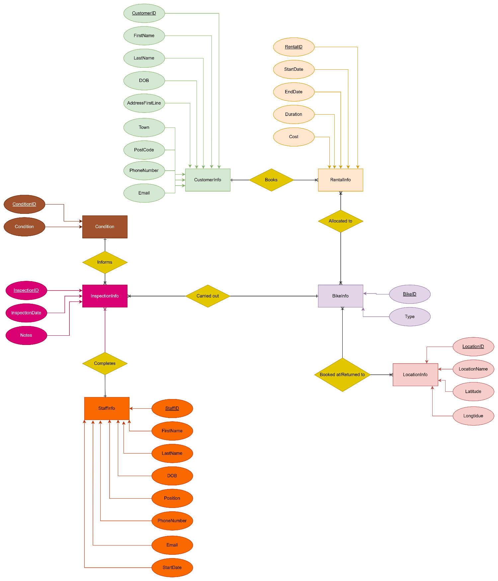

Data Structure Development

CustomerInfo
This entity stores data in relation to customers. Attributes include:
- CustomerID - This is the primary key for this entity. It is an autonumber which is unique to each customer held in the database.
- FirstName, Last Name, AddressFirstLine, Town and Postcode - These are 4 separate short text attributes which hold the customer’s name and address. These will all be mandatory fields.
- DOB - Mandatory field that holds date of birth and is a Date/Time data type.
- Email address - Short text field to hold email address.
- PhoneNumber - Mandatory text field and contains contact telephone number. Rules will be enforced to ensure a valid 11-digit UK telephone number.
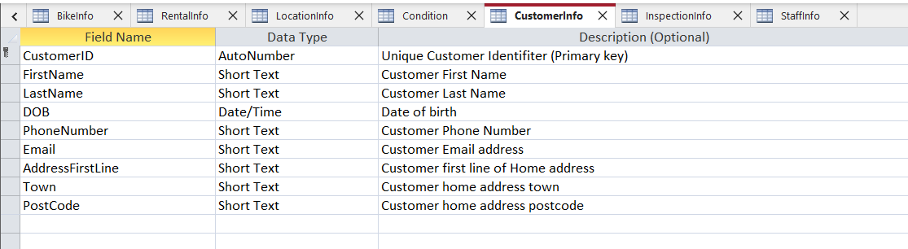

BikeInfo
This entity will hold information on bikes operated by EcoRide. Attributes include:
- BikeID - This is the primary key for this entity. It is an autonumber which is unique to each bike held in the database.
- Type - A short text field which holds the bike type data.
- Current Condition - This field will hold the current condition for the bike. This will be updated by staff on completion of inspection and will related to the Condition entity.
- LocationID - Holds the current location of the bike based on the most recent rental activity. This will be updated by staff when booking rentals and is a foreign key from the Location entity.
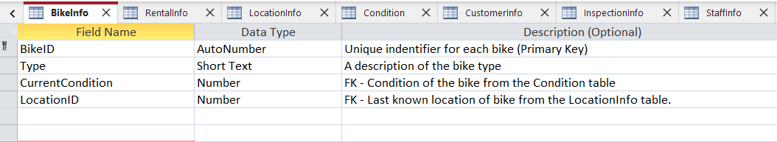

InspectionInfo
Entity will hold inspection records for bikes along with details of which staff have completed it. Attributes include:
- InspectionID - This is the primary key for this entity. It is an autonumber which is unique to each Inspection record held in the database.
- BikeID – Foreign Key from the Bikeinfo table which will allow for staff to select which bike has been inspected
- InspectionDate - Date field holding date of inspection
- StaffID - Foreign key from the StaffInfo table which will allow for monitoring of which staff have completed the inspection
- InspectionCondition – Foreign key from Condition table which will allow staff to select the condition of the bike following inspection
- Notes – Long text field allowing staff to input a free text description of work carried out during inspection
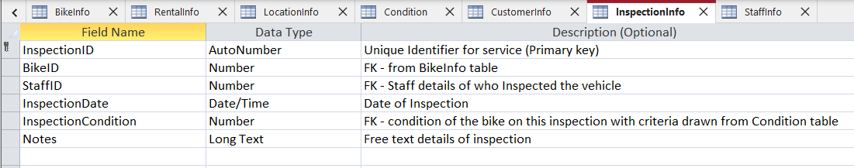

Condition
Entity which holds description of bike conditions. Attributes include:
- ConditionID - This is the primary key for this entity. It is an autonumber which is unique to each Inspection record held in the database.
- Condition – Shorttext data which comprises of pre-determined bike conditions
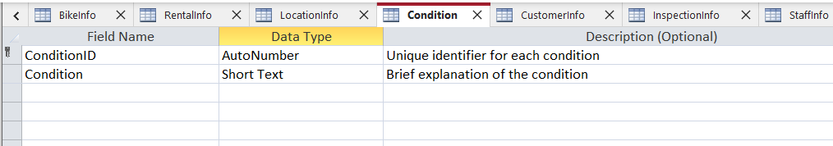

StaffInfo
Entity to hold details of staff employed.
- StaffID - This is the primary key for this entity. It is an autonumber which is unique to each staff record held in the database.
- FirstName, LastName, Position and Email - These are 4 separate short text attributes which hold the first and last name, email address and personal address.
- DOB - Mandatory field that holds date of birth and is a Date/Time data type.
- Email address - Short text field to hold email address.
- PhoneNumber - Mandatory text field and contains contact telephone number. Rules will be enforced to ensure a valid 11-digit UK telephone number.
- StartDate – Date field to hold the start date of the employee.
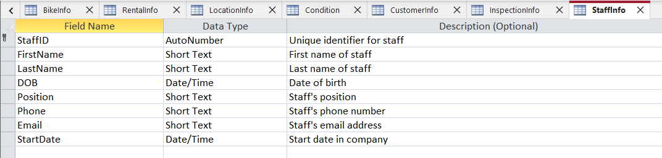

RentalInfo
Entity to hold all rental information for the company. Attributes include:
- RentalID – Primary key. Autonumber which is unique to each record
- BikeID – Foreign key from Bikeinfo table
- CustomerID - Foreign key from Customerinfo
- StartDate and EndDate – Two separate date fields to record rental dates
- ReturnLocation – Foreign Key from LocationInfo table
- Duration – Number field which calculates the duration of rentals in days
- Cost – Currency field which calculates the cost of rentals
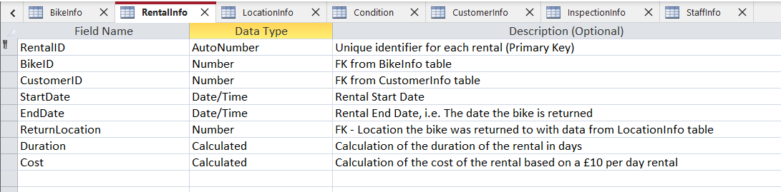

LocationInfo
Entity which holds data of rental locations. Attributes include:
- LocationID – Primary key. AutoNumber which is unique to each record
- LocationName – Short text field which provides logical name of location
- Latitude and Longitude – Two separate number fields which holds exact location data
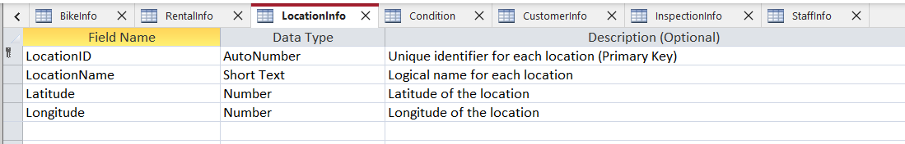

Relationships
The relationships between entities created in MS Access is displayed below:
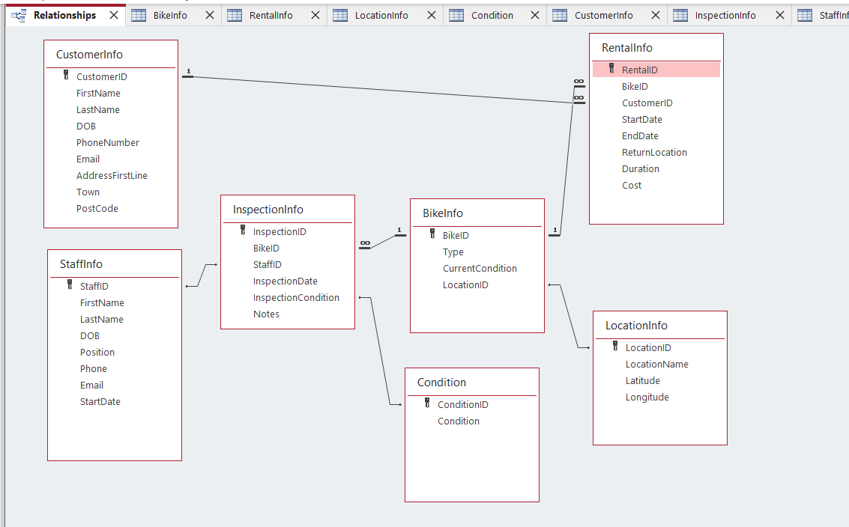

Normalization Compliance
Normalization of databases is the process of organising data within the database to improve the integrity of data and also reduces redundancy. It can also aid with standardising the format of data within the database ensuring consistency throughout. While 3NF is generally considered to be the standard there are options of extending to 5NF.
A study published in 2024 showed that while normalisation does reduce redundancy and update anomalies, expected performance gains from reducing joins did not materialise [2]. In view of this, normalisation for this project will not go beyond 3NF.

1NF
All entities were checked against 1NF and only contain atomic values. Address values have been split into different columns to ensure 1NF compliance. All values are the same data type with a unique name.

2NF
Each table has its own unique primary key and has no partial dependencies within.

3NF
Transitive dependencies have been removed from some of the tables through the through creation of a separate location and condition table.
There is an issue within the RentalInfo table, in that the Duration and Cost fields are derived from other fields within the table. This means that the table is not 3NF compliant. This could be resolved through the creation of a macro on the rental form which would update the fields on completion of the rental, or through creation of a separate table which calculates the cost of rentals and has a relationship with the rental table. This would be considered for further development.

Sample Data Population
Sample Data has been populated into each entity and is displayed below:

CustomerInfo
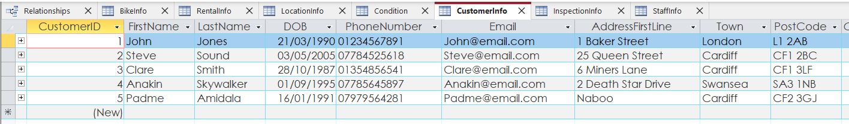

BikeInfo
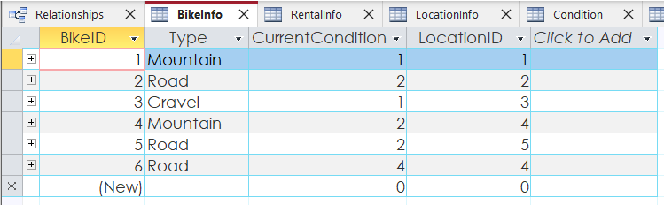

StaffInfo
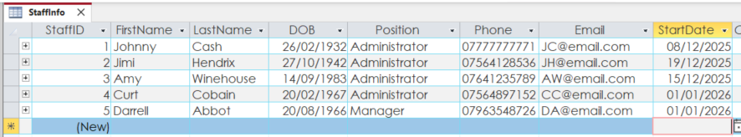

LocationInfo
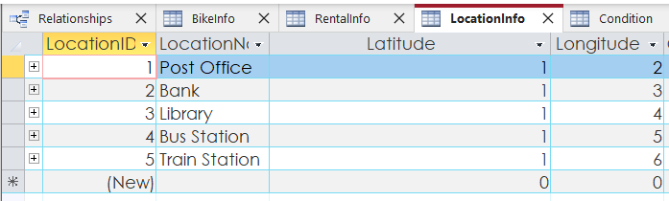

InspectionInfo
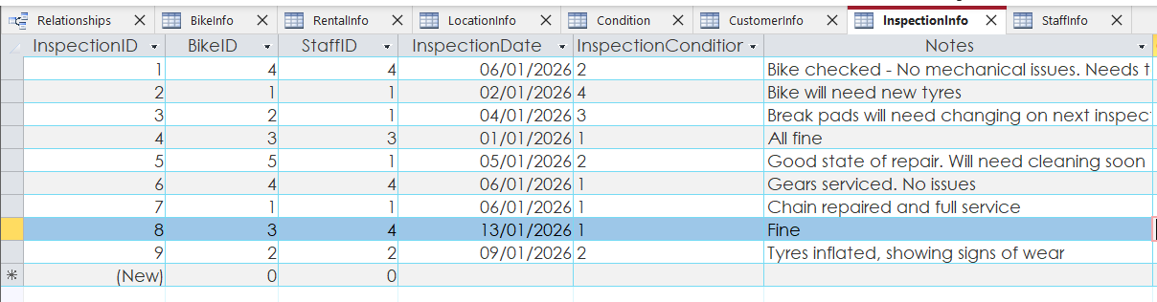

Condition
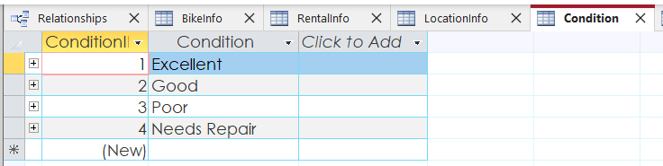

RentalInfo
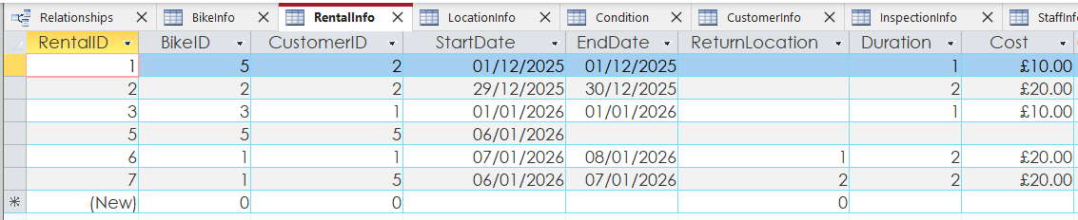

Query Development
Several queries have been developed to assist in the use of the database.

Available Bikes
This query allows users to find which bikes are available through filtering those bikes that are either still out on rental (have no return date) or those that have no rental information attached.
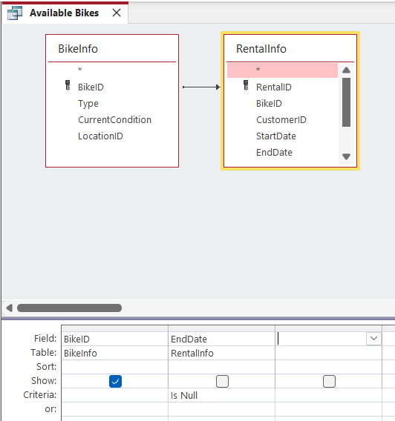
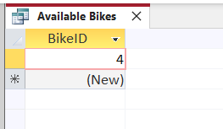

Bikes that need service
This query allows users to quickly identify which bikes need repair by filtering against the current condition of the bike from the BikeInfo table. The criteria being the primary key of the condition table which in this case is “4” or “Needs Repair”.
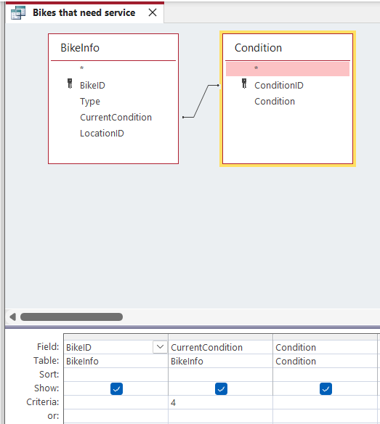

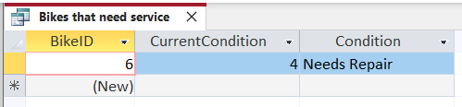

Number of inspections by staff
This query allows users to identify how many inspections have been carried out by each staff member. This is a count of the number of inspections compared to the ID number of each staff member run through the InspectionInfo table.
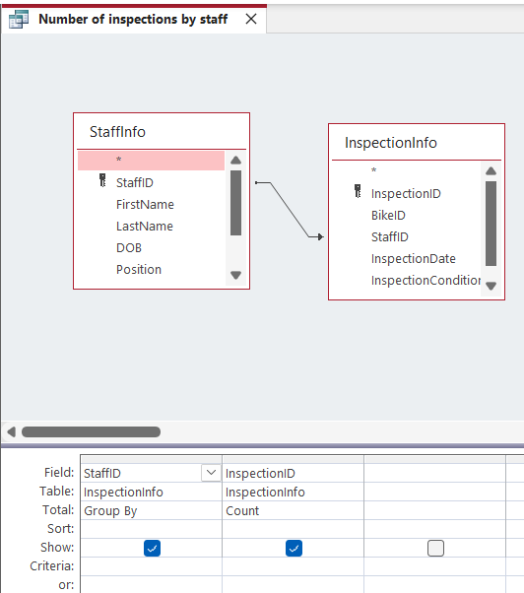
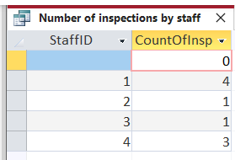

Number of rentals per customer
This query allows user to track customer activity through counting the number of rentals associated with each CustomerID and is broadly configured in the same way as the above Inspection query.
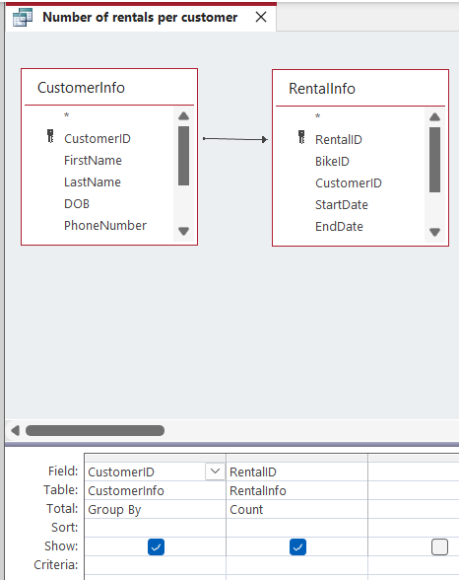

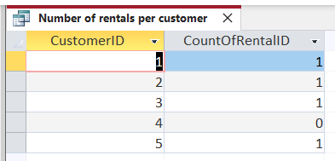

Form Creation

New Customer and Staff form
Simple forms have been created to allow staff to easily add New customers and New staff to the database. Both forms follow the same basic principle of allowing staff to enter data into the relevant fields (using textboxes) which are held in the entity.
There are also two buttons. The first allows for new records to be created and the second saves the record to the database.
The forms are displayed below:
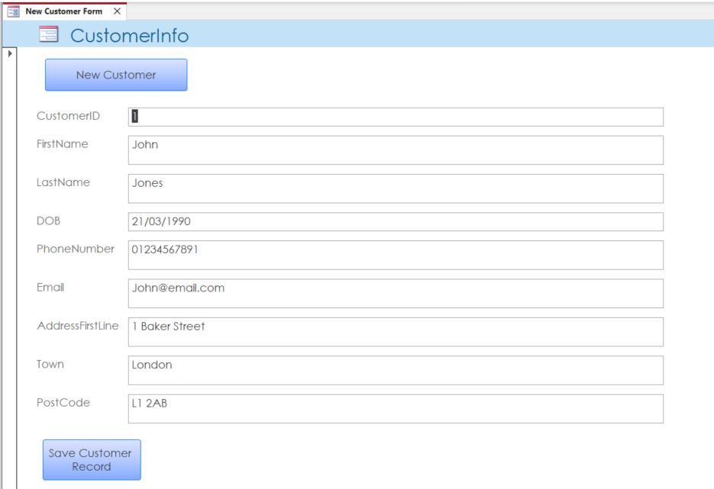

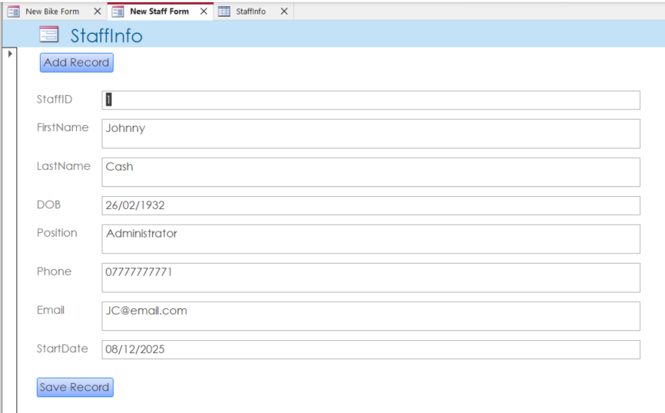

New Bike Form
The new bike form allows staff to enter new bike information into the database. The type of bikes is a free text textbox where as the Condition and LocationName options are combo boxes which draw options from either the Condition or LocationInfo table. This enforces continuity when data is entered. Again, there are two buttons added for creating new records and saving the record once populated.
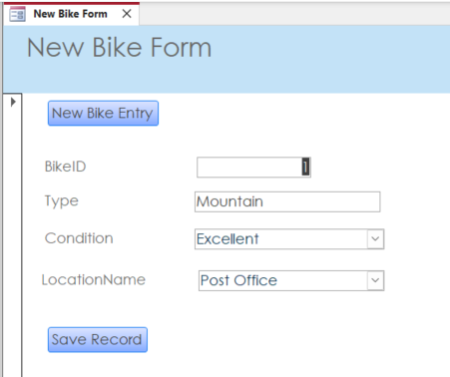

Inspection Form
The inspection form has a combination of textboxes and comboboxes as per the new bike form. The addition in this form which differs from the Bike form is the Inspection Condition. This combobox draws information from the condition table but has an additional button next to it.
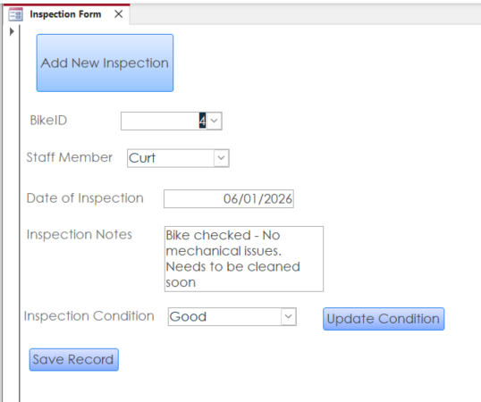

The “Update Condition” button updates the condition of the Bike in the BikeInfo table through running a query which has been created to support this feature.
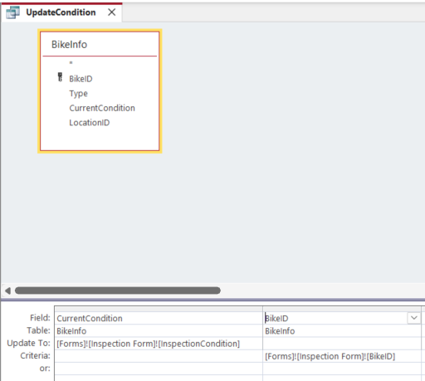
This allows form allows staff to log their inspections and also update the current condition of the bike following inspection.

Rental Form
The rental form allows staff to create and update rentals.
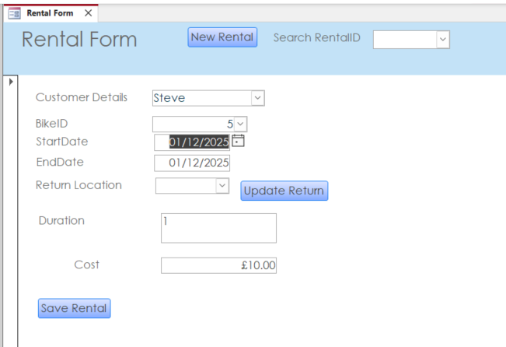
It has the same features as previous forms with the inclusion of a different query which updates the current location of the bike in the BikeInfo table using the “Update Return” button. The query follows the same structure but has different sources of data and a different update area. This is displayed below:
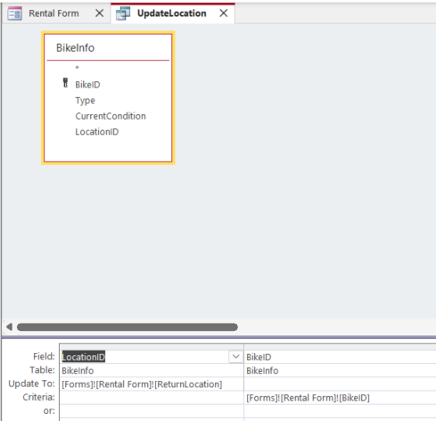

There is a final addition which is the “Search RentalID” function. This is a simple combo box which allows the user to select an ID and then displays the relevant information associated with that ID. This allows staff to find rentals and update them accordingly. This is useful when looking to update a return of a bike.

Validation and Testing

Null Testing
There are several fields that are mandatory fields, this restricts users from saving a record with a null entry in some of the attributes.
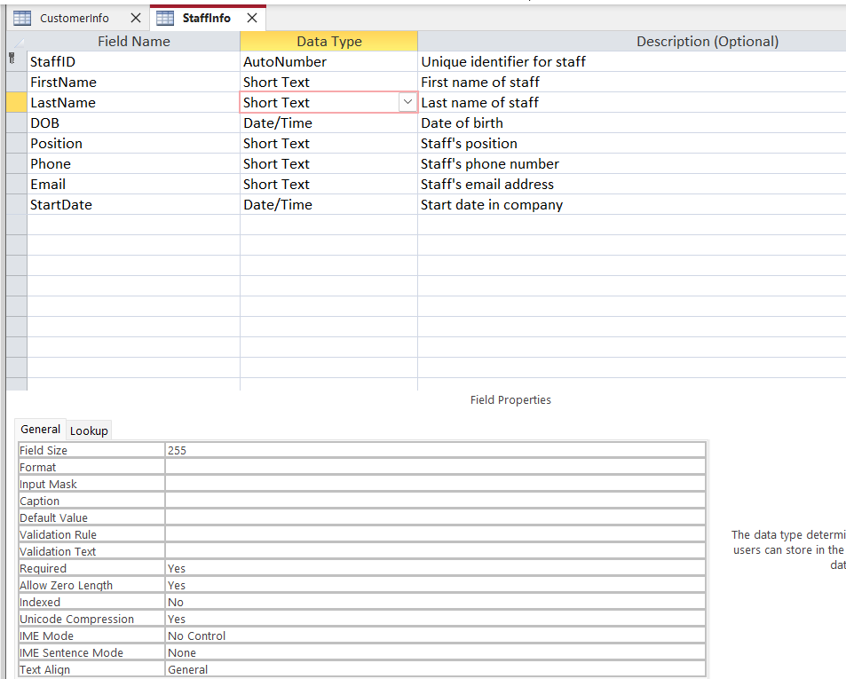
This has initially been tested through direct entry into the database as per the below example.
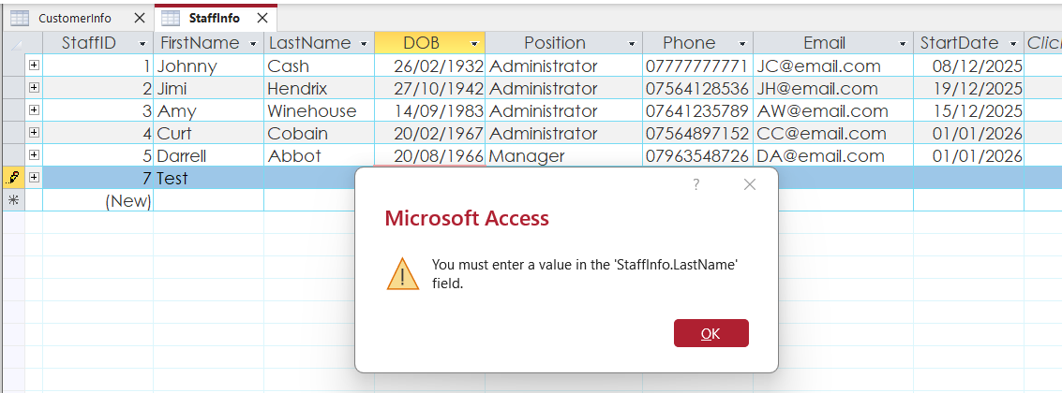

In addition this has also been tested through using the forms.
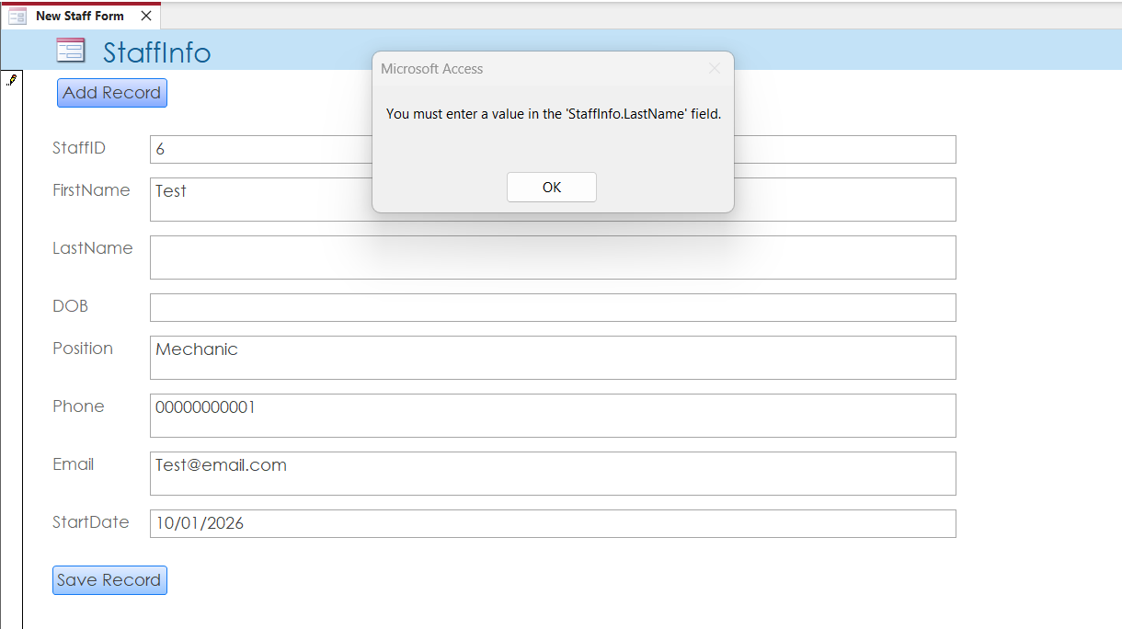
A further example of testing displayed below.

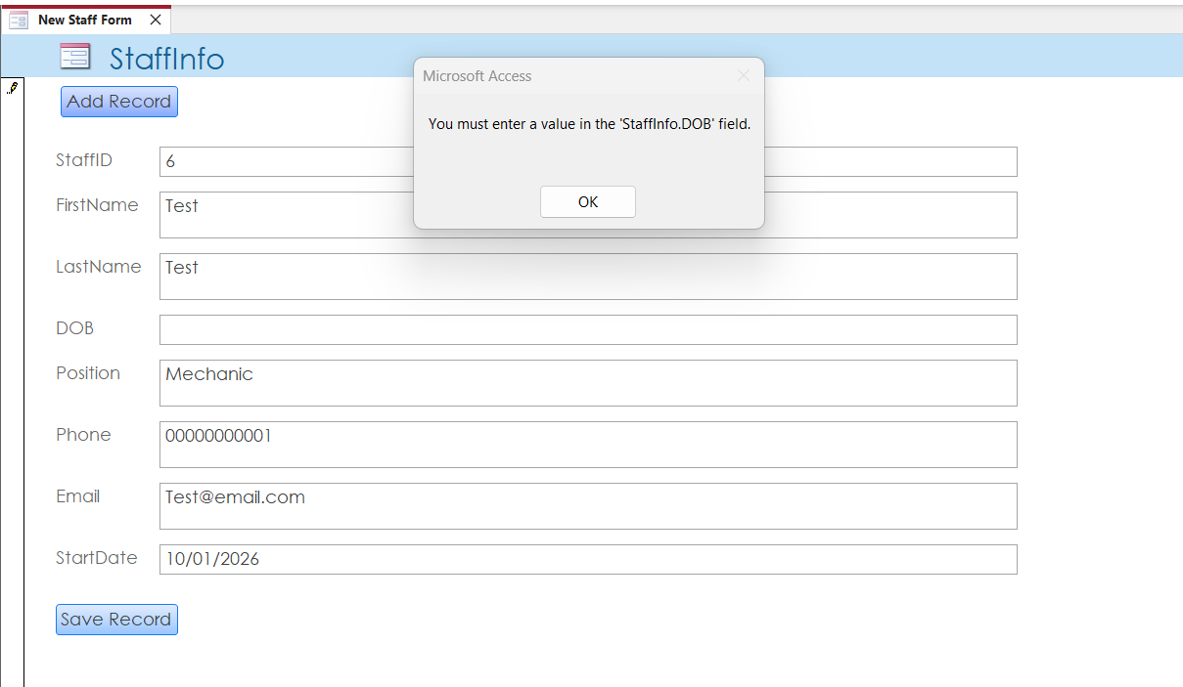

Data validation testing
Telephone number fields in the database have a validation rule which requires user to enter a pre-determined 11-digit number.
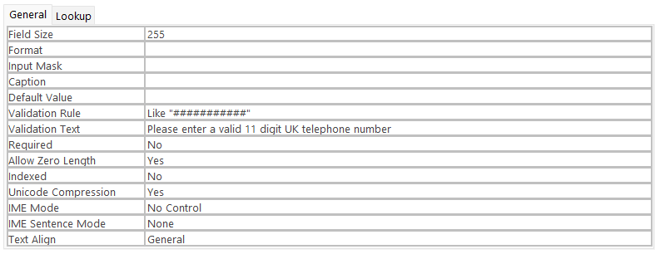
This has been tested as displayed below and correctly restricts users from entering numbers that are too long or short.
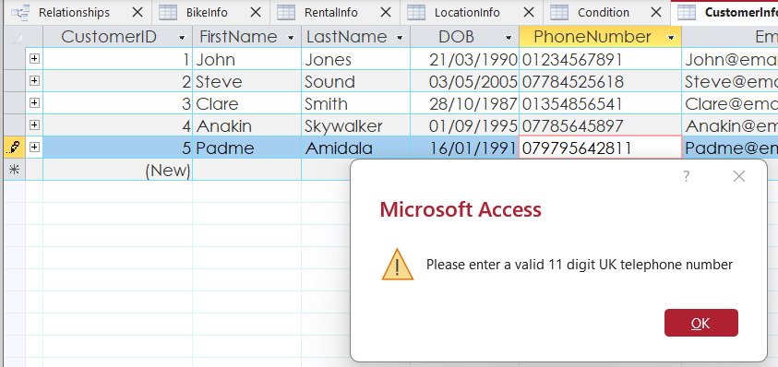
Through testing it was identified that while the above validation rule required an 11-digit entry, it would permit a null entry, as displayed below.
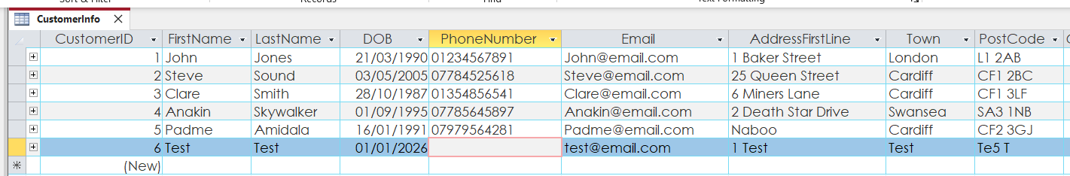
In view of this the required field option was changed to “Yes” which resolved this issue.

Summary
When considering the scenario posed as part of this assignment, the initial entities required were apparent. Tables such as Customer, Bike, Rental, Staff and Inspection were required. Carrying out further analysis, it became clear that additional entities would be needed to support features desirable for the implementation. Location and Condition tables were useful enhancements to the database to allow lookup functions and maintain data integrity, which is why they were included.
I decided to create several forms to make data entry user friendly. This enhances the user experience and minimises the potential for human error when inputting data.
Overall, the designed database meets the customer’s needs of storing customer and staff details, recording rental transactions and tracking staff involvement. Relevant queries have been developed to allow easy access to this information.
I would consider the use of macros in future updates to this database system. Updating the location and condition of bikes is currently configured in a way that requires the user to press a separate button to complete this action. A macro would allow this data to be updated automatically following the saving of a record. In addition, as previously highlighted, the RentalInfo table would benefit from 3NF compliance through using a macro to update the fields rather than relying on a calculated field

Bibliography

[1] | T. Connolly, Database Systems: A Practical Approach to Design, Implementation, and Management, Pearson Education, 2015.
[2] | M.-I. C. T. T. G. T. Marian Fotache, “Information Systems - Data: Creation, Management and Utilization,” The effects of database normalization on decision support system performance, 2025.

