BMIH6001 Contemporary Themes in the Hotel

and Hospitality Sector

Student ID: 2013505
SHARIFUL ISLAM

Table of Contents
Assignment 1: Research paper 1
Introduction 1
Overview of literature 2
Application to the hotel and hospitality sector 5
Evaluate future policy and management options for dealing with this issue. 8
References 10
Assignment 2: Conference presentation 13
Introduction 13
Overview of literature 14
Application to the hotel and hospitality sector 16
Evaluate future policy and management options for dealing with this issue. 19
References 21

Assignment 1: Research paper

Introduction
The concept of sustainability has arisen as one of the most important modern issues, cutting across all business sectors and becoming especially important in the hotel and hospitality industry. Sustainability is no longer only a catchphrase; rather, it is an obligation that has become more important as worldwide awareness of environmental and socioeconomic concerns has grown. In the hotel and hospitality industry, sustainability is of the utmost importance because of the significant influence it has not only on the bottom line but also on the surrounding environment and communities (Bansal and Song, 2021). Not only can sustainable business practices like energy efficiency, waste reduction, and responsible sourcing help to make the globe a better place, but they also help to save operating expenses and improve a brand's image. In addition, the hospitality business has a social obligation to ensure the well-being of both its workers and its customers, as well as to engage with the communities in which it operates in order to facilitate the expansion of both parties. In the middle of this transition towards more environmentally friendly practices, Hilton Hotels serves as an illuminating case study. Hilton, which operates one of the world's biggest and most well-known hotel chains, has made great strides in incorporating environmentally responsible business practices into its daily operations. Hilton offers a perfect example of how a significant player in an industry can lead the way in sustainability while also benefitting both society and its company by taking a complete strategy that covers environmental conservation, social responsibility, and economic viability (Hilton Worldwide Inc., 2023). This approach allows Hilton to provide a win-win situation for all parties involved. This article will investigate the sustainability measures that Hilton has taken, providing light on their significance as well as the larger relevance of sustainability in the hotel and hospitality business as a whole.

Overview of literature
As shown by a PESTLE study, the modern topic of sustainability has a substantial amount of effect not only on the hotel sector as a whole but also on Hilton Hotels:
Political Considerations
The hotel industry is subject to a significant amount of influence emanating from the sphere of politics pertaining to sustainability (Binder, 2019). Regulations and policies aiming at the protection of the environment and the preservation of resources are being more stringently implemented by governments all over the globe. These rules cover a wide range of hotel activities, including energy usage, trash management, and emissions control, among others, such as those mentioned. As a worldwide player, Hilton is required to traverse a complicated web of environmental rules and norms, which requires the company to make significant expenditures in environmentally responsible practices in order to stay compliant (Bansal and Song, 2021). However, it is important to keep in mind that some governments do, in fact, provide financial incentives and other forms of assistance to enterprises that are committed to environmental responsibility. This includes tax credits, subsidies, and grants, all of which are able to assist Hilton in offsetting some of the initial expenses connected with the implementation of environmentally friendly projects.
Aspects of the Economy
There are short-term as well as long-term financial repercussions associated with the implementation of sustainability efforts in the hotel business. In the beginning, the adoption of sustainable practices may need large financial expenditures on various technologies and procedures that lessen the effect on the environment and the amount of resources that are used (Aguinis, 2021). On the other hand, in the long term, Hilton and other hotels that place a priority on sustainability often see cost benefits. These cost reductions come in the form of decreased energy usage, expenditures related to waste management, and increased operational efficiency. In addition, because of the growing awareness of environmental concerns on a worldwide scale, a sizeable proportion of customers are increasingly prepared to pay a higher price for lodgings that have been verified as being environmentally responsible (Bjerregaard and Jonasson, 2021). Through its commitment to sustainability, Hilton will be able to attract the business of environmentally conscientious customers, which will result in greater sales and market share.
Aspects of Society
The road towards sustainability that the hotel sector is on is significantly impacted by social concerns. Hotels are coming under increased scrutiny for the ethical and environmental practises they uphold as a direct result of the growing knowledge and concern among consumers about a variety of social and environmental concerns. Along with its competitors, Hilton Hotels is required to react to the rising public demand for environmentally friendly solutions. Hilton has the potential to strengthen its image and appeal to a rising section of environmentally concerned travellers by implementing ecologically friendly practices (Campbell et al., 2021). Some examples of these practices include decreasing waste, saving resources, and sourcing locally. Additionally, Hilton's involvement with local communities and support for social issues may help its image as a responsible and caring corporate citizen, further strengthening brand loyalty and consumer satisfaction.
Aspects Relating to Technology
The fast progression of technology presents a wealth of chances for hotels like Hilton to adopt environmentally responsible practices. The advent of technology has made it possible to create solutions that are more energy efficient, approaches that reduce waste, and intelligent systems that can expedite operations while decreasing their effect on the environment. In order to lessen its impact on the environment and lower its overall energy usage, Hilton Hotels & Resorts has outfitted its hotels with cutting-edge technology such as LED lighting, smart thermostats, and eco-friendly home appliances (Coles et al., 2019). These technology solutions not only fit with the sustainability strategy but also enhance the visitor experience by giving a more pleasant and eco-conscious place to stay. In other words, they improve the guest experience while simultaneously aligning with the sustainability agenda.
The modern topic of sustainability has a significant impact on the hospitality sector as a whole and on Hilton Hotels in particular, as shown by the PESTLE study. Hilton is able to strengthen its brand image, create long-term economic advantages, and contribute to a more sustainable future if it understands and adapts to these political, economic, social, and technical elements. This enables Hilton to not only fulfil the increasing needs of its customers and the regulatory obligations that go along with them but also to better serve its customers.

Application to the hotel and hospitality sector
The research project focused on the "Waste Management" sector of the hospitality business in order to investigate the actual effects that the current "Sustainable" trend has. Management of waste is an essential component of hotels' efforts to become more sustainable since it has a direct bearing on environmental preservation, operational effectiveness, and financial savings. Hotels produce a significant quantity of garbage, including food, paper, plastic, and technological waste, which, if not handled effectively, may have a negative influence on the environment (Cruz and Boehe, 2021). Hotels also create a significant amount of rubbish. Additionally, inadequate waste management practices may result in harm to a company's image as well as concerns with regulatory compliance. In response to these issues, the management of the hotel has devised a variety of solutions to handle waste management, all of which will be critically examined in terms of their respective strengths and weaknesses in the following paragraphs.
Management Response 1: Recycling Programs
In an effort to lessen the quantity of trash that is disposed of in landfills, a number of hotels have implemented extensive recycling programmes. Through these programmes, both visitors and workers are encouraged to sort recyclable materials like paper, plastic, glass, and aluminium from the rest of the general garbage (Currie and Spyridonidis, 2020). Recycling programmes may greatly lessen their negative effects on the surrounding environment, and implementing them is not very difficult. In addition, they illustrate the hotel's dedication to environmental protection, which contributes to an improved perception of the brand.
Strengths: Recycling programmes may effectively minimise the amount of garbage that is delivered to landfills, and their implementation is quite straightforward. Additionally, they assist hotels in demonstrating their dedication to sustainability, which is an important factor in attracting customers who are ecologically sensitive (Dahlmann and Grosvold, 2017).
Limitations: If visitors and staff members do not actively engage in recycling programmes, the programmes' potential for success may be restricted. Both the contamination of recyclables and the search for cost-effective recycling choices are widespread challenges, particularly in areas of the country that have a deficient recycling infrastructure (Delbridge and Edwards, 2022).
Management Response 2: Food Waste Reduction
Given the enormous amounts of food that are produced and served, the hotel business has a significant challenge in the form of food waste. In many hotels, efforts have been made to limit the amount of food that is wasted via the use of techniques such as portion control, menu optimisation, and food donation programmes (Doh et al., 2021). These initiatives not only lessen their influence on the environment but also bring about significant financial savings.
Strengths: Initiatives to reduce the amount of food wasted have advantages for the environment as well as the economy. They decrease the quantity of garbage that is sent to landfills, which in turn lowers the expenses associated with disposal while simultaneously enhancing the hotel's image as a socially responsible organisation (Farrington et al., 2017).
Limitations: It might be difficult to implement efficient ways to reduce food waste because of the wide variety of demands and preferences expressed by customers (Forcadell and Aracil, 2017). In addition to this, hotels have a responsibility to check that food safety regulations are followed if they provide extra food.
Management Response 3: Reducing Single-Use Plastics
Straws, bottles, and other single-use plastic items are among those that are being phased out of usage at a number of hotels. Instead, they are turning to environmentally friendly substitutes such as solutions that are biodegradable or reusable (Fong et al., 2018). This answer is in line with the rising public concern about the pollution caused by plastic and the deterioration of the environment.
Strengths: Reducing the usage of plastics with a single use helps prevent environmental damage and indicates a commitment to sustainability (Friedland and Alford, 2021). This is especially important in areas with stringent environmental rules and visitors who are environmentally conscientious.
Limitations: Eliminating single-use plastics entirely may be difficult, particularly in locations where there is little availability of environmentally preferable alternatives. There is a possibility that visitors who are used to the ease of single-use goods may push back against hotels (Gioia et al., 2022).
Waste management is an essential sector that has seen substantial transformations as a direct result of the modern "Sustainable" trend that has permeated the hotel business. The ability of these management approaches to lessen their influence on the environment, enhance the reputation of the brand, and bring about cost reductions is where their strengths lie (Greenwood et al., 2021). However, it is important to keep in mind that there are constraints, such as the need for active engagement from both guests and employees as well as the logistical difficulties associated with implementation. When it comes to successfully addressing issues related to sustainability, effective waste management strategies in hotels often need a mix of different approaches as well as a commitment to ongoing development.

Evaluate future policy and management options for dealing with this issue.
Recommendations for the hotel sector to better embrace and flourish in the modern 'Sustainable' theme:
Invest in Technologies That Are Environmentally Friendly
The hotel sector needs to maintain its investment in cutting-edge technology that is kind to the environment. This involves the implementation of energy-efficient lighting, water-saving technologies, and building management systems that are smart. These technologies not only lower the consumption of resources and expenses associated with operations, but they also improve the experience of customers (Huang and To, 2018). In order to increase the rate of adoption, governments and industry groups may choose to provide financial incentives or tax breaks to hotels that make investments in environmentally friendly technologies.
Strategies for the Comprehensive Reduction of Waste
Inns and hotels have to devise and put into action comprehensive waste reduction plans that go beyond the scope of standard recycling programmes. This may involve reducing wasted food, doing away with plastics designed for single use, and taking steps to limit waste from electronic devices. Hotels that want to be successful should emphasise the significance of reducing waste and being environmentally responsible to their employees, customers, and vendors (Hughes and Scheyvens, 2016). In addition, working together with community groups and charities to give unused food is another way to guarantee the environmentally appropriate disposal of unwanted food.
Participate actively in the communities
It is important for the hospitality business to forge closer links with the communities in which it operates. Projects and collaborations that include collaboration may be beneficial to the hotel as well as to the community. This might include purchasing local goods, participating in community development programmes, or giving financial support to local organisations or causes (Husted and Allen, 2016). The engagement of the hotel with the community around it not only improves the hotel's reputation but also makes a positive contribution to the expansion of the region's social and economic conditions.
Management of the Supply Chain That Is Sustainable
The sustainability initiatives of hotels need to be expanded to include the supplier chain. Working with suppliers that are committed to ethical and environmentally responsible business practices is required for this. Hotels have the potential to establish sustainable standards for their suppliers and routinely evaluate the performance of those providers (Jamali and Karam, 2016). Hotels may not only lessen their impact on the environment and society by obtaining their supplies in a responsible and ethical manner, but they can also make a contribution to the larger push towards sustainability.
Training of Employees and Facilitation of Empowerment
It is essential for the effective adoption of sustainable practices to make investments in the training and empowerment of workers. It is the responsibility of hotels to give their staff the education and resources necessary to actively engage in sustainability projects (Jamali et al., 2017). Empowered employees may assist in driving sustainability initiatives from inside the organisation, ensuring that waste reduction, energy efficiency, and other green practices are routinely followed across the whole organisation.
Transparency as well as Open Lines of Communication
When it comes to proving one's dedication to sustainability, transparency is essential. It is important for hotels to be transparent with their customers and the general public on their sustainability efforts, objectives, and successes. This may be accomplished by providing comprehensible communication on their websites, in the materials provided in the rooms, and through social media (Jamali and Mirshak, 2021). A feeling of responsibility within the business may be encouraged via the use of transparent reporting, which can also assist in creating confidence with visitors who are environmentally sensitive.
The hotel sector is one of the most important players in the promotion of sustainable practices. Hotels have the potential to flourish in the modern 'Sustainable' theme if they make investments in environmentally friendly technologies, execute thorough waste reduction programmes, collaborate with local communities, oversee sustainable supplier chains, delegate authority to employees, and engage in open and honest communication. Not only are the environment and society better off as a result of these guidelines, but hotels are also better positioned for long-term success in a market that is becoming more eco-conscious.

References
Aguinis, H. (2021), “Organizational responsibility: doing good and doing well”, Zedeck, S. (Ed.), APA Handbook of Industrial and Organizational Psychology, American Psychological Association, Washington DC, pp.855-879.
Bansal, P. and Song, H. (2021), “Similar but not the same: differentiating corporate sustainability from corporate responsibility”, Academy of Management Annals, Vol.11 No.1, pp.105-149.
Binder, A. (2019), “For love and money: organizations’ creative responses to multiple environmental logics”, Theory and Society, Vol.36 No.6, pp.547-571.
Bjerregaard, T. and Jonasson, C. (2021), “Organizational responses to contending institutional logics: the moderating effect of group dynamics”, British Journal of Management, Vol.25 No.4, pp.651-666.
Campbell, J. T., Eden, L. and Miller, S. R. (2021), “Multinationals and corporate social responsibility in host countries: Does distance matter?”, Journal of International Business Studies, Vol.43 No.1, pp.84-106.
Coles, T., Fenclova E. and Dinan, C. (2019), “Responsibilities, recession and tourism sector: perspectives on CSR among low-faires airlines during the economic downturn in the UK”, Current Issues in Tourism, Vol.14 No.6, pp.519-536.
Cruz, L. B. and Boehe, D. M. (2021), “How do leading retail MNCs leverage CSR globally? Insights from Brazil", Journal of Business Ethics, Vol.91 No.2, pp.243–263.
Currie, G. and Spyridonidis, D. (2020), “Interpretation of multiple institutional logics on the ground: Actors’ position, their agency and situational constraints in professionalized contexts”, Organization Studies, Vol.37 No.1, pp.77-97.
Dahlmann, F. and Grosvold, J. (2017), “Environmental managers and institutional work: reconciling tensions of competing institutional logics”, Business Ethics Quarterly, Vol.27 No.2, pp.263-291.
Delbridge, R. and Edwards, T. (2022), “Inhabiting institutions: Critical realist refinements to understanding institutional complexity and change” Organization Studies, Vol.34 No.7, pp.927- 947.
Doh, J., Husted, B. W. and Yang, X. (2021), “Ethics, corporate social responsibility, and developing country multinationals”, Business Ethics Quarterly, Vol.26 No.3, pp.301-315.
Ertuna, B. and Tükel, A. (2019), “Traditional versus International Influences: CSR Disclosures in Turkey”, European Journal of International Management, Vol.4 No.3, pp.273-289
Farrington, T., Curran, R., Gori, K., O’Gorman, K. D. C. and Queenan, J. (2017), "Corporate social responsibility: reviewed, rated, revised", International Journal of Contemporary Hospitality Management, Vol.29 No.1, pp.30-47.
Forcadell, F. J. and Aracil, E. (2017), “Sustainable banking in Latin American developing countries: leading to (mutual) prosperity”, Business Ethics: A European Review, Vol.26 No.4, pp.382-395.
Fong, V. H., Wong, I. A. and Hong, J. F. L. (2018), “Developing institutional logics in the tourism industry through coopetition”, Tourism Management, Vol.66, pp.244-262.
Friedland, R., and Alford, R. R. (2021), “Bringing society back in symbols, practices, and institutional contradictions”, Powell, W. W. and DiMaggio, P. J. (Eds.), The New Institutionalism in Organizational Analysis, University of Chicago Press, Chicago, pp.223–62.
Gioia, D. A., Corley, K. G. and Hamilton, A. L. (2022), “Seeking qualitative rigour in inductive research: Notes on the Gioia methodology”, Organizational Research Methods, Vol.16 No.1, pp.15-31.
Greenwood, R., Raynard, M., Kodeih, F., Micelotta, E. R. and Lounsbury, M. (2021), “Institutional complexity and organizational responses”, Academy of Management Annals, Vol.5 No.1, pp.317-371.
Hilton Worlwide Inc. (2023), “Annual Report”, available at: http://www.corporatereport.com/hilton/2023/ar/ (accessed 15 October 2023).
Huang, G. and To, W.M. (2018), “Importance-performance ratings of corporate social responsibility practices by employees in Macao’s gaming industry”, International Journal of Contemporary Hospitality Management, Vol.30 No.9, pp.2870-2887.
Hughes, E. and Scheyvens, R. (2016), “Corporate social responsibility in tourism post-2015: a development first approach”, Tourism Geographies, Vol.18 No.5, pp.469-482.
Husted, B.W. and Allen, D. B. (2016), “Corporate social responsibility in the multinational enterprise: strategic and institutional approaches”, Journal of International Business Studies, Vol.37 No.6, pp.838-849.
Jamali, D. and Karam, C. (2016), “Corporate social responsibility in developing countries as an emerging field of study”, International Journal of Management Reviews, Vol.20 No.1, pp.32-61.
Jamali, D., Karam, C., Yin, J. and Soundararajan, V. (2017), “CSR logics in developing countries: translation, adaptation and stalled development”, Journal of World Business, Vol.52 No.3, pp.343–359
Jamali, D. and Mirshak, R. (2021). “Business-conflict linkages: Revisiting MNCs, CSR, and conflict. Journal of Business Ethics” Vol.93 No.3, pp.443-464

Assignment 2: Conference presentation

Introduction
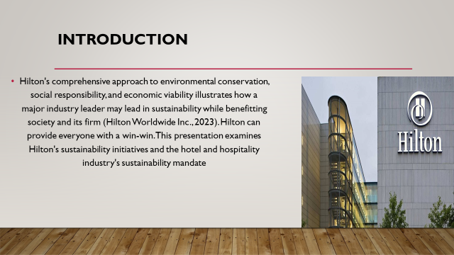
All industries, especially hotels and hospitality, are concerned about sustainability. Global understanding of environmental and socioeconomic challenges makes sustainability a duty. The hotel and hospitality industry's bottom line, environment, and communities depend on sustainability (Bansal and Song, 2021). Sustainable company practices including energy efficiency, waste reduction, and ethical buying save money, improve the earth, and raise brand image. The hotel sector also has a social obligation to safeguard its workers and customers and assist their communities to flourish. Hilton Hotels shows this environmental trend. Hilton has made tremendous progress in adopting green business practices. Hilton's comprehensive approach to environmental conservation, social responsibility, and economic viability illustrates how a major industry leader may lead in sustainability while benefitting society and its firm (Hilton Worldwide Inc., 2023). Hilton can provide everyone with a win-win. This presentation examines Hilton's sustainability initiatives and the hotel and hospitality industry's sustainability mandate.

Overview of literature
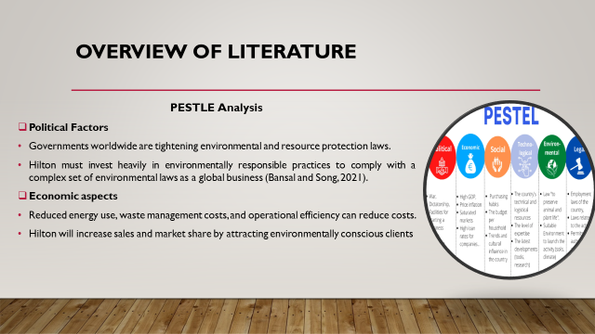
A PESTLE analysis shows that sustainability affects Hilton Hotels and the hotel industry as a whole:
Political Factors
Sustainability politics heavily impact the hotel business (Binder, 2019). Governments worldwide are tightening environmental and resource protection laws. These standards encompass energy consumption, garbage management, pollution control, and more in hotels. Hilton must invest heavily in environmentally responsible practices to comply with a complex set of environmental laws as a global business (Bansal and Song, 2021). It is crucial to note that some governments provide financial incentives and other aid to environmentally responsible businesses. Tax credits, subsidies, and grants may help Hilton defray some of the early costs of environmentally friendly initiatives.
Economic aspects
Sustainability in the hotel industry has short- and long-term financial effects. Sustainable practices may need considerable initial investments in technology and processes that reduce environmental impact and resource usage (Aguinis, 2021). However, Hilton and other sustainable hotels generally save money over time. Reduced energy use, waste management costs, and operational efficiency can reduce costs. Due to global environmental awareness, many clients are willing to pay more for ecologically friendly hotels (Bjerregaard and Jonasson, 2021). Hilton will increase sales and market share by attracting environmentally conscious clients via its sustainability efforts.
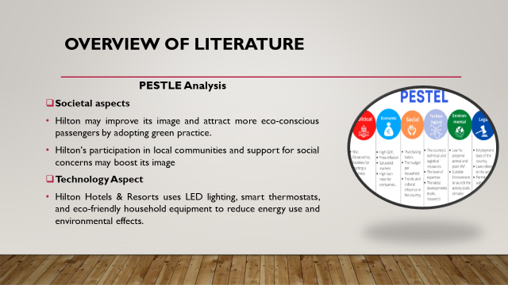
Societal aspects
Social considerations affect the hotel industry's sustainability journey. As customers become more aware of social and environmental issues, hotels are under more scrutiny for their ethical and environmental practices. Hilton Hotels must respond to public demand for eco-friendly solutions like its rivals. Hilton may improve its image and attract more eco-conscious passengers by adopting green practices (Campbell et al., 2021). Waste reduction, resource conservation, and local sourcing are examples. Hilton's participation in local communities and support for social concerns may boost its image as a responsible and caring corporate citizen, increasing brand loyalty and customer satisfaction.
Technology Aspect
The rapid advancement of technology offers hotels like Hilton opportunities to embrace environmentally conscious practices. Technology has enabled energy-efficient, waste-reduction, and intelligent systems that speed up processes while reducing their environmental impact. Hilton Hotels & Resorts uses LED lighting, smart thermostats, and eco-friendly household equipment to reduce energy use and environmental effects (Coles et al., 2019). These technological solutions support the sustainability plan and make stays more pleasurable and eco-friendly. They enhance the visitor experience while promoting sustainability.

Application to the hotel and hospitality sector
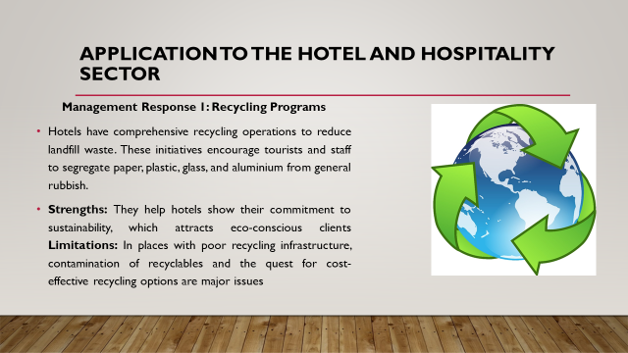
The "Waste Management" sector of the hotel industry was studied to see how the "Sustainable" trend affects it. Waste management is crucial to hotels' sustainability since it affects environmental protection, operational efficiency, and financial savings. Hotels generate a lot of food, paper, plastic, and technological waste, which may harm the environment if not properly managed (Cruz and Boehe, 2021). Hotels generate a lot of trash. Poor waste management may damage a company's image and regulatory compliance. The hotel management has developed many waste management methods to address these concerns, which will be critically assessed in the following paragraphs.
Management Response 1: Recycling Programs
Hotels have comprehensive recycling operations to reduce landfill waste. These initiatives encourage tourists and staff to segregate paper, plastic, glass, and aluminium from general rubbish (Currie and Spyridonidis, 2020). Recycling schemes may reduce their environmental impact and are easy to implement. They also demonstrate the hotel's environmental commitment, improving its brand reputation.
Strengths: Recycling schemes reduce landfill waste and are easy to implement. They also help hotels show their commitment to sustainability, which attracts eco-conscious clients (Dahlmann and Grosvold, 2017).
Limitations: Recycling schemes may fail if visitors and workers don't recycle. In places with poor recycling infrastructure, contamination of recyclables and the quest for cost-effective recycling options are major issues (Delbridge and Edwards, 2022).
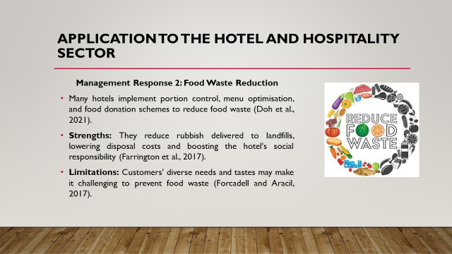
Management Response 2: Food Waste Reduction
Hotel food waste is a major issue due to the massive quantity of food generated and provided. Many hotels implement portion control, menu optimisation, and food donation schemes to reduce food waste (Doh et al., 2021). These approaches save money and reduce their environmental impact.
Strengths: Food waste reduction benefits the environment and economy. They reduce rubbish delivered to landfills, lowering disposal costs and boosting the hotel's social responsibility (Farrington et al., 2017).
Limitations: Customers' diverse needs and tastes may make it challenging to prevent food waste (Forcadell and Aracil, 2017). Hotels must also ensure food safety if they supply additional meals.
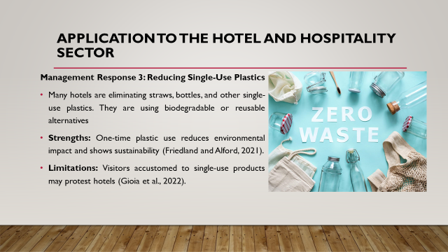
Management Response 3: Reducing Single-Use Plastics
Many hotels are eliminating straws, bottles, and other single-use plastics. They are using biodegradable or reusable alternatives (Fong et al., 2018). This response reflects societal concern about plastic pollution and environmental degradation.
Strengths: One-time plastic use reduces environmental impact and shows sustainability (Friedland and Alford, 2021). This is particularly significant in countries with strict environmental laws and eco-conscious tourists.
Limitations: Eliminating single-use plastics may be challenging in areas with few ecologically friendly alternatives. Visitors accustomed to single-use products may protest hotels (Gioia et al., 2022).

Evaluate future policy and management options for dealing with this issue.
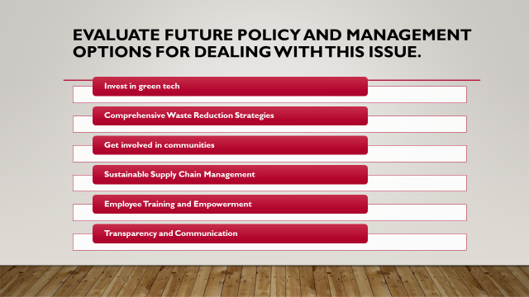
Suggestions for hotels to accept and thrive in the current 'Sustainable' theme:
Invest in green tech
Hotels must keep investing in eco-friendly technologies. Energy-efficient lighting, water-saving technology, and smart building management systems are used. These technologies reduce resource use and operational costs while improving user experience (Huang and To, 2018). Governments and industry associations may provide hotels with financial incentives or tax exemptions to use environmentally friendly technology to boost adoption.
Comprehensive Waste Reduction Strategies
Inns and motels must create and implement complete waste reduction initiatives beyond recycling. This may include decreasing food waste, eliminating single-use plastics, and lowering electronic device waste. Successful hotels should stress waste reduction and environmental responsibility to staff, customers, and suppliers (Hughes and Scheyvens, 2016). Working with community organisations and charities to donate surplus food is another strategy to ensure ecologically friendly disposal.
Get involved in communities
The hotel industry must strengthen relationships with local communities. Collaborative projects may benefit the hotel and community. This might involve buying local items, supporting local causes, or engaging in community development activities (Husted and Allen, 2016). The hotel's community involvement boosts the region's social and economic development and enhances its reputation.
Sustainable Supply Chain Management
The supply chain must be included in hotel sustainability efforts. This requires ethical and ecologically responsible providers. Hotels may set sustainable supplier requirements and regularly review their performance (Jamali and Karam, 2016). By sourcing ethically, hotels may reduce their environmental and social effect and contribute to sustainability.
Employee Training and Empowerment
Investments in worker training and empowerment are crucial to sustainable practices. Hotels must educate and equip workers to participate in sustainability programmes (Jamali et al., 2017). Empowered staff may drive sustainability projects from inside the firm, ensuring waste reduction, energy efficiency, and other green practices are adopted across the board.
Transparency and Communication
To demonstrate sustainability, openness is crucial. Hotels should disclose their sustainability goals, initiatives, and results to consumers and the public. Communicating clearly on their websites, in-room materials, and on social media may do this (Jamali and Mirshak, 2021). Transparent reporting helps foster a sense of responsibility in the organisation and reassure environmentally conscious customers.
The hotel industry is a major promoter of sustainability. Hotels can thrive in the modern 'Sustainable' theme if they invest in environmentally friendly technologies, reduce waste, collaborate with local communities, manage sustainable supplier chains, delegate authority to employees, and communicate openly. These regulations benefit the environment, society, and hotels, positioning them for long-term success in an eco-conscious market.

References
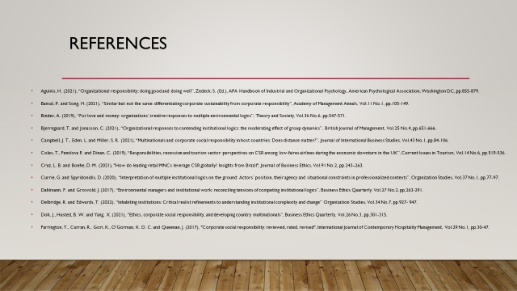
Aguinis, H. (2021), “Organizational responsibility: doing good and doing well”, Zedeck, S. (Ed.), APA Handbook of Industrial and Organizational Psychology, American Psychological Association, Washington DC, pp.855-879.
Bansal, P. and Song, H. (2021), “Similar but not the same: differentiating corporate sustainability from corporate responsibility”, Academy of Management Annals, Vol.11 No.1, pp.105-149.
Binder, A. (2019), “For love and money: organizations’ creative responses to multiple environmental logics”, Theory and Society, Vol.36 No.6, pp.547-571.
Bjerregaard, T. and Jonasson, C. (2021), “Organizational responses to contending institutional logics: the moderating effect of group dynamics”, British Journal of Management, Vol.25 No.4, pp.651-666.
Campbell, J. T., Eden, L. and Miller, S. R. (2021), “Multinationals and corporate social responsibility in host countries: Does distance matter?”, Journal of International Business Studies, Vol.43 No.1, pp.84-106.
Coles, T., Fenclova E. and Dinan, C. (2019), “Responsibilities, recession and tourism sector: perspectives on CSR among low-faires airlines during the economic downturn in the UK”, Current Issues in Tourism, Vol.14 No.6, pp.519-536.
Cruz, L. B. and Boehe, D. M. (2021), "How do leading retail MNCs leverage CSR globally? Insights from Brazil", Journal of Business Ethics, Vol.91 No.2, pp.243–263.
Currie, G. and Spyridonidis, D. (2020), “Interpretation of multiple institutional logics on the ground: Actors’ position, their agency and situational constraints in professionalized contexts”, Organization Studies, Vol.37 No.1, pp.77-97.
Dahlmann, F. and Grosvold, J. (2017), “Environmental managers and institutional work: reconciling tensions of competing institutional logics”, Business Ethics Quarterly, Vol.27 No.2, pp.263-291.
Delbridge, R. and Edwards, T. (2022), “Inhabiting institutions: Critical realist refinements to understanding institutional complexity and change” Organization Studies, Vol.34 No.7, pp.927- 947.
Doh, J., Husted, B. W. and Yang, X. (2021), “Ethics, corporate social responsibility, and developing country multinationals”, Business Ethics Quarterly, Vol.26 No.3, pp.301-315.
Farrington, T., Curran, R., Gori, K., O’Gorman, K. D. C. and Queenan, J. (2017), "Corporate social responsibility: reviewed, rated, revised", International Journal of Contemporary Hospitality Management, Vol.29 No.1, pp.30-47.
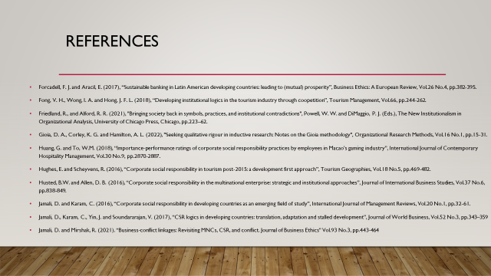
Forcadell, F. J. and Aracil, E. (2017), “Sustainable banking in Latin American developing countries: leading to (mutual) prosperity”, Business Ethics: A European Review, Vol.26 No.4, pp.382-395.
Fong, V. H., Wong, I. A. and Hong, J. F. L. (2018), “Developing institutional logics in the tourism industry through coopetition”, Tourism Management, Vol.66, pp.244-262.
Friedland, R., and Alford, R. R. (2021), "Bringing society back in symbols, practices, and institutional contradictions", Powell, W. W. and DiMaggio, P. J. (Eds.), The New Institutionalism in Organizational Analysis, University of Chicago Press, Chicago, pp.223–62.
Gioia, D. A., Corley, K. G. and Hamilton, A. L. (2022), "Seeking qualitative rigour in inductive research: Notes on the Gioia methodology", Organizational Research Methods, Vol.16 No.1, pp.15-31.
Huang, G. and To, W.M. (2018), “Importance-performance ratings of corporate social responsibility practices by employees in Macao’s gaming industry”, International Journal of Contemporary Hospitality Management, Vol.30 No.9, pp.2870-2887.
Hughes, E. and Scheyvens, R. (2016), “Corporate social responsibility in tourism post-2015: a development first approach”, Tourism Geographies, Vol.18 No.5, pp.469-482.
Husted, B.W. and Allen, D. B. (2016), “Corporate social responsibility in the multinational enterprise: strategic and institutional approaches”, Journal of International Business Studies, Vol.37 No.6, pp.838-849.
Jamali, D. and Karam, C. (2016), “Corporate social responsibility in developing countries as an emerging field of study”, International Journal of Management Reviews, Vol.20 No.1, pp.32-61.
Jamali, D., Karam, C., Yin, J. and Soundararajan, V. (2017), “CSR logics in developing countries: translation, adaptation and stalled development”, Journal of World Business, Vol.52 No.3, pp.343–359
Jamali, D. and Mirshak, R. (2021). “Business-conflict linkages: Revisiting MNCs, CSR, and conflict. Journal of Business Ethics” Vol.93 No.3, pp.443-464

