

Assessment Component 2
Written Essay

Student name: Modou Mbacke
Student ID: 1916151
Modules Name: Children Young People and Families
Module code: BMHP5004_LON
Lecturer name: Bianca Sanfilippo

Contents
Introduction----------------------------------------------------------------------------------2
Definition--------------------------------------------------------------------------------------2
Childhood as social construction--------------------------------------------------------3
Key element of the family life---------------------------------------------------------4-5
Historical prospective children and they family--------------------------------5-6-7
Conclusion--------------------------------------------------------------------------------------7
Reference ------------------------------------------------------------------------------------8-9

Introduction:
This essay ideas concerning childhood within different disciplines and societies, and in United Kingdom and international law. Furthermore, this report will provide overview of the changes in childhood in UK from Victorian era to present time. Will analysis the deferent definition of childhood and why the definition can be different from one society to other due to cultural, religious, and social structure of the society where the child is live and current intervention in the UK to reduce inequalities between children from disadvantaged and advantaged background. Children daily activities such as play, study, work and etc these are very important for the children social construction. According to IPPF, (2012) one such barrier that impedes young people’s access to education and services is the widely held and historically rooted belief that young people are incapable of making their own positive decision. Children as social construction, key elements of the family life and prospective of children in family life will be also discus in this essay. This essay will analyse the international laws and why these laws cannot work everywhere and what the international and national organisation are doing to protect children and young people. It is important for young to have they autonomous decisions about sexual life, freedom of speech and freedom of moment.
Definition:
According to UNICEF articles 1 child means every human being below the age of eighteen years unless under the law applicable to the majority is attained earlier. Definition of child in England is anyone who has not yet reached their 18th birthday. However, age alone does not determine who gets to be a child it depends on cultural, religious, and social-construct of the society where the child is living.’ Child protection guidance points out that even if a child has reached 16 years of age and is: living independently, in further education, a member of the armed forces, in hospital or in custody in secure estate they are still legally children and should be given the same protection and entitlements as any other child (Department of education, 2018a’ NSPCC, (2021). In modern UK we tend child to think of children as being vulnerable, innocent, naïve and in need of protection from the society. However, in some society they see a child as someone evil and need to be persecuted.

Key elements of family life and childhood:
Childhood is neither universal nor natural because not all societies in the world have the same concept of childhood. There is high degree of separation between the spheres of childhood and adulthood its part of the social construction of childhood in present day UK. According to S Norozi and T Moen (2016) The idea that childhood is socially construct refer to the understanding that childhood is not natural process rather it is society which decides when a child is a child and when a child become an adult. Due to different social and cultural circumstance children may experience different childhood for example child prostitution is more pronounced in Thailand than United Kingdom so experience being child in Thailand not same as being child in United Kingdom.” The parents smoking dose-response effect suggest that children inn smoking families are more at risk to start smoking and, more specifically, that the risk of child smoking increase as the number of parents who smoke increase” R Otten et al, (2007). Cultural and environmental influences are very important on the child development. Children with indulgent families with not high strictness experienced more autonomy compared to children with high strict families. Children adopt language, religion and behaviour through peer culture and interacting with their families, children, and other adults in the society where the child life. Family influence is severely high when it comes to child behaviour for example children can adopt criminal behaviour through their parents or in their frequentation. Most physiologist asserted childhood is more of a social construct than it is a biological. Parenting is having a several impact in the child habit, children can adopt some habit from their parents for example children who grow up with obese parents can adopt the habit of diet from their parents and become obese as well. It is not only the parent have very important influence in the child but most of the time child also look their parents as a someone to copy and follow. However, from certain age child starting to take they on way and the adults around the child can have an important influence in the child behaviours for example if the child frequentation is criminal the child can be criminal and may end up in hand of law enforcement agencies and it can affect the child for lifetime.

Key element of family life
There is not universal correct definition of family as is driven by unique social constructs in different communities. Family, is group of persons united by blood, adoption, or marriage, interacting with each other in their social positions usually those of siblings, parents, children r spouses. However, this concept of family could be different in one community to other for example in Africa and some Asian societies concept of family is severely large. Extended family are very common, and family could be included long time family neighbours or even long-time family friends and far away cousins. Because in this communities’ ancient belief, cultural and religion promote this kind of family structure. In addition, this belief is disappearing day by day due to social change of this communities. In western countries particularly UK concept of family are very narrowed to close families like children, spouses, parents, and siblings. Additionally, the structure of UK families and households is continually changing. According to office for national statistics ONS, (2019) opposite-sex and same-sex married, or civil partner couples remain the most common family type in 2019 and represent two-third of all families in the UK (19.8 million).” Nuclear family, also called elementary family, in sociology and anthropology, a group of people who are united by ties of partnership and parenthood and consisting of a pair of adults and their socially recognized children.” Britannica.com (2021). The most basic and universal organization of family is nuclear families. In modern Britain where same sex marriage is legal and gay couple allowed to have children this concept of nuclear families not always the case. According to W Meezan & J Rauch (2005) same-sex couples cannot conceive together, their children arrive by multiplicity of route into families that assume a variety of shapes. In many case children living with gay and lesbian couples are the biological offspring of one member of the couple whether by an earlier marriage or relationship. However, in some countries where same-sex marriage is not allowed the gays and lesbians couples not seen as a family but people who must be persecuted even sometime with death penalty. This why which is seen as family in UK not a same in everywhere. Family structure is changing year by year for example cohabiting couples is growing fast in UK which is different to traditional family structure.

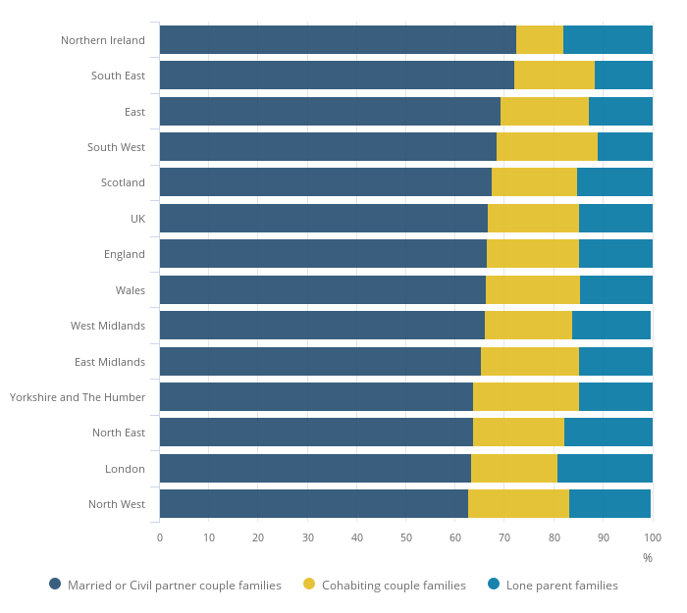
‘In 2016, married or civil partner couple families remained the most common type of family in the UK although cohabiting couple families were the fastest growing family type over the last twenty years. The growth in cohabiting couple families may be due to couples choosing cohabitation as an alternative or precursor to marriage’ ONS (2016). However, cohabitation is not allowed to some cultures and religions for example the Muslims does not do cohabitation because their religion do not allow it. I addition the child who burn out of marriage is not recognised in the Islamic as a legitimated child and that child have not right to inheritance and other right which same child can have in Western cultures.
Historical Perspective of Children and their Families
The perspective of families and children in UK have evolved in history and till today modern Britain. The families in Victorian time were a traditional and religious families where religion was very important in their life, God was in the centre of everything. Furthermore, in medieval time in some culture particularly in middle east parents prefer to have a boy than girl because girls was not valued in that time and can be a shame for the families. The size of the families in Victorian time were larger than nowadays Britain. The average family’s size in Victorian time were five or six children in the single families. Child labor were common in Victorian time because that time was an industrial revolution time in Britain and families preferred to send their children to work rather than send them to schools. Children was participating in household income due to size of their family and poverty that time. According to J Humphries (2003) it was particularly important to the early starters on the path of industrial progress, notable Britain, Belgium, France, the western part of Prussia, and united states. For these early starters the intensive use of child labor in the key sectors of the industrial revolution was superimposed on -children’s employment in proto industry and occurred in a cultural setting predisposed to “making children useful”. In Victorian era children did not have the right as they have in today modern Britain. The children was playing a important role in the industrial revolution by working even in very hard working sectors like mining and factories. Some places in the world the situation of children and families still the same till these days. For example child marriages is very common in Africa and parent can even push or force their children to married to someone who they think can help them financially due to they financial situation. In some societies man can married to more than one wife and it can have some bad effect to the children. According to P Antoine (2006) marriage system in Africa differ from one society to another. But some common features are found in the lineage-based society: as rule, unions concern lineage group more than individuals. Polygamy is very common practice in some countries nowadays, particularly some countries in Africa and Asia, this practice can have negative impact in the families particularly for women which is not fair to share your husband with other women without having a right to say no. In this women are very discriminate and their has been taken by patriarchal society. However, this is changing because of the globalization women in this countries are aware more and more about what is going on in other more developed countries in the world like Europe and United States. From late nineteen century to early twenty century the family situation has changed particularly children because some legislation has put in place to protect children. According to NSPCC (2021) legislation to prosecute people accused of child cruelty has been in force since the 1880s. Over the time a range of factors, including some high profile child abuse death and subsequent inquiries, have contributed to the development of child protection system we have in the UK today. However, children had suffered from the first and second world wars in Britain and Europe and there was plenty of orphans, children who lost one their parents or both parents. Those wars made a very negative impact in the families particularly for women and children because many men was engaged to the army and lost their lift behind their children and partners. However, the legislation change in late 19th has contributed to the better conditions of children young people and families in Britain. Nowadays right of children is respect, right of education, health and housing which was not the case in early industrialisation era.

Modern day Britain families has evaluated since Victorian time, today marriage and partnership not an only between males and females but can be same sex persons as well and children can grow in with same sex parents which was unimaginable in Victorian era. “The civil partnership Act 2004, for example, granted civil partnerships to same sex couple in the United Kingdom with right and responsibilities identical to civil marriage”. Parliament.gov.uk (2013). However, Act 2013 has replaced Act 2004 to granted more right to same sex couples, like right to have religious marriages and to adopt children. However, this right does not exist in every country for example same sex marriages is ban in most of Muslim countries. Nowadays families, children and young people are more protect in Britain than previous century and this right goes with time and can be changed to adopt it with the time in the future. The family allowance was established in 1945 by wartime government, a benefit was paid to each subsequent and second child. This benefit made a huge different to the families particularly families with low incomes.

Conclusion
In this report you can see family is not universal and it can change by generation to generation. In medieval era families dominated by men, women and children was not have their rights respected because there was not any law or legislation to organise and enforce human right in the society particularly for children and women rights. In that time in some societies parent prefer to have Male children than females and school was not obligatory for the children under 16 years of age, and it was going on until late 19th century. Which is very different to our modern time which children and women know they rights because their education is better than Victorian era. In this report we were analysis and compare the definition of childhood in different societies. To conclude family is the most important thing in the life but can be most difficult thing in the life as well but we all need a family some point in our life.
Reference
Britannica (2021) ‘nuclear family’ [online] available at: https://www.britannica.com/topic/nuclear-family (accessed 28 August 2021)
J Humphries (2003) ‘ child labor: lesson from the historical experience of today’s industrial economies’ The World Bank Economic Review 17 (2)pp175-196 [online] available at: https://scholar.google.com/scholar?start=10&q=child+labor+victorian+britain&hl=en&as_sdt=0,5#d=gs_qabs&u=%23p%3DoKP9w_e7P6EJ(accessed 29 August 2021).
NSPCC (2021) ‘ History of child protection in the UK’ [online] available at: https://learning.nspcc.org.uk/child-protection-system/history-of-child-protection-in-the-uk ( accessed 01 September 2021)
ONS (2019) ‘ Marriage, cohabitation and civil partnerships’ [online] available at: https://www.ons.gov.uk/peoplepopulationandcommunity/birthsdeathsandmarriages/marriagecohabitationandcivilpartnerships ( accessed 24 August 2021)
ONS (2016)’ Families and households in the UK’ [online] available at: https://www.ons.gov.uk/peoplepopulationandcommunity/birthsdeathsandmarriages/families/bulletins/familiesandhouseholds/2016 (accessed 27 August 2021)
R Otten et al (2007)’ parent smoking and adolescent smoking stages: the role of parents ‘current and former smoking, and family structure’ journal of behavioural medicine 30 (2) pp 143-154 [online] available at:
R Otten et al (2007)’ parent smoking and adolescent smoking stages: the role of parents ‘current and former smoking, and family structure’ journal of behavioral medicine 30 (2) pp 143-154 [online] available at: https://scholar.google.com/scholar?hl=en&as_sdt=0%2C5&q=children+in+smoking+families&oq=#d=gs_qabs&u=%23p%3Dyw7v3Xg-QlEJ(accessed 23 august 221).
S Norozi & T Moen (2016) ‘childhood as a social construction’ journal of educational and Social Research 6 (2) pp75

W Meezan & J Rauch (2005)’ Gay marriage, same-sex parenting and America’s children’ The Future of Children 97-115 [online] available at: https://scholar.google.co.uk/scholar?q=same+sex+marriage+children&hl=en&as_sdt=0&as_vis=1&oi=scholart#d=gs_qabs&u=%23p%3Dzga_Kqfi-GMJ (accessed 28 August 2021)

