

“The other side of the coin”

Exploring the Lived Experiences of Neurodivergent Counselling Trainees: An Interpretive Phenomenological and Structural Existential Analysis

Emma Davies
Student ID: 2206803

A dissertation submitted in partial fulfilment of the requirements for the degree of MA Psychotherapeutic Practice: Humanistic

University of Wales, Trinity Saint David
July 2026
Word count: 16,434

Abstract

This study explored the lived experiences of neurodivergent counselling trainees, situated in response to deficit-oriented, neuronormative and objectifying accounts of neurodivergence. Such accounts can obscure the relational, regulatory and environmental conditions that shape neurodivergent experience within counselling training and professional environments. The study aimed to examine how neurodivergent trainees made sense of their experiences of training, addressing the question of how counselling training can become more neuroinclusive. Using Interpretative Phenomenological Analysis, alongside Structural Existential Analysis, data were generated through semi-structured interviews with six participants and analysed through a staged, idiographic and reflexive process.

Findings suggested that neurodivergent experience was not adequately understood through isolated traits, deficits or simple individual/social binaries. Instead, participants’ accounts pointed to an interconnected ecology of experience shaped by relational recognition and misrecognition, environmental fit and mismatch, sensory and regulatory needs, masking/camouflaging, adaptation, fragmented self-understanding, authenticity and access to belonging. These findings informed the development of An Ecological Formulation of Neurodivergent Experience, a conceptual model for mapping personal ecology and attending to individual dynamic thresholds before distress escalates into crisis.

The study argues that neuroinclusive counselling training and practice require more than individual adjustment or inclusion in principle. They require attention to the relational and environmental conditions through which neurodivergent people are understood, supported, constrained or enabled. Implications are considered for counselling training, therapeutic practice, supervision and future research.

Keywords: neurodivergence; counselling training; neuroinclusive practice; masking/camouflaging; regulatory thresholds; relational ecology; Interpretative Phenomenological Analysis; Structural Existential Analysis.

Dedication

This work is dedicated to my husband and children; my ‘neurospicy’ tribe, who always provide me with a soft place to land.
Daf, without your complete, unwavering support and belief, this would never have been possible. I thank you from the bottom of my heart for your unending kindness, patience, and the privilege of a marriage unmasked. You truly are ‘the best one’.
Jack and George, you teach me every day what an unapologetically authentic neurodivergent existence can be. My deepest wish is that you grow in a world able to see your beauty, warmth, and brilliance. I love you both without measure.

Acknowledgements

First, I would like to thank my supervisor, Dr Beverly Cole, for such dedicated, expert, inclusive, and warm support throughout this process. You made the academic journey so much less painful for my neurodivergent brain, and dare I say, enjoyable.
I am deeply grateful to my participants for their courage and authenticity when sharing their experiences for this research. I learned so much from you all. Our neurotype-aligned interactions were truly a joy to be part of.
I would also like to thank my wonderful peers, study buddies, and academic ‘older siblings’ who supported, celebrated, commiserated, and agonised with me through every stage of the process. These relationships were my touchstone of sanity during the murky fog I often found myself in.
I would like to acknowledge the neuroinclusive and neurotype-aligned therapeutic support I received during this process, which helped me feel truly seen, understood and able to continue in a way that honoured my own neurotype.
I must also thank the hosts and creators of the podcast Divergent Conversations. Although we have never met, your content was a source of inspiration, connection, and constant companionship during the often-isolating process of conducting research. I never felt alone while listening to you.
And finally, my family and friends. Thank you for the hugs, laughs, walks, saunas, babysitting and, most of all, for kindly listening to me talk about my special interest for the past 12 months. You are all saintly beyond belief.

Declarations and Statements

Declaration
This work has not previously been accepted in substance for any degree and is not
being concurrently submitted in candidature for any degree.
Signed: Emma Davies (candidate)
Date: 14/06/26

Statement 1
This dissertation is being submitted in partial fulfilment of the requirements for the
degree of MA Psychotherapeutic Practice: Humanistic
Signed: Emma Davies (candidate)
Date: 14/06/26

Statement 2
This dissertation is the result of my own independent work / investigation, except where otherwise stated.
Other sources are acknowledged through footnotes and in-text citations, and a reference list is appended.
Signed: Emma Davies (candidate)
Date: 14/06/26

Statement 3
I hereby give consent for my dissertation, if accepted, to be available for
photocopying and for inter-library loan, and for the title and summary to be made
available to outside organisations.
Signed: Emma Davies (candidate)
Date: 14/06/26

AI Statement

I acknowledge the use of ChatGPT (https://chatgpt.com/) during the research and proofreading stages of this dissertation to support literature exploration, readability, grammar, syntax, and language refinement in accordance with university guidance on acceptable AI use.
Example prompts included:
- “Please check the following paragraph for readability, grammar and syntax.”
- “Can you help summarise key themes within this paper?”
- “Can you suggest clearer wording for this sentence?”

I confirm that I have not presented AI-generated text as my own work. All analytical interpretations, conceptual development, participant analysis, and final written arguments remain my own independent work. I confirm that I have retained relevant notes, drafts, and source materials used throughout the research and writing process, which I may be asked to provide as evidence.

Contents
Abstract 2
Dedication 3
Acknowledgements 3
Declarations and Statements 4
AI Statement 5
Contents 6
List of Tables 9
List of Figures 9
List of Appendices 10
Chapter 1: Introduction 11
1.1 Conceptualising Neurodivergence and Diagnostic Overlap 11
1.2 Models of Neurodivergence: Medical, Social and Neurodiversity Perspectives 13
1.3 Under-represented Populations within Neurodivergence Research and Practice 14
1.4 The Relevance of Neurodivergence to Counselling and Psychotherapy 15
1.5 A Note on Style and Terms 16
Chapter 2: Literature Review 18
2.1 Literature Search Terms and Strategy 18
2.2 Neuronormativity and the Shaping of Neurodivergent Experience 18
2.3 Neurodivergent Ways of Experiencing and Relating 21
2.4 Neuronormativity within Institutional and Training Contexts 23
2.4a Neuronormativity in Higher and Postgraduate Education 24
2.4b Neuronormativity within the Counselling frame and Training Environment 25
2.5 Adaptation, Representation, and the Research Gap 26
Chapter 3: Methodology 29
3.1: Context 29
3.1a Aims and Objectives 29
3.1b Paradigm, Ontology, Epistemology and Methodology 30
3.1c Research Question 33
3.2: Participants 33
3.2a Sampling 33
3.2b Optional ‘Mixed Method’ Demographics 34
3.3: Data Collection 38
3.3a Method 38
3.3b Interview Process 38
3.4: Data Analysis 39
3.4a Stage 1: Data Reduction and Initial Conceptual Clusters (ICCs) 40
3.4b Stage 2: Development of Personal Experiential Themes (PETs) and Individual Case Portraits (ICPs) 40
3.4c Stage 3: Development of Group Experiential Themes (GETs) 41
3.4d Reflections on Neuroinclusive Analysis 42
3.5: Ethical Considerations 42
3.5a Positionality Statement and Pre-research Reflections 42
3.5b Reflexivity and Reflective Practice Measures 43
3.5c Risk Management, Participant Contact and Documentation 44
Chapter 4: Findings 46
4.1 Personal Experiential Themes (PETs): A Commitment to Ideography through Individual Case Portraits (ICP) 46
4.1a Angharad ICP and PETs 46
4.1b Benny ICP and PETs 49
4.1c Anne ICP and PETs 52
4.1d Iwan ICP and PETs 55
4.1e Jade ICP and PETs 58
4.1f Frankie ICP and PETs 61
4.2 The Cross-Cutting Principle of Duality 64
4.3 Group Experiential Theme (GET) 1. Regulating Engagement: A Cyclical Process of Activation, Immersion, and Transition 66
4.3a Subtheme 1: Conditional Activation of Engagement 66
4.3b Subtheme 2: Immersion and the Regulation of Sustained Engagement 68
4.3c Subtheme 3: Effortful Transitions and the Regulation of Disengagement 69
4.4 Group Experiential Theme (GET) 2. Relational Attunement, Authenticity, and the Construction of Self 70
4.4a Subtheme 1: Attunement as Strength and Strain 71
4.4b Subtheme 2: Relational Misattunement and Systemic Mismatch 71
4.4c Subtheme 3: Authenticity versus the Performed Self 72
4.4d Subtheme 4: Neurotype Alignment and Relational Flow 73
4.4e Subtheme 5: Being Seen and the Reconstruction of Self 74
4.5 Group Experiential Theme (GET) 3. Systemic Mismatch and Neurodivergent Adaptation 75
4.5a Subtheme 1: Normative Expectations and the Absence of Neurodivergence-Informed Understanding 76
4.5b Subtheme 2: The Cost of Functioning in Normative Systems 77
4.5c Subtheme 3: Accommodation as Partial and Misaligned Support 78
4.5d Subtheme 4: Adaptive Responses to Systemic Misalignment 79
Chapter 5: Discussion 81
5.1 Dynamic thresholds and context-dependant regulation 81
5.2 The Intertwining of Sensory, Relational, Emotional, and Attentional Experience 85
5.3 Being Truly Seen versus Being Perceived 88
5.4 Training and Representation: Neither Alone is Sufficient 90
5.5 Environmental Fit and Flexible Accommodation 93
5.6 Limitations and Suggestions for Future Research 95
5.7 Implications for Practice and Recommendations 97
5.7a Moving Beyond Duality: An Ecological Formulation of Neurodivergent Experience 99
5.7b Beyond Simplistic Unmasking: Regulation, Safety, and Choice 102
5.7c Neuro-Affirming Training, Representation, and Responsive Support 103
Chapter 6: Conclusion 104
Reference List 106
Appendices 118
Appendix A: Covering Letter 118
Appendix B: Information Sheet, Consent Form and Contract 120
Appendix C: Interview Schedule 126
Appendix D: Signposting and Resource Sheet 129
Appendix E: Example of Analysis Process 131
Appendix F: Mapping of GETs, Linked PETs and Relevant Literature 132
Appendix G: Recruitment Flyer 134

List of Tables
Table 5.1: Practical Implications p?

List of Figures
Figure 1.1: Co-occurrences of Neurodiversity p?
Figure 3.1: Research Question and Interview Schedule p?
Figure 3.2: Demographics Q1 p?
Figure 3.3: Demographics Q2 p?
Figure 3.4: Demographics Q3 p?
Figure 3.5: Demographics Q4 p?
Figure 3.6: Demographics Q5 p?
Figure 3.7: Demographics Q6 p?
Figure 3.8: Demographics Q7 p?
Figure 4.1: Angharad PETs p?
Figure 4.2: Benny PETs p?
Figure 4.3: Anne PETs p?
Figure 4.4: Iwan PETs p?
Figure 4.5: Jade PETs p?
Figure 4.6: Frankie PETs p?
Figure 4.7: The Cross-Cutting Principle of Duality and GETs as a Multi-level Regulatory Model of Neurodivergent Experience p?
Figure 5.1: Hidden Thresholds: The Masked Middle Between Neurodivergent Regulation and Dysregulation p?
Figure 5.2: An Ecological Formulation of Neurodivergent Experience p?

List of Appendices
Appendix A: Covering Letter p?
Appendix B: Information Sheet, Consent Form and Contract p?
Appendix C: Interview Schedule p?
Appendix D: Signposting and Resource Sheet p?
Appendix E: Example of Analysis Process p?
Appendix F: Mapping of GETs, Linked PETs and Relevant Literature p?
Appendix G: Recruitment Flyer p?

Chapter 1: Introduction

1.1 Conceptualising Neurodivergence and Diagnostic Overlap

Neurodivergence is an increasingly discussed topic, with recent figures placing around 15-20% of the global population within this category (Sutton, Scott and Deemer, 2025; Quigley et al, 2024). Put simply, neurodivergence refers to differences in how people process and interact with the world. This may involve sensory, social, or processing differences and includes, though is not exclusive to; autism, ADHD, Tourette's, dyslexia, dyscalculia and dyspraxia, with many neurodivergent people meeting the criteria for multiple categories (NHS, n.d.; Ramtekkar, 2017; Hours, Recasens and Baleyte, 2022; Royal College of Nursing, 2026). A significant overlap is autism and ADHD, whereby a dual diagnosis has only been possible since 2013, before which they were considered mutually exclusive (Ramtekkar, 2017). Importantly, this historical separation meant that whole aspects of experience were overlooked within diagnosis and treatment, rendering support only partially effective.

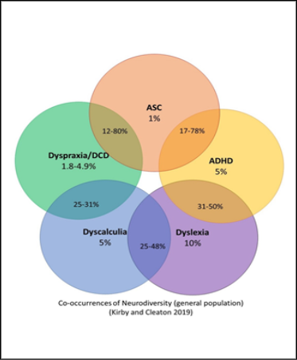
Figure 1.1: Co-occurrences of Neurodiversity
Source: Reproduced from Royal College of Nursing (2026), based on Kirby and Cleaton (2019).

The examination of neurotype categories in isolation therefore holds significant risks. In the case of autism and ADHD, the little understood interplay can lead to diagnostic overshadowing and missed as well as misdiagnosis, the latter most commonly as bipolar or personality disorders (Craddock, 2025; Eaton, 2024; Sutton, Scott and Deemer, 2025). Craddock (2025) further outlines the concept of ‘residual diagnostic categories’, referring to cases that do not comfortably fit within existing frameworks. Inhabiting such a category is said to create a tension or ‘torque’, which may result in ambivalence and fragmented identity experiences, as individuals struggle to locate themselves within diagnostic categories.

This brief overview highlights the heterogeneity inherent within neurodivergent experience and, despite recent increases in knowledge, healthcare services remain ill-equipped to recognise or work with this complexity, with no joined-up clinical pathways currently available (Sutton, Scott and Deemer, 2025). Given the extent of co-occurrence across neurodivergent profiles, a single-diagnosis focus may risk fragmenting lived experience, supporting the use of a broader neurodivergent framework in the present study. Importantly, this does not dilute single-neurotype research or culture, but instead reflects a desire to capture complexity.

1.2 Models of Neurodivergence: Medical, Social and Neurodiversity Perspectives

Early work consistently positions neurodivergent individuals as lacking empathy or emotional depth, reinforcing deficit-based interpretations. However recent developments, influenced by the rise of lived experience research, have begun to challenge this view, contributing to a gradual shift away from the traditionally objective medical model (Trew, 2025). Alternative, neuroaffirming frameworks include the Neurodiversity Paradigm, Quality of Life (QOL) Model, and a resurgence of the Social Model of Disability (Bąbel and Ostaszewski, 2023; Benson, 2023; Legault, Bourdon and Poirier, 2021; Liñares-de-Marcos et al., 2026; Quigley et al., 2024).

Although social models are a much-needed antidote to misrepresentation and discrimination, relying on them alone risks discounting differences in neurology. Considering this, Quigley et al. (2024) argue that the Neurodiversity Paradigm may be understood as a bridge between medical and social models, recognising both the strengths and very real difficulties experienced by neurodivergent individuals. Still, the legacy of objectification persists, particularly within the language of the DSM-5 and, by extension, wider clinical practice (Bolton, 2023), with concepts such as ‘Compulsory Neuro-normativity’ (Benson, 2023) highlighting how normative expectations frequently pressure individuals towards conformity, often at personal cost.

1.3 Under-represented Populations within Neurodivergence Research and Practice

Historically, neurodivergence has been conceptualised through a narrow lens, contributing to the under-recognition of diverse presentations, including the relative invisibility of autistic women and girls within both research and diagnostic frameworks, shaping how neurodivergence is understood across multiple settings (Craddock, 2024; Rippon, 2025). Although there is limited scope to explore each instance in detail here, similar patterns of under-representation have been noted across other marginalised groups within both scholarship and systems of recognition, including gender, sexuality, and ethnicity (Chapman and Botha, 2023; Nair, Farah and Boveda, 2026; Nelson, 2024; Walker, 2021).

1.4 The Relevance of Neurodivergence to Counselling and Psychotherapy

As well as challenges with daily life and accessing spaces such as employment, education and healthcare, neurodivergent individuals experience significantly higher rates of poor mental health than their neurotypical counterparts (Black et al., 2024; Sonuga-Barke, 2023; Kudiakova et al., 2024). Increased rates of anxiety, depression, suicidal ideation, and completed suicide are frequently linked to factors such as stigma, cognitive marginalisation, social isolation, burnout, camouflaging/masking, and trying to function within environments that are designed for neurotypicality (Kudiakova et al., 2024; Legault, Bourdon and Poirier, 2021).

Given the increased prevalence of mental health difficulties, neurodivergent individuals are more likely to engage with mental health services and seek therapeutic support, therefore counselling and psychotherapy become key sites in which these difficulties are explored and addressed (Leong and Graichen, 2024). However, many therapeutic models remain rooted in neurotypical assumptions around communication, emotional expression, regulatory, and relational processes (Bolton, 2023). Such differences may misalign with therapeutic expectations, leaving neurodivergent individuals misunderstood or inadequately supported within the very spaces intended to help, particularly where standard approaches fail to account for diversity of experience (Jones, Hamilton and Kargas, 2025; Kroll et al., 2024).

With a clear need for updated therapeutic frames, current neuro-affirming research has largely focused on clients; however, comparatively little attention has been given to the experiences of neurodivergent practitioners and trainees. This highlights a mismatch between the presence of neurodivergent individuals within professional counselling contexts and the extent to which their experiences are recognised and understood. Although research in this area is emerging, it predominantly examines singular neurotypes such as autism, with training environments forming a subsection of the investigation (Taylor and Sims, 2025). The present study seeks to build on this important work, by exploring the lived experiences of neurodivergent trainee counsellors with a particular focus on the training process, to better understand these experiences across neurotypes. The following literature review will examine key concepts, including neuronormativity, neurodivergent experience, and how these are shaped within therapeutic and training contexts.

1.5 A Note on Style and Terms

In line with neuroinclusive principles, the structure and language of this dissertation have been designed to reflect neurodivergent needs, with additional diagrams included to support processing differences. Neurodivergence is used as an umbrella term throughout, except where research or participant accounts specify a particular neurotype. Where counselling/counsellors are referred to, this should be considered inclusive of psychotherapy/psychotherapists. Lastly, literature often uses masking and camouflaging inconsistently; within this dissertation, camouflaging is used as the broader term, with masking understood as one form of camouflaging, and ‘camouflaging/masking’ is used to highlight both, unless a cited source uses a more specific term. Where participants used the term masking, this language has been retained.

Chapter 2: Literature Review

2.1 Literature Search Terms and Strategy

This review included English-language literature relevant to neurodivergence, counselling/psychotherapy training and lived experience, with qualitative research prioritised. Search terms included: neurodiversity; neurodivergence; counselling/psychotherapy trainees; counsellor/psychotherapist training; higher education; masking/camouflaging. Databases searched were Google Scholar and the UWTSD library system.

2.2 Neuronormativity and the Shaping of Neurodivergent Experience

Society is shaped by dominant norms that influence behaviour, with conformity frequently linked to inclusion, safety, and belonging (Glen, 2025; Goffman, 1972). While norms may support cooperation and cohesion, they can also become narrow and exclusionary, marginalising those who do not conform and increasing pressure on neurodivergent individuals to adopt normative ways of being and presenting themselves, including through camouflaging/masking as an adaptive response (Benson, 2023; Chapman and Botha, 2023; Cook et al., 2021; Legault, Bourdon and Poirier, 2021; Leong and Graichen, 2024).

By overriding natural ways of being and replacing them with perceived acceptability, the purpose of masking is to avoid social stigma and being misinterpreted, as well as other adverse outcomes (Pryke-Hobbes et al., 2023). Further support for the adaptive nature of masking comes from Cleary et al. (2023) who link it directly to discriminatory experiences of belonging to a minority group, and the survival instinct to avoid bullying, exclusion and social rejection. Although commonly associated with autism, camouflaging behaviours have also been observed in wider neurodivergent populations such as ADHD, and to a lesser degree neurotypical populations (Goffman, 1972; Miller, Rees and Pearson, 2021; van der Putten et al., 2024). However, neurodivergent individuals appear to engage in camouflaging more frequently and to a greater extent than their neurotypical counterparts to compensate for misalignment between themselves and environments typically dominated by neuronormativity.

While camouflaging/masking certainly assists immediate social acceptance and protection, in the long term it is associated with significant personal cost to mental health, self-image, and identity, often contributing to burnout (Cleary et al., 2023; Zhuang et al., 2023). Carpita et al. (2025) further found that increased engagement in camouflaging behaviours was predictive of and linked to greater severity of eating disorder symptoms. Importantly, Cook, Crane and Mandy (2024) found that autistic individuals reported reduced masking and increased authenticity within environments of acceptance and flexibility, strengthening the view that masking is context dependant and socially mediated, rather than an inherent feature of neurodivergence.

Alongside pressure to camouflage/mask, pathologising narratives may contest or dismiss self-identification and diagnosis, despite emerging research affirming both as valid and meaningful for many individuals (Chapman and Botha, 2023; Newton et al., 2025; Walker, 2021). Diagnosis therefore remains a contested mechanism for legitimising neurodivergent identity, with some clinicians strongly opposing self-identification (David and Deely, 2024). While formal diagnosis may provide increased self-understanding, validation, and access to support, it is frequently described as non-affirming and remains unequally accessible due to structural barriers such as long waiting lists and clinician bias (Newton et al., 2025). As a result, more people are relying on, or choosing, self-identification as an alternative means of gaining self-understanding and belonging. Emerging evidence suggests that self-identification is not merely subjective, but can accurately reflect neurodivergent cognitive and experiential differences, offering comparable predictive value to formal diagnosis (van Rijswijk and Curşeu, 2025). However, self-identification continues to be questioned within clinical and social spaces, positioning formal diagnosis as a gatekeeper to identity and experiential legitimacy, further entrenching the medicalisation of neurodivergence (Newton et al., 2025).

2.3 Neurodivergent Ways of Experiencing and Relating

Having outlined how neurodivergent individuals adapt to normative systems, often at personal cost, it is equally important to examine how these systems may misinterpret neurodivergent ways of experiencing and relating. The double empathy problem offers an alternative to deficit-based models, whereby difficulties in cross neurotype interactions are framed as an issue of reciprocity as opposed to stemming from neurodivergence itself (Milton, 2012). Importantly, Heasman and Gillespie (2018) demonstrate that understanding is co-constructed and dependant on shared expectations and interpretive frameworks, drawing on observations of autistic adults engaged in a structured task. This perspective is supported by research demonstrating that rapport within mixed neurotype interactions is decreased, though increased within neurotype aligned interactions (Crompton et al., 2020a; Crompton et al., 2020b).

These findings strengthen the argument that social difficulty should not be located solely within the neurodivergent individual, but understood as a mismatch of social, communicative, sensory, and experiential styles. Such mismatch may influence how environments are perceived, engaged with, and misinterpreted (Boldsen, 2022), while Dallman’s (2024) phenomenological research highlights intense and complex autistic emotional lives often missed by normative social and therapeutic frameworks. Although the double empathy problem remains influential, Livingston, Hargitai and Shah (2025) caution that its concepts remain scattered and its empirical support inconsistent, suggesting a need for conceptual refinement rather than dismissal.

As well as relational interaction and emotional life, another common area of misalignment is attention and task engagement. Neurodivergent attention has traditionally been interpreted through a deficit-based lens, popularly conceptualised as inattention and restricted interests, however, such framings miss the other side of this experience, which is increasingly characterised as experientially rich and holding significant functional value (Rapaport et al., 2024). From a monotropic perspective, attention and cognitive resources are organised intensely around a small number of prominent interests, supporting sustained engagement but making transitions between tasks more difficult (Dwyer et al., 2024b; Lawson, 2025). Empirical and neurodiversity informed research further challenges deficit-based models by demonstrating that neurodivergence exhibits distinct patterns of attention, marked by sustained focus, intensity, and interest driven variability, suggesting that the concept of hyperfocus may reflect adaptive forms of engagement that are mediated contextually, rather than individual dysfunction (Bertilsdotter Rosqvist et al., 2023; Dupuis et al., 2022).

Qualitative accounts indicate that experiences of flow, hyperfocus, and monotropic attention may represent overlapping expressions of a shared state defined by deep immersion, intrinsic drivers of motivation, and reduced awareness of other demands (Heasman et al., 2024; Rapaport et al., 2024). However, while some researchers find a strong correlation between concepts such as monotropism and hyperfocus, the link between them remains unclear, with some proposing they are distinct processes (Dwyer et al., 2024a). Regardless of how these phenomena are labelled, patterns of engagement that prioritise depth of attention appear to produce similar real-world effects: on the one hand, they offer many benefits, while on the other, significant difficulty can arise within environments involving sensory disruption, frequent transitions, or expectations for dispersed and shallower forms of attention. Taken together, these perspectives suggest that neurodivergent engagement, experience, and relating are not inherently deficit-based, but distinct patterns of difference, with strengths and challenges heavily mediated by external expectations and environments.

2.4 Neuronormativity within Institutional and Training Contexts

Having outlined both the structural context of neuronormativity and the internal dynamics of neurodivergent engagement, it is important to examine how these patterns are interpreted and responded to within everyday systems and environments. Counselling training is unique in that there are multiple sets of norms operating at once, often conflicting in their expectations. For this reason, relevant research concerning education and neurodivergence, as well as neuronormativity within the therapeutic frame and professional environments will be examined distinctly under the following two subheadings.

2.4a Neuronormativity in Higher and Postgraduate Education

As Quigley et al. (2024, p. 1) posit, there remains a “gap between rhetoric and reality concerning neurodiversity at the third level, with many students’ lived experiences being reported as challenging, and at times compounding stigma, masking, and feelings of inadequacy.” Despite increasing emphasis on inclusion, research consistently outlines how higher education institutions remain grounded in normative assumptions that shape expectations around engagement and professionalism (Quigley et al., 2024). Within such environments, neurodivergent students are often required to navigate systems that misinterpret their behaviour, resulting in pressure to conform if they are to belong and progress. This is associated with barriers to disclosure, identity strain, and reliance on masking (Gray et al., 2025), further reinforced by deficit-focused supports and interventions designed to reduce or correct neurodivergent traits and ways of functioning (Ross, Dommett and Byrom, 2026).

Such approaches not only reward conformity but may create singular pathways whereby camouflaging/masking becomes the primary means of success and inclusion. Within this context, Quigley and Gallagher (2026) discuss the psychological consequences for the individual, proposing the concept of “double masking”, whereby not only neurodivergence is concealed, but also the perceived failure to meet society’s narrow prescription of neurodivergent strengths. This reflects an ongoing and multilayered tension whereby systems that aim to be inclusive create additional hidden burdens for the individuals they propose to help. Collectively, these findings indicate that challenges faced by neurodivergent students are not located solely within the individual, but emerge through ongoing interactions between natural neurodivergent ways of functioning and structurally misaligned systems.

2.4b Neuronormativity within the Counselling frame and Training Environment

While research within education highlights the pressure to conform, similar dynamics can be observed within counselling contexts, whereby professional and conceptual norms shape both practice and training environments. Counselling frameworks often privilege forms of communication, emotional expression, and relational engagement that align closely with neurotypical standards, thus creating potential for misalignment for neurodivergent clients, counsellors, and trainees (Bolton, 2023). Empirical research indicates that neurodivergent individuals may experience therapeutic spaces as confusing or invalidating, with difficulties arising from unclear communication, sensory discomfort, and the need to mask within sessions as a way of meeting perceived expectations (Jones, Hamilton and Kargas, 2025). These dynamics may be intensified within training environments, where expectations surrounding professionalism, therapeutic competence, and appropriate relational engagement are not only taught, but assessed.

At a practice level, approaches grounded in deficit-oriented models may reinforce conformity by positioning neurodivergent ways of being as problems to be corrected, rather than differences to be understood (Fuld and McKelvie, 2024). In contrast, emerging neuro-affirming approaches emphasise therapist adaptation around relational expectations and the environment, with evidence suggesting that identity-affirming mental health treatment can support improved well-being for neurodivergent clients (Kroll et al., 2024). Despite these developments, therapeutic provision often remains inconsistently adapted and affirming, with research indicating significant variability in practitioner understanding and confidence when working with this client group (Paynter, Summer and Cook, 2025). As such, practice and training environments may continue to operate under broader neuronormative frameworks, creating a tension between stated commitments to inclusivity and implicit expectations placed upon individuals to conform. This suggests that, rather than being resolved within therapeutic practice, issues of misalignment and camouflaging/masking may persist within the very contexts intended to safely hold authenticity.

2.5 Adaptation, Representation, and the Research Gap

While the preceding section highlights how neurodivergent individuals may experience misalignment within normative systems, it is also important to consider how these dynamics are navigated in practice. Camouflaging/masking has been conceptualised as an adaptive response to normative expectations, whereby individuals modify or suppress aspects of behaviour to align with socially accepted norms (Leong and Graichen, 2024). Although such strategies may facilitate access, inclusion, and progression within educational and professional environments, they are frequently associated with exhaustion, identity strain, and reduced well-being, reflecting the psychological cost of sustained adaptation (Leong and Graichen, 2024). Camouflaging/masking may therefore be understood not as an inherent feature of neurodivergence, but as a response to environments misaligned with neurodivergent ways of being.

Despite increasing recognition of neurodivergence within counselling practice, the experiences of neurodivergent counsellors remain comparatively underexplored. This is significant because the profession’s ability to position itself as neuroinclusive for clients may be limited if neurodivergent counsellors and trainees remain insufficiently included within training and professional environments. Emerging research has begun to address this gap. Taylor and Sims (2025), for example, explored the experiences of autistic counsellors, identifying limited awareness, accommodation, and representation within training and professional contexts, with consequences for confidence and mental health. Participants also described training structures and professional expectations as grounded in neurotypical norms, often requiring adaptation and camouflaging/masking to participate and succeed. Similar dynamics are reflected in practitioner accounts, whereby neurodivergent therapists describe unclear expectations and normative modes of participation as contributing to camouflaging/masking, misrecognition, and exclusion (Marnau, 2025). Together, these accounts suggest that training environments may shape not only access and sustainability within the profession, but also how neurodivergence is understood and enacted within therapeutic practice.

While studies such as Taylor and Sims (2025) provide a valuable springboard, there remains scope to expand inclusion criteria and methodological approach. Extant research has tended to focus on singular neurotypes, most commonly autism, with less attention to broader and often overlapping neurodivergent identities. Furthermore, while thematic analysis captures shared patterns across participants, it does not fully explore the depth of lived experience and meaning-making. There is also limited exploration of training environments as distinct sites of neuronormativity, despite their central role in shaping professional identity and practice. As such, there remains a lack of phenomenological research examining how neurodivergent counsellors, across multiple and intersecting neurodivergent identities, experience and interpret training and professional environments. Addressing this gap is important not only for understanding the personal and professional impact of neuronormativity, but also for informing more inclusive counselling training and practice frameworks. Such work may also carry downstream benefits for clients by supporting forms of inclusion that are more organic, representative, and aligned with neurodivergent experience.

Chapter 3: Methodology

3.1: Context

3.1a Aims and Objectives

This research aims to explore the lived experiences of neurodivergent counselling trainees, with a focus on the training process, addressing the current gap within the academic literature.

It further aims to contribute towards wider conversations within the profession, concerning how counselling training can be more neuro-inclusive for trainees, therefore taking a downstream approach to neuro-inclusion for clients (Dark, 2024; Leong and Graichen, 2024; Taylor and Sims, 2025).

To achieve this the research will:
- Explore lived experiences of challenges/strengths and inclusion/exclusion regarding the counselling training process.
- Use thoughtful analysis and the presentation of diverse experiences to challenge objectifying stereotypes, stigma, and reductive narratives about neurodivergent individuals within society and the counselling profession.
- Provide an example of how research may be conducted within a neuro-inclusive framework also aligning with the Neurodiversity Paradigm (Dark, 2024; Dwyer, 2022)
- Provide clear recommendations from a lived experience perspective, of how counselling training, wider institutions, and individuals, might expand their environments and knowledge base to become more neuroinclusive.

3.1b Paradigm, Ontology, Epistemology and Methodology

Pellicano and den Houting (2022) propose that research is undergoing a paradigmatic shift in response to rigid and one-dimensional schools of thought becoming obsolete. This nuance is reflected in Dörfler’s (2023) Critical Interpretivism, which blends Critical Realism and Interpretivism to account for both real and interpretive realms. Similarly, Dwyer (2022) argues that respecting and preserving the Neurodiversity Paradigm within research requires approaches capable of accounting for multiplicity of experience. Frost and Bowen (2012, p.27) similarly describe pluralism as able to “tap into the multiple dimensions of lived identities” while maintaining researcher curiosity and responsiveness.

As the current research does not fit neatly within an existing discrete paradigmatic structure, it takes a pluralistic stance reflecting its roots in the Neurodiversity Paradigm (Dwyer, 2022; Frost and Bowen, 2012). This flexibility moves the research away from rigid “methodological fetishism” (Poulis and Kastanakis, 2020), maintaining openness to participant experience, researcher interpretation, co-construction within interviews, and wider structures of influence. Under this framework, experience is viewed as emergent through interaction and interpretation; disablement may arise relationally; neither neurology nor institution alone provides sufficient explanation; and participant experiences are understood as both varied and overlapping. In summary, this research is concerned with exploring the lived interface between a person and their context.

The ontological position of Subtle Realism (Hammersley, 1992) acknowledges that neurodivergent processing differences, institutional structures, schools of thought, and professional training norms exist as real, while being mediated through interaction and interpretation. Epistemologically, the research assumes that knowledge is diverse and rooted in meaning-making, taking a largely interpretive stance (Ryan, 2018; Smith, Flowers and Larkin, 2022). Knowledge is also understood as co-constructed through relational interaction, particularly within interviews (Van Deurzen and Arnold-Baker, 2025). While informed by a Critical Disability lens (Ryan, 2018), and therefore recognising the influence of normative frames, this lens is not applied universally (Dwyer, 2022). This blended approach is not a retreat from challenging power structures, but a refusal of reductive accounts of neurodivergent people, alongside caution against replacing biological determinism with social determinism (Bayram, 2025; Shakespeare, 2014; Walker, 2021).

Interpretative Phenomenological Analysis (Smith, Flowers and Larkin, 2022) was therefore used as the dominant methodology, focusing on participants’ lived experiences as felt and interpreted, while retaining awareness of individual neurological differences and structural power. IPA is suited to this topic because its idiographic depth gives space for individual expression, resisting assumptions that neurodivergent people are homogenous. The double hermeneutic also supports reflexive attention to possible internalised ableism within participants’ meaning-making and researcher interpretation. The development of Group Experiential Themes (Smith, Flowers and Larkin, 2022) allows tentative cross-participant patterns to be suggested, which may, alongside individual themes, inform individuals and institutions seeking more neuroinclusive thought and practice.

Although IPA is the dominant methodology, elements of Structural Existential Analysis (Van Deurzen and Arnold-Baker, 2025) were blended with this to enhance neuroinclusion during data collection and analysis. Specifically, SEA’s use of disclosure, personability, and deep experiential dialogue within interviews supported relational depth and safety for participants (Van Deurzen and Arnold-Baker, 2025). Safety is particularly important for neurodivergent participants when unmasking, sharing authentically, and examining experience freely (Cage and Troxell-Whitman, 2019; Hull et al., 2017; Hull et al., 2019; Milton, 2012; Pearson and Rose, 2021; Yalom, 2002). SEA’s analytical framework was also considered during analysis and discussion, providing an additional lens for the many dualistic and existential tensions that arose (Van Deurzen and Arnold-Baker, 2025).

3.1c Research Question

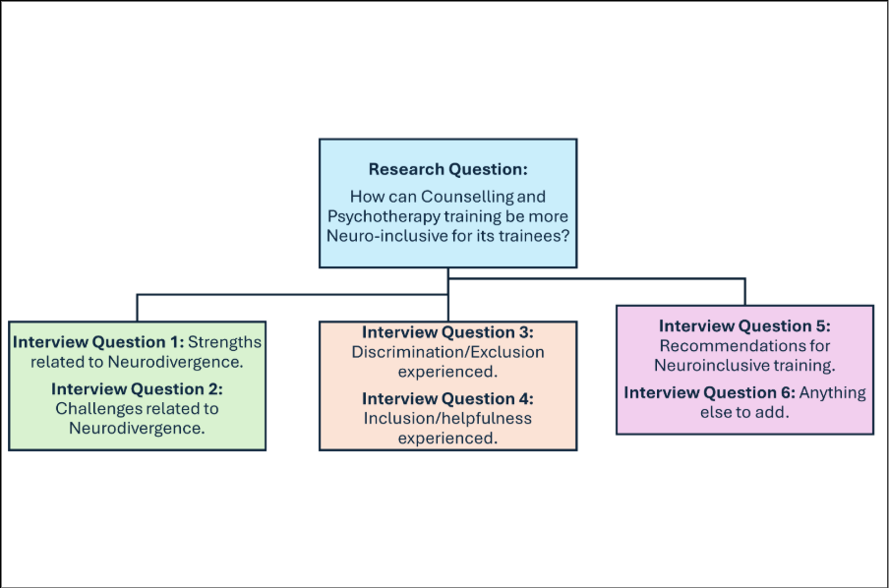Figure 3.1: Research Question and Interview Schedule

3.2: Participants

3.2a Sampling

A purposive sample of 6 participants were recruited via a flyer (Appendix G) that was circulated around social media and professional networks. Inclusion criteria were as follows:

- Be self or officially diagnosed/identified as neurodivergent; either generally neurodivergent or with a specific or combined neurotype.
- Participants must have been enrolled on a counselling or psychotherapy practice-based training course for at least 3 months (including individuals who may have left before completion); or have completed a practice-based training course in counselling or psychotherapy within the past 3 years.
- Participants must have had access to either supervision or personal therapy.

3.2b Optional ‘Mixed Method’ Demographics

Demographic information was collected separately using Microsoft Forms and was optional as well as being anonymous, with 5 out of 6 participants choosing to complete the form. To honour multiple, complex and fluid identities, some questions were tick box (with option to tick multiple as well as expand), some were more straightforward answers, and some asked for more qualitative descriptions of how identities are experienced. Age was not formally collected, though was diverse. Direct extractions of questions and answers can be found below in Figures 3.1-3.8.
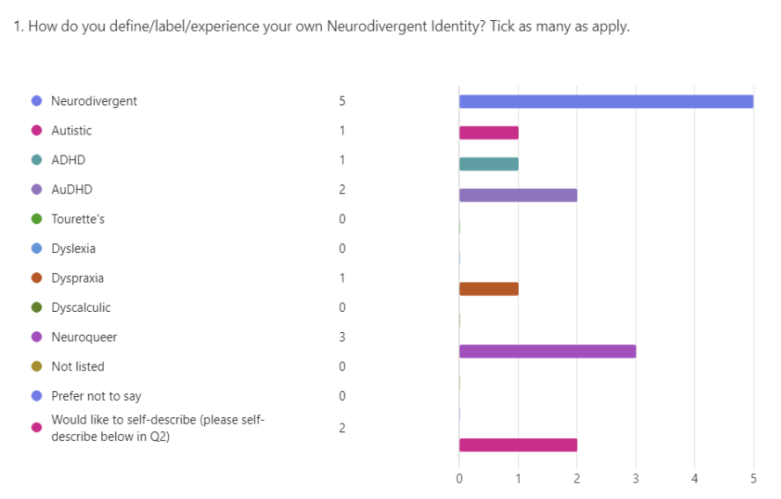
Figure 3.2: Demographics Q1

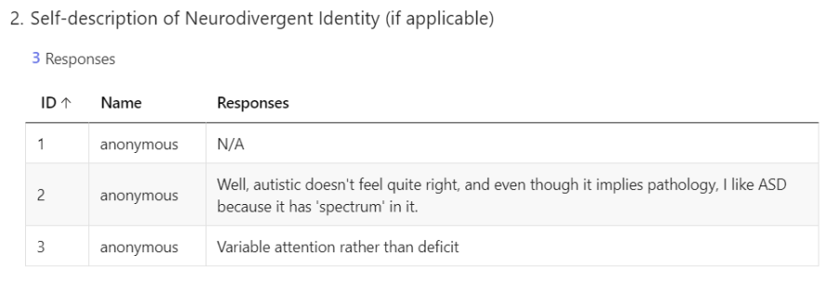
Figure 3.3: Demographics Q2

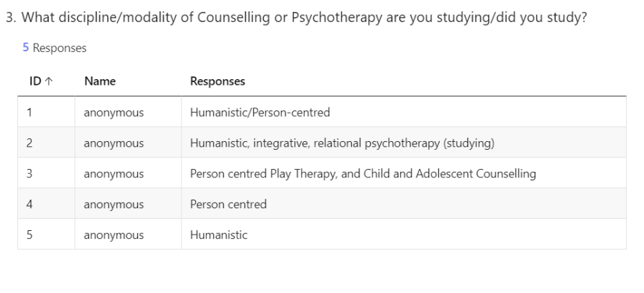
Figure 3.4: Demographics Q3

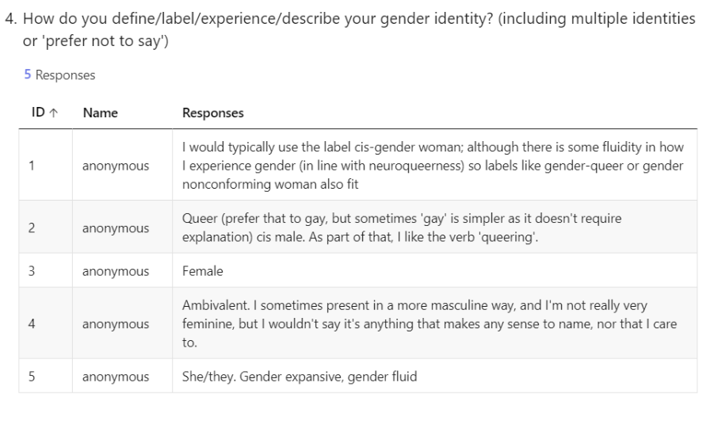
Figure 3.5: Demographics Q4

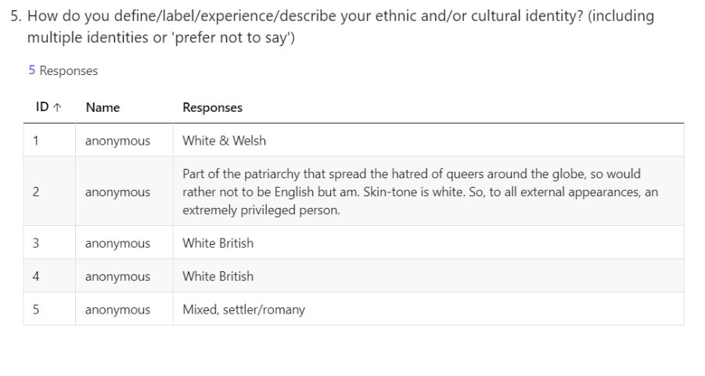
Figure 3.6: Demographics Q5

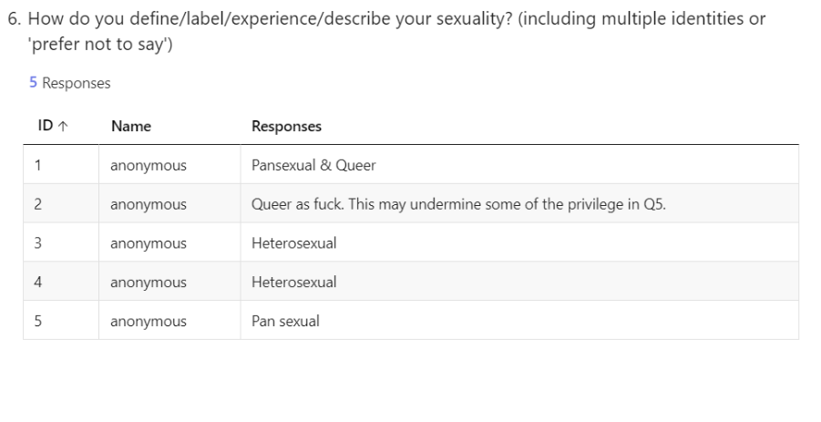
Figure 3.7: Demographics Q6

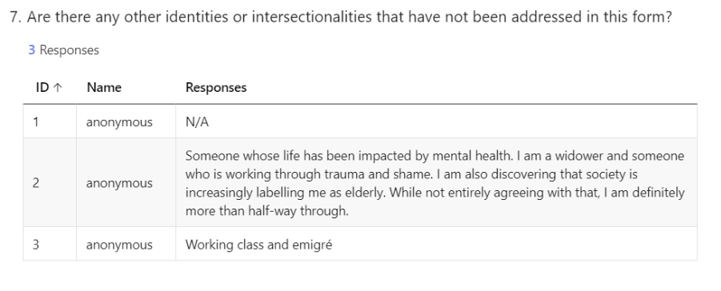
Figure 3.8: Demographics Q7

3.3: Data Collection

3.3a Method

The study used semi-structured interviews, held, recorded, and transcribed online via Microsoft Teams. Interviews lasted between 1.5 and 2 hours, including introductions, ending reflections, debriefing and signposting. Participants received an interview pack (see Appendices A–D) at least two weeks before their interview to support informed consent, preparation, and access to signposting/resources.

3.3b Interview Process

IPA and SEA interview techniques were integrated to be both neuroinclusive and reflexive to the emerging needs of participants. Due to all participants belonging to a cognitively marginalised group (Legault, Bourdon and Poirier, 2021), carefully considered disclosure and a prioritising of the relationship were considered optimal for creating an environment of safety, under which authentic experience may unfold (Brown, 2018; Dwyer and Buckle, 2009; Jordan, 2010; Milton, 2012; Cage and Troxell-Whitman, 2019). Further support for the use of interviewer disclosure comes from research regarding shared frames of reference, and the role of counter narratives on mutual understanding and meaning making (Crompton et al., 2020a; Taylor and Sims, 2025; Walker, 2021).

During interviews, IPA’s typically facilitative style (Smith, Flowers and Larkin, 2022) blended well with SEA’s more relational, co-constructed exploration (Van Deurzen and Arnold-Baker, 2025). Moving between the two approaches felt natural and supported attunement to participants’ emerging needs. Additional neuroinclusive measures included discussing movement and communication needs at the beginning of each interview, for both interviewer and participant, offering structured and unstructured breaks, ongoing check-ins regarding pacing, a post-interview debrief, and a spirit of collaboration throughout (Dark, 2024).

3.4: Data Analysis

Data were analysed using a staged, idiographic IPA process (Smith, Flowers and Larkin, 2022). At Stage 3, interpretation was lightly informed by Structural Existential Analysis and a critical neurodiversity-informed lens to support attention to existential, relational and socio-cultural dimensions (Van Deurzen and Arnold-Baker, 2025; Walker, 2021; Botha, 2021). Literature was considered lightly before analysis, with a fuller and more intentional review conducted afterwards to keep interpretations grounded in participant accounts, rather than overly shaped by existing theories, findings, or literature structures.

3.4a Stage 1: Data Reduction and Initial Conceptual Clusters (ICCs)

Transcripts were exported from Microsoft Teams, checked for accuracy, and read repeatedly to support immersion. Extracts of interest were highlighted and transferred into participant-specific ICC spreadsheets in Excel, where they were organised into broad conceptual clusters, such as strengths, attention, and difficulties. Sub-concepts were tentatively grouped using visual structuring, including colour coding and formatting, with analytic reflections recorded alongside, but distinct from, participant data. Each case was analysed individually, with a purposeful time gap before moving to the next interview and stage 1 analysis, in line with IPA’s idiographic commitment.

3.4b Stage 2: Development of Personal Experiential Themes (PETs) and Individual Case Portraits (ICPs)

ICCs were revisited through further immersion and refined into PETs using a second spreadsheet. Extracts were reviewed, contextualised against the original transcript, and organised into superordinate and corresponding subthemes. Where necessary, extracts were distilled, split, or, rarely, duplicated to preserve meaning. Analytical summaries and interpretations were documented alongside theme development. From PET spreadsheets, ICPs were developed for each participant to capture individuality and to preserve idiographic depth within the findings. Participant anonymity was protected through self-chosen pseudonyms, curated anonymisation, and participant review of ICPs, with participants able to request amendment or removal of content they felt could identify them or misrepresent their meaning.

3.4c Stage 3: Development of Group Experiential Themes (GETs)

Following completion of the idiographic stage, all PETs were reviewed comparatively to identify patterns across cases. A GETs spreadsheet was developed, organising shared and divergent meanings into overarching superordinate and corresponding subthemes. Existential and critical neurodiversity-informed perspectives were considered at this stage to deepen interpretative analysis, specifically examining how emerging tensions, socio-cultural norms, and power structures shaped neurodivergent experience (Botha, 2021; Van Deurzen and Arnold-Baker, 2025; Walker, 2021). A worked example of the analysis process, showing movement from transcript extract to initial conceptual cluster, PET/subtheme and GET, is provided in Appendix E. A summary mapping of GETs, linked PETs and relevant literature is provided in Appendix F.

3.4d Reflections on Neuroinclusive Analysis

Throughout all stages, a reflexive and iterative analytic process was maintained, with attention to the double hermeneutic central to IPA, and particular care given to the historical misinterpretation of neurodivergent experiences. As counselling trainees and professionals, participants were highly reflective and had frequently considered the topics discussed prior to interview. Interpretation within this study was therefore not confined to post-hoc analysis, but also emerged through participants’ prior reflections, the dialogical and reflexive nature of the SEA-informed interview process, and the further synthesis undertaken during discussion writing. These factors, combined with a tendency toward direct and authentic communication by both participants and interviewer, informed a cautious and highly reflexive interpretative approach that sought to privilege expressed meanings rather than impose unwarranted or ungrounded layers of interpretation (Botha, 2021; Finlay, 2002b; Smith, Flowers and Larkin, 2022; Walker, 2021; Yardley, 2000).

3.5: Ethical Considerations

3.5a Positionality Statement and Pre-research Reflections

As a neurodivergent counselling trainee, I inhabit an insider-outsider position within this research, carrying both potential benefits and significant risks (Berger, 2015; Dwyer and Buckle, 2009). From my experience of working with neurodivergent clients, the greatest potential benefit of this position may be an enhanced sense of safety through neurotype alignment (Taylor and Sims, 2025), with the greatest risk being overidentification and potential misinterpretation of participants’ lived experience. My personal standpoint on neurodivergence aligns closely with the Neurodiversity Paradigm, which acknowledges experience as nuanced, fluid, and complex. To mitigate overidentification and bias, robust reflexive and reflective measures were engaged with throughout the research process.

3.5b Reflexivity and Reflective Practice Measures

Reflexivity was maintained throughout the research process via journalling, self-care, academic supervision, and neuro-affirming personal therapy, in alignment with established qualitative research and counselling training practices (BACP, 2018; Etherington, 2004; Finlay, 2002a; Olmos-Vega et al., 2023). As a trainee counsellor, these processes were already embedded within my routine; however, reflexive journalling was engaged with more intentionally across all stages of the project to support the double hermeneutic process central to IPA (Smith, Flowers and Larkin, 2022).

My prior practical experience within a trauma-focused placement, where many clients were also neurodivergent, further shaped my capacity for in-the-moment bracketing and careful use of self-disclosure, both of which were supported by supervision.

3.5c Risk Management, Participant Contact and Documentation

Ethical approval was obtained through the programme’s required ethical review process before participant recruitment and data generation began. This study was conducted in accordance with relevant ethical and legal frameworks, including the BACP Ethical Framework for the Counselling Professions (BACP, 2018), BACP Ethical Guidelines for Research in the Counselling Professions (BACP, 2019), the UWTSD Research Ethics and Integrity Code of Practice (University of Wales Trinity Saint David, 2022), the General Data Protection Regulation (Regulation (EU) 2016/679), the Data Protection Act (2018), and Dark’s (2024) Eight Principles of Neuroinclusion.

Data security was maintained through password-protected and encrypted systems, with raw transcripts accessed only by the researcher in a private setting. Personal identifiers, including consent forms and contact details, were stored separately from research data. Participant anonymity was preserved through pseudonyms and curated anonymisation, with participants able to request removal of specific content or quotations post-interview. All raw transcripts, participant details, and consent forms will be securely destroyed following award of the degree.

Participants received an interview pack (see Appendices A-D) including a covering letter, information sheet, consent form and contract, interview schedule, and signposting resources sheet. In recognition of neurodivergent processing differences, participants were offered up to one week to provide additional reflections and up to two weeks to withdraw their data.

Chapter 4: Findings

Before moving to Group Experiential Themes, each participant is introduced through an Individual Case Portrait (ICP), reflecting a commitment to the idiographic nature of IPA research. This was also an ethical decision, intended to elevate neurodivergent voices and experience so the reader may gain a sense of each participant’s personhood and individuality. Following the ICPs, the cross-cutting principle of duality is briefly discussed before presenting the outcome of cross-case analysis through Group Experiential Themes (GETs).

4.1 Personal Experiential Themes (PETs): A Commitment to Ideography through Individual Case Portraits (ICP)

4.1a Angharad ICP and PETs

Angharad experiences engagement as state dependent rather than continuous, with presence requiring specific temporal and transitional conditions. She has access to states of deep immersion and “hyperfocus”, facilitated by more singular “monotropic” attention, minimal transitions between tasks, and a “sweet spot [of around] 3 hours” engagement. Although experienced as a strength within therapeutic work, deep focus and attunement can be energetically costly, particularly when self-care, autonomous pacing, and “buffer zones” are not available. Within the training environment, the “effortful” process of gaining accommodations allowed Angharad to take additional breaks between tasks to meet this need without being “questioned” by staff. Relatedly, Angharad describes wanting the structure of the day to be more singular, allowing deeper task immersion and reducing the need for additional buffering around transitions. This recognition itself appeared significant, as “just saying that felt good… [bringing] relief [and] satisfaction.”

The pressure to conform to dominant norms within training and professional environments is deeply felt, with masking often required to appear “competent”. Angharad gives an example of dropping her mask in order to listen and engage effectively, only to be misinterpreted as unhappy and uninterested, therefore “had to put [her] mask on again”. Safety, “flow states” and “relational depth” are experienced within neurotype aligned relationships and interactions, while Angharad makes a strong case for representation at all levels of the profession. For Angharad, queering extends beyond identity and becomes a way of flexing and adapting the therapeutic frame to better fit herself and her clients. Similarly, she draws on Walker’s concept of “Neurocosmopolitanism” as a move beyond “tolerance” towards a “genuine valuing of difference” (Walker, 2021).

Key quote from Angharad:
“I work in that queer way. I'm queering all the things all the time. And I think it allowed me to kind of take from the therapeutic frame, adapt it in the way that works for me […] Nick Walker's ideas, neuro-queerness, neuro-cosmopolitanism. That is how I practice. That is my being. You know that is, that is me, really. That is what I strive for. So yeah. Thank you for letting me say my stuff.”

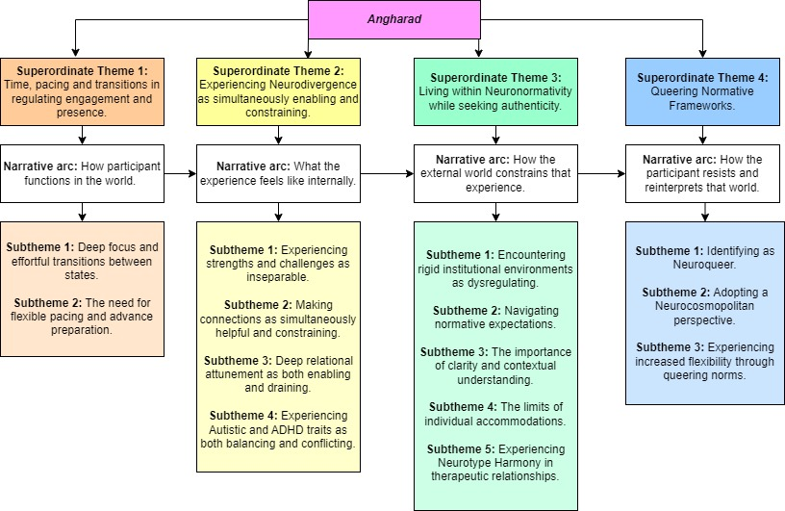
Figure 4.1: Angharad PETs

Key recommendation from Angharad:
“There are certain things about the frame I don't like. I don't like the time frame for example. Like I understand the importance of boundaries and time boundaries and stuff. But for a lot of the time for me and as a client in therapy and for the clients, the neurodivergent clients I've worked with, it's like you just kind of warming up around that 40 minute, half an hour mark. And I've had training where neurodivergent therapists have said that in their private practice, they offer an hour and a half session for people and I think that's something I definitely want to do, because I think that's really important. And again, for that nervous system regulation, for settling in. Like, I feel that's happened in this interview, like it's taken me that time to really like get into it...You know?”

4.1b Benny ICP and PETs

Benny holds significant experience of being mis-seen, mislabelled and misdiagnosed spanning multiple contexts. Within peer relationships and professional settings, this often manifests as misattunement and misunderstanding, though in the case of medical settings has resulted in a history of incorrect diagnosis, ineffective treatment plans, and their experience being entirely dismissed. Over time, this has led to feelings of overexposure and vulnerability when in group settings, as well as consistent and prolonged periods of masking. Masking is described not as a choice, but as a necessity, that facilitates the meeting of basic needs such as acquiring income under normative frameworks. Benny speaks extensively of the personal cost they endure as a result of trying to function within systems that are misaligned with their natural ways of being. During the interview they cite severe “burnout” on multiple occasions, to the extent of being physically unable to exit their car for hours at a time, while attempting to transition between the outside world and home. Benny describes a tension between their naturally instinctive, fluid and creative way of engaging and the professional frame; a frame that they say has little space for much needed “movement” and “spontaneity”.

Benny describes an enhanced capacity for attunement, or a “sixth sense”, with client work being the “one place that [they] feel at home”, however, this comes at an energetic cost. This high-level attunement has cross functions with authenticity, which is a non-negotiable personal value, with them describing the thought of lying as “traumatic”. While having positive effects for client work, Benny links high attunement and the desire for authenticity as directly responsible for disengagement in relationships in which they are not taking the therapist role (“if I can sense even a little whiff of like, inauthentic ways […] I can’t do it”). Despite this inner and interpersonal struggle, they describe with great warmth a single tutor who had a significant impact, with this relationship appearing to support the emergence of a more positive and coherent sense of self. In the absence of aligned structures and accommodations, and armed with increased self-knowledge and confidence, Benny often uses creative skills to develop adaptation techniques that work with, rather than against their natural way of functioning.

Key quote from Benny:
“I feel like she [tutor on course] saw me in a way that nobody's ever seen me before. And like that did something to me. Cause it was like oh. So, I can say what I think or I can be rambunctious. I can move if I need to move. I can be upset if I'm upset […] It was the acceptance, I think, like she accepted me for me, like all sides of me. The flawed parts of me, the bits that I hate about me, the bits that I've been told to shut down and hide and throw away. She let them be. She was like, no, here's the space to have them.”
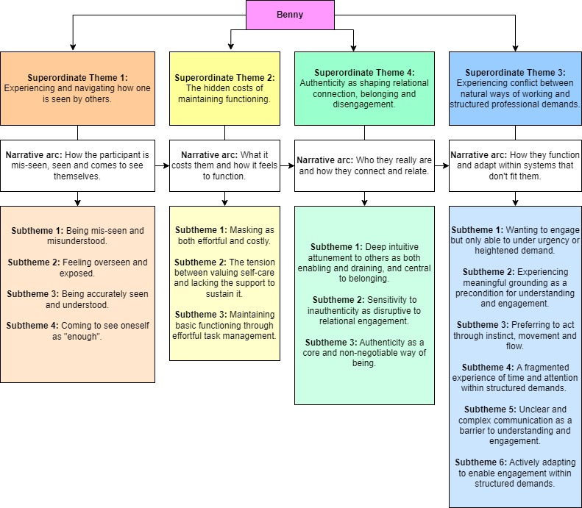
Figure 4.2: Benny PETs

Key recommendation from Benny:
“Yeah. They just need more education, especially in women. Especially in women [...] about hormones and how hormones affect what's going on, like loads of people will come out when they're going through menopause. All I'm ADHD suddenly. Well, no. You were always ADHD. Just the strategies that you put into place suddenly don't work for you anymore. Which is then exacerbating the symptoms. This is not that they’ve just magically gone **** ,ADHD, because lots of people find when they have kids or when they've become menopausal...that's when it changes and then everything's changed. But we get ignored. So, I think there needs to be a lot more understanding around women especially.”

4.1c Anne ICP and PETs

Anne describes a highly structured and functional internal system of task regulation, comprising advance preparation, organisation, and the ability to “stick” to a plan. These elements are described as a “need” rather than a desire and are highly influenced by the immediate sensory environment as well as predictability of conditions. Another fundamental element of this internal system is the ability to access states of “hyperfocus” which are accelerated by “special interest” energy. Anne speaks with gratitude about this combination as being a “superpower” if external conditions align, though reflects that it can sometimes tip into “over focus”, whereby basic needs are neglected and exhaustion can set in.

Anne talks with passion of a deep ability to attune to others and “getting that sense” of someone from the “feeling of being next to them”. She reflects that this type of connection is made possible due to not relying on facial expressions and describes an enriching cyclical process of understanding self and others. With clients she excels, as well as other one to one interaction, especially if the topic is a special interest rather than unstructured small talk. Difficulty arises as group size increases, if interactions become inauthentic (such as role play), when relationship status or boundaries are unclear and implied, or within environments of mismatch. Structured professional environments have been a consistent source of misalignment and sensory dysregulation, with experiences of ableism and discrimination common. Anne reflects with irony, about the rigidity she has experienced within normative environments, with a stated desire for more flexibility in both attitudes and practicality, as well as increased education, awareness and open discussion about what it feels like to be neurodivergent.

Key quote from Anne:
“And we're getting that sense of where they are just [from the] feeling of being next to them as opposed to what these examples are and all that outward behaviour […] I feel I can connect with people because I don't rely on the facial expressions. I feel like I connect to people probably way better than other people do [...] as a foster carer, I can sit there and I know I'm understanding this child so much better than everybody else around me.”

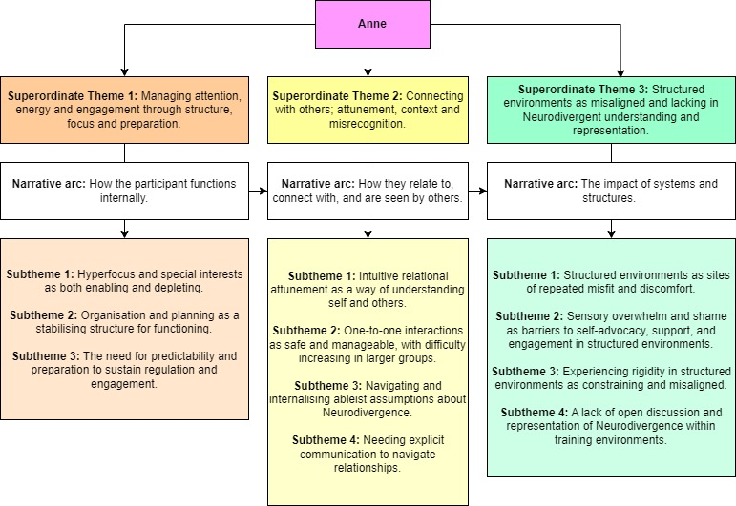
Figure 4.3: Anne PETs

Key recommendation from Anne:
“So, the more [neurodivergence] is part of the course, you know, learning about it and talking about it and allowing people to talk about what comes up for them, what's different for them, or what's positive for them and what works well for them. These conversations aren't had, which is a shame because there's learning for everybody. And if there are, then it allows everybody to feel comfortable to talk about what is working for them and what's not working for them.”

4.1d Iwan ICP and PETs

Iwan describes making connections and “rabbit hole” thinking as his natural mode of operation and demonstrates a strong pattern-based, systems-oriented way of thinking. He is particularly skilled at solving problems of a technical nature and speaks of using his “weaknesses to support [his] strengths”. However, he experiences significant frustration when engaging with inefficient, unnecessarily complicated, and cognitively demanding systems. As well as placing additional strain on executive functioning, these systems are fundamentally mismatched with his naturally logical, streamlined, and efficient way of processing information and approaching tasks. When he has the autonomy to do so, Iwan develops self-designed systems that outsource much of the cognitive overload, while also providing additional benefits for confidentiality through automatic filing systems and supporting neuroinclusive client practice via online booking. Time is also used as a regulatory tool, with preparation and arriving early to get into the right “zone” being key to focus, engagement, and success. Alongside this, Iwan compassionately supports his everyday functioning by using environmental scaffolds, such as duplicates of essential items, while also acknowledging the limits of his capacity for certain types of tasks.

Iwan experiences misalignment in social contexts within professional environments, such as a lack of desire for expected small talk, busy events, and parties. Misunderstanding is experienced while seeking clarity which is often labelled as “trouble making”, as well as so named 'flat affect' being fundamentally misunderstood with an iceberg-like effect occurring; he astutely reflects that the stiller the face, the more is going on underneath. Iwan speaks with conviction about his positive experiences of neurotype aligned interactions, both as a therapist as well as in other contexts. He talks about how lived experience and carefully considered self-disclosure can help reduce shame in clients, as well as enabling authentic interactions that strengthen the therapeutic relationship. However, he strongly argues that representation without education limits compassionate and effective practice, and even though he had a high level of neurodivergent representation on his course at all levels, education around neurodivergence as a topic, despite being requested, always seemed to “fall off the list”.

Key quote from Iwan:
“I said [to client] you might notice I don't give you as much eye contact as most other people. That's not because you're boring or uninteresting. It's because I can't cope with the intensity of looking at someone all the time. But believe me, I am here with you...It's because everything's going on in the brain, so you haven't got time to cope with what's happening on your face...all that muscle processing goes offline to give more computing power for the thought.”
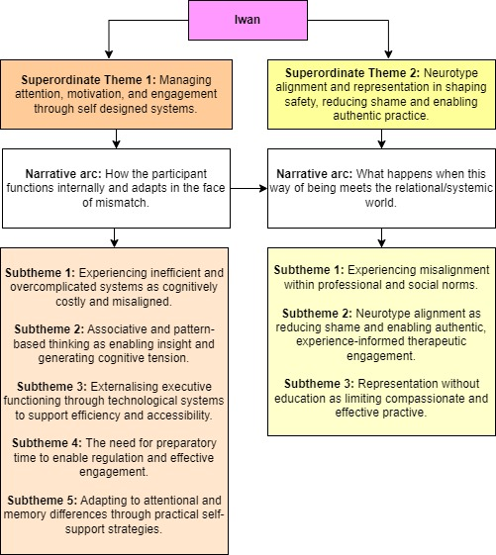
Figure 4.4: Iwan PETs

Key recommendation from Iwan:
“A lot of the [adaptations] are about supporting my weaknesses by using my strengths. So, for instance, I'm rubbish at organising paper, as I'm looking around my office at the moment and seeing heaps of paper it's terrible, but I'm really good at getting computers to file stuff for me […] I know that if I do rely on paper filing, it will end up as a mess, so I just don't rely on paper filing, and that's OK.”

4.1e Jade ICP and PETs

Jade “lean[s] more towards…skipping about…for short bursts” when it comes to task focus, unless she is “completely absorbed to the point of exclusion of hearing anything else”, indeed, when the material is challenging or “really catches [her] attention [she will] dig down to the deepest detail”. However, there is often “no warning” that these states of hyperfocus will descend, and typically, they are accompanied by an absence of hearing or ability to pick up on interoceptive cues (such as hunger or thirst). Jade has a great capacity for absorbing information and can remember content after “one reading”, which is viewed as a significant strength and further, assigned to facilitating confidence and engagement during class discussion with peers, adding depth and nuance to group understanding.

Jade describes a keen somatic sensitivity that allows her to register the tone and emotional atmosphere of the room in the absence of explicit cues. She speaks of being inherently emotionally steady, with a natural “emotional range most of the time between 4 and 7”, yet this stability, along with an innately high distress tolerance, is consistently interpreted by others as “repression”, while her direct communication style is assigned the value label of “inappropriate”. She reflects that these responses may have made others “feel unsafe, because [she] didn’t react the way they expected, because it wasn’t in their books. Maybe they did not have other neurodivergent people around them to be able to place the way [she] reacted.”, and at times this contributed towards emerging self-doubt in relation to having the “wrong way of reacting”. The result of this mismatch is a fragmentation in connection to both self and others, with Jade experiencing the immediate and wholesale adoption of counselling norms by peers as inauthentic and “as if [they were] lifted from the book”. However, through increasing experiences of safety within neurotype-aligned relationships, and with growing self-knowledge, Jade begins to see herself more clearly and compassionately, reframing earlier experiences through a neuro-affirming lens. As relational and internal safety develop, both her sense of self and her personal relationships shift in a mutually reinforcing and cyclical manner, with this deepening attunement with loved ones ultimately becoming “everything”.

Key quote from Jade:
“No, they never called me out like that. I think they were trying their hardest to be respectful. Like they knew they had to react a certain way because they were on a counselling course. And so, they couldn't say anything, but did you ever get it when you have a reaction and then, you get a prickly feeling and go cold? Does that make sense? And you're like, this is awkward. It's like the air's suddenly been sucked out of the room but like through nothing that I could...there's not audible gasps or anything, but it's just something about the energy that changes. And then I...I'm confused...even thinking about it now, I've got that cold feeling, like, all over. Yeah, yeah.”
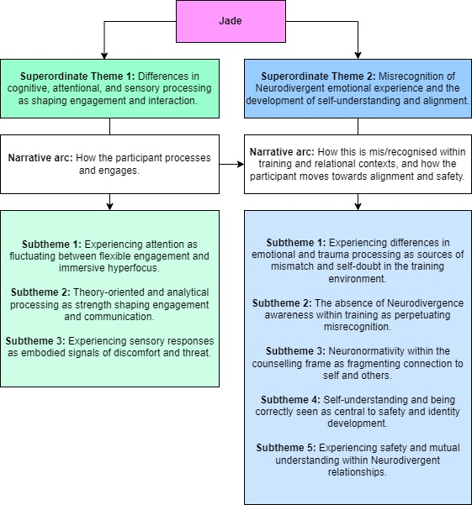
Figure 4.5: Jade PETs

Key recommendation from Jade:
“It [counselling texts] describes, I guess, a normative response, right? I don't know whether the research has been done, [but there’s] no consideration for, a response that maybe wouldn't be as emotional. Or maybe if they do mention something like that, they're like, oh well, you've got to look at how it makes you feel inside. Or why don’t you feel like this? Or why do you feel this? Sometimes there's not a reason beyond that's just who you are, like there's no emotional attachment to what someone has just told you. And there seemed to be within the class such strong reactions as if that was expected.”

4.1f Frankie ICP and PETs

Frankie passionately and coherently discusses the concept of intrinsic drivers as the foundation of her neurodivergent engagement and motivation, relating this to Dodson’s interest-based account of ADHD motivation, including interest, novelty, challenge, urgency and passion (Dodson, 2022), before adding another ‘C’ for ‘connection’ as the interview progressed (INCCUP). One or more of these drivers need to be present for task execution to both take place and be sustained, with the presence of multiple drivers being responsible for states of excitement and “firing on all cylinders”. Frankie describes an associative cognitive style, with understanding unfolding because of connections being made, or what she terms “rabbit hole” thinking. Procrastination is experienced as multifaceted, and while often looking the same to the outside observer, can take on the role of either useful incubation or disengaged delay. When conditions for engagement are misaligned, urgency moves from helpful nudge to state dominance and can result in exhaustion, dysregulation, and burnout. An additional barrier to action lies in the organising and sequencing of tasks, associated with dyspraxia, which helps explain why intention does not always translate into action. As a result, Frankie appears to gravitate towards a more fluid and creative mode of working, which remains equally engaged and effective.

After a lifetime of misattunement, particularly within educational and professional settings, the process of masking begins to be explored, with self-knowledge being key to increasing authenticity. Frankie describes a tension between appearing to listen and internally processing information, often feeling required to prioritise one over the other. On a positive note, she speaks fondly of a supervisor who seemed to instinctively understand her fluid style, reflecting it back positively in an experience of deep validation. However, despite having gained vital self-knowledge, as well as experiencing some corrective attunement, trust and belief in her unique process and “a sense of [her] capacity [still] often leaves [her] sitting there in doubt”. Frankie has a deep passion for equality, social justice, and care for the environment, believing that neurodivergence is vital to systemic change through its innate curiosity and the fundamental need to “ask why?”.

Key quote from Frankie:
“Hard work doesn't look the same...and doing it well doesn't look the same for everyone...and so, having reflected back some sort of…yeah, it would be great to have reflected back some process, that wasn't just neurotypical, wouldn't it? Because it's all assumed to be that way. And the processes we're learning are assumed to be quite the norm. And there might be other processes in there that work better with different ways of being. I guess I would love to…yeah, I would have liked to have had support to not feel so uncertain about my own process...you know, it would have saved me a lot of stress, because I think 90% of the stress was not trusting that I could do it, because I did it so differently to everyone else.”

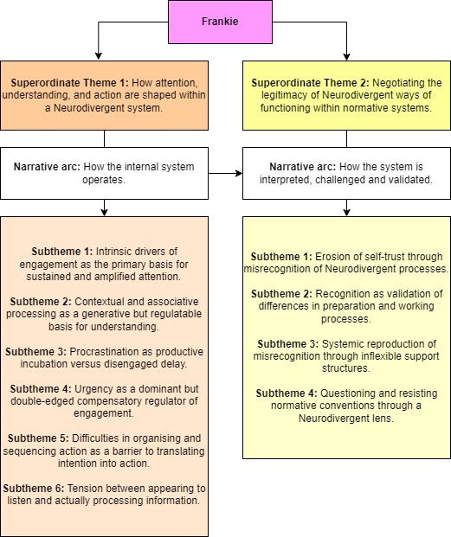
Figure 4.6: Frankie PETs

Key recommendation from Frankie:
“I love the idea of training on neurodiversity being part of every counsellor's standard training. And I‘d love it if you could think of a way of making that experiential in a way that could suit people, and just kind of, I guess the fluidity, the flexibility to be able to find out what kind of teaching, what kind of support suits people individually and how they best...what's it called? That cognition of how I learn? And the lecturers getting to grips with what works for different neurotypes and being able to be flexible enough that people can learn in those different ways in the same room. I don't know how you do that necessarily, but having a combination of different ways of learning the same thing, perhaps?”

4.2 The Cross-Cutting Principle of Duality

Participants consistently described their internal and relational experiences as carrying both enabling and constraining qualities, with strengths and challenges experienced as inseparable and largely context-dependent. This pattern of tension appeared so consistently across accounts that, rather than being presented as a standalone group theme, it is understood here as a cross-cutting principle that shapes the entirety of experience. This principle is consistently evident within the ICPs above, as well as the cross-case analysis (GETs) below. As Angharad reflected early in interview:

“I think one thing for me is when I was going through the questions is that I might be kind of repeating myself if I split them up. This thing was really good, but then kind of the other side of the coin type thing. So, I'm just aware of that.”

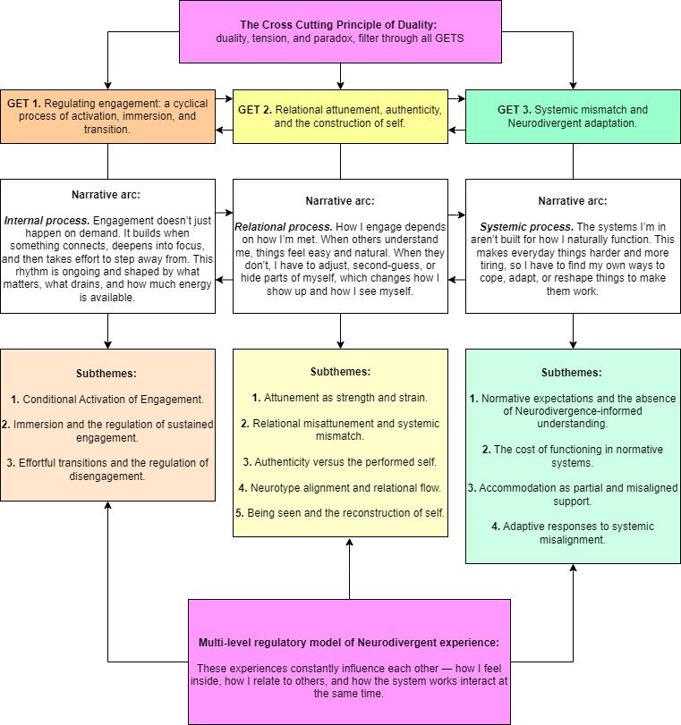
Figure 4.7: The Cross-Cutting Principle of Duality and GETs as a Multi-level Regulatory Model of Neurodivergent Experience

4.3 Group Experiential Theme (GET) 1. Regulating Engagement: A Cyclical Process of Activation, Immersion, and Transition

GET 1 presents participants’ experiences at an internal level, outlining where natural modes of operation may be facilitated or blocked by others, systems, or levels of self-knowledge and acceptance. While presented here as three separate subthemes, participants’ accounts suggest that engagement does not unfold in a linear sequence of initiation, sustainment, and transition. Instead, engagement is experienced as a continuous and cyclical process of regulation, in which preparation, immersion, disengagement, and recovery are interdependent and cumulative. Engagement is therefore better understood as a fluctuating rhythm rather than a series of discrete stages, in which the capacity to move between states is continuously negotiated and shaped by both internal conditions and external demands. Within this process, periods of disengagement may function either as productive incubation and/or rest and therefore supporting subsequent engagement; or as disengaged delay, reflecting dysregulation of the process, or insufficient alignment with intrinsic drivers and natural modes of operation.

4.3a Subtheme 1: Conditional Activation of Engagement

Engagement initiation was experienced as conditional rather than automatic, emerging more consistently when participants had;
- Clarity; surrounding instructions, expectations and the purpose of tasks.
- Sufficient preparation; regarding advance information and time to “get in the zone”.
- Internal readiness; based on, sensory regulation, intrinsic drivers/INCCUP (interest, novelty, challenge, connection, urgency, passion).
- Natural modes of operation being facilitated; such as spontaneity and movement.
Where these conditions were absent, participants described significant difficulty, and in some cases complete inability, in initiating tasks despite a desperate desire to engage, and “want to do well” (Benny).

Variation was evident in how participants preferred to access engagement, with some requiring preparation, predictability, and “buffer zones” to “get into the right frame of mind” (Iwan, Angharad and Anne), while others engaged more readily through spontaneous, embodied, or urgency-driven pathways (Frankie and Benny). Where conditions were misaligned or blocked natural modes of operation, participants described reliance on compensatory strategies such as urgency dominance, external pressure, or camouflaging/masking to initiate engagement. While urgency was widely experienced as draining when dominant or prolonged, when used minimally or alongside other drivers, it was often experienced as a facilitating nudge toward task engagement, where “the drive of urgency might get you there” (Frankie).

4.3b Subtheme 2: Immersion and the Regulation of Sustained Engagement

Sustained engagement is characterised by deep, immersive attention, consistently described as “hyperfocus” across all participants, despite individual neurotype. Hyperfocus can be highly productive and experienced positively, but is difficult to predict or regulate, often expanding associatively beyond task boundaries and tipping into what Anne describes as “overfocus”, leading to exhaustion. While this deep immersion was present across all six participants, variation emerged in how engagement was mediated by intrinsic drivers, natural modes of operation, and task complexity. Jade, the only participant on a foundation-level course, described a greater capacity and preference to “skip about”, transitioning flexibly between tasks when they were less complex or engaging. By contrast, participants on postgraduate courses, where engagement appeared more cognitively and emotionally demanding, described needing to fully immerse in order to engage, though this was frequently disrupted by environmental, relational, and systemic factors.

Participants described sustained engagement as being driven by a combination of intrinsic factors, including interest, novelty, challenge, connection, urgency, and passion (INCCUP). These drivers did not operate in isolation, but appeared to interact, creating a heightened state of engagement in which multiple drivers were aligned, for example Frankie’s description of instances where “everything’s firing on all cylinders”. This intensity of immersion was closely linked to later difficulty disengaging, suggesting that the depth of sustained engagement directly shapes the effort required for transition within this cyclical process.

4.3c Subtheme 3: Effortful Transitions and the Regulation of Disengagement

Transitions between tasks were experienced as effortful and often dysregulated, particularly following periods of deep immersion or overload. Rather than occurring automatically or passively, transitions required active regulation, with participants describing the need for intentional “buffering”, autonomous pacing, and self-care measures to facilitate effective disengagement and subsequent re-engagement. Immersion directly impacted the ability to transition, with deeper immersion making disengagement more difficult, and incomplete or unsatisfactory immersion leaving unresolved internal load that carried into subsequent tasks. Angharad spoke at length about an optimal timeframe, or “sweet spot”, of around three hours for immersing and naturally transitioning out of a task.

However, adequate immersion and pacing were rarely facilitated, with unpredictable and frequent transitions forming part of the learning environment’s culture. In some cases, this overload resulted in “shutdown” transitions, where participants described entering dissociative states to cope (Anne, Angharad, Benny). In Benny’s case, shutdown transitions often moved from difficulty to complete inability to move, becoming “stuck” in place and needing loved ones to physically assist them. Buffering strategies, such as creating time and space between tasks (Anne, Iwan, Angharad), grouping similar tasks together to reduce transition frequency (Angharad), and intentional transition self-care rituals (Angharad, Benny, Iwan), were therefore experienced as essential rather than optional. Where these were absent, participants described delayed disengagement, cognitive and embodied carryover, increased difficulty re-engaging, and burnout.

4.4 Group Experiential Theme (GET) 2. Relational Attunement, Authenticity, and the Construction of Self

GET 2 conceptualises participants’ experiences as a relational-regulation system, in which the quality of relational attunement directly shapes both immediate engagement and longer-term self-perception. Participants demonstrated a heightened capacity for attuning to others, alongside a parallel and interlinked sensitivity to the authenticity of relational responses directed toward them. When interactions were experienced as authentically attuned, often within neurotype-aligned relationships, all participants described their own versions of ease, “relational depth”, “richness”, and “flow” (Angharad).

In contrast, environments characterised by misattunement, where participants felt misread, invalidated, or responded to through misinterpretation, elicited protective regulatory strategies, including masking, withdrawal, hyper-monitoring, and “watching for [others’] cues” (Frankie). Over time, repeated experiences of misattunement were internalised as self-doubt and erosion of self-trust, whereas moments of being accurately seen and accommodated had a reparative effect, supporting self-acceptance and the reconstruction of identity.

4.4a Subtheme 1: Attunement as Strength and Strain

Participants described a heightened and often embodied capacity to attune to others, characterised by intuitive, somatic, or felt awareness of relational dynamics and described as a “sixth sense” (Benny) or “prickly” sensation (Jade). This attunement was experienced as both strength and strain: a strength in facilitating depth, connection, and effectiveness within therapeutic contexts, but a strain when prolonged without “buffering”, when multiple relational signals competed for attention, such as in group settings, or when behaviour conflicted with group norms and resulted in overt or covert disapproval. Several participants described a reciprocal process, whereby attuning to others simultaneously deepened their understanding of themselves, suggesting that attunement functioned as a key mechanism in both relational and self-awareness.

4.4b Subtheme 2: Relational Misattunement and Systemic Mismatch

Across accounts, all participants reported pervasive experiences of being misread, misinterpreted, or responded to through frameworks that failed to accurately capture their underlying processes or intentions. These misattunements often arose within structured or normative environments, where neurodivergent ways of processing emotion, communication, or attention were interpreted as incorrect or deficient, or in some cases missed altogether. Participants highlighted recurring patterns, such as flat affect being read as disengagement, when the opposite was often true, or questioning being perceived as defiance, when it stemmed from a deep desire to understand and cooperate. Frankie’s account similarly illustrates how normative expectations around visible listening could conflict with genuine attentional engagement:

“And I think at least in that circumstance, when it's somebody trying to teach you something, I feel like when I am intently focused on looking, I'm intent on ‘the mask of I'm listening’ the ‘I am listening mask’. And it's like, yeah, I'm going to be acknowledging to you, I'm going to be, you know, using those facial gestures and that thing to let you know I'm listening. That's when I'm least likely to be listening.”

Here, the performance of attentiveness becomes misaligned with actual attention, suggesting that relational misattunement may arise when neurotypical signs of engagement are treated as more valid than the participant’s own mode of processing.

4.4c Subtheme 3: Authenticity versus the Performed Self

In response to relational misattunement, participants described engaging in active self-monitoring, often shifting between authentic expression and performed or masked versions of self. Authenticity was experienced as both essential and vulnerable, with some participants describing inauthenticity, either in themselves or others, as deeply uncomfortable or even threatening (Benny and Anne). Where misattunement was anticipated or detected, often unconsciously, some participants reported adapting their behaviour in real time through an effortful, semi-conscious process of interpreting others’ cues and translating their own responses into more normative and therefore “acceptable” portrayals of internal experience. This semi-conscious process resembled translation: an effort to make internal experience legible within normative relational frameworks, rather than an optional or deceptive performance.

4.4d Subtheme 4: Neurotype Alignment and Relational Flow

When interacting within neurotype-aligned relationships and environments, participants consistently described a significant shift toward ease, safety, and “relational depth”. These interactions were characterised by reduced camouflaging/masking, greater mutual understanding, and a sense of “flow” or natural connection. More specifically, this was facilitated by shared communication styles such as directness, differing expectations around eye contact and small talk, and engagement through shared or special interests. Such relationships and environments enabled participants to operate in ways that felt both authentic and effective, highlighting that relational difficulty was not inherent, but contingent upon context and alignment.

4.4e Subtheme 5: Being Seen and the Reconstruction of Self

Moments of being accurately seen and understood were described as highly impactful, often resulting in significant inner transformation. Participants emphasised the importance of being recognised in a way that allowed previously suppressed or misunderstood aspects of self to be expressed without judgement. These experiences were associated with increased self-acceptance and permission to exist authentically. Conversely, repeated experiences of misattunement and misinterpretation were internalised as negative character labels, such as “lazy”, or as self-doubt, contributing to enduring uncertainty around participants’ own processes and capabilities. Both positive and negative experiences took on a self-recursive quality, with external responses shaping self-perception, and self-perception in turn influencing future relational engagement. These relational experiences did not occur in isolation, but were shaped by broader systemic structures and expectations, which are explored further in GET 3. Jade reflected on this process following neurodivergence discovery:
“And obviously my husband knew me very well, obviously knows me very well, but I think his kind of understanding of me has increased since then as well, as I thought more about myself and kind of found ways that helped me every day, you know, that became everything.”

4.5 Group Experiential Theme (GET) 3. Systemic Mismatch and Neurodivergent Adaptation

GET 3 conceptualises participants’ experiences at a systemic level, focusing on how normative structures, expectations, and institutional practices shape the conditions under which neurodivergent individuals are required to function. Across accounts, participants described training and professional environments as largely organised around neuronormative assumptions, with limited integration of neurodivergence-informed and affirming understanding. This resulted in a persistent mismatch between individual ways of functioning, the specific norms of the training environment, including both educational and counselling frames, and wider systemic demands such as social norms and institutional structures.

Functioning within these environments was associated with significant and often hidden cumulative costs, requiring ongoing effort from the whole individual system to meet expectations frequently misaligned with participants’ natural modes of processing and engagement. While accommodations were available, they were often experienced as reactive, limited, inflexible, or inconsistently effective, placing responsibility on individuals to identify, request, and manage their own support. In response, participants engaged in a range of adaptive strategies, from practical system redesign to behavioural regulation and, in some cases, more fundamental reframing and deconstruction of normative frameworks. These adaptations were shaped by individual strengths and contexts, highlighting variability in both access to and need for different strategies. Overall, GET 3 positions neurodivergent experience not as deficit within the individual, but as emerging from misalignment between individuals and the systems in which they operate, with adaptation functioning as a necessary, though often effortful, response.

4.5a Subtheme 1: Normative Expectations and the Absence of Neurodivergence-Informed Understanding

Participants universally described training and professional environments as underpinned by neuronormative assumptions, with counselling, educational, and professional norms operating simultaneously, and often conflicting or competing with each other. Expectations around personal presentation, such as eye contact and movement, emotional expression, and engagement through vulnerability despite dysregulation, were not only implicitly regulated by the group, but also explicitly outlined in counselling textbooks and therapeutic models. Angharad described being given an “invitation” to share in a group setting, then being questioned about opting out, while also experiencing pressure to be assessed, graded, and appear “competent”, directly conflicting with authenticity in that moment. Conversely, Jade described how her “unexpected” and non “textbook” presentation, including direct communication and high distress tolerance when sharing personal trauma, could make others “feel unsafe”. Frankie also questioned the validity and transparency of professional standards and assessment criteria, giving the example that preparation for supervision could easily be deemed absent if difference was not recognised, with implications for discrimination under existing and emerging frameworks such as SCoPEd (BACP, 2025).

Participants also highlighted how these systemic conditions were maintained through institutional prioritisation, with neurodivergence-related content frequently pathologised, deprioritised, or overlooked entirely. All participants noted a consistent absence of structured education around neurodivergence, alongside a lack of open discussion, which was cited as contributing to the marginalisation of neurodivergent individuals and perspectives. As the only participant who noted high neurodivergent representation at all levels of his course, Iwan reflected that there remained a persistent lack and deprioritising of education on neurodivergence, suggesting that representation alone is not enough for true inclusion.

4.5b Subtheme 2: The Cost of Functioning in Normative Systems

Functioning within normative systems was associated with substantial and ongoing cost, described across participants as cumulative, embodied, and difficult to sustain. Benny spoke at length and passionately about this topic, giving many examples of tasks that many consider to be routine, though to the neurodivergent system require complex sequencing and high energy output. Though personal costs varied across participants, each outlined their own version of unseen effort, which was often compounded by the need to maintain outward functioning over extended periods, resulting in experiences of dissociation, shutdown, paralysis, and chronic burnout.

Structural constraints, such as the necessity of maintaining employment, housing, or progressing through training, limited the ability to reduce or avoid these demands, creating a tension between capacity and external expectations. Participants frequently had to make sacrifices to basic self-care to conserve the energy required to be included in such environments, highlighting that systemic misalignment is not neutral, but instead produces significant personal cost, which is borne by the individual. In some cases, this cost was experienced as simply too high, with several participants deciding to leave placement, training, and employment in order to regain functional capacity.

4.5c Subtheme 3: Accommodation as Partial and Misaligned Support

While accommodations were available within training and professional contexts, participants described them as inconsistently effective and effortful to gain. Accessing support frequently required individuals to engage in complex or confusing additional processes and administration, therefore not only placing responsibility on the individual to advocate for their needs, but paradoxically giving them additional cognitive and emotional load, which the accommodations are supposed to reduce. Participants highlighted that accommodations were typically delivered through predefined options, rather than through collaborative exploration of individual needs, resulting in support that could be misaligned or counterproductive. Iwan and Frankie gave the specific example of extra time for assignments, and while Angharad cited this as helpful, Iwan reflected that for someone with ADHD this is often “actually the worst thing you can do”, indicating that “bespoke” and flexible support would be optimal. This subtheme underlines that accommodation, while intended to mitigate systemic barriers, functions as a partial and imperfect solution at best, and at worst as an additional load.

4.5d Subtheme 4: Adaptive Responses to Systemic Misalignment

In response to systemic conditions and misaligned accommodations, participants described a range of adaptive strategies, reflecting both practical and conceptual forms of adjustment. These adaptations were not uniform, but varied according to individual need, capacity, and skill. Iwan, for instance, has high-level ability in I.T. and systems thinking and describes “supporting [his] weaknesses by using [his] strengths” by outsourcing executive functioning and motivation challenges to automated systems. Benny illustrates the use of behavioural strategies such as body doubling, treats for word-count intervals, and self-imposed deadlines in the absence of a sufficient “container”. Iwan also uses environmental scaffolds through duplicate items across different locations to account for challenges with memory.

While adaptation enabled continued functioning within misaligned systems, it was often effortful and uneven, highlighting both the resourcefulness of participants and the limitations of systems that require such adaptation. At a more conceptual level, participants described processes of reframing and challenging normative assumptions, questioning the necessity of existing structures and, in some cases, actively reshaping their practice to align with neurodivergent ways of being, such as Angharad’s example of “queering” the counselling frame and its norms. Frankie further illustrates the value of neurodivergent perspectives in questioning convention and outdated constructs, not only for neurodivergent individuals and groups, but for wider relational and systemic change.

Chapter 5: Discussion

Though findings were presented as separate themes, they are better understood as part of a wider ecological-regulatory system in which internal, relational, and systemic processes continuously shape one another. The following discussion is therefore organised around broader interpretive principles that cut across themes, while remaining grounded in participants’ lived experience. It moves from the phenomenological layer of participants’ accounts towards a more contextual and interactional understanding of neurodivergent experience, drawing on critical and existential perspectives where these illuminate tensions evident in the data.

5.1 Dynamic thresholds and context-dependant regulation

Participants frequently described experiences in dualistic terms, often describing two sides of the “same coin”. Here the same underlying processes were universally experienced as simultaneously enabling and constraining depending on context. Dominant frameworks often encourage binary interpretations of neurodivergent experience, positioning individuals as either coping or struggling, functioning or in crisis, and this was reflected in the binary language participants often used on the surface. However, experiences such as hyperfocus, urgency, procrastination, and the desire for connection were rarely described as fixed traits or static strengths and difficulties, but rather, they appeared to fluctuate according to immersion, duration, relational safety, sensory load, environmental fit, and systemic expectation. While the phenomenological layer of experience was often expressed through contrast and tension, the interpretive layer of analysis suggests movement across dynamic and context-dependent regulatory thresholds, rather than fixed oppositional states. In this sense, what participants experienced as contradiction may be better understood as fluctuating forms of regulation and engagement shaped by context and alignment.

This interpretation aligns with non-pathologising conceptualisations of autistic flow and monotropism, which frame engagement not as a stable attentional deficit or strength, but as a dynamic process involving immersion, sustainment, and effortful transition between attentional states (Heasman et al., 2024; Dwyer et al., 2024a; Lawson, 2025). Rather than difficulties residing solely within the individual, Heasman et al. (2024) argue that engagement is shaped relationally and environmentally, with factors such as sensory overwhelm, interruption and pacing issues, and systemic demands influencing an individual’s ability to sustain or transition between states of focus and regulation. Wain et al. (2026) similarly identified predictability, environmental control, sensory regulation, and uninterrupted immersion as central to engagement and well-being. This appeared strongly reflected within participant accounts, particularly in GET 1, where engagement itself was not inherently problematic, but where difficulties often emerged through normative relational disruption, systemically forced transition, or prolonged sensory dysregulation caused by both relational and environmental demands.

Importantly, participants’ accounts also suggested that the middle of neurodivergent experience often remains obscured, both socially and internally. In describing his ability to dissociate parts of his body in order to override sensory discomfort, Iwan reflects on the longer-term impact this had upon his relationship with his own interoceptive experience:

“It's also one of the things that I've had to go through in therapy, actually getting back in contact with my own interoception and that has at times been painful, I even said to my therapist. I know it's good to have feelings, but it's much easier not to have them.”

Here, adaptation appears to involve not only external masking, but a gradual distancing from internal regulatory signals themselves, aligning with broader conceptualisations of masking as involving the suppression of natural responses across sensory, cognitive, behavioural, and bodily domains, rather than solely social performance (Pryke-Hobbes et al., 2023). Experiences frequently became recognised only once they had tipped into visible overwhelm, exhaustion, shutdown, or dysregulation, whilst intermediate states of strain, effort, or narrowing capacity often remained unnoticed or invalidated. Consistent with this, participants in Pryke-Hobbes et al. (2023) described masking becoming “second nature,” with some reporting they could no longer recognise when masking was occurring. Anne’s description of hyperfocus tipping into “overfocus” is particularly relevant here, suggesting that regulatory difficulty may emerge less from the presence of immersion itself, and more from the gradual crossing of individual thresholds that are often only recognised retrospectively if reflection and self-awareness are sufficient. This may be compounded by prolonged adaptation to neuronormative environments, where participants described learning to override, minimise, or distrust early indicators of need, overwhelm, or dysregulation. While existing camouflaging/masking literature has primarily focused on social presentation and stigma management, participants’ accounts here suggest that prolonged adaptation may also reshape individuals’ relationships with their own bodily and interoceptive experience, potentially obscuring early regulatory signals until distress becomes acute.
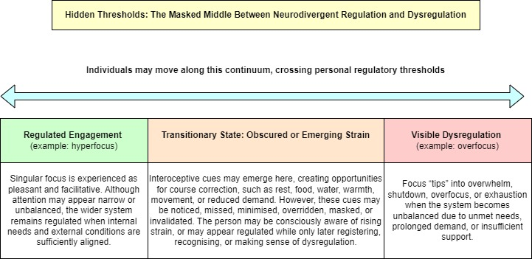
Figure 5.1: Hidden Thresholds: The Masked Middle Between Neurodivergent Regulation and Dysregulation

As illustrated in Figure 5.1, intermediate states of strain may be noticed, missed, masked, or only recognised retrospectively before visible dysregulation occurs. In this sense, counselling and neuro-affirming relational environments may have an important role not simply in reducing distress, but in supporting the re-recognition and validation of internal regulatory signals before crisis thresholds are reached. Several participants described experiences of being accurately seen and relationally validated as transformative in this regard. Benny’s key quote (see section 4.3) appeared to reflect not only interpersonal acceptance, but a gradual restoration of permission to recognise and respond to their own needs authentically. The findings therefore suggest that regulation may depend not solely upon self-management, but upon relational and systemic conditions that make authentic self-recognition possible.

5.2 The Intertwining of Sensory, Relational, Emotional, and Attentional Experience

Participants’ accounts frequently suggested that sensory, emotional, relational, and attentional experiences were not encountered as separate domains of functioning, but as deeply intertwined and mutually shaping aspects of lived experience. Difficulties relating to attention, emotional regulation, social engagement, or environmental overwhelm were rarely experienced in isolation, instead appearing to emerge through ongoing interaction between sensory environment, relational safety, cognitive demand, emotional state, and contextual expectation. This supports Boldsen’s (2022) argument that sensory experience cannot be cleanly separated from social functioning, whilst also extending this understanding beyond sensory-social interaction alone. Within the present findings, these processes appeared phenomenologically inseparable, operating less as distinct categories and more as part of an interconnected experiential ecology.

This interconnectedness was particularly evident in participants’ descriptions of relational engagement, which were frequently shaped not only by interpersonal dynamics themselves, but also by sensory load, environmental predictability, attentional demand, emotional safety, and perceived authenticity within the interaction. Participants often described becoming overwhelmed within environments that were noisy, unpredictable, lacked clarity, or had performative expectations, with these conditions going on to alter attentional flexibility, emotional regulation, and capacity for relational connection. In this sense, social difficulty did not appear reducible to isolated deficits in communication or interaction but instead emerged through the interaction between multiple experiential domains. This was clearly reflected in Anne’s account, where severe auditory sensitivity was described as directly blocking both cognitive processing and relational engagement during sudden or loud auditory experiences, often followed by feelings of shame and self-consciousness regarding how these reactions were perceived by others. Such findings further support Boldsen’s (2022) argument that sensory and social experience cannot be meaningfully separated within neurodivergent lived experience, whilst extending this interconnectedness to include emotional and attentional domains. Similar interconnected sensory, attentional, emotional, and environmental processes were identified by Wain et al. (2026), whose IPA study conceptualised autistic flow as a broader regulatory phenomenon shaped through ongoing interaction between sensory conditions, emotional regulation, predictability, and attentional immersion.

Likewise, emotional experience often appeared contingent upon contextual and relational conditions. Several participants described emotional depth, access, or expression as becoming possible only under particular circumstances, suggesting that emotional experience itself may be partially mediated through safety, attunement, environmental fit, and the extent to which authentic and aligned engagement are felt possible. For example, Angharad speaks of experiences in personal therapy, both as client and therapist, where they are only “warming up around the 40-minute mark” suggesting that both temporal structures, as well as the normative frameworks that dictate them, can have a direct impact on the ability to access emotion. This aligns with Dallman’s (2024) work on emotional depth and phenomenological intensity, whilst also suggesting that emotional accessibility may fluctuate according to relational, temporal, and systemic conditions rather than existing as a fixed internal capacity.

Similarly, participants frequently described greater ease, fluidity, and relational “flow” within neurotype-aligned interactions, supporting literature surrounding double empathy, neurotype matching, and neurotype-aligned therapeutic relationships (Heasman and Gillespie, 2018; Milton, 2012; Taylor and Sims, 2025). This was particularly evident in Angharad’s description of reaching a “flow state” with clients who shared similar communication styles or neurotypes, where relational engagement was experienced as involving greater “depth”, “meaning”, and “richness”. However, findings suggest these experiences may extend beyond communication alone, with neurotype-aligned interactions appearing capable of simultaneously altering emotional regulation, sensory tolerance, attentional flexibility, self-perception, and capacity for authenticity. Whilst existing literature has primarily explored neurotype alignment through communication, rapport, and mutual understanding, participants’ accounts here suggest these interactions may also facilitate broader states of relational-regulatory “flow”, in which attentional, sensory, emotional, and interpersonal processes become more integrated, flexible, and sustainable simultaneously. Such experiences were often accompanied by feelings of familiarity, depth, and relational ease, such as Benny’s depiction of neurotype-aligned interaction as feeling like “home”.

The findings therefore challenge dominant compartmentalised frameworks which position sensory, emotional, attentional, relational, and behavioural experiences as discrete symptom clusters or independent domains of functioning. Whilst such categorisation may be useful within clinical and diagnostic settings, participants’ accounts instead suggested a far more integrated experiential structure, in which these processes appeared phenomenologically and functionally inseparable within lived experience. Neurodivergent experience may therefore be better understood less through isolated traits operating independently, and more through ongoing interaction between relational, sensory, emotional, attentional, and systemic conditions. Importantly, these patterns emerged through participant accounts themselves, rather than being forced into pre-existing theoretical frameworks.

5.3 Being Truly Seen versus Being Perceived

Participants repeatedly described a profound difference between being perceived and being truly seen, with this distinction appearing central to experiences of identity, relational safety, authenticity, and self-trust. Whilst being perceived was frequently characterised by misalignment, misinterpretation, and pathologising assumptions fuelled by normative frameworks, being truly seen appeared to involve accurate attunement, recognition, validation, and the valuing of natural ways of functioning. Both experiences involved attention being directed towards the neurodivergent person, though through very different lenses, with the latter comprising a sense of felt understanding that could be non-verbal and somatic in nature. This distinction appeared to shape not only direct relational experiences, but also identity formation, cognitive engagement, sensory-affective regulation, and participants’ capacity to trust their own internal experience. Participants also frequently described high somatic attunement to others in terms of a “sixth sense”, often citing neurotype alignment as highly facilitative in this area spanning roles. However, whilst such interactions could feel like “home”, they could simultaneously feel emotionally intense or “draining”, requiring strategic self-care and “buffer zones” to regulate and contain the depth of engagement.

These experiences align with attachment literature more broadly, but more specifically with Milton’s (2012) work on the Double Empathy Problem (DEP). Though sometimes criticised for containing scattered concepts and inconsistent empirical evidence (Livingston, Hargitai and Shah, 2025), the present findings provide tentative support for the idea that difficulties neurodivergent people experience do not reside within them alone, but may emerge relationally through mismatched expectations, communicative norms, and differing ways of processing and relating. This was reflected in participants’ descriptions of normative frameworks and interactions as often inflexible, performative, impractical, or emotionally and communicatively vague. Interestingly, many of these descriptions appeared inversely related to common deficit-based characterisations of neurodivergent people themselves, suggesting that communicative and relational difficulty may arise less from objective interpersonal deficits, and more from clashes between differing relational norms, values, and expectations surrounding authenticity, emotional expression, practicality, and communication. The findings further support literature suggesting neurotype alignment may facilitate engagement, social ease, reduced masking and subsequent reductions in cognitive load (Crompton et al, 2020a; Crompton et al, 2020b; Dallman, 2024; Heasman and Gillespie, 2018; Taylor and Sims, 2025). However, findings also suggest these experiences may extend beyond communication and relational comfort alone, appearing capable of shaping identity development, authenticity, and self-trust itself. Participants described accurate recognition and relational validation as transformative, enabling internalised narratives of deficiency or “wrong[ness]” to be reconsidered and supporting a more coherent, self-accepting sense of identity.

5.4 Training and Representation: Neither Alone is Sufficient

Across participant accounts, a consistent lack of education on neurodivergence within counselling training environments was described as a significant barrier to understanding, support, and engagement. Although five participants described limited neurodivergent representation within training itself, Iwan’s account suggested that representation alone was insufficient. As the only participant with high neurodivergent representation among staff, peers, and leadership, Iwan described neurodivergence as still consistently deprioritised in favour of topics deemed more important for client work, reflecting that “it’s not compassionate to not teach about neurodivergence”. This was also reflected within educational materials, with Jade describing counselling textbooks as primarily reflecting normative ways of relating, communicating, and experiencing emotion, leaving neurodivergent experiences absent, peripheral, or difficult to recognise within formal training structures. Participants also suggested these issues extended beyond formal education to the informal relational culture surrounding neurodivergence, with Anne stating that people were often “afraid” to broach the subject. Her reflection suggests that silence itself may become part of the relational and systemic environment, reinforcing isolation, shame, uncertainty, and otherness.

The findings therefore suggest that representation or education alone may not alter the neuronormative frameworks through which neurodivergent experience continues to be interpreted unless accompanied by nuanced neuro-affirming understanding. Participants frequently described environments where inclusion was verbally supported, while neurodivergent ways of processing, communicating, regulating, or relating remained misunderstood, pathologised, or implicitly measured against normative expectations. This reflects wider critiques of the gap between institutional commitments to inclusion and the lived realities of neurodivergent students within higher education, where stigma, masking, and inadequacy may persist despite rhetorical support for neurodiversity (Quigley et al., 2024). It also aligns with neurodiversity-oriented critiques of pathologising frameworks, which argue that neurodivergent experience is frequently interpreted through deficit-based and neuronormative assumptions that position normative functioning as the implicit standard against which mental health and favourable outcomes are measured (Chapman and Botha, 2023). This appeared particularly relevant within counselling training contexts, where participants described tensions between neuro-affirming values of authenticity and relational presence, and educational structures that rewarded normative performance, communication, and neurotypically dominated forms of emotional expression. Meaningful neurodivergent inclusion may therefore depend not solely upon visibility, representation, or education, but upon neuro-affirming lenses being applied within relational, educational, and systemic contexts.

5.5 Environmental Fit and Flexible Accommodation

Participants described navigating multiple overlapping and sometimes contradictory normative systems. This was particularly evident within counselling training environments, where participants experienced tension between expectations surrounding authenticity, emotional presence, relational openness, professionalism, assessment, and performance. Alongside broader tensions around authenticity and belonging, participants described an additional tension between being perceived as a good student and a “good counsellor”, with these roles at times requiring opposing behaviours, forms of engagement, or emotional presentation. Angharad’s account was particularly illustrative, describing participation as an “invitation” within a counselling frame that encouraged authenticity and non-performance, whilst simultaneously existing within an educational environment of assessment, evaluation, and implicit expectations around participation, task engagement, and normative performance. Similarly, participants described being verbally reassured that environments were “safe” or supportive, whilst experiencing strong embodied signals of threat, vigilance, or dysregulation, with Angharad describing “everything in [their] body telling [them] it isn’t”. Such findings align with Quigley and Gallagher’s (2026) conceptualisation of “double masking”, though participant accounts here suggest these tensions extend beyond social masking alone, emerging through attempts to negotiate multiple conflicting relational, educational, and systemic expectations.

Participants described developing highly individualised and context-sensitive adaptations to regulate engagement, sensory load, communication, transitions, and emotional overwhelm. These strategies were often more nuanced and responsive than the accommodations formally provided within institutional settings. Rather than requiring static or universal adjustments, participants’ accounts suggested the need for flexible, collaborative approaches capable of responding to fluctuating regulatory needs both within and between individuals. This appears particularly important given emerging research highlighting how regulation and engagement may be shaped by environmental predictability, uninterrupted immersion, transition support, and opportunities for self-scaffolding rather than solely individual coping capacities (Wain et al., 2026). This aligns with broader neuro-affirming perspectives which conceptualise support not as increasing conformity to normative functioning, but as reducing unnecessary friction between natural ways of functioning and the environments in which they occur. Effective accommodation may therefore depend less upon standardised adjustment frameworks alone, and more upon relational understanding, environmental flexibility, predictability, and responsiveness to individual thresholds and patterns of regulation.

5.6 Limitations and Suggestions for Future Research

As with all IPA research, the findings within this study are interpretive, context-dependent, and based upon a relatively small sample of six participants, meaning the intention is not statistical generalisability but depth of experiential understanding. Participants were drawn specifically from counselling training contexts, which may shape the relational, educational, and emotional experiences described throughout the study. Although this particularity was intentional, it is important to acknowledge that, as counselling trainees, participants often demonstrated high levels of reflectiveness, emotional literacy, and experiential awareness, likely influencing the depth and articulation of findings. Additionally, the sample lacked broader demographic diversity, potentially limiting the extent to which these findings reflect neurodivergent experiences across differing cultural, social, or institutional contexts. Whilst the sample included a high proportion of participants assigned female at birth and/or identifying outside heteronormative categories, ethnicity was largely homogenous, with all but one participant identifying as White British. Furthermore, all participants were training within either person-centred or broader humanistic modalities, which may shape the values, relational orientations, and interpretive frameworks reflected throughout participant accounts.

However, the depth and consistency of interconnected regulatory themes across participant accounts suggest valuable directions for future research. Future studies may benefit from exploring neurodivergent experience through broader ecological and regulatory frameworks, particularly regarding interactions between sensory, relational, emotional, attentional, and systemic processes over time. Further research may also explore neurotype-aligned relational processes, flexible accommodations, supportive environments, transitions, predictability, and participant-developed self-scaffolding strategies across broader populations and settings.

5.7 Implications for Practice and Recommendations

The findings of this research carry several implications for counselling practice, training environments, and broader neuro-affirming approaches to support. In particular, neurodivergent experience may be more helpfully and accurately understood through interconnected patterns of regulation occurring across relational, sensory, emotional, attentional, and systemic domains, rather than through isolated traits or deficits. Table 5.1 summarises key practical implications and indicates where each is grounded in the preceding analysis.

Table 5.1: Practical Implications
Area of implication | Practical implication | Discussion Section
Ecological formulation | Practitioners may benefit from understanding neurodivergent experience through interactions between sensory, emotional, attentional, relational, and systemic domains, rather than treating difficulties as isolated traits or deficits. | 5.2; 5.7a
Thresholds and early recognition | Support should help identify early signs of strain before distress escalates into overwhelm, shutdown, withdrawal, exhaustion, or crisis. | 5.1; 5.7a
Masking and unmasking | Unmasking should not be treated as a universal or straightforward goal; safety, pacing, agency, and context should guide therapeutic work. | 5.1; 5.3; 5.7b
Relational safety | Experiences of being accurately seen, validated, and understood may support self-trust, regulation, authenticity, and sustainable engagement. | 5.3; 5.7b
Training and representation | Representation, visibility, and education should be combined through a neuro-affirming lens, rather than treated as sufficient in isolation. | 5.4; 5.7c
Flexible accommodation | Accommodations should be collaborative, flexible, and responsive to fluctuating regulatory needs, rather than static or standardised. | 5.5; 5.7c
Environmental fit | Support should reduce unnecessary friction between neurodivergent ways of functioning and sensory, temporal, relational, and institutional demands. | 5.1; 5.2; 5.5; 5.7c
Self-scaffolding | Practitioners and training environments should support individuals to develop sustainable, self-directed strategies for regulating engagement, transitions, sensory load, and emotional overwhelm. | 5.1; 5.5; 5.7a; 5.7c

5.7a Moving Beyond Duality: An Ecological Formulation of Neurodivergent Experience

In this section, “duality” refers not only to trait-based binaries such as strength/difficulty, but also to wider oppositional framings such as regulation/dysregulation, functioning/dysfunction, coping/crisis, and masking/authenticity. Rather than rejecting these tensions, the ecological formulation developed here suggests that they may be better understood as context-dependent movements within an interconnected regulatory system, where thresholds may be recognised, mapped, and influenced through individual awareness, relational support, and therapeutic practice.

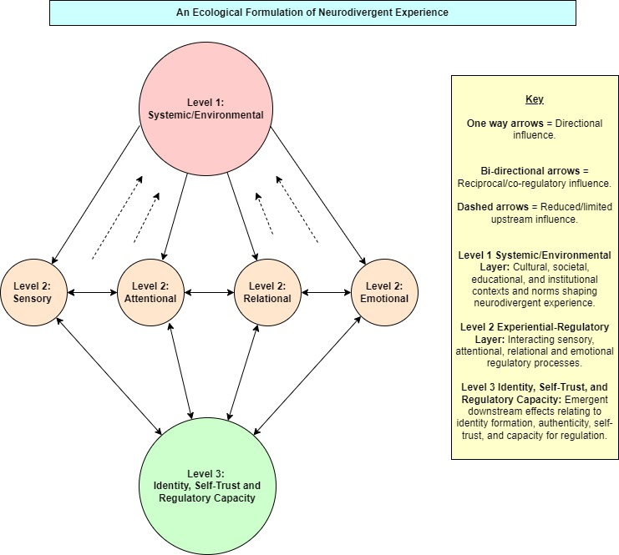
Figure 5.2: An Ecological Formulation of Neurodivergent Experience

Figure 5.2 illustrates neurodivergent experience as an interconnected ecology rather than a set of separate traits, symptoms, or difficulties. Internal regulatory processes, relational experiences of recognition or misrecognition, and wider environmental or systemic conditions are represented through mutually influencing vertical layers and horizontal domains. Within this formulation, experiences described by participants as contradictory or dualistic may instead reflect movement across different regulatory states, shaped by the extent to which internal, relational, and environmental/systemic conditions are aligned or misaligned.

This ecological formulation also helps explain why relatively small changes in one domain or level may have wider effects across the system. For example, increased predictability, reduced sensory load, relational validation, temporal flexibility, or permission to engage authentically may influence not only immediate distress, but also attention, emotional access, self-trust, camouflaging/masking, and capacity for connection. Conversely, misrecognition, interruption, performative expectations, sensory overload, or rigid institutional demands may narrow regulatory capacity and push individuals closer to thresholds of overwhelm, shutdown, withdrawal, or exhaustion.

The practical value of this model lies in making thresholds visible before crisis points are reached by identifying individual limits, interactions across layers and domains, and cumulative effects that may otherwise appear unrelated. Rather than treating difficulties as isolated problems within the individual, practitioners, educators, and training environments may collaboratively map conditions that intensify or reduce dysregulation, support earlier recognition of strain, and develop more flexible accommodations. In this sense, neuro-affirming practice involves not only validating neurodivergent experience, but also identifying and adapting the relational, sensory, temporal, and systemic conditions that support regulation, authenticity, and sustainable engagement.

5.7b Beyond Simplistic Unmasking: Regulation, Safety, and Choice

The findings also carry important implications for understandings of masking and unmasking within neuro-affirming practice. Whilst reducing chronic masking and increasing authenticity may hold significant benefits for neurodivergent individuals, participant accounts suggest that this process is not always simple, linear, or immediately safe. As reflected in Iwan’s account, reconnecting with internal states and interoceptive awareness may initially increase vulnerability, overwhelm, or dysregulation, particularly where sufficient relational safety, regulatory strategies, or environmental alignment are not yet present.

This suggests that unmasking should not be approached as a universal or straightforward therapeutic goal. In some contexts, masking may continue to serve protective, relational, or regulatory functions, particularly within environments that remain unsafe, pathologising, or poorly attuned to neurodivergent needs. This was reflected in Angharad’s experience of needing to “put [her] mask back on” after being openly challenged about her unmasked presentation within the training environment. Rather than representing a failure of authenticity, masking appeared to serve an immediate protective and regulatory function in response to misaligned visibility and relational rupture. The aim may therefore be less about abandoning masking entirely, and more about increasing awareness, agency, and flexibility around when, where, and how masking occurs.

Therapeutically, this highlights the importance of pacing, choice, and collaborative formulation. Neuro-affirming practice may involve supporting individuals to recognise masking patterns, reconnect with internal regulatory signals, and explore authenticity gradually, while acknowledging the grief, risk, and life changes that may accompany this process. In this sense, unmasking is not only an individual act of self-expression, but a relational and environmental process that fluctuates according to the degree of safety available.

5.7c Neuro-Affirming Training, Representation, and Responsive Support

The findings further suggest that meaningful neurodivergent inclusion within counselling and training environments requires representation, visibility, and education to be combined and integrated through a neuro-affirming lens. Without this lens, inclusion risks remaining tokenistic or superficial, leaving underlying neuronormative assumptions largely unchallenged. Participants frequently described environments where inclusion was verbally supported, while neurodivergent ways of processing, communicating, regulating, or relating remained misunderstood or implicitly measured against normative expectations. Effective support may therefore depend less upon static or standardised accommodations alone, and more upon flexible, collaborative, environmentally responsive approaches that reduce unnecessary friction between neurodivergent ways of functioning and their environments.

Chapter 6: Conclusion

This study explored the lived experiences of neurodivergent counselling trainees and found that participants’ experiences were not adequately captured through isolated traits, deficits, or simple dualities. Although participants often described their experiences through contrast, such as regulation and dysregulation, coping and crisis, masking and authenticity, these tensions appeared to reflect a more complex multi-level regulatory system shaped through interactions between internal states, relationships, environments, and wider systemic expectations.

The findings suggest that neurodivergent distress and well-being may be more helpfully understood through ecological-regulatory processes, in which sensory, emotional, attentional, relational, identity-related, and systemic conditions continuously influence one another over time. From this perspective, difficulties do not reside solely within the individual, nor can they be fully addressed through isolated interventions or standardised accommodations. Instead, participant accounts indicated that relatively small shifts in relational attunement, environmental predictability, temporal flexibility, and neuro-affirming understanding could produce wider effects across regulation, identity, authenticity, engagement, and self-trust, with implications for counselling training and practice. This ecological formulation therefore offers a way of mapping personal ecology and recognising dynamic thresholds earlier, before strain becomes visible primarily through overwhelm, withdrawal, shutdown, exhaustion, or crisis.

In response to the research question, counselling training may become more neuroinclusive for trainees not simply through language, representation, or accommodation, but through sustained attention to the conditions through which neurodivergent people are recognised, supported, misunderstood, or required to adapt. As Anne observed, “there’s learning for everybody”, suggesting that improving neurodivergent inclusion within counselling training benefits not only neurodivergent trainees, but the wider relational and educational ecosystems in which people are invited to function, connect, and belong.

Reference List

Bąbel, P. and Ostaszewski, P. (2023). Between neurodiversity and therapy: the importance of making conscious and responsible choices in supporting individuals on the autism spectrum. Postępy Psychiatrii Neurologii, 32(4), pp. 175–182. https://doi.org/10.5114/ppn.2023.135596

BACP (2018). BACP Ethical Framework for the Counselling Professions. Available at: https://www.bacp.co.uk/events-and-resources/ethics-and-standards/ethical-framework-for-the-counselling-professions/ (Accessed: 18/09/25).

BACP (2019). BACP Ethical Guidelines for Research in Counselling Professions. Available at: https://www.bacp.co.uk/events-and-resources/research/publications/ethical-guidelines-for-research-in-the-counselling-professions/ (Accessed: 18/09/25).

BACP (2025). SCoPEd Framework: A ground-breaking shared framework for our profession. Available at: https://www.bacp.co.uk/about-us/advancing-the-profession/scoped/scoped-framework/ (Accessed: 14/06/2026)

Bayram, Y. (2025). The Relationship of Determinism, Free Will and Randomness Beliefs with Authenticity and the Mediating Role of Life Meanings among Young Adults in Türkiye: An Existential Social Work Perspective in Clinical Social Work. Clin Soc Work J, 53, pp. 479–493. https://doi.org/10.1007/s10615-025-00997-8

Benson, K. J. (2023). Perplexing Presentations: Compulsory Neuronormativity and Cognitive Marginalisation in Social Work Practice with Autistic Mothers of Autistic Children. The British Journal of Social Work, 53(3), pp. 1445–1464. https://doi.org/10.1093/bjsw/bcac229

Berger, R. (2015). Now I see it, now I don’t: Researcher’s position and reflexivity in qualitative research. Qualitative Research, 15(2), pp. 219–234.
https://doi.org/10.1177/1468794112468475

Bertilsdotter Rosqvist, H., Hultman, L., Österborg Wiklund, S., Nygren, A., Storm, P., and Sandberg, G. (2023). Intensity and Variable Attention: Counter Narrating ADHD, from ADHD Deficits to ADHD Difference. The British Journal of Social Work, 53(8), pp. 3647–3664. https://doi.org/10.1093/bjsw/bcad138

Black, M. H., Helander, J., Segers, J., Ingard, C., Bervoets, J., de Puget, V. G., and Bölte, S. (2024). Resilience in the face of neurodivergence: A scoping review of resilience and factors promoting positive outcomes. Clinical Psychology Review, 113, Article 102487. https://doi.org/10.1016/j.cpr.2024.102487

Boldsen, S. (2022). Autism and the Sensory Disruption of Social Experience. Frontiers in Psychology, 13, Article 874268. https://doi.org/10.3389/fpsyg.2022.874268

Bolton, M.J. (2023). De-centering neuronormativity in humanistic psychotherapy: Towards a neurodiversity-informed, person-centered approach. The Person-Centered Journal, 26(2021–2023), pp. 13–48. Available at: https://adpca.org/article/pcj-volume-26-2021-2023-full-edition/decentering-neuronormativity-in-humanistic-psychotherapy-towards-a-neurodiversity-informed-person-centered-approach/ (Accessed: 01/05/26).

Botha, M. (2021). Academic, Activist, or Advocate? Angry, Entangled, and Emerging: A Critical Reflection on Autism Knowledge Production. Frontiers in Psychology, 12, Article 727542. https://doi.org/10.3389/fpsyg.2021.727542

Brown, L. S. (2018). Feminist Therapy. 2nd edition. Washington, DC: American Psychological Association.

Cage, E. and Troxell-Whitman, Z. (2019). Understanding the reasons, contexts and costs of camouflaging for autistic adults. Journal of Autism and Developmental Disorders, 49(5), pp. 1899–1911. https://doi.org/10.1007/s10803-018-03878-x

Carpita, B., Nardi, B., Pini, S., Parri, F., Perrone, P., Pronestì, C., Giovannoni, F., Russomanno, G., Bonelli, C., Massimetti, G., Cremone, I. M., Fiorillo, A., and Dell’Osso, L. (2025). Social camouflaging of autistic traits is associated with more severe symptoms among subjects with feeding and eating disorders. Eating and Weight Disorders, 30(1), Article 81. https://doi.org/10.1007/s40519-025-01785-6

Chapman, R. and Botha, M. (2023). Neurodivergence‐informed therapy. Developmental Medicine and Child Neurology, 65(3), pp. 310–317. https://doi.org/10.1111/dmcn.15384

Cleary, M., West, S., Kornhaber, R. and Hungerford, C. (2023). Autism, Discrimination and Masking: Disrupting a Recipe for Trauma. Issues in Mental Health Nursing, 44(9), pp. 799–808. https://doi.org/10.1080/01612840.2023.2239916

Cook, J., Crane, L. and Mandy, W. (2024) Dropping the mask: It takes two. Autism, 28(6), pp. 1500–1510. https://10.1177/13623613231183059

Cook, J., Hull, L., Crane, L. and Mandy, W. (2021). Camouflaging in autism: A systematic review. Clinical Psychology Review, 89, Article 102080. https://doi.org/10.1016/j.cpr.2021.102080

Craddock, E. (2024). Being a Woman Is 100% Significant to My Experiences of Attention Deficit Hyperactivity Disorder and Autism: Exploring the Gendered Implications of an Adulthood Combined Autism and Attention Deficit Hyperactivity Disorder Diagnosis. Qualitative Health Research, 34(14), pp. 1442–1455. https://doi.org/10.1177/10497323241253412

Craddock, E. (2025). Navigating residual diagnostic categories: The lived experiences of women diagnosed with autism and ADHD in adulthood. Health: An Interdisciplinary Journal for the Social Study of Health, Illness and Medicine, 30(2), pp. 235–257. https://doi.org/ 10.1177/13634593251336163

Crompton, C. J., Sharp, M., Axbey, H., Fletcher-Watson, S., Flynn, E. G., Ropar, D. (2020a). Neurotype-matching, but not being autistic, influences self and observer ratings of interpersonal rapport. Frontiers in Psychology, 11, Article 586171.
https://doi.org/10.3389/fpsyg.2020.586171

Crompton, C. J., Ropar, D., Evans-Williams, C. V., Flynn, E. G., and Fletcher-Watson, S. (2020b). Autistic peer-to-peer information transfer is highly effective. Autism: The International Journal of Research and Practice, 24(7), pp. 1704–1712. https://doi.org/10.1177/1362361320919286

Dallman, A. (2024). Affective Contact in Autism: A Phenomenological Study of the Emotional Experiences of Autistic Adults. The American Journal of Occupational Therapy, 78(4), Article 7804205070. https://doi.org/10.5014/ajot.2024.050502

Dark, J. (2024). Eight principles of neuro-inclusion; an autistic perspective on innovating inclusive research methods. Frontiers in Psychology, 15. https://doi.org/10.3389/fpsyg.2024.1326536

Data Protection Act (2018). Available at: https://www.gov.uk/data-protection (Accessed: 18/09/25).

David, A. S., and Deeley, Q. (2024). Dangers of self-diagnosis in neuropsychiatry. Psychological Medicine, 54(6), pp. 1057–1060. https://doi.org/10.1017/S0033291724000308

Dodson, W. (2022) How ADHD shapes your perceptions, emotions & motivation. Available at: https://adhd.dk/wp-content/uploads/sites/2/2022/05/Dodson-How-ADHD-Shapes-Your-Perceptions-Emotions-.pdf (Accessed: 14/06/26).

Dörfler, V. (2023). Critical interpretivism: the first outline, paper presented at PHILOS 2023: 3rd Colloquium on Philosophy and Organization Studies, Minoa Palace, 22–24 June. Available at: https://strathprints.strath.ac.uk/85177/ (Accessed: 03/06/26).

Dupuis, A., Mudiyanselage, P., Burton, C. L., Arnold, P. D., Crosbie, J., and Schachar, R. J. (2022). Hyperfocus or flow? Attentional strengths in autism spectrum disorder. Frontiers in Psychiatry, 13, Article 886692. https://doi.org/10.3389/fpsyt.2022.886692

Dwyer, P. (2022). The Neurodiversity Approach(es): What Are They and What Do They Mean for Researchers? Human Development, 66(2), pp. 73–92. https://doi.org/10.1159/000523723

Dwyer, P., Sillas, A., Prieto, M., Camp, E., Nordahl, C. W., and Rivera, S. M. (2024b). Hyper‐focus, sticky attention, and springy attention in young autistic children: Associations with sensory behaviors and cognitive ability. Autism Research, 17(8), pp. 1677–1695. https://doi.org/10.1002/aur.3174

Dwyer, P., Williams, Z. J., Lawson, W. B., and Rivera, S. M. (2024a). A trans-diagnostic investigation of attention, hyper-focus, and monotropism in autism, attention dysregulation hyperactivity development, and the general population. Neurodiversity, 2. https://doi.org/10.1177/27546330241237883

Dwyer, S.C. and Buckle, J.L. (2009). The space between: On being an insider–outsider in qualitative research. International Journal of Qualitative Methods, 8(1), pp. 54–63. https://doi.org/10.1177/160940690900800105

Eaton, J. (2024). Autism Missed and Misdiagnosed: Identifying, Understanding and Supporting Diverse Autistic Identities. Jessica Kingsley Publishers.

Etherington, K. (2004) Becoming a Reflexive Researcher: Using Our Selves in Research. Jessica Kingsley Publishers.

Finlay, L. (2002a). Negotiating the swamp: the opportunity and challenge of reflexivity in research practice. Qualitative Research, 2(2), pp. 209–230. https://doi.org/10.1177/146879410200200205

Finlay, L. (2002b). “Outing” the researcher: The provenance, process, and practice of reflexivity. Qualitative Health Research, 12(4), pp. 531–545. https://doi.org/10.1177/104973202129120052

Frost, N. and Bowen, C. (2012). Commentary: New Pluralistic Strategies for Research in Clinical Practice. Qualitative Research in Psychology, 9(1), pp. 27–31. https://doi.org/10.1080/14780887.2012.630634

Fuld, S. and McKelvie, M. R. (2024). A perspective on neurodivergent‐affirming relational practice: Exploration of identity and the healing process. Counselling and Psychotherapy Research, 24(4), pp. 1141–1144. https://doi.org/10.1002/capr.12792

General Data Protection Regulation (Regulation (EU) 2016/679) (2016). Available at: https://eur-lex.europa.eu/eli/reg/2016/679/oj (Accessed: 18/09/25).

Glen, Z. (2025). Neuronormativity, naturalism and the neurotypical gaze: the equating of neurotypicality and quality in actor training. Theatre, Dance and Performance Training, 16(1), pp. 119–135. https://doi.org/10.1080/19443927.2024.2428615

Goffman, E. (1972). The presentation of self in everyday life. Penguin.

Gray, L., McNeill, B., Pecora, L., Macfarlane, S., Hayley, A., Hitch, D. and Evans, S. (2025). Navigating neurodivergence: A scoping review to guide health professions educators. Medical Education, 59(10), pp. 1037–1048. https://doi.org/10.1111/medu.15676

Hammersley, M. (1992). What's Wrong with Ethnography? Methodological Explorations. Routledge.

Heasman, B. and Gillespie, A. (2018). Neurodivergent intersubjectivity: Distinctive features of how autistic people create shared understanding. Autism: The International Journal of Research and Practice, 23(4), pp. 910–921. https://doi.org/10.1177/1362361318785172

Heasman, B., Williams, G., Charura, D., Hamilton, L. G., Milton, D. and Murray, F. (2024). Towards autistic flow theory: A non‐pathologising conceptual approach. Journal for the Theory of Social Behaviour, 54(4), pp. 469–497. https://doi.org/10.1111/jtsb.12427

Hours, C., Recasens, C. and Baleyte, J. M. (2022). ASD and ADHD comorbidity: What are we talking about? Frontiers in Psychiatry, 13, pp. 154–159. https://doi.org/10.3389/fpsyt.2022.837424

Hull, L., Petrides, K. V., Allison, C., Smith, P., Baron-Cohen, S., Lai, M-C. and Mandy, W. (2017). “Putting on My Best Normal”: Social Camouflaging in Adults with Autism Spectrum Conditions. Journal of Autism and Developmental Disorders, 47(8), pp. 2519–2534. https://doi.org/10.1007/s10803-017-3166-5

Hull, L., Mandy, W., Lai, M-C., Baron-Cohen, S., Allison, C., Smith, P. and Petrides, K.V. (2019). Development and validation of the Camouflaging Autistic Traits Questionnaire (CAT-Q). Journal of Autism and Developmental Disorders, 49, pp. 819-833. https://doi.org/10.1007/s10803-018-3792-6

Jones, F., Hamilton, J. and Kargas, N. (2025). Accessibility and affirmation in counselling: An exploration into neurodivergent clients’ experiences. Counselling and Psychotherapy Research, 25(1). https://doi.org/10.1002/capr.12742

Jordan, J. V. (2010) Relational–Cultural Therapy. 2nd edition. Washington, DC: American Psychological Association.

Khudiakova, V., Russell, E., Sowden-Carvalho, S. and Surtees, A. D. R. (2024). A systematic review and meta-analysis of mental health outcomes associated with camouflaging in autistic people. Research in Autism Spectrum Disorders, 118, Article 102492. https://doi.org/10.1016/j.rasd.2024.102492

Kroll, E., Lederman, M., Kohlmeier, J., Kumar, K., Ballard, J., Zant, I. and Fenkel, C. (2024). The positive impact of identity-affirming mental health treatment for neurodivergent individuals. Frontiers in Psychology, 15, Article 1403129. https://doi.org/10.3389/fpsyg.2024.1403129

Lawson, W. (2025). Research by autistic researchers: an “insider’s view” into autism. The autistic way of being. Frontiers in Psychiatry, 16, Article 1664507. https://doi.org/10.3389/fpsyt.2025.1664507

Legault, M., Bourdon, J-N. and Poirier, P. (2021). From neurodiversity to neurodivergence: the role of epistemic and cognitive marginalization. Synthese (Dordrecht), 199(5/6), pp. 12843–12868. https://doi.org/10.1007/s11229-021-03356-5

Leong, C. and Graichen, R. (2024). Decentring Neuronormativity: A Transactional Analysis Impasse Theory Perspective for Understanding ADHD Masking and Authentically Honoring the Da Vinci Archetype Within. Transactional Analysis Journal, 54(1), pp. 91–106. https://doi.org/10.1080/03621537.2024.2286581

Liñares-de-Marcos, J., Palomero-Sierra, B., Sánchez-Gómez, V., Fernández-Álvarez, C. J. and Canal-Bedia, R. (2026). An integrative approach between neurodiversity perspectives and quality of life models for autistic people across the spectrum of support needs. Frontiers in Psychiatry, 16, Article 1756323. https://doi.org/10.3389/fpsyt.2025.1756323

Livingston, L. A., Hargitai, L. D., and Shah, P. (2025). The Double Empathy Problem: A Derivation Chain Analysis and Cautionary Note. Psychological Review, 132(3), pp. 744–757. https://doi.org/10.1037/rev0000468

Marnau, M. (2025). On Being an Autistic Therapist. PCCS Books.

Miller, D., Rees, J. and Pearson, A. (2021). “Masking Is Life”: Experiences of Masking in Autistic and Nonautistic Adults. Autism in Adulthood, 3(4), pp. 330–338. https://doi.org/10.1089/aut.2020.0083

Milton, D. (2012). On the ontological status of autism: The “double empathy problem”. Disability & Society, 27(6), pp. 883–887. https://doi.org/10.1080/09687599.2012.710008

Nair, V. K., Farah, W. and Boveda, M. (2026). Is neurodiversity a Global Northern White paradigm? Autism: The International Journal of Research and Practice, 30(2), pp. 544–551. https://doi.org/10.1177/13623613241280835

Nelson, T. (2024). ‘Before people see the autism, they see my race’: An intersectional exploration of the lived experiences of masking and camouflaging Black Autistic girls in UK education using IPA and DisCrit. PhD Thesis. The Tavistock and Portman NHS Foundation Trust, University of Essex. Available at: https://repository.essex.ac.uk/39207/2/Research%20Thesis%20Jordan-Nelson.pdf (Accessed: 09/10/25).

Newton, A., Flinn, A., Downs, J. and Richmond, L. (2025). Rethinking self-identification in neurodivergent communities: barriers, harms, and the need for change. Frontiers in Child and Adolescent Psychiatry, 4. https://doi.org/10.3389/frcha.2025.1682129

NHS (n.d.). Neurodivergence. Available at: https://www.kentcht.nhs.uk/childrens-therapies-the-pod/neurodivergence/ Accessed: 20/02/2026

Olmos-Vega, F.M., Stalmeijer, R.E., Varpio, L. and Kahlke, R. (2023). A practical guide to reflexivity in qualitative research: AMEE Guide No. 149. Medical Teacher, 45(3), pp. 241–251. https://doi.org/10.1080/0142159X.2022.2057287

Paynter, J., Sommer, K. and Cook, A. (2025). How can we make therapy better for autistic adults? Autistic adults’ ratings of helpfulness of adaptations to therapy. Autism: The International Journal of Research and Practice, 29(6), pp. 1540–1553. https://doi.org/10.1177/13623613251313569

Pearson, A. and Rose, K. (2021). A conceptual analysis of autistic masking: Understanding the narrative of stigma and the illusion of choice. Autism in Adulthood, 3(1), pp. 52–60. https://doi.org/10.1089/aut.2020.0043

Pellicano, E. and den Houting, J. (2022). Annual Research Review: shifting from “normal science” to neurodiversity in autism science. Journal of Child Psychology and Psychiatry, 63(4), pp. 381–396. https://doi.org/10.1111/jcpp.13534

Poulis, K. and Kastanakis, M.N. (2020). On theorizing and methodological fetishism. European Management Journal, 38(5), pp. 676–683. https://doi.org/10.1016/j.emj.2020.06.006

Pryke-Hobbes, A., Davies, J., Heasman, B., Livesey, A., Walker, A., Pellicano, E. and Remington, A. (2023). The workplace masking experiences of autistic, non-autistic neurodivergent and neurotypical adults in the UK. PloS One, 18(9), Article e0290001. https://doi.org/10.1371/journal.pone.0290001

Quigley, E. and Gallagher, T. (2026). Neurodiversity and higher education: double masking by neurodivergent students. European Journal of Special Needs Education, 41(2), pp. 286–302. https://doi.org/10.1080/08856257.2025.2511369

Quigley, E., O’Hanlon, M., Brandes, M., Kennedy, R. and Gavin, B. (2024). Neurodiversity and third-level education: A lacuna between the strength-based paradigm shift and the lived experience. Neurodiversity, 2. https://doi.org/10.1177/27546330241277427

Ramtekkar, U. P. (2017). DSM-5 Changes in Attention Deficit Hyperactivity Disorder and Autism Spectrum Disorder: Implications for Comorbid Sleep Issues. Children, 4(8), Article 62. https://doi.org/10.3390/children4080062

Rapaport, H., Clapham, H., Adams, J., Lawson, W., Porayska-Pomsta, K. and Pellicano, E. (2024). “In a State of Flow”: A Qualitative Examination of Autistic Adults’ Phenomenological Experiences of Task Immersion. Autism in Adulthood, 6(3), pp. 362–373. https://doi.org/10.1089/aut.2023.0032

Rippon, G. (2025). The Lost Girls of Autism. Macmillan.

Ross, F., Dommett, E. J. and Byrom, N. (2026). A systematic review of higher education-based interventions to support the mental health and wellbeing of neurodivergent students. Npj Mental Health Research, 5(1), Article 14. https://doi.org/10.1038/s44184-026-00196-4

Royal College of Nursing (2026). What is Neurodiversity? Available at: https://www.rcn.org.uk/Get-Help/Member-support-services/Peer-support-services/Neurodiversity-Guidance/What-is-Neurodiversity (Accessed: 20/02/2026).

Ryan, G. (2018). Introduction to positivism, interpretivism and critical theory. Nurse Researcher, 25(4), pp. 14–20. https://doi.org/10.7748/nr.2018.e1466

Shakespeare, T. (2014). Disability Rights and Wrongs Revisited. 2nd edition. Routledge.

Smith, J. A., Flowers, P. and Larkin, M. (2022). Interpretive Phenomenological Analysis: Theory, Method and Research. 2nd edition. SAGE.

Sonuga‐Barke, E. J. S. (2023). Paradigm ‘flipping’ to reinvigorate translational science: Outlining a neurodevelopmental science framework from a ‘neurodiversity’ perspective. Journal of Child Psychology and Psychiatry, 64(10), pp. 1405–1408. https://doi.org/10.1111/jcpp.13886

Sutton, E., Scott, S. and Deemer, P. (2025). Neurodivergence – An Exploration of Challenges and Opportunities Within the United Kingdom’s Clinical Academic Health and Care Professionals Workforce. Neurodiversity, 3. https://doi.org/10.1177/27546330251328411

Taylor, J. R. and Sims, M. (2025). To understand the experiences of autistic counsellors: A United Kingdom phenomenological study. Counselling and Psychotherapy Research, 25(2). https://doi.org/10.1002/capr.12839

Trew, S. (2025). The experience of autism from the perspective of autistic adolescents. Disability & Society, 40(7), pp. 1801–1831. https://doi.org/10.1080/09687599.2024.2374484

University of Wales Trinity Saint David (2022). Research Ethics and Integrity Code of Practice. Available at: https://www.uwtsd.ac.uk/sites/default/files/2024-02/REICoP-July-2022.pdf (Accessed: 10/09/25).

Van Deurzen, E. and Arnold-Baker, C. (2025). Structural Existential Analysis: An Existential-Phenomenological Method for Researching Life. Routledge.

van der Putten, W. J., Mol, A. J. J., Groenman, A. P., Radhoe, T. A., Torenvliet, C., van Rentergem, J. A. A. and Geurts, H. M. (2024). Is camouflaging unique for autism? A comparison of camouflaging between adults with autism and ADHD. Autism Research, 17(4), pp. 812–823. https://doi.org/10.1002/aur.3099

van Rijswijk, J. and Curşeu, P. L. (2025). Formal Versus Self-Identified Neurodivergence: A Comparative Study in Work Environments. Behavioral Sciences, 15(4), Article 420. https://doi.org/10.3390/bs15040420

Walker, N. (2021) Neuroqueer Heresies: Notes on the Neurodiversity Paradigm, Autistic Empowerment, and Postnormal Possibilities. Autonomous Press.

Wain, D., Williams, G., Charura, D., Hamilton, L.G., Milton, D., Wortman, D. and Heasman, B. (2026). Transitioning in and out of autistic flow: a qualitative study presenting a non-pathologising approach to autistic well-being and conceptualising autistic ways of being in clinical and therapeutic settings. Counselling and Psychotherapy Research, 26(1), Article e70073. https://doi.org/10.1002/capr.70073

Yalom, I.D. (2002). The Gift of Therapy. HarperCollins.

Yardley, L. (2000). Dilemmas in qualitative health research. Psychology & Health, 15(2), pp. 215–228. https://doi.org/10.1080/08870440008400302

Zhuang, S., Tan, D. W., Reddrop, S., Dean, L., Maybery, M. and Magiati, I. (2023). Psychosocial factors associated with camouflaging in autistic people and its relationship with mental health and well-being: A mixed methods systematic review. Clinical Psychology Review, 105, Article 102335. https://doi.org/10.1016/j.cpr.2023.102335

Appendices

Appendix A: Covering Letter


Date: 05/10/25

Title of research study: Exploring the Lived Experiences of Neurodivergent Counselling Trainees; An Interpretive Phenomenological and Structural Existential Analysis.
You are invited to take part in a research study to explore the lived experiences of Neurodivergent Counselling Trainees.
Participation in this research is voluntary and should be thoughtfully considered. In order to make an informed decision about whether to take part in this research, it is important that you understand the following:

- Why this research project is being conducted.
- What this research hopes to achieve.
- How the researcher aims to achieve it.
- What is required of you as a participant, and how you will be looked after throughout the process.

All of these questions may be answered by reading the ‘Information Sheet, Consent form and Contract’ provided in this pack. If you have any further questions, these are welcomed by contacting the primary researcher at the email address provided.
This MA research project is supervised by Dr Beverly Cole (UWTSD) and has been approved by UWTSD’s Research Ethics Committee. It is also bound by the ethical framework of the British Association for Counselling and Psychotherapy. The hope is that it will contribute towards making the counselling profession more Neuro-inclusive for its Trainees, Counsellors and Clients.

Thank you for taking the time to read this information.

Primary Researcher: Emma Davies 2206803@student.uwtsd.ac.uk
Research Supervisor: Beverly Cole beverly.cole@uwtsd.ac.uk

Appendix B: Information Sheet, Consent Form and Contract


Information Sheet, Consent Form and Contract
Research Study Title: Exploring the Lived Experiences of Neurodivergent Counselling Trainees: An Interpretive Phenomenological and Structural Existential Analysis
Primary Researcher: Emma Davies 2206803@student.uwtsd.ac.uk
Research Supervisor: Beverly Cole beverly.cole@uwtsd.ac.uk

Research Study Information
If you are reading this information sheet, it means that you have been invited to take part in this research project and are thoughtfully considering whether to take the next step. Being a participant in qualitative research is a unique experience that can be as rewarding as it is challenging. Hopefully the information provided below will significantly contribute towards your decision as to whether this particular experience would meet your individual needs at this time.

Why is this research project being conducted?
I am a Neurodivergent Counselling Trainee who has moved in to specialising in working with Neurodivergent clients. During my time studying Counselling and Psychotherapy I have come up against multiple normative and ableist barriers, spanning academic, theoretical, practical and social. I have witnessed similar struggles in my fellow Neurodivergent classmates and placement-mates, as well as my counselling clients.
Being excluded from systems and environments, or masking to fit into them, can cause significant issues for Neurodivergent individuals, including; depression, anxiety, burnout, chronic health struggles, suicidal thoughts, completed suicide, unemployment, loneliness, additional mental health diagnosis and/or misdiagnosis.
Experiencing and witnessing these struggles has led to a passion for Neuro-inclusion and Neuro-affirming practice. Put simply, this is a desire to increase environments, systems and ways of thinking and being that work for, include and benefit all brains, while affirming these differences as normal, valid and useful to the world.

What does this research hope to achieve?
I truly believe that representation matters in the quest for inclusion, and that a top-down approach within the profession would benefit all. How can we be truly Neuro-inclusive for clients if we continue to marginalise our trainees and professionals? I wish to contribute towards filling the current gap in the academic literature by answering the research question:
“How can Counsellor training be more Neuro-inclusive?”

How does the researcher aim to achieve this?
In order to answer the research question, as well as contribute towards authentic and unmasked Neurodivergent voices being represented within the world of Counselling research and practice, I intend to:

- Conduct semi-structured interviews that explore the lived experiences of Neurodivergent counselling trainees (covering challenges, strengths, what was/is helpful/unhelpful regarding the training process)

- Conduct and produce research that is Neuro-inclusive for its participants and readers.

- Analyse Data using Interpretive Phenomenological Analysis and Structural Existential Analysis (methods that aim to uncover and present the accurate lived experience of participants).

Participant Criteria
Participants must meet the following inclusion criteria:

- Be either self-identified or diagnosed as Neurodivergent; either generally Neurodivergent or with a specific or combined Neurotype (including but not exclusive to, Autism, ADHD, AuDHD, Dyspraxia, Dyslexia, Tourette’s).
- Have been enrolled on a Counselling or Psychotherapy practice-based training course for at least 3 months (including individuals who may have left/not fully completed such training) or have completed a practice-based training course in either Counselling or Psychotherapy within the last 3 years.
- To have access to either supervision or personal therapy.

Participants will take part in a semi structured interview via Teams, where the primary researcher will go through the interview schedule (see interview schedule document in this pack for further details).

Participant Care
All qualitative research interviews have the potential to rouse strong emotion, and therefore great care and consideration must be taken by both parties before commencing data collection.

Study design: This study is bound by UWTSD ethical approval as well as UWTSD and BACP ethical guidelines. It is designed to be Neuro-inclusive and will consider personal processing styles throughout the process.
https://www.uwtsd.ac.uk/research/research-integrity-and-ethics
https://www.bacp.co.uk/events-and-resources/ethics-and-standards/ethical-framework-for-the-counselling-professions/
https://www.bacp.co.uk/events-and-resources/research/publications/ethical-guidelines-for-research-in-the-counselling-professions/
Inclusion Criteria: Participants must have access to either a supervisor or personal therapist so that, if they wish, they may further and safely explore any themes, questioning or personal distress that may arise as a result of discussing the topics covered in the interview schedule.

Preparation: Participants will be given an interview pack and schedule at least 2 weeks prior to interviews taking place to allow for adequate processing and reflection time on the material. The primary researcher will be conducting a thorough self-reflective process in order to remain reflexive and to reduce bias (this will include reflecting on the research questions, journalling, engaging in personal therapy and supervision).

Interviews: Interviews will be relaxed and informal in style, though held by a loose structure that will be managed by the researcher, similar to the experience of personal therapy. At the beginning of the interview participants will be reminded of the consent form and their right to withdraw at any time up until 2 weeks after data has been collected. As a trained counsellor the researcher is competent in holding space, spotting and dealing with any distress that may arise, and navigating complex emotional terrain in a safe and ethical way. Recordings and data handling will be covered by UWTSD and UK data protection, and Teams privacy policies
https://digitalservices.uwtsd.ac.uk/library/open-access-and-research/research-data-management/
https://www.gov.uk/
https://www.microsoft.com/en-gb/microsoft-teams/security

Aftercare: After the official interview questions have been covered, a 15-30 minute debrief will be offered by the researcher. Here the participant can reflect on their experience and any residual feelings that have arisen as a result of the process. If necessary, the researcher will signpost to ongoing aftercare if this is deemed necessary or helpful (also see signposting sheet within this pack). Full interview transcripts will be available to participants should they wish to see them (concerning their own data only). Participants will be forwarded any final and published works if they wish (see consent form).

Complaints: Should participants wish to complain about any aspect of the research or their treatment during the process, they should follow the complaints procedure listed below.
https://www.uwtsd.ac.uk/external-complaints

Thank you for taking the time to read this information.
Please scroll to the next page for Consent Form and Contract

Research Study Consent Form and Contract
- I have read and understood the above information sheet ☐
- I understand that my participation in this study is voluntary and that I have the right to withdraw at any point up until 2 weeks after data is collected ☐
- I understand that I have the right to not answer questions asked during interview and that I can stop the interview at any time ☐
- I understand that interviews will be recorded via Teams and will be subject to UWTSD and UK Data Protection policies and legislation, as well as the Teams privacy policy, which I have been signposted to ☐
- I understand that my data will be analysed and used anonymously (including curated anonymity) by the primary researcher in final works and future related published works, including direct quotes ☐
- I understand that this research study is bound by the ethical guidelines of UWTSD and the BACP and subject to UWTSD Ethical Approval ☐
- I understand that my data will be handled within legal data protection requirements of the UK, and that my raw data will be destroyed after the researcher’s degree is awarded ☐
- I understand my right to complain as outlined in the information sheet provided ☐
- I wish/do not wish (delete as appropriate) to be forwarded any final and published works related to this research project ☐

Name:
Signed:
Date:

If you wish to take part in this study, please return a signed and dated copy of this consent form and contract to the primary researcher. Once this has been done you will be contacted to arrange a time and date for your interview.
Thank you

Appendix C: Interview Schedule
Interview Schedule

Title of research study: Exploring the Lived Experiences of Neurodivergent Counselling Trainees; An Interpretive Phenomenological and Structural Existential Analysis.
Date:
Start time:
Duration: 1hr30min-1hr45min
(Breakdown: welcome 10min, main interview up to 1hr, de-brief 15-30 minutes)
Interview with: (participant code)
Interviewed by: Emma Davies (primary researcher)

Welcome (up to 15 minutes):
- Introductions.
- Confirm that information sheet, consent form and contract, and interview schedule have been read and understood.
- Discussion on how interviewee will stop the interview/skip questions if needed.
- Cover prompts and Neuro-inclusive pacing (pausing after and in-between questions if needed)
- Discuss Neuro-inclusive needs (using fidgets or comfort objects during the interview process, eye contact preferences etc).
- Offer grounding exercise if needed.

Main Interview (up to 1 hour):

Question 1.
Can you tell me about any strengths you feel that you have related to being Neurodivergent that were/are helpful throughout the counsellor training process?

Prompts: you may want to consider academic assignments, client work, placement organisation, supervision, paperwork, lectures, communication, social elements (Note: these are just suggestions of areas that may be affected, you do not need to cover all or any of these if they do not relate. Please feel free to bring anything you feel to be relevant or central to your lived experience of this topic).

Question 2.
Can you tell me about any challenges you may have experienced during the counsellor training process, that you feel are linked to your being Neurodivergent?

Prompts: you may want to consider academic assignments, client work, placement organisation, supervision, paperwork, lectures, communication, social elements (Note: these are just suggestions of areas that may be affected, you do not need to cover all or any of these if they do not relate. Please feel free to bring anything you feel to be relevant or central to your lived experience of this topic).

Question 3.
Can you tell me about anything you experienced during your time training as a counsellor that felt unhelpful/discriminatory/Neuro-normative?

Prompts: this may include direct interactions with people as well as expectations of the counselling frame, counselling skills, modality, academic environment or placement environment (Note: these are just suggestions of areas that may be affected, you do not need to cover all or any of these if they do not relate. Please feel free to bring anything you feel to be relevant or central to your lived experience of this topic).

Question 4.
Can you tell me about anything you experienced during your time training as a counsellor that felt helpful/inclusive to your Neurodivergent needs?

Prompts: this may include direct interactions with people as well as expectations of the counselling frame, counselling skills, modality, academic environment or placement environment (Note: these are just suggestions of areas that may be affected, you do not need to cover all or any of these if they do not relate. Please feel free to bring anything you feel to be relevant or central to your lived experience of this topic).

Question 5.
Do you have any recommendations of what you would like to see implemented/increased/standardised as a part of the Counsellor training process that may be helpful to Neurodivergent trainee counsellors?

Prompts: this may include direct interactions with people as well as expectations of the counselling frame, counselling skills, modality, academic environment or placement environment (Note: these are just suggestions of areas that may be affected, you do not need to cover all or any of these if they do not relate. Please feel free to bring anything you feel to be relevant or central to your lived experience of this topic).

Question 6:
Is there anything else you would like to add?

Prompt: This may be anything else that you would like to add to the areas we have already discussed, or anything new that you want to be included about your lived experience of being Neurodivergent).

Debrief (15-30 minutes):
Researcher will ask interviewee how they are feeling, if they would like to reflect on the process, and offer a grounding exercise if needed.
Interviewee will be reminded of the support and signposting information given in the interview pack, and of their right to withdraw up until 2 weeks after the date of the interview taking place.

Appendix D: Signposting and Resource Sheet

Neuro-affirming Signposting and Resource Sheet
Here are some great resources covering a wide range of topics concerning Neurodivergence. As a Neurodivergent person, I have found many of these sources incredibly helpful and Neuro-affirming in their content. Finding sources of information and helping professionals who have lived experience of the topic can be particularly useful.
If you have any recommendations of resources that I can add to this list and my learning, I would love to hear from you

Divergent Conversations Podcast:
Two AuDHD Health professionals discuss topics such as Burnout and Identity with occasional guest speakers:
https://www.divergentpod.com/

Neurodivergent Insights:
Website run by Dr Neff, who themselves is AuDHD. Great resources and information on topics concerning Autism, ADHD and AuDHD such as Burnout and Misdiagnosis:
https://neurodivergentinsights.com/autism-and-adhd-burnout/

The Mix:
Great source of Neuro-affirming information covering a wide range of Neurodivergences. Support services for 13–25-year-olds. From this main page you can navigate to pages covering specific neurotypes.
https://www.themix.org.uk/explore-our-topics/your-body/neurodiversity/

Tourettes Action:
A charity which is majority run by those with lived experience of Tourettes.
https://www.tourettes-action.org.uk/

Eviemeg on Instagram:
Eviemeg is a lived experienced influencer with Tourettes and Dystonia:
https://www.instagram.com/p/DPow6atDDtw/

Late Bloomers Podcast:
Podcast discussing the lived experience of having and living with ADHD.
https://www.youtube.com/watch?v=2NiWzNk4AG4

ADHD Chatter Podcast:
Podcast discussing the lived experience of having ADHD where experts and influential people in the field are interviewed.
https://www.youtube.com/@ADHD_Chatter_Podcast

Dr Ned Hallowell:
Ned Hallowell came up with the alternative term for ADHD ‘VAST’
https://www.youtube.com/watch?v=6PcY_BFbE2o

Appendix E: Example of Analysis Process

Worked example from Angharad’s analysis
Transcript Extract | Initial Conceptual Cluster Note | PET/Subtheme | Link to GET
I didn't really feel ever fully in it like there was ever really enough time for me to get into that counsellor mode...Yeah, just need more time to get in it. Immerse myself in it. Yeah. And, like, work from that embodied place. And I think now I'm thinking about it, you know, that sweet spot for me is 3 hours. So maybe having that three or four hours with a break or maybe a few breaks. Yeah, that would probably. I would have found that helpful or easier to. Yeah. Really engage, really engage with it, I think. | Monotropism, hyperfocus, and transitions. Wording was also bolded and colour coded within the initial extract to highlight and consider emerging meaning. | PET 1: Time, pacing and transitions in regulating engagement and presence.  Subtheme 1: Deep focus and effortful transitions between states.  Subtheme spreadsheet notes: can enter immersive states that are useful, though transitioning out is costly and difficult and needs to be factored in and accounted for via buffer zones. | GET 1: Regulating Engagement: A Cyclical Process of Activation, Immersion, and Transition.  Subtheme 2: Immersion-based engagement that is deep, resource-intensive, and difficult to regulate in duration and direction.

Appendix F: Mapping of GETs, Linked PETs and Relevant Literature

GET | Linked PETs/ Participants | Relevant Literature | Connection to Literature
GET 1: Regulating Engagement: A Cyclical Process of Activation, Immersion, and Transition | PET material across Angharad, Benny, Anne, Iwan, Jade and Frankie contributed to this GET. Linked areas included task initiation, preparation and predictability, sensory regulation, urgency, intrinsic drivers/INCCUP, immersive focus/hyperfocus, experiential grounding, transitions, decompression and recovery. | Heasman et al. (2024); Dwyer et al. (2024a); Lawson (2025); Wain et al. (2026); Pryke-Hobbes et al. (2023). | This literature supports engagement as dynamic, context-dependent and shaped by sensory, attentional, relational and environmental conditions. It connects with the finding that engagement moved through cyclical phases of activation, immersion, transition and recovery, rather than reflecting fixed traits, deficits or simple strengths.
GET 2: Relational Attunement, Authenticity, and the Construction of Self | PET material across all participants contributed to this GET. Linked areas included embodied attunement, relational depth, misattunement, masking/camouflaging, authenticity, neurotype-aligned interaction, being accurately seen, self-trust and reconstruction of identity. | Milton (2012); Heasman and Gillespie (2018); Crompton et al. (2020a; 2020b); Dallman (2024); Taylor and Sims (2025); Livingston, Hargitai and Shah (2025); Pryke-Hobbes et al. (2023). | This literature connects with double empathy, neurotype alignment, masking/camouflaging, emotional depth and relational recognition. The findings extend this by suggesting that attunement and misattunement shaped not only communication, but also regulation, authenticity, self-trust and identity.
GET 3: Systemic Mismatch and Neurodivergent Adaptation | PET material across all participants contributed to this GET. Linked areas included normative training expectations, limited neurodivergence-informed education, representation without sufficient understanding, the cost of functioning in misaligned systems, partial or inflexible accommodations, self-advocacy burden, and participant-developed adaptations. | Quigley et al. (2024); Chapman and Botha (2023); Quigley and Gallagher (2026); Dark (2024); Wain et al. (2026). | This literature connects with critiques of neuronormative systems, inclusion rhetoric, inflexible accommodations and deficit-based interpretations of neurodivergent experience. The findings support the view that distress and adaptation often emerge from systemic mismatch, rather than from individual deficit alone.

Appendix G: Recruitment Flyer

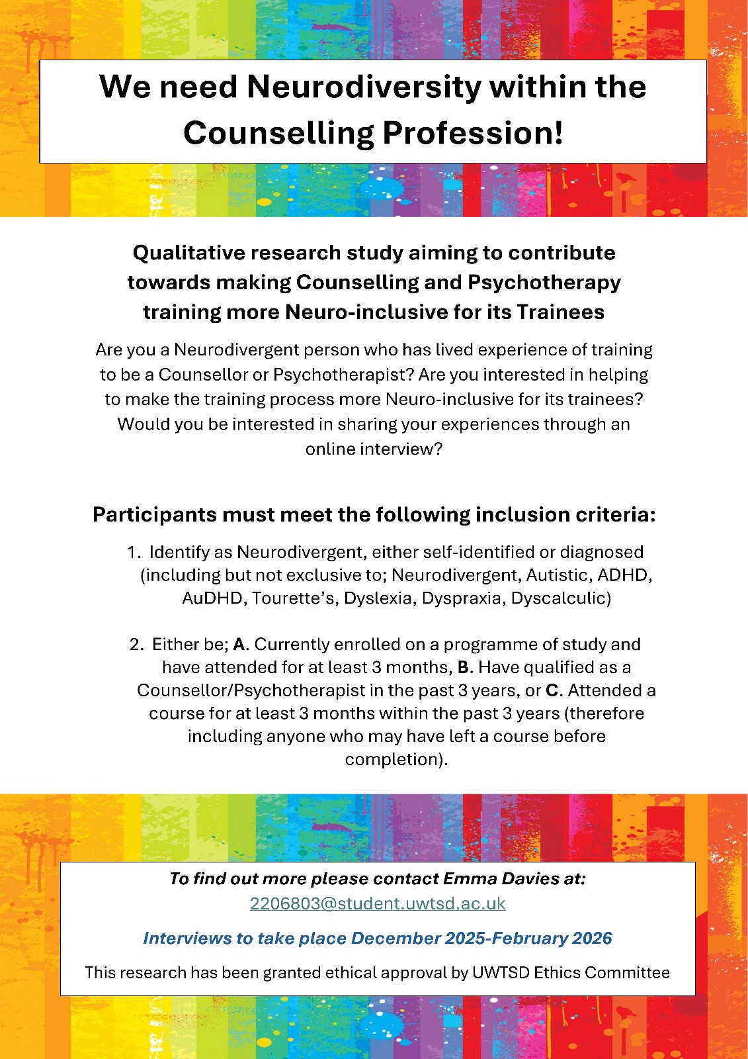

Here, queering is used in Angharad’s sense: as a process of questioning, blurring boundaries, loosening and reworking normative assumptions, rather than referring only to sexual or gender identity.

