MENU ENGINEERING (practical task)
Name: Eduardo Polanco Adoka
Student code: 2132108
Module: Food & Beverage Operations
Module code: BMIH4002
Lecture: Philippa Fitzgerald

In this report, a new restaurant chain has been decided to open which is a part of the Trinity hotel chain, situated in the United Kingdom. The restaurant has set a special menu which is a fusion of Indian and Chinese cuisine . There will be an elaborate list of items.
The restaurant specializes in offering a unique fusion of cuisine of Indian and Chinese which would help in satiating the taste buds of the visitors of the restaurant. This restaurant is dedicated to providing quality food to the visitors. The restaurant has experienced chefs who are skilled enough in cooking Indian and Chinese cuisine (Jiang et al. 2021). The chefs would try to provide authentic taste to the visitors of the restaurant. The fusion of both of these two popular cuisines would give a different experience to the Customers that they have never experienced before (Ng et al. 2021). All the signature spices are brought down from India and China so that the taste is authentic (Zhang et al. 2019). The restaurant would also curate the dishes as per the choices and preferences of the customers in such a manner so that they can help build the reputation of the restaurant (Slack et al. 2021).
The restaurant attracts customers who are interested in trying something new and extraordinary. The Menu is set in such a manner that customers can be helpful enough for both vegan and non-vegetarian Customers. The vast course of the menu can be enticing enough to attract a large number of Customers from the UK. Since the Customers of the UK have a preference for eating continental cuisine, the menu is thus set in such a way that there are items that are less spicy which is up to the preferences of the Continental cuisine eater (Carpentieri et al. 2021). Since the prices of the dishes are moderately lower this can be easier for Customers of all strata to try out the dishes in the restaurant.
The menu is selected by incorporating a variety of vegetables, meat items, and eggs. The menu has been formed with a wide scale of research that can be applied to meeting the demands of Customers with various food preferences (Weriza et al. 2021). The menu has different courses of meals from starters, main courses, side dishes, and desserts to beverages. The real spices of China are introduced (Stano,2019). The dishes are made up of intricate spices that give the real flavor of both India and China. The skilled chefs of India and China have done good research and experimented with the dishes to give a fusion taste of these two cuisines (Ensaff,2021). The regional dishes of India are incorporated to give a rich taste (Ghosh,2022). Indian menu is rich in flavor of spices (Mandal and Tsai, 2020)
All the items on the menu were selected after researching the preferences of the guests and then curated into the menu book for grandly celebrating . The restaurant is a part of the Trinity hotel chain, in the UK.

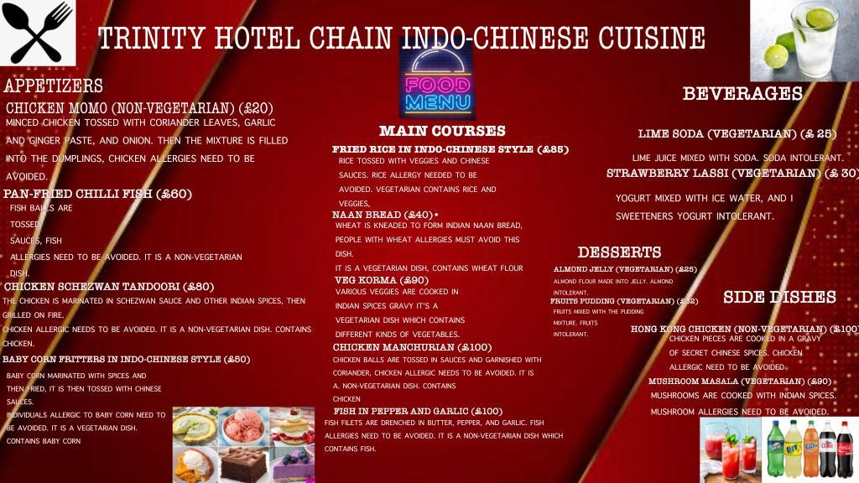

References

Carpentieri, S., Soltanipour, F., Ferrari, G., Pataro, G. and Donsì, F., (2021). Emerging green techniques for the extraction of antioxidants from agri-food by-products as promising ingredients for the food industry. Antioxidants, 10(9), p.1417.Available at:https://www.mdpi.com/2076-3921/10/9/1417/pdf (Accessed on: 27 October 2023)

Ensaff, H., (2021). A nudge in the right direction: the role of food choice architecture in changing populations' diets. Proceedings of the Nutrition Society, 80(2), pp.195-206. Available at:https://www.cambridge.org/core/services/aop-cambridge-core/content/view/C9920D90BE1B3BF41C1EAADFB9814BB2/S0029665120007983a.pdf/nudge_in_the_right_direction_the_role_of_food_choice_architecture_in_changing_populations_diets.pdf (Accessed on: 27 October, 2023)

Ghosh, A., (2022). An Overview of Indian Culinary Journey with Glimpse of Regional Cuisine. Bulletin of Culinary Art and Hospitality, 2(1), pp.33-40.Available at: http://bocahjournal.um.ac.id/index.php/bocah/article/download/20/15 (Accessed on: 27 October, 2023)

Jiang, S., Zhang, H., Wang, H., Zhou, L. and Tang, G., (2021). Using restaurant POI data to explore regional structure of food culture based on cuisine preference. ISPRS International Journal of Geo-Information, 10(1), p.38. Available at:https://www.mdpi.com/2220-9964/10/1/38/pdf (Accessed on: 27 October, 2023)

Mandal, A. and Tsai, Y.H., (2020). TASTE OF INDIA: A CASE STUDY OF INDIAN CUISINE IN TAIWAN. International Journal of Organizational Innovation, 13(2). Available at: https://www.ijoi-online.org/attachments/article/270/1115%20Final.pdf (Accessed on: 27 October, 2023)
Ng, S., Liu, Y., Gaither, S., Marsan, S. and Zucker, N., (2021). The clash of culture and cuisine: A qualitative exploration of cultural tensions and attitudes toward food and body in Chinese young adult women. International Journal of Eating Diso
rders, 54(2), pp.174-183.Available at: https://www.marshmemorylab.com/s/eat23459.pdf (Accessed on: 27 October, 2023)
Slack, N.J., Singh, G., Ali, J., Lata, R., Mudaliar, K. and Swamy, Y., (2021). Influence of fast-food restaurant service quality and its dimensions on customer perceived value, satisfaction and behavioural intentions. British Food Journal, 123(4), pp.1324-1344.Available at: https://www.academia.edu/download/93337949/BFJ-09-2020-077120221030-1-1gmsyxz.pdf (Accessed on: 27 October, 2023)

Stano, S., (2019). The aesthetics of food: Chinese cuisine (s) between the East and the West. I SAGGI DI LEXIA, 34, pp.277-301.Available at: https://iris.unito.it/bitstream/2318/1714278/1/201910_STANO_The%20Aesthetics%20of%20Food.pdf (Accessed on: 27 October, 2023)
Weriza, J., Mallisza, D., Dahri, N. and Susanti, M., (2021). Restaurant Menu Design Muaro New Sand Jamak. Dinasti International Journal of Digital Business Management, 2(6).Available at:https://repo.unespadang.ac.id/id/eprint/156/1/1089-Article%20Text-2380-3-10-20220309.pdf (Accessed on: 27 October, 2023)
Zhang, C., Yue, Z., Zhou, Q., Ma, S. and Zhang, Z.K., (2019). Using social media to explore regional cuisine preferences in China. Online Information Review, 43(7), pp.1098-1114.Available at:https://www.researchgate.net/profile/Chengzhi-Zhang-2/publication/337453172_Using_social_media_to_explore_regional_cuisine_preferences_in_China/links/5ddc6ec3458515dc2f4dbf68/Using-social-media-to-explore-regional-cuisine-preferences-in-China.pdf (Accessed on: 27 October, 2023)

