
Sports Industry Research Project
Literature Review

Student Name

Project Title

Contents Page (use relevant number of pages)
Context page
1.0 General barriers Page 3
1.1 Barriers from teacher’s perspective Page 3
1.2 Motivational factors Page 3
1.3 Sports preferred, rankings Page 4
2.0 Participation levels
2.1 Global Page 5
2.2 UK Page 5
2.2.1 Girls Active Survey Page 6
2.2.2 Muslim Page 6
2.3 Wales- state of nation report Page 6
2.4 Rural Page 7
3.0 Strategies for future Page 7

Aim and Objectives
Aim- A critical analysis of the challenge’s sports development officers in the PASS team and PE teachers face whilst targeting ks3 and ks4 girls for physical activity.

Identify why the drop-out rate for sport is apparent from girls transitioning from ks3 to ks4.
Analysing the challenges and barriers that young girls are facing within participating.
Discovering what the sport development officers and PE teachers are doing to overcome the barriers and find solutions.
Create a plan to suggest sports that are most popular and provide variations that the sports development officers and PE teachers can use to benefit ks3 and ks4 girls.

Literature Review (use relevant number of pages)
- General barriers
Female participation is a problem that sports clubs and schools have faced for many years, with several barriers causing them to drop out after finishing primary/ secondary school or to also not take part at all. The most common barriers mentioned throughout many journal articles are stated below: (Watson, Eliott and Mehta, 2015; O'Reilly, Brunette and Bradish, 2018; Casey et al., 2009; Dagkas, Benn and Jawad, 2011)
- Bullying/ peer teasing
- Lack of skill
- Lack of time
- School uniform
- Cost of training
- Stereotyping
- Teachers
- Interferes with religion
Verloigne et al., (2016) study has discovered that higher parental and peer role models, co-participation and encouragement made a significant positive impact to physical activity amongst adolescent girls. The benefits of self-efficacy, is having fun, being around friends, meeting new people and not being bored. Interventions should include both peers and parents as they have a big influence on girls’ physical activity by creating fun extrinsically and intrinsically by girls’ gaining self-confidence. Comparing to a earlier study by Butcher (1985) as they identified 5 variables that related to participation and created a positive or negative impact: significant others participation/encouragement, movement satisfaction, independent abilities such as skills or knowledge about sport, sports equipment available and preference to be active rather than sedentary lifestyle. Even though Butchers’ study was over 20 years old, it is still making relevant points to what is being said in Verloignes’ study in 2016, proving that we haven’t gained any new knowledge on the barriers to participation.
Wetton et al., (2013) explained how 15-16-year old girls knew the benefits of regular physical activity such as reduced risk of cardiovascular disease, heart attacks and obesity, therefore continues to ask why they aren’t regularly participating. The four barriers that became prominent was internal factors e.g. confidence, self-esteem, existing stereotypes e.g. ‘masculine’ and ‘feminine’ sports, other hobbies or school work taking a priority and teachers as they can either positive influence the girls into trying hard or can negatively influence by creating boredom, no support within lessons, or favouring certain pupils over others.
1.1 Barriers from teacher’s perspective
Okely et al., (2017) findings showed staff’s reasons for girls not participating in physical education or sport was: how the lessons were structured with a lack of variety and choice of activity, lack of resources and the lack of skill/expertise amongst non-PE staff who helped supervise school sport, for example weren’t able to give any tips or feedback. Coaches perceiving themselves as role models can impact physical activity levels, and within this study found that they challenged the girls enough in areas of variability, skill and intensity. However, they noticed poor parental support during training and matches and this showed a major impact in performance, therefore Guagliano et al., (2014) suggested future research on educating coaches to promote physical activity to organised youth sport but the impact of positive parental support. Wetton et al,. (2013) found methods from a teachers perspective on how to overcome these barriers, including: teachers’ changing their attitudes and shifting the focus away from just male competitive sports, to ask girls what sports they would prefer to do during PE and to encourage more girls 15-16-years old to take part.
1.2 Motivational factors
Studies of motivation show that gender plays a part in different motivations and needs for sports (Azzarito and Solmon, 2009; Crosnoe, 2001). The school and type of activities it offers is a significant factor in 15-16-year-old girls, due to boredom of lack of variety. Scraton (1990) found that boys focused on competition whereas girls preferred social interaction and friendship, this has been an issue due punishing girl for speaking in class whereas boys are positively reinforced for competitions making girls less likely to enjoy physical education as an outcome. Azzarito and Solman (2009) also discovered that girls are pressured to participate in “feminine, appropriate” activities.
1.3 Sports preferred
Ranking order from girls for sporting preferences in Wales (Allison, L. Bird and McClean, 2017):
- Dance
- Football
- Basketball
- Gymnastics
- Athletics
- Badminton
- Hockey
- Netball
The results showing that dance was vote top by a high margin shows that majority of girls aren’t supporting the idea of participating in team games, the reasons the girls choose dance was because, they enjoyed improving their own skills, they can practise/ participate individually or in a team and it’s a sport that aims at improving confidence. Correspondingly, Eime et al., (2008) investigated that females physical activity level changes during two life transition points. Females around 23 years old plus, shifted away from competitive team sports and focused towards individual sports such as running, swimming, attending the gym. Kilpatric, Herbert and Bartholomew (2005) indicated that motivation of enjoyment, physical activity and the better health was most important to women whereas men enjoyed sport to compete.
Canada is in complete contrast with research from other countries, in the theory of women preferring individual sports, as seen in the top organised sports for Canadian Females (Statistics Canada, 2013)
Girls (under 18 years)
- Swimming (20%)
- Dance (17%)
- Ballet (9%)
- Gymnastics (9%)
Women
- Golf (15%)
- Football (12%)
- Volleyball (9%)
2.0 Global
The Department of Health and Aging recommends children should take part in 60 minutes of moderate to vigorous physical activity each day, these targets are becoming less frequently reached as age increases and girls are less often to meet the recommendations. Watson, Eliott and Mehta (2015) explained, a study in Australia discovered that school lunch times are the ideal time to maximise children’s physical activity, the research also indicates that girls are consistently less active then boys. The activities were considered ‘gender appropriate’ but bullying and teasing were significant barriers along with a “girls” uniform as it fitted with stereotypes, a unisex uniform would’ve been preferred.
The perception of gender identities has been a problem for sports participation in many cultures, one male stated “young women should ideally spend time helping their mothers cook and family-oreintated” (Walseth, 2006, p.91) There is a minority and majority sports participation gap, for boys there is very little difference, however the minority girls at (12%) had significantly lower participation levels compared to majority girls (25%) (Strandbu, Bakken and Sletten, 2017). Class and socioeconomic resources have explained differences in participation rates between majority and minority groups of youth (Dagkas & Hunter, 2015).
2.1 UK
The findings from O'Reilly, Brunette and Bradish, (2018) align with the sport barriers for females previously stated, sports participation is significantly influenced by support from peers, family and coaches. One response was, certain sports aren’t ‘feminine’ enough, whilst another stated “some girls think sports are for boys as coaches pay more attention to boys during physical education” (see appendix 1).
Allison, L. Bird and McClean, (2017) believe that team sports have the potential to increase female participation. Results showed that physical activity interventions can encourage girls into trying new sports but didn’t sustain their participation within these new team sports. Strategies to promote participation included: implementation of peer-leaders, consultations with the girls, strategies for friendship groups. Working with the local governing bodies for their initiatives such as “Sportivate”, “Girls on the move” and “Us Girls”, 60% of PE staff noticed the initiatives increasing participation amongst low active girls, and successfully reaching their target of 30,000 young women engaging in sports. This article also supports previous research that girls feel more confident to take part in sport in a single-sex PE class.
2.1.1 Girls Active Survey
The Girls Active programme aims to create a positive impact by improving girls’ attitudes to school, physical education, confidence and increasing levels of participation in PE, and activities amongst girls. Youth Sport Trust is a programme for providing high quality PE and school sport. Some results from the Girls Active (2017) survey include questions to 11-14-year olds and 14-16 years olds such as: ‘Physical activity is an important part of my life’ – boys 72%, girls 56%, ‘I like when PE lessons are competitive’ – boys ages 14-16 were particularly higher with 63% and girls 40%, whereas the girls aged 11-14 had 52% and boys 71%, this research supports Allison, L. Bird and McClean, (2017) theory of the older girls get the less competitive they become. ‘What stops you participating in physical activity in school?’, the answers the girls said were: I’m not confident, I don’t like people watching me, when I have my period, I’m not good at it and I don’t like boys watching, a lot of these answers were marked highly by 14-16 year olds with 35%, 34% and 45% being the highest. In contrast with the boy’s answers: I’m not good at it, I’m not confident, I have an injury, I don’t enjoy, I don’t like the activities offered, with the highest answer being only 14%. Another pressure girls’ face to stop participating in sports are school commitments, girls aged 14-16 answered 37% whilst only 16% of boys (see appendix 2).
2.1.2 Muslim
Within physical education in England, it’s not the activities that is the causing Muslim girls to not participate, it’s the mandatory dress codes and gender organisations, schools struggle to find the balance of suitable learning environments for participation for everyone. Kirk (2000) defines a pedagogy approach as an aim to assist people to ‘look beyond the obvious’ and is concerned with social change. A factor which is affecting young Muslim women is there traditions and how previous generations are viewing the activities, as states by Evans et al, (2004) there is an association with sport being considered a low value and the ideal of ‘physical culture’ is just to create ‘ideal-bodies’. The tension between sport/physical education and Islamic requirements have included: gender conscious groupings, modesty and religious practises such as fasting in Ramadam (Sarwar, 1994; Benn, 2000; Dagkas, Benn, 2006; Muslim Council of Britain, 2007).
2.2 Wales - State of nation report
Sport Wales (2019) stated that 32% of adults participated 3 times a week or more in a sporting activity, comparing to 49% not participating in over a week. Comparing to previous research from Allison, L. Bird and McClean, (2017); Statistics Canada, (2013) it states both males and females have 35% walking over 2 miles, 17% of females and 15% of males go to the gym, 13% of females compared to 9% of males go swimming, 8% of females go jogging in comparison to 13% of males. The latent demand for sport states that 50% of adults would like to do more sport if it was available, including the highest in demand for females is: 16% indoor swimming, 11% gym/fitness class, 8% walking, 7% dance and 7% cycling. In Wales, females aren’t participating in sport has frequently as males and the report shows 42% of females participating 3 or more times a week comparing to males 58%, they also have higher rates of no participation with 55% of females and 45% of males. The most common area people are participating is in local areas with 84%, such as parks to go dog walking, walking, running etc. Sport centres receive around 56% of the 540,000 people in wales (see appendix 3).
2.3 Rural
Casey et al (2009), research found that rural adolescence girls were positively influenced by fun physical activities and being involved with friends, also with support from families and teachers providing positive feedback. This article insisted that sport and physical activity needs to be focused on developing appropriate activities for fun purposes and offering single-sex classes to avoid peer teasing, and most importantly to encourage non-competitive and self-discovering activities.
2.4 Strategies for future
In Australia, an important part of sustaining sports participation within teams are healthy welcoming environment, including factors of knowing someone at the club, friendliness of the coach, friendliness of the club, day and time of competition, experience/skill of coach as research by Casey et al., (2017). All of these factors were stated to have a positive impact on the players, a new statement which has also proven effective is to stop/ limit parents/spectators drinking alcohol and smoking whilst watching the match with 55.5% of the children saying it’s better. This club created a welcoming environment, so adolescent girls didn’t feel shy and they felt ready to participate, it also stated to have created a positive environment for girls from rural backgrounds with the 2 healthy environment practises (smoke/alcohol free and injury free). (See appendix 4 for Canadas strategies).

Literature Review

Literature Review

Literature Review

Literature Review

Literature Review

Literature Conclusion

In conclusion, there are many authors that are stating the same factors and barriers affecting participation. Wetton et al,. (2013) and Verloigne et al., (2016) are both stating how important peer and parental support and encouragement is for girls to continue in sport and physical activity. Peer teasing and bullying needs to be addressed more harshly in secondary schools as it can lead to major affects such as avoiding physical activity all together or mental health issues. The other main barriers that were identified from the Girls Active survey (2017) was that girls wanted single-sex groups or given the option to be in one, from all research looked into it, it’s been prominent that girls want to take part in sport if they can be with friends in a welcoming social environment. Some strategies for overcoming these barriers were to focus on a welcoming approach so girls felt happy from the first experience with a club but Statistics Canada (2013) providing examples of: providing training to female coaches so there are more available to work with adolescent girls, launch and promote free/low cost girls only sports clubs within the community and most importantly to get all the girls to socialise together focusing on the fun, pleasurable aspect rather than competition based.

Reference List (use relevant number of pages)
Allison, R., L. Bird, E. and McClean, S. (2017). Is Team Sport the Key to Getting Everybody Active, Every Day? A Systematic Review of Physical Activity Interventions Aimed at Increasing Girls’ Participation in Team Sport. [online] 4(2). Available at: https://doaj.org/article/d3da60098e7f44c8b3dee1ef3cde941e [Accessed 11 Dec. 2019].
Azzarito, L. & Solmon (2009). An Investigation of Students' Embodied Discourses in Physical Education: A Gender Project. Journal of Teaching in Physical Education, 28, 173-191
Benn, T. 2000. “Towards inclusion in education and physical education”. In Primary school physical education, research into practice, pp 118–135. London: Routledge.
Butcher, J. (1985). Longitudinal Analysis of Adolescent Girls’ Participation in Physical Activity. Sociology of Sport Journal, [online] 2(2), pp.130-143. Available at: https://journals.humankinetics.com/view/journals/ssj/2/2/article-p130.xml [Accessed 11 Dec. 2019].
Casey, M., Eime, R., Harvey, J., Sawyer, N., Craike, M., Symons, C. and Payne, W. (2017). The influence of a Healthy Welcoming Environment on participation in club sport by adolescent girls: a longitudinal study. BMC Sports Science, Medicine and Rehabilitation, 9(1).
Casey, M., Eime, R., Payne, W. and Harvey, J. (2009). Using a Socioecological Approach to Examine Participation in Sport and Physical Activity Among Rural Adolescent Girls. Qualitative Health Research, [online] 19(7), pp.881-893. Available at: https://journals.sagepub.com/doi/abs/10.1177/1049732309338198 [Accessed 10 Dec. 2019].
Crosnoe, R. (2001). The social world of male and female athletes in high school. Sociological Studies of Children and Youth, 8, 89-110
Dagkas, S., & Hunter, L. (2015). ‘Racialised’ pedagogic practices influencing young Muslims' physical culture. Physical Education and Sport Pedagogy, 20(5).
Dagkas, S., Benn, T. and Jawad, H. (2011). Multiple voices: improving participation of Muslim girls in physical education and school sport. Sport, Education and Society, [online] 16(2), pp.223-239. Available at: https://www-tandfonline-com.ezproxy.uwtsd.ac.uk/doi/full/10.1080/13573322.2011.540427 [Accessed 10 Dec. 2019].
Dagkas, S. and Benn, T. 2006. Young Muslim women's experience of Islam and physical education in Greece and Britain: a comparative study. Sport Education and Society, 11(1): 21–38. Taylor & Francis [Accessed, 10/12/2019)
Eime, R., Payne, W., Casey, M. and Harvey, J. (2008). Transition in participation in sport and unstructured physical activity for rural living adolescent girls. Health Education Research, [online] 25(2), pp.282-293. Available at: https://academic.oup.com/her/article/25/2/282/667285 [Accessed 13 Nov. 2019].
Kilpatric, M.; Hebert, E. & Bartholomew, J. (2005). College students' motivation for physical activity: differentiating men's and women's motives for sport participation and exercise. Journal of American College Health,
Kirk, D. 2000. “A task-based approach to critical pedagogy in sport and physical education”. In Sociology of sport: theory and practice. Pearson Education pp 201.
Muslim Council of Britain. 2007 Towards greater understanding: meeting the needs of Muslim pupils in state schools: information and guidance for schools Muslim Council of Britain, London. Available online at: www.mcb.org.uk (Accessed, 10/12/2019)
Okely, A., Lubans, D., Morgan, P., Cotton, W., Peralta, L., Miller, J., Batterham, M. and Janssen, X. (2017). Promoting physical activity among adolescent girls: the Girls in Sport group randomized trial. International Journal of Behavioral Nutrition and Physical Activity, 14(1).
O'Reilly, N., Brunette, M. and Bradish, C. (2018). Lifelong Female Engagement in Sport: A Framework for Advancing Girls’ and Women’s Participation. Journal of Applied Sport Management, [online] 10(3), pp.15-30. Available at: https://search-proquest-com.ezproxy.uwtsd.ac.uk/docview/2137528348/fulltextPDF/3992E096C1174D03PQ/1?accountid=130472 [Accessed 11 Dec. 2019].
Sarwar, G. 1994. British Muslims and schools, London: Muslim Education Trust
Scraton, S. (1990). Gender and Physical Education. Geelong, Deakin University Press. Siedentop, D. (2002) Sport Education: A retrospective. Journal of Teaching in Physical Education, 21
Sport.wales. (2019). Sport and active lifestyles- State of nation report. [online] Available at: http://www.sport.wales/media/2018123/full_state_of_the_nation_report_2018_19_eng.pdf [Accessed 11 Dec. 2019].
Statistics Canada. (2013). Sport Participation 2010. Published Research Report, February, Government of Canada
Strandbu, Å., Bakken, A. and Sletten, M. (2017). Exploring the minority–majority gap in sport participation: different patterns for boys and girls?. Sport in Society, 22(4).
Verloigne, M., Cardon, G., De Craemer, M., D’Haese, S. and De Bourdeaudhuij, I. (2016). Mediating Effects of Self-Efficacy, Benefits and Barriers on the Association between Peer and Parental Factors and Physical Activity among Adolescent Girls with a Lower Educational Level. PLOS ONE, [online] 11(6), p.e0157216. Available at: https://journals.plos.org/plosone/article?id=10.1371/journal.pone.0157216 [Accessed 11 Dec. 2019].
Walseth, K. (2006). Young Muslim Women and sport: The impact of identity work. Journal of Leisure Studies, 25(1), 75-94.
Watson, A., Eliott, J. and Mehta, K. (2015). Perceived barriers and facilitators to participation in physical activity during the school lunch break for girls aged 12–13 years. European Physical Education Review, [online] 21(2), pp.257-271. Available at: https://journals.sagepub.com/doi/abs/10.1177/1356336X14567545 [Accessed 11 Nov. 2019].
Wetton, A., Radley, R., Jones, A. and Pearce, M. (2013). What Are the Barriers Which Discourage 15-16 Year-Old Girls from Participating in Team Sports and How Can We Overcome Them?. BioMed Research International, [online] 2013, pp.1-8. Available at: https://doaj.org/article/22f6303d5f9d4f7d871117b098a55a8e [Accessed 11 Dec. 2019].
Womeninsport.org. (2017). Key findings from Girls Active Survey. [online] Available at: https://www.womeninsport.org/wp-content/uploads/2017/11/Girls-Active-statistics-1.pdf?x99836 [Accessed 11 Dec. 2019].
Reference List

Bibliography (use relevant number of pages)
Dagkas, S., Benn, T. and Jawad, H. (2011). Multiple voices: improving participation of Muslim girls in physical education and school sport. Sport, Education and Society, [online] 16(2), pp.223-239. Available at: https://www-tandfonline-com.ezproxy.uwtsd.ac.uk/doi/full/10.1080/13573322.2011.540427 [Accessed 10 Dec. 2019].

Appendices (use relevant number of pages)
Appendix 1, barriers to girls and womens sports participation.
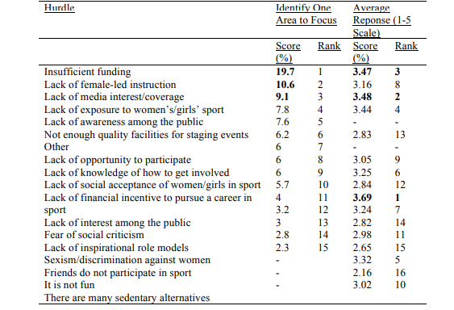
Appendix 2

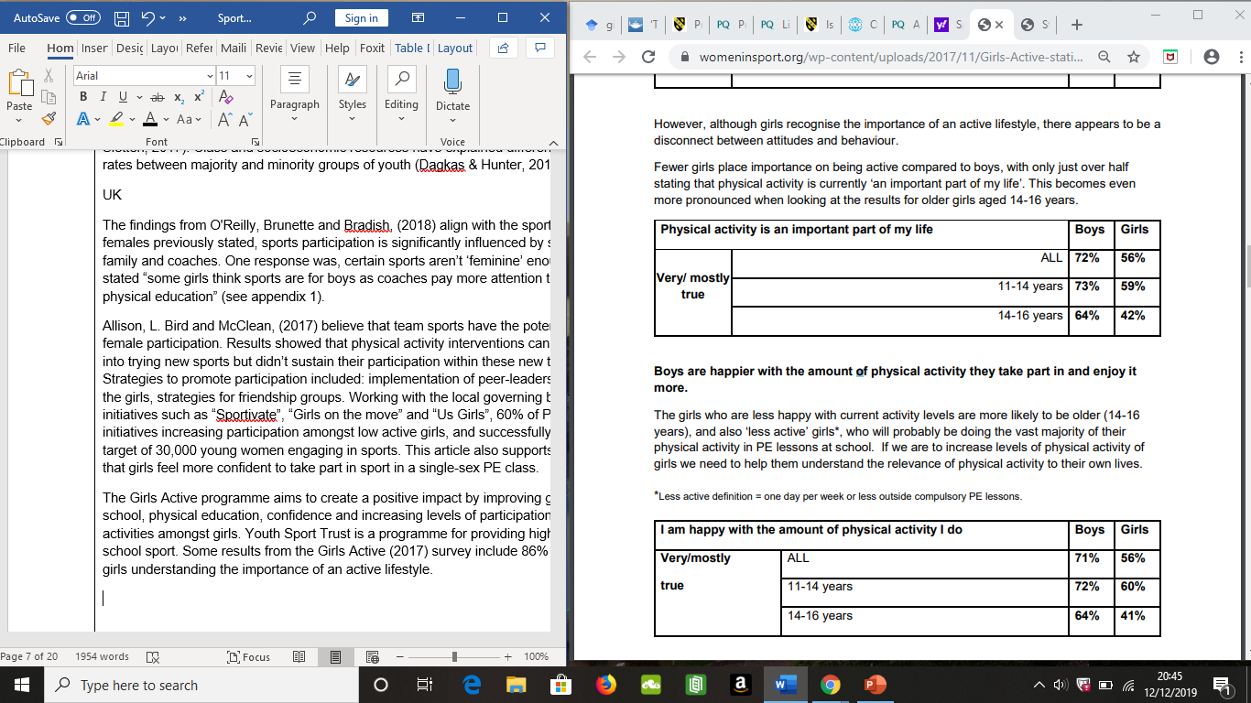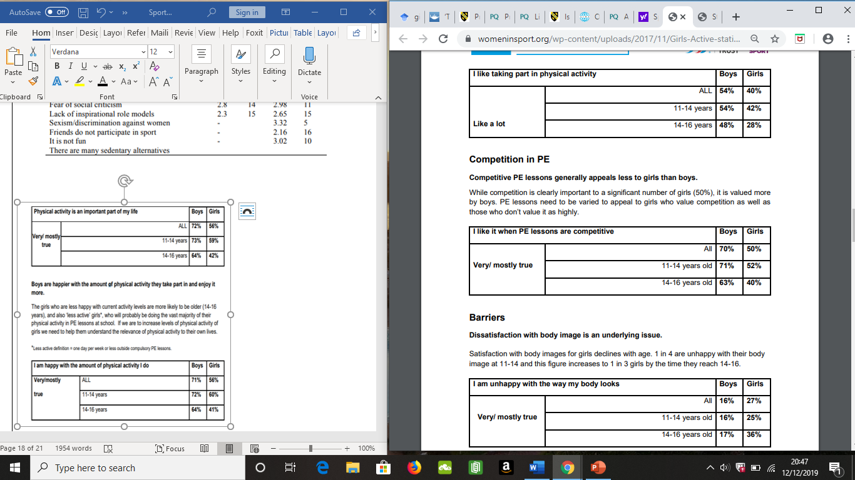

Appendix 3
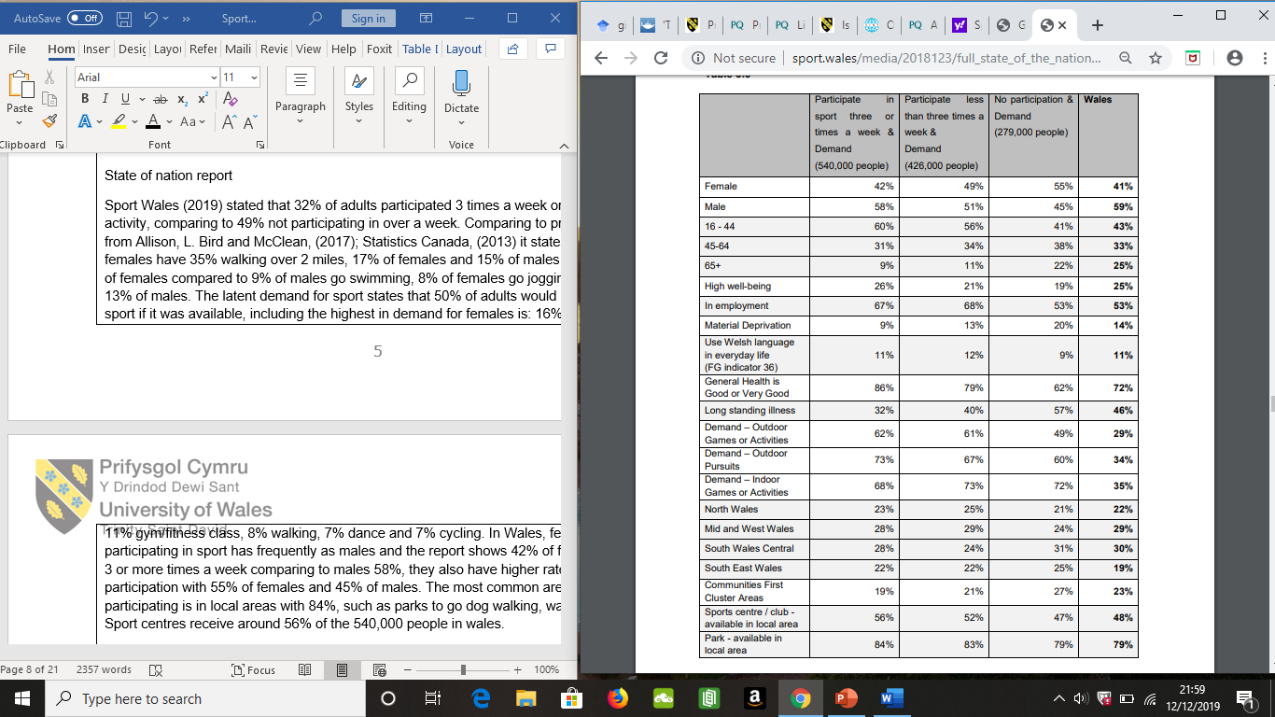

Appendix 4- Actions to take place
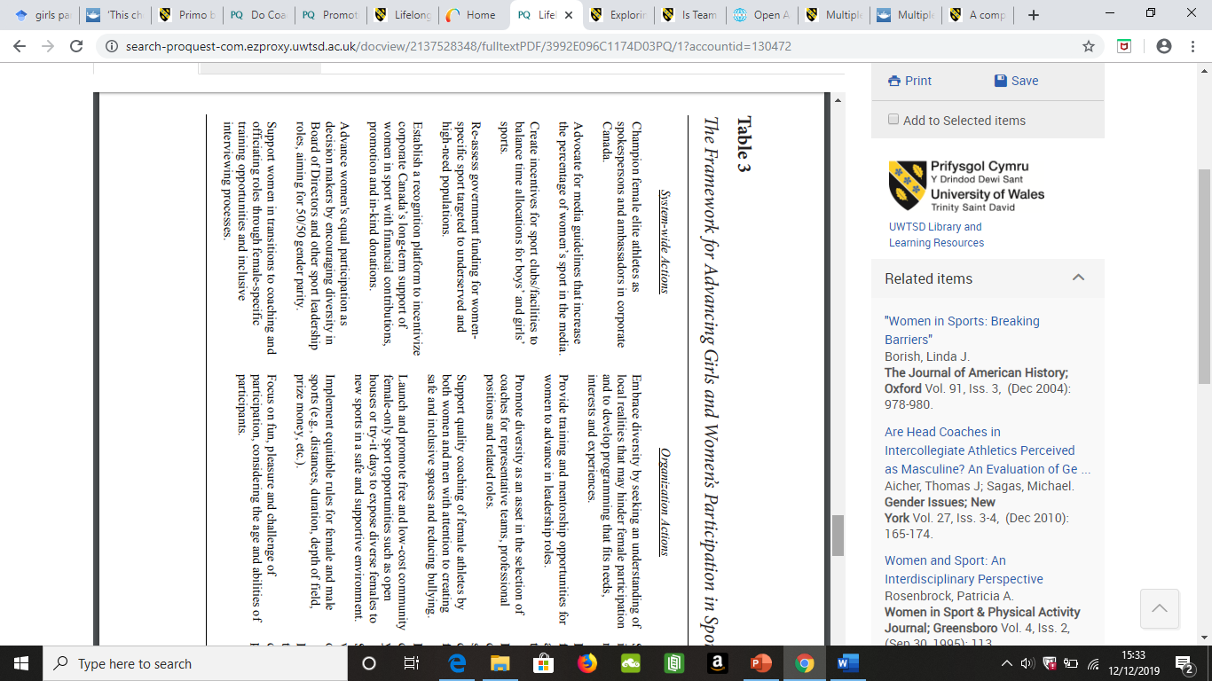

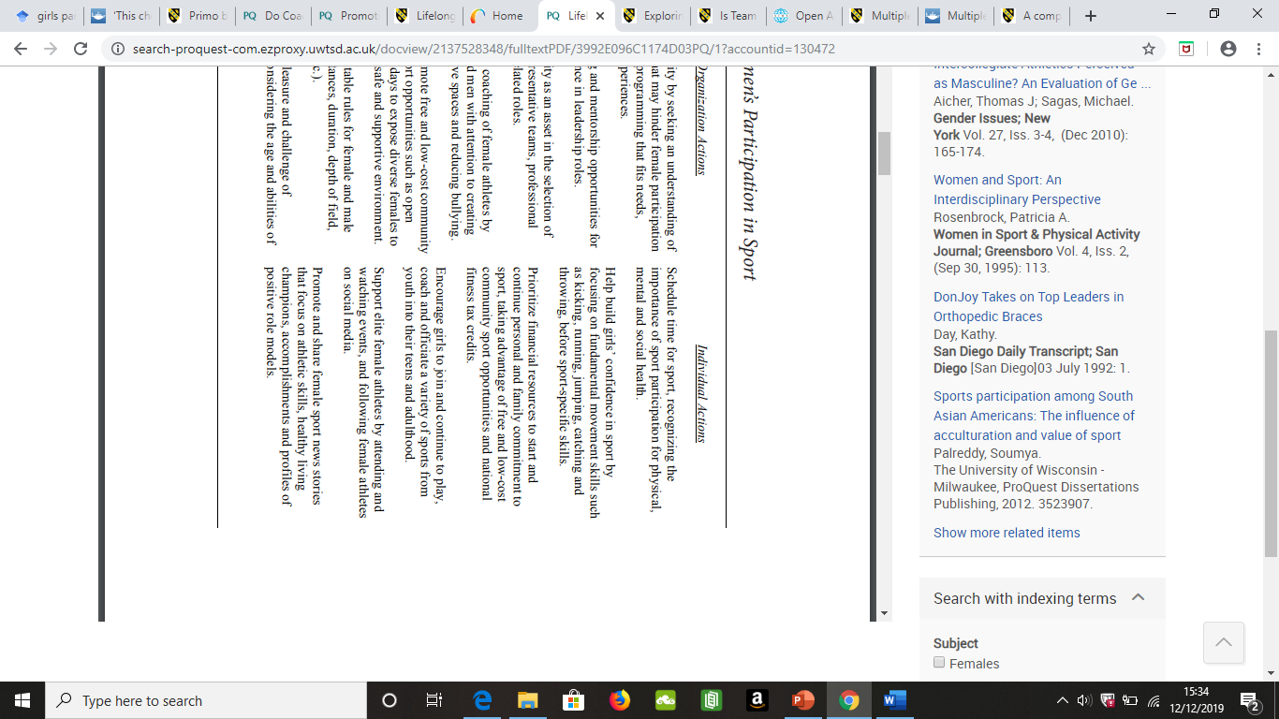



BA Sports Management Portfolio

Literature Review

UWTSDSport

